Artificial Intelligence and Machine Learning: Teronix AI/ML Appraisal
ACCA6011
University of Wales Trinity Saint David
Emily Stockdale
1906962

Lecturer: Terry Walcott

Table of Contents

Abstract

Introduction

Literature review

Teronix Data

Technology available

Methodology

Results

conclusion

Abstract
Artificial intelligence and machine learning tools and techniques are being increasingly utilised across the business sector. This report aims to provide insight into how an online business known as ‘Teronix Online’ can utilise the tools available to further improve understanding of the data held within the organisation.
Introduction
Teronix online is an online business that sells both consumer focused and general household commodities, additionally Teronix online import and export select products to Europe and the United States of America (North and South). This report is designed to provide Teronix online with insight into the benefits associated with the introduction of artificial intelligence and machine learning techniques and how these tools and techniques can be used to further understand the data held within the organisation [1]. The CEO of teronix online has provided the consultant with a dataset created by a previous consultant. In this report the consultant will use the dataset to appraise the data provided and provide insight into how machine learning and artificial intelligence tools can be applied to aid in further understanding and utilisation of the data held within the organisation.
Literature review
It has been said that technological innovations have been fundamental drivers for economic growth for over 250 years, with the most impactful being artificial intelligence [1]. Artificial intelligence otherwise known as AI has been defined by John McCarthy as the science and engineering of building and creating intelligent machines and computer programmes [2]. McCarthy suggests that artificial intelligence is the practice of using computers to understand and replicate human intelligence, although he does argue that intelligence cannot be defined however, we are aware that humans, animals, and some machines have a varying range of intelligence [2]. Russell and Norvig state that historically there are four approaches to artificial intelligence [3]:
- Thinking humanly
- Thinking rationally
- Acting humanly
- Acting rationally
Brynjolfsson and McAfee agree that machine learning is the most impactful subfield of artificial intelligence [1]. According to Brown, machine learning is a subfield of artificial intelligence that uses algorithms to problem solve, behave, and learn in an attempt to imitate intelligent human behaviour [4]. Similarly, Daume suggests that machine learning predicts the future based on past data and trends [5].
Artificial intelligence and Machine learning in practice
Felix Webber and Reinhard Schutte suggest that the application of artificial intelligence and machine learning is a natural fit to the retail sector, arguing that the retail sector is known for its high proportion of human work and low profit margins [6]. Artificial intelligence and machine learning techniques are used in the retail sector, specifically the supermarket industry to aid in informed decision making. Some examples of the benefits of machine learning include, but are not limited to, the ability to improve marketing campaigns, remaining competitive in the market, forecasting and customer and consumer prediction [7]. Hadjitchoneva suggested that artificial intelligence is an essential tool to modern day business as it complements and increases competitive advantages [8].
Some examples of how artificial intelligence and machine learning techniques are currently applied in the retail and supermarket sector include, but are not limited to:
- Produce and product management
- Marketing
- Theft prevention
- Customer and consumer predictions
- Smart shopping (lane hawk, amazon store)
Algorithms
Modern supermarkets and online retailers such as Asda, Morrisons, Walgreens and Amazon have adopted artificial intelligence and automation software [9] [10]. Each supermarket and retailer used a unique individual approach to the introduction of artificial intelligence and machine learning. There are four types of machine learning, supervised, unsupervised, reinforcement and semi supervised learning each associated with unique algorithms depending on the data at hand [3].
- Natural Language Processing
Natural language processing otherwise known as NLP is a branch of artificial intelligence which designed to enable computers to comprehend and manipulate human language [11]. Oshogbunu states that NLP is a computer based approach that uses a range of theories and techniques to analyse textual and speech data [12]. Examples of NLP in the supermarket sector include but are not limited to chat bots (customer service automation), Semantic analysis of social media (SASM), and search engine optimisation [12].
There are many benefits associated with the use of NLP in the retail and supermarket sector, the introduction of NLP can aid in reducing staffing costs and increase productivity and efficiency. NLP can be used to analyse customer history and as a result can provide product suggestions to customers while browsing based on previous purchases and preferences [13]. Additionally, Avasthi agreed that NLP techniques such as chat bots can be used as a customer service tool providing 24 hour support 7 days a week for 365 days a year, therefore providing continuous support and service without the addition of staffing fees, resulting in improved customer care and experience [14].
NLP has the capacity to [15] [12]:
- Automate support, by using chat bots rather than human agents as a first point of customer contact.
- Improve user experience by introducing features such as spell check and auto-fill.
- Analyse feedback by analysing consumer feedback from a range of sources such as social media, feedback forms and customer reviews.

- Pattern analytics
Pattern analytics is a machine learning classification technique defined by Boesch as the computational ability to identify patterns in data, otherwise known as machine-driven data analysis [16]. Classification is a machine learning technique that uses historical data to learn and predict by categorising data into a given class based on the data provided [17]. The use of pattern analytics in supermarkets can aid in improving marketing strategies by identifying trends an example of this could be identifying seasonal trends. Dr Rijmenam states that pattern analytics can identify customer interests providing the opportunity to base stock on customer and consumer need while providing insight into future sales trends [18]. Pattern analytics benefit businesses by providing insight into what stock is needed and when, aiding in the reduction of waste, especially when associated with consumable goods such as food therefore increasing revenue and decreasing loss. Additionally, the ability to manage and maintain marketing strategies based on ever changing consumer behaviour.
Summary
To summarise, there are many ways in which artificial intelligence and machine learning can be used to improve business productivity, efficiency, and aid in the process of understanding and utilising the consumer based data collected. Artificial intelligence and machine learning tools and techniques can be adopted to improve marketing strategies, reduce staffing costs, aid in productivity, and provide tools to fully utilise the data at hand.
Teronix Data
To enable accurate analysis of the data provided by Teronix Online it must first be identified what data types are present in the dataset. Data is split into two main types qualitative and quantitative data [19]. Quantitative data is data associated with numbers used for statistical analysis. Qualitative data otherwise known as categorical data can contain numeric values or text, often qualitative data can be split into categories for example, male and female, demographic data or in stock out of stock. These data types can be further classified into four categories [20]:
- Nominal data (qualitative)
- Ordinal data (qualitative)
- Discrete data (quantitative)
- Continuous data (quantitative)
The dataset provided by teronix contains both nominal and continuous data, combining both qualitative and quantitative data. The teronix data includes:
- Invoice data
- Stock codes
- Data descriptions
- Quantity purchased
- Invoice date
- Price
- Customer ID
- Customer demographic information
There are many ways that this data could be used to improve understanding of the dataset and business efficiency and productivity. Many artificial intelligence and machine learning tools and techniques can be applied to appraise this dataset such as liner regression to predict future trends, snow clustering to identify new commonalities or traits and pattern analysis to identify customer and consumer behaviours.
Technology available
To enable the application of artificial intelligence and machine learning an appropriate software must first be identified and selected. There are many open source software applications available examples of these applications include but are not limited to Jamovi, KNIME and WEKA. These tools are used to perform analyses, data exploration and, apply artificial intelligence, and machine learning algorithms and visualise data.
KNIME is an open source analytics platform written in Java used to build analyses of data of all complexities [21]. KNIME enables users to analyse and visualise data without code, it has the ability to automate spreadsheets, ETL and implement machine learning using integrated machine learning and data mining tools using a modular data pipelining concept. Like every application KNIME has it’s benefits and drawbacks [21]. A benefit of KNIME is that it enables users to process large datasets with no prior coding knowledge. Additionally, KNIME is easily integrated with environments such as cloud and data environments [22]. Despite it’s benefits some tools in KNIME are not user friendly. Another drawback associated with KNIME is that it can use a lot of memory resulting in slow operation.
Jamovi, similar to KNIME is a free open source stand-alone software used mainly for statistical analysis [23]. The ‘jamovi project’ was founded to provide users with a free open source user friendly application for statistical analysis. The core aim of jamovi was to provide open access to an application where anyone can complete and publish analyses, it is said by the jamovi founders that scientific software should be community driven [24]. Similar to KNIME jamovi has integrated machine learning tools to enable analyses such as liner regression, clustering, classification and more.
Waikato environment for knowledge analysis otherwise known as WEKA is another example of a free open source tool made up of a collection of machine learning algorithms used primarily for data mining. WEKA has a range of capabilities and tools these include the ability to work with big data, data pre-processing, regression, clustering, and visualisation. One of the main benefits of WEKA is that it has a lot of integrated machine learning tools and algorithms [25], however although this is a benefit it’s also a drawback as it can be overwhelming for users to know which algorithms to use and when [26].
For the purpose of this report jamovi was used, this software was selected as users do not require prior coding knowledge [24]. Additionally, jamovi is a user friendly platform with data visualisation and integrated machine learning tools.
Methodology
Teronix online provided the consultant with a dataset that contained over a hundred thousand records, to enable this dataset to be manageable and analysed accurately it must first be pre-processed. Pre-processing data is the process of preparing the data for further analysis essentially cleansing the data to ensure that the data is of quality for further exploration [27].
The data provided by the CEO of teronix online was in the form of an excel spreadsheet, including two sheets which contained data from 2009-2010 and data from 2010-2011.

As displayed below the data included invoice numbers, stock code, item description, quantity, invoice date, customer ID and country.
Once the data was opened in excel the consultant began the pre-processing process, the first step was to change the data into table format this was to enable filtering. Filtering enabled the consultant to review the dataset and identify missing values and data that may need removing.
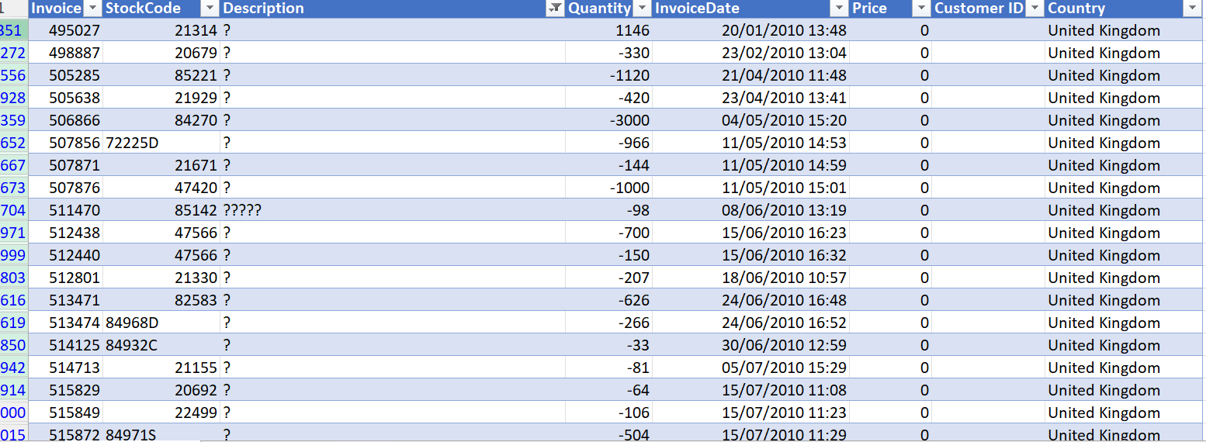
It was identified that there was data present in customer ID, stock code and description that had missing values or was not of use for the purpose of the task in hand.
The consultant removed, post, samples, and test data from the dataset as this enables the consultant to focus on sales data only.
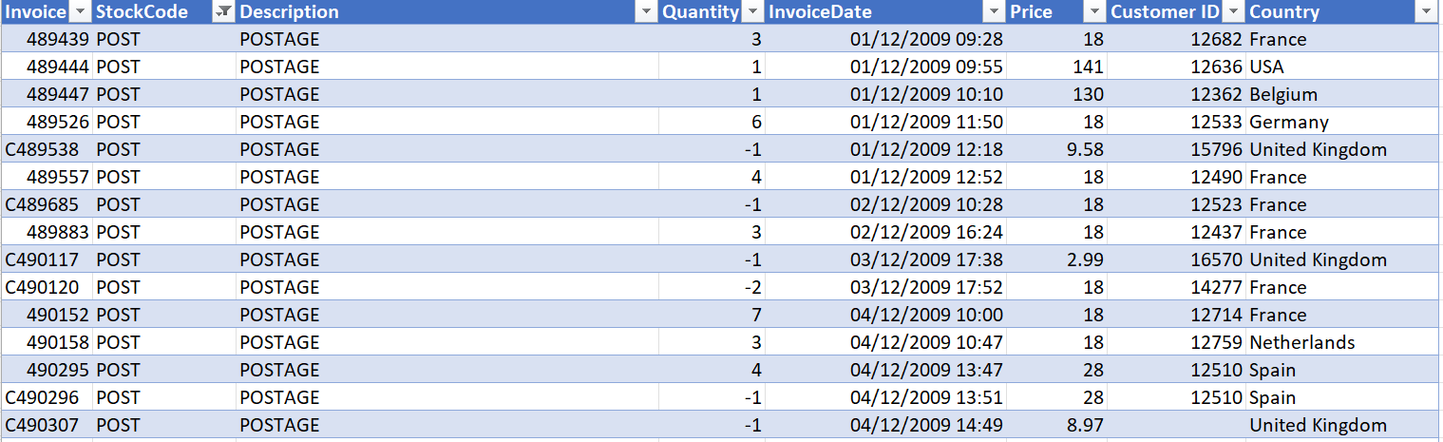
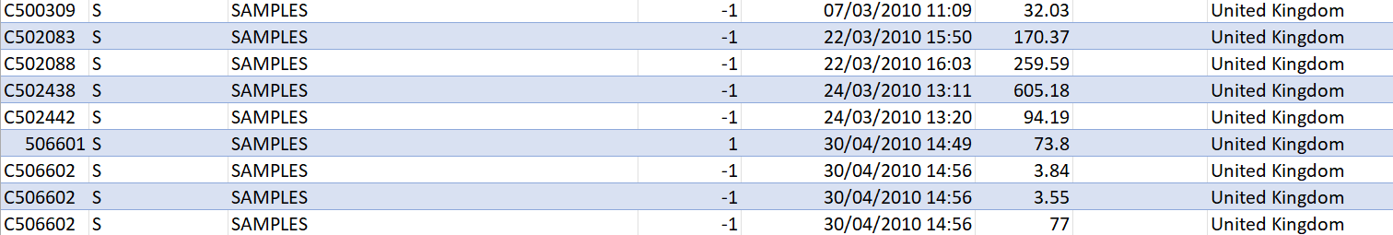
The consultant then continued to remove the blank customer ID’s as it’s possible that blank customer ID data could represent failed sales and therefore may affect the accuracy of the data.
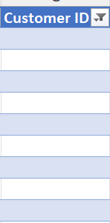
Similarly blank product descriptions were also removed, the reason for this is that blank data cannot be analysed as it is a missing value.
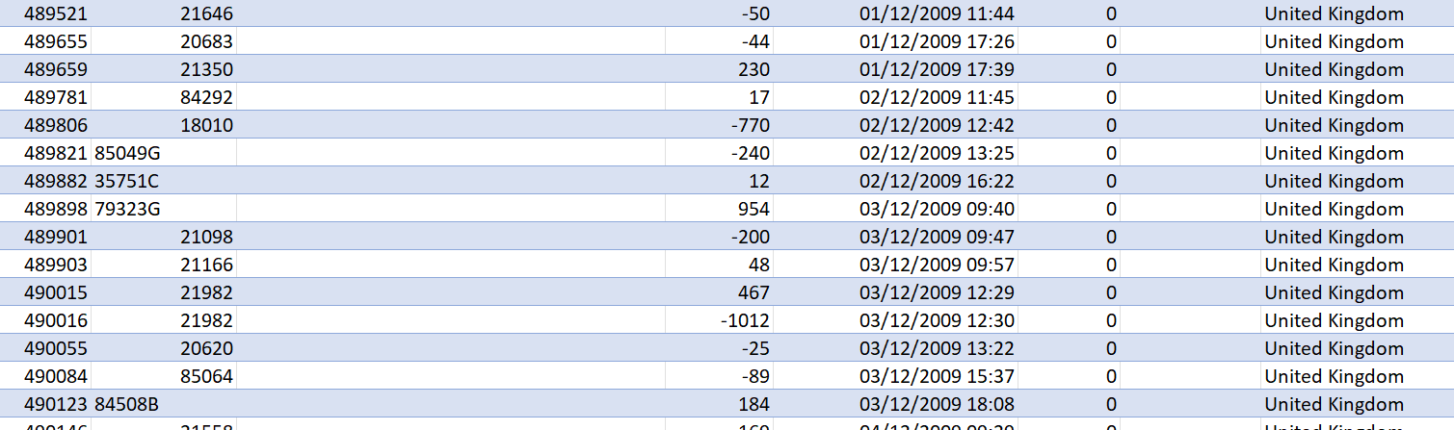
Following the removal of missing values and data that required removal to enable standardisation of the data the consultant added columns and fields to improve the data quality.
As the data provided by teronix online included customer demographic information ISO codes were added, ISO codes are individual country codes which are an international data standard [28]. The addition of this data ensured that the data is conforming with data standards current.
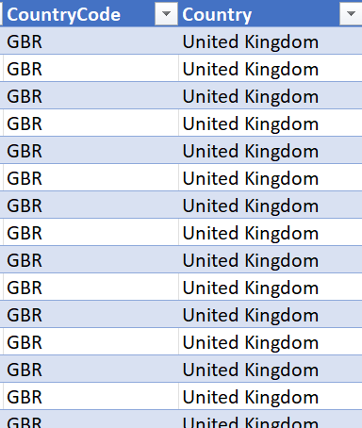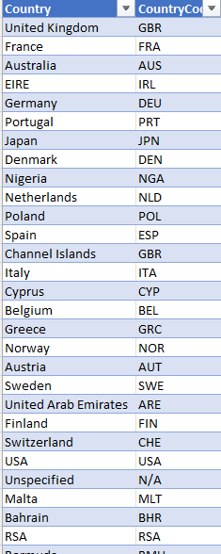
It was identified that the stock codes were inconsistent in their formatting, to improve this the consultant added UniqueStockCode. This enables standardisation.
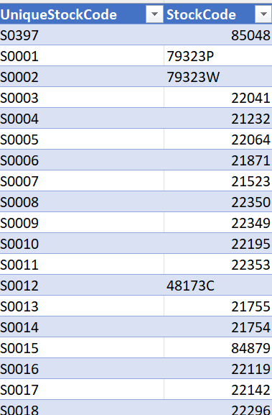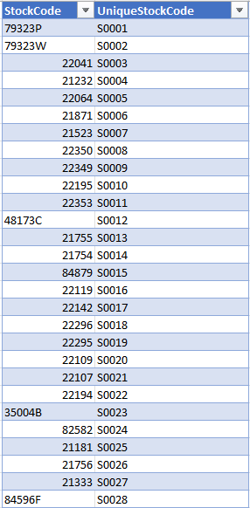
Following the removal of missing values and data that was not required and the addition of required data and information the excel spreadsheets were merged and saved as a csv file ready to be loaded into jamovi.
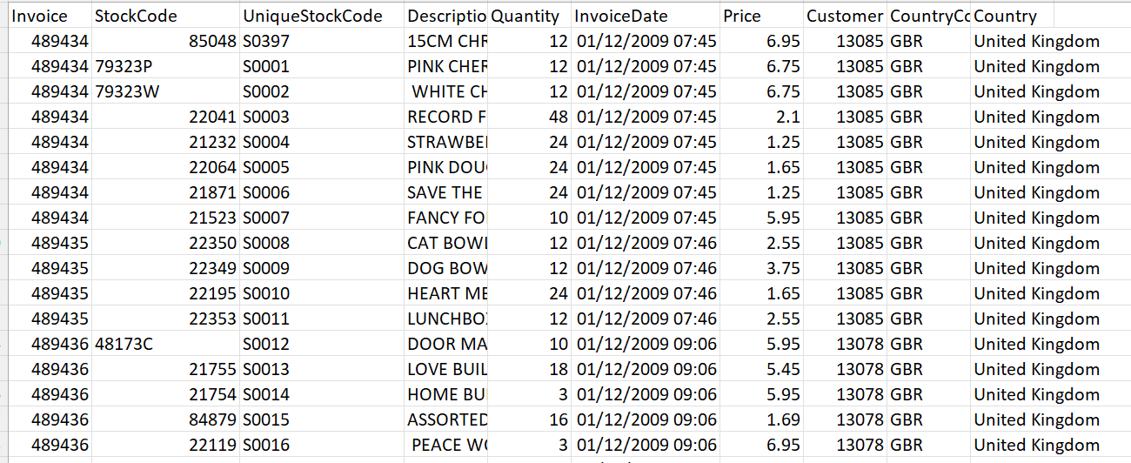
Results
First the consultant used the exploration feature in jamovi to identify which country was the main target demographic for teronix online. The consultant uses the ‘frequency table’ feature which provided an output (displayed below) identifying the main target area. The main target area for Teronix online is the United Kingdom (GBR) with 92.2% of customers and consumers being from this demographic region. This information will aid in identifying target audiences.
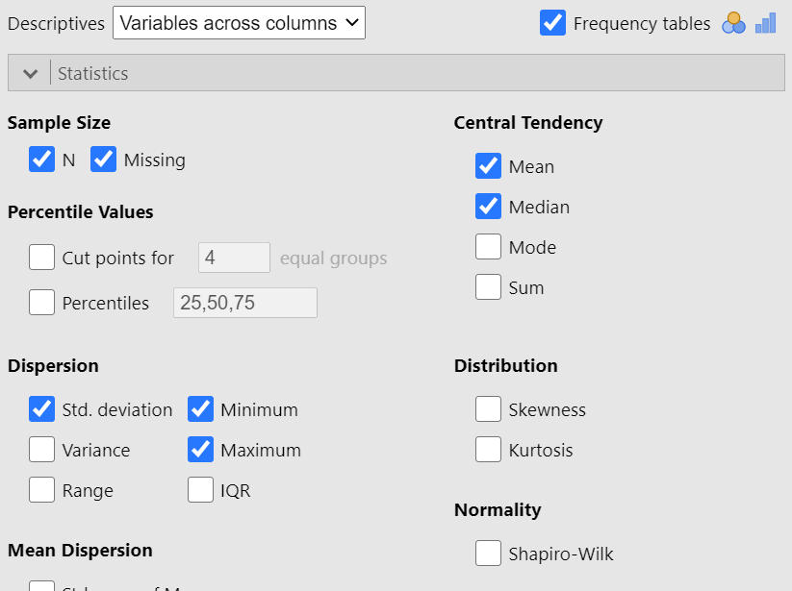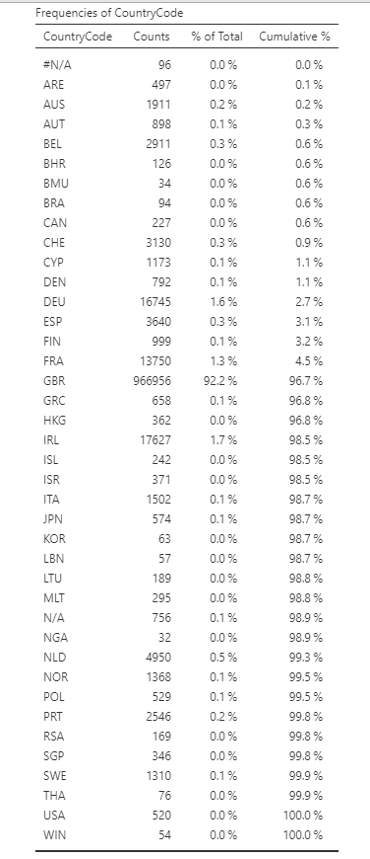

To identify price over time the consultant used a linear regression module [29], however the data fed into jamovi as an ID, so the linear regression did not work immediately. To enable this to work the consultant added a new column named ‘F’ with the measure type as nominal and the datatype as text. The result of this was the data fed from the original column and as this was now nominal data it could be used for a linear regression model.
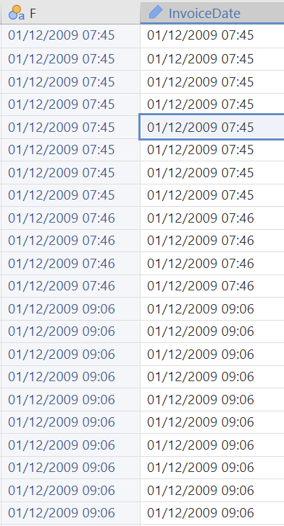
Using ‘F’ and ‘Price’ the consultant was able to successfully implement a linear regression model.
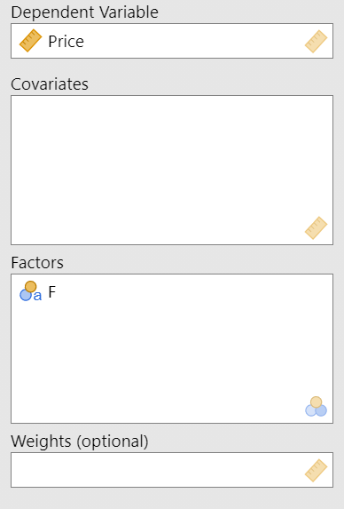
The linear regression model results showed that over time prices have increased over time. This is natural inline with the stock market, but this Q-Q plot can be used for further future comparison and analyses.
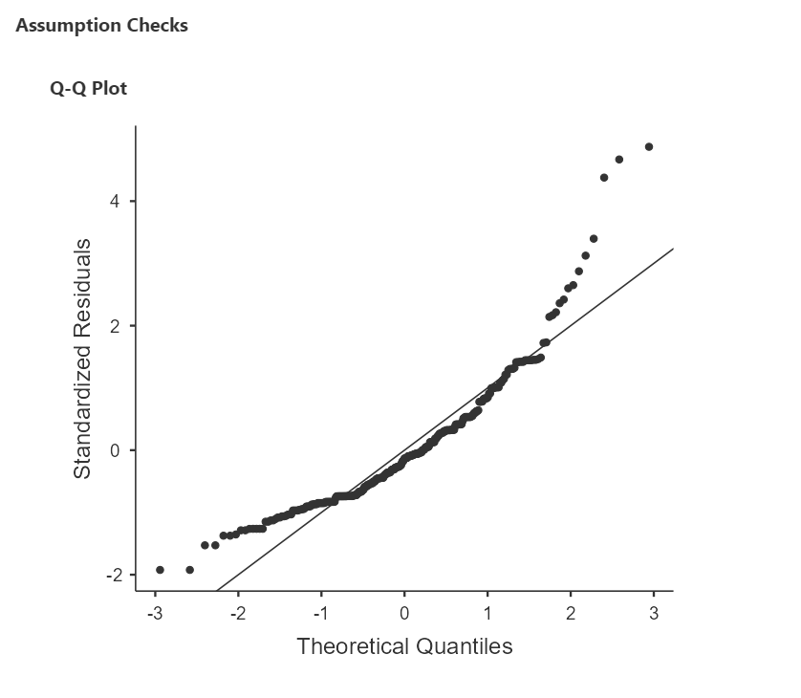
Conclusion
Through analysis using jamovi the consultant was able to identify multiple patterns and factors with the dataset provided [24]. Using a frequency table the consultant was able to identify that 92.2% of Teronix online customers are based in the UK. This data could be used for a range of things such as targeting marketing campaigns to UK consumers rather than other regions as this is where the target audience is. Based on this data considerations such as postage fees, delivery resources and stock warehouses should be discussed.
Additionally using a linear regression model [29] the consultant was able to identify that prices have increased over time, meaning that consumers are paying more for products over a period of time. However this is natural with the stock market and changes associated with the cost of living. This could be further compared to stock to allow management of teronix online to compare stock prices vs sale prices to ensure maximum profit.
It would have been beneficial to compare sales quantities over time to identify shopping patterns and trends of the teronix online customers. However due to the vast amount of outdated data this information would not be beneficial as consumer shopping habits may have changed along with item trends, what was popular between 2009-2011 may not be popular in the current climate [30].
Although patterns and trends have been identified using artificial intelligence and machine learning tools and techniques it’s important to highlight that the dataset provided is from 2009 – 2011 meaning that it is over 10 years old. It’s likely that the data is now outdated and new products and produce have since been introduced and therefore the trends and patterns may no longer aid in improving business performance. It is advised that teronix online provide the consultancy team with more up to date data to enable accurate analysis to enable the best results.

References

[1] | A. M. Erik Brynjolfsson, Artifical Intelligence, For real, 2017.
[2] | J. McCarthy, What is Artificial Intelligence?, Stanford, 2004.
[3] | P. N. a. E. D. S. J. Russell, Artificial Intelligence: A Modern Approach, 3rd ed., Boston: Pearson, 2010.
[4] | S. Brown, "Machine Larning, Explained," Management Sloan School, 21 04 2021. [Online]. Available: https://mitsloan.mit.edu/ideas-made-to-matter/machine-learning-explained#:~:text=Machine%20learning%20is%20a%20subfield%20of%20artificial%20intelligence%2C,that%20is%20similar%20to%20how%20humans%20solve%20problems.. [Accessed 05 01 2023].
[5] | H. D. III, "A course in machine learning," 2017. [Online]. Available: http://ciml.info/dl/v0_9/ciml-v0_9-ch03.pdf. [Accessed 07 01 2023].
[6] | S. R. h. Felix Webber, "A domain-oriented analysis of the impact of machine learning in the case of retail," Big data and Cognitive Computing, vol. 3, no. 1, p. 11, 2019.
[7] | J. R. Fernandez, "Recognition of supermarket products using Computer Vision," MS thesis. Universitat Politècnica de Catalunya, 2020.
[8] | C. R. M. R. a. A. M. J. Hadjitchoneva, "The use of artificial intelligence in the online retail sector: the case of the eBag supermarket," 6th Iberian Conference on Information Systems and Technologies (CISTI), pp. 1-8, 2021.
[9] | J. Lee, "The Secret to Successful Supemarket AI Deployment," Retail Technology, 21 08 2019. [Online]. Available: https://cb4.com/blog/supermarket-ai-deployment/#:~:text=While%20Heinen%E2%80%99s%2C%20Walmart%2C%20and%20Food%20Giant%20apply%20supermarket,and%20their%20AI%20helpers%20have%20the%20same%20foundation.. [Accessed 05 01 2023].
[10] | BBC NEWS, "Supermarket cameras to guess age of alcohol buyers," BBC, 02 02 2022. [Online]. Available: https://www.bbc.co.uk/news/technology-60215258. [Accessed 06 01 2023].
[11] | S. K. Vineet Raina, Bulding an Effective Data Science Practice, Berkeley, CA: Apress, 63-73.
[12] | N. R. V. ,. S. R. a. O. L. Michael Akpovona Oshogbunu, "Applying natural language processing algorithm for predicting consumer product preferences in retail stores," 4th International Conference on Innovative Computing and Communication, 2021.
[13] | N. Joshi, "Creating customer friendly retail stores with NLP," Forbes, 2020.
[14] | A. Avasthi, "The impact of NLP on online retail shopping," 15 10 2021. [Online]. Available: https://datasaur.ai/blog-posts/nlp-on-online-retail-shopping#:~:text=The%20Impact%20of%20NLP%20on%20Online%20Retail%20Shopping,Functionality%20...%205%20Translation%20for%20Global%20Reach%20. [Accessed 05 01 2022].
[15] | Wonderflow, "12 NLP examples: how natural language processing is used," Wonderflow, 17 12 2018. [Online]. Available: https://www.wonderflow.ai/blog/natural-language-processing-examples#why-use-nlp. [Accessed 08 01 2023].
[16] | G. Boesch, "What is Pattern Recognition? A Gentle Introduction (2023)," Visio.Ai, [Online]. Available: https://viso.ai/deep-learning/pattern-recognition/. [Accessed 10 01 2023].
[17] | M. Waseem, "How To Implement Classification In Machine Learning?," 03 01 2023. [Online]. Available: https://www.edureka.co/blog/classification-in-machine-learning/#:~:text=What%20Is%20Classification%20in%20Machine%20Learning. [Accessed 08 01 2023].
[18] | D. M. v. Rijmenam, "Three Ways Pattern Analytics Will Grow Your Business," 31 12 2014. [Online]. Available: https://datafloq.com/read/three-ways-pattern-analytics-grow-your-business/#:~:text=Pattern%20analytics%20on%20customer%20and%20sales%20data%20can,and%20interest%20and%20news%20happening%20around%20the%20world.. [Accessed 08 01 2023].
[19] | Great Learning, "4 Types Of Data – Nominal, Ordinal, Discrete and Continuous," 16 01 2023. [Online]. Available: https://www.mygreatlearning.com/blog/types-of-data/. [Accessed 18 01 2022].
[20] | R. Sharma, "4 Types of Data: Nominal, Ordinal, Discrete, Continuous," 04 10 2022. [Online]. Available: https://www.upgrad.com/blog/types-of-data/. [Accessed 07 01 2023].
[21] | KNIME, "KNIME Software," KNIME, [Online]. Available: https://www.knime.com/software-overview. [Accessed 10 01 2023].
[22] | M. Wong, "Is KNIME (A Machine Learning Platform With ZERO Coding Involved) Suitable For You/Your Business?," 15 05 2018. [Online]. Available: https://medium.com/@matthew.mh.wong/is-knime-a-machine-learning-platform-with-zero-coding-involved-suitable-for-you-your-business-10f4b2864e1d#:~:text=Why%20KNIME%20and%20What%E2%80%99s%20Good%20About%20It%3F%201,supports%20Python%20and%20R%20via%20wrappe. [Accessed 10 01 2023].
[23] | George Mason University Library, "Software for Digital Scholarship," [Online]. Available: https://infoguides.gmu.edu/software/jamovi#:~:text=Jamovi%20is%20a%20free%2C%20open-source%2C%20standalone%20software%20that,was%20started%20by%20developers%20who%20worked%20on%20JASP.. [Accessed 10 01 2023].
[24] | Jamovi, "About Jamovi," Jamovi, [Online]. Available: https://www.jamovi.org/about.html. [Accessed 10 01 2023].
[25] | J. Brownlee, "How to Use Machine Learning Algorithms in Weka," Machine Learning Mastery, 15 07 2016. [Online]. Available: https://machinelearningmastery.com/use-machine-learning-algorithms-weka/. [Accessed 10 01 2023].
[26] | D. Sanford, "why do we use WEKA," TimesMojo, 07 07 2022. [Online]. Available: https://www.timesmojo.com/why-do-we-use-weka/. [Accessed 10 01 2023].
[27] | S. M. a. T. C. Arnab Chakrabarty, Multiscale Modeling for Process Safety Applications, Science Direct, 2016.
[28] | ISO Standards, "ISO 3166 Country Codes," ISO , [Online]. Available: https://www.iso.org/iso-3166-country-codes.html#:~:text=Using%20ISO%20Codes%20ISO%20allows%20free-of-charge%20use%20of,are%20ready-to-use%20for%20a%20wide%20range%20of%20applications.. [Accessed 11 01 2023].
[29] | D. Nelson, "What is Linear Regression?," 05 06 2021. [Online]. Available: https://www.unite.ai/what-is-linear-regression/. [Accessed 12 01 2023].

