Comment on the following image of Fountains Abbey, from the southwest.
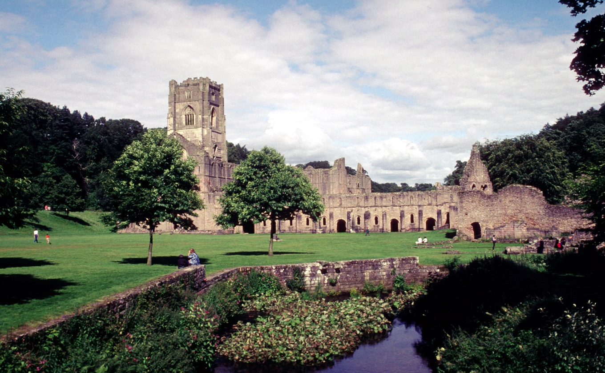

The image depicts the ruins of Fountains Abbey, one of the largest and most complete Cistercian monasteries in England. Founded on 27 December 1132 by thirteen monks who left Saint Mary’s Abbey, York, seeking stricter adherence to the Rule of Saint Benedict, and supported by Archbishop Thurstan of York, the new community joined the Cistercian Order by 1134 (Robinson, 1998; Whitworth, 2009). Fountains became a leading Cistercian house, reflecting the order’s rapid expansion (Whitworth, 2009). This growth was part of a broader revival of monasticism in Yorkshire, with about sixty to seventy religious houses built between 1069 and 1215, including eight Cistercian abbeys that transformed the region’s spiritual and economic landscape (Burton, 1999, pp. 3–8). Fountains exemplifies the paradox between Cistercian austerity and wealth. Built to embody poverty, simplicity, and discipline, its architecture also demonstrates prosperity, economic ambition, and evolving liturgical practices.

Initially constructed of timber, the buildings were replaced with stone between 1136 and 1146. Following a fire, a larger cruciform church was erected in the 1150s–1160s (Coppack, 2006, pp. 35–45; Hodges, 1904, pp. 28–35). Fountains, one of the earliest northern Cistercian houses, embodied the order’s austerity, discipline, and retreat from worldly concerns (Donkin, 1969). Its remote location, “far from the concourse of men,” reinforced the Cistercian aim of self-sufficiency and separation from worldly influence (Coppack, 2009, p. 15). Between 1138 and 1150, it founded seven daughter houses, illustrating the order’s swift growth across England (Spence, 2020, p. 23). Yorkshire hosted over one hundred Cistercian houses by the late twelfth century, shaping the landscape and supporting the wool trade (Whitworth, 2009; Cistercians in Yorkshire, n.d.). Today, Fountains Abbey is a UNESCO World Heritage Site, preserved by the National Trust and English Heritage (UNESCO, 2025; National Trust, 2025; English Heritage, 2025; Cistercians in Yorkshire, n.d.).

The south-west view frames Fountains within its extensive grounds, highlighting its monumental scale and layered architecture. The River Skell valley setting provided resources and enhanced spiritual seclusion (Cistercians in Yorkshire, n.d.). The 1500–1526 tower, with Gothic windows and battlemented parapets, along with the 1494 west front window, conveys authority and restrained decoration (Robinson, 1998). These features typify late Cistercian ‘restrained grandeur’ (Lekai, 1977, p. 270). Built under Abbot Marmaduke Huby (1495–1526), the forty-eight-metre tower marks a departure from traditional Cistercian norms. Attached to the north transept (Coppack and Gilyard-Beer, 1993, pp. 22–23), it contrasts with laws forbidding stone bell towers, reflecting the order’s austerity. In 1157, the General Chapter at Cîteaux declared that “stone towers with bells are not to be built,” a rule reaffirmed in the thirteenth century. By the late Middle Ages, attitudes softened, yet Huby’s tower remains the largest in England (Carter, 2010). Carter (2010) reinterprets the tower, once seen as prideful, as an expression of Huby’s piety and reform, with inscriptions and imagery embodying renewed Cistercian devotion.

To the west, the nave and transepts are now roofless walls, with traces of arcades and clerestory windows indicating a cruciform plan. The largely hidden east presbytery housed the high altar and choir stalls. Claustral buildings like cloisters, chapter houses, and dormitories integrated spiritual, domestic, and economic life (Coppack, 1986). Appendix A shows how architecture reflected shifts in monastic and liturgical priorities over four centuries. The seventy-acre precinct, divided by the river, balanced devotion with practicality, poverty with self-sufficiency and labour (Coppack and Gilyard-Beer, 1993, p. 12). Cistercian churches embodied ascetic principles, simplicity, functionality, and minimal decoration (Sternberg, 2018). Fox (2007) notes that Cistercian ‘architecture of simplicity,’ with plain lines, natural light, and stillness, fostered prayer and contemplation. By the early sixteenth century, heraldry, like the azure shield with three golden horseshoes, symbolised Fountains’ changing identity (Carter, 2010). Regional traditions and practical needs also influenced each monastery’s design, often by professional builders, not monks (Sternberg, 2018).

Wool was a primary source of wealth for Fountains Abbey, which became one of England's leading wool producers and exporters by the late 13th century (Cistercians in Yorkshire, n.d.). Overexpansion led to financial strain and a brief royal administration in 1272 (Spence, 2020, p. 26), but trade profits funded major architectural projects under Abbots John of York, John Hessle, and John of Kent (Jacob, 2025). These expansions made Fountains a grand religious and economic centre (Jacob, 2025). As Coppack (2009, p. 13) notes, agricultural efficiency generated surplus wealth for building, showing prosperity from spiritual discipline. After Henry VIII’s Dissolution in 1539, the site became private property and part of Studley Royal, shifting to a heritage site (Jacob, 2025).
Fountains Abbey embodies Cistercian ideals of poverty, simplicity, and discipline. Its architecture reflects humility and obedience, with its secluded valley location enhancing spiritual focus (Donkin, 1969). Monastic life followed a counter-cultural rhythm of prayer and labour, contrasting sharply with secular economic systems (Moore, 2025). The abbey reveals tension between ideals and wealth. By the twelfth and thirteenth centuries, prosperity enabled expansion, with lay brothers doing manual work and monks handling administration (Madden, 1963). Workshops processed wool, cloth, and metal, illustrating how economic systems supported religious duties (Coppack, 1986). The ruins embody the paradox of asceticism versus affluence, bridging spiritual retreat and worldly engagement.

The image shows the tension between Cistercian spiritual ideals and material realities. The architecture and landscape express devotion, while the abbey’s size and infrastructure reveal adaptation to social and economic needs. Fountains Abbey’s ruins represent austerity and transformation, reflecting the dual nature of Cistercian monasticism and balancing devotion with ambition, connecting the monks’ contemplative retreat and active economic role. As a World Heritage Site, it connects modern viewers with medieval monastic life, demonstrating how architecture, landscape, and material culture preserve faith and worldly compromises.

BIBLIOGRAPHY

Secondary Sources
Burton, J. (1999) The Monastic Order in Yorkshire, 1069–1215. 1st edn. Cambridge: Cambridge University Press. Available at: https://doi.org/10.1017/CBO9780511585210
Carter, M. (2010) ‘The Tower of Abbot Marmaduke Huby of Fountains Abbey: Hubris or Piety?’, The Yorkshire Archaeological Journal, 82(1), pp. 269–286. Available at: https://doi.org/10.1179/yaj.2010.82.1.269
Carter, M. (2017) ‘Azure, Three Horseshoes Or: The Arms of Fountains Abbey, An Enduring Puzzle’, Notes and queries, 64(2), pp. 234–242. Available at: https://doi.org/10.1093/notesj/gjx002
Cistercians in Yorkshire (n.d.) Fountains Abbey. Available at: https://www.dhi.ac.uk/cistercians/fountains/ (Accessed: 25 September 2025).
Coppack, G. (1986) ‘The excavation of an outer court building, perhaps the Woolhouse, at Fountains Abbey, North Yorkshire’, Medieval Archaeology, 30(1), pp. 46-87. Available at: https://doi.org/10.1080/00766097.1986.11735485
Coppack, G. (2006) ‘According to the Form of the Order: The Earliest Cistercian Buildings in England and their Context’, in Kinder, T. (ed). Perspectives for an Architecture of Solitude: Essays on Cistercians, Art and Architecture in Honour of Peter Fergusson, pp. 35-45. Available at: https://moodle.uwtsd.ac.uk/mod/folder/view.php?id=391022 (Accessed: 25 September 2025).
Coppack, G. (2009) Fountains Abbey. Stroud: Amberley.
Coppack, G. and Gilyard-Beer, R. (1993) Fountains Abbey: North Yorkshire. London: English Heritage.
Donkin, R. A. (1963) ‘The Cistercian Order in Medieval England: Some Conclusions’, Transactions and Papers (Institute of British Geographers), 33, pp. 181–198. Available at: https://doi.org/10.2307/621007
Donkin, R. A. (1969) ‘The Cistercian Order and the Settlement of Northern England’, Geographical Review, 59(3), pp. 403–416. Available at: https://doi.org/10.2307/213484
Engh, L.C. (2019) ‘Imaginative immersion in the Cistercian Cloister’, Acta ad archaeologiam et artium historiam pertinentia, 31(17), pp. 133–160. Available at: https://doi.org/10.5617/acta.7804
English Heritage (2025) Yorkshire and the Humber discounted partner attractions. Available at: https://www.english-heritage.org.uk/members-area/partner-attractions/yorkshire/ (Accessed: 22 September 2025).
Fox, T.C. (2007) ‘The architecture of simplicity: a concern for light and quiet shape Cistercian monasteries and spirituality’, National Catholic reporter, 43(13), pp. 13-14. Available at: https://www.proquest.com/docview/2163103715?accountid=130472&parentSessionId=SFY3NMotgSJ%2F8oirJ0ShOEkAoa2tJyHYOGiIyirfx3k%3D&pq-origsite=primo&sourcetype=Trade%20Journals (Accessed: 6 October 2025).
Hodges, G. (1904) Fountains Abbey: The Story of a Mediaeval Monastery. London: J.M. Dent & Sons. Available at: https://www.gutenberg.org/cache/epub/52581/pg52581-images.html (Accessed: 6 October 2025).

Jacob, L. (2025) Fountains Abbey: History of Yorkshire monastic ruins known as one of the largest and best preserved monasteries in England where The Secret Garden and The Witcher were filmed. Available at: https://www.yorkshirepost.co.uk/heritage-and-retro/retro/fountains-abbey-history-of-yorkshire-monastic-ruins-known-as-one-of-the-largest-and-best-preserved-monasteries-in-england-where-the-secret-garden-and-the-witcher-were-filmed-4978116 (Accessed: 22 September 2025).
Lekai, L.J. (1977) The Cistercians: ideals and reality. Kent, Ohio: Kent State University Press.
Madden, J. (1963) ‘Business Monks, Banker Monks, Bankrupt Monks: The English Cistercians in the Thirteenth Century’, The Catholic Historical Review, 49(3), pp. 341–364. Available at: http://www.jstor.org/stable/25017300 (Accessed: 22 September 2025).
Moore, M.E. (2025) ‘Monastic Counter-Culture and Its Medieval Origins’, Religions, 16(6), p. 760. Available at: https://doi.org/10.3390/rel16060760
National Trust (2025) Fountains Abbey and Studley Royal Water Garden. Available at: https://www.nationaltrust.org.uk/visit/yorkshire/fountains-abbey-and-studley-royal-water-garden (Accessed: 22 September 2025).
Robinson, D. (1998) Cistercian Abbeys of Britain: far from the concourse of men. Batsford. Available at: https://moodle.uwtsd.ac.uk/mod/folder/view.php?id=391022 (Accessed: 25 September 2025).
Spence, M. (2020) The late medieval Cistercian monastery of Fountains Abbey, Yorkshire : monastic administration, economy, and archival memory. Brepols Publishers.

Sternberg, M. (2018) Cistercian Architecture. Medieval Studies. Oxford University Press. Available at: https://doi.org/10.1093/obo/9780195396584-0257

UNESCO (2025) Studley Royal Park including the Ruins of Fountains Abbey. Available at: https://whc.unesco.org/en/list/372/ (Accessed: 22 September 2025).
Webster, H. (2025) Architecture (Fountains Plan). Available at: https://moodle.uwtsd.ac.uk/mod/folder/view.php?id=391022 (Accessed: 25 September 2025).
Whitworth, A. (2009) Fountains Abbey through time. Available at: https://books.google.co.uk/books?hl=en&lr=&id=qECoAwAAQBAJ&oi=fnd&pg=PT5&dq=fountains+abbey+cistercian+monastery&ots=tATQQUbAdo&sig=LMB2a-Rh6cOfr7HH3eWHZhJ2G2Q&redir_esc=y#v=onepage&q&f=true (Accessed: 22 September 2025).
Zerubavel, E. (1980) ‘The Benedictine Ethic and the Modern Spirit of Scheduling: on Schedules and Social Organization’, Sociological inquiry, 50(2), pp. 157–169. Available at: https://2024.sci-hub.se/964/924e03a5d645be2ccd2a12fa89b5e07c/zerubavel1980.pdf (Accessed: 6 October 2025).
Zucker, P. (1961) ‘Ruins. An Aesthetic Hybrid’, The Journal of Aesthetics and Art Criticism, 20(2), pp. 119–130. Available at: https://doi.org/10.2307/427461

APPENDIX:

Appendix A: Historical Ground Plan of Fountains Abbey
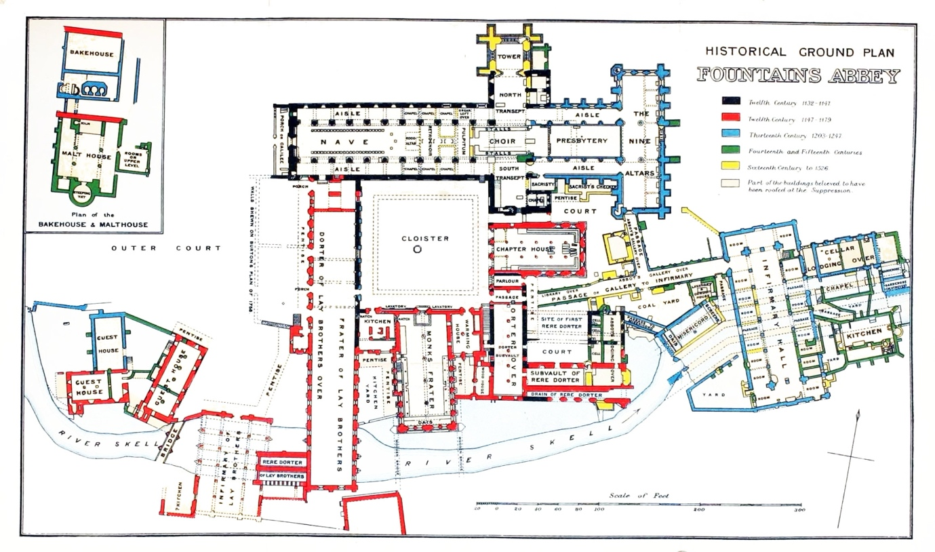
Ref: (Webster, 2025)

