Robyn watts
BSc/HND*/HNC* Quantity Surveying
Fundamentals of Construction Technology
Case Study
ACBA 4022

Table of Contents
1. Introduction 3
2. Understanding Offsite Construction 3
3. Comparative Analysis of Construction Methods 4
3.1 Ground Floor Construction and External Wall Junctions 4
Timber twin frame 4
SIPS 4
Brick and block 4
3.2 Window Opening Detail 4
Timber Twin Frame 5
SIPS 5
Brick And Block 5
3.3 Eaves and Roof Detailing 5
Timber twin frame 5
SIPS 6
Brick And Block 6
4. Recommendation and Conclusion 6
5. References 7

1. Introduction
This case study was written for Miss A Client, who has planning permission to build a two-storey detached house on a level, reclaimed agricultural site. The project must follow modern building regulations and meet planning conditions related to materials, insulation, and window and roof design. A retaining wall is found on the south side of the site, and a raft foundation is recommended due to the ground conditions. The client has asked for a comparison of three construction methods Timber Twin Frame, SIPS, and Brick and Block looking at how each performs in terms of construction, thermal efficiency, and suitability for the site.

2. Understanding Offsite Construction
Offsite construction is a building method that enhances the overall value of a project by manufacturing and partially assembling components, elements, or modules in a factory setting before transporting them to their final location for installation.

“Offsite construction allows key elements of a building to be designed, planned and constructed using prefabricated or pre-assembled products, manufactured in an offsite factory environment.” (Morgansindall).

1.Volumetric Construction:

“Volumetric modular buildings and homes are prefabricated buildings or homes that consist of multiple three-dimensional units or sections called modules” (offsiteconstruction).

Involves the creation of complete three-dimensional units—such as fully fitted bathroom pods or entire rooms—within a factory environment.
Application: These finished modules can be transported to the site and installed directly into the structural frame of the house.

2. Panellised Systems:
Consists of flat-packed elements like wall panels, floor cassettes, and roof panels that are fabricated offsite and assembled on location.
Application: Structural Insulated Panels (SIPs) or Timber Frame wall sections can be quickly erected to form the building’s envelope.

3. Sub-Assemblies and Prefabricated Components:
Refers to individual building elements manufactured offsite, such as pre-made staircases, window units, or roof trusses.
Application: These components can be integrated seamlessly into the build during the on-site construction phase.

4. Hybrid systems
A broad term that encompasses a wide range of construction methods, especially where various systems and/or materials are combined to perform a specific function.
Application:

3. Comparative Analysis of Construction Methods
Timber Twin Frame is a type of high-performance timber construction system that uses two separate timber stud wall frames built parallel to each other with a gap in between. This gap is usually filled with insulation, and the whole setup is designed to drastically reduce thermal bridging and improve acoustic performance.

SIPS stands for Structural Insulated Panel System. It’s a modern construction method that uses large, prefabricated panels made of:
- Two layers of OSB (Oriented Strand Board) on the outside
- A rigid foam insulation core in the middle (usually polyurethane or expanded polystyrene)
These panels form both the structure and the insulation of a building.

Brick and Block construction is a traditional method widely used in the UK, consisting of two wall layers: an outer skin of facing bricks for weather protection and appearance, and an inner skin of concrete blocks for structural strength. Between them is an insulated cavity, filled with cavity, blown insulation, or rigid boards. The two layers are tied together using stainless steel wall ties for stability.

3.1 Ground Floor Construction and External Wall Junctions

Timber twin frame
Insulation is placed on top of the raft foundation, followed by a screed layer that incorporates underfloor heating pipes. The twin timber frame walls are filled with mineral wool insulation, and an internal service void provides space for added insulation and services. On the outside, a facing brick skin is tied back to the frame over a ventilated cavity with a breather membrane. Damp-proof courses and cavity closers are installed at the base to prevent moisture ingress.

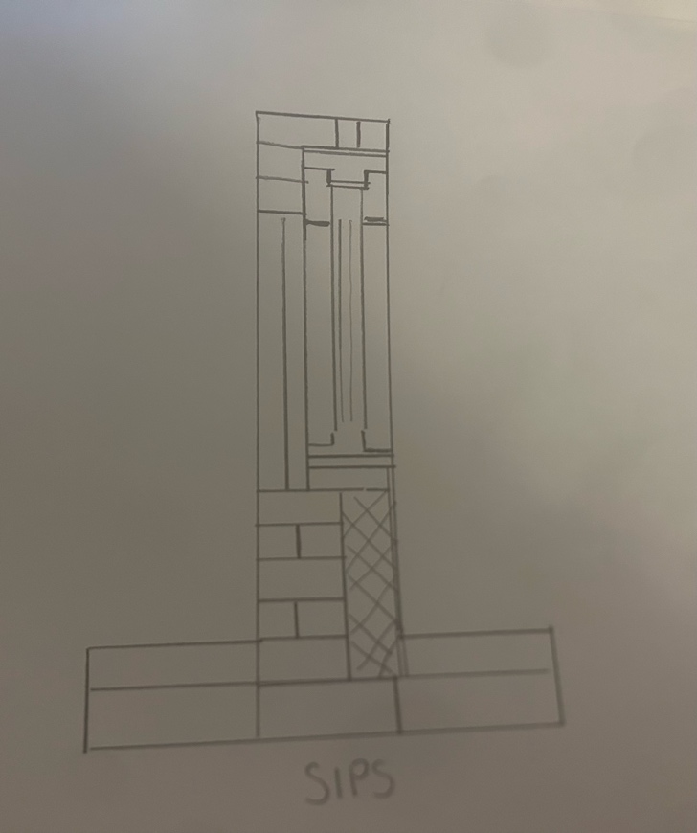
SIPS
Structural Insulated Panels (SIPS) are installed on a base plate fixed to the raft foundation, providing a level surface for panel assembly. Each panel has a rigid insulation core between two OSB boards, creating a strong, insulated wall system. Beneath the panels, the floor includes rigid insulation, a damp-proof membrane, a vapour control layer, and a screed with underfloor heating if needed.
A ventilated cavity is formed externally, allowing for moisture control, with the brick outer skin tied back to the structure. SIPS offer excellent air tightness due to tight panel joints and sealed connections, while the continuous insulation layer minimises thermal bridging, delivering high energy efficiency and strong compliance with modern building standards.

Brick and block
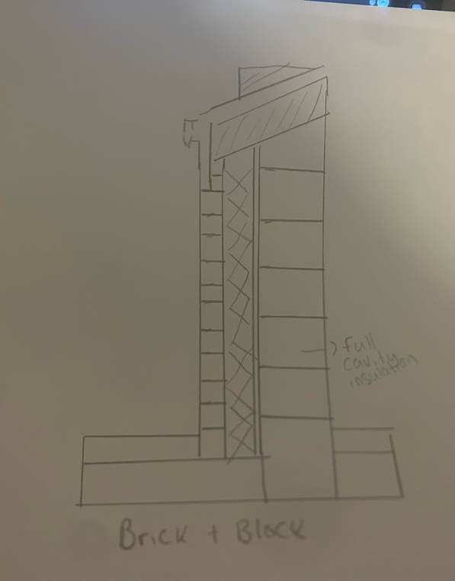
This traditional method places the block wall directly on the raft. Insulation is laid under the screed and rigid cavity insulation is used between the brick and block skins. Cavity trays and DPCs protect against moisture. It’s durable and familiar, but slower to build.

Insulation is placed on top of the raft foundation, followed by a screed layer that incorporates underfloor heating pipes. On the outside, a facing brick skin is tied back to the block over a ventilated cavity with a breather membrane. Damp-proof courses and cavity closers are installed at the base to prevent moisture ingress.

3.2 Window Opening Detail

Timber Twin Frame
Windows installed within structural timber studs. The opening includes an insulated cavity closer to reduce heat loss and prevent cold bridging. Internal plasterboard reveals and a vapour control layer ensure airtightness. Externally, the brick outer skin returns to form a reveal, with a cavity tray and weep vents above the lintel for drainage.

SIPS
Openings in SIPS panels are either pre-cut during manufacturing or formed on-site. The rigid foam insulation and OSB facing provide solid edges for securely fixing window units. The perimeter of the window frame is sealed using expanding foam or airtight tape to ensure airtightness. An insulated cavity closer helps support thermal performance, while the outer brickwork includes a cavity tray and weep vents to prevent moisture penetration.

Brick And Block

Traditional lintels span the window opening, and frames are fixed to the outer block leaf on a concrete sill. Cavity closers are installed to prevent thermal bridging. Airtightness is improved by taping around the frame. External reveals are completed with brick, with cavity trays and weep vents ensuring moisture is directed outward.

3.3 Eaves and Roof Detailing

Timber twin frame
In a Timber twin-frame construction, the eaves and roof assembly are designed to ensure continuity of insulation and weather protection while allowing ventilation of the roof space. The timber trusses are fixed securely onto a timber wall plate, which is anchored at the top of the twin-frame structure. OSB (Oriented Strand Board) sheathing is laid over the rafters, providing a solid base for the breathable roofing membrane, which in turn supports the final metal profile roof covering.

The roof structure must include soffit vents to enable cross-ventilation through the roof void, which helps to prevent the buildup of moisture and condensation. This is particularly important in timber constructions to preserve the structural integrity of the frame. Insulation from the wall continues into the roof area to maintain thermal continuity, reducing heat loss at the junction. Cavity barriers are installed at the eaves to limit the spread of fire between the cavity and roof structure, following Approved Document B of the Building Regulations. The use of eaves trays and sparking felt helps direct water away from the wall and into the gutter system, improving weather resilience.

SIPS
For SIPS construction, the eaves detailing must accommodate the structural and thermal characteristics of the panel system. SIPS panels provide a high level of built-in insulation, with a rigid polyurethane core sandwiched between OSB faces. To support the roof trusses, a timber ring beam or engineered top plate is often used along the panel head, distributing loads evenly and providing a secure fixing point.

Because SIPS are highly airtight by design, maintaining this airtightness at the eaves is critical. All joints between panels and the roof structure are sealed with airtight tapes or membranes to create a continuous vapour control layer. A breather membrane is laid over the OSB sheathing of the roof and protected by the metal profile sheeting. Soffit vents or over-fascia vents provide necessary airflow into the
loft area, helping manage internal moisture levels. Proper integration of
insulation at the junction ensures there are no cold bridges, and thermal
performance is maintained to the eaves.

Brick And Block
In traditional Brick and Block construction, the roof trusses are supported by a timber wall plate fixed to the inner leaf of the cavity wall, typically a medium-density concrete block. The outer skin of the brick continues upward to conceal the cavity and form the visible facade. The cavity itself is fully insulated, with the insulation extending vertically to meet the underside of the roof structure to minimise thermal bridging.

At the eaves, soffit and fascia boards are installed to house rainwater gutters and provide protection against weather ingress. Vents integrated into the soffit or above the fascia ensure ventilation of the roof space is in line with building regulations. An eaves tray helps support the roofing membrane and guides any water into the guttering system. OSB sheathing covers the rafters and insulation and is overlaid by a breathable membrane before the metal profile roof finish is applied. Careful installation of cavity closers and fire barriers at the top of the wall helps meet fire
safety and energy efficiency standards.

4. Recommendation and Conclusion

After a thorough comparison of the three proposed construction methods—Timber Twin Frame, Structural Insulated Panels (SIPS), and traditional Brick and Block—SIPS is the most suitable choice for the client's project. It delivers the strongest combination of thermal performance, airtightness, structural efficiency, and construction speed. Due to its prefabricated nature, SIPS ensures high levels of precision and quality control, resulting in fewer defects and less on-site labour. This makes it especially helpful for use on reclaimed or sensitive ground conditions, where minimising site disruption is important.
SIPS construction also aligns well with modern sustainability and energy-efficiency targets. The high level of built-in insulation, combined with its excellent airtightness, can help the building exceed the smallest requirements of Part L of the Building Regulations. Over time, this leads to lower energy consumption, reduced heating costs, and a smaller environmental footprint—key benefits for any modern home. Additionally, the airtight envelope supports the use of advanced ventilation systems such as MVHR (Mechanical Ventilation with Heat Recovery), further enhancing indoor air quality and comfort.
While traditional Brick and Block is well established and known for its robustness and widespread industry familiarity, it tends to be more labour-intensive and slower to construct. Timber Twin Frame, meanwhile, offers flexibility and good insulation potential but may not match the airtightness and thermal bridging performance of SIPS without extensive added detailing.
SIPS is compatible with the planning requirement for a brick and render external finish. This is achieved by creating a ventilated cavity between the structural panel and the outer skin of facing brickwork. It also integrates seamlessly with the project’s specifications, including triple-glazed aluminium windows and a raised tie trussed roof with a metal profile sheeting finish.

5. References

- Morgan Sindall Construction (n.d.) Modern Methods of Construction (MMC). Available at: https://www.morgansindallconstruction.com/our-approach/modern-methods-of-construction-mmc/ (Accessed: 21 April 2025)
- Offsite Construction Network (n.d.) What is Offsite Construction? Available at: https://offsiteconstructionnetwork.com/what-is-offsite/ (Accessed: 11 April 2025).

