Component-1
Task 1- Blogs
Task 2- Poster

Studdent Name: Khushi Harshadkumar Patel
Student ID: 2406318
Module: Population Health and Digital Health Promotion
Module code: LCHS7007
Programme: MSc Public Health and Social Care in Practice
Lecturer’s Name: Dr Ping Wu

TASK 1 – 2-Blogs

Blog 1
Mindfulness on the Go: How Headspace is Transforming Mental Wellness
- Due to multiple factors, mental wellness has emerged as a crucial public health problem that affects large numbers of people. Attention from the World Health Organisation (WHO) showed that worldwide, 4 out of every 10 people will suffer from mental health disorders throughout their existence. Adult mental health problems occur weekly throughout the UK, affecting 16% of the adult population (World Health Organization, 2022).
- The seriousness of the situation pushes us to develop creative solutions that address an escalating issue. Digital health technology, particularly mental health apps like “Headspace” has become the rising solution to address public health challenges.

- Headspace functions as a mindfulness application providing meditation-based exercises that assist users in dealing with mental health problems through guided practice sessions (Headspace, 2024). Digital tools prove their essential role in supporting mental health by providing accessible, flexible, and cost-effective support to users, which represents a great example.

- The application equips users with various therapeutic practices, which include breathing techniques along with meditation guidance to develop emotional strength.

So, how does it work?

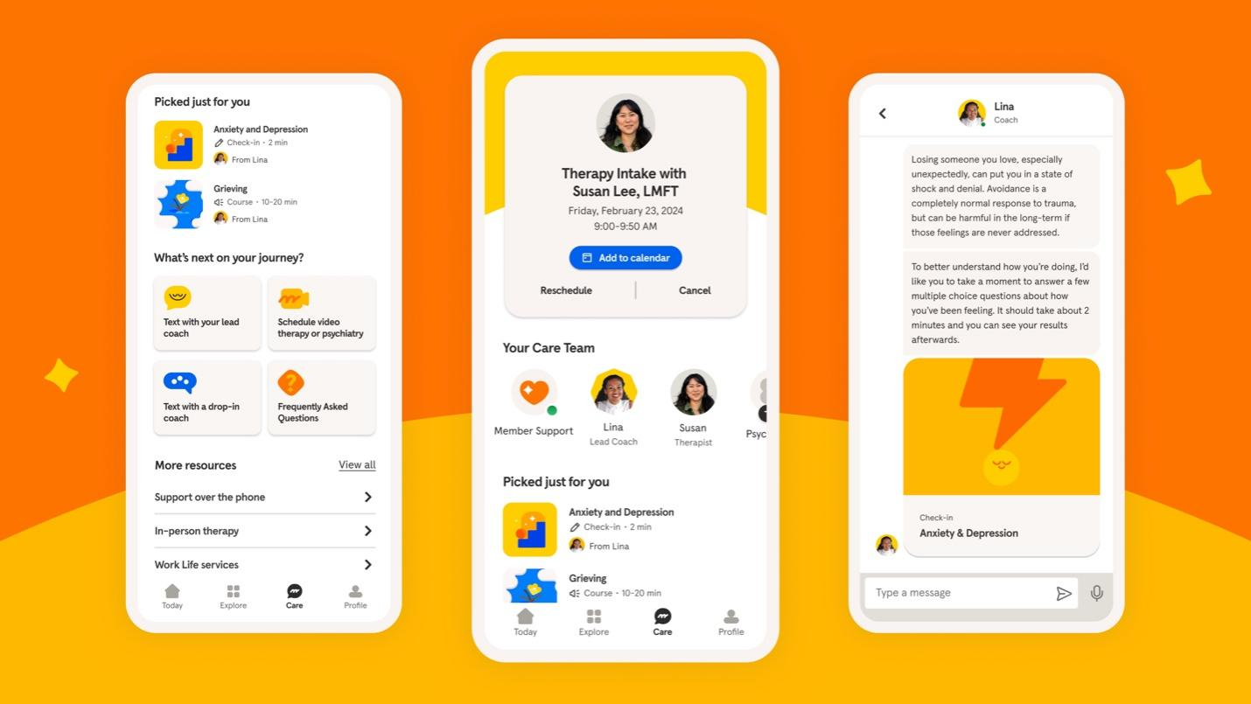
Strengths:
- Scientific research demonstrates that practicing mindfulness alongside meditation helps people decrease their symptoms of anxiety as well as depression and stress.
- The JAMA Internal Medicine research study demonstrated an application like Headspace helped decrease anxiety symptoms and depression symptoms in users (Headspace, 2024).
- Digital platforms establish their ability to deliver mental health support at three levels which includes both instant relief alongside continued vitalisation of mental wellness outside standard clinical services (Mensah, 2024).

Weaknesses:
- Not all communities can utilise smartphones or access reliable internet due to the digital divide, which bars some people from reaping digital resource benefits (Andrea Causio et al., 2025).
- Although the Headspace application acts as a valuable resource, it fails to deliver sufficient support that severe mental health patients require.
- The accessibility of these tools requires enhancement so people can access them better through healthcare provider collaborations and in-application professional support links (Zwack et al., 2023).
- Digital health technologies will expand their impact on global mental health when these revealed gaps receive proper solutions.
- The portable technology of today has the potential to become the future approach to mental health therapy.

References

- Andrea Causio, F., Gandolfi, S., Kaur, J., Sert, B., Fakhfakh, M., De Angelis, L., Di Pumpo, M., Diedenhofen, G., Berionni, A., Rizzo, C. and Cascini, F., 2025. Impact of Digital Health Interventions on Health Literacy: A Systematic Review with Quality Appraisal. medRxiv, pp.2025-02. https://www.medrxiv.org/content/10.1101/2025.02.27.25323025.full.pdf
- Headspace, 2024. Meditation and Mindfulness Made Simple - Headspace. [online] Headspace. Available at: https://www.headspace.com/ [Accessed 22 Mar. 2025].
- Mensah, G.B., 2024. Regulating Malpractice in Telemedicine and Digital Health. Africa Journal For Regulatory Affairs (AJFRA), 1, pp.1-16. https://jamanetwork.com/journals/jamanetworkopen/articlepdf/2815070/katz_2024_oi_231646_1707335323.06233.pdf
- World Health Organization, 2022. Mental Disorders. [online] World Health Organization. Available at: https://www.who.int/news-room/fact-sheets/detail/mental-disorders [Accessed 22 Mar. 2025].
- Zwack, C.C., Haghani, M., Hollings, M., Zhang, L., Gauci, S., Gallagher, R. and Redfern, J., 2023. The evolution of digital health technologies in cardiovascular disease research. NPJ digital medicine, 6(1), p.1. https://www.nature.com/articles/s41746-022-00734-2.pdf

Blog 2
“MindCalm”: A Personalised Path to Mental Wellness Through Digital Innovation

- According to the World Health Organisation (WHO) data shows that 1 in 4 individuals will face mental health issues throughout their lifetime because anxiety and depression, along with stress, now spread across the global community (World Health Organization, 2022). The UK has a mental health problem rate of one adult in six undergoing problems each week.
- The search for appropriate mental health solutions that are available to everyone requires immediate action because mental health disorders affect vast populations. Traditional therapy poses two major barriers for underserved populations who need these services: high costs and difficulties obtaining treatment, which supports digital intervention development.

Rethinking Mental Health Solutions: How MindCalm Delivers Timely, Tailored Support


In order to solve the issue, I have designed an innovative mobile application known as “MindCalm”, which serves as my solution to help people improve their mental health and well-being.
Features and advantages:
- The platform diverges from typical mindfulness or meditation applications.
- It will integrate mindful practices with emotional tracker systems and customise stress-management solutions and cognitive therapy methods (Yee et al., 2022).
- Daily practices in MindCalm will be determined by the user’s emotional state.
- It will offer personalised exercises that include guided meditation, breathing practice, and self-reflection exercises.
- Throughout the app, users can track their moods while the system.
- The app helps them identify patterns together with real-time assistance that appears when their emotional levels exceed normal thresholds (Badr et al., 2024).

Health promotion will greatly depend on MindCalm's function as a personal mental health resource available anytime to users. Users gain mental wellness independence through this tool which ensures flexibility together with ease of access to support. Real-time data-driven recommendations in MindCalm will deliver timely mental health support directly to users so they can get the help that suits them at critical moments. Therefore, the service provides immediate accessibility for mental health management (Yeung et al., 2023).

Customised Calm: Why MindCalm Goes Beyond Traditional Mental Health Apps
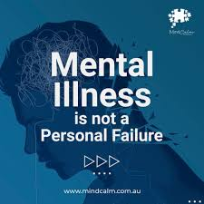

Similar to all digital health systems, MindCalm comes with specific restrictions for its use. They are:
- The primary obstacle consists of making the app available to people from marginalised communities which includes individuals who do not possess smartphone devices or lack internet connectivity.
- Although useful for those with mild to moderate mental health challenges, the app cannot provide suitable care for severe disorder cases (Badr et al., 2024).
- The shortfalls can be resolved by MindCalm partnering with healthcare providers to create a combined service model allowing users to link with top professionals for specific needs (Giebel et al., 2023).
- MindCalm should include both offline functionality and community-run centres as part of its strategy to make mental health assistance accessible to all populations.

References

- Badr, J., Motulsky, A. and Denis, J.L., 2024. Digital health technologies and inequalities: A scoping review of potential impacts and policy recommendations. Health Policy, p.105122. https://www.sciencedirect.com/science/article/pii/S0168851024001325
- Giebel, G.D., Speckemeier, C., Abels, C., Plescher, F., Börchers, K., Wasem, J., Blase, N. and Neusser, S., 2023. Problems and barriers related to the use of digital health applications: scoping review. Journal of Medical Internet Research, 25, p.e43808. https://www.jmir.org/2023/1/e43808/
- World Health Organization, 2022. Mental Disorders. [online] World Health Organization. Available at: https://www.who.int/news-room/fact-sheets/detail/mental-disorders [Accessed 22 Mar. 2025].
- Yee, V., Bajaj, S.S. and Stanford, F.C., 2022. Paradox of telemedicine: building or neglecting trust and equity. The Lancet Digital Health, 4(7), pp.e480-e481. https://www.thelancet.com/pdfs/journals/landig/PIIS2589-7500(22)00100-5.pdf
- Yeung, A.W.K., Torkamani, A., Butte, A.J., Glicksberg, B.S., Schuller, B., Rodriguez, B., Ting, D.S., Bates, D., Schaden, E., Peng, H. and Willschke, H., 2023. The promise of digital healthcare technologies. Frontiers in Public Health, 11, p.1196596. https://www.academia.edu/download/109640239/JURNAL_REG_8082219_PHDYOESOEP_EDHIE_RACHMAD.pdf

TASK 2- Poster
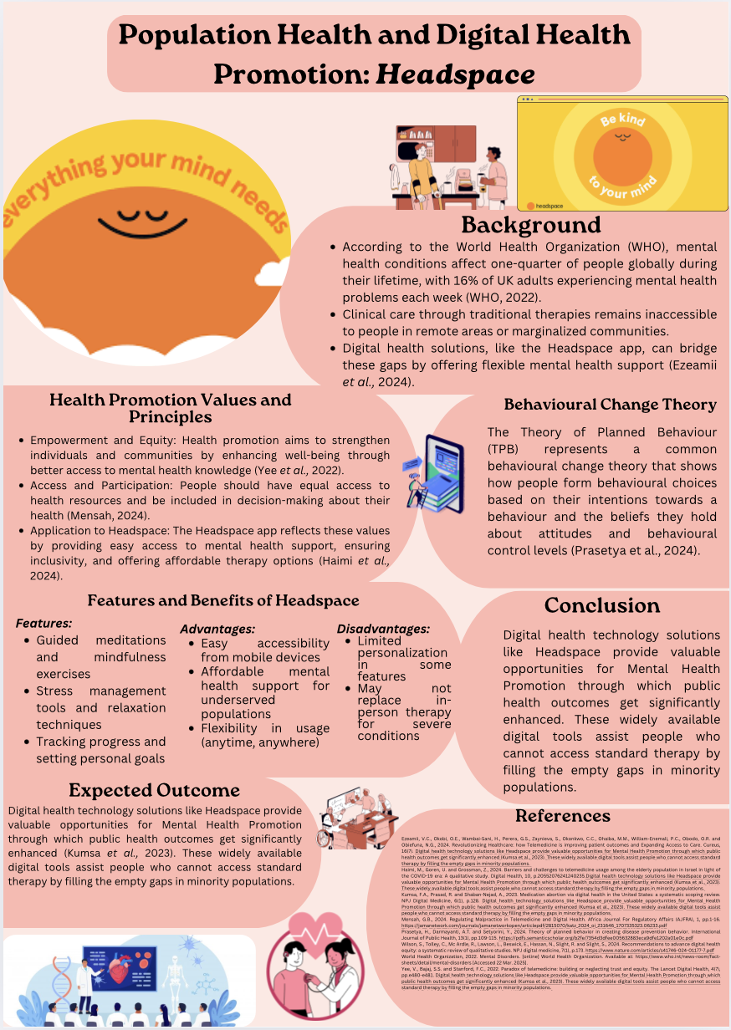

References

Ezeamii, V.C., Okobi, O.E., Wambai-Sani, H., Perera, G.S., Zaynieva, S., Okonkwo, C.C., Ohaiba, M.M., William-Enemali, P.C., Obodo, O.R. and Obiefuna, N.G., 2024. Revolutionizing Healthcare: how Telemedicine is improving patient outcomes and Expanding Access to Care. Cureus, 16(7). https://www.cureus.com/articles/265705-revolutionizing-healthcare-how-telemedicine-is-improving-patient-outcomes-and-expanding-access-to-care.pdf
Fitzpatrick, P.J., 2023. Improving health literacy using the power of digital communications to achieve better health outcomes for patients and practitioners. Frontiers in Digital Health, 5, p.1264780. https://www.frontiersin.org/journals/digital-health/articles/10.3389/fdgth.2023.1264780/pdf
Giebel, G.D., Speckemeier, C., Abels, C., Plescher, F., Börchers, K., Wasem, J., Blase, N. and Neusser, S., 2023. Problems and barriers related to the use of digital health applications: scoping review. Journal of Medical Internet Research, 25, p.e43808. https://www.jmir.org/2023/1/e43808/
Haimi, M., Goren, U. and Grossman, Z., 2024. Barriers and challenges to telemedicine usage among the elderly population in Israel in light of the COVID-19 era: A qualitative study. Digital Health, 10, p.20552076241240235. https://scholar.google.com/scholar?output=instlink&q=info:TIgbfJzEi7sJ:scholar.google.com/&hl=en&as_sdt=0,5&as_ylo=2022&scillfp=5026282216768233523&oi=lle
Kumsa, F.A., Prasad, R. and Shaban-Nejad, A., 2023. Medication abortion via digital health in the United States: a systematic scoping review. NPJ Digital Medicine, 6(1), p.128. https://www.nature.com/articles/s41746-023-00871-2.pdf
Mensah, G.B., 2024. Regulating Malpractice in Telemedicine and Digital Health. Africa Journal For Regulatory Affairs (AJFRA), 1, pp.1-16. https://jamanetwork.com/journals/jamanetworkopen/articlepdf/2815070/katz_2024_oi_231646_1707335323.06233.pdf
Prasetya, H., Darmayanti, A.T. and Setyorini, Y., 2024. Theory of planned behavior in creating disease prevention behavior. International Journal of Public Health, 13(1), pp.109-115. https://pdfs.semanticscholar.org/b2fe/7354d3dfee005632883eca9dfe1202a01e0c.pdf
Shaffer, K.M., Turner, K.L., Siwik, C., Gonzalez, B.D., Upasani, R., Glazer, J.V., Ferguson, R.J., Joshua, C. and Low, C.A., 2023. Digital health and telehealth in cancer care: a scoping review of reviews. The Lancet Digital Health, 5(5), pp.e316-e327. https://scholar.google.com/scholar?output=instlink&q=info:lJsRXbnUuBAJ:scholar.google.com/&hl=en&as_sdt=0,5&as_ylo=2022&scillfp=3325505479052309658&oi=lle
Whitehead, L., Talevski, J., Fatehi, F. and Beauchamp, A., 2023. Barriers to and facilitators of digital health among culturally and linguistically diverse populations: qualitative systematic review. Journal of medical Internet research, 25, p.e42719. https://www.jmir.org/2023/1/e42719/
Willis, V.C., Thomas Craig, K.J., Jabbarpour, Y., Scheufele, E.L., Arriaga, Y.E., Ajinkya, M., Rhee, K.B. and Bazemore, A., 2022. Digital health interventions to enhance prevention in primary care: scoping review. JMIR medical informatics, 10(1), p.e33518. https://medinform.jmir.org/2022/1/e33518
Wilson, S., Tolley, C., Mc Ardle, R., Lawson, L., Beswick, E., Hassan, N., Slight, R. and Slight, S., 2024. Recommendations to advance digital health equity: a systematic review of qualitative studies. NPJ digital medicine, 7(1), p.173. https://www.nature.com/articles/s41746-024-01177-7.pdf
World Health Organization, 2022. Mental Disorders. [online] World Health Organization. Available at: https://www.who.int/news-room/fact-sheets/detail/mental-disorders [Accessed 22 Mar. 2025].
Yee, V., Bajaj, S.S. and Stanford, F.C., 2022. Paradox of telemedicine: building or neglecting trust and equity. The Lancet Digital Health, 4(7), pp.e480-e481. https://www.thelancet.com/pdfs/journals/landig/PIIS2589-7500(22)00100-5.pdf
Yeung, A.W.K., Torkamani, A., Butte, A.J., Glicksberg, B.S., Schuller, B., Rodriguez, B., Ting, D.S., Bates, D., Schaden, E., Peng, H. and Willschke, H., 2023. The promise of digital healthcare technologies. Frontiers in Public Health, 11, p.1196596. https://www.academia.edu/download/109640239/JURNAL_REG_8082219_PHDYOESOEP_EDHIE_RACHMAD.pdf
Zwack, C.C., Haghani, M., Hollings, M., Zhang, L., Gauci, S., Gallagher, R. and Redfern, J., 2023. The evolution of digital health technologies in cardiovascular disease research. NPJ digital medicine, 6(1), p.1. https://www.nature.com/articles/s41746-022-00734-2.pdf

