DIGITAL SKILLS AND RESEARCH METHODS
Ivan Kenov
Student number:1814550
Executive summary
This report highlights the importance of digital skills in a workplace and its contribution to the competency for research methods. Modern technologies including the robust types of technological systems and advance procedures into the system procurement procedure have been major perspectives of the digital world. This has effectively created a gap in digital skills and workplace competency. The digital skills can also increase the revenue of an organization as most of the business has been recognized as having a stronger online presence. Data collection procedures through the use of social media is a very effective strategy to boost the spirit and profitability pattern of business with high altitudes. communication in workplaces is highly boosted with the effective functioning of social media usage among workers to increase the rate of job delivery and performances.

Table of Contents
Introduction 4
Effectiveness of the utilization of modern type of technological systems within the workplace 4
Business productivity 5
Competitive Edge 5
Revenue increment 5
Building customer relationship 6
Exploring social media 6
Marketing 7
Gathering information 7
Effective communication within the workplace 8
Competence of digital skills in the workplace for data handling 9
Conclusion 10
Reference list 12
Appendix: Cyber Security Concerns 14

Introduction
The implementation of digital skills can be effective in terms of embracing the changes in the reaping benefits for bringing satisfaction to work. The digital skills can also affect the collaboration as well as communication within an organization as well as improve the efficiency of the work. The digital skill can also be important for an employee in a workplace in terms of employee motivation. This can increase productivity as well as staving off the issues and challenges that are pre-existed in a workplace This report sheds light on the importance of digital skills in a workplace and its contribution to the competency for research methods.

Effectiveness of the utilization of modern type of technological systems within the workplace
Modern technologies including the robust types of technological systems and advance procedures into the system procurement procedure have been major perspectives of the digital world. Since the workforce is turning out to be increasingly more digitized, bosses presently are searching for new contracts to be carefully educated with the delicate aptitudes like coordinated effort, convincing correspondence, basic reasoning, inventiveness, and critical thinking, and are offering benefits like the adaptability to suit this sort of important worker (Gay, 2019). The leaders can consider improving their understudies' advanced proficiency so as to create graduates who are serious in a cutting-edge workforce.

Figure 1: Impact of using Digital Skills
(Source: Barker, 2018)
The modern technologies can be effective in the workplace with the compliance of certain factors such as Leadership and increased performance in the workforce. Generation Z and millennials have been subjected to be grown along with digital skills. However, there is a need for the older generations to be familiarized with digital skills (Rooney, 2017). The biggest factor which has been responsible for driving the need for the implementation of digital technology in the workplace is customer preference. As per the stats presented by Lloyds UK Consumer Digital Index 2018, there has been critical depreciation for about 4.3 million people in the acknowledgment of the basic digital skills of people in the UK (Barker, 2018). This has effectively created a gap in digital skills and workplace competency. The impact of digital skill in the workplace can enhance the workplace has been resented as follows;

Business productivity
Digital skill has been effective in increasing business productivity. The project managers in a business implement various tools and strategies which have been based on technologies for handling the tasks and activities of the project. For example, the digital documentation can be stored as well as assessed by the employees in an organization which can be beneficial in evaluating the financial data as well as revenue of designated time period.

Competitive Edge
Digital skill is also responsible for developing a competitive edge for an organization. There can be the necessity of implementation of digital skills in the workplace as 90% of the job can be subjected to digital skills in the next decades which can include augmentation of technical skills (Microsoft, 2020). This can be beneficial for an organization in terms of improving the competitive edge in a market place as the organization requires the recruitment of a highly skilled employee who can outperform employees of a rival organization.

Revenue increment
The digital skills can also increase the revenue of an organization as most of the business has been recognized as having a stronger online presence (Beckingham, 2014). The traditional form of marketing, as well as sales, has replaced almost every organization as most of the customers have been favouring the purchasing method from digital channels (Baker, 2018). Therefore, customary types of deals as well as promoting have been becoming obsolete as the buyers have been turning towards computerized channels in order to make the best buy. The organizations can plan to expand the income and revenue in terms of determining customer preferences as well as utilizing the scope of computerized ability. The organizations can drive through the requests as well as favour the customer’s preference for purchasing online.

Building customer relationship
The digital skills in a workplace can also be effective in building an ideal customer relationship. The constant demand for the improvement of quality and changing level of cost is met through regular basis observation and interaction techniques with customers from international and domestic level. Digital technology including strong and advanced web-based networking systems and key utilization of networking systems are the most proactive ways to constantly interact with customers (Silion, 2020). Along with that, meeting each demand based on quality and changed price level along with supply chain processes are met properly with the constant type of utilizing advanced and strong web-based procedures connected with key server systems. Customers are oriented with getting in touch with employees and acting senior members of IT Organizations like Ensoft who pay attention to their demands and decisions.

Exploring social media
Social media has been a strong platform that has taken part as the most influential tool for the promotion of business. Social media has been used by almost 39 million users in 2017 which has drastically increased up to 41.27 million users in 2020 (Statista, 2020).
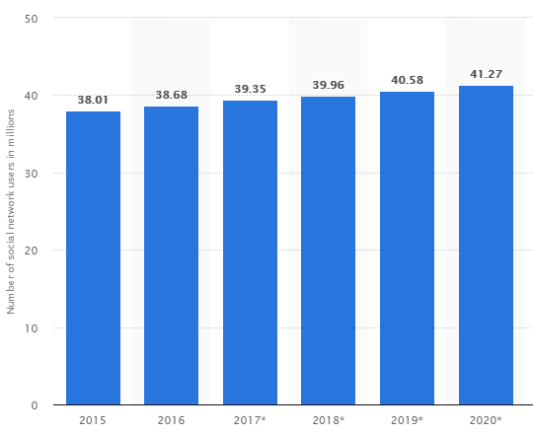
Figure : usage of social media in the UK from 2015 to 2020
(Source: Statista, 2020)

Marketing
Social media like Twitter and Facebook helps in creating a competitive edge in business markets. Marketing channels without being helped by social media face the loss of risk-taking initiatives in business which hurts their profit earning criteria. The tools give chance to business markets to respond adequately to business-facing risks and challenges. In the modern era more and more companies are capitalizing on resources harnessed to develop the standards of social media in increased fashion. In the UK, firms are seen to be enhancing business processes linked with social media usage in prolific fashion. For example, social media is helping employees and digital marketers of UK digitized companies like Ensoft with better data traffic to increase sales operations (Social Media Today, 2020).
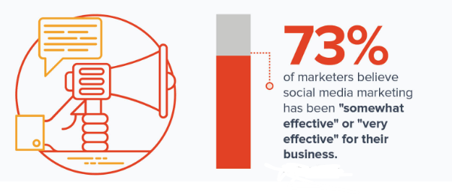
Figure 3: Use of Social media in Marketing
(Source: Mohsin, 2020)
Building a proper marketing approach and plans can be done with the help of social media platforms like Linkedln and Twitter which generates continuous business-based interests in followers in the UK. Posting business based innovative posts open strategies to be used for better decision-making utilities in the marketing arena genuinely. The customization process has also been developed through proper feedback mechanisms through the use of social media tools in marketing intensively (Mohsin, 2020). This seems to generate interests among customers regarding the sales and delivery of business products truly.

Gathering information
Online media is intensively used for data gathering oriented operations in the business. Data collection procedures through the use of social media is a very effective strategy to boost the spirit and profitability pattern of business with high altitudes. Brand promotion strategies and consumer interaction strategies are truly affected by the use of social media-specific services in business with a higher range of accuracy. Online data which is the data collected through the use of social media tools has intense usage in business prospects (Wu, et al. 2016). For example, the longer the variety of likes, shares, and increase in a number of followers of specific posts greater the popularity of that posts among individuals connected with the media. Hence, more profusely the data in that content will be taken into consideration in business.
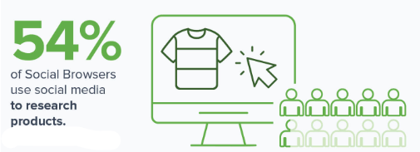
Figure 4: Social Media Usage for information sharing
(Source: Mohsin, 2020)
Proper data collection through the use of online types of media tools helps to optimize social content in a true sense of terms (Pixlee, 2020). The highest level of content stratification process is linked with the sound application of data gathering and utility processes in social media. The maximum reach of customers towards markets in terms of social media usage can be seen to be revitalized by the use of social media in a genuine fashion. Engagement in online media tools-oriented activities is highly significant for the user engagement process in business.
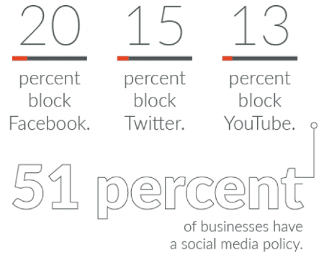
Figure 5: Use of Social media in workplace
(Source: Digital Information, 2020)

Effective communication within the workplace
The use of social media can change the way communication is undertaken in business. The sharing of information internationally is the most proactive way to make the stakeholders stay together in well-networked fashion. Online tools like Twitter have taken the business in professional terms in the UK to higher levels of proficiency. The sharing of information internationally is the most prominent perspective in the business process (Sheffield Hallam University, 2014). Snapchat which allows users to share content across corridors of business is the most lucrative social media platform for carrying online business. Personalization of digitized messages occurs through specific varieties of communication channels in a genuine fashion. For example, Snapchat regularly shares features of the relevant cities around the world (Collins et al. 2016) .
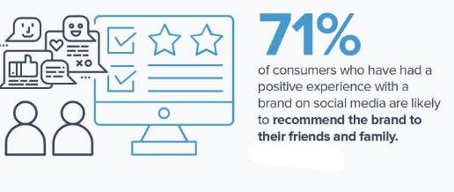
Figure 6: Social Media for enhancing customer preferences
(Source: Mohsin, 2020)
Creating a sense of urgency that needs to be shared is one of the most developed methods of effective communication in the workplace (Circa,2020). Mailing of messages and data contained in terms of online communication in business is a highly proactive process in business procedures. Features newly installed on social media sites like Facebook live on Facebook allow an uncountable number of followers to be in a live connection with their kith and kins through this platform. Hence, communication in workplaces is highly boosted with the effective functioning of social media usage among workers to increase the rate of job delivery and performances.

Competence of digital skills in the workplace for data handling
In order to improve the competency of the workplace, the employee can implement the use of certain digital skills. The most essential skills which can be considered by an employee is the Expert Data Analysis (MathsIsFun, 2016). The analysis of data can be effective in untapping the organizational data which can provide the information related to customers, workforce as well as organizational processes. The data can be diagnostic data, predictive data, descriptive data well as prescriptive data which is being analysed by the use of data analysis software and applications (Cottrell, 2011). The employee can also have the skill of selling socially (Digital marketing, 2020).

Figure 7: Strategies for increasing digital competency
(source: Digital marketing, 2020)
The advanced social selling can also be considered by an employee in order to increase the competency in a digital workplace. This can be effective in terms of attracting a greater number of customers who are available online (Beckingham, 2014). In addition, digital skills can also be enhanced with the integration of multi-platform UX design. The employee can have the skills of handling various devices and software which can be effective in term of being adaptive to the workplace. Finally, the employee can have the capability to handle the information for protection against cybersecurity. The digital competency can be improved when the employee has knowledge regarding network and security (Digital marketing, 2020). This can prepare the employee to protect the confidential data of the organization. Thus, the skills that have been mentioned in this section can be critically beneficial in handling the data as well as solve issue of the organization. [Refer to Appendix]

Conclusion
Thus, it can be concluded that the digital skill is critically important for the workplace competency as this can improve the organizational performance and overall productivity. The traditional form of marketing, as well as sales, has replaced almost every organization as most of the customers have been favouring the purchasing method from digital channels. The Digital technology including strong and advanced web-based networking systems and key utilization of networking systems are the most proactive ways to constantly interact with customers. communication in workplaces is highly boosted with the effective functioning of social media usage among workers.

Reference list
Barker, S., (2018), The Importance of Digital Skills in the Workplace, Seetec, Available at: https://www.seetec.co.uk/employer/insights/the-importance-of-digital-skills-in-the-workplace [Accessed on: 23/3/2020]
Beckingham, S. (2014) Why you need a professional online presence. [online] Available at:
Bell, J. (2005) Doing your research project: A guide for first-time researchers in social science, education and health. 4th edn. Maidenhead, England: Open University Press.
Circa(2020).6 Ways Social Media Changed The Way We Communicate. Available at: https://circaedu.com/hemj/how-social-media-changed-the-way-we-communicate/g/ [Accessed on: 23/3/2020]
Cottrell, S. (2011) Critical thinking skills: Developing effective analysis and argument (Palgrave study skills). 2nd edn. Basingstoke: Palgrave Macmillan.
Digital marketing (2020), 6 DIGITAL SKILLS THAT WILL FUTURE-PROOF A WORKFORCE, Available at: https://digitalmarketinginstitute.com/blog/6-digital-skills-that-will-future-proof-a-workforce [Accessed on: 23/3/2020]
Gay, A., (2019), How Digital Literacy Affects the Modern Workforce, Adobe Blog, Available at: https://theblog.adobe.com/how-digital-literacy-affects-the-modern-workforce/ [Accessed on: 23/3/2020]
http://www.slideshare.net/suebeckingham/why-you-need-a-professional-online-presence-and-how-to-do-it-rscon5 [Accessed on: 23/3/2020]
MathsIsFun (2016) Data, probability and statistics. [online] Available at https://www.mathsisfun.com/data/index.html [Accessed on: 23/3/2020]
Microsoft (2020), Improve Businesses and IT professionals, Available at: https://www.microsoft.com/en-gb/athome/digitalskills/improve/ [Accessed on: 23/3/2020]
Mohsin, M., (2020), 10 Social Media Statistics You Need to Know in 2020 [Infographic], Oberlo, Available at: https://www.oberlo.com/blog/social-media-marketing-statistics [Accessed on: 23/3/2020]
Pixlee (2020). Why Social Media Data Collection Is Essential for Marketing. Available at: https://www.pixlee.com/blog/why-social-media-data-collection-is-essential-for-marketing/ [Accessed on: 23/3/2020]
Rooney, J., (2017), The Growing Importance of Digital Skills in the Workplace, Training Industry, Available at: https://trainingindustry.com/articles/it-and-technical-training/the-growing-importance-of-digital-skills-in-the-workplace/ [Accessed on: 23/3/2020]
Sheffield Hallam University. (2014) Social Media and Employability. [online] Available at: https://sites.google.com/a/my.shu.ac.uk/shusome/employability
Silion, X., (2020), What the Digital Skills Gap is Secretly Costing Your Organization and Employees, Seetec, Available at: https://trainingindustry.com/magazine/issue/what-the-digital-skills-gap-is-secretly-costing-your-organization-and-employees/ [Accessed on: 23/3/2020]
Social Media Today(2020). Role of Social Media Marketing in Business. Available at: https://www.socialmediatoday.com/social-business/role-social-media-marketing-business. [Accessed on: 23/3/2020]
Statista (2020), Forecast of social network user numbers in the United Kingdom (UK) 2015-2022, Available at: https://www.statista.com/statistics/553530/predicted-number-of-social-network-users-in-the-united-kingdom-uk/ [Accessed on: 23/3/2020]
Collins, K., Shiffman, D. and Rock, J., (2016). How are scientists using social media in the workplace?. PloS one, 11(10).
Wu, Y., Cao, N., Gotz, D., Tan, Y.P. and Keim, D.A., (2016). A survey on visual analytics of social media data. IEEE Transactions on Multimedia, 18(11), pp.2135-2148.

Appendix: Cyber Security Concerns
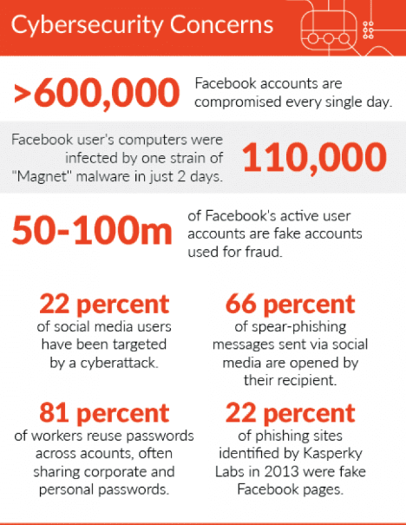
(Source: https://www.digitalinformationworld.com/2018/09/problems-social-media-workplace.html)

