

LEVEL 7 ASSESSMENT SPECIFICATION




Executive Summary

This study is about the financial resources management of Hong Kong listed company – Shanghai Fosun Pharmaceutical (Group) Company Limited (2196.HK). The study will divide into six parts: (1) introduction of the company situation, including business scope, corporate structure and market environment; (2) calculation of financial ratios to analyze the company’s operating table, key competitors and comparison; (3) analyze on the company’s internal controls and risk management; (4) investment project assessment on regional pharmaceutical Centre plus factory; (5) analysis on fund-raising methods; and (6) efficiency operational audit programs.

The first chapter describes the background and business conditions of Shanghai Fosun Pharmaceutical (Group) Co., Ltd; and compares it with two other companies: China Grand Pharmaceutical and Healthcare Holdings Limited (0512.HK) and China Medical System Holdings Limited (0867.HK).

The second chapter uses all kinds of financial ratio to analysis different dimensions of Shanghai Fosun Pharmaceutical (Group) Co. Ltd. and the financial structure and debt-servicing capacity via insolvency index tests, operating capacity, profitability and growth capacity. Improvement programs basic on the investor’s viewpoint are recommended.

The third chapter mentions the corporate governance issues and improvement plan of Shanghai Fosun Pharmaceutical (Group) Co., Ltd; including organizational performance, risk governance reorganization, and maintain an effective governance infrastructure to improve its operational capability and competitiveness.

The fourth chapter examines the effectiveness and investment value of the regional pharmaceutical Centre plus factory project through the calculation of cash flow, net present value and investment return. The investment project can bring financial benefits to the group and advantage to business and financial situation.

The fifth chapter analyzes the best recommendation to Shanghai Fosun Pharmaceutical (Group) Co., Ltd. on financial situation and fund investment. The study recommends Shanghai Fosun Pharmaceutical (Group) Co., Ltd to adopt 5-year loan program from bank for 38,437 million to fund regional pharmaceutical Centre plus factory project.

The sixth chapter describes the operational audit planning of Shanghai Fosun Pharmaceutical (Group) Co., Ltd; with different segment of audit controls to improve cost effective and reduce operation costs and revenue turnover ratio.

The conclusion part recommends Shanghai Fosun Pharmaceutical (Group) Co., Ltd to reduce Research and Development (R&D) costs and maintain high profitability and to achieve higher return on investment in R&D. The study recommends the company to enhance the operational efficiency of profitability and growth rate and to reduce crisis risk.

Table of Contents
Page
Executive Summary i
Table of Contents ii
List of Tables iii
List of Figures iv

- Introduction 1
  - Company Background
  - Operating Business Overview
  - Today’s Business Environment
  - Company Structure
  - Research Comparison on Company Information

- Financial Analysis 14
  - Listed Company Bankruptcy Index Z-score Analysis
  - Financial Structure
  - Paying Debt Ability
  - Operating Capacity
  - Profitability
  - Growth Capacity
  - Stock Market Prospects Analysis

- Corporate Governance Assessment 25
3.1 Corporate Governance of Business Organization, Impact and Importance
3.2 Fosun Existing Corporate Governance
3.3 Suggestions for Improvement

- Investment Project Assessment 30
4.1 Project Items Basic Information
4.2 The First Year Calculation of Sales
4.3 Computing Tax Cost
4.4 Cashflow Calculation
4.5 ARR and NPV Calculation
4.6 Payback Period and IRR
4.7 Investment Appraisal
4.8 New Project Appraisal Methods for Analysis
4.9 Suggestion for Cashflow of New Project

- Financing and Capital Management 35
5.1 Financing Methods for Analyzing
5.2 Financing Method Proposed

- Recommendations and Audit Plan 38

- Conclusion 40

- Reference 44

- Appendix 45

- Introduction

  - Company Background

Shanghai Fosun Pharmaceutical (Group) Co., Ltd. (“Fosun”) mainly engages in the investment management, development, manufacture and sale of pharmaceutical products, medical equipment, import and export of medical equipment and the provision of related and other consulting services. Fosun's listed company began its initial public offering of A shares in China (600196.SH) in 1998 and the initial public offering of H shares in Hong Kong (2196.HK) in 2012.

In 2003, Fosun Pharma acquired a 49% stake in Sinopharm Holding Group (1099.HK). In 2008, one year before the initial public offering of Sinopharm Group, Fosun Pharma replaced the direct parent company of Sinopharm Group's Sinopharm Group; the major shareholder of the joint venture is the state-owned China Pharmaceutical Group (Sinopharm).

Fosun is a leading healthcare company in China, and its business operations strategically address many important aspects of the healthcare industry value chain. According to IMS data, Fosun is one of the top five domestic pharmaceutical companies in China's pharmaceutical manufacturing revenue in 2011. Fosun's business units include pharmaceutical manufacturing, pharmaceutical distribution and retail, and healthcare services; before October 2011, Fosun passed an investment in Chindex and a subsidiary of diagnostic products and medical devices in Chindex since October 2011 and invested and participated in the medical service business. Fosun is a Chinese listed company headquartered in Shanghai, its A shares stocks have been listed in Shanghai Stock Exchange since August 1998. As of the Latest Practicable Date, the market value was RMB 20,834.10 million. According to the 2016 Financial Times report, Fosun Pharma acquired Gland Pharma at a price of no more than US$1.26 billion, becoming the largest Indian company acquisition of a Chinese company (Fosun’s annual report, 2018).

Fosun Group's revenue has increased by 34.59% from 2017 to RMB 24.714 billion. Excluding the impact of newly acquired companies as a comparable factor and other factors, revenue will increase by 20.44% on the same basis. Net profit will attributable to shareholders of listed companies and attributable to listing. The net profit (non-recurring gains and losses) of the company's shareholders was RMB 2,708 million and RMB 2,090 million, respectively, a decrease of 13.33% and 10.92% compared with 2017.

  - Operating Business Overview (products and services and the sales market)

The chart below shows the products and revenue flows of the Fosun business unit in the healthcare industry value chain.
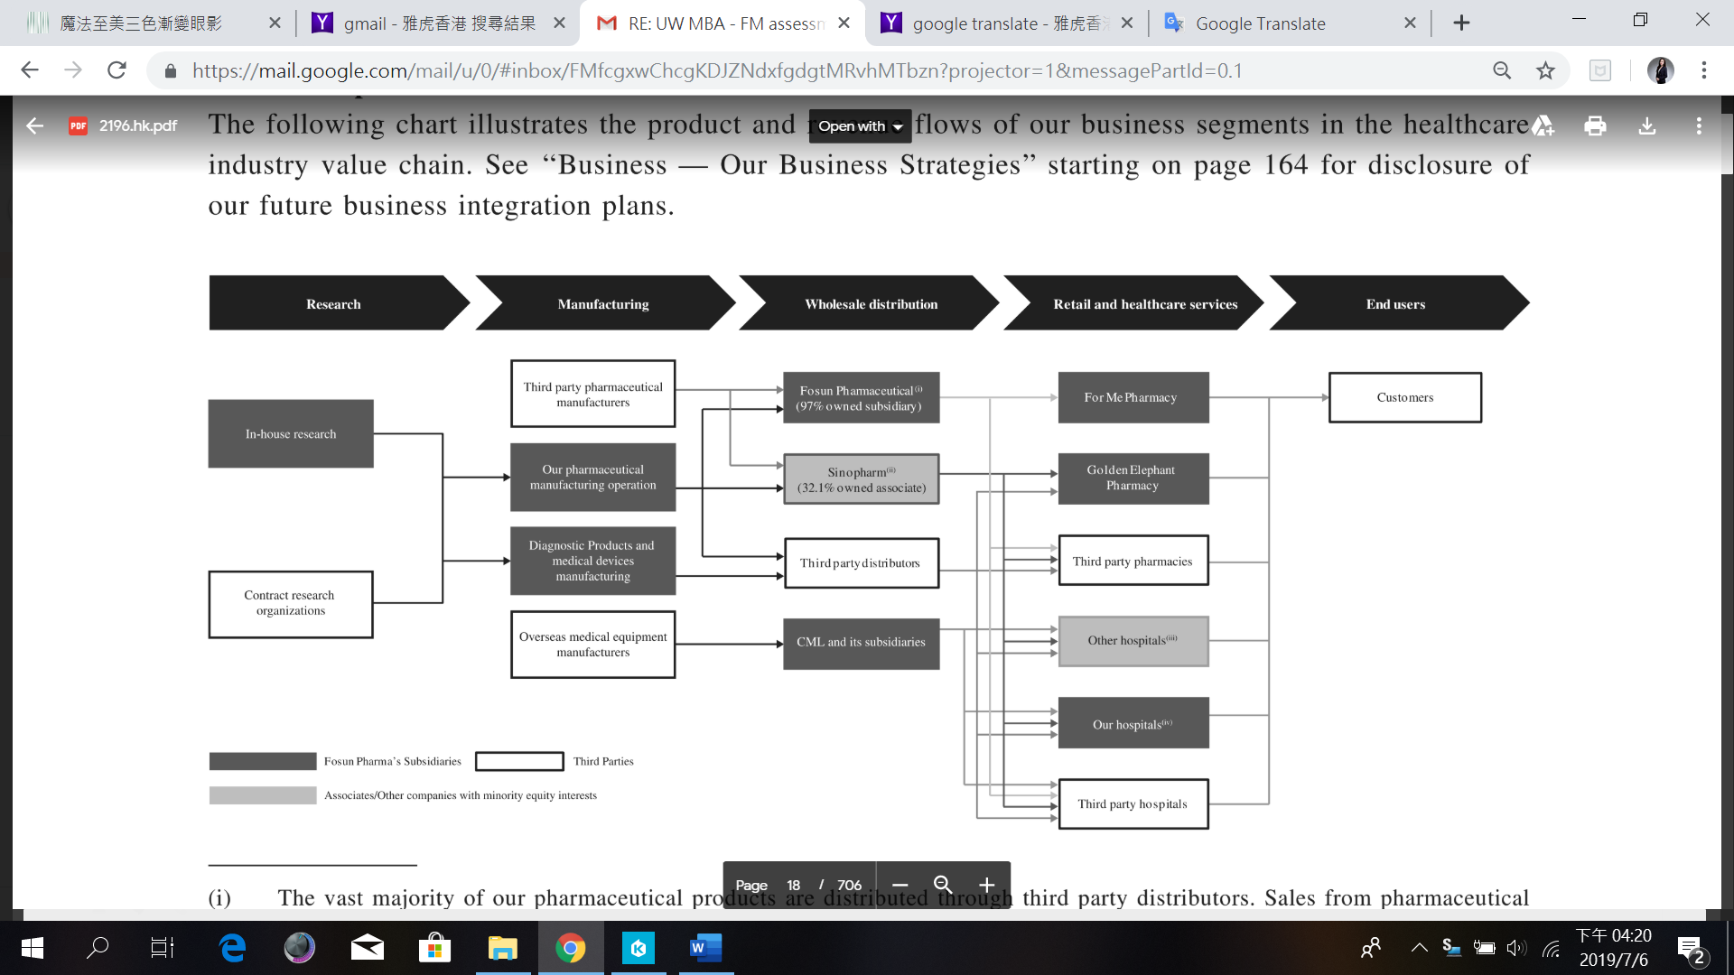
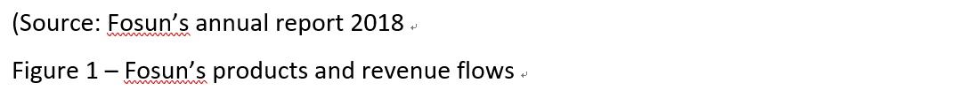

The main goals of Fosun are to consolidate and further enhance Fosun's position as China's leading healthcare company, increase its market share in the pharmaceutical and other business sectors in the Chinese market, and gradually enter or expand its presence in certain attractive international markets.

Pharmaceutical Manufacturing and R&D
Fosun continues to promote the construction of an innovation system and improve the drug R&D system of “innovation and combination”, and further strengthens R&D investment. According to the reporting cycle, the R&D investment of the Fosun's pharmaceutical business was RMB 2,250 million, an increase of RMB 975 million or 76.49% over 2017. The R&D investment in the pharmaceutical business accounted for 12.0% of the pharmaceutical business revenue; among them, the research and development expenses were RMB 1,255. Million dollars, an increase of RMB 456 million compared with 2017, an increase of 57.10%, accounting for 6.7% of the pharmaceutical business income. At the end of the reporting period, the Group is investing in 215 projects such as the evaluation of new drugs, generic drugs, biosimilar drugs and generic drugs, including 15 small molecule innovative drugs, 10 bio-innovative drugs, 17 biosimilar drugs, and international standards. There are 117 generic drugs, 54 special consistency evaluations and 2 Chinese medicines.

The Group also actively participates in the pilot reform of the pharmaceutical industry. In the beginning of the reporting cycle, Fosun (“Fosun Pharmaceutical Industry”), the headquarters pharmaceutical business platform, became the first enterprise in Shanghai to obtain the approval of the drug marketing license holder and promote the Group's continuous improvement in the quality control capabilities of pharmaceuticals throughout the life cycle and the expansion of the pharmaceutical manufacturing business.

At the same time, the Group continues to focus on innovation and internationalization, vigorously develops strategic medical products, and seeks opportunities for mergers and acquisitions in the industry actively, integrates and coordinates the Group's existing product lines and resources, and actively explores the business of the international market.
Healthcare Services
In year 2018, Fosun continues to strengthen its strategic layout of the medical services business of high-end medical care, second- and third-tier city specialists and general hospitals in the coastal developed cities. Through the continuous promotion of the medical institution's specialist construction, internal integration and expansion, the Group will build a regional medical center and a large health industry chain to improve business scale and profitability.

According to the reporting cycle, Fosun continues to support and promote the company development and layout of leading brands of high-end medical services and the network of hospitals and clinics actively. While investing in the domestic medical service industry, Fosun decide to pay more attention to the exploration of new business models in the global mainstream medical service sector.

Medical equipment and medical diagnosis

In 2018,Fosun continued to promote its business in the field of medical device and medical diagnostics. During the reporting period, the medical device and medical diagnostics business achieved operating income of RMB 3, 627 million, an increase of 13.20% over 2017. The segment results were RMB 558 million, an increase of 16.31% over 2017; the profit was RMB 440 million, an increase of 13.48% compared with 2017.

Pharmaceutical distribution and retail

The distribution networks of Fosun covers thirty-one provinces, municipalities and autonomous regions in China, and the coverage rate of prefecture-level administrative districts reaches 97%, and the coverage rate of county-level administrative districts reaches 98%. According to the reporting cycle, the distribution business of Sinopharm's pharmaceutical realized revenue of RMB 281, 049 million, an increase of 9.29% compared with 2017. In the pharmaceutical retail sector, the retail network cover in 30 provinces, municipalities and autonomous regions, and more than 229 cities across the country, with a total of 5,183 retail pharmacies (Fosun’s annual report, 2017 & 2018).

  - Today’s Business Environment

In early 21st century, the “blockbuster” drug development model that provides good services to the pharmaceutical industry and its investors has come to an end as market expectations for operations have shifted from optimizing liquid assets to creating value for businesses. In short, they must now go beyond effective production, rethink their holistic approach, and demand innovation levels that match the recent changes in the pharmaceutical industry.

  - Company Structure

The offering document (2012) of Fosun disclosed the company structure of management including the board, supervisors and executives and the 8 major pharmaceutical products: Metabolism & Digestive Tract, Cardiovascular, Blood, Central Nervous, Anti-inflection, Anti-tumor, Vaccine, API and Intermediate.

The below table shows the simplified corporate structure of Fosun following the completion of the Global Offering, assuming that the Over-allotment Option has not been exercised after the Latest Practicable Date on 2012 and the shareholding changes of the following shareholders:

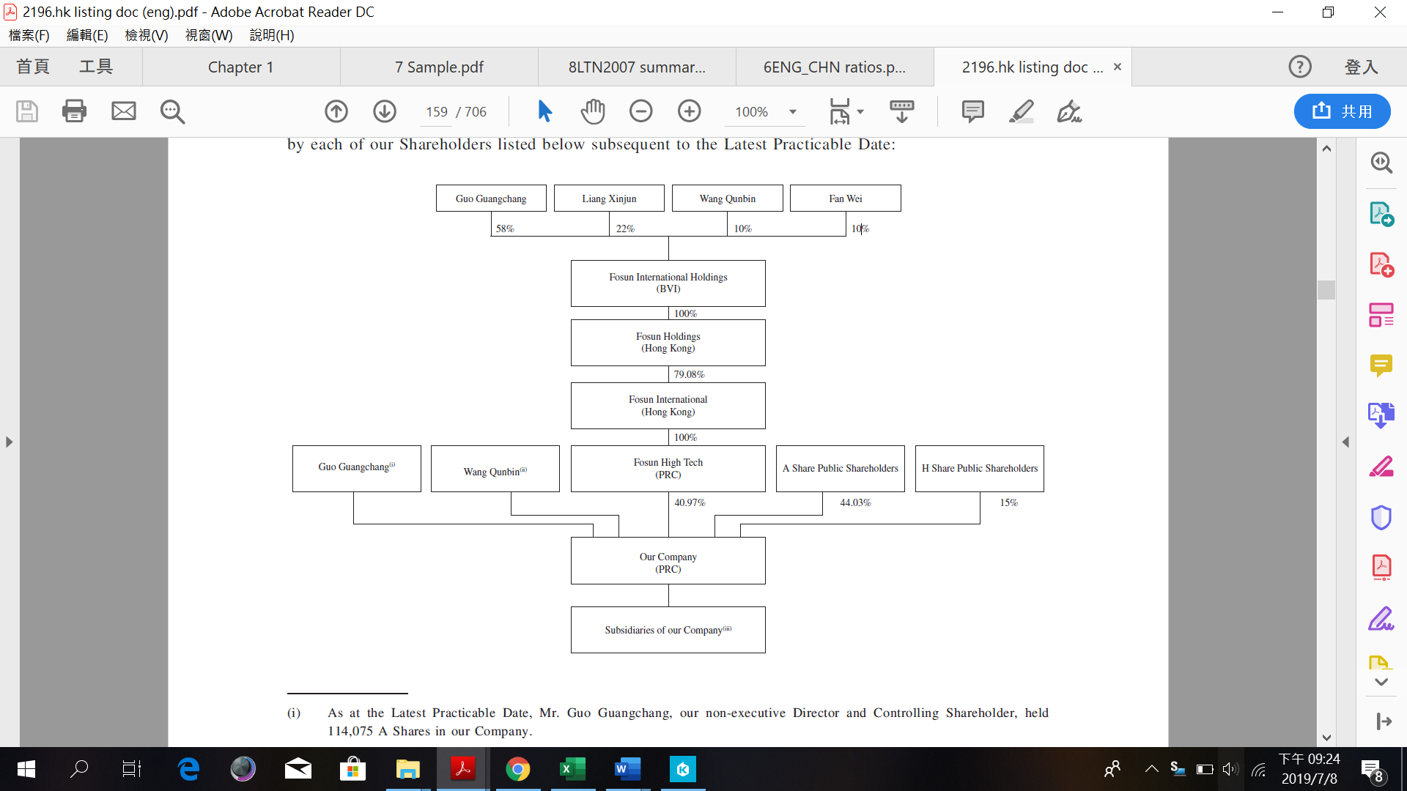
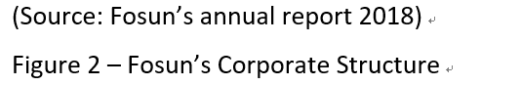
  - Research Comparison Company Information

To compare with Fosun with equal comparative analysis, this research comparison chooses two of the Hong Kong listed companies to compare with: China Grand Pharmaceutical and Healthcare Holdings Limited (0512.HK), (“China Grand Ph”) and China Medical System Holdings Limited (0867.HK), (“CMS”). Both listed companies have the same business nature as Fosun and have similar size of enterprise and market shares. Below chart shows the financial details of these companies:

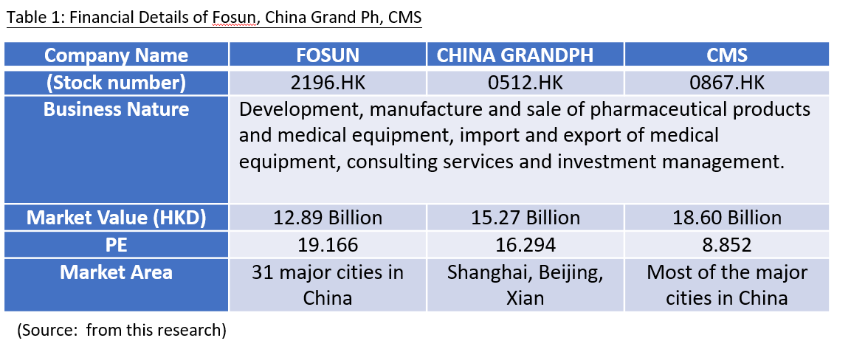

- Fosun’s Financial Analysis

To analysis Fosun’s financial reports on financial structure, the following analysis refers to the analysis of enterprises, projects or investments by financial indicators and methods such as profit rate, solvency, liquidity, stability, growth history and prospects, and peer comparison of Fosun.

2.1 Listed Companies of Bankruptcy Index Z-Score Analysis

Z-Score majorly is used to calculate the bankruptcy rate; the Altman Z-score is the output of a credit strength test that measures the likelihood of a publicly traded manufacturing company going bankrupt. Below are financial details and Z-Score values of three companies:

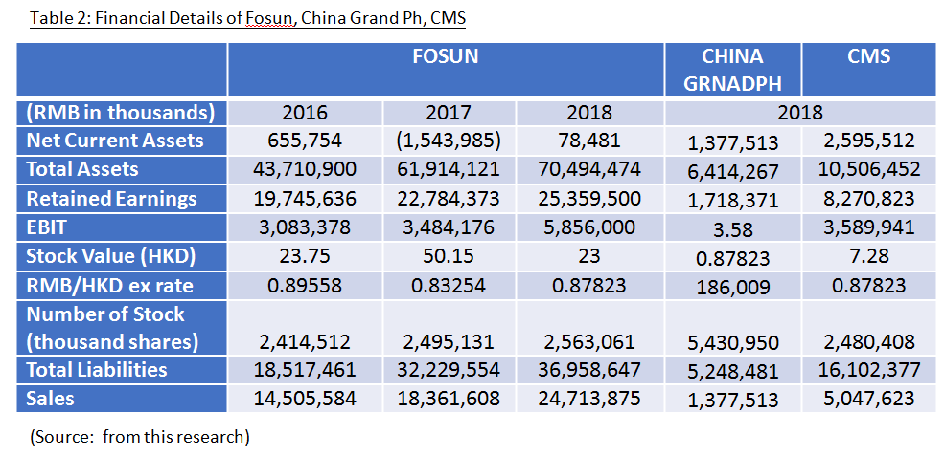
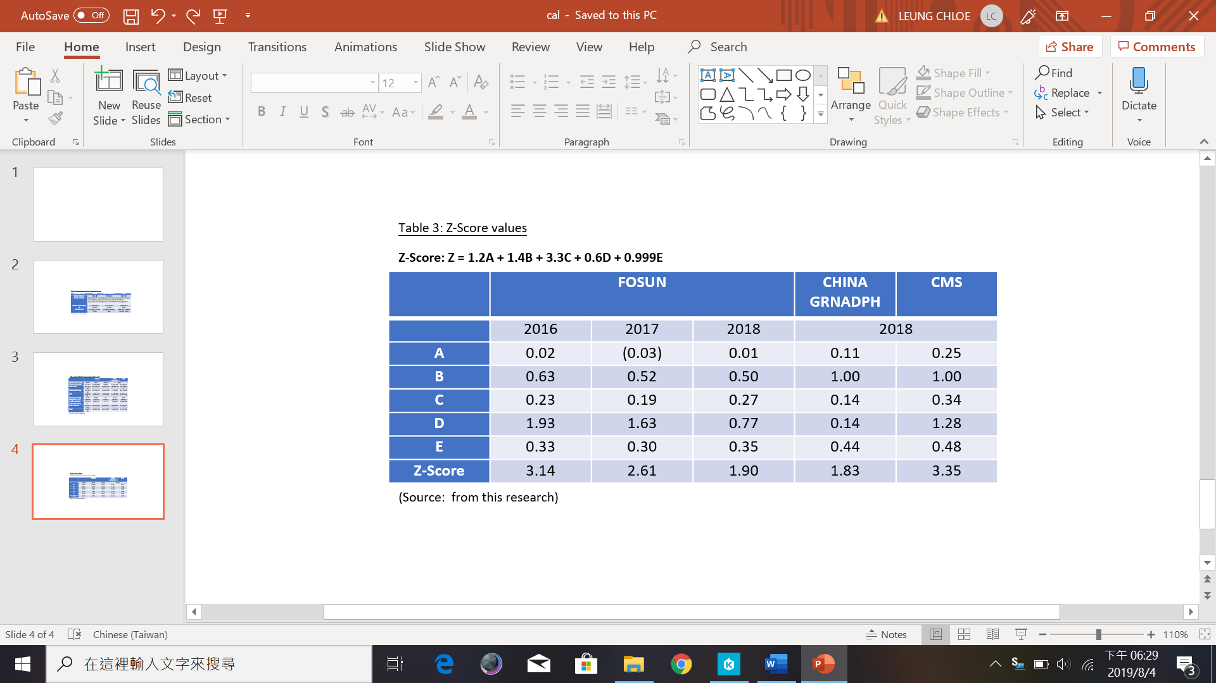

2.2 Financial Structure

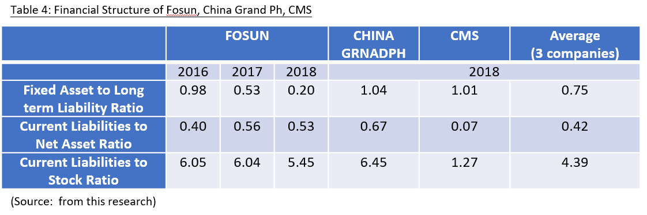

Fixed Asset to Long term Liability Ratio

The ratio of fixed assets to long-term liabilities is an indicator of a company's solvency. This ratio is calculated by dividing the value of the fixed asset by the amount of the long-term debt, lower rate means more stable of its source of funds. Fosun’s source of funds become more stable compare with year 2016 and 2017, from 0.98 drop to 0.20; due to the increase of sales and total assets. Though the above comparison, Fosun has stronger long-term funds.
Current Liabilities to Net Asset Ratio

The ratio of current liabilities to net assets indicates dependence on equity to pay debt. To measures a company's solvency, a higher ratio means huge pressure on future cash flow. Compare with 2017, the ratio of current liabilities to net asset receive 5% decrease to 0.53 in year 2018; it shows the problem of current liabilities which has been alleviated.

Current Liabilities to Stock Ratio

The current debt-to-inventory ratio indicates that the available stock is used to pay the debt. It is one of the measures of the company's solvency. Compare with China Grand Ph and CMS, Fosun has larger number of issued stocks and higher stock values. It shows that Fosun gets a reasonable solvency.

2.3Paying Debt Ability

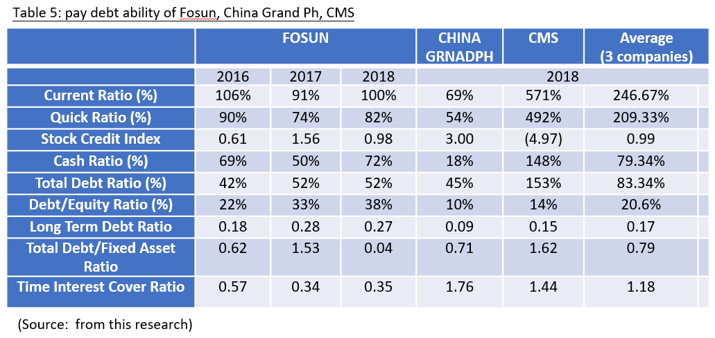
Current Ratio and Quick Ratio

The current ratio and quick ratio are intended to estimate the company's ability to pay its current liabilities, the difference between the two indicators is that fast interest rates are concentrated on more liquid assets. The pharmaceutical manufacturing and R&D of Fosun obtain numerous of cash, it shows that the cash-flow of Fosun is positive. The current ratio and quick ratio of Fosun have 9% and 8% increased between 2017 and 2018 repeatedly. Compare with CMS, the current and quick ratio is the highest due to CMS has the fewest R&D and manufacturing costs.

Stock Credit Index

In year 2016 to 2018, the inventory confidence of Fosun to the market is positive, because the financial status of Fosun is inferior. The current liabilities are larger than current assets. Fosun should reduce the current liabilities. Although 2018 has slightly dropped compare with 2017, due to the influence of fake vaccines in China pharmaceutical industry. But the stock credit index is still greater than year 2016, which means the adversity tolerance of Fosun is strong.

Cash Ratio

The cash ratio is an indicator of the company's liquidity, especially the ratio of the company's cash and cash equivalents to its current liabilities. In year 2018, the cash ratio of Fosun has slight risen compare with 2017; this indicator calculates that Fosun has the ability to repay short-term debt in cash or near-cash resources.

Debt and Equity Ratio

The debt-to-equity ratio is calculated by dividing the company's total liabilities by shareholders' equity, this ratio is used to assess the company's financial leverage. Fosun has worse performance than China Grand Ph and CMS, which rises from 22% to 38% in year 2018, the long-term repayment capital of Fosun is on average.

Time Interest Cover Ratio

The interest coverage ratio can be calculated by dividing the company's interest and the pre-tax profit (EBIT) for a given period by the company's interest payments due during the same period. The ratio shows that Fosun is satisfied with the time earned by interest, as compare with 2016 to 2018, the movement is consistent. In comparison, China Grand Ph has higher time interest cover ratio than Fosun and CMS.

Paying Debt Ability

The solvency ratio measures the company's ability to pay long-term debt and interest on debt. The financial status of Fosun is stable and steady, as part of the financial ratio analysis, the solvency ratio helps the business owner of Fosun to determine the likelihood of a company's long-term survival.
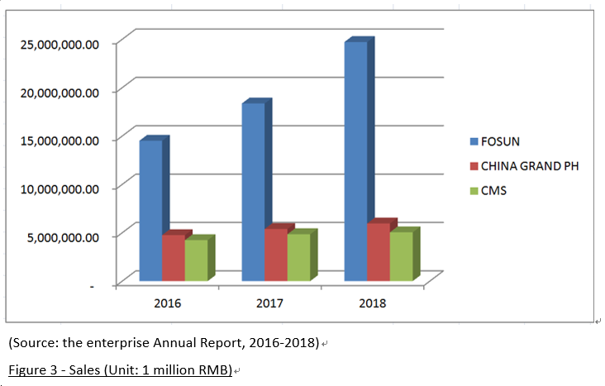

2.4Operational Ability

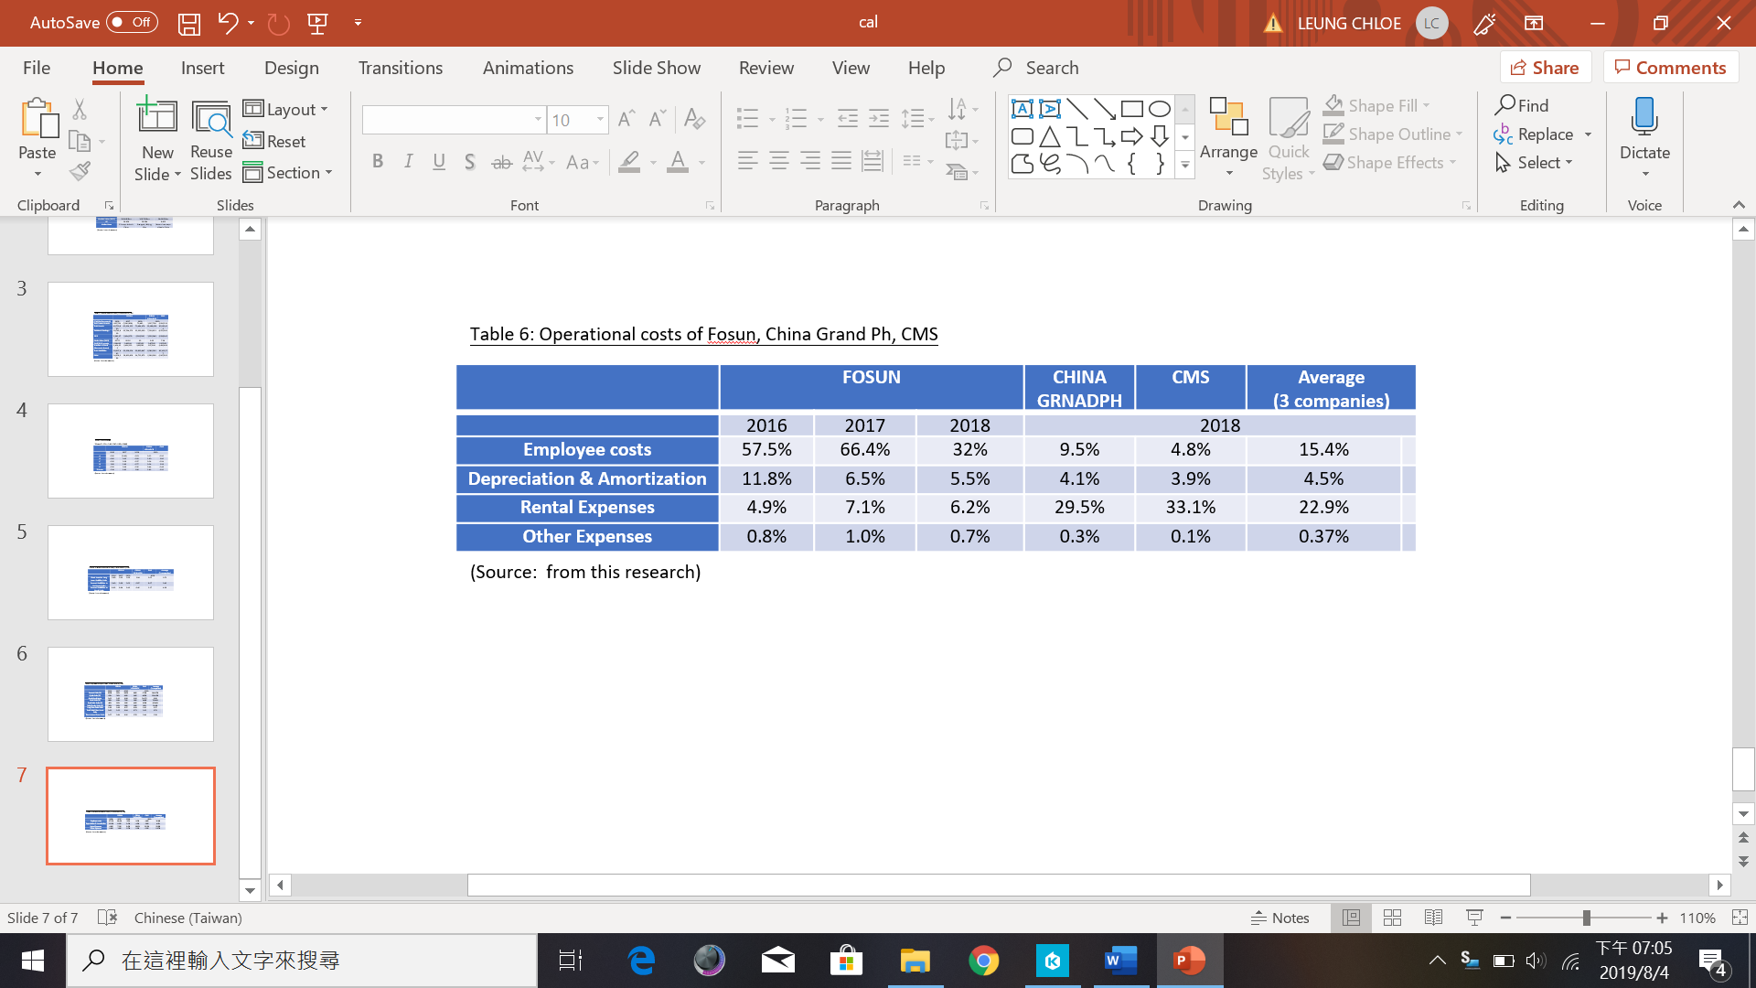

According to above data analysis, the employee costs and the depreciation and amortization of Fosun are higher than other two companies. Fosun has more factories and operation manpower to spend.

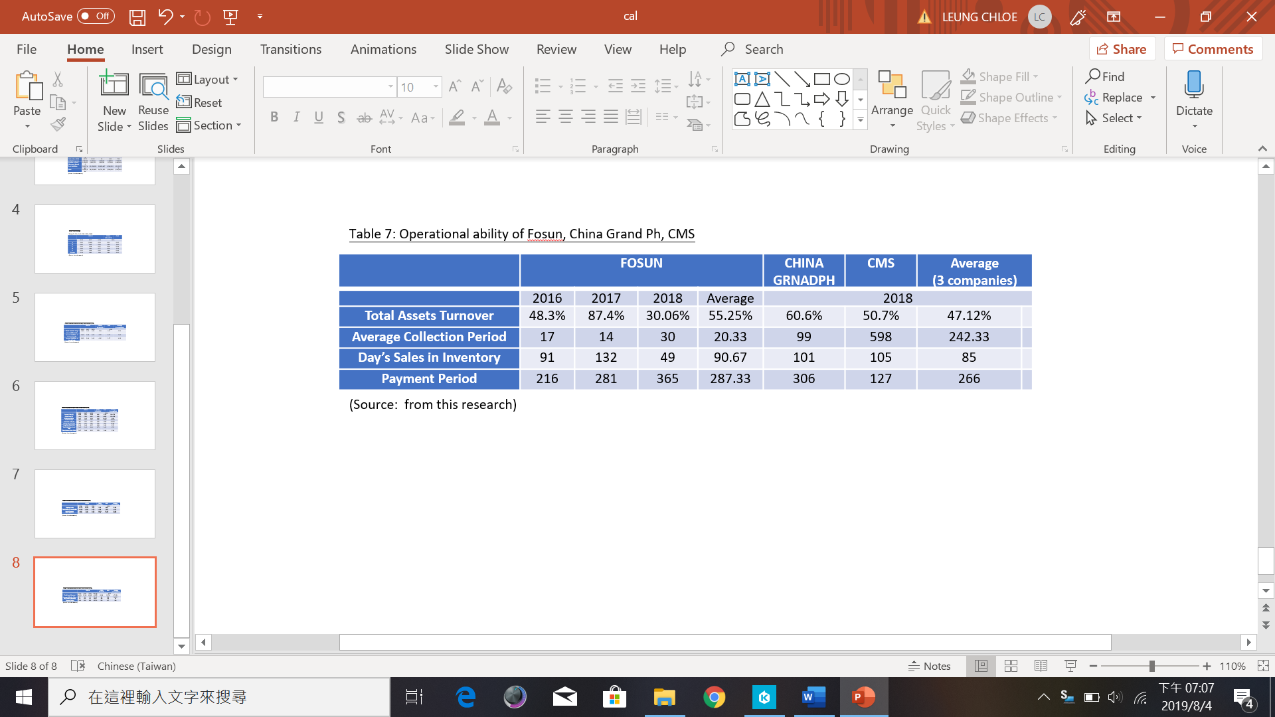

Total Assets Turnover

The asset turnover rate is calculated by dividing net sales by the average total assets. Fosun’s average assets turnover from 2016 to 2018 is 55.25% and it’s decreased from 87.4% to 30.06% in year 2018, which due to fake vaccines in China pharmaceutical industry.

Account payable Turnover Days

The accounts payable turnover days shows the average number of days that no accounts payable has been paid. Affect by the fake vaccines in China pharmaceutical industry in 2018, the turnover days has 65% increased compare with year 2017; which means that Fosun needs longer days to collect money. Compare with China Grand Ph and CMS, Fosun still has shorter account payable turnover days.

Inventory Turnover Days

Inventory turnover is the ratio of the number of times a company sells and replaces inventory during a specific period of times. Based on the comparison, the average inventory turnover days of Fosun is 287.3 day. In year 2018, Fosun has sharp growth compare with year 2016 and 2017; it’s a good trend and the data show the financial steady of Fosun.

2.5 Profitability

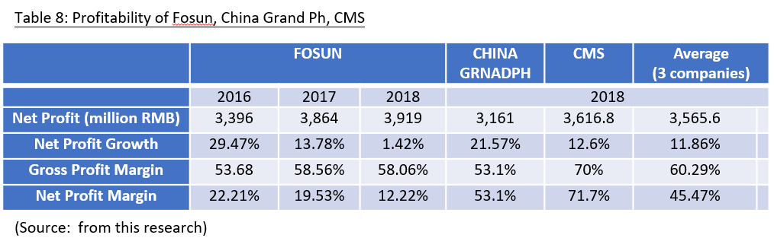

Gross Profit Margin – the business focus of Fosun is to develop, manufacture and sale of pharmaceutical products and medical equipment in China. Therefore, the gross profit margin of Fosun is high according to the trend and on average it is high and steady. Compare with CMS and China Grand Ph in year 2018, CMS receives 11% higher than Fosun because of the better company turnover.

Net Profit Margin – compare with 2016 to 2018, the net profit margin of Fosun drop year-on-year, from 22.21% decreases to 12.22%. It is affected by the sharp fall of its net profit growth and China fake vaccines incidents. The higher R&D expense also influence the numerical value of Fosun’s net profit margin compare with CMS and China Grand Ph, both have fewer R&D expense than Fosun.

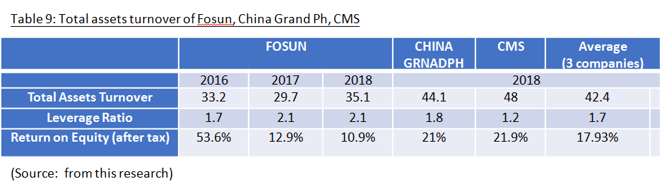

Total Assets Turnover – the average total assets turnover of Fosun is 32.67, and the turnover tendency from 2016 to 2018 is growing steady although there is a slight drop in year 2017.

Leverage Ratio/ Return on Equity (after tax) – Fosun’s Return on Equity has a sharp decline in year 2017, due to the bad influence of China fake vaccines cases on their sales revenues. In year 2018, the decline has been alleviated. Compare with its competitors, CMS and China Grand Ph got higher after-tax equity returns in 2018.

Profitability Analysis –though this capability analysis of indicators, the capability of Fosun is close to the industry inferior. In recommendation, Fosun needs to explore more sales channel in world-wide hence to leverage the growth of sales and return on equity.

2.6 Growth Ability

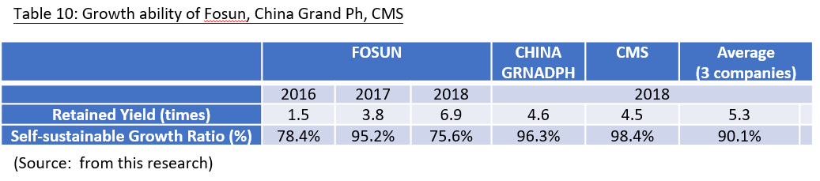

Retained Yield – the retained yield of Fosun for three years average is 4.07 times. Compare with year 2016, year 2018 has 78% growth, which reflects that the business development of Fosun is rising up and the rate of return is increased at reasonable levels.

Self-sustainable Growth Ratio – for the three years average of Fosun is 83.07, compare with year 2016 and 2017, the self-sustainable growth ratio has slight decreased in year 2018. CMS and China Grand Ph receive higher ratio than Fosun in 2018, therefore Fosun needs to increase the retained yield to maintain its self-sustainable growth ratio in pharmaceutical industry.

2.7 Stock Market Prospects Analysis

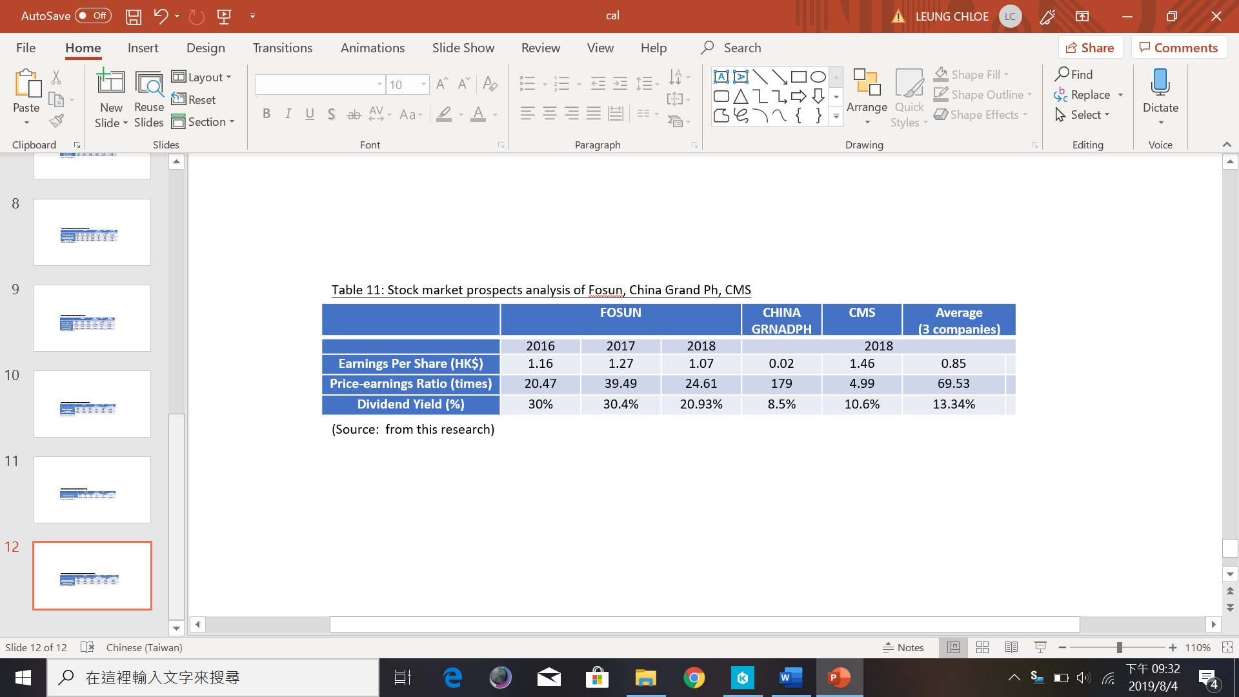

The average P/E Ratio of Fosun is 28.19 times, compare with year 2017, the P/E ratio of 2018 has decreased 37.68% which affects the pursuit of dividends return stability. China Grand Ph has higher P/E Ratio compare with Fosun in year 2018, which shows that the financial status of China Grand Ph is more stable.

Stock Market Prospects Analysis – the dividend returns of Fosun is stable, and the stock market prospect is in the steady growth level.

- Fosun’s Corporate Governance Assessment

Being a listed company in the Shanghai Stock Exchange and the Hong Kong Stock Exchange, Fosun has always been strictly comply with the company's Articles of Association, with relevant laws and regulations, and the listing rules of Shanghai and Hong Kong. Fosun strives to continuously improve the structure of corporate governance and to optimize the internal management control and company operations to improve its corporate governance.

3.1 Corporate Governance of Business Organization, Impact and Importance

The board members of Fosun are responsible for leading and controlling the company and overseeing Fosun's business and strategic decisions, though directing and supervising their affairs, the collective is responsible for promoting the company's success. Directors have to objectively make decisions for the benefit of the company.

The Board of Fosun is responsible for implementing the functions which set out in Code Provision D.3.1 of the Code on Corporate Governance. Fosun has established a comprehensive corporate governance practices and procedures. Board of Directors of Fosun has to:

(1) Formulate and review corporate governance policies and practices, and formulate relevant regulations suggested;
(2) To review and to supervise the training and sustainable development for Fosun’s directors and senior management;
(3) To review and to supervise Fosun’s policies and practices when complying with the laws and the required requirements of regulatory;
(4) To establish, reviews and supervises the code of conduct of directors and employees;
(5) Review whether the company complies with corporate governance guidelines and disclose in corporate governance report.

3.2 Fosun Existing Corporate Governance

Fosun believes that the effective communication with shareholders is an essential to strengthen the investor relations; and the investors' understanding of Fosun's business performances and strategy. Fosun strives to maintains sustainable development and to dialogue with its shareholders, especially from the annual shareholder meetings and others general meetings. The chairman of the board and board committees (or their representatives) will attend the annual general meeting in person and meet with shareholders to answer their inquiries.

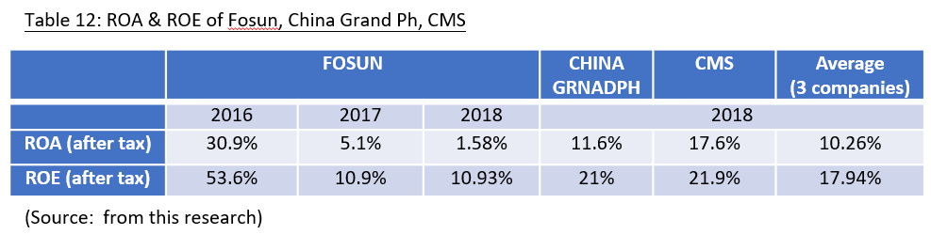

3.3 Suggestions for Improvement

After reviewing Fosun’s situation, below are suggestions for improvements:

1. Recognize that good governance is more than just compliance - the board needs to balance compliance with board performance factors. Understanding the role of the board and the people involved in governance has come a long way in maintaining a good relationship between management and the board.
2. To clarify the role of the board of directors though the strategies – The board's contribution to the strategy ranges from one party to the other. Each director must determine the appropriate role and clarify the understanding with management.
3. Monitoring the organizational performances – Supervising organizational performances is an important function of the board of directors, ensuring that legal compliance is a major aspect of the board's oversight responsibilities. It ensures the company decisions are aligned with organizational strategy and the expectations of the owners. Success is best determined by identifying the organization's key performances to drivers and determining appropriate measures. Directors need to develop an agreed format for the reports they monitor to ensure that all of the reporting matters are reported.
4. Understand the board of directors hired CEO – Board/ customer relationships are critical to the effective implementation of corporate governance and are the link between the role of the board in determining the strategic direction of the organization and the role of management in achieving corporate goals.
5. Recognize the risk governance is the responsibility of the board of directors – establishing sound risk monitoring and management and internal control systems is another fundamental responsibility of the board of directors. Effective risk management supports better decision making.
6. Ensure that directors have the information they need – better information means that producing better regular board documents will provide directors with information that the CEO or management team has decided. Most importantly, directors need to be able to find answers to the questions they have, so it is recommended to visit an independent professional advice policy.

7. Establish and maintain an effective governance infrastructure – in order to ensure a clear definition of the scope of responsibility between the board and management, it is particularly important for the board to develop policies related to the mandate.
8. Appoint a competent chairman – as the “leader” of the board of directors, the chairperson must demonstrate strong and recognized leadership, the ability to build relationships with the CEO, and the ability to hold meetings and lead the team's decision-making process.
9. Build a skills-based board – the board should strive to ensure that its members strike the right balance between directors with organizational experience and knowledge and directors with expertise or new perspectives. Directors must consider the additional qualities they have and their “behavior ability” as these qualities will affect the relationship between the board, the board and management, and the directors and key stakeholders.

10. Assess the performance of the board of directors and seek opportunities for improvement – in order to effectively govern, the board must be aware of its strengths and weaknesses. The effectiveness of the board of directors can only be measured when the board regularly evaluates the performance of its directors and individual directors. Improvements to board and director evaluations can include board processes, director skills, competencies and motivations, and board relationships. Any agreed behavior that appears in the assessment must be implemented and monitored. The board must consider the weaknesses identified in the board's assessment through the director's development plan and strengthen its governance process.

- Investment Project Assessment

In order to expand Fosun's business growth, the company plans to develop overseas markets in USA (such as medical machinery, Chinese medicine, etc.) and to establish a strong regional drug retail network worldwide. The HK$500 million investment plan will focus on building a regional pharmaceutical Centre plus factory, which create network for at least 500 pharmacies, to recognized Fosun’s brand names through organic growth. In addition, the project will increase the competition in medicine industry by introducing a wide range of new product options and additional services as well as competitive prices for end users in USA and Europeans market. As a result, more than 2,000 jobs will be created.

4.1 Investment Project Appraisal

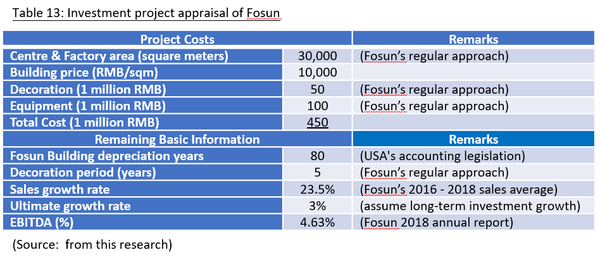

4.2 The First Year Calculation of Revenue
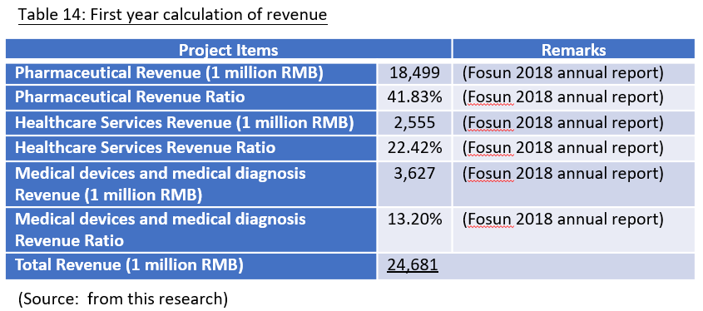

4.3 Computing Tax Cost
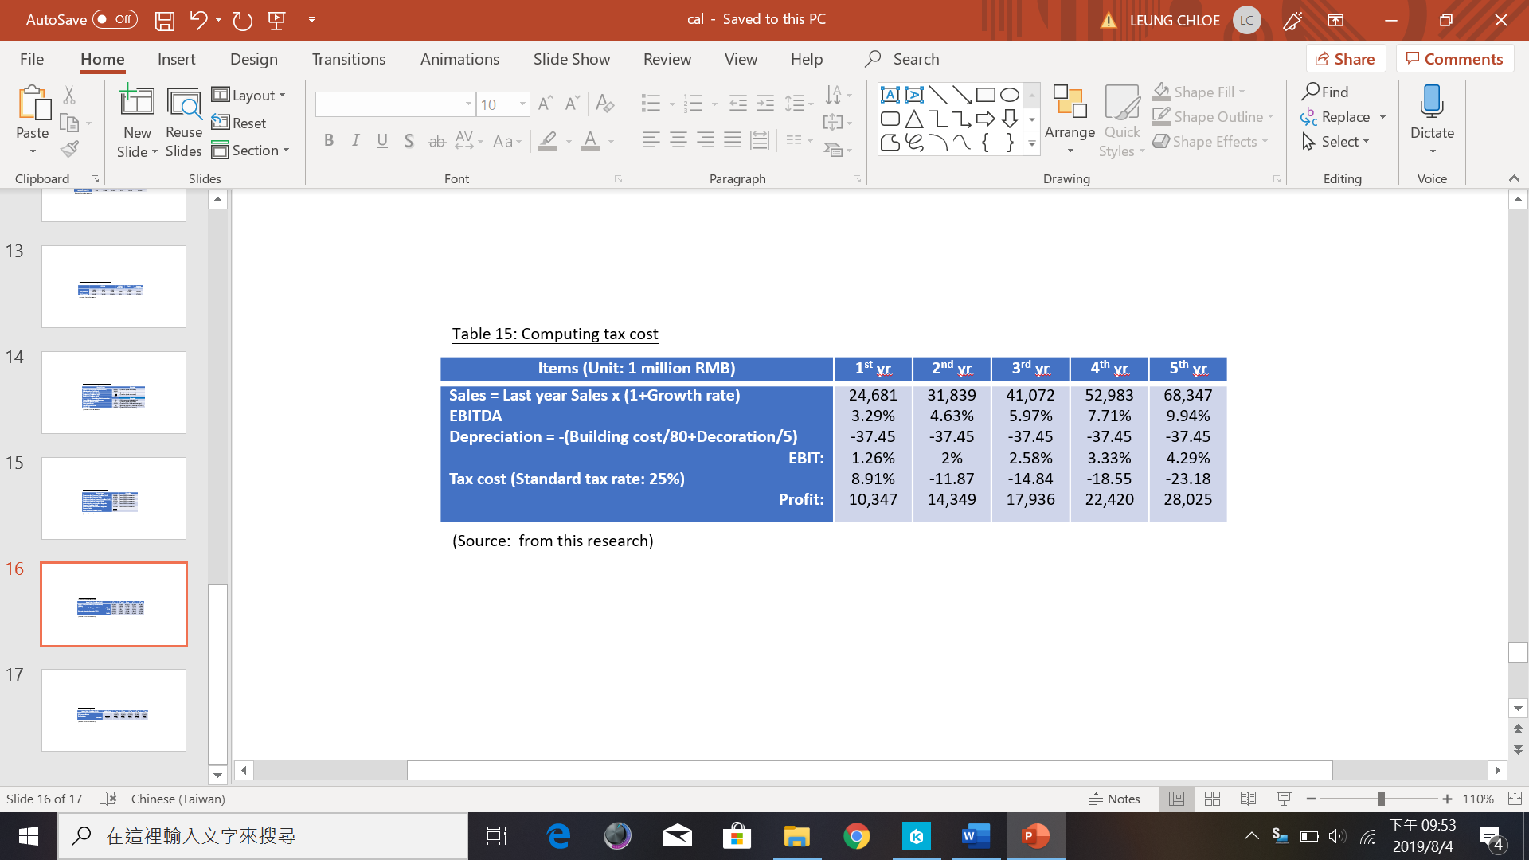

4.4 Cashflow Calculation
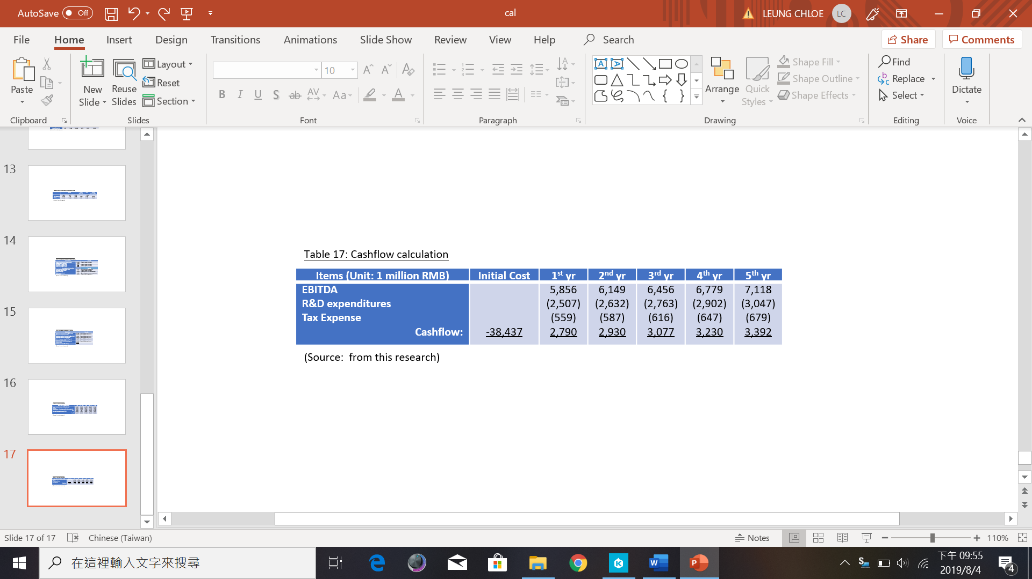
4.5 ARR and NPV Calculation

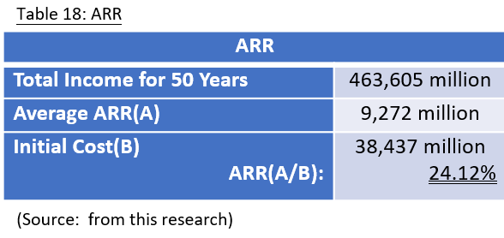

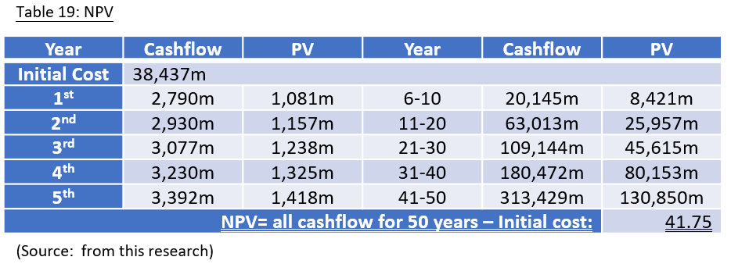

4.6 Payback Period and IRR

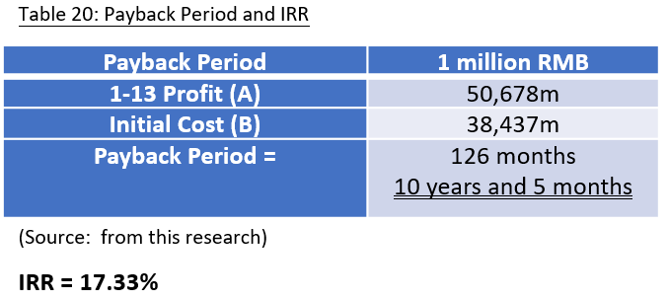

4.7 Investment Appraisal

According to data analysis result of the investment project, the payback period of new regional pharmaceutical Centre plus factory in USA is 10 years and 5 months, the net present value is positive. Base on those data, the investment project appraisal is in a positive return, and can help Fosun to explore USA and Europeans pharmaceutical market network successfully. Fosun can carry on this direction of investment project to growth its market share in worldwide.

4.8 New Project Appraisal Methods for Analysis

  - ARR – the ARR of the investment project is 24.12%, which higher than Fosun’s current return on assets on the existing investment. The average rate of return can take advantages to each year calculation and mirror in the long-term return projects.

  - NPV – in year 2018, the ROA of Fosun is 1.58%, and the NPV of investment project is 4,175 million RMB. Net present value provides a means of assessing and comparing capital items or financial products with cash flows over time, such as loans, investments, insurance contract payments, and many other applications.

  - IRR – after calculation, the IRR of investment project is 17.33%. Internal rate of return is an indicator of the ability to estimate the profitability of a potential investment in a capital budget, and to measure the return on investment. The term "internal" means that internal interest rates do not include external factors such as inflation, capital costs or various financial risks.

4.9 Suggestion for Cashflow of New Project

The new regional pharmaceutical Centre plus factory in USA will require approximate 800 million RMB of cashflow, which is 11.35% of Fosun 2018 cash flow. Fosun can deploy to planning the use of company internal resources to attain the liquidity requirements more satisfaction.

- Financing and Capital Management

Fosun’s new regional pharmaceutical Centre plus factory will initiate additional cash of 38,437 million RMB according to the pervious part. The following essays will analyze the various financing program advantage and disadvantage of Fosun’s capital management analysis.

5.1 Financing Methods for Analyzing

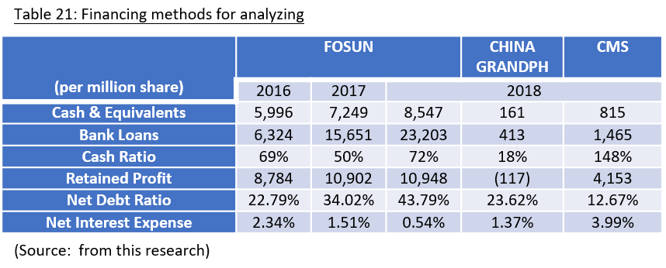

- Cash Payments – is the sources of funding. According to the analyzing, Fosun is in a stable financial status, although the net debt ratio is steady increase, but the cash ratio of Fosunin year 2018 has remarkable growth and net interest expenses keep decrease. It might be a slight impact to the future development of Fosun.

- Bank Loan Financing – Fosun has more numbers of bank loan compare with year 2016 and 2017, which influence by the fake vaccines of China in year 2017; the drop of sales cause Fosun to borrow long-term loan from bank. Fosun’s new investment project needs to raise 38,437 million RMB as investment funding; it’s feasible for Fosun to borrow from long-term loan program.

- Commercial Credit Financing –is the pre-approved amount issued by the bank to the company, and the borrowing company can visit the company at any time to fulfill various financial obligations. Fosun’s new investment project needs to raise 38,437 million RMB as investment funding; it’s not feasible for Fosun to conduct fund-raising.

- Issued Share Capital Fund-raising – use raised 38,437 million RMB fund as an example, issue new share fund-raising can reduce shareholders’ equity ratio, and will have higher often return from shareholders to creditor. Therefore, the liabilities rate will not high, so it’s not suggested to conduct issue share capital as fund-raising.

5.2 Financing Method Proposed

According to the above analyzing, Fosun will propose to adopt long-term loan program from bank for 38,437 million with annual interest 9.1% for 5 years amortization. The key financial data is as below:

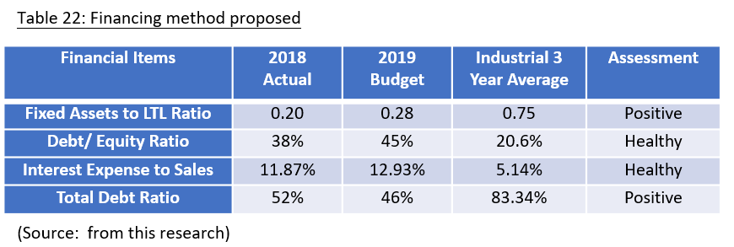

The borrowing of bank loan will have no major impacts to Fosun and will have further improvement to Fosun’s financial structure. Also, the operation cost of new regional pharmaceutical Centre plus factory can reduce substantiality.

6. Recommendations and Audit Program

According to data analysis result of the investment project, below are recommendations for operational audit program in each quarter:

Table 23: Audit plan
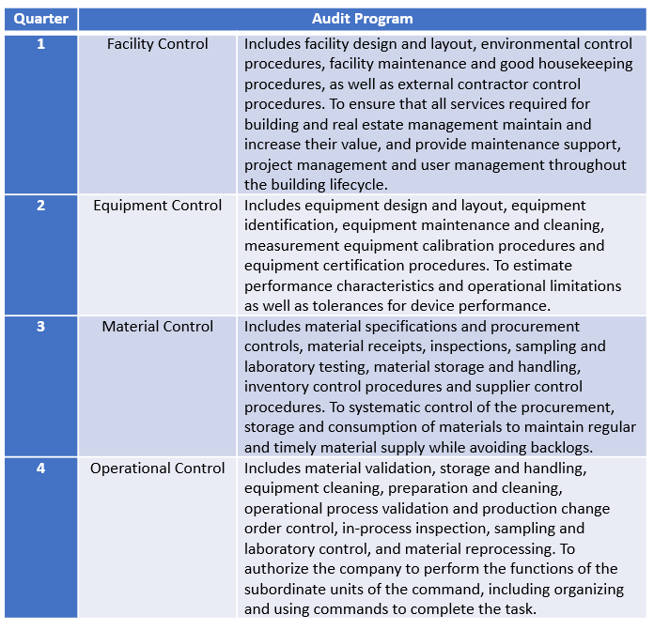

General controls will be an audit plan for the whole year, which includes organization and management responsibilities, employee orientation, quality awareness and vocational training, factory safety and security, internal quality and quality cost planning so as to operate in accordance with government regulations.

7. Conclusion and Recommendations

In the pharmaceutical industry, most of the pharmaceutical companies are still facing how to maintain high profitability. R&D costs and some setbacks have raised concerns about whether pharmaceutical companies have been able to maintain comfortable profitability in the past due to product launches and costly development failures. The industry has taken a number of initiatives to increase its efficiency, including efforts to increase the productivity of its extensive R&D investment. For example, portfolio management techniques are increasingly being applied to R&D to maximize portfolio value and balance portfolio risk across projects. As we all know, many companies currently rely on a very small number of high-volume products. Given the well-known uncertainties in the life sciences industry, the most important and difficult issue is not to identify high-priority projects, but to terminate projects based on their limited economic potential. Companies that better respond to this challenge than other companies have an advantage over their competitors because they are more likely to allocate R&D resources to projects that create great value. In other words, these companies should receive a higher return on investment in research and development.

A range of strategic approaches have shown that almost all companies can benefit from drug reduction. The strength lies in the overall high success rate and the pre-risk structure of such projects, which means that the greatest risk of failure is in the early stages of development and the reduction in the R&D budget is minimized. In addition, the price of a redesigned product is usually not significantly different from the original product price, or even higher, depending on the competitive advantage; however, redesigning the market positioning requires a large marketing budget. For companies that follow this business model, it is important to have a strong intellectual property position in the technology they use, because formula patents are more easily circumvented than patent portfolios that protect new active ingredients. In any case, many companies are looking for drug delivery strategies, many of which are supported by venture capital. This is vivid evidence that this risk minimization strategy is attractive to investors.

Niche products are usually commercialized after major development milestones are completed. At that stage, the risk is low and the risk-adjusted net present value is clearly positive. However, investment project decisions are made in the early stages of development, and the results are still highly uncertain, ie decisions are not based on success scenarios. Common causes of failure are: (a) the company's failure to successfully obtain sustainable venture capital financing, and (b) clinical trials failing to compensate for the development of other treatment indication candidates, enabling the company to restore preclinical compensation, or (c ) to achieve exit, but economic conditions cannot create value for investors. Because there seems to be no systematic analysis of the economic success rate of biotech companies pursuing niche indications, biases to drive success stories may decline. In any case, this analysis suggests a careful financial assessment to consider potential failures in order to make informed decisions.

In recommendation, Fosun has to reduce employee cost to lower the current liabilities and to raise the total assets turnover back to 2016/2017 level. Our analysis compares funding decisions with preclinical development projects. At that stage, NPV is less affected by development risks and many niche projects will be approved. If the number of cases with positive results can be correlated with the number of companies that fail to develop true niche products, then it can be concluded that approval of the new investment project will be a reasonable decision for Fosun.

Reference

Aswath, D. (2014) Applied Corporate Finance, 4th Edition, Wiley

David K. et. al. (2016) Multinational Business Finance, Global Edition, 14th Edition, Pearson International

Jae, K. et al. (2014) Accounting Handbook, 6th Edition, Barrons Educational Series

Kate, C. and William, J. (2015) Introduction to Mergers & Acquisitions, 1st Edition, Trends. Be

Michael, T. (2012) Orporate Finance for Dummies, 1st Edition, For Dummies

Patrick, A. (2015) Mergers, Acquisitions, and Corporate Restructurings, 6th Edition, Wiley

Stanley, F. et. al. (2007) The Art of M&A, 4th Edition, McGraw-Hill Education

Stanley, J. (2005) Principles of Private Firm Valuation, 1st Edition, Wiley

Thomas, I.(2009) Financial Statements, 2nd Edition, Weiser

Wayne, L. (2013) Accounting for Non-Accountants: The Fast and Easy Way to Learn the Basics, 3rd Edition, Sourcebooks

Appendix

Appendix 1 – Financial Statement of Fosun 2018

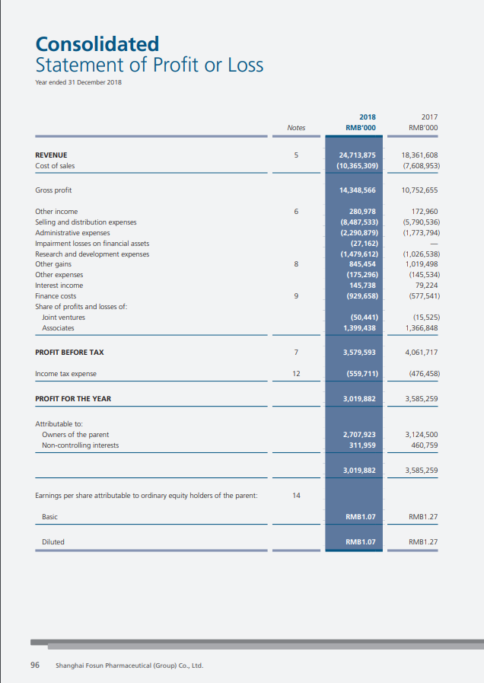

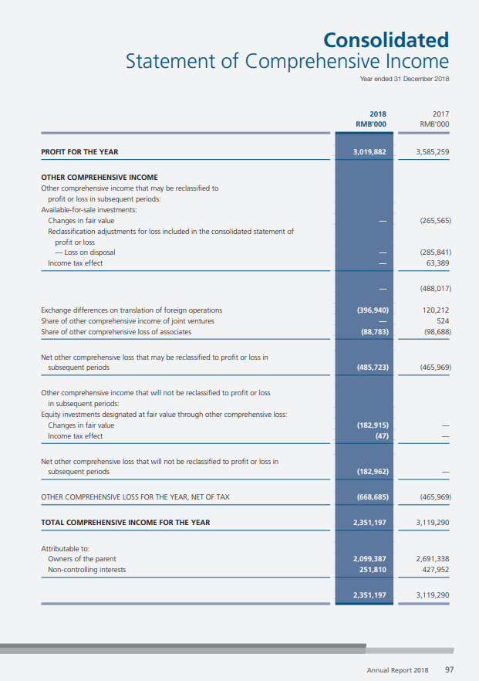

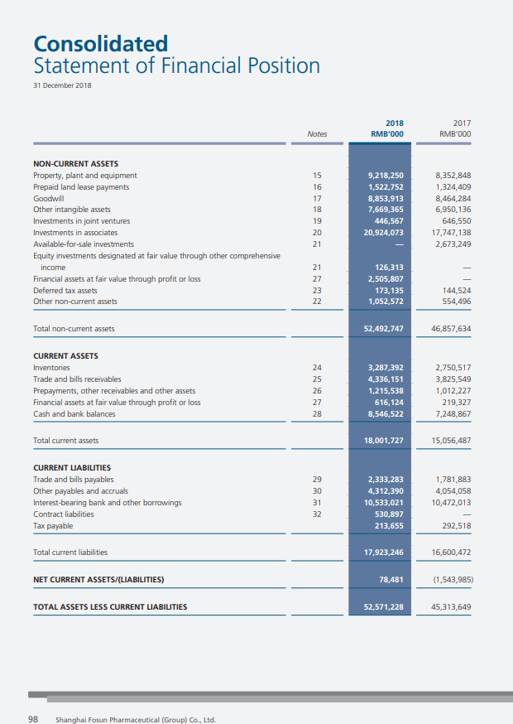

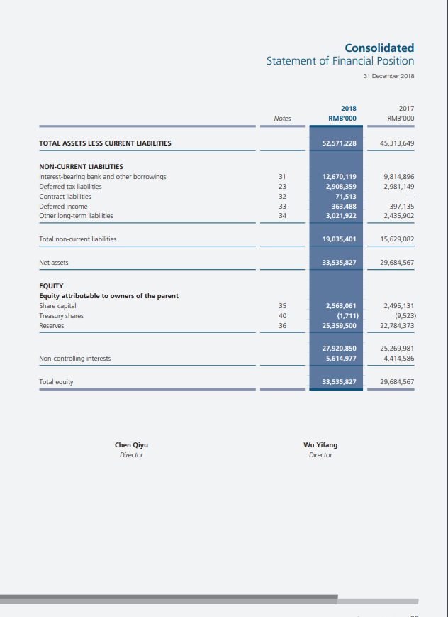

Appendix 2 – Financial Statement of Fosun 2017

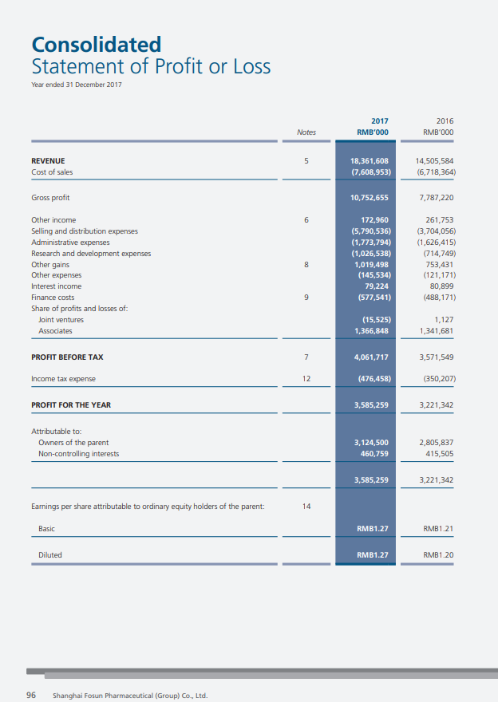

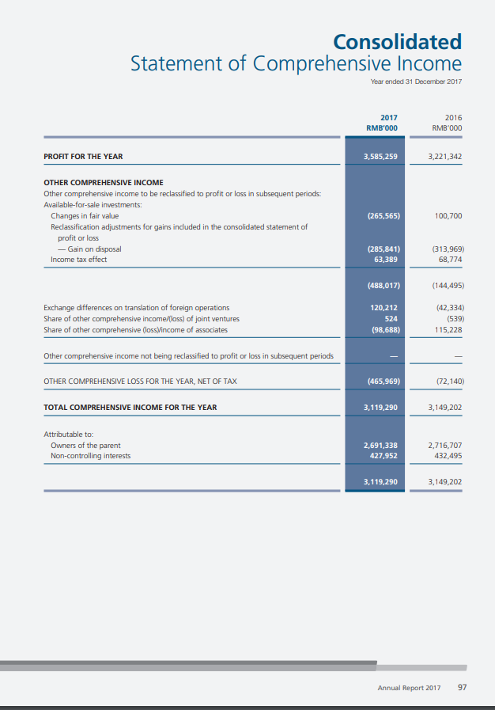

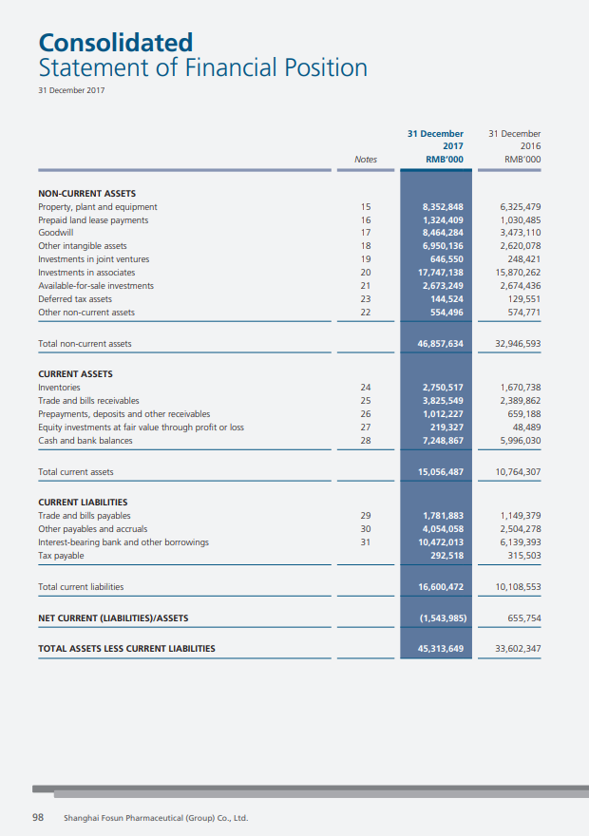

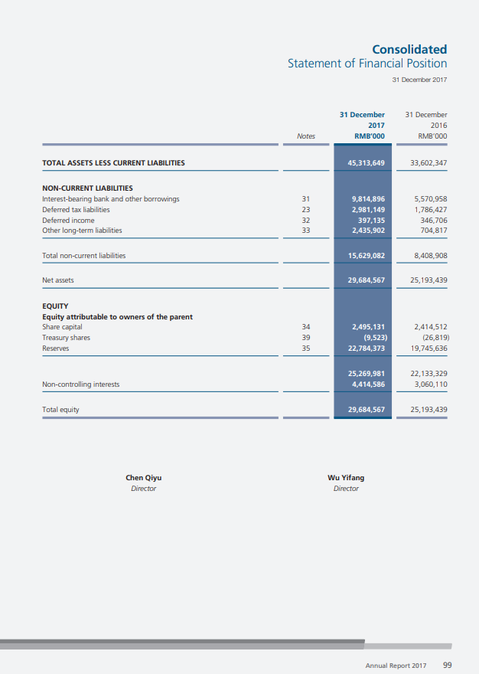

Appendix 3 – Financial Statement of Fosun 2016

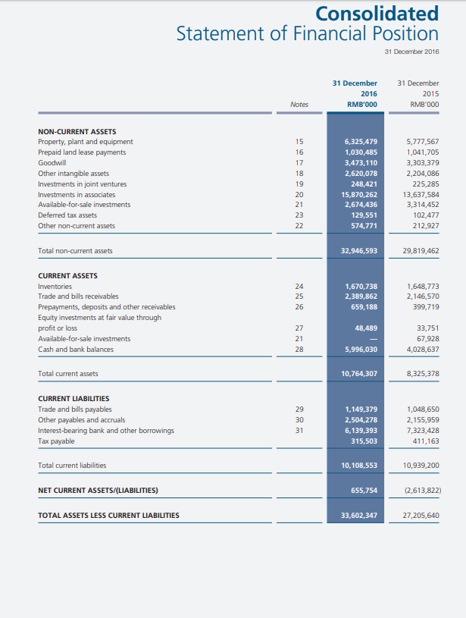

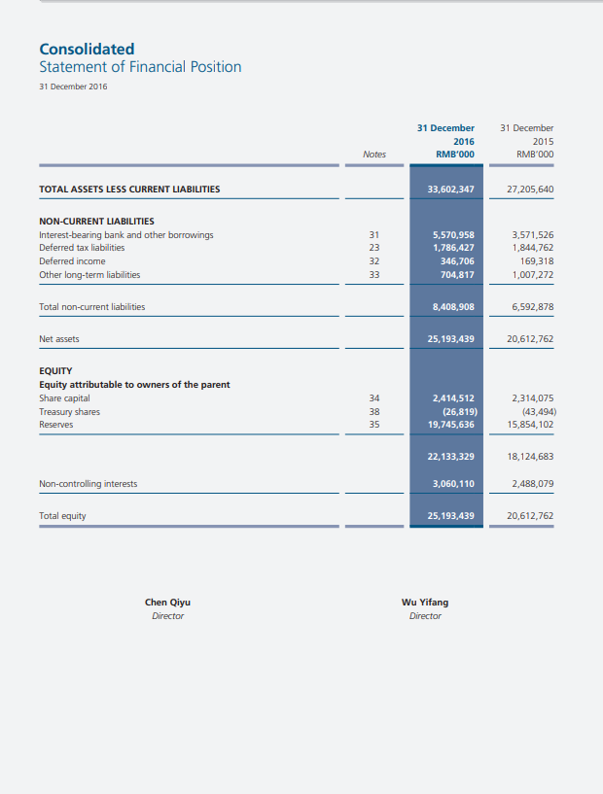

Appendix 4 – Financial Statement of China Grand Ph 2018

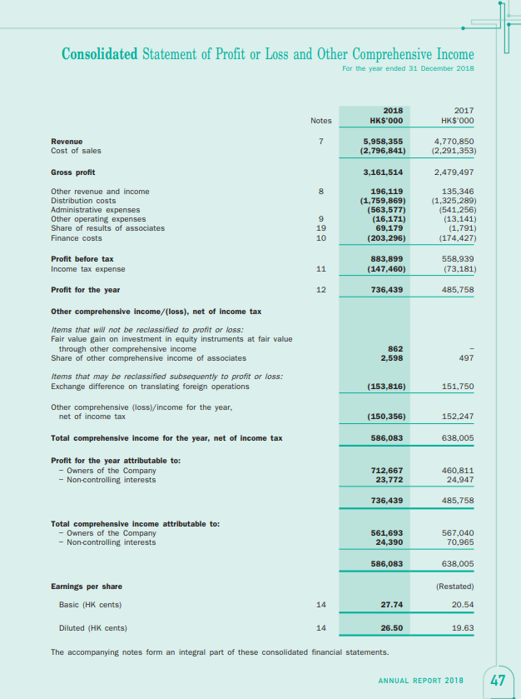

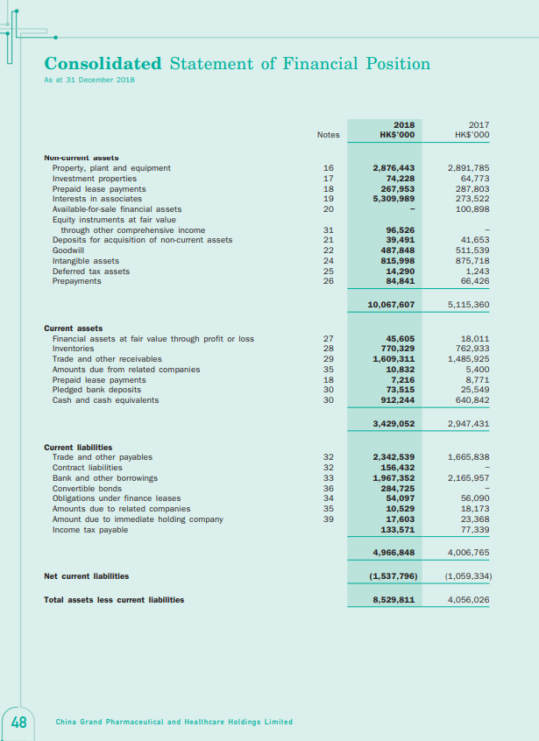

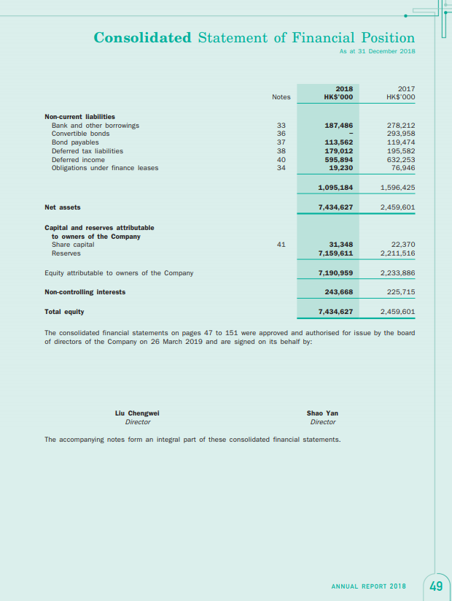

Appendix 5 – Financial Statement of CMS 2018

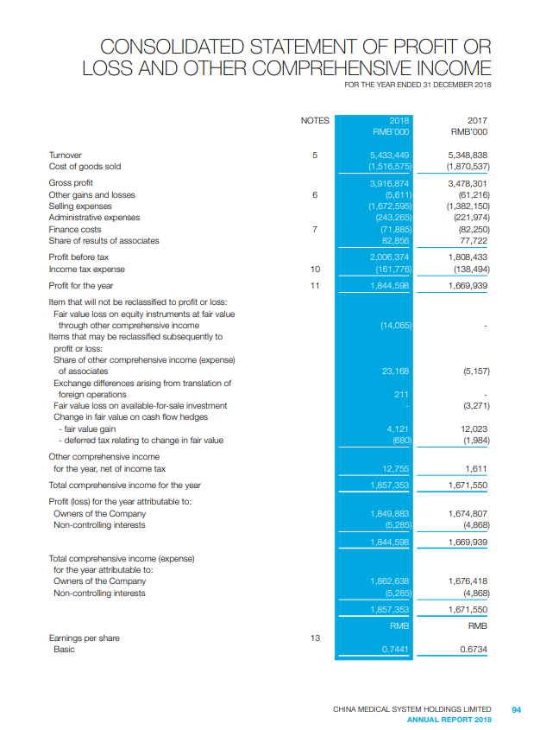

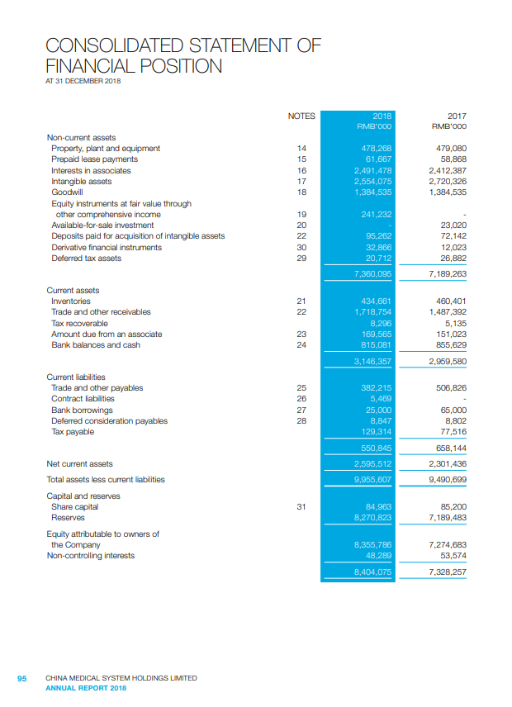

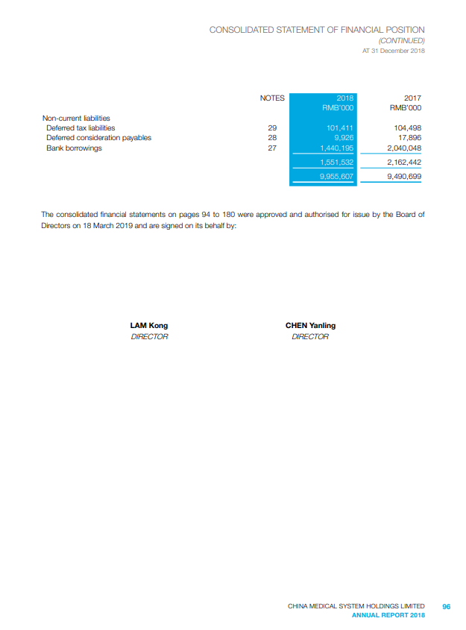

Appendix 6 – Z Score and Ratio Calculation



