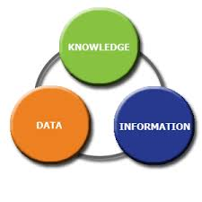


Name: Suraya Begum
Student NO:1712135
Module: Knowledge and Information Management Skills for workplace BMSK5006
Lecturer: MD Nazmul Hasan
Task 1

1. Explain why the same set of data can be considered as useful information by some and useless data by others. Further, could this useful information be termed as “knowledge”? Why?
The same set of data can be considered useful depending on what the data is being used for and by who.

Eg.1 Holiday Abroad
If you’re going on a holiday for the very first time by flight, you will need some guidance to get around. You will need to do some research beforehand so that you know what to pack, where to tour, where to eat and most importantly have the correct currency. All this information is very important and very useful for those people that are travelling for the very first time. They will have to do some research and gather all the information they need to make their holiday a success. And at the end all this research and information gathering will become knowledge for them and they will no longer need a tour guide or need to do any research.
In a bookshop you have books everywhere but not everyone is buying the same type of book as you. You can buy a tour guide on Spain which will be very helpful to you to get around the place as its going to be your very first time abroad but it won’t be useful for some people who’s already been there. So, this book will be meaningless for them to purchase.
This is because all this information may be new to some people but is old to those who already has the knowledge of the place and will become knowledge to those who has purchased it.

Eg.2 Tuition centres
An advertisement of tuition centre on the internet offering help to children in Key stage 1, Key stage 2 and GCSE level. This kind of information will be very useful to a number of people especially those who are looking for this kind of help to support their children because the schools are trying to implement extra studies to help children succeed and do better in the future. So, you will have a number of individuals searching for this same set of information.
But on the other hand, it may not be as useful information to the same set of people if they were all looking for different help because their children may not require the same kind of support as each other. This is because tuition centres are not only offering help in one subject, or at the same level. Tuition centres offer different kind of help to all children of different ages and academic levels. You will have children of different academic years needing help in different subjects and levels so again its useful for some and not for others.
The basic information of the tuition centre will be useful information for the same number of people such as the location of the centre, the opening times and fees of the subjects as this is all basic information.
This data will become knowledge for those parents who have just found out where the centre is and what the centre is offering to their children. They will now become aware of the times, what subjects are taught, and they can now recommend and pass on their knowledge to other parents that may be looking for the same help.

2. Describe the ways in which “knowledge” differs from “data” and “information.” Justify your answer with a relevant diagram.

What is knowledge?
Knowledge could be a lot of things, such as:

- Familiarity
- Awareness
- Remembering
- Discovery
- Understanding
- Someone/something
- Facts
- place
- Information
- Descriptions
- Experience
- Education
- Experiment
- Memory
- Skills

Knowledge is facts, information, and skills that have acquired through your experiences and education. Knowledge is your understanding of certain things which could be a number of things. Knowledge can be explicit or tacit, depending on you and how you transfer this knowledge.
Knowledge is defined in what you have learnt, it could be anything for e.g. something you have learnt from doing a coursework in a subject at college or school. Whatever you were taught in that lesson will become your knowledge because you are learning and taking in all the information that’s being taught to you and understanding it to make sense in your brains. Once you have understood the information then that information will be transferred as knowledge. Knowledge can be something that is true or even made up, it could be an opinion too, it can also be something that your familiar with or that you are aware of, e.g. you are aware of the consequences of doing something that’s not right or illegal. You know you have done something wrong and you could get into trouble and end up paying a penalty.
A classical definition of knowledge is – justified true belief, so for something to be knowledge it must be true, you must believe it and you must have some justification for believing it. (JJ. Chikawa2001)

What is data?
Data is unstructured facts, figures, statistics details, description, symbols, raw and specific. Data are individual units of information, it is distinct pieces of information, usually formatted in a special way. In an IT organisation environment, they use data as a software which is divided into two general categories: data and programs. Programs are collections of instructions for manipulating data. (V. Beal)
There are two main types of data, Qualitative data and Quantitative data.
Quantitative Data – is numbers and things you can measure Objectively: dimensions such as height, width, length. E.g. Temperature and humidity, prices and shares, area and volume, measurements in centimetres and inches.
When you measure an object or even a room you give it a number value and that is you creating a Quantitative data.
Qualitative Data – means Characteristics and descriptions that can’t be easily measured, but can be observed subjectively- such as Smells, tastes, textures, noise, attractiveness and colour.
When you describe or judge someone or something then you are creating a Qualitative Data.
Data can also exist in many different formats such as: numbers or text on a piece of paper, as bits and bytes stored in electronic memory, or as facts stored in a person’s mind. In the mid-1900s, people have used to word data to mean computer information that is transmitted or stored on the computer.
Another example I work at the library and we have borrowers joining the library in order to use the facilities we offer. You need to be a member to borrow books and use the computers. First, they have to fill out a joining form, they need to fill out all their personal information such as: name, date of birth, address, contact number, email address etc. All this data will then get put onto the computer to create an account under their name. Without this data we will be unable to create an account so it’s important we gather all this data first and then create their own account, this keeps a record of all the borrowers and helps to manage their account.

What is information?
Information is what you have gathered from research, it is structured, organised, understandable, clear and makes sense. Information is facts that’s been provided or learn about which could be of someone or something. Its details of particular facts that’s made into information.
Information is data that has been designed to help answer and solve problems. An information system helps organise data, the purpose of information system is to turn raw data into useful information that can be used for decision making and problem solving easier in an organisation or even in your personal lives.
Definition of information is news or knowledge that’s been given to you or received e.g. if you wanted to find out about something or someone who maybe is famous person or place and then you did a search on that subject, you will end up finding so much information on that topic.
Information is used in connection of understanding what information sources people chose to use, and in the ways in which people apply the information to make sense of their lives and situations. You basically make decisions based on the information you receive and how and what format you receive it in.
In an organisation and in your personal life information is a very important role because information helps you to make the right decisions in your life and guides you the right way too. You have to be careful too, the information has to be accurate because without the correct information you can end up making lots of mistakes and take the wrong path making your decision which can lead you to a huge loss in a business. Information is the key role and plays a very important step in transformation of decision making and problem-solving processes. Information is important in our lives as it can help to improve the quality of our lives and it can be used as a learning curve. It can also educate us and provide us a guidance to widen our knowledge as we will be learning from our mistakes and absorbing the information into our system.

Decision making
Synthesizing
Knowledge
Analysing
Summarising
Information
Organising
Collecting
Data

(Source: Created by Learner)
Raw data put together makes information, making sense of information and understanding the information becomes Knowledge.

3. Does a player in a card game use tacit or explicit knowledge? Explain why. Define and explain the difference between the two.
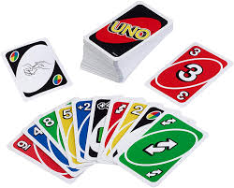
Yes, a player does use both tacit and explicit knowledge in card games because this makes the game interesting and enjoyable which can go on and on for ages. It depends on what game you are playing and what information you want to share. For example, playing Uno, which is a card game, like all card games you have basic instructions on how to play which everyone will be aware of. By playing this game I may have picked up a few tricks and techniques which helps me in winning the game. I can keep that knowledge to myself and wish not to share it. Although this will make the game easier to play but it will get boring and everyone will end up knowing all the tricks. So, if I keep it all to myself then that knowledge becomes Tacit Knowledge as I have decided not to share it. I can use those techniques to win every game whereas if I shared my tricks then the opposition player will learn my tricks and decide to use it against me and beat me in the game. If I shared my tacit knowledge, then this knowledge will no longer be tacit it will become Explicit knowledge.

What is the difference between Tacit Knowledge and Explicit Knowledge?

Tacit Knowledge (knowing how to do it) is the kind of knowledge that is difficult to transfer to another person. Tacit knowledge is hidden knowledge that’s embedded into the individuals mind through experience and job. They know how to do certain things through learning, which is embedded within the mind, their personal wisdom.
Explicit Knowledge (knowing that this is the way to do it) its coded, digitalized, written in books, documents, instructions, reports and memos. Its information that can be documented and facilitated to others, it’s a knowledge that is easily identified, shared and employed.
Explicit Knowledge | Tacit (implicit) Knowledge
- Structured  - Fixed content  - Content independent  - Externalized  - Easily documented  - Easy to codify  - Easy to share  - Easily transferred/taught/learned  - Exists in high volumes | - Subjective cognitive, experiential learning  - Personal  - Content sensitive/specific  - Dynamically created  - Internalised  - Difficult to capture  - Difficult to share  - Hard to document  - Hard to transfer/teach/learn

Source (Created by learner)
Tacit Knowledge is hidden knowledge, unspoken communication and is hard to understand or learn as its something that only the individual that has control over. Once its shared and communicated amongst other then it no longer stays a tacit knowledge it becomes explicit knowledge.
Explicit Knowledge is a knowledge that can be easily transferred, shared with and communicated with through spoken or written. Explicit knowledge can be learnt as it is structure information.

4. Consider five decisions you have made today (they could be simple such as taking a turn while driving or even choosing a soda at a convenience store). In each case determine the data, information, or knowledge that were involved in the decision.

Decision 1 Cooking a Dish
I woke up today and decide to cook a dish.
The data will be my utensils and ingredients that I will need to cook my dish.
- Ingredients: Pots, pans, spoons, chopping board, knife, onions, garlic, ginger, salt, herbs, curry powder, cooking oil, green chillies and fresh coriander.
- Fish, meat, chicken?

All this is above is the data as it doesn’t make sense what it is at the moment, it’s just a list of ingredients not knowing what’s going to be cooked. Once I have decided what to cook then that becomes my information as I know exactly what I’m cooking its no longer confusing.
How to cook it step by step and how much quantity of the ingredients is my knowledge. If I hadn’t known how to cook it then I would be clueless but because I know what I’m doing and how I’m doing that is the knowledge.

Decision 2 taking a short cut to School.

I have only 20mins to put some fuel in my car before school runs and we are running late so I need to think quickly how to get to the petrol station, put fuel in and get to school on time. I have to also think of a shortcut avoiding all the school rush too. The Data here is the time, fuel, short cut and avoiding the traffic. The Information is how can I get to the petrol station quickly and get to school in 20 mins. The knowledge here is I know I have only 20mins, the school is only 5mins away, the petrol station is just up the road and I know there’s a short cut to take so I can avoid all the traffic. Because I have done it before and I am aware of this, that’s the knowledge.

Source (google images)

Decision 3 Sending an Important Email
I need to send a very important email to my manager containing confidential information. The Data here will be the information that I’m going to send, how I’m going to send it and to who.
- Need a computer/laptop
- Open up my emails
- Click compose new message
- Add recipient, add more if need be in Cc or Bcc field
- Add a subject
- Write the message
- Check and send

The Information here will be what contents I will need to write in the email and the person whom I’m sending the email to. Making sure I have the right information and the right email address put in the correct fields before I start writing my email and press send.
The Knowledge is knowing how to do it the step by step instructions of sending an email. Knowing which field is what and where exactly to input all the information. Making sure the grammar is correct, clear understanding, makes sense and professional.

Decision 4 wearing Make-up
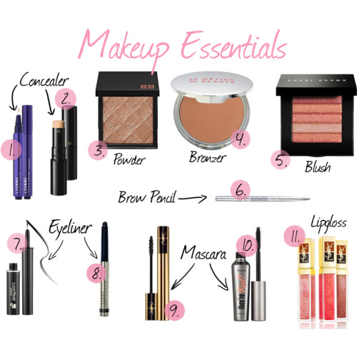
I wanted to create a glamorous look for tonight evening meal with my friends. To apply make-up, I will need:

- Brushes
- Sponge (beauty blender)
- Primer
- Contour kit
- Eyeshadow pallet
- Concealer
- Foundation
- Blusher
- Highlighter
- Lip liner
- Lipstick
- Eyebrow pencil
- Eyeliner
- Translucent powder
- Mascara
- Fixing spray
- Lash curler
- Eye lashes
Source (google image)

All above is the Data, all those items on its own doesn’t mean anything combining it all together you can create a beautiful flawless look which is the Information. You need to make sense of all the items before you understand what to do with it and how to apply it. The Knowledge here is knowing how to create the look you want and what colours to use along with what kind of brushes you need to use to apply the make-up. You need to know exactly what each item is for and how to use it. You need to know what your skin type is and what shade you are for the base which is the foundation. You will also need to know the techniques to apply the makeup without having any idea or knowledge of how to apply makeup then you will not know where to start.

Decision 5 Shopping List
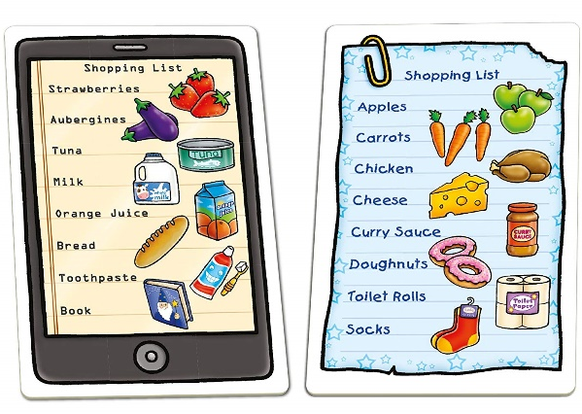
I need to get some shopping for the house I have made a Shopping list of all the items I need from various different shops; the shopping list is the Data as it’s just a list of items and nothing more. The Information is what is it I need to buy and where from for e.g. which shop, what brand and how many the quantity. The Knowledge is I know what I need to buy and where I need to go to buy the items from, for e.g. which shops I need to visit and which aisle the items are kept.

5. Now consider how those decisions would have been influenced by the lack of pre-existing data, information, or knowledge.

If i didn’t know how to cook, I didn’t know what ingredients I needed to cook or the step by step and the quantity of how much salt I need to add, then I wouldn’t be able to cook it at all. I would have been a terrible cook, I could end up putting too much ingredients in, I could end up burning it or end up using the wrong utensils.

If I wasn’t aware of the short cuts, or knew how long it would take me to get to school on time then I would have been unable to mange it in time, but because I knew exactly how long it takes me I was able to do it.

If I had no idea of how to send an email I would have been confused and end up sending confidential emails to so many different people and end up getting into a big trouble. Ii I didn’t input the correct information I would end up getting the manager concerned and worried or even if I didn’t put the correct email address in, the email will bounce back saying unable to send.
Makeup is a very talented technique and is a beautiful art once you know how to apply it on correctly using the correct items and shades matching your skin tone. If you end up using a shade that is darker than your skin or lighter tone, then you would end up looking very pale. You need to know your face and the tone of your face before you purchase the makeup, and you need to know how to apply it otherwise it can look very uneven and messy.
I can write a shopping list in such simple words such as cat food, biscuits or even milk and tell my neighbour to buy it for me but would they know what brand cat food I need or what type of biscuits, is it plain biscuits or chocolate biscuits? or what kind of milk do I need is it semi skimmed or full fat milk? So, a shopping list isn’t clear, but if you know what your getting then it will make sense to you as you know exactly what it is you need.

6. You have recently invented a new product. Collect demographic data from a sample population, determine how you would use this data, and convert it into information and possibly knowledge for promoting the product.
My Unique skincare product is suitable for all skin types and its made with all natural organic ingredients. This product is ultra-soft silky facial cream which is formulated to leave your skin feeling silky smooth and very soft like feather. It is designed for all skin types including sensitive skin.
My targeted audience is young adults aged 25 plus. It is priced at a very affordable price of £18.50 per 50ml tube. Looking at the demographic data and population of Birmingham, I had done some research on young adults and beauty. I wanted to find out what beauty meant to them, did it mean having beautiful skin or makeup? Majority of the population wanted beautiful healthy-looking skin as true beauty was from within and not what’s on your skin from the outside for example makeup. If you have good skin, then the makeup will look better on your skin. That had given me enough data and information in what I had to do next. I knew there was a need of beauty products in today’s beauty industry as a lot of young teenagers and adults are after beautiful skin more than makeup. I had to come up with a product that’s is in need in the beauty world that isn’t too expensive to buy.
I have advertised it to friends and family first for a trial use to see what they had thought of the cream and what the outcome results was. I wanted to see what the reviews were and demand for the product, by doing this I can get a clear vision on what’s working or what needs improving.
Once it was a success, I knew I can start to advertise it at the local beauty stores and on my social media pages such as Facebook, Instagram and snapchat. I had used my own face and few of my friends face as the unique selling point, advertising the before and after pictures. Slowly I had a few customers that was interested and wanted to try out the product. This success has given me enough information into making my product more successful as I knew it was working and got some very positive feedback. I knew what I had to do to promote my unique facial cream, so I did some research and started advertising my product online:

- Have a Unique logo
- Post to google my business
- offering existing customers exclusive previews
- social media contests
- Email Marketing
- Facebook ads
- In-store promotions
- Host an Event
- Contact distributors
- Explore social networking
- Contacted independent sales representatives
- Participate in trade shows
- Request experts to review the product


After promoting my product on many different sources my product had become very popular was in demand.

Beautiful skin beautiful you
Beauty is from within
Source (google image, Created by learner)

References

Designhill. (2017). 10 Marketing Tips To Promote Your Cosmetic Brand Effectively. [online] Available at: https://www.designhill.com/design-blog/10-marketing-tips-to-promote-your-cosmetic-brand-effectively/ [Accessed 22 Oct. 2019].

Bizfluent. (2010). How to Start a Business Selling Cosmetics Online. [online] Available at: https://bizfluent.com/how-7666014-start-business-selling-cosmetics-online.html [Accessed 27 Nov. 2019].

BusinessDictionary.com. (2019). What is tacit knowledge? definition and meaning. [online] Available at: http://www.businessdictionary.com/definition/tacit-knowledge.html. [Accessed 21 Nov.2019]

Designhill. (2017). 10 Marketing Tips To Promote Your Cosmetic Brand Effectively. [online] Available at: https://www.designhill.com/design-blog/10-marketing-tips-to-promote-your-cosmetic-brand-effectively/. [Accessed 23 Nov. 2019]

Ichikawa, J.J. and Steup, M. (2017). The Analysis of Knowledge (Stanford Encyclopedia of Philosophy). [online] Stanford.edu. Available at: https://plato.stanford.edu/entries/knowledge-analysis/. [Accessed 20 Nov.2019]

Minitab Blog Editor (2017). Understanding Qualitative, Quantitative, Attribute, Discrete, and Continuous Data Types. [online] Minitab.com. Available at: https://blog.minitab.com/blog/understanding-statistics/understanding-qualitative-quantitative-attribute-discrete-and-continuous-data-types. [Accessed 20 Nov.2019]

PC Dreams. (2019). PC Dreams. [online] Available at: https://pcdreams.com.sg/importance-of-information-and-communications-technology-ict-in-our-daily-life/. [Accessed 22 Nov.2019].

Webopedia.com. (2019). What is Data? Webopedia Definition. [online] Available at: https://www.webopedia.com/TERM/D/data.html [Accessed 15 Oct. 2019].

Task 2 Case study
1.Describe how the overall approach adopted by American Airlines incorporated the basic competitive strategies of cost leadership and product differentiation.
The overall approach adapted by the two airlines merging together has increased its profits by agreeing to work with sabre for the newly combined airlines single reservation system. Sabre was built to reduce the costs of making airlines reservation. Sabre offers a range of software and data solutions to help airlines sell their products, enhance their customer service and help market themselves well. Sabre has replaced the handwritten reservation system to more up to date online reservation system. The new data rich software helps airlines to make smarter operational decisions and helps to retail their products to their travellers. By merging with sabre, the sabre system has saved 30%on its investments, this has given American airlines a better strategy to achieve higher profits. This has given American airlines and opportunity to grow and expand their industry. Their strategy is to offer an exciting vision for transforming the airline passenger experience and they will be working closely with sabre to bring flexible technology solutions. The travel agents wanted to expand this new system as it was cheap low rate fares and it made reservations possible through online terminals. The new system has helped with their flight schedules, customers and employee reply on the system to identify any available flights, helped with meeting customers needs, preparation of lights e.g. delivering flight status and gate numbers, checking and receiving luggage/baggage. American airlines have benefited a lot by merging in with sabre.

2. In what ways did SABRE provide American Airlines with a competitive advantage? Your analysis should refer to concepts related to the strategic use of information systems, for example, entry barriers.
The threats of substitute was low as American airlines was the first to jointly work with sabre, and they continued to invent and bring industry defining capabilities to American airlines by introduction bargain finder pricing which automatically provided American airlines with the lowest fare prices, a service which was matchless in the business and was welcomed by travel agents because of the lowest fare prices for its customers. During that time sabre had expanded to store 36 million fares and by the end of the time. Sabre system were already running over 130,000 travel agents worldwide.
Sabre released its very first revenue management system, which increased its revenue by optimizing a price for each seat sold. Sabre became one of the most advantaged technological airlines in the world which made them low at risk. Because they were in the low risk of competitive advantage this gave them an opportunity to enhance their service and promote more new services. Because they were one of the first to come up with this reservation system, they were at low risk and treat of new entrants were very low. They have expanded and grew very quickly in the industry which benefit them a lot as they become more demanded by travel agents. Today sabre has a global presence with primary locations around the world. they became a much larger asset than just an internal IT group.

3. Although SABRE was undoubtedly successful, American Airlines was not able to maintain its competitive advantage beyond the late 1980s. What factors played a part in the erosion of the company’s lead over its competitors and how did the company react?
Sabre started taking their technology to the marketplace, providing software consulting and systems management services to other airlines. Once American airlines was one of the most technological advanced. In 1985 American created easy sabre to give customers online access on the internet. Not long after that sabre had broken a new ground launching the industry’s first revenue management system. This system was helping other airlines maximise the air fare. In 2000 sabre decided to separate from American airlines to form their own company called sabre holidays corporation. Sabre gave their customers the first experiences with the way computers could instantly handle transaction and kept track of supply prices and customers. American airlines started making mistakes and upset their customers. Their flights started arriving late, and that had a huge impact on the cost. American airlines started giving out rewards, free meals, vouchers, upgraded seats to their upset angry customers. Airlines failed to deliver 3rd of their customers to arrive on time to their desired destinations on the scheduled arrival times.

Part 2 -Information Systems

1. Define an Information System
An information system is a software that helps an organisation to organise and analyse data. This makes it possible to answer questions and solve issues relevant to the business mission in an organisation. It’s a computer-based system for collecting, creating, sorting, processing and distributing information. It’s a hardware and software system, the use of information systems to solve business problems.
Technology – is a system where you store information on a computer on its hard drive. It’s a software, hardware system where data is stored and network communication. Hardware is a computer, tablet, laptop and a phone. Software is a program that is stored into these hardware’s which makes it work.
An information system is a methodology created by a firm to gather assemble and provide data in a form or forms useful to managers. Most information systems are computerised. (R.W. Griffin2002. p446)
The business information system gets data and processes them to comply with the informational needs of different individuals connected with the business.
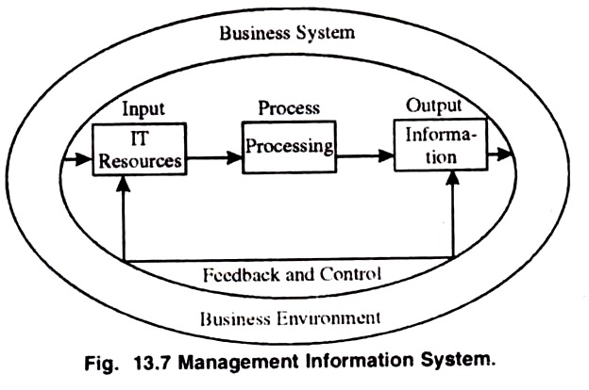

Source (google image)

There are some systems that take control over the IT supplies and gets feedback of useful clues to increase the benefits of Information system.
Categories of computer-based information system are as follows:
- Transaction processing system
- Decision support systems
- Knowledge management systems
- Learning management systems
- Database management systems
- Office information systems
These are some types of the information system.

1. Define an information system; 2. Describe the categories of computer-based information systems, providing relevant business examples for each category identified.

Office Automation Systems – this information system supports in automating office tasks in decision making they have a limited role but are useful for operational level of employees. This system can be used for rule- based decision making for managers. However, these systems play an important part in automating several functions of an office and helps to create a paperless office. These system deals with operational data and helps increase the productivity and efficiency of a workforce environment tasks. The advantages of this systems office work become faster, and all basic data is digitalised and stored away.
Transaction Processing System – this is a critical system which smooths the functioning of an organisation. This kind is to capture the data relations between the organisations external and internal customers. Transaction processing system is the most widely used information system because the provide the management with the flexibility of storing data in a structured way.
Decision Support system – this system helps support senior management to take strategic decisions. This system helps managers develop and analyse the different scenarios that may occur and helps make decision made better. It deals with both external and internal data. The main role is to access data from data storage area.

3. Explain how computer-based information systems can support managers at each level of an organisation.

Computer based information system supports management in every aspect of the organisation. It helps with analysing sensitive data, helps with storing data safe, helps with decision making, gives an accurate information, it helps with identifying who the competitors are as the executive support system helps to provide a macro-organisational wide view for senior executives. Decision support system helps management to develop ‘what if analysis’ so that different scenarios can be developed.

References
Schlangenstein, M. (2019). American Airlines keeps canceling flights and its CEO is taking the heat. [online] Los Angeles Times. Available at: https://www.latimes.com/business/story/2019-09-03/american-airlines-keeps-canceling-flights-and-its-ceo-is-taking-the-heat [Accessed 29 Nov. 2019].
‌
Travel Agent Central. (2014). American Airlines Selects Sabre Reservation System. [online] Available at: https://www.travelagentcentral.com/transportation/american-airlines-selects-sabre-reservation-system [Accessed 25 Nov. 2019].
‌
The Sabre Story. (2016). [online] Available at: https://www.sabre.com/files/Sabre-History.pdf. [Accessed on 25 Nov.2019]
‌
Sabre.com. (2014). American Airlines selects Sabre reservations system « Sabre. [online] Available at: https://www.sabre.com/insights/releases/american-airlines-selects-sabre-reservations-system/ [Accessed 27 Nov. 2019].
‌
Ibm.com. (2012). IBM100 - Sabre. [online] Available at: https://www.ibm.com/ibm/history/ibm100/us/en/icons/sabre/ [Accessed 20 Nov. 2019].
‌
Reed, D. (2018). American Airlines Is Sorry You’re Upset With Them, Just Not Sorry Enough To Fix The Real Problem. Forbes. [online] 26 Jul. Available at: https://www.forbes.com/sites/danielreed/2018/07/26/american-airlines-is-sorry-youre-upset-with-them-just-not-sorry-enough-to-fix-the-real-problem/ [Accessed 22 Nov. 2019].
‌
Your Article Library. (2015). Business Information System: Meaning, Features and Components. [online] Available at: http://www.yourarticlelibrary.com/management/information-system/business-information-system-meaning-features-and-components/70319 [Accessed 25 Nov. 2019].
‌
Griffin, R.W. and Pustay, M.W. (2002). International business : a managerial perspective. Upper Saddle River, Nj: Prentice Hall. [Accessed 29 Nov.2019]
‌

