 | Targed/target | Yr hyn yr wyf wedi'i wneud yn yr aseiniad hwn  What I have done in this assignment...
Targed/Target 1 | Please look at Academic Phrasebank | Being critical (manchester.ac.uk) which will help you develop a more academic style of writing. You should also check your use of the possessive apostrophe and always proof read your writing carefully. | To ensure my academic style of writing has increased, I have used the Phrasebank to increase my level of academic writing.
Targed/Target 2 | You should ensure that you engage with a wider range of literature (primary sources) and use this to reinforce what you are trying to say - you need to avoid sweeping statements and name the authors who you are mentioning. | I have used a wider range of resources, including Welsh government resources, articles and reports.
Targed/Target 3 | Aim to structure your work so that there is depth in what you are saying - you can use sub headings as you are writing that can later be deleted. This will help you to go into more depth. | Throughout this assignment I have used subheadings to ensure the report is structured.

How a school develops one aspect of its SDP: a report that critically reflects on the actions, impact and evidence base.

Introduction
This report will critically examine the process of how a school develops a specific aspect of their school development plan. According to the Welsh Government (2014) to achieve improvement within a school setting, a strategic plan is put in place with aims to improve pupil results recognised as a school development plans (SDP). To be able to outline the aims it is fundamental that reflection takes place first (Zepeda, 2019). A school development plan cycle focuses on the sequence of: ‘Self-evaluation, strategic planning, making improvement/action and reviewing impact’ (Welsh Government, 2014, p.7). In contrast, Estyn’s role is providing external school inspections with consistently planned, extensive and thorough action points (Welsh Governement, 2021a; OECD, 2014). The importance of stakeholder involvement and reviewing the impact are included in the various steps of the school improvement sequence (Estyn, 2021a).

Through this report, The British Educational Research Association, BERA (2018) Ethical Guidelines for Educational Research will be considered, the school will remain anonymous and will be known as school X. School X is based in southwest Wales and is a large English medium primary school with a current roll of 566.5 pupils and 24.48% entitled to free school meals, the catchment area may be identified as economically disadvantaged (School development plan, 2023).

Literature review
School development plan
The main priorities that are recognised by the school are clearly highlighted in an advanced report under the SDP, this will also include the actions in which the school will follow to improve pupil outcomes (Woods and Brighouse, 2013; Welsh Government, 2021C). The SDP must be a live document which is frequently monitored and updated to reflect on the school’s progress, while considering the recent performance data (Welsh Government, 2014). In addition to this, Abdallah and Alkaabi (2023) state to meet the expected improvements, school development planning should base the drive decision-making on data analysis because it pinpoints important areas for immediate improvement. The compulsory period of a SDP is three years, the first year consists of specified targets, priorities, and strategies, in the second and third years the focus is identifying high-level targets and priorities (Welsh Government, 2014).
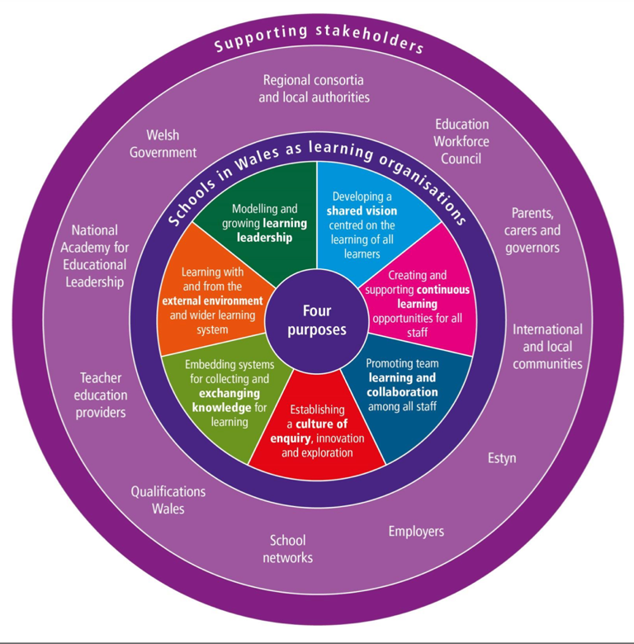
In Wales, it is essential to promote schools as learning organisations (SLOs) (See figure 1) to inspire them to implement the new curriculum effectively. It appears schools are making progress in encouraging learning and collaboration between staff, while also inserting systems to gather and share knowledge and learning (OECD, 2018). A school as a learning organisation sharing a vision provides guidance towards actions and motivation for the school to achieve goals, it is a collaboration process that involves pupils, staff, parents and stakeholders (OECD, 2016).

Appendix 1 – Schools in Wales as learning organisations model (SLOs)
The key to combining all areas of the learning organisation is leadership, school leaders promote collaboration with parents, schools, and the community while also leading example of adopting leadership development and sharing responsibilities (Gouedard et al, 2023). Goldstone (2022) suggests that inclusive leadership is essential by informing all school stakeholders with regular progress and allowing all to participate. According to Brighouse and Woods (1999, p5), all schools need a ‘critical friend’ commonly known as a stakeholder. However, it was discovered in research by MacGilchrist and Mortimore (1997) that governors preferred reports from the headteacher instead of observations or meetings, as they felt that due to their lack of confidence in evaluating and monitoring progress of the plan.
Following the considerations of the SLO model, closely associated is the school development cycle which many schools in Wales have adopted (See figure 2), setting out priorities and targets founded on strong and direct evidence-based self-evaluation (Welsh Government, 2022). Estyn (2023) discussed effective practise in a school and how all stakeholders are included in the process of self-evaluating and following a quality cycle aids effective and detailed improvement.

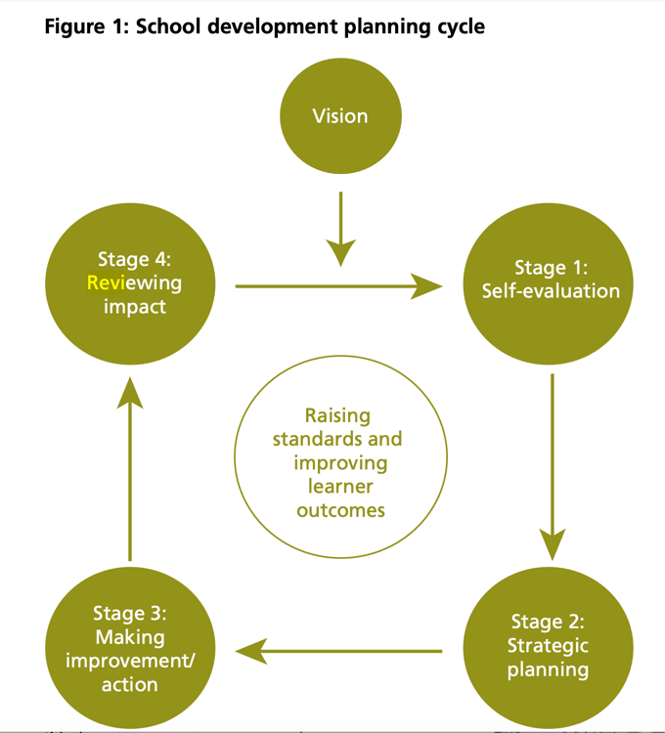

Appendix 2 – School development planning cycle
Whole school approach
The Welsh government’s aim for 2050 is to have one million Welsh speakers, to achieve this vision three strategic themes have been identified: ‘increasing the number of Welsh speakers’, ‘increasing the use of Welsh’ and ‘creating favourable conditions – infrastructure and context’ (Welsh Governement, 2017, p.4). It is suggested through evidence-based reports that the number of Welsh speakers would roughly reach 750,000 in two generations (Williams, 2017). To form a concept of the future, the Cymraeg 2050 is a strategic policy document to support this, including another goal to double the percentage of everyday Welsh speakers from 10% to 20% (Welsh Government, 2017).
Jeremy Miles states in ‘Our national mission’ (Welsh Government, 2023) the likely long-term effects of coronavirus (COVID-19) pandemic on education will be tackled by creating a more equitable, inclusive, and high-quality education system preparing learners to succeed in a changing world. To support this the Welsh in education workforce plan (Welsh Government, 2022) will develop and increase leaders, teachers, and support staff Welsh language skills to be able to teach through the medium of Welsh.
Starting in 2022 the same curriculum for the Welsh language will be followed by all pupils, however the standards will vary between Welsh medium pupils and English medium pupils and support the teachers’ skills through a sabbatical system (BBC, 2019). The Welsh sabbatical scheme, also known as the Professional learning sabbatical scheme, offers teachers and headteachers the opportunity to take leave and develop their Welsh language skills by the Welsh Government (Welsh Government, 2021C). During 2006 to 2016, more than 1000 teachers successfully completed the course with the aim to enhance their Welsh language skills (Cymraeg, 2016).
In their research, Baker and Wright (2017) consider the impact of strengthening the Welsh language in Welsh-medium schools. Although, they note the possibility that Welsh could only be restricted in educational settings if it is not used beyond the classroom. To encourage pupils use of Welsh language outside of the classroom, it is essential that teachers allow for opportunities for pupils to start conversations rather than the teacher (Morris Jones, 1995). This is support by Morris (2010) suggesting that increasing Welsh in everyday environments and extracurricular Welsh activities for pupils will strengthen Welsh in the community. In a report by Estyn (2007a) it is suggested that the importance of incidental Welsh in the classroom is not always recognised by trainee teachers, indicating simple commands were being used.
Under the Well-being of Future Generations (Wales) Act (Welsh Government, 2021a) one of the goals is to protect and promote the Welsh language, culture, and heritage inspiring individuals to partake in sports, recreation, and arts.

Developing an action point
Self-evaluation
Outlined by Donaldson (2015) self-evaluation in schools should make a large contribution in improving the quality of education and increasing standards of achievement. Considering the school development cycle (see figure 2), it is an on-going process and the school (school X) in which this report is focused on self-evaluates termly (Head teacher, 2024). School X continuously focuses on improving standards across the school, the Welsh Government (2014) note outcomes should prioritise raising standards and improving pupil’s results.
After COVID-19 pandemic, school X noticed a decrease in the use of Welsh language throughout the school (Head teacher, 2024). In September 2021, school X’s results found that 78% of pupils throughout the school were unable to understand and answer to questions. In a recent research article, Hampton and McAuley (2023) identify several factors which may have impacted pupils during the pandemic such as the level of online provision, pupils with additional learning or support needs and appropriate home learning environments. While also considering there are low levels of Welsh spoken across the community which means very few pupils will speak Welsh at home with their families (Estyn, 2016).
To help overcome the impact of COVID-19, school X have included in their SDP that teachers are expected to teach at least 15% of school activities in Welsh, inside the classroom and outside. While also considering the Welsh Governments (2017) Cymraeg 2050 million speakers.
Through the Welsh language charter award, a questionnaire was sent to years 1 to 6 used to highlight any areas for improvement against targets, it Identified areas for development (Head teacher, 2024). Considering Estyn’s (2016, p5) report on School X, it stated that during Welsh activities ‘nearly all pupils take part enthusiastically’, this clearly indicates that there are still a more pupils who should be taking part and confidently.
Strategic planning
The process of planning for improvement includes authentic self-evaluation through using qualitative and quantitative data (Welsh Government, 2014). Through the monitoring of standards school X conducts learning walks, books scrutiny and analysed data, resulting in vigorous monitoring of quality of teaching, learning and the curriculum (Estyn, 2017). A learning walk is an observation of teaching, provision or school life which can be formal or informal with stakeholders such as governors, parents and staff contributing to the process (Estyn, 2017).
On inset days, the headteacher (2024) includes both teachers and support staff, the significance of developing the skills of not only leaders, teachers and governors but also support staff is highlighted by Estyn (2013; cited in OECD, 2014) given they play a crucial role in contributing considerably to improving the school’s engagement with parents and the community.

MARS EARS is a pedagogical cycle over 6 weeks, where pupils will not complete any written work until the end, initially it focuses on sentence patterns and builders with an effective end product (Y Gromlech, n.d).
Each class through the school will do daily ‘drilio’, where the pupils will be asked various everyday questions regarding the weather, date, wellbeing check in. From early years the pupils are hearing incidental Welsh throughout the day, the Welsh Assembly Government (WAG) (2008) expresses that all teachers in foundation phase classrooms should create bilingual environments.
The Welsh advisory teachers will regularly communicate and support other staff members in the school. Results found that team learning and collaboration between staff was encouraged by seven out of ten schools, however felt more observations and team problem solving could be done (OECD, 2018). Overall, the school’s provision for encouraging the Welsh language is very successful by basing a pupil and staff ‘Welsh champion’ in each wing who will provide opportunities for development (Estyn, 2016). The great teaching toolkit constructed by Coe et al (2020) highlights that great teachers have a passion to improve their teaching by collaborating with other staff members and supporting them. It is fundamental that all stakeholders and school partners are involved in the SDP to ensure everybody is dedicated so it is most successful (Welsh Government, 2014).
Making improvements/actions
Once a strategic plan has been formed the next step is to put the SDP into practice by implementing the actions and strategies outlined (Welsh Government, 2014). Following this, the roles and responsibilities are clearly outlined to each member of staff including timescales to maintain focus (Welsh Government, 2021).
Donaldson (2015) discusses an important aspect of leadership is encouraging and supporting staff explore new responsibilities. To ensure all staff members are continuously dedicated and involved, high-quality leadership is vital (Welsh Government, 2014). The headteacher (2024) provides management roles across the school to each year group, this also ensures all classes and year groups are differentiated correctly.
Reviewing impact
According to the Welsh Government (2014) reviewing impact must be annually. Although, the headteacher (2024) advised that reviewing the impact is conducted on a termly basis, which aligns with Estyn’s framework for inspection. School X regularly monitors and reviews targets, this is supported by Luneburg and Ornstein (1991, cited in Javed, 2019) stating that constant reviewing and evaluation of pupils success is one of the important principles of a SDP. As informed by the headteacher (2024), to review the impact and measure the effectiveness of strategies and interventions used, pupils feedback is gathered through questionnaires which aligns with the learning organisation model (OCED, 2018).
Aiming to increase pupils ability and enjoyment of Welsh, schools will provide Welsh-language experiences throughout the curriculum and encourage the use of the Welsh-language outside of the classroom (Welsh Government, 2019). Following this objective, school X noted an increased level of pupils enjoyment when learning and speaking Welsh in enriched experiences and activities.

Reflection and evaluation
Critically reflecting on school X’s SDP to increase the use of Welsh language, they are inspiring members of staff and pupils to become leaders and experts. Each year group has a pupil and staff member who is considered a ‘Welsh champion’, these individuals feed their knowledge to the rest of the school (Head teacher, 2024). Equally, the school has effectively adopted the school development planning cycle (2014) The school effectively monitor standards through learning walks, ensuring all stakeholders are involved (Estyn, 2017).
The school has regular training and meetings to further inform staff of new interventions, Estyn (2022) suggests providing professional learning opportunities for staff is identified as effective practice as it enhances their Welsh language skills to support pupils over time. School X could look to support more staff members by putting them through the Welsh language Sabbatical Scheme, although there are other available courses to support teacher and teaching assistants including part time courses (Welsh Government, 2018).
Reflecting on the SLO model, staff commonly share perceptions on learning and teaching, collaborate to tackle challenges to improve student learning (OECD, 2016). A pilot survey was sent to schools by the Welsh Government and the OECD, the survey was the School as Learning Organisation (SLO) that school X took part in. Overall, the results were highly positive from staff leading to an average score on all SLO dimensions, although it was noticed that support staff were offered less continuous learning opportunities than teachers (OECD, n.d).
In a recent report by the BBC (2019) quoted Prof Sioned Davies recommended to achieve a million Welsh speakers, the term Welsh second language needs to be removed.
To further develop more pupils school X could provide extracurricular activities for pupils in Welsh, especially areas for improvement (Morris Jones, 1995), will increase their level of Welsh and skills to improve their confidence (Welsh Government, 2021b).
Reflecting on the enhancement days in university, a lecturer discussed a very important point that most teachers will teach about other countries history and not Welsh history. Considering the statements of ‘What Matters’ for Humanities the Welsh Government reinforced it in 2021, ensuring Welsh history is precise and mandatory in schools (Welsh Government, 2022). Following this, an Estyn (2021) report agreed with the Welsh government and will assess Welsh history being taught in schools.

Conclusion
The aim of this assignment was to critically examine the process of how school X develops an aspect of their SDP. Considering the process and methods implemented, it has provided an understanding of the effective strategies used by school X. It has outlined the importance of how a SDP is an ongoing process, with consistent monitoring, self-evaluation, and adaptation to improve any priorities (Welsh Government, 2014). Through exploring the SLO model and school development planning cycle it has clearly demonstrated the significance of everyone being involved in the SDP (Welsh Government, 2022). Moving forward with my own personal teaching career I will ensure to explore the schools SDP and provide full engagement and understanding of my role and responsibilities (Gouedard et al, 2023). To further develop personal Welsh language skills the research will be keen to take part in the sabbatical scheme (Welsh Government, 2018).

References
Abdallah, A. and Alkaabi, A. (2023) Restructuring leadership for school improvement and reform. 1st ed. Hershey, PA: Information Science Reference.
Baker, C. and Wright, W. (2017) Foundations of Bilingual Education and Bilingualism. Clevedon: Multilingual Matters.
BBC (2019) English-medium education to put more emphasis on Welsh. Wales section of BBC News. Available at: https://www.bbc.co.uk/news/uk-wales-46909295 [Accessed: 27 February 2024].
Brighouse, T. and Woods, D. (1999) How to improve your school. London ; Routledge. Available at: https://doi.org/10.4324/9780203978894 . [Accessed: 23 February 2024].
British Educational Research Association (2018) ‘Ethical Guidelines for Educational Research, fourth edition’. London. Available at: https://www.bera.ac.uk/researchers-resources/publications/ethicalguidelines-for-educational-research-2018 [Accessed: 12 February 2024].
C.H. Williams (2017) ‘Policy review: Wake me up in 2050! Formulating Language Policy in Wales’, Language Policy in Wales | Languages, Society and Policy. Available at http://www.meits.org/policy-papers/paper/wake-me-up-in-2050-formulating-language-policy-in-wales [Accessed: 16 February 2024].
Coe, R., Rauch, C., Kime, S. and Singleton, D. (2020). Evidence Review Great Teaching Toolkit In partnership with. Available at: https://www.cambridgeinternational.org/Images/584543-great-teaching-toolkit-evidence-review.pdf [Accessed: 21 February 2024].
Cymraeg (2016) Sabbatical Scheme for teaching practitioners celebrates 10 years. WG Press Release. [Online] http://cymraeg.gov.wales/Mwy/index/cynllun-sabathol?lang=en [Accessed: 22 February 2024].
Donaldson, G. (2015) Successful Futures – Independent Review of Curriculum and Assessment Arrangements in Wales. Cardiff: Welsh Government. Available at: http://gov.wales/docs/dcells/ publications/150317-successful- futures-en.pdf [Accessed: 15 February 2024].
Estyn (2007) A report on the quality of initial teacher training in University of Wales, Aberystwyth. Cardiff: Crown.
Estyn (2013), Guidance for the Inspection of Primary Schools from September 2010, Updated September 2013, Estyn, Cardiff.
Estyn (2016) A report on Pembroke Dock CP School’. Available at: https://www.estyn.gov.wales/system/files/2020-08/Pembroke%2520Dock%2520CP%2520School.pdf [Accessed: 15 February 2024].
Estyn (2017) ‘Active and experiential learning’. Available at: https://www.estyn.gov.wales/system/files/2020-07/Estyn%2520Active%2520and%2520experiential%2520learning_E_Accessible_1.pdf [Accessed: 18 February 2024].

Estyn (2021a) The teaching of Welsh history including Black, Asian and Minority Ethnic history, identity and culture. Available at: https://www.estyn.gov.wales/book/print/pdf/20673

Estyn (2022) The Welsh language in education and training, 2022-2023. Available at: https://annual-report.estyn.gov.wales/2023/the-welsh-language-in-education-and-training/

Estyn (2023) ‘Self-evaluation and Improvement planning securing a strong impact on provision and pupil progress’. Available at: https://www.estyn.gov.wales/effective-practice/self-evaluation-and-improvement-planning-securing-strong-impact-provision-and [Accessed: 27 February 2024].
Estyn (2023) Self-evaluation and improvement planning securing a strong impact on provision and pupil progress. Available at: https://www.estyn.gov.wales/effective-practice/self-evaluation-and-improvement-planning-securing-strong-impact-provision-and [Accessed: 21 February 2024].
Goldstone, R (2022) School self-evaluation for school improvement: Principles of effective practice. Available at: https://www.bera.ac.uk/blog/school-self-evaluation-for-school-improvement-principles-of-effective-practice [Accessed: 20 February 2024].=
Hampton, J. and McAuley, C. (2023) ‘The Impact of COVID-19 on Well-Being: Welsh Children’s Perspectives’, International journal on child maltreatment : research, policy and practice, 6(3). Available at: https://doi.org/10.1007/s42448-023-00149-w. [Accessed: 17 February 2024].
Head teacher (2024) Interviewed by Katy Rossiter. 17 January 2024, Wales.
Estyn (2021b) The teaching of Welsh history including Black, Asian and Minority Ethnic history, identity and culture. Available at: https://www.estyn.gov.wales/thematic-report/teaching-welsh-history-including-black-asian-and-minority-ethnic-history-identity [Accessed: 22 February 2024].
Javed, M.N. et al. (2019) ‘An Implementation of School Improvement Plan through Results Based Management: A Framework to Practice’, Review of economics and development studies. Available at: https://doi.org/10.26710/reads.v5i1.222 [Accessed: 18 February 2024].
MacGilchrist, B. and Mortimore, P. (1997) ‘The Impact of School Development Plans in Primary Schools’, School effectiveness and school improvement, 8(2), pp. 198–218. Available at: https://doi.org/10.1080/0924345970080202. [Accessed: 20 February 2024].
Marzano, R.J., Waters, T. and McNulty, B.A. (2005) School leadership that works : from research to results. Alexandria, Va: Association for Supervision and Curriculum Development.
Morris Jones, B. (1995) ‘Schools and Speech Communities in a Bilingual Setting’ In B.M. Jones & P. Ghuman (eds.) Bilingualism, Education and Identity. Cardiff: University of Wales Press.
Morris, Delyth. (2010) Welsh in the twenty-first century. Cardiff: University of Wales Press.
OECD (2014) ‘Improving Schools in Wales: An OECD Perspective’. Available at: https://www.oecd.org/education/Improving-schools-in-Wales.pdf [Accessed: 22 February 2024].
OECD (2016) What makes a school a learning organisation? A guide for policy makers, school leaders and teachers. Available at: https://www.oecd.org/education/school/school-learning-organisation.pdf [Accessed: 20 February].
OECD (2018) ‘Developing Schools as Learning Organisations in Wales, Impletmenting Education Policies, OECD Publishing, Paris. Available at: https://doi.org/10.1787/9789264307193-en [Accessed: 18 February 2024].
OECD (n.d) School as Learning Organisation: Snapshot of Pembroke Dock Community School. Available at: https://hwb.gov.wales/api/storage/00a0f436-f73a-42ca-87ff-c7c1a58dc811/School%20as%20Learning%20Organisation%20A%20Snapshot.pdf?preview=true [Accessed: 29 February 2024].
Pembroke Dock Community School (2023) School Development Plan 2021-2024 2023-2024 version. Available at: https://sites.google.com/hwbcymru.net/pdcsprimary/key-information/school-development-plan [Accessed: 18 February 2024].
Welsh Assembly Government (2008a) Welsh Language Development, 3-7 Foundation Phase. Cardiff: WAG. http://gov.wales/docs/dcells/publications/141111-welsh-language-development-en.pdf [Accessed: 17 February 2024].
Welsh Government (2014) School improvement guidance: framework for evaluation, improvement and accountability. Available at: https://hwb.gov.wales/evaluation-improvement-and-accountability/school-improvement-guidance-framework-for-evaluation-improvement-and-accountability [Accessed: 22 February 2024].
Welsh Government (2014). School development plans Guidance. Available at: https://www.gov.wales/sites/default/files/publications/2018-03/school-development-plans.pdf [Accessed: 11 February 2024].
Welsh Government (2015) Well-being of Future Generations (Wales) Act 2015: the essentials. Available at: https://www.gov.wales/well-being-future-generations-act-essentials-html [Accessed: 22 February 2024].
Welsh Government (2018) Sabbatical scheme contributing to one million Welsh speakers. Available at: https://www.gov.wales/sabbatical-scheme-contributing-one-million-welsh-speakers [Accessed: 22 February 2024].
Welsh Government (2021a) School improvement guidance: framework for evaluation, improvement and accountability. Available at: https://www.gov.wales/sites/default/files/consultations/2021-01/210126-school-improvement-guidance-framework-for-evaluation-improvement-accountability.pdf [Accessed: 14 February 2024].
Welsh Government (2021b) Guidance on Welsh in Education Strategic plans. Available at: https://www.gov.wales/sites/default/files/publications/2021-02/guidance-welsh-in-education-strategic-plan.pdf [Accessed: 13 February 2024].
Welsh Government (2021c) ‘Evaluation of the Welsh Language Sabbatical Scheme for education practitioners’. [Online] Available at: https://www.gov.wales/sites/default/files/statistics-and-research/2021-03/evaluation-of-the-welsh-language-sabbatical-scheme-for-education-practitioners.pdf [Accessed: 19 February 2024].
Welsh Government (2022) Written Statement: Welsh history in the Curriculum for Wales. Available at: https://www.gov.wales/written-statement-welsh-history-curriculum-wales [Accessed: 23 February 2024].
Welsh Government (2023) Our national mission: High standards and aspirations for all. [online] Available at: https://www.gov.wales/sites/default/files/publications/2023-03/our-national-mission-high-standards-and-aspirations-for-all_0.pdf. [Accessed 13 February 2024].
Welsh Government (N.D) Developing Schools in Wales as Learning Organisations’ Available at: https://hwb.gov.wales/api/storage/f87e720f-8568-4a60-9383-55e20b9a1bb7/schools-in-wales-as-learning-organisations.pdf [Accessed: 20 February 2024].
Welsh Government (2017) Welsh Language Strategy, Cymraeg 2050. Available at: http://gov.wales/docs/dcells/publications/170711-welsh-language-strategy-eng.pdf [Accessed: 13 February 2024].
Woods, D. and Brighouse, T. (2013) The A-Z of school improvement : principles and practice. London: Bloomsbury.
Y Gromlech (n.d) Teaching Framework PS2 + PS3. Available at: https://sites.google.com/hwbcymru.net/ygromlech/cyfrwng-saesneg/cynllun-datblygiad-iaith/cc2-cc3-mars-ears [Accessed: 02 March 2024].
Zepeda, S.J. (2019) Professional development: what works. Third edition. Boca Raton, FL: Taylor and Francis, an imprint of Routledge.

Appendices
Appendix 1 - OECD (2018) Schools in Wales as learning organisations. Available at: https://hwb.gov.wales/api/storage/f87e720f-8568-4a60-9383-55e20b9a1bb7/schools-in-wales-as-learning-organisations.pdf [Accessed: 19 February 2024]
Appendix 2 - Welsh Government (2014). School development plans Guidance. [online] Available at:https://www.gov.wales/sites/default/files/publications/2018-03/school-development-plans.pdf. [Accessed: 20 February 2024]

