Digital skills and research method
Impact of VIRTUAL LEARNING ENVIRONMENT

Table of Contents
1.0 Introduction 3
2.0 Background: Literature review 3
3.0 Aims and objectives 4
4.0 Method 5
5.0 Results 7
6.0 Discussion 9
7.0 Conclusion 9
8.0 References 10

1.0 Introduction
The virtual learning environment is the web-based platform which is used for educational purposes with the help of technology by the students as well as the tutors. It is a digital platform which helps in learning courses given by institutions (Herrera Mosquera, 2017). The virtual learning environment is designed in such a way that resembles sophisticated building and it replaces the classroom, not the existing educational practices. It is a way to promote the learning method and add value as it is done in a physical learning environment. The virtual learning environment also creates opportunity in stretching the imagination of students and teachers effortlessly. It also provides space for the constructors and the learner to perform their tasks together over time.
Considering the above description of the virtual learning environment, the present study will be based on investigating the impact of the virtual learning environment and its usefulness along with its opportunities and challenges. The data for the current study will be collected from primary as well as secondary sources and different methods will be used to get effective results of this study.

2.0 Background: Literature review
2.1 Overview on VLE
According to the statement of the author Mosquera (2017), the virtual learning environment creates a link between teacher and the student by using online pathways and embedded videos it also provides an opportunity for the students to get a platform for student-created podcasts. However as per the research of the author Larmuseau et al. (2018), apart from using the virtual environment for learning purposes, it also develops opportunities for virtual learning software that offer gateways to limitless pathways of connection to benefit the student as well as the instructor. On the other hand, the statement of the author Chaim et al. (2018), describes a virtual learning environment and anti-social space that replaces the real-life learning experience. Contrary to the statement, the research of the author Tabatabai (2020), indicates that VLE enhances the social space of the classroom and opens up the possibility for discussion polls, service and threats. It helps the students to submit their assignment without searching for the teacher and provides a hub for an infinite number of resources in the form of worksheet documents and PowerPoint.
2.2 Importance of VLE
According to Phungsuk et al. (2017), virtual learning environment provides a convenient platform for the learner as well as the educator and it increases inclusivity. The virtual learning environment will help the student to enhance their participation in making assignments without feeling anxious. On the other hand, the statement of the author Dung (2020), indicates that the other important source of VLE is that it helps in building relationships and community by sharing the area of interest. The students get an opportunity to work with a collaborative effort and talk about the same topic and improve their teamwork skill while making the project. However, according to the statement of Rienties et al. (2016), the virtual learning environment is cost-saving and also improves the accessibility of the child as it can be looked in virtually with flexibility. In addition, it also improves technical skills. Therefore according to this statement of Ochs et al. (2019), it is important to know the benefit of a virtual learning environment to make it practice in the real world learning platform to enhance the capability of the learner in multiple fields.
2.3 Impact of VLE on learners
As per the comments of Xiaoyun and Siqi (2018), VLE creates a positive impact on the learner as it improves their technical skills to handle the new updated interface used as a learning source. It increases the engagement of the learner to work with focus and make use of abundant secondary sources as well. Contrary to this the statement of Ochs et al. (2019), indicates that virtual learning environments might cause a disturbance in the learning process due to external disturbances which might reduce the concentration level of the learner. In addition, the cost of internet and advanced technology required might be disadvantages for the user. According to the statement of Al-Azawei and Al-Masoudy (2020), the information design in VLE is not only restricted to for distance education but it allows multiple technology and integration in one single system which create an opportunity for the learner to upgrade their technological skill. In addition, the learner can improve their teamwork, collaborative effort skill knowledge communication and performance as well.

3.0 Aims and objectives
The aim of this research is to investigate the impact of the virtual learning environment and the main objectives of the study are:
- To examine the importance of virtual learning environment
- To analyse the advantages and disadvantages of virtual learning environment
- To investigate the opportunities created by the virtual learning environment
- To access the challenges created due to the usage of the virtual learning environment

4.0 Method
4.1 Data collection method
The two types of data collection method are primary data collection method and secondary data collection method. For this study, both the primary as well as the secondary data collection method is considered. The primary source of data collection method is collected by surveying the participants or interviewing those on the other hand secondary data collection is done from secondary sources such as books articles newspapers journals and online sources. In the case of the primary data collection method in this study, a survey is conducted where the 20 students of the University of Wales Trinity Saint David London campus were the sample size.
4.2 Data analysis
Analysis of primary data collected is done by a statistical method in which feedback from the participants was analysed by making charts and graphs in excel sheets and then further investigation was analysed by looking at the percentage of responses from the participants. On the other hand, the information collected from secondary sources were analysed by constant comparison of each article to extract effective information with the successful review.
4.3 Conducting survey
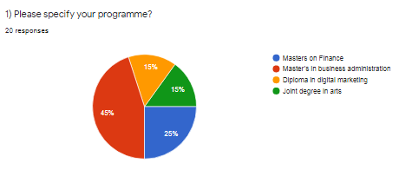
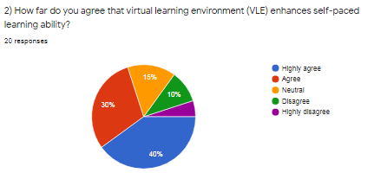
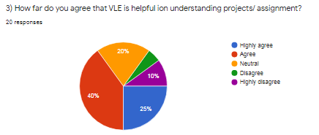
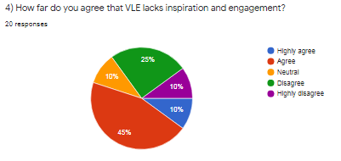
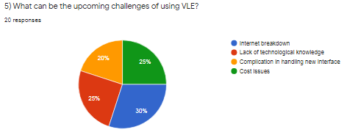
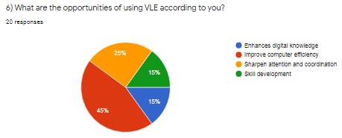
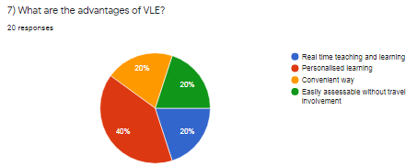

5.0 Results
5.1 Primary data collection result (survey)
From the survey conducted about the impact of virtual learning environments, the result of the primary survey indicates partial towards the positive side. The students were asked several questions regarding the advantages, opportunities and challenges of the virtual learning environment and their response indicates that most of the students were in favour of a virtual learning environment. In the survey, the students were asked about their study program and the analysis of their responses indicates that the institute provides opportunities to learn masters as well as diploma courses for the learners.
The participants were asked about their agreement on the virtual learning environment enhances their self-paced learning ability it was noted from the response that majority of around 40% of the total respondents were highly in support of the question asked and 30% agreed to the question on the other hand rest of the participants showed disagreement. This indicates that the majority of the participants believes that VLE enhances self-paced learning.
However when the participants were asked about the opportunity and advantages of VLE around 45% of the responded supported for or the opportunity of learning and has computer efficiency and around 42% responded as personalized learning to be the advantage of VLE. On the other hand, Almost equal distribution of all the participants responded for the challenges of VLE related to lack of technological knowledge, cost issues, a complication in handling new interfaces and the Internet back down at the same time around 45% agreed that VLE lacks inspiration and engagement. This indicates that apart from the advantages and opportunities many students think that VLE might create challenges and minimises engagement at work.
5.2 Secondary data collection result (literature review)
The result of the data collected from secondary sources reviewed in the literature review section indicates the fact that there are many advantages of VLE. One of the major advantages is that it creates a link between the student and the teacher by using our online pathway to embed videos. Apart from the advantage, the virtual learning environment develops opportunities for the learners by creating a platform of student creative podcasts. The collection of data indicates that VLE is a convenient platform for the learners as well as the educator's which can be used intensively and its usage has increased inclusively. It helps the engagement capability and collaborative workability of the students as well as enhances their team effort and focus in these studies.
On the other hand, it is also identified that apart from positive aspects it has some disadvantages as well such as the cost associated with the internet usage or glitch on the internet when making any important assignment or in video conferencing. However, VLE is a convenient option for the student as identified from the review of secondary sources because this student can use it for personalised learning as per their time and convenience. It is found that apart from the learning platform the VLE also developed an opportunity for virtual learning software learning a new interface and Technology for the student which can be helpful for them in their future. Therefore by reviewing the secondary literature it is found that apart from some of the disadvantages the VLE provides opportunity and has many advantages to enhance the skills and technological knowledge among the learner as well as the educator.

6.0 Discussion
From the analysis of primary as well as the secondary data one thing that was identified in common from both the data collection methods is that what will be a learning environment is helpful in enhancing the skills and engagement level among them and creates the opportunity to learn multiple technological expect for both the known as well educated. On the other hand, it is also found that some of the loopholes of the virtual learning environment are that it is not cost-effective as the cost of the internet can be a major disadvantage for most of the users. In addition, issues related to internet connectivity and handling the interface is one of the other loopholes of using a virtual learning environment. Furthermore, it is also identified that it increases the personal learning experience and digital knowledge along with sharpening the coordination and teamwork popularity.

7.0 Conclusion
From the above discussion, it can be concluded that along with the advantages of virtual learning environment has some major disadvantages and also from data collected from surveys of students that virtual learning environment inspires in engagement, on the other hand, many things that it creates opportunity and its advantages in learning new technological aspects.

8.0 References
- Al-Azawei, A. and Al-Masoudy, M., 2020. Predicting Learners' Performance in Virtual Learning Environment (VLE) based on Demographic, Behavioral and Engagement Antecedents. International Journal of Emerging Technologies in Learning (iJET), 15(9), pp.60-75.
- Chaim, O., Muschard, B., Cazarini, E. and Rozenfeld, H., 2018. Insertion of sustainability performance indicators in an industry 4.0 virtual learning environment. Procedia Manufacturing, 21, pp.446-453.
- Dung, D.T.H., 2020. The advantages and disadvantages of virtual learning. IOSR Journal of Research & Method in Education, 10(3), pp.45-48.
- Herrera Mosquera, L., 2017. Impact of implementing a virtual learning environment (VLE) in the EFL classroom. Íkala, Revista de Lenguaje y Cultura, 22(3), pp.479-498.
- Larmuseau, C., Evens, M., Elen, J., Van Den Noortgate, W., Desmet, P. and Depaepe, F., 2018. The relationship between acceptance, actual Use of a virtual learning environment and performance: An ecological approach. Journal of Computers in Education, 5(1), pp.95-111.
- Mosquera, L.H., 2017. IMPACT OF IMPLEMENTING A VIRTUAL LEARNING ENVIRONMENT (VLE) IN THE EFL CLASSROOM. Íkala: Revista de Lenguaje y Cultura, 22(3).
- Ochs, M., Mestre, D., De Montcheuil, G., Pergandi, J.M., Saubesty, J., Lombardo, E., Francon, D. and Blache, P., 2019. Training doctors’ social skills to break bad news: evaluation of the impact of virtual environment displays on the sense of presence. Journal on Multimodal User Interfaces, 13(1), pp.41-51.
- Ochs, M., Mestre, D., De Montcheuil, G., Pergandi, J.M., Saubesty, J., Lombardo, E., Francon, D. and Blache, P., 2019. Training doctors’ social skills to break bad news: evaluation of the impact of virtual environment displays on the sense of presence. Journal on Multimodal User Interfaces, 13(1), pp.41-51.
- Phungsuk, R., Viriyavejakul, C. and Ratanaolarn, T., 2017. Development of a problem-based learning model via a virtual learning environment. Kasetsart Journal of Social Sciences, 38(3), pp.297-306.
- Rienties, B., Giesbers, B., Lygo-Baker, S., Ma, H.W.S. and Rees, R., 2016. Why some teachers easily learn to use a new virtual learning environment: A technology acceptance perspective. Interactive Learning Environments, 24(3), pp.539-552.
- Tabatabai, S., 2020. COVID-19 impact and virtual medical education. Journal of Advances in Medical Education & Professionalism, 8(3), pp.140-143.
- Xiaoyun, P. and Siqi, M., 2018. The number of virtual learning environment and their effective using impact on students’ information literacy. Journal of Advances in Humanities and Social Sciences, 4(2), pp.93-103.

