

LEVEL 7 ASSESSMENT SPECIFICATION

Student name: | Seto chi shing | Student ID number: | 1812207
Programme: | MBA
Module: | Marketing Management
Module code: | SBMA7138 | Contribution to Overall Module Assessment (%): | 75%
Lecturer: | Dr Arion WONG | Internal Verifier:
Assignment Title: | Assignment 1 | Word count (or equivalent): | 3500 words
Submission deadline: | 28 Jun 2019 | Return date of provisional marks & written feedback: | Within 20 days after submission
Submission method: | All written assessments, where practical and possible, must be submitted via Turnitin unless otherwise instructed by the Lecturer. (Please DO NOT put this assessment specification into Turnitin or it will match many similarities with other students’ submissions.)  Alternative submission method (if applicable):  Late submission of the assessment will result in a late penalty mark. Penalties for late submission: Up to one week late, maximum mark of 50%. Over one week late, 0%. Only the Extenuating Circumstances Panel may approve a change to submission dates.
Academic honesty / referencing: | Academic honesty is required. In the main body of your submission you must give credit to authors on whose research and ideas your work is based. Append to your submission a reference list that indicates the books, articles, etc. that you have used, cited or quoted in order to complete this assessment.

Executive summary

Tesla Motors Inc. manufactures and sells 100% electric cars and advanced electric vehicle components. Tesla is an ethical and social responsible company that sees to the proper functioning of the environment. It produces cars with zero emission of gas. It also produces batteries that are no toxic and easily recyclable. The company also has it threats, which come from its competitors. Lastly performs its functions of management effectively. It has a solid organization structure that brings employees together.

Table of contents

1 Introduction 1

2 Situation analysis 2

3 Market strategy 10

4 Recommendations and Conclusion 16

5 References 17

1 Introduction

Company profile

Tesla was found in 1st July 2003. The Tesla headquarters is in Palo Alto, California, US.
The business of the Tesla industry segment are Automotive, and Energy generation and storage and its automotive segment are Design, development, manufacturing, and sales of electric vehicles. For the Tesla energy generation and storage segment are design, manufacture, installation, and sale or lease of stationary energy storage products and solar energy
Tesla major produce and sell are the following electric car list:
Model S sedan delivered first in June 2012
Model X sport utility vehicle (“SUV”) delivered third quarter of 2015
Model 3 sedan delivered first quarter of 2016
They are the new version of the Tesla Roadster an all-electric supercar and they are home powered by tesla combine solar panels and a power-wall battery.
The major manufacturing plant and factories are in Fremont –California, Lathrop –California, Tilburg –Netherlands, Gigafactory 1 near Reno, Nevada, Buffalo, New York (Gigafactory 2)
The Tesla number of employees is as 31 December 2017 had 37543 full time employees. The chief executive officer, chairman, product architect is Elon Musk –Chairman. The chief technical officer is JB Straubel. The chief financial officer is Deepak Ahuja.

Industrial environment

In recent years, battery prices have fallen, policy makers everywhere continue to promote low-carbon transportation, and automakers are focusing on the development of electric vehicles. As a result, more attractive electric vehicles enter the market and increase consumer interest in electric vehicles. For consumers, there are two main considerations for buying or adopting electric vehicles, including the price of electric vehicles and the growth of infrastructure such as charging stations.
The report expects that the adoption rate of electric vehicles will start to accelerate in 2024. However, given the different development plans for electric vehicles in various countries and regions around the world, the global automotive market will be diversified. The availability of infrastructure will be one of the keys to the development of the electric vehicle market in the 2030s.

Tesla sales drop in Hong Kong after tax breaks removed
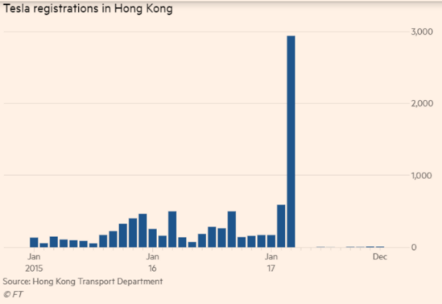

Tesla, the electric car manufacturer, announced at the beginning of this month that it sold 63,000 units in the first quarter of this year, down 31% quarter-to-quarter. This is the worst forecast for the company since its record.

1
Market objective

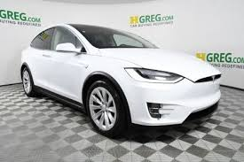

To increase the Tesla luxury private Model S electric car sales revenue to 2 percent.

2 Situation analysis

Macro-environment analysis
PEST (Political, Economic, Socio Cultural, Technological)

Political factors

The SAR government has promoted electric vehicles for more than a decade, but the policy has fallen into a logical contradiction: it wants to curb the growth of private cars, improve road congestion and air pollution, but it can't take practical measures. Finally, it has to cut into electric vehicles. As a result, the policy was reversing, and the growth of the charging capacity was also "turtle speed", which hindered the development of electric vehicles. The fuel private car continued to grow and could not achieve the original goal of the government.

It is also worth noting that the government did not express any intention to amend the one-for-one plan qualification not long ago, but it did not take long to announce the immediate relaxation arrangement, and the process changed very rapidly.

Electric private car is a major trend Hong Kong has threatened 30% of electric vehicles in 2020

Electric vehicles are the general trend of private car development, and the technology has developed rapidly in the past ten years. Although the production of automobiles and power supply also have carbon emissions, the emission of nitrogen oxides and suspended particles on the road surface can be significantly reduced. If the electricity comes from cleaner energy sources, the overall pollution will be reduced. This is a broad international consensus.

Many countries or regions have set policy targets to stop selling gasoline vehicles before the designated term and switch to electric vehicles or hybrid vehicles. The process may be fast or slow, and there may be a technical block, but the overall direction is unchanged. In addition to the most famous American Tesla, many established large-scale automakers such as Mitsubishi, Ford, and South Korea Hyundai have to keep up with this trend.
2
The promotion of electric vehicles by the Hong Kong Government can be traced back to the former Chief Executive Donald Tsang. In the 2009-2010 policy address, Mr Tsang proposed that the long-term policy objective of the Government is to make Hong Kong one of the most widely used areas in Asia. In May 2011, the Government revised the Hong Kong Planning Standards and Guidelines to point out long-term goals. In 2020, 30% of private cars are electric vehicles or hybrid vehicles, and 30% of private car parking spaces in new buildings can provide relevant charging facilities.

More than 10,000 electric vehicles, more than 2,000 forklifts

The primary concern of electric vehicle owners is that it is a charging problem. It’s just a charging problem that has plagued many car owners for years. It takes only a few minutes for the petrol car to add oil once, but the standard charging of the electric car takes 6 or 7 hours to fill. The "fast fork" takes 1 hour and 2 hours. Even the latest foreign technology takes at least half an hour.

In Hong Kong, it is said that the introduction of the latest technology, even the existing charging equipment is not enough. The total number of registered private private cars in Hong Kong increased from 69 in April 2011 to 10,940 in October last year, an increase of more than 150 times. However, the number of public chargers has only increased from 872 in 2011 to 2,166 at the end of 2018. The increase cannot catch up with demand, and the fast chargers only account for 498. The development can be said to be quite slow.

Although the government argues that the policy of the authorities is that electric private car owners should use charging facilities installed in their homes, office places or other appropriate places, public charging facilities are only auxiliary, and private is the focus. However, the Legislative Council Member Ma Fengguo has said that the development of electric vehicle charging stations in private parking lots is only in its infancy. The Government has no targeted measures. In particular, private housing estates have no incentives. Therefore, in reality, not many people have the opportunity to "daily charge", or rely on public chargers, the government must first change the policy direction.

Chen Maobo cancels the first registration tax exemption

Since it is inconvenient to use, it is naturally dependent on financial incentives to encourage use. Since 1994, the Hong Kong Government has exempted the first registration tax on electric private cars and has extended the relevant regulations several times. Since there were not many choices of electric vehicles in the early years, the policy was of little significance. Until many car manufacturers put electric vehicles into mass production in recent years, electric vehicles began to be used by many people in Hong Kong.

However, in the policy thinking of the Hong Kong Government, the Administration should avoid the continued growth of private cars. Electric vehicles are also regarded as private cars. Therefore, the Government considers that it is not appropriate to exempt the public from buying private cars. In the 2017 Budget, Chen Maobo announced that from April of the same year, the first registration tax for electric private cars will not be fully reduced or reduced, and the upper limit of 97,500 yuan will be set.

Since electric vehicles are much more expensive than traditional gasoline vehicles, the lack of financial incentives instantly doubles the price. Looking at the statistics of the Transport Department, the number of registered private motor vehicles has generally increased by three figures per month before April 2017. By March, the number of new registrations was nearly 3,000. However, after the implementation of the new policy, the number of new registrations was immediately inserted into single digits, and in April it was even zero.
3
No increase in traffic growth, disguised encouragement to buy gasoline vehicles

At the end of February last year, Chen Maobo relaxed the first registration tax requirement for electric vehicles, allowing old private car owners to change one, destroy old cars and change electric vehicles, and get a tax reduction of 250,000 yuan. However, the old car must be over six years old. Applicants are also required to hold the old private car for three consecutive years and a minimum of 20 months for the 24-month period before the old vehicle is cancelled. The original intent of the regulation was to prevent the owner from buying a large-scale old car, but he was accused of being too strict and did not help the owner to change the car, so the reaction was cold.

According to the Government's figures, the number of registered electric private cars for the first time from March to December last year was 454. Of these, the "one for one" scheme accounted for 321 cases, that is, the average monthly rate was only about 32 cases, far from the full exemption period. The Government has relaxed the terms of its holdings this time. At best, it is only to correct the past policy problems. The results are still unknown.

The more deadly point is that because the government can't find a way to curb the growth of private cars, the prospective car owners will not buy electric cars, and will naturally re-flow to traditional gasoline cars. According to the statistics of the Transport Department, the number of first registrations of private cars per month has remained stable at around three or four thousand before and after the implementation of the tax reduction arrangement. It has not fallen at all. The only difference is that before the tax exemption is abolished, the registration of electric private cars accounts for at least 10% of all private car registrations (larger floating), but after April 2017, electric vehicle registration only accounts for one to two percent of the total. Left and right, the decline is obvious.

Economic factors

Like all export-led cities, Hong Kong is vulnerable to changes in global trade trends. In 2018, Hong Kong's economy grew by 3.0%, lower than the government's forecast of 3.2% and 2017's 3.8%. As the government expects Hong Kong's economy to grow by 2% to 3% in 2019, investors should focus on areas other than gross domestic product (GDP), so that Hong Kong's uncontrollable economic challenges will allow everyone to underestimate actual risks. Here are two of the three major challenges for Hong Kong in the coming year. Investors should be prepared.

Tensions in Sino-US relations have aggravated global trade slowdown

Hong Kong's economy is closely related to global economic activities. In 2017, the total value of goods exported by Hong Kong reached US$550.2 billion, accounting for about 3.4% of global trade. Hong Kong's two major trading partners, China and the United States, accounted for 54% and 7% respectively. Therefore, if China and the United States fail to reach an agreement on the current trade dispute, Hong Kong will be affected.

This is very important for Hong Kong for several reasons. First, Hong Kong's trading industry, which includes logistics and warehouses, employs about 475,000 people, accounting for 12% of the local employed population and accounting for about 18% of the Hong Kong economy.

4
Second, Hong Kong's export data is slightly misleading and vulnerable to wrong policy responses. Chinese-made products are usually "sold" to affiliates in Hong Kong with zero profit and then re-exported from Hong Kong because Hong Kong's tax rate is lower than the mainland. However, although the sales and profits of the company offset the related activities, Hong Kong's re-export activities will still be counted in the final export data, resulting in the exaggeration of natural trade figures, making it difficult to detect the slowdown in exports.

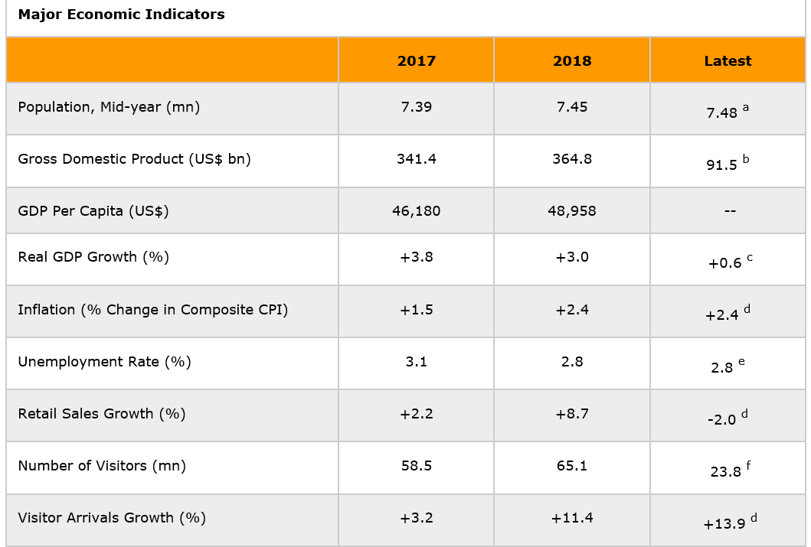

http://hong-kong-economy-research.hktdc.com/business-news/article/Market-Environment/Economic-and-Trade-Information-on-Hong-Kong/etihk/en/1/1X000000/1X09OVUL.htm

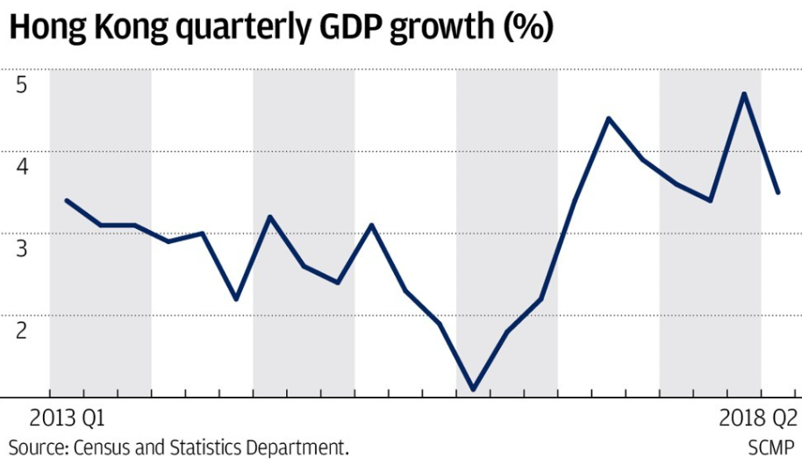
Hong Kong GDP records 3.5 per cent growth for second quarter on strong consumption and markets

https://www.google.com/search?biw=1531&bih=810&tbm=isch&sa=1&ei=MnQEXcLFMou9hwOyq7eQCQ&q=hong+kong+gdp+2018&oq=hong+kong+gdp+2018&gs_l=img.3..0i24l3.214572.215579..215989...0.0..0.57.263.5......0....1..gws-wiz-img.......0i19j0i30i19j0i8i30i19.ywQHVb641FA#imgrc=Ay9xSbBa8vExzM:&spf=1560573195209

5

Business Performance in 2018, Projected Salary Increase and Bonus Pay out in 2019

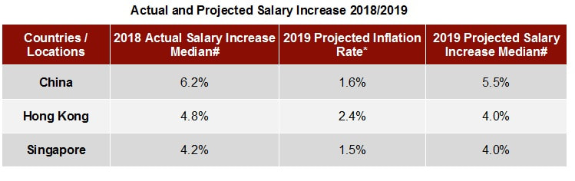
# Source: Pretium Year-end Rewards and Human Resource Trends Survey Report- 2018
* Source: Trading Economics
https://www.pretium-asia.com/pretium-asia-salary-increase-and-bonus-projection-2019.html

Social factors

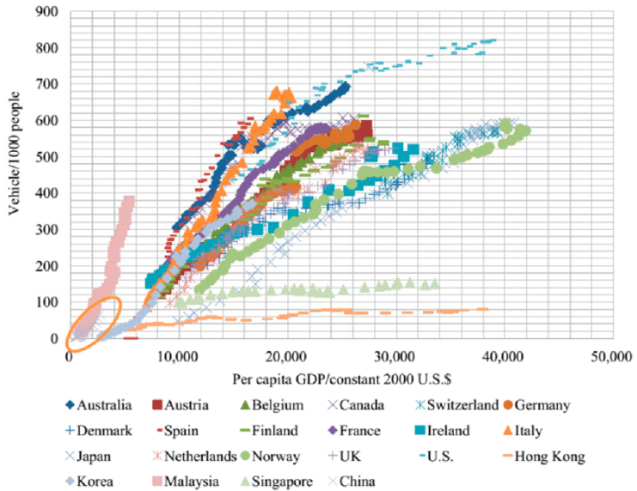
Worldwide vehicle ownership trends and per capita GDP (Data source: [28,29]).
https://www.researchgate.net/figure/Worldwide-vehicle-ownership-trends-and-per-capita-GDP-Data-source-28-29_fig2_277673929

6

Distribution of Salaries in Hong Kong | All Jobs
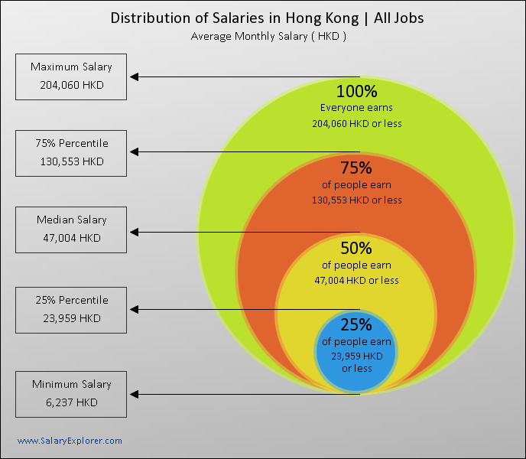

These Figures: Salary Range, Median and Percentiles
The Hong Kong people’s monthly salary range is between HKD 6237 to 204060.
http://www.salaryexplorer.com/salary-survey.php?loc=97&loctype=1

Salary Trend and Forecast in Hong Kong

How are Hong Kong salaries changing over time? Listed below is a chart that shows the average salary over the past few years.
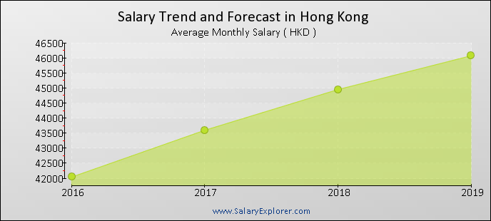
http://www.salaryexplorer.com/salary-survey.php?loc=97&loctype=1

7
Technological factors
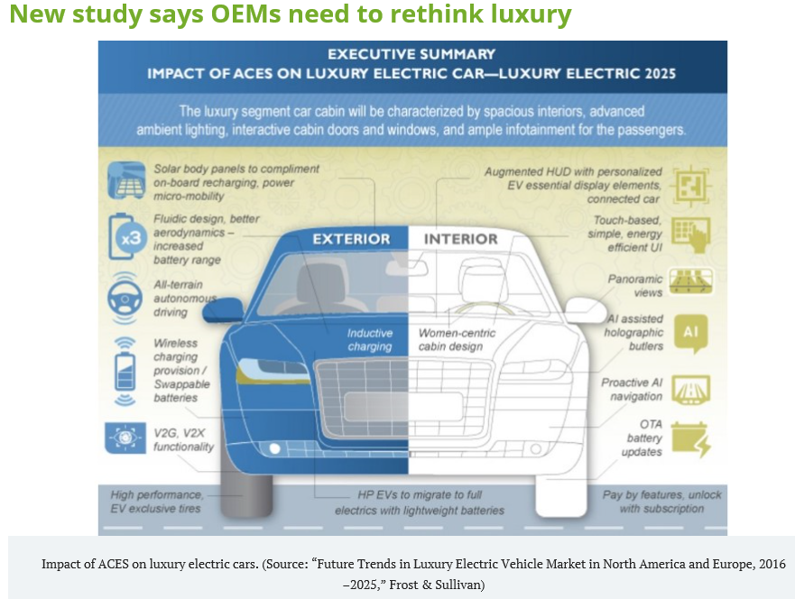
https://www.autonomousvehicletech.com/articles/655-new-study-says-oems-need-to-rethink-luxury
The most major technological factors of Tesla electric car are the performance, innovation, energy efficiency, ease of driving and luxuriousness.
Micro-environment analysis
Company’s strengths and weakness

The strengths of Tesla:
Tesla has highest technology of battery packs, powertrain, and motor.
Tesla has political government support, for example Tesla has US department of energy management project.
Tesla has a monopoly market segment which was electric and alternate energy.
Tesla has its own distribution channel.

The weakness of Tesla:
Tesla has only USD 3 billion poor cash flow comparison to competitors.
Tesla has only one manufacturing plant in Fremont, California.
Poor customer awareness.

Micro-environment analysis
Create value to customer
To let customer feel that the Tesla luxury electric private car is a very safety, comfortable and environmental friendly.

8
Micro-environment analysis
Porter’s 5 forces analysis

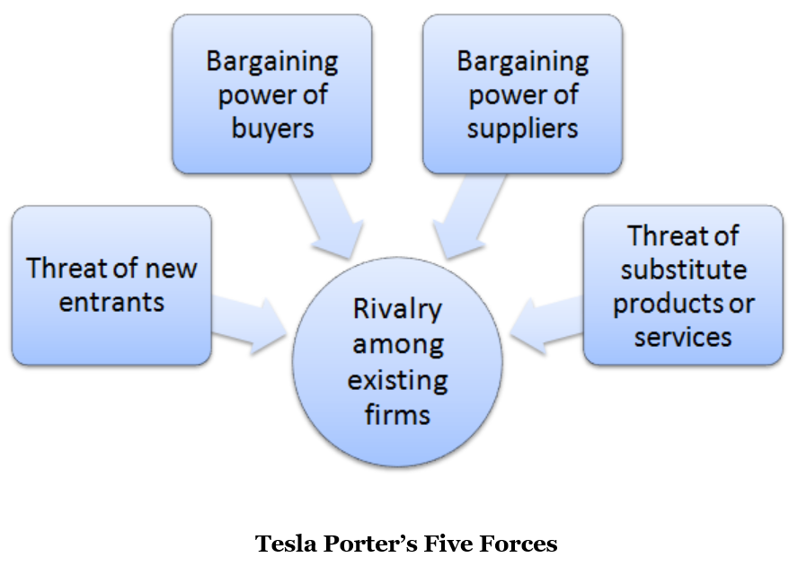

Threat of New Entrants in Tesla’s Porter’s Five Forces Analysis

The other brand electric private car prices such as Mitsubishi, Nissan, BMW, Renault, TAZZARI, Smart Fortwo, Volkswagen and Hyundai are not expensive.

The electric car batteries each running mileage in single charge is shorter than the traditional fuel car.

The Tesla model S manufacturing cost is high than another private car in the market.

Bargaining power of buyers in Tesla’s Porter’s Five Forces Analysis

Because the Tesla electric cars are most expensive, so customers can switch from Tesla model S to another brand electric private car easily.

Rivalry among existing firms in Tesla’s Porter’s Five Forces Analysis

Another electric private car companies plan to increase their focus in this segment.

Solar energy electric private car is also a competition matter.

9

3 Market strategy

STP (Segmentation, Targeting, Positioning)

The segmentation for Tesla Electric Car model S5:

Geographic:
Region (Hong Kong, China)
Density (urban, rural)

Demographic:
Age (18-29, 30-59, 60-80)
Gender (Males, Females)
Income (high, low)
Occupation (employees, professionals, senior manager, executives)

Behavioural:
Degree of loyalty (hard core loyal, soft core loyal, switchers),
Benefits sought (status, perception of being environmentally friendly, long term cost effectiveness)
Personality (determined, ambitious)
User status (non-users, potential users, first time user)

Psychographic:
Social class (middle class, upper class)
Life style (aspirer, succeed person, explorer, reformer)

The targeting for Tesla Electric Car model S5:

Region (Hong Kong)
Density (urban)

Demographic:
Age (30-59)
Gender (Males and Females)
Income (high)
Occupation (senior manager, executives)

Behavioural:
Degree of loyalty (soft core loyal),
Benefits sought (perception of being environmentally friendly, long term cost effectiveness)
Personality (determined)
User status (potential users)

Psychographic:
Social class (upper class)
Life style (succeed person)
10
Positioning: high quality, high price, special feature, positioning process for goods/services
Price and quality charts:

Item | Manufacturer | Private car | Price HK$ | Quality
1 | Universal Cars Limited | Mitsubishi iMiEV | 268,800 | Low
2  3  4 | Honest Motors Limited | Nissan LEAF  Nissan E-NV200 5-seater  Nissan E-NV200 EVALIA 5-seater | 299315  378800  358800 | Low  Low  Low
5  6  7  8 | Tesla Motors HK Limited | Model 3  Model S  Model X  Model Y | 272503  1242410 (tax)  1275950(tax)  305000 | Low  High  High  Medium
9 | BMW Concessionaires (HK) Limited | BMW i3 94AH(I01) | 529,000 | Medium
10 | Wearnes Motors (HK) Limited | Renault ZOE | 329,800 | Medium
11 | Fortune Dragon Motors Limited | TAZZARI "EM1" | 200,000 | Low
12 | Mercedes-Benz Hong Kong Limited | Smart Fortwo Coupe Electric Drive (C453) | 199,900 | Low
13 | Volkswagen Group Hong Kong Limited | Volkswagen  e-GOLF 85kW 24.2kWh CL | 459,980 | Medium
14 | Hyundai Hong Kong Co., Ltd | Hyundai Ioniq Electric | 308,800 | Low

11
The position of Tesla and other electric private car is shown in following diagram:

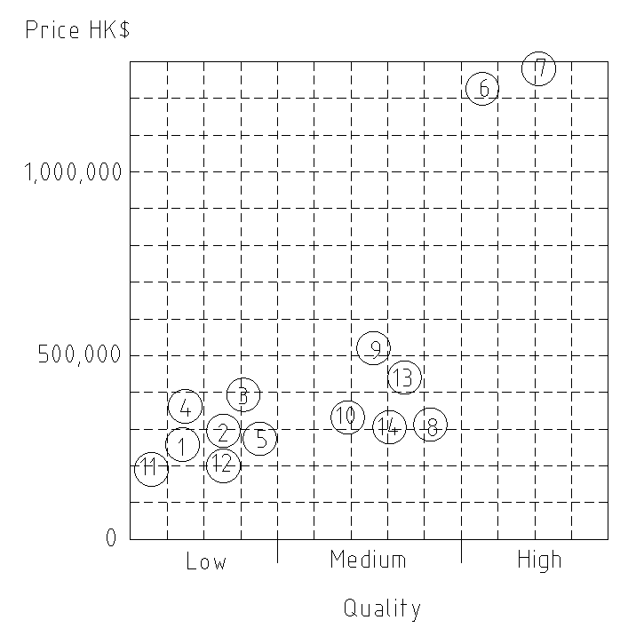

The new position of the Tesla Model S (6) is as shown in following diagram:

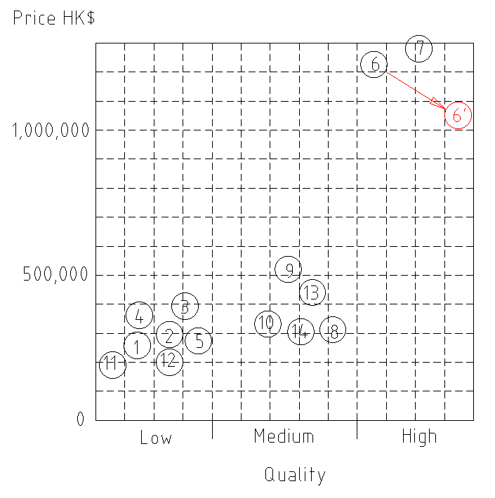

12
Marketing mix 4P (Product, Price, Place, Promotion)

Product: service, life cycle, quality, feature, Brand, competition

The product life cycle of the Tesla model S stage should be in Growth stage.

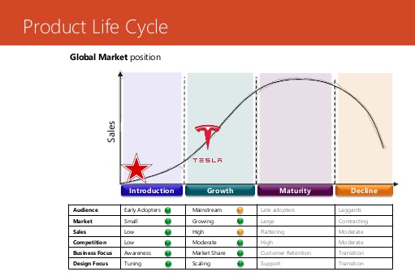

The competitors of the Tesla electric private car are Mitsubishi, Nissan, BMW, Renault ZOE, TAZZARI, Mercedes-Benz, Volkswagen and Hyundai.

The quality and feature of Tesla model S electric car is as following:

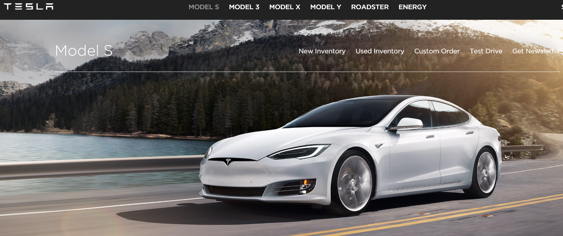

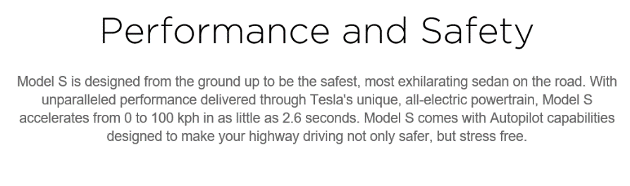

13
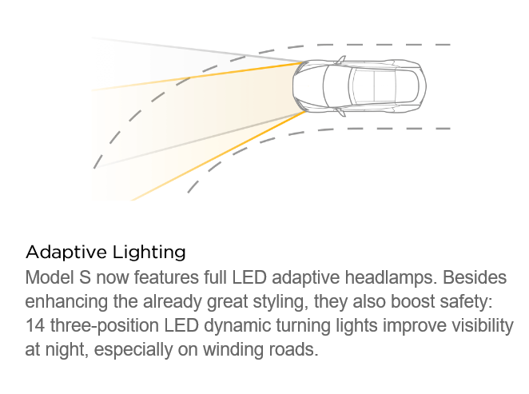

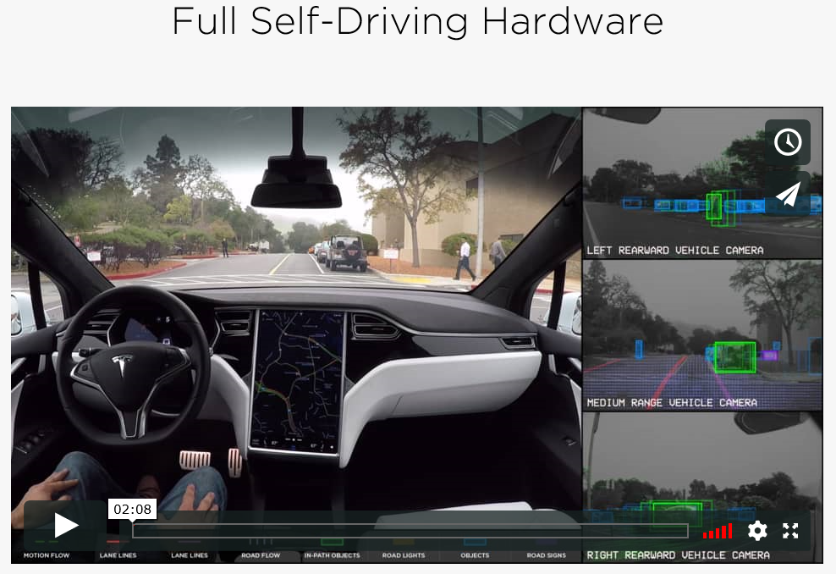
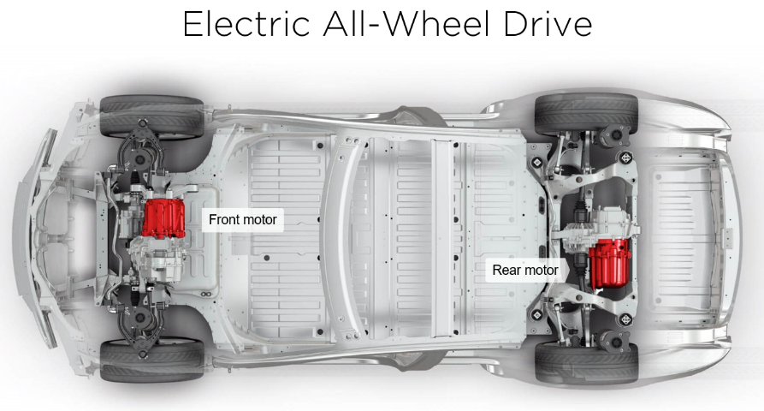
14
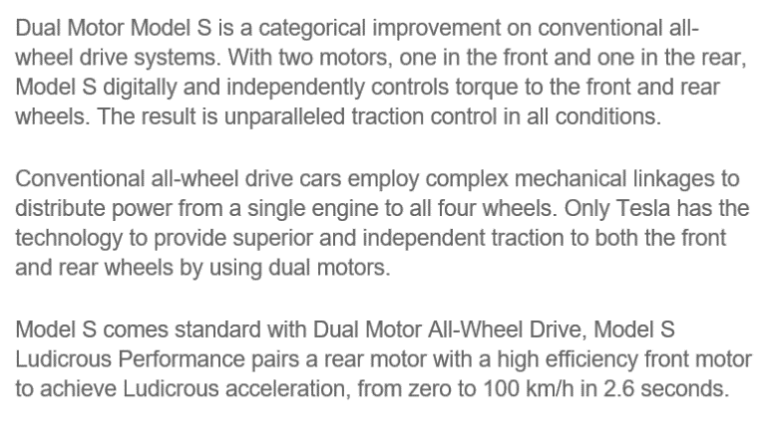
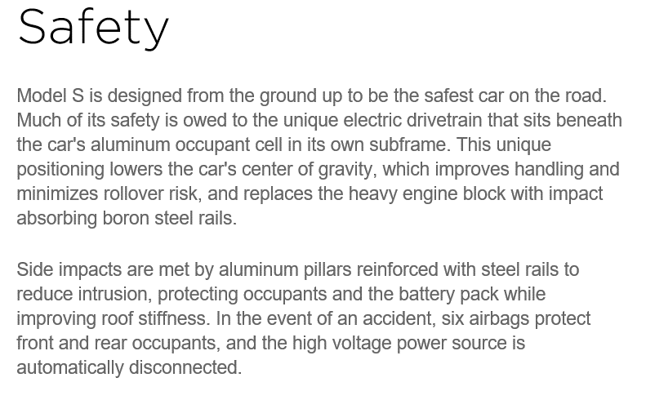
Price:
The Tesla model S5 competitor’s price are much lower, but the quality of them are also lower then it. The Model S5 is the highest price and best quality in the Hong Kong market. So the demand and supply is low.

Place:
The showrooms location of Tesla electric private car are in busy business district in Hong Kong. The showrooms rental cost is high but it is very convenient businessman, executive to see the new car.
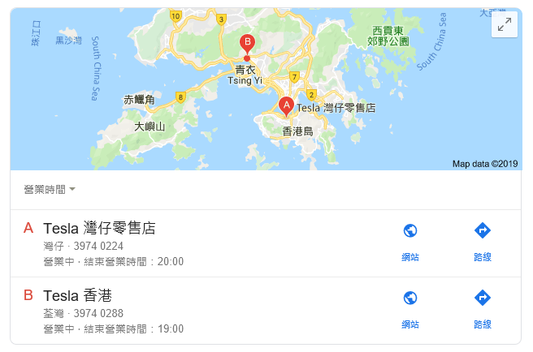

15
Promotion

Strategy in supply chains: “push” and “pull”

Electric private car driver needs to have more service, such as charging station, repair centre and service sector. And used car parts and recycling planning.
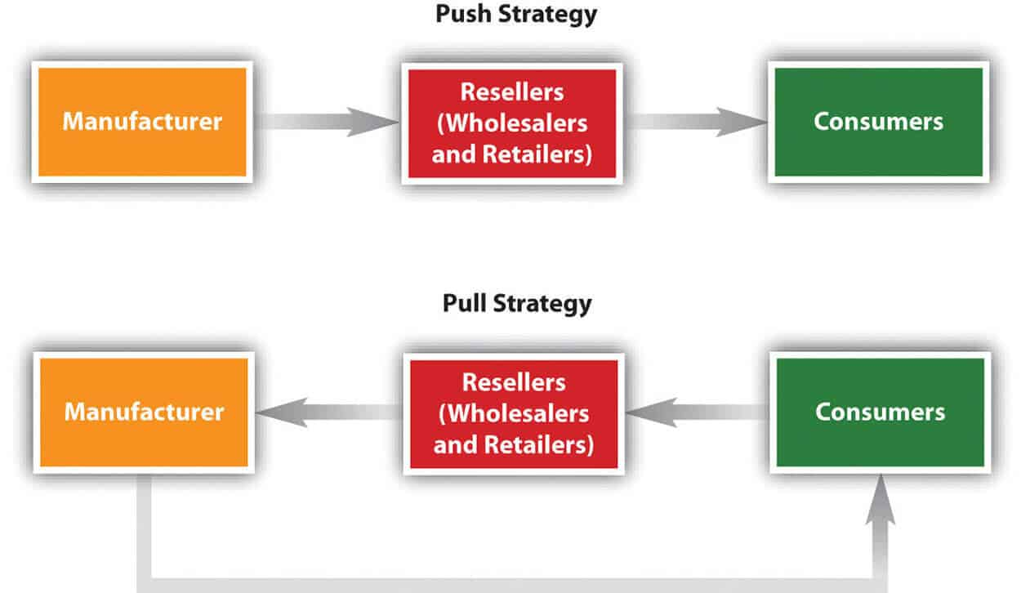


Toyota uses pull strategy. Toyota can produce electric private car cheaper and faster than Tesla, because Toyota produce hybrid (fuel plus electric) private car. They can use existing sales and service networks.

Tesla uses push strategy. Tesla asked Hong Kong Government to make charging station, repair centre and service sector, and arrange to prepare batteries recycling policy.

4 Recommendations and Conclusion

Tesla can improve the car batteries each running mileage in single charge.
Tesla can reduce the sales price to 1 to 2 percent but improve the overall car quality.
Tesla can provide more services after sales.
Tesla can ask Hong Kong Government to build more battery charging station in Hong Kong.
Tesla can provide old car trading service.
Tesla can arrange more energy saving and environment protection activity to the target customer.

16
5 References

M.p. Pagare, Rathod A. U , SERVICE MARKETING: A STUDY OF DEVELOPMENT AND CHALLENGES IN MACRO &MARKET ENVIRONMENT, Figshare, DOI: 10.6084/M9.FIGSHARE.1233544 2014

Liu, Quanhua, Electric car with solar and wind energy may change the environment and economy: A tool for utilizing the renewable energy resource, Earth's Future, January 2014, Vol.2(1), pp.7-13

Case, L. , Development environment for Next-generation electric car, Automotive Industries AI, September 2009, Vol.189(9)

Li, Z. ; Lin, Y. ; Gong, X. , ; Simulation and experimental study for a micro hybrid electric car with smart start-stop system, Zhongguo Jixie Gongcheng/China Mechanical Engineering, 10 January 2010, Vol.21(1), pp.110-114

Shao, Fun ;Shu, Wise ;Tian, Tracy, Electric, Electronic and Control Engineering : Proceedings of the 2015 International Conference on Electric, Electronic and Control Engineering (ICEECE 2015), Phuket Island, Thailand, 5-6 March 2015, London: CRC Press LLC 2015

Flynn, Sean Masaki, Economics : principles, problems, and policies, McConnell, Campbell R. Brue, Stanley L. 1945

Vitan Daniela, The SWOT Analysis of Pre-university Education, Ovidius University Annals: Economic Sciences Series, 01 January 2017, Vol.XVII(1), pp.601-605

Cantab, SWOT, Notes and Queries, 30 March 1850, Vol.s1-I(22), pp.352-353

Kiamanesh, Parvin ; Olafsen, Kåre S. ; Drozd, Filip, ; Understanding factors that promote and limit the use of video guidance in child protection services: A SWOT analysis, Child & Family Social Work, November 2018, Vol.23(4), pp.582-589

Dibb, Sally, Market segmentation: strategies for success, Marketing Intelligence & Planning, 1998, Vol.16(7), pp.394-406

Kampamba, J. , ; An analysis of the potential target market through the application of the STP principle/model,
Mediterranean Journal of Social Sciences, 1 August 2015, Vol.6(4), pp.324-340

Ostaseviciute, R ; Sliburyte, L , Theoretical aspects of product positioning in the market, Inzinerine Ekonomika-Engineering Economics, 2008, Issue 1, pp.97-103

Šliburytė, Laimona ; Ostasevičiūtė, Rūta , Theoretical Aspects of Product Positioning in the Market, Engineering Economics, 2008, Issue 1(56), pp.97-103

Huang, Rong ; Sarigöllü, Emine , ; How brand awareness relates to market outcome, brand equity, and the marketing mix, Journal of Business Research, Jan 2012, Vol.65(1), p.92
17
Festa, Giuseppe ; Cuomo, Maria Teresa ; Metallo, Gerardino ; Festa, Antonio , ; The (r)evolution of wine marketing mix: From the 4Ps to the 4Es, Journal of Business Research, May 2016, Vol.69(5), pp.1550-1555

Borza, Sorin Ioan ; Borza, Iunia Cristin , A Broad Analysis of Marketing Strategies for their Incorporation as Activities in a User Centred Process, Procedia Economics and Finance, 2014, Vol.16, pp.239-250

Wu, Kuo-Jui ; Tseng, Ming-Lang ; Chiu, Anthony S.F. , Using the Analytical Network Process in Porter's Five Forces Analysis – Case Study in Philippines, Procedia - Social and Behavioral Sciences, 9 October 2012, Vol.57, pp.1-9

Aldershot, Hampshire, MBA management models, Brookfield, Vt. : Gower 1998

Klein, Tom , The Push, Pull and Pricing Of Go-to-Market Investments, Adweek, Oct 8, 2018, Vol.59(27), p.10

Horbach, Jens ; Rammer, Christian ; Rennings, Klaus , Determinants of eco-innovations by type of environmental impact — The role of regulatory push/pull, technology push and market pull, Ecological Economics, June 2012, Vol.78, pp.112-122

Timsit, Jean-Philippe ; Castiaux, Annick ; Truong, Yann ; Athaide, Gerard A. ; Klink, Richard R. , The effect of market-pull vs. resource-push orientation on performance when entering new markets, Journal of Business Research, September 2015, Vol.68(9), pp.2005-2014

Horbach, Jens , Determinants of eco-innovations by type of environmental impact the role of regulatory push/pull, technology push and market pull, Ecological economics : the transdisciplinary journal of the International Society for Ecological Economics, 2012, pp. 112-122

Loughlin, Clive , Market pull and market push, Industrial Robot: An International Journal, 03 May 2011, Vol.38(3)

18



