Name: Diana Octavia Constantin
Student number: 2331926
Modul: Changemakers Creativity and Value
BMHP5014
Lecture Name: Tsiwani Khumalo

Table of Contents
Task 1 – Concept Map 3
Task 2 - Self-Reflection of Group Activity 5
Task 3 - Case Study of a UK innovation 6
Task 4 - Research Task 7
Task 6 - NHS Leadership Framework Analysis 8
Task 7 - Self-Reflection Journal Entry 10
Reference List 11

Task 1 – Concept Map
In the health and social care context, creativity acts as the spark that generates innovative ideas. According to Thornhill-Miller et al. (2023), creativity is the capacity for producing original and novel work that fits task constraints and has value within its context. It also helps in envisioning new ways of health and social care through service design and process innovation by challenging the status quo. Creativity then directly translates to value creation. Value creation helps in forging a reciprocal relationship between a company and its potential stakeholders (Nicita, 2024). In the sector, value creation is also of utmost importance as it helps ensure that the creative ideas are capable of driving improvements in health and social care based on tangible benefits. For instance, it enhances the patient satisfaction rate, minimises waiting times, and abolishes long queues. the waiting lists of the NHS had decreased to 7.39 million from 7.42 million in April within 17 years in June 2025 (NHS, 2025). The organised measures that include effectiveness, patient focus, safety, fairness, and efficiency are described by Health and Social Care Improvement. These are crucial for aspects like value creation and creativity.
Value creation and creativity also help strengthen the accessibility and efficiency of the services in the industry, making it a key attribute of the industry. Hence, in conclusion, the relation among these concepts helps ensure continuous improvement for better service quality and the long-term sustainability of health and social care.

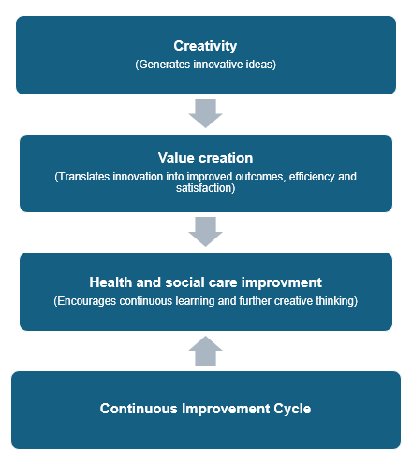
Concept Map

Task 2 - Self-Reflection of Group Activity
Using Gibbs Reflective Cycle (1988), I reflected on a group project where my team and i designed ana innovative medical clinic inspired by the structure of the DNA helix. Our aim was to create a space that combined science, technology, and patient care to address genetic disorders.
Description
The activity required us to generate and refine ideas collaboratively. We began with open brainstorming sessions, exploring creative possibilities for clinic design and services. Later, we applied convergent thinking to select the most practical concept that could be supported by available resources and ethical guidelines.
Feelings
At first, I felt slightly overwhelmed by the complexity of the topic and unsure haw my ideas would fit into the group vision. As discussions continued, I became more confident, especially when my suggestions about integrating digital health tools were appreciated by my teammates.
Evaluation
This project effectively balanced creativity with critical thinking, It allowed me to explore innovative medical concepts while also learning the importance of realistic planning. However, there were moments of disagreement about priorities, which showed me haw essential communication and compromise are in teamwork.
Analysis
The experience highlighted haw divergent thinking encourages imagination and exploration, whereas convergent thinking brings structure and feasibility. I learned that innovation in healthcare requires both approaches-visionary ideas grounded in scientific
Conclusion
In conclusion, this particular class activity has helped reinforce a sense of creativity, critical thinking and problem-solving attitude to tackle future complex tasks.
Action Plan
In the future, I will focus on structuring time limits for brainstorming as well as consult with my peers and tutors with respect to avoid any conflict.

Task 3 - Case Study of a UK innovation
Although with some other aspects of the digital revolution, the health and social care lag behind, there are several reviews that underpin organizational approaches and interventions applying smartphones, as well as applications installed in them to solve issues. Over the years, the NHS has launched the NHS app, which has undergone several redesigns, including some of the potential ambitions concerning record access and digital care provision (King’s Fund, 2021). This was a major innovative initiative, which was designed as a single point of call, deployed as local providers and areas select their own systems. This innovative approach was mainly adopted across the UK for various aspects of care, especially primary care, during the pandemic. In such an instance, the NHS website played a vital role in the response as it helped offer guidance regarding social distancing, non-covid related cases, and what a person must do if experiencing coronavirus symptoms. In such a situation, the online NHS 111 symptom checker developed by NHS Digital emerged as the most recommended destination for all with Covid-19 symptoms, by August 2020, hitting more than 30 million views (King’s Fund, 2021). Moreover, the NHS 111 also became the official entry point for every urgent care other than cancer due to additional pressures on A&E (accident and emergency) services.
This particular creative approach helped create immense value for those in need. Through digital technologies, the NHS reported witnessing a rapid expansion of its remote access and online triage to primary care. Other than video consultations, the shift in primary care resulted in more telephone contacts and text messaging. Based on patient feedback, the majority of the users mentioned that they liked the look as well as the feel of the app. Further, 64% of the users also said that the NHS App was the first application they had downloaded and that it is quite easy to navigate, and people can easily access any information they need (NHS, 2025). Moreover, they also mentioned that the app is very user-friendly. Most of the users also mentioned that they used the app for observing their medical records, ordering repeat prescriptions, booking appointments, and choosing data sharing preferences. On the other hand, this particular app requires setting up an NHS login to prove authenticity to keep data safe. 52% of those who completed the survey designed by the NHS agreed that they could view what they were searching for, and 49% mentioned viewing sufficient records (NHS, 2025). 87% of the surveyed users mentioned being capable of finding all the advice and information they needed, while 67% said they found the Health A-Z quite beneficial symptom-checking service (NHS, 2025).

Task 4 - Research Task
Journal 1
The research by Morgan (2022) provides a detailed representation of the staff shortage issue that the UK health and social care sector, especially the NHS, is facing. The major reason behind this issue is the lack of ability of the management to accurately predict and plan for the future workforce. Apart from this, with the constantly evolving technological landscape, the skills employees gained through training have become redundant, making it all the more challenging for the organization to ensure a skilled workforce. The article has also highlighted the unforeseen legal and policy changes, which can directly or indirectly affect healthcare workers. For example, the ruling regarding the clarification of aspects of the European Working Time Directive resulted in an increase in the staff shortage of junior doctors to 12,000. Moreover, the changing working preferences of workers have also contributed to the uncertainty of workforce planning, amplifying the issue immensely. The impact of staff shortage is immense on the current health and social care, as this has resulted in increasing workload, causing burnout, depression and anxiety among employees.
Journal 2
The findings of Anderson et al. (2021) imply that the overreliance on foreign healthcare staff has contributed to the growing challenge of staff shortage. In the UK, around 30% of physicians and 15% of nurses were from foreign countries. However, after the departure of country from the European Union and the changes in foreign policies, these dependencies led to the country facing a severe shortage. Additionally, the article has also highlighted that the changing skill mix and task shifting have also been some major contributors to the staff shortage issues. Although there have been many attempts to improve skill mix across the country, in the fast-paced environment, these approaches have not been entirely fruitful. The gap in the supply of unpaid carers, increasing multimorbidity, and more will continue to pose a threat to the sector. In this context, it is necessary to focus on workforce planning and implementation. Effectively using campaigns to present interventions regarding increasing skills, changing attitudes, and motivations can be useful (Refer to lecture notes). Furthermore, reforming training programs and working mechanisms within the sector are also necessary interventions to combat the staff shortage issue.

Task 6 - NHS Leadership Framework Analysis
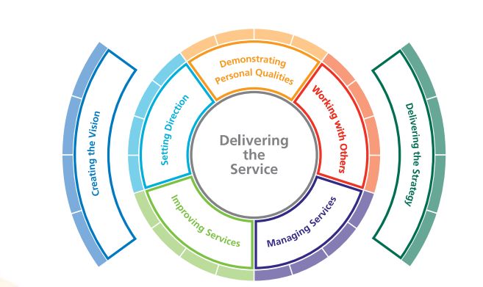
Figure 2: Leadership Framework
(Source: NHS Leadership Academy, 2014)
The NHS leadership framework is a comprehensive guide that has been developed to define the core capabilities of leadership to deliver high-quality and patient-centered care to all. It identifies seven interdependent domains associated with leadership to drive transformational change across the health and social care industry in the UK.
Demonstrating Personal Qualities: The core focus of this component is integrity, emotional resilience and professional accountability. As leaders are the driving force for fostering creativity, being self-aware and acting with honesty are the key behavioral skills that they need to possess.
Working with Others: Collaboration, nurturing an inclusive workspace, and fostering partnerships are the key focus of the component. To attain this component, leaders must be collaborative, possess a keen knowledge of cultural diversity, and have the ability to resolve conflict.
Managing Services: This focuses on ensuring effective, efficient and safe delivery of crucial healthcare services. Hence, leaders need to be able to manage time, maintain accountability and ensure compliance with standards and laws.
Improving Services: The focus is on driving innovation through continuous improvement to enhance service processes and quality.
Setting Direction: One of the main capabilities of leaders is to formulate and define purpose and objectives for healthcare professionals, while prioritizing organizational goals.
Creating the Vision: Without a comprehensive vision for the organization, guiding healthcare professionals and leading the organization towards its desired goal cannot be attained. Hence, a leader must create a compelling vision for staff for a patient-centric system.
Delivering the Strategy: Translating strategic plans into tangible action is another necessary aspect of an NHS leader who should be able to ensure the alignment across structures, monitoring of processes and outcomes (NHS Leadership Academy, 2014).
Improving Services
Improving services in the health and social care sector is a necessity in the current scenario, considering the changing environment and increasing expectations of patients. The element of seeking and action on new ideas presents significant importance to boost creativity and innovation among individuals. Bird et al. (2021) referred to creativity as the process of generating new ideas. Designing a structured process that can be useful for companies to transform new and creative ideas into specific services, processes, or products remains highly important in the healthcare industry. The leadership of the NHS should focus on developing a psychologically safe work space for workers to take risks and identify solutions on their own accord. A creative leader is a person who can listen to constructive criticism and address problems early on (Refer to lecture notes). Through appreciation, collaboration, fostering good relationships, and discipline, creativity can be fostered at the NHS (NHS File, 2025). Seeking innovative and unique ideas can allow the organization to develop new and more effective processes, which not only save time and resources but also improve the overall quality of healthcare services.

Task 7 - Self-Reflection Journal Entry
The module has presented me with a critical understanding of leadership, creativity, and value creation within the health and social care industry. I have understood the necessity of a strong leadership capability to boost creativity, as mentioned in the leadership framework. From my perspective, creativity and innovation remain significant factors to achieve more efficient and better services across the industry. The rapid development in technology has necessitated the focus on creating value for not only patients and their families but also for staff. The learning indicated the increasing use of technology in creating efficient health services, such as the NHS app. Learning about these aspects made me quite interested in the topic, as I have always dreamt of working in the industry. It further informed me on the necessary practices like seeking new ideas and acting upon them, taking accountability, being self-aware, and such practices are necessary to not only drive innovation but also create value for others. As I tend to seek tested and proven practices, it will be necessary for me to focus on practicing taking risks and trying out new ideas. Brainstorming, keeping journals, and more can be quite beneficial practices to achieve this.

Reference List
Anderson, M., O'Neill, C., Clark, J.M., Street, A., Woods, M., Johnston-Webber, C., Charlesworth, A., Whyte, M., Foster, M., Majeed, A. and Pitchforth, E. (2021) Securing a sustainable and fit-for-purpose UK health and care workforce. The Lancet, 397(10288), pp.1992-2011.
Bird, M., McGillion, M., Chambers, E.M., Dix, J., Fajardo, C.J., Gilmour, M., Levesque, K., Lim, A., Mierdel, S., Ouellette, C. and Polanski, A.N. (2021) A generative co-design framework for healthcare innovation: development and application of an end-user engagement framework. Research involvement and engagement, 7(1), p.12.
King’s Fund (2021) Shaping the future of digital technology in health and social care. Available at: https://www.kingsfund.org.uk/insight-and-analysis/reports/future-digital-technology-health-social-care (Accessed: 6 October 2025).
Morgan, B. (2022) NHS staffing shortages. Why do politicians struggle to give the NHS the staff it needs.
NHS (2025) NHS App pilot report: what we learned from users. Available at: https://digital.nhs.uk/services/nhs-app/nhs-app-pilot-research-report/what-we-learned-from-users#the-design-of-the-nhs-app-is-good-and-it-s-easy-to-navigate (Accessed: 6 October 2025).
NHS (2025) NHS waiting list hits two-year low as staff work to ‘turn the tide’. Available at: https://www.england.nhs.uk/2025/06/nhs-waiting-list-hits-two-year-low-as-staff-work-to-turn-the-tide/ (Accessed: 6 October 2025).
NHS File (2025) Creativity. Available at: https://www.nhsfife.org/services/all-services/child-and-adolescent-mental-health-service-camhs/things-to-try/creativity/ (Accessed: 6 October 2025).
NHS Leadership Academy (2014) Leadership Framework. Available at: https://www.leadershipacademy.nhs.uk/wp-content/uploads/2014/11/Leadership-Framework.pdf (Accessed: 6 October 2025).
Nicita, C. (2024) Four Stumbling Blocks To Value Creation And How To Overcome Them. Available at: https://www.forbes.com/councils/forbesbusinesscouncil/2024/12/05/four-stumbling-blocks-to-value-creation-and-how-to-overcome-them/ (Accessed: 6 October 2025).
Thornhill-Miller, B., Camarda, A., Mercier, M., Burkhardt, J.M., Morisseau, T., Bourgeois-Bougrine, S., Vinchon, F., El Hayek, S., Augereau-Landais, M., Mourey, F. and Feybesse, C. (2023) Creativity, critical thinking, communication, and collaboration: Assessment, certification, and promotion of 21st century skills for the future of work and education. Journal of Intelligence, 11(3), p.54.
Velumyan, N. (2023) What Kind Of Leaders Do Businesses Need Nowadays? Available at: https://www.forbes.com/councils/forbescoachescouncil/2023/08/17/what-kind-of-leaders-do-businesses-need-nowadays/ (Accessed: 6 October 2025).

