Workplace Culture and its impact on Organisational Efficiency

BMSW_5105

Table of Contents
Introduction 2
Main Body 3
Critical assessment of impact of environmental factors on culture of UWTSD using: 3
Pestle analysis 3
Porter’s 5 forces 5
Cultural web 9
Critical appraisal of UWTSD promoting ethical behaviour 10
Recommendations 12
Conclusion 13
References 14

Introduction
This report has been presented in order to highlight the culture that is prevalent and necessary at workplace. The chosen organisation has been University of Wales trinity Saint David or UWTSD. According to Castle, (2017), the impacts which it has on the performance of the workers and the organisation’s productivity as a whole has been discussed. The analysis has been conducted using 3 main macroeconomic parameters to judge and determine workplace culture and environment. These are PESTLE analysis, Porter’s 5 forces and Cultural web. Necessary statistics and graphical images have also been presented to highlight the quantitative analysis. This is in correlation with qualitative aspects from the headings discussed above. An elaborate discussion on the ethical aspect of UWTSD’s culture has also been discussed. Finally, the necessary recommendations to improve the UWTSD’s workplace culture have been discussed followed by a conclusion to sum up the report.

Main Body

Critical assessment of impact of environmental factors on culture of UWTSD using:

Pestle analysis
The University has maintained that it shall imply INSPIRE (Institute of sustainable practice and resource Effectiveness) to make sure that the students who graduate become eligible to work effectively in the future and their soft skills and technical skills acquired are put to the best purpose and use in companies which become the benchmark for the future generations to abide by. As opined by Palmerand Saint David, (2018), the UK has been amongst the leading countries in the world which has a highly prestigious education system. There have been over students coming from over 205 other countries to study in UK and 40% at PG level. UWTSD is one of the leading universities in UK. It has very high standards of education. The costs of taking tuitions are also very low and many students come to UWTSD with the hope of successfully completing tertiary education. There have been many changes made to the government policies to aid higher education in UK. This requires a lot of collection of funds from the public like collecting research grants. However, the reduction in finding will lead to reduction in EMS allocated resources. This has made the University use sustainable measures which would reduce costs. The increase in levying taxes will reduce funding in EMS and hence UK government must address this. There could be student engagement programs promoted in NGOs which would help a lot of needy but useful talent flourish. UWTSD engages in the proper maintenance of its environment and looks to maintain reputation by proper community services provisions. There have been some issues found of losing the supportive staff if management especially in Covid 19 times. During the lockdowns imposed in UK the universities and other educational institutions suffered a lot as they had to be shut down and many employees were not paid their remuneration in full or laid off simply leading to unemployment. After the restrictions were eased off and many universities started their classes new staff members were selected which gave the management to restructure its budget and reallocate the initiative of development at the campus. There have been some drawbacks also noted in the political aspect when the management has been unable to commit at times which has made many employees resistant to change lack of commitment and lack of motivation in engaging with students and faculty members alike. Many students have to take student loans and hence get in financial debts. They have to make arrangements for their stay. UWTSD has been making efforts to cater to this (Southern, 2018). There has been focus on consuming electricity less and focusing more on renewable sources of energy like the usage of solar panels. Apart from this the campus has engaged in funding schemes like revolving green fund.
PESTLE at UWTSD
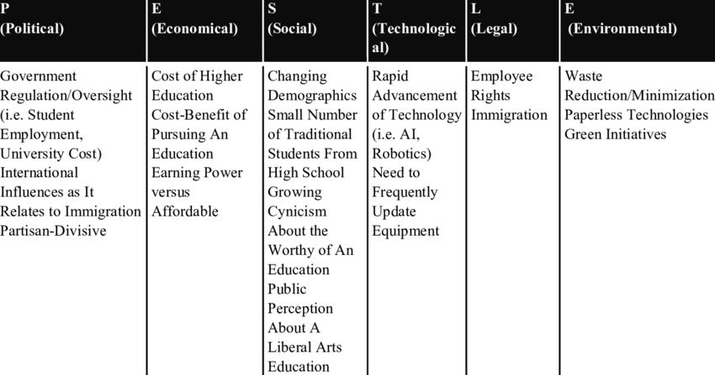

Source: (Southern,2018)

There have been many budgetary changes by the university to reallocate the funds away from the EMS and other plans. This has given higher returns on investment. As stated by Morgan, (2021), the university must also look at investing in large capital projects which may help it in addressing the issues of sustainable development. There has to be high number of funding made in the university by increasing the volume of students from different countries which will boost the financial state of the institute. There have been many societal and cultural pressures in the UK university scene which has also affected UWTSD. There have been many cross-cultural issues arising in UK from the Black Lives Matter movement and #me too movements which has many protests and mobs being formed by young adults and students. At times there have been certain norms which led to UK wide protests among students in many months in the last few years. The UWTSD has also made sure that it takes responsibilities to make all the students at the university feel welcome. There have been groups of students at the university which has looked at various projects to promote the environmental wellness. The shareholders in the university have also engaged in many CSR activities to help communities especially in the pandemic phase. There has been conscious effort made by the institute to not employ technologies which have a long payback period as these reduce the uptake features. The continued development of technical aspects has also made the scope of education wider in terms of varied nature in teaching, engagement with the parents, teachers and students. There have been efforts to reduce any form of carbon emissions and the university promotes the go green initiative in the campus. There have been better features of offering hygienic water and food in the canteens. The safety of the students has been put at the forefront. There have been few legal compliances in UK especially after Brexit which has affected the institute. There has been focus in following the government legal framework and inculcate more detailed research-based education at the institute. The University shall work with partners in HEFCW, local and Welsh government to formulate better strategies post covid. It will collaborate with SMEs and focus on MADE, CBM and other technologies. The university has increased the climate changes awareness by forming sustainable development programs and teaching the students and sending them to locales in UK to promote and spread awareness about the need for environment protection. The university is committed in provision of a high-quality environment that enables exchange of research and knowledge in which students can thrive. This also develops the brand image globally (Penaluna, 2021). As of 2020, there are 2.53 million students studying in UK universities. 72.6% of undergraduates studying in 2019-2020 were white in complexion. 12.2% were Asian, 8.7 % were black, 4.5% had mixed ethnic origins while 2% belonged to other ethnicities.

Porter’s 5 forces
New Entrants Threats
UWTSD must look at ensuring that they give more credentials, certificates, EMBAs and associate degrees. This is because these have acquired significant value in the job market. The employees in modern times are more switchers who shift from one company to another. Hence, they need to study relevant degrees at their institutions. At UWTSD the new entrants could be affected mainly from the requirements of capital, the economies of scale, the reaction to the new universities and the resistance from the buyers of courses. The economies of scale here refer to the ability of the institute to reduce the costs of production by employing better human resources. The teaching has to be conducted in such a manager that the students feel engaged and when they mingle with the outside society which is their friends, relatives and the society in general they can harp about their teachers. This will improve the brand image of UWTSD. Students often find it difficult to adjust to new universities and this can be worked upon by the institute by making them feel secured so that they do not leave.
Substitution threats
It has been noted that students of universities in general at UK and also UWTSD are slowly developing a customer frame of mind in their pursuit if education. This means that they believe in inflation of grades, better accommodation facilities in the campus and nearby and their preferences being met. It has been observed that most students who are financially well off are preferring universities on external features which they deem as beneficial for them apart from the studies that they will embark upon to build a successful career. Studies for NCES has shown that there many 4-year courses have been divided with gaps, combination of online courses and life experiences so that the students do not face may issues in workplace once they become employed. These competitive alternatives have been formed from increasing tuitions, increase in dents of students and ROI decreasing at UWTSD. To combat this UWTSD has to increase the admissions budget (Saint David, 2020).

Porter’s Five Forces at UWTSD

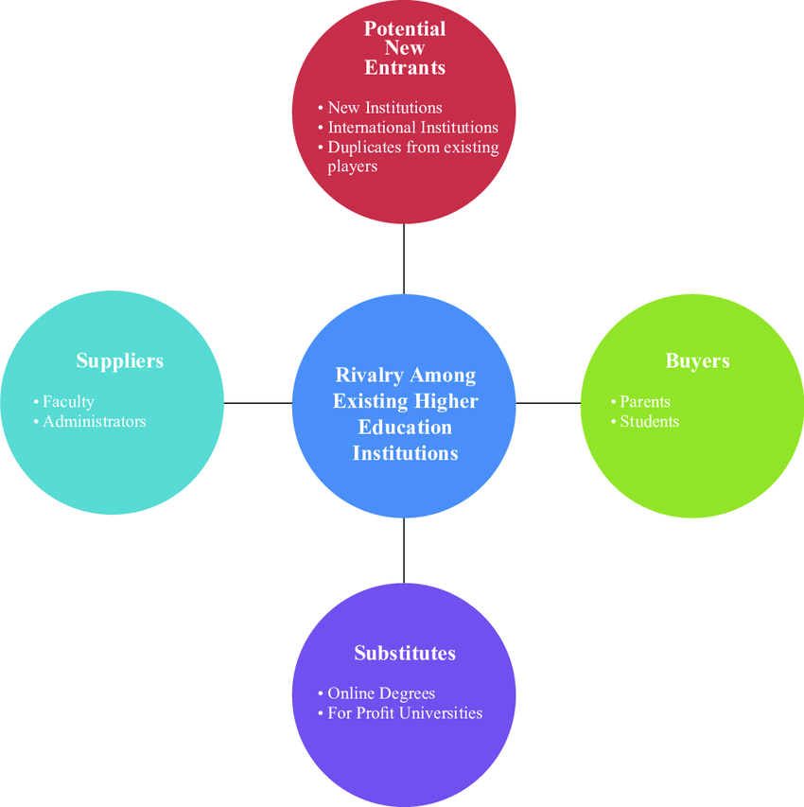
Source: (Weichtand Jónsdóttir, 2021)

Determination of existing Competition
From 1957 4-year public and private post-secondary institutions in 1981 the number has increased to 3026 in 2013. This is an increase over 54%. The estimated increase in students has been estimated at 16.8% from 2016 to 2025. Hence UWTSD must understand that competition to enrol students is stiff and make amends. The reduction of switching costs by providing online modes to study which reduce many maintenance costs at the institute. There are courses like STEM which are promoted and come with lucrative salary packages for those who successfully complete it (Weichtand Jónsdóttir, 2021). The STEM teachers also get an average of £64296 and salaries in humanities are much lower at around 59000 GBP.
Buyer power determinants
In the last few years there has been huge influx of foreign students in UK. There have been scholarship support programs that have also supported this. At tie the parents of the students who have enrolled at UWTSD are also the buyers. Their perception of sending their children is determined by few factors namely the information they get about the educational institutes, the rankings which they read form publications and hear from ex-students. Hence, these offerings and accreditations get compared and met the students take admissions. UWTSD is ranked 13th in UK for the satisfaction of students which is very high.
Supplier power determinants
The teachers and support staff at UWTSD are globally recognised. There is also the presence of a very sound infrastructure across the entire campus. There are also many laboratories and other personalized laptop facilities which are being given to the students at the institute. The books of the libraries, the raw materials for preparing the food at the canteen and many non-academic elements are also determined by the quality of suppliers which a university keeps. UWTSD must ensure that these real the best as students futures depend on them.

Cultural web
At UWTSD there is an elaborate and rigid cultural web that is followed. According to Hayles, (2018), there is work conducted around all outside elements in order to build a better environment and uplift the culture at the university. There are processes which are considered repeatable by foreseeing the future trends in education. The cultural feedback is taken regularly at the university to identify and mitigate any gaps in cultural diversity. There are cross cultural teams comprising of faculty members and students which are addressed and called for meetings to discuss if there are any shortcomings that they have been facing or face while on campus. If any undue incident is reported by the concerned members, then strict action is taken immediately. A GAP analysis template has also been suggested by many members of the institute’s management which would help in identification and solving of the differences. There are workshops held with the results delivery team on the performance of not only teachers but the teachers and other non-teaching staff to evaluate performance and give them feedback on ways to improve. The cultural web analysis at the institution has helped in identifying the realities of how the students, teachers, administrative staff and other managerial employees feel at the University. These reports have been sent to the University directors and shareholders for them to analyse upon. The hierarchies of power at the institute have also been evaluated. The behaviours of the teachers, the students and staff have been monitored. There has been significant progress in the educational curriculum in the last few years with many modules and courses taught online with augmented reality mediums. The institute is steeped in rich history of almost 200 years as UWTSD will celebrate 200 years of establishment in 2022. There have been seminars to inculcate the university’s principles and facets like discipline, hard work, cordial behaviour, mutual trust and other aspects which would benefit the students in their personal and professional life once they graduate. One of the primary elements the institution focuses on is the communication factor between teachers and students. There are peer-to-peer sessions held and many group activities to promote harmony and cohesiveness. Refresher sessions are also given to the students who find it difficult to grasp certain concepts. All these aspects have boosted the culture at UWTSD.
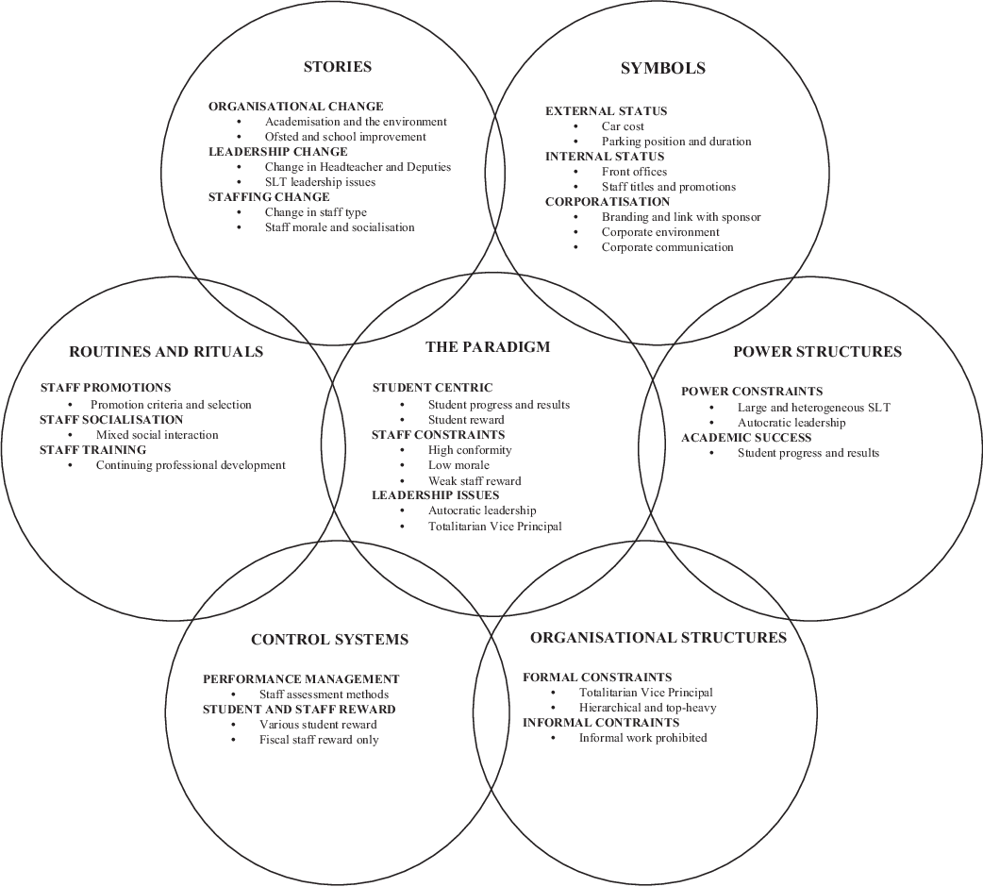
Source: (Hayles,2018)

Critical appraisal of UWTSD promoting ethical behaviour
The employees within the organization belong to varied cultures and there is a need to maintain the ethical framework of such a workplace which would make the individuals cooperative with one another and respect their differences. The employees would be guided by the leaders to behave appropriately with each other so that they are able to fulfil their ultimate targets quite effectively. The perceptions, beliefs and the individual differences in varied cultural background would require prioritizing the needs of the employees so as to promote their maximum engagement for better team work that can fulfil their aspirations and demands (Lozano and Escrich, 2017.). The culture of University of Wales Trinity Saint David is such that there are a diversified group of international students who acquire their educational degrees from this university and they are entitled to cater to the ethical framework that has to be maintained on behalf of the organization. Distance learning programme in the university provide better flexibility to all the learners residing in distant places. The diversified community of students and the scholars connect to each other and bring about better integration of knowledge that was essential in framing their scope of educational career quite effectively. The university has been dealing with the specialized studies in various field that would be dated back to the ancient times that would enable the learners to gain diversified knowledge about each other’s cultures. The individuals have been able to ensure better learning among them by cooperating with their peers that would instil in them with the relevant values. The digitalized teaching courses in the university have attracted learners from all over the world wide so as to promote equal opportunities to all the learners registered in the particular university. The university also lays focus on the diversification of the learners as well as ensure their professional practice through their consolidation of career. Various equipment as well as resources are used to ensure the prioritization of range of learning processes that would effectively service to the learners. They also cater to employment opportunities without discriminating on their opportunities provided to the learners. The vocational approach had been widely promoted to the culturally diversified students who have been maintaining the norms of the organization. The development of the graduates and skilled practitioners would enable a sustainability of the society and enhance their transfer of knowledge through the diversified networks which are available. The university would deal with culture capital and ensure social justice so that no individual culture is prioritized that would lead to inequality within the campus (Leslie, 2019).
Various other universities can be taken into consideration in UK namely University of Oxford, University of Cambridge, University of London, University of Bristol and many others have been focussing on the maintenance of their work ethics so that the learners are able to progress in their educational field quite effectively. They have been promptly accepting students from world- wide to determine their strengths as well as the skills which they possess for their progression in the field of academics and ensure their development. Apart from universities various organizations in UK namely Sainsbury’s, Morrison, Next plc, Tesco have been quite acquainted with workplace ethics and culture so that the employees are hired on the basis of their competencies and talents that they have to promote the smooth functioning of the business. (Chams and García-Blandón, 2019). Further the organizations are led by efficient management teams who would be responsible to ensure team cooperation and collaboration through better communication to eliminate any gaps in their business operations. Their ethical framework would ensure disciplined attitude of the employees who would be highly responsible for maximizing their engagement and promoting better profits. The employees collectively as a whole would function in a team and express their opinions that can make them highly satisfied to serve with their best potentials. The employees would be considerate to understand each other and promote competitive advantage for ensuring their brand loyalty which can lead to the sustainability of their business. The personality of the leaders of the organizations would be such that they are quite tolerant in their attitude for dealing with the challenging circumstances in business which they face with the diversified group of employees. They handle the conflicting situations among the culturally varied individuals so that they are able to maintain safe working environment which would promote highly skilled and competent employees who are conjointly dealing with their business operations and the fulfilment of the ultimate targets without pinpointing the differences which exist among them (Newman, et al., 2017). Such an organization is bound to prosper where the integration of different ideas from the diversified individuals would enhance the business of the organization.

Recommendations
UTWSD is a university which has a rich hand diverse background. It already follows a very detailed and harmonious methodology in its organisation and framework that has proved to be successful in its long history. However, it needs to take note of certain changing trends in education which will dawn upon us in the near future. The future of higher education shall be combining a mix of physical and online education which ahs already started post covid-19. The institute can look upon programs which are location based. It can inculcate more teaching by pragmatic means and also combine synchronised and disruptive learning digitally. For example, there could be hybrid models of students living in the institute campus while taking part in their classes without actually visiting them (Smith, 2021). This will be more flexible and also economically beneficial as physical classrooms have a lot of maintenance costs attached to them. This costs lowerance will result in more flexible fees being taken from the students. There has been a drastic drop in the enrolment as a lot of admissions had to be cancelled in the last 2 academic years. Now the university needs to rebrand its marketing strategies and ensure that the footfall of students is large. There have been several effects created on the mobility of the students and hence UTWSD must ensure that it does not go into financial turmoil and risk insolvency. There has to be amends to sell courses online so that the education dose not face any issues in admission process. UTWSD must improve the pedagogy and curricula and update the modules being taught at regular intervals. This shall keep the students updated with the latest knowledge which is paramount for survival in their later careers as entrepreneurs, corporate or any profession that they choose. The institution must make better use of available technology. For example, noting down the productive time of the lectures that are being given to the students. This helps the lecturers measure the degree of efficiency that the students gain and the amount that they are able to retain and relocate in their examinations. This also gives a better idea of objective participation and ways in which it can be improved. There could be forums created by the institution where the voices of the parents and students be catered to improve their teaching pedagogy (Hunter, 2021). The university can also look to introduce the students to cultures which they are nit much aware of. This will solve a lot of cultural difference and language barriers which students often face at these institutes. There could be workshops for the same. This will also aid them in their career when they become professional as at the workplace a diverse cultural ethnicity is generally present in most MNCs around the world. The students can also be kept involved with different interactive sessions.
Conclusion
UWTSD has been a university which is synonymous with excellence. IT rates high on all parameters ranging from quality of education, lecturers teaching methods, course curricula and other pedagogies. The non-teaching staff are also extremely efficient. The senior management at the University ensures that special care is taken to all facets at the institute and that everyone behaves in a manner that is best suited for an educational institution. The covid-19 pandemic disrupted the flow in the institution as was the case across Wales and UK but things have been improving since the restrictions have been eased off (Mort, 2021). The University is making plans to celebrate its 200th anniversary in a pompous manner. It has also made plans to maintain its standards of excellence depicting its vibrant culture.

References
Castle, C., 2017. Make a Meal of It: Lessons from a household food waste project in West Wales. Submitted to the University of Wales in partial fulfilment of the requirements for the Degree of Master of Education University of Wales Trinity Saint David.
Chams, N. and García-Blandón, J., 2019. On the importance of sustainable human resource management for the adoption of sustainable development goals. Resources, Conservation and Recycling, 141, pp.109-122.
Hayles, C., 2018. Embedding Education for Sustainable Development through the Well-being of Future Generations (Wales) Act 2015.
Hunter, J., 2021. The MA in Ecology and Spirituality: Background and Interview with Dr. Andy Letcher. Journal for the Study of Religious Experience, 7(2), pp.140-145.
Leslie, L.M., 2019. Diversity initiative effectiveness: A typological theory of unintended consequences. Academy of Management Review, 44(3), pp.538-563.
Lozano, J.F. and Escrich, T., 2017. Cultural diversity in business: A critical reflection on the ideology of tolerance. Journal of Business Ethics, 142(4), pp.679-696.
Morgan, C.E., 2021. An exploration of the perceptions of undergraduate trainee teachers regarding the factors that impacted upon their use of incidental Welsh in the primary classroom (Doctoral dissertation, University of Wales Trinity Saint David).
Mort, C.J., 2021. Exploration of the lived experiences of young british muslims in wales through a postcolonial and epistemic injustice lens (Doctoral dissertation, University of Wales Trinity Saint David).
Newman, A., Round, H., Bhattacharya, S. and Roy, A., 2017. Ethical climates in organizations: A review and research agenda. Business Ethics Quarterly, 27(4), pp.475-512.
Palmer, S. and Saint David, T., 2018. Can positive and coaching psy chologists become more involved in social prescrib ing? The prescription for enhanced wellbeing. Coaching Psychology International, 11(8), pp.28-31.
Penaluna, K., 2021. Through a design education lens: Are we reinventing the wheel for entrepreneurial education? (Doctoral dissertation, University of Wales Trinity Saint David).
Saint David, T., 2020. 1. Teachers, researchers... and teacher researchers. BERA Bites, p.8.
Smith, R.K., 2021. “I think it's quite an insulting question,‘what’s it like to be white?’... It's not a question that needs to be asked”: An exploration of how white trainee counsellors in South Wales understand ‘race’, racism, and whiteness (Doctoral dissertation, University of Wales Trinity Saint David).
Southern, A., 2018. Disrupting the habitus? Media representations and participant experience of Teach First: an exploratory case study in Wales. Teachers and Teaching, 24(5), pp.584-597.
Weicht, R. and Jónsdóttir, S.R., 2021. Education for Social Change: The Case of Teacher Education in Wales. Sustainability, 13(15), p.8574.

