MARKETING FUNDAMENTALS ANALISYS AND EVALUATION
  - LCBB4004
  - ASSESSMENT 2


  - MATEI DENISA ANDREEA
  - STUDENT ID: 1921544
  - LECTURER: RULA ALOUSI
Table of Contents
INTRODUCTION 4
COMPANY OVERVIEW- APPLE INC. 5
PHASES OF MARKETING AND THE ROLE OF THE MARKETING MIX 6
IMPACT OF STAKEHOLDER ENGAGEMENT ON THE MARKETING ACTIVITIES OF APPLE INC. 18
CONCLUSION 20
REFERENCES 21

LIST OF FIGURES
Figure 1: Marketing Process Overview 6
Figure 2: Marketing Planning Process 8
Figure 3: SWOT ANALYSIS 9
Figure 4: PESTLE ANALYSIS 11
Figure 5: THE STP PROCESS 14
Figure 6: MARKETING MIX 16

INTRODUCTION
Marketing refer to the set of activities that an organization undertake to promote the selling and buying of a product or service. In other terms, marketing is the sum of processes involved in directing the flow of goods from producers to consumers. According to Sailer (2020), Marketing is complex as it comprises of tons of distinct strategies, disciplines and tactics. He believes that success in future always starts with solid fundamentals; hence he suggested a few of actionable advices but at its core, marketing revolves around four key factors: product, price, place and promotion, these are the notion and principles everything else revolves around. As the concept of marketing has become widespread, large corporations have started recognizing the significance of market research, sustained communication with clients, better product design and effective distribution channels in making their brand a success.
This essay will provide an all-inclusive appraisal on the marketing processes of Apple Inc., a multinational technology company deals in designing, producing and selling consumer electronics. The highlights will be the theoretical models and frameworks including SWOT, PESTLE, STP and Marketing Mix outlining their role in the success of Apple.

COMPANY OVERVIEW- APPLE INC.
Apple Inc. is an American multinational technology firm established in the year 1976 by Steve Jobs, Ronald Wayne and Steve Wozniak within the computer electronics industry. It is headquartered in Cupertino, California, US. As of now, the company has more than 510 retail stores all across the world. Apple ranked itself among top five corporations working within Information Technology industry, alongside Microsoft, Facebook, Google and Amazon. Ward (2019) revealed the story behind the marketing success of Apple and proved that market capitalization is the key behind the growth of Apple in becoming the largest technology brand. It started business from a small garage in California Menlo Park and now it has employed over 100,000 employees from different corners with $260.17 billion revenue in last financial year, which is slight retreat from $265.6 billion which is a historical record.

PHASES OF MARKETING AND THE ROLE OF THE MARKETING MIX

MARKETING
According to Hibbard (2020), Marketing is a discipline seeks taking company’s product or services, identifying the ideal customers and drawing their attention towards the product or service. Marketing is thus defined as the series of activities a firm undertaken to promote its products and maintain positive association with the customers. The ultimate aim of marketing is to ensure profitability.
MARKETING PROCESS
Weller (2017) highlighted the key elements of a strategic marketing plan including a deliberate set of steps that helps a firm in determining and reaching its goals. By following the essential steps for a successful marketing process, a company can get the ability to align marketing with its business goals. The marketing process encompasses different activities that has to be followed by Apple to stay ahead of competitors by building large customer base, it ranges from analyzing strategic marketing, planning marketing mix, implementing marketing tactics and controlling the outcomes. A CMO Survey Award has been given to a market leader Apple to achieve marketing excellence for seven consecutive years. The reason is the successful implementation of marketing campaign across the world.
STAGES IN THE MARKETING PROCESS
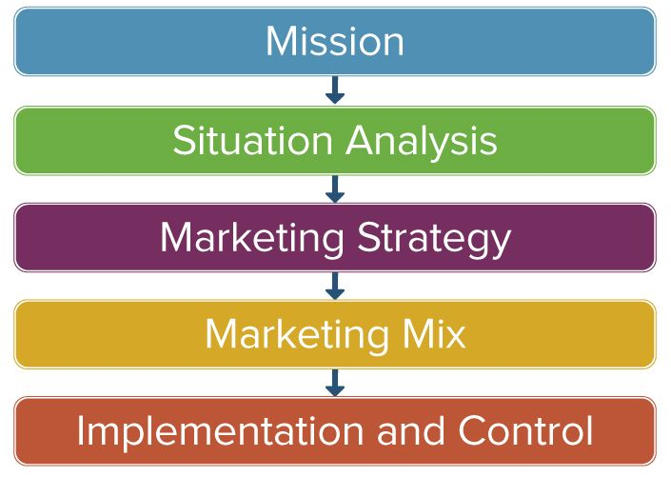
Figure 1: Marketing Process Overview
Source: (Seturi and Urotadze, 2017)
Mission
In a concise and simple term, a mission is truly a purpose of a company for its existence i.e. for being in the industry; it usually explains a company’s values, ethics and culture. The core mission of Apple is to distribute the best personal computing products that can support the educators, students, scientists, designers, businesspersons and the society at a large. Although, Apple is operating is more than 140 countries at present, it aims at expanding its reach globally by considering the changing business landscape, recognizing trends in the consumer electronic industry and changes in the industry environment (Rowland, 2020).
Situation Analysis
At its core, situation analysis is associated with the analysis of the internal as well as external factors of a business, alongside determining the capabilities, competencies, business environment, potential customers and their influence on the company itself. The competitive advantage of Apple is driven by its commitment to serve the diverse range of products matching the consumer preferences and needs and fostering a collaborative work culture (Ward, 2019). SWOT analysis is the best framework that can be applied by any firm to analyze every marketing aspect and the factors that can contribute to its unparalleled success.
Marketing Strategy
It is the overall game plan of a business prepared to reach prospective consumers and to turn them into potential customers. This forward-looking approach is usually planned for long-term and encompasses the value proposition, brand messaging, target customer demographics and other high-level components. The products served by Apple speak for themselves, this way the company positioned its marketing, keeping visuals and messaging simple. This shows that Apple’s marketing is built on simplicity (Seturi and Urotadze, 2017).
Marketing Mix
Marketing mix is referred as the combination of factors including product, price, place, promotion and other such elements that a firm can control to influence consumers for purchasing its products. Apple often uses premium pricing strategy when it offers diverse range of products; also it depends upon strict guidelines for distribution. The 4Ps of marketing is the best way of communicate the value of business to the consumers.
Implementation and Control
At this stage, a company put the defined plan into action, search for the effective ways of launching a product, reaching out to potential clients, encouraging them to purchase products, accessing required material resources (cash and equipment), organizing human resources, developing schedules and keep monitoring the progress timely. Each of the products served by Apple complements the other one and operates within the similar ecosystem, this help in building customer loyalty for a long run ((Ward, 2019).
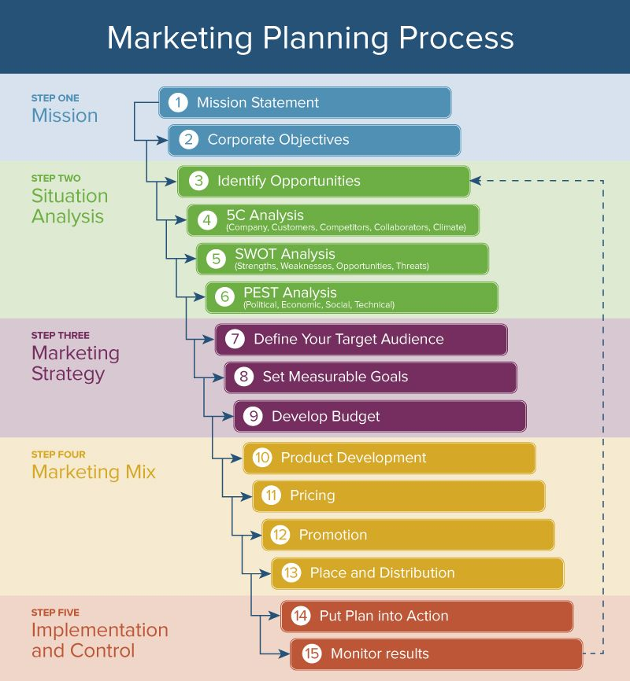
Figure 2: Marketing Planning Process
Source: (Seturi and Urotadze, 2017)

SWOT ANALYSIS
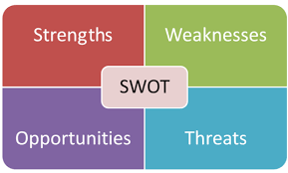
Figure 3: SWOT ANALYSIS
Source: (Omer, 2019)
Strengths
Apple is positioned as the most valuable brand as it is ranked number 1 for the seventh consecutive year with revenue of $260 billion. The company is said to be the most reliable firm when it comes to build new lines of smart technology devices or personalized advanced computers. With steady increment, Apple succeeded in having millions of loyal potential customers (Smithson, 2020). Although, sales volumes are limited, Apple does exhibit the ability to gain higher profit margins through its premium pricing strategy; this is proven by the case of MacBook laptops.
Weaknesses
Due to Apple’s policy of exclusivity, the company end up maintaining limited distribution network, for e.g., the company choses the authorized sellers to sell its premier products, such as Macs and iPhones. This initiative of the company limits the market reach, and does not make consumer electronics readily available in all locations. Also, the company can only rely upon high-end market segments due to its premium pricing strategy, this marks the weakness of sales dependence.

Opportunities
As it is observed that company has access to limited distribution network, it has the opportunity to expand its network for its tablets and smartphones. It also needs to focus on aggressive marketing to seize the available opportunity for increasing sales volume, particularly for its mobile devices. Further, Apple can complement its existing product lines by exploring new, this may include improving online services (Omer, 2019).
Threats
Competition is the biggest threat in the case of Apple as the existing players in the information technology industry are placing strong efforts to digitalize this world and bring a positive change in the consumer style of living. Amazon, Microsoft and Samsung are three leading players that are using rapid innovation to stay ahead of competition. Further, Apple faces a threat of imitation as its competitions do have the ability to copy the features Apple provides, for e.g., Google has copied the payment app features of Apple and built in its Android Pay Application, also iPhone and iTunes can be easily imitated by these competitors. Furthermore, the rising cost for labor in outside countries where Apple maintain production facilities also creates threat in terms of reducing profit margins and pushing higher selling prices (Smithson, 2020).

PESTLE ANALYSIS
According to Lombardo (2019) the performance of Apple is directly linked to the company’s efficiency in addressing the external factors in the remote environment of the company and eventually in seizing the opportunities present within the information technology & consumer electronics industry.
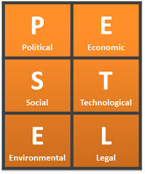
Figure 4: PESTLE ANALYSIS
Source: (Perera, 2017)
Political factors
Political factors present both opportunities and threat for Apple, however mainly brings opportunities. The creation of free trade policies offers a chance to Apple to distribute its products worldwide. As Apple is currently operating within different developed countries, for e.g. UK and US, they provide stable political scenario and landscape with reduced political issues. Despite these opportunities, the trade disputes between the China and US, creates a threat for the company to obtain global sales revenues. These disputes could force China to impose higher tariffs on imported equipment Apple often use in product assembly (Perera, 2017).
Economic factors
Apple has the opportunity to expand globally by taking advantage of the economic stability in the developed as well as developing countries. For e.g. Apple can seize opportunities available in the Asian markets which in turn help the company in increasing its revenues through investments and sales in the overseas markets. Additionally, Apple can target those customers who are having higher income and are able to spend excessive amount on its products. However, the increasing labor cost in some countries, such as China, could take away the cost advantage of Apple products. Also, a strong U.S. dollar may increase exchange rates which in turn increase outlay for Apple to do business in other key markets, including China and Europe (Lombardo, 2019).
Socio-cultural factors
It is observed that the people living in Africa are more willing to spend money on technology products; however they are unaware with the products of Apple, thus Apple can take benefit of growth in consumer spending. However, it is witnessed that people in UK and US lack the strong emotional attachment with Apple’s products that would have helped company in driving sales. Despite these circumstances, it cannot be denied that the consumers, especially the youths are dependent on digital systems and this increasing dependence is another socio-cultural trend that brings an opportunity for Apple to enhance customer base. On a contrary, the international anti-apple sentiments are mounting due to which the Apple’s brand image has reduced, alongside consumer confidence in its products.
Technological factors
Although, the products served by Apple are unique, the competitors can still copy its products, for e.g. Samsung and Google have the strong ability to imitate the Apple’s products. It is observed that Google have brought an Android Pay app with the same features as Apple introduced, it only took a year for Google to do so. Apple has the opportunity to expand its cloud infrastructure as it has recognized a growing cloud computing demand (Lombardo, 2019). Not only this, Apple can integrate many technological tools to better customer service, for e.g. App Store or other digital content distribution platforms. However, the growing technological capabilities of other firms create threat for Apple to stay of competition.
Legal factors
Today, people are living in a digital world where governments are pressurizing businesses to focus on privacy concerns, particularly have increased the privacy regulations; this could act as a threat by imposing costly regulatory compliance requirements, however could also act as an opportunity that Apple could seize by enhancing the privacy measures and ultimately boosting the business. Additionally, the company has faced strong criticism regarding the policies on third-party repair services, these legal battles are the threats for the company, hence Apple need to focus on privacy protection & to adjust its practices to address legal pressures (Perera, 2017).
Environmental factors
The disposal of non-working or used electronic devices is the biggest environmental concern facing Apple. The ecological trend offers an opportunity for Apple to strengthen its corporate image. The company further has the opportunity to bring environmentally-friendly products to fulfill the needs of environmentally conscious people. Also, Apple needs to improve its operational cost efficiencies to make the business sustainable, however this is not fully possible as the company is highly vulnerable to increase the cost of electricity due to its increased dependence on internet infrastructure and data centers (Lombardo, 2019).
STP MODEL
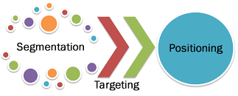
Figure 5: THE STP PROCESS
Source: (Camilleri, 2018)
Segmentation
Segmentation involves making division of the entire population into smaller groups as per certain characteristics and attributes. The majority of the Apple’s customer share common set of attributes including appreciating design and performance of quality products over prices.
Targeting
Targeting involves selecting particular groups identified through segmentation. The target customer segment of Apple comprises well-off persons who are able and not reluctant to pay extra for Apple’s premium products serving advanced functionalities and capabilities. After Tim Cook has become Apple’s CEO, the company shifted its products ranges from mono-segment positioning to multi-segment positioning.
Positioning
Positioning involves choosing the marketing mix that is appropriate and suitable for the large customer segment. Apple has positioned itself as a premium brand that offers products with advanced capabilities and functionalities to obtain higher profit margins. Under multi-segment positioning, the company is placing efforts to target multiple customer segments simultaneously with distinct products or service packages (Camilleri, 2018).
The segmentation, targeting and positioning of Apple is demonstrated concisely in the table below

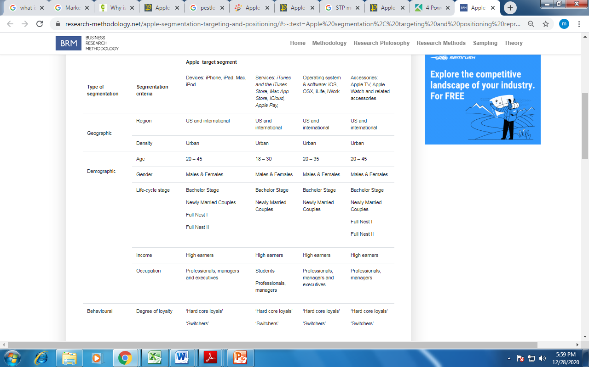
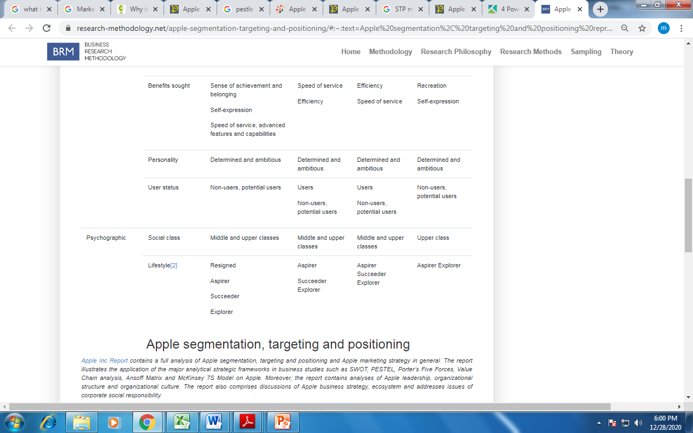
MARKETING MIX

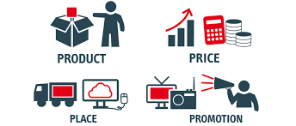
Figure 6: MARKETING MIX
Source: (Singh and De, 2017)
Product: Apple has diversified product portfolio that comprises a wide range of computers and mobile devices for different market segments. In particular, the Mac Product line includes desktop & laptop computer systems of different sizes, the mobile devices further include iPad, iPod, iPhone and Apple Watch. Furthermore, the digital content product line includes digital videos, music, e-games and e-books (Greenspan, 2019). Apple operates in digital content distribution industry by serving Apple TV, creating mobile applications and other software. Further, the cloud technology used by Apple allow people to store huge amount of data and use SaaS i.e. Software as a service, for e.g. iWork for iCloud.
Price: Apple often uses premium pricing strategy to serve its products as the main targets are middle and upper-class consumers having stable income and who can easily afford to pay higher prices to receive top-quality brands. For e.g. Apple’s iPhone is comparatively expensive than Samsung’s smartphones but with more unique features. To ensure competitiveness, it has secondary focus on freemium pricing strategy- a combination of free and premium in which customers pay money to get extra better features in free products or services. For e.g. Apple provide access to 5-gigabyte iCloud storage, yet consumers pay a recurring fee to get added more storage capacity. This states that Apple’s marketing mix is aligned with premium branding (Singh and De, 2017).
Place: Apple has a strong online presence; however the company too has large number of stores situated across the world. The Apple physical stores usually deal in selling MacBook units and other peripheral devices. In addition to this, Apple has the company-owned online stores and websites where consumers can find product details and can find discount packages as well. Further, the mobile-friendly applications such as iTunes store of App store allow consumers to find movies, music and other digital content. These channels would help Apple In expanding its international market reach. Further, the company also has Authorized sellers to distribute its products; these sellers include Best Buy and Walmart. The company also has signed contracts with telecommunication companies, such as AT&T and Verizon (Singh and De, 2017).
Promotion: Apple often advertise its products on technology news websites and on Google’s digital advertising network, further the employees convince consumers personally to visit Apple Store, it is called Personal selling approach. The Super Bowl ad of Apple for the launch of Macintosh in 1984 is still considered widely as the best Super Bowl commercial. However, the decision to release that ad was controversial as the board of director of the company was not in the favor of the advertisement, marking it costly and a failure to stay ahead of competition, yet Jobs was happy with the ad. As a result, the company recorded over $150 million with the sales of Macintosh, only after 100 days of releasing that advertisement (Greenspan, 2019).

IMPACT OF STAKEHOLDER ENGAGEMENT ON THE MARKETING ACTIVITIES OF APPLE INC.

STAKEHOLDER
A stakeholder can be an individual, a group or an institute who is interested in a project and impacted by the outcome of that project. In simple terms, these are the individuals that are concerned with organisation’s activities. A stakeholder can be an investor, employee, customer, supplier, competitor, communities or government (Cardwell et al.,2017).
INTERNAL AND EXTERNAL STAKEHOLDERS
Internal stakeholders are those individuals that are financially involved in the operational activities of a firm and have a stake in the company. These may include primarily employees, managers, owners and internal people having some kind of influence on the organisation’s decisions and strategy. Internal stakeholders have a greater influence on organizational management and take on higher amount of responsibility as compared to external stakeholders.
External stakeholders are those individuals that are indirectly impacted by the organisation’s operations and have a legitimate interest in a given action or situation. These individuals may include customers, suppliers, investors and government that are not involved in company’s internal decision making but can get severally impacted financially (Cardwell et al.,2017).
David (2020) outlined detailed analysis of Apple’s stakeholders by examining both internal and external individuals interested in its operational activities. The leadership of Steve Jobs has been the area of focus whenever studying the involvement of stakeholders as it has a massive role in shaping the future of the company. Also, employees are crucial for Apple’s growing success. The design teams formulated at Apple are being trained in a well manner which in turn maximize the productivity of the overall institute. However, it cannot be denied that most of the key stakeholders of Apple are former employees and investment companies. The investors of Apple are active in different developed as well as developing countries, especially institutional investors holds a majority ownership of AAPL through outstanding shares counts for 59.28% that they control.

COMMUNICATION WITH STAKEHOLDERS AT APPLE ICNC.
Very often, Apple uses advertising campaigns to convey message among the target market and potential consumers. In addition to this, the company has a bulk of information available on different online platforms, especially on its owned websites (www.apple.com) through which it directly makes interaction with all of its key stakeholders. It often shares the product information to access potential clients, career information to recruit more skilled people, prospective applications for senior roles, corporate information for the investors and external parties and many more. All such information is available on its website. Apple has made a record of spending over $1.8 billion on setting up marketing campaign and advertising.
IMPACT OF STAKEHOLDERS ON APPLE’S MARKETING PROCESSES
Maintaining positive association with internal as well as external stakeholders can directly contribute to the marketing success of the organisation. On a frequent basis, Apple is engaged in making regular interaction with consumers through distribution surveys & feedback forms, this is the best way to collect necessary data regarding consumer preferences and expectations that would be useful further in planning marketing tactics (David, 2020).

CONCLUSION
The marketing success of Apple does not merely depends on the development of Apple I and Apple II lines of personal computers served in 1976, but the efforts of Steve Jobs in developing range of unique technology products, from Mac computer, iPhone, iPod, iPad, Apple Watch and Apple TV. The co-founder of Apple- Steve Wozniak believed that marketing is the greatest skill of Steve Jobs that is reflected in its keynote introduction of the iPhone on the stage of Macworld that is still considered as the finest marketing performance of Jobs. He had a passion for developing unique and better designed products for the mass market.

REFERENCES
- Camilleri, M.A. (2018). Market segmentation, targeting and positioning. In Travel marketing, tourism economics and the airline product (pp. 69-83). Springer, Cham.
- Cardwell, L.A., Williams, S. and Pyle, A. (2017). Corporate public relations dynamics: Internal vs. external stakeholders and the role of the practitioner. Public Relations Review, 43(1), pp.152-162.
- David, J. (2020). Stakeholders of Apple (Analysis of Apple’s stakeholders). Online available at https://howandwhat.net/stakeholders-apple-analysis-apples-stakeholders/#:~:text=Product%20information%20for%20customers%2C%20career,to%20communicate%20with%20its%20customers. Last accessed at 22nd December, 2020.
- Dudovskiy, J. (2019). Apple Segmentation, Targeting and Positioning. Online available at https://research-methodology.net/apple-segmentation-targeting-and-positioning/#:~:text=Apple%20segmentation%2C%20targeting%20and%20positioning%20represents,core%20of%20its%20marketing%20efforts.&text=Common%20set%20of%20characteristics%20shared,and%20services%20over%20their%20prices. Last accessed at 23rd December, 2020.
- Greenspan, R. (2019). Apple Inc.’s Marketing Mix or 4Ps (An Analysis). Online available at http://panmore.com/apple-inc-marketing-mix-4ps. Last accessed at 22nd December, 2020.
- Hibbard, J. (2020). Marketing. Online available at https://www.britannica.com/topic/marketing. Last accessed at 22nd December, 2020.
- Lombardo, J. (2019). Apple Inc. PESTEL/PESTLE Analysis & Recommendations. Online available at http://panmore.com/apple-inc-pestel-pestle-analysis-recommendations. Last accessed at 23rd December, 2020.
- Omer, S.K. (2019). SWOT analysis implementation's significance on strategy planning Samsung mobile company as an example. Journal of Process Management. New Technologies, 7(1), pp.56-62.
- Perera, R. (2017) The PESTLE analysis. Nerdynaut.
- Rowland, C. (2020). Apple Inc.’s Mission Statement and Vision Statement (An Analysis). Online available at http://panmore.com/apple-mission-statement-vision-statement#:~:text=Apple's%20corporate%20mission%20is%20%E2%80%9Cto,that%20influences%20the%20possibilities%20of. Last accessed at 24th December, 2020.
- Sailer, B. (2020). Marketing Basics: The 101 Guide to Everything You Need to Know. Online available at https://coschedule.com/blog/marketing-basics-101-guide/#:~:text=Understanding%20the%20Marketing%20Mix%20and,re%20principles%20that%20never%20change. Last accessed at 22nd December, 2020.
- Seturi, M. and Urotadze, E. (2017). About Marketing Process Model and Relationship Marketing. In Proceedings of International Workshop „Model-Based Governance for Smart Organizational Future (pp. 169-171).
- Singh, H.G. and De, K.K.G. (2017). Effect of Marketing Mix Elements on Brand Awareness of Consumer Durables (Doctoral dissertation).
- Smithson, N. (2020). Apple Inc. SWOT Analysis & Recommendations. Online available at http://panmore.com/apple-inc-swot-analysis-recommendations. Last accessed at 22nd December, 2020.
- Ward, S. (2019). An Explanation of Marketing in Business. Online available at https://www.thebalancesmb.com/marketing-in-business-2948349. Last accessed at 22nd December, 2020.
- Weller, J. (2017). The Definitive Guide to Strategic Marketing Planning. Online available at https://www.smartsheet.com/strategic-marketing-processes-and-planning. Last accessed at 24th December, 2020.

