Callum Wallis-Evans (2426155)
Software Engineering
Learning in the digital era
ACCA4025
Assignment 1: E-Portfolio

Table of Contents
E-Portfolio 2
Task 1 – Written Summary 3
Task 2 – Mind Map & Poster 4
Task 3 – Automatic Referencing Tool 5
Task 4 – E-portfolio Creation and Review 6

E-Portfolio
Link - https://2426155.wixsite.com/callum-l4---learni-1
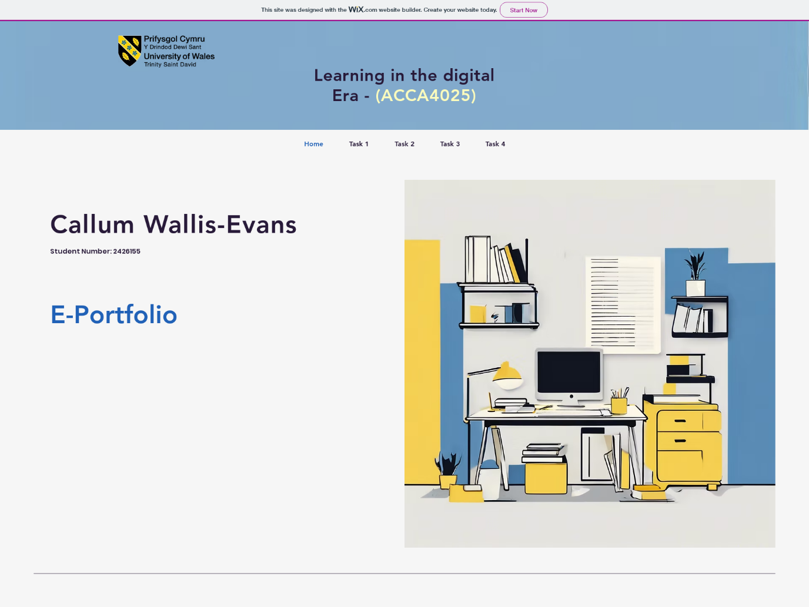
Screenshot of the Home page from the e-portfolio, “Learning In The Digital Era”, by Callum Wallis-Evans.

Task 1 – Written Summary
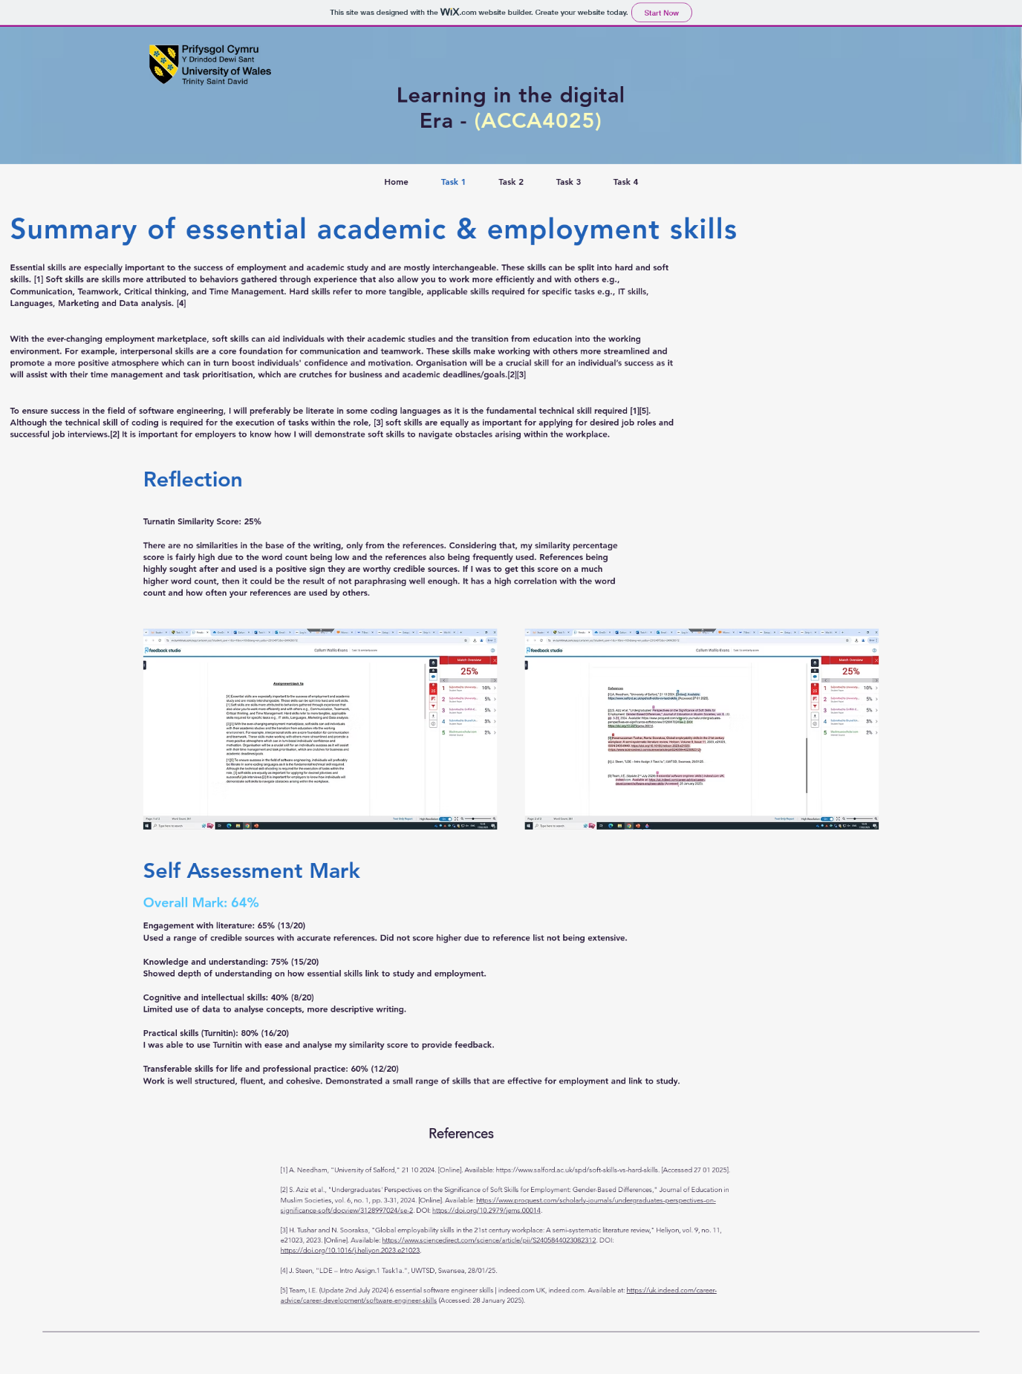
Screenshot taken from the Task 1 section of the e-portfolio, outlining essential skills for academia and employment.

Task 2 – Mind Map & Poster

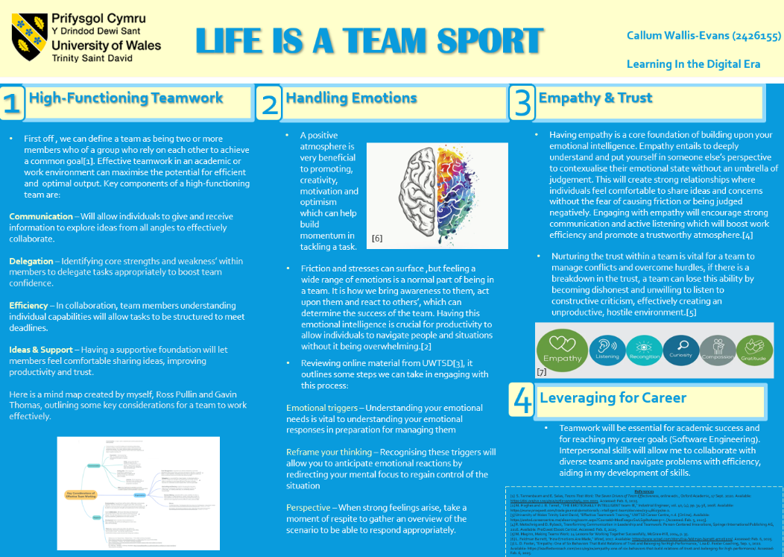
Poster Link - Task 2 poster final.pptx
Task 2 academic poster, “Life Is A Team Sport”, highlighting importance of team working skills for employment and academic success.

Mind map link - MindMap 3.jpg
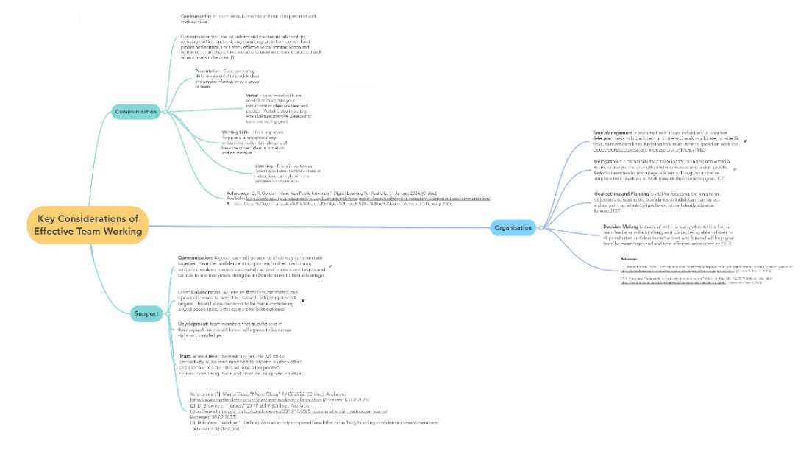
Mind map, “Key Considerations of Effective Team Working”, created by Callum Wallis-Evans, Ross Pullin and Gavin Thomas.

Task 3 – Automatic Referencing Tool
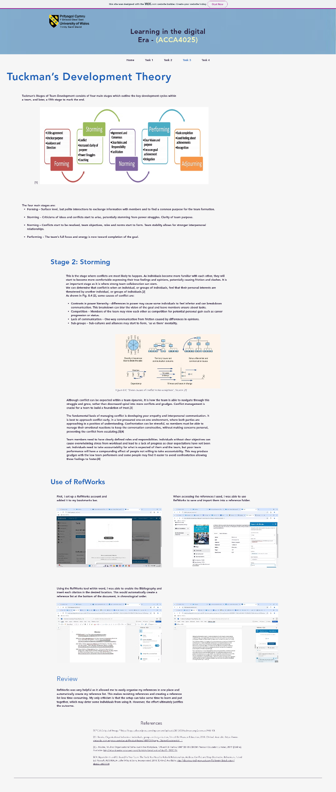
Screenshot from Task 3 showing a brief summary of Tuckman’s Development Theory, focussing on “Storming”. A review is included on how RefWorks was used in Completion.

Task 4 – E-portfolio Creation and Review
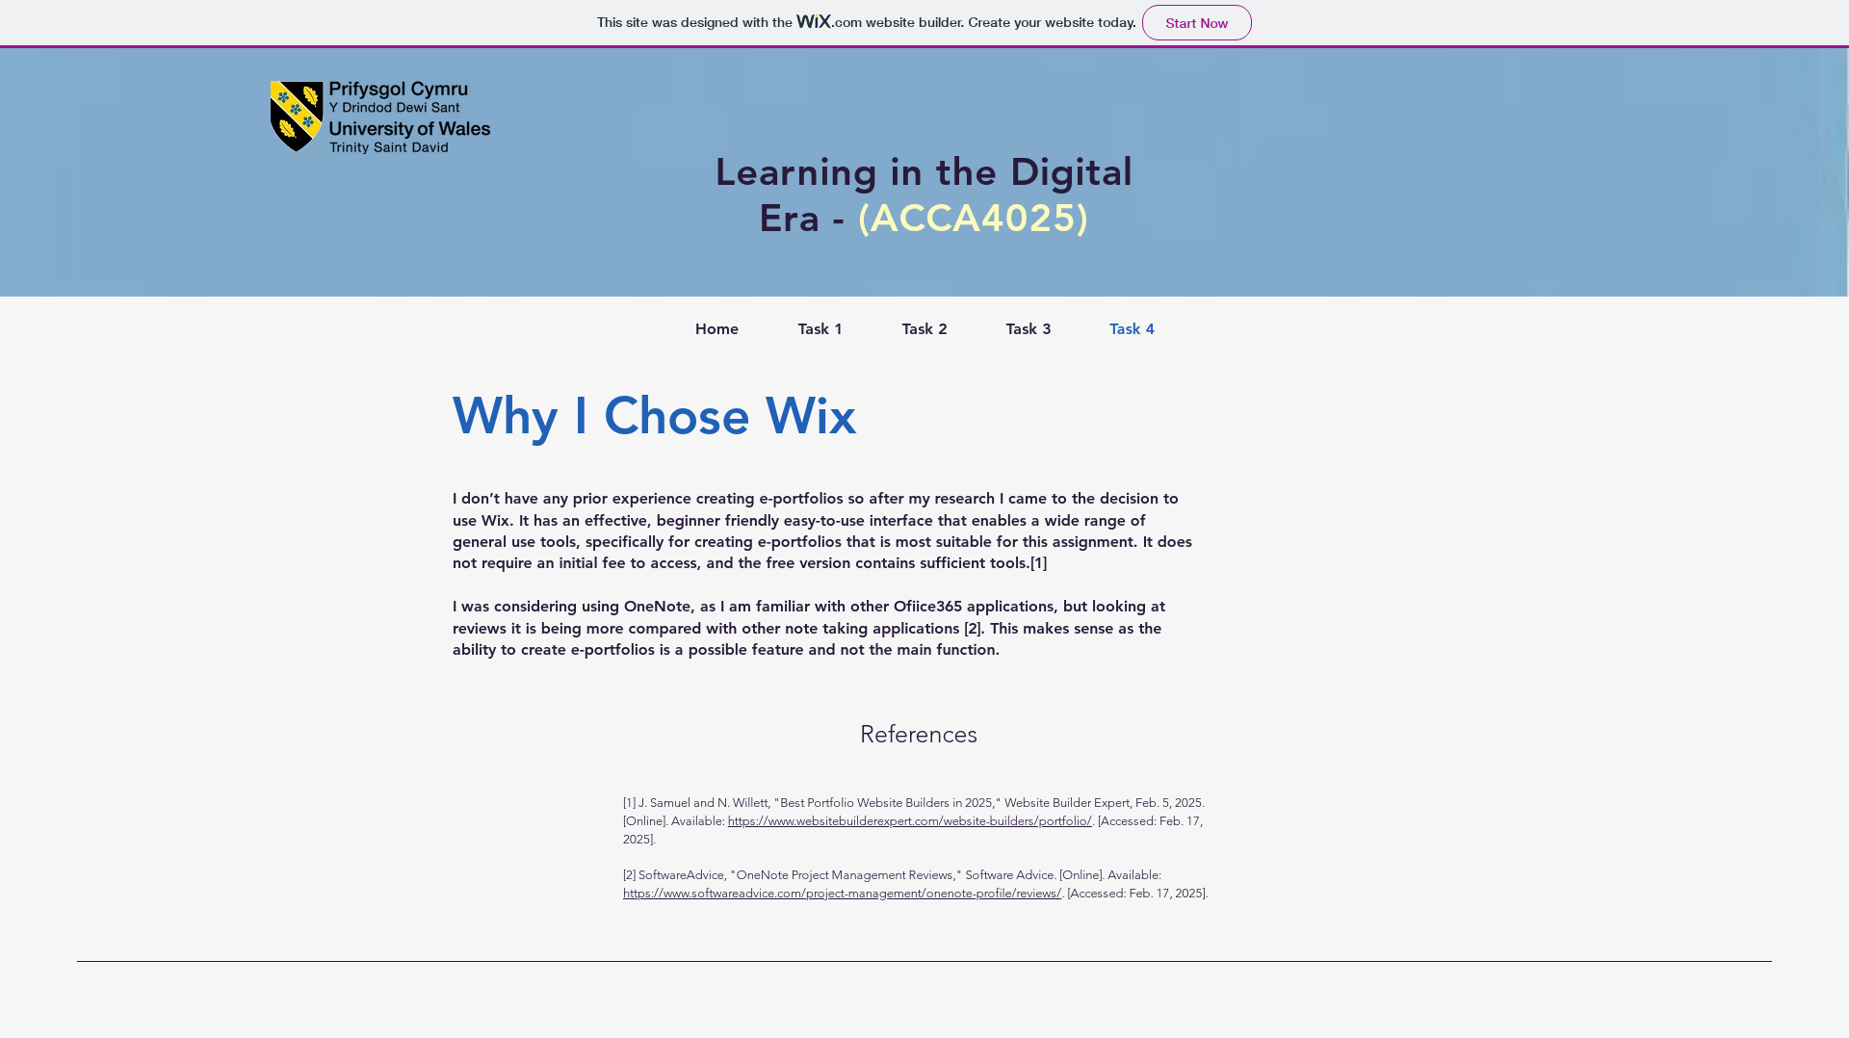
Task 4 section showing why Wix was chosen for completion of the assignment.

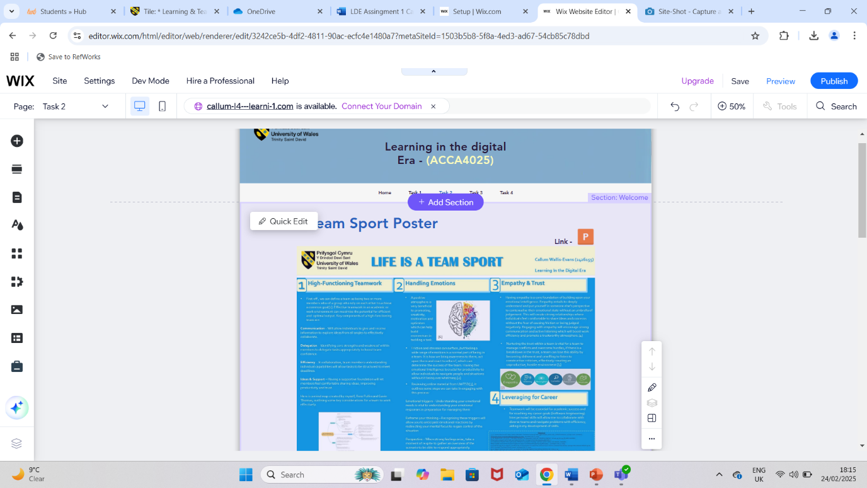
Screenshot showing Wix in edit mode for the e-portfolio creation.

