Charlie Payton
2334149
BMHP5015

My Personal Brand and Future Career Goals
My personal brand is shaped by my values, lived experiences and commitment to supporting vulnerable individuals. As a Health and Social Care student, I recognise that compassion, resilience, effective communication and professionalism are essential qualities for developing a successful career. My personal responsibilities have strengthened my patience, empathy and ability to respond to challenging situations.
Schön (1983) emphasises the importance of reflective practice in professional development. Reflecting on my experiences allows me to recognise my strengths while identifying areas requiring improvement. However, I acknowledge that personal experience alone does not guarantee professional competence. Developing evidence-based knowledge, maintaining boundaries and gaining practical experience are equally important.
My career aspiration is to become a Substance Misuse Support Worker, helping individuals affected by drug and alcohol dependency. Bandura (1997) identifies self-efficacy as an important influence on motivation and achievement, highlighting the value of developing confidence through learning and experience.
Furthermore, Dacre Pool and Sewell (2007) demonstrate that employability involves more than academic qualifications, incorporating skills, experience and personal attributes. Although I possess transferable interpersonal skills, I recognise the need to strengthen my professional confidence and practical knowledge.
Using Gibbs’ (1988) reflective approach, I intend to evaluate my development, seek constructive feedback and pursue volunteering opportunities within substance misuse services. I also aim to develop safeguarding knowledge and professional communication skills. These actions will support my transition into employment and establish a professional identity based on empathy, accountability and continuous improvement.

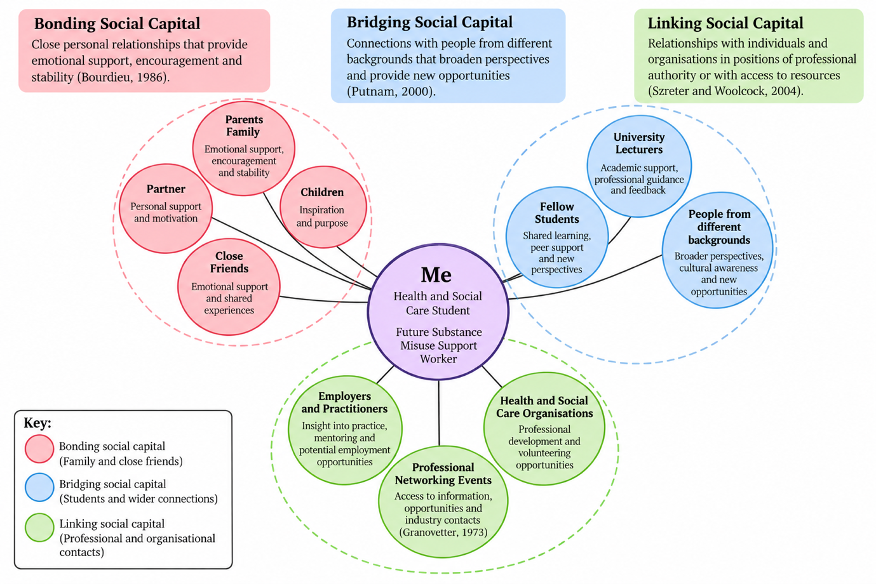
My Network Map and Professional Connections

My personal and professional network plays an important role in developing my identity and future career within health and social care. My network currently consists primarily of family, friends, university lecturers and fellow students. Although these relationships provide valuable support, I recognise the importance of expanding my professional and community connections.
Bourdieu (1986) identifies social capital as resources developed through relationships and networks. Within my network, family and close friends provide bonding social capital through emotional support, encouragement and stability. However, relying heavily on familiar relationships may limit exposure to alternative perspectives and professional opportunities.
Bridging social capital is developed through connections with fellow students and individuals from different backgrounds. Putnam (2000) highlights the importance of wider social connections in strengthening opportunities and cooperation. Furthermore, Granovetter (1973) argues that weaker social ties can provide access to information and opportunities unavailable through close relationships.
Linking social capital involves developing relationships with individuals and organisations holding professional authority or resources (Szreter and Woolcock, 2004). University lecturers, employers and substance misuse organisations could therefore support my professional development.
Critically evaluating my network highlights limited direct connections within substance misuse services. To address this, I intend to pursue volunteering, attend professional networking events and engage with community organisations supporting people affected by addiction. These opportunities would strengthen my employability, broaden my understanding of service users’ experiences and help me develop the professional relationships needed for my future career.
I will also contact local drug and alcohol recovery organisations to explore volunteering opportunities. Building these connections will help me understand professional expectations, develop practical skills and improve my confidence when applying for employment.

Young Minds Matter: Why We Cannot Ignore Mental Health
Mental health is just as important as physical health, yet many young people struggle without receiving the support they need. With increasing pressures from education, relationships and social media, recognising emotional difficulties early is essential. Parents and carers have an important role in recognising changes and encouraging young people to seek support.
How serious is the problem?
Mental health difficulties affect a significant proportion of young people. NHS England (2023b) reported that 20.3% of children aged 8–16 had a probable mental disorder in 2023. Globally, approximately one in seven adolescents aged 10–19 experiences a mental health condition (World Health Organization, 2025).
These findings demonstrate why mental health should be prioritised within education, healthcare and communities.
What affects young people’s mental health?
Young people may experience anxiety, depression, bullying, family difficulties and social isolation. Poverty and adverse childhood experiences can also increase vulnerability (World Health Organization, 2025).
However, mental health difficulties cannot be attributed to one cause. Social, psychological and environmental factors interact differently for each individual.
Some young people may withdraw socially, experience changes in behaviour or struggle academically. Recognising these signs without judgement can encourage earlier conversations and access to support.
Why does early intervention matter?
Early intervention can help prevent difficulties from becoming more severe and affecting future wellbeing.
The National Institute for Health and Care Excellence (NICE, 2022) recommends a whole-school approach that promotes emotional wellbeing, positive relationships and appropriate support.
Nevertheless, awareness alone is insufficient. Support must also be accessible, inclusive and responsive to individual needs. Families experiencing financial difficulties or other disadvantages may encounter additional barriers when seeking help.
What can parents and carers do?
Parents and carers can make a meaningful difference by creating safe environments where young people feel comfortable expressing emotions. Listening without criticism, recognising changes in behaviour and encouraging conversations about mental health are important steps.
When concerns persist, families can seek guidance from schools, GPs or NHS mental health services. NICE (2022) also emphasises involving young people in decisions about their support, helping promote independence and empowerment.
Final thoughts
Supporting young people’s mental health requires collaboration between families, schools, healthcare professionals and communities. Parents should remember that they are not expected to manage every difficulty alone. Seeking professional guidance when necessary can help young people receive appropriate support.
By promoting understanding, challenging stigma and encouraging open conversations, families can contribute to a more supportive environment where young people feel heard, respected and valued.

NHS Equality, Diversity and Inclusion Improvement Plan

1. What is the primary goal of the NHS EDI Improvement Plan?
The primary goal is to reduce discrimination and inequalities within the NHS workforce by promoting fairness, inclusion and equal opportunities (NHS England, 2023a).
2. How does the plan aim to tackle the gender pay gap?
The plan encourages NHS organisations to examine pay inequalities, improve transparency and promote fair career progression opportunities (NHS England, 2023a).
3. What does intersectionality mean?
Intersectionality describes how overlapping characteristics, including gender, ethnicity and disability, can create different experiences of discrimination and disadvantage (Crenshaw, 1989).
4. Why is psychological safety important?
Psychological safety enables employees to raise concerns, share ideas and report mistakes without fear of humiliation, improving teamwork and patient safety (Edmondson, 1999).
5. How can the experience of internationally recruited staff be improved?
The NHS can improve experiences through effective induction, pastoral support, inclusive workplace cultures and equal access to professional development (NHS England, 2023a).
6. What role does leadership play in advancing EDI?
Leaders must challenge discrimination, promote inclusive workplace cultures and demonstrate accountability through measurable equality objectives (NHS England, 2023a).
7. How can workforce health inequalities be reduced?
Providing accessible wellbeing support and addressing discrimination can help reduce inequalities affecting NHS employees (NHS England, 2023a).
8. Why is collecting data on protected characteristics important?
Workforce data helps identify inequalities in recruitment, promotion and pay, allowing organisations to monitor progress and introduce improvements (NHS England, 2023a).
9. How does flexible working promote inclusion?
Flexible working helps employees balance professional responsibilities with childcare, disability and caring commitments, supporting workforce participation (NHS England, 2023a).
10. How can workplace bullying and harassment be addressed?
The NHS can establish confidential reporting procedures, investigate concerns fairly and ensure employees receive appropriate support (NHS England, 2023a).

A letter to myself
Dear my future self
If I could speak to you during the most difficult moments of your life, I would tell you that although the journey ahead will be painful, you will discover strength you never knew you possessed.
Losing your mum at such a young age, under traumatic circumstances, will change your life forever. You will experience grief, confusion and moments when you desperately need her guidance. Becoming a young mother while navigating these emotions will bring responsibilities that sometimes feel overwhelming.
You will also experience domestic abuse, which will challenge your confidence, emotional wellbeing and sense of self-worth. Looking back, I recognise how emotional intelligence could have helped me understand my feelings, establish boundaries and seek support. Goleman (1995) identifies self-awareness and emotional regulation as important aspects of emotional intelligence.
Developing these skills earlier may have helped me recognise unhealthy relationships, communicate my needs and understand that asking for help is not a weakness. However, emotional intelligence does not prevent another person’s harmful behaviour.
Raising a child with additional needs will present further challenges, requiring patience, understanding and determination. These experiences will deepen your empathy and awareness of the difficulties families face when accessing support.
Masten (2001) explains that resilience develops through protective relationships and positive adaptation during adversity. I have learned that resilience is not about accepting mistreatment or managing everything independently, but recognising when support is necessary.
Despite everything, you will raise four children and pursue a university degree in Health and Social Care. Your experiences will strengthen your ambition to support vulnerable individuals and advocate for those whose voices are often unheard.
Most importantly, I would remind you that your past does not determine your future. You deserve safety, happiness and opportunities to achieve your ambitions. Be proud of your progress and continue believing in yourself.
With love,
Your Future Self

Gantt Chart
Career goal: Substance Misuse Support Worker
Illustrative career development plan | November 2026 – October 2028
Development activity | Nov–Jan  26–27 | Feb–Apr  2027 | May–Jul  2027 | Aug–Oct  2027 | Nov–Jan  27–28 | Feb–Apr  2028 | May–Jul  2028 | Aug–Oct  2028
Research roles and entry requirements | ● | ●
Update CV and identify transferable skills | ● | ●
Complete safeguarding and substance misuse CPD |  | ● | ● | ●
Apply for relevant volunteering / placements |  | ● | ● | ●
Gain supervised support experience |  |  |  | ● | ● | ● | ●
Complete degree and reflect on learning | ● | ● | ● | ● | ● | ●
Build contacts and seek career guidance |  |  | ● | ● | ● | ● | ●
Apply for jobs and prepare for interviews |  |  |  |  |  | ● | ● | ●
Key: ● = planned activity. Dates are provisional and should be adjusted to your actual degree completion and placement availability.
Supporting rationale
My long-term employment goal is to become a Substance Misuse Support Worker, supporting individuals affected by drug or alcohol use. This Gantt chart breaks that ambition into achievable stages. Initially, I will research local roles and entry requirements, update my CV and identify transferable skills developed through my Health and Social Care studies, including empathy, communication and safeguarding awareness. I will then seek relevant short courses and volunteering or placement opportunities to build practical experience in a supervised environment. Throughout my degree, I will review my progress, request feedback and develop professional contacts. Closer to graduation, I will prepare applications and interviews for suitable entry-level roles. The timetable is flexible because volunteering availability, training requirements and recruitment dates may change. Reviewing it regularly will help me identify delays and adapt my actions while keeping my employment goal realistic.

Improving Substance Misuse Awareness and Support in a Residential Care Home

Introduction
As the manager of a residential care home, I propose introducing a substance misuse awareness and support programme to improve staff knowledge, safeguarding practices and residents’ wellbeing. The change would focus on recognising alcohol and drug-related difficulties, reducing stigma and ensuring residents receive appropriate person-centred support.
Proposed Change and Implementation
Substance misuse can affect physical health, mental wellbeing and social relationships. The National Institute for Health and Care Excellence (NICE, 2011) recommends appropriate assessment and treatment for individuals experiencing alcohol dependence.
To implement the programme, I would apply Lewin’s (1947) three-stage change management model.
Unfreezing: I would review existing policies, identify staff training needs and consult employees about their concerns. This would establish the need for change and encourage participation.
Changing: Staff would receive training on recognising substance misuse, responding without judgement, safeguarding and referring residents to specialist services. Clear procedures would support confidential discussions and appropriate professional interventions.
Refreezing: Updated policies, regular supervision and refresher training would help integrate the new approach into everyday practice.
Leadership Skills and Potential Barriers
Effective implementation requires communication, empathy, teamwork, problem-solving and inclusive leadership. Kotter (1996) emphasises the importance of communicating a clear vision and gaining staff commitment during organisational change.
Potential barriers include limited funding, staffing shortages, resistance to change and negative attitudes towards substance misuse. Stigma may discourage residents from seeking help, while insufficient training could affect staff confidence.
To address these challenges, I would introduce training gradually, encourage staff involvement and establish partnerships with local substance misuse services. Training could be delivered through short sessions to minimise disruption to residents’ care.
However, Lewin’s (1947) model may be difficult to maintain in residential care due to staff shortages and changing residents’ needs. Therefore, ongoing training, flexible leadership and regular feedback would be necessary to sustain improvements while protecting residents’ safety and dignity.

Conclusion
Success would be measured through staff knowledge assessments, care plan audits, resident feedback and referral reviews. Comparing results before and after implementation would help identify improvements and areas requiring further development. Regular evaluation would support sustainable organisational change and improve person-centred care.

References
Bandura, A. (1997) Self-efficacy: The exercise of control. New York: W.H. Freeman.
Bourdieu, P. (1986) ‘The forms of capital’, in Richardson, J.G. (ed.) Handbook of theory and research for the sociology of education. New York: Greenwood Press, pp. 241–258.
Crenshaw, K. (1989) ‘Demarginalizing the intersection of race and sex: A Black feminist critique of antidiscrimination doctrine, feminist theory and antiracist politics’, University of Chicago Legal Forum, 1989(1), pp. 139–167.
Dacre Pool, L. and Sewell, P. (2007) ‘The key to employability: Developing a practical model of graduate employability’, Education + Training, 49(4), pp. 277–289.
Edmondson, A. (1999) ‘Psychological safety and learning behavior in work teams’, Administrative Science Quarterly, 44(2), pp. 350–383.
Gibbs, G. (1988) Learning by doing: A guide to teaching and learning methods. Oxford: Oxford Polytechnic.
Goleman, D. (1995) Emotional intelligence: Why it can matter more than IQ. New York: Bantam Books.
Granovetter, M.S. (1973) ‘The strength of weak ties’, American Journal of Sociology, 78(6), pp. 1360–1380.
Kotter, J.P. (1996) Leading change. Boston, MA: Harvard Business School Press.
Lewin, K. (1947) ‘Frontiers in group dynamics: Concept, method and reality in social science; social equilibria and social change’, Human Relations, 1(1), pp. 5–41.
Masten, A.S. (2001) ‘Ordinary magic: Resilience processes in development’, American Psychologist, 56(3), pp. 227–238.
National Institute for Health and Care Excellence (NICE) (2011) Alcohol-use disorders: Diagnosis, assessment and management of harmful drinking and alcohol dependence. Clinical guideline CG115. Available at: https://www.nice.org.uk/guidance/cg115 (Accessed: 15 October 2026).
National Institute for Health and Care Excellence (NICE) (2022) Social, emotional and mental wellbeing in primary and secondary education. NICE guideline NG223. Available at: https://www.nice.org.uk/guidance/ng223 (Accessed: 15 October 2026).
NHS England (2023a) NHS equality, diversity and inclusion improvement plan. Available at: https://www.england.nhs.uk/publication/nhs-edi-improvement-plan/ (Accessed: 15 October 2026).
NHS England (2023b) One in five children and young people had a probable mental disorder in 2023. Available at: https://www.england.nhs.uk/2023/11/one-in-five-children-and-young-people-had-a-probable-mental-disorder-in-2023/ (Accessed: 15 October 2026).
Putnam, R.D. (2000) Bowling alone: The collapse and revival of American community. New York: Simon & Schuster.
Schön, D.A. (1983) The reflective practitioner: How professionals think in action. New York: Basic Books.
Szreter, S. and Woolcock, M. (2004) ‘Health by association? Social capital, social theory, and the political economy of public health’, International Journal of Epidemiology, 33(4), pp. 650–667.
World Health Organization (WHO) (2025) Mental health of adolescents. Available at: https://www.who.int/news-room/fact-sheets/detail/adolescent-mental-health (Accessed: 15 October 2026).

