
Approaches to innovation and organisational change
Management, Innovation and Sustainability (ACMA5007) Julian Edwards (2315607)

April 28, 2025
University of Wales Trinity Saint David

Executive Summary
This report is only around 50% complete
The purpose of this report is to analyse……..
DO THIS SECTION LAST!!!!!!
NOT INCLUDED IN WORD COUNT – this section should be around ¾ of a page in length for a 2500 word report.

DO NOT cite any sources in this section.

Table of Contents
Executive Summary 1
Introduction 3
Main Findings 4
Overview of the Change 4
Lewin’s Force Field Analysis 4
Effectiveness of the Change 6
Conclusion (average of 10% of word count) 7
Bibliography 8

Introduction
TATA Steel is ‘the largest steel producer in the UK’ (TATA Steel, 2025) with operations in 26 countries (TATA Steel, 2025). The primary steel plant within the United Kingdom is Port Talbot. It previously had its blast furnaces to produce its steel from slabs and process it on-site or send it to downstream processes to produce premium steel products. The UK business has been making severe financial losses, reporting a loss of ‘more than £4 billion after tax’ (TATA Steel, 2025) since 2007. This, and several other factors, has led TATA Steel to decide to reduce the carbon emissions in their UK business to promote a ‘green steel feature’ (TATA Steel, 2025).
Change can be essential to a business to ensure that it can adapt and survive, (Kotter, 2012) suggests that change can be both positive and negative to businesses and ‘is inevitable’ (Kotter, 2012). Management and leadership are key aspects that affect the process of change and can have a significant impact on the result. (Kotter, 2012) states that individual people ‘never have all the assets needed to overcome tradition’, suggesting that leadership is needed to combine individuals as a single entity to ensure all the ‘assets’ are available to ‘overcome tradition’. Management also plays a significant role in this, (Burns, 2017) suggests that there may be a relationship between more successful businesses and effective leadership and management. (Burns, 2017) also goes on to suggest that management and leadership have similar roles and can be difficult to distinguish the responsibilities and actions between leaders and managers but are both essential regardless.

Main Findings
(Cameron & Green, 2020), with reference to (Buchanan & Huczynski, 2023) states ‘Learning the process of acquiring knowledge through experience which leads to a lasting change in behaviour.’ (Buchanan & Huczynski, 2023). This suggests that change is a crucial result of learning, and can also be inferred from (Burns, 2017), which suggests that development is needed in order for organisations to effectively survive in an ‘increasingly hostile world’ (Burns, 2017). This can be used to further define change, in an organisation, as a process in which can be used by an organisation to adapt to survive a changing environment which has the ability to positively and negatively impact growth. From this, it can be suggested that better performing businesses are those who are more open to change and are constantly adapting. This is supported by (Akhatar, 2025), which states that the ‘highest performing organizations are, and will continue to be, those that create and nurture adaptability in a variety of ways’ and goes on to suggest that leadership is a larger contributor to this.

Overview of the Change
As previously mentioned, TATA Steel’s Port Talbot Steelworks in undergoing a significant change to decarbonise its products to promote a ‘green steel feature’ (TATA Steel, 2025). It involves the decommissioning of its blast furnaces that will later be replaced a by an electric arc furnace which will allow the company to significantly reduce its carbon emission. This change has, and will, have significant effects on the company itself, as well as the steel industry as a whole. There are both positive and negative effects of this change, which will have to effectively managed to ensure a smooth transition and beneficial result. One change management tool that can be used to help understand this change process is Lewin’s Force Field Analysis.

Lewin’s Force Field Analysis
Force field analysis characterises change as a ‘state of imbalance’ between ‘driving forces’ and ‘restraining forces’ (University of Cambridge, 2016), see figure 1.
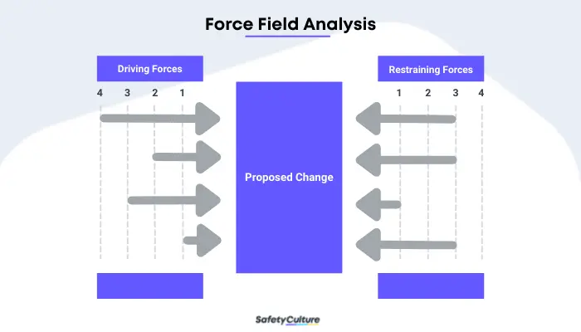
Figure 1 - Force Field Analysis (Reyes, 2024)
(Reyes, 2024) States that there are only 4 steps involved which including, stating and describing the change, identify driving and restraining forces as described by (University of Cambridge, 2016), applying a scoring scheme, and finally, analysing and applying methods to reduce restraining forces or increasing driving forces to help carry out the change as suggested by (University of Cambridge, 2016). Steps 2-4 can be applied to the change occurring at TATA Steel as below (See Table 1):
Table 1 - Force Field Analysis
Score | Driving Forces | Restraining Forces | Score
5 | Environmentally beneficial | Redundancy / Job Losses | 4
3 | Help to reduce customer turnover and potential new customers | Requires Funding from Government and parent company | 4
2 | Modernisation | Will require significant Research & Development even after the change | 4
4 | Financially beneficial in long term | No material production during interim | 4
5 | End of life for current assets
3 | Redundancies are beneficial to some
21 |  |  | 12

From Table 1, it is clear that there are several significant restraining forces, such as the job losses that have been produced, the funding that is required, and operational changes that they will face. However, these are out weighed by the driving forces that benefit both the company and environment, showing that the change is beneficial. This does not mean that the restraining forces do not affect the change, for example there were protests and ballets cast for industrial action due to the job losses proposed by the company. (Hoskin, 2024) stated that ‘Hundreds’ of people had joined in the protest, and suggested that many members of the community have been let down by the company and UK politicians.
This shows that Lewin’s Force Field analysis has both benefits and drawbacks. It’s simple to use as explained by the four steps stated by (Reyes, 2024) which is supported by (Carnall & Todnem, 2014) which describes a similar four steps. Force field analysis also clearly highlights supporting and opposing factors which may have been missed when initially proposing the change and conveys their influence effectively when a scoring or priority system has been introduced. However, no method is perfect, there are flaws that need to be considered when carrying out force field analysis, such as being too simplistic on its own as suggested by (Burnes, 2004) stating that ‘When seen alongside the other elements of Lewin’s Planned approach, it becomes a much more robust approach to change’ (Burnes, 2004). Another drawback is that the list is just what were visible and appropriate at the time, there may be more resisting forces now, or less driving forces, or environment in which the change is taking place has changed which can be inferred from (Burns, 2017) which states that ‘No organisation’s culture is static’, and as organisation’s culture changes, so will the proposed force field analysis. For example there were protests when the job losses were proposed by TATA (Hoskin, 2024), and while there are some who are still not happy with the change, many people volunteered for redundancies, many of whom were happy to receive it so they could have an earlier retirement. Overall, Lewin’s force field analysis is a good tool to use when initially identifying driving and restraining forces, but as they change develops, it may be more appropriate to use another tool or combine it with one of the ‘other elements of Lewin’s Planned approach’ (Burnes, 2004).

Effectiveness of the Change
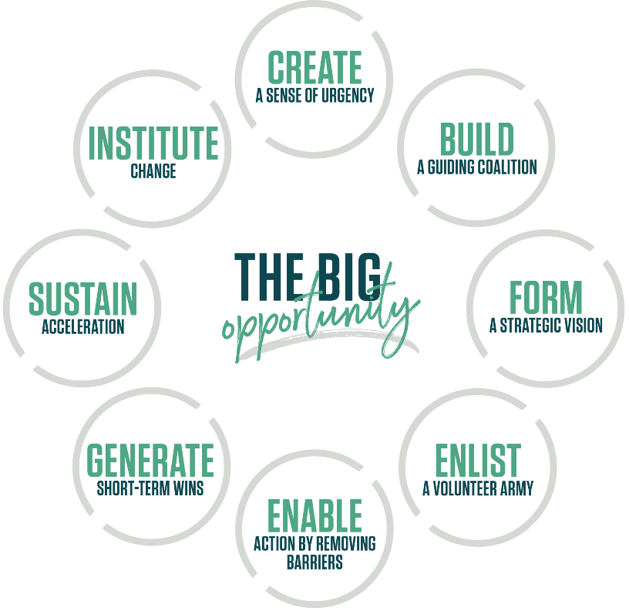
Figure 2 - Kotter's 8 Steps (Kotter, 2025)

Conclusion (average of 10% of word count)

Bibliography
Akhatar, V., 2025. Outmaneuver Uncertainty: How Adaptable Organizations Win in the Long Run: Kotter. [Online]
Available at: https://www.kotterinc.com/outmaneuver-uncertainty-how-adaptable-organizations-win-in-the-long-run/
[Accessed 28 June 2025].
Buchanan, D. A. & Huczynski, A. A., 2023. Organizational Behaviour. 11th ed. Harlow: Pearson Education.
Burnes, B., 2004. Journal of management studies. Kurt Lewin and the Planned Approach to Change: A Re-appraisal, 41(6), pp. 977-1002.
Burns, B., 2017. Managing Change. 7th ed. Harlow: Pearson Education.
Cameron, E. & Green, M., 2020. Making sense of change management : a complete guide to the models, tools and techniques of organizational change. 5th ed. London: Kogan Page.
Carnall, C. A. & Todnem, R., 2014. Managing change in organizations. 6th ed. Harlow: Pearson Education.
Hoskin, R., 2024. Tata Steel workers protest over proposed job losses. BBC News, 17 February.
Kotter, 2025. The 8-Step Process. [Online]
Available at: https://www.kotterinc.com/methodology/8-steps/
[Accessed 27 June 2025].
Kotter, J. P., 2012. Leading Change. Boston, Massachusetts: Harvard Business Review Press.
Lines, R., 2004. Influence of participation in strategic change: resistance, organizational commitment and change goal achievement. Journal of change management, 4(3), pp. 193-215.
Reyes, J., 2024. A Guide to Force Field Analysis. [Online]
Available at: https://safetyculture.com/topics/force-field-analysis/
[Accessed 27 June 2025].
TATA Steel, 2025. At a glance: TATA Steel. [Online]
Available at: https://www.tatasteeluk.com/about-us/at-a-glance
[Accessed 27 June 2025].
TATA Steel, 2025. Green Steel Future. [Online]
Available at: https://www.tatasteeluk.com/green-steel-future
[Accessed 27 June 2025].
University of Cambridge, 2016. Force Field Analysis: IfM. [Online]
Available at: https://www.ifm.eng.cam.ac.uk/research/dstools/force-field-analysis/
[Accessed 27 June 2025].

