INVESTIGATING HOW CULTURE IS INFLUENCING THE ADOPTION OF CRYPTOCURRENCY FOR REMUNERATION PURPOSES

Student name: MohammedakibMahammediqbal Shaikh
Student id: 2237233
Institute: University of wales Trinity saint David
Programme: MBA General management
Supervisor: Prof. Dennis Pepple

Declarations

I, MohammedakibMahammediqbal Shaikh declare that this dissertation has been composed by myself, that the work contained herein is entirely my own except where explicitly stated otherwise in the text, and that this work has not been submitted for any other degree or qualification, in whole or in part, except as specified.

Signature:... ...
Date: …10.05.2024………

Acknowledgement
I would like to dedicate my profound appreciation to my dissertation guide, for their extremely useful guidance, unshakable support, and endless belief which were crucial for accomplishing this dissertation. Their savvy, review, and slow accommodation have been a vital component in the development of this piece. Therefore, I am not less indebted than those are to the magnificent guidance of my dissertation committee members, all of who have contributed vastly to the superiority of this piece through the evaluation, suggestions, and correction they provided.
It is my peers and friends who I turn to when I feel stuck or overwhelmed. They help me work through toughest of times with the understanding, support, and above all acceptance. Here I would like to express my family my most sincere gratitude for their limitless love, profound support and unquestionable belief in my capabilities. They have played the most important role in maintaining my spirit and taking me further through this long, difficult journey.

Abstract
Cryptocurrencies which have been a creative proliferation pave the way for the birth of new meanings and values in the economy of the digital era. The pace is equally creating the dynamics of the global economy and plans to slash down the financial sector. There exist in one, and among the natives of the other culture the individualistic, risk-averse, and long-term-focused national cultures, both contribute to the spread of the new technology. Thanks to the empirical findings after the review of literature it has been understood that the crypto-currencies are emerging based on the blockchain technology. Where per is innovation diffusion theory, cryptocurrency adoption is based on the adaptation to culture is usually laid on the shoulders of ideas bearing trailblazers and influential people. With this in consequence, earmark strategy to make better use of technology so they can be ahead of competitors and use technology early on which might highly pay off later. Secondary analysis was performed of 50 articles which were purposely chosen to elaborate Chinese people, UAE and the USA citizens’ cultural preferences. The cultural background which Chinese recommend very highly the value of uncertainty aversion. In UAE too, fear of uncertainty avoidance and social facilitation notion come into play to shape people's perception and behaviour which in turn affect the way cryptocurrencies are adopted. In USA cases people tends to undertake risks or innovation in their financial matters since with USA the low certainty avoidance level is present. That is true, for the “cryptoecosystem” becomes more supporting, it only allows a small number of people to use it for receiving their salary. In addition, one of the Key benefits of the education, long-term orientation, and avoidance of risks’ dimensions as related to using cryptocurrency is highly valued.

Table of Contents
Chapter 1: Introduction 10
1.1 Chapter introduction 10
1.2 Research background 10
1.3 Research aim 13
1.4 Research objective 13
1.5 Research question 13
1.6 Research rationale 13
1.7 Research problem 14
1.8 Significance of the study 15
1.9 Chapter summary 15
Chapter 2: Literature review 17
2.1 Chapter introduction 17
2.2 Conceptual framework 18
2.3 Analysing the impact of social and cultural properties influencing the cryptocurrency adoption in remuneration purposes 19
2.4 Advantages and disadvantages of cryptocurrency adoption in remuneration purposes 21
2.5 Critical analysis of the influence of technological perspectives within the countries for cryptocurrency adoption 22
2.6 Effective practices of cryptocurrency adoption managing cultural differences 23
2.6.1 Practices influencing China for adapting crytocurrency for remuneration purposes 24
2.6.2 Analysing the implementation strategies of cryptocurrency for remuneration purposes in the US 25
2.6.3 Critical analysis of how United Arab Emirates is adapting cryptocurrency for remuneration purposes 27
2.7 Theoretical underpinning 28
Block chain theory 30
Innovation Diffusion Theory 31
2.8 Literature gap 32
2.9 Chapter summary 33
Chapter 3: Methodology 34
3.1 Chapter introduction 34
3.2 Research onion 34
3.3 Research philosophy 35
3.4 Research design 36
3.5 Research strategy 37
3.6 Research approach 37
3.7 Search strategy 38
3.8 Data collection and analysis 38
3.9 Data reliability and validity 42
3.10 Ethical consideration 42
3.11 Chapter summary 42
Chapter 4: Findings, Analysis and discussion 44
4.1 Chapter introduction 44
4.2 Annotated bibliography 44
4.3 Thematic analysis 60
4.3.1 Institutional factors associated to cryptocurrency within the countries USA, UAE, China 60
4.3.2 Individual dimensions impact people adopting cryptocurrency for the remuneration process 63
4.3.3 Uncertainty avoidance dimensions impact people adopting cryptocurrency for the remuneration process 67
4.3.4 Motivations towards achievements and success dimensions impact people adopting cryptocurrency for the remuneration process 69
4.3.5 Long-term orientation dimensions impact people adopting cryptocurrency for the remuneration process 72
4.4 Discussion 74
4.5 Chapter Summary 78
Chapter 5: Conclusion and recommendation 80
5.1 Summary of the findings 80
5.2 Contribution to theory 80
5.3 Recommendations to business 81
5.4 Limitation of the study 81
References 83
Appendices 95
Appendix 1: Ethics form 95
Appendix 2: Research proposal 110

List of figures
Figure 1.1: Relationship of cryptocurrency usage within the remuneration process 7
Figure 2.1: Conceptual framework 15
Figure 2.2: Relationship between individualistic approaches with cryptocurrency adoption 16
Figure 2.3: Flow chart relationship between technological awareness and developing behavioural intentions 19
Figure 2.4: Dubai cryptocurrency position 24
Figure 2.5: Hofstede cultural dimensions 26
Figure 2.6: Innovation diffusion theory 28
Figure 3.1: Research Onion 31
Figure 3.2: Hofstede country comparison tool 34
Figure 4.1: USA Dollar vs. Tether of China trading volume by 2021 40
Figure 4.2: Cryptocurrency market forecast of UAE, 2024-2028 41
Figure 4.3: Country Comparison between China, UAE, and US 43
Figure 4.4: Average revenue of cryptocurrency users, 2024 45
Figure 4.5: User penetration in cryptocurrency market expectation, 2024 &2028 47
Figure 4.6: Number of cryptocurrency user expected by 2028 49
Figure 4.7: Annual revenue projection growth rate in cryptocurrency market by 2028 52
Figure 4.8: Implementation of analysis through Innovation Diffusion theory 55
Figure 4.9: Theoretical representation 57

List of tables

Table 3.1: Search strategy 36
Table 3.2: Data source 39
Table 4.1: Annotated bibliography 48

Chapter 1: Introduction

1.1 Chapter introduction
A digital currency or a virtual form of money, cryptocurrency has entered into the money market as a major disruption that contests the mainstream monetary systems and methods of Payments. Besides being a known investment source or medium of exchange, cryptocurrency is getting more and more attention related to its usage as an incomes’ source, with a few companies proposing to pay it out as part of their employees’ remunerations. The examination of the intricate relations between culture and remuneration using cryptocurrency as an example in this chapter so as to comprehend which factors of culture creates, sustains or reduces the level of adoption of this form of remuneration within organizations. The cultural aspect of the cryptocurrency adoption has many-sidedly focused on organizational culture and mindsets of how the society works, regulation and secure system, and personal opinions. The organizational culture, which can be understood as the common values, attitudes, and behaviors possessed by the organization in its collective form, is regarded as an important factor that influences ways that the new technologies and innovations will be perceived. On the other hand, the societal perception of cryptocurrency directly, which is determined by these factors like socio-cultural background, economic stability, and the regulatory climate, could be a key to the adoption and prohibition of its usage in organizations.

1.2 Research background
The ramifications ensuring the study of culture that drives the adoption of cryptocurrency for payment purposes come to play at the crossroads of financial innovation, organizational behaviour, and cultural studies. Ömeroğlu (2023) has conformed to the fact of the studies that organizations are willing to consider issuance of cryptocurrency for payment, it is a must to know the cultural factors that are used as bases of remuneration decisions. As a result of employing decentralized blockchain technology, that involves an existence of such benefits, is seeing an increase in security, transparency, and borderless transactions. Its fundamental attribute is that it does not have any central authority, therefore it is challenging for traditional financial intermediaries (Kher et al. 2021). For instance, people can do transactions with each other without involving the services from the banks. For the past years, organizations have continued to evolve their compensation practices in the manner in which they have developed new ways of doing business, technology and social norms. The payment systems ranging from that of the ancient traditional forms of cash and checks, to that of the contemporary electronic transfers and stock options have been a standard to companies and they continue to adapt their compensation strategies. The emergence of cryptocurrency introduces a new dimension to compensation practices, offering potential benefits: faster payment, lower cost, more visibility.
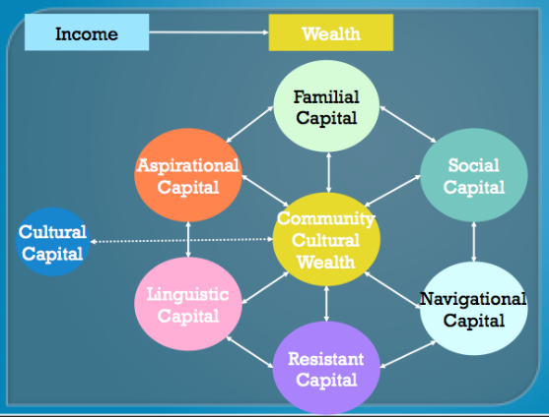

Figure 1.1: Relationship of cryptocurrency usage within the remuneration process
(Source: Influenced from Ömeroğlu, 2023)
The study's influential focus was that alongside technical and macroeconomic factors, there are individual psychological factors like trust, perceived risk, security threat, perceived benefit, and perceived ease of use that determine Bitcoin’s acceptance at individual and country levels. The crucial reasons that form network susceptibility to e-money ('Bitcoin') adoption include implications on community commitment. Intervention against the emerging economic-technological disruptive innovation having a society aspect and psychological impacts might be an issue that monetary policy could take into account. According to the study of Abraham et al. (2019), the impact of national cultures, which can be measured by such traits as individualism, uncertainty avoidance, and long-term orientation, is strongly associated with the possibility of mobile payment or digital banking penetration. Spatial/physical, social and hypothetical distances demonstrate a positive correlation. This dependence can be used to predict whether a particular innovation will be adopted. cultural and psychological variables that automatically lead to economic activity such as Bitcoin institutionalization and generalization down to nation and personality.

In different cultures, one finds dissimilarities when it comes to risk-taking and cultivating innovations. In societies that take chances and technology seriously, cryptocurrency could have more chances of acceptance as a type of compensation. On the other hand, in a culture that is more cautious, the chances of acceptance of this technology may be less as well. While the cultural attitudes toward financial institutions and central authorities can greatly influence the adoption of cryptocurrency, it is also worth considering the degree to which these institutions contribute to the overall market (Gagarina et al. 2019). The economies fraught with weak systems of trust and prejudice for traditional banking might integrate crypto-tokens into salaries as their universal currency. As per the opinion of Salcedo and Gupta (2021), broader cultural values like “individualism, collectivism, transparency, and privacy” may affect crypto-assets as crypto-assets may take into account the broader existing cultural proclivities. cultural values national “(collectivism, expertise distinction, masculinism, avoidance of uncertainty, and long-termism)” undergo significant influence on adoption of the blockchain-based currencies. For instance, the populations that highly stress the autonomy of the individual and privacy of the monetary system will be perceived as the most probable users of the cryptocurrencies as an alternative. These cultural norms can be employed to govern money, the finances and the work involved with cryptocurrencies. This process can be slow because of the cultural liking of original forms of payment and also the tendency towards the opposed to the newly created financial technologies.

1.3 Research aim
The study aims to highlight how culture is influencing the adoption of cryptocurrency in remuneration purposes

1.4 Research objective
- To evaluate cultural factors and societal values influencing trusts and sense of security related to cryptocurrency in remuneration
- To investigate the cultural barriers in the adaptation of cryptocurrency in remuneration
- To recommend implementation of cryptocurrency in remuneration process through successful navigation of the organisational cultural challenges

1.5 Research question
- What are the cultural factors and societal values influencing trusts and sense of security related to cryptocurrency in remuneration?
- What are the cultural barriers in the adaptation of cryptocurrency in remuneration?
- How is the implementation of cryptocurrency in the remuneration process through successful navigation of the organisational cultural challenges?

1.6 Research rationale
The intention behind the study has led to a cultural perspective and the cultural splendors of different countries in terms of the highest financial characteristics of the current generation. Creating knowledge on how the emerging trend of digital finance paradigms interplays with the factoring of other cultural factors already provides multidimensional reflection of understanding, such as trust dimensions, risk identification and perception, culture, and development of a deeper understanding (Dewani et al. 2020). In addition, there are many employee management strategies linked to payment involving motivation and retention processes that need to be further looked into since the main perceptions and preferences of employees regarding the cryptocurrency remuneration process will determine success or failure.
The development of cryptocurrencies has transformed the traditional financial systems that exist at present by introducing decentralised and digital equivalents of current fiat currencies. According to Smutny et al. (2021), one of the most important facets when it comes to the utilization of cryptocurrency is to supplement how people receive salaries and how organizations dole out financial reimbursements to their employees. Although the cryptocurrencies are converted to fiat money not in all cultural contexts, the adoption of cryptocurrencies has created disruption of the wage systems be it in the finance, in communications, civilization, and many others. On the contrary, Gagarina et al. (2019) have also opined that it is the essence of research to explore the impact of the culture of Cryptocurrency as a means of payment, acknowledging the fact that cultural variables are the key driving forces that shape different views, actions and rituals revolving around the monetary system and technology.
Both society and each person place an importance on money, work, and innovation. It, therefore, forms the basis on which people decide whether to accept cryptocurrency as payment. According to Sagheer et al. (2022), traditional and stability-oriented cultures that have been known to be cautious about adopting cryptocurrencies may display this same skepticism towards using cryptocurrencies. Additionally, innovation, independence, and entrepreneurship may be more common in the cultures that embrace cryptocurrencies with less difficulty. The attitudinal gap in educational infrastructure and the knowledge that surrounds the crypto space plays a big role in the crypto literacy of individuals (Magbitang et al. 2023). Education systems as well as widespread awareness about cryptocurrencies may render a kind of cultural environment with pronounced adoption for salaries into consideration, as this is another way to express the fact that there are more people who are aware of and confident in using cryptocurrencies.

1.7 Research problem
The major prade of cryptocurrencies and their widespread adoption globally does not prevent certain cultural factors which promote the adoption or generally prevent the adoption of cryptocurrencies for the purposes of remuneration. Whilst technological, economic and regulatory characteristics of cryptocurrency usage have all been well-documented and researched, the influence of culture on shaping the attitudes, behaviors and customs around cryptocurrency as a mode of compensation for workforms is still a subject of inquiry for researchers. Cryptocurrency falls under the disciplines of monetary economics and economics of information. Being such, the problem of the study is not only to stress how cryptocurrency is mindfully institutionalized in the financial sector, but it also discusses in a broader sense how knowledgeable awareness is promoted in order to hasten the rise of a cryptocurrency market. Policymaking and financial institutions would as well be in a strong position, in ensuring that crypto-currency is integrated in traditional systems and they can also make their own systems easier by considering introducing it in the payment system, as well as other payments. It would also be advisable to achieve this by dissipating such common misunderstandings and highlighting factors such as utility, trust, consistency, and simple use among other rights.

1.8 Significance of the study
The study is mainly concerned with the extent to which culture affects the use of cryptocurrencies for compensations and related issues such as policy making, business management, cross-cultural understanding, global adoption, social equality and academic research present further complexities that stress the cultural factors in the spheres of financial technologies. Cultural factors being one of the main aspects to be considered in the case of finding out if the employees would be ready to be paid in cryptocurrency, it also allows one to understand the degree of readiness of the organization as a whole. By having awareness of cultural views on tech, trust, and finances, businesses can design their approaches in order for the mainstream adoption and appreciation of the cryptocurrency as a remuneration tool to successfully be promoted. Studying the medium of culture in which cryptocurrencies are adopted equips people with a more comprehensive perspective and lively discussion on inter-cultural topics. The given study seeks to explore cultural expressions of policymakers, users, and thought leaders’ opinions about fintech approaches towards cryptocurrency adoption. Hence, cultural awareness and appreciation for diversity would be cultivated in this expanse.

1.9 Chapter summary
The opening chapter is an anticipation of this research aimed at studying the cultural role in determining the ability for use of cryptocurrency as a payment method. It starts by giving a brief explanation about the following phenomenon of cryptocurrencies in international payment systems and then moving on to the recent tendency of gaining crypto tokens as a form of remuneration. The chapter thus clearly demonstrates a need for the research in the area of a role of culture in determining attitudes and behaviors of employees during a crypto remuneration as it fills the gap in the literature by identifying the problem. In the opening chapter, a direction is taken outlining the forthcoming sections of the research study. The development of the outline presents a guide showing the readers a way to get through the chapters that cover research methodology, literature review, empirical findings, discussion, and conclusion. Eventually, the study ends by stressing the need for the research in the culture background on crypto adoption for payment purposes and emphasizing the research study as significant enhancements of the contemporary trends and challenges in the financial technology.

Chapter 2: Literature review

2.1 Chapter introduction
The beginning of chapter 2 of the literature review in the dissertation about "Examining How Culture Affects the Acceptance of Cryptocurrency as a Form of salary" makes an important contribution in presenting an overview of the entire research. This element is aimed at describing and portraying the particular research problem or deficiency in the current literature. It is objective and gives reasons why the research problem is being researched. It explains what is not yet understood about the way culture affects the use of cryptocurrencies in remuneration. The introduction of the researcher is to lay out important key themes, concepts, and variables which are related to the area of research. Such factors in this paper could involve cultural factors, cryptocurrency adoption, and modes of salaries payment. The main purpose of the introduction is to outline the progress and theme of a chapter that reviews literature. It forms the introduction and enunciates the major themes, theories, and research findings that will be covered in the subsequent sections. This allows the readers to follow the building of the literature review in a systematic way.

2.2 Conceptual framework
Lack of development in cryptocurrency adaptation in remuneration purposes
Block chain theory
Innovation Diffusion Theory
Hofstede cultural dimensions
Theoretical underpinning
Critical analysis of the influence of technological perspectives within the countries for cryptocurrency adoption
Effective practices of cryptocurrency adoption managing cultural differences
Advantages and disadvantages of cryptocurrency adoption in remuneration purposes
Analysing the impact of social and cultural properties influencing the cryptocurrency adoption in remuneration purposes
INVESTIGATING HOW CULTURE IS INFLUENCING THE ADOPTION OF CRYPTOCURRENCY IN REMUNERATION PURPOSES

Figure 2.1: Conceptual framework

2.3 Analysing the impact of social and cultural properties influencing the cryptocurrency adoption in remuneration purposes
Consumers nowadays are keen on a cashless economy entirely based on digital currency and a quicker and more convenient method of payment. The overwhelming majority of research on cryptocurrency is done in developed countries (mainly the United States and Europe) (Jung et al. 2019). Despite a significant level of research on cryptocurrency acceptance behaviour and factors that affect such behaviour, the aspect of recognition has been poorly explored, largely amongst the low-income countries. Performance Expectancy, Effort Expectancy, Social Influence, Belief in Trust and Enabling Conditions are the critical factors that influence the intention to use cryptocurrency among the students. Trust is an issue for Malaysians in the survey presented as all variables were given a negative response. Malaysian users of cryptocurrencies are still careful to transact, despite world-renowned tech corporations using it as a payment option (Farhana and Muthaiyah, 2022). Cryptocurrency transaction analysis was conducted in terms of microestructural characteristics: economic feasibility, payment convenience, government regulation, and risk as independent variables and response characteristics among countries were compared with different usage intentions of cryptocurrencies in the context of Korea, China, and Vietnam. Moreover, since cultural or country-specific expectations, organizations modifying functions, and industrial requirements are playing significant roles in accelerating cryptocurrency adoption. It is also evident that cryptocurrency usage has positively correlated with the medium of economic development in the country. Chen et al. (2022) asserted that behavioural intentions are one of the valid factors for the adoption of cryptocurrencies which is differing from one country to another as well as based on its culture, especially the Islamic. Hence, it is emotion and perception engaging activities that form the basis of the reaction which is different in one country/culture from the other. Therefore, to develop the perception and intentions in regards to cryptocurrency adoption, "Technological Acceptance Model" holds a great part. The influence of uncertainty in different groups is significant on cryptocurrency adopt.
A comprehensive approach that will assess the dynamics of cryptocurrency’s adoption as an international currency covering its intrinsic transformational qualities, incorporation of external factors such as the influences from regulations, public support, and technological and economic impacts that will shape the future of cryptocurrency in the world economy. How cryptocurrency is money is examined and evaluated, together with a few specific risks and restrictions (Kuikka, 2019). by offering several useful advantages in implementing the blockchain based monetary systems, some of which might get assimilated into the global economy in the future, and there is a need for upgrade of presently existing payment methods matching the growing technological advancements. Blockchain could, therefore, replace the form itself, or rather the beneficial features of blockchain may be retained in the new form of virtual currency which is centralized as opposed to the decentralized cryptocurrency. Although, at this stage, the emergence of a blockchain-based virtual cryptocurrency operating in parallel with fiat money is a rather probable outcome of the technological, societal, and economic developments, it all depends on the nature of these developments. Nevertheless, at this point of time it is unrealistic that cryptocurrency could serve as a replacement for fiat currency.
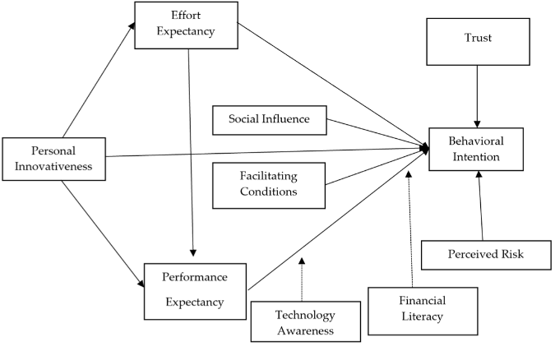

Figure 2.2: Relationship between individualistic approaches with cryptocurrency adoption
(Source: influenced from Kuikka, 2019)
While digital technology was developing, digital commerce was coming up and e-commerce was expanding. Moreover, the number of electronic payments was growing, and virtual and digital currencies were gaining popularity. Also, the German financial market was very competitive as it made huge profits from the business (Prytula et al. 2021). To inspect the current legal system of the cryptocurrency in the modern world, to underline the practice of the law in the cases of the circulation of cryptocurrency, to look through possible variants of the device of crime, which is carried on using the application of the cryptocurrency. That is why there is currently no unified international legal crypto regulation, which aggravates preventing and combating the transnational crimes, the cryptocurrency or means and subject of the crypto mining.

2.4 Advantages and disadvantages of cryptocurrency adoption in remuneration purposes
The technology use level of humanity has risen to a new point, and interest in digital assets has also increased during the pandemic period's effect. This increasing interest has already bred in some questions on what sort of consumer experience crypto will offer when transacted through physical stores. Due to the fact that they are fast, safe and cheap global payment channels, we foresee that it will be acceptable by the consumers and retailers for crypto money in Turkey (TEMİZKAN et al. 2022). Nevertheless, it’s been ascertained that in addition to people who are aware of payments with crypto currencies, there exist those who are completely unaware of them. Many consumers cannot use crypto currencies at the same time owing to the low usage level of the technology or the lack of trust in the system. On the other hand, we will come across the situation when mandatory legal sub-rules will be issued and all the money will be digitized, so the common opinion of people will also be given to digital money. It is envisaged that crypto-payments could be one of the main alternative payment tools of the future, following the legal grounding of the cryptocurrencies in turkey.
For the human angles, the components of consideration must cover the factors of ease of use, usefulness, social factors, and facilitating conditions. Furthermore, other variables that require to be considered by citations include subjective cultures, money shock, value shaping and the power of the government which the latter determines the usage and acceptance of mobile money (Al-Amri et al. 2019). From the security aspect, cryptocurrencies are related to finances; therefore, it is important to ensure that security issues are address including “(the risk of perceived security, financial security, the risk of information, the risk of social , the risk of the time , the risk of the performance and the risk of psychological)” trust, privacy, reliability, and awareness. The implementation, use, and economic and legal status of cryptocurrencies in many international examples of diverse countries are contrasted. At the current stage of Ukraine's economic and technological growth, the benefits and drawbacks of using cryptocurrencies have been widely agreed upon (Bondarenko et al. 2019). In the "grey" area of the major point, the phenomena of cryptocurrencies as electronic money and a payment mechanism has expanded to practically every country in the globe. Moreover, monetary instability, value creation as well as the government support are also a factor that strongly influences the rate of diffusion among users.

2.5 Critical analysis of the influence of technological perspectives within the countries for cryptocurrency adoption
Implementation of a financial system utilizing a technical approach featuring open innovation for cryptocurrency. The TPS (transactions per second) data array reflects the actual speed of the cryptocurrency system, which is measured in the transactions per second units (TPS), as a median annual value (Titov et al. 2021). Among these reasons, the practicality and the convenience attract merchants and users, and these other reasons such as the financial transaction time, the payment time and the simplicity of the payment process contribute to financial system adoption.
Push factors as mentioned, it is the driving force that pushes people away from the traditional form of money and to use the cryptocurrencies. Such fats include mistrust of the government, and also uncertainties with traditional money, and indeed financial institutions. Furthermore, it has been demonstrated by Hemantha (2021), the influence of the push factors such as perceived usability, perceived usefulness and investment mechanism alternatives in the process of bringing individuals into cryptocurrencies. It has interestingly been observed that mooring factors like risks will be the factors that counter the adoption of cryptocurrency, while social, technical and security factors will be the factors that will enhance sooner the adoption of cryptocurrency. As individual factors, mooring factors also impact on those decisions. Thus, individuals' cryptocurrency adoption is also influenced by the same factors.
At present, public blockchains have reached the highest stage of development that can be proven by cryptocurrencies that provide a lot of benefits including universal means of payment as well as minimum fees with the removal of intermediaries. While quite a number of tourism vendors have started accepting cryptocurrencies, and the potential role of cryptocurrencies in travel-dominated consumption has been intensively documented, the literature on cryptocurrencies as a payment alternative remains wanting (Treiblmaier et al. 2021). Conventional models do not take into account the peculiarities of cryptocurrencies and mislead the study of factors that cause the adoption of travel-related payments among travellers. The contingency factors were addressed via correspondence analysis in which technological factors such as network and security were identified among others along with the positive and negative perceptual antecedents.
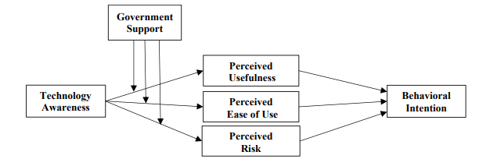

Figure 2.3: Flow chart relationship between technological awareness and developing behavioural intentions
(Sources: influenced from Hemantha, 2021)

2.6 Effective practices of cryptocurrency adoption managing cultural differences
A cryptocurrency is a digital currency that is decentralized, that is, does not depend on banks. It employs Cryptography to confirm transactions and oversee asset transfer. Several studies have been carried out, which have stated that several factors are responsible for the limited success of cryptocurrency, such as national culture, consumer psychology variables and regulations/monetary policy. Cryptocurrencies, innovation that marks the era, have become impediments to governments and central banks as their phasing in are often hampered by strict regulation and monetary policy (Wong et al. 2022). Adequate psychological barriers such as the need for interpersonal contact, functional role barriers and other factors such as power distance and uncertainty avoidance are the hindering factors for cryptocurrency acceptance.
The major barrier is the need for an extensive and deep consumer market base for the adoption of cryptocurrency. evolving functional financial policies and instruments, which is critical for the encouragement and knowledge acquisition towards financial services usage leading to currency adoption among existing and potential users (Busse et al. 2022).
Make communication tools resonate with native cultures. Employing culturally appropriate language and visuals are important to ensure correct understanding and to avoid any misunderstanding. Provide an option to select between the traditional and blockchain based payment methods to employees as remuneration. Hence, such an option allows users with various comfort levels and preferences from different cultural environments. This also leads to the fact that the impact of both performance expectancy and infrastructure support on the behavioral acceptance of bitcoin payment is significantly influenced by government regulation. Then the government regulatory strategies which conflict with the interpretations were not considerable in mediating the relationship between EE and security and the acceptance of bitcoin payments. Performance expectancy, security, EE and infrastructure support were main factors that determined behavioural adoption in the bitcoin world (Mensah and Mwakapesa, 2022). Through the process of analysing the practical and theoretical effect these discoveries might have on the implementation and propagation of bitcoin technology the author discusses the issue in detail.

2.6.1 Practices influencing China for adapting crytocurrency for remuneration purposes
Positive influence of an attitude, subjective norms, perceived behavioral control and a herd behavior, on this intention activity. Due to the fact that the topic does not fall into the category of cryptocurrencies that are inertly technological in terms of principles and exposed to large fluctuations of the global economics, however the consideration is separate (Cristofaro et al. 2022). Nevertheless, the country of origin did not affect the perceived behavioral control however the culture does. More often, the use of cryptocurrency for e-commerce gets influential when the sense of power through the idea of holding intangible resources, education and technology is being designed and acquired for e-commerce.
Inclusive appraisal for the use and incentives of using China’s DCEP electronic payment (DCEP) system – a national digital transaction and payment procedures network. This is so because we shall consider and compare both cash provision and the services of the third-party payment system. by integrating technology-task fitting approaches within DCEP, users’ interest turn to be positive towards trying DCEP (Xia et al. 2023). The technical factors of DCEP, the payment purposes, and the come-through government interference can be the strengthening factors of users’ acceptance intention which helps to match the required task-technology. On the contrary, significant and negative e-Ted effect of switching cost has maleficent the role in adoption intention, while insignificant number of switch drivers will not play any role on adoption intention. Furthermore, adding more knowledge to the awareness of the determinants that shape the intentions in digital cash eCEPT, the application to practice, and policy making when it comes to improving the efficiency and effectiveness of DCEP.
The amount of the market's fixed price, in total, amounts to 51 percent and is represented by the mentioned companies. Traditionally, Nasdaq has been the home of technology-based companies, small and medium enterprises, which have used the platform for voluntary disclosures (global.chinadaily.com.cn, 2024). The China Securities Regulatory Commission planned to build and improve the environmental, social, and corporate governance (ESG) disclosure of listed companies within three years, which was announced at the action plan for the quality of the listed companies made in November, 2022. Meanwhile the stock exchanges have since been awarded with the guidelines of publicity. The exchanges announced that they will listen to and consider as much feedback as possible from market players about the document and make public release of the paper in the prescribed time. According to the SSE and SZSE guidelines, market capitalization of more than 500 million yuan, and the period of dual listing from 2026 can require the listed companies to disclose a wide range of sustainability issues (sustainablefutures.linklaters.com, 2024). According to the BSE blueprints, listed companies can reasonably provide the sustainability and ESG report by their own volition – BSE which is a new regulatory platform that was only founded in September 2021 was set up as SMEs primary listing in China. Hence, inclusion of the cryptocurrency for remuneration process in China is a much more positive aspect.

2.6.2 Analysing the implementation strategies of cryptocurrency for remuneration purposes in the US
The pace of the digital economy, most states are looking forward to crypto currency operations or, even, now they already develop frameworks that regulate crypto assets. Besides national authorities being deprived of chances of pretending business’ operations with crypto assets as not being their concern, additional responsibilities arise. Besides, agreement pertaining to the common terminology of financial, tax, and other cross-countries relationships will suppress the existence of the underground economy due to the consistency of the decision-making process (Morozova et al. 2020). In this regard the problems of the macroeconomic factors regulating the crypto assets including them to the current structure, the procedure for their fair valuation which is to be also considered as part of range and the content construction in the financial statements of the companies is very significant. The last one is also to carry out a thorough examination for the purpose of selecting technicalities and possibilities for the purpose of categorizing and measuring the performance within the remuneration process. Since, it is a difficult, intangible and complex process and cryptocurrency developments in the scientific research, professional judgments of major audit international organizations. Theoretical investigation of the accounting practices of companies pursuing business by crypto assets in light of the fact that the EU wants to develop one “International Financial Reporting Interpretations Committee”.
Making it possible for the employees to be paid part of their wages in cryptocurrency, and, the remaining part of wages in traditional form available for their choice in the US. That allows one to choose when to use cryptocurrency, and which one oneself is comfortable with. Being thoroughly informed regarding all alterations in US cryptocurrency regulations is the key. Cryptocurrency legislation is changing fast and may force businesses to change the way they operate in regards to any new requirements that appear. Form a support system for those using digital coins and collect feedback from the community about it. These allow visiting all sections of the website and locate places those issues have to be resolved as well as improve the user experience.
The main area of crypto regulation for the U.S. government is to protect and restrict the use of crypto assets, commodities or services by crypto platforms. Multiple agencies are in this process with the “Securities and Exchange Commission (SEC), Commodity Futures Trading Commission (CFTC), and Financial Crimes Enforcement Network (FinCEN)” that are involved. On the one hand, many top government agencies and policymakers maintain that such technologies have the capability of playing a vital part in the structure of the future of the U.S., while on the other hand, they struggle with the issue of allowing the development of cryptocurrencies while at the same time restricting their illegal uses. As a culmination of its efforts, on August 10 this year, the U.S. Senate settled for a $1 trillion bill that will allocate about $150 billion to infrastructure spending in the next 8 years. To help finance these funding, the Senate incorporated a provision mandating that cryptocurrency "brokers" submit these same financial reports as individual investors, estimated that the IRS would collect an additional $28 billion in tax revenue over the span of ten years (skadden.com, 2021).
This step within the organization aimed to eliminate the threats of extortion by a sanctioned actor that the CISA’s Ransomware Guide of September 2020 highlights; and, it was whether the attack got reported to presumably legitimate government agencies or not; and also if the organization cooperated with the OFAC, law enforcement and other relevant agencies, including whether there was any voluntary self-disclosure about any violation (montague.law, 2024).

2.6.3 Critical analysis of how United Arab Emirates is adapting cryptocurrency for remuneration purposes
The UAE government has been indeed progressive in fostering a regulatory system that on the one hand is resolute, yet, on the other, it is still adaptable. The emirates, especially the contenders of the Emirates-UAE- and Dubai-coast in the past two years have been driving the region’s pace. This is backed by making huge regulatory efforts to draw the best talent, investors and exposure the world wide web can offer to these wealthy businesses focusing on digital assets. The 2023 Crypto Oasis Ecosystem report by 2023 shows that over 1800 businesses are active in this domain and employing over 8650 people in the MENA (forbes.com, 2023). It believes the economic basis of the UAE traditionally, but currently this country is in the stage of diversifying, and technology, as well as financial spheres, has become the main incentives in the process of diversification.
Consideration of Dubai and its sister city Abu Dhabi, top-ranking in the regulatory structure (the most significant consideration which is about 35% of the total score) indicates that the regulatory framework of the two cities is sound. Nonetheless, the UAE secondary position in crypto adoption within the region was partly offset by the lower score of this country in the bottom-quartile, showing that they are far behind in crypto adoption than the residents in these two hubs (coindesk.com, 2023). While the number of the overall drivers score for Dubai is rather low, the emirate maintains its position among top five score places thanks to the high scores in the “opportunities” category which evaluated per capita number of crypto events, companies and jobs (the amount of jobs calculated per the population number). In addition, we observed that the emirate here was ranked the second best in terms of quality of life among all the countries in our entire sample. Another subcategory of enablers, quality of life, was the second important criterion (15% of all score) of the score.
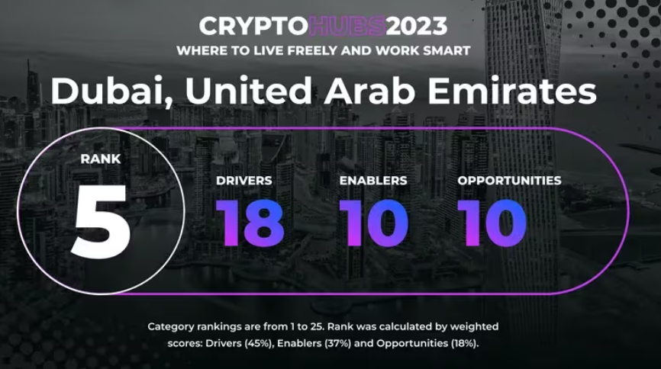

Figure 2.4: Dubai cryptocurrency position
(Source: coindesk.com, 2023)
In reply, the regulations for cryptocurrencies stipulated that the central bank started regulating every cryptocurrency transaction and asset starting from 2017, so all digital assets had to be traded via authorized exchanges, and these had to adhere to the anti money laundering regulations laid out by the central bank (cointelegraph.com, 2024). One can notice a law-and-order focus that aims at prevention and prosecution of crime-related use of virtual assets.

2.7 Theoretical underpinning
Hofstede cultural dimensions
In societies that have a bigger power distance, there is a tendency to greater authority acceptance and centralized control. The cultures that are based on the central authority principles may reject the cryptocurrencies that function according to the decentralized principles. The accenting of the emancipation factor of cryptocurrencies could also be so important in getting people to accept it. Whereas, cultures with low PDI are more willing to accept the decentralization systems. Cryptocurrencies, by their very peer- to-peer nature, could match with an inherent preference for egalitarian structures. It is the long-term societies, that are more and more oriented towards short-run payoffs, that may be more receptive to the innovations that have a long-term payback. In order to focus more on their long-term sustainability, financial planning, and factors linked to future prospects, it is recommended to put forward these possibilities. The immediate examples (benefits and practical applications) of cryptocurrencies may be more important at the beginning in normative cultures that emphasize the short-term. Proving the advantages of using cryptocurrencies for salary is very important to show the quick and close results (Urus et al. 2022). Most companies move to digital business processes in order to keep the business running in this tough situation. That's why digital payment services, which are provided by fintech (Financial Technology), are the most popular in terms of financial transactions in the conditions when people are unable to move and communicate freely. The rise of Fintech as a pillar that attracts the interest of the whole world, including Malaysia and Indonesia in Asia, is phenomenal. Though Fintech offers many benefits, its adoption is still quite slow in both the countries. This is true for the mostly fresh graduates who are tech-friendly.
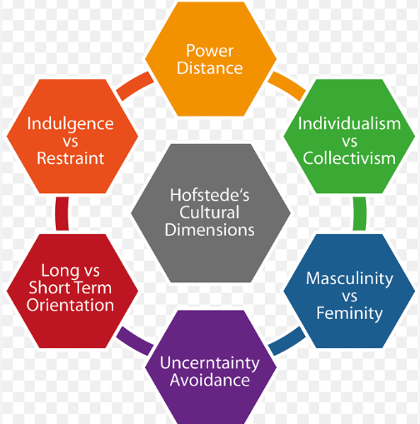

Figure 2.5: Hofstede cultural dimensions
(Source: influenced from Urus et al. 2022)

Block chain theory
Blockchain is the key technology that is behind the cryptocurrencies while cryptocurrencies are the tops of the iceberg for the cryptocurrencies adaptation, which is the deepest adaptation of blockchain technology. Blockchain as a technology develops a chain of transactions whose reviews are transparent and traceable. Such transparency normally results in a higher accountability of financial transactions and conviction of the parties involved. Blockchain is a system that can be trusted and this could be a good solution for any individual or organization facing the cases where transparency is of paramount importance. While digital currencies are booming, many vendors nowadays will allow you to pay coins which are based on blockchain technology. However, there is little information on the way people would behave if the blockchain-based currency was a way of cash spending worldwide. According to Salcedo and Gupta (2021), the fact that virtual currencies are prevalent worldwide as well as the national culture values of an individual could affect his/her propensity to use blockchain-based currencies for the USA and India. National cultural values “(collectivism, power distance, masculinism, uncertainty avoidance, and long-term orientation)” have an impact on the ways the cryptocurrency is used. In this process, there is no kind of intermediary involved and the trust no longer exists, which in turn leads to the decrease of transaction costs and hence to the fact that the cryptocurrencies are a more interesting option for the users.

Innovation Diffusion Theory
Cryptocurrency adaptation flexed this principle, which presents a more detailed picture of a multi-stage mechanism that is a complex composition. This mechanism is determined by specific factors that are required for the acceptance and participation of cryptocurrencies. It is typically this culture adaptation that ideas refers to pioneers and early adopters. It is aimed at businesses that commence using technology early on leveraging the chances for future rewards (Mukabi and Vu, 2019). The first adopters and ambassadors of cryptocurrency help others join the fray in its turf warfare of recognition. The emergence of payment habits that are unifying may also be a major force in spreading new payment technologies, and hence economic performance. Some studies show that the digitalization of the retail payment system is an important point for the performance of the banking sector and economic progress. The retail payment market is a representative example of two-sided markets where new payment tools need some critical mass of users to become feasible and further grow.

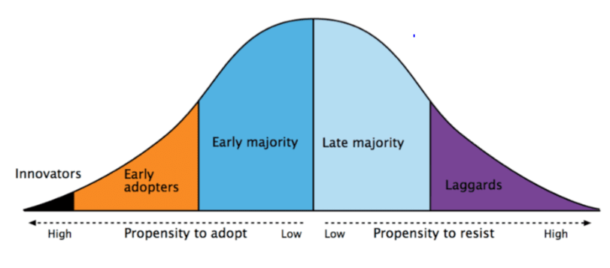Figure 2.6: Innovation diffusion theory
(Source: Mukabi and Vu, 2019)

2.8 Literature gap
A great number of studies have focused on the cultural factors within a particular culture, but the comparative analysis of cultural phenomena across cultures is still in its infancy. By knowing the way different cultures perceive the unification of cryptocurrency in remuneration practices, the global landscape will be possible to explore in more depth with a finer approach (Mensah and Mwakapesa, 2022). Trust is one of the most crucial contributing factors for adoption of any financial technology, ranging from cryptocurrencies to any other. The literature currently has not been found to holistically examine the cultural trust dynamics, both at the societal and organizational level, in terms of the creation of perceptions and attitude relating to cryptocurrencies as an alternative remuneration. More often than not, research fails to notice that socioeconomic and demographic factors can differ within a cultural context. The discipline should probe how diversified factors like income level, education, and age play a role in the acceptance of cryptocurrency as a mode of payment; such an extension of understanding demonstrates an integrated aspect of the target public. Most currently conducted studies give "instant photos" of attitudes and behavioural patterns from a specific time (Hemantha, 2021). Longitudinal studies are the bread and butter of scientists who investigate cultural views of cryptocurrency and studying patterns of adoption which is important for identifying the trends and fluctuations in cryptocurrency acceptance within different cultural contexts.

2.9 Chapter summary
It has been seen that, Cryptocurrency transaction analysis was conducted in terms of microestructural characteristics: the study examines the "economic feasibility, payment convenience, government regulation, and risk" as independent variables and "different usage intentions among countries'' as the response characteristic; this was compared. The behavioural intentions of accepting virtual currencies are among the most effective influencing factors that are different for each country and its culture. However, there has been affection for the fact that more people who use cryptocurrency payments are also the ones who are aware of their existence. Many end users also lack the understanding of crypto currencies due to the low usage level of the technology and the lack of trust in the system as a result.

Chapter 3: Methodology

3.1 Chapter introduction
The currency offered in cryptocurrency for the payment purposes signals a change in finance where technology, money, and culture initiate a new epoch. In this chapter then, the analysis encompassess a look at the methodological framework which will be used to look into the influence that culture has on employment compensation systems that use cryptocurrency. Decentralized digital currencies alter the global landscape in terms of a fundamental change shift. This volatility necessitates the need to understand the cultural role for grasping a better comprehension of the various trajectories that cryptocurrency adoption follows.
The main idea of this study is to determine the hidden complexities between the cultural factors, and people’s ability and/or willingness to adapt cryptocurrency as a form of payment. Culture is embedded with them as society norms; values, beliefs, and practices act together as a lens through which people understand and get involved with digital finance platforms. Therefore, the strategy responsible for the methodology applied must be all-inclusive in the sense that it should not only capture the numerical factors of cryptocurrency usage but also explore the socio-cultural facets of adoption.

3.2 Research onion
“Research onion” is an established visualization technique which reliably depicts seven levels (and often more) of a process of research. Another example would be Saunders's research method that clearly illustrates the different steps that a research method should encompass. The use of teamwork in the research process or scientific discovery is very crucial in ensuring that the research is cent percent satisfactory. The unearthed discovery of one onion layer shows a well-designed but not uniform system of convergence or divergence and decision making (Saunders et al. 2019). Research philosophy implies the adaptation of particular views based on research designs, approach, techniques, and other findings; this contributes to the most significant contribution to the study. Respect the fact that cultural factors are complex and it is likely that some of them might contradict or be contrary to one another. Differentiate the obstacle of generalizing digitalization of outcomes for the diverse cultural settings. Flex with an interpretive mode portraying the factually subject habits that will influence the cryptocurrencies adoption. Admit that people and companies can interact with unconscious biases depending on their cultural backgrounds.
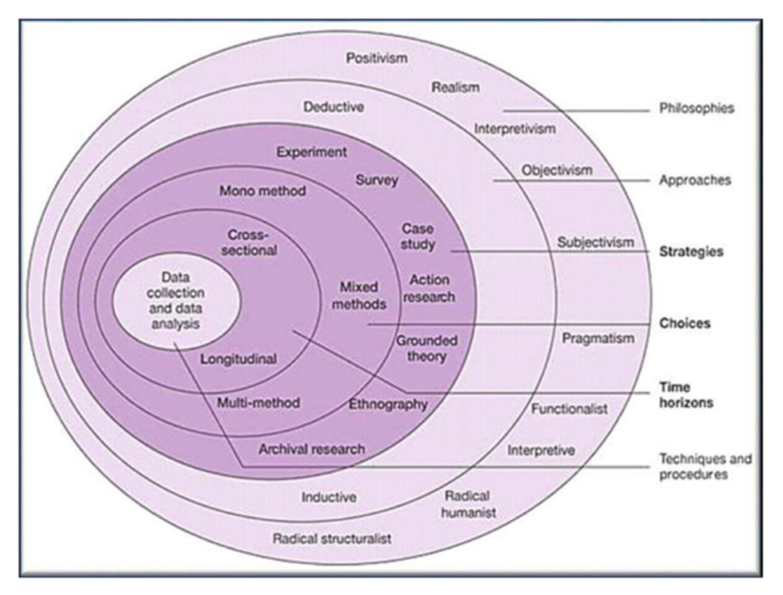

Figure 3.1: Research Onion
(Source: Inspired by Saunders et al. 2019)

3.3 Research philosophy
The type of research philosophy known as interpretivism rests on the idea of social construction of reality and subjectivity-that is, the reality and subjectivity of any thing are all being socially created. Stress out that culture has an influence on an investigated phenomenon and it has to be dug into and understood in order to realize the effect. Interpretivism stands for contextualized eclecticism by virtue of the degree of social construction present in these cultural meanings and interpretations. Harness qualitative research techniques explore the experience and contribute to the appreciation and understanding of various cultures. Strategies like in-depth culture contrast and studying texts using methods like content analysis are powerful tools that help to learn more about subjective experiences and thoughts (Pervin and Mokhtar, 2022). Enrich the culture seen during observation with interesting and detailed descriptions. Employ the culture comparison as a tool to probe for more information. Provision of such context is quite helpful as readers use these to understand the specific context and interpret the findings regarding the cultural specifications. Implement the method of thematic analysis in order to perceive and quantify repeated data (qualitative) meaning. The work entails identifying patterns, words, and symbols that the participants used during their narratives, as it contributes to the deeper understanding of the community aspects. Keep on comparing the data which occurs in real time every hour, this provides a chance to form categories and themes. This interactive procedure among people, which, is a section of the interpretivist approach to the process of cultural influence understanding.
Picking the suitable philosophic way is very important for the study direction since it should be systematic for the researchers to follow (Sun et al. 2020). Since this research involves Interpretivist philosophical research, the end goal is to find out the most probable answers that the world of the research area. Perspectivism especially addresses subjective nuances of the studied topics which is indeed favourable for we assessing the adaptation of cryptocurrency as being a very peculiar case. Its perspectives of the diversified approach and of “balancing” with the present realities will play the roles of determining influences and accessible obstacles in the expansion of cryptocurrency pace to the great extent among the people for the payment purposes.

3.4 Research design
The central purpose is to explain the cultural aspect influencing the probabilities of the use of cryptocurrency as a salary. The study implies here that there is a need to state the main cultural features that characterize organizations and communities by norms and values. For sampling, apply a random or a stratified sampling technique to meet the presented sample. Consider a group whose members work in different cultural settings, companies, and organizations find it easier to have a wider scope of perspectives. A descriptive research design intends to provide a detailed portrait of a phenomenon or specifying the current situation as is the case with the description of characteristics or relationships among variables (Sileyew, 2019). In this kind of study, there is no effort to describe some phenomena or situation, or even further than that, the reason for its existence which is why it's also called qualitative research design. The means of descriptive research is to picture a certain group vividly, or to give a vivid representation of a particular event or situation. It might be useful to spot patterns, trends, and relates in the data.

3.5 Research strategy
The choice of developing the most appropriate research strategy holds the notion of connectivity with the research objectives. Gathering data with the most appropriate data collection tool has a huge impact in setting up the concrete findings. Developing the most credible framework for the that findings on the cultural instances of cryptocurrency have the greatest deal of acknowledgement. Using the country comparison tool for the study which has been considered quantitative data based on the qualitative factors are utterly important.

3.6 Research approach
Analyse the existing culturally oriented or frameworks of adoption which can be related to culture and cryptocurrency. Identify and include those that seem civil and might be used to build a theory about the link between cultural factors and the use of cryptocurrency as a means of remuneration. The use of a specific research approach during a research ultimately supports decision making on methodology designs for dissertation writing (Baştuğ et al. 2020). Such an activity can in every way be related to the systematic mode of investigation. Particularly, the deduction research approach will be preferred for this present study in formulating the research design so as to have the most effective way of collecting data that will form the basis of coming up with a research theory so as to help understand the cultural influence to accepting cryptocurrency for remuneration purposes. The deductive approach of research methodology adopted in this study can be fair to its intent because the study is hypothesis based, specifically focused towards adoption and culture that would bring out the fact that can guide the implementation of the study at the latter end.

3.7 Search strategy
The systematic review search strategy used in this dissertation consisting of two sessions performs major role in the testing phase of its comprehensiveness and rigor with respect to the topic which we propose to tackle in this dissertation, "How is Culture Affecting the Adoption of Cryptocurrency for Remuneration Purposes." The procedure made extensive, covering literatures that are relevant to the finance, technology, sociology and cultural studies across various of the disciplines. Through a huge variety of keywords and search terms extending to most relevant literacies’ not a single one was missing under the strategy. This interdisciplinary approach was essential for getting insights from a comprehensive point of view and for making summaries and finding out different perspectives and findings.

Search components | Search terms
Academic journals  (PubMed, Scopus, and Google Scholar) | Crytpcurrency, remuneration process, cultural influence
Data bases  (Nasdaq, coinbase, Hofstede country comparison, DeFi, Forbes) | China, UAE, USA, cryptocurrency adaptation
Government and institutional reports  (Statista, country reports) | Cryptocurrency trends, remuneration process, revenue through cryptocurrency
Inclusion criteria | In English language, full accessibility, not older than 5 years
Exclusion criteria | Other than the language English, grey literature, older than 5 years

Table 3.1: Search strategy

3.8 Data collection and analysis
The data for the study was mainly collected using the Hofstede country comparison tool. The parameters such as “individualism, uncertainty avoidance, motivations towards achievements and success, long term orientation” are the best fit to analyse influences based on the motivation and perceptions towards adopting cryptocurrency for the remuneration purposes. Three countries such as China, the United States, along with the United Arab Emirates are only considered for analysis. Simultaneously, through online websites such as Nasdaq, stock exchange, international security exchange are considered for analysing cryptocurrency acceptance within the companies of the selected countries for the remuneration purposes. Authentic newspapers of the selected countries are the best choice to support the notion based on the cultural as well as behavioural context in order to accept cryptocurrency within their daily life in terms of remuneration. Apart from that BBC, FT, TheGaurdian, NewsToday are considered to develop holistic views about the study on cryptocurrency adoption.
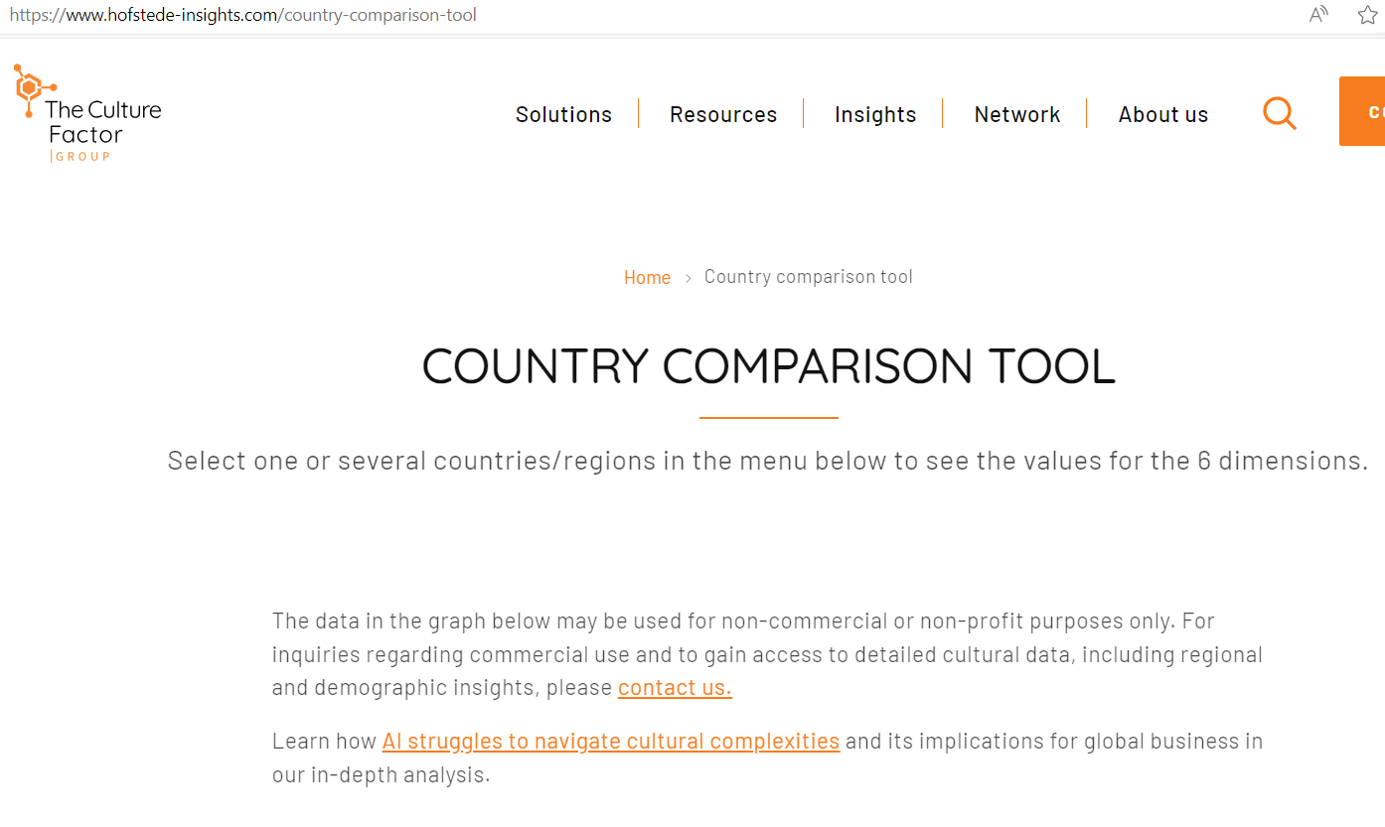

Figure 3.2: Hofstede country comparison tool
(Source: hofstede-insights.com, 2024)

Sources of data
The type of data sources for this study- the qualitative literature, include scholarly articles, reports, as well as qualitative researches got from academic databases such as PubMed, PsycINFO, Scopus, and Google Scholar. On top of that the visual aids that are used for the purpose of reinforcing organizations while writing about policy manuals and diversity reports can be thought of as quite informative. The inclusion criteria serve as a tool to determine the efficacy of the chosen sources which therefore provides useful information regarding the influence of culture which might be a motivational factor for the employees to adopt crypto currency for remuneration. In this sense sources include dealing with multiple organizational contexts. Throughout the data collection procedure, scientific standards have been applied and respected, such as referencing and proper citation on the one hand and under the law of copyright, on the other hand.
PRISMA framework

Identification of studies via databases and registers

Records removed before screening:
Duplicate records removed (n = 200)
Records marked as ineligible by automation tools (n = 80)
Records removed for language issues (n = 70 )
Records identified from*:
Databases (n = 800)
Registers (n = 200)

Identification

Records screened
(n = 650)
Records excluded**
(n = 400)

Reports not retrieved
(n = 180)
Reports sought for retrieval
(n = 250)

Screening

Reports excluded:
(n = 20)

Reports assessed for eligibility
(n = 70)

Studies included in review
(n =50)

Included

Data analysis
Thematic representation of data has been selected based on the chosen three countries reflecting the research questions. For supporting the arguments, literature from Google scholar, PubMed, ScienceDirect are considered for detailed analysis. The topic analysis is outstanding for it in applied research and dealing with the world crisis of tangible nature. It can serve as an engine to stimulate the introduction of preventive approaches, policies or to put into effect acceptable solutions unveiling key aspects associated with the research area. Thematic analysis has a major role in generating a clear-cut report. Theme and sub-theme identification is a pathway towards ordering and simplifying a research document for a reader's sake and eventually enhancing its transparency and reproducibility (Vaismoradi and Snelgrove, 2019). Theme analysis of a research engages reflectivity of a researcher. Along with their analysis, researchers need to pay attention to their standpoints, preconceptions, and biases. This helps maintain high levels of transparency and brings up the entirety of the scientist involved in the research results.
Compared countries | Data sources
China | Nasdaq, coinbase, Statista
USA | Statista, Nasdaq
UAE | Statista, forbes, DeFi

Table 3.2: Data source

The inclusion criteria beholds that all the data collected are considered from only previous to 5 years. Means all the data available before the year 2019 are not considered for the present study. Along with this, only authentic websites are considered for collection of the data. No random websites are considered. Only reliable data sources such as, newspaper websites, national as well as internationally claimed websites are considered for the current study. Journal articles from SienceDirect, PubMed, Elsivier are considered for the data collection and proofread.

3.9 Data reliability and validity
Data accumulation is well-presented with reliability and validity of data which are contributively for the present study. In addition, this technique is useful for maintaining homogeneous uniformity and constructing rational conclusions from the research questions perspective. Data which are separated between the present information and authenticity and this is used for the current research is the most important feature for data reliability and validity. All the data that are gathered for the current study, considering the authentic sources, such as Government websites, which, are considered as the valid and reliable. Along with this, authentic news paper sources also pave the path of having great analysis.

3.10 Ethical consideration
All the requirements concerning the norms and regulations as indicated by university are taken into account while the study is receiving the go ahead. Therefore, the data that are collected are entirely at the disposal for the purity of research. None will be included that aims to hurt the sentiments and the values and preferences of the people (Smith et al. 2021). Studies highlight the fact that data privacy and protocols are things, which is paid the highest attention to, while conducting the research. IP belonging to the “Institute of Intellectual Property Rights'' are to be retained at all times during the duration of the study. All the information that is to be collected is to be stored in the file which is password protected and so privacy would not be disturbed. Exaggerating the figures and findings as it were to meet the present objective of the research work is and must not be allowed. This means that fraudulent behaviour such as manipulation of the data will not be tolerated. “Data Protection Act, 2018” is the overarching framework that is going for referencing throughout this work.

3.11 Chapter summary
A detailed strong approach for studying this complex connection among three fundamentally different countries between culture and usage of cryptocurrency as a currency, for the chapter is very intrinsic. The introduction of a country comparison tool has served significantly to help in bringing out the niceties of a nuanced analysis of the cultures seen to influence this complex business and with this insight the study views all factors clearly. This tool works as the backing element, which helps one to systematically analyze country specific cultural factors, and that in turn will determine how cryptocurrency gets adopted for remuneration. The methodology is made stronger through the use of the country comparison tool that serves as the backbone on which all cross-cultural developments are carried out. Crypto culture tool provides comparison of cultural components, cryptocurrency adoption rates and regulatory framework for numerous countries to map the entire cultural layout. The methodology in this chapter does not only intend to present a strong background of culture impact on cryptocurrency acceptance but rather introduce a strong framework to initiate the study on how remuneration is influenced by culture. The setting of the united nation contributes to the content quality and quantity of our research providing us with a unique perspective from which to unravel the pulling forces shaping this eclectic culture.

Chapter 4: Findings, Analysis and discussion

4.1 Chapter introduction
The cryptocurrency payment culture integration is a major intersection of technology and culture where innovative digital currency arose due to the advanced digital finance conditions. This chapter deals with the results, analysis and discussion stemming from an investigation into the use of culture in adopting crypto currency payment methods. Through multi-faceted exploration, this chapter is intended to give the in-depth understanding of this matter concerning the impact of cultural influences on crypto adoption as for payment purposes. This is the place where the author should focus on the complex role of crypto in financial sector, and how cryptocurrencies that were introduced into the world of culture slowly replaced the traditional way of conducting financial activities. This chapter focuses on revealing the results, analytics, and discussion of researching the implications of culture on the perception of using digital coins for wage purpose. Through a multifaceted exploration, this part of the book seeks to offer a deeper understanding of the cognitive complexities of the adoption of cryptocurrency which is a matter of cultural influences.

4.2 Annotated bibliography
Index | Authors | Year | Title | Themes
1 | Nadeem et al. | 2021 | “Investigating the adoption factors of cryptocurrencies—a case of bitcoin: empirical evidence from China” | Theme 1
2 | Bhimani et al. | 2022 | “Do national development factors affect cryptocurrency adoption?” | Theme 1
3 | Jegerson et al. | 2023 | “Investigating the unexpected determinants of cryptocurrency adoption in the UAE” | Theme 1
4 | Jegerson et al. | 2023 | “Adoption of cryptocurrencies for remittances in the UAE: the mediation effect of consumer innovation” | Theme 1
5 | Saif Almuraqab | 2020 | “Predicting determinants of the intention to use digital currency in the UAE: an empirical study” | Theme 1
6 | Bajalan et al. | 2022 | “Examining and predicting variables affecting cryptocurrencies and the future trend of money” | Theme 1
7 | Foley et al. | 2022 | “Who buys Bitcoin? The cultural determinants of Bitcoin activity.” | Theme 1
8 | Goundar et al. | 2021 | “Cryptocurrencies—An Assessment of Global Adoption Trends.” | Theme 1
9 | Murugappan et al. | 2023 | “Global Market Perceptions of Cryptocurrency and the Use of Cryptocurrency by Consumers: A Pilot Study” | Theme 1
10 | Wang et al. | 2020 | “Is China the world’s blockchain leader? Evidence, evolution and outlook of China’s blockchain research” | Theme 1
11 | Esmaeilzadeh et al. | 2019 | “Individuals’ cryptocurrency adoption: A proposed moderated-mediation model.” | Theme 2
12 | Salcedo and Gupta | 2021 | “The effects of individual-level espoused national cultural values on the willingness to use Bitcoin-like blockchain currencies” | Theme 2
13 | Hasan et al. | 2022 | “A moderated mediation model of factors influencing intention to adopt cryptocurrency among university students” | Theme 2
14 | Palos-Sanchez et al. | 2021 | “An exploratory approach to the adoption process of bitcoin by business executives” | Theme 2
15 | Nuryyev et al. | 2020 | “Blockchain technology adoption behavior and sustainability of the business in tourism and hospitality SMEs: An empirical study” | Theme 2
16 | Almarashdeh et al. | 2021 | “The adoption of bitcoins technology: The difference between perceived future expectation and intention to use bitcoins: Does social influence matter?.” | Theme 2
17 | Wu et al. | 2022 | “Investigating e-retailers’ intentions to adopt cryptocurrency considering the mediation of technostress and technology involvement” | Theme 2
18 | Steinmetz et al. | 2021 | “Ownership, uses and perceptions of cryptocurrency: Results from a population survey” | Theme 2
19 | TEMİZKAN et al. | 2022 | “Motivations of retailers accepting cryptocurrency payments and their implications on retail customer experience” | Theme 2
20 | Abraham et al. | 2019 | “Acceptance and penetration of bitcoin: The role of psychological distance and national culture” | Theme 2
21 | Jalan et al. | 2023 | “The role of interpersonal trust in cryptocurrency adoption” | Theme 3
22 | Sridharan et al. | 2023 | “Effect of risk attitude on cryptocurrency adoption for compensation and spending” | Theme 3
23 | Nadeem et al. | 2021 | “Investigating the adoption factors of cryptocurrencies—a case of bitcoin: empirical evidence from China” | Theme 3
24 | Abadi and Hamdan | 2023 | “Individual Cultural Values and Profit Expectations on Investment Intentions in Crypto Currency: Religiosity as a Moderating Variable” | Theme 3
25 | Albayati et al. | 2020 | “Accepting financial transactions using blockchain technology and cryptocurrency: A customer perspective approach” | Theme 3
26 | Ikejiofor | 2022 | “The Perceived Impact of Cryptocurrency Adoption on the Financial Management Behaviors of SMEs in the United States: A Correlational Study” | Theme 3
27 | Jung et al. | 2019 | “An international comparative study on the intension to using crypto-currency” | Theme 3
28 | Smutny et al. | 2021 | “Motivations, barriers and risk-taking when investing in cryptocurrencies” | Theme 3
29 | Wu et al. (2022) | 2022 | “Research on factors affecting people’s intention to use digital currency: Empirical evidence from China” | Theme 3
30 | Gagarina et al. | 2019 | “Social and psychological predictors of youths’ attitudes to cryptocurrency” | Theme 3
31 | Silva and Silva | 2021 | “Motivations to regulate cryptocurrencies: a systematic literature review of stakeholders and drivers.” | Theme 4
32 | Muttar et al. | 2021 | “New Paradigm of Behavioral Finance in Islamic Banks: the Role of Leadership to Facilitate Creative Behavior.” | Theme 4
33 | Abikari | 2024 | “Emotions, perceived risk and intentions to adopt emerging e-banking technology amongst educated young consumers” | Theme 4
34 | Huo et al. | 2022 | “A comprehensive survey on blockchain in industrial internet of things: Motivations, research progresses, and future challenges.” | Theme 4
35 | Knott et al. | 2021 | “Persuasive System Design for Blockchain End-User Adoption–Evidence from the Creative Industries” | Theme 4
36 | Darwesh | 2023 | “Assessing the Impact of Blockchain Technology on Guests Behavior in Five-Star Hotels Using UFAUT Model” | Theme 4
37 | Higueras‐Castillo et al. | 2024 | “Examining the two‐dimensional perceived marketplace influence and the role of financial incentives by SEM and ANN” | Theme 4
38 | Raddatz et al. | 2023 | “Becoming a blockchain user: understanding consumers’ benefits realisation to use blockchain-based applications” | Theme 4
39 | Cowden and Tang | 2022 | “Institutional entrepreneurial orientation: Beyond setting the rules of the game for blockchain technology” | Theme 4
40 | Kabir | 2021 | “Behavioural intention to adopt blockchain for a transparent and effective taxing system” | Theme 4
41 | Qin et al. | 2022 | “Platform trust in C2C e-commerce platform: the sellers’ cultural perspective” | Theme 5
42 | Zhao and Pan | 2023 | “A Study of the Impact of Cultural Characteristics on Consumers’ Behavioral Intention for Mobile Payments: A Comparison between China and Korea” | Theme 5
43 | Cristofaro et al. | 2022 | “Behavior or culture? Investigating the use of cryptocurrencies for electronic commerce across the USA and China” | Theme 5
44 | Santalainen | 2019 | “Sustainable strategizing: Extending competitive advantages to viability advantage” | Theme 5
45 | Ključnikov et al. | 2020 | “How do security and benefits instill trustworthiness of a digital local currency?” | Theme 5
46 | YILMAZ | 2022 | “THE INTERACTION BETWEEN COGNITIVE BIASES AND THE CULTURAL DIMENSIONS OF THE COUNTRY IN INDIVIDUAL INVESTMENT DECISIONS” | Theme 5
47 | Armani Dehghani et al. | 2023 | “Bridging the adoption gap for cryptocurrencies: understanding the affordances that impact approach–avoidance behavior for potential users and continuation usage for actual users” | Theme 5
48 | Sham et al. | 2023 | “Cryptocurrencies have arrived, but are we ready? Unveiling cryptocurrency adoption recipes through an SEM-fsQCA approach” | Theme 5
49 | Yu-chen | 2021 | “Digital banks: igniting platform revolution in banking” | Theme 5
50 | Jangir et al. | 2022 | “The moderating effect of perceived risk on users’ continuance intention for FinTech services.” | Theme 5

Table 4.1: Annotated bibliography

4.3 Thematic analysis

4.3.1 Institutional factors associated to cryptocurrency within the countries USA, UAE, China

China

By 2023, the volume of crypto transactions in China from the point it implemented its ban of Bitcoin, of $86.4 billion had occurred. The exponential rise in the popularity of BTC in China is mainly triggered by the bearish Chinese stock markets and the almost epochal Evergrande crisis that spread panic in the country last year. Chinese people become the most significant clients of the HK cryptocurrency as they use the $50,000 quota for foreign exchange on a yearly basis (Nadeem et al. 2021). Crypto trading and mining activities have been banned in China since 2021, except Chinese residents who reallocate funds to digital assets as a financial destination to avert the nosediving of their stock market in 2023 (nasdaq.com, 2024). The Evergrande real estate collapse shall be remembered as a blow three times more potent than the US housing market crash in 2007-08 and saw many investors’ money of more than $81 billion invested and downpaid at risk. At the same time, the Chinese stock market took a hit. CSI 300 index started to drop by 11.8% in 2023. Crypto wallet downloads on a total scale (all of them) for the whole year of 2022 were below the ones in 2021. Coinbase, Blockchain.com, and MetaMask among several others were downloaded to a lesser extent from the "crash of crypto winter" which transpired over the year (statista.com, 2024). Whether the crypto market is experiencing good or bad press, it is affected considerably when the big crashes, like FTX in November 2022 - the biggest crypto exchange ranked by market share - occurs. The picture is somewhat different with Binance, which has managed to regain some of the market share, which it had lost between September and October 2022, and grew by 0.8 percentage points in November (Wang et al. 2020).
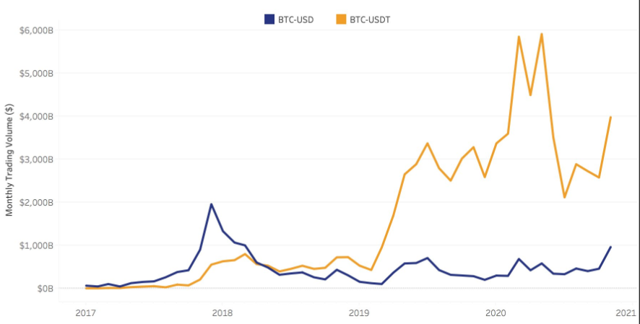

Figure 4.1: USA Dollar vs. Tether of China trading volume by 2021
(Source: statista.com, 2024)

USA
Over this period (2020 to 2023) of time, there was the creation of a country ranking that estimates crypto adoption based on transaction volume. This ranking was found to rate the US in a top 10 position among the other countries. Particularly, it is worth to note that the increase in the index in 2021 has broken the previous trend. It might be that the Financial Research Association (NFA) has done some methodology adjustments, which now include decentralized finance (DeFi) in the index (statista.com, 2024). It is the fact that the open sea or Web3 wallets are majorly a common thing in the United States (US) amongst many other countries, particularly the first months of this year (Murugappan et al. 2023). Moreover, Uniswap's native token uni (UNI) broke $15 per token on Coinbase on Wednesday at around 12:15 ET. Its price has doubled more than 92% in one week and has soared nearly 1,300% since it was initially launched in September 2020. This gives UNI premium as the coin with the largest market cap in the DeFi sector (nasdaq.com, 2021). Moreover, the early signals of a pending response were DeFi’s “total value locked” surpassing $25 billion. GrayScale Investments, the biggest maker of digital asset-based products, has applied to regulators for registration for five trusts comprising various crypto assets and a couple of them related to Decentralized financing (DeFi) (Goundar et al.2021). Grayscale and CoinDesk are a couple of digital currency firms owned by Digital Currency Group (nasdaq.com, 2021). “Aave, cosmos, polkadot, monero and cardano” came up in fresh filings but that does not mean that a question of whether there will be Grayscale XLM trust will be definitely answered soon or, indeed at all.
- UAE
According to the forecast, total income in the Cryptocurrencies market might tentatively be equal to US$ 292.1 million in the year of 2024. Prospective revenue is forecasted to move with a compound annual rate (CAGR, 2024-2028) of 7.89%, which translates into the market value of US$395.8m at the end of eight years in 2028. Discover that the Cryptocurrencies area cover an average revenue per user of~$105.7 in the year 2024 (statista.com, 2023). It is further depicted from a global orientation that the maximum profit is obtained in the United State (US$23,220.00m in 2024) (Jegerson et al.2023). The cryptocurrencies market is forecasted to have an increased number of participants that is the user number is expected to be 3.15m users by the year 2028 in the United States. As for user penetration, it had a value of 26.96% in 2024 and was forecast to reach 29.85% in 2028 (Saif Almuraqab, 2020). Digital finance (DeFi) darling Curv signed an agreement with Algorand, which is a Pan To Pan structure network signed-off by Turing Award winner Silvio Mehaliya, to build and deploy their new wallet technology.
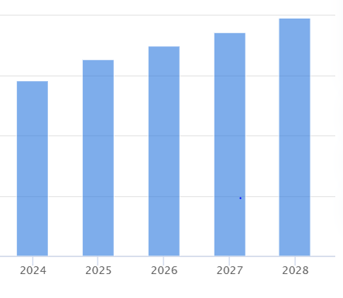

Figure 4.2: Cryptocurrency market forecast of UAE, 2024-2028
(Source: statista.com, 2024)
In the front line the DP World's Abu Dhabi Global Markets can boast its financial regulator Financial Services Regulatory Authority. It released its initial guidance for regulation of crypto asset activities as early as in 2018 (and has been updating it year after year) thus setting up a regulatory benchmark (Jegerson et al.2023). FSRA has taken upon itself the task of validating modern traditional financial apparatuses for the creation of updated regulatory systems with regard to digital assets. More recent updates cover Toncoin TON 0.0% , XRP 0.0% and DIFC approves members of the list. These were added to the already available digital assets such as Bitcoin BTC 0.0% , Ether ETH 0.0% , and Litecoin LTC 0.0% (forbes.com, 2023). DIFC also engages in an active vocal dialogue with the industry players with the

4.3.2 Individual dimensions impact people adopting cryptocurrency for the remuneration process
New-age financial technologies, such as open banking and peer-to-peer mobile payments have been shown to influence performance expectancy. The regulatory environment is important since China's strict laws on cryptocurrencies which strictly prohibit circulation in the market have hindered this digital investment adoption (Peretolchin, 2023). Social influence has affected individuals' intention and culture based on their conduct by using digital currencies including cryptocurrencies. The primary reason people in China are not employing due to ignorance or a misunderstanding of the usage procedures. Based on the Hofstede model, this dimension rate in China is 43 indicating that people act in the interests of the group (hofstede-insights.com, 2024). The disposition of individuals to adopt cryptocurrencies is influenced by cultural attitudes toward creativity and financial risk. China’s forever desire to be on the technologically advanced position within the world has made up the intentions of collectivists along with the individualism phenomena.
The Confucian beliefs which stress social consensus, respect of tradition and elderly, and emphasis of order and hierarchy may affect crypto currency adoption. It is possible that people are more likely to appreciate the stable financial institutions approved by the public than partially anonymous and volatile cryptocurrencies (Roussou, et al. 2019). As well these things, Confucianism are focusing on stability and continuity. So, that an individual can possibly call cryptocurrencies very unhappy and non-societal orderly. The Chinese collective orientation causes the society to value group wellbeing rather than personal desires (Salcedo and Gupta, 2021). Among the users, one might be hesitating to use it as a medium of exchange if he thinks it as not socially acceptable or there is no one in the area that acknowledges and accepts it. In another example, if the cryptocurrency adoption is considered advantageous for the wider community, then the individuals may be enthusiastic to use it.
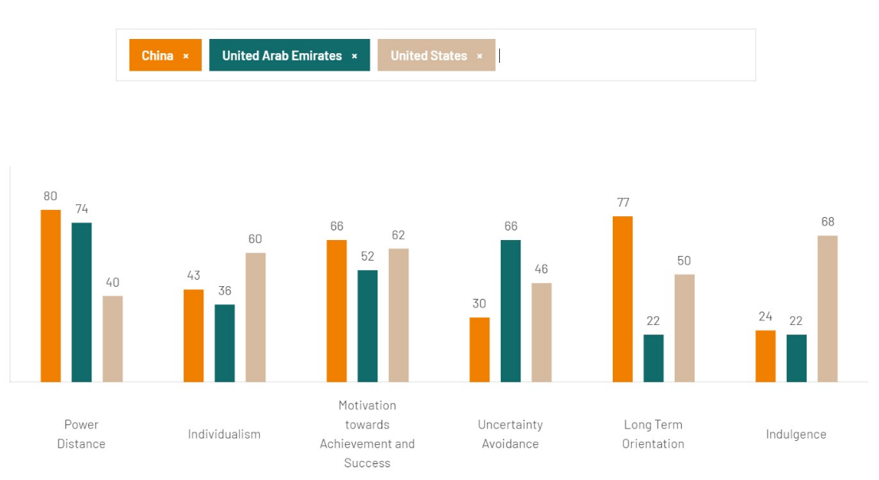

Figure 4.3: Country Comparison between China, UAE, and US
(Source: hofstede-insights.com, 2024)
China – a collectivist country – relationships in society – social action impact on the social account decision making. Also individualist societies are profit driven while the people of collectivist societies have other purposes too such as making friends as a reason to attend some movies, seminars, conferences and other events (Yan. and Halpenny, 2019). This happens because consumers and vendors of a collectivist society will still try to preserve or keep a communal environment, as communication and interaction between each other is their priority relationships. On the other hand, the people of the individualistic societies are usually the ones who are free-thinking and thus resist any forms of control (Almarashdeh et al.2021). Interdependency and dependence of those in collectivistic cultures reflect socio-cultural characteristics of their societies. Requirements of a group that one will be directed to by its social norms intention to act.
Cultural dimensions – through the varying attitudes of consumers that exerts influences on their behavior. There are three major rules in terms of marketing strategy when it comes to product sales across the USA – which in turn is an individualistic society. Cryptocurrency sales are allowed in situations that qualify as the sale of securities under federal or state law (Abraham et al. 2019). Besides, the seller is acting in a way that qualifies them as money services business ("MSB") under federal law. The behavioural simplicity of using cryptocurrency for transactions is dependent on the availability of digital platforms and the state of technological infrastructure which modulates the intentions within cryptocurrency for the remuneration process (Shahzad et al. 2024). It connects with current mobile applications and payment methods which made it easier for cryptocurrency adaptation. In 2023, the percentage of Americans who hold cryptocurrency increased by 10 percentage points (security.org, 2024). People's propensity to use cryptocurrency for compensation is influenced by cultural views on risk-taking and financial innovation. Another condition that culture generates is the influence of illegal habits and the perceived risk on the intention to employ cryptocurrencies.
Culture and cryptocurrencies have a close relationship nowadays. In this case, the intention targets cryptocurrencies can be positively influenced when the environment is effectively balanced in the US context. Americans are willing to tolerate the illicit use of cryptocurrency but risk seems of greatest concern for their usage and is connected with the increased interest in them (Kethineni and Cao, 2020). So, this would contradict the way people view risk, which was described in a previous study in Cultural perspectives. From the perspective of someone from the USA who tends to be more tolerant of financial risk-taking than in some other cultures, an individual may be more likely to consider cryptocurrency transfer as confidential as compared to through regular bank systems despite the currency fluctuations (Gupta et al. 2020). A focus on the impact of perceived risk on an exchange means will be brought up as the issue. In the USA, where there has been a long-standing tradition of the distrust of authority and innovation as well as entrepreneurship that are the Central American values, individuals might be more inclined to deal with such as cryptocurrencies to replace fiat money.
Legal clarity is essential since people's confidence in utilizing cryptocurrencies for compensation may be impacted by the UAE's regulatory approach. The simplicity of transacting with cryptocurrency is influenced by technological infrastructure and the availability of digital platforms such as the integration of current mobile applications and payment systems which manipulates the behavioural intentions towards adapting cryptocurrency (Wu et al. 2022). Cryptocurrencies are used in the UAE for compensation, emphasizing the interaction of technology, culture, economics, and regulation. Customers, to remain confident and enhance proficiency to choose sustainable investors the most intelligent way (Aboelenein, 2023). Moreover, the results of our investigation of “Information on the financial sector”, which actually impels industry experts to learn that the more legible data on. "Conventional approach and understanding" are failing to proffer the tools that are prudent in succeeding on the volatile crypto niche market.

Figure 4.4: Average revenue of cryptocurrency users, 2024
Cultural standards as well as social characteristics about the technology adoption play a role in acceptance of it. Taking the social customs and traditions of the UAE as an example, the implementation of some cryptocurrency may be depending on the psyche of an individual to perceive the social norms and the religious constraints. Culturally-based viewpoints of technology including digital innovations play a significant role when it comes to currency incorporation (Sharma et al. 2023). In the UAE the strong to the world modernization and technology advancement come before, people who are taking advantage of the technological literate and open to adopting new digital platforms may be more likely to discover something about cryptocurrency as a way of payment (Nuryyev et al.2020). However, the UAE's bottom-quintile crypto adoption score lessened the impact, demonstrating that the country's general populace has been less tech-savvy than those who live in these two cities (Kumar and Aithal, 2023). Dubai maintained its position in the top five with the low overall driver's category score by receiving strong marks in the opportunities category, which assessed per-capita crypto events, businesses, and jobs.

4.3.3 Uncertainty avoidance dimensions impact people adopting cryptocurrency for the remuneration process
Hofstede's definition of uncertainty avoidance as a cultural behaviour component has a significant influence on the use of cryptocurrencies for payment in China. In financial transactions, stability, security, and familiarity have been favored in China due to the country's high level of uncertainty avoidance culture. The Chinese government is building its economy where cryptocurrencies are gaining traction making a strong stand against Cryptocurrencies (Liu Yinqi, 2023). It is taking part in the formulation of Bitcoin regulations which has considered starting its own CBDC. On the other hand, the purpose of the digital yuan is to minimize financial crime. In societies with high cultural diversity, there is the possibility that they may prefer group-wide decision-making and following conventional norms. It seems in China, where collectivism is a personal belief that is deeply hidden in the values, some people may tend to be influenced by what their friends say and what have strong social networks (Nadeem et al. 2021). If crypto currencies lack popularity or are not recognized and accepted within social circles it must be less likely for them to be used as a form of salary by people who appear to want to go with the ways and customs of the majority (Luchkin et al. 2020). Hence, people are averse to cryptocurrencies due to their volatility and unpredictability.

Figure 4.5: User penetration in cryptocurrency market expectation, 2024 &2028
The use of cryptocurrencies for payment in the United Arab Emirates (UAE) is influenced by aspects of uncertainty avoidance. Emiratis may be less afraid to take risks and be innovative when it comes to money matters during a lower culture of uncertainty avoidance than people in other countries (Alnassai, 2023). This might create a friendlier environment for the use of cryptocurrencies as payment methods. It takes advantage of development prospects and adjusts to an economy that is changing quickly by adopting innovative financial technologies. Furthermore, the United Arab Emirates' status as a global center of finance and technology contributes to the accessibility and knowledge of cryptocurrencies among its citizens. In the cultures with overtones of high uncertainty avoidance, the individuals may be subconsciously inclined to comply with social norms and to follow group decisions (Sridharan et al.2023). In the United Arab Emirates where Social cohesion is compounded, this opinion and behaviour of friends and network of society may influence upon decision making of the individuals related to adoption of cryptocurrencies to be paid (Al Hinai, 2022). Oftentimes, people would rather stick to familiar norms and practices in order to avoid feeling different than the others, even if they can benefit from a new technology. Therefore, the endorsement and widespread acceptance of cryptocurrencies within their respective social groups of the society may inspire the society at large to consider adopting it (Albayati et al.2020). Therefore, it encourages the usage of cryptocurrencies for payment in the United Arab Emirates to resolve concerns over their security and volatility.
The use of cryptocurrencies for compensation is influenced by uncertainty avoidance features in the United States. Americans are more accepting of risk and innovation in financial affairs than people from cultures that put a higher value on uncertainty avoidance (Gagarina et al. 2019). The intricacy of cryptocurrency is an obstacle for non-investors, and investors are concerned about losing access to their accounts or private keys that are connected to trust in technology (Neves et al., 2023). The residents of the US have the potential to provide financial variety and growth, and people may be more receptive to cryptocurrencies as a form of compensation due to this transparency. Property prices rise resulting in cryptocurrency wealth after strong cryptocurrency returns, home values climb more quickly in countries with greater cryptocurrency wealth. However, the demographics of the US continue to be worried regarding the security and volatility of cryptocurrencies despite their willingness to take risks (Hadan et al., 2023). Intercultural Low Uncertainty Avoidance builds an entrepreneurial environment and an innovative approach to change. In the United States with a solid foundation of entrepreneurship, development, and its pride in technological discoveries, there is a good chance that people will innovate ways of getting paid by using cryptocurrencies (Ikejiofor, 2022). Just as entrepreneurs and companies beefing up the competitors are likely to be willing to accept cryptocurrencies as an advance in employees acquisition or for facilitation of international deals, cryptocurrencies may witness spectacular growth (Smutny et al.2021). These concerns via legal clarification, consumer education, and technological developments promote wider acceptance and adoption of cryptocurrencies for payment in the US.

4.3.4 Motivations towards achievements and success dimensions impact people adopting cryptocurrency for the remuneration process
The acceptance of cryptocurrencies for payment in China is influenced by motivations for success and performance. Bitcoin was not backed by a centralized authority, the Bank of China refused to recognize it and refused to grant any privileges against it, which led to its ban in China in 2013 (LI, 2023). People who live in a culture that emphasizes performance, success, and financial prosperity look at innovative financial options including cryptocurrency. The inclination to use digital currency in China was positively influenced by attitudes and perceived behavioural control (Raddatz et al.2023). People of China prefer non-traditional forms of payment including cryptocurrencies, which function outside of established financial systems to achieve their goal of independence and autonomy in issues of money (Cristofaro et al. 2022). However, people could also be wary due to the hazards that come with using cryptocurrency with these aspirations for achievement. It maintains a balance between risk management and the pursuit of achievement to promote the growing popularity of cryptocurrencies for payment in China. The development of certain material assets or practices can be led by cultural communities, which place material wealth and success at the forefront. In China, where perceptions of success and social status one holds matters greatly, some may feel that it helps build credibility and shows intelligence to a certain extent if they are seen owning or investing in cryptocurrencies (Knott et al. 2021). Such inclination leads to acceptance of this kind of a technology by young people who are after becoming successful and different from others.

Figure 4.6: Number of cryptocurrency user expected by 2028
The usage of cryptocurrencies for payment in the UAE is influenced by motivations towards achievements and success factors. The risks associated with digital currencies such as Bitcoin have led the UAE Central Bank to disapprove due to their speculative nature (Jegerson et al., 2023). The country's strong emphasis on ambition, entrepreneurship, and financial wealth helps to develop behavioural intention for adaptation of cryptocurrency within the remuneration process. Adoption among people improves their wealth and position through the temptation of potentially large returns and the chance to diversify investment portfolios (Higueras‐Castillo et al.2024). Saudi Arabia cautioned against trading Bitcoin due to its lack of regulatory compliance with the bank. Cultures that prize finessing and supreme accomplishments as the one and only means to get ahead then accept and are gladly warming to novel ideas and advanced technology (abany et al. 2020). The UAE that is practically deeply identified with the technological growth and modernization gives individuals a chance to invest in cryptocurrencies, as they are innovative in their nature and may transform the financial systems generally used. The aim of more people to be a step ahead and get associated with new innovative technologies could lead to charging people with cryptocurrencies for their remuneration, especially from tech-savvy individuals and enterprises (Hemantha 2021). People could be wary of cryptocurrencies due to their volatility and lack of clarity regarding regulations for success. The use of digital currency will increase the security and efficiency of cross-border financial transactions (Huo et al. 2022). For cryptocurrencies to be widely used for compensation in the UAE to achieve a balance between ambition and risk management benefits both domestically and globally.
Americans may be inspired to use cryptocurrency as a tool to accomplish their objectives in a culture that stresses the high importance of financial success, individual ambition, and inventiveness. A significant increase in the general personal savings rate coincided with a large rise in U.S. households' involvement in crypto-assets, or crypto. As of mid-2022, about 15% of people had made transfers into cryptocurrency accounts (security.org, 2024). Adoption rates are restrained due to people's concerns about possible security threats and regulatory ambiguity. Moreover, the efforts improve security measures, clarify regulatory policies, and inform the public about the advantages and disadvantages of these digital currencies by promoting wider acceptance and usage of cryptocurrencies for payment purposes in the United States.
In a civilization that glorifies success and achievements, people are often tantalized by the monetary benefits. Digital assets resemble a new investment type that may be a source of above-average income, thus attracting people who are searching for an investment attempt (Muttar et al. 2021). The persons who are not just passionate about growing financially are more motivated to use cryptocurrencies as parts of their payment methods and see them as opportunities for broadening their income channels and capitalization. When you live in a culture that is intensely tied to achievement and success, standing out and achieving the "stars of life" become important factors (Cristofaro et al. 2022). Cryptocurrency use can touch status and prestige, both for early adopters and those who have managed to become successful in dealing with cryptocurrency. The sort of people who find status and recognition to be important to them will be more likely to buy cryptocurrencies as a way of marking their own cutting edge or being ahead of their time.

4.3.5 Long-term orientation dimensions impact people adopting cryptocurrency for the remuneration process
The acceptance of cryptocurrencies for compensation in China is influenced by long-term orientation dimensions. The Chinese cultural norms emphasize tenacity, planning, and long-term success. As a result, it may influence Chinese people's propensity to embrace cryptocurrencies. While the short-term oriented cultures admire quick wins and immediate success, the long-term ones know the power of patience and perseverance in a journey to get to the goals. It is logical that in China where work and persistence is the tradition, individuals would be ready to withstand shortcoming in the short-term by investing in the adaptability of digital currencies to expect long-term benefits (Zhao and Pan, 2023). The ability to hold volatility and price fluctuation of crypto markets may be seen by the crypto adopters as a kind of authenticity test and long term vibe and so could be used by these types of people as a remuneration medium (2023). Long-term culture perspective encourages changes and adaptability instead of stickiness to old techniques in face of a dynamic environment. In China, especially in light of the past which indicates China's ability to stand firm and draw on its own resources. People might be more willing to try new fin-tech tools like cryptocurrencies as a way to ensure their economic well-being in the face of change (Teodorescu and Korchagina, 2021). As the number of cryptocurrency enthusiasts increases, a greater interest in alternative forms of payment resulting from a mindset that embraces change and one with the long-term view may drive the adoption of cryptocurrencies.

Figure 4.7: Annual revenue projection growth rate in cryptocurrency market by 2028
People's acceptance of cryptocurrencies for compensation in the UAE is influenced by their long-term orientation, with the possibility of steady and consistent financial growth. Emiratis' embrace of cryptocurrencies aligns with their cultural values by investing in future planning and achieving long-term success. The UAE possesses a multicultural environment and has the aspect of globalization which can spur its orientation towards long-term goals (Xu et al. 2024). Immigrants in addition to citizens from varied cultural groups can provide an alternative but vital approach to financial planning and investments. However, it is one of those cultures that may put huge emphasis on saving for a rainy day and building wealth over long periods of time vs. those that promote risk-taking and making use of tech advancements like crypto (Ključnikov et al. 2020). This cultural diversity could play a big role in the increased use of cryptocurrencies for workers’ wages and the level of attribute will be very different if duration causes the life orientation will be very different (Parisi and Eger, 2020). The nation's leadership has been distinguished as having demonstrated genuine willingness to whole-heartedly embrace technological advancements, which, in consequence, could result into establishment of an environment that is favorably inclined to the acceptance of cryptocurrencies as futuristic means of settling salaries.
Adoption among individuals looking to increase their wealth and prestige might be influenced by the possibility of large returns, financial diversification, and the attractiveness of cutting-edge financial technology. It was observed during the COVID-19 epidemic that a small percentage of people owned cryptocurrency five years ago. The score of the US is 50 to deal with the challenges prioritizing the nation’s existential goals (hofstede-insights.com, 2024). Cryptocurrencies experience a competitive edge in financial affairs in a nation renowned for its entrepreneurial culture and technical breakthroughs for achievement. The culture encourages creativity and taking chances, but worries about market instability and governmental unpredictability may prevent cryptocurrencies from being widely used for payment (Santalainen, 2019). Long-term-orientation in the United States cultural diversity and complexity may be the reason for the adoption of cryptocurrency by many people is due to creation of new emerging ideas, financial planning, creation of startups, risk-taking attitudes and technological advancement altogether.

4.4 Discussion
People's perceptions of the compensation process are impacted by cryptocurrencies in various cultures such as China, the UAE and the United States. It might accept cryptocurrencies gradually, striking a balance between risk aversion and the need for success. On the other hand, the UAE's mix of individualistic and collectivist ideals, as well as its low level of uncertainty avoidance may encourage the adoption of cryptocurrencies due to success-driven motivations and an innovative culture. The acceptance of cryptocurrencies pursuing financial success is influenced by focusing on individualism and achievement in the United States, which cultivates an entrepreneurial culture (Arjaliès, 2020). Comprehending cultural subtleties is vital to navigating cryptocurrency acceptance and remuneration processes throughout diverse cultural contexts. The technology infrastructure regulates the use of cryptocurrencies for payment purposes and their accessibility. Compared to fiat-based or online banking transactions, it is employed for specific sorts of transactions. Moreover, it is essential to integrate with current mobile platforms and payment techniques to penetrate the concepts of cryptocurrency among the Chinese population (Quan et al. 2023). Adoption rates are impacted by trust in conventional banking institutions. Chinese Organizations may employ social influence to advertise the benefits of cryptocurrencies by using them for their intended purpose.

Businesses operate in the cross-border payments, NFTs (non-fungible tokens), decentralized payment wallets, and the metaverse where blockchain-based digital currency payments such as cryptocurrency payments can be implemented for increasing user onboarding by thriving awareness and explaining to people the advantages of the currencies in China to hike their interest. On the other hand, Cultural views on risk-taking and financial innovation affect people's readiness to accept cryptocurrency in exchange for payment (Sridharan et al. 2023). Educational initiatives and awareness campaigns influence people's comprehension and willingness to use cryptocurrencies for payment purposes. Quality of life included in the facilitator's category was the second-heaviest weighted factor, accounting for 15% of the total score (coindesk.com, 2024). Adoption rates influence trust in conventional financial institutions of the US based on maintaining sale constitutes, and sales of a security under state or federal law. Apart from that, In the US, adoption has increased to 40% from 30% a year ago (security.org, 2024). Thus, the appeal of cryptocurrencies as compensation is influenced by economic factors including exchange rate stability and inflation.
Cryptocurrencies are not nearly as appealing as CBDCs. Money can be moved unlawfully with cryptocurrency because transactions can be completely anonymous. It comprehends uncertainty avoidance in China that affects cultural perceptions of cryptocurrency adoption to navigate China's compensation market and change tactics to suit local concerns and preferences. Cryptocurrencies are unstable to use for compensation by accepting cryptocurrencies as payment because of the strict limitations imposed by the Chinese government (Riley, 2021). Moreover, the use of cryptocurrencies as payment might be accepted in a society where people avoid uncertainty to take risks and innovate. The adoption of innovative financial technologies like cryptocurrencies is also helped by the robust entrepreneurial and technology innovation cultures found in the United States. Based on investment and consumption in different types of assets, cryptocurrencies have a significant positive economic bounce.

Figure 4.8: Implementation of analysis through Innovation Diffusion theory
Adoption might be influenced by the temptation of perhaps large profits and the chance to obtain a competitive advantage in wealth accumulation. Furthermore, cryptocurrencies might reach financial success and status in China's quickly changing economic environment, where a drive to succeed is valued and promoted. The government commits to providing transactional tools to maintain anonymity, providing clarification on rules on interest rates, and individual assets, and providing authority to affect consumers' PBC and use of a digital currency issued by central banks (Drechsler et al. 2021). Besides, people in the UAE might be inclined towards cryptocurrencies as a way to attain success and financial autonomy. Moreover, cryptocurrencies might be viewed as getting a competitive edge in financial concerns in a nation renowned for its dynamic corporate environment and technological innovation (Giudici et al. 2020). Similarly, Individuals might be incentivized to explore non-traditional forms of compensation such as cryptocurrency supporting financial autonomy and independence. The market's volatility and the lack of certainty around the future of cryptocurrency asset use, this development may have an impact on the health of family balance sheets.
- Theoretical explanation
The study highlighted based on the strategic representation of the selected countries such as China, UAE along with USA corresponding with their profit and acceptable measures. Thus, the theory highlighted the niche of “theory of planned behaviour” and “block chain theory” along with the aspect of innovation diffusion aspect. As usage of cryptocurrency is a measure of worldwide kinetics, which involves lots of mixed emotions while being within the same and different culture (Peters, 2021). For example, being within a Collectivists culture China also portrays the individualistic perception. Surprisingly this is higher than UAE. Simultaneously, in uncertainty avoidance USA falls back from the UAE. In long term orientation China left USA behind.
According to the Perceived behavioural control approach, success of the behaviour change is based on the individual's belief that he or she has the ability to implement and succeed with the new behaviour. In cultures with a high level of Uncertainty Avoidance, individuals may understand the use of cryptocurrencies as prohibitive by technical and institutional impediments, such as insecurity, regulation and or skill development (Agarwal et al. 2021). This may be the case of a patronizing perception of such loss of control that forms obstacles in the implementation. On the other hand, in cultures with highly motivated change and technical innovation, people may feel braver and more capable to get through the difficulties related to cryptocurrency adoption and for that the perceived behavioural control is going to be higher, and adoption rates are going to be increased (Miraz et al. 2020). As a whole the theory can assist in understanding what cultural factors have led in association with pay in the adoption of cryptocurrency (Ajzen, 2020). The research analyses the different behavioural, psychological, and cognitive characteristics of the different socio-cultural backdrops to pinpoint cultural barriers and introduce the right strategies to promote the use of cryptocurrencies or address cultural issues.
Perceived behavioural control: Desire of financial success
Subjective norm: innovativeness
Inclusion of cryptocurrency in remuneration process
Developing intentions
Impact of innovative diffusion theory
Inclusion of block chain technologies in remuneration process
Attitude: being tech savvy

Figure 4.9: Theoretical representation
(Source: made by learner)

4.5 Chapter Summary
Hence, as per the analysis, it has been found that through cryptocurrencies' influence on people's perceptions of the compensation process in different cultures, such as, China, the UAE, the United States and so on, readily grasp this fact. It can process crypto payments beginning and fusing together the parities to preserve healthy prosper. UAE is also characterised by a wonderfully mixed up ideology of individualism and collectivism as well as an extremely low level of preference for uncertainty avoiding. This too would makes it easier for cryptocurrencies to be accepted as the success-oriented nature and an innovative culture eases the process. Chinese society can mobilize the social factor to show the superiority of cryptocurrencies in the capacity they were designed for. The stability issues related to the exchange rates and inflation rates involving cryptocurrencies influence their appeal as center of compensation.

Chapter 5: Conclusion and recommendation

5.1 Summary of the findings
A synthesis of thematic analysis through the consideration of institutional factors, individual dimensions, reluctance towards uncertainty and the desire for performance and success produces a picture of the perspective toward cryptocurrency mining for salary payment in China, UAE and the United States. The examination brings to light the effect of cultural archetypes, regulatory regimes, technological foundation as well as motivations of achievement on adoption of cryptocurrency as a standard payment method. Take for instance the Chinese culture, which highly values uncertainty aversion. This value gives more preference stability, firmness, and familiarise financial trade-offs that require success and performance (Saadat et al. 2020). In the UAE too, elements of uncertainty avoidance and motivation to succeed are taken into account, the influence of cultural features on individuals' attitudes and behaviour in regard to crypto currencies' adoption. Culture is added to the whole deal, thus its role is huge in forming the attitude and behaviour of people in using crypto currencies (Albayati et al. 2020). Given that in USA people are more willing to accept risk and innovation in financial issues, which is because lower uncertainty avoidance level is characteristic for this nation, the ecosystem of cryptocurrency becomes more supporting the limited amount of people who use this technology for receiving salary.

5.2 Contribution to theory
A multifaceted evaluation of the magnitude of the impact of sociocultural influences on the growth of cryptocurrency as a means of payment. It covers a number of approaches, including behaviour theory, new communication theory, diffusion innovation theory, and the impact of cultural constituents on cryptocurrency adoption. The research also implies the relativity of emotions, self-assessment, risks, and character features in the dramatic implementation of mobile payments, and the effects of socio-cultural behaviour on consumers' behavioural intention (Santalainen, 2019). Not only is it the part that examines those motivations, barriers and risk-takings based on the socio-economic as well as demographic factors affecting cryptocurrency investments analysed in the research. Along with the trend analysis of cryptocurrency payments and revenue generation made a vital role that has played as leaders in fostering creativity within the study. In general, it can be said that this document is very important for understanding the meaning of cultural factors on the cryptocurrency adoption as well as it can be used as a mean of payment and as reward.

5.3 Recommendations to business
- Attitude and cultural adaptation
Assessment of measures relating to adopting of digital currency for use by companies in payment processing should account for some major factors. From attitude to cultural dimensions in different countries including USA, UAE, and China are the largely controlling factors in the consumer’s decision behaviour as these could be the reason for the difference in employee behaviour for remuneration process (Wagner and Walstad, 2019). Consequently, if a business is to adopt cryptocurrency as an alternative for remuneration, it should take note the effect of the individual and long-term orientation as well as uncertainty avoidance dimensions on the adoption of cryptocurrency.
- Development of educational, technological and legal measures
In addition, the employees should have a legal clear view of the regulations over cryptocurrencies in each country because it could affect people's trust. Along with the providing of digital platforms and feasible technological infrastructure, how people take decisions on usage cryptocurrency is also significantly affected by a technological factor (Albayati et al. 2020). Educational initiatives and awareness campaigns can enlighten individuals’ comprehension of cryptocurrencies as mediums of payment and increase their interest to use it.
- Proper assessment of risks
Opt for a side-by-side approach and avoid risking family members' balance sheets in a volatile market which like cryptocurrencies carry uncertainty regarding the future of its asset use. In the end, it is crucially vital to focus on the achievements and success factors related to money flow, emotions influence, perceived risks of online transactions and cultural features specific to the educated young consumers when implementing e-currency.

5.4 Limitation of the study
The study explores in depth certain cultural contexts; this can very well occur at the expense of other—far more multicultural—influences in the world. Such restricting coverage can put in question attitude indices’ ability to detect changes in moods of people in more complicated cultural environments. Culture itself is not easy to enumerate with not enough time afforded to identify all of the existing cultural angles. Such a research may partially ignore the dynamic way in which culture influences cryptocurrency adoption, and thus, likely to only focus on the general cultural implication. It may be quite challenging to make a comparison of cultural influences in different countries and regions as some of the cultural norms, economic states, and regulatory frameworks are not the same. The possibly disparate outcomes may even be considered as a confounding factor that could mislead the researchers and prevent them from drawing a meaningful parallelism. The thesis may be restricted to assessing remuneration functions, and will not take the other use cases for cryptocurrency to be into account. Such talents can create a blind spot and prevent us from gaining a wider perspective on how culture influences the implementation of the crypto in the given situations.

References
Abadi, M.K.R. and Hamdan, H.B., 2023. Individual Cultural Values and Profit Expectations on Investment Intentions in Crypto Currency: Religiosity as a Moderating Variable. BASKARA: Journal of Business and Entrepreneurship, 6(1).
Abikari, M., 2024. Emotions, perceived risk and intentions to adopt emerging e-banking technology amongst educated young consumers. International Journal of Bank Marketing.
Aboelenein, A.A., 2023. Technology Effects on Emerging Economies’ Financial Services and Economic Development: The case of Egypt and India.
Abraham, J., Sutiksno, D.U., Kurniasih, N. and Warokka, A., 2019. Acceptance and penetration of bitcoin: The role of psychological distance and national culture. SAGE Open, 9(3), p.2158244019865813.
Agarwal, J.D., Agarwal, M., Agarwal, A. and Agarwal, Y., 2021. Economics of cryptocurrencies: Artificial intelligence, blockchain, and digital currency. In Information for efficient decision making: big data, blockchain and relevance (pp. 331-430).
Ajzen, I., 2020. The theory of planned behavior: Frequently asked questions. Human behavior and emerging technologies, 2(4), pp.314-324.
Al Hinai, M., 2022. Ethical leadership in the cultural context of Oman (University of Worcester).
Al-Amri, R., Zakaria, N.H., Habbal, A. and Hassan, S., 2019. Cryptocurrency adoption: current stage, opportunities, and open challenges. International journal of advanced computer research, 9(44), pp.293-307.
Albayati, H., Kim, S.K. and Rho, J.J., 2020. Accepting financial transactions using blockchain technology and cryptocurrency: A customer perspective approach. Technology in Society, 62, p.101320.
Almarashdeh, I., Eldaw, K.E., Alsmadi, M., Alghamdi, F., Jaradat, G., Althunibat, A., Alzaqebah, M. and Mohammad, R.M.A., 2021. The adoption of bitcoins technology: The difference between perceived future expectation and intention to use bitcoins: Does social influence matter?. International Journal of Electrical and Computer Engineering, 11(6), p.5351.
Alnassai, J.M.I.A., 2023. A Study on the Barriers to Entrepreneurship in the UAE. Journal of Risk and Financial Management, 16(3), p.146.
Armani Dehghani, M., Karavidas, D., Rese, A. and Acikgoz, F., 2023. Bridging the adoption gap for cryptocurrencies: understanding the affordances that impact approach–avoidance behavior for potential users and continuation usage for actual users. Information Technology & People.
Bajalan, S., Namaki, A. and Rahbar, F., 2022. Examining and predicting variables affecting cryptocurrencies and the future trend of money. Journal of University Studies for Inclusive Research, 2(21), pp.7702-30.
Baştuğ, S., Arabelen, G., Vural, C.A. and Deveci, D.A., 2020. A value chain analysis of a seaport from the perspective of Industry 4.0. International Journal of Shipping and Transport Logistics, 12(4), pp.367-397.
Bhimani, A., Hausken, K. and Arif, S., 2022. Do national development factors affect cryptocurrency adoption?. Technological Forecasting and Social Change, 181, p.121739.
Busse, K., Tahaei, M., Krombholz, K., von Zezschwitz, E., Smith, M., Tian, J. and Xu, W., 2020, September. Cash, Cards or Cryptocurrencies? A Study of Payment Culture in Four Countries. In 2020 IEEE European Symposium on Security and Privacy Workshops (EuroS&PW) (pp. 200-209). IEEE.
centralbank.ae, (2024). GDP rates in Dubai. Available at: https://www.centralbank.ae/media/dbrc3tgl/cbuae-fsr-report-2022.pdf [Accessed on: 17 March 2024].
coindesk.com, (2023), Dubai: Launching a Crypto Regulatory Arm to Become a Global Financial Power, Available at: Dubai: Launching a Crypto Regulatory Arm to Challenge the Global Financial Hubs (coindesk.com), [Accessed on: 28/02/2024]
cointelegraph.com, (2024), Cryptocurrency regulation in the UAE and the Dubai Virtual Assets Law, Available at: Cryptocurrency regulation in the UAE and the Dubai Virtual Assets Law (cointelegraph.com), [Accessed on: 28/02/2024]
Cowden, B. and Tang, J., 2022. Institutional entrepreneurial orientation: Beyond setting the rules of the game for blockchain technology. Technological Forecasting and Social Change, 180, p.121734.
Cristofaro, M., Giardino, P.L., Misra, S., Pham, Q.T. and Phan, H.H., 2022. Behavior or culture? Investigating the use of cryptocurrencies for electronic commerce across the USA and China. Management Research Review, 46(3), pp.340-368.
Darwesh, S.A.E., 2023. Assessing the Impact of Blockchain Technology on Guests Behavior in Five-Star Hotels Using UFAUT Model. Journal of Tourism, Hotels and Heritage, 6(2), pp.27-41.
Dewani, J., Ghodawat, M., Vadhera, S., Patel, M., Mishra, A. and Kotha, N., 2020. A research study on awareness regarding crypto currency among investors. International Journal on Integrated Education, 3(3), pp.114-125.
Esmaeilzadeh, P., Hemang, S. and Cousins, K., 2019. Individuals’ cryptocurrency adoption: A proposed moderated-mediation model.
Fantazzini, D., 2023. Assessing the Credit Risk of Crypto-Assets Using Daily Range Volatility Models. Information, 14(5), p.254.
Farhana, K. and Muthaiyah, S., 2022. Behavioral intention to use cryptocurrency as an electronic payment in Malaysia. Journal of System and Management Sciences, 12(4), pp.219-231.
Foley, S., Frijns, B., Garel, A. and Roh, T.Y., 2022. Who buys Bitcoin? The cultural determinants of Bitcoin activity. International Review of Financial Analysis, 84, p.102385.
forbes.com, (2023), How The UAE Became A Crypto Hub Poised For Explosive Growth, Available at: How The UAE Became A Crypto Hub Poised For Explosive Growth (forbes.com), [Accessed on: 25.03.2024]
Gagarina, M., Nestik, T. and Drobysheva, T., 2019. Social and psychological predictors of youths’ attitudes to cryptocurrency. Behavioral sciences, 9(12), p.118.
global.chinadaily.com.cn, (2024), China's stock exchanges release guidelines on corporate sustainability disclosure, Available at: China's stock exchanges release guidelines on corporate sustainability disclosure - Chinadaily.com.cn, [Accessed on: 28/02/2024]
Goundar, S., Tabunakawai, N., Tamata, J., Deb, A. and Nusair, S., 2021. Cryptocurrencies—An Assessment of Global Adoption Trends. In Blockchain Technologies, Applications and Cryptocurrencies: Current Practice and Future Trends (pp. 231-248).
Gupta, M., Parra, C.M. and Salcedo, E., 2020. Are americans nowadays more willing to use cryptocurrencies?. Cutter IT Journal, 33(11), pp.34-40.
Hadan, H., Zhang-Kennedy, L., Nacke, L. and Mäkelä, V., 2023. Comprehending the crypto-curious: How investors and inexperienced potential investors perceive and practice cryptocurrency trading. International Journal of Human–Computer Interaction, pp.1-22.
Hasan, S.Z., Ayub, H., Ellahi, A. and Saleem, M., 2022. A moderated mediation model of factors influencing intention to adopt cryptocurrency among university students. Human Behavior and Emerging Technologies, 2022, pp.1-14.
Hemantha, R., 2021. Factors influencing cryptocurrency adoption among individuals: a systematic literature Review.
Higueras‐Castillo, E., Ramdhony, D., Kalinic, Z. and Liébana‐Cabanillas, F., 2024. Examining the two‐dimensional perceived marketplace influence and the role of financial incentives by SEM and ANN. Expert Systems, 41(1), p.e13480.
hofstede-insights.com, (2024), COUNTRY COMPARISON TOOL, Available at: Country comparison tool (hofstede-insights.com), [Accessed on: 28/02/2024]
Huo, R., Zeng, S., Wang, Z., Shang, J., Chen, W., Huang, T., Wang, S., Yu, F.R. and Liu, Y., 2022. A comprehensive survey on blockchain in industrial internet of things: Motivations, research progresses, and future challenges. IEEE Communications Surveys & Tutorials, 24(1), pp.88-122.
Ikejiofor, E.O., 2022. The Perceived Impact of Cryptocurrency Adoption on the Financial Management Behaviors of SMEs in the United States: A Correlational Study
Jalan, A., Matkovskyy, R., Urquhart, A. and Yarovaya, L., 2023. The role of interpersonal trust in cryptocurrency adoption. Journal of International Financial Markets, Institutions and Money, 83, p.101715.
Jangir, K., Sharma, V., Taneja, S. and Rupeika-Apoga, R., 2022. The moderating effect of perceived risk on users’ continuance intention for FinTech services. Journal of Risk and Financial Management, 16(1), p.21.
Jegerson, D., Khan, M. and Mertzanis, C., 2023. Adoption of cryptocurrencies for remittances in the UAE: the mediation effect of consumer innovation. European Journal of Innovation Management.
Jegerson, D., Mertzanis, C. and Khan, M., 2023. Investigating the unexpected determinants of cryptocurrency adoption in the UAE. International Journal of Emerging Markets.
Jung, K.J., Park, J.B., Phan, N.Q., Bo, C. and Gim, G.Y., 2019. An international comparative study on the intension to using crypto-currency. In Applied Computing and Information Technology (pp. 104-123). Springer International Publishing.
Kabir, M.R., 2021. Behavioural intention to adopt blockchain for a transparent and effective taxing system. Journal of Global Operations and Strategic Sourcing, 14(1), pp.170-201.
Kethineni, S. and Cao, Y., 2020. The rise in popularity of cryptocurrency and associated criminal activity. International Criminal Justice Review, 30(3), pp.325-344.
Kher, R., Terjesen, S. and Liu, C., 2021. Blockchain, Bitcoin, and ICOs: a review and research agenda. Small Business Economics, 56, pp.1699-1720.
Ključnikov, A., Civelek, M., Polách, J., Mikoláš, Z. and Banot, M., 2020. How do security and benefits instill trustworthiness of a digital local currency?. Oeconomia Copernicana, 11(3), pp.433-465.
Knott, M., Strich, F., Mayer, A.S. and Fiedler, M., 2021. 4 Persuasive System Design for Blockchain End-User Adoption–Evidence from the Creative Industries. Blockchain: Disrupting the Creative Industries, p.97.
Kuikka, O., 2019. Can cryptocurrency come to fulfil the functions of money? An evaluation of cryptocurrency as a global currency.
Kumar, S. and Aithal, P.S., 2023. Tech-Business Analytics in Secondary Industry Sector. International Journal of Applied Engineering and Management Letters (IJAEML), 7(4), pp.1-94.
LI, X., 2023. China’s Pursuit of Central Bank Digital Currency: Reasons, Prospects and Implications.
Liu Yinqi, D.J.S., 2023. CAN DIGITAL CRYPTOCURRENCIES OVERTURN INCLUSIVE FINANCE? AN ANALYSIS OF ITS SIGNIFICANCE BASED ON CHINESE INTERNET FINANCE. Pakistan Journal of International Affairs, 6(3).
Luchkin, A.G., Lukasheva, O.L., Novikova, N.E., Melnikov, V.A., Zyatkova, A.V. and Yarotskaya, E.V., 2020, August. Cryptocurrencies in the global financial system: problems and ways to overcome them. In Russian Conference on Digital Economy and Knowledge Management (RuDEcK 2020) (pp. 423-430). Atlantis Press.
Magbitang, J.P., Caballero, M. and Bool, N., 2023. Evaluating the Impact of Financial Literacy and Awareness to Acceptance and Attitude Towards Cryptocurrency of Filipino Millennials Workforce in the City of Makati. American Journal of Economics and Business Innovation, 2(1), pp.39-51.
Mensah, I.K. and Mwakapesa, D.S., 2022. The drivers of the behavioral adoption intention of BITCOIN payment from the perspective of Chinese citizens. Security and Communication Networks, 2022.
montague.law, (2024), An Overview of U.S. Government Cryptocurrency Regulation, Available at: An Overview of U.S. Government Cryptocurrency Regulation - Montague Law, [Accessed on: 28/02/2024]
Morozova, T., Akhmadeev, R., Lehoux, L., Yumashev, A.V., Meshkova, G.V. and Lukiyanova, M., 2020. Crypto asset assessment models in financial reporting content typologies. Entrepreneurship and Sustainability Issues, 7(3), p.2196.
Mukabi, C. and Vu, N.L., 2019. Cryptocurrency as a Payment Method in the Retail Industry: An application of Diffusion of Innovation Theory (DOI) on the characteristics of Bitcoin: the case of Bitrefill.
Murugappan, M., Nair, R. and Krishnan, S., 2023. Global Market Perceptions of Cryptocurrency and the Use of Cryptocurrency by Consumers: A Pilot Study. Journal of Theoretical and Applied Electronic Commerce Research, 18(4), pp.1955-1970.
Muttar, A.K., Alansari, S., Aldulaimi, S., Abdeldayem, M. and AlKubaisi, M., 2021, December. New Paradigm of Behavioral Finance in Islamic Banks: the Role of Leadership to Facilitate Creative Behavior. In 2021 International Conference on Sustainable Islamic Business and Finance (pp. 1-7). IEEE.
Nadeem, M.A., Liu, Z., Pitafi, A.H., Younis, A. and Xu, Y., 2021. Investigating the adoption factors of cryptocurrencies—a case of bitcoin: empirical evidence from China. SAGE open, 11(1), p.2158244021998704.
nasdaq.com, (2021), Blockchain Bites: DOGE Chases After GameStop, Guggenheim Doubts $30K Bitcoin, Available at: Blockchain Bites: DOGE Chases After GameStop, Guggenheim Doubts $30K Bitcoin | Nasdaq, [Accessed on: 25.03.2024]
nasdaq.com, (2024), China’s Crypto Trading Surges to $86.4 Billion Despite Bitcoin Ban, Available at: China’s Crypto Trading Surges to $86.4 Billion Despite Bitcoin Ban | Nasdaq, [Accessed on: 25.03.2024]
nasdaq.com, (2024), Cryptocurrencies, Available at: Cryptocurrencies | Nasdaq, [Accessed on: 25.03.2024]
Neves, C., Oliveira, T., Santini, F. and Gutman, L., 2023. Adoption and use of digital financial services: A meta analysis of barriers and facilitators. International Journal of Information Management Data Insights, 3(2), p.100201.
Nuryyev, G., Wang, Y.P., Achyldurdyyeva, J., Jaw, B.S., Yeh, Y.S., Lin, H.T. and Wu, L.F., 2020. Blockchain technology adoption behavior and sustainability of the business in tourism and hospitality SMEs: An empirical study. Sustainability, 12(3), p.1256.
Ömeroğlu, Ö.F., 2023. A Study on Corporate Image Perception of Companies Accepting Cryptocurrency as a Payment Method (Master's thesis, Marmara Universitesi (Turkey)).
Palos-Sanchez, P., Saura, J.R. and Ayestaran, R., 2021. An exploratory approach to the adoption process of bitcoin by business executives. Mathematics, 9(4), p.355.
Parisi, L. and Eger, J., 2020. Exploring multiculturalism as a dynamic factor for spurring the new economy, particularly present within port cities. Urban and Regional Planning, 5(4), pp.114-121.
Peretolchin, A.P., 2023. Genesis and Prospects of Development of Legal Regulation of Digital Financial Assets in the Russian Federation. Journal of Digital Technologies and Law, 1(3), pp.752-774.
Pervin, N. and Mokhtar, M., 2022. The Interpretivist research paradigm: A subjective notion of a social context. International Journal of Academic Research in Progressive Education and Development, 11(2), pp.419-428.
Prytula, A., Lutsyk, V., Sviatoshniuk, A., Тkalia, O. and Kalachenkova, K., 2021. Cryptocurrency in transnational offenses: criminal and civil legal aspects. Amazonia Investiga, 10(46), pp.209-216.
Qin, L., Qu, Q., Zhang, L. and Wu, H., 2022. Platform trust in C2C e-commerce platform: the sellers’ cultural perspective. Information Technology and Management, pp.1-11.
Rabany, M.G., von Stamm, B. and Etcheberry, M., 2020. Inspiring Communication and Relationships. In Secrets of Working Across Five Continents: Thriving Through the Power of Cultural Diversity (pp. 223-282). Emerald Publishing Limited.
Raddatz, N., Coyne, J., Menard, P. and Crossler, R.E., 2023. Becoming a blockchain user: understanding consumers’ benefits realisation to use blockchain-based applications. European Journal of Information Systems, 32(2), pp.287-314.
Rose, J. and Johnson, C.W., 2020. Contextualizing reliability and validity in qualitative research: Toward more rigorous and trustworthy qualitative social science in leisure research. Journal of leisure research, 51(4), pp.432-451.
Roussou, I., Stiakakis, E. and Sifaleras, A., 2019. An empirical study on the commercial adoption of digital currencies. Information Systems and e-Business Management, 17, pp.223-259.
Sagheer, N., Khan, K.I., Fahd, S., Mahmood, S., Rashid, T. and Jamil, H., 2022. Factors affecting adaptability of cryptocurrency: An application of technology acceptance model. Frontiers in psychology, 13, p.903473.
Saif Almuraqab, N.A., 2020. Predicting determinants of the intention to use digital currency in the UAE: an empirical study. The Electronic Journal of Information Systems in Developing Countries, 86(3), p.e12125.
Salcedo, E. and Gupta, M., 2021. The effects of individual-level espoused national cultural values on the willingness to use Bitcoin-like blockchain currencies. International Journal of Information Management, 60, p.102388.
Santalainen, T., 2019. Sustainable strategizing: Extending competitive advantages to viability advantage. Rethinking strategic management: Sustainable strategizing for positive impact, pp.87-104.
Saunders, M.N., Lewis, P., Thornhill, A. and Bristow, A., 2019. Understanding research philosophy and approaches to theory development.
security.org, (2024). Cryptocurrency-annual-consumer-report in the US. Available at: https://www.security.org/digital-security/cryptocurrency-annual-consumer-report/#:~:text=Meanwhile%2C%20the%20rate%20of%20crypto,hold%20one%20or%20more%20cryptocurrencies.[Accessed on: 17 March 2024].
Shahzad, M.F., Xu, S., Lim, W.M., Hasnain, M.F. and Nusrat, S., 2024. Cryptocurrency awareness, acceptance, and adoption: the role of trust as a cornerstone. Humanities and Social Sciences Communications, 11(1), pp.1-14.
Sham, R., Aw, E.C.X., Abdamia, N. and Chuah, S.H.W., 2023. Cryptocurrencies have arrived, but are we ready? Unveiling cryptocurrency adoption recipes through an SEM-fsQCA approach. The Bottom Line, 36(2), pp.209-233.
Sharma, R.S., Mokhtar, I.A., Ghista, D.N., Nazir, A. and Khan, S.Z., 2023. Digital literacies as policy catalysts of social innovation and socio-economic transformation: Interpretive analysis from Singapore and the UAE. Sustainable Social Development, 1(1).
Sileyew, K.J., 2019. Research design and methodology. Cyberspace, pp.1-12.
Silva, E.C. and Silva, M.M.D., 2021. Motivations to regulate cryptocurrencies: a systematic literature review of stakeholders and drivers. International Journal of Blockchains and Cryptocurrencies, 2(4), pp.360-388.
skadden.com, (2021), Cryptocurrency Regulation and Enforcement at the US Federal and State Levels, Available at: Cryptocurrency Regulation and Enforcement at the US Federal and State Levels | Insights | Skadden, Arps, Slate, Meagher & Flom LLP, [Accessed on: 28/02/2024]
Smith, J., Blevins, B., Werse, N.R. and Talbert, S., 2021. Researcher positionality in the dissertation in practice. In Practice-based and practice-led research for dissertation development (pp. 43-63). IGI Global.
Smutny, Z., Sulc, Z. and Lansky, J., 2021. Motivations, barriers and risk-taking when investing in cryptocurrencies. Mathematics, 9(14), p.1655.
Sridharan, U., Mansour, F., Ray, L. and Huning, T., 2023. Effect of risk attitude on cryptocurrency adoption for compensation and spending. Journal of Financial Economic Policy, 15(4/5), pp.337-350.
statista.com, (2023), Cryptocurrencies - United Arab Emirates, Available at: Cryptocurrencies - UAE | Statista Market Forecast, [Accessed on: 25.03.2024]
statista.com, (2024), Crypto Adoption Index ranking of the United States from 2020 to 2023, by metric, Available at: Crypto Adoption Index, by metric U.S. 2020-2023 | Statista, [Accessed on: 25.03.2024]
statista.com, (2024), Cryptocurrencies - United States, Available at: Cryptocurrencies - United States | Statista Market Forecast, [Accessed on: 10/04/2024]
statista.com, (2024), Number of identity-verified cryptoasset users from 2016 to June 2023, Available at: Crypto users worldwide 2016-2023 | Statista, [Accessed on: 25.03.2024]
statista.com, (2024). Inflation rates in the US. Available at:https://www.statista.com/statistics/273418/unadjusted-monthly-inflation-rate-in-the-us/[Accessed on: 17 March 2024]
statista.com, (2024). Inflation rates in UAE. Available at: https://www.statista.com/statistics/297779/uae-inflation-rate/ [Accessed on: 17 March, 2024]

Steinmetz, F., Von Meduna, M., Ante, L. and Fiedler, I., 2021. Ownership, uses and perceptions of cryptocurrency: Results from a population survey. Technological Forecasting and Social Change, 173, p.121073.
Sun, Y., Fu, Z., Bo, Q., Mao, Z., Ma, X. and Wang, C., 2020. The reliability and validity of PHQ-9 in patients with major depressive disorder in psychiatric hospital. BMC psychiatry, 20, pp.1-7.
sustainablefutures.linklaters.com, (2024), China’s stock exchanges release for public consultation mandatory sustainability reporting requirements for listed companies, Available at: China’s stock exchanges release for public consultation mandatory sustainability reporting requirements for listed companies, Alex Roberts, Amy Ding (linklaters.com), [Accessed on: 28/02/2024]
TEMİZKAN, V., YETGİN, M.A. and YILMAZ, K., 2022. Motivations of retailers accepting cryptocurrency payments and their implications on retail customer experience. Cumhuriyet Üniversitesi İktisadi ve İdari Bilimler Dergisi, 23(1), pp.25-48.
Teodorescu, M. and Korchagina, E., 2021. Applying blockchain in the modern supply chain management: Its implication on open innovation. Journal of Open Innovation: Technology, Market, and Complexity, 7(1), p.80.
Titov, V., Uandykova, M., Litvishko, O., Kalmykova, T., Prosekov, S. and Senjyu, T., 2021. Cryptocurrency open innovation payment system: Comparative analysis of existing cryptocurrencies. Journal of Open Innovation: Technology, Market, and Complexity, 7(1), p.102.
Treiblmaier, H., Leung, D., Kwok, A.O. and Tham, A., 2021. Cryptocurrency adoption in travel and tourism–an exploratory study of Asia Pacific travellers. Current Issues in Tourism, 24(22), pp.3165-3181.
Urus, S.T., Kurniasari, F., Faiza Syed Mustapha Nazri, S.N., Utomo, P., Othman, I.W., Jimmy, S.Y. and Hamid, N.A., 2022. A COMPARATIVE STUDY OF FINTECH PAYMENT SERVICES ADOPTION AMONG MALAYSIAN AND INDONESIAN FRESH GRADUATES: THROUGH THE LENS OF UTAUT THEORY. Eastern-European Journal of Enterprise Technologies, 119(13).
Vaismoradi, M. and Snelgrove, S., 2019. Theme in qualitative content analysis and thematic analysis.
Wang, Q., Su, M. and Li, R., 2020. Is China the world’s blockchain leader? Evidence, evolution and outlook of China’s blockchain research. Journal of Cleaner Production, 264, p.121742.
Wong, S.C., Tenk, M.T.T. and Heong, A.Y.K., 2022. Determinants of cryptocurrency adoption behavior in Malaysia. Jurnal Pengurusan, 65, pp.1-15.
Wu, G., Yang, J. and Hu, Q., 2022. Research on factors affecting people’s intention to use digital currency: Empirical evidence from China. Frontiers in Psychology, 13, p.928735.
Wu, R., Ishfaq, K., Hussain, S., Asmi, F., Siddiquei, A.N. and Anwar, M.A., 2022. Investigating e-retailers’ intentions to adopt cryptocurrency considering the mediation of technostress and technology involvement. Sustainability, 14(2), p.641.
Xia, H., Gao, Y. and Zhang, J.Z., 2023. Understanding the adoption context of China’s digital currency electronic payment. Financial Innovation, 9(1), pp.1-27.
Xu, R., Farooq, U., Alam, M.M. and Dai, J., 2024. How does cultural diversity determine green innovation? New empirical evidence from Asia region. Environmental Impact Assessment Review, 106, p.107458.
Yan, N. and Halpenny, E., 2019. The role of cultural difference and travel motivation in event participation: A cross-cultural perspective. International Journal of Event and Festival Management, 10(2), pp.155-173.
YILMAZ, N.K., 2022., THE INTERACTION BETWEEN COGNITIVE BIASES AND THE CULTURAL DIMENSIONS OF THE COUNTRY IN INDIVIDUAL INVESTMENT DECISIONS. Finans Ekonomi ve Sosyal Araştırmalar Dergisi, 8(3), pp.828-839.
Yu-chen, H., 2021. Digital banks: igniting platform revolution in banking. Financial Management In The Digital Economy, 6, p.121.
Zhao, Y. and Pan, Y.H., 2023. A Study of the Impact of Cultural Characteristics on Consumers’ Behavioral Intention for Mobile Payments: A Comparison between China and Korea. Sustainability, 15(8), p.6956.

Appendices

Appendix 1: Ethics form
APPLICATION FOR ETHICAL APPROVAL

In order for research to result in benefit and minimise risk of harm, it must be conducted ethically. A researcher may not be covered by the University’s insurance if ethical approval has not been obtained prior to commencement.

The University follows the OECD Frascati manual definition of research activity: “creative work undertaken on a systematic basis in order to increase the stock of knowledge, including knowledge of man, culture and society, and the use of this stock of knowledge to devise new applications”. As such this covers activities undertaken by members of staff, postgraduate research students, and both taught postgraduate and undergraduate students working on dissertations/projects.

The individual undertaking the research activity is known as the “principal researcher”.

Ethical approval is not required for routine audits, performance reviews, quality assurance studies, testing within normal educational requirements, and literary or artistic criticism.

Please read the notes for guidance before completing ALL sections of the form.

This formmust be completed and approved prior to undertaking any research activity.Please see Checklist for details of process for different categories of application.

SECTION A: About You (Principal Researcher)
1 | Full Name: |  | Mohammedakib Mahammediqbal Shaikh
2 | Tick all boxes that apply: |  | Member of staff: | ☐ | Honorary research fellow: | ☐
 | Undergraduate Student | ☐ | Taught Postgraduate Student | ☐ | Postgraduate Research Student | ☐

3 | Institute/Academic Discipline/Centre: | University of wales Trinity saint David
4 | Campus: | Birmingham
5 | E-mail address: | Shaikh.akib65@gmail.com
6 | Contact Telephone Number: | 07767573565
 | For students:
7 | Student Number: | 2237233
8 | Programme of Study: | MBA General management
9 | Director of Studies/Supervisor: | Prof.Dennis Pepple

SECTION B: Approval for Research Activity
1 | Has the research activity received approval in principle?  (please check the Guidance Notes as to the appropriate approval process for different levels of research by different categories of individual) |  | YES | ☐ | NO | ☐
 |  |  |  |  | Date
2 | If Yes, please indicate source of approval (and date where known):Approval in principle must be obtained from the relevant source prior to seeking ethical approval | Research Degrees Committee |  | ☐
2 |  | Institute Research Committee |  | ☐
2 |  | Other (write in) |  | ☐

SECTION C: Internal and External Ethical Guidance Materials
 | Please list the core ethical guidance documents that have been referred to during the completion of this form (including any discipline-specific codes of research ethics, location-specific codes of research ethics, and also any specific ethical guidance relating to the proposed methodology). Please tick to confirm that your research proposal adheres to these codes and guidelines. You may add rows to this table if needed.
1 | UWTSD Research Ethics & Integrity Code of Practice | ☐
2 | UWTSD Research Data Management Policy | ☐
3 | [List any other relevant documents here] | ☐

SECTION D: External Collaborative Research Activity
If there are external collaborators then you should gain consent from the contact persons to share their personal data with the university. If there are no external collaborators then leave this section blank and continue to section E.
1 | Institution
2 | Contact person name
3 | Contact person e-mail address
4 | Is your research externally funded? |  | YES | ☐ | NO |  | ☐
5 | Are you in receipt of a KESS scholarship? |  | YES | ☐ | NO |  | ☐
6 | Are you specifically employed to undertake this research in either a paid or voluntary capacity? | Voluntary | YES | ☐ | NO | ☐
7 |  | Employed | YES | ☐ | NO | ☐
8 | Is the research being undertaken within an existing UWTSD Athrofa Professional Learning Partnership (APLP)? | If YES then the permission question below does not need to be answered. | YES | ☐ | NO |  | ☐
9 | Has permission to undertake the research has been provided by the partner organisation? | (If YES attach copy)  If NO the application cannot continue | YES | ☐ | NO |  | ☐

Where research activity is carried out in collaboration with an external organisation
10 | Does this organisation have its own ethics approval system? | YES | ☐ | NO | ☐
 | If Yes, please attach a copy of any final approval (or interim approval) from the organisation (this may be a copy of an email if appropriate).

SECTION E: Details of Research Activity
1 | Indicative title: | INVESTIGATING HOW CULTURE IS INFLUENCING THE ADOPTION OF CRYPTOCURRENCY IN REMUNERATION PURPOSES
2 | Proposed start date: | 25.01.2024 | Proposed end date: | 03.05.2024
Introduction to the Research (maximum 300 words per section)
Ensure that you write for a Non-Specialist Audiencewhen outlining your response to the points below:
- Purpose of Research Activity
- Proposed Research Question
- Aims of Research Activity
- Objectives of Research Activity
Demonstrate, briefly, how Existing Research has informed the proposed activity and explain
- What the research activity will add to the body of knowledge
- How it addresses an area of importance.
3 | Purpose of Research Activity  It is also quite visible within emerging countries such as India, China, as one of the most blatant users (statista.com, 2022). At the same time, Vietnam has been indicated to use cryptocurrency largely together with Turkey, Venezuela, and Argentina as a more stimulating approach in the firms. According to Bennani and Arpaci (2022), the personal innovativeness based on the “Innovation Diffusion Theory” is having a significant role in the adoption of cryptocurrency in the organisational level. As described by Arias-Oliva et al. (2019), around 85% individuals from Spain created the plans of using the cryptocurrency for their daily exchange purpose. This information has also been collected that they like it in the business world. Better client and consumer satisfaction has been observed in the business in Spain. On the other hand, the risks of the cryptocurrency are viewed as liabilities in the market as well as the fruitful prerequisite management is also important to enhance the adaptation towards this.
4 | Research Question  What are the cultural factors and societal values influencing trusts and sense of security related to cryptocurrency in remuneration?  What are the cultural barriers in the adaptation of cryptocurrency in remuneration?  How is the implementation of cryptocurrency in the remuneration process through successful navigation of the organisational cultural challenges?
5 | Aims of Research Activity  Thus, the study aims to highlight how culture is influencing the adoption of cryptocurrency in remuneration purposes
6 | Objectives of Research Activity  To evaluate cultural factors and societal values influencing trusts and sense of security related to cryptocurrency in remuneration  To investigate the cultural barriers in the adaptation of cryptocurrency in remuneration  To recommend implementation of cryptocurrency in remuneration process through successful navigation of the organisational cultural challenges
Proposed methods (maximum 600 words)
Provide a brief summary of all the methods that may be used in the research activity, making it clear what specific techniques may be used. If methods other than those listed in this section are deemed appropriate later, additional ethical approval for those methods will be needed. You do not need to justify the methods here, but should instead describe how you intend to collect the data necessary for you to complete your project.
7 | The “research onion” is a classic conceptual model that is particularly suitable for describing several layers of a research process. Saunders has provided a detailed framework on which proper research design should be based (Saunders et al., 2019). It is highly useful for conducting the most effective research process. The interdependencies between the research onion layers reveal that such functionality and decision making are different in each study. It offers specific insights into the adoption of research philosophy, approach, research designs, extra methods to generate the strongest results for the study. For this specific investigation, the interpretivism research philosophy will be used to understand the most conclusive answers for this particular study.  Its wide-angle view and the acceptance of contextual facts not only can point to limitations, but it is also useful in detecting the boundaries of the spread of cryptocurrency mainly regarding the salary goals. The research procedure in a specific research is advantageous in making strategies for investigation within a dissertation. It is highly effective in building the concept of the research mode. To gather the research data, the deductive research approach will be used for the current study, and a research theory will be formed that will be very effective in understanding the cultural aspect for using cryptocurrency for remuneration. In this case, deductive approach of research would be applicable because the investigation aimed at hypothesis confirmation and investigating the specific concept of influence towards the adoption process and cultural factors that would be valuable in specifying in the future. The secondary qualitative research approach would be modified for the above-mentioned study to determine distinct cultural perceptions of cryptocurrency implementation as a means of payment. The secondary search option will thus aid in the varied search, although the cross-border aspect of understanding the barriers and influences. Together with this, the qualitative study can provide such intentions as that of understanding and presenting the true meaning of the cultural concept behind cryptocurrency adaptation. This research procedure is also highly effective based on the “cost effective mode of analysis” for the current study. The study has been ceded as it aims at understanding the cultural notion and background of the diverse countries according to the most developed financial components of the present condition. By developing understanding as a result of the cognition of the interplay between the emerging paradigm of digital finance and cultural factors, are given a multi-dimensional reflection of understanding of trust dimensions, cultural factors that create understanding behind that.  Hofstede’s country comparison tool will be highly effective in order to find out the perception of risks for having long term valuation would be considered in the study after selecting several countries. In order to analyse cultural orientation for the future perspective of cryptocurrency in the countries for the long term success in the remuneration purposes. The data that will be collected from governmental websites about adaption of different country for cryptocurrency will be compared on the basis of Hofstede’s country comparison tool. The research will employ thematic analysis of data. This is a common format when developing an approach to analyzing qualitative data that is flexible. Thematic analysis is highly applicable in providing a detailed analysis of the cultural aspects that are affecting the cryptocurrency adoption or promoting the same. Besides this, the determination of gaps and overspecification of the core aspects of the study may be carried out with the help of this approach only. A thematic representation of data can be used to effectively portray the flexibility of the secondary research approach.
Location of research activity
Identify all locations where research activity will take place.
8 | NA  (this box should expand as you type)
Research activity outside of the UK
If research activity will take place overseas, you are responsible for ensuring that local ethical considerations are complied with and that the relevant permissions are sought. Specify any local guidelines (e.g. from local professional associations/learned societies/universities) that exist and whether these involve any ethical stipulations beyond those usual in the UK (provide details of any licenses or permissions required). Also specify whether there are any specific ethical issues raised by the local context in which the research activity is taking place, for example, particular culturaland/or legal sensitivities or vulnerabilities of participants. If you live in the country where you will do the research then please state this.
9 | NA  (this box should expand as you type)

10 | Use of documentation not in the public domain: Are any documents NOT publicly available? | NO | ☐
10 |  | YES | ☐
11 | If Yes, please provide details here of how you will gain access to specific documentation that is not in the public domain and that this is in accordance with the current data protection law of the country in question and that of England and Wales.  (this box should expand as you type)

 | Does your research relate to one or more of the seven aims of the Well-being of Future Generations (Wales) Act 2015? | YES | NO
12 | A prosperous Wales | ☐ | ☐
13 | A resilient Wales | ☐ | ☐
14 | A healthier Wales | ☐ | ☐
15 | A more equal Wales | ☐ | ☐
16 | A Wales of cohesive communities | ☐ | ☐
17 | A Wales of vibrant culture and thriving Welsh language | ☐ | ☐
18 | A globally responsible Wales | ☐ | ☐
19 | If YES to any of the above, please give details:
 | (this box should expand as you type)

SECTION F: Scope of Research Activity
 | Will the research activity include: | YES | NO
1 | Use of a questionnaire or similar research instrument? | ☐ | ☐
2 | Use of interviews? | ☐ | ☐
3 | Use of focus groups? | ☐ | ☐
4 | Use of participant diaries? | ☐ | ☐
5 | Use of video or audio recording? | ☐ | ☐
6 | Use of computer-generated log files? | ☐ | ☐
7 | Participant observation with their knowledge? | ☐ | ☐
8 | Participant observation without their knowledge? | ☐ | ☐
9 | Access to personal or confidential information without the participants’ specific consent? | ☐ | ☐
10 | Administration of any questions, test stimuli, presentation that may be experienced as physically, mentally or emotionally harmful / offensive? | ☐ | ☐
11 | Performance of any acts which may cause embarrassment or affect self-esteem? | ☐ | ☐
12 | Investigation of participants involved in illegal activities? | ☐ | ☐
13 | Use of procedures that involve deception? | ☐ | ☐
14 | Administration of any substance, agent or placebo? | ☐ | ☐
15 | Working with live vertebrate animals? | ☐ | ☐
16 | Procedures that may have a negative impact on the environment? | ☐ | ☐
17 | Other primary data collection methods. Please indicate the type of data collection method(s) below. | ☐ | ☐
 | Details of any other primary data collection method:  (this box should expand as you type) | ☐ | ☐
If NO to every question, then the research activity is (ethically) low risk and may be exempt from some of the following sections (please refer to Guidance Notes).

If YES to any question, then no research activity should be undertaken until full ethical approval has been obtained.

SECTION G: Intended Participants
If there are no participants then do not complete this section, but go directly to section H.

 | Who are the intended participants: | YES | NO
1 | Students or staff at the University? | ☐ | ☐
2 | Adults (over the age of 18 and competent to give consent)? | ☐ | ☐
3 | Vulnerable adults? | ☐ | ☐
4 | Children and Young People under the age of 18?(Consent from Parent, Carer or Guardian will be required) | ☐ | ☐
5 | Prisoners? | ☐ | ☐
6 | Young offenders? | ☐ | ☐
7 | Those who could be considered to have a particularly dependent relationship with the investigator or a gatekeeper? | ☐ | ☐
8 | People engaged in illegal activities? | ☐ | ☐
9 | Others. Please indicate the participants below, and specifically any group who may be unable to give consent. | ☐ | ☐
 | Details of any other participant groups:  (this box should expand as you type) | ☐ | ☐

Participant numbers and source
Provide an estimate of the expected number of participants. How will you identify participants and how will they be recruited?
10 | How many participants are expected? | (this box should expand as you type)
11 | Who will the participants be? | (this box should expand as you type)
12 | How will you identify the participants? | (this box should expand as you type)

 | Information for participants: | YES | NO | N/A
13 | Will you describe the main research procedures to participants in advance, so that they are informed about what to expect? | ☐ | ☐ | ☐
14 | Will you tell participants that their participation is voluntary? | ☐ | ☐ | ☐
15 | Will you obtain written consent for participation? | ☐ | ☐ | ☐
16 | Will you explain to participants that refusal to participate in the research will not affect their treatment or education (if relevant)? | ☐ | ☐ | ☐
17 | If the research is observational, will you ask participants for their consent to being observed? | ☐ | ☐ | ☐
18 | Will you tell participants that they may withdraw from the research at any time and for any reason? | ☐ | ☐ | ☐
19 | With questionnaires, will you give participants the option of omitting questions they do not want to answer? | ☐ | ☐ | ☐
20 | Will you tell participants that their data will be treated with full confidentiality and that, if published, it will not be identifiable as theirs? | ☐ | ☐ | ☐
21 | Will you debrief participants at the end of their participation, in a way appropriate to the type of research undertaken? | ☐ | ☐ | ☐
22 | If NOto any of above questions, please give an explanation
 | (this box should expand as you type)

 | Information for participants: | YES | NO | N/A
24 | Will participants be paid? | ☐ | ☐ | ☐
25 | Is specialist electrical or other equipment to be used with participants? | ☐ | ☐ | ☐
26 | Are there any financial or other interests to the investigator or University arising from this study? | ☐ | ☐ | ☐
27 | Will the research activity involve deliberately misleading participants in any way, or the partial or full concealment of the specific study aims? | ☐ | ☐ | ☐
28 | If YESto any question, please provide full details
 | (this box should expand as you type)

SECTION H: Anticipated Risks

Outline any anticipated risksthat may adversely affect any of the participants, the researchers and/or the University, and the steps that will be taken to address them.

If you have completed a full risk assessment (for example as required by a laboratory, or external research collaborator) you may append that to this form.
1 | Full risk assessment completed and appended? |  | Yes | ☐
1 |  |  | No | ☐
2 | Risks to participants  For example: sector-specific health & safety, emotional distress, financial disclosure, physical harm, transfer of personal data, sensitive organisational information
 | Risk to participants:  (this box should expand as you type) | How you will mitigate the risk to participants:  (this box should expand as you type)
3 | If research activity may include sensitive, embarrassing or upsetting topics (e.g. sexual activity, drug use) or issues likely to disclose information requiring further action (e.g. criminal activity), give details of the procedures to deal with these issues, including any support/advice (e.g. helpline numbers) to be offered to participants. Note that where applicable, consent procedures should make it clear that if something potentially or actually illegal is discovered in the course of a project, it may need to be disclosed to the proper authorities
 | NA
4 | Risks to the investigator  For example: personal health &safety, physical harm, emotional distress, risk of accusation of harm/impropriety, conflict of interest
 | Risk to the investigator:  (this box should expand as you type) | How you will mitigate the risk to the investigator:  (this box should expand as you type)
5 | University/institutional risks  For example: adverse publicity, financial loss, data protection
 | Risk to the University:  (this box should expand as you type) | How you will mitigate the risk to the University:  (this box should expand as you type)
6 | Environmental risks  For example: accidental spillage of pollutants, damage to local ecosystems
 | Risk to the environment:  (this box should expand as you type) | How you will mitigate the risk to environment:  (this box should expand as you type)

 | Disclosure and Barring Service
 | If the research activity involves children or vulnerable adults, a Disclosure and Barring Service (DBS) certificate must be obtained before any contact with such participants. | YES | NO | N/A
7 | Does your research require you to hold a current DBS Certificate? | ☐ | ☐ | ☐
8 | If YES, please give the certificate number. If the certificate number is not available please write “Pending”; in this case any ethical approval will be subject to providing the appropriate certificate number.

SECTION I: Feedback, Consent and Confidentiality

1 | Feedback  What de-briefing and feedback will be provided to participants, how will this be done and when?
 | (this box should expand as you type)
2 | Informed consent  Describe the arrangements to inform potential participants, before providing consent, of what is involved in participating. Describe the arrangements for participants to provide full consent before data collection begins. If gaining consent in this way is inappropriate, explain how consent will be obtained and recorded in accordance with prevailing data protection legislation.
 | NA
3 | Confidentiality / Anonymity  Set out how anonymity of participants and confidentiality will be ensured in any outputs. If anonymity is not being offered, explain why this is the case.
 | The major concerns while doing research include data protection and compliance with the protocol. In the course of the investigation, we shall safeguard intellectual property rights. The “Data Protection Act, 2018” shall be considered when the study is presented. The data collected will be stored in password protected folders to ensure anonymity. It is not allowed to exaggerate data and results so that they correspond to the current objective of the study.

SECTION J: Data Protection and Storage

 | Does the research activity involve personal data (as defined by the General Data Protection Regulation 2016 “GDPR” and the Data Protection Act 2018 “DPA”)? | YES | NO
1 | “Personal data”means any information relating to an identified or identifiable natural person (‘data subject’). An identifiable natural person is one who can be identified, directly or indirectly, in particular by reference to an identifier such as a name, an identification number, location data, an online identifier or to one or more factors specific to the physical, physiological, genetic, mental, economic, cultural or social identity of that natural person. Any video or audio recordings of participants is considered to be personal data. | ☐ | ☐
 | If YES, provide adescription of the data and explain why this data needs to be collected:
2 | (this box should expand as you type)
 | Does it involve special category data (as defined by the GDPR)? | YES | NO
3 | “Special category data” means sensitive personal data consisting of information as to the data subjects’ –  (a) racial or ethnic origin,  (b) political opinions,  (c ) religious beliefs or other beliefs of a similar nature,  (d) membership of a trade union (within the meaning of the Trade Union and Labour Relations (Consolidation) Act 1992),  (e) physical or mental health or condition,  (f) sexual life,  (g) genetics,  (h) biometric data (as used for ID purposes), | ☐ | ☐
 | If YES, provide adescription of the special category data and explain why this data needs to be collected:
4 | (this box should expand as you type)

 | Will data from the research activity (collected data, drafts of the thesis, or materials for publication) be stored in any of the following ways? | YES | NO
5 | Manual files (i.e. in paper form)? | ☐ | ☐
6 | University computers? | ☐ | ☐
7 | Private company computers? | ☐ | ☐
8 | Home or other personal computers? | ☐ | ☐
9 | Laptop computers/ CDs/ Portable disk-drives/ memory sticks? | ☐ | ☐
10 | “Cloud” storage or websites? | ☐ | ☐
11 | Other – specify: | ☐ | ☐
12 | For all stored data, explain the measures in place to ensure the security of the data collected, data confidentiality, including details of backup procedures, password protection, encryption, anonymisation and pseudonymisation:
 | (this box should expand as you type)

 | Data Protection
 | Will the research activity involve any of the following activities: | YES | NO
13 | Electronic transfer of data in any form? | ☒ | ☐
14 | Sharing of data with others at the University outside of the immediate research team? | ☐ | ☐
15 | Sharing of data with other organisations? | ☐ | ☐
16 | Export of data outside the UK or importing of data from outside the UK? | ☐ | ☐
17 | Use of personal addresses, postcodes, faxes, emails or telephone numbers? | ☐ | ☐
18 | Publication of data that might allow identification of individuals? | ☐ | ☐
19 | Use of data management system? | ☐ | ☐
20 | Data archiving? | ☐ | ☐
21 | If YESto any question, please provide full details, explaining how this will be conducted in accordance with the GDPR and Data Protection Act (2018) (and any international equivalents, where appropriate):
 | NA
22 | List all who will have access to the data generated by the research activity:
 | Researcher and professor
23 | List who will have control of, and act as custodian(s) for, data generated by the research activity:
 | Researcher and professor
24 | Give details of data storage arrangements, including security measures in place to protect the data, where data will be stored, how long for, and in what form. Will data be archived – if so how and if not why not.
 | The sources of data will be the website of the institution and Google Scholar. It will be kept in a folder that requires a password. The files that are password-protected will contain the annotated data securely.
25 | Please indicate if your data will be stored in the UWTSD Research Data Repository (see https://researchdata.uwtsd.ac.uk/). If so please explain. (Most relevant to academic staff)
26 | Confirm that you have read the UWTSD guidance on data management (see https://www.uwtsd.ac.uk/library/research-data-management/) | YES | ☐
27 | Confirm that you are aware that you need to keep all data until after your research has completed or the end of your funding | YES | ☐

SECTION K: Declaration
The information which I have provided is correct and complete to the best of my knowledge. I have attempted to identify any risks and issues related to the research activity and acknowledge my obligations and the rights of the participants.

In submitting this application I hereby confirm that I undertake to ensure that the above named research activity will meet the University’s Research Ethics and Integrity Code of Practice which is published on the website: https://www.uwtsd.ac.uk/research/research-ethics/
1 | Signature of applicant: | Mohammedakib Mahammediqbal Shaikh | Date: 16.02.2024

For STUDENT Submissions:
2 | Director of Studies/Supervisor: | Prof.Dennis Pepple | Date: 16.02.2024
3 | Signature: |  | Date: 16.02.2024

For STAFF Submissions:
4 | Academic Director/ Assistant Dean: |  | Date:
5 | Signature: |  | Date:

Checklist: Please complete the checklist below to ensure that you have completed the form according to the guidelines and attached any required documentation:
☐ | I have read the guidance notes supplied before completing the form.
☐ | I have completed ALL RELEVANT sections of the form in full.
☐ | I confirm that the research activity has received approval in principle
☐ | I have attached a copy of final/interim approval from external organisation (where appropriate)
☐ | I have attached a full risk assessment (where appropriate)ONLY TICK IF YOU HAVEATTACHED A FULL RISK ASSESSMENT
☐ | I understand that it is my responsibility to ensure that the above named research activity will meet the University’s Research Ethics and Integrity Code of Practice.
☐ | I understand that before commencing data collection all documents aimed at respondents (including information sheets, consent forms, questionnaires, interview schedules etc.) must be confirmed by the DoS/Supervisor, module tutor or Academic Director.

RESEARCH STUDENTS AND STAFF ONLY
All communications relating to this application during its processing must be in writing and emailed to pgresearch@uwtsd.ac.uk , with the title ‘Ethical Approval’ followed by your name.
You will be informed of the outcome of your claim by email; thereforeit is important that you check your University and personal email accounts regularly.
STUDENTS ON UNDERGRADUATE OR TAUGHT MASTERS PROGRAMMES should submit this form (and receive the outcome) via systems explained to you by the supervisor/module leader.

This form is available electronically from the Academic Office web pages:https://www.uwtsd.ac.uk/academic-office/appendices-and-forms/

Appendix 2: Research proposal
TITLE: INVESTIGATING HOW CULTURE IS INFLUENCING THE ADOPTION OF CRYPTOCURRENCY FOR REMUNERATION PURPOSES

Student name: MohammedakibMahammediqbal Shaikh
Student id: 2237233

Table of Contents
Introduction 2
Background 2
Research problem 2
Significance of the study 2
Research aim 5
Research objectives 5
Research questions 5
Preliminary literature search 5
Social and cultural factors influencing cryptocurrency adoption in remuneration 5
Pros and cons of using cryptocurrency in remuneration system 6
Theoretical analysis 7
Hofstede cultural dimensions 7
Innovation Diffusion Theory 8
Block chain theory 9
Research methodology 10
Research onion 10
Research philosophy 11
Research approach 12
Research method 12
Data collection 13
Rationale 13
Data analysis 13
Ethical consideration 14
Potential Risks 14
Timeline (Gantt chart) 14
Findings 14
Conclusion 15
References 17

Introduction

Background
Cryptocurrencies have developed new notions in formulating transformative changes within the paradigm of digital economy. This has been rapidly developing the dynamics of the global economy while remarking on the financial sector. Nonetheless, there is still a noticeable reluctance about its widespread popularity and adoption, mostly because of misunderstandings and inadequate instruction on its application. These knowledge gaps present a chance to resolve these issues. It is anticipated that the use of cryptocurrencies will only grow. In order to determine customer satisfaction as an intermediary variable for adoption of digital currencies, the roles of the factors that are dependent "social impact (SI), transparency (TR), pricing value (PV), traceability (TRA), and attitude (AT)" are to be considered as the main notion of accepting cryptocurrency for remuneration purposes. According to Abraham et al. (2019), the individualistic, risk-averse, and long-term-focused national cultures can forecast the penetration. The acceptance can be predicted by spatial along with the physical distance, distance from society, and speculative distance.

Research problem
The problem within the study will be effective in highlighting how important it is to promote a knowledgeable awareness of cryptocurrencies in order to hasten their wider acceptance within the financial sector. Policymakers along with the financial institutions can put themselves in a stronger position in order to integrate and promote cryptocurrencies in traditional economies by including it into the remuneration system by clearing up common misconceptions and highlighting elements like utility, trust, consistency, and simplicity of use.

Significance of the study
The study is effective for highlighting the cultural causes of bondage that is hindering the cryptocurrency adoption vastly. Simultaneously, the misconception that has been most accurately causing problems while providing remuneration as well. This study will be efficiently contributing knowledge to the practitioner along with the academics. The current study will also contribute in emphasing an challenge that relies within the cultural adaptation and barriers for the cryptocurrency acceptance in remuneration while protruding opportunities after inclusion of the same.
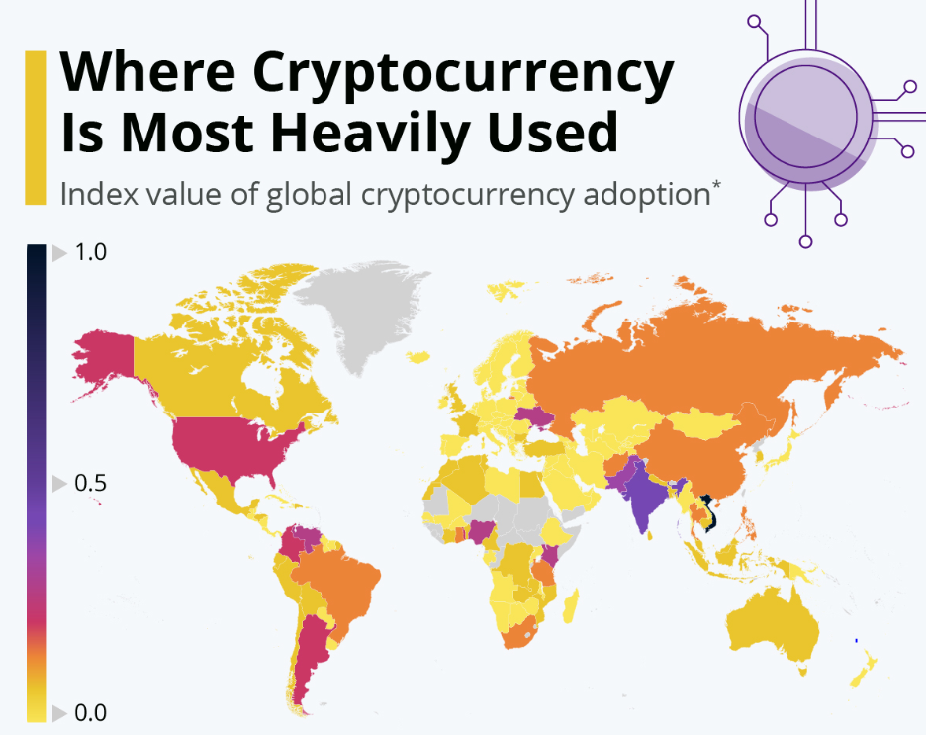
Figure 1: Worldwide usages of cryptocurrency
(Source: statista.com, 2022)
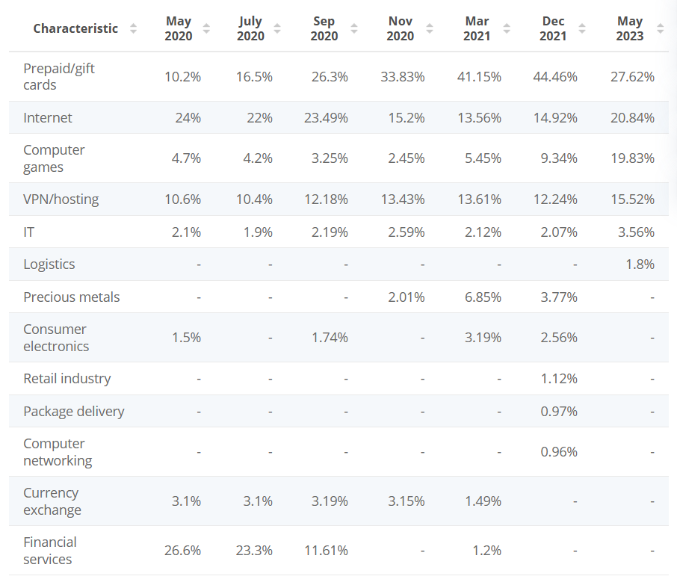
Figure 2: Cryptocurrency transaction distribution based on industry via Bitpay, 2020-2023
(Source: statista.com, 2024)
The above first figure depicts that cryptocurrency has been widely accepted in the English speaking developed countries. Along with this, it is also quite effectively seen within developing countries such as India, China as one of the most explicit users (statista.com, 2022). Simultaneously, Vietnam has been reported as using cryptocurrency vastly along with Turkey, Venezuela and Argentina as a form of higher incentive within the companies. However, from the second figure, it has been understood that every industry has been quite efficiently developing the cryptocurrency payments via Bitpay. Hence, the number goes at least a 5% hike in every sector. As per the opinion of Bennani and Arpaci (2022), the personal innovativeness based on the “Innovation Diffusion Theory” is developing a high impact in the adaptation of cryptocurrency at the organisational level. The “Hofstede cultural dimensions” are also helpful in this case in developing assessment and benefits towards long term goal and individual orientation.

Research aim
Thus, the study aims to highlight how culture is influencing the adoption of cryptocurrency in remuneration purposes

Research objectives
To evaluate cultural factors and societal values influencing trusts and sense of security related to cryptocurrency in remuneration
To investigate the cultural barriers in the adaptation of cryptocurrency in remuneration
To recommend implementation of cryptocurrency in remuneration process through successful navigation of the organisational cultural challenges

Research questions
What are the cultural factors and societal values influencing trusts and sense of security related to cryptocurrency in remuneration?
What are the cultural barriers in the adaptation of cryptocurrency in remuneration?
How is the implementation of cryptocurrency in the remuneration process through successful navigation of the organisational cultural challenges?

Preliminary literature search

Social and cultural factors influencing cryptocurrency adoption in remuneration
Electronic cash or more specifically digital currency was introduced in the year 2017. It was widely accepted within the market through the property of “market push”. Monetary transaction based on the cryptocurrency is totally based on the distributed technology as its aligning aspects. As per the opinion of Saleh et al. (2020), consumer and employee satisfaction are the main pillars of adapting cryptocurrency within the market. Along with this, it has also been seen that “social influence (SI), transparency (TR), price value (PV), traceability (TRA), and attitude (AT)” plays a huge role in the adaptation of crypto within any particular business. The social influence, price value along with transparency are directly related towards cryptocurrency adaptation within the business simultaneously within the remuneration purposes. Additionally, it has been stated by Chen et al. (2022), behavioural intentions are highly justified for adaptation of the cryptocurrency which is variable based on the country and its culture especially which are Islamic. Hence, emotional connectivity and perceptions which are utterly distinct on the basis of different culture and country varies the acceptance of cryptocurrency. Hence, “Technological Acceptance Model” plays a great role in developing perception and intentions of cryptocurrency adaptation. The perception of uncertainty within different communities impacts hugely on the cryptocurrency adaption.
Additionally, different societal factors such as countries' prospects, business functionalities, along with industrial demands are highly influencing in cryptocurrency adaptation. Simultaneously, “Human Development Index”, "Regulatory guidelines”, “the Network Readiness Index”, “Corruption Perception Index” are highly influential (Bhimani et al. 2022). It has also been seen that usage of cryptocurrency has been vividly dependent on the factor of economic development of the country. Technical knowledge along with the issues and impacts on the commercial prospects are highly influential for the adaptation of cryptocurrency within the business especially at the remuneration process.

Pros and cons of using cryptocurrency in remuneration system
Various international examples of diversified countries in the world regarding how they implement, use, and their economic and legal status of cryptocurrency are compared. It has unanimously defined the pros and cons of cryptocurrency use at the current level of Ukraine’s economic and technological development (Bondarenko et al. 2019). The phenomenon of cryptocurrency as the payment method and electronic money has spread to almost all countries of the world in the ‘grey’ area in the major point. But blockchain technologies, which are the bases for a cryptocurrency, have not yet reached the stage of complete development. The very first measure will be the development of its own mode of behaviour that would help reshape a properly constructed cryptocurrency market that shall be responsible for the progress of the economy in itself.
Money circulation systems were conducted; contemporary tendencies in the creation of modern payment systems identified business opportunities of digital currency; the opportunities to use electronic and virtual money were contained in modern digitization circumstances were analyzed; digital fraud opportunities were evaluated; ways to regulate the turnover of cryptographic money were uncovered. As per the opinion of Luchkin et al. (2020), by looking at the historical perspective of the development of monetary systems it is possible to say what definitive reasons indicate the cryptocurrencies and that the creation of a legal and economic system of regulation in terms of the development of the digital economy justifies their presence.
This can be possible if the amalgamation succeeds in mixing cryptocurrency together with consumer Internet-of-Things (IoT) devices with a view to ushering in new business applications in the machine-to-machine economy. Nevertheless, it has been shown by the study of Mercan et al. (2021), block chain initial designs are non-scalable and energy intensive and as such make block chain integration impractical making it difficult to see or understand how consumer devices adopt cryptocurrency. However, no offline channel payment stands so far as a second layer solution to address the scalability problem, facilitating instant payment at minimum cost. New models are applied towards semicentralized organization and operate lightweight consensus protocol in need of low-end computation power.

Theoretical analysis

Hofstede cultural dimensions
Hofstede’s cultural dimensions have been shown to have a number of consequences, and they can factor in the adaptation of cryptocurrency cases across many socio-cultural aspects in the conversations about the integration of the digital asset. In cultures that are more self oriented, such pressure may call for greater involvement of individuals in freedom of financial stake and high tendency to welcome the idea of cryptocurrencies (Escandon-Barbosa, et al. 2022). While on the other side, in collectivist cultures, where the individuals’ values are honored, the assumption would be a little bit slow because of the issues of sharing of responsibilities and control. Cultural beliefs on cryptocurrencies may bias their status in the social world. But in more masculine cultures where financial success is important, the curse termination of the legitimacy of cryptocurrencies could be higher.
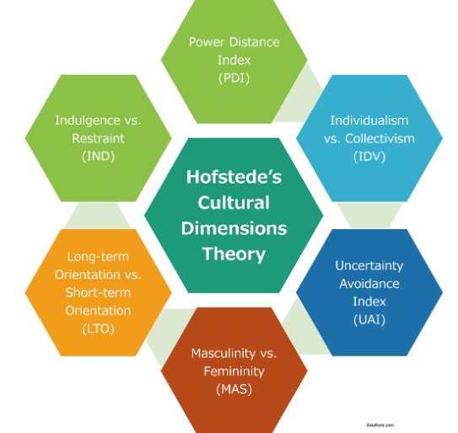
Figure 3: Hofstede cultural dimensions model
(Source: Influenced from Escandon-Barbosa, et al. 2022)

Innovation Diffusion Theory
The innovative diffusion theory of Everett Rogers states that it is the tendency of innovation, idea, product or technology to spread and be accepted by society. Flexed to the adaptation of cryptocurrencies, this theory presents deeper insights into a several-step process characterized by different factors, which are used for the cryptocurrency’s acceptance and involvement. Usually this info adoption refers to innovators and innovators that are first. It refers to entities that integrate the technology at early phases buying in the odds for long-term benefits (Ali et al. 2019). Pioneers and evangelists of the cryptocurrency bring others up to speed in the battle of its acceptance.
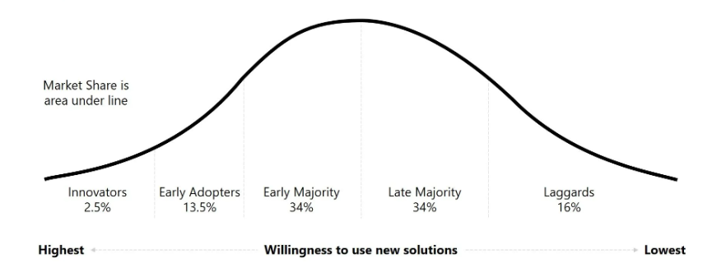
Figure 4: Innovation diffusion law
(Source: influenced from Ali et al. 2019)

Block chain theory
Blockchain technology is the basic technology of cryptocurrencies, and cryptocurrencies are the surfaces for cryptocurrencies adaptation, which is the deepest adaptation of blockchain technology. Blockchain as a technology creates a history of transactions which are transparent and traceable (Sheel and Nath, 2019). This transparency can lead to an improved level of both accountability and conviction in financial transactions. Blockchain is a system that can be transparent and that could appeal for both individuals and the organization in the cases where transparency is the top priority. By removing any kind of intermediary and automating trust that is present in this blockchain technology, the transaction costs, among others, are reduced, thus making cryptocurrencies to become more preferable to the users.
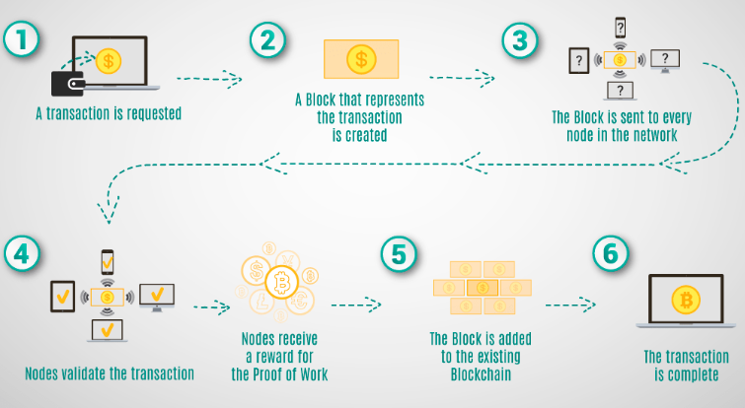
Figure 5: Block chain parameters in cryptocurrency
(Source: influenced from Sheel and Nath, 2019)

Research methodology

Research onion
The “research onion” is an established conceptual model which effectively describes several layers of a research process. The propounder Saunders has demonstrated a comprehensive framework in order to properly design a research method (Saunders et al. 2019). It is very much helpful in conducting a most successful research process. The interconnectedness within the layers of the research onion shows a varied functionality and decision making process within a particular study. It provides particular views based on the adaptation of research philosophy, approach, research designs and its additional techniques in order to develop the most influential findings for the study.

Figure 6: Research Onion
(Source: Inspired by Saunders et al. 2019)

Research philosophy
Selecting the most appropriate research philosophy is very much effective for a particular study in order to provide a systematic way to the research (Sun et al. 2020). Interpretivism research philosophy will be adapted to this particular research in order to find out most definite answers in the realm of the study. Interpretivism particularly focuses on the subjective norms of the study which will be beneficial for answering the influence of the adaptation of cryptocurrency in particular. Its diverse perspective and notion of accepting contextual facts will not only help to identify the influence but it will be helpful for identifying the barriers of cryptocurrency adaptation vastly within the remuneration purposes.

Research approach
Research approach in a particular research is helpful in drafting strategies for investigation within a dissertation. It is widely effective in developing the idea of research mode. The deductive research approach will be selected for this current study in order to collect data most effectively followed by developing a research theory which will be very much helpful for understanding the cultural influences for adapting cryptocurrency for remuneration purposes. Deductive approach of research will be effective in this case because the study needed hypothesis confirmation studying the specific notion of influence towards the adoption process and cultural facts that would be effective in addressing specifically in later (Baştuğ et al. 2020).
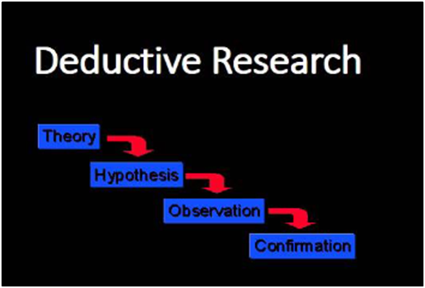

Figure 7: Deductive research approach
(Source: influenced from Baştuğ et al. 2020)

Research method
The secondary qualitative research method would be adapted for the particular study in order to find out different cultural notions of cryptocurrency adaptation for remuneration purposes. The secondary mode will be helpful for the varied search despite the cross border aspect in understanding the barriers and influences. Along with this, the intentions to understand and depict the true sense of the cultural concept behind cryptocurrency adaptation can be greatly elaborated with the help of qualitative study. This type of research method is also very much effective based on the “cost effective mode of analysis” for the present study.

Data collection
Secondary data will be collected on the basis of “country comparison tool” in the context of Hofstede’s cultural dimension model. Already existing data bases such as statista and governmental websites to find out the cultural differences in the realm of adaptation of cyptocurrency especially in the remuneration purposes. Along with that, Hofstede’s indulgence within the cultures of different nations would be the prime concern of the data collection. Hofstede’s country comparison tool will be highly effective in order to find out the perception of risks for having long term valuation would be considered in the study after selecting several countries. In order to analyse cultural orientation for the future perspective of cryptocurrency in the countries for the long term success in the remuneration purposes. The data that will be collected from governmental websites about adaption of different country for cryptocurrency will be compared on the basis of Hofstede’s country comparison tool.

Rationale
The study has been taken over in order to understand the cultural notion and background of the different countries based on the most advanced financial aspects of the current situation. Developing understanding based on the cognition of interplay between the emerging paradigm of digital finance and cultural factors provides multifaceted reflection of understanding of trust dimensions, risk identification and perceptions, and cultural factors of developing understanding behind that. Along with this, as remuneration involves employee motivation and retention practices, it will be highly intriguing finding the true properties of employee preferences and perceptions towards the cryptocurrency remuneration process.

Data analysis
Thematic mode of data analysis will be done in the particular research. This is a widely accepted form in developing a flexible approach of analysing qualitative data. Thematic analysis is very much helpful in delivering in depth analysis of the cultural facts that are hindering the cryptocurrency adaptation or influencing in the same. Along with this, the identification of the gaps and overarching the core components of the research can be particularly found with the help of this technique only (Kiger and Varpio, 2020). Depicting the versatility of the secondary research approach can be highly effective with the help of thematic representation of data.

Ethical consideration
The study will be conducted as per considering all the norms and regulations as per university guidelines. Thus, all the data that will be gathered, will be used purely for the purpose of study. There will be no intentions of harming any sentiments and beliefs (Smith et al. 2021). Maintaining data privacy and protocols are the top most priority conducting the research. The “Intellectual Property Rights” will be maintained throughout the study. All the data that will be gathered will be secured in the password protected files so that anonymity can be maintained. Exaggeration of the data and findings in order to meet the current objective of the study is strictly prohibited. Also, no manipulation of the data will be entertained. “Data protection Act, 2018” will be taken into account throughout the study.

Potential Risks
- Finding particular aim and research objectives
- Time management
- Developing most appropriate research method
- Data collection and appropriate representation of the data
- Proper presentation of the data report

Timeline (Gantt chart)
Tasks undertaken | Week 1 | Week 2 | Week 3 | Week 4 | Week 5 | Week 6 | Week 7 | Week 8 | Week 9 | Week 10
Selection of the topic
Develping research aim and definition
making background of the project
Outline research objectives
Literature review
Methodology
Data collection
Data analysis
Conclusion
Final submission

Findings
Developing understanding based on the cultural domains on emerging concepts of cryptocurrency within the remuneration are highly impactful. As per the study of Nadeem et al. (2021), using cryptocurrency in a mode of electronic transformation has a huge impact of maintaining cross border usage, speedy transaction, maintaining anonymity and security have the highest impact in developing intentions using bitcoin. It has also been seen that cryptocurrency has usage in business and is highly effective in developing economic awareness within the community. The bondage within the cultural functionality has been seen that security measures that are adapted not to use cryptocurrency provides indefinite aspects of using it. On the other hand, Arias-Oliva et al. (2019) have suggested that about 85% people from Spain have developed the intentions of using cryptocurrency as their daily exchange method. Information regarding this has also been gathered that people prefer it in the business ecosystem as well. Enhanced perception of client and consumer satisfaction has been seen within the business in Spain. However, the risk of cryptocurrency are considered as liabilities within the market along with this the fruitful precondition management is also very much important in order to develop more adaptation towards this. Hence, it has been suggested that education of the internet while using cryptocurrency can be more beneficial for the entire upcoming generation within the country. On the contrary, as per the narration of Almajali et al. (2022), in Jordan, attitude towards adaptation of cryptocurrency has been very much influential for the usage. Cryptocurrency perseverance in Jordan has been seen highly significant in the realm of its usefulness and perceived influence. It has been suggested that financial losses are not highly dependent in terms of risk assessment for the business. Along with this, technological enhancement within the country has been more acceptable in terms of using the Cryptocurrency within the business especially for the remuneration purposes. However, behavioural intentions are played as the most important component in order to use the cryptocurrency. Trust in the usage of cryptocurrency has seen massive effect in implementing cryptocurrency for remuneration purposes.

Conclusion
Hence, as per conclusion, it can be stated that multifaceted reflection of the understanding of trust dimensions, risk identification and perceptions, and cultural factors of developing understanding behind cryptocurrency adaptation can be very fascinating. This can be obtained by developing understanding based on the cognition of the interaction between the emerging paradigm of digital finance and cultural factors. Preliminary studies have shown that there are re;evance of employee perception and trust with cryptocurrency adaptation at the workplace. With the help of a secondary qualitative research method it will be most effective to find out vivid potential of the cultural factors towards the adaptation. It will also be quite interesting to discover the genuine characteristics of employee preferences and perceptions regarding the cryptocurrency remuneration process, since remuneration impacts employee incentive and retention strategies.

References
Abraham, J., Sutiksno, D.U., Kurniasih, N. and Warokka, A., 2019. Acceptance and penetration of bitcoin: The role of psychological distance and national culture. SAGE Open, 9(3), p.2158244019865813.
Ali, M., Raza, S.A., Puah, C.H. and Amin, H., 2019. Consumer acceptance toward takaful in Pakistan: An application of diffusion of innovation theory. International Journal of Emerging Markets, 14(4), pp.620-638.
Almajali, D.A., Masa’Deh, R.E. and Dahalin, Z.M., 2022. Factors influencing the adoption of Cryptocurrency in Jordan: An application of the extended TRA model. Cogent Social Sciences, 8(1), p.2103901.
Arias-Oliva, M., Pelegrín-Borondo, J. and Matías-Clavero, G., 2019. Variables influencing cryptocurrency use: a technology acceptance model in Spain. Frontiers in psychology, 10, p.475.
Baştuğ, S., Arabelen, G., Vural, C.A. and Deveci, D.A., 2020. A value chain analysis of a seaport from the perspective of Industry 4.0. International Journal of Shipping and Transport Logistics, 12(4), pp.367-397.
Bennani, K.S. and Arpaci, I., 2022. Factors influencing individual and organizational adoption of cryptocurrencies. In Cryptofinance: A New Currency for a New Economy (pp. 147-169).
Bhimani, A., Hausken, K. and Arif, S., 2022. Do national development factors affect cryptocurrency adoption?. Technological Forecasting and Social Change, 181, p.121739.
Bondarenko, O., Kichuk, O. and Antonov, A., 2019. The possibilities of using investment tools based on cryptocurrency in the development of the national economy. Baltic Journal of Economic Studies, 5(2), pp.10-17.
Chen, X., Miraz, M.H., Gazi, M.A.I., Rahaman, M.A., Habib, M.M. and Hossain, A.I., 2022. Factors affecting cryptocurrency adoption in digital business transactions: The mediating role of customer satisfaction. Technology in Society, 70, p.102059.
Escandon-Barbosa, D., Ramirez, A. and Salas-Paramo, J., 2022. The effect of cultural orientations on country innovation performance: hofstede cultural dimensions revisited?. Sustainability, 14(10), p.5851.
Kiger, M.E. and Varpio, L., 2020. Thematic analysis of qualitative data: AMEE Guide No. 131. Medical teacher, 42(8), pp.846-854.
Luchkin, A.G., Lukasheva, O.L., Novikova, N.E., Melnikov, V.A., Zyatkova, A.V. and Yarotskaya, E.V., 2020, August. Cryptocurrencies in the global financial system: problems and ways to overcome them. In Russian Conference on Digital Economy and Knowledge Management (RuDEcK 2020) (pp. 423-430). Atlantis Press.
Mercan, S., Kurt, A., Akkaya, K. and Erdin, E., 2021. Cryptocurrency solutions to enable micropayments in consumer IoT. IEEE Consumer Electronics Magazine, 11(2), pp.97-103.
Nadeem, M.A., Liu, Z., Pitafi, A.H., Younis, A. and Xu, Y., 2021. Investigating the adoption factors of cryptocurrencies—a case of bitcoin: empirical evidence from China. SAGE open, 11(1), p.2158244021998704.
Saleh, A.H.A.I., Ibrahim, A.A., Noordin, M.F. and Mohadis, H.M., 2020. Factors influencing adoption of cryptocurrency-based transaction from an Islamic perspective. Global Journal of Computer Science and Technology, 20(4), pp.1-13.
Saunders, M.N., Lewis, P., Thornhill, A. and Bristow, A., 2019. Understanding research philosophy and approaches to theory development.
Sheel, A. and Nath, V., 2019. Effect of blockchain technology adoption on supply chain adaptability, agility, alignment and performance. Management Research Review, 42(12), pp.1353-1374.
Smith, J., Blevins, B., Werse, N.R. and Talbert, S., 2021. Researcher positionality in the dissertation in practice. In Practice-based and practice-led research for dissertation development (pp. 43-63). IGI Global.
Statista.com, (2022), Where Cryptocurrency Is Most Heavily Used, Available at: Chart: Where Cryptocurrency Is Most Heavily Used | Statista, [Accessed on:01.02.2024]
Statista.com, (2024), Distribution of cryptocurrency transactions processed via BitPay from 2020 to 2023, by industry, Available at: BitPay: payment volume, by industry 2023 | Statista, [Accessed on:01.02.2024]
Sun, Y., Fu, Z., Bo, Q., Mao, Z., Ma, X. and Wang, C., 2020. The reliability and validity of PHQ-9 in patients with major depressive disorder in psychiatric hospital. BMC psychiatry, 20, pp.1-7.

