

Changemakers: Creativity and Value Creation
Professions (BMHP5014)

Component 1: Online portfolio of set exercises

Student name: Musa Bamwine
Student number: 2425291
Lecturer’s name: Brian Mashumba

TABLE OF CONTENT

Creativity, Innovation, Value Creation and Change in Health and Social Care 4
Innovation 4
Creativity 4
Value Creation 4
Change 5
Central problem: Staff burnout in health and social care 5
Self-Reflection of Group Activity 6
Case Study Analysis of a UK Innovation 7
NHS Virtual Wards 7
Research Task: Staff Burnout 8
Exploring Digital Innovation in Health and Social Care 9
1. Wearable Health Technologies 9
2. Electronic Health Records 9
3. Digital Technology for Preventative Care and Health Promotion 10
Task 7 – Understanding the NHS Leadership Framework 10
NHS Healthcare Leadership Model 10
Leadership Behaviour: Inspiring Shared Purpose 11
Reflective Journal 11
Task 8 – Self-Reflection Journal Entry 12
Reference List 13

Creativity, Innovation, Value Creation and Change in Health and Social Care

Innovation
Innovation is the process of introducing and implementing new or improved ideas, products, services or processes that create beneficial changes. Rogers (2003) explains innovation through the Diffusion of Innovations Theory, which describes how new ideas are communicated and gradually adopted within organisations. Innovation is important in health and social care because services must respond to changing patient needs, increasing demand and limited resources. For example, NHS virtual wards use remote monitoring technology to provide hospital-level care in patients’ homes, helping reduce pressure on hospital beds.

Creativity
Creativity refers to generating ideas that are both novel and useful. Amabile’s (1996) Componential Theory of Creativity suggests that creativity develops through the interaction of relevant knowledge, creative-thinking skills, motivation and the surrounding environment. Creativity is important because health and social care professionals frequently need to find alternative ways of solving problems. For example, a care worker may creatively adapt communication methods, such as using pictures or simplified instructions, to support a service user with communication difficulties.

Value Creation
Value creation refers to producing benefits that are meaningful to service users while making effective use of available resources. Porter (2010) argues that healthcare value should focus on health outcomes achieved relative to the cost of providing care. This is particularly important because health and social care organisations have finite budgets but must maintain safe, high-quality and person-centred services. For example, preventing hospital admission through effective community support can create value by improving a person’s quality of life while reducing avoidable hospital costs.

Change
Change involves moving from an existing way of working towards a different practice, process or behaviour. Lewin’s Change Management Model describes change through three stages: unfreezing existing practices, implementing new behaviours and refreezing the improvement (Burnes, 2017). Change is essential because health and social care must continually respond to new evidence, technologies, legislation and population needs. For example, introducing electronic records requires staff to change established documentation practices and develop new digital skills.

Central problem: Staff burnout in health and social care
Mind-map structure to place into the Word template:
STAFF BURNOUT → Causes: staff shortages → excessive workload → long hours → emotional demands → insufficient recovery time
→ Impacts on staff: exhaustion → reduced motivation → sickness absence → staff turnover
→ Impacts on service users: reduced quality of interaction → increased risk of mistakes → less person-centred care
→ Impacts on organisations: recruitment costs → staffing pressures → reduced productivity
→ Possible solutions: workforce planning → supportive leadership → flexible working → staff wellbeing support → adequate breaks → involving staff in decisions
→ Overall connection: staffing pressures increase workload → workload increases stress → burnout affects staff wellbeing → reduced capacity can further increase pressure.
SELF BURN OUT ILLUSTRATION

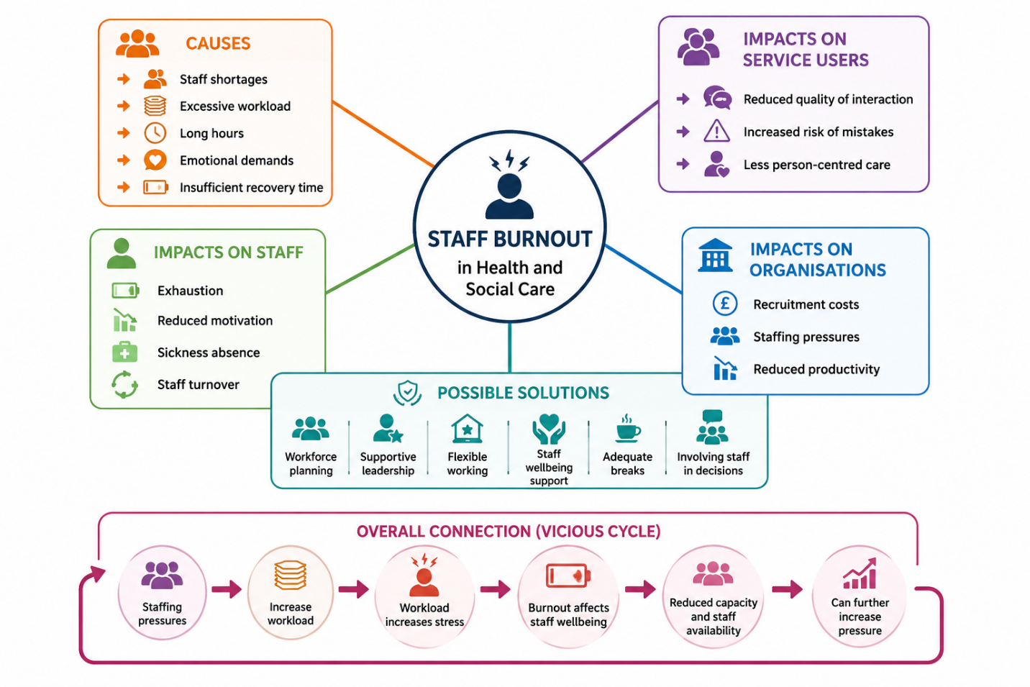

Staff burnout is a significant health and social care problem because prolonged occupational stress can affect workers and the quality and safety of care. Research has identified burnout as involving emotional exhaustion, depersonalisation and reduced personal accomplishment (Ghahramani et al., 2021). A systems-thinking approach recognises that burnout is not caused by one individual factor but by interconnected organisational and workforce pressures (Meadows, 2008).

Self-Reflection of Group Activity
I used Gibbs’ Reflective Cycle (1988) to reflect on the convergent and divergent thinking activity. Divergent thinking involves generating several possible ideas, whereas convergent thinking involves evaluating and narrowing these ideas towards an appropriate solution. Gibbs’ model considers description, feelings, evaluation, analysis, conclusion and an action plan (Gibbs, 1988).
During the activity, my group initially used divergent thinking by suggesting several possible solutions without immediately judging them. I found this stage comfortable because I could contribute ideas freely and build on suggestions made by other group members. However, when we had to choose the strongest idea, convergent thinking became more difficult because different group members preferred different options. I contributed by comparing the advantages and disadvantages of the suggestions and encouraging the group to consider which option would have the greatest practical benefit.
The activity helped me recognise that creativity is not only about producing ideas. It also requires communication, listening and the ability to evaluate ideas constructively. I learned that I naturally prefer generating ideas, but I need to become more confident when making final decisions. Next time, I would introduce clear criteria, such as cost, feasibility and impact on service users, earlier in the discussion to help the group reach a decision more efficiently.

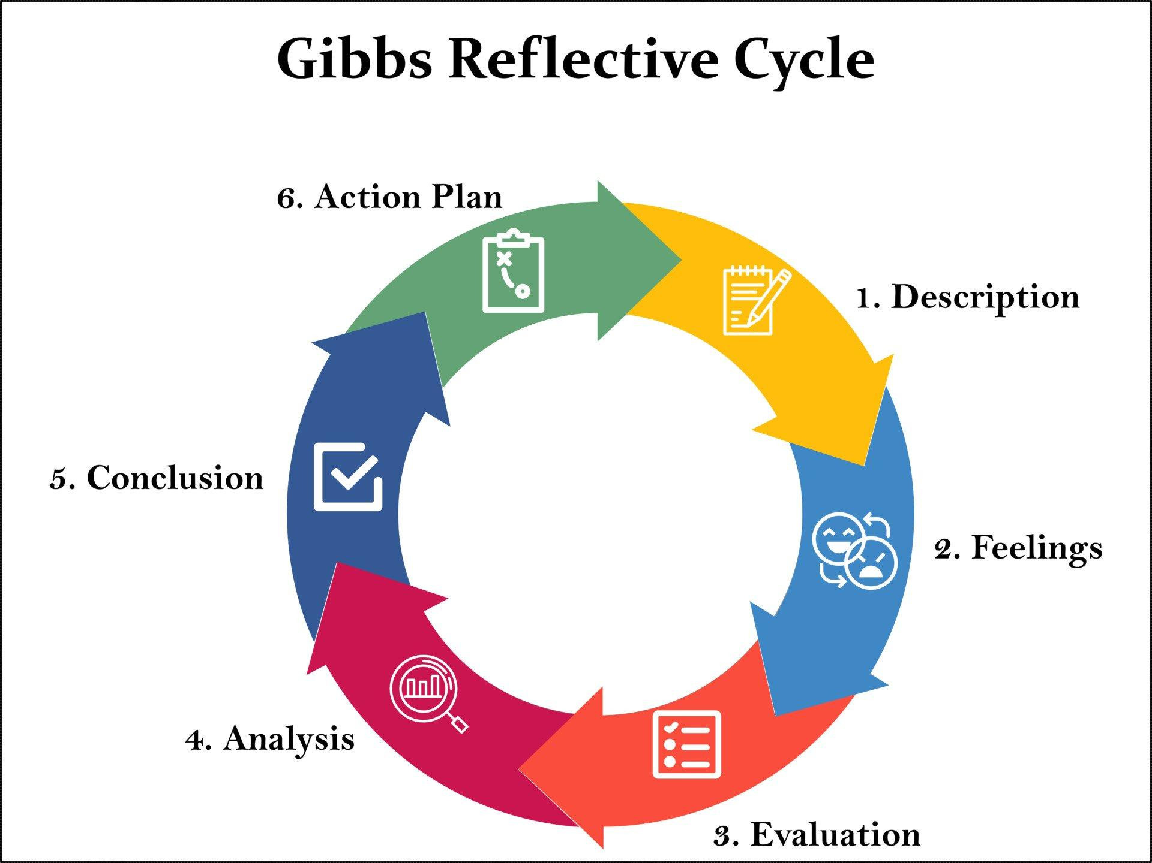

Figure 3: Gibbs’ Reflective Cycle (Gibbs, 1988).

Case Study Analysis of a UK Innovation

NHS Virtual Wards
NHS virtual wards are an example of innovation developed to address pressure on hospital capacity while enabling appropriate patients to receive care closer to home. Virtual wards, also known as hospital-at-home services, allow patients to receive hospital-level care without remaining in a hospital bed (NHS England, 2024).
Creativity was important because healthcare professionals moved beyond the traditional assumption that hospital-level care must always take place inside a hospital. Digital monitoring devices can allow clinicians to observe relevant patient information remotely and intervene when necessary. This can provide patients with greater comfort and convenience while maintaining clinical oversight.
Innovation can create value for service users through greater choice and the opportunity to recover in familiar surroundings. It can also create value for the NHS by potentially reducing avoidable admissions and releasing hospital capacity. NHS England reported that approximately 9,000 hospital admissions had been avoided in the South East through virtual wards over a year, demonstrating their potential contribution to reducing pressure on acute services.
Rogers’ (2003) Diffusion of Innovations Theory is relevant because successful adoption depends on how healthcare professionals perceive the innovation’s usefulness, compatibility and practical advantages. Virtual wards could be expanded elsewhere where appropriate infrastructure, staffing and patient suitability are available.

Research Task: Staff Burnout
Staff burnout is an important contemporary issue because health and social care workers operate in emotionally demanding environments where sustained pressure can affect wellbeing and care quality. Ghahramani et al. (2021) conducted a systematic review and meta-analysis involving healthcare workers during COVID-19 and found a pooled burnout prevalence of 52%. The research highlights how demanding working conditions and exposure to intense clinical pressures can contribute to emotional exhaustion and reduced professional wellbeing.
Alanazy and Alruwaili (2023) examined burnout among emergency department healthcare workers and identified multiple associated factors. Their findings demonstrate that burnout is influenced by both occupational demands and wider organisational circumstances, rather than being simply an individual weakness. Emergency departments can involve unpredictable workloads, time pressure and frequent exposure to critically ill patients.
The two articles therefore agree that burnout is a complex occupational problem influenced by working conditions. However, Ghahramani et al. (2021) focus more broadly on healthcare workers during a major system-wide crisis, whereas Alanazy and Alruwaili (2023) concentrate specifically on emergency department staff. Maslach and Jackson’s burnout framework is relevant because it conceptualises burnout through emotional exhaustion, depersonalisation and reduced personal accomplishment. Together, the studies demonstrate why health and social care organisations need to consider workload, working environments and organisational support when addressing burnout.

Exploring Digital Innovation in Health and Social Care

1. Wearable Health Technologies
Wearable health technologies, including smartwatches and activity trackers, can support people living with chronic health conditions by collecting health information continuously. Devices may monitor measures such as heart rate, physical activity and sleep, allowing individuals to recognise changes in their health and become more involved in self-management. Mattison et al. (2022) found that wearables provide patient-centred health information in real time and may support chronic disease self-management.
For example, a person with cardiovascular disease could use a wearable device to monitor activity and heart rate and share relevant information with healthcare professionals. This could encourage adherence to healthy behaviours and support earlier recognition of concerning changes. However, accuracy, digital literacy and access to devices must be considered. The Technology Acceptance Model suggests that people are more likely to adopt technology when they perceive it as useful and easy to use (Davis, 1989).

2. Electronic Health Records
Electronic Health Records (EHRs) improve communication by allowing authorised healthcare professionals to access and update patient information digitally. Instead of relying on separate paper records, professionals across different services can use shared information to understand a patient’s medical history, treatment and current needs. This can support collaboration between GPs, nurses, hospitals and other professionals.
Interoperability is particularly important because information needs to move between different organisations and systems. A systematic review by Li et al. (2022) found evidence that EHR interoperability can improve patient safety and quality of care, although the effects varied between studies.
For example, when a patient moves from hospital to community care, accurate electronic information can help the community team understand medication changes and follow-up requirements. The Technology Acceptance Model (Davis, 1989) remains relevant because successful implementation depends partly on whether staff perceive EHR systems as useful and manageable.

3. Digital Technology for Preventative Care and Health Promotion
Digital technology can support preventative care by helping people monitor health behaviours, access reliable information and receive reminders about screening, appointments or healthy lifestyle choices. Digital health promotion includes a wide range of interventions designed to encourage healthier behaviours and prevent illness (Margariti et al., 2023).
For example, a health service could use a mobile application to remind eligible users about NHS screening appointments and provide personalised information about physical activity, smoking cessation and healthy eating. This could encourage people to take action before health problems become more serious.
The Technology Acceptance Model (Davis, 1989) suggests that preventative technologies are more likely to be used when people believe they are useful and easy to operate. However, digital exclusion must be considered because people without suitable devices, internet access or digital skills may not benefit equally. Therefore, digital prevention should complement rather than completely replace non-digital services.

Task 7 – Understanding the NHS Leadership Framework

NHS Healthcare Leadership Model
The NHS Healthcare Leadership Model is designed to support leadership development by helping people understand and improve their leadership behaviours. It is relevant to both clinical and non-clinical staff and consists of nine dimensions: inspiring shared purpose, leading with care, evaluating information, connecting our service, sharing the vision, engaging the team, holding to account, developing capability and influencing for results (NHS Leadership Academy, 2026).
The framework is important because leadership behaviours can influence workplace culture, staff relationships and the quality of care provided to patients and service users. It does not only apply to people with formal management positions; leadership can be demonstrated by staff at different levels of an organisation. For example, a healthcare professional who identifies a problem and encourages colleagues to test a new approach is demonstrating leadership through improvement and collaboration.

Leadership Behaviour: Inspiring Shared Purpose
The behaviour I would focus on is inspiring shared purpose. This involves connecting staff with the values and purpose of the organisation and encouraging them to think about how services can be improved for patients. A leader could use this behaviour to encourage creativity by creating an environment where staff feel that their ideas are valued. For example, if staff identify delays in a service, a leader could invite the team to generate different solutions and then collaboratively test the most feasible idea. Transformational leadership similarly suggests that leaders can motivate employees through vision, encouragement and support (Bass and Avolio, 1994). This approach could increase staff engagement while keeping improvements focused on patient outcomes.

Reflective Journal
Using Kolb’s (1984) Experiential Learning Cycle, I have developed my understanding of creativity and value creation through the module’s practical activities. Initially, I viewed creativity mainly as producing original ideas. However, activities involving divergent and convergent thinking showed me that creativity also involves developing, evaluating and applying ideas to real problems. I now understand that an idea is not necessarily valuable simply because it is innovative; it must improve outcomes or experiences for service users.
This has changed how I think about future professional practice. I would be more willing to contribute ideas when identifying problems, but I would also consider feasibility, resources and measurable benefits before supporting an innovation. Kolb’s model links experience, reflection, conceptual learning and future experimentation, which reflects how the module has developed my thinking (Kolb, 1984).

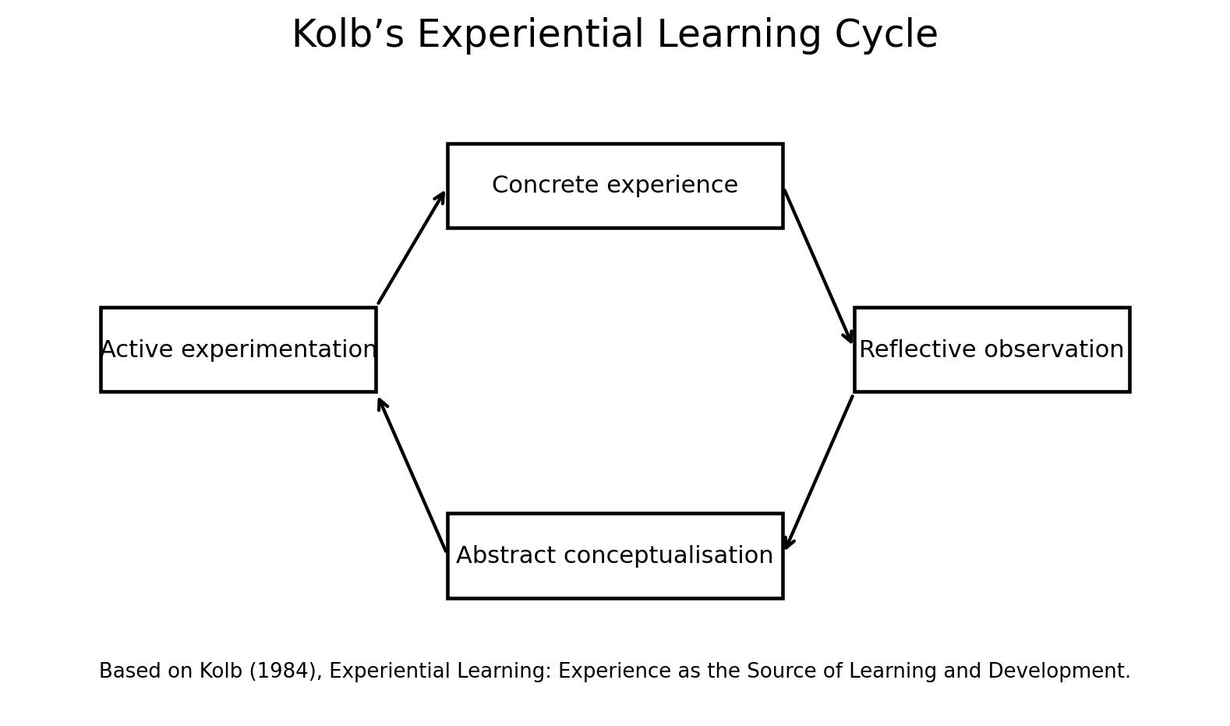

Figure 4: Kolb’s Experiential Learning Cycle (Kolb, 1984).

Task 8 – Self-Reflection Journal Entry
Using Gibbs’ Reflective Cycle (1988), I have reflected on how my understanding of creativity, innovation and value creation developed throughout this module. Previously, I mainly associated creativity with artistic or highly original ideas. The divergent and convergent thinking activity changed this perspective because I learned that creativity can be used systematically to solve practical health and social care problems.
The concept of value creation also influenced my thinking. I now understand that an innovative idea should not be considered successful simply because it is new. It should create meaningful benefits for service users, staff or the wider care system. Porter’s (2010) emphasis on outcomes relative to resources helped me understand this distinction.
In my future professional role, I would apply this learning by questioning existing practices and considering whether improvements could make services more effective, accessible and person-centred. I will carry forward the principle that creativity should lead to purposeful innovation and measurable value rather than change for its own sake.

Reference List
Alanazy, A.R.M. and Alruwaili, A. (2023) ‘The global prevalence and associated factors of burnout among emergency department healthcare workers and the impact of the COVID-19 pandemic: a systematic review and meta-analysis’, Healthcare, 11(15), p.2220.
Amabile, T.M. (1996) Creativity in Context. Boulder, CO: Westview Press.
Bass, B.M. and Avolio, B.J. (1994) Improving Organizational Effectiveness Through Transformational Leadership. Thousand Oaks, CA: Sage.
Burnes, B. (2017) Managing Change. 7th edn. Harlow: Pearson.
Davis, F.D. (1989) ‘Perceived usefulness, perceived ease of use, and user acceptance of information technology’, MIS Quarterly, 13(3), pp.319–340.
Ghahramani, S., Lankarani, K.B., Yousefi, M., Heydari, K., Shahabi, S. and Azmand, S. (2021) ‘A systematic review and meta-analysis of burnout among healthcare workers during COVID-19’, Frontiers in Psychiatry, 12, p.758849.
Gibbs, G. (1988) Learning by Doing: A Guide to Teaching and Learning Methods. Oxford: Further Education Unit.
Kolb, D.A. (1984) Experiential Learning: Experience as the Source of Learning and Development. Englewood Cliffs, NJ: Prentice Hall.
Li, E., Clarke, J., Ashrafian, H., Darzi, A. and others (2022) ‘The impact of electronic health record interoperability on safety and quality of care in high-income countries: systematic review’, Journal of Medical Internet Research, 24(9), e38144.
Margariti, A., Stathopoulou, A., Koulouvari, A.-D., Sakellari, E. and Lagiou, A. (2023) ‘Digital health and health promotion: a scoping review of systematic reviews’, Studies in Health Technology and Informatics.
Mattison, G., Canfell, O., Forrester, D., Dobbins, C., Smith, D., Töyräs, J. and Sullivan, C. (2022) ‘The influence of wearables on health care outcomes in chronic disease: systematic review’, Journal of Medical Internet Research, 24(7), e36690.
Meadows, D.H. (2008) Thinking in Systems: A Primer. White River Junction, VT: Chelsea Green Publishing.
NHS Leadership Academy (2026) Explore the Healthcare Leadership Model. Available through NHS Leadership Academy.
NHS England (2024) Virtual wards. Available through NHS England.
Porter, M.E. (2010) ‘What is value in health care?’, New England Journal of Medicine, 363(26), pp.2477–2481.
Rogers, E.M. (2003) Diffusion of Innovations. 5th edn. New York: Free Press.

