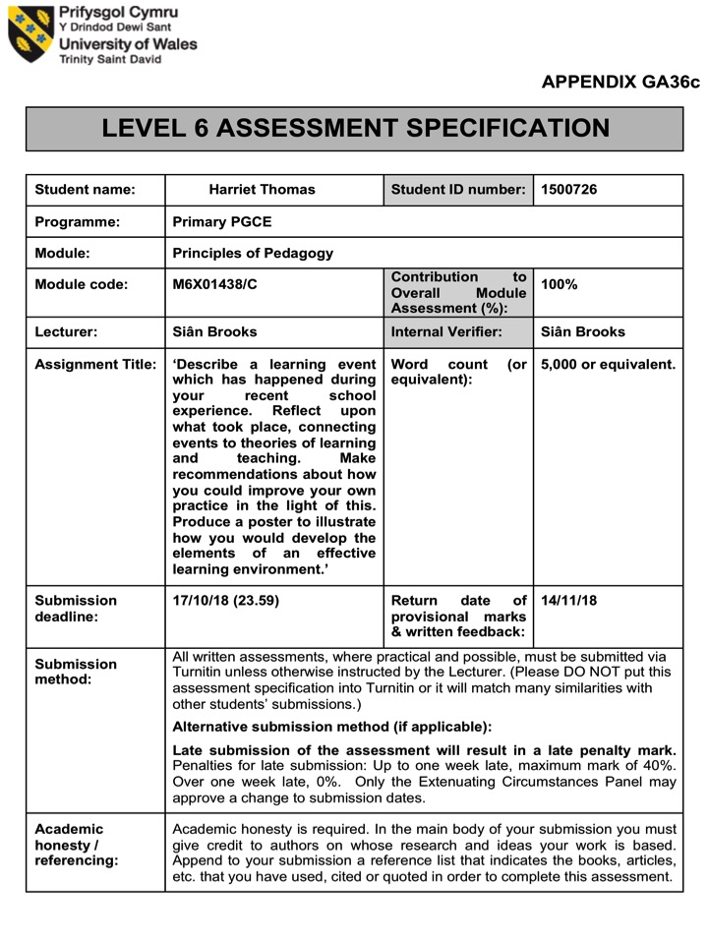

4,803

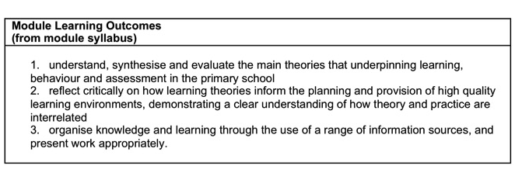

Principles of Pedagogy
The aim of this assignment is to discuss the learning event that took place during the classroom observation I carried out. I will reflect upon what took place, connecting events to theories of learning and teaching, and critically evaluate the key theories that underpin the physical, cognitive and social development of children.
Furthermore, I will apply the theoretical knowledge to practical contexts in a reflective manner, making recommendations on how I can improve my own personal teaching practice in order to support and extend children’s learning. This assignment will additionally include a digital poster illustrating how the findings of the observation allows myself as a trainee teacher to develop my own understanding of the elements of an effective learning environment.
The aim of the observation was to analyse and reflect on the outcomes of active learning within the role-play area. The observation took place in a Foundation Phase class of approximately 30 children, aged between six and seven years old, at a Primary School in a small, deprived town in South Wales. The duration of the observation was 20 minutes.
The purpose of this assignment is to highlight the importance of role-play, learning through play, and how the Foundation phase Framework encourages child-led learning, as the teacher being the facilitator to supporting and scaffolding the learning (Department for Children, Education, Lifelong Learning and Skills 2008). Within this assignment and the observation I undertook of two children, I ensured that I considered the ethical issues of confidentiality and anonymity. Confidentiality and anonymity are central to ethical research practices, within observations, reports and other forms of research. It is a researchers aim to ensure participants’ personal data is protected at all times and cannot be traced back to them (Crow and Wiles, 2008). Therefore, the children discussed within this assignment are known as Child A and Child B.

During my classroom observation, the learning experience that took place involved Child A and Child B in the role-play area during continuous provision. Within the classroom, part of the role-play area was based on the termly taught topic, which at this time was ‘Holidays’, resulting in the role-play area being a ‘Travel Agency’.
Child A acted in role as the Travel Agent and Child B was the Customer, this learning event was child-led, the teacher did not steer the activity but provided a scaffold to the learning. The teacher succeeded this by providing the children with an iPad and a QR code; at the start of the activity the children scanned the code with the iPad, which revealed a video clip for them to watch before commencing within the role-play activity. The video clip was of the class teacher sitting within the ‘Travel Agency’ facilitating the learning, the teacher acted in role of a Travel Agent by asking questions to stimulate the children’s thinking before the activity began, such as,
“What’s your favourite holiday? Where would you like to go on holiday? If you could go anywhere in the world where would it be? How much do you think holiday’s cost? What do you love doing on holiday?”
In addition, the teacher pointed out the learning resources (the toy till and money, real life holiday broachers as well as handmade ones by the teacher, price lists and question cards) available to the children within the role-play area to ensure that the children used them to benefit and extend their learning further throughout the role-play activity.
The video clip was open-ended; the teacher did not state exactly what the children were required to do or what the outcome had to be, however the teacher ensured that the children were hooked and interested, and had ownership of their learning. A hook is an essential element of enjoyment to any lesson a teacher plans; it is quick and easy without adding to the workload (Jw_teach, 2017). In my opinion, a ‘hook’ is an excellent way to clutch children’s interest and engagement within the learning, which is what the teacher did within the learning event I observed.

After the video ended, Child A sat down and said to Child B,
“Where would you like to go on holiday? I have a holiday book here for Disneyland, I love Disneyland!”

Child B replied,
“I’d love to go to Disneyland, Cinderella is my favourite!”

Child A said,
“Here look at the book, there’s Cinderella, and Mickey and Minnie Mouse!”

Child B shouted,
“Oh yay! I will go there please. How much is it please?”

Child A checks the pricelist for Disneyland and says,
”Disneyland is £20”.

Child B looks at the price list too and replies,
“No it’s not £20, that says £200, wow that’s a lot of money!”

Child A replies back,
“Yes but Disneyland is sunny and lots of fun. There’s lots of rollercoasters there too that go really fast, and a swimming pool in the hotel, which has a blue slide!”

Child B then gets the money and hands it to Child A, and says,
“I will buy the holiday to Disneyland please, and here’s £200.”

Child A replies,
“Thank you, have a nice day!”

Child A and Child B both leave the role-play area.

I selected this as a significant event for my classroom observation in relation to the module ‘Play and Active Learning in the Foundation Phase’. I chose this because I believe play within children’s learning is a crucial part to their growth and development, also play influences a child’s personality and decision-making skills, which will impact their future choices. Issacs (1929) supports this, Issacs states that play experiences allow children’s minds to grow and the nature of play supports children’s thinking and learning. It is apparent that within the observation of the role-play, the children were learning through play, by engaging in fantasy worlds and analysing the real world, Child A and Child B acted in the roles of a Travel Agent and a Customer within a real life context, possibly based on scenarios they may have already witnessed within their lives.
Furthermore, the children were also developing their thinking skills by problem solving during the activity. This was observed when Child B checked the price list in the result of Child A stating ‘£20’ instead of ‘£200’, this highlights the support between Child A and Child B during the activity, it allowed them to extend their thinking skills further as the result of solving the problem that occurred within the role-play. Vygotsky’s ‘The More Knowledgeable Other (MKO) Theory’ underpins this. Vygotsky claimed that social interaction between children is a fundamental role in the process of their cognitive development (David, 2014). The MKO theory is apparent within this part of the observation, revealing that Child B, in this case was the More Knowledgeable Other. This theory supports the observation of that Child B possibly has greater knowledge of number formations or understanding of the value of money, therefore guided Child A in correcting their slight mistake during the activity.
Moreover, play also encourages children to develop their imaginative skills and to discover possibilities. Imaginative play is when a child uses their imagination to role-play scenarios they have seen, experienced or would like to experience (Persil, 2018). This is apparent within the learning event I observed, where Child A discussed Disneyland with Child B.
Child A, “Yes but Disneyland is sunny and lots of fun. There’s lots of rollercoasters there too that go really fast, and a swimming pool in the hotel, which has a blue slide!”
It is apparent that Child A used their imagination to explain their idea of Disneyland to Child B, whether it be that Child A has already seen and experienced Disneyland for themselves or has thought about the possibility and would like to experience it. Either way, Child A’s imagination encouraged the use of persuasive and descriptive language to influence Child B’s decision. Goddard Blythe (2011) states, that this imaginative play is how children begin to develop problem-solving skills, discovering new possibilities, new ways of seeing and being, which promote important faculties in critical thinking that will help children throughout their lives. This justifies my reasoning for wanting to observe this specific learning event, relating to the module of play and active learning, highlighting the importance of play within children’s learning and development.
Additionally, when carrying out the classroom observation, I had to consider what method and specific tools I needed to ensure that I could capture the learning event the best way that I could. I decided to undertake a written observation as that is what I believed would have optimum results. Bacon and Ridgway (2014) highlight the advantages and disadvantages of my method of choice. There is much strength to my selected approach; written observations, also known as narrative observations, allow the observer to record a considerable amount of detail during an observation, this method provides in-depth information about the learning behaviours that occur, when they occur and in what context during the observation, therefore benefiting the observer when reading it back at a later date. Also, a written record provides the observer with the ability to focus on a sequence of events throughout the lesson or activity that is being recognised.
On the other hand, there are many limitations to written observations, this approach can be time consuming and only be suitable when observing one or two children, this method does not work well when observing groups of children. In addition, when carrying out a written observation the observer must keep themselves apart from the children, this can deem difficult if the children have a relationship with the observer, as they are likely to want to interact.
In my opinion, the approach I decided to use within the classroom observation was the most appropriate, in contrast to other methods such as checklists and time samples. The written approach allowed myself to observe and record the learning event in detail, and to make informative notes to have an in-depth knowledge of the observation when reflecting back on it.

Learning through play is now widely recognised and practiced by teachers and childcare practitioners as an essential method of learning and development for children, and a number of theorists and researchers have identified the values of imaginative or role-play as an essential contributor to the development of a child (Homan, 2016). In this part of the assignment I will further discuss the learning theories that explain and support an understanding of what went on during the observation and how this could impact on outcomes for pupils in future practice. I will also reflect on the critiques that have been made of some theories, comparing and contrasting through different perspectives.
It is important that the value of play in children’s learning is acknowledged and explained. The Welsh Government Overview Document ‘Play and Active Learning’ by the Department for Children, Education, Lifelong Learning and Skills (2008) underpins the provision of play experiences and learning within education in Wales. It is vital that there are clear aims for children’s learning through play and for it to be planned effectively in the Foundation Phase. This guidance is essential for careful planning to be undertaken in ensuring children are actively involved in their learning and result in positive outcomes for future practice. Play is an essential factor in the curriculum in Wales, which should be fun and interesting for all children; it is a teacher’s priority to facilitate well-planned opportunities for play to help promote children’s development, cognitive skills and an understanding of the world around them.
The Welsh Government Play and Active Learning Document provides guidance on how play provision can extend children’s communication skills, enables them to be creative, to investigate and explore different materials inside and outside of the classroom, and how to provide opportunities for free play to follow their own interests and ideas. Children’s learning is most effective when it arises from first-hand experiences; whether they are spontaneous or structured, children must be given time to free play without any instructions from the teacher, this allows children to discover and reach conclusions for themselves. This can be seen within the classroom observation I undertook. The continuous provision role-play activity that I observed was clearly well-planned by the teacher, the teacher provided a scaffold for the children, but the opportunity for the children to spontaneously play was apparent, which resulted in the children reflecting on past experiences, developing their problem solving skills and discovering conclusions for themselves.
There are many theories that support the understanding of what occurred during the learning event I observed. The constructivist theory is based on the observation of how individuals learn, constructivist teaching and learning is based on the belief that learning occurs when individuals are actively involved in the process of meaning and knowledge, gaining and constructing their own understanding of the world, through experiences and reflection, rather than just acquiring it (Concept to Classroom, 2004). Lev Vygotsky’s Social Constructivist Theory highlights the understanding of play and active learning within my observation. Vygotsky’s theory believed that children learn actively through hands-on experiences such as play, he believed learning is a social process, and through integration with peers children are able to understand the learning for themselves (Daniels, 2012).
It is apparent that the learning event I observed was a social learning process, the theory of Vygotsky supports how the interaction between Child A and Child B allowed them to develop their learning by working together during the play activity. His theory also states how teachers have a responsibility in providing opportunities for children to do this, providing them with challenging and educational learning experiences. The teacher within my classroom observation did this also; the teacher did this by facilitating the learning for the children, the role-play activity was not adult-led, it provided the children with a scaffold created by the teacher (QR code and Video) and the ability to then challenge themselves further within the activity (Question cards, Price lists).
Furthermore, in addition to his theory, Vygotsky discussed the ‘Zone of Proximal Development’ (ZPD). This part of his theory claims that this is the gap between what children can do with the support and help from others, and what they can do on their own. Vygotsky considered the ZPD as an essential function to children’s learning; it is the ideal learning between child and teacher or child and child, the ZPD is vital within the social learning process (Berk et al. 1995). It is with the help of the More Knowledgeable Other (MKO, as previously stated) that children are able to progressively learn, develop an understanding of new knowledge and increase their skills. The social learning process I observed highlights the connection between the ZPD and MKO and how Child A and Child B worked together within the role-play to solve the problem that occurred within the activity. It is seen within the observation that Child B possibly has greater knowledge of number formations or understanding of the value of money, therefore guided Child A in correcting and understanding their slight mathematical error.
On the other hand, another constructivist theory by Jean Piaget supports the learning process within children, however Piaget states that learning happens in stages based on biological maturation. This contradicts Vygotsky’s theory of learning being a social process. Piaget believes that the development of children stems largely from independent explorations of play and learning, which children contract knowledge of their own (Pellegrini et al. 2011). Piaget claimed that children actively learn through self-discovery, and that it is a crucial part of child development. He believed that children will only learn when they are ready and at particular stages of their life, whereas Vygotsky believed that the development of learning can be extended at any time if provided with the correct scaffolding and within the Zone of Proximal Development.
In my opinion, I believe Vygotsky’s social constructivist theory supports my observation in regards to play and active learning being a social process, compared to it being stemmed independently, as claimed by Piaget. It is apparent that the views of Vygotsky’s theory are visible within the observation I carried out; Vygotsky believes play as being ‘socio-dramatic or make-believe play’ that has three features- children create an imaginary situation, take on and act out roles, and follow a set of rules determined by those specific roles (Bodrova et al. 2015). These features are witnessed within the learning event I recognised, Child A and Child B both used their imagination to believe the role-play area as being a ‘Travel Agency’ and took on the roles of the Travel Agent and Customer and acted out in ways determined by their specific roles. Therefore, Vygotsky’s theory supports the social interaction between the children within this role-play activity enhanced their learning and provided them with the ability to extend it further based on the scaffolding and resources given by the teacher.

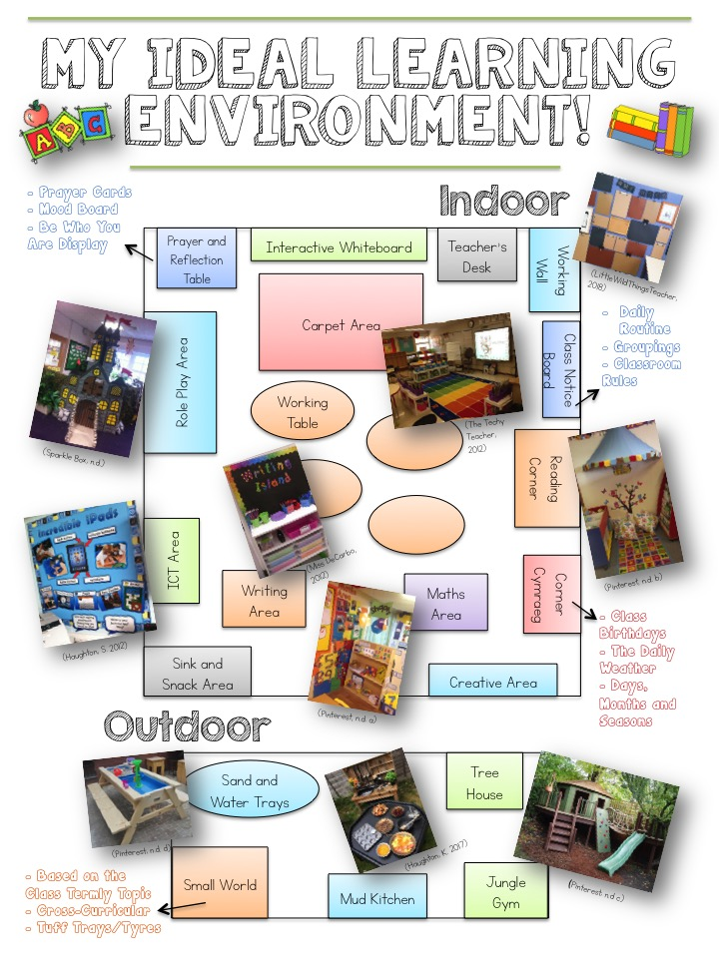

This digital poster exemplifies my ideal learning environment, considering the pedagogical principles of the teaching and learning arrangements underpinning the provision. The classroom observation I undertook and the research I have carried out justifies the decisions within my ideal learning environment. In this part of the assignment, I will discuss and explain the reasoning behind my choices, examining particular areas on the poster in-depth and why the learning event I observed influenced my findings.
A positive, thought-out, well-designed classroom is critical for effective learning. A well publicised study by The University of Salford (Prof. Barrett et al. 2015) ‘Clever Classrooms’ highlights that the classroom environment can affect children’s learning and academic progress by as much as 25%. This is why as a trainee teacher I believe it is important that all teachers aim to create their classroom’s as effective learning environments for all children. Within the creation of the digital poster, my aim was to ensure that my classroom is an eye-catching, challenging and informative learning environment, accessible to all pupils. The study by the University of Salford supports my idea of an effective learning environment, the report suggest that by putting an average ability child in an ineffective learning environment, as opposed to the most effective, could have a negative impact of their academic progress by as much as the average improvement across a year. Therefore, reviewing classroom-learning environments should be a key priority for all teachers across the education sector.
Moreover, the ideal design and look of a successful classroom environment is crucial for effective learning, Trudie Lawrence the Project Director of Envoplan strongly believes this (Envoplan, 2018). Lawrence claims that an ideal learning environment needs to withhold a balance between the teaching methods and learning styles that take place in a classroom. This pedagogical principle of combining learning and teaching help to create an environment that benefits both the children and the teacher, facilitating a much more fulfilling learning experience. This is what I aimed to achieve within the design of my ideal learning environment.
Firstly, in regards to my classroom observation, I believe that a role-play area is a vital part of an effective learning environment. The Play House (2018) highlights how the role-play area can take many different forms and serve as many purposes. Suggesting that a role-play area within a classroom feeds children’s imagination encourages empathy and is a powerful way for children to develop their social skills by interacting with their peers. Within the education sector today, teachers are encouraged to provide more opportunities for role-play, however it is apparent that this is a fear for most teachers. The time for literacy and numeracy, the dread of chaos in the classroom, and the concern of handing the learning over to the children can all make this difficult for teachers.
However, teachers need to consider the importance of child-led learning and the benefits of it, this can be seen within the learning event I observed. In addition, as seen in my digital poster, the image attached of the role-play area is an idea of what I aim to construct within my ideal learning environment. My intention is to provide imaginative and innovative stimuli within a role-play area that also provides creative opportunities for the children’s responses. I want to base my role-play area on the class termly topic to encourage all areas of learning within it and to ensure the children get the most out of the learning of the topic.
Secondly, another part of my ideal learning environment I am going to consider is the ICT area. In my opinion, within today’s society technology plays a huge part in everyday life, we live in a world consumed by technology and the role of ICT in education has become a major role in the delivery of teaching and learning within schools. Aston (2016) supports this, highlighting its importance within an effective learning environment for children. Aston reveals how widespread ICT is within the classroom today, from interactive whiteboards, class iPads, educational computer games and e-learning platforms, ICT is playing a huge role in children’s lives, so much that it has even become part of the curriculum within schools. In addition, Aston states how ICT allows children to work independently or as groups, encouraging them to explore, observe, engage, solve problems and investigate exciting discoveries for themselves, supporting them to extend the learning experience.
Likewise, this is the reason as to why in my view, technology use within a learning environment is important. Whether it be the interactive whiteboard, class iPads or computers, in my opinion ICT allows children to extend their learning further in whatever area of learning and experience, by encouraging their digital competency skills as a cross-curricular responsibility- skills such as, citizenship, interacting and collaborating, producing, and data and computational thinking (Learning Wales, 2018). It is believed that these skills will help learners thrive in an increasingly digital world.
Thirdly, a classroom Reading Corner is another aspect I have considered within my ideal learning environment. Enjoying books and reading stories from an early age is a significant role in the development of children. Reading helps children to have the ability to understand words, develop their imagination and promote speech and language skills, as well as being something they really enjoy (Early Learning Furniture, 2017). It is recognised that teachers, in addition to parents, play an important part in the development of children’s reading skills. In my opinion, the more children experience books the more interest and passion they will gain for reading. Therefore, this love of reading will also help children to develop spelling, listening, writing and social skills. This is why I acknowledge that a reading corner is essential to an effective learning environment.
As seen on my digital poster, the image I selected of my ideal reading corner is a visually appealing and stimulating area for children that aims to create an excitement for reading even before the child has chosen a book. The reading corner must have a range of interesting and age appropriate books that catch the eye of children. It is important that the books are easy accessible and easy to view for the children. In my ideal reading corner, It is my intention to have book trolleys and book spinners, which allow children to access books easily from each side, also making it a fun task for children to look for a book. Additionally, it is important that in a reading corner there is somewhere for children to sit and look at the books, I have considered colourful floor cushions, themed pillows and different shaped bean bags to make a comfortable and intriguing area for children to read within my ideal learning environment.
Lastly, the outdoor area has a huge significance in my ideal learning environment. The digital poster highlights that the outdoor area is an external shelter within the school grounds; it is an extended covered practical area for outdoor learning and play. Outdoor classrooms are an ideal solution to extend learning space, no matter what the weather, whether it be a sheltered spot in the windy or wet weather or a shaded area in the hot and sunny months, an outdoor classroom has all-round benefits, meaning that learning activities and experiences can take place outside all year round (Broad, 2016). Broad (2016) suggests that outdoor learning results in children having increased concentration and motivation, being inspired and willing to learning. The opportunity to learn and play outdoors can also potentially give children who find it difficult to concentrate and engage within learning indoors an alterative experience of learning.
Furthermore, an outdoor learning environment provides children with an opportunity for hands-on learning, such as messy and exploratory play. Within my ideal learning environment I have considered the mud kitchen and the sand and water trays to be available within the outdoor area. In my opinion, the outdoors is the best place for children to explore and get messy, it provides children with the freedom to express themselves, work together with their peers, to be hands-on with the natural world and to conduct the learning for themselves. As previously states within my observation findings, child-led learning is a key element to the Foundation Phase Framework and in my view an outdoor learning area provides children the opportunity to do so.
Moreover, I believe outdoor learning can also provide cross-curricular activities; this can be seen within my digital poster. I have included a small world area in the outdoor classroom, stating that my intention is to link the small world area to the termly topic of the class, to extend the children’s understanding of the topic further, and making it more exciting learning about it outdoors. In addition, I will acknowledge the use of tuff trays and tyres for the small world to promote children’s fine motor skills to encourage their physical development also. Learning outside the classroom supports children’s physical development, by promoting healthy and active lifestyles, offering children experiences for physical activity, freedom and movement, and supporting a sense of well-being (Council for Learning Outside the Classroom, 2010). In my view it is an important aspect for schools and teachers to promote children’s health and well-being. In my ideal learning environment, I have considered a tree house and a jungle gym to support this; the ability to play outdoors, promote all areas of development, express their imagination and interact with one another is a vital part in a child’s learning experience.

To conclude, this assignment clearly highlights the importance of play and active learning within education today, how it allows children to develop their learning, skills and experiences through child-led activities and hands-on experiences. Welsh Government documents have been put in place to provide guidance for teachers and childcare practitioners, informing them on the importance of play being open-ended, active learning for children. The documents state that adults must not steer or decide on an outcome of the learning but ensure that the children have an interest and an ownership of the activity, which will then enable them to extend their own learning further.
In addition, this assignment conveys how play is not merely for passing time within classrooms, but is the gateway for children to strengthen their bodies, challenge their minds and to develop their personalities by engaging in social situations. It is suggested that play allows children to practice and gain skills and qualities that they need now and will require in the future as adults. Children do this by discovering themselves and others, exploring different relationships and boundaries. This assignment also highlights the benefits of play, such as promoting physical development, health and well-being and developing personal, social and emotional skills.
Moreover, there are many theories regarding play and active learning for children. This assignment discusses the two many constructivist theories- Vygotsky and Piaget. It is recognised that the theory of Vygotsky supports my classroom observation and the sequence of episodes that occurred between Child A and Child B within the learning event, such as the ability to learn through a social process, unlike Piaget’s theory of individual learning through stages. Furthermore, the theory of Susan Issacs was also discussed to support the observation that was carried out; her theory highlights how in play, children’s learning and thinking grows. Play enables children to solve problems, discover possibilities, interact and socialise with other children and adults, and to have the ability to engage in fantasy worlds and analyse the real world.

Reference List

Bacon, H. Ridgway, J. (2014) Observing Learning- Learners First. Available at: www.learnersfirst.net/wp-content/.../10/SHU-Observing-Learning-October-2014.ppt (Accessed: 4 October 2018)

Berk, L.E. Winsler, A. (1995) Scaffolding Children’s Learning: Vygotsky and Early Childhood Education. Washington DC: National Association for Education of Young Children.

Bodrova, E. Leong, D.J. (2015) ‘Vygotskian and Post-Vygotskian Views on Children’s Play’, American Journal of Play, 7(3) pp. 372-376.

Broad, S. (2016) Six Ways Outdoor Classrooms Benefit Learning. Available at: https://academytoday.co.uk/Article/six-ways-outdoor-classrooms-can-benefit-learning (Accessed: 8 October 2018)

Concept to Classroom (2004) What is Constructivism? Available at: https://www.thirteen.org/edonline/concept2class/constructivism/ (Accessed: 10 October 2018)

Council for Learning Outside the Classroom (2010) Benefits for Early Years of Learning Outside the Classroom. Available at: https://www.lotc.org.uk/wp-content/uploads/2010/12/Benefits-for-Early-Years-LOtC-Final-5AUG09.pdf (Accessed: 8 October 2018)

Crow, G. Wiles, R. (2008) ‘Managing anonymity and confidentiality in social research: the case of visual data in Community research.’ ESRC National Centre for Research Methods, 8(08), pp. 3.

Daniels, H. (2012) An Introduction to Vygotsky (2nd edn). London: Routledge.
David, L. (2014) Social Development Theory (Vygotsky). Available at: https://www.learning-theories.com/vygotskys-social-learning-theory.html (Accessed: 4 October 2018)

Early Learning Furniture (2017) The Importance of Early Years Reading. Available at: https://www.earlylearningfurniture.co.uk/blog/the-importance-of-early-years-reading/ (Accessed: 7 October 2018)

Envoplan (2018) Successful Classroom Design. Available at: https://envoplan.co.uk/spaces/classrooms (Accessed: 7 October 2018)

Goddard Blythe, S. (2011) The Genius of Natural Childhood- Secrets of Thriving Children. Gloucestershire: Hawthorn Press Ltd.

Haughton, K. (2017) Mud Kitchen [Image] Available at: https://www.earlyyearsstaffroom.com/mud-kitchen/ (Accessed: 3 October 2018)

Haughton, S. (2012) iPad Display [Image] Available at: https://twitter.com/simonhaughton/status/241616004453629952 (Accessed: 3 October 2018)

Homan, E. (2016) Why Pretend Play is Important to Child Development. Available at: https://www.pentagonplay.co.uk/news-and-info/why-pretend-play-is-important-to-child-development (Accessed: 10 October 2018)

Isaacs, S. (1929) The Nursery Years – The Mind of the Child from Birth to Six. London: G Routledge & Sons Ltd.

Jw_teach (2017) Importance of the Hook. Available at: https://www.collaboroo.com/t5/Cross-Curricular-Teaching-Blog/Importance-of-the-Hook/ba-p/2399 (Accessed: 4 October 2018)
Learning Wales (2018) Digital Competence Framework. Available at: http://learning.gov.wales/docs/learningwales/publications/180620-dcf-guidance-2018-en.pdf (Accessed: 7 October 2018)

LittleWildThingsTeacher. (2018) Child Initiated Bulletin Board [Image] Available at: https://www.instagram.com/p/BiA6vuCHJoc/ (Accessed: 3 October 2018)

Miss DeCarbo (2012) Writing Centre [Image] Available at: https://www.missdecarbo.com/my-2012-2013-first-grade-classroom/ (Accessed: 3 October 2018)

Pellegrini, A.D. Nathan, P.E. (2011) The Oxford Handbook of the Development of Play. Oxford: Oxford University Press.

Persil (2018) What is Imaginative Play? 10 Ideas for the Whole Family. Available at: https://www.persil.com/uk/dirt-is-good/real-play/what-is-imaginative-play.html (Accessed: 4 October 2018)

Pinterest (n.d c) High Life Tree Houses [Image] Available at: https://www.pinterest.co.uk/pin/253960866472779327/ (Accessed: 3 October 2018)

Pinterest (n.d. a) Maths Area [Image] Available at: https://www.pinterest.co.uk/pin/253960866472779055/ (Accessed: 3 October 2018)

Pinterest (n.d. b) Reading Corner [Image] Available at: https://www.pinterest.co.uk/pin/253960866472779054/ (Accessed: 3 October 2018)
Pinterest (n.d. d) Sand and Water Bench [Image] Available at: https://www.pinterest.co.uk/pin/AaptVUHk5aWtJEqYZc85NeN2pcvvLzt5Pp8R1BvyeWt7dVz__3akvbE/ (Accessed: 3 October 2018)

Prof. Barrett, P. Dr. Zhang, Y. Dr. Davies, F. Dr. Barrett, L. (2015) Clever Classrooms Summary Report of the HEAD Project (Holistic Evidence and Design). Manchester: University of Salford.

Sparkle Box. (n.d.) Fairytale Castle Role Play Display [Image] Available at: http://www.sparklebox.co.uk/gallery/gal1351-1360/gal1351.html#.W7TS6xNKjF4 (Accessed: 3 October 2018)

The Play House (2018) The Importance of Role Play. Available at: http://theplayhouse.org.uk/climbaboard/category/early-years-play/the-importance-of-role-play/ (Accessed: 7 October 2018)

The Techy Teacher. (2012) Carpet Area, Library and SmartBoard [Image] Available at: http://tekyteach.blogspot.com/ (Accessed: 3 October 2018)

Wales: Department for Children, Education, Lifelong Learning and Skills (2008) Play/Active Learning Overview for 3 to 7 Year Olds. Cardiff: Welsh Assembly Government.

