

Marketing Fundamentals
Student Name: Maria Nastas
Student ID: 2028223

Table of Contents
Task 1 3
Blog 1: Talent and People Development 3
Blog 2: Helping our Customers to Recycle Flexible Plastics 4
Blog 3: Helping Customers to Make Healthy Choices 6
Blog 4: Sainsbury’s Partners with Neighbourly to Donate Surplus food to Local Communities 6
Blog 5: Our Approach to Defining Healthy Choices 8
Blog 6: Accelerating towards a Gender-equal Workplace - Our Success 10
Reference 12

Task 1

Blog 1: Talent and People Development
Teamwork has become one of the most essential working processes for every company that can keep up the organisational activities within the organisational context. The companies succumbed to building up a significant teamwork process within the company in order to cope with the changing situation of the organisational world (Bruyère, and Saleh, 2018). However, large companies have taken this process as the most essential success factor for the company (Sainsbury’s, 2022). Sainsbury’s is one of those companies that have imposed themselves to build up a strong teamwork process within the business environment in order to fulfil the requirements of the company collaboratively. The employees of the company basically observe an apprenticeship teamwork process that helps them to acknowledge enhanced knowledge regarding different professions within the organisational world. The company has established apprenticeships for different age groups within the company and provides opportunities to earn by learning new skills. It has made the employees more engaged in acknowledging the continuous learning process and enhancing their personal skills.
In addition to this, Sainsbury’s has established the learning level starting from 2 to 7 and the annual report has shown that the company has been able to retain its employees within the organisational context. They have been able to impose experienced employees by providing them with the opportunities to grow more and strengthen their knowledge regarding different professions. The retention rate in the company has increased by 27% from the time they acknowledged apprenticeships within the company (Sainsbury's, 2022). The employees can get endless opportunities to learn new things through face-to-face conversation, 121 support, and a practical learning process. It has helped the employees to keep up the experience of the employees within the organisational context in an enhanced way that can support them in their growth rate (Bruyère and Saleh, 2018). Sainsbury’s has been able to establish learning support centres within the organisational context that can increase their potential and providing rewards for performance enhancement has fostered the engagement rate of the employees within the organisational environment. This process has helped the company to enhance its competitiveness of the company and sustainability process of the company within the highly competitive environment.

Blog 2: Helping our customers to Recycle Flexible Plastics
The sustainability of the environment is the major concern of every individual in society so every company has also imposed their large concern on this factor in an enhanced way. The company is boycotting non-biodegradable products in order to enhance the sustainability and quality of the environment within the society (Mehta et al., 2022). The enhancement in the quality of the environment is able to keep up with the living trends of the citizens of the nation vastly. In recent times, flexible plastics are the most innovative products within the organisational context but it has not been accepted by the UK councils particularly. It needs to be mentioned that only 16% of the UK companies have accepted this change and Sainsbury’s is one of them (Sainsbury's, 2022). The company has acknowledged the requirements of the customers and their concerns regarding recycling products within the organisational context. It needs to be mentioned that the customers are not able to observe an enhanced use of recycled plastics in their daily lives. Thus, Sainsbury’s has also taken an initiative to provide the processes to use these plastics and recycle those plastics.
The annual report of the UK has shown that it has launched approximately 63 stores in Northeast England and introduced recycling plastics as a trial for the customers (Sainsbury's, 2022). This process has led the company to acknowledge the perceptions of the customers regarding these recycling plastics within the business environment. Sainsbury’s has acknowledged Polypropylene as the packaging component and recycling plastic for the customers effectively. In the year 2019, Sainsbury’s had taken the initiative to reduce the use of plastics by 50% within the year 25% (Sainsbury's, 2022). Thus, the company has been able to enhance the knowledge of the customers as well as the employees regarding recycling plastics and their usage. The employees are also able to assist the customers and make them understand the effectiveness of using these recycling plastics in their daily lives. It will help them to become responsible for enhancing the environmental quality within the business environment particularly (Mehta et al., 2022).
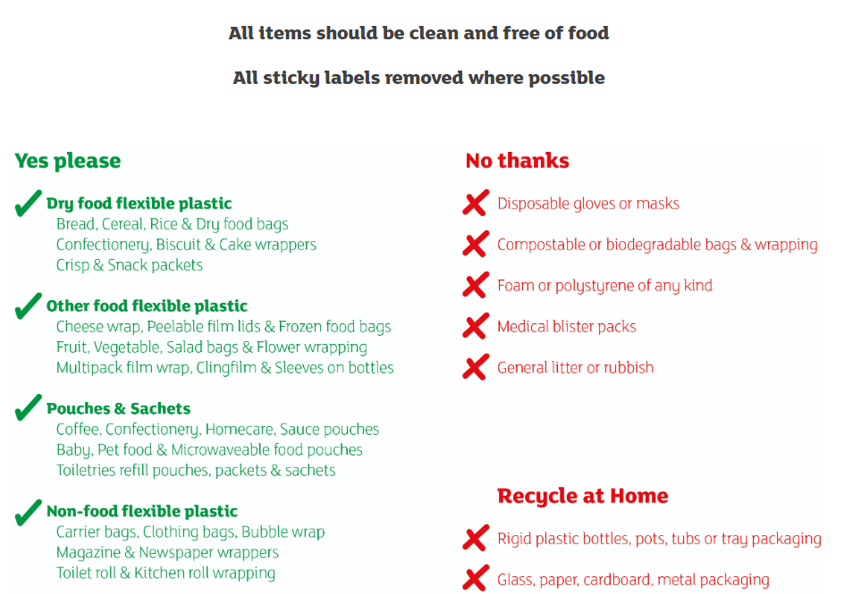
Figure 1: The uses of recycling plastics
(Source; Sainsbury’s, 2022)

Blog 3: Helping Customers to Make Healthy Choices
People have become more conscious regarding their health and nutrition level in their daily lives particularly. There are various criteria of nutrition that need to be observed in order to enhance health quality and stay healthy. Thus, the preferences of individuals are changing within the organisational world and it is essential for the company to maintain pace with this changing environment within the business environment particularly (Sainsbury's, 2022). Sainsbury’s has taken an initiative to make the customers understand the actual criteria of nutrition foods so that they can fulfil their health objectives and aim in their daily lives (Maston et al., 2020).
Sainsbury’s has acknowledged an approach to develop a food chart that signifies the actual proportion of different food items within the human body and can fulfil the requirements of the human body. The approach has assisted the company to identify the food item from the categories for own label products as well as branded products (Sainsbury's, 2022). It has helped the company to understand the shift in the selling process and its purposes within the organisational context particularly. Sainsbury's has developed the decision tree that defines the customer's most effective food habits in daily lives and can help them to acknowledge their aims to become fit (Sainsbury's, 2022). All these approaches have helped the company to stay competitive and helped the customers to purchase healthier foods for themselves.

Blog 4: Sainsbury’s Partners with Neighbourly to Donate Surplus food to Local Communities
The surplus food distribution is one of the most inhibitory integrated processes in Sainsbury’s. The company has a significantly enriched strategic response to the surplus distribution in terms of excessive food. The company started the ‘Fareshare’ program back in 1994. After almost t10 years, Sainsbury's has decided to integrate the ‘Zero Waste' initiatives to improve its food management system (Sainsbury’s, 2022). The company has decided to change the redistribution strategies based on the current logistics developed by the customer purchase frequency scheduling tracking process. The company had covered the implementation of the logistics in the food management system where the backup strategic diversity distribution process was embedded in the retail distribution and flea marketing redistribution techniques. According to Lemaire and Limbourg (2019), the donation of surplus food to the animal feed was one of the most innovative initiatives taken by Sainsbury’s. The company has decided to integrate its delivery system initiated with tracking the farming redistribution processors where the agricultural and poultry suppliers are communicating with the nearest stores regarding their animal feeding demands. Sainsbury’s has developed a track-optimisation process to supply, distribute and redistribute excellence of the transport and supply-distribution system.
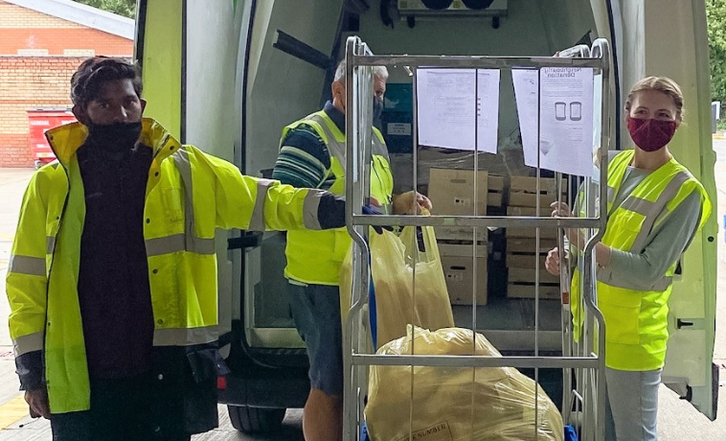
Figure 2: Food Redistribution to Farm for Better Food Management in Sainsbury’s
(Source: Sainsbury’s, 2022)
This has simultaneously improved the carbon emission rate from 16% to 31% in 11 years span. The food waste is expected to be reduced by 50% before 2030 and the initiative has been renewed in 2017 (Sainsbury’s, 2022). This gives Sainsbury’s a heads up since the company has already reached a 16% redistribution expertise along with a 19% reduction in food waste. The 5% increment in animal feed has been gained by the advanced agri-cultivation applications provided to the farmers. This has also allowed the company to provide smart tracking of animal health and hygiene practices to the farmer. According to Lemaire and Limbourg (2019), the voluntary initiative with business interests has allowed Sainsbury’s to increase its CSR status in the contemporary market (Sainsbury’s, 2022). The Corporate Responsibility and Sustainability group in the company has developed some marketing initiatives creating monthly blogs regarding the distribution and redistribution process of food management to increase awareness in the UK market more proficiently.

Blog 5: Our Approach to Defining Healthy Choices
Defining, identifying and approaching the food technological solution with the healthy choice initiatives is one of the most popular and convenient initiatives of Sainsbury’s. Using modern technology, legislative orders and food standard optimisation processes are the inhibiting determinants in this process. Sainsbury’s with its advanced food technology initiatives has arranged the Microtech filtration process where the company tracks the farming, quality and nutrition value of the grocery items. According to Lemaire and Limbourg (2019), the vegetables and fruits are analysed with the shelf life and freshness indeed xis set to understand the distribution or retail timings. The inventory management system allows the company to determine which food has better value to the customer if the retailer is at the right time (Sainsbury’s, 2022). The Public Health England reformulation criteria for sugar and salt are adjusted in the ingredients of processed foods and the mixture of raw or ready-to-cook food items. The regulated nutrition value is added to every type of food in order to create a good food range with healthy lifestyle values integrated. The Eatwell initiatives are also integrated into the marketing process in social media where the company promotes good and healthy food to interested customers. The product details are tracked and customer orientations are handled with personalised record-keeping logistics.
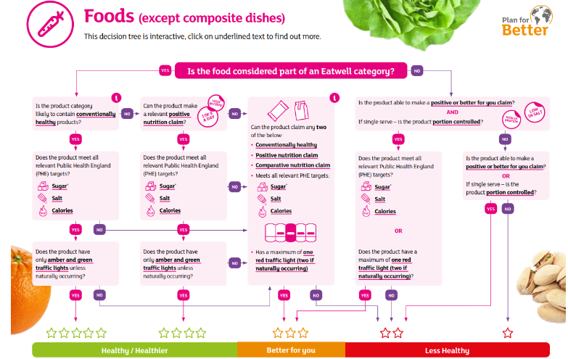
Figure 3: Traffic Light Inventory Management and Redistribution Tree
(Source: Sainsbury’s, 2022)
The company also provides a health index to the customers based on their purchases. This motivates the customers to value their healthy lifestyle and control their food orders accordingly. Therefore, the health consciousness of the comedy regarding their customers' lifestyle is justified by the customers. According to Lemaire and Limbourg (2019), this concern cannot be misinterpreted, however, some personalised data manipulation is charged against the company which the IT department is working on to neutralise the customer complaint threats further (Sainsbury’s, 2022). However, key reformulation targets determined by the government are followed strictly in the company so that potential competitors like Tesco or ASDA cannot get any opportunities to exploit the market position of the company. Sainsbury’s is trying its best to implement a raw packaging system with traffic digital tagging of traffic light notifications so that the company can adjust the inventory management system with extensive calculation and simple sorting operations without any complicated logistics data analysis. The decision tree is implemented in the supply, inventory management and distribution and re-distribution system to integrate a better food management implementation in Sainsbury’s.

Blog 6: Accelerating towards a Gender-equal Workplace - Our Success
According to Wenham et al. (2020), enabling the gender equal drivers according to the labour quantities is considered to be one of the most concernable corporate orientations when it comes to physical labouring. According to Wenham et al. (2020), the usefulness of the KPI system and human rights associations has increased the possibilities of mitigation in this particular domain. Sainsbury’s as a FTSE100 company in the UK market, has integrated the gender equal spectrum for equal pay obligations with the proper logistical implementation in the salary structure of the company (Sainsbury’s, 2022)‌. Since the company has a 4:1 ratio of administrative and operation staff structure, the gender equal approach has been extremely difficult for Sainsbury’s to implement effectively. According to Erikson and Verge (2022), however, the company has managed to function effectively in this domain so that the female executives, staff, IT recruitment process and salary structures are fairly distributed along with maternity leave and other benefits. The working hour proposition has been arranged to both genders based on cohesive criticalities (Sainsbury’s, 2022)‌. This has increased the recognition of the company in the global market as well. According to Erikson and Verge (2022), Sainsbury’s has arranged the 26 weeks’ pay and paternity leaves of four weeks to the employees and warehouse staff which increase the gender neutrality awareness in the company creating a sustainable gender-neutral culture in the company (Sainsbury’s, 2022)‌.

Reference
Bruyère, S.M. and Saleh, M.C., (2018). Leveraging employer practices in global regulatory frameworks to improve employment outcomes for people with disabilities. Social Inclusion, 6(1), pp.18-28.
Erikson, J. and Verge, T., 2022. Gender, power and privilege in the parliamentary workplace. Parliamentary Affairs, 75(1), pp.1-19.
Lemaire, A. and Limbourg, S., 2019. How can food loss and waste management achieve sustainable development goals?. Journal of Cleaner Production, 234, pp.1221-1234.
Maston, G., Franklin, J., Gibson, A.A., Manson, E., Hocking, S., Sainsbury, A. and Markovic, T.P., (2020). Attitudes and approaches to use of meal replacement products among healthcare professionals in management of excess weight. Behavioral Sciences, 10(9), p.136.
Mehta, N., Cunningham, E., Doherty, M., Sainsbury, P., Bolaji, I., Firoozi-Nejad, B. and Smyth, B.M., (2022). Using regional material flow analysis and geospatial mapping to support the transition to a circular economy for plastics. Resources, Conservation and Recycling, 179, p.106085.
Sainsbury’s, (2022). Accelerating towards a gender-equal workplace: our success. Available at: https://www.about.sainsburys.co.uk/sustainability/plan-for-better/our-stories/2022/01-03-2022-accelerating-towards-a-gender-equal-workplace [Accessed 22 August 2022]
Sainsbury’s, (2022). Helping our customers to recycle flexible plastics. Available at: https://www.about.sainsburys.co.uk/sustainability/plan-for-better/our-stories/2021/flexible-plastics [Accessed 22 August 2022]
Sainsbury’s, (2022). Our approach to defining healthy choices. Available at: https://www.about.sainsburys.co.uk/sustainability/plan-for-better/our-stories/2021/health-categorisation [Accessed 22 August 2022]
Sainsbury’s, (2022). Sainsbury’s partners with Neighbourly to donate surplus food to local communities. Available at: https://www.about.sainsburys.co.uk/sustainability/plan-for-better/our-stories/2021/08-09-2021-sainsburys-partners-with-neighbourly [Accessed 22 August 2022]
Sainsbury's, (2022). Our approach to defining healthy choices. Available at: https://www.about.sainsburys.co.uk/sustainability/plan-for-better/our-stories/2021/health-categorisation [Accessed 22 August 2022]
Sainsbury's, (2022). Talent and people development. Available at: https://www.about.sainsburys.co.uk/sustainability/plan-for-better/our-stories/2021/apprenticeships-stories [Accessed 22 August 2022]
Wenham, C., Smith, J. and Morgan, R., 2020. Covid-19 is an opportunity for gender equality within the workplace and at home. Bmj, 369.

