Student Name: Yasmeen Begum
Student Number: 2119725
Lecturer Name: Hafiz Rehmani
BMSW4002_BIRM
Effective team working and communication
Date 03/07/2022

Executive Summary
The study has discussed that collaboration assumes a significant part in the advancement and accomplishment of progress at Pelsall Hall. Individuals feel propelled while they are working in a group that shows a part of managing the various circumstances. No withstanding, the utilization of Belbin Team Roles works fair and square of efficiency among the colleagues and improves the degree of inspiration of a person. The utilization of Tuckman's hypothesis and Hackman’s hypothesis helps the colleagues at various phases of the development, for example, framing, raging, and norming, performing, and concluding. It assists in offsetting what is going on with the alternate points of view of the work.
Table of Contents
1. Introduction 4
2. Model of teamwork 4
3. Role for creating effective teams 6
4. Impact of effective teamwork on team success 9
5. Conclusion and recommendations 11
6. References 13

1. Introduction
Teamwork can be termed as the group of people who are working together to attain specific goals and objectives of the team. In this report, there is a discussion about effective teamwork along with the appropriate use of team development models like Tuckman for the growth of the team. Further, it also discusses the roles which are required for developing effective teams along with the theories related to it such as Belbin Team roles. Moreover, the discussion includes the benefits of effective team working along with some of the barriers which can affect teamwork. At last, recommendations for making improvements in the teamwork.

2. Model of teamwork
According to (Prabhakar, 2009), In general, a team has usually explained a set of individuals who act self-goal work to toil in the direction of completing a shared short-term perspective or explicit goals. Few kinds of teams have restricted life for instance a planning team creating an item, or an ongoing process development team prearranged to resolve s definite problem. Different organizations have various teams keeping in mind the kind of work they need to deliver. Like in the case of Pelsall Hall Care home need to develop a team with an intention to keep the employees intact and work together devoid of any kind of misunderstandings so that they can serve the people in a better manner.
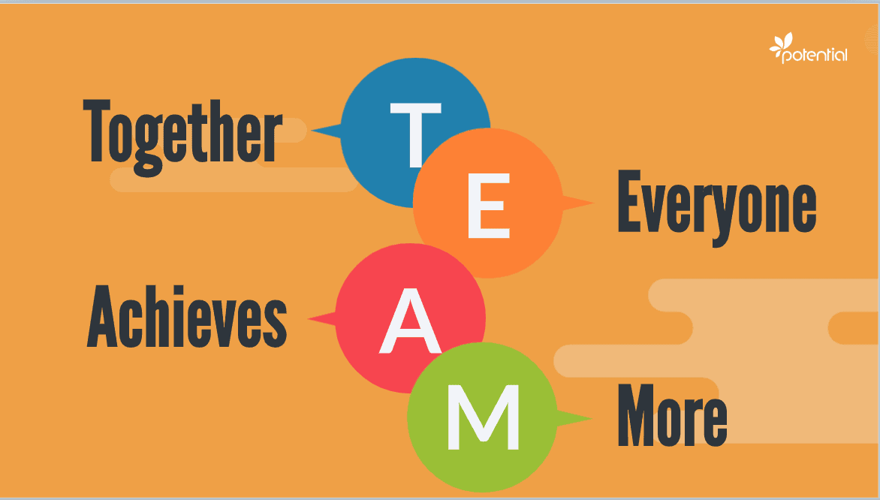
Figure 1: Layout of a team
Now in case of Pelsall Hall Care it can be seen that though the members of the team are very hard working and focused, but they are not contributing enough to the care home as a team. As a result, it will be important to note what adds to actual teamwork which is discussed in the table below:

Honesty in between the team | Preparing to involve in discussion around notion | Learn to dedicate to decisions and course of action | Concentration on attaining shared outcome
Developing conviction among teams generally is time taking. Assuming honesty is deficient with regards to it should be the obligation of the group chief to concentrate first on developing conviction, the manager of Pelsall Hall Care will need getting colleagues to open up and uncover their shortcomings and fears to one another. | It will be also important for the team members to make them prepare for taking part in any kind of decision making so that employees can learn the ideas shared by each other which can be used to develop a good team at Pelsall Hall Care | Group outcome will just happen because of group obligation to group choices, this incorporates settling on the points of interest of activity plans. | According to (BlueSteps, 2020), the long-term objective, as well as the short-term objective of the group, should be acknowledged by all the colleagues and basic objectives saw as the aggregate liability of the group

3. Role for creating effective teams
Considering the issue identified in Pelsall Hall Care where it has been identified that team members were facing issues in working in a team where many a time misunderstands are created and as a result the task is not getting completed. Thus, in this situation the two important model of team development can be used which are Tuckman's FSNP Model and The Hackman Model. Both these models are applicable in the stated case of Pelsall Hall Care because these two models are focused on managing the communicational issues which is created due to improper management of team.
Tuckman's FSNP Model: According to (Hurt, 2007), considering the first stage of this this model the manager of Pelsall Hall will need to form a team that will totally depend on his leadership and also will allow decisions from the team members too. The manager in this stage of forming need to get ready for answering the questions asked by the tams so that they can feel they are forming a group altogether that will lead to dissolve the misunderstanding between them. In the storming stage it might happens that the team members will not get agree on the notions shared by each other which might create power fight. In this situation as pointed out by Tinuke Fapohunda (2013), the manager of Pelsall hall will need to make them understand and concentrate over the main objective to avoid unnecessary misunderstanding. In addition to this the manager also need to combine the last three stages of the Tuckman's s theory to lead and create a team that will dedicate their energy towards betterment and development of the home care for the upcoming times.
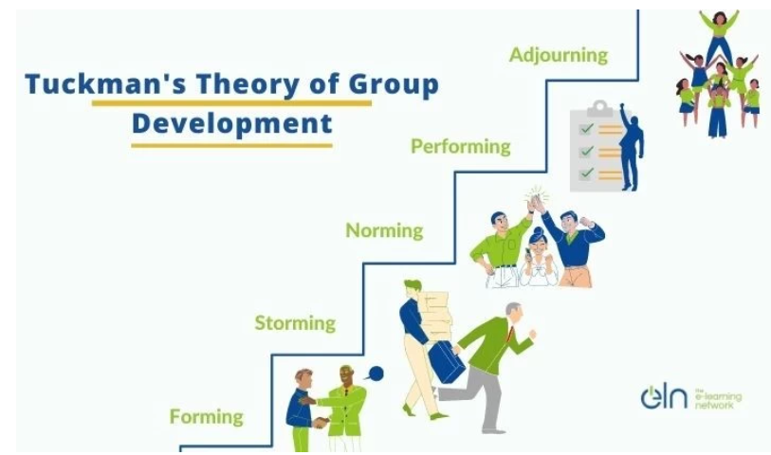

The Hackman Model: According to (Ali, 2014), considering this theory the manager of Pelsall Hall will need to create a team working environment within which they will feel motivated. In order to do so it will be important to follow the 5 job traits which is the main point if this theory. The first part that needs to get focus on is skill variety in which it will be pivotal to identify the particular skills for the designated roles. Secondly based on this the manager will need to identify the task to fit those skills based on the task segregated. Task importance, independence and feedback in this case will identify the level of the occupation significantly affects the existence of others inside the association yet in addition to society all in all.
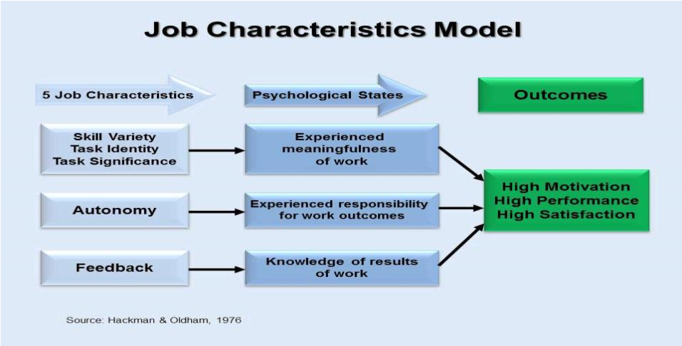

To develop a cohesive as well as effective team it will be required for the manager of Greenfield to firstly encourage proper flow of interaction among the team members in order to avoid any sorts of misunderstanding. Secondly considering the issues identified in the case it is also important to practice team development exercises that will help in bringing the team close together. The theory that will be best fitted with this situation is Belbin’s team roles theory.
According to (Lynch, and et.al., 2018), based on the case study of Pelsall Hall, there is the use of different team theories for making improvements in effective teamwork activities. The use of Belbin’s theory helps to understand the role of an individual at a Care Home in a team which helps to make development in the strength of people along with handling the weakness. However, Belbin’s theory helps the team members to adapt to changes as per the requirement of work as it also highlights the collective strength which makes the team members more cohesive to work in the dynamic environment.
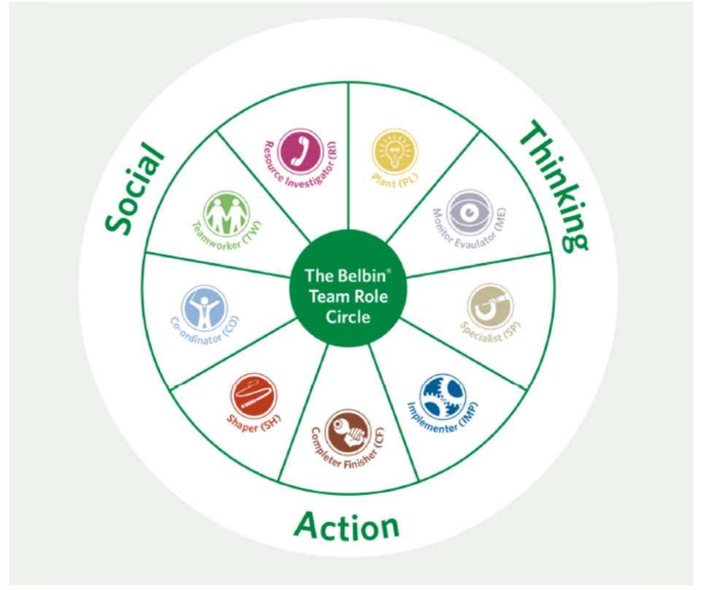

However, Belbin’s team roles provide balanced teamwork for the teams of Care Home and increase the self-awareness regarding the responsibilities which affects positively the outcomes. It gives authority to an individual to perform in the right manner with appropriate behaviour with the team members which can make improvement in the process of teamwork.

4. Impact of effective teamwork on team success
In order to discuss the advantages of effective teamwork at Pelsall Hall Care Home, there are certain points which are required to consider:
- Met deadlines: when a team work together, it helps to increase in the level of productivity that leads to reduce the huge workload and it will be manageable for the people to meet the deadlines.
- Flexibility: There is more flexibility during the teamwork as it divides the work as well as knowledge between many individuals. It helps in gaining more flexibility as any people are working in a team.
- New opportunities and ideas: The effective teamwork brings out new ideas from an individual that helps to analyse the new business opportunities for Pelsall Hall Care Home.
- Increase in productivity: The contribution of an individual leads to enhance the productivity at Pelsall Hall Care Home as people are more committed towards the work (Wei, and Ohland, 2021).
In addition to this, there are some of the barriers to the effective team working in the present scenario of Pelsall hall Care Home which are as follows:
Due to the communication gap between the team members as there is requirement of appropriate skills of communication for the people to connect each other at Care Home that is a significant part for them.
In the environment of the team at Pelsall Hall Care Home, there is a pressure of work on an individual as there is more responsibility along with the aspect of duties in the process of decision making. It is considered as a major barrier in the preened scenario of the Pelsall Hall Care Home where the collaborative work is less contributed to the ideas of work.
There are certain issues of accountability in the case of performance of team members as some of them are not taking responsibility which affects the progress of the team of Pelsall Hall Care Home.
In addition to this, poor conflict resolution skills affect teamwork management and the goal of work, and it is quite challenging for the team members to handle conflicts in the workplace.
On the basis of Coyle’s Code team composition at Pelsall Hall includes the behaviours of people which helps to develop a safe connection with each other as it helps to make improvements in the qualities of people. However, there is the use of different techniques for designing the issues and providing appropriate resolution for managing the situation among team members with culture.
So according to (Rosen, and et.al., 2018) stated that in order to analyse the impact of effective teamwork at Pelsall Hall Care Home as people are more considering the calculated risks at the workplace. Further, teamwork encourages personal development, maximization of job satisfaction along with reducing the level of stress.In addition to this, teamwork helps to solve the problems at Pelsall Hall Care Home in an effective manner by getting the opinions of different people which increases the chances of solving the issues. It has been identified that people are happier in the process of effective teamwork as they can help each other with any task that affects positively the team members. However, there is an enhancement in the personal growth of the team members at Care Home is a positive aspect of effective teamwork. It is beneficial to make decisions and provide opinions for the tasks which increases the level of self-confidence to deal with the challenges at the workplace. Thus, effective teamwork makes changes in the opportunities for growth and development which plays a significant role for the people at Pelsall Hall Care Home. It proves to be effective for the development and growth of people.

5. Conclusion and recommendations
From the above discussion, it can be concluded that teamwork plays a crucial role in the progress and achievement of success at Pelsall Hall. The people feel motivated while they are working in a team that shows an aspect of dealing with different situations. However, the use of Belbin Team Roles improves the level of productivity among the team members and enhances the level of motivation of an individual. The use of Tuckman’s theory helps the team members at different stages of growth such as forming, storming, norming, performing, and adjourning. It helps in balancing the situation with the different perspectives of the work.
Recommendation: It can be recommended that the team members should make two-way communication for improving teamwork. It must be proper communication toward the set objectives and clear goals so that it will be easier to analyse the issues within the workplace. The other recommendation includes that flexibility must be provided to the team members as it allows an individual to be productive at different stages of work. Further, it is essential to make use of various tools for collaboration which increase the level of capacity to handle tasks for the delivery of services at Pelsall Hall Care Home.

6. References
1. Ali, S.A.M., 2014. Hackman and Oldham's Job Characteristics Model to Job Satisfaction. Procedia - Social and Behavioral Sciences, 129, pp.46-52.
2. BlueSteps, 2020. 5 Key Factors to Managing Successful Teams. [Online] Available at: https://www.bluesteps.com/blog/5-key-factors-managing-successful-teams#:~:text=The%20key%20elements%20to%20successful,will%20have%20difficulty%20functioning%20effectively. [Accessed 20 June 2022].
3 .Fapohunda, T., 2013. Towards Effective Team Building in the Workplace. Lagos State University.
4 .Hurt, A.C.a.H.M.T., 2007. The Punctuated-Tuckman: Towards a New Group Development Model. Texas A&M University.
5. Prabhakar, G.P., 2009. Teams and Projects: A Literature Review. International Journal of Business and Management, 3(10).
6 .Rosen, M.A., DiazGranados, D., Dietz, A.S., Benishek, L.E., Thompson, D., Pronovost, P.J. and Weaver, S.J., 2018. Teamwork in healthcare: Key discoveries enabling safer, high-quality care. American Psychologist, 73(4), p.433.
7. Sharon Mickan, S.M., 2000. Characteristics of Effective Teams. Australian health review: a publication of the Australian Hospital Association , 23(3).
8. Wei, S. and Ohland, M.W., 2021, October. The Relative Importance of Team Dynamics in Predicting Effective Teamwork Behaviors. In 2021 IEEE Frontiers in Education Conference (FIE) (pp. 1-5). IEEE.

