Paula Smith 1903588 Excavation and Fieldwork. HPAR 5004 May 2024.

Field Journal.

Abstract.
This Field journal records the archaeological excavation at Llanllyr, Talsarn, Ceredigion, in 2024. It draws on previous excavations and surveys of the site and follows the processes, finds and experience of this year’s excavation.

Landscape and soil can be seen as historical documents for interpretation, detailed evidence being read alongside a wider picture . Being a destructive ‘unrepeatable experiment’ excavation cannot be validated by comparison as no two sites are the same. Therefore, each excavation needs to be as objective as possible. Only excavation can reveal the sequence of structures, recover stratified dating evidence and the mass of environmental or economic evidence a site contains . Over the past few years surveys have been completed and analysed for Llanllyr, informing the decisions regarding subsequent archaeological work .
Developments in non-invasive surveying include systematic and non-systematic methods, from walking across a site to using drones, satellite images, LIDAR/SIDAR, and software that combines information to provide 3D models . Geophysical sensing devices- seismic and acoustic echo-sounding sonar, electro-magnetic radio pulses, resistivity surveys, metal detectors and geochemical analysis is all available before a spade hits the ground- the following are from Llanllyr.
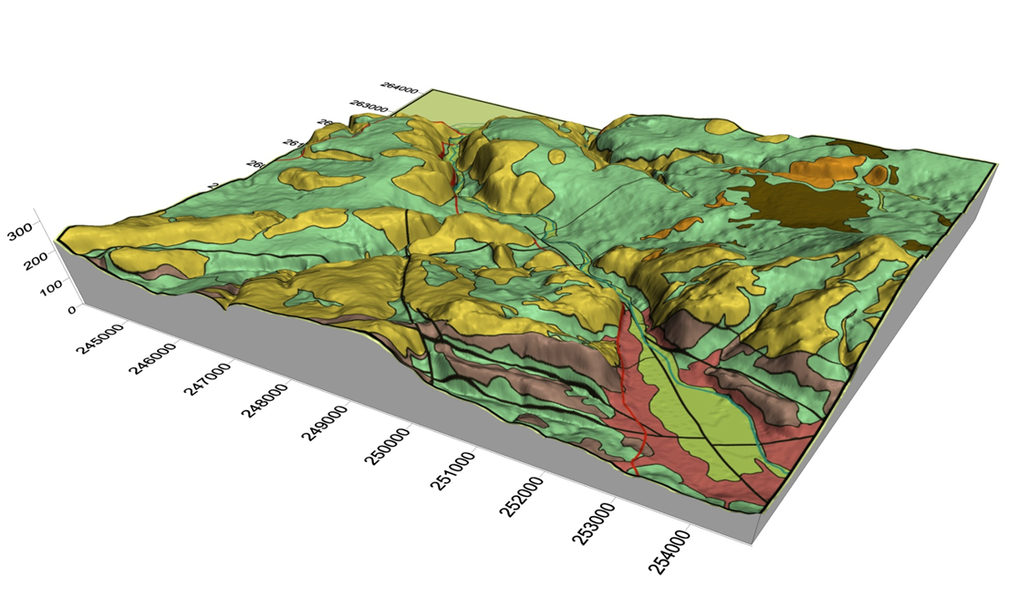
LLanllyr
Fig 1. 3D model. Picture courtesy of Martin Bates. Llanllyr. 2022.

The LIDAR image below shows the pre-drained waterways snaking their way across the rectangular fields, which are evident in the surface vegetation still.

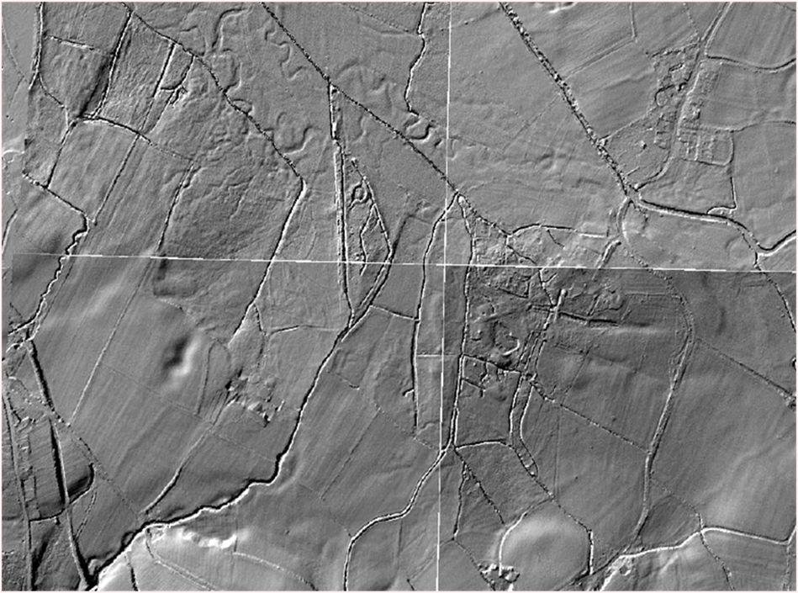
Fig.2. LIDAR. Picture courtesy of Martin Bates. Llanllyr. 2022.
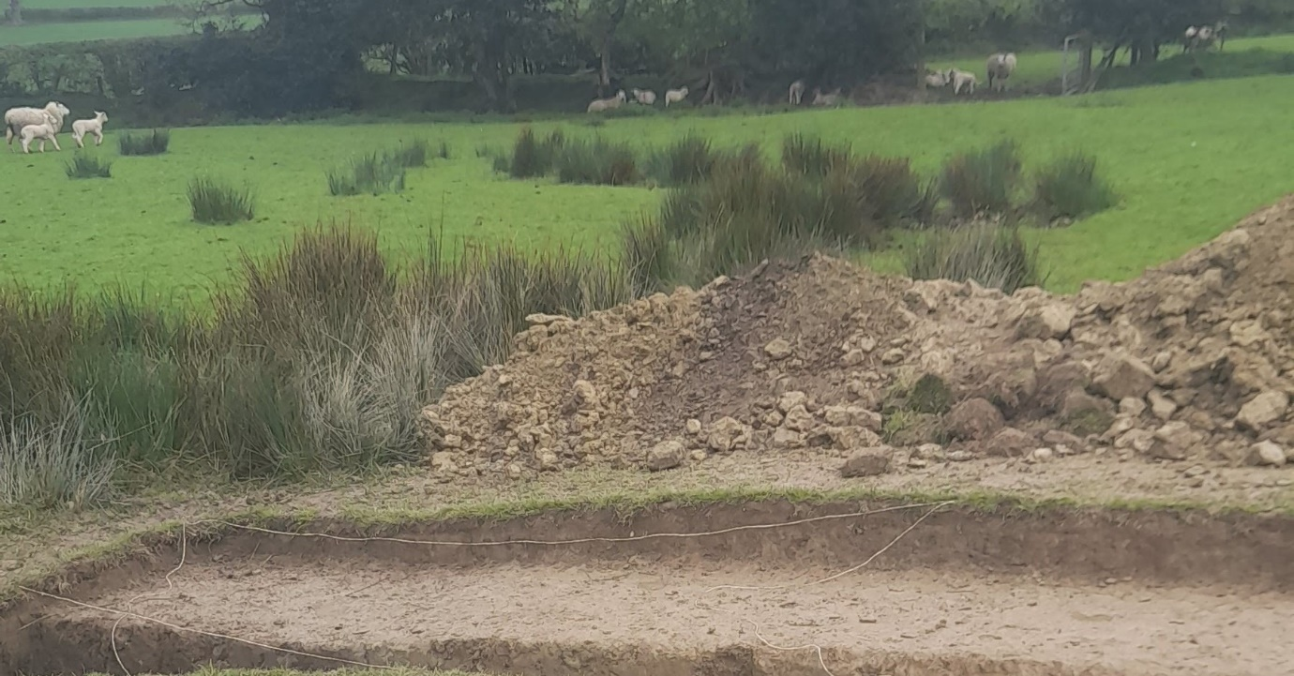
Fig 3. Snaking vegetation. Photo authors own. 2024.

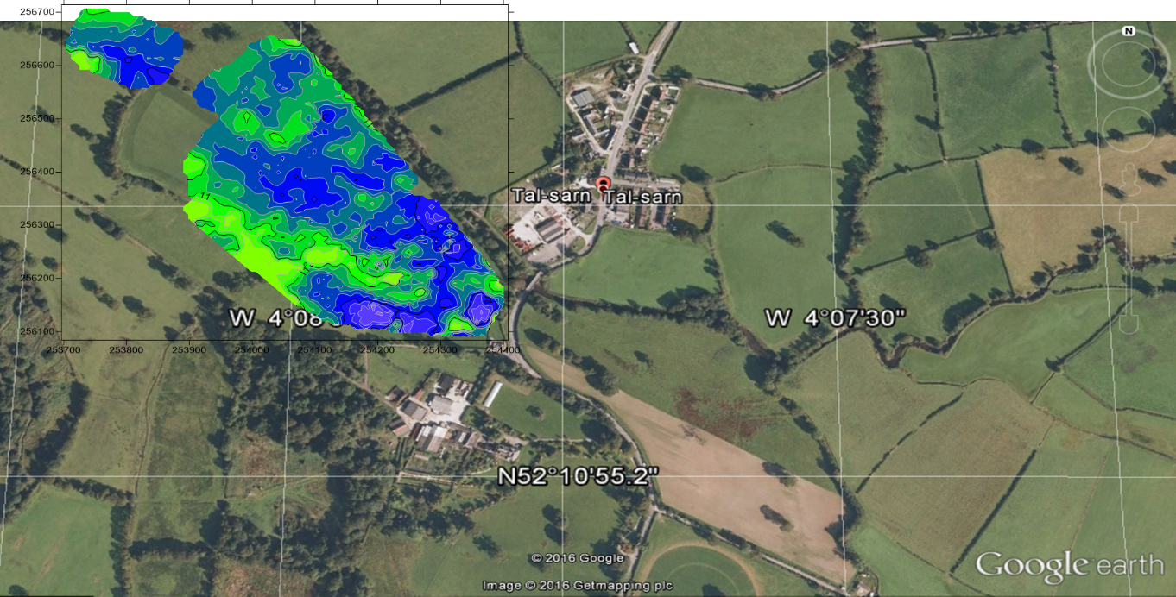
Fig 4. Bore holes. Picture courtesy of Martin Bates. Llanllyr. 2022.

Invasive procedures.
The Test Pit and Core samples taken in 2023 map the edge of the marsh/lake by the depth of peat horizons, seen below. The peat horizon in bore hole 9 dates to 10880 +/-40 BP at a depth 3.83m below current ground. The distance between Mesolithic marshland/ water and the current mound reveals a slope and much larger island, which today’s undulations conceal.
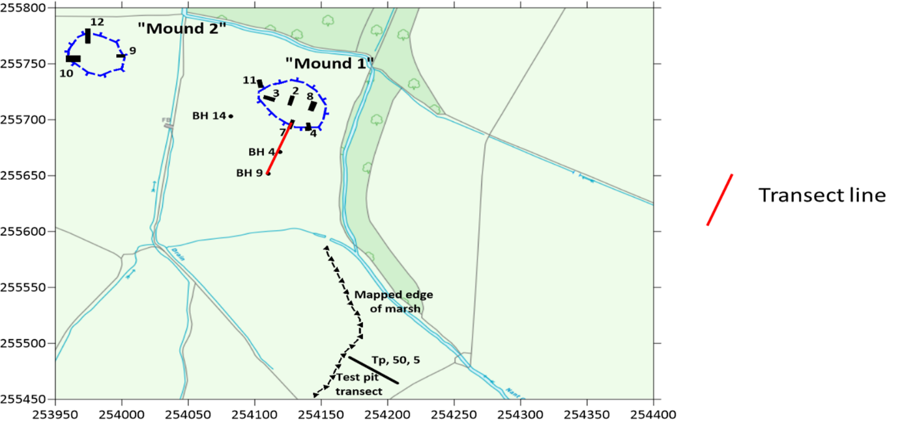
Fig 5. Mapped results from Bore Holes and Test Pits. Courtesy of M. Bates. Fieldwork and excavation presentation, 2024.
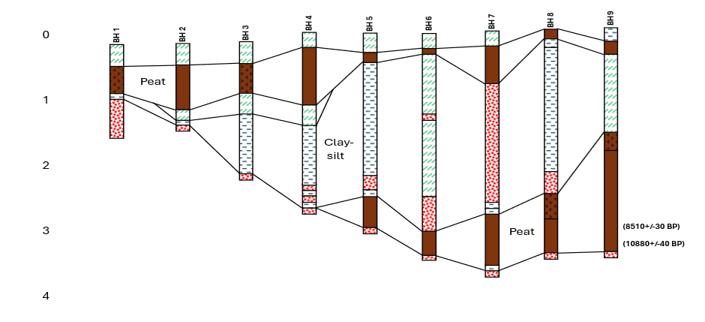
Fig 6. Bore Holes. Courtesy of M. Bates. Fieldwork and excavation presentation, 2024.
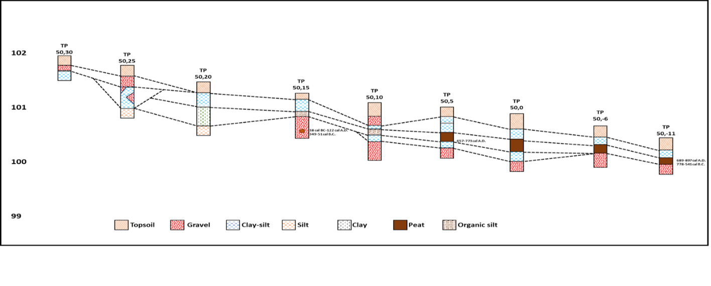
Fig 7. Test Pits. Courtesy of M. Bates. Fieldwork and excavation presentation, 2024
Introduction week.
The presentation of past survey results and discussions on the Mesolithic/Neolithic period inspired research into Mesolithic people, culture, and climate. This is the start of human-directed eco-system change in ways that can still be seen . I had not appreciated the complex culture and architecture of this time. Reading about the sophistication of Star Carr and Bouldnor Cliff, coupled with an image of Cheddar Man, I had a better idea of the possible activity in this valley. Understanding the climate, coastline and pre-drained state of the valley conjured warmth, densely wooded valley sides, open water, marshland and islands- making this place of rich resources attractive to our ancestors.

Week 1.
The team contains new and experienced students, volunteers, and the Site Director, Martin Bates, lecturers Ros Coard and Quentin Drew. Many had not met before, so creating a team involved large group activity such as field walking, pace measuring, guided decisions on trench placement. Formed into smaller teams with a group lead, the initial jobs of trenching broke us in. Nothing like de-turfing and mattocking in the rain to bond people!
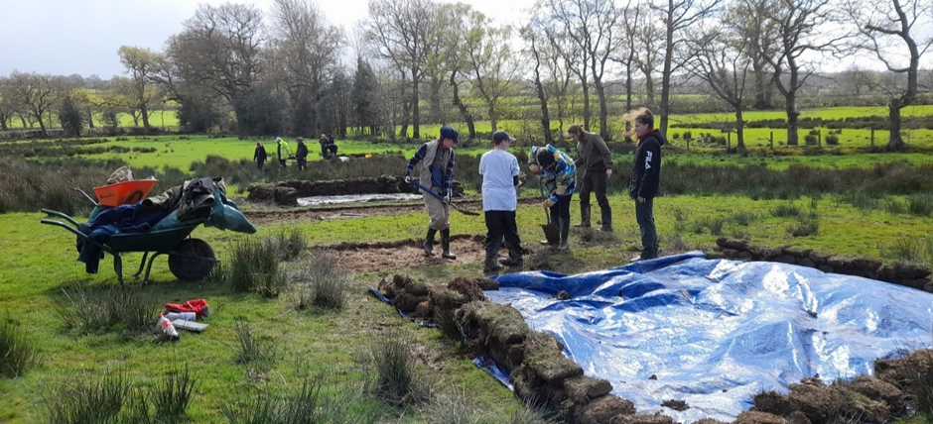
Fig 8. Tr 10 expansion- North and South. De-turfing. Photo authors own. 2024.
After a spectacularly wet winter, we experienced the valley in a soggy state, moving about through sucking bog. Regarding the raised mounds as original islands, trenches were set from wet to dry looking for the lake/marsh edge and most likely places of activity.
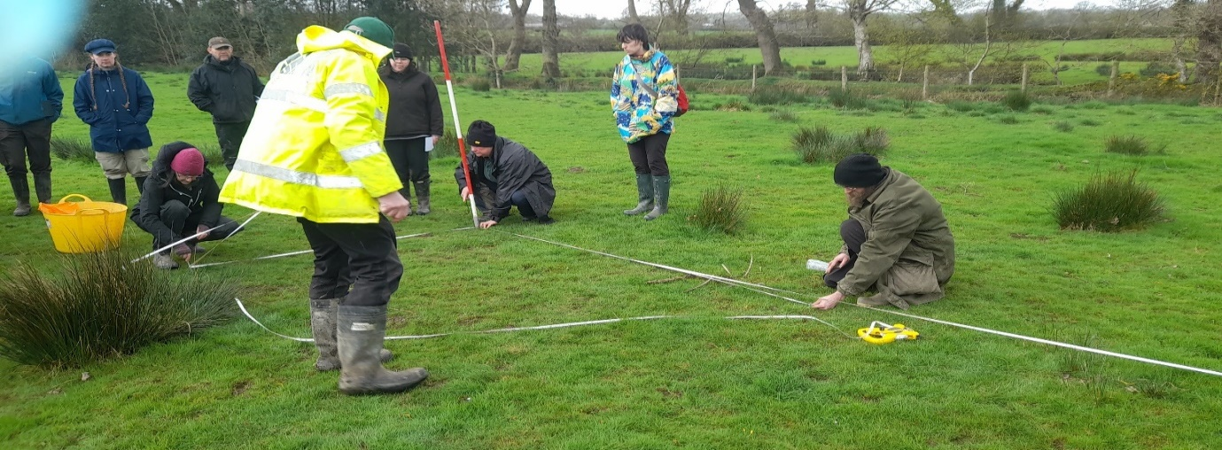
Fig 9. Pythagoras in action, the 3,4,5 triangle. Photo authors own. 2024.
Offsetting from a baseline- still in evidence from last year- and using the 3,4,5 triangle to create an accurate rectangle , the position of each trench will be easily identified in the future. This was plotted by Quentin as the week progressed, but meanwhile the heavy work commenced. I was part of Tr 10 South, 8.3m x 2m, adjacent to the productive Tr10 of the preceding years.
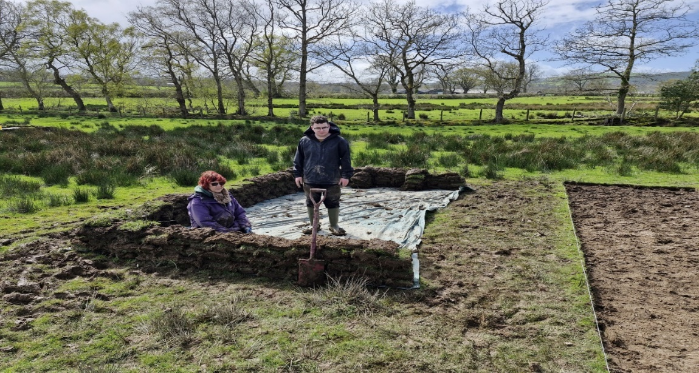
Fig 10. Tr 10 South. The team. Photo courtesy of Gareth. 2024.
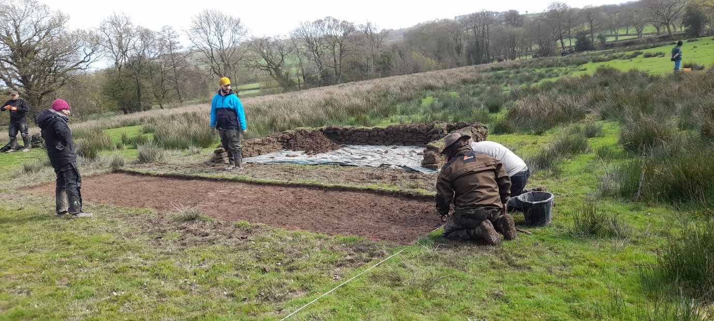
Fig 11. Tr 10 South. The team. Photo authors own. 2024.
After the final mattocking, trowelling could begin- trying to follow the 45° trowel and ridged wrist advice , working backwards, filling the buckets with loose. Our Tr10 S produced one flint in sieving and features- plough marks, charcoal spatter adjacent to that found last year, and a possible firepit.
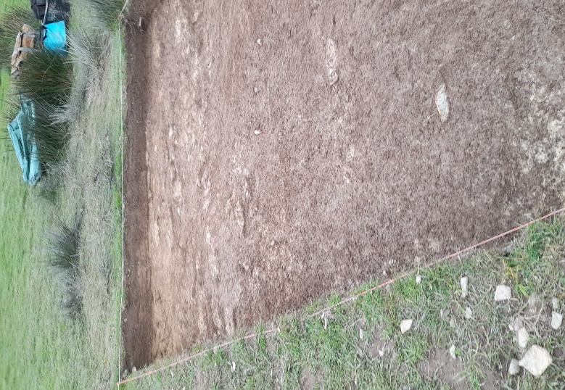
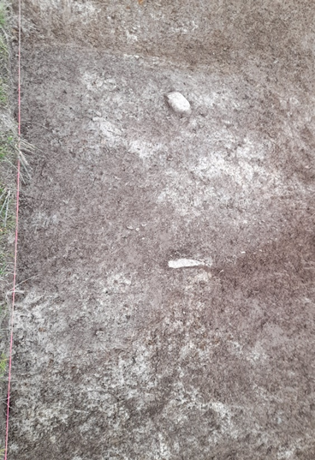
Fig 12. Trench 10 South. Charcoal and plough marks. Photo authors own. 2024.
Meanwhile, our neighbouring Tr10 North was producing flint flakes from day 3.
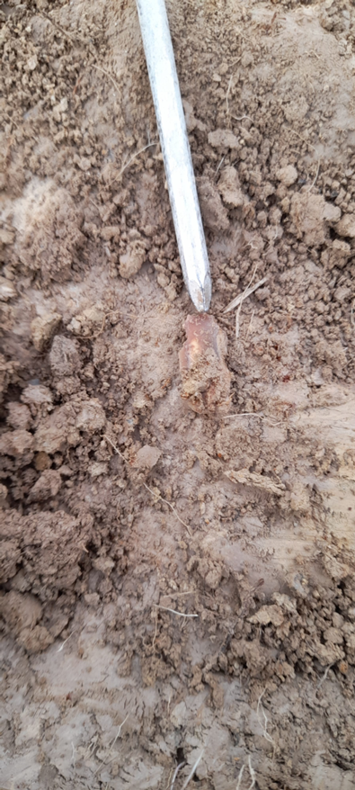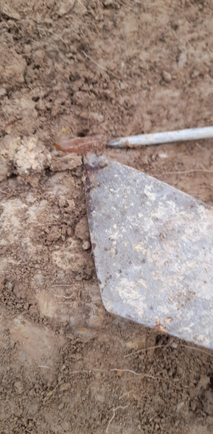
Fig 13. Trench 10 North. Flint flakes. Photo authors own. 2024.

In the second week, I joined Tr 17, on Mound 1.
This Trench produced five flints, two by sieving. Animal holes were revealed into the clay/silt subsoil with the flints being found along the NE edge- see Plan below. We revealed three contexts, then to ease re-opening it was lined before backfilling.

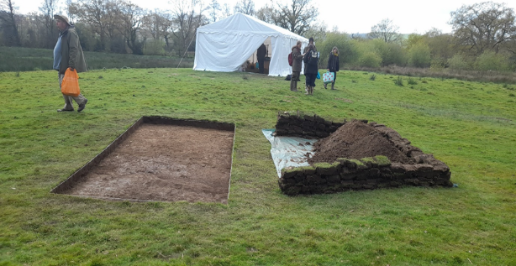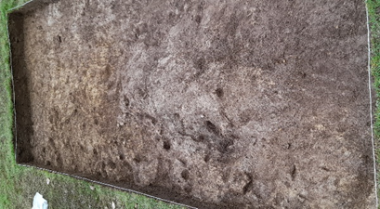
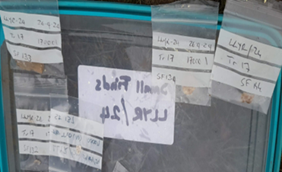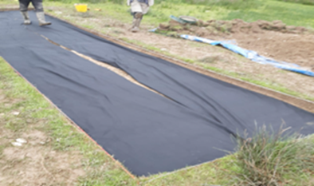

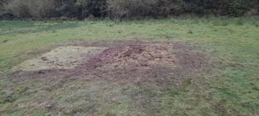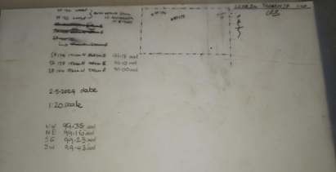
Fig 14 . Tr 17. From opening to closing. 2024. Photo authors own.

Recording the finds.
Although there is no national applied standard for recording, most systems are broadly similar . The Context Sheet, Artifact Record, Finds Sheet, drawn record on Permatrace, Photographs - together these record the exact position, and surrounding context.
Following strict methodology, under the supervision of Ros, the finds are recorded and mapped before removal- Fig 15. Lithics require care in handling to avoid secondary retouch, even sieving can cause microwear , so each is bagged for protection. On removal a nail is put in place ready for mapping. The vertical and horizontal dimensions record the position in the trench- vertical reveals the stratification and activity through time; horizontal reveals the spatial contemporary relationships between artifacts and features . I imagine this as the pages of a book being scraped away descending through time.
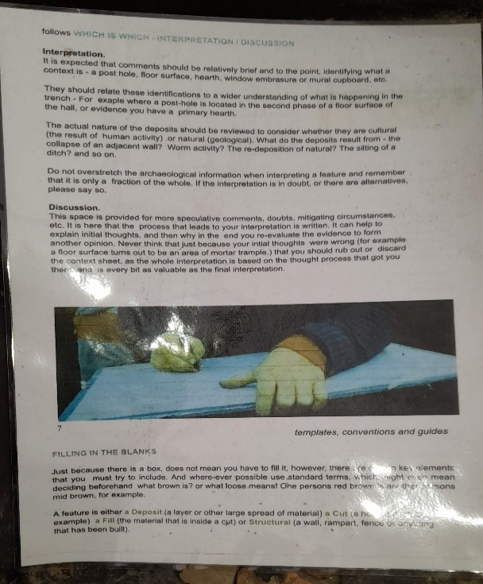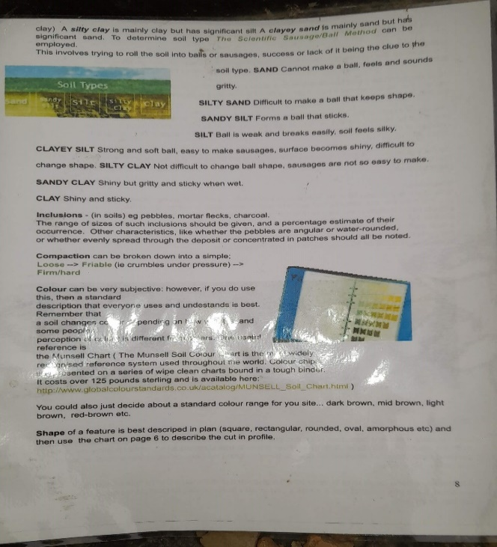
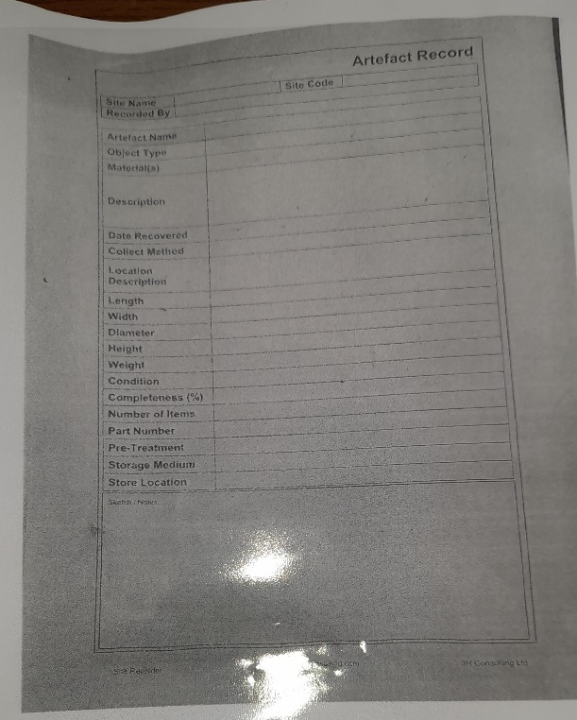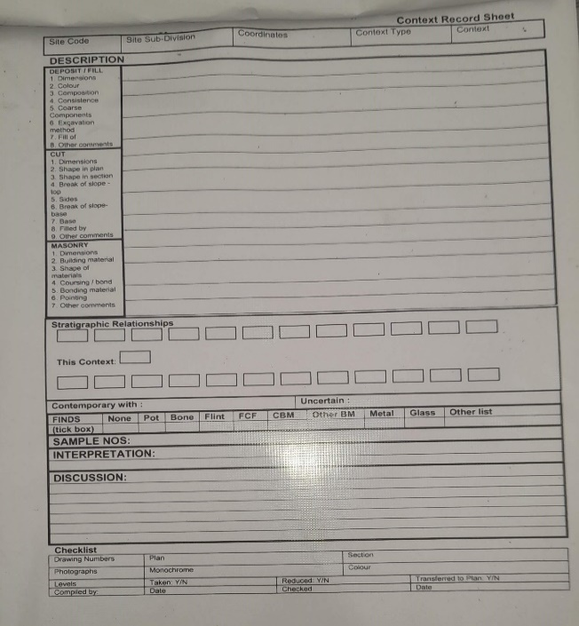
Fig 15. Guide and recording sheets. Photo authors own.2024.
Mapping was plotted by Quentin- we did this for Tr17 in the second week. A Dumpy measures the position of any artifact or feature in relation to Ordinance Datum- or sea level. Accurate readings from a Levelling Staff are ensured by delicate adjustments incorporated in the Dumpy. Detailed mapping plots the exact position of an artifact or feature within a potentially global map.
A Temporary Bench Mark (TBM) is chosen by being as fixed through time as possible to achieve in nature. At Llanllyr, the gate post is used throughout all excavations, and has a value of 100m O.D. Sighting the Levelling Staff through the Dumpy the line of vision above the gate post is measured- the Back Sight. The Back Sight plus the TBM is the plane of Collimation .
For Tr 17, TBM + 1.05m= 101.05m = Collimation.
The height of each trench/artifact is measured- the Fore Sight. This is taken away from the Collimation, producing the Reduced/Real Level- see Fig 16.
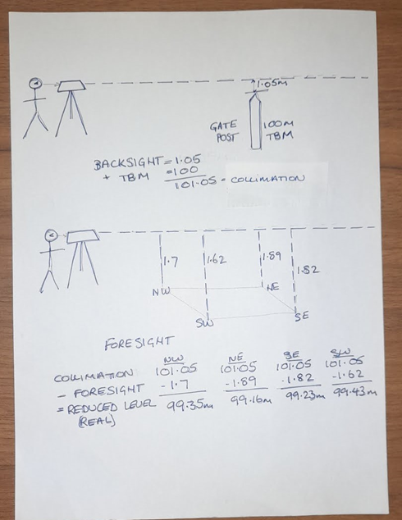
Fig 16. Photo authors own.2024.
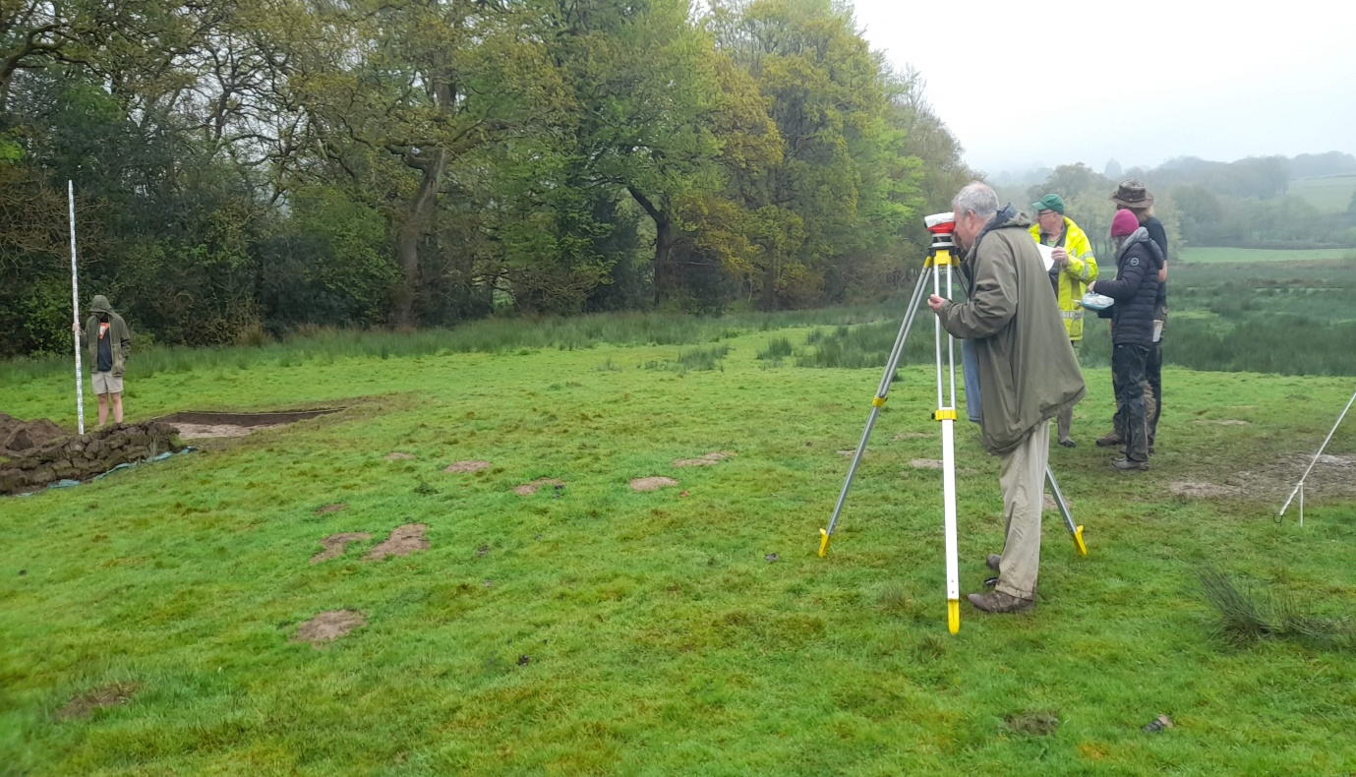
Fig 17. Mapping with Dumpy, and Levelling Staff. Photo authors own. 2024.
Artifacts are measured from their nail, the horizontal co-ordinates and Reduced Level are added alongside the context and given a number and brief description-Fig 17. As the dig progressed a total of 70 finds were discovered, adding to those found throughout the previous excavations.
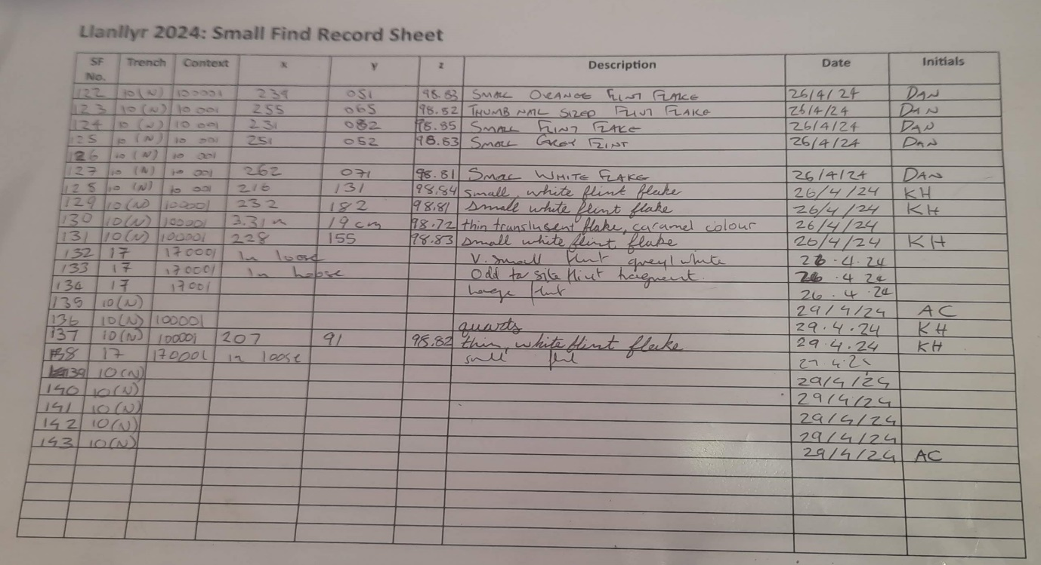
Fig 18. Photo authors own.2024.
The artifacts and features are mapped with the past finds to produce an accurate representation of contemporary activity, in a way not visible in the field, as excavation destroyed the evidence. For example, Tr10 below. Carbon has been removed for dating from both burnt areas, the results will follow. Tr10 N was lined before backfilling.

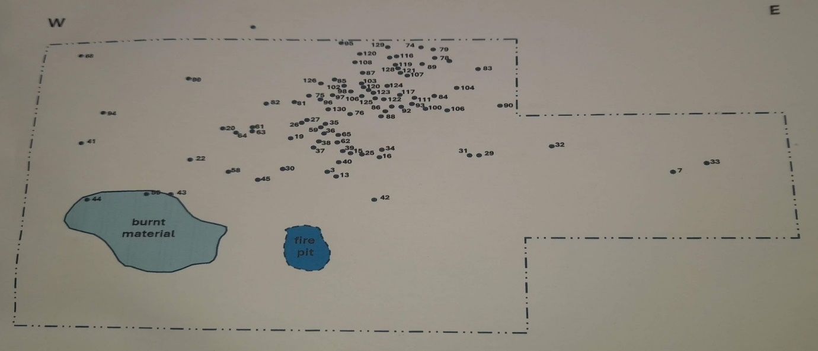
Fig 19. Photo authors own. 2024.

Geoarchaeology.
All trenches tell the story of landscape formation. The ones in Llanllyr reveal the hidden depth of wetlands in contrast to the mounds at their present height. Evidence of serial flooding and drought portrays a dynamic landscape.
Tr13 shows stratification from the lake/marsh edge flooding. Layers of allochthanous sediment over autochthanous peat horizons tell of alternate flooding which pools and deposits silt/clay, and exposed growth periods stable enough to create soil. The organic material is to be dated, indicating which layer corresponds to the knapping events on Mound 2, revealing the contours at that time.
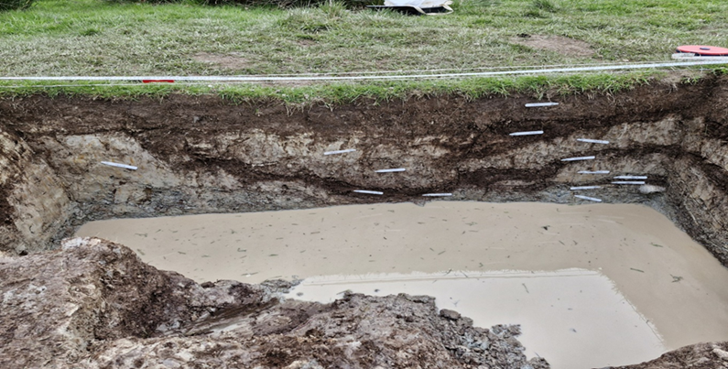
Fig 20. Trench 13 Section. 2024. Photo courtesy of Gareth Jenkins.

In Tr 10 S, polygon cracking of bare sediment surface suggests blistering sun and drought, leaving deep crevasses to fill with soil created by pioneer plants as conditions changed.
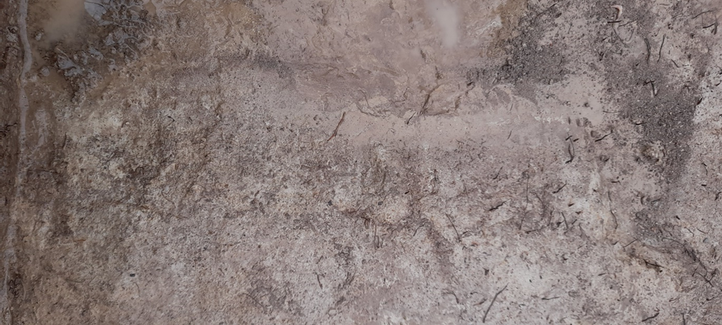
Fig 21. Y shaped remains of polygon cracking of sediment surface due to drought. 2024.

Tr 14 shows evidence of a strong body of water cutting through clay/silt sediment down to the gravel layer beneath. The steep incline of the cut demonstrates the power and volume of the flood that came down the valley in one event.
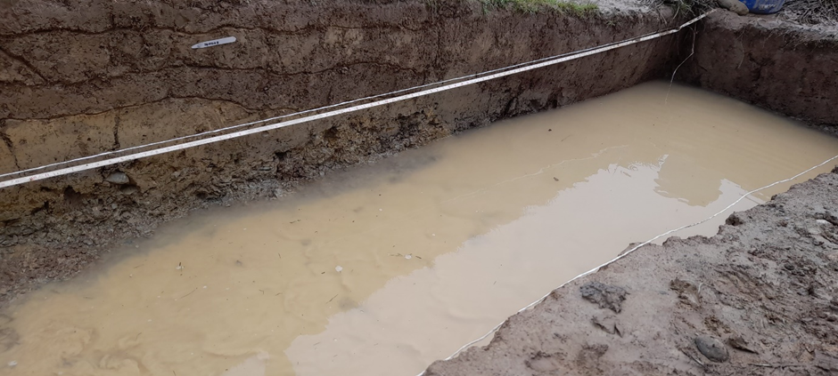
Fig 22. Cut through sediment to gravel layer from flooding event. 2024.

Post excavation analysis.
A session in the Laboratory on campus introduced us to analysing the monoliths and bore samples. The contents include animal and mineral substances. I was intrigued by Bore sample 9 from the transect to Mound 1 containing 10880BP organic layer from the marsh edge- Fig 23.
The core contains charcoal in several places, which can be dated. Presence in a gravel layer indicates probable transport from elsewhere in rapidly moving water. However, higher in the column there is charcoal in laminated sediment indicating slow water movement, that may be more useful in dating. There is also a possible hazelnut in sediment that needs more investigation. They decay quickly so being covered and preserved may reveal an accurate date of deposition. Hazelnuts can even indicate whether the microhabitat surrounding the tree was open or closed, as carbon isotopes vary according to an open sunny environment or a thick, shady forest .

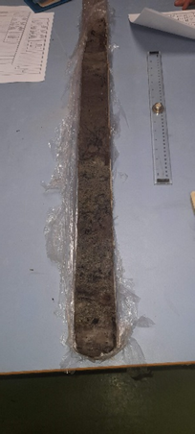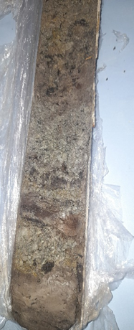
Fig 23. Bore sample 9, peat horizon 10880 BP. 2024.

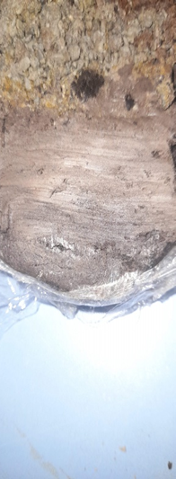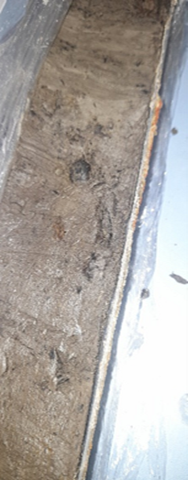

Fig 24. Charcoal in gravel at 10880BP horizon. Hazelnut in laminated sediment. 2024.

Summary.
This excavation has built on past results and further proven Mesolithic/Neolithic activity in this valley. The processes have taught me about meticulous methods working as a team in often rotten conditions, to produce results that yield maximum information in post excavation analysis.
This year I learnt to read historical environments in bore samples, monoliths and stratification. Geoarchaeology fills the valley with moving water and large islands, creeks sometimes baking in the sun and cracking, sometimes flooding with great force and volume, pooling here behind the restrictive hills further down the valley. Feeding the vegetation with rich silts, the warmth and shelter would make a garden of diversity, in contrast to the acres of grazing it has become.
The concentrated finds of flint debitage and firepit demonstrates at least one knapping event, with other flakes in less concentration across several fields showing a wide territory. Feeling immersed in the marsh and island landscape, it is possible to imagine relatively sophisticated Mesolithic life. Harvesting enough to be healthy and support others in the community from the raw environment was challenging, and this lush valley would be attractive. Nesting wildfowl, fishing, hunting small mammals and harvesting tubers and leaves would be possible. Our species had barely impacted the environment at this time, and this stirs strong emotion. What have we done since? It is like a grief.
When I take a break from study, I inevitably garden. Is this what happens when you live on a piece of land, with a need to maximise resources while minimising the effort it takes to gather them? Doing ‘gardening’ hits a button in the soul, answers a deep need that is subconscious. Putting brush down over a boggy patch to support access next spring is seeing into the future while looking at a puddle. Not being able to walk across my garden without compulsively tending my plot is surely a link with this past.

2263.

Images.
Fig 1,2,4. Courtesy of Martin Bates. Excavation: Introduction Llanllyr, Talsarn, 2022. Excavation, methods, techniques.
Fig 5,6,7. Courtesy of Martin Bates. Introduction to Llanllyr excavation 2024.
Fig 3,8,9,11,12,13,14,15,16,17,19,21,22,23,24. Photos authors own.
Fig 10, 20 Photos courtesy of Gareth Jenkins, student, UWTSD, Lampeter.

References.
Barker, Philip, Techniques of Archaeological Excavation, 3rd ed. (London ; Routledge, 1993) Available at: https://librarysearch.uwtsd.ac.uk/permalink/44WHELF_UWTSD/1pbrh66/alma99100107880002421 Accessed on 26.4.24.
Bintliff, J. L. (John L.), A Companion to Archaeology, 1st ed. (Malden, MA ; Blackwell, 2004) Available at: https://librarysearch.uwtsd.ac.uk/permalink/44WHELF_UWTSD/11c0l68/alma99100107940902421 Accessed on 28.4.24.

Bouldnor Cliff. Maritime Archeology Trust. 2024.Avaialble at: https://maritimearchaeologytrust.org/projects-research/bouldnor-cliff/ Accessed on 25.4.24.
Lotzof, K. Cheddar Man: Mesolithic Britain’s blue-eyed boy. Natural History Museum. 2024. Available at: https://www.nhm.ac.uk/discover/cheddar-man-mesolithic-britain-blue-eyed-boy.html Accessed on: 20.4.24.
Milner, Nicky, Chantal Conneller, and Barry Taylor, Star Carr. Volume 1, A Persistent Place in a Changing World (Sheffield, England ; White Rose University Press, 2018) Available at: https://librarysearch.uwtsd.ac.uk/permalink/44WHELF_UWTSD/1ir6fgh/cdi_oapen_primary_oai_library_oapen_org_20_500_12657_30156 Accessed on: 20.4.24.
Renfrew, Colin, and Paul G. Bahn, Archaeology : Theories, Methods and Practice, Eight edition, revised and updated. (London: Thames & Hudson, Limited, 2020) Available at: https://librarysearch.uwtsd.ac.uk/permalink/44WHELF_UWTSD/1pbrh66/alma99100327260202421 Accessed on 26.4.24.
Schofield, John, Paul. Belford, and John Carman, Archaeological Practice in Great Britain : A Heritage Handbook (New York: Springer, 2011) Available at: https://librarysearch.uwtsd.ac.uk/permalink/44WHELF_UWTSD/11c0l68/alma99122348802421 Accessed on 28.4.24.
Seeing the wood for the trees: using hazelnuts to reconstruct ancient woodlands. University of Oxford. News and Events. 1st Mar 2024. Available at: https://www.ox.ac.uk/news/2024-03-01-seeing-wood-trees-using-hazelnuts-reconstruct-ancient-woodlands Accessed on 5.5.24.
Simmons, Ian G., “The Mid-Holocene Ecological History of the Moorlands of England and Wales and Its Relevance for Conservation,” Environmental Conservation, 17.1 (1990), 61–69 Available at: https://librarysearch.uwtsd.ac.uk/permalink/44WHELF_UWTSD/1ir6fgh/cdi_proquest_miscellaneous_14249142 Accessed on 20.4.24.

Barker, Philip, Techniques of Archaeological Excavation, 3rd ed. (London ; Routledge, 1993)
Barker, Philip, Techniques of Archaeological Excavation, 3rd ed. (London ; Routledge, 1993)
Schofield, John, Paul. Belford, and John Carman, Archaeological Practice in Great Britain : A Heritage Handbook (New York: Springer, 2011)
Renfrew, Colin, and Paul G. Bahn, Archaeology : Theories, Methods and Practice, Eight edition, revised and updated. (London: Thames & Hudson, Limited, 2020)
Simmons, Ian G., “The Mid-Holocene Ecological History of the Moorlands of England and Wales and Its Relevance for Conservation,” Environmental Conservation, 17.1 (1990), 61–69
Milner, Nicky, Chantal Conneller, and Barry Taylor, Star Carr. Volume 1, A Persistent Place in a Changing World (Sheffield, England ; White Rose University Press, 2018
Bouldnor Cliff. Maritime Archeology Trust. 2024.
Lotzof, K. Cheddar Man: Mesolithic Britain’s blue-eyed boy. Natural History Museum. 2024.
Bintliff, J. L. (John L.), A Companion to Archaeology, 1st ed. (Malden, MA ; Blackwell, 2004)
Schofield, John, Paul. Belford, and John Carman, Archaeological Practice in Great Britain : A Heritage Handbook (New York: Springer, 2011)
Schofield, John, Paul. Belford, and John Carman, Archaeological Practice in Great Britain : A Heritage Handbook (New York: Springer, 2011)
Bintliff, J. L. (John L.), A Companion to Archaeology, 1st ed. (Malden, MA ; Blackwell, 2004)
Renfrew, Colin, and Paul G. Bahn, Archaeology : Theories, Methods and Practice, Eight edition, revised and updated. (London: Thames & Hudson, Limited, 2020)
Bintliff, J. L. (John L.), A Companion to Archaeology, 1st ed. (Malden, MA ; Blackwell, 2004)
Bintliff, J. L. (John L.), A Companion to Archaeology, 1st ed. (Malden, MA ; Blackwell, 2004)
Seeing the wood for the trees: using hazelnuts to reconstruct ancient woodlands. University of Oxford. News and Events. 1st Mar. 2024.

