“It is useless and tedious to represent what exists, because nothing that exists satisfies me…. I prefer the monsters of my fantasy to what is positively trivial.” Baudelaire, Salon Review 1859
Is Baudelaire’s position defensible in light of the case lens-based art-forms make to ‘represent what exists’? Or, from a contemporary perspective, do the ‘monsters of fantasy’ still allow artists to engage with ‘what exists’ creatively?

1701338

BA Photojournalism and documentary photography

2036 words

Paul Duerinckx

This essay is an analysis of a quote by Charles Baudelaire and hopes to explore the case lens-based image making with regards of representing what exists. It also hopes to look from more of a contemporary perspective weather the monsters of fantasy allow artists to creatively engage with what exists. Charles Baudelaire born April 9th, 1821, was a French poet, art critic, and philosopher. He is perhaps best known for his unique style of prose – poetry which influenced a whole new generation of poets including Arthur Rimbaud and Paul Verlaine. He is also credited with conning the term ‘Modernity’ meaning the quality or condition of being modern. Salon de 1859 is perhaps one of Baudelaire’s most important and impressive pieces of works. Although being a huge advocate for the modern; and in 1846 he even sought out a painter that would capture the modern dress and manners, he disliked the newest medium of the time Photography, so much so he put aside his search for a painter and his close ties to several realist painters including Courbet, Manet and the photographer Nadar.

“It is useless and tedious to represent what exists, because nothing that exists satisfies me…. I prefer the monsters of my fantasy to what is positively trivial.” (Baudelaire, 1859) Here Baudelaire is talking about the idea that what he imagines is far more exciting and interesting than anything that exits to be photographed. He claims that photographing what exists is “useless and tedious” possibly because it already exists to be viewed and so in his eyes there is simply no ned for it to be photographed and presented as art. While he does make a valid point here, there is a lot more to photographing what plainly exists, for instance the way a certain person photographs something and presents it can cause it to be seen in a completely different light to how it may have been viewed beforehand and thus changing people’s opinions and beliefs. He then goes on to say “nothing that exists satisfies me” (Baudelaire, 1859) this statement is very nihilistic and almost depressing as he is literally saying that nothing that exists makes him feel happy or even any kind of emotion, while this could well be true it is more likely to be exaggeration as he is trying to convey that the creations of his imagination are far more satisfying than anything captured by a lens. Next Baudelaire talks about preferring “the Monsters of my fantasy” (Baudelaire, 1859). For this quote I am looking at (Fig 1), George Rodgers photograph of a little boy walking down the road with rows of dead bodies on grass beside him. This photograph on its own is quite powerful but when you learn more details about the context and read the notes Rodgers took himself it becomes so much more. It shows us that the “monsters of our fantasy” exist in the real world and without photography these monsters would perhaps stay as just fantasy. While this is more of a literal interpretation of what Baudelaire means by monsters of my fantasy, it represents that even the most evil or ridiculous thoughts/nightmares can be made into reality and in these cases, it is the practice of photography that ensures they are remembered for either good or bad.
Looking at this quote from a more metaphorical interpretation Baudelaire is suggesting that the dark thoughts and torments of his mind, his monsters are much more interesting than what he sees around him, even though he cannot physically see what’s in his mind. Using this interpretation, it is easy to see why Baudelaire is opposed to the idea of “representing what exists” (Baudelaire, 1859) as there is nothing that exists that can compete with the demons of his mind, not just physically but also in a mental and psychological way, as nothing could give off the same atmosphere or feeling.
Baudelaire compares everything else to his monsters as “positively trivial” suggesting that nothing could be as complicated or meaningful, while this is a valid point because Baudelaire’s demons are his own and no one could ever know their impact. However, another French Philosopher Roland Barthes writes in his infamous book ‘Camera Lucida’, about a photograph of Jerome, Napoleon’s youngest brother taken in 1852 (Fig 2) “I am looking into he eyes that looked at the emperor” (Barthes, 1981). This quote talks about Barthes realisation of how through photography we can almost feel glimpses of a person’s life, of how through this photograph of Jerome he can feel the presence of the great Napoleon just by looking at the eyes that once witnessed him. This belief through photography is anything but trivial, it shows the enormous power of photographs, of how the can be used to make people, places, events etc. live for ever, immortal.

Eugen Atget’s photographs of the streets of Paris between 1897 and 1927, are a perfect example of the kind of photography that Baudelaire finds tedious and boring. However, Atgets work is widely known and widely praised among artists and critics, his historical documentation of Paris is far from the type of photography that could compete with Baudelaire’s ‘monsters’ but, yet this type of photography is not only needed but also contains a surreal sense of beauty and grace. It can easily be seen as bland or trivial, but these photographs have a much deeper meaning and conception than just photographs of Paris, not only is it one man’s legacy but it is also in a way a legacy of Paris, as half the buildings and places he photographed have been destroyed or no longer exist. The documentation of things now gone is in itself a type of art and can be perceived as fantasy by those who could not imagine such scenes existing and know only about them through photographs.

Walter Benjamin was a German Philosopher, essayist and cultural critic, who wrote a great deal on Baudelaire. His book “The writer of Modern life” consist of several essays about Baudelaire’s various poems and throughout his writing we find a strong identification with the poet, “With his social isolation, with the relative failure of his work, and in particular with the fathomless melancholy that suffuses every page” (Jennings, 2006). Benjamin writes that “Underlying Baudelaire’s writings is the old idea that knowledge is guilt” (Benjamin, 2006), with this in mind we can see that one of Baudelaire’s reasons for hating photographs of what exists is because of guilt. Because photographs like Eugen Atget’s give us knowledge of what exists or what has existed, while the scenes inside his mind are all fantasy and don’t hold the truth of knowledge.

Gregory Crewdson is an American photographer who specialises in creating “Tableaux” of American homes. His work depicts surreal and disturbing or melancholy scenes mostly set in small mid-western towns. Each photograph or scene takes weeks and months to set up with some even having over 100 crew members working on it, all for just one perfect shot. Crewdson openly admits that Spielberg’s film close encounters of the third kind is a direct influence on his work. Like in the film Crewdson’s own characters perform eccentric, ritual like acts. Another heavy influence for Crewdson was his own father and experiences from his childhood. Crewdson’s photography is in a way representing peoples “Monsters of Fantasy” (Baudelaire, 1859) through a lens. He crafts these surreal almost dreamlike scenes that represent our own psychological anxieties, fears and longings, they show an almost subconscious side of humanity were all are monsters exist. This photograph (Fig 3) by Crewdson is a perfect example of the feelings Baudelaire claims can’t be produced through lens-based image making. It depicts a woman floating in dark water that’s flooded a living room (presumably hers), she wears a thin white night dress and there is the impression of sunlight seeping through the blinds and curtains, yet the room is still fairly dark. The connotations of the girl floating among the dark murky water is feelings of depression and anxiety, as if the water is a representation of this emotions and they’re slowly drowning her and as they pile up, they begin flooding her life. The stark contrast between her bright white clothes and the black water submerging her portrays the idea of her innocence and purity being corrupted by these mental aliments as people suffering from such diseases are seen as broken or impure. The use of lighting is another way Crewdson shows these ideas, as we can assume that due to the bits of sun coming through that it’s the middle of the day or some time during the day, this reinforces the idea of depression as lots of people suffering find it hard to get put of bed or leave the house, it also shows a different perspective for those un educated about it as it is commonly associated with the night and darkness. Crewdson’s work from 2009 (Fig 4) shows a different side to the idea of representing “the monsters of fantasy” (Baudelaire, 1859), with several black and white prints that depict what look like abandoned and derelict sites avoid of all human presence, which is unlike all his other photographs that use people as one of the key subjects in making his eerie and disturbing pictures. However, having this lack of people doesn’t take away from the effect it only changes the context to more of a dystopian and nihilistic feel, almost like the troubles of one’s mind portrayed as a landscape or how the world would be affected if it too had theses monsters.

“Photographs bear witness to a human choice being exercised in a given situation. A photograph is a result of the photographer's decision that it is worth recording that this particular event or this particular object has been seen. If everything that existed were continually being photographed, every photograph would become meaningless”. (Berger, 1972) This quote by John Berger relates to both sides of Baudelaire’s argument. Here Berger talks about how a photograph is more an extension of the photographer as it only exists due to the photographer believing it is “worth recording” and so this belief and decision creates the meaning behind it, making it more than just a photograph. Another way of looking at this is the idea that through looking at what people photograph you can learn a lot about them as most people will tend to see different things worthy of being recorded. Berger then goes on to say that if “everything that existed ……. Was photographed …… every photograph would become meaningless” (Berger, 1972). This is related to how Baudelaire sees photography, he sees it simply as a means of recording everything around you and that that’s its only use and so he can’t accept it as an art form because he believes it will cripple itself with overuse. If this was true then as Burger says every “photograph would become meaningless” (Berger, 1972) and while this hasn’t happened yet, in the modern age with every phone having a built-in camera and everyone able to practice this once rare medium we are at risk of everything becoming mundane and “trivial” with nothing having meaning anymore.

In conclusion it is unjust to judge Baudelaire’s position on photography not being an acceptable art form, as at the time of his writings the medium of photography was just beginning, his quote was written only 20 years after the daguerreotype process was introduced, and so with such limited technical capabilities it is easy to see how someone can see no way of experimenting especially compared to the other art forms such as painting that had been around for hundreds of years with constant experimentation, however as a pioneer of the modern it is contradictory for him to be so against this ‘new’ medium of art. With all the photographic technology and capabilities we have today, the ideas Baudelaire discussed as being imposable to convey through photography, are more than capable and hopefully the ways and people that have portrayed them have been highlighted in this essay, it would also be fascinating to see if Baudelaire’s position would be different today considering these advancements in technology and art.

Bibliography:

Barthes, R. (1981) Camera Lucida. USA: Hill and Wang
Baudelaire, C. (1859) Salon Review. Paris: Révue Française
Benjamin, W. (2006) The Writer of Modern Life. Cambridge: Harvard University press
Berger, J. (1972) Selected essays and articles: The Look Of Things. UK: Penguin

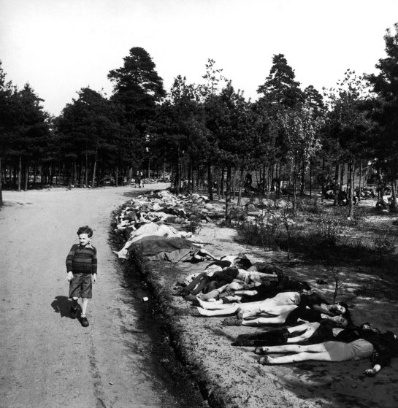
(Figure 1)
Rodger, R. (1945) Bergen-Belsen, Life Picture Collection/Getty Images Available at: http://time.com/3679103/at-the-gates-of-hell-the-liberation-of-bergen-belsen-april-1945/ (accessed: 12th December 2018)

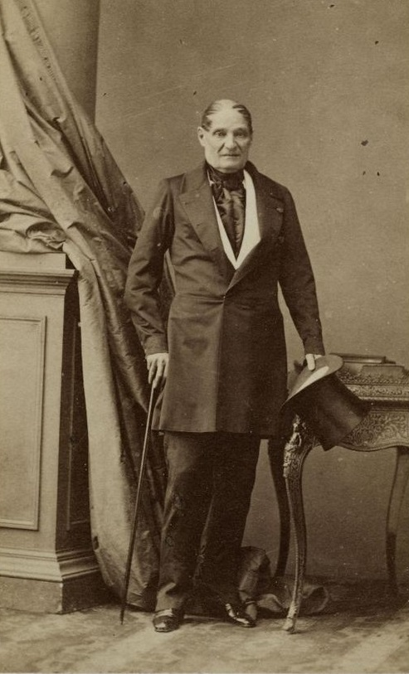
(Figure 2)
Disderi, A. (1852) Jerome Bonaparte, Available at: https://shannonselin.com/tag/jerome-bonaparte/ (accessed: 12th December 2018)

(Figure 3)
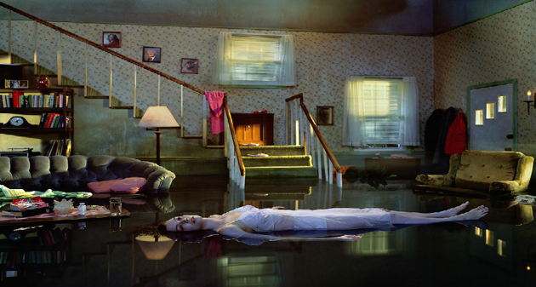
Crewdson, G. (2001) Untitled, Twilight Series Available at: https://uk.phaidon.com/agenda/photography/articles/2012/november/13/gregory-crewdson-laid-bare-in-new-film/ (accessed: 12th December 2018)

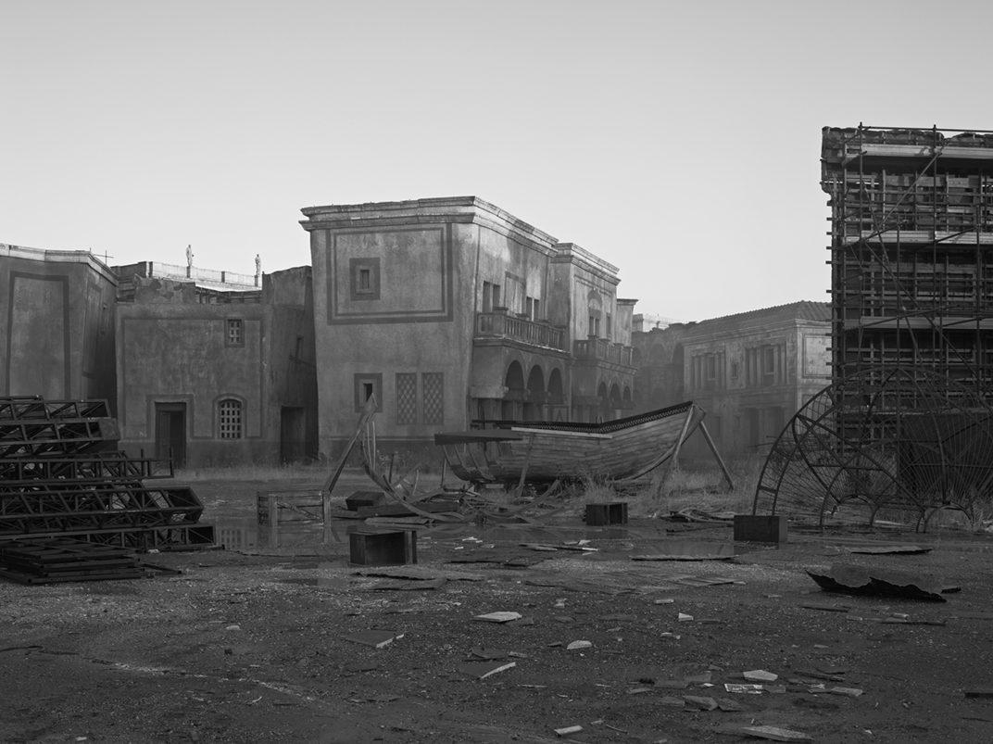
(Figure 4)
Crewdson, G. (2009) Untitled 09, Available at: https://www.thebroad.org/art/gregory-crewdson (accessed: 12th December 2018)

