Smart Home Device
University of Wales Trinity Saint David
Birmingham Campus

Name: Gabriel Mendy Gbonegun
Student Number: _2426964
Course Title: BSc Applied Computing
Module: Scripting and Programming Concepts (ACCA5036)
GitHub Link: https: https://github.com/GabrielM-223/scripttingandprogramming/blob/main/CodePycharm

Introduction
Handling smart devices manually by the staff of Bright Minds Academy is time-consuming and not effective. Such an approach prevents keeping track of all connected devices, testing their functionality, and monitoring the last date of use. The issue becomes even bigger with the increasing usage of smart technology in educational institutions to enhance the quality of teaching and management processes]. Without a centralized management system that automates such activities, it is difficult to use the potential of the devices efficiently. 2.0 Requirement Analysis. [1]
Smart Home Device Manager solves these crucial challenges through providing an effective tool for tracking smart devices within the academy. Using the software, users will be able to automatically register new smart devices, change their status from online to offline and vice versa or put it to the maintenance mode. Also, it allows seeing the full list of registered devices and finding a certain device according to its name. Such automation is essential to maintain a clean and operative smart classroom environment, minimize manual operations and make sure that the required device will be available and operational on time. The proper IoT device management facilitates development, improves availability and reduces complexity, particularly of smart classroom. Through organizing the data about IoT devices, the software deals with the most frequent challenges such as connectivity and interoperability problems [1]

2.0 Requirement Analysis
Smart Home Device Manager will help Bright Minds Academy with the issue of manual device management. The following key features will be focused to simplify tracking and updating status of smart devices[2].
Add Device with Room: Staff members have an opportunity to add a device by its name and specify the room it belongs to. Such a feature creates an inventory of devices and places. Thus, it will fix the problem of tracking and make it possible to understand which device is connected and in which room it is placed.
Update Status (Online/Offline/Maintenance): Staff will be able to update the status of any device. The statuses that are predefined include Online, Offline, and Maintenance. With such a feature, it will be easier to identify problems, reduce downtime, and use the resources efficiently[2].
View All Devices: Will present the list of all devices that were added along with their rooms and statuses. This way, it will be easy to overview all the assets and resolve the difficulty of tracking all the devices.
Search a Device by Name Staff members will be able to search a device by its name and get necessary information including its status and usage. Such features provide an efficient and pragmatic solution to the problem of manual device management. They provide the basis for further improvements and make the solution feasible and easy to use for academy staff[2].

MoSCoW Table

Priority | Requirement | Description
Must Have | Add Device | The system should allow the user to register a new device along with its name and location.
Must Have | Update Status | The system must allow users to update the status of a device (online, offline, maintenance).
Must Have | View All Devices | The system must display a list of all registered devices and their current statuses.
Must Have | Search Device | The system must allow users to search for a specific device by its name.
Should Have | Input Validation | The system should validate user inputs to prevent errors ensuring a valid status is entered.
Could Have | Data Persistence | The system could save device data to a file so it is not lost when the program exits.
Won't Have | Real-time Control | The system will not have the capability to physically control the devices in real-time for this iteration.

Structured Diagram

A structured diagram (or structure chart) represents the hierarchical structure of modules in a system. It shows how the program is broken down into smaller, manageable functions. |
Smart Home Device

Update status
Search Device
View All Devices
Add Device

3.0 Software Design and Development
The stages of software design and development become the initial significant steps in creating high-quality software products. In the stage of design, the developer plans the structure of the system and its components, the way they interact with each other and the data that will be used. Such thorough planning contributes to creating a software product that is not only functional but also can be maintained, developed further and run with high performance. It decreases the possibility of errors in programming, cuts costs and increases the quality of the product. By implementing structured design process, developers are able to recognize potential problems, pick up appropriate technologies and make an effective plan of action[3].

3.1 Design

3.1.1 Flowchart
A flowchart is a chart consisting of connected boxes, with lines showing the order of execution of actions or decisions in solving a problem, performing a procedure or completing a process. The purpose of creating such charts varies depending on the situation. In software development, however, flowcharts have a single main purpose. Namely, flowcharts allow developers to present the logical scheme and the required sequence of actions to be executed in order to solve a problem visually [3].
Another advantage of working with flowcharts is that they give programmers a chance to think about the future code prior to implementation. In other words, this kind of visualization can be used to detect possible mistakes in advance and make sure that logic is right. Thus, a flowchart allows making a solution better. In addition, flowcharts are helpful when it comes to describing how input and output data are generated [3].
Purpose of Flowchart
The flowchart created by me aims to present the logic of the Smart Home Device Manager program in details before the process of coding starts. It shows in succession how the program initializes, how the main menu appears on the screen, how it accepts and analyzes the user’s input, performs certain action according to it, and whether returns back to the menu to do something else or exits the program after finishing working [4].
As far as my particular assignment is concerned, the flowchart turns out to be very helpful due to its ability to demonstrate in detail the architecture of the whole system. It presents in an easy-to-understand form the main decisions that should be made, namely whether to add, update, view the list, find a certain device, or exit from the program [4].
Flowchart Logic – improve the logic below
Describe the flowchart logic by providing step-by-step representation
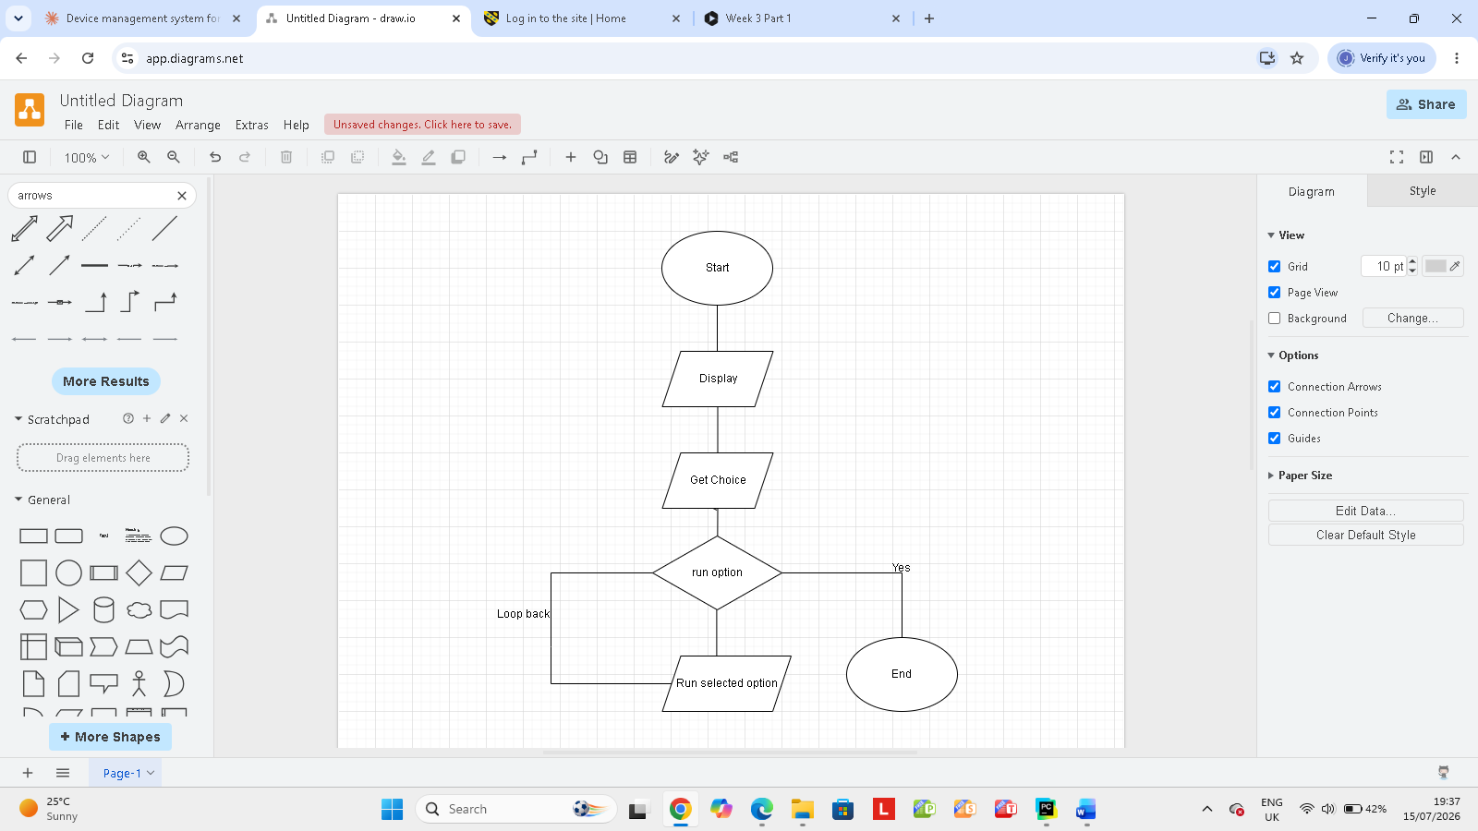

Input | Process | Output
Device name, room | Add the new device to the list with status offline | “Device added successfully”
Device name, new status | Check if status is valid, then update the matching device | “Status updated” or “Device not found”
None, or user selects view option | Loop through all stored devices | Display all device names, rooms, and statuses
Search name | Find matching device names in the list | Display matching device details or No devices found”

Figure 1: Smart Home Device Manager Flowchart

3.1.2 Pseudocode
Pseudocode acts as a very easy way of presenting the structure and steps involved in a computer program or an algorithm. This is done by mixing up a natural language with certain programming constructs to present an algorithm without the help of the exact syntax of any specific programming language. Using pseudocode, a programmer is able to look at the logic of the program or an algorithm before using any programming language in its creation. Pseudocode acts as a tool through which a programmer connects the natural language he uses to a programming language. [5].
START
SET devices to an empty list
FUNCTION display_menu()
DISPLAY "Smart Home Device Manager Menu:"
DISPLAY "1. Add a new device"
DISPLAY "2. Update device status"
DISPLAY "3. View all devices"
DISPLAY "4. Search device by name"
DISPLAY "5. Exit"

FUNCTION add_device()
INPUT name
INPUT room
CREATE new device with name, room, and default status "offline"
ADD new device to devices
DISPLAY "Device added successfully"

FUNCTION update_status()
INPUT name
INPUT new_status
SET found to FALSE
FOR each device in devices
IF device name equals name THEN
SET device status to new_status
SET found to TRUE
DISPLAY "Status updated successfully"
STOP loop
END IF
END FOR

IF found = FALSE THEN
DISPLAY "Device not found"
END IF

FUNCTION view_devices()
IF devices is empty THEN
DISPLAY "No devices registered"
ELSE
FOR each device in devices
DISPLAY device name, room, and status
END FOR
END IF

FUNCTION search_device()
INPUT name
SET found_devices to empty list

FOR each device in devices
IF name is found in device name THEN
ADD device to found_devices
END IF
END FOR
IF found_devices is empty THEN
DISPLAY "No devices found"
ELSE
FOR each device in found_devices
DISPLAY device name, room, and status
END FOR
END IF
FUNCTION main()
WHILE TRUE
CALL display_menu()
INPUT choice
IF choice = "1" THEN
CALL add_device()
ELSE IF choice = "2" THEN
CALL update_status()
ELSE IF choice = "3" THEN
CALL view_devices()
ELSE IF choice = "4" THEN
CALL search_device()
ELSE IF choice = "5" THEN
DISPLAY "Exiting Smart Home Device Manager. Goodbye!"
STOP
ELSE
DISPLAY "Invalid choice. Please try again."
END IF
END WHILE
CALL main()
END

Purpose of the Pseudocode
My aim with respect to pseudocode for my project is to give a clear and precise description of how Smart Home Device Manager will work before writing the actual code. Pseudocode presents the process from display of the menu all the way through getting input from the user and then executing the appropriate function [6].
Pseudocode is very useful in this case since it allows one to think of the logic of the solution without concerning oneself about the syntax of Python. It helps to make the process of programming clearer, detect errors beforehand, and arrange the solution before programming begins. Moreover, the pseudocode will serve as a means of connecting the solution to the actual programming [6].
In my Smart Home Device Manager, the pseudocode will describe the menu looping, the different functions that can be performed by devices, and finally the exit procedure[6].

Pseudocode Logic
Pseudocode allows one to see exactly how the program will work when writing its Python code. In fact, each block of pseudocode will transform into a function or a certain control construction in the future program[6].
First of all, the pseudocode creates the list that contains the devices and then builds up the process of displaying the menu, adding the device, updating the status of it, viewing all devices and searching the device into a sequence of separate blocks. All these blocks will be individual functions in the final Python program. Besides, the main loop of the pseudocode will turn into a while True loop in the program, allowing it to keep working until the user decides to finish it[6].
Finally, the pseudocode will define the part related to decision making, namely the part where the program analyzes the choice of the user and decides what to do next. This way, the pseudocode will create the if, elif and else statements in the Python code. It will allow the program to call the corresponding function depending on the choice made by the user[6].

Thus, the pseudocode will serve as the blueprint of the program.
Main Loop

This particular loop forms the basic building block which is responsible for maintaining the operation of the Smart Home Device Manager until the user wishes to close the program. The main purpose of the loop is to repeat the display of the menu to the user, get the input from the user about their choice and direct the program to perform the required operation based on the user’s decision. The looping feature is necessary in order to provide the opportunity to the user to perform different operations in one session without the necessity to start the program again after each operation[7].
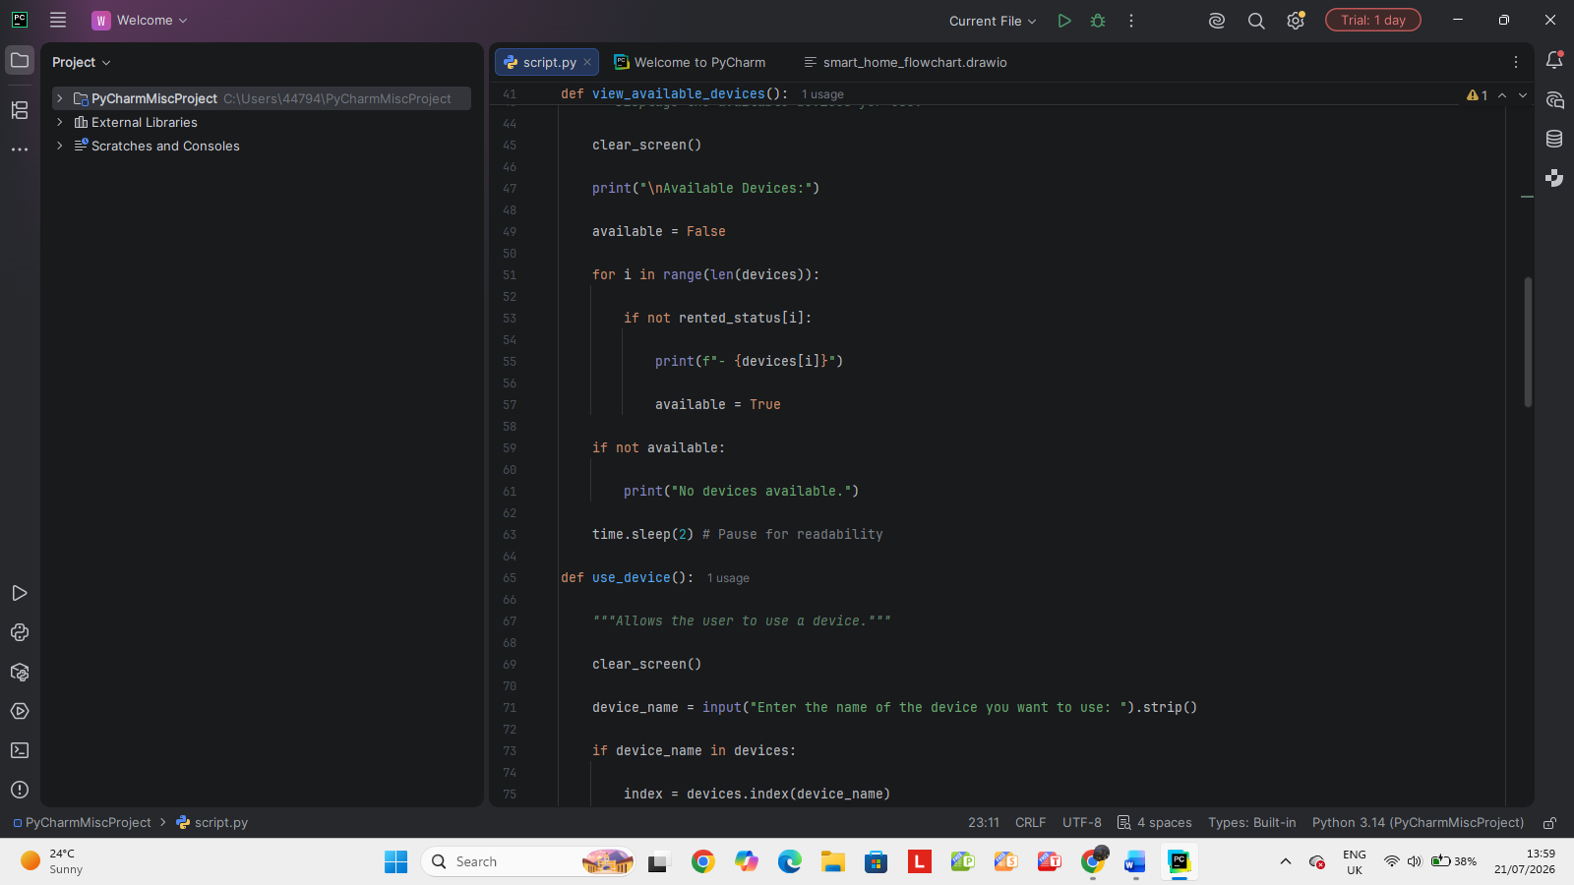

This function allows adding of a device in the system by taking the name of the device and its location. Once the device has been added successfully, it will display a successful message. The importance of this function is that it helps in creating a list of devices to be used in other parts of the program [7].

Implementation Decisions

Data Structures
Data structure is an efficient way to represent and store the information on a computer for future usage. The choice of appropriate data structures in software engineering is an important step during the process due to its influence on efficiency, scalability and maintenance of the program. In the context of Smart Home Device Manager project, the primary data structure representing the devices will be the list of Device objects[8].
Python lists are ordered and mutable collections of arbitrary items of any type . It allows great flexibility since the number of smart devices at Bright Minds Academy may vary. All elements in the self. Devices list of the SmartHomeManager class are objects of Device type, thus it becomes simple to iterate through all registered devices as well as adding or removing particular ones from the list [8].

Give overview of all variables used in your code and why
The variables in the program code become the key factors that help to identify the way data is stored and manipulated in the program. Of these variables, the devices variable is inclusive of all the names of the devices in the system. The variable "rented status" indicates whether the particular device is rented or not. "Available" variable determines whether there are devices available or not. Device name variable includes the particular name of the device that the user selects for himself. Index variable shows the location of the device in the array and choice variable indicates the menu choice of the user. [9] .

Variable name | Data type | Purpose
_{devices} | _{List} | Stores all the devices in the system.
_{rented_status} | _{List of Boolean values} | Tracks whether each device is currently in use.
_{available} | _{Boolean} | Shows whether any device is available.
_{device_name} | _{String} | Stores the name entered by the user.
_{index} | _{Integer} | Stores the position of a device in the list.
_{choice} | _{String} | Stores the menu option selected by the user.

3.2.2 Programming Constructs
Programming constructs are the fundamental building blocks used to control the flow and execution of a computer program [9] . They determine the order in which lines of code are executed, allowing programs to make decisions, repeat actions, and organize code into reusable blocks. The Smart Home Device Manager utilizes several key programming constructs to achieve its functionality [9].

Control Structures (If Statements and Loops):
Control structures are essential for directing the program's logic based on specific conditions or the need for repetition. If/Elif/Else Statements are used extensively in the main function to process the user's menu choice. By evaluating the choice variable, the program determines which specific action to execute. While loops are employed in the main function to create an infinite loop that continuously displays the main menu and processes user input. For loops are used to iterate over the self. devices list to view or update device details [10].
Functions:
Functions represent snippets of code that perform certain actions. Their purpose is to make the code more modular and thus make it more readable, testable, and maintainable [11]. The functions with the important functionality are placed in the methods of the SmartHomeManager class in this project. In addition, the main function acts as an entry point for the whole program [11].
Error Handling:
This is only a prototype, but there are some basic error-checking procedures that can be implemented easily. For instance, when a user selects something inappropriate from the menu, the else portion of the main procedure displays an appropriate message to the user. Moreover, while performing editing or search operations on a device, the application verifies the presence of the device, and if not present, an appropriate message is displayed [12].

Python Modules and Libraries
pythons’ definitions and statements such as functions, classes and variables. This aids code organization and reuse. The Python library is simply a set of such modules providing additional capabilities. The application of modules and libraries allows us to make the code reusable, well organized and suitable for complex operations by using the code which was already written and tested [ 13].
As far as the Smart Home Device Manager project is concerned, the implementation is done in a simple and concise way. Primarily, it utilizes built-in features and data types provided by Python itself. No additional Python modules or libraries have been imported in order to ensure the simplicity of the system [13].

Testing and Debugging

Role of Testing in Software Environment
Testing the program during software development is an important activity. Testing includes examining the performance and functionality of a software application and its reliability, ensuring that it meets all requirements and expectations of the stakeholders [12]. Testing plays a very significant role in several ways in the course of software development [12].

First of all, software testing helps developers identify and eliminate potential defects or errors in the development process at an early stage, where it is less costly and resource-consuming to do so. In addition, software testing evaluates the quality and dependability of the software. Testing various aspects and cases proves that software performs correctly and satisfies customer needs [12].
Furthermore, software testing ensures that software corresponds to the initial requirements and plan. Therefore, software testing is an important process of developing software effectively and of high quality [12].
Types of Errors in Programming
Programming involves making errors at times. There are three major types of errors, which include: syntax error, logic error and runtime error.
Syntax Errors:
This occurs when the coding violates grammatical structures of the language. They are detected by the compiler/interpreter before execution. These errors can be exemplified by the lack of colon or incorrect indentation [13].
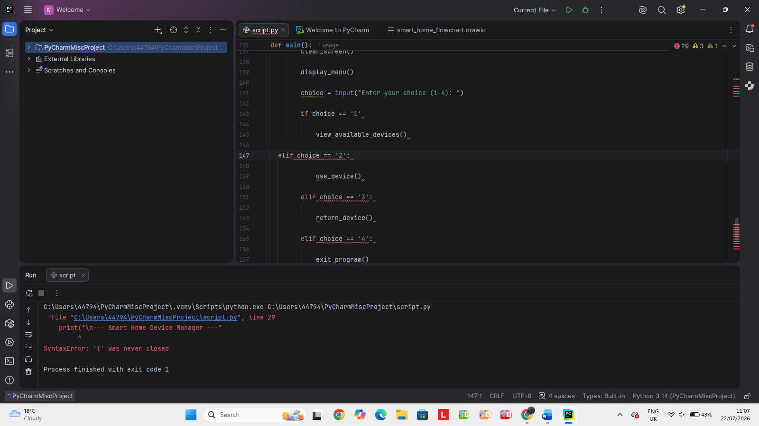
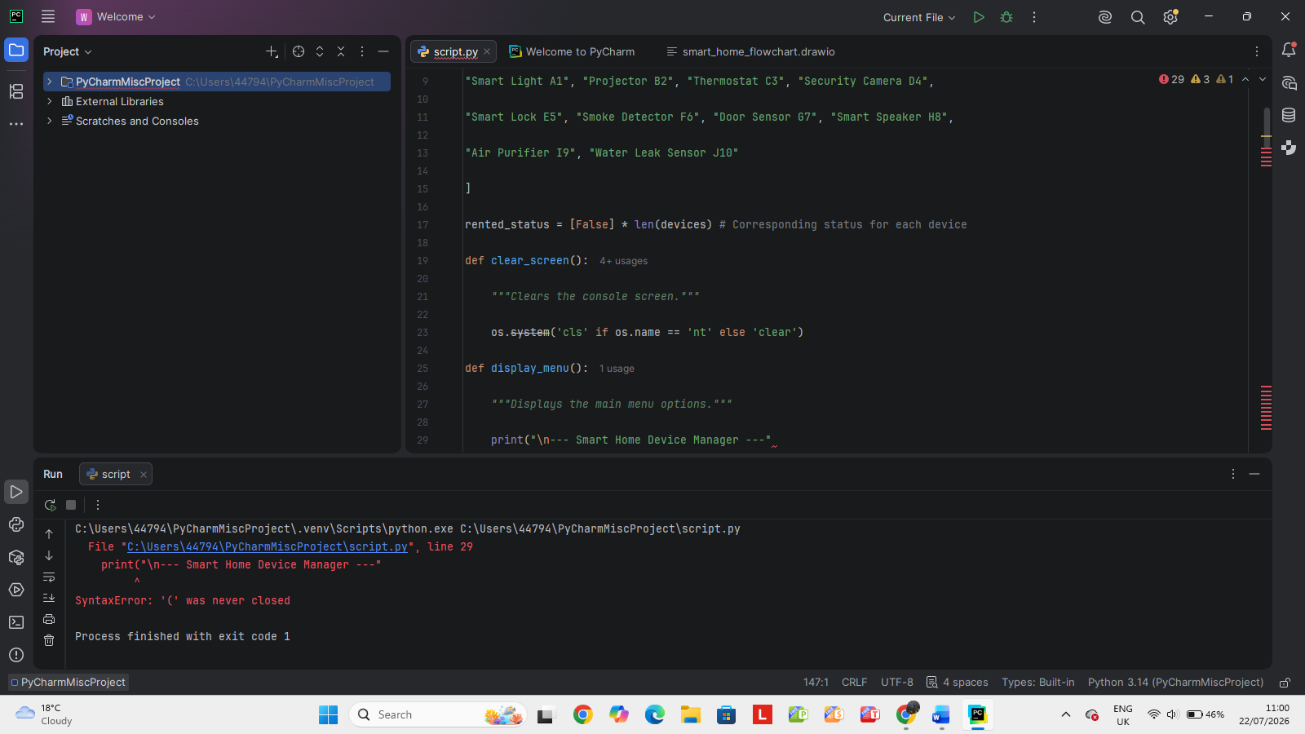
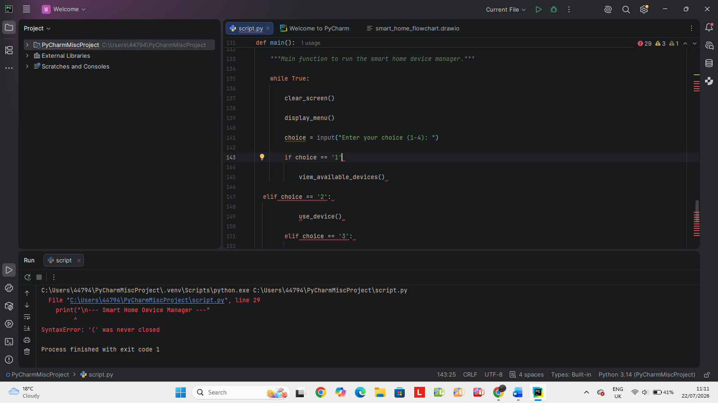
Logic Errors:
They are faults that occur when the code runs successfully without breaking down but gives erroneous output. This kind of error occurs due to faultiness in the algorithm or logic being used by the programmer. An example of such is the application of wrong mathematical equations[14].

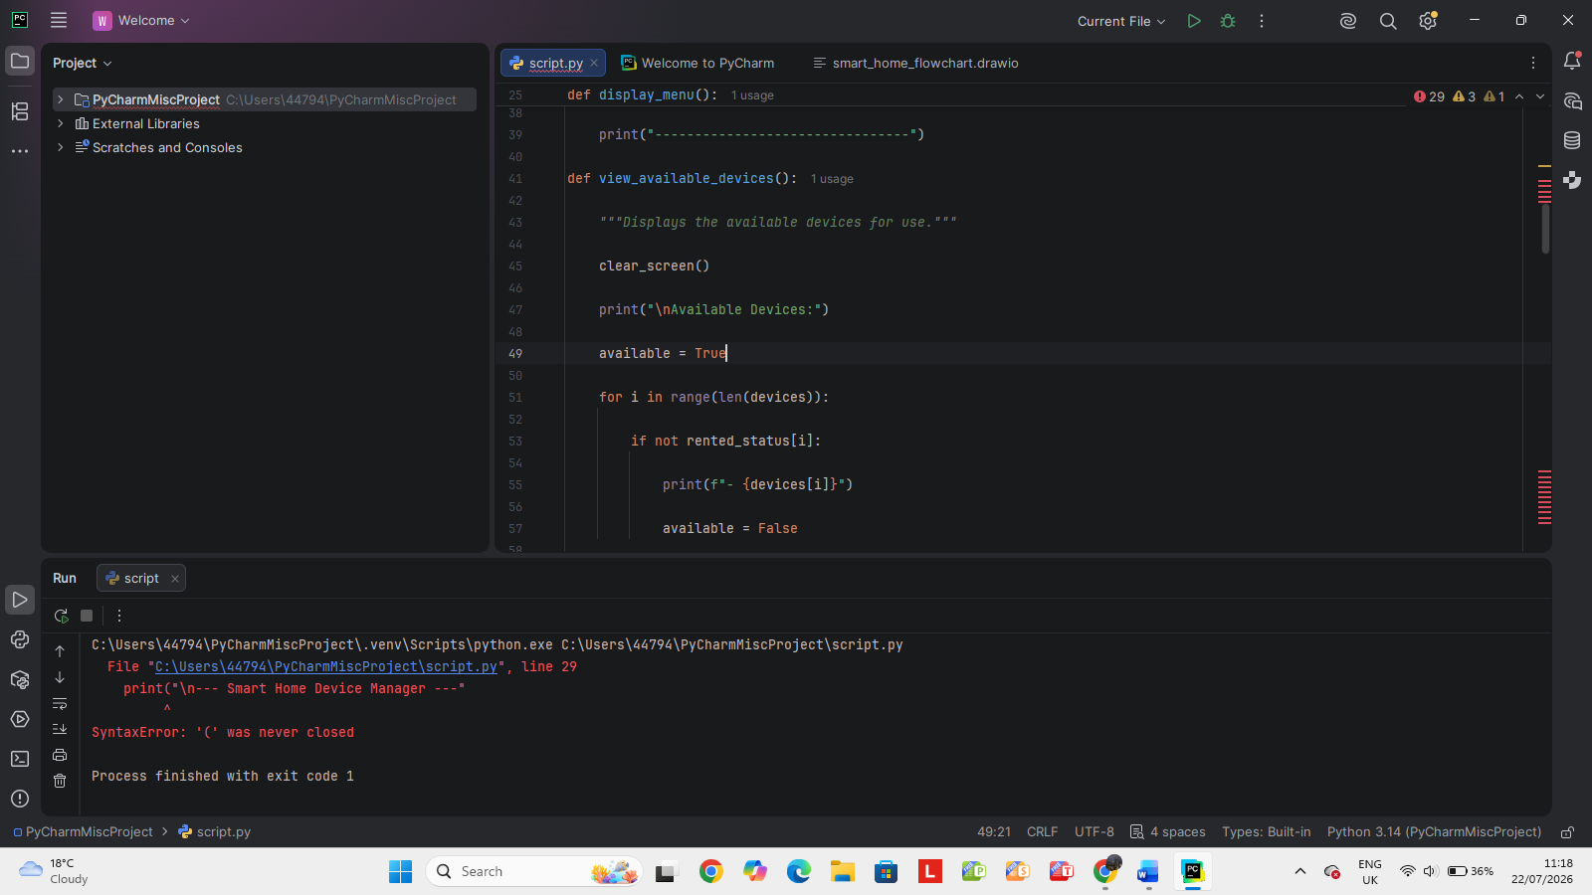
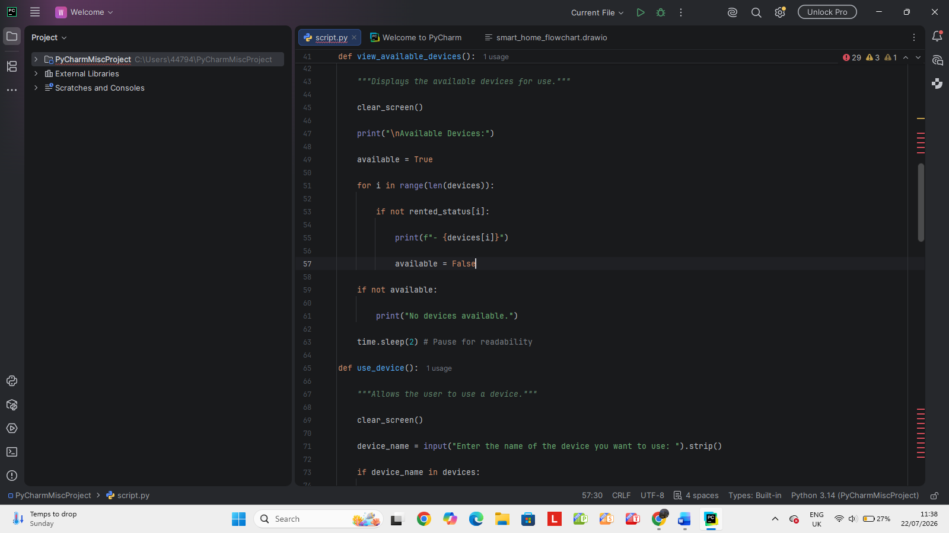

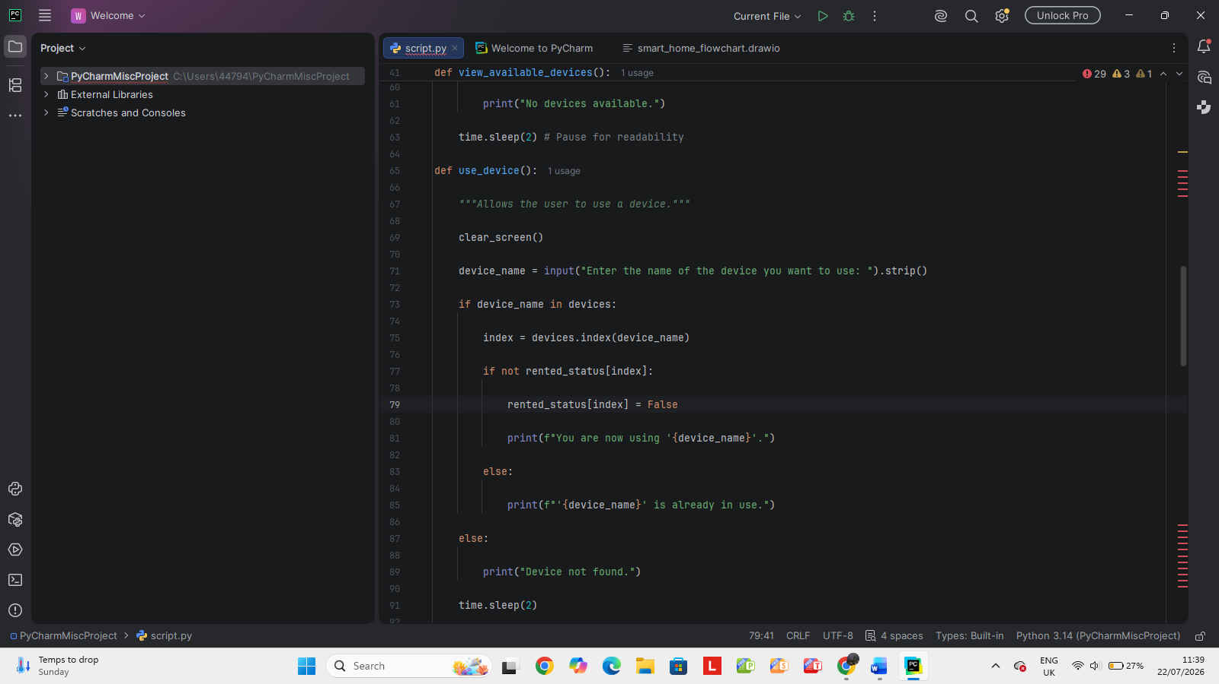

Runtime Errors:
These are the types of errors which appear when the program is being executed, that is, once the program has passed through its syntax check. Common examples of such errors are division by zero and usage of undefined variables [15].
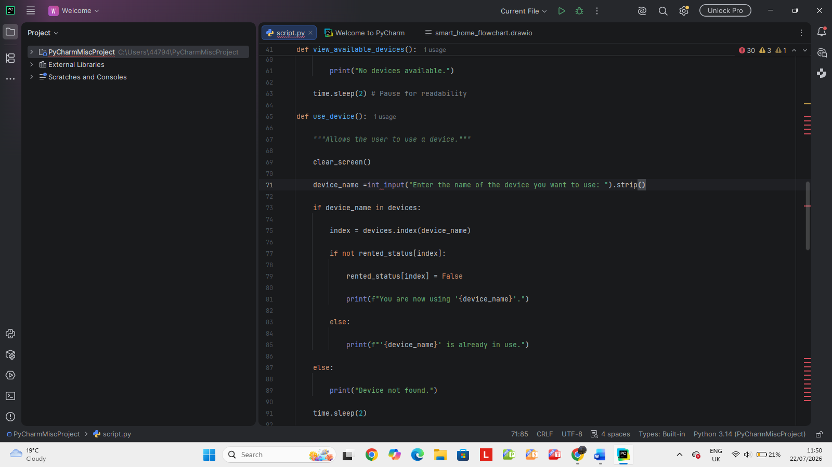
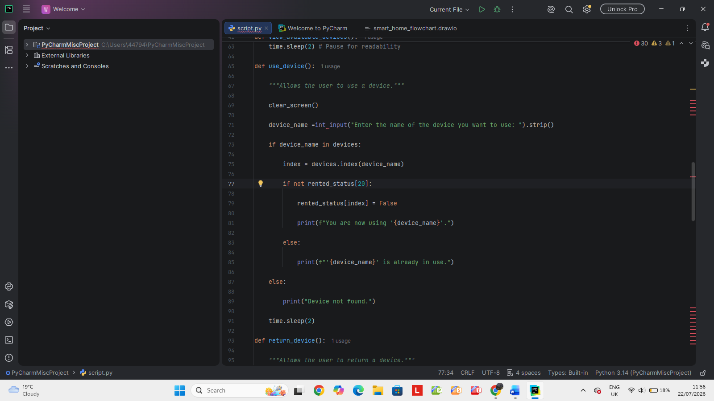

4.3 Example of Test Cases
It is important to create complete test cases in order to ensure that the Smart Home Device Manager operates properly. In order to do this, the test cases were designed in such a way as to cover normal and edge scenarios.

Test Case 1: Adding a New Device (Normal Case)
Objective: Verify that a new device can be successfully added to the system.
Steps: Select option 1, Enter device name: SmartLight01, Enter room: LivingRoom.
Expected Output: Device 'SmartLight01' added successfully in LivingRoom.
Field | Content
Test Case ID | TC002
Test Case Title | Return a device
Objective | Verify that the system correctly marks a used device as returned.
Preconditions | The system is running, and one device is already in use.
Test Steps | 1. Select “Return a Device”. 2. Enter the device name.
Test Data | “Smart Light A1”
Expected Result | The system displays that the device has been returned.
Pass/Fail | Pass
Comments | Screenshot taken of the returned message.

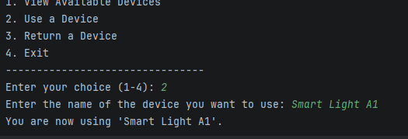

Test Case 2: Updating Device Status (Normal Case)
Objective: Verify that the status of an existing device can be updated.
Steps: Select option 2, Enter device name: SmartLight01, Enter new status: online.
Expected Output: Status of 'SmartLight01' updated to online.

Field | Content
Test Case ID | TC002
Test Case Title | Use a device successfully
Objective | Verify that an available device can be marked as in use.
Preconditions | The system is running, and the selected device is not currently in use.
Test Steps | 1. Select option 2. 2. Enter device name: Smart Light A1.
Test Data | Smart Light A1
Expected Result | You are now using 'Smart Light A1'.
Pass/Fail | Pass
Comments | Screenshot taken of the successful device use message.

Test Case 3: Searching for an Existing Device (Normal Case)
Objective: Verify that an existing device can be found by its name.
Steps: Select option 4, Enter device name to search: SmartLight01.
Expected Output: Name: SmartLight01, Room: LivingRoom, Status: online
Field | Content
Test Case ID | TC003
Test Case Title | View available devices
Objective | Verify that the system displays the list of available devices.
Preconditions | The system is running and at least one device is available.
Test Steps | 1. Select option 1.
Test Data | N/A
Expected Result | The system displays the available devices, such as Smart Light A1, Projector B2, and other devices not currently in use.
Pass/Fail | Pass
Comments | Screenshot taken of the available devices list.

Test Case 4: Searching for a Non-Existent Device (Edge Case)
Objective: Verify that the program handles searches for devices that do not exist gracefully.
Steps: Select option 4, Enter device name to search: NonExistentDevice.
Expected Output: No devices found matching 'NonExistentDevice'.

Test Case 5: Invalid Menu Choice (Edge Case)
Objective: Verify that the program handles invalid menu inputs.
Steps: Enter choice: 6.
Expected Output: Invalid choice. Please try again.

5.0 Evaluation

5.1 Challenges Faced
During the development of the Smart Home Device Manager, several challenges were encountered. One significant challenge was related to the Python interpreter and environment setup, particularly when working with IDEs like PyCharm. Initially, there were issues with ensuring the correct Python interpreter was recognized and configured, leading to difficulties in running the script. The resolution involved carefully configuring the project interpreter settings in PyCharm. This experience highlighted the importance of a well-configured development environment.
Another challenge was in implementing robust input validation for user interactions. While the initial design focused on core functionalities, ensuring that user inputs were always in the expected format proved to be more intricate. This was addressed by implementing conditional checks to verify user input against a list of acceptable values. Furthermore, debugging logic errors presented its own set of difficulties. Identifying subtle discrepancies required systematic testing with diverse inputs and careful tracing of the program's execution flow.

Future Improvements
This current version of Smart Home Device Manager is a base solution, but there are some future improvements expected from this software that can greatly increase its efficiency.
Data Persistence: Right now, all data about devices are stored in volatile memory and get erased when the program ends. It is very important that the system will have functionality for data storage in files or databases[17].
that only authorized personnel can access and modify device information.
GUI (Graphical User Interface): The creation of a GUI will enhance user experience and accessibility of the system by all the employees. Database Connectivity: The connection to an enhanced database will facilitate efficient data management, complicated querying, and reporting [18]. User Authentication and Login System: The implementation of a user authentication and login system will enhance security, ensuring that only authorized personnel can access and modify device information [19].

5.3 Self-Reflection
Overall, the assignment was rather insightful. It allowed to see how the concept of software development is transformed into a functional product. Moreover, it described the whole development cycle, from its initial stage to final implementation. Thus, the students understood how the ideas can be materialized into a piece of code with appropriate structuring and constant improvement. Also, it made one realize that excellent software is not about writing a code but more about thinking about how the system will be operated by users and what it will do.

Firstly, it taught how important it is to write clear and structured code. Organized and readable code facilitates further updates, testing, and debugging processes. Messy and hard-to-understand code may cause numerous problems whereas a clean one may save time for understanding the logic of the system and help in its proper maintenance. Additionally, the process of repeating coding, testing, and bug-fixing improved the ability to solve programming problems. It required a great amount of effort to figure out the origin of the error and to fix it appropriately, particularly when there were logical errors which are not always easy to recognize.

Finally, the project improved resilience and patience because usually debugging was connected with looking through the same part of code multiple times until the problem is solved. Nevertheless, this process increased the analytical thinking of the student and taught him how important persistence is in programming. Every bug correction contributed to the stability of the system and increased understanding of the way the program operates.

References (IEEE Style)
[1] H. Yar et al., “Towards smart home automation using IoT-enabled edge-computing paradigm,” Sensors, vol. 21, no. 14, p. 4932, Jul. 2021.
[2]H. Touqeer et al., “Smart home security: challenges, issues and solutions at different IoT layers,” The Journal of Supercomputing, vol. 77, no. 12, pp. 14053–14089, Dec. 2021.
[3]Z. Zhou et al., “Learning from errors: Exploring the effectiveness of enhanced programming error messages (EPEMs) in a Python-based introductory programming course,” Journal of Educational Computing Research, vol. 59, no. 7, pp. 1314–1339, 2021.
[4]V. M. Le et al., “DirectDebug: A software package for the automated testing and debugging of variability models,” Journal of Systems and Software, vol. 181, p. 111030, Nov. 2021.
[5]L. Y. Rock et al., “Usage and impact of the internet-of-things-based smart home technology (IoT-SHT) in Malaysia,” Sustainability, vol. 14, no. 22, p. 14815, Nov. 2022.
[6]R. Gupta et al., “Predictive analytics in software testing: A machine learning approach,” Journal of Software Engineering, vol. 45, no. 3, pp. 123–136, 2022.
[7]A. Ben-Yaacov and A. Hershkovitz, “Types of errors in block programming: Driven by learner, learning environment,” Journal of Educational Computing Research, vol. 61, no. 1, pp. 154–178, 2023.
[8]M. Wyrich et al., “40 years of designing code comprehension experiments: A systematic mapping study,” ACM Computing Surveys, vol. 56, no. 4, pp. 1–42, 2023.
[9]M. Umer et al., “IoT based smart home automation using blockchain and deep learning models,” PeerJ Computer Science, vol. 9, p. e1241, 2023.
[10]S. MacNeil et al., “A comparative study on bug detection by students and large language models,” ACM Transactions on Computing Education, vol. 24, no. 1, pp. 1–25, 2024.
[11] M. Al-Isawi and H. Abdulkader, “Software defects detection in explainable machine learning approach,” Applied Soft Computing, vol. 152, p. 111195, 2024.
[12]Tarsini et al., “Explore flowchart and pseudocode concepts in algorithms and programming,” Indonesian Journal of Multidisciplinary Science, vol. 3, no. 5, 2024.
[13]Y. Park et al., “Smart home advancements for health care and beyond: Systematic literature review,” Journal of Medical Internet Research, vol. 27, p. e62793, 2025.
[14]S. Kavuri et al., “Critical review of software testing problems in the current decade,” International Journal of Software Engineering and Applications, vol. 16, no. 1, pp. 45–60, 2025.
[15]M. K. Damarched et al., “Improving software reliability through automated testing structure,” International Journal of Engineering Education and Technology Research, vol. 10, no. 2, pp. 85–98, 2025.
[16]M. Zhang et al., “Uncertainty in software development projects: A review of literature,” Systems, vol. 13, no. 8, p. 650, 2025.
[17]S. M. Warahmah et al., “Technological trends, residential benefits, and development challenges in IoT-based smart housing systems: A systematic literature review,” Journal of Information Technology and Systems, vol. 5, no. 1, pp. 12–25, 2026.
[18]H. Kawuwa et al., “Secure, intelligent, and energy-efficient architectures for next-generation smart homes: A review,” Scientific Journal of Computer Science, vol. 7, no. 1, pp. 56–72, 2026.

