Accounting Fundamentals
LCBB4001
Assessment 1

Table of Contents
Introduction 3
Question 1 4
a) Kedison PLC’s Profit and Loss Statement & Balance sheet for the year ended 31st December 2020 4
b) Explanation on ‘Why the balance sheet always balances?’ 10
Question No 2 12
a) Financial ratio analysis of Chocco PLC, year 2020 and 2019 12
b) Comments on financial performance and position depending on the financial ratio analysis and financial statements of the Chocco PLC 15
Conclusion 17
References 18

Introduction
The process of entry data which is related to financial transactions of any business or corporation, analysing data, sampling, categorising, summarising and reporting is accounting. The procedure involves many tools and set of formulas (Chishiba, 2020). The main goal of the accounting is to observe the financial condition of the organisation and provide information regarding various financial issues of the organisation. The provided information of the financial state of any organisation can help management to take important decisions. Every decision of a business organisation is important. Each and every step towards progress must be measured and analysed (EISEN, 2019). In this assessment, financial information of two renowned and established business organisation is provided. To begin with, Kedison PLC is a company, the author will be preparing financial statement and statement of financial position for the company by using provided information. Later the reason ‘why statement of financial position always balance’ is explained (Elliott and Elliott, 2019). Financial information of Chocco plc (an Established chocolate and confectionary manufacturer company) is being provided for the assessment. Author will be running various financial ratio analysis formula to measure the financial condition of the organisation. Furthermore, the analysis of the financial position and performance of the Chocco PLC will be done in the assessment. Accounting knowledge is required to understand how numbers can decide the fate of a business organisation.

Question 1

Kedison PLC’s Profit and Loss Statement & Balance sheet for the year ended 31st December 2020
The term accounting carries different duties, basically the term accounting coins the procedure of amalgamating financial information to the extent in which general people such as shareholders and stockholders may comprehend (Ferranti, 2013). The sole purpose of the accounting is to keep records of the company’s financial transactions, assess the financial performance of the organisation and report cash flow to the designated authority.
The financial statement of the business organisation needs to be transparent, accurate and reliable. Standards or the accounting system and procedure acquired the reliability, accuracy and transparency. The foundation formula and the basic principles of the accounting proves that accounting reduces the probability of disorganised transections of any business. The financial statements of business organisation achieves reliability through the standards of accounting (Elliott and Elliott, 2019). Income statement, balance sheet, cash flow statement and the statement of retained earnings are the few important financial statements that retrieves essential information of the business.
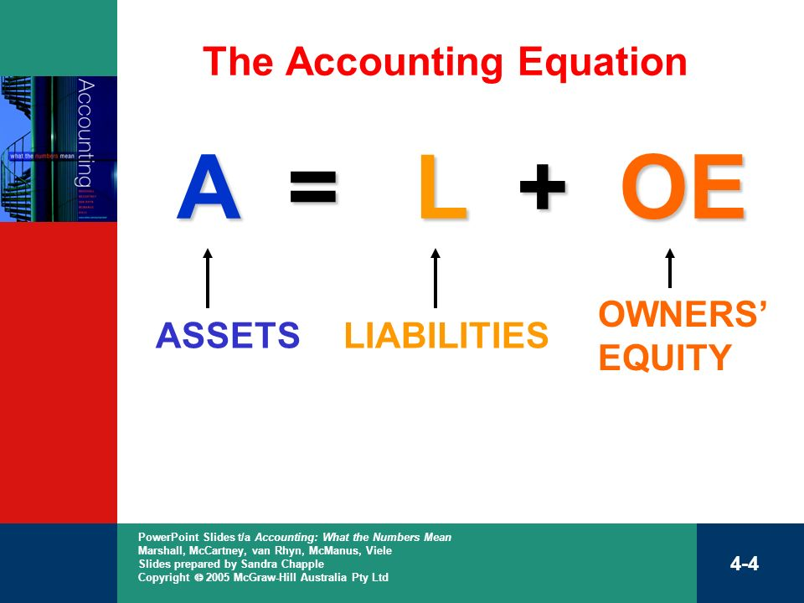
Figure 1 Accounting Equation
Fundamental accounting equation refers to the equation in which asset of any organisation is equal to liabilities and owner’s equities added number (Ferranti, 2013). In the equation there are three basic components of the fundamental accounting equation, those are asset, liabilities and owner’s equity. The financial records of the business activity and performance of a business is assessed in the financial statement. Financial statements are prepared to serve many purposes for the business organisation. The financial statement is being prepared for the accurate information on business organisation’s financial health. Moreover, the financial statement serves as a reliable document for investors. Investors and financers of the business get clear picture about the organisation and follows the financial trends to get invested on any potential project (Horngren and Harrison, 2015). The information extracted from the financial statement is important and assists experts to predict about the business organisation stock price and financial trends. Financial analysts dissects the information and analyse the performance of the company depending on the financial statements. Profit and Loss statement shortly introduced as P&L statement is the statement which is a financial statement summarises revenue, costs and expenses happened during a specific period time for example quarterly or yearly (Kieso, Weygandt and Warfield, 2020). Most commonly the income statement or P&L statement is prepared at the end of the year. The records associated with the financial transection of the company presents the ability or inability to make profit at the end of the year. In this statement the information can be helpful to take important decisions such as ‘is it necessary to reduce operational costs?’ or income and expenditure status of the organisation.
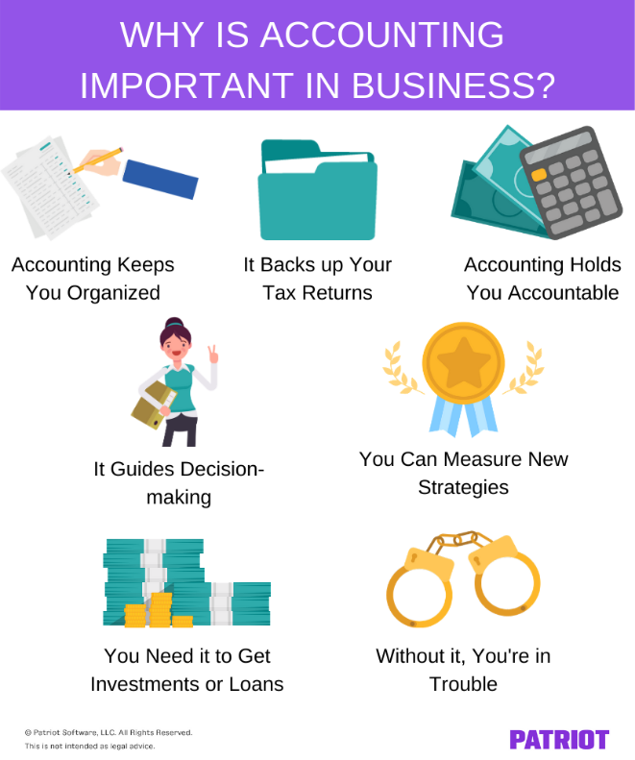
Figure 2 Importance of accounting in business
Balance sheet is vastly known as statement of financial position. Balance sheet depicts the financial picture which involves asset, liabilities and owner’s equity of the business organisation (Kimmel, 2018). The balance sheet of any company gives a snapshot on the business asset or liabilities. The balance sheet provides information regarding organisations financial stability and marks out the potential risks for the organisation.
Accounting is the lifeblood of the business organisation. Accounting is very important for any kind of business organisation or non-profit organisation (Horngren and Harrison, 2015). Accounting keeps detailed record of business transection of an organisation on a day to day basis. The systematic way of accounting is fault proof and if all the steps followed properly actual predictions can be gained from the potential of the accounting. The process of decision making is being facilitate by the accounting as it provides important information on organisation to its internal users (Kieso, Weygandt and Warfield, 2020). Internal users of the organisation refers to the management team of an organisation those who execute plans and take vital decisions for the organisation. The primary external users of the accounting information outside of the business organisation is investors, financers, money lenders and other creditors. Information provided by the accounting is the main way of communication with the external users of it. Every business organisation runs within the state jurisdiction of its geographical location. The financial statements and the gross income gives the exact and accurate number to give tax for the state. Various agency, firms and government bodies relies on the accounting system’s standard to recognise financial information provided by the system.
Kedison PLC’s financial information is being provided to prepare P&L statement and balance sheet.
Financial statements for the Kedison PLC is being prepared below for the year ended in 31st December 2020:

Kedison PLC
P&L statement
For the year ended December 31, 2020
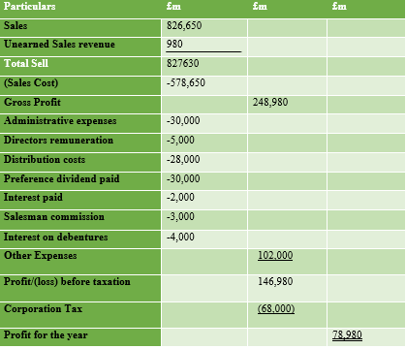
Profit and Loss statement of Kedison PLC depicts the financial statement in which the business organisation made profit at the end of the year (Kimmel, 2018). The profit for the Kedison PLC in the given period time is 78,980. Using proper formula income statement of Kedison PLC extracted few vital information which can be useful for the management in future. Gross profit of the organisation is 248,980 and corporation tax of the company is 68,000.
Balance sheet or statement of financial position of Kedison PLC required to be prepared to understand the current condition of the company asset, liabilities and owner’s equity (Kieso, Weygandt and Warfield, 2020). Income statement or P&L statement gives the understanding of profitability of the organisation whereas balance sheet portrays total picture of financial health of the organisation.
Kedison PLC
Statement of financial Position (Balance Sheet)
For the year ended December 31, 2020
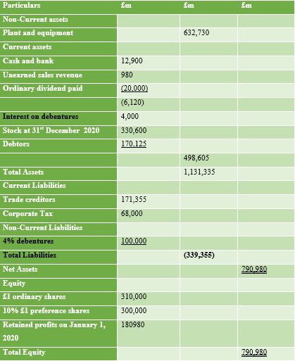
The Kedison PLC has total asset of 1,131,335 and total liabilities of 339,355. Kedison PLC’s Net Assets 790,980 and Equity is 790,980. The balance of statement of financial position of Kedison PLC indicates that the entries of the organisation’s financial transaction were accurate.
Kedison PLC
The Equity Statement
December 31, 2020
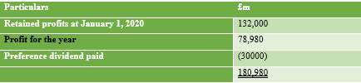
The equity statement refers to the statement in which the owners’ equity is being calculated along with any modification or changes in the equity (Kimmel, 2018). The statement of equity also known as the statement of retained earnings in several places of the world. The sections which changes in the equity statement are earned profits of the organisation, dividends yet to be distributed, inflow of equity, withdrawal of equity and net loss. These changes affect the owner’s statement of equity in the process of accounting.

Explanation on ‘Why the balance sheet always balances?’
Balance sheet always balances at the end. The name of it explains the principle nature of the statement. Balance sheet is often called statement of financial position (Miller, 2018). The accounting fact which is asset equals to liabilities and owner’s equity is the base of the financial statement. The nature of the financial statement is very dynamic and provides solid information on the financial health condition of an organisation. Balance sheet can be used in any organisation to assess the financial condition of the organisation.
In the balance sheet the asset of the organisation is the things company owns which are financially measurable and could be the future owner (Kimmel, 2018). The possibility of owning potential asset which are measurable is used to assess the amount of asset in the balance sheet. The concept of liabilities is very clear which is the amount company owes such as payables, taxes, salaries, and debt (Does the Balance Sheet Always Balance?, 2021). The section shareholder’s equity in the balance sheet displays the company’s retained earnings and owner’s contribution to the organisation in liquid form of transection. As the total asset of the company is provided by either owners or debts, loans or other forms of lending. The total amount of asset must be equal to the total liabilities and stockholder’s equity. To explain the paradox the old fundamental equation of accounting emerges again. The fundamental accounting equation describes that A = L + OE.
There are few basic facts because of why the balance of the balance sheet always balances. There is a basic accounting principle called double entry (Miller, 2018). The double entry accounting principle is one of the reasons behind the fact that balance sheet always balances. Double entry system of the accounting principle enters every transection history twice. This nature of the system of entry gives every account minimum of two entries and the consistency of remaining balance all the time (Does the Balance Sheet Always Balance? 2021). When the final statement of the financial position is being created the history of the double entry automatically balance the balance sheet final sum. Which is the asset equals to the liabilities and stockholder’s equity.
There are three major categories on the statement of financial position or balance sheet, those are asset, liabilities and shareholder’s equity.
The current asset of the organisation can be converted into cash within a one year period and used to cover operational expenses and pay various short term debts. The current asset are the account receivables, prepaid expenses, inventory and cash and cash equivalents.
Noncurrent asset of the organisation is the opposite of it land, site, property, trademarks, brands and long term investments are the noncurrent asset. Long term investments, fixed asset and intangible asset are the noncurrent assets of the organisation.
There are two kind of liabilities one is the current liabilities and another is noncurrent liabilities. Current liabilities are the short term liabilities such as supplier’s short term debt, accounts payable and accrued expenses. Noncurrent liabilities are the long term liabilities such as bonds payable and property lease.
Shareholder’s equity is the amount of money which is going to be left over after paying all the debt of the organisation (Miller, 2018). Shareholder’s equity indicates the health of the business organisation. Another form of it is the retained earnings of the organisation. The retained earnings of the organisation can be reinvested or paid to the shareholder’s as dividends. The management of the company with the vote of shareholders or board directors decides what to do with the retained earnings of the business organisation.

Question No 2

Financial ratio analysis of Chocco PLC, year 2020 and 2019
The company Chocco PLC is renowned company placed in London. The company produces delicious chocolates and variety of confectionary products. The company now operates worldwide and aims to reach global standard (Noble and Niswonger, 2017). The organisation also believes in sustainability. To assess the present financial condition and profitability of the organisation financial ration analysis is essential. Financial ratio analysis is the technique of comparing two or more data set of the financial statements to achieve predictions and facts about specific factor of the company. Such as the ratio of using asset to produce revenue or ratio of using owner’s equity for the betterment of the organisation.
- ROCE: The full version of ROCE is the Return of Capital employed, this is a financial ratio to assess the profitability and the efficiency of employed capital of the organisation (Miller, 2018). On an easy word the ratio determines the rate of using company’s capital to generate profitability. The ROCE financial ratio is very useful for the investors’ financers and shareholders while scouting for business organisation’s to invest. The formula and equation is being implied to calculate ROCE of Chocco PLC for the year of 2020 and 2019:
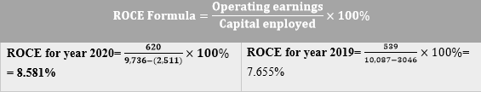
- ROE: The formula for ROE is net income divided by shareholder’s equity. The meaning of ROE is Return on Equity (Noble and Niswonger, 2017). The financial ratio expresses the profitability ratio considering the uses of the owner’s equity to generate revenues for the business organisation. The ROE for Chocco PLC is calculated below:
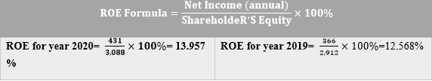
- EPS: EPS is short for the Earnings per share, the formula to calculate earnings per share is company’s profit divided by outstanding shares of the business organisation. The outcome of the calculation indicates the profitability of the business. High number of earnings per share indicates the more profitability of the business (Racine, 2018). The earnings per share formula and calculation is given below for the year of 2020 and 2019 of Chocco PLC:
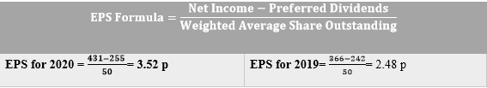
- Net Profit Margin: Net profit margin through calculation procedure is to divide net income from the bottom of the income statement by the revenue of the organisation (How to Calculate Net Profit Margin, 2021). After that for the conversion purpose of the figure into percentage multiply it with the 100. Net profit margin financial ratio is considered as one of the important ratio which indicated the financial stability of the organisation. Net profit margin of Chocco PLC is as follows:
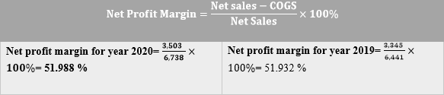
- Asset Turnover: Asset turnover ratio can be inflated by the new big purchase of the asset for the organisation (문용호, 2013). Asset turnover ratio of the organisation indicates the efficient uses of the asset in terms of generating profit for the organisation. Asset Turnover ratio for the Chocco PLC:
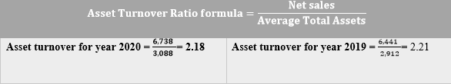
- Stock Holding Days: The formula to calculate Stock holding days is to divide average inventory by the average daily cost of goods sold. The stock holding days represents the number of days stocks needed to turn into sales. In this ratio, the lesser is the number, the better is the business. Stock holding days of Chocco PLC:
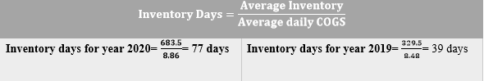
- Debtor’s Collection Period: The average time needed for the organisation to collect the amount of money it owes from other parties while doing business. Account receivables are the major amount which is to be collected in a certain period of time by the organisation (문용호, 2013). The collection of the account receivables is important for the company to ensure enough cash flow for the operational cost of the business organisation. The reliability on account receivable for the organisations cash flow indicates the decreased reliability on loans for the purpose of running the operations of the business. Debtor’s collection period for the Chocco PLC is as follows:
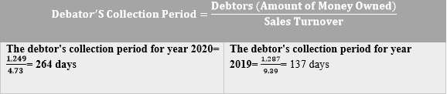
- Current Ratio: Every organisation has short term obligations and liabilities to meet on time. The current ratio refers to the amount of liquidity company owns in order to meet its sort term obligations and liabilities(Racine, 2018). The asset those are in cash or can be turned into cash and the capability of the asset to meet short term obligations and liabilities is the current ratio. The current ratio of Chocco PLC is given below:
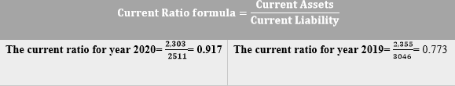
- Gearing Ratio: The gearing ratio is the kind of ratio which compares specific form of capital or owner’s equity. The gearing ratio is the standard to calculate fund resources. In a nut shell the gearing ratio expresses the ratio of creditors fund against the fund of the organisation. The comparison can be engaged with multiple entities of the organisation.
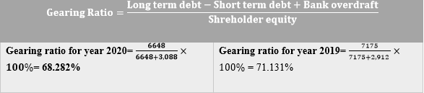
- Interest Coverage Ratio: The business organisation’s efficiency of covering outstanding debt’s interest is known as interest coverage ratio (Racine, 2018). The other name of interest coverage ratio is times interest earned. This formula of financial ratio is used to assess risk associated with the current debt of the business organisation.
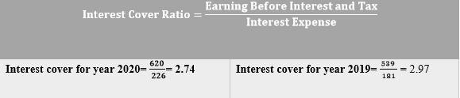

Comments on financial performance and position depending on the financial ratio analysis and financial statements of the Chocco PLC
Chocco PLC is operating worldwide and becoming international business figure soon. The position of the organisation can be described by the financial ratio analysis of the organisation.
Aforementioned financial analysis numbers indicates the present condition of the Chocco PLC.
The ROCE of the Chocco PLC refers that the company should work more efficiently to utilise its capital on optimum level. For the year 2020 and 2019 the ROCE of the organisation is increased but yet to meet the standard which is minimum of 15%. The present ROCE of is year 2020, 8.581% and year 2019, 7.655%. Return on Equity of Chocco PLC is 13.957% for the year 2020 which is increased from the previous year (Noble and Niswonger, 2017). The ROE from 15% to 20% is considered as good. Earnings per share of the Chocco PLC, for the year 2020 is 3.52p which is very poor. The net profit margin of the organisation is the indication of the generated profit from the sales of the organisation. The Net Profit margin of the year 2020, 51.988% and 51.932% for the year of 2019. The profit margin of the Chocco PLC is excellent (How to Calculate Net Profit Margin, 2021). Chocco PLC asset turnover is 2 times and above for the two consecutive years. The asset turnover of the Chocco PLC indicates the healthy condition of the organisation. The number of stock holding days is 77 days, 2020 and 39 days, 2019. The impact of pandemic is reflected on the number of stock holding days. The number indicates that sale is decreased compared to the previous year. Debtor’s collection period is too much for the organisation (Miller, 2018). It indicates that the organisation relies on loans for the operating costs. Although the profit margin is very high for the organisation. The current ratio is very poor of the chocco PLC the present liabilities and short term obligations must be covered. Company needs to utilise its asset and collect account payables to solve the problem. Gearing ratio is at the risky point for the organisation. The high gearing ratio indicates the inflated number of ratio which can be sign of huge debt. Interest coverage ratio is good.
All the financial ratio analysis number indicates that the company needs to work more to sustain in future. Otherwise the company will meet difficulties to operate properly.

Conclusion
Accounting fundamentals is the bloodstream of the organisation. Accounting helps organisations to operate properly and make right use of the money invested. The proper figures of the financial statements, balance sheet and Owner’s Equity statement gives vital information to the management to take important decisions for the future of the organisation.

References
Chishiba, W., 2020. Financial Ratio Analysis -Reviewing the Financial Performance of ZANACO Bank (2013-2015). TEXILA INTERNATIONAL JOURNAL OF MANAGEMENT, 6(1), pp.41-48.
EISEN, P., 2019. ACCOUNTING. 2nd ed. [S.l.]: BARRONS TEST PREP.
Elliott, B. and Elliott, J., 2019. Financial Accounting and Reporting. 2nd ed. Harlow, United Kingdom: Pearson Education Limited.
Ferranti, K., 2013. Digging deep into derivatives: balance sheet management – making strategic decision‐making better. Balance Sheet, 11(3), pp.20-22.
Horngren, C. and Harrison, W., 2015. ACCOUNTING. 4th ed. Lisbon: Pearson Australia Pty Ltd.
Investopedia. 2021. Does the Balance Sheet Always Balance?. [online] Available at: <https://www.investopedia.com/ask/answers/09/does-balance-sheet-always-balance.asp> [Accessed 29 August 2021].
Investopedia. 2021. How to Calculate Net Profit Margin. [online] Available at: <https://www.investopedia.com/terms/n/net_margin.asp> [Accessed 29 August 2021].
Kieso, D., Weygandt, J. and Warfield, T., 2020. Intermediate accounting. 3rd ed. Hoboken, N.J.: Wiley.
Kimmel, P., 2018. Accounting. 5th ed. New York: Wiley.
Miller, E., 2018. The Definition of Capital for Solow's Growth Accounting Formula. Southern Economic Journal, 56(1), p.157.
Noble, H. and Niswonger, C., 2017. Accounting Principles. 8th ed. Cincinnati: South-Western Publishing Company.
Racine, S., 2018. Accounting principles. 12th ed. Charleston, SC: BiblioLife.
문용호, 2013. Comparison Study on Difference of Financial Reporting Standards between China and Korea - Focused on Asset items on Statement of Financial Position -. Korea International Accounting Review, null(50), pp.323-344.

