Voice and Movement
Process Workbook
Leah Sheridan
2404472

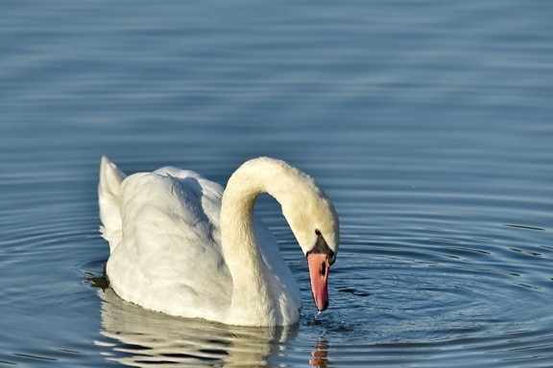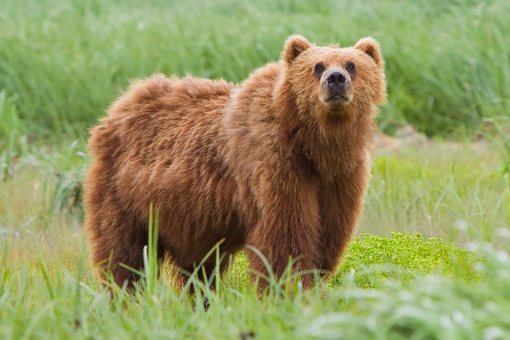
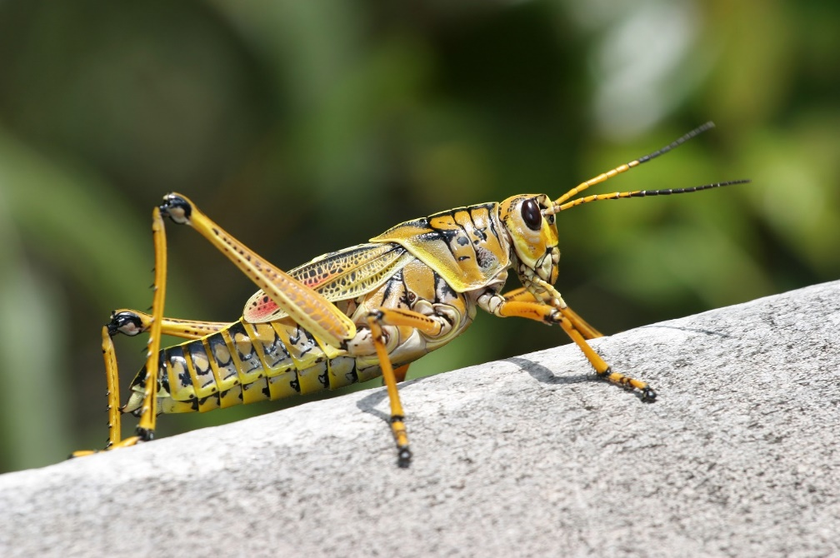

I confirm that I have not used any AI tools for this assessment. All of the work contained in this piece is my own. I confirm that I have copies of my drafts and notes that can be provided if needed.
During this module, we were asked to pick a poem and create a movement and voice piece. We did this by applying what we have learned throughout the term to our piece. For me, the practitioners that helped me to create my piece were Rudolf Laban, Jack Lecoq and Anne Bogart. I also have a background in contemporary dance, movement through yoga and a small knowledge of ballet which was very helpful when creating movement. I picked a poem which is about a grasshopper called ‘The Summers Day’ by Mary Oliver. (See appendix 1) (Oliver 1992). The piece uncovers a journey the grasshopper ventures on, and it invites people to think about their own journey through life. I thought it was the perfect poem for me as I start university in Wales after living in Ireland my whole life.

‘To become better actors, we need to learn more about the laws of movement than the styles of dance’ (Newlove 1993)
Laban Effort Graph
During the term, we had classes where we focused on ‘Laban’s effort graph’ (see Appendix 2)( Newlove Dalby 2004). I found it interesting to think about movement in terms of how it looks in relation to this graph. As we were workshopping the method I found that there were connections between how the movements looked on the graph and what emotions I was feeling. For example, if the piece had ‘gliding’ or ‘flicking’( See appendix 2) movements the feelings could be conveyed as positive and upbeat. This new technique made it a lot easier for me to convey emotions through movement clearly. It was quite interesting to start with the movement work rather than my initial emotional response.
In relation to my poem assessment, the graph was a good tool to use as a springboard for my work. ‘Now she lifts her pale forearms and thoroughly washes her face’ (see appendix 1) (Oliver 1992), was a line I knew I wanted to be light, free and flexible. I began to apply these types of movement to that line, and I got a free-flowing dip-like movement. From then, I was able to add emotion to the line by adding a deep inhale and exhale of breath.
I also did research on ballet moves and did my own take on how I thought they should be, this gave me a great starting point and I tested out different versions of the move to make it my own. (see appendix 4) (Warren 1989)

Jacques Lecoq
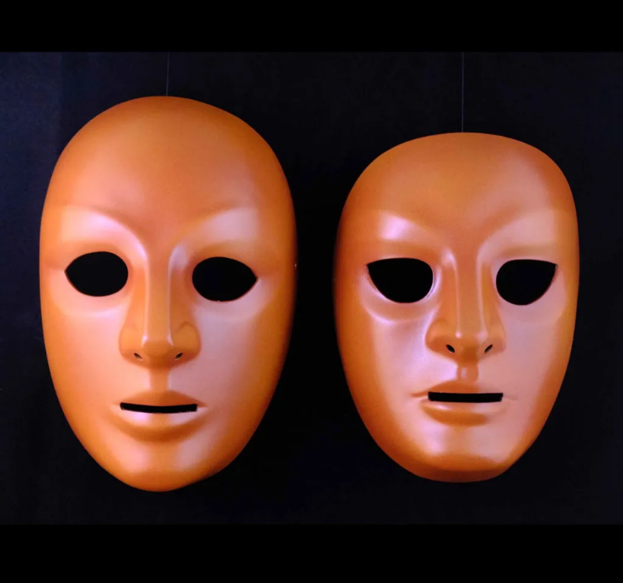
In one of our classes, we worked with masks and imagined what it was like to explore a new space with these masks on, (as seen above).We began to go on a ‘fundamental journey’ (Lecoq 2002) as our lecture called out the different types of landscapes we were exploring. I noticed that the masks used made me feel as if we had no identity and were exploring the world for the first time because I couldn’t see my face. This was interesting to me because it helped me to fully immerse myself in this new world.
In terms of my assessment, I used ‘The Fundamental Journey’ to imagine I was the actual grasshopper walking through the grass or lying in the grass. I learned that a way that helped me to find and clearly imagine was by closing my eyes and picturing the grass and how it felt on my feet and how clean the air was. As I was visualizing, I thought it was similar to a technique my horse-riding coach taught me, so I did some research on ‘sport imagery’ (Cumming 2024) (Cumming, n.d.).Before jumping over a high jump, we would imagine all the steps it would take to do it and visualize it in our mind before we started. So, as we were rehearsing a section in my poem where we walk in a square as the grasshopper walking through grass, I would apply the sport imagery technique combined with how I felt my identity changed with the mask on.
I also used sketches to help visualize the images (see appendix 3).

Anne Bogart
I found Anne Bogart to be helpful for me during class exercises, as I was able to learn about how gestures can evoke emotions in me. Her ‘viewpoints’ (Bogart 2005) also connected me to the audience.
One of our tasks in class was to give a gesture and apply that to her viewpoints. In relation to her viewpoints of space and gesture specifically, I started to wave. That led me on to changing my viewpoints of time, e.g. increasing the tempo made me seem and felt more excited as I waved. I believe this happened because my body associates being excited with fast movements. As I changed my tempo, duration, repetition, etc., the movement felt like I was in different situations depending on the way I applied Bogart’s ‘viewpoints’. I came to realise that her ideas gave my body a domino effect physically, meaning as I added more of her viewpoints the gesture was more clearly translated, and I was able to connect my body emotionally more to that gesture.
On page 11 of her book, The Viewpoints Book’ Anne Bogart asks, ’’What is the full range of possible distance between things on stage?’’ (Bogart, 2005, p.11). (Landau, 2005). I wanted to explore how the audience could be in relation to that question. It was a lot of trial and error. At first, I wanted to sit in the audience, but I couldn’t find a point in the poem what would justify my movement. I played with getting the audience to repeat a line from the poem, but again it would have been hard to communicate that to the audience during the performance. In the final section of my piece, I decided to invite one of my peers to join in my piece.

Reflection on Assessment
Overall, I was very happy with the assessment, I made sure to fully delve myself into the poems and try to get lost in them. With reference to ‘The Fundamental Journey’ (Lecoq 2002) I could have had more points of reference, e.g. specific places where different smells would be involved in the field, for example, flowers. Although, I think I was able to become fully engulfed by the scene because I had done the work of imagining being in that specific situation at that specific time, so all I had to do was go back to those strong images I created.
Audience interactions
It was so wonderful to see the audience engaged because it was something new for them. It also made me have to be very expressive with my eyes and physically show them what to do with my movements, rather than words. It was fun to explore how I communicated through my body.
Tone of voice and repetition
I was nervous about having different levels to my voice for the performance, because the poem is calm; but then I realised that I didn’t have to change my voice drastically because the pauses between sections in my poem did that work for me. When I translated my poem into Irish at parts, I was aware that no-one in the room would understand me. To help combat that I used gestures associated with the Irish words. If I did it again, I would add more Irish language, as I felt it made the piece more important and personal for me and my identity.

Reference List

Cumming, D. J., n.d. Sport Imagery Training. [Online]
Available at: https://appliedsportpsych.org/resources/resources-for-athletes/sport-imagery-training/
[Accessed December 2024].
Dalby, J. N. &. J., 2004. Laban For All. First ed. New York: Routledge.
Hulscher, H., 1994. Haguyahime. s.l.: MONARDA Arts.
Landau, A. B. a. T., 2005. The Viewpoints book . In: London: Theatre Communications Group, p. 11.
Lecoq, J., 2002. The Moving Body. In: s.l.:Methuen, p. 42.
Love Song. 2012. [Film] Directed by Steven Hoggett Scott Graham. United Kingdom: Frantic Assembly .
Mute Swan Family with 8 Cygnets Crossing the Road 4K. 2021. [Film] s.l.: Youtube https://youtu.be/J8qpcv4ONPI?si=0nGGArRIrtyfaIRi.
Newlove, J., 1993. LABAN FOR ACTORS AND DANCERS . In: Putting Laban's Movemnt Theory into Practice: Step-by-Step Guide. New York : Nick Hern Books , p. 29.
Oliver, M., 1992. The Summers Day. [Online]
Available at: https://www.poetry.com/poem/173568/the-summer-day
[Accessed November 2024].
Warren, G. W., 1989. Classical Ballet Techniques . In: Arabesque. Florida: The University Press of Florida , p. 50.
Watch These Bears Walk on Hind Legs Entertaining Surprised Tourists. 2016. [Film] s.l.: Youtube https://youtu.be/Q2K3WFToonA?si=eT3lOnerWQGJVvGz.
(Warren, 1989)
(Lecoq, 2002)

Appendices
Appendix 1
A Summers Day by Mary Oliver
Who made the world?
Who made the swan, and the black bear?
Who made the grasshopper?
This grasshopper, I mean--
the one who has flung herself out of the grass,
the one who is eating sugar out of my hand,
who is moving her jaws back and forth instead of up and down--
who is gazing around with her enormous and complicated eyes.
Now she lifts her pale forearms and thoroughly washes her face.
Now she snaps her wings open, and floats away.
I don't know exactly what a prayer is.
I do know how to pay attention, how to fall down
into the grass, how to kneel in the grass,
how to be idle and blessed, how to stroll through the fields,
which is what I have been doing all day.
Tell me, what else should I have done?
Doesn't everything die at last, and too soon?
Tell me, what is it you plan to do
With your one wild and precious life?

Appendix 2
Laban’s Effort graph based upon Newlove and Dalby

 | Weight | Space [Direction] | Time [Speed] | Flow
Pressing | Strong | Direct | Sustained | Bound
Slashing | Strong | Flexible / indirect | Sudden / quick | Free
Flicking | Light | Flexible / indirect | Sudden / quick | Free
Gliding | Light | Direct | Sustained | Free
Wringing | Strong | Flexible / indirect | Sustained | Bound
Thrusting / Punching | Strong | Direct | Sudden / quick | Bound
Dabbing | Light | Direct | Sudden / quick | Bound
Floating | Light | Flexible / indirect | Sustained | Free
 | Could also use the word ‘Heavy’ rather than ‘Strong’.

Appendix 3
Sketches of work
A)
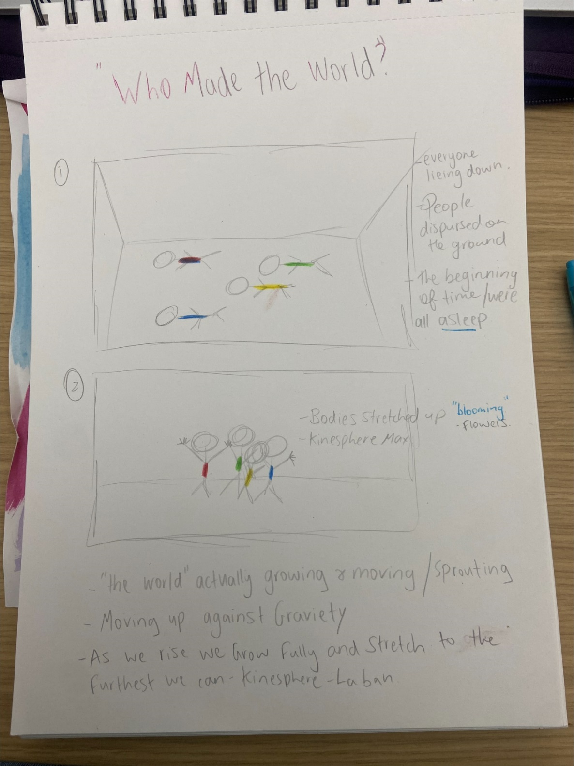

I was quite intrigued with working with overlapping kinespheres. As my poem contained an intimate message of moving on with life and being brave, I wanted that to reflect that in my piece.
A few weeks earlier in class we imagined being in a box and seeing how large our kinesphere was. As it was happening, I noticed the different types of shapes that were appearing when I stretched fully out and how clear the movement could be. From my sketches I focused on when we should overlap our kinespheres and when not.
I found everyone looked very individual and for sections when that individualism was need, ‘who made the grasshopper’ (appendix 3 B). The repetition of the same line while being separated was another way I emphasised it.

B)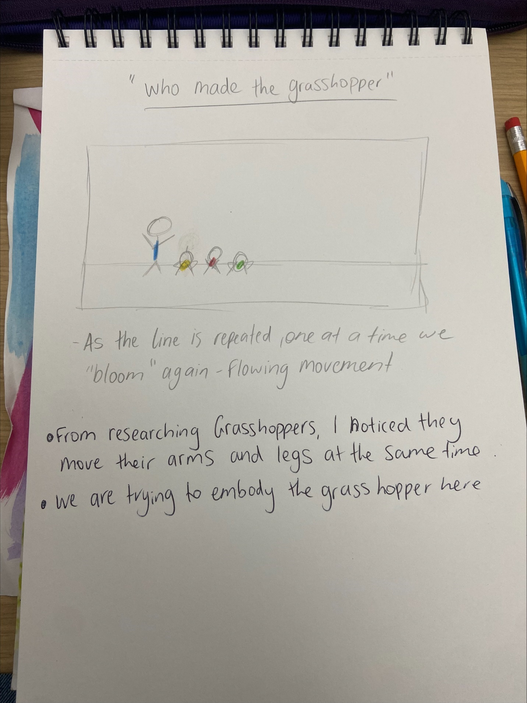
C)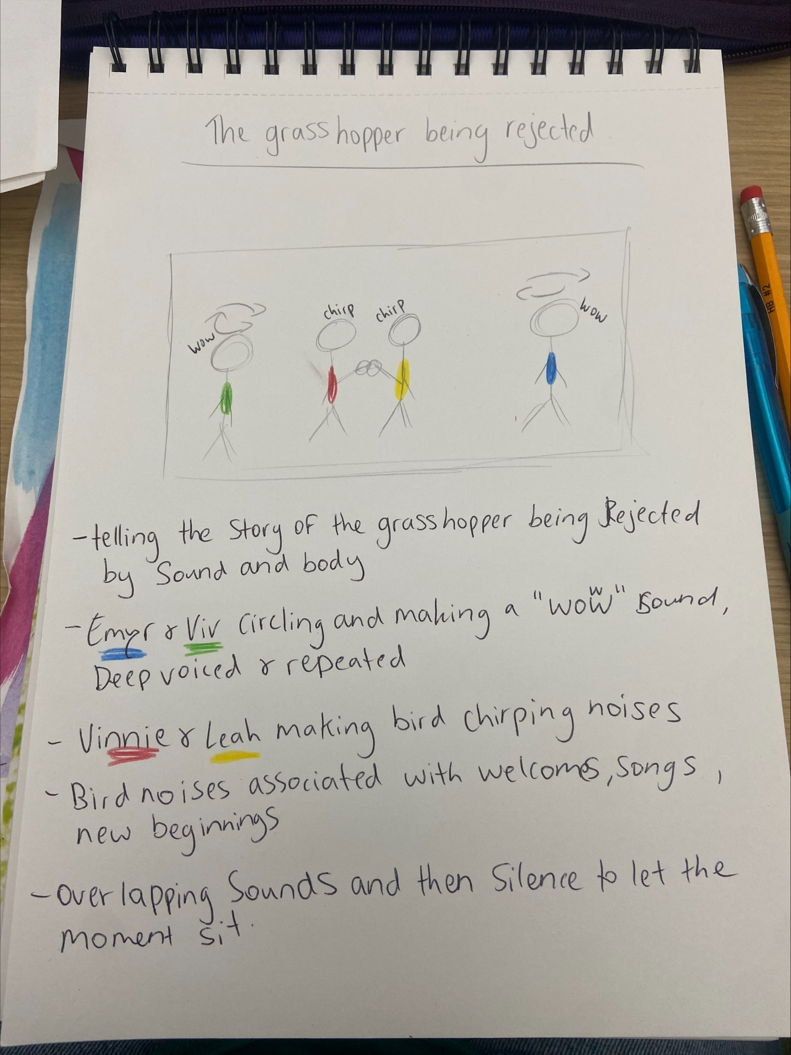
D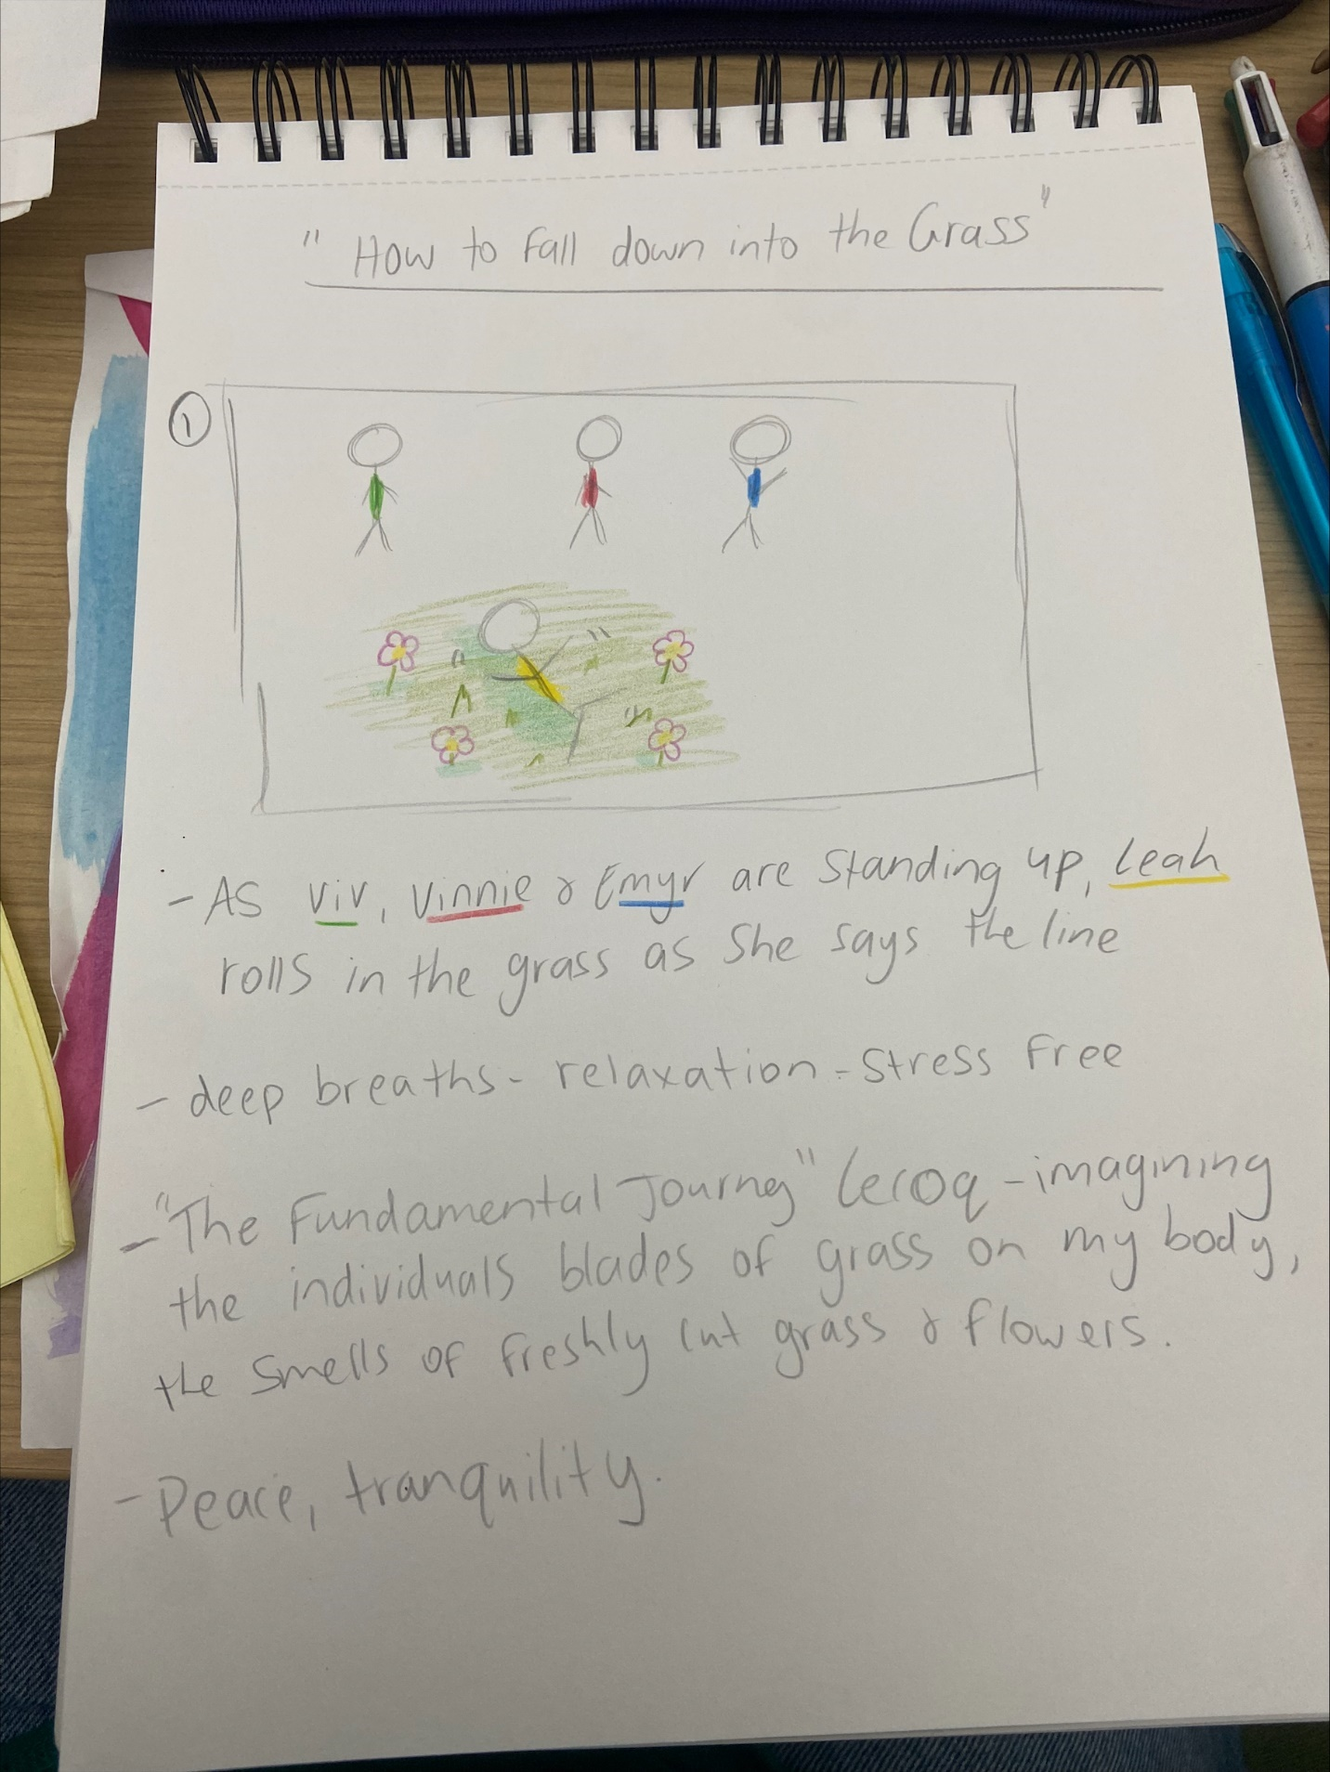
E)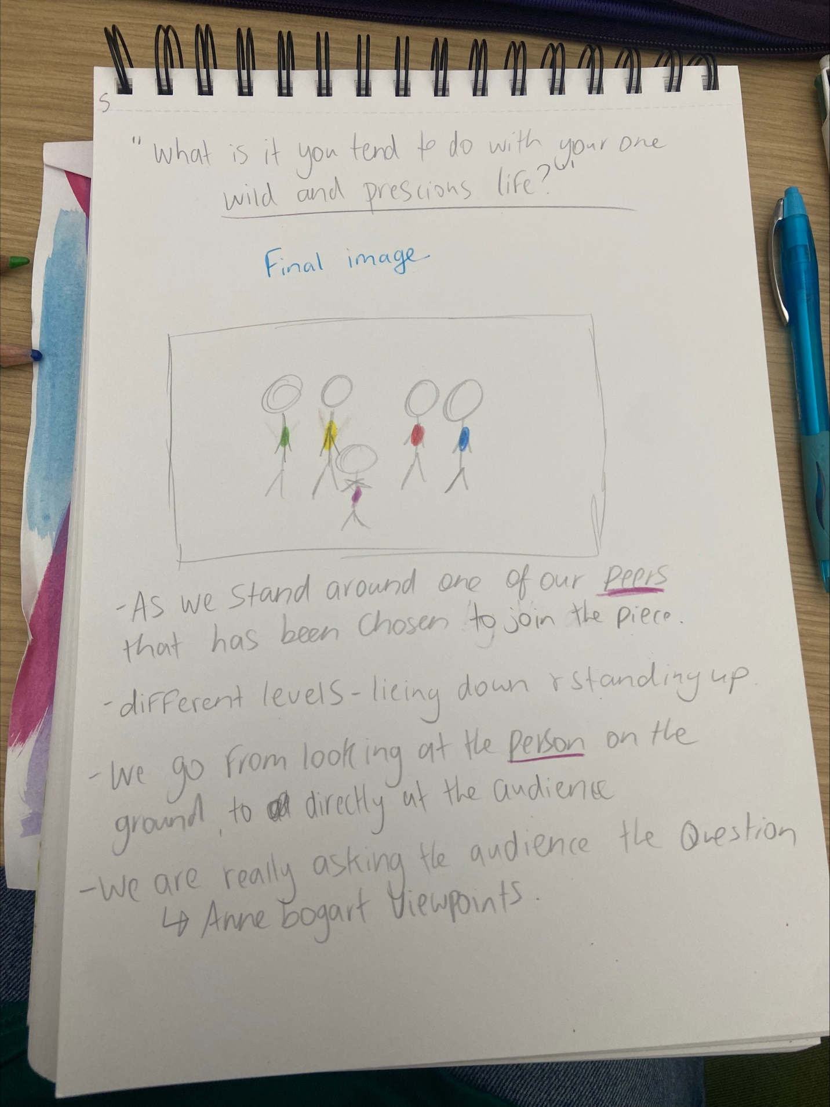
Appendix 4
‘Now she lifts her pale forearms and thoroughly washes her face’. I used this movement to combine with Labans effort graph.


