Extra exercise to practice SQL queries

CREATE DATABASE called dream home
Create the following tables :
- Branch (branchNo, street, city, postcode)
- Staff (staffNo, fName, IName, position, sex, DOB, salary, branchNo)
- PropertyForRent (propertyNo, street, city, postcode, type, rooms, rent, ownerNo, staffNo,branchNo)
- Client (clientNo, fName, IName, telNo, prefType, maxRent, eMail)
- PrivateOwner (ownerNo, fName, IName, address, telNo, eMail, password)
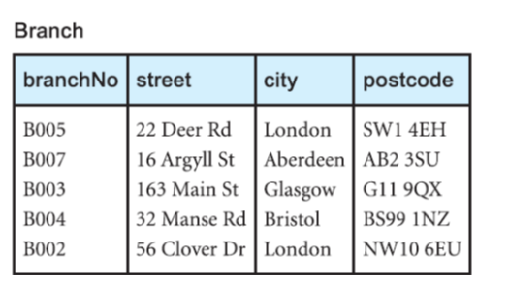
- Viewing (clientNo, propertyNo, viewDate, comment)
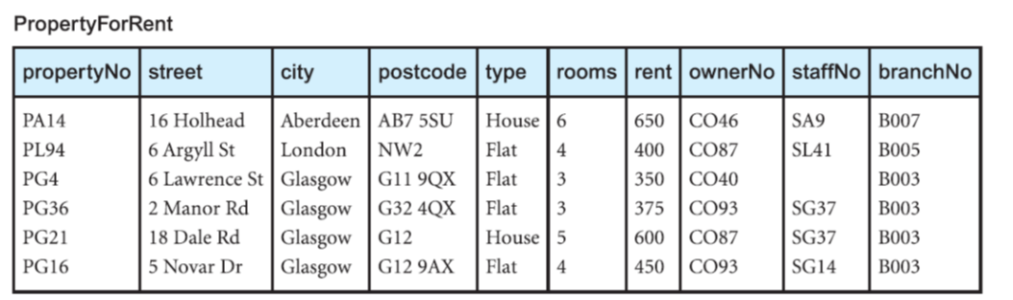

Create all the necessary tables
Insert the test data

Exercises
1. SELECT propertyNO, type, rent FROM propertyForRent;
2. SELECT * FROM branch;
3. SELECT fname, lname, telNo from client;
4. SELECT propertyNo, street, city, type, rent AS monthlyRent, rent *12 AS annualRent FROM propertyForRent;
Calculated fields

5. SELECT CONCAT(lName, ", ", fName) AS fullName FROM staff;
6. SELECT * FROM propertyForRent WHERE rent <= 400;
7. SELECT clientNo, fName,lName FROM client WHERE preftype = "house" ;
8. SELECT * FROM viewing WHERE viewDate > "2015-05-15" ;
9. SELECT fNAME, lName, branchNo FROM staff WHERE position = "assistant" AND salary = 9000;
10. SELECT * FROM propertyForRent WHERE RENT < 400 AND CITY ="Glasgow" ;
11. SELECT * FROM viewing WHERE viewDate >= '2015-04-01' AND viewDate <= '2015-04-31';
12. SELECT * FROM viewing ORDER BY ViewDate DESC;
13. SELECT * FROM viewing ORDER BY clientNo, ViewDate;
14. SELECT propertyNo FROM Viewing;
15. SELECT DISTINCT propertyNo FROM Viewing;
16. SELECT staffNo, fName, IName, salary/12 AS monthlySalary FROM Staff;
17. SELECT staffNo, fName, IName, position, salary FROM Staff WHERE salary > 10000;
18. SELECT * FROM Branch WHERE city = ‘London’ OR city = ‘Glasgow’;
19. SELECT staffNo, fName, IName, position FROM Staff
WHERE position = ‘Manager’ OR position = ‘Supervisor’;
20. SELECT clientNo, viewDate FROM Viewing
WHERE propertyNo = ‘PG4’ AND comment IS NULL;
21. SELECT propertyNo, type, rooms, rent FROM PropertyForRent
ORDER BY type, rent DESC;
22. SELECT staffNo, fName, IName, position FROM Staff
WHERE branchNo = (SELECT branchNo FROM Branch
WHERE street = ‘163 Main St’);
23. SELECT fname,lname,b.branchno FROM Staff s, Branch b
WHERE s.branchno=b.branchno and b.city='London';
24. SELECT clientno, propertyno FROM Viewing WHERE comment!='';
25. SELECT staffNo, fName, lName, salary FROM Staff ORDER BY salary DESC;
26. SELECT SUM(salary) from Staff;
----------------------*-----------------------------------------*----------------------------------------------

