
Student Name:Nahidur Rahman
Student id:2430028

LCLM5002

Developing and Managing Individuals and Teams

Table of Contents
Introduction 3
1. Factors Affecting HR Practices 3
2. Evaluation of Contemporary HR Practices 5
3. Role of Departmental Managers in Implementation 6
4. Conclusion 8
5. Recommendations 8
References 9

Introduction
The human resource (HR) departments are in the centre stage in assisting organisations to adapt to the fast changes in the business environment (Ajibola, 2022). The companies in the United Kingdom are getting it tough due to the pressure of technological change, global competition and changing workforce expectations. This report is devoted to one of the UK-based firms, Tesco Plc, to investigate major HR issues and reactions. It explores three key influences on HR practice, including technological change, talent acquisition and retention and diversity, equity and inclusion (DEI). The report then reviews modern HR practices applied to deal with these problems and critically discusses how the departmental managers can see to it that the practices are effectively and timely implemented.

1. Factors Affecting HR Practices
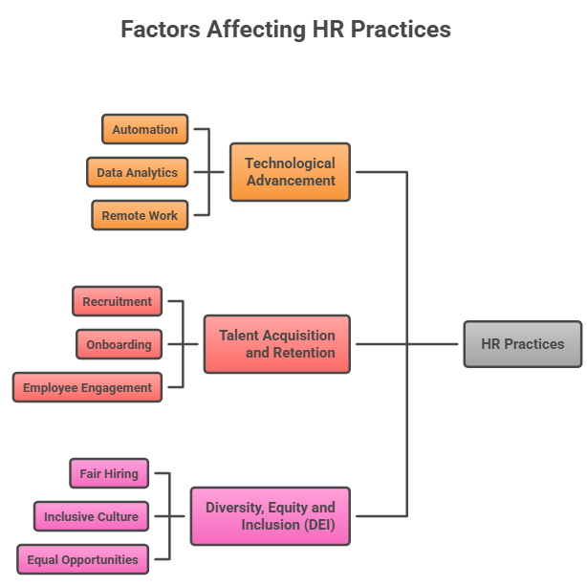
Figure 1: Factors Affecting HR Practices at Tesco
Source: (Khanagha et al., 2022)
Technological Advancement
One of the greatest challenge of the HR departments is the technological advancement. Firms such as Tesco Plc need to alter their technology continuously in the face of new technologies such as automation, artificial intelligence, and digital retail systems (Chaudhary, Patel and Vidani, 2023). These transformations impact on the way in which employees work and the skills required. HR departments should make sure that employees are trained and ready to utilize new systems in an effective manner. HR operations have also changed with the alteration towards digital platforms. Digital tools are now commonly used to administer recruitment, performance management and employee engagement. Although such tools enhance efficiency, they also necessitate new technical skills by the HR professionals (Chen, 2022). Unless employees feel that they are ready to change, they might oppose it and this puts an extra burden on HR to ensure that transitions are managed. In addition, job redesign is brought about by technological advancement (Denysenko and Yurynets, 2022). Certain jobs might be eliminated and new jobs that need specialisation skills are created. HR should strategize to ensure that they do not have skill gaps in the development of the workforce. Life-long and continuous learning and development is now a necessity because staff has to refresh their skills on a regular basis to keep abreast with the rapidly evolving world.
Talent Acquisition and Retention
The other significant challenge to the HR department is attracting and retaining the talented employees. The UK labour market is very competitive and organisations need to compete in order to secure skilled labour (Egorova, Grishunin and Karminsky, 2022). An example of this is Tesco Plc which needs a diverse array of workers which include store workers and technology experts. Both categories have other expectations and professional aspirations. The changing candidates expectations have complicated the recruitment. Salary is no longer the only consideration sought by job seekers. They have a high regard of work-life balance, career development opportunities and organisational culture. HR departments need to come up with attractive employer brands to attract these expectations. The employee turnover may bring in high costs and decreased productivity (Gonzalez-Fernandez et al., 2023). The workers can quit when they feel that they are under-rated or lack any chances of development. To retain talent, HR has to concentrate on employee engagement, recognition and career development. Moreover, the emergence of remote and flexible work has altered the perceptions of the employees towards their jobs (Khanagha et al., 2022). Although flexibility has the potential to enhance the satisfaction, it also enhances competition since workers are now able to work in other organisations without necessarily moving.
Diversity, Equity and Inclusion (DEI)
Diversity, equity and inclusion have become the major concerns of organisations in the UK. Companies such as Tesco Plc have different communities that they serve and hire individuals with various backgrounds. HR departments should make sure that workplaces are accommodating and equitable to all employees (Mehta, 2024). Diversity can be defined as the presence of a workforce that is diverse in terms of gender, ethnicity, age, and background. Equity entails giving fair opportunities and encouragement to every employee. Inclusion implies the need to have an environment in which all feel appreciated and honored. One of them is to deal with unconscious bias when recruiting and promoting employees (Meng, 2024). Prejudice may result in discriminating against some groups and restricting their opportunities. HR should use reasonable policies and training to decrease bias. The other challenge is to establish an inclusive culture. The employees must also feel secure and honoured in the workplace. This needs to be well led and with organisational values. Another burden on compliance by HR is that it needs to be compliant with UK equality laws (Sharma, Jain and Pajni, 2022). DEI is a moral, as well as a business, issue. Creativity and decision making can be enhanced by diverse teams. Nevertheless, a meaningful diversity can only be attained by constant efforts and dedication of the HR and management.

2. Evaluation of Contemporary HR Practices
Addressing Technological Advancement
In the quest to adapt to the technological changes, a number of organisations have embraced digital HR systems. Such systems enhance effectiveness in recruitment, training and performance management (Szcześniak, 2025). Indicatively, the online learning platforms enable employees to receive training at their convenience. This helps in ongoing skill development. Reskilling and upskilling programmes is another best practice. Companies invest in employee training in order to acquire new skills due to technological changes. This will prove to be cost-efficient rather than having to employ new workers and retain the current ones. Nevertheless, it is very expensive and needs to be planned. Another new HR practice that has been associated with technology is agile working (Vilochani et al., 2024). It enables teams to be flexible and be able to adapt to change. Although this enhances productivity, it may pose difficulties in communication and coordination when not well handled.
Addressing Talent Acquisition and Retention
One of the modern practices applied in attracting talent is employer branding. Organisations advertise their values, culture and benefits so as to attract prospective employees. This is commonly done in the social media and company websites (Woods, 2022). Also, having a good employer brand can help to hire good employees, yet the brand must accurately reflect the reality of the experience that employees have. Flexible working programs are also popular in enhancing retention (Ajibola, 2022). Employees prize the opportunity to work and personal life balance. Job satisfaction can be enhanced by providing an alternative like remote working or flexible working schedules. It might not however be applicable to every job including those in retail. The performance management systems have developed to emphasize more on the continuous feedback as opposed to the yearly reviews. Consistent feedback assists the employees to become better and feel encouraged (Chaudhary, Patel and Vidani, 2023). This is able to enhance participation and minimise turnover. Another practice is employee development programmes. Training and career development will help to retain employees in the organisation. Also, these programmes should be focused on the needs of individuals in order to be effective.
Addressing Diversity, Equity and Inclusion (DEI)
Organisations have come up with different practices to facilitate DEI. Diversity training is one of the common methods, and it assists employees to learn to respect and more so comprehend the differences. Although this may create awareness, it might not result in a permanent change as it should be complemented with other efforts (Denysenko and Yurynets, 2022). Inclusive practices of recruiting are also significant. These involve hiring practices such as hiring various hiring panels and eliminating biased terminology in job descriptions. These practices will enhance equity in the recruitment process, however, they need to be carried out on a regular basis. Another modern practice is the employee resource groups (ERGs) (Gonzalez-Fernandez et al., 2023). These organizations offer service to employees who have common backgrounds or interests. They have the ability to enhance inclusion and empower employees to have a voice in the organisation. Pay equity is also applied to make sure that it is fairly paid. Organisations assess the salary information to recognise and eliminate any disparities. This practice promotes fairness and this needs to be transparent and checked frequently (Khanagha et al., 2022). All in all, DEI practices are necessary in contemporary organisations, yet the success of such practices requires a dedication, as opposed to the implementation of policies.

3. Role of Departmental Managers in Implementation
The departmental managers are important in ensuring the HR practices are carried out effectively and urgently. Although the HR departments come up with the policies, it is the managers who will be dealing with policy implementation in day-to-day operations (Sharma, Jain and Pajni, 2022). The experience of employees is directly affected by their activities. Communication is one of the major roles that managers undertake. They have to be explicit in communicating new HR practices, like digital tools or flexible working policies, to their staff. In the absence of effective communication, the employees can be resistant to changes or fail to understand the purpose of the changes (Szcześniak, 2025). Managers ought to guide and assist the employees to adapt. The other significant role is to be an example. Managers should be willing to be dedicated to HR practices, particularly in such areas as DEI. As an example, they ought to encourage non-discriminatory behaviour and combat discrimination. Unless these practices are taken seriously by the managers, employees are not likely to adhere to them. Monitoring of performance and progress is also in the hands of managers (Vilochani et al., 2024). They should make sure that workers are engaged in training programmes and effective use of new technologies. Challenges can be noticed and solutions given through regular feedback sessions. This helps in advancing the current practice and maintaining practices do not go unnoticed.
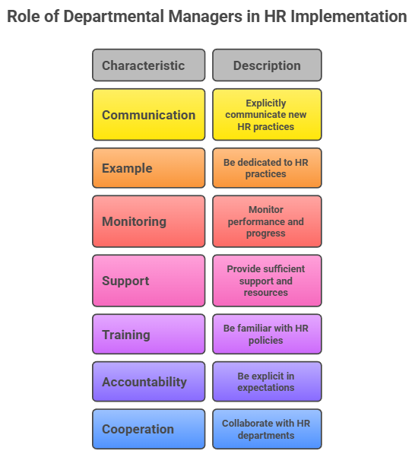
Figure 2: Role of Departmental Managers in HR Implementation
Source: (Woods, 2022)
Also, it encounters difficulties in assuring immediate execution. Managers can have excessive workloads and thus concentrate on operational aspects at the expense of HR programs. This has the potential of postponing implementation (Woods, 2022). To deal with this, organisations need to support and equip managers with sufficient support and resources. They should be familiar with the HR policies and their application. Managers might not be able to properly practice without proper training (Gonzalez-Fernandez et al., 2023). They can unwillingly be biased during the recruitment process or lack of flexibility in working arrangements, among others.
Accountability has also been a crucial fact in this situation as well. Organisations need to be explicit in their expectations and performance of managers in putting HR practices into practice (Egorova, Grishunin and Karminsky, 2022). This may be achieved by the use of performance reviews and key performance indicators (KPIs). When managers are held responsible then they are more likely to be quick and effective. Moreover, the cooperation between the managers and the HR is essential (Denysenko and Yurynets, 2022). Guidance, tools and support should be offered by the HR departments and feedback should be offered by managers on behalf of their teams. This collaboration makes sure practices are applicable and applicable.
All in all, the departmental managers can play a critical role in translating HR policies into practice. The effectiveness and speed of implementation of these practices will depend on their dedication, abilities, and leadership.

4. Conclusion
To sum up, human resources in the UK organisations like Tesco Plc have to deal with a lot of challenges regarding technological development, talent management and diversity and inclusion. These aspects should be well planned and contemporary HR practices to deal with. Modern solutions like digital systems, flexibility, and inclusive policies are useful solutions, and their effectiveness relies on the way the solutions are implemented. Departmental managers are involved in making sure that these practices are used in day to day operations. Unless there is effective leadership and dedication on the managerial level, even the best HR strategies can fail to deliver the desired results.

5. Recommendations
Organisations ought to invest in life-long training so that the employees can adjust to the changes in technology. To retain and attract talent, HR departments have to enhance employer branding and offer straightforward career development. Companies must also incorporate DEI as organisational culture, as opposed to making it a distinct programme. The HR practices should be carried out by regularly training and supporting departmental managers. There must be clear accountability measures that are put in place to take action on time. Lastly, good working relationships between HR and managers must exist to make sure that the policies are realistic, accommodative and in line with the organisational objectives.

References
Ajibola, E.B., (2022). An investigation into talent management in the Irish retail sector: a case of Tesco, Aldi and Super Valu (Doctoral dissertation, Dublin, National College of Ireland).
Chaudhary, N., Patel, V. and Vidani, C.J., (2023). A review of non-technical training programmes conducted by corporate trainers for IT companies. International Journal of Management Analytics (IJMA), 1(1), pp.85-110.
Chen, J.J., (2022). Tesco Plc. In International Cases of Corporate Governance (pp. 27-44). Singapore: Springer Nature Singapore.
Denysenko, M. and Yurynets, Z., (2022). Building teams of professionals and their role in economic development and strategic business management. Journal of strategic economic research, 1(23), pp.67-75.
Egorova, A.A., Grishunin, S.V. and Karminsky, A.M., (2022). The Impact of ESG factors on the performance of Information Technology Companies. Procedia Computer Science, 199, pp.339-345.
Gonzalez-Fernandez, S., Gestoso, C., Acabado Romana, F. and Silva, J.M.D., (2023). Social responsibility practices in companies: A theoretical review.
Khanagha, S., Volberda, H.W., Alexiou, A. and Annosi, M.C., (2022). Mitigating the dark side of agile teams: Peer pressure, leaders’ control, and the innovative output of agile teams. Journal of Product Innovation Management, 39(3), pp.334-350.
Mehta, S., (2024). Rewriting the Rules of Employment Equity: How Fire-and-Rehire Landed Tesco in Trouble. SAGE Publications: SAGE Business Cases Originals.
Meng, S., (2024). Operation Management of Grocery Retailer in the UK: A Case of Tesco. Pacific International Journal, 7(2), pp.136-142.
Sharma, A., Jain, R. and Pajni, N.S., (2022). Risk identification techniques in retail industry: A case study of Tesco plc.
Szcześniak, W., (2025). Barriers to Intercultural Communication within International Business-Tesco (Doctoral dissertation, Dublin, National College of Ireland).
Vilochani, S., Borgianni, Y., McAloone, T.C. and Pigosso, D.C., (2024). An investigation into the extent to which sustainable product development practices are implemented in manufacturing companies. Sustainable Production and Consumption, 50, pp.155-167.
Woods, M., (2022). Risk Management in Retail: Tesco PLC (2004–2019). In Risk Management in Organisations (pp. 109-156). Routledge.
Works, H.I., (2023). Tesco's Internal & External Conflicts: A Case Study.

