BA Leadership and Management Skills for the Workplace

Module: Strategic Management for SME’s
Module Code: BMSW6104_BIRM

Assignment Title: Academic Report
Link-Food Bank Redditch


Student Name: Abdul Wahid Ullah
Student Number: 1912519
Lecturer: Dr Eric Osei
Date: 04/10/2022

Executive Summary

This is a proposal for a social enterprise utilising the right strategic tools for the best strategies to enter the markets. The purpose of the business is to serve its community with a vital service of a food bank that is much needed. Strengths are a competitive advantage and skilled employees to execute the plan. The problem is a lack of food banks in Redditch, where there is an unprecedented demand for it. With the cost-of-living crisis and inflation so high this has affected most of the demographics in our society. Some feel ashamed or embarrassed to use a food bank. We will provide a Café for all to use and that will bring awareness to what we offer in our locality. We will deliver in discreetly in our unmarked vehicles and plain paper packaging. No one should ever go hungry or without the essential needs to survive.

Table of Contents
Executive Summary 2
Introduction. 4
Overview of the Social Enterprise. 4
Proposed Plan Of Social Enterprise and its Sector. 5
Strategic Direction of Link-Food Bank Redditch (LFBR). 6
Mission Vision Values. 7
Environmental Analysis - PESTEL Analysis 9
Industry – Micro Environmental Analysis/Porters 5 Forces 10
Internal/Firm Analysis – VRIO 13
Internal/Firm Analysis – Value Chain 14
Internal/Firm Analysis SWOT Analysis 16
Stakeholders Analysis 18
Strategy Implementation 21
Balance Scorecard 21
Organisation Structure 23
Recommendations. 24
Conclusion. 24
References 25

Introduction.

The benefit of this proposed social enterprise will help the community and bring awareness, that we are all effected by the cost-of-living crisis. The proposed SME will use the relevant micro and macro analysis to navigate the best strategic objectives for a better competitive advantage and its future success. The proposed social enterprise, named, Link-Food Bank Redditch, (LFBR) will be a non-profit food bank that will serve the people of Redditch, Worcestershire, in the United Kingdom. LFBR’s goal is to alleviate the hunger in Redditch, by collecting and packaging food for distribution through a network of service agencies and programs that serve our target population groups. Using strategic direction with clear vision and mission values. This report will identify key implementation of the successful social enterprise, named Link-Food Bank (LFBR).

Overview of the Social Enterprise.

What is a social enterprise? They are businesses that trade with a social and environmental objective, according to (Perera, 2022). Social Enterprise UK demonstrates another way to do business, that is sustainable, that benefits people and utilises most of the profits invested back into the business. Social enterprises can be in any sector of the UK economy from services to waste, recycling projects, products, cafes, restaurants, and public services stated by (Perera, 2022). The structure would be a social enterprise. Proposed as a non-governmental organisation (NGO). According to (NGOsource, 2022) NGOs work independently from governments that help causes and development locally or internationally, that hinge on various funding from different sources and government grants. There are many NGOs like UNICEF. According to (Perera, 2022), social enterprises are becoming a very popular way to trade with a growth rate of 80% according to the report in 2021, see graph below.

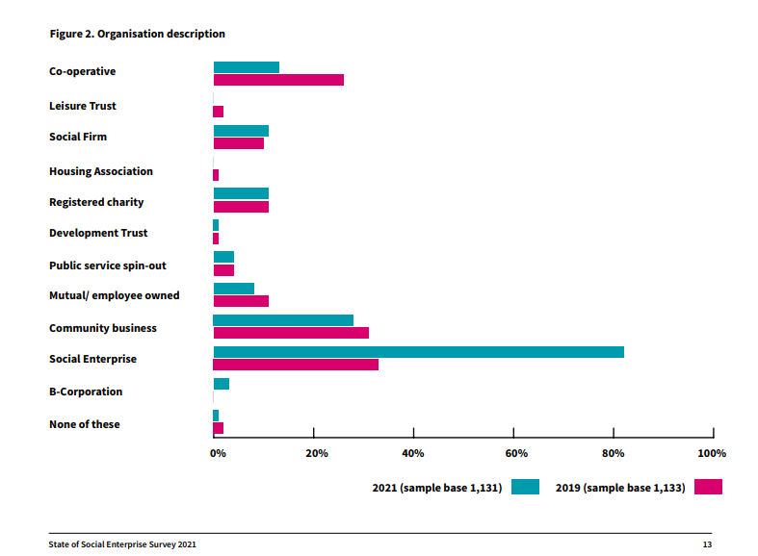
Graph of 80% growth of social enterprise. (Perera, 2022)
A quote taken from the Social Enterprise UK says that …
“There are 100,000 social enterprises in the UK, contributing £60 billion to the economy and employing 2 million people”. Reported by (Perera. 2022).
With the key evidence collated, the proposal seemed more lucrative and achievable. The report will look into the processes strategies that needs to be put in place for the SME to be successful.

Proposed Plan Of Social Enterprise and its Sector.

According to (BBC, 2019), Food Banks help people who are in need, who cannot afford to eat or buy their essential shop for living. Products are all basic food, like cereals, tinned food, and toiletries that people may need. These are all donated by the public and shops alike.
By identifying a lack of food bank facilities in Redditch, Worcestershire in UK, the proposed SME was initiated by key research. The methods used was from (Statista, 2022) and (United Nations, 2022) and (GOV.UK, 2022) plus from the national news and archives online. The statistics show a massive spike of Food Bank users in the UK from 2008 to 2022 according to (Clark, 2022). There were 2.17 million people that used a food bank reports (Clark, 2022), see graph below. Food Banks are mostly run by the Trussell Trust in the UK. But the demand has risen and is under pressure.

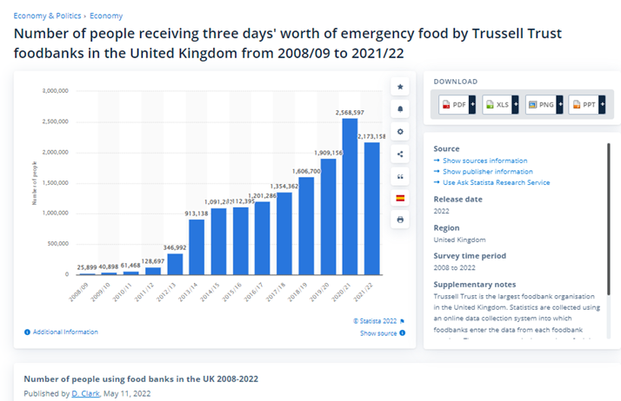
Image: Statistics of Food Banks in UK, (Clark, 2022).
According to an online article on (ITV, 2022) there is a huge demand for Food Banks which are now at breaking point, due to the cost-of-living crisis. Exacerbated by the Covid-19 pandemic, and the War on Ukraine, reported (United Nations, 2022). Furthermore, existing Food Banks are at breaking point reports (Savage, 2022). Iceland’s CEO claimed there was more branches of Food banks than McDonalds in the UK, reported by (BBC, 2021). There is only one Food Bank in Redditch according to (Trussell Trust, 2022). Most of our clients are from a low-income based criterion, but through the cost-of-living crisis it has affected people of all backgrounds and classes, according to (Coughlan, 2017). The disposable income has also fell dramatically reported by (King, 2022).
By identifying the gap and disparity of services in the town, this vital resource will help the people of Redditch with our strategic direction of the social enterprise.

Strategic Direction of Link-Food Bank Redditch (LFBR).

LFBR will operate a Café and a warehouse facility where storage of donated of non-perishable foods for distribution and collection. Additionally, rescued food from local restaurants who are five starred hygiene rated, by (FSA, 2022), will be providing and donating food actively for the homeless and the vulnerable for distribution at our cafe. The program success solely depends on volunteers and actively soliciting food from public, local food growers, retailers, and wholesalers.
Our name ‘Link’ is the essence of our enterprise, without the ‘link’ this would not be possible, so participation of our community, local supermarkets, businesses, and restaurants are all vital source of resource and manpower. LFBR would be linked with all the Supermarkets in Redditch, Aldi, Co-op, Lidl, Morrisons, Sainsburys, Tesco and many participating Redditch restaurants and public alike. The local restaurants and takeaways will play a vital role in providing hot meals for the very vulnerable, that will be served in our annexed café.
Services will include a volunteered run café open to all, and storage for our donated food. Which will also include food parcels and emergency food parcels for the vulnerable. LFBR will receive support from the government and local government council, charitable organisations and through corporate sponsorship. Our food bank will also serve our community by personally delivering food parcels in our non-marked vehicles and paper packages, for the discretion and privacy of our perspective clients.
The strategic direction of the SME is by implementing strategies and objectives from the Mission, Vision and Values statement.
Strategy defined is a reflection in relation to having a competitive advantage for its long-term survival of the business according to (Carpenter, et al, 2013).
Objectives or Goals defined are targets or milestones to gain the stated mission values lectured by (Osei, 2022). These need to be specific, for example like reporting on a result on net sales. Which then those net sales figures should be measured, so progression can be implemented and specify when these results will be achieved by and when. These objectives are known as SMART objectives. Which is an acronym for being:
Specific, Measurable, Achievable, Relevant and Time Based.
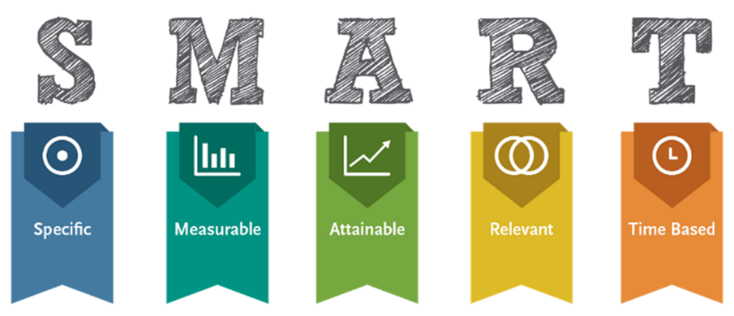
Image: SMART, (SMART-Goals, 2022).
S – LFBR to provide an efficient, vital resource to the community and a café hub
M – LFBR’s data analysis target objectives
A – LFBR’s opening 7 days a week
R – LFBR’s providing the care and resource to our community
T – LFBR – committed to its objectives within the year

Mission Vision Values.

To have goals and values according to (Carpenter, et al, 2013) the vision and mission are the initial strategy to be implemented. Mission statement message resonates to the stakeholders. Whilst the vision is founded on the future message according to (Carpenter, et al, 2013). The future of the company relies on the vision and mission strategies articulates (Mirvis et al,2010). To formalise a company’s purposes, goals and values is to have the formal mission and vision statements argues (Carpenter, et al, 2013).
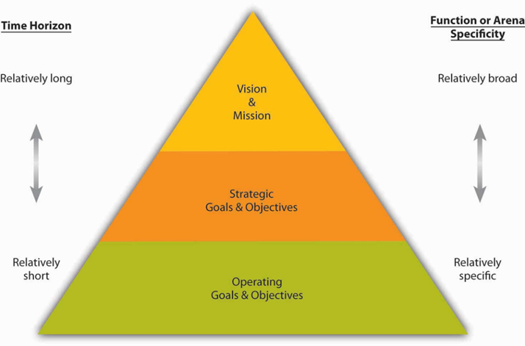
The Mission Statement summarises and defines what business we do and how we make a difference
The Vision Statement captures what the company wants to achieve.
Values are the organisations’ future objectives set by the mission and vision statements, on the organisations’ purpose. This will identify the strategies are working with the attained goals by keeping all stakeholders informed. See Image below.
According to (Carpenter et al, 2013) by setting goals, leaders can develop an action plan from the company’s vision statements in relation to the objectives that transmits its purpose to the stakeholders. See image below.
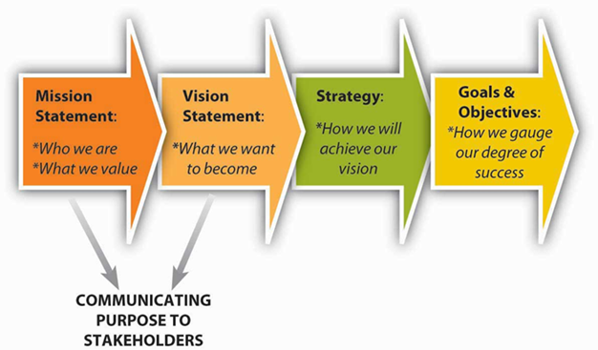
Image: Mission, Vision, Values, (Libraries, 2010)

LFBR Mission Statement: “Without prejudice, to alleviate and banish hunger and aid our community, through tribulations and turbulent times”.
LFBR Vision Statement: “To achieve our goals and sustain our partnership links, by aiding and helping all in our society, through our continued commitment is paramount”.
Through our Mission and Vision will determine our values and objectives by implementing the SMART objectives.

Environmental Analysis - PESTEL Analysis

PESTEL According to (Osei, 2022) is an analysis that identifies outside factors effecting an organisation known as the macro (external) environment. This is a great tool to utilise when starting a new business, or when entering an existing company. PESTEL is an acronym that stands for, Political, Economic, Social, Technological, Environmental, and Legal factors. These six components together, scan the organisation's external environment.
Political. This factor is about what power government plays with the economy that effects businesses. This can include government policy on trade, taxation or trade policies, lectured (Osei, 2022).
According to (Business Management, 2022), government raising corporation tax. This can impact the business negatively.
According to (Business Management, 2022), government may change health and safety laws. This can impact the business positively by training the staff or upgrading any equipment’s.

Economic factors are the workings of legislation and administration of a government’s economy. This encompasses factors that can have a direct or indirect effect on a business due to:
- Austerity
- Inflation
- Interest rates
- Unemployment
According to (Business Management, 2022) when inflation rates rises, customers are inclined to stop spending by not buying any luxury items. This would have a positive impact in a crisis as more customers will be inclined to use our services by the most effected.
According to (Business Management, 2022), exchange rates are always fluctuating. If the pound is weak then the raw materials and energy costs from abroad will cost higher especially for the products for our café which the customer may pay higher prices. This will have a negative impact.
Social factor constitutes things like the customers age, gender and the attributes of norms, customs, and values, (Osei, 2022). This includes trends like the population growth rate, demographics, earnings and the vantage point of job position held in a company lectured (Osei, 2022).
According to (Business Management, 2022), Redditch is increasing in an ageing population according to (ONS, 2022), this has a positive impact for users and volunteers to help aid in our organisation.
According to (Business Management, 2022) there are cultural and pride barriers that effect people from using our services that has a negative impact. But by providing delivery services in unmarked packaging and cars will have a positive impact on helping all that are in need.
Environmental factors have come to the forefront with the governments and people of the world. The news broadcasts regularly about climate change, unprecedented floods, global warming, and drought. The environmental issues with C02 emissions and carbon footprints have increasingly been highlighted by activists, UN, and certain governments around the world. This has led to businesses that are incorporating policies such as environmental sustainability. lectured (Osei, 2022).
According to (Business Management, 2022), bad weather can hinder our deliveries, inbound and outbound. The delivery services is vital in providing a good continuity of service to our customers which can lead to a negative effect.
According to (Business, Management, 2011), sustainability by operating with green credentials to lower our carbon footprint will have a good impact on our organisation, where customer feel that we also have a green responsibility to our environment.
Legal factors are similar to political factors, this factor highlights judicial law of the land, set by the administration of the government. These laws include:
- Health & Safety laws
- Consumer Protection laws
- Employment laws
- Taxation laws
These are just a few mentioned, and all businesses need to comply with all legal factors to operate successfully and lawfully, lectured (Osei, 2022).
Choosing the right structure for the organisation this could impact the company negatively or positively, according to (Kelly, 2022).
According to (Kelly, 2022), that all NGOs in UK was revised in 2006 called The Charities Act (2006). The proposed SME is for the publics benefit, that would essentially be a legal requirement for us to operate.

Industry – Micro Environmental Analysis/Porters 5 Forces

According to (Porter, 1998), a business’s micro - environment encompasses all five components that have a relationship to the business, evidently the business needs to comprehend the internal factor of the organisation to compete in the industry articulates (Porter, 1998).

Harvard strategist professor Michael Porter developed an analysis tool to evaluate a firm’s micro-environment, explains (Matthews, 2013), the Porters 5 forces scrutinises and looks at each of the forces to comprehend what the affect it would have in those factors. For the proposal, the Porters 5 Forces Model will be implemented.
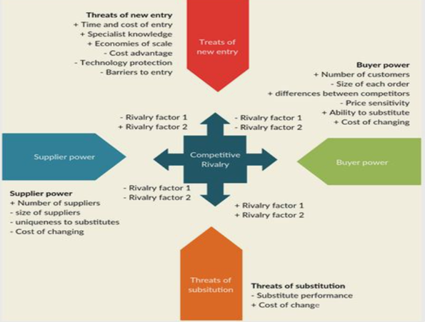
Image, Porters 5 Forces Analysis (Creatley, 2022).

Industry Rivalry
The first level of 5 porters forces is rivalry. When there is many or plenty of competition, it makes it so arduous when you are challenging, and competing for customers, and ultimately profit margins, articulates (Matthews, 2013).
Applying the 5 forces analysis managers can identify all forces that impact the industry in a negative or a positive way. Whilst having the aptitude on competitiveness by retaining and gaining customers articulates (Porter, 1988).

- LFBR competition rivalry minimum, operating as a social enterprise for the interest of the people.
- There is only one Trust that is in competition.
The Threat of New Entrants
According to (Porter, 1998), the challenge of newcomer can make an industry less attractive. For example, the entry barriers in the burger shop industry is low, it is trouble free to enter the business. This means that a burger shop owner does not only have to compete against established competitor, but also may challenge rivals too. Other industries, such as core manufacturing or more difficult to enter and companies know they will not face many new competitors.
- LFBR bound by government policies.
- LFBR capital requirements.
Threat of Substitutes
Burger shops do not only compete against each other, but also against products and other service sector that is similar. For example, if you cannot buy a burger from a burger shop you can buy it from a supermarket instead. If the products are of a standard, then this threat of a substitutes for burger shops will limit the profitability in that industry.
- Buyer power to substitute
- Relative price of substitute
Supplier Power
If suppliers are powerful that offer bespoke or unique products that businesses cannot go without, the industry is less attractive articulates (Porter, 1998). For example, burger shops selling drinks, buns, chips are not powerful since there are more choices out there and by switching from one supplier to another is easy lectured (Osei, 2022)
- Uniqueness of suppliers/donations
- Firms’ ability to substitute suppliers
Buyer Power
Porter’s buyer power forces is the connection with the customer and the business. If the goods and services are of a high standard, the business can also charge a high price for the goods and services. But if there are various businesses selling the same goods or services then it limits industry profitability. Customers can switch from one business to another even leaving feedback or reviews increase their power.
- Number of customers
- Size of each customer’s order

LFBR’s Porters 5 Forces Analysis as shown.
1. Competitive rivalry or competition – Weak Force
2. Bargaining power of customers – Strong Force
3. Bargaining power of suppliers – Strong Force
4. Threat of substitutes – Weak Force
5. Threat of new entrants – Moderate Force

Internal/Firm Analysis – VRIO

VRIO was developed in the 1990’s by James Barney, a familiar technique often used before strategic planning, that takes place after determining the firms’ vision and mission. It is a Resource Based View known as RBV of strategic planning. VRIO is linked to the five forces tools and is used to identify sources of sustained competitive advantage according to (Barney and Hesterly, 2020). VRIO is based on four steps and is known for:
- Value – Is it Valuable
- Rarity – is it Rare
- Imitability – is Imitable
- Organisation - are we Organised to make best use of it?

The VRIO analysis shows a pragmatic approach, for leaders to identify the businesses strengths and weakness according to (Barney and Hesterly, 2020). VRIO generates improvements to strategies to maintain a competitive advantage articulates (Barney and Hesterly, 2020). The VRIO analysis identifies the connection performance and the internal resources that aids the business articulates (Barney and Hesterly, 2020).
Benefits of VRIO
(Barney and Hesterly, 2020) explains that the VRIO identifies the internal resources to maintain its competitive advantage for the future.
Evaluating a business with a VRIO analysis potentially gives more opportunities with strategies. It also helps the leadership solve potential threats with planning. (Barney and Hesterly, 2020).

COMPETITIVE DISADVANTAGE
COMPETITIVE PARITY
TEMPORARY COMPETITIVE ADVANTAGE
UNUSED COMPETITIVE ADVANTAGE
SUSTAINABLE COMPETITIVE ADVANTAGE
From the VRIO analysis it can be determined that LFBR will have a competitive advantage.

Internal/Firm Analysis – Value Chain

What is a value chain? The Value Chain analysis is a strategic management tool that helps managers to identify abilities that make their companies for a sustainable competitive advantage lectured (Osei, 2022).
The purpose of value chain is to increase the value of the items from that industry. Value chains integrate a variety of supply chain activities, from customer needs, production, distribution, marketing and after sales service too lectured (Osei, 2022).
What is value stream mapping? It is a two-step process. Firstly, develop the value stream map or flow of the current supply chain and then develop and improve the most effective flow for your product or service.
What is Porter's value chain? This focuses on systems and how inputs are changed into the output. Evidently (Porter, 1998) described this succession of undertakings as common practice and is split into two types, ‘primary’ and ‘support activities’ that are listed below.
Primary activities are related to the sale, maintenance and supports of a product or service according to (Hart, 2022), listed below.
- Inbound logistics, operations, outbound logistics, marketing and sales and service. Inbound logistics are the process is related to receiving, storing, and distributing inputs.
- Operations are the activities that change inputs into outputs. Here operational systems create value.
- Outbound logistics are the activities that deliver your product or service to your customer.
- Marketing and sales are the process is you use to persuade clients to purchase from you instead of your competitors. Service are the activities related to after sales service.
According to (Hart, 2022) In the diagram it illustrates all the undertakings of support activities are interrelated with the primary activities.
- Purchasing human resource management,
- Technological development,
- Infrastructure.
- Procurement
According to (Hart, 2022) Procurement is what the organisation resources that needs to purchase to operate. That maybe searching for a new supplier and haggling a best price scenario to the organisation advantage. Also having a good HR system is also paramount in the training and coaching, policy making, with compensation and reward packages for staff members articulates (Hart, 2022).
Technological development activities are the daily operations of the firm, from legal to accounting, to the infrastructure from administration in an organisation according to (Hart, 2022). This tool is vital for strategies proposal of LFBR, for its future success in competitive advantage.

SUPPORT ACTIVITIES
MARGIN
LFBR Infrastructure
Human Resource Management
Technology Development
Procurement

MARGIN
Outbound
Logistics
Marketing & sales
Inbound
Logistics
Operations
Services

PRIMARY ACTIVITIES

Diagram of Value Chain Analysis.

Internal/Firm Analysis SWOT Analysis

What Is SWOT Analysis
SWOT is an acronym for Strengths, Weaknesses, Opportunities and Threats. The framework analysis is used to identify businesses competitive advantage by developing strategies. It identifies external and internal factors for present and future prospective.
A SWOT analysis gives a holistic fact about the strengths and weaknesses of a business. These formulate strategies and objectives on the facts and implement them as a guide to the business.
A SWOT analysis is divided into four quadrants. Each quadrant has its own part of the SWOT. The overview of the quadrants gives insight into the company’s competitive advantage. Typically, the SWOT analysis is divided into external factors which are opportunities and threats at the bottom and internal factors that are strengths and weaknesses. See diagram below.
The SWOT table is often laid out with the internal factors on the top row and the external factors on the bottom row. In addition, the items on the left side of the table are more positive/favourable aspects, while the items on the right are more concerning/negative elements.

HARMFUL
HELPFUL
EXTERNAL
INTERNAL
Interpretation of SWOT

Strengths are its core competencies, in where the business exceeds competitive advantage over competitors. An example of a company’s strength could be brand recognition.
Weaknesses are the areas that need improvement. These faults in the workplace needs attention. This will lead to a loss and will lose the competitive edge. An example is a damaged reputation.
Opportunities is where you can identify as favourable factors that are bedded in macro factor. It is where improvements or advantage can be made for a competitive advantage. An example of an opportunity is a value-added service.
Threats comes from a company's macro factor can seriously affect the running of the business. By identifying any threat is a great way of consolidating to mitigate any issues foreseen and take care of business. An example of a threat is the entry of a strong competitor with better innovation and technology.
This shows the strengths and weaknesses from the analysis which can be used to harness the proposal’s competitive advantage as a guide.

Stakeholders Analysis

Who are the stakeholders? Stakeholders are groups of people that have an interest or who may be affected by the organisation. Some stakeholders will have an Influence and some stakeholders none. A stakeholder is an individual or a group that could affect or impact the success of an organisation’s objectives according to (Freeman, 1984).

Stakeholder Analysis the propensity to identify key stakeholders that have a big influence on the business to help attain the organisations objectives and communicating with the high-powered stakeholders frequently. The Power Interest Matrix Model illustrated below.

Power Interest Matrix
According to (Osei, 2022), stakeholders can be assessed and categorised by the assumption of power they possess, and the extent to which they are likely to have or show an interest in the organisation activities. See figure below, the X axis identifies stakeholders ‘Interest’ and on the Y axis identifies stakeholders ‘Power’.

- Power – How much influence do they have on a project or idea.
- Interest – How much interest or benefit they have in a project or an idea.

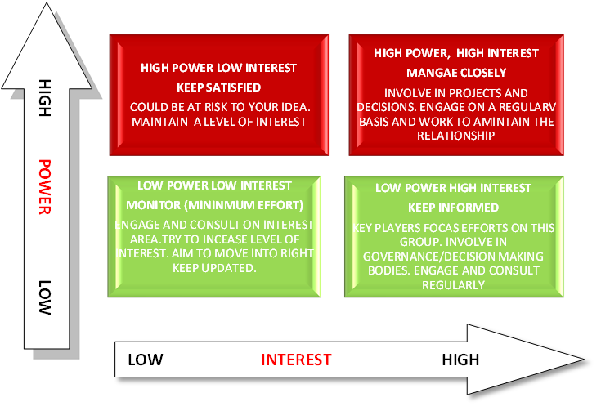
Power Interest Matrix Model.
Power Interest Matrix identifies the organisations stakeholders who are importntant to them.
It is vtal that communication is key when engaing with the stakeholders argues (Husted and Allen, 2011). This process is key when identifying connections with the stakeholders and the firm. It identifies stakeholders on the basis of power and the interest they are likely to have or show in the organisation’s activities articulates (Husted and Allen, 2011).

Mapping Stakeholders for Link-Food Bank Redditch (LFBR)
Stakeholder | Power/Interest | Key Interest & Issues | Communication channel | Frequency | Comments
Community | Low/high | Unaware | Local events or local charities | Occasionally | Keep informed
Customers  LFBR | High/low | Neutral | Newspaper/flyer/social media word to mouth | Frequently | Keep satisfied
Government | High/high | Supportive | Email/office/letters | Frequently | Manage Closely
Workers & LFBR | High/high | Resistant | Emails/memos/newsletter  Or Staff Meetings | Frequently | Manage Closely
Owner of  LFBR | High/high | Resistant | Annual Report/ | Frequently | Manage Closely
Partners  Donators | High/high | leading | Members | Frequently | Manage Closely
Stakeholders Power Interest Table.

Strategy Formulation

Strategy Formulation is the process by which an organisation chooses the most appropriate course of action to achieve its defined goals. The managerial process of crafting and executing a company strategy is an on-going, continuous process, consisting of five integrated stages called the 5 Phase Model.
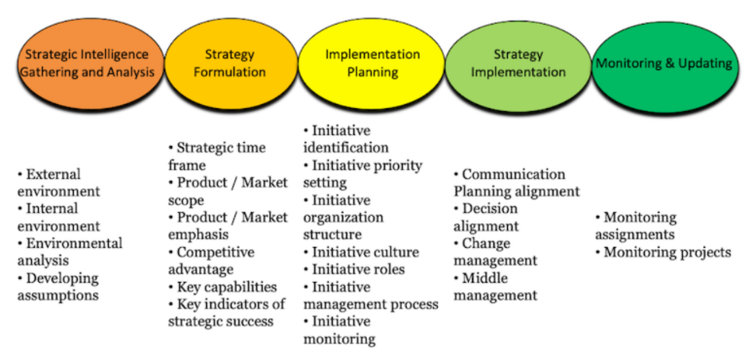
Image of the 5 Phase Model, (Robinson, 2020)
This figure displays that five-step process. The model illustrates the need for management to evaluate several external and internal factors in deciding upon a strategic direction, appropriate objectives, and executing the strategy according to (Barney and Hesterly, 2020)
- Step One: developing a strategic vision that charts the company's long-term direction, a mission statement that describes the company's business.

- Step Two: setting objectives for measuring the company's performance and tracking its progress in moving towards the intended direction.

- Step Three: crafting a strategy for advancing the company along a management envisioned future and achieving its objectives.
.
- Step Four: implementation and use of the strategies efficiently and effectively.

- Step Five: Analyse and learn the external environment and the businesses internal state and performance to apply the correct measure (Barney and Hesterly, 2020).

Ansoff Matrix
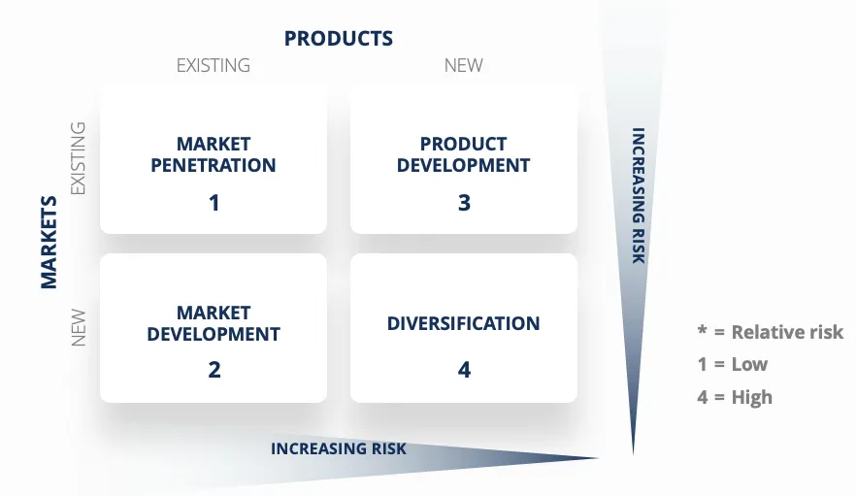
Ansoff Matrix, According to (Peterdy, 2022) existing products and new products along the top and new markets in existing markets along the side. There are four strategies to apply in each situation. See Ansoff Matrix Image above.
For existing markets and existing products, the strategy is market penetration.
For existing markets and new product, the strategy is product development.

Strategy Implementation

According to (Barney and Hesterly, 2020) the organisation and implementation of any strategy are very difficult and can be very taxing to undertake which consumes a lot of resource and valuable time. A good practice is by undertaking and identifying on how the internal business processes are carried out by managers and supervisors. By tallying and seeing the organisation goals are reached and are attained, it is a good practice to acknowledge or reward the achievement of due diligence argues (Barney and Hesterly, 2020).
A scrutiny of ongoing analysis of goals and objectives that have been met also need to implement further analysis on the continuity of the business process in its effectiveness and efficiency in the company’s microenvironment argues (Barney and Hesterly, 2020).
Training and coaching or mentoring staff provides for improved skills, expertise and competencies in the workplace affirms (Barney and Hesterly, 2020). Actioning in a good practice of current policy and procedure strategies help staff to perform at their optimum and being effective and efficient in their tasks and duties according to (Barney and Hesterly, 2020).

Balance Scorecard

The balanced scorecard elucidated is the propensity of a vital strategic plan of the management systems used in the business according to (Kaplan and Norton, 1996). Its main objectives of the balance score card is to identify, measure and action the initiative to achieve competitor’s advantage.
In the past businesses have depended on the sales to calculate and estimate their performance argues (Kaplan and Norton, 1996). However, nowadays a company's success no longer depends primarily on its physical assets, argues (Kaplan and Norton, 1996) but more on the less tangible factors, such as the loyalty of its customers, the efficiency of its work processes of indicators. So, these key indicators cannot be tracked just by the financial indicators argues (Kaplan and Norton, 1996).
That is why the company vision, mission strategy are at the centre of the balance scorecard, whilst surrounded by measures of four perspectives. See diagram below.
- Financial
- Customer
- Internal business process
- Learning and growth.

When the balance score card is developed, the organisation can implement the (BSC) to track progress and act where it is needed to be amended as when needed. By implementing these procedures and strategies this will align the business by obtaining their organisation goals according to (Sardana, 2007).

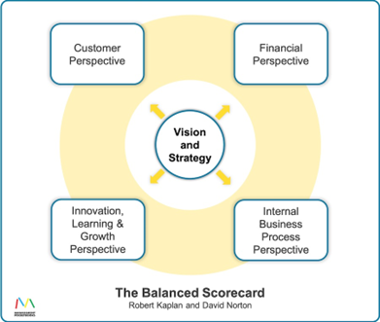
Diagram Balance Scorecard, (Kaplan and Norton, 1996).

CUSTOMER PERSPECTIVE

INTERNAL PERSPECTIVE

LEARNING & GROWTH

FINANCIAL PERSPECTIVE
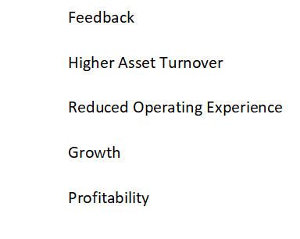

BSC Metrics

Organisation Structure

The proposed organisation structure would be an entrepreneurship structure. The SME would have a top-down approach. With the owner/CEO at the top with set of operational managers/supervisors below the CEO to oversee the day to running of the social enterprise. The communication between the CEO and his subordinates would not be hindered in the organisation structure. See diagram below.

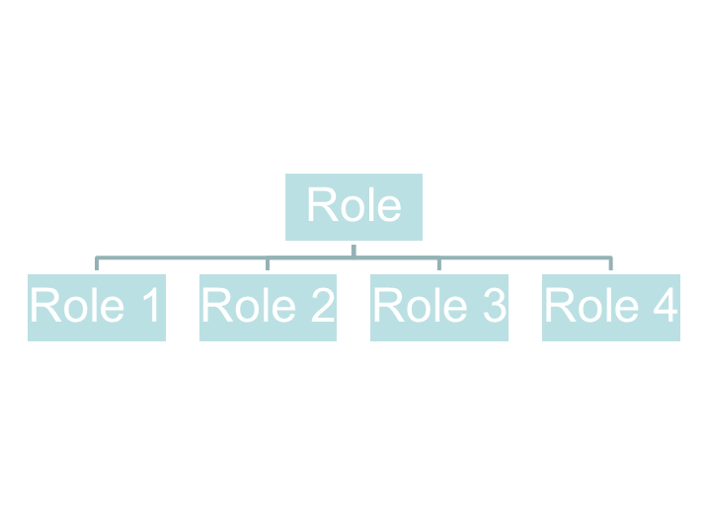
Role/CEO
Role 1 /Manager
Role 2 Assistant. Manager
Role 3 Supervisor 1
Role 4 Supervisor 2

Recommendations.

It is very challenging to navigate especially post Brexit, the Covid-19 pandemic lockdown and post Covid-19, to strategize on any businesses was no mean feat, as new strategies were formed and implemented to adjust and align to gain competitive advantage and ultimately business survival. This was a learning curve for all businesses with their strengths and weaknesses, as we saw big companies like Debenhams collapse during the pandemic. This should be a lesson to us all for not being too complacent and to have the correct strategies and policies in place for any future actualisation. For the continued success of SMEs, it is recommended that innovation and R&D are always at the forefront of any organisation. Prevention is better than cure.

Conclusion.

To conclude, from the necessity to reach a vital service that was much needed in these difficult times in the locality, was the conception of this social enterprise, Link-Food Bank Redditch (LFBR). The social enterprise sector has grown exponentially of over 80% growth. This was the ideal opportunity to start this enterprise currently. With its clear goals and ambitions to be successful with its vision, mission, and values sets out its objectives to succeed. Identifying the key stakeholders and communicating proficiently can only bind the firm stronger with its stakeholders. By analysing and identifying the micro and macro factors puts LFBR in a healthy position for any hinderance that may stand in its way.

References

Barney, J.B. and Hesterly, W.S. (2020) Strategic management and competitive advantage: Concepts. Harlow, United Kingdom: Pearson Education Limited.
BBC News (2021) Iceland boss: UK has more food banks than McDonalds, BBC News. BBC. Available at: https://www.bbc.co.uk/news/av/uk-politics-58678787. (Accessed: November 21, 2022).
BBC, N. (2019) Food banks: What are they and who are they for?, BBC News. BBC. Available at: https://www.bbc.co.uk/newsround/49002620. (Accessed: November 1, 2022).
Business Management (2022) Political factors - external factors - higher business management revision - BBC Bitesize, BBC News. BBC. Available at: https://www.bbc.co.uk/bitesize/guides/zd3prj6 /revision/2(Accessed: November 23, 2022).
Carpenter, M.A. et al. (2013) Principles of Management. Washington, DC, Virginia: Flat World Knowledge.
Chris Jeffs (2008) Strategic Management. Los Angeles: SAGE Publications Ltd (SAGE Course Companions). Available at: https://search-ebscohost-com.ezproxy.uwtsd.ac.uk/login.aspx?direct=true&db=nlebk&AN=309802&site=ehost-live. (Accessed: 7 November 2022).
Clark, D. (2022) UK foodbank users 2022, Statista. Statista. Available at: https://www.statista.com/statistics/382695/uk-foodbank-users/ (Accessed: November 22, 2022).
Coughlan, S. (2017) Who really goes to a food bank?, BBC News. BBC. Available at: https://www.bbc.co.uk/news/education-40431701. (Accessed: November 2, 2022).
Creatley (2022) Porters 5 Forces. Creatley.com. Available at: https://www.pinterest.com.au/pin/464011567859298760/ [IMAGE] (Accessed: November 22, 2022).

FSA (2022) Food hygiene rating scheme | food standards agency, Food Hygiene Rating Scheme. Food Standards Agency. Available at: https://www.food.gov.uk/safety-hygiene/food-hygiene-rating-scheme. (Accessed: November 20, 2022).
GOV.UK (2021) Humanitarian response funding: Guidelines for ngos, GOV.UK. Foreign, Commonwealth & Development Office. Available at: https://www.gov.uk/guidance/humanitarian-response-funding. (Accessed: November 22, 2022).
Guðlaugsson, B. et al. (2020) ‘Classification of stakeholders of sustainable energy development in Iceland: Utilizing a power-interest matrix and fuzzy logic theory’, Energy for sustainable development, 57, pp. 168–188. Available at: https://doi.org/10.1016/j.esd.2020.06.006. (Accessed: November 21, 2022).
Hart, M. (2022) The straightforward guide to value chain analysis [+ templates], HubSpot Blog. HubSpot. Available at: https://blog.hubspot.com/sales/value-chain-analysis. (Accessed: November 23, 2022).
Husted, B.W. and Allen, D.B. (2011) Corporate social strategy: Stakeholder engagement and competitive advantage. Cambridge: Cambridge University Press.
ITV News (2022) Food banks reach breaking point as they face 'relentless' demand, ITV News. ITV News. Available at: https://www.itv.com/news/2022-04-11/food-banks-reach-breaking-point-as-they-face-relentless-demand. (Accessed: November 7, 2022).
Kelly, L. (2019) GOV.UK, Legislation on non-governmental organisations (NGOs) in Tanzania, Kenya, Uganda, Ethiopia, Rwanda and England and Wales. Available at: https://assets.publishing.service.gov.uk/media/5fdb557e8fa8f54d5733f5a1/ Funerals_-_Final_report.pdf (Accessed: November 23, 2022).
King, J. (2022) “Disposable income to drop by 7% over next two years in ‘staggering’ fall,” Metro [Preprint]. London. Available at: https://metro.co.uk/2022/11/17/disposable-income-to-drop-by-more-than-7-over-next-two-years-17778213/. (Accessed: November 21, 2022).
Lynch, R 2018, Strategic Management, Pearson Education, Limited, Harlow, United Kingdom. Available from: ProQuest Ebook Central. [7 November 2022].
Mathews, J. (2013) ‘The Competitive Advantage of Michael Porter’, in The Oxford Handbook of Management Theorists. Oxford University Press. Available at: https://doi.org/10.1093/oxfordhb/9780199585762.013.0022.
Mayers, J. (2005) Stakeholder power analysis, policy-powertools.org. Available at: https://policy-powertools.org/Tools/Understanding/docs/stakeholder_power_tool_english.pdf (Accessed: November 22, 2022). .
NGOsource (2022) Ngosource.org. NGOsource. Available at: https://www.ngosource.org/what-is-an-ngo (Accessed: November 1, 2022). what is an NGO?
Osei, E. (2022) “Internal Analysis (Stakeholder Analysis),” BMSW6104_BIRM. Strategic Management for SME's, Birmingham: UWTSD, 10 October.

Perera, S. (2022) All about social enterprise, Social Enterprise UK. Social Enterprise UK. Available at: https://www.socialenterprise.org.uk/all-about-social-enterprise/ (Accessed: November 22, 2022).
Perera, S. (2022) The State of Social Enterprise, Social Enterprise UK. SEUK. Available at: https://www.socialenterprise.org.uk/the-state-of-social-enterprise/. (Accessed: November 24, 2022).
Peterdy, K. (2022) Ansoff Matrix, Corporate Finance Institute . CFI. Available at: https://corporatefinanceinstitute.com/resources/management/ansoff-matrix/ [IMAGE] (Accessed: November 23, 2022).
Porter, M.E. (1998) Competitive advantage: creating and sustaining superior performance. New York ;: Free Press.
Rayport, J.F. and Sviokla, J. (2014) Exploiting the virtual value chain, Harvard Business Review. HBR. Available at: https://hbr.org/1995/11/exploiting-the-virtual-value-chain (Accessed: November 22, 2022).
Robinson, J. (2020) CLOSING THE GAP BETWEEN STRATEGY FORMULATION AND EXECUTION, Consult Magazine Canada. CMC-CANADA. Available at: https://www.cmc-canada.ca/consult/Closing-the-Gap-Strategy-Formulation-Execution [IMAGE] (Accessed: November 23, 2022).
Sardana, G.D. (2007) “Alignment: Using the balanced scorecard to create corporate synergies kaplan, Robert S. and Norton, David P.,” Paradigm, 11(1), pp. 88–89. Available at: https://doi.org/10.1177/0971890720070114.
Savage, M. (2022) UK food banks at breaking point urge Liz Truss to boost aid to poorest, 16 October. Available at: https://www.theguardian.com/society/2022/oct/16/uk-food-banks-at-breaking-point-urge-liz-truss-to-boost-aid-to-poorest. (Accessed: November 1, 2022).
Sheffield Foodbank benefits as runners donate food as entry fee (2022) BBC News. BBC. Available at: https://www.bbc.co.uk/news/uk-england-south-yorkshire-63534716. (Accessed: November 6, 2022).
Trussell Trust, T. (2016) Redditch Foodbank, The Trussell Trust. The Trussell Trust. Available at: https://www.trusselltrust.org/get-help/find-a-foodbank/redditch/. (Accessed: November 21, 2022).
United Nations (2021) GLOBAL ISSUES - Food, United Nations. United Nations. Available at: https://www.un.org/en/global-issues/food (Accessed: November 22, 2022).
United Nations (2022) Global Impact of war in Ukraine on food, energy and finance systems - BRIEF NO.2. United Nations. Available at: https://unsdg.un.org/resources/global-impact-war-ukraine-food-energy-and-finance-systems-brief-no2. (Accessed: November 21, 2022).
Whitworth, D. and England, R. (2022) Food Banks warn they are struggling to keep up with demand, BBC News. BBC. Available at: https://www.bbc.co.uk/news/business-62228972. (Accessed: November 2, 2022).
Willetts, P., 2002. What is a non-governmental organization. Conventions, treaties, and other responses to global issues, 2(11), pp.229-248.

