

Changemakers: Creativity and Value Creation
Professions (BMHP5014)

Component 1: Online portfolio of set exercises

Student name: Liliana Vladut
Student number:2411574
Lecturer’s name: Brian Mashumba

Table of contents
Introduction
Task 1 – Defining Key Concepts in Practice
Task 2 – Mind Map
Task 3 – Self-Reflection of Group Activity
Task 4 – Case Study Analysis of a UK Innovation
Task 5 – Research Task
Task 6 – Exploring Digital Innovation in Health and Social Care
6.1 Wearable Health Technologies
6.2 Electronic Health Records (EHRs)
6.3 Digital Technology for Prevention and Health Promotion
Task 7 – Understanding the NHS Leadership Framework
Task 8 – Self-Reflection Journal Entry
Reference List

Introduction

Organisations that provide health and social care must contend with a growing number of issues, including an ageing population, a lack of workers, an increase in service demand, and quick advancements in technology. Professionals must employ creativity, innovation, and leadership to effectively address these issues and raise the standard of care while optimising the use of existing resources. This portfolio examines important ideas in value creation and creativity and shows how they may be used in actual health and social care environments. The portfolio emphasises the value of creating creative solutions that enhance service user outcomes and promote ongoing service improvement through hands-on activities, case studies, research, and introspection. It also takes into account how modern health and social care practices benefit from digital technologies and capable leadership.

Task 1 – Defining Key Concepts in Practice

Innovation

Innovation is the introduction of fresh concepts, techniques, tools, or services that enhance current procedures. Innovation helps health and social care organisations adapt to changing requirements, resulting in safer, more effective, and person-centred care. According to Rogers' Diffusion of Innovation Theory (Rogers, 2003), new concepts are gradually embraced based on their practicality, compatibility, and ease of implementation. The NHS's implementation of digital consultations, which enable patients to receive healthcare remotely while cutting down on needless in-person sessions, is an example of innovation.

Creativity
Creativity is the ability to generate original and practical ideas that solve problems or improve services. It pushes experts to think beyond the box and create solutions that cater to specific demands. According to Amabile's Componential Theory, knowledge, creative thinking abilities, and intrinsic motivation come together to produce creativity (Amabile, 1996). Creating individualised daily activities for dementia patients in a care facility can enhance their quality of life, mental health, and participation.
Value Creation
Value creation is enhancing service user outcomes while making efficient use of available resources. Porter (2010) contends that when improved patient outcomes are attained without needless expense increases, healthcare provides value. Introducing multidisciplinary team meetings, where medical experts work together to create coordinated care plans, is one way that value creation can be implemented in practice. This strategy enhances communication, cuts down on work duplication, and offers service consumers more comprehensive help.

Change
The process of switching from current methods to better ones that better serve the demands of service consumers and organisational objectives is known as change. Healthcare systems must constantly adjust to new regulations, technologies, and expectations from the populace. In order to guarantee long-term development, Lewin's Change Management Model outlines change as a three-stage process that involves unfreezing current practices, implementing change, and refreezing new habits (Burnes, 2017). The use of electronic health records, which has revolutionised information exchange and enhanced continuity of care across healthcare systems, serves as a concrete illustration.

Task 2 – Mind Map

Topic: Poor Communication in Health and Social Care
Mind Map
Poor Communication
│
┌───────────────────────────┼───────────────────────────┐
│ │ │
Causes Impacts Solutions
│ │ │
• Staff shortages • Medication errors • Staff training
• Heavy workload • Delayed treatment • Electronic Health Records
• Lack of training • Patient dissatisfaction • MDT meetings
• Poor handovers • Poor teamwork • Standardised handovers
• Different IT systems • Increased complaints • Digital communication
│
│
Better Patient Safety
Higher Quality of Care

Explanation
One of the most prevalent issues in health and social care is poor communication, which can have an impact on teamwork, patient safety, and the standard of care given. Staffing shortages, excessive workloads, poor handovers, or infrequent use of digital tools can all lead to communication issues. Medication errors, therapy delays, and decreased patient satisfaction might result from these problems. The mind map illustrates how the causes, effects, and potential remedies are interconnected rather than existing separately. According to a systems thinking approach, there are several interrelated elements that contribute to healthcare issues rather than a single cause (Meadows, 2008). Electronic health records, better staff communication training, and multidisciplinary team meetings can improve person-centred care across health and social care systems, increase professional collaboration, and decrease errors.

Task 3 – Self-Reflection of Group Activity
Reflective Model: Gibbs' Reflective Cycle
During the convergent and divergent thinking activity, my group worked together to generate ideas before selecting the most practical solution. Divergent thinking encouraged us to think creatively by suggesting as many ideas as possible without judging them immediately. Convergent thinking then helped us evaluate these ideas and decide which option was the most realistic and effective.
Using Gibbs' Reflective Cycle (1988), I reflected on my contribution to the activity. Initially, I was slightly hesitant to share my ideas because I wanted to ensure they were relevant. However, after listening to my classmates, I became more confident and contributed several suggestions that supported the group discussion. I realised that I naturally prefer convergent thinking because I like organising information and identifying practical solutions. At the same time, I recognised the value of divergent thinking in encouraging creativity and allowing everyone to contribute different perspectives.
This activity improved my communication, teamwork, and problem-solving skills. It also showed me that successful innovation often depends on combining creative thinking with critical evaluation. In future group activities, I would participate more actively from the beginning and encourage quieter group members to share their ideas, creating a more collaborative and inclusive discussion.
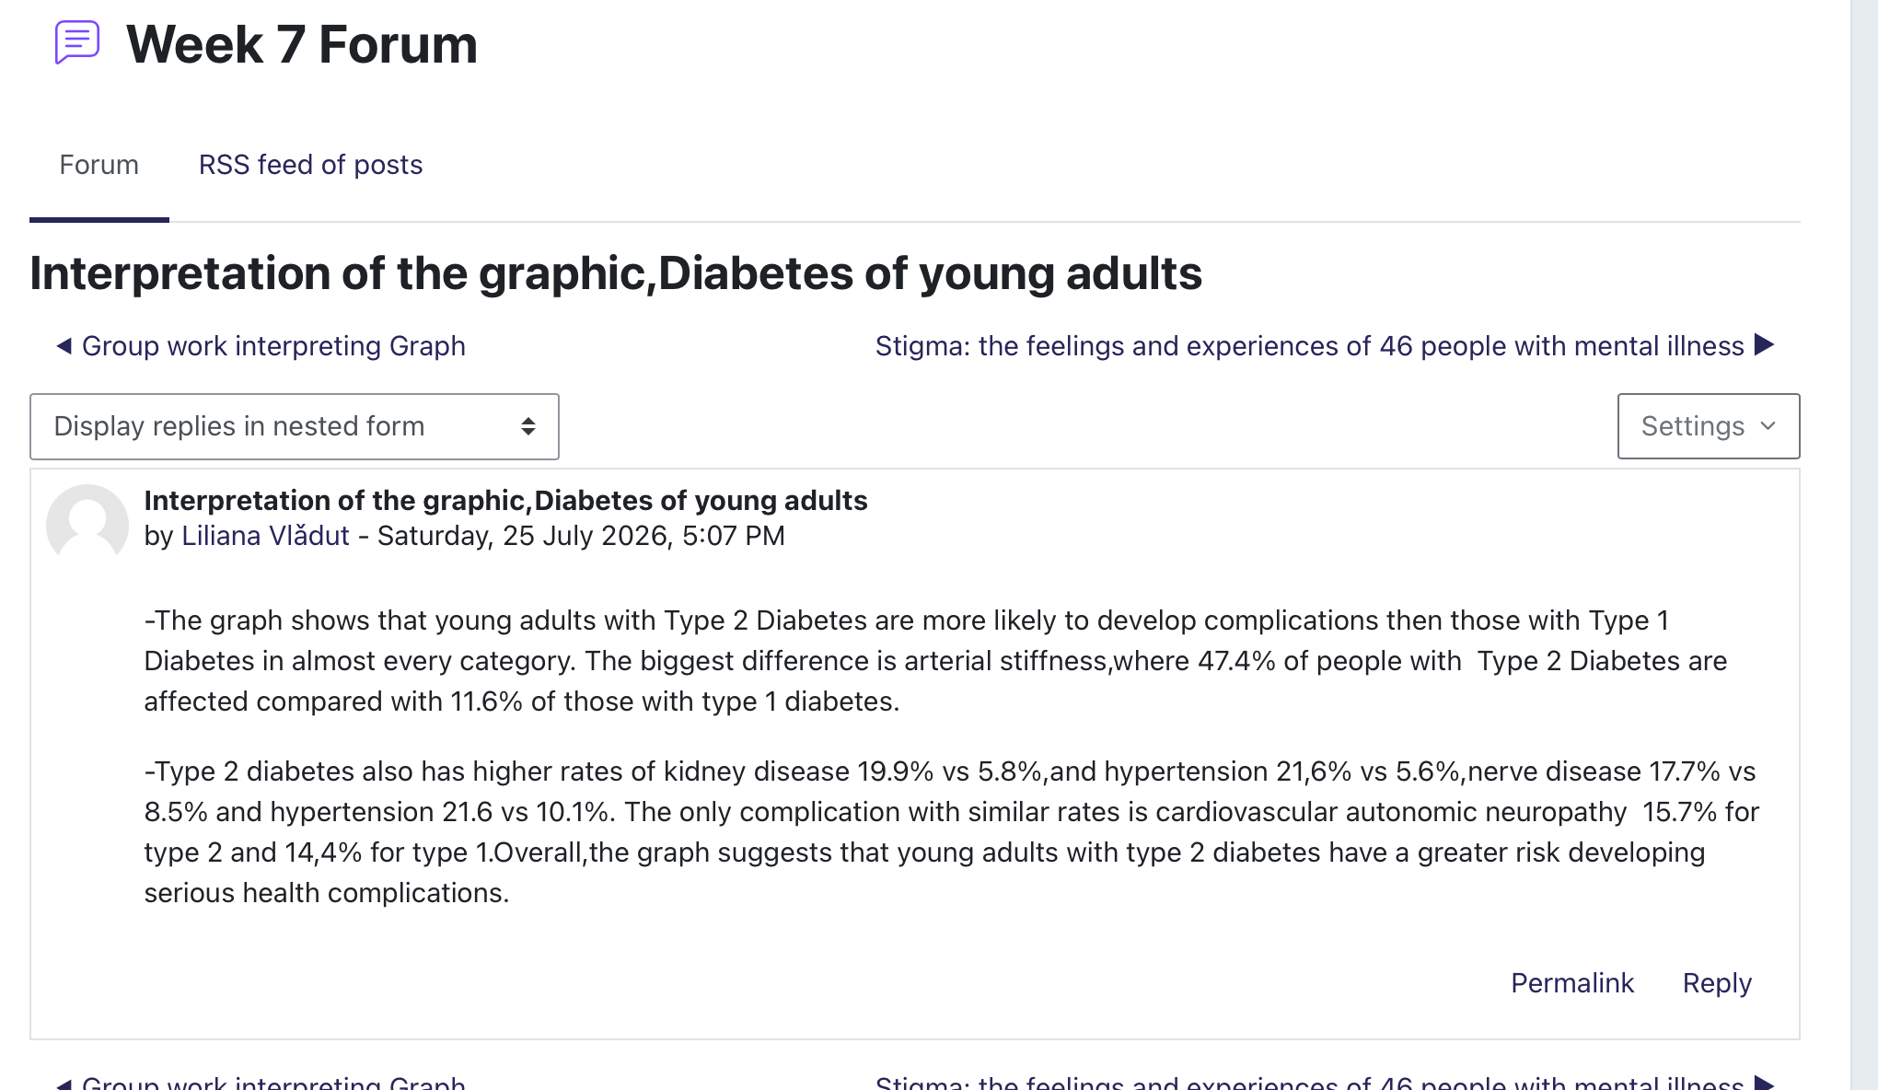
Figure 1. Forum activity completed during class (Liliana Vladut own screenshot, 2026)

Task 4 – Case Study Analysis of a UK Innovation

NHS App: Improving Access to Healthcare
By providing patients with an easy-to-use digital health management tool, the NHS App was designed to increase access to healthcare services. Prior to its implementation, a lot of patients had to call general practitioner offices to schedule appointments, ask for repeat prescriptions, or obtain medical information. This frequently led to lengthy wait periods and more administrative work.
In order to create the NHS App, which combines several healthcare services into a user-friendly digital platform, creativity was crucial. Through the app, users can examine portions of their medical records, schedule appointments, order repeat medicines, and obtain health information via their smartphone.According to Rogers' Diffusion of Innovation Theory, healthcare innovations are more likely to be adopted when users recognise clear benefits and find them easy to use (Rogers, 2003).
The NHS App has created value for both patients and healthcare professionals. Patients benefit from greater convenience, quicker access to services, and increased control over their healthcare, while staff spend less time on routine administrative tasks. Overall, the innovation has improved efficiency, patient experience, and communication across NHS services.

Task 5 – Research Task

Current Issue: Workforce Stress in Health and Social Care
One of the key issues facing health and social care systems is still workforce stress. Burnout and decreased wellness among healthcare workers are caused by heavy workloads, staffing shortages, and emotional pressures.
According to West et al. (2022), two of the main factors contributing to stress in the NHS are growing workloads and workforce shortages. According to their research, excessive pressure may lower the standard and safety of patient care, have an adverse effect on worker wellbeing, and increase sick leave. In order to increase employee retention, the study emphasises the significance of workforce planning and supportive leadership. In a similar vein, Dall'Ora et al. (2020) found that nurses' emotional weariness and burnout are increased by long work hours and low staffing levels. According to the authors, burnout is linked to decreased productivity, decreased job satisfaction, and an increased risk of clinical errors.
Workload and staffing pressures are the main factors contributing to workforce stress, according to both surveys. Together, they show how maintaining safe, excellent health and social care services depends on enhancing leadership, working environment, and employee wellness.

Task 6 – Exploring Digital Innovation in Health and Social Care

6.1 Wearable Health Technology
Wearable health technologies, such as smartwatches and fitness trackers, help individuals monitor long-term health conditions by collecting real-time information about heart rate, physical activity, sleep, and other health indicators. These gadgets can notify users of changes that could need medical care and inspire people to take a more active role in their own health management. A person with cardiovascular illness, for instance, might wear a smartwatch to track their heart rhythm and consult a doctor if an abnormal heartbeat is noticed. According to the Technology Acceptance Model (Davis, 1989), people are more inclined to use digital technologies if they feel them to be practical and simple to use. By promoting healthier lives and assisting medical personnel in better patient monitoring, wearable technology improves preventative care.

6.2 Electronic Health Records
Electronic Health Records (EHRs) improve communication between healthcare professionals by allowing patient information to be accessed securely across different healthcare settings. Professionals such as doctors, nurses, pharmacists, and others can examine current and correct information, which minimises job duplication and enhances clinical decision-making. By giving users access to allergies, past treatments, and current prescriptions, EHRs also lower the chance of pharmaceutical errors. For instance, medical personnel can swiftly evaluate a patient's medical history and administer safer care if they are abruptly admitted to the hospital. The Technology Acceptance Model (Davis, 1989) states that when digital solutions are user-friendly and increase efficiency, healthcare personnel are more inclined to adopt them. In general, electronic health records enhance patient safety and promote continuity of care.

6.3 Digital Technology for Prevention and Health Promotion
Digital technology plays an important role in preventing illness and promoting healthier lifestyles. Mobile health applications, online health campaigns, and remote monitoring systems help individuals manage their health before medical problems become more serious. For example, the NHS Better Health campaign provides online advice about healthy eating, exercise, and smoking cessation, encouraging people to reduce their risk of chronic disease. Digital platforms also allow healthcare professionals to share personalised advice and educational resources with patients. These technologies improve access to health information and encourage individuals to take greater responsibility for their wellbeing. The Technology Acceptance Model explains that people are more willing to use digital health services when they believe they are beneficial and straightforward to use (Davis, 1989). As a result, digital technology supports both health promotion and early intervention.

Task 7 – Understanding the NHS Leadership Framework

Understanding the NHS Leadership Framework
The NHS Leadership Framework describes the behaviours and values that help leaders deliver safe, effective, and compassionate care. Rather than focusing only on management responsibilities, the framework encourages leaders at every level to inspire others, work collaboratively, and continuously improve healthcare services. The NHS Healthcare Leadership Model includes behaviours such as leading with care, inspiring shared purpose, evaluating information, engaging the team, influencing for results, connecting services, developing capability, and holding to account. These behaviours support a positive working culture where staff feel respected, motivated, and confident to contribute new ideas. Effective leadership is essential because it improves communication, strengthens teamwork, and promotes person-centred care. Leaders who follow the framework can respond more effectively to organisational challenges while maintaining high standards of patient safety and service quality. In modern health and social care, good leadership also encourages innovation and continuous learning, helping organisations adapt to changing healthcare needs.

Leadership Behaviour: Leading with Care
One important leadership behaviour is Leading with Care. Leaders who demonstrate empathy, respect, and compassion create a positive working environment where staff feel valued and supported. When employees feel psychologically safe, they are more willing to suggest creative ideas, report concerns, and participate in service improvement. For example, a care home manager who regularly listens to staff feedback and recognises good performance can improve morale and encourage innovation. This supportive approach benefits both staff and service users because motivated teams are more likely to provide high-quality, person-centred care.

Reflection
I've learned from studying the NHS Leadership Framework that being a leader involves more than just making choices; it also involves encouraging and supporting people. I've discovered that good leaders foster an atmosphere that fosters collaboration, communication, and creativity. I intend to work in a leadership role in health and social care, thus this information will have an impact on my future profession. I now understand that providing safe, efficient, and compassionate care requires supporting personnel, listening to differing viewpoints, and encouraging continuous improvement.

Task 8 – Self-Reflection Journal Entry
Throughout this module, my understanding of creativity and innovation has changed significantly. Before studying this subject, I believed creativity mainly referred to developing completely new ideas. I now understand that creativity also involves improving existing services, solving problems, and finding practical ways to deliver better care. Learning about innovation, leadership, value creation, and digital technology has shown me how these concepts work together to improve health and social care services. The activities completed during the module, particularly the case study and group discussions, helped me appreciate the importance of collaboration and different ways of thinking. Using Gibbs' Reflective Cycle encouraged me to evaluate my own learning and identify areas for future improvement. In my future professional practice, I intend to apply these principles by supporting teamwork, remaining open to new ideas, and contributing to continuous service improvement that benefits both staff and service users.

Reference List
Amabile, T.M. (1996) Creativity in Context. Boulder: Westview Press.
Bass, B.M. and Avolio, B.J. (1994) Improving Organizational Effectiveness Through Transformational Leadership. Thousand Oaks: Sage.
Burnes, B. (2017) Managing Change. 7th ed. Harlow: Pearson.
Dall'Ora, C., Ball, J., Reinius, M. and Griffiths, P. (2020) 'Burnout in nursing: a theoretical review', Human Resources for Health, 18(1), pp. 1–17.
Davis, F.D. (1989) 'Perceived usefulness, perceived ease of use, and user acceptance of information technology', MIS Quarterly, 13(3), pp. 319–340.
Gibbs, G. (1988) Learning by Doing: A Guide to Teaching and Learning Methods. Oxford: Oxford Polytechnic.
Meadows, D.H. (2008) Thinking in Systems: A Primer. White River Junction: Chelsea Green Publishing.
NHS England (2024) NHS App. Available at: https://www.nhs.uk/nhs-app/
NHS Leadership Academy (2013) Healthcare Leadership Model. Available at: https://www.leadershipacademy.nhs.uk/
Porter, M.E. (2010) 'What is value in health care?', New England Journal of Medicine, 363(26), pp. 2477–2481.
Rogers, E.M. (2003) Diffusion of Innovations. 5th ed. New York: Free Press.
West, M., Bailey, S. and Williams, E. (2022) The Courage of Compassion: Supporting Nurses and Midwives to Deliver High-Quality Care. London: The King's Fund.

