  Component One:  What are the key skills required when working in the housekeeping team? 750 words (+/- 10%)  Contribution to Overall Module Assessment: 25% | Student No: | Maria Ana Iordache  2126874
 | Module Title: | Operating Hotel Facilities
 | Module Code: | BMIH 4006
 | Lecturer: | Lola Villard
What are the key skills required when working in the housekeeping team?

The purpose of this journal is to identify and perfect the skills I need to work in the housekeeping department after completing my education. Because I desire a position based on my qualifications and university training, I believe I should have both, soft and hard skills to properly fulfil the role of Executive Housekeeper of the housekeeping team (Marriott Careers, 2023).

A skill is an ability to perform an action with determined results often within a given amount of time, energy, or both, developed through life and work experiences or learned through study (Institute of Hospitality, 2023).

During my placement at the Marriott Hotel in Leicester, I discovered that an Executive Housekeeper, among other things, manages a crew of housekeepers and ensures that all sections of the hotel are clean and properly kept. I anticipated that he needed a wide variety of abilities to be effective in this. Customer orientation is critical; the housekeeping team's mission is to deliver cleanliness and a pleasant atmosphere to guests in order to exceed their expectations and gain their loyalty (Employeepedia, 2023).

I also observed direct communication with the manager of the rooms division and members of my housekeeping team. I understand that I must cultivate a teamwork spirit and good communication skills to assist teams in resolving conflict and improving teamwork, which was also evident in my previous position.
The executive housekeeper gave us training on our first day in the housekeeping department, which reminded me of when I was doing the same thing with the new care assistants who joined the care team for the senior residents. To be an excellent trainer with efficient training skills, this activity takes specific attention and competence. Furthermore, I should be an excellent recruiter as well as a leader and team player, as the success of the hotel and brand is dependent on the individual in this role. Customers of a hotel are extremely concerned with cleanliness; they are quite demanding, and their opinions are more valuable than any marketing. (Climb, 2023).
Judging by the fact that all the careers I have chosen for my team in the past job, have been extraordinary, I believe I am a good reader of people, and I have the recruitment skills to be able to recruit a team of housekeepers with the appropriate skills: attention to detail, focus on customers, reliability, listening skills, adaptability, planning and organisation, integrity, flexibility, honesty, good energy, and remarkable team spirit, which matters enormously in achieving success (Indeed, 2023).

In my placement, I noticed how vital and difficult housekeeping is: washing the carpet, sweeping, general cleaning, cleaning window treatments and mopping, vacuuming, dusting, cleaning the bathrooms and bedrooms, avoiding infection, and polishing. As a result, they must continue to grow personally and professionally, with the help of a flexible and competent executive housekeeper with great time management abilities (Wikihow, 2023).
Because in the future I could have the authority to hire and manage employees while practising executive housekeeping, I must be an excellent planner to assign work assignments, brief new employees on regulations, inspect the workloads of housekeeping staff, request supplies, and even procure new suppliers (BSR, 2023).

During the placement, I enquired about the extra tasks and functions the role requires so that I could focus on acquiring the skills I would need to execute this work in the future. In order to prepare a monthly calculation for the housekeeping department, manage various other departments, be in charge of lost or found procedures, maintain capital expenditures, and plan various housekeeping strategies, I will need to effectively manage all costs and keep accurate records of them. I'll also have to consider the monthly utilisation of chemicals, linen parachute stockings, and other operations-related products. I already know about stock control, inventory completion, and evidence retention, which I will put into practice if I secure this position (Stobierski, 2021).

An executive housekeeper's work also includes handling any visitor complaints. Things make me consider my talents in the arts of communication and problem-solving, as well as my capacity to cope with guests. I also learned how to handle complaints in order to restore client loyalty. listening, emphasising, apologising, resolving, and never repeating, to surpass customer expectations by focusing on customer service and the degree of customer experience given.
Furthermore, in this position, I will be able to supervise the emergency team, conduct risk assessments, and provide good professional training. Owning professional decision-making skills, I will send the employees to general training once a year, and as required, I will construct pieces of training on a variety of themes in order for the housekeeping team to meet client expectations (ARCSI, 2023).

I am ecstatic about the knowledge I have gained, and I am confident that even though managing a housekeeping team is a complex business, I will manage it. Success as a housekeeping manager requires a strong work ethic, organisational skills, management aptitudes, and—most importantly—a "taste" for cleaning.

Word Count 822

Component Two:
Contribution to Overall Module Assessment: 25%
In this scenario – You have just been promoted to team leader for a floor within the hotel. A guest complains that on their arrival, their room had not been properly cleaned. Create an action plan and answer the following questions.

Problem | Why did it happen? | What are you going to do? | How will you prevent this from happening in the future? | What measures would you introduce to improve team effectiveness?
Unpleasant odours. | Type of guest notoriously difficult to satisfy. | - I will stay calm and listen,  - I will go to the guest room to see what could be wrong.  - I will apologize for his displeasure caused by the smell that is not to his liking,  - I will show empathy and ask my guest if could he give me an example of pleased odours, in the hope that I can fix this aspect. | I will advise the cleaning team to ventilate better in the future.  I will explain to my team that my mission as a staff accountant is to satisfy customer expectations, to exceed expectations as much as possible, to create unique, special, personalised moments and experiences, in order to obtain their satisfaction and loyalty. As an employee, I represent a brand that must be protected and developed, as I am part of the consistency of this brand, part of the corporate culture, and impact the reputation of the hotel to which I belong.  I will tell them, pleasantly, that my mission is our mission, as a team, as a part of the same corporation, with exactly the same rights and facilities provided by our employer. | I will remember to my team that operations in the housekeeping department are all the things that staff members do to be ready for guests' arrival and tend to their requirements throughout their stay and until they leave.  In addition, supervision, a discussion with my team, and the signing of a document outlining the client's displeasure, with the recommendation to properly ventilate the rooms after cleaning, since the client could not stand the perfume scent in the cleaned spaces.
Traces of cigarette ash on the balcony of the rooms. | The room and balcony neighbour smoked on his balcony, and the wind threw the cigarette ashes on the outraged guest's balcony after the room was checked. | - I will stay calm and listen,  - I will go to the guest room to see what could be wrong.  - I will apologize for his displeasure caused by this inconvenience, I will ask someone to clean it, or I will do it myself if my colleagues are busy. | Weather and customers cannot be controlled, but I will follow instinct and the policies and procedures of the brand whose employee I am, to meet the customer expectation.  I will be empowering the guest with apologies and empathy. The recovery plan, which stands for Listen, Empathise, Apologies, Resolve, and Never Repeat, and AREC, which stands for Act, Responsibility, Empowerment, Compensation, or LEARN, are two examples of rehabilitation strategies. | I will contact the guest to inform him gently that smoking in hotel rooms, on the balcony, and in public spaces is banned due to the immediate risk of fire, and I will inform him about the specially designated smoking areas.  I will inform my superior about this aspect, taking into account the fact that smoking is prohibited in the hotel and I cannot put ashtrays with wet napkins on the guests' balconies.  My duty is to report hazards.
A black comb was found in one of the dressers. | The lack of expertise of the colleague who cleaned the room, as well as the supervisor's lack of time to properly inspect the colleague's work. | - I will stay calm and listen,  - I will go to the guest room to clean and disinfect the space where the comb was found.  - I will apologize for his displeasure caused by this inconvenience,  -The next day I will take care to configure a flower from the towel on the bedding. | I will advise my colleagues to be more careful and to clean with a sense of responsibility and I will check in the same way in the future.  I will remember our mission in this corporate. | I will remind them of the role, duties and responsibilities of a housekeeper and the fact that the effort made by housekeeping to provide a visitor with a desired room has a direct impact on the guest's experience in a hotel.  Additionally, supervision, a discussion with my team, and the signing of a document outlining the client's displeasure, with the recommendation that in the future seriousness and sudden attention will be allocated to hard-to-access spaces.
Unpleasant odours (pets) | Lack of communication between the front office and the housekeeping department.  The guest was assigned a room to which guests with animals have access, and he notices the persistent smell of the pets. | - I will stay calm and listen,  - I will go to the guest room to see what could be wrong.  - I will contact the front office department, and request to change the guest's room, explaining to them that the guest is not accompanied by an animal, and that is indeed a room intended for guests with animals, precisely on the grounds that odours can persist even after a thorough cleaning.  - I will apologize for his displeasure caused by this inconvenience and I will direct the guest to another room. | I will communicate more details to colleagues from the room allocation department.  Housekeeping's key communications are with the front desk/reception personnel because they are accountable for the quick return of the rooms. The status of each room is regularly reported from housekeeping to the front desk and vice versa. A room status update can be performed via modern technologies such as hotel software, telephone systems, housekeeping mobile applications, and so on. | I will report to my superior, and I will propose the participation of the entire staff in inter-departmental communication training.
Room with large clumps of dust, and filthy surroundings. | The lack of expertise of the colleague who cleaned the room, as well as the supervisor's lack of time to properly inspect the colleague's work, because of short staff that day. | - To prevent leaving a bad impression on our guests, I will relocate them to a new pristine room as soon as possible, or I will go the additional mile and upgrade them to a much nicer room.  - I will apologize for his displeasure. | I will request the implementation of additional verification persons, rigorous cleaning checks and maybe even random inspections to ensure the cleaning crew is adhering to the necessary standards. | I will request the full training of the entire cleaning department, according to Standard Operating Procedures (SOPs), which are written step-by-step guides on how to perform routine or repetitive activities in the workplace.

Component Three:
Contribution to Overall Module Assessment: 50%
Your task is to create and prepare a presentation following the detailed scenario provided below.

As the floor housekeeping manager and given the recent guest complaints you need to put together a basic training presentation for your colleagues within the housekeeping team to get the best out of them, ensure that brand standard is being achieved and that Health and Safety procedures are also being followed.

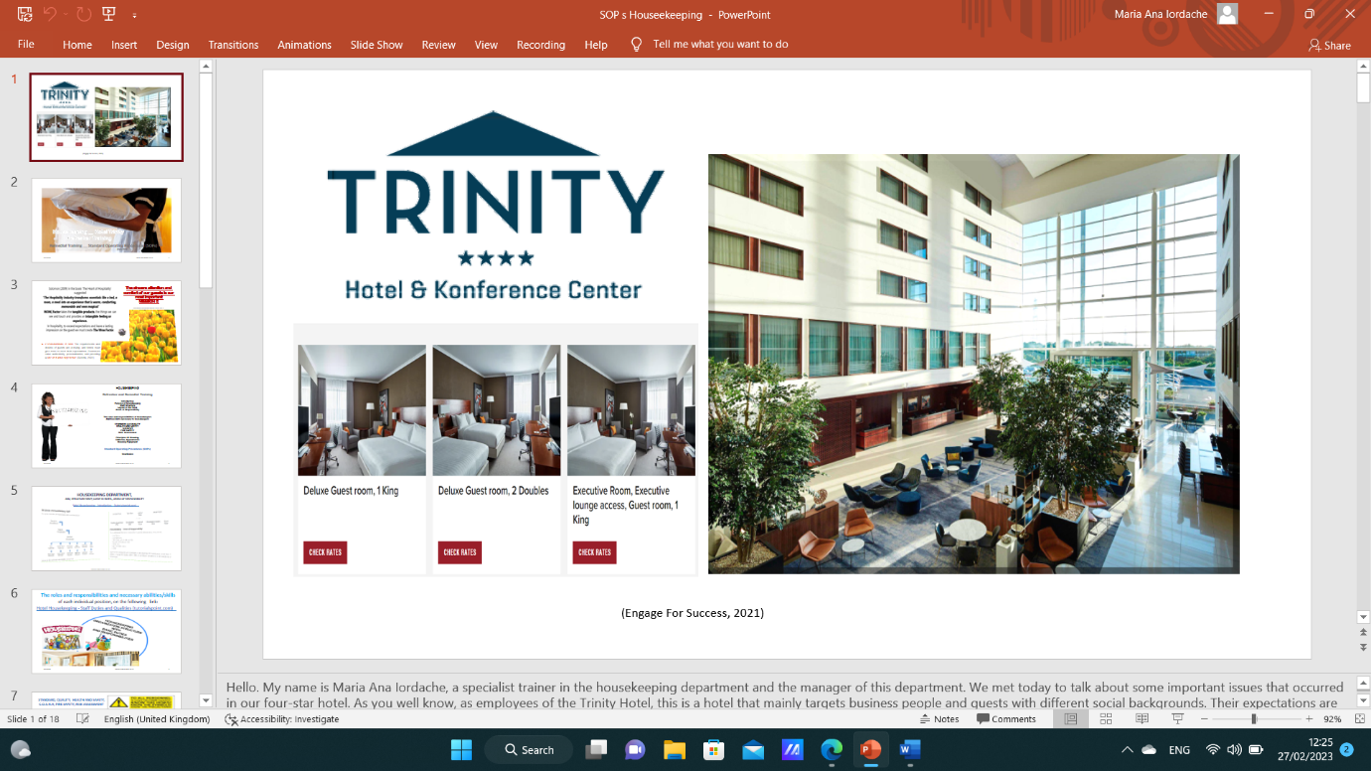

Training Notes:

ADVISE NOTE:
The words printed in blue reflect the guidelines that you must follow as a trainer. The words written in black, indicate what you will read in front of the audience.

Hello. My name is Maria Ana Iordache, a housekeeping trainer and manager of your department.
We met today to discuss some important issues that occurred in our four-stars hotel. As you well know, as employees of the Trinity Hotel, this is a hotel that mainly targets business people and guests with different social backgrounds. Their expectations are proportionate to the amount of money spent on lodging in order to satisfy the reasons for their visit.
We were wondering what the expectations are regarding housekeeping because this is the field in which we excel through our profession by offering our services to consumers.

The solution is quality! meeting service quality standards, maintaining the hotel's reputation, fostering long-term client loyalty, and converting them into brand ambassadors.
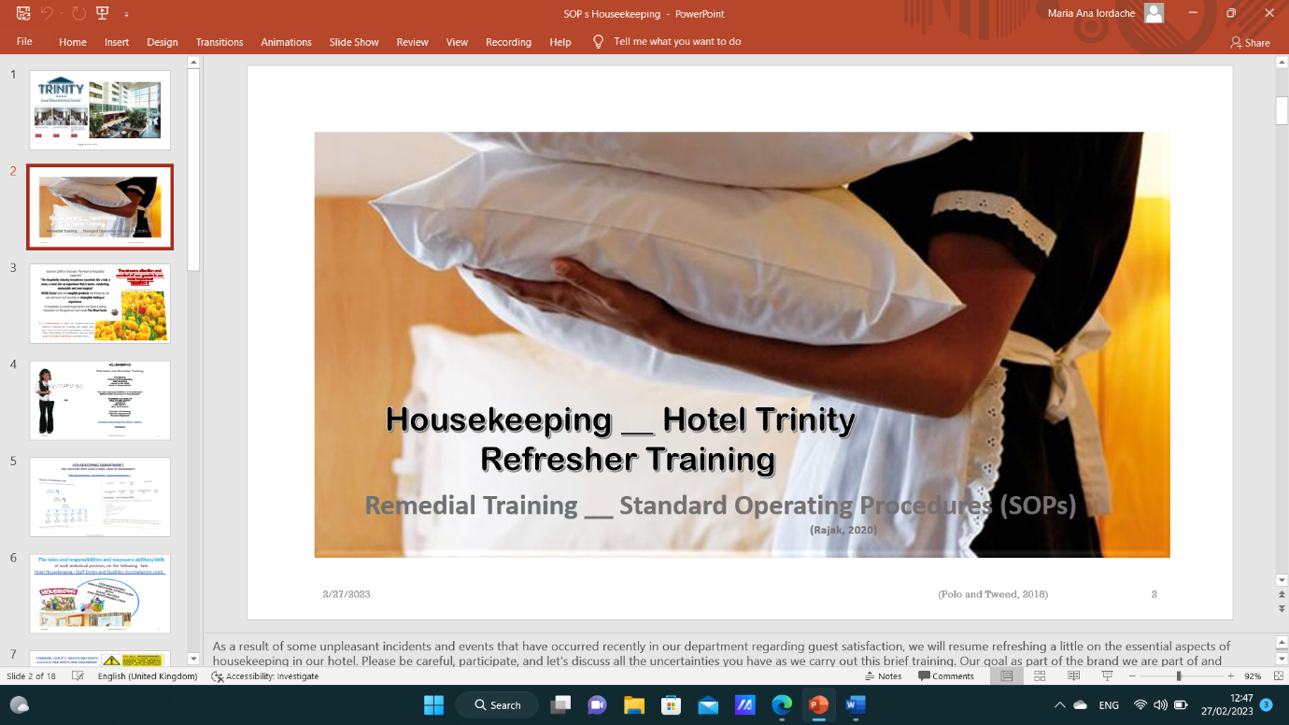

Training Notes:

As a consequence of various unpleasant situations and events that have recently happened in our department regarding guest satisfaction, we will refresh ourselves on the essential aspects of housekeeping in our hotel in hopes of remedial and preventing future problems.

Please be attentive, participate, and express any concerns you have while we carry out this brief training. As part of the brand we represent, our mission is to fulfil customer expectations, meet their requirements, or create some events or unique things for each individual guest in a way that exceeds their expectations, gains their loyalty, and transforms them into a positive ambassador of the brand and the hotel.

Our hotel's reputation is very important, and critical, in the context in which the hospitality industry is flourishing and customers have a lot of choices. All these things belong to each of us and must be fulfilled: the involvement and the job well done; the quality offered for consumption; following the SOPs standards; resulting in the well-being of the business; and ours, as ambassadors of the provision of services to the clients. As you can see, it is like a Domino. If one piece collapses, they all fall with it. The domino effect!

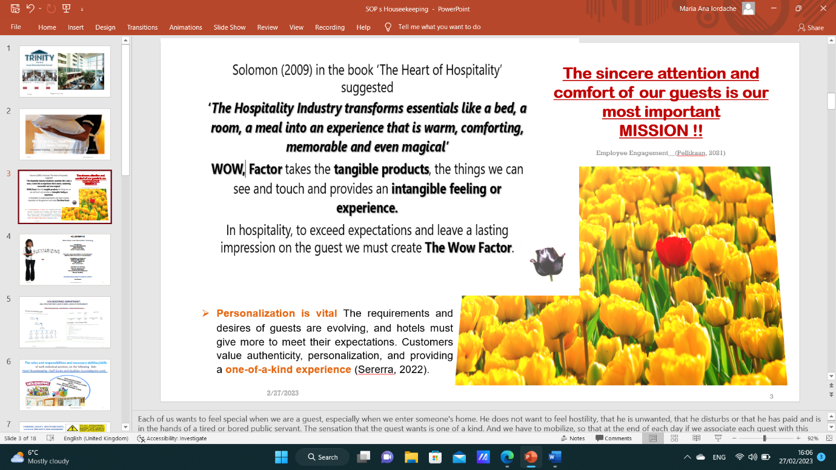

Training Notes:

Each of us wants to feel special when we are a guest, especially when we enter someone's home. He does not want to feel hostility, that he is unwanted, that he disturbs, or that he has paid and is in the hands of a tired or bored public servant. The sensation that the guest wants is unique. And we have to mobilize, so that at the end of each day if we associate each guest with this red tulip, we will have a red field of tulips at the end of the shift. Making a black tulip is detrimental to our business, as part of the system, and can lead to a bad reputation with undesirable consequences for the business and for us individually.
No one wants to be disciplined or put in the situation of having to look for another job because the references will not be enough—the consequence of repeated or serious mistakes. It is important to do the job well, with responsibility, and to try to exceed the condition. We have many facilities as part of our employment status and enough opportunities to perfect ourselves, to advance in this wonderful hospital career. This training is an example of our investment in our employees.
Let us not believe that when things go wrong, it is immediately noticed and that no one notices when we do things well and conscientiously. Performance statistics are counted daily. Our investment in work and following standards, policies, and procedures is the most important part of achieving these performances.

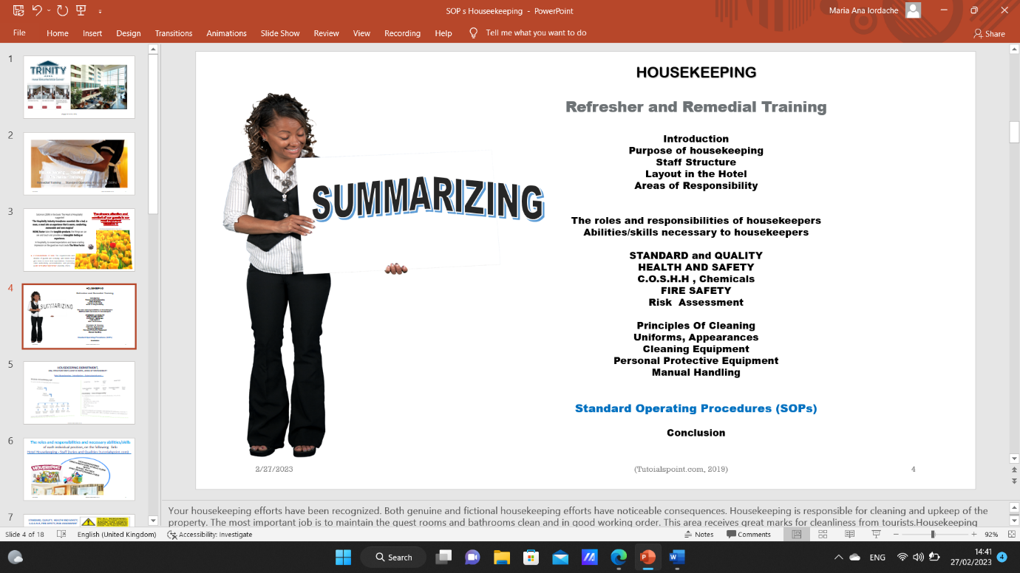

Training Notes:

Your housekeeping efforts have been recognized. Both genuine and fictional housekeeping efforts have noticeable consequences. Housekeeping is responsible for cleaning and upkeep of the property. The most important job is to maintain the guest rooms and bathrooms clean and in good working order. This area receives great marks for cleanliness from tourists.
Housekeeping personnel may help maintain satisfied visitors while also attracting new guests who want to return to the hotel by following the best cleaning and maintenance standards. This increases hotel revenue. Housekeeping employees must create and adhere to cleaning and maintenance practises in order to achieve both visitor enjoyment and job productivity by adhering to the summary standards specified in this content.

! Here, in this section, you will go through the points in the table of contents, which you will read from the slide.

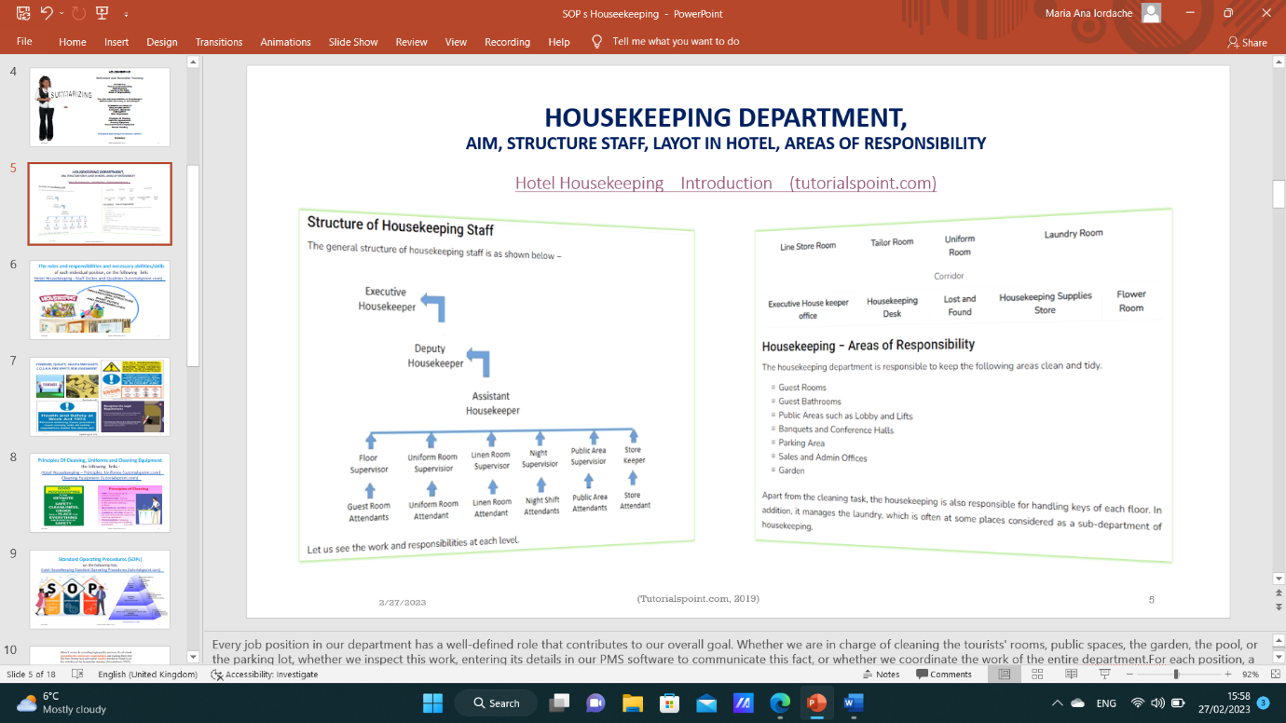

Training Notes:

Every job position in our department has a well-defined role that contributes to our overall goal. Whether we are in charge of cleaning the tourists' rooms, public spaces, the garden, the pool, or the parking lot, whether we inspect this work, enter its details in our PMS software to communicate this fact, or whether we coordinate the work of the entire department.
For each position, a set of operational standards with well-defined processes is planned; adhering to them should result in the achievement of the quality demanded by visitors and be reflected in their well-being, facts that determine their contentment.

As soon as the personnel contracts are signed, these processes are made available to the firms where we work together with training instructions.

! At this moment, please open the following link, which the participants have at the top of the slide, and read this page aloud!
Hotel Housekeeping Introduction (tutorialspoint.com)

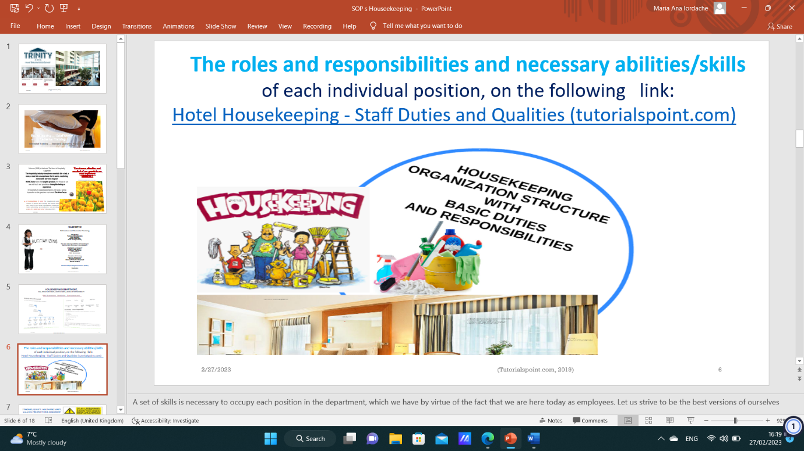

Training Notes:

A set of skills is necessary to occupy each position in the department, which we have, by virtue of the fact that we are here today as employees. Let us strive to be the best versions of ourselves!
The role and responsibilities mean one’s function, position, and assignment within an organization. And the ability, the skill, means, the mastery with which you have been gifted or you have learned it, in view of the perfection of some things.

! At this moment, please open the following link, which the participants have at the top of the slide, and tell them to do it as well, and read on the page aloud, the Roles and responsibilities at each level and the Qualities of Housekeeping Staff!
Hotel Housekeeping - Staff Duties and Qualities (tutorialspoint.com)

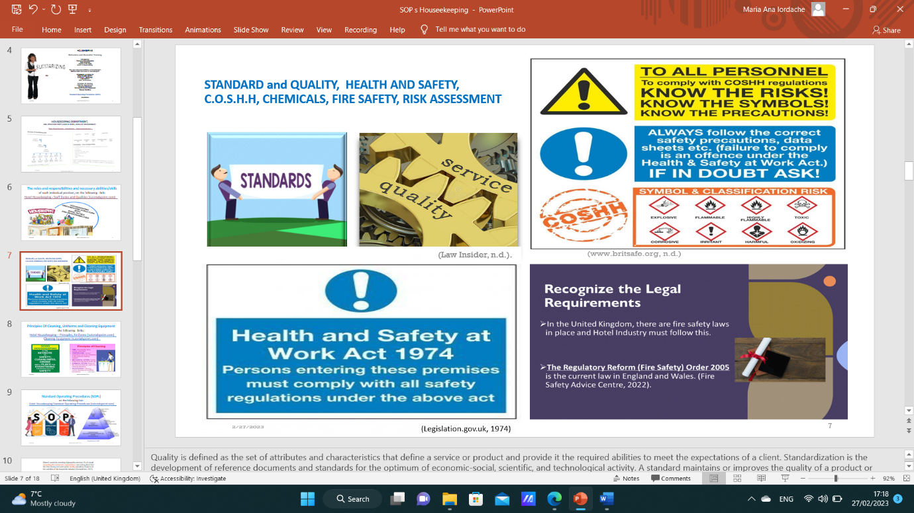

Training Notes:

Quality is defined as the set of attributes and characteristics that define a service or product and provide it with the required abilities to meet the expectations of a client. Standardization is the development of reference documents and standards for the optimum of economic-social, scientific, and technological activity. A standard maintains or improves the quality of a product or service, offers information, assures interoperability, and boosts customer safety and value.

Health and Safety Work Act, of 1974 legislation is very important to the Company and standards comply with EC Framework Directive (89/391/EEC).
The areas covered in this legislation are:
• Management of Health & Safety
Job Safety Analysis/ Risk Assessments. Appointment of competent people. Emergency procedures
• Work Place (Health, Safety and Welfare)
The environment e.g. windows, lighting, toilets, noise and temperature etc.
• Manual Handling Operations Job Safety Analysis/ Risk
Assessments
The reduction of manual handling where possible
• Health & Safety (Display Screen Equipment)
Comfort/light/eye test/ergonomics. Job Safety Analysis/ Risk Assessment
• Provision and Use of Work Equipment
Covers all working equipment e.g. from knives to slicing machines. Machines are to be guarded where necessary. Training of employees. Signage for Dangerous Machinery. Location suitable (well-lit etc).
• Personal Protective Equipment at Work
Job Safety Analysis/ Risk Assessments. Correct Personal Protective Equipment for the task. Training of employees.
Employees must use the equipment correctly
• Chemical Safety
Control of substances hazardous to health e.g. chemicals, bodily fluids and so on.

You have a duty to take reasonable care of yourself and anyone else that may be affected that what you do, or fail to do at work. If your action or omission causes someone to have an accident, you could be held responsible and prosecuted.
The employee must always cooperate with the employer on health and safety issues.

Risk assessment is a simple and methodical approach to ensuring that hazards to workers' (and others') health, safety, and well-being are appropriately removed, minimised, or controlled. The primary goals of risk assessments are: Identifying health and safety issues and assessing the risks in the workplace

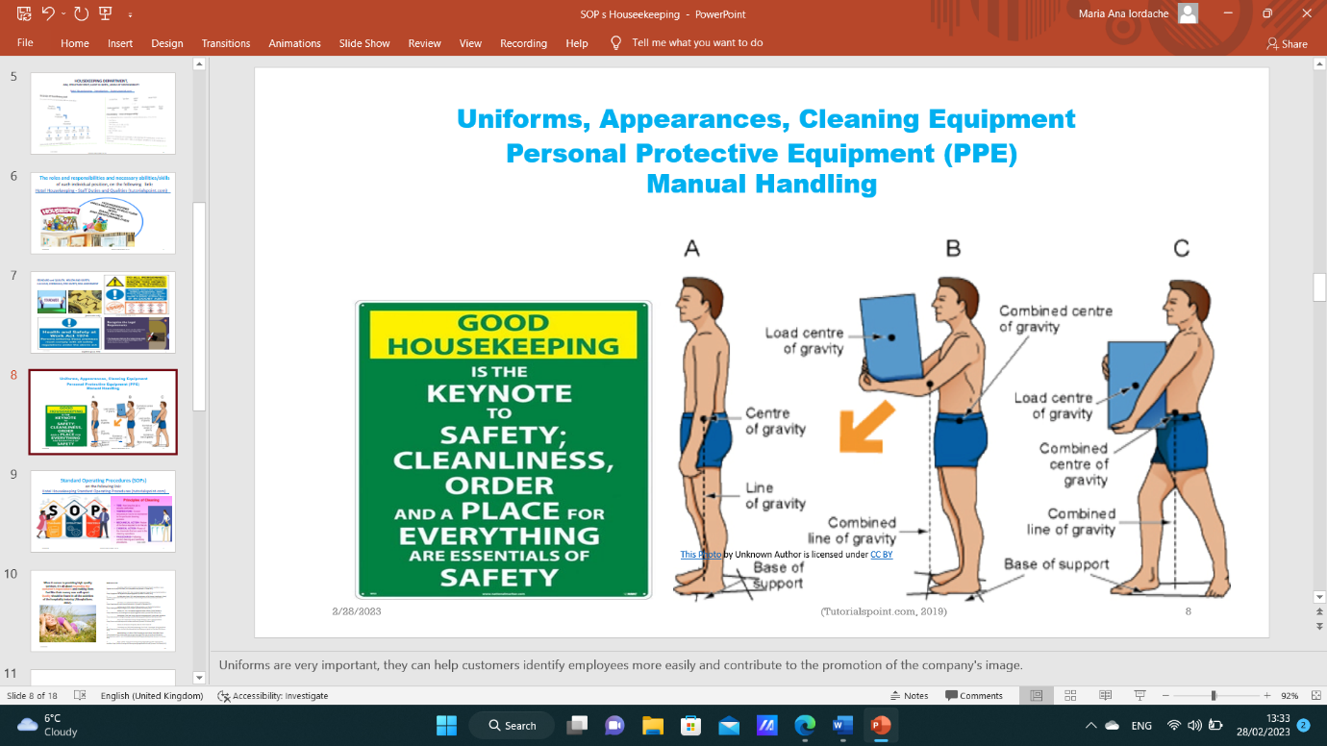

Training Notes:

Uniforms are very important, they can help customers identify employees more easily and contribute to the promotion of the company's image.

Personal Protection Equipment (PPE) is clothing or equipment meant to protect employees against chemical, biological, and physical threats on the job. It is used to safeguard personnel when engineering and administrative procedures to decrease hazards to acceptable levels are not practicable.

PPE housekeeping: Gloves, Masks, Aprons, Spirigels.
Additionally: Clothes for washing: RED – Toilets, BLUE – General Surfaces, GREEN – Disinfectant Surfaces, YELLOW - Bathrooms, Restrooms.
CHEMICALS:
- Oasis Pro 20 (Disinfectant Cleaner, including Kitchen staff)
- SIRIFAN SPEED (Disinfectant Cleaner Rooms, P/A)

Moving and handling in housekeeping is about the procedures that must be respected to prevent and reduce injuries when you manipulate different things:
- Moving beds and furniture
- Lifting and turning the mattress
- Bags of clean and dirty linens
- Pushing of housekeeping trolleys
- Lifting vacuum cleaners and floor polishers

The key pieces of Health and Safety legislation that relate to assisting, moving and handling are:

Health and Safety at Work Act 1974
• A general framework to ensure health, safety and well-being in the workplace
• Defines the roles and responsibilities of employers and employees
• Several additional regulations cover various specific aspects of health and safety
Management of Health and Safety at Work Regulations
1999
• Employers must perform risk assessments
• Employers must provide health and safety information to employees
• Employers must create agreed ways of working (policies and procedures) for employees to work in a safe manner
Manual Handling Operations Regulations (MHOR) 1992 (as amended 2002)
• As far as possible, avoid any manual handling activity that is hazardous and could result in injury
• Where it is not practical to avoid an activity, carry out a risk assessment and put measures in place to reduce or eliminate the risk of injury
. Employers must provide all necessary equipment and training
• Employees must do everything they can to keep themselves and others safe, attend training, only perform manual handling tasks that they have been trained in, adhere to policies, procedures and manufacturers' instructions and report/record any hazardous activities.
Provision and Use of Work Equipment Regulations (PUWER)
1998
• Employers must ensure all work equipment is safe to use and well-maintained
• Employees must not use equipment that is defective and employers must arrange for it to be replaced or repaired
• Employers must ensure all work equipment is suitable for the intended use and is only used by employees with the correct training
• Employees must follow manufacturers' instructions
• Suitable health and safety measures should be put in place (e.g. warning signs)
Lifting Operations and Lifting Equipment Regulations
(LOLER) 1998
• Lifting equipment should be installed correctly and be kept well-maintained, which includes regular recorded safety checks
Lifting equipment should only be used for its intended purpose
• Lifting equipment should have warning labels and signs to show safe working loads
• Lifting tasks must be performed by employees who are competent
• Lifting tasks must be planned properly and carried out in a safe manner
• Employees must not use equipment that is defective and employers must arrange for it to be replaced or repaired.

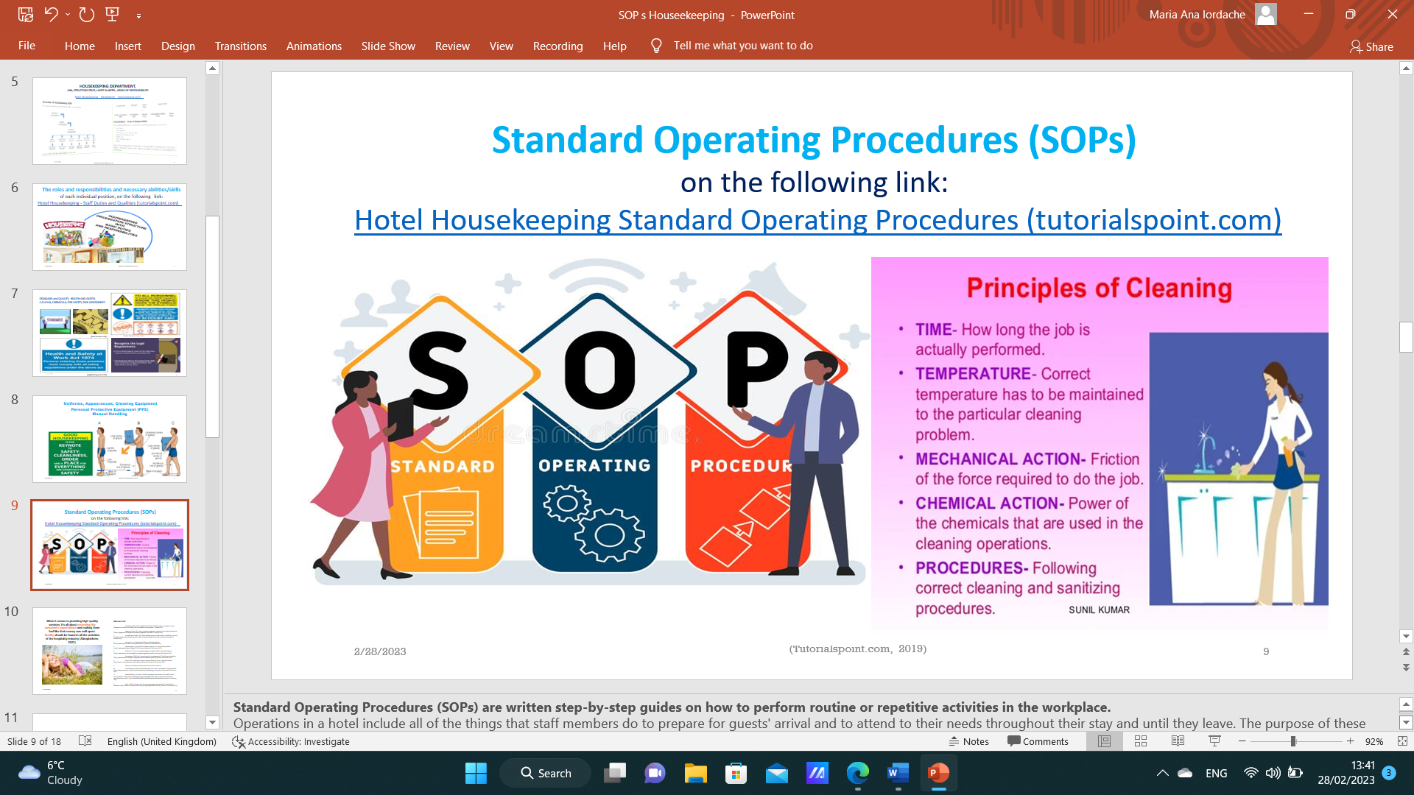

Training Notes:

Standard Operating Procedures (SOPs) are written step-by-step guides on how to perform routine or repetitive activities in the workplace.

Operations in a hotel include all of the things that staff members do to prepare for guests' arrival and to attend to their needs throughout their stay and until they leave.
The purpose of following these daily procedures ( SOPs) determines the quality of the service offered and can outstanding customer expectations, which is our purpose in terms of reputation management which generates profitability.

! At this moment, please open the following link, which the participants have at the top of the slide, and read this page aloud!
Hotel Housekeeping Standard Operating Procedures (tutorialspoint.com)

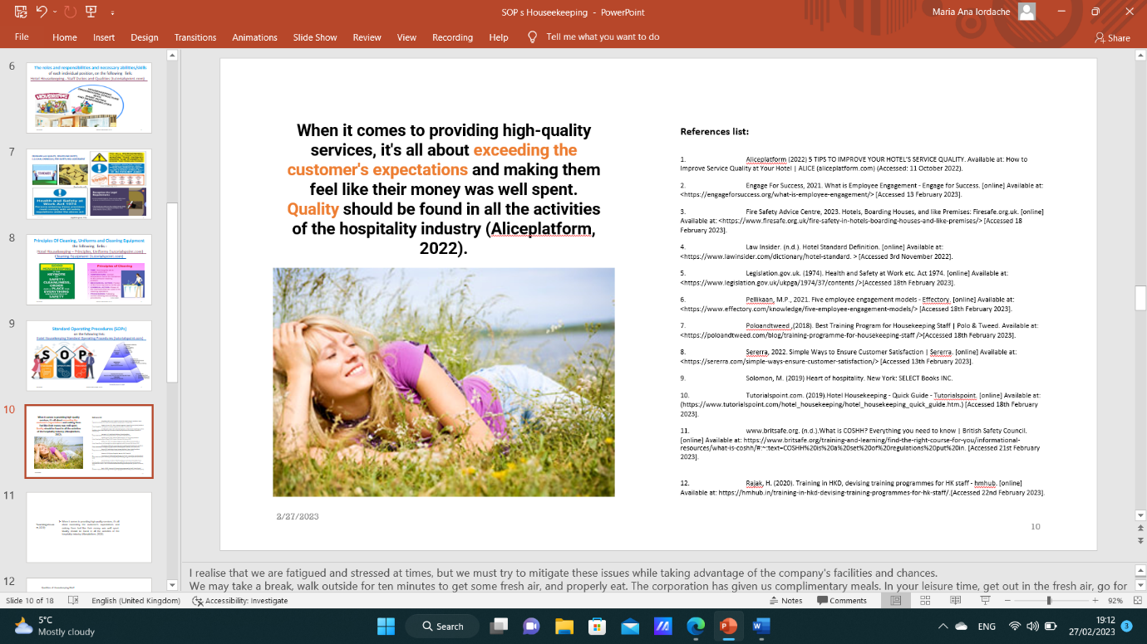

Training Notes:

Afterwards, I realise that we are fatigued and stressed sometimes, but we must try to mitigate these issues while taking advantage of the company's facilities and chances.

We may take a break, walk outside for ten minutes to get some fresh air, and properly eat. The corporation has given us complimentary meals. In your leisure time, get out in the fresh air, go for walks, dress up, use the exercise facility and the hotel's swimming pool, and relax with a tee or a coffee at the discounted pricing that you receive as a hotel employee. Schedule city breaks and holidays at our resorts at discounted rates, as though you were an employee of the corporation, and replenish your batteries.

Today is the best time to start from the beginning!

DO NOT FORGET!
Two examples of rehabilitation strategies are our Trinity Hotels recovery program, which stands for Listen, Empathise, Apologies, Resolve, and Never Repeat, and AREC, which stands for Act, Responsibility, Empowerment, Compensation, or LEARN.

Thank you for your attention, participate and I wish you success in your career as part of our wonderful and prosperous business.

References:

Component One:

- ARCSI, 2023. RESIDENTIAL CLEANER CERTIFICATIONS - ARCSI. [online] Available at: <https://arcsi.org/certifications/> [Accessed 29 January 2023].

- BSR, 2023. Executive Housekeeper Job Descriptions and Key Skills Required. [online] Available at: <https://www.bestsampleresume.com/job-descriptions/hospitality/executive-housekeeper.html> [Accessed 29 January 2023].

- Climb, 2023. 16 Executive Housekeeper Skills for Your Career and Resume . [online] Available at: <https://climbtheladder.com/executive-housekeeper-skills/> [Accessed 29 January 2023].

- Employeepedia, 2023. Customer Oriented: 15 Examples for Setting Performance Goals . [online] Available at: <https://www.employeepedia.com/manage/setting-goals/8127-customer-oriented-15-examples-for-setting-performance-goals> [Accessed 2 February 2023].

- Indeed, 2023. The Importance of Training Employees: 11 Benefits | Indeed.com. [online] Available at: <https://www.indeed.com/career-advice/career-development/importance-of-training> [Accessed 29 January 2023].

- Institute of Hospitality, 2023. Hard and soft skills - what. [online] Available at: <https://www.instituteofhospitality.org/professional-development/hard-and-soft-skills-whats-the-difference/> [Accessed 6 February 2023].

- Wikihow, 2023. 15 Basic Skills You Need to Be a Good Housekeeper. [online] Available at: <https://www.wikihow.com/What-Basic-Skills-Do-You-Need-to-Be-a-Good-Housekeeper> [Accessed 29 January 2023].

- Marriott Careers, 2023. Executive Housekeeper-Asst in Multiple Locations - Marriott Careers. [online] Available at: < Executive Housekeeper in Multiple Locations | Westin Hotels & Resorts (marriott.com) > [Accessed 29 January 2023].

- Stobierski , T., 2021. 13 Financial Performance Measures Managers Should Monitor . [online] Available at: <https://online.hbs.edu/blog/post/financial-performance-measures> [Accessed 29 January 2023].

Component Two:

- Casado, M. (2012) Housekeeping Management. London: Wiley.

- Fallon, M. & Rutherford, D. (2010) Hotel Management and Operations. London: Pearson.

- Ferdinand, N. and Kitchin, P. (2017) Events Management - An International Approach. 2nd ed. London: SAGE Publications Ltd.

- Johnston, R., Clark, G. & Shulver, M. (2012) Service Operations Management. London: Pearson. Jones, T. (2010) Professional Management of Housekeeping Operations. London: Wiley.

- Mullins, L. and Dossor, P. (2013) Hospitality Management and Organisational Behaviour. 5th ed. Harlow: Pearson.

- Raghubalan, G. and Raghubalan, S. (2016) Hotel Housekeeping - Operations And Management. 3rd ed. India: Oxford University Press.

- Quick, L. (2020) Managing Events. Real Challenges, Real Outcomes. London: SAGE Publications Ltd.

Component Three:

- Aliceplatform (2022) 5 TIPS TO IMPROVE YOUR HOTEL’S SERVICE QUALITY. Available at: How to Improve Service Quality at Your Hotel | ALICE (aliceplatform.com) (Accessed: 11 October 2022).

- Engage For Success, 2021. What is Employee Engagement - Engage for Success. [online] Available at: <https://engageforsuccess.org/what-is-employee-engagement/> [Accessed 13 February 2023].

- Fire Safety Advice Centre, 2023. Hotels, Boarding Houses, and like Premises: Firesafe.org.uk. [online] Available at: <https://www.firesafe.org.uk/fire-safety-in-hotels-boarding-houses-and-like-premises/> [Accessed 18 February 2023].

- Law Insider. (n.d.). Hotel Standard Definition. [online] Available at: <https://www.lawinsider.com/dictionary/hotel-standard. > [Accessed 3rd November 2022].

- Legislation.gov.uk. (1974). Health and Safety at Work etc. Act 1974. [online] Available at: <https://www.legislation.gov.uk/ukpga/1974/37/contents />[Accessed 18th February 2023].

- Media Partners (2015) The Right Words at the Right Time – Customer Service Recovery for Hospitality [video]. Available at: https://www.youtube.com/watch?v=tWnaKsmQ6k8 (Accessed: 2nd November 2022).

- Pellikaan, M.P., 2021. Five employee engagement models - Effectory. [online] Available at: <https://www.effectory.com/knowledge/five-employee-engagement-models/> [Accessed 18th February 2023].

- Poloandtweed ,(2018). Best Training Program for Housekeeping Staff | Polo & Tweed. Available at: <https://poloandtweed.com/blog/training-programme-for-housekeeping-staff />[Accessed 18th February 2023].

- Sererra, 2022. Simple Ways to Ensure Customer Satisfaction | Sererra. [online] Available at: <https://sererra.com/simple-ways-ensure-customer-satisfaction/> [Accessed 13th February 2023].

- Solomon, M. (2019) Heart of hospitality. New York: SELECT Books INC.

- Tutorialspoint.com. (2019).Hotel Housekeeping - Quick Guide - Tutorialspoint. [online] Available at: (https://www.tutorialspoint.com/hotel_housekeeping/hotel_housekeeping_quick_guide.htm.) [Accessed 18th February 2023].

- www.britsafe.org. (n.d.).What is COSHH? Everything you need to know | British Safety Council. [online] Available at: https://www.britsafe.org/training-and-learning/find-the-right-course-for-you/informational-resources/what-is-coshh/#:~:text=COSHH%20is%20a%20set%20of%20regulations%20put%20in. [Accessed 21st February 2023].

- Rajak, H. (2020). Training in HKD, devising training programmes for HK staff - hmhub. [online] Available at: https://hmhub.in/training-in-hkd-devising-training-programmes-for-hk-staff/.[Accessed 22nd February 2023].

