PCD (professional career development)
BMSW4005
Harun Miah
1916786
Lecture- MD Kalam

Content page

Introduction……… 1
Main body………….2
Self- evaluation myself….3
Self-evaluation on role play exercise…..4,5
Professional development plan (PDP)……6
References……….7
Appendix………….8,9,10,11,12,13,14

Page 1

Introduction

The purpose of this report is to write a personal reflection on the role play exercise I have done with my partner santiana on Microsoft teams and also do a career development planning. On this report I am going to start of talking about professional career development (PCD) what this means and how we can develop our career, I am also going to talk about Employment law and recruitment selection in this part and how important it is to know our rights in the workplace. My next aim in this report will be my self-evaluation of myself where I will be talking about my present work, what industry I want work in the future and my future goals and aspirations. I am also going to do a SWOT ANALYSIS and identify my strength and weakness. My next part in this report is the self- evaluation on the role play exercise for this part I have used Gibbs reflective cycle (1988) and it’s 6 stages
To reflect back on the exercise. I have finished this report with my career development planning where I have identified what I need do and learn to achieve my short term and long term goals.

Page 2

Main body
PCD(professional career development)

Professional career development ( PCD) is a process of getting in to a chosen career you aspire to be bye creating an action plan for yourself and on your future goals. This can be by making improvements and by working on the necessary skills to better ourselves and our career, PCD also allows you to work on our personal strength and weakness and this will help us to get into the right career path. Professional career development can be used to get into our ideal job, continue education and skills based training. Professional career development allows us to plan our future, move forward in a career, take responsibility of our future, take career in our own hand.

Employment law is very important for employees and employers because this allows business to follow UK acts and regulations and also they protects employees rights. Employment law can protect employees and employers on recruiting, employment contracts, data protection, pay and holidays entitlements, working times, health and safety at work, discrimination, discipline, grievances, dismissal and redundancy.By following these legislation it protects everyone and it’s fair for every individual at work place. There is also equality act (2010) in the workplace where this act protects employee’s rights against discrimination like your sex, age, colour, beliefs, disability, pregnancy etc. All this also fall under discrimination act 2010.There is also Acas code of practice for all employees and employers must follow.

Recruitment selection-

Recruitment selection is the hiring process a company use to select the suitable candidate for the job that has been on offer or advertised for specific positions. Recruitment is when a company is advertising for a job and selection is the process when the company goes through CVs and interview process to select the right person for that job. Recruitment selection is very vital for professional career development because without this process we can not get into professional job we aspire to get into.

Page 3

Self-evaluation for myself

I am working in the restaurant industry as a waiter at the moment at a small Indian restaurant and I am not happy with this job and this career path, because I have been working there for 6 years and this job does not satisfy me because this job does not have career growth, I want to aspire to do better, I want to get into hotel management so I can improve my career prospects. To accomplish my goal I am going to start of bye making an action plan for my future goals .To improve my academic skills I am doing a course in higher education skills for the workplace level 4 at UWTSD, my goal will be to complete level 5 and 6 in the next two years and graduate ,this will help me gain academic skills and employability skills needed to improve my careers and help me get into hotel management, Graduating from this course also will give me the confidence to better myself and encourage me to get the job I desire.

SWOT Analysis- strength and weakness

My strength are good communication skills, good customer service skills, good time management skills, good listening skills, leadership skills and I am team player. I believe working in the restaurant industry for almost ten years helped me gain these strength especially working with customers

My weakness is I am too friendly and trustworthy I can not say no, therefore I take on to much work and some time rush to finish the work, but recently I have learned to say no where appropriate and when I think I am taking on to much work, and also I believe my good time management has help me to finish the work on deadline.

From the VAK learning style questionnaire I have learned that I have visual learning style, this means I like to observe things like pictures, diagrams and pie charts . Visual learning style also means I like to see things visual to understand more.

Page 4

Self-evaluation on the role play exercises ( using Gibbs 6 stages 1988)

Description-
I had to do role play interview with my partner santiana as a employer and employee, the interview had to last 5 minutes and in the 5 minutes we had to answer 5 questions related to the job description we wanted to apply. I wanted to apply a job in restaurant manager and my partner wanted to work in the beauty industry as , we took turns in being the employee and employer I was the employee first and then the employer. We did this role play online on Microsoft teams due to the current pandemic situation so the atmosphere was different because me and my partner was performing from different house.

Feelings-
When I heard I have to do a role play exercise with a partner I was feeling really anxious because I did not know who my partner would be and how I will perform but when I was teamed up with santiana I was pleased and happy because we did different role play together before on another assignment. On the day of our task I was feeling nervous after talking to my partner about the role play on the phone and practicing the role play I was more relaxed. During the the role play I was feeling happy and confident we

Evaluation-
I was really good as the employee in my role play as I was answering the questions very well and keeping eye contact with my partner and I was very confident and came out really well but I think I was little nervous and rushing my questions in my interview as employer I also got this feedback from my lecture. The good experience about this role play was that everyone who took part in the exercise got feedback from other students in our class and also our lecture about our performance. The bad experience was that we did the role play online rather than doing it in the classroom due to the current covid 19 pandemic.

Analysis-
I think the role play interview went well because me and my partner santiana practice the role play beforehand and we encourage each other to do well, we took turns on becoming the interviewer and interviewee for the role play and that helped us to get more motivated and confident.I found my part as the interviewee very easily done because I did attend real interview before for a job and that experience helped me for the role play exercise that day. I found the part as the employer little difficult because I was not in this situation before so I rushed through the questions . The preparation I did with my partner helped me for that part. overall I think the role play went very well.

Page 5

Conclusion-

The role play exercise as interviewer and interviewee I did with my partner went well, especially my part as the interviewee I was really good at this part. The feed back from my partner and my lecture MR Kalam confirm this. The part as interviewer could have been little better as I rushed through my questions and I could not give enough time for my partner to answer the question. Overall I did good and this role play will gave me the experience of how to conduct a interview situation future. Doing this exercise I realised how important team work is we could not do this exercise without each other’s help.

Action plan-

This role play exercise has given me confidence that I can do well in a real life interview and if this situation arises again I will be more calmer and talk slowly so I do not rush my questions and I will also take time to speak and listen more. In the future if I come across similar situations I will ensure that I make a better connection with my partner or my colleagues so I do not get nervous Therefore I will be more relaxed around them.

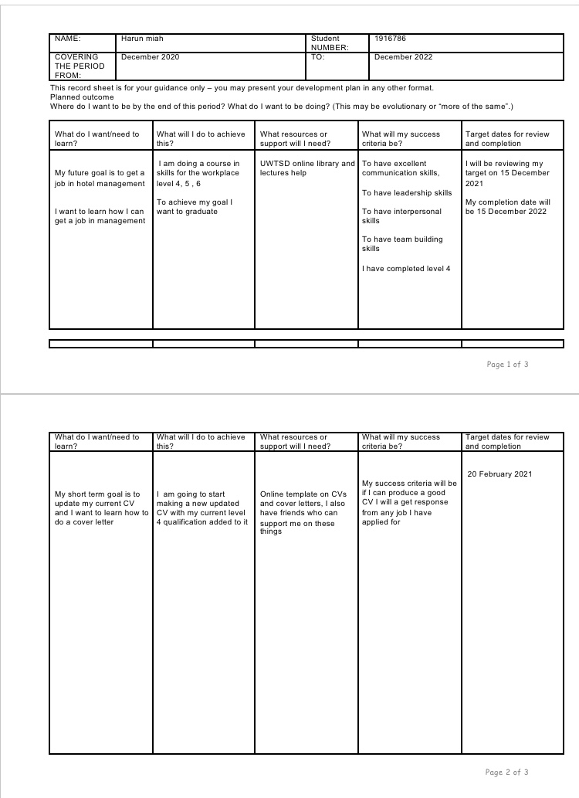

Page 7

References

Morgan, P.(2016). The business students guide to study and employability

Maund, A. Schriek,M.and Tinkler , P.(2017). Certificate in higher education: skills for the workplace students year book.

Cottrell, S.(2010) skills for success: personal development planning handbook ( 2nd edition ). Hampshire: palgrave McMillan

Cottrell, S. (2010) skills for success: personal development and employability

Prospects. (2016) career advice [online] https;//www.prospects.ac.uk

www.thecdi.net What is career development

Google. professional career development August 04 2020

Craig A . Kelley, Claudia Bridges first published 1 December, 2005 introducing professional and career development skills in the marketing curriculum.

Donald E Gibson: Role model in career development; new directions for theory and research
30 October 2002

University of Cumbria: Gibbs reflective cycle June 2020

Page 8

Appendix

Feed back Form from my role play partner santiana
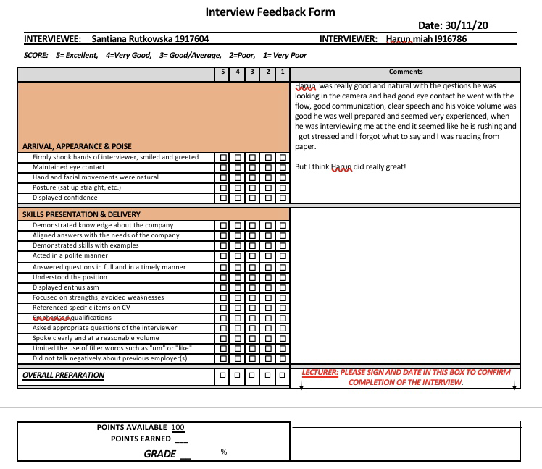
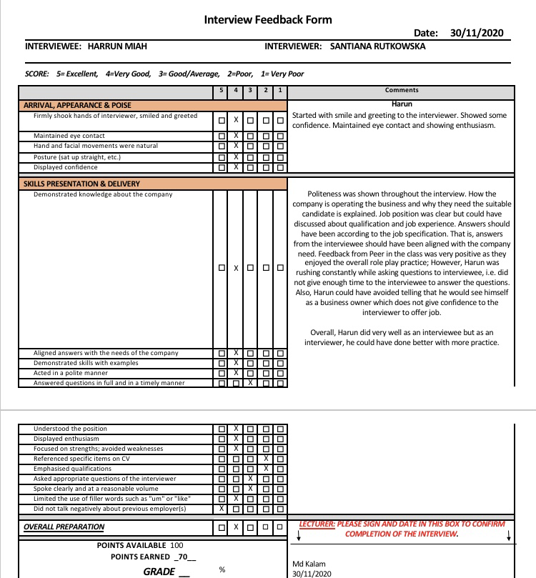

Page 9

Feed back form role play- MD Kalam (lecture)

Adapted

