
Community Care and Management
of Longer-term Conditions

Management of
Long-term Conditions
ASSIGNMENT BOOKLET

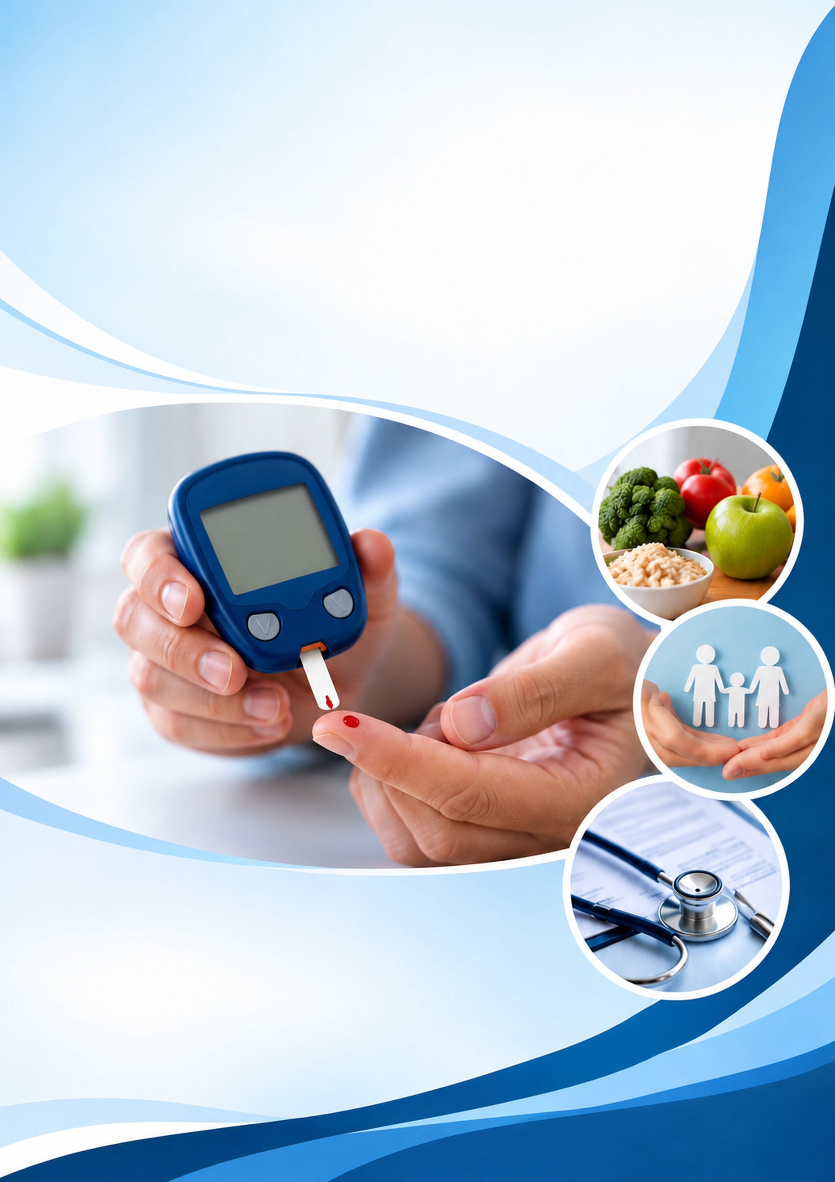
CASE STUDY: TYPE 2 DIABETES

Student Name: Samina Gul
Student ID: 2118248
Component 1
Information Booklet of Long- term Condition Management: LCHS7003
Lecturer: Aishat Bakere

Understanding Type 2 Diabetes
Key definition
Type 2 diabetes mellitus (T2DM) is a long-term metabolic condition in which the level of glucose in the blood becomes too high.
It develops mainly because body cells become less responsive to insulin, known as insulin resistance, while the pancreas gradually becomes unable to produce enough insulin to meet the body’s needs (American Diabetes Association Professional Practice Committee for Diabetes, 2026). Unlike type 1 diabetes, insulin production is usually not completely lost. T2DM accounts for approximately 90–95% of diabetes cases, making it the most common form of diabetes (American Diabetes Association Professional Practice Committee for Diabetes, 2026).
The causes of T2DM are complex because genetic, biological, behavioural and environmental factors interact. Modifiable risk factors include overweight and obesity, particularly excess abdominal fat, physical inactivity and an unhealthy diet. However, describing T2DM simply as a lifestyle-related condition can be misleading because individuals have different levels of biological and social risk. Important non-modifiable factors include increasing age, family history and ethnicity. In the UK, people of South Asian, African-Caribbean and Black African backgrounds have a higher risk, while having a close family member with T2DM can substantially increase risk (Diabetes UK, 2026). Other recognised factors include previous gestational diabetes, polycystic ovary syndrome, hypertension and dyslipidaemia (American Diabetes Association Professional Practice Committee for Diabetes, 2026).
The scale of T2DM makes it an important public health concern. Almost 6 million people in the UK are estimated to be living with diabetes, including around 1.3 million people who may have undiagnosed T2DM; approximately 90% of diagnosed cases are type 2 (Diabetes UK, 2026). Globally, around 830 million people were living with diabetes in 2022, although this figure includes all types of diabetes (World Health Organization, 2024). These figures demonstrate the substantial burden of T2DM, but comparisons require caution because global estimates combine different diabetes types and diagnostic methods. Therefore, prevention requires more than individual lifestyle change; early identification and attention to wider social and biological risks are also important.

How Common Is Type 2 Diabetes?
Type 2 diabetes is a growing public health concern worldwide. The World Health Organization (2024) estimates that approximately 830 million adults were living with diabetes in 2022, compared with 200 million in 1990. However, these figures include all types of diabetes, although type 2 accounts for around 90% of cases. Therefore, global statistics demonstrate the scale of the problem but do not provide an exact measure of type 2 diabetes alone.
UK diabetes burden
In the UK, Diabetes UK (2026) estimates that almost 6 million people are living with diabetes, including approximately 1.3 million with undiagnosed type 2 diabetes.
This suggests that relying only on diagnosed cases underestimates the true burden and may delay essential treatment.
Diabetes UK (2026) also reports that approximately 6.9 million people have raised blood glucose levels, placing them at increased risk of developing type 2 diabetes. However, risk estimates should not be confused with confirmed diagnoses.
Importantly, diabetes is not equally distributed across society. NHS England (2026) reports higher diabetes prevalence in deprived communities, suggesting that income, living conditions and access to healthcare influence the disease burden.
Overall, although prevalence statistics highlight the seriousness of diabetes, they cannot fully explain its impact on individuals or healthcare services. Therefore, earlier screening, targeted prevention and improved access to NHS care are essential, particularly for disadvantaged communities.
What Causes Type 2 Diabetes and Who Is at Risk?
Type 2 diabetes develops when the body becomes resistant to insulin and the pancreas cannot produce enough insulin to control blood glucose levels. Its causes are complex, involving genetic, biological, lifestyle and environmental factors (American Diabetes Association Professional Practice Committee for Diabetes, 2026).
Risk factors are divided into modifiable and non-modifiable factors. Modifiable factors include obesity, unhealthy eating, physical inactivity and smoking. Excess abdominal fat is particularly important because it increases insulin resistance (NICE, 2012).
However, focusing only on lifestyle choices is misleading because poverty, food insecurity and limited access to healthy environments can restrict people's ability to make healthier choices.
Non-modifiable factors include increasing age, family history and ethnicity. In the UK, people from South Asian, Black African and African-Caribbean backgrounds have a higher risk (Diabetes UK, no date b). Nevertheless, ethnicity alone cannot explain these differences because genetic susceptibility interacts with social and environmental conditions.
Although lifestyle changes can reduce diabetes risk, their effectiveness depends partly on people's living conditions. NICE (2012) supports targeted prevention for high-risk individuals, while NICE (2011) emphasises population-level interventions. Both approaches have strengths and limitations. Individual programmes provide personalised support but may overlook financial barriers, whereas population-wide interventions may not address specific needs.
Therefore, combining personalised prevention with policies addressing health inequalities offers a more balanced approach. This recognises that preventing type 2 diabetes requires both individual action and wider social support.
How Does Type 2 Diabetes Affect People?
Type 2 diabetes affects physical health, psychological wellbeing and everyday life. Its impact depends on disease progression, treatment, personal circumstances and access to healthcare. Although medical treatment reduces complications, it may not address all the challenges people experience (World Health Organization, 2024).

Physical Health
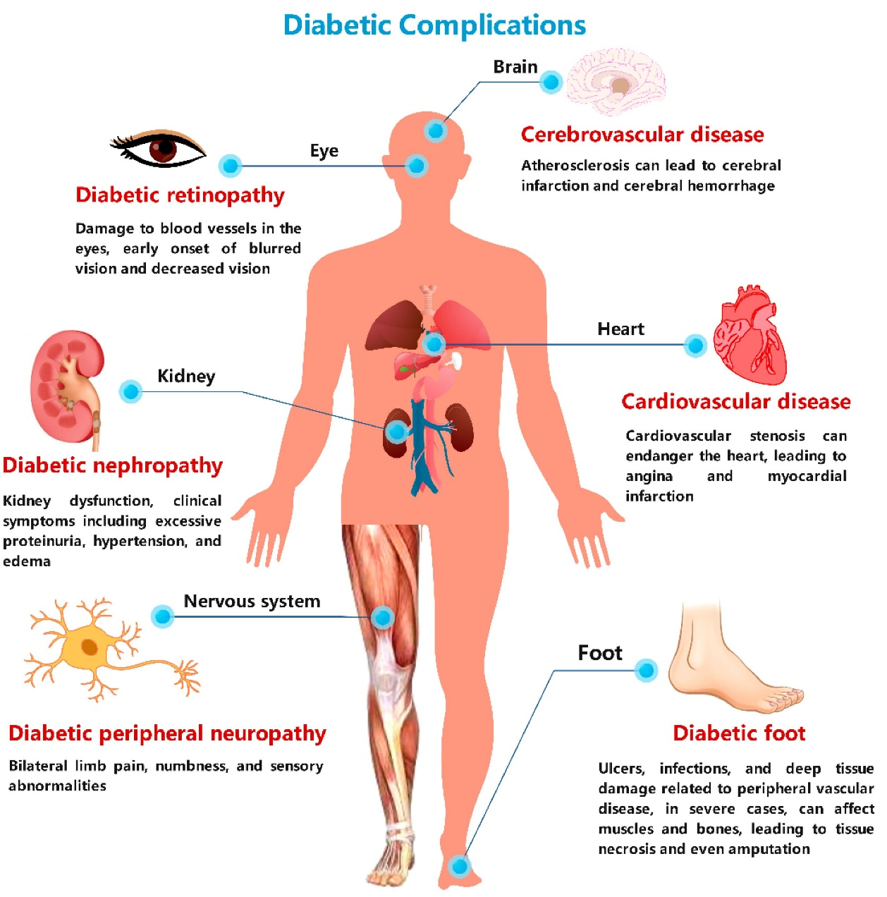
Long-term high blood glucose can damage blood vessels and nerves, increasing the risk of heart disease, stroke, kidney disease, sight loss and foot complications (NICE, 2026). People may also experience tiredness, frequent urination and slow wound healing. However, these complications are not inevitable. Early diagnosis and effective treatment can reduce risks. Nevertheless, focusing only on blood glucose is insufficient because blood pressure, cholesterol and other health conditions also influence outcomes (American Diabetes Association Professional Practice Committee, 2024).
Figure 1:Major complications of diabetes affecting different organs (Source: Zhang et al., 2024).

Psychological Wellbeing
Managing diabetes requires continuous decisions about food, medication, exercise and monitoring. These responsibilities can cause diabetes-related distress, anxiety and depression. Skinner et al. (2020) explain that psychological difficulties can reduce engagement with treatment. However, poor diabetes management should not automatically be blamed on individual motivation, as emotional difficulties and limited support may contribute. Psychological care can improve wellbeing, but access to specialist services may be restricted by NHS staffing and resource pressures.

Social and Everyday Life
Type 2 diabetes can affect employment, relationships, social activities and financial security.
Some people struggle to attend appointments, purchase healthy food or balance treatment with family responsibilities. Diabetes UK (2024b) highlights that diabetes-related stigma can also affect confidence and wellbeing.
Although self-management education supports independence, its benefits may be limited for people experiencing poverty, language barriers or poor access to healthcare. Therefore, providing identical support to everyone may increase existing health inequalities.

Critical Evaluation
Medical treatment is essential for preventing complications, but it mainly addresses biological problems. In contrast, person-centred care considers emotional wellbeing, social circumstances and individual preferences (NICE, 2026). However, delivering holistic care can be challenging because of limited resources and unequal access to specialist support.
Therefore, combining medical treatment with psychological support, accessible education and practical assistance offers a more balanced approach. This may improve quality of life while supporting effective long-term diabetes management.
Impact on Families and Carers
Type 2 diabetes affects not only individuals but also their families and carers. Family members often provide emotional support, prepare suitable meals, remind individuals about medication and help them attend healthcare appointments. Although this support can improve diabetes management, it may also create additional responsibilities and emotional pressure (Mayberry and Osborn, 2012).

Emotional and Psychological Impact
Families may experience anxiety about complications such as heart disease, kidney failure and sight loss. Carers can also feel stressed when balancing caring responsibilities with employment and personal commitments. However, family involvement is not always beneficial. Excessive monitoring or criticism may create tension and reduce the person's independence (Baig et al., 2015).

Financial and Social Impact
Diabetes can increase household expenses through travel, dietary adjustments and time away from work. These challenges may be greater for low-income families. Although NHS services provide essential treatment, indirect costs and caring responsibilities can still affect family wellbeing (Diabetes UK, 2024a).

Critical Evaluation
Family-centred care can strengthen emotional support and encourage healthy behaviours. However, expecting relatives to provide continuous care may increase carer burden and disadvantage families with limited resources. Therefore, healthcare professionals should involve families with the person's consent while respecting individual independence.
Providing accessible education, emotional support and information about available services may improve outcomes for both individuals and carers. This balanced approach recognises that effective diabetes management requires support without placing unreasonable responsibilities on families.
Treatment and Management of Type 2 Diabetes in the NHS
The NHS provides several treatments for type 2 diabetes, including lifestyle support, medication, regular health checks and specialist services. The main aims are to control blood glucose, prevent complications and improve quality of life. However, treatment should reflect individual health needs rather than follow the same approach for everyone (NICE, 2026).

Lifestyle Changes and Education
Healthy eating, regular physical activity and weight management are important parts of diabetes care. The NHS also offers structured education to help people understand their condition and manage it confidently (NICE, 2026). Although education can improve self-management, its effectiveness may be limited by language barriers, low health literacy and financial difficulties.

Medication and Blood Glucose Control
NICE (2026) recommends modified-release metformin alongside an SGLT-2 inhibitor for many adults with type 2 diabetes. These medicines help control blood glucose, while SGLT-2 inhibitors also provide heart and kidney benefits. Other treatments, including GLP-1 receptor agonists, tirzepatide and insulin, may be appropriate depending on individual circumstances.
However, medicines can cause side effects, increase treatment costs and create difficulties for people taking several medications. Therefore, shared decision-making is essential to balance treatment benefits, risks and personal preferences (NICE, 2026).

Monitoring and Preventing Complications
NHS diabetes care includes HbA1c blood tests, blood pressure monitoring, kidney assessments, foot examinations and diabetic eye screening. These services help identify complications early. However, screening alone is insufficient if patients experience delays in receiving follow-up treatment (NICE, 2026).

Diabetes Remission Programmes
The NHS Type 2 Diabetes Path to Remission Programme offers eligible patients a supervised low-calorie diet and ongoing support (NHS England, no date b). Valabhji et al. (2024) reported that 32% of participants with recorded follow-up measurements who completed the programme achieved remission. However, this finding does not represent every participant, and maintaining weight loss can be challenging (Valabhji et al., 2024).

Critical Evaluation
Although medicines such as metformin and SGLT-2 inhibitors help manage type 2 diabetes, not every treatment is suitable for every patient (NICE, 2026). For example, some medicines may offer additional benefits for people with heart or kidney problems, while lifestyle programmes may help eligible patients achieve diabetes remission. However, maintaining lifestyle changes can be difficult, particularly for people with financial difficulties or limited support. Therefore, combining suitable medication with personalised lifestyle advice may be more effective than using one approach alone.
Therefore, combining personalised medication, accessible education, regular monitoring and psychological support offers a more balanced approach.
However, unequal access to services and limited resources may affect its delivery. Improving continuity of care and reducing these inequalities should remain priorities.
Models for Better Long-Term Care
Managing type 2 diabetes requires continuous support because it is a long-term condition. Different care models aim to improve coordination, encourage self-management and reduce complications. Two relevant approaches are the NHS House of Care model (UK) and the Chronic Care Model (international).

UK Model: NHS House of Care
The House of Care model promotes person-centred care through shared decision-making, supported self-management and coordinated services. It encourages healthcare professionals and patients to develop care plans based on individual needs and preferences (NHS England, 2014).
A major strength is that patients become active partners in managing diabetes rather than simply following instructions. However, successful implementation requires trained staff, sufficient appointment time and effective communication. These requirements may be difficult to achieve in overstretched NHS services (NHS England, 2023).

International Model: Chronic Care Model
The Chronic Care Model, developed by Wagner et al. (2001), focuses on improving long-term conditions through organised healthcare teams, self-management support, clinical information systems and community resources.
Its strength is that it connects different parts of healthcare, potentially improving continuity and reducing fragmented diabetes services. However, implementing the model requires investment, reliable information systems and cooperation between professionals, which may be challenging in under-resourced settings (Baptista et al., 2016).

Critical Comparison and Evaluation
Both the House of Care and Chronic Care Model aim to improve long-term diabetes care, but they focus on different areas. The House of Care encourages patients to take part in decisions about their treatment (NHS England, 2014). In comparison, the Chronic Care Model focuses on better communication and teamwork between healthcare professionals (Wagner et al., 2001). Baptista et al. (2016) found that the Chronic Care Model may improve diabetes care. However, the findings may not apply equally to all healthcare settings. Both models also require trained staff and sufficient resources. Therefore, combining patient involvement with coordinated healthcare services may provide better long-term support than using either model alone.
Neither model guarantees improved outcomes. The House of Care may struggle when patients face language or health literacy barriers, whereas the Chronic Care Model may be difficult to implement without sufficient resources.
Therefore, combining the person-centred approach of the House of Care with the coordinated systems of the Chronic Care Model could provide more effective long-term diabetes support. This would require accessible education, multidisciplinary teamwork and regular evaluation of patient outcomes.
Policy and Current Healthcare Priorities
UK healthcare policies aim to prevent type 2 diabetes, improve early diagnosis and reduce inequalities. However, their success depends on funding, accessibility and effective implementation.

National Healthcare Policies
The NHS Long Term Plan prioritises diabetes prevention, improved treatment and reducing avoidable complications (NHS England, 2019). The NHS Diabetes Prevention Programme supports people at high risk through lifestyle education and behaviour changes (NHS England, no date a). Although this approach can reduce diabetes risk, participation may be difficult for people facing language barriers, work commitments or financial difficulties.
The NHS 10 Year Health Plan for England promotes a shift from treating illness towards prevention, alongside more community-based and digital healthcare (Department of Health and Social Care, 2025). These priorities could improve diabetes care, but digital services may exclude people with limited internet access or digital skills.

Health Inequalities and Local Priorities
The Core20PLUS5 framework supports action to reduce healthcare inequalities in disadvantaged communities (NHS England, 2021). This is important because diabetes outcomes are influenced by income, ethnicity and access to services.
Local Integrated Care Boards and councils also have responsibilities for improving population health and coordinating prevention services (NHS England, 2025)
However, differences in local resources may create unequal access to support.

Critical Evaluation
National policies recognise that prevention and early intervention are essential. Nevertheless, focusing mainly on individual lifestyle changes may overlook poverty, unhealthy food environments and other social barriers.
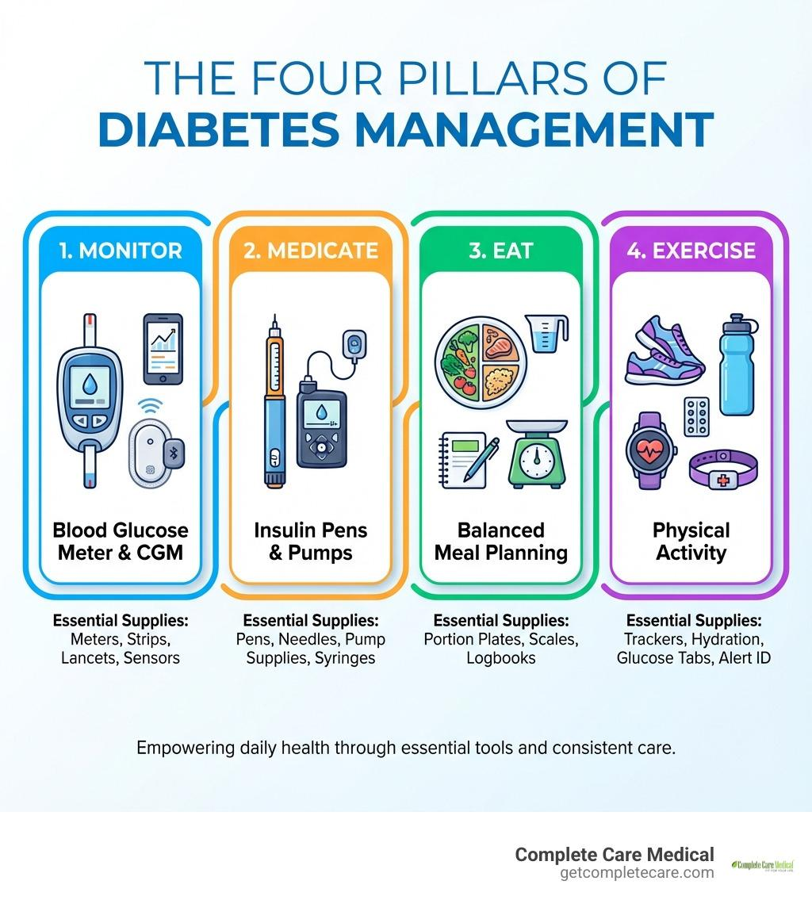
Therefore, effective diabetes policy should combine personalised prevention with wider action on health inequalities. Stronger community partnerships, culturally appropriate education and regular evaluation are needed to ensure that policy commitments lead to measurable improvements in diabetes outcomes.
Figure 2:The four pillars of diabetes management: monitoring, medication, healthy eating and physical activity (Source: Monteverde, 2026).
Living Well and Self-Management
Living well with type 2 diabetes requires regular self-management, including healthy eating, physical activity, medication adherence and monitoring blood glucose when appropriate. The NHS encourages people to take an active role in managing their condition to prevent complications and maintain independence (NICE, 2026).

Healthy Lifestyle and Daily Management

A balanced diet, regular exercise, adequate sleep and weight management can improve blood glucose control. Structured diabetes education also helps people understand treatment and make informed decisions (NICE, 2026). However, lifestyle advice may be difficult to follow when individuals face financial difficulties, cultural dietary preferences or limited access to safe exercise facilities.

Emotional Support and Independence
Living with diabetes can create anxiety and emotional distress. Support from healthcare professionals, family members and peer groups can improve confidence and motivation. Nevertheless, excessive family involvement may reduce independence, highlighting the importance of shared decision-making and respecting personal preferences (Young-Hyman et al., 2016).

Critical Evaluation
Chrvala, Sherr and Lipman (2016) found that diabetes education can improve blood glucose control. However, education alone may not lead to lasting improvements because patients face different challenges. Young-Hyman et al. (2016) also highlight the importance of psychological support in diabetes management. Comparing these findings suggests that patients need both practical knowledge and emotional support. For example, people with language barriers, financial difficulties or limited health knowledge may need additional help. Therefore, personalised education, psychological support and regular follow-up may be more effective than providing general advice to every patient.
Therefore, effective self-management requires personalised advice, regular follow-up and practical support. NHS services should provide culturally appropriate education and accessible resources, particularly for disadvantaged communities. This approach balances individual responsibility with professional support and may improve long-term wellbeing.
Recommendations and Looking Forward
Improving type 2 diabetes care requires a person-centred approach that combines prevention, effective treatment and long-term support. Based on the evidence discussed, several improvements should be prioritised.

Recommendations
First, strengthen early prevention and diagnosis. The NHS should expand targeted screening and prevention programmes, particularly for people from disadvantaged communities and those at higher risk (NHS England, 2021).
Second, improve personalised care. Healthcare professionals should involve patients in treatment decisions, considering their medical needs, cultural backgrounds and personal circumstances (NICE, 2026).
Third, expand psychological and self-management support. Accessible education, emotional support and regular follow-up could improve confidence and treatment adherence. However, education alone may be insufficient without addressing financial and social barriers (Diabetes UK, no date a).
Fourth, improve coordination between services. GPs, diabetes specialists, community nurses and social care professionals should work together to reduce fragmented care and prevent complications (NHS England, 2019).

Looking Forward
Digital monitoring and community-based services may improve access and continuity of care. However, digital exclusion and limited NHS resources could widen existing inequalities.
Therefore, future diabetes care should combine medical innovation with accessible, culturally appropriate and affordable support. Regular evaluation of patient outcomes and experiences is essential to ensure improvements benefit everyone.
Conclusion / Key Messages
Type 2 diabetes is a growing public health challenge that affects physical health, emotional wellbeing and everyday life. Although NHS treatments and prevention programmes can reduce complications, their effectiveness depends on early diagnosis, accessible services and individual circumstances (NICE, 2026).
The evidence highlights that medical treatment alone is insufficient. Poverty, health inequalities and limited support can make diabetes management more difficult. Therefore, person-centred care, structured education, psychological support and coordinated services are essential.
Overall, improving diabetes outcomes requires shared responsibility between individuals, healthcare professionals and policymakers.
Future priorities should focus on prevention, equality, independence and improved quality of life.

References
American Diabetes Association Professional Practice Committee for Diabetes (2026) ‘2. Diagnosis and classification of diabetes: Standards of Care in Diabetes—2026’, Diabetes Care, 49 (Supplement 1). Available at: https://diabetesjournals.org/care/article/49/Supplement_1/S27/163926/2-Diagnosis-and-Classification-of-Diabetes
American Diabetes Association Professional Practice Committee (2024) ‘10. Cardiovascular disease and risk management: Standards of Care in Diabetes—2024’, Diabetes Care, 47(Supplement 1), pp. S179–S218. Available at: https://doi.org/10.2337/dc24-S010
Baig, A.A. et al. (2015) ‘Family interventions to improve diabetes outcomes for adults’, Annals of the New York Academy of Sciences, 1353(1), pp. 89–112. Available at: https://doi.org/10.1111/nyas.12844
Baptista, D.R. et al. (2016) ‘The chronic care model for type 2 diabetes: A systematic review’, Diabetology & Metabolic Syndrome, 8, article 7. Available at: https://doi.org/10.1186/s13098-015-0119-z
Chrvala, C.A., Sherr, D. and Lipman, R.D. (2016) ‘Diabetes self-management education for adults with type 2 diabetes mellitus: A systematic review of the effect on glycemic control’, Patient Education and Counseling, 99(6), pp. 926–943. Available at: https://doi.org/10.1016/j.pec.2015.11.003
Department of Health and Social Care (2025) Fit for the future: 10 Year Health Plan for England. Available at: https://www.gov.uk/government/publications/10-year-health-plan-for-england-fit-for-the-future (Accessed: 8 October 2026).
Diabetes UK (2024a) Diabetes and emotional wellbeing. Available at: https://www.diabetes.org.uk (Accessed: 12 October 2026).
Diabetes UK (2024b) Diabetes stigma. Available at: https://www.diabetes.org.uk (Accessed: 10 October 2026).
Diabetes UK (2026) How many people in the UK have diabetes? Available at: https://www.diabetes.org.uk/about-us/about-the-charity/our-strategy/statistics (Accessed: 7 October 2026).
Diabetes UK (no date a) Emotional and psychological support for people with diabetes (our position). Available at: https://www.diabetes.org.uk/about-us/about-the-charity/our-strategy/position-statements/emotional-and-psychological-support-for-people-with-diabetes (Accessed: 12 October 2026).
Diabetes UK (no date b) Type 2 diabetes risk factors. Available at: https://www.diabetes.org.uk/about-diabetes/type-2-diabetes/diabetes-risk-factors (Accessed: 9 October 2026).
Mayberry, L.S. and Osborn, C.Y. (2012) ‘Family support, medication adherence, and glycemic control among adults with type 2 diabetes’, Diabetes Care, 35(6), pp. 1239–1245. Available at: https://doi.org/10.2337/dc11-2103
Monteverde, L. (2026) ‘A practical guide to diabetes supplies’, Complete Care Medical, 28 February. Available at: https://getcompletecare.com/blogs/news/diabetes-supplies-complete-guide (Accessed: 16 October 2026).
National Institute for Health and Care Excellence (NICE) (2011) Type 2 diabetes prevention: population and community-level interventions. Public health guideline PH35. Available at: https://www.nice.org.uk/guidance/ph35 (Accessed: 11 October 2026).
National Institute for Health and Care Excellence (NICE) (2012) Type 2 diabetes: prevention in people at high risk. Public health guideline PH38. Available at: https://www.nice.org.uk/guidance/ph38 (Accessed: 13 October 2026).
National Institute for Health and Care Excellence (NICE) (2026) Type 2 diabetes in adults: management. NICE guideline NG28. Available at: https://www.nice.org.uk/guidance/ng28 (Accessed: 15 October 2026).
NHS England (2014) Action for Diabetes. Available at: https://www.england.nhs.uk/rightcare/wp-content/uploads/sites/40/2016/08/act-for-diabetes-31-01.pdf (Accessed: 9 October 2026).
NHS England (2019) NHS Long Term Plan to tackle major killer conditions and save up to half a million lives. Available at: https://www.england.nhs.uk/2019/01/long-term-plan/ (Accessed: 10 October 2026).
NHS England (2021) Core20PLUS5: An approach to reducing health inequalities – supporting information. Available at: https://www.england.nhs.uk/publication/core20plus5-an-approach-to-reducing-health-inequalities-supporting-information/ (Accessed: 12 October 2026).
NHS England (2023) NHS Standard Contract 2023/24. Available at: https://www.england.nhs.uk/wp-content/uploads/2023/03/30-nhssc-fl-ps-draft-vs-final.pdf
NHS England (2025) Neighbourhood health guidelines 2025/26. Available at: https://www.england.nhs.uk/publication/neighbourhood-health-guidelines-2025-26/ (Accessed: 14 October 2026).
NHS England (no date a) NHS Diabetes Prevention Programme (NHS DPP). Available at: https://www.england.nhs.uk/diabetes/diabetes-prevention/ (Accessed: 7 October 2026).
NHS England (no date b) NHS Type 2 Diabetes Path to Remission Programme. Available at: https://www.england.nhs.uk/diabetes/treatment-care/diabetes-remission/ (Accessed: 11 October 2026).
NHS England (2026) Health Survey for England 2024: Adults’ health. Available at: https://digital.nhs.uk/data-and-information/publications/statistical/health-survey-for-england/2024/adults-health (Accessed: 13 October 2026).
Skinner, T.C. et al. (2020) ‘Twenty-five years of diabetes distress research’, Diabetic Medicine, 37(3), pp. 393–400. Available at: https://doi.org/10.1111/dme.14157
Valabhji, J. et al. (2024) ‘Early findings from the NHS Type 2 Diabetes Path to Remission Programme: a prospective evaluation of real-world implementation’, The Lancet Diabetes & Endocrinology, 12(9), pp. 653–663. Available at: https://doi.org/10.1016/S2213-8587(24)00194-3
Wagner, E.H. et al. (2001) ‘Improving chronic illness care: Translating evidence into action’, Health Affairs, 20(6), pp. 64–78. Available at: https://doi.org/10.1377/hlthaff.20.6.64
World Health Organization (2024) Diabetes. Available at: https://www.who.int/news-room/fact-sheets/detail/diabetes (Accessed: 15 October 2026).
Young-Hyman, D. et al. (2016) ‘Psychosocial care for people with diabetes: A position statement of the American Diabetes Association’, Diabetes Care, 39(12), pp. 2126–2140. Available at: https://doi.org/10.2337/dc16-2053
Zhang, F., Shan, S., Fu, C., Guo, S., Liu, C. and Wang, S. (2024) ‘Advanced mass spectrometry-based biomarker identification for metabolomics of diabetes mellitus and its complications’, Molecules, 29(11), article 2530. Available at: https://doi.org/10.3390/molecules29112530

