Dissertation – Proposal
LCBB6000
BA (Hons) Business Management
Simona Radulescu
2023029
Proposed research title: Topic: Impact of Management Skills on the Performance of an Entrepreneur

University of Wales Trinity Saint David (London Campus)
Submission date: 29/08/2023
Table of contents
Chapter 1: Introduction 3
Key concepts of the topic 3
Significance of the topic 3
Purpose of the research 3
Proposed aim, objectives and research questions 3
Chapter 2: Literature Review 4
Theoretical understanding 4
Theories and models 5
Conceptual framework 6
Chapter 3: Research Methods and Methodology 6
Chapter 4: Conclusion 10
Chapter 5: References and Bibliography 11

Chapter 1: Introduction

1.1. Key concepts of the topic
Management skill is one of the key concepts that help business owners and entrepreneurs. It can be explained as the certain attributes that aid the executives of the business organisation related to the management of the resources and handling of the staff members. It is a very essential tool that allows the management to understand and set objectives and aims of the business ventures (Hwang et al., 2020). Planning, organising, directing, and coordinating are the key actions that help the management of the business organisations determine the requirements of the organisations and the businesses as per the external environment analysis. Problem-solving, planning of businesses and managing effective communication are considered to be the key advantages of management skills (Hidayatullah et al., 2019). In the case of entrepreneurs, the presence of management skills is very important as this allows the new businesses to survive in the market competition.

1.2 Significance of the topic
Acquiring management skills has become one of the necessities for new start-up ventures, especially for entrepreneurs. In the modern era of technological advancements, and in the rapid phase of digitisation, proposing a new and successful business start-up or business venture is comparatively challenging due to the competitiveness of the market and frequent changes in consumer behaviour patterns. Recent research has depicted that, starting from February 2022, overall consumers have intended to change their purchasing habits for a wide range of products regarding the rising consumer goods (Sabanoglu, 2022). So, entrepreneurs are required to have an adaptive nature regarding market diversification and consumer preference aspects. Moreover, this study is significant in analysing the impact of management skills on entrepreneurs approaching new start-up ventures.

1.3 Purpose of the research
Successful entrepreneurs will rely on business skills regarding business management and brand enhancement. Developing business management skills mainly based on aspects like the power of multitasking, delegating responsibilities to the respective subordinates for better decision-making aspects and increasing the sales revenue and profitability of the overall business (Sulistyo and Ayuni, 2020). Due to the lack of management skills, entrepreneurs mostly face problems regarding managing business and performing relevant activities of marketing, handling operations, managing the existing staff base and others. It has been observed that the amount of low-skilled employees is higher in numbers in comparatively small companies compared to large-scale companies. It has been observed that with respect to the competitive environment, start-ups are required to produce an innovative approach that will justify the present market and create a significant impact on the existing market. For instance, the case study of Kodak can be aligned with where the company was unable to adopt the opportunity of digital photography invention (Mui, 2012). As a result, the rising market was captured by other competitor companies like Fuji Films which is considered to be one of the major competitors of Kodak. So, it highlights the importance of management skills especially for new start-up ventures. This study will shed light on the impact of management skills on entrepreneurs and how it positively regulates business operations in the early stages.

1.4 Proposed aim, objectives and research questions
The aim of this research is to analyse the impacts of managerial skills on entrepreneurial performance.
The objectives are:
- To understand the concept of managerial skills and entrepreneurial performance
- To evaluate the impacts of managerial skills on entrepreneurial performance
- To find out the challenges in enhancing entrepreneurial performances
- To identify the effectiveness of the management strategies to overcome the challenges associated with entrepreneurial performance.
The research questions are as follows:
- How does the management skill influence the performance of entrepreneurial performance?
- What are the key impacts of management skill on the business performance of entrepreneurs?
- What are the primary challenges the entrepreneurs face?
- How do management strategies can be used in overcoming the challenges?

Chapter 2: Literature Review

2.1 Theoretical understanding
Concept of managerial skills and entrepreneurial performance
Managerial skills are significant for developing entrepreneurial performances. As described by Astuti et al. (2019), managerial skills enhance the business management focusing on the strategic planning, follow-up, and implementation to enhance the business performances. Managerial skills are beneficial to deal with the environmental changes in the modern contemporary business environment to increase the entrepreneurial performances focusing on a long-term growth. As critically evaluated by Singh et al. (2021), managerial skills are effective in attracting open innovation that can influence the organisational performance. On the other hand, entrepreneurial skills engage managerial, technical, innovation skills to enhance the probability of success.
2.2 Impacts of managerial skills on entrepreneurial performance
Managerial skills help an individual to use the resources adequately to attract greater performance in the business management process. As described by Christa and Kristinae (2021), managerial skills are efficient in improving the entrepreneurial performances focusing on business growth. Managerial skills are further beneficial in improving knowledge-sharing process which is efficient in enhancing the business growth. As argued by Udriyah et al. (2019), inadequate managerial skills can affect innovative approach focusing on gathering greater competitive advantages. It can further affect the entrepreneurial efficiencies. Therefore, there is a major impact of managerial skills on entrepreneurial performance.
2.3 Challenges in enhancing entrepreneurial performances.
There are different challenges faced by the entrepreneurs to enhance the skills. As elaborated by Nguyen et al. (2021), entrepreneurial leadership inefficiencies can cause challenges in terms of the success of entrepreneurial performances. Further, proper financial resources availability can also threat the entrepreneurial performances. As evaluated by Hameed and Irfan (2019), issues in strategic decision-making can affect the entrepreneurial performance. Further, inappropriate managerial skills can affect the business efficiency focusing on the entrepreneurial approaches. Thus, lacking in the skills, capabilities and resources is imposing challenges in increasing entrepreneurial performance.
2.4 Effectiveness of the management strategies to overcome the challenges associated with entrepreneurial performance.
There are several ways through which entrepreneurial performance can be improved in an organisation. One of the strategies is to conduct market research in order to find out the tastes and preferences of the customers for mitigating the amount of risks the entrepreneurs can face. As per the opinion of Akpan et al. (2022), social computing can be used in businesses to establish low-cost communication strategies. This is an effective approach combined with Virtual Reality to help the entrepreneurs such as the SMEs to develop and manage operations and activities. Similar to the above opinion Lüdeke‐Freund (2020), stated the use of clean energy business models to provide a much fairer access to financial capital. This is a sustainable approach for entrepreneurs in providing access to financial capital instead of striving for lower costs.

2.5 Theories and models
Scientific management theory
Scientific management theory is to be considered and further analysed based on the requirement of the research proposal. In the opinion of Taylor (2023), scientific management theory can be defined as the theoretical framework that addresses the systematic progress and awareness of the education of workers. Furthermore, this theory addresses the benefits and enhances the production of the workers and also helps in addressing any flaws in their training. On the other hand Fonti et al. (2023), it can also be observed that this theory though provides the accessibility of knowledge, using this theory may face the issue of the requirement of higher capital. But on the contradictory observation, referring to Baker (2023), as this theory provides the ability to control the activities and performance of the employees managing and formulating the management strategies can be much easier.
Cochran's theory of entrepreneurship
Another theory of entrepreneurship theory can be considered based on the requirements of the project is Cochran’s theory of entrepreneurship. Ijiola et al. (2023), have defined the theory as the approach of an individual from the occupational hazard perspective that is being addressed and encountered by the other profession. Furthermore, this Cochran's theory of entrepreneurship motivated individuals in making their own bosses. Therefore, it can be further analysed that this theory can help in impacting Management Skills. On the other hand, Cochran (2019) has mentioned this theory of entrepreneurship often takes a longer time and complicated procedure to obtain the objectives. Thus, after analysing the impacts of both the theory, it can be further stated that the scientific management theory can be much more applicable towards addressing the Impact of Management Skills on the Performance of an Entrepreneur.

Conceptual framework
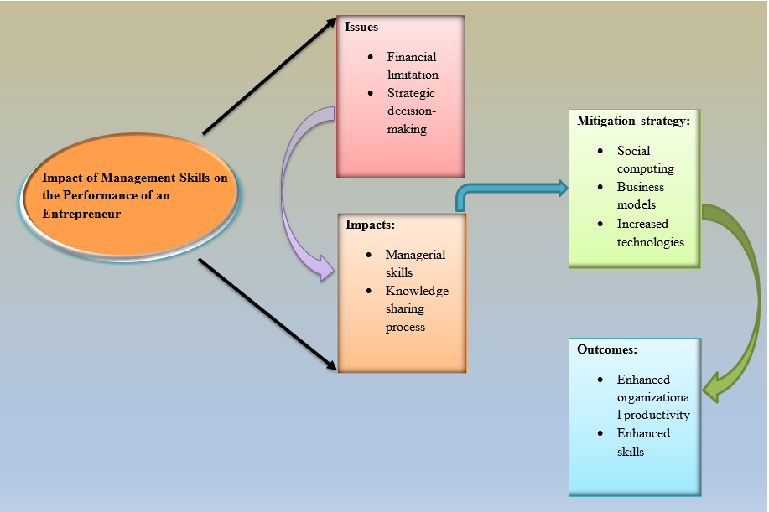
Figure 1: Conceptual Framework
(Source: Created by the learner)

Chapter 3: Research Methods and Methodology
3.1 What research philosophy and why?
Research Philosophy can be illustrated as the belief of the researcher about the way data should be gathered and analysed. Among several types of research philosophy, the researcher will use interpretivism research philosophy. It is because it helps to employ multiple methods and reflect on the various aspects of the issue (research methodology, 2023). Hence, this philosophy will allow the researcher to analyse various challenges that affect entrepreneur performance.
3.2 What research paradigm and why?
Research paradigm can be depicted as a set of ideas, beliefs and patterns in order to conduct research. There are three paradigms used in research such as ontology, epistemology and methodology. Here the researcher will use methodology as it explores the social environment and proves the validity of the knowledge gained. Hence, the use of this paradigm will help the researcher to explore various research articles in order to compare the validity of the research.
3.3 What research approach and why?
The research approach is a general plan to conduct a study. Among the three types of research approaches the researcher will use a deductive approach as it helps to establish a relation between the concept and variables (Dudovskiy, 2023). For instance, using this approach will help the researcher to verify the connection between the theories and models of management and their impact on the entrepreneur's performance.
3.4 What research methodology and why?
Research methodology is the process of exploring the way a researcher intends to carry out research logically and systematically. Among various types of research methodology, the researcher will use qualitative methods to conduct the research. The application of this methodology will help the researcher to understand the social and economic constraints that reduce the managerial competencies of entrepreneurs.
3.5 What research strategy and why?
A research strategy is illustrated as a step-by-step plan of action which provides direction to the thoughts and efforts. There are various types of research strategies such as statistical analysis, literature review, case studies, and content analysis (Dudovskiy, 2023). In this research, the researcher will use a literature review as it will help the researcher to segregate the information into various themes in order to reach a conclusion.
3.6 Sampling methods and why
Sampling is the process of selecting a group of articles from a larger set of articles and journals. In this research, the researcher will select 8 articles based on themes and they will be supported using other supporting articles. These articles will be chosen based on the inclusion and exclusion criteria. These criteria are mentioned below:
Inclusion | Exclusion
Articles which are written in the English language are considered. | Articles which are written in any other language rather than English are excluded.
Contemporary articles which are written within 5 years are included. | Articles which are older than 5 years are excluded.
Articles and journals having an abstract, information about the author, qualifications, and details of the publishing house are included. | Articles and journals which does not contain a proper abstract, and details of the publishing house and author are excluded.
Table 1: inclusion and exclusion criteria
(Source: Created by the learner)
3.6 Data collection methods/tools
Data collection means the way data is collected by the researcher. There are two types of data collection such as primary data and secondary data. In this research, the researcher will collect data through a secondary data collection method that involves articles, journals, websites, company information and others (research methodology, 2023). The reason behind choosing this method is that it helps to collect data quickly and helps the researcher to go through past developments on the selected topic. To collect secondary data the researcher will use a Boolean search strategy using search operators such as “and” “or” “the” and so on. It is because it helps to narrow the search results to get the most relevant journals and articles.
3.7 Ways of interpreting data/How are you going to interpret data?
Data analysis is the technique of interpreting the collected information. In this research, the researcher will use a thematic analysis technique. It is because this technique will help the researcher to segregate the information based on the research aim and objectives to reach a conclusion.
Time prospects of the research (Gantt chart)
Activities | Start date | Duration (Days) | End date
Setting research aim and objectives | 10-08-2023 | 8 | 18-08-2023
Setting research themes | 18-08-2023 | 10 | 28-08-2023
Findings Literatures | 28-08-2023 | 3 | 31-08-2023
Planning for the research procedures | 31-08-2023 | 7 | 07-09-2023
Selecting research methodologies | 07-09-2023 | 8 | 15-09-2023
Application of the inclusion and exclusion criteria | 15-09-2023 | 13 | 28-09-2023
Shortlisting of the studies | 28-09-2023 | 12 | 10-10-2023
Final Drafting | 10-10-2023 | 4 | 14-10-2023
Submission | 14-10-2023 | 14 | 28-10-2023
Table 2: WBS structure
(Source: Created by the learner)
Gantt chart
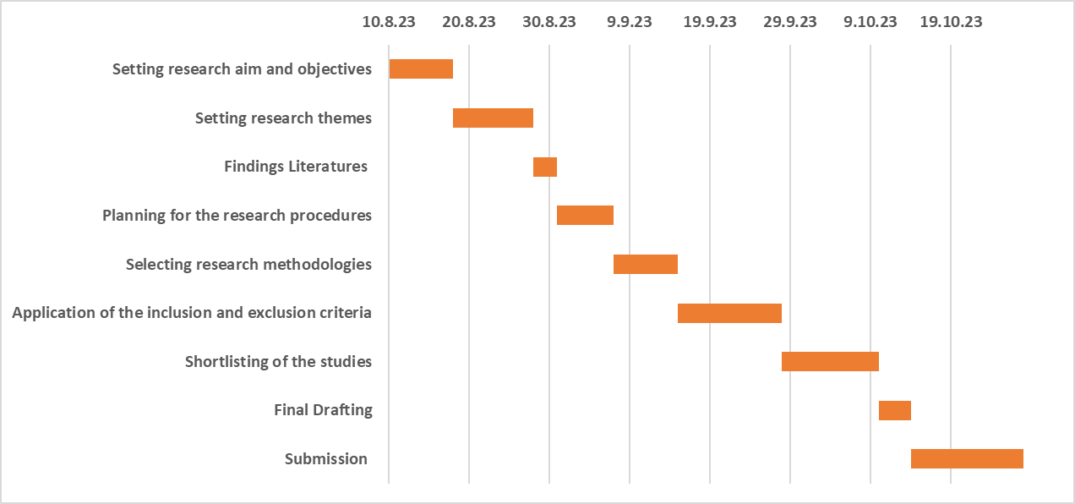
Figure 2: Gantt Chart
(Source: Created by the learner)
Ethical consideration of the research
While conducting research the researcher needs to follow some ethics and guidance in order to make the research in an ethical way. In this research, the researcher will follow General Data Protection Regulations (GDPR 2018). The researcher will avoid exaggeration of the aim and objective and provide proper references while using the work of other authors throughout the research.

Chapter 4: Conclusion
It is expected that the research study will evaluate the impacts of managerial skills on entrepreneurial performance. It will further discover different managerial skills that influence the entrepreneurial performances. In addition, the concept of entrepreneurial performance will be found in terms of potential outcomes of the present research. It will also focus on finding out the challenges faced by the entrepreneurs in terms of enhancing entrepreneurial performance. It will also analyse effectiveness of different strategies to improve entrepreneurial skills in order to enhance the managerial capabilities while performing the business.

Chapter 5: References and Bibliography
Akpan, I.J., Udoh, E.A.P. and Adebisi, B., (2022) Small business awareness and adoption of state-of-the-art technologies in emerging and developing markets, and lessons from the COVID-19 pandemic. Journal of Small Business & Entrepreneurship, 34(2), pp.123-140.
Astuti, W., Supanto, F. and Supriadi, B., (2019) Entrepreneurial skills and SME’s business performance: Empirical study culinary business. Journal of Economics and Sustainable Development, 10(22), pp.160-166.
Baker, E., (2023) The Rise of Entrepreneurial Management Theory in the United States. Modern Intellectual History, 20(1), pp.195-219.
Christa, U. and Kristinae, V., (2021). The effect of product innovation on business performance during COVID 19 pandemic. Uncertain Supply Chain Management, 9(1), pp.151-158.
Cochran, S.L., (2019) What's gender got to do with it? The experiences of US women entrepreneurship students. Journal of Small Business Management, 57, pp.111-129.
Fonti, F., Ross, J.M. and Aversa, P., (2023) Using sports data to advance management research: A review and a guide for future studies. Journal of Management, 49(1), pp.325-362.
Hameed, I. and Irfan, Z., (2019). Entrepreneurship education: a review of challenges, characteristics and opportunities. Entrepreneurship Education, 2, pp.135-148.
Hidayatullah, S., Firdiansjah, A., Patalo, R.G. and Waris, A., (2019) The effect of entrepreneurial marketing and competitive advantage on marketing performance. International Journal of Scientific and Technology Research, 8(10), pp.1297-1301.
Hwang, W.S., Choi, H. and Shin, J., (2020) A mediating role of innovation capability between entrepreneurial competencies and competitive advantage. Technology Analysis & Strategic Management, 32(1), pp.1-14.
Ijiola, O. and Nwogwugwu, N., (2023) Entrepreneurship Development Centres and Employment Generation in Lagos State, Nigeria. KIU Journal of Humanities, 8(2), pp.49-55.
John Dudovskiy (2023) Research Design [Online] available at:<https://research-methodology.net/research-methodology/research-design/#google_vignette:> [Accessed on 19th August, 2023]
John Dudovskiy, (2023) Research Approach [Online] available at:<https://research-methodology.net/research-methodology/research-approach/:> [Accessed on 19th August, 2023]
Lüdeke‐Freund, F., (2020) Sustainable entrepreneurship, innovation, and business models: Integrative framework and propositions for future research. Business Strategy and the Environment, 29(2), pp.665-681.
Mui., C. 2012. How Kodak Failed. Online available at: <https://www.forbes.com/sites/chunkamui/2012/01/18/how-kodak-failed/?sh=17e394056f27 > [Accessed on: 19th August, 2023]
Nguyen, P.V., Huynh, H.T.N., Lam, L.N.H., Le, T.B. and Nguyen, N.H.X., 2021. The impact of entrepreneurial leadership on SMEs’ performance: the mediating effects of organizational factors. Heliyon, 7(6).
Research-methodology, (2023). Ethical Considerations [Online] available at:<https://research-methodology.net/research-methodology/ethical-considerations/:> [Accessed on 19th August, 2023]
Research-methodology (2023) Research Philosophy. [Online] available at:<https://research-methodology.net/research-philosophy/#google_vignette:> [Accessed on 19th August, 2023]
Sabanoglu., T. (2022) Rising prices: consumers who changed purchasing habits worldwide in 2022, by product. Online available at: < https://www.statista.com/statistics/1302963/inflation-response-purchasing-habits/ > [Accessed on: 19th August, 2023]
Singh, S.K., Gupta, S., Busso, D. and Kamboj, S., (2021) Top management knowledge value, knowledge sharing practices, open innovation and organizational performance. Journal of Business Research, 128, pp.788-798.
Sulistyo, H. and Ayuni, S., (2020) Competitive advantages of SMEs: The roles of innovation capability, entrepreneurial orientation, and social capital. Contaduría y administración, 65(1).
Taylor, F.W., (2023). the Rise of Scientific Management. The Quantified Worker: Law and Technology in the Modern Workplace, p.9.
Udriyah, U., Tham, J. and Azam, S.J.M.S.L., (2019.) The effects of market orientation and innovation on competitive advantage and business performance of textile SMEs. Management Science Letters, 9(9), pp.1419-1428.

