Chapter 1. Introduction
Border control is an important aspect of national security and migration management. Governments use border controls to regulate the movement of people across national borders, identify potential risks and prevent unauthorised entry. In the United Kingdom (UK), Border Force is responsible for carrying out immigration and customs controls at ports and airports, using procedures such as identity checks, intelligence and technology to manage entry into the country (Home Office, 2023). However, the effectiveness of border control remains a widely debated issue, particularly in relation to irregular migration.
The issue of irregular entry has received significant public and political attention in the UK, particularly due to small-boat crossings across the English Channel. The Home Office recorded 36,816 small-boat arrivals in the UK during 2024 (Home Office, 2025). Although these figures demonstrate the continuing relevance of irregular migration, arrival numbers alone do not provide a complete measure of border-control effectiveness. It is therefore important to consider the policies and procedures used to prevent irregular entry, alongside the wider circumstances that influence migration routes and patterns.
The effectiveness of stricter border controls is also debated within academic literature. While enforcement measures are intended to protect national borders and prevent unauthorised entry, research suggests that stricter controls may sometimes influence the routes used by migrants rather than prevent migration altogether (Pickering and Weber, 2014). This raises questions about how border-control effectiveness should be assessed and whether existing strategies achieve their intended aims. Border control must also balance security with efficiency and fairness, creating further challenges for those responsible for managing entry into the country (Bosworth and Guild, 2008).
Public perception is another important consideration when examining border-control effectiveness. People's views may be influenced by their understanding of immigration policy, their confidence in government institutions and the information they receive through news and social media. Media coverage can play a significant role in shaping how irregular migration is understood by the public, particularly when reporting focuses on small-boat crossings, rising arrival numbers and concerns about border security. Repeated exposure to particular headlines or narratives may influence whether people perceive border control as effective or ineffective, even when they have limited direct knowledge of border-control procedures. Research has highlighted the importance of public trust in institutions such as policing and government authorities when considering perceptions of security and policing (Bradford et al., 2014). It is therefore important to examine not only how effective border control is, but also how the media may shape public understanding and confidence in its effectiveness.
A comparative approach will also be used to examine border-control strategies in Australia and Poland. Australia has adopted a strict approach to unauthorised maritime arrivals through Operation Sovereign Borders, which includes maritime interception and measures intended to deter irregular arrivals (Australian Government, 2023). Poland provides a different comparison because of its geographical position on the European Union's external border and the migration pressures it faces (Eurostat, 2024). Comparing these approaches with those in the UK can help identify differences in border-control policies and assess whether other strategies offer more effective alternatives. However, these comparisons must recognise that each country operates within different geographical, political and legal circumstances.

Research Focus
This research will critically examine the effectiveness of current UK border control in preventing illegal entry into the United Kingdom. It will consider existing policies, procedures and enforcement strategies, explore public perceptions of border-control effectiveness and compare the UK approach with those used in Australia and Poland.

Aim
To critically analyse the effectiveness of the UK Border Force in preventing illegal entry into the United Kingdom.

Objective’s
- To evaluate current UK Border Force policies, procedures and enforcement strategies aimed at preventing illegal entry, by comparing them with approaches used in Australia and Poland.
- To assess public perceptions of border-control effectiveness and confidence in national border security.
- To recommend evidence-based strategies for improving the effectiveness of border control within the UK.

Method

This research study will use a mixed-method approach, consisting of a survey, to collect relevant data on public perceptions of border control systems. This survey will include multiple-choice and Likert-scale questions that will capture public opinion on border control systems. Open-ended questions will also be included to allow respondents to express their views in their own words. This will give the researcher additional qualitative data and potentially reveal explanations and perspectives that may not be captured through closed-ended questions (Sheppard, 2020).
According to Oranga (2025), using qualitative and quantitative methods can provide a more comprehensive understanding of the research topic. This is beneficial to the study as quantitative data can identify patterns in public opinions, while qualitative data can allow for a wider range of the public’s opinions and views. However, one limitation of this approach is that analysing both types of data can require additional time and effort (Oranga, 2025). Despite this limitation, the mixed-methods approach is suitable for this research as it will provide both measurable results and a deeper understanding of participants opinions.
As this survey covers Australia, Poland, and the UK, the data collected will provide a broader view of public opinion. The results can help us analyse and compare a wider and greater understanding of border control systems.

Value of Research
Issues regarding the UK Border Force are a current topic of debate, particularly regarding the effectiveness of current measures in preventing unauthorised entry into the UK. Existing research has examined the impact of immigration enforcement policies and the challenges associated with their implementation (Griffiths and Yeo, 2021). However, further research is valuable for exploring public perceptions of border-control effectiveness and comparing these views across geographical contexts.
The research may also help identify areas where existing border control measures could be improved and contribute to discussions about government policy and operational practice. Comparing different approaches of border control may also highlight strategies that could be considered for future improvements. Furthermore, the research will explore the importance of balancing border security with legal obligations and the protection of vulnerable individuals. Aliverti (2020) highlights the challenges of balancing immigration enforcement with safeguarding vulnerable people. Therefore, this research is valuable because it considers not only the perceived effectiveness of border control but also the wider issues involved in managing national borders.

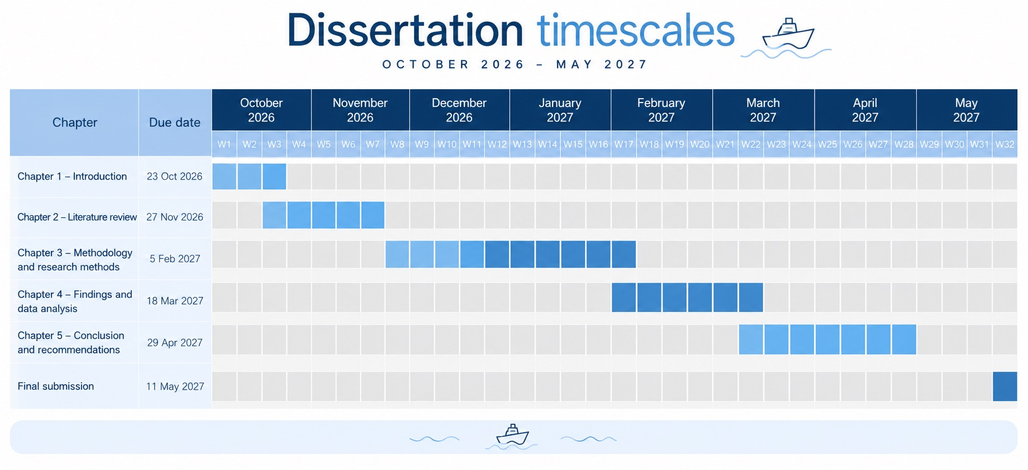
Timescales

Chapter 2. A Literature review (2,500)

Chapter 3. A Methodology / Research methods (1,500)

Thematic Analysis - Braun & Clarke (Qualitative)

Descriptive data (Quantitative)

Chapter 4. The findings of your research methods or data analysis (2000)

Chapter 5. The conclusion (800)

Refrences
Australian Government (2023) Operation Sovereign Borders. Operation Sovereign Borders Monthly Update December 2023. Available at: https://www.abf.gov.au/newsroom-subsite/Pages/Operation-Sovereign-Borders-Monthly-Update-December-2023.aspx (Accessed: 4 October 2026).
Bosworth, M. and Guild, M. (2008) Governing through migration control. Oxford: Oxford University Press. pp. 1-17 Available: https://www-jstor-org.uwtsd.idm.oclc.org/stable/23639617?sid=primo&seq=1 (Accessed: 11 October 2026).
Bradford, B., Murphy, K. and Jackson, J. (2014) ‘Trust in justice and public confidence in security institutions’, British Journal of Criminology, pp. 1006-1028 Available at: https://eprints.bbk.ac.uk/id/eprint/16337/1/16337.pdf (Accessed: 14 October 2026).
Eurostat (2024) Enforcement of immigration legislation statistics. Available at: https://ec.europa.eu/eurostat/statistics-explained/index.php?title=Enforcement_of_immigration_legislation_statistics (Accessed: 10 October 2026).
Home Office (2020) 2025 UK Border Strategy. Available at: https://www.gov.uk/government/publications/2025-uk-border-strategy (Accessed: 16 October 2026)
Home Office (2023) About Border Force. Available at: https://www.gov.uk/government/organisations/border-force/about (Accessed: 14 October 2026).
Home Office (2024) Immigration system statistics: How many people come to the UK irregularly? Available at:https://www.gov.uk/government/statistics/immigration-system-statistics-year-ending-december-2024/how-many-people-come-to-the-uk-irregularly (Accessed: 18 October)
Pickering, S. and Weber, L. (2014) Hardening the border: Border security and migration control. Basingstoke: Palgrave Macmillan. Available at: https://www.academia.edu/41937823/BORDERS_MOBILITY_AND_TECHNOLOGIES_OF_CONTROL (Accessed: 10 February 2026).
Sheppard, V.A. (2020) Research Methods for the Social Sciences: An Introduction. BcCampus. Available at: https://www.researchgate.net/profile/Valerie-Sheppard/publication/353999416_Research-Methods-for-the-Social-Sciences-An-Introduction_Updated_Aug_2021/links/611e420f0c2bfa282a55960b/Research-Methods-for-the-Social-Sciences-An-Introduction-Updated-Aug-2021.pdf (Accessed: 10 February 2026).
Page 205- 206 chapter 8.7 – response options
NEED TO REFERENCE.
Oranga, 2025
https://jaruda.id/index.php/go/article/view/213/187
Griffiths and Yeo, 2021
https://journals.sagepub.com/doi/10.1177/0261018320980653
Aliverti 2020
https://wrap.warwick.ac.uk/id/eprint/134477/1/WRAP-benevolent-policing-vulnerability-moral-pains-border-Aliverti-2020.pdf

