Project Management Plan

Module Code: BMSW5104

Student Name’s:

George Giuliano Mihai - 2027230

Cristian Dumitru -2108821

Dan Dumitru -2025728

Lecturer: Abel Agoba

Contents
Introduction 3
Scope of the Project 4
Stakeholders Analysis 4
PESTLE Analysis 6
Quad Chart 9
Risk Assessment 12
Conclusion 14
References 16

Introduction
The objective of this document is to offer a comprehensive outline of the project, encompassing various elements. It will provide a detailed account of the project's Scope, Stakeholders Analysis, PESTLE Analysis, Quad Chart, Risk Assessment, and Conclusion. The intention is to present a thorough and well-structured report, ensuring a clear understanding of the project's process and content.
The project aims to establish a tomato cultivation operation, focusing on sustainable and efficient practices to maximize yield, quality, and profitability. It encompasses all aspects of tomato production, from seed selection and propagation to harvesting and marketing. The scope outlines the key objectives, deliverables, and major components involved in successfully growing tomatoes.
Incredible Vegetables is a unique and innovative company that focuses on growing and promoting an extraordinary variety of rare and exotic vegetables. With a passion for biodiversity and sustainable farming practices, Incredible Vegetables aims to inspire individuals and communities to explore the world of unusual and fascinating edible plants. The project we are working on is called “incredible tomato” Scope of the project is to grow the most flavoured tomato in the UK within the allocated budget and the allocated special area. Founded by dedicated horticulturists, Incredible Vegetables is driven by a mission to expand the culinary horizons and challenge the norms of vegetable cultivation. The company specializes in sourcing, cultivating, and distributing a wide array of rare, heirloom, and unusual vegetable varieties that are not commonly found in mainstream markets.

Scope of the Project
Incredible Vegetables has built strong partnerships with local markets, grocery chains, and restaurants, enabling efficient distribution of its produce to customers across the region. Its commitment to quality and consistency has earned the company a loyal customer base and accolades within the industry.
Furthermore, the company actively engages with the community, offering educational programs on sustainable farming practices and supporting local initiatives. This community-driven approach reflects its values of social responsibility and fostering positive change.
With a focus on innovation, sustainability, and customer satisfaction, Incredible Vegetables continues to grow, earning a reputable position in the agricultural market and contributing to the well-being of both consumers and the environment.
The scope of the project involves establishing and operating a site dedicated to the cultivation and production of tomatoes. The key components include seed selection, cultivation practices, post-harvest management, and marketing. The objective is to deliver high-quality tomatoes while ensuring sustainability and profitability. The project scope encompasses the following. Implementing efficient and sustainable cultivation practices to maximize crop yield and quality. This involves selecting appropriate tomato varieties, preparing the soil, managing irrigation, fertilization, pest, and disease control, and ensuring optimal growing conditions. The scope outlines the primary objectives, deliverables, and major components involved in establishing and operating a tomato-growing company. It serves as a foundation for planning and executing the project, with the aim of delivering high-quality tomatoes, achieving profitability, and contributing to sustainable agriculture practices (Bukk, 2023).

Stakeholders Analysis
Stakeholder analysis is an essential part of project management that involves identifying, understanding, and prioritizing the individuals, groups, or organizations that have a stake in a particular project. It is important to analyse stakeholders because they can influence the success or failure of a project. By identifying and understanding their needs, expectations, and interests, project managers can effectively manage relationships and communication with stakeholders, ensuring that their concerns are addressed, and their support is gained.
Stakeholder analysis typically involves four steps:
Identification: This involves identifying all potential stakeholders who could be affected by or have an interest in the project. Stakeholders can include individuals, groups, organizations, or even communities.
Understanding: Once stakeholders are identified, it is important to understand their needs, expectations, and concerns. This can be done through interviews, surveys, focus groups, or other means of gathering information. This step helps project managers gain insight into stakeholder perspectives and anticipate potential issues.
Prioritization: Stakeholders are not all equal in terms of their influence or impact on the project. Prioritization involves categorizing stakeholders based on their level of power, interest, and influence. This helps project managers determine which stakeholders require more attention and resources.
Strategy Development: Once stakeholders are identified, understood, and prioritized, project managers can develop strategies for effectively managing relationships and communication with them. This may involve regular updates, engaging stakeholders in decision-making processes, addressing their concerns, and seeking their support.
By conducting a thorough stakeholder analysis, project managers can minimize conflicts, gain support and buy-in, and ultimately increase the chances of project success. It helps in ensuring that the project meets the needs and expectations of all key stakeholders for maximum impact. (Burt, 2023).
Stakeholders Analysis for a Company Growing Tomatoes:
Farmers and Owners: These are the individuals or groups who own and operate the tomato-growing company. They have a direct stake in the success and profitability of the business. Their objectives typically include maximizing crop yield, ensuring quality, and achieving financial sustainability.
Employees and Laborers: The workforce involved in the day-to-day operations of the tomato-growing company, including farm managers, agricultural workers, technicians, and administrative staff. Their interests revolve around fair wages, job security, safe working conditions, and opportunities for growth and development within the company.
Suppliers: Suppliers of various inputs required for tomato cultivation, such as seeds, fertilizers, pesticides, irrigation equipment, and packaging materials. They have a stake in maintaining a strong business relationship, timely payments, and reliable demand for their products.
Customers: Customers encompass both wholesale and retail buyers, including grocery stores, restaurants, food processors, and individual consumers. Their expectations revolve around high-quality tomatoes, timely delivery, competitive pricing, and consistency in supply. Meeting customer demands and building long-term relationships is crucial for business success.
Local Community: The local community surrounding the tomato-growing company's operations may have an interest in the company's environmental impact, job creation, and contributions to the local economy. Engaging with the community through employment opportunities, participating in local events, and implementing sustainable practices can foster a positive relationship.
Regulatory Authorities: Government agencies and regulatory bodies responsible for overseeing agricultural practices, food safety, environmental regulations, and labour laws. Compliance with regulations, obtaining necessary permits and licenses, and maintaining transparent operations are essential for building a good rapport with regulatory authorities.

PESTLE Analysis
PESTLE analysis remains a widely popular and user-friendly business analysis tool, valued for its effectiveness. The core idea of PESTLE analysis revolves around evaluating an organization from six diverse standpoints: Political, Economic, Sociocultural, Technological, Legal, and Environmental. This comprehensive approach provides valuable insights into the overall performance of a business.
Though simple in concept, beginners often encounter challenges when attempting their own PESTLE analyses. In this article, we aim to dispel any uncertainties surrounding this distinctive business analysis technique, offering clear guidance and abundant examples to help you harness its potential (BUSH, n.d.).
Political Factors:
• Government policies and regulations related to agriculture, farming practices, and food safety can impact the company's operations and compliance requirements.
• Trade agreements and tariffs can influence import/export of tomatoes, affecting market dynamics and competition.
• Political stability and changes in leadership can impact business continuity and long-term planning.
Economic Factors:
• Economic conditions and trends, such as inflation, exchange rates, and interest rates, can affect production costs, profitability, and consumer purchasing power.
• Market demand for tomatoes, including factors like consumer preferences, dietary trends, and price sensitivity, can impact sales and revenue.
• Availability and cost of labour, transportation, and other resources can influence production costs and logistics.
Sociocultural Factors:
• Consumer preferences, dietary habits, and cultural practices related to tomato consumption can impact market demand and product positioning.
• Changing demographics, lifestyles, and health consciousness can influence the demand for organic, locally sourced, or specialty tomatoes.
• Social attitudes towards sustainability, environmental stewardship, and ethical farming practices can shape consumer perceptions and affect the company's reputation.
Technological Factors:
• Technological advancements in agricultural practices, irrigation systems, greenhouse technologies, and precision farming can enhance productivity, quality, and efficiency in tomato cultivation.
• Adoption of digital platforms, data analytics, and automation in farming operations can improve decision-making, resource management, and supply chain processes.
• Changes in food processing and preservation technologies can impact shelf life, product innovation, and value-added opportunities.
Environmental Factors:
• Climate patterns, weather conditions, and natural disasters can affect crop yields, harvest timings, and overall productivity.
• Water availability and sustainability practices, such as efficient irrigation and water management techniques, are important for long-term cultivation.
• Environmental regulations, conservation efforts, and biodiversity preservation initiatives can influence farming practices and land use.
Legal Factors:
• Compliance with agricultural and food safety regulations, including pesticide use, labelling requirements, and traceability standards, is essential for legal operations.
• Intellectual property rights and plant variety protection laws can impact seed selection, proprietary varieties, and research collaborations.
• Employment laws and labour regulations govern aspects like minimum wages, working hours, and safety standards for farm workers.
By considering these PESTLE factors, a company growing tomatoes can gain insights into the external environment, identify opportunities, mitigate risks, and make informed decisions to ensure sustainable growth and success in the industry.
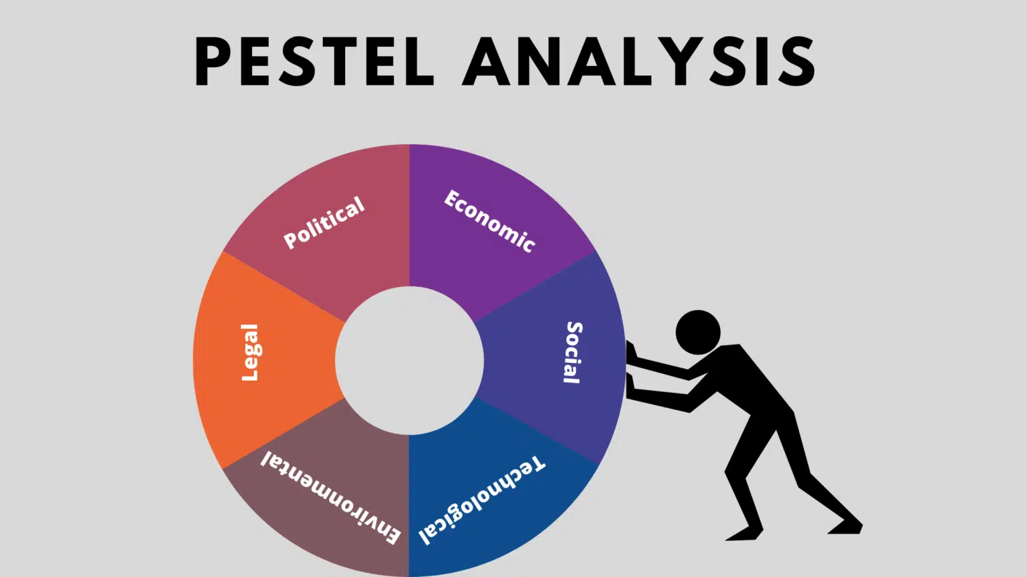
(Sharma, 2021).

Quad Chart
A quad chart is a simple one-page document divided into four equal quadrants, presented in landscape mode, also known as 2x2 charts or matrices. It has been widely employed for various purposes to present information concisely. In my case, I will primarily use the quad chart to categorize items that vary in two dimensions. By dividing a coordinate system into four basic categories, the quad chart enables making general statements about each category effectively according to (Kiskis, 2020).
The Quad chart is a popular format for presenting technical information about a project. It includes four key elements: the project's goal, the target audience, the expected outcomes, and the success metrics.
The goal of the project refers to the overarching objective or purpose that the project aims to achieve. It should be clear, specific, and aligned with the needs and priorities of the organization.
The target audience refers to the group of people or stakeholders who will benefit from the project or be directly impacted by it. This could include internal stakeholders such as employees or external stakeholders such as customers, suppliers, or the general public.
The expected outcomes are the specific results or deliverables that the project is expected to produce. These could be tangible outcomes such as new products or services, improved processes or systems, or intangible outcomes such as increased customer satisfaction or brand awareness.
Success metrics are the measures or indicators that will be used to determine whether the project has achieved its goals and produced the expected outcomes. These metrics should be specific, measurable, attainable, relevant, and time-bound (SMART).
By including these four elements in a Quad chart, project teams can provide a concise and visually appealing overview of the project's key aspects. This can help stakeholders understand the project's purpose, target audience, expected outcomes, and how success will be measured. (Kaufman, 2021). However the explaneison is can be seen below, has been made based on the Analysis above PESTLE and STAKEHOLDERS.
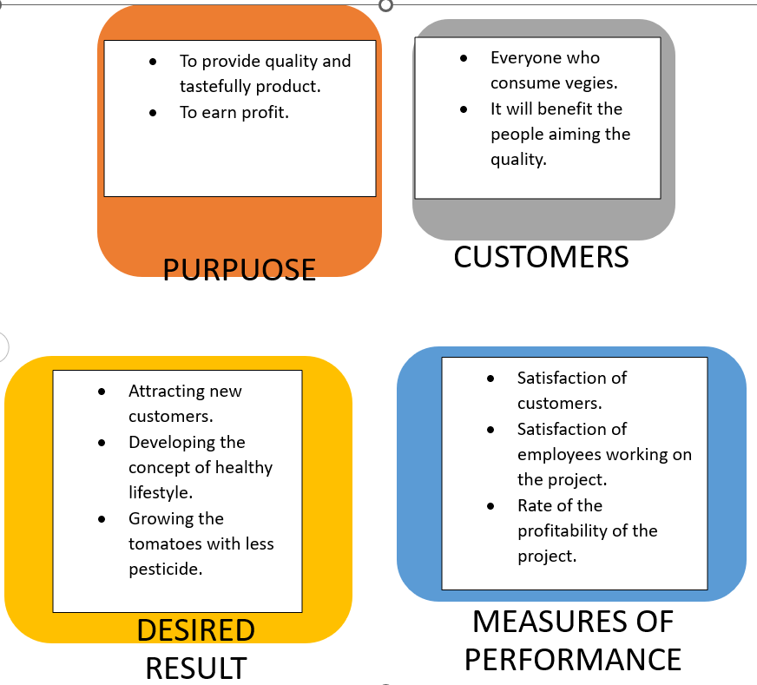
Purpose:
- To provide quality vegies (tomatoes).
- To make profit by reduction of cost of production.
Customers:
Most people tend to follow a healthy lifestyle our products are helping them, but also people who are just trying once can benefit because of the quality.

Desired Results:
- Attracting new customers, it is helping us to develop the concept of Healthy lifestyle.
- Using less pesticide in the process of growing vegies (tomatoes).
Measures of Performance:
- Satisfaction of customers.
- Satisfaction of employees working on the project.
- Rate of the profitability of the project.

Risk Assessment

Risk Assessment for a Company Growing Tomatoes:
Identifying and assessing potential risks is crucial for managing and mitigating potential disruptions to a tomato-growing company's operations. Here's a risk assessment for such a company (Elisabete Figueiredo,, 2021).
Market Risk:
• Fluctuations in tomato prices due to changes in demand, supply, or market conditions.
• Competition from other tomato growers or substitute products in the market.
• Shifts in consumer preferences towards alternative vegetables or dietary trends.
Environmental Risk:
• Adverse weather conditions, such as droughts, floods, or extreme temperatures, affecting crop growth and yield.
• Outbreaks of pests, diseases, or invasive species damaging tomato crops.
• Environmental regulations impacting farming practices, water usage, or land use restrictions.
Operational Risk:
• Equipment breakdown or failure, leading to disruptions in farming activities.
• Labour shortages or issues related to workforce management, including recruitment, training, and retention of skilled laborers.
• Crop failure or poor quality due to errors in cultivation practices, irrigation, fertilization, or pest management.
Supply Chain Risk:
• Disruptions in the supply of inputs, such as seeds, fertilizers, pesticides, or packaging materials.
• Issues with transportation, logistics, or delays in delivering tomatoes to customers.
• Dependency on key suppliers or buyers, leading to vulnerability if they face financial difficulties or cease operations.
Financial Risk:
• Fluctuations in input costs, such as labour, fertilizers, or fuel prices, impacting production expenses.
• Credit or liquidity risks, including difficulties in accessing capital or managing debt repayments.
Changes in interest rates or exchange rates affecting financial stability and profitability.
Reputation Risk:
Negative publicity or product recalls due to food safety incidents or quality issues, leading to damage to the company's reputation and customer loyalty.

Environmental Risk

Reputation Risk
Supply Chain Risk

Operational Risk
Market Risk

Decision making

Financial Risk

A problem-solving tool that uses a diagram shaped like a fish to identify potential causes of problems and determine possible solutions. It is also known as an Ishikawa diagram, named after its creator Kaoru Ishikawa, as well as a herringbone diagram or cause-and-effect diagram (George, 2023).
Fishbone diagrams are frequently employed in the process of identifying the underlying causes of a problem in areas such as quality management, product development, nursing, and healthcare. Additionally, they are utilized as a tool for brainstorming and facilitating the organization of ideas, which many students find to be beneficial (Tegan G, 2023).

Conclusion
In conclusion, the project to establish a tomato cultivation operation is driven by the goal of producing high-quality tomatoes using sustainable and efficient practices. The scope of the project involves various components, including seed selection, cultivation practices, post-harvest management, and marketing. By implementing efficient and sustainable cultivation practices, the project aims to maximize crop yield and quality.
The stakeholder analysis highlights the various groups involved in the tomato-growing company, including farmers and owners, employees and laborers, suppliers, customers, the local community, and regulatory authorities. Each stakeholder has specific interests and expectations that need to be considered for the success of the project. Building strong relationships with stakeholders and addressing their needs is crucial for the long-term sustainability and profitability of the company.
The PESTLE analysis provides insight into the external factors that can impact the tomato-growing company. It identifies political, economic, sociocultural, technological, environmental, and legal factors that need to be taken into consideration for strategic planning and risk management. By understanding these factors, the company can make informed decisions and adapt to changes in the industry and market conditions.
The quad chart summarizes the purpose, target audience, desired results, and measures of performance for the project. The goal is to provide high-quality tomatoes while reducing production costs and making a profit. Customer satisfaction and employee satisfaction are important metrics to gauge the success of the project, along with the profitability of the company.
Lastly, the risk assessment highlights potential risks and challenges that the tomato-growing company may face. These include market fluctuations, competition, adverse weather conditions, pests and diseases, equipment failure, labor shortages, and financial risks. By identifying these risks and implementing appropriate risk mitigation strategies, the company can minimize the impact of potential disruptions and ensure the long-term success of the project.
Overall, the project to grow tomatoes aims to deliver high-quality, sustainable, and profitable tomato production. By considering the insights from the stakeholder analysis, PESTLE analysis, quad chart, and risk assessment, the company can make informed decisions and take proactive steps to overcome challenges and achieve its goals.

References
Bukk, 2023. Logistics and Transportation for Bulk Industrial Tomato Purchases. [Online]
Available at: https://www.onesourcefoodsolutions.com/bulk-tomatoes/logistics-and-transportation-for-bulk-industrial-tomato-purchases/
Burt, E., 2023. What is stakeholder analysis? Template, examples, frameworks. [Online]
Available at: https://blog.logrocket.com/product-management/stakeholder-analysis-template-examples-frameworks/
BUSH, T., n.d. PESTLE Analysis Explained (With Examples). [Online]
Available at: https://pestleanalysis.com/pestle-analysis-explained-with-examples/
[Accessed 2023].
Elisabete Figueiredo,, 2021. Risk Assessment for Tomato Fruitworm in Processing Tomato Crop-Egg Location and Sequential Sampling. [Online]
Available at: https://www.ncbi.nlm.nih.gov/pmc/articles/PMC7824523/
[Accessed 2023].
George, T., 2023. What Is a Fishbone Diagram? | Templates & Examples. [Online]
Available at: https://www.scribbr.co.uk/the-research-process/fishbone-diagrams/
Kiskis, D., 2020. The Quad Chart as a Strategic Planning Tool. [Online]
Available at: https://publication.usingstrategy.com/the-quad-chart-as-a-strategic-planning-tool-eed259cf66a7
Sharma, P., 2021. PESTEL Analysis – What it Means and its 6 Factors Explained. [Online]
Available at: https://www.techpluto.com/pestel-analysis/

Kaufman, G., 2021. Displaying parenthood, (un)doing gender: parental leave, daycare and working-time adjustments in Sweden and the UK. Families, Relationships and Societies, 10(2), pp.213-229.
Zwikael, O., 2016. International journal of project management special issue on “project benefits management”. International Journal of Project Management, 34(4), pp.734-735.
Torres 4, 2020. Risk Assessment for Tomato Fruitworm in Processing Tomato Crop-Egg Location and Sequential Sampling. [Online]
Available at: https://www.mdpi.com/2075-4450/12/1/13
FRUE, K., 2020. PEST Analysis Ultimate Guide: Definition, Template, Examples. [Online]
Available at: https://pestleanalysis.com/pest-analysis/

