

Global Marketing Strategy
M3X9086
Assignment 2
NAME OF STUDENT | Pargat Singh Khosa
STUDENT ID | 1912411
ASSIGNEMENT TITLE | Designing an International Marketing Mix
NAME OF LECTURER | Gareth Hughes
SUBMISSION DEADLINE | 28 May 2020
WORD COUNT | 2011 words (excluding references)

Executive summary

The following report is about designing a marketing mix for Babas that intend to expand to Russia. The Market entry strategy would be direct exporting along with hiring local Russian agents as represntatives for Babas. This report includes a PESTEL analysis of the situation in Russia and the external factors that can affect Babas when trying to penetrate the Russian market. The recommendations provided included targeting heavily Asian influence areas such as Moscow and St Petersburg, keeping up with any changed with the strict law and policies of Russia’s government and modifying products to cater to the local Russian preferences.

Introduction

Babas
Babas is a Malaysian company founded in 1976 that sells and distributes various types of packaged spices and blends which are mostly used in Asian cuisines and dishes. Babas has succesfully penetrated many foreign markets all over the world and are currently growing in regions such as Asia, North America, Europe and Africa. Despite this high global presence, Babas has not yet expanded its line of products to Russia. Hence recommended in my first report, I believe based on the research done that Russia would be a suitable country to venture into for Babas.

Russia
Since the world cup in 2018, Russia have been open minded and more welcoming to new cultures and differences which could be seen by the growing number of local Russians dining in restaurants that served Asian cuisine (Smith 2020). Russia has also shown great potential to newer market entries due to its economy rise in the last few years (Trading Economics 2019). The growth and advancement of technology has also risen over the years. Due to this, trading is made easier and the use of ecommerce by consumers has grown accordingly making a more “free market” situation which opens up the market to outsiders especially in strongly controlled markets such as Russia (Dentzel 2013). In addition to this, Russia also has many immigrant workers and students from mostly Asia which contribute to the influence of Asian culture to the locals. These numbers are severely undervalued and overlooked as these immigrants are not considered in Russia’s census (European Council on Foreign Relations 2010).

Market entry strategy

Referring to the first report, it is in the best interest for Babas to adopt the direct exporting market strategy when trying to enter the Russian market. Direct exporting is basically when a company chooses selling their product or service directly using the resources, they own to the intended target market. Once set up, companies may also hire agents or representatives that are key and work closely with the company to ensure that the company brand, name and goals are within similar interests (Risbood, 2019). In terms of Babas and Russia, Babas gets directly involved with the moving and distributing of their products to Russia. This is the most straightforward route into the market and has little complications but will lead to challenges such as delayed responses to consumer targets and heavy involvement in Russian law and regulatory practices. These challenges can be overcome by the appointment of a diligent agent(s) in Russia with knowledge and skill to establish Babas in the Russian market (Jeewa, 2020).

Pestle Analysis

Internal Analysis of Babas was analyzed with the use of the SWOT diagram in the previous report. Hence, this report would follow up with an external analysis of entering the Russian market using the PESTLE analysis. PESTLE is an acronym that represents 6 external marketing factors that have a significant impact on the well being of a company in a specific market which in this case in Russia (Weeks, 2020). The key difference between a PESTLE and SWOT analysis is that PESTLE focuses on the external analysis and uncontrollable factors whereby SWOT is used to analyze internal strengths and weaknesses (Woodruff, 2019).

Political

Russia’s current president, Vladimir Putin, has been heavily involved with many changes in the country’s policies and actions since he took power in 2000. These changes have seen Russia be more active on the international stage than before the century meaning better chances for Babas to establish themselves there (Luhn, 2015).

Although mostly moving forward and adopting a healthy economy, Putin’s political stance occasionally involves unpredictable and irrational decisions that would either hinder or encourage the movement of foreign companies like Babas from entering their market. Babas should also take into consideration that businesses that involve foreign companies could be at risk if the government were to change to more radical parties that believe in total protectionism (Alén, 2017).

Other than that, Babas should also take note one of the most problematic factor when doing business in Russia was corruption based on the reports by the World Economic Forum in 2015 and 2016. It was found that the corruption existed in all levels of the government in terms of the law enforcement, judicial system, commerce and many more (Schwab 2016).

In terms of relations, Russia generally have good relations with the whole of Asia and is looking to strengthen their relations with most of the Asian countries. In 2016, with efforts to boost relations between both countries Malaysia and Russia formed a business council to strengthen the cooperation between the two in terms of economy, technological advancements and spreading of culture (Korablinov, 2016).

Economic

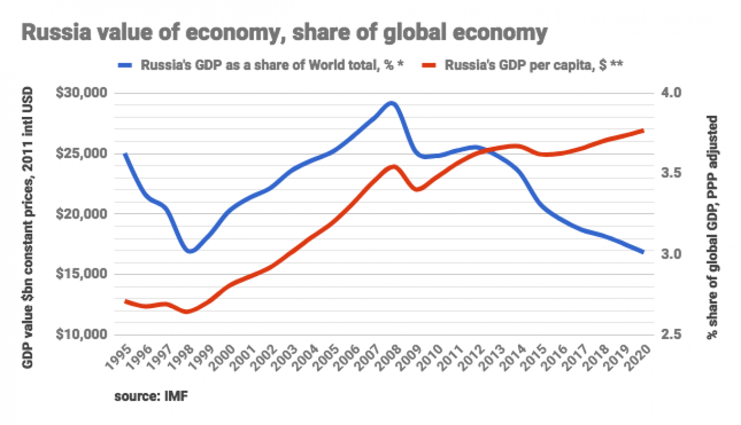(Aris, 2019)

According to the graph above, Russia’s GDP per capita has been steadily growing but has decreased in terms of GDP as a share of world total. This basically means that although Russia have been growing steadily over the years they have not grown as fast as other countries all over the world (Aris, 2019).

Since the collapse of the Soviet Union, Russia’s market has been transitioning from a planned economy towards a free market system. Even though moving towards a freer market-based system, Russia government constantly interferes with operations within many industries. Babas would have to keep this in mind when penetrating the market but should not be overly concerned as Interference in the food industry by the Russian government rarely occurs. In the 1990s, most industries were privatized except for commodities and services such as energy, national defense, transportation and banking. This is because the majority of profits gained by the country are from the production of oil and natural gases as well as natural minerals and steels like aluminum. Due to this the revenue generated by the country fluctuates according to the movement of prices of these commodities in the world market which involve booms and crashes making it extremely volatile (CIA, 2020).

Russia today are slightly more independent from their reliance on their export of their commodities as Russia slowly adopts a free market. This change should suit Babas as the market now prioritizes needs and demands of consumers rather than what the government allows.

Sociological

In an age where information can be accessed from everyday personal devices like handphones and laptops, people worldwide including those in Russia, have developed more health consciousness especially when in comes to their food intake (Afable, 2019). This health prioritization by people should be noted by Babas to ensure they produce their products based on the standards of health set by the consumers of the market.

Russians are also considered people that have a strong sense of pride in their culture and country and would assume adoption of other cultures or ethics from other countries to be unpatriotic. This is due to the immense levels of patriotism instilled by the government to their people during the reign of the Soviet Union (Friedman, 2020). As time passed by and with political reforms occurring over the years, as well as hosting a world renowned event such as the Football World Cup in 2018, Russia and its residents have slowly opened up to the world, accepting and more importantly embracing other cultures from other countries especially in terms of food and drinks (Smith, 2018).

It was found that in recent survey that craft beer had surpassed vodka as the most consumed alcohol in Russia, breaking the stereotype and showing change in consumers behavior in Russia (McCarthy, 2018) (Britannica, 2020). This also can be proved by the increase in Russians that now consume Asian delicacies and dishes as well (Ong, 2018). All these changes are beneficial for Babas as it means more people are more likely to accept, consume and venture into Asian cuisines. The only slight adjustments that should be made by Babas to its products are how spicy or how strong their spices are as Russians that usually consume milder spices and would most likely be overwhelmed if their food is too spicy (Golubeva, 2015).

Technological

Due to the fact that Babas is a sundry good supplier and would handle the production and packaging of their products in Malaysia would mean they would only need to worry about distribution to and within Russia. No serious competitive advantage could be achieved by having a technological edge over competitors in terms of distribution and production of Babas’ products and would currently seem to have no great effect on sales or market penetration. Any major technological breakthrough that occurs within Russia itself would also not affect the competitive stage for Babas. Babas would be using direct exporting that removes any external factors in terms of technology. Thus, the technological levels of Russia’s F&B industry have no relation to the chances of Babas penetrating Russia.

Legal

Russia has stuck with implementing protectionism ever since the falling out with Europe and America in 2014 which has led to a major decrease in growth since then. This policy gives power to local industries and companies giving them competitive advantages over foreign firms. This system usually belongs in countries that have a planned economy (Bloomberg, 2019). Today this protectionism is not overly enforced as Russia aims to attract foreign firms to provide a healthy competition in the market. Babas could use this window to penetrate the market before a high influx of investors arrive or if Russia reverse their attitude towards foreign companies.

Russia also has requirements such as permits and minimum capital and restriction that have to be acknowledged and agreed upon before being allowed to conduct business there. There are also various types of permissions given by the Russian Government to either conduct business, manufacture, hire or export goods (Stephens, 2018). It is of utmost importance that Babas, when conducting their direct exporting, appoint a suitable and capable agent that knows the norms of the system. This would not only assure Babas a legal approach to penetrate Russia but also reduce the workload and effort to get used to the new terms and conditions.

Environmental

Other than natural disasters or engagement in war, people will always demand for food and ingredients and will not affect the food industry. Just like technology, environmental factors will not be a concern for Babas as it does not affect the rate or performance of the business as the products will be directly exported to Russia. Only extreme environmental factors such as war, natural disasters, plague or a pandemic would hinder or stall Babas in conducting business in Russia.

Conclusion

In a nutshell, this report shows the steps that need to be taken by Babas and the responses towards the obstacles faced when trying to venture into Russia. The method of distribution would be direct exporting and appointing of agent(s) in Russia to represent Babas. The PESTLE analysis in this report explains the external factors in Russia that may affect business conducted by Babas as well as the methods to overcome them.

Recommendations
In short Babas should use the PESTLE analysis above to gain an advantage in penetrating the market by:-
- Direct Exporting products to Russia.
- Appoint a capable and experienced agent to represent Babas in Russia.
- Modify product by reducing the strength and intensity of the spices to cater to the local preference by trial and error.
- Abiding and closely following the law and foreign policies set by the government.
- Target populations such as St. Petersburg and Moscow that have a heavy influence of Asian cultures.

References

- Afable, M., 2019. Health-Conscious Consumers And The Demand For Holistic Nutrition. [online] Bold Business. Available at: <https://www.boldbusiness.com/health/health-conscious-consumers-demand-holistic-nutrition/> [Accessed 28 May 2020].
- Alén, L., 2017. Internationalization: Entering the Russian Market. [online] Available at: <https://www.theseus.fi/bitstream/handle/10024/125542/Alen_Linda.pdf?sequence=1> [Accessed 21 May 2020].
- Aris, B., 2019. Long Read: 20 Years Of Russia's Economy Under Putin, In Numbers - The Moscow Times. [online] The Moscow Times. Available at: <https://www.themoscowtimes.com/2019/08/19/long-read-russias-economy-under-putin-in-numbers-a66924> [Accessed 27 May 2020].
- Babas.com.my. 2020. BABAS Business - Our Business. [online] Available at: <https://www.babas.com.my/index.php/business/business#business-map> [Accessed 19 May 2020].
- Britannica, 2020. Russia - Post-Soviet Russia. [online] Encyclopedia Britannica. Available at: <https://www.britannica.com/place/Russia/Post-Soviet-Russia> [Accessed 28 May 2020].
- Bloomberg, 2019. Putin’S Costly Protectionism Experiment Is A Lesson For Trump - The Moscow Times. [online] The Moscow Times. Available at: <https://www.themoscowtimes.com/2019/10/02/putins-costly-protectionism-experiment-is-a-lesson-for-trump-a67561> [Accessed 28 May 2020].
- CIA, 2020. Field Listing :: Economy - Overview — The World Factbook - Central Intelligence Agency. [online] Cia.gov. Available at: <https://www.cia.gov/library/publications/the-world-factbook/fields/207.html> [Accessed 27 May 2020].
- Dentzel, Zaryn. "How the Internet Has Changed Everyday Life." In Ch@nge: 19 Key Essays on How the Internet Is Changing Our Lives. Madrid: BBVA, 2013.
- Friedman, M., 2020. Opinion | To Be A Russian. [online] Nytimes.com. Available at: <https://www.nytimes.com/interactive/2014/07/06/opinion/sunday/exposures-russian-patriots.html> [Accessed 28 May 2020].
- Golubeva, T., 2015. Why Russians Love Mayo, Sour Cream And Dill?. [online] Understand Russia. Available at: <https://understandrussia.com/mayo-sour-cream-and-dill/> [Accessed 28 May 2020].
- Jeewa, N., 2020. 8 Strategies To Enter A New Foreign Market. [online] Bubbles Translation Services. Available at: <https://www.bubblestranslation.com/8-strategies-to-enter-a-new-foreign-market/> [Accessed 20 May 2020].
- Korablinov, A., 2016. Russia, Malaysia Establish Business Council. [online] Rbth.com. Available at: <https://www.rbth.com/news/2016/03/16/russia-malaysia-establish-business-council_576091> [Accessed 21 May 2020].
- Luhn, A., 2015. 15 Years Of Vladimir Putin: 15 Ways He Has Changed Russia And The World. [online] the Guardian. Available at: <https://www.theguardian.com/world/2015/may/06/vladimir-putin-15-ways-he-changed-russia-world> [Accessed 21 May 2020].
- McCarthy, N., 2018. Russians Are Turning Their Backs On Vodka And Drinking More Beer [Infographic]. [online] Forbes. Available at: <https://www.forbes.com/sites/niallmccarthy/2018/10/26/russians-are-turning-their-backs-on-vodka-and-drinking-more-beer-infographic/#26ec111d3516> [Accessed 28 May 2020].
- Ong, J., 2018. From Peking Duck To Wok Hei Noodles, Russia’S Far-Flung Cities Warm To Asian Cuisine. [online] CNA. Available at: <https://www.channelnewsasia.com/news/world/peking-duck-wok-hei-noodles-russia-asian-food-cuisine-10526724> [Accessed 28 May 2020].
- Risbood, T., 2019. International Trade And Transport. 1st ed. OrangeBooks Publication.
- Schwab, K., 2019. The Global Competitiveness Report 2019. [online] Www3.weforum.org. Available at: <http://www3.weforum.org/docs/WEF_TheGlobalCompetitivenessReport2019.pdf> [Accessed 21 May 2020].
- Smith, R., 2020. The World Cup Changed Russia, But For How Long?. [online] Nytimes.com. Available at: <https://www.nytimes.com/2018/07/16/sports/world-cup/russia.html> [Accessed 19 May 2020].
- Stephens, M., 2018. Doing Business in Russia 2018. [online] Available at: <https://www.moore-global.com/MediaLibsAndFiles/media/MooreStephens/Documents/Doing%20business%20guides/DBI-Russia-2018_final.pdf> [Accessed 28 May 2020].
- Tradingeconomics.com. 2020. Russia GDP | 1988-2019 Data | 2020-2022 Forecast | Historical | Chart | News. [online] Available at: <https://tradingeconomics.com/russia/gdp> [Accessed 13 March 2020].
- Woodruff, J., 2019. Reason To Use SWOT & PESTLE Analysis. [online] Small Business - Chron.com. Available at: <https://smallbusiness.chron.com/reason-use-swot-pestle-analysis-40810.html> [Accessed 20 May 2020].
- Weeks, A., 2020. PESTLE Analysis | Factsheets | CIPD. [online] CIPD. Available at: <https://www.cipd.co.uk/knowledge/strategy/organisational-development/pestle-analysis-factsheet> [Accessed 20 May 2020].

