
ECES4004
Blog 1 – Emotional Development
Emotional Development is acknowledging and conveying one’s feelings and identifying one’s unique nature. The process of obtaining effective emotional development means an individual can handle pressure, can show compassion and is self-assured (Greenway, 2014).
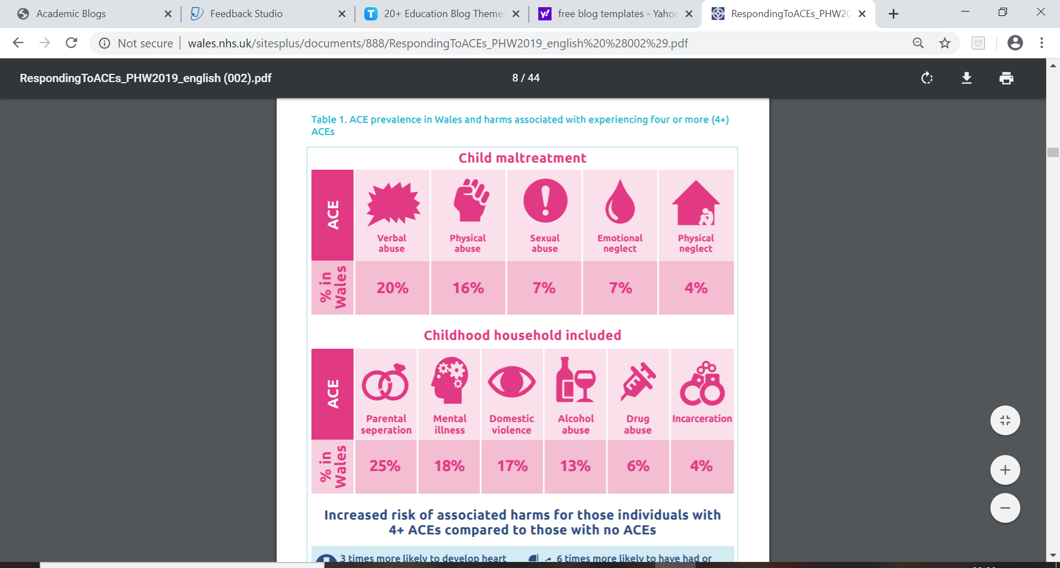
Stress can uphold a negative effect on a child’s emotional development. There are differing types of stress, positive stress and toxic stress. Positive stress includes meeting new people and studying for a test, which ensures children are prepared for future challenges. Toxic stress is bad for a child’s brain development, if a child is continually exposed to parental addiction, abuse and neglect it will cause basic structures in a child’s evolving brain to become damaged. Some children lack a healthy foundation, without this in place to support future development the child’s development will be delayed. The child is also at high risk of suffering with health problems, development issues and in some instance’s addiction in later life. It is possible to undo the damage of toxic brain structure. But it is far simpler and more cost effective to ensure there are sturdy foundations in one’s life to begin with. (NSPCC, 2017). Adverse Childhood Experiences (ACEs) are distressing experiences in early childhood that uphold an impact on the rest of the child’s life. Growing up with extreme adversities such as abuse, neglect and witnessing parental addiction is a public health concern in Wales and universally. Improvements have been made and continue to be made to identify the difficulty faced by those who have and continue to suffer with ACE’s. The Welsh Government aim to improve the lives of individuals who have been affected by ACE’s. Responding to Adverse Childhood Experiences (Public Health Wales, 2019).

Secure attachment is vital to build a relationship between the primary caregiver and the child. It is a crucial relationship as it aids a child’s brain function and their social milieu, it determines the way they develop socially, emotionally, academically and physically. Secure attachment provides your infant with a positive structure for life; it provides them with a willingness to be educated, a strong sense of self – awareness and it aids them in being thoughtful towards others. Moreover, an insecure attachment would uphold a negative effect on an infant’s development. If their welfare and education is not at the forefront of their caregiver’s mind, these children may develop chaotically and have difficulties learning and communicating effectively with their peers. Building a Secure Attachment Bond with Your Baby (Help Guide, 2019).
Attachment does not need to be equal; the attachment may have an unequal weighting towards one side. Attachment can be described by specific behaviours in children. For example, requesting closeness to their attachment figure when in a distressing or uncomfortable situation Bowlby, 1969. Attachment theory explores the connection between a parent and their child and how a positive relationship between a parent and child led to positive child development. Attachment is a “lasting psychological connectedness between human beings” (Bowlby, 1969 https://www.simplypsychology.org/attachment.html#stages).
Emotional abuse can uphold a large impact on a child’s emotional development. These factors can have a negative impact in the following ways.
- “Feeling, expressing and controlling emotions
- Lacking confidence or causing anger problems.
- Finding it difficult to make and maintain healthy relationships later in life.”
(NSPCC, 2019 https://www.nspcc.org.uk/what-is-child-abuse/types-of-abuse/emotional-abuse/).
Depression is prevalent with individuals who have endured emotional abuse in their childhood, in comparison to individuals who experienced different forms of child abuse. Always look out for how a child is acting and responding to events, there may be hidden messages in their actions.
As children grow their emotions are not always easy to determine, but it is always best practise to ask for support and guidance if you are alarmed by a child’s behaviour and fear they may be under threat of any form of abuse. For example, physical or emotional abuse or neglect. There are a variety of warning signs that indicate that a child is subject to emotional abuse. These signs are not always clear but the National Society for Prevention of Cruelty to Children more commonly known as the NSPCC have stated the following factors as a guideline.
- Children may lack confidence or self – assurance.
- Find it difficult to control their feelings.
- Find it challenging to create and keep friendships.
- Act in a way that is unsuitable for their age. For example, acting in a childish manner.
Signs of emotional abuse (NSPCC, 2019).
Socio-emotional development allows gifted children to be more readily able to deal with and effectively handle personal and social challenges. There is a historical background that acknowledges gifted children are more able to deal with challenges that may arise. This is not due to their sole intellectual ability but also their physical and mental wellness, displaying more emotional strength and displaying that high IQ leads a gifted individual to achieve highly throughout life. (Neihart, Pfeiffer, & Cross, 2015; Neihart & Yeo, 2018).
To conclude it is important that children have a supportive home environment for their mental health to be good. If a child has a positive home environment and is therefore secularly attached to their parent’s, they will be more emotionally available to learn.
Blog 2 – Physical Development
Typically, after the first two months of a baby’s life they learn how to not rely fully on adults around them. If a baby displays with a floppy head after two-months old this may be a warning sign of a neurological condition.
A baby will display their developing reflexes, these are displayed through attempting “stepping, walking, crawling, climbing and swimming movements”. These tasks cannot be completed effectively at such a young age, but such actions seem to be conditioned into the human brain in order to aid development. For example, a young baby when placed under water will instinctively breath.
Between three and six months a baby becomes much stronger and becomes more aware of their surroundings. They have developed the ability to track objects with their eyes, the baby appears to hold up their head more without aid. Between four and six months old a baby can roll over, reach for items and hold them using a palmar grasp. The palmar grasp includes a baby using their entire hand and placing it around an object that is placed up against their palm. The palmer grip differs to the pincer grip in which a child must be more developed to ascertain the knowledge to use the pincer grip. If supported the baby has gained the ability to sit up. Some teeth may have developed by this stage indicating that weaning a child onto solid foods is due to happen. Between four and six months a child usually will enjoy moving and kicking. This is positive indication that a child is developing at the correct rate and they are on track to achieve milestones at an average rate.
Between the ages of seven months and one year the child can sit unaided, they continue to grow inquisitive to the world around them. They begin to crawl and with support can bring themselves up to a standing position. Balance, skill and strength are only beginning to develop. Therefore, if a parent supports a baby when standing up and then releases this support the child will fall. At this age the pincer grip is developed. The pincer grip means a child can hold objects with their fingers and thumb. This is a more complex sensory motor action in comparison to the palmar grasp, the pincer grip demonstrates the first example of fine motor skills.
Typically, when a child is aged twelve months, they will begin to show signs of walking unaided. Woodfield (2004) was a good source of information.
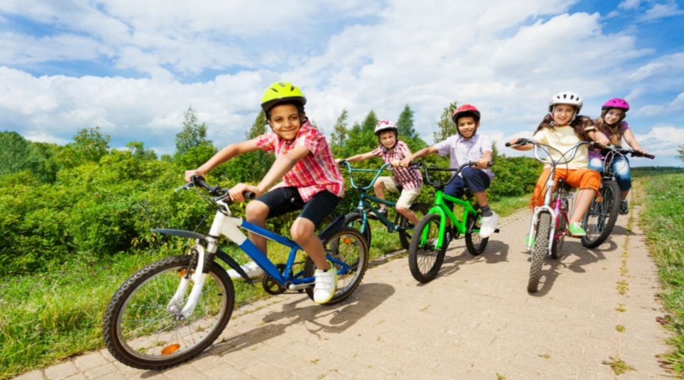
We use fine motor skills to make small movements, they involve the combined efforts of the brain and muscles acting in unison, to allow a child to complete activities such as writing, drawing and using scissors. Fine motor skills rely on an individual’s effective use of gross motor skills; we use gross motor skills to do essential tasks that require the use of large muscle groups. Gross motor skills are affected by the following things: balance, coordination, physical strength and reaction time. Examples of milestones that are met using these skills is a child aged three to four can jump with two feet and a child aged between seven and eight generally can ride a bike without stabilisers. Gross Motor Skills vs Fine Motor Skills: What’s the Difference? (Understood, 2017).

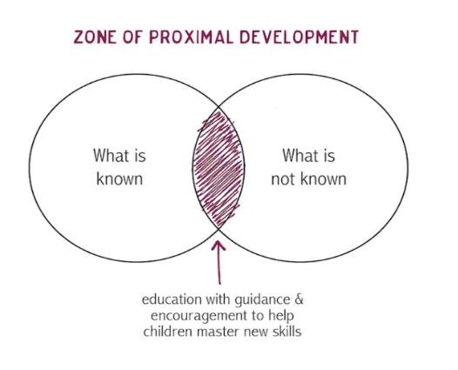
The zone of proximal development is a theory which refers to what a child can achieve currently, what a child can do without help and what they can do with guidance from a supportive individual, perhaps a childcare practitioner or a parent. The term “proximal” indicates the skills that the learner has nearly obtained. Vygotsky’s definition of proximal development is
the distance between the actual developmental level as determined by independent problem solving and the level of potential development as determined through problem-solving under adult guidance, or in collaboration with more capable peers (Vygotsky, 1978 https://www.simplypsychology.org/Zone-of-Proximal-Development.html).

According to Vygotsky (1978) social interaction is vital for a child’s development important educational opportunities take place through interaction. The practitioner might model certain behaviours and give the child verbal instructions. Vygotsky states that this is cooperative or collaborative dialogue. Typically, children mirror behaviour that has been portrayed to them by their parent or practitioner. This is an informal way of a parent or practitioner monitoring a child’s academic and physical improvement. (McLeod, 2019).
The zone of proximal development is synonymous with scaffolding. Scaffolding is a method “that enables a child or novice to solve a task or achieve a goal that would be beyond his unassisted efforts." (Wood, Bruner and Ross, 1976 https://www.simplypsychology.org/Zone-of-Proximal-Development.html).
To conclude, a child develops in stages and is assessed to see if they are meeting their recommended development stages. It is vital for health visitors and parents to ensure the child is meeting these points, so that a child is not delayed in their development. Often when a child reaches education their greatest barrier is self-belief.
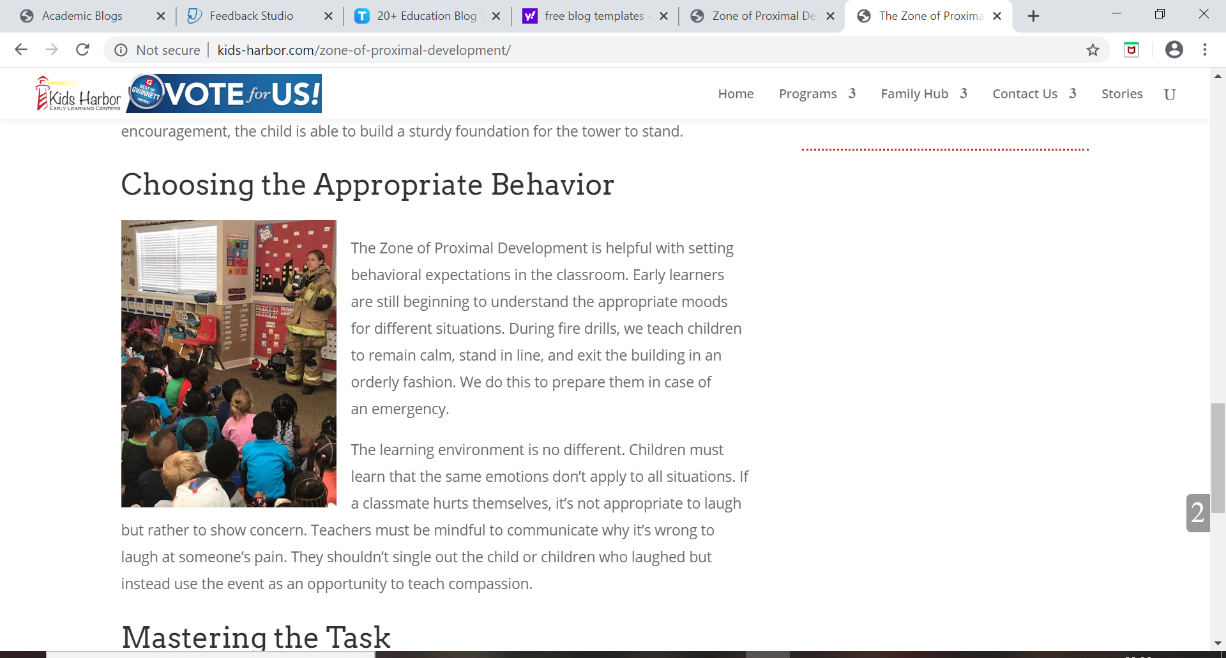
Topic 3 - Brain Development
“Education is the great engine of personal development” (Mandela, 1995).
There are activities that are conducted by adults daily that aid a child’s brain development. Different sections of the brain develop in different aspects of a child’s life. The lower section of the brain is improved through basic life – support, whether this be a supportive family network or supportive peers. Mid – brain controls motor functions, impulses and strong emotions all of which are vital parts of a child’s life. The higher brain controls social, emotional and cognitive function emotional wellbeing is vital for an individual’s mental health. Social skills are important to ensure that a child can function within society efficiently and cognitive function allows children to become educated. The right hemisphere of an individual’s brain is social, emotional, intuitive and unconscious. The left hemisphere is cognitive, rational, language and an individual’s conscious.
In challenging situations different parts of an individual’s brain shut down or reduce their efficiency. People may state that they become more unproductive during this time. For example, we are currently experiencing the coronavirus pandemic which is an unprecedented event which has the whole nation on high alert and has the future looking bleak. During difficult times you may hear the phrase “surviving not thriving” this simply states there is a lot of new information having to be processed and this can be overwhelming to individuals. Particularly to those who have pre-existing mental health difficulties. A stressful situation may temporarily stop the brain from developing. The lower brain is the section which either reacts in a fight or flight mode when it is presented with a threatening situation. Alternatively, the lower brain can cause an individual to freeze through fear. The upper brain is responsible for aggression, absence and appeasement.
When an individual feels threatened by a situation their lower brain will release adrenalin and cortisol. Your body will react in the following ways when it feels that you are in a threatening or harmful situation. You will endure rising blood pressure; you will experience shallow breathing and have increased muscle tension.
When an individual feels they are in a safe situation their upper brain will then take over from their lower brain. The following will return to full function.
- Oxytocin, dopamine
- Lowering blood pressure
- Deeper breathing
- Reduced muscle tension.
The brain is evolving and developing until an individual is twenty-five years old. If babies are born into a highly stressful home, they may have more increased levels of cortisol from birth. Cortisol negatively impacts brain development and the function of an individual’s brain.
The following five steps can be taken in order to maximise oxytocin these steps are known as ‘5 to Thrive’.
- Respond
- Engage/cuddle
- Relax
- Play
- Talk.
Responding and reviewing a child’s needs is vital to aid their brain development and allows you to acknowledge when a child needs to be educated or nurtured. Responding only occurs when the child’s caregiver is emotionally available to the child and realises when the child requires their attention. The swift response from an adult ensures the child feels at ease and as a result it aids the child’s brain function.
Engaging or displaying affection to a child allows their nervous system to be calmed, as without this their brain function cannot reach fully capacity. If a child is securely attached to their caregiver their nervous system will match that of their caregiver.
Relaxing allows a child to regulate their stress, once a child is securely attached, they will mirror the actions of their caregiver. If their caregiver adopts a state of relaxation the child will imitate this. This allows children to establish self-regulation which builds brain patterns.
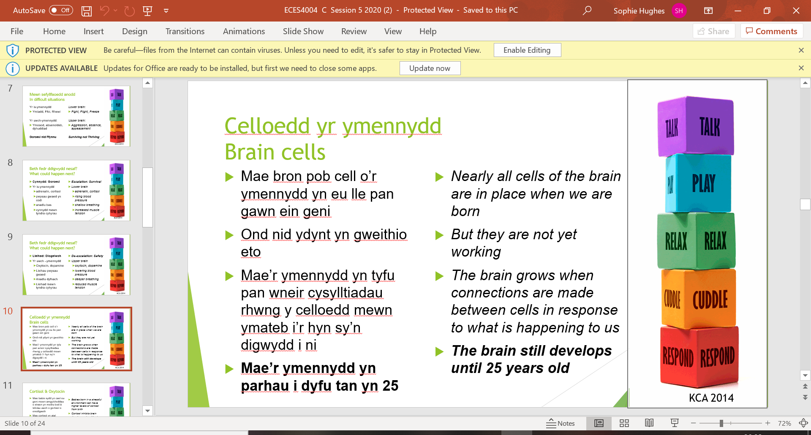
Play is vital in a child’s development because when children engage in play it activates the right brain. Play develops brain pattern and allows children to develop communication skills with their peers through play. It allows children to process emotional and social experiences.
Talking activates, the left side of the brain, it creates a narrative. The left side of the brain is used to establish what is being said within a sentence.
The key to optimal brain function is the regulation of stress hormones, as our brain works best when we feel safe. (KCA, 2014)
When an embryo is only 8 weeks old the basic structure of a brain and never system is already in place. At birth all 100 billion neurons of the human brain is already set in place, however the brain is still in proportion to the rest of the child’s body. Therefore, the brain only weighs twenty five percent of the size it will be when it reaches capacity. At aged six the brain is ninety percent of the size it will be as an adult. Major milestones that a baby reaches in relation to their brain function are as follows. At two months old a baby gains the capacity to smile, a one year will begin to talk although they will ‘babble’ before this stage. Lastly, at three years old a child will begin to dress themselves. Individuals will gain knowledge and will quickly learn whether they are doing something correctly. For example, if a child dresses themselves and an item of clothing is on the wrong way around which is common for children who are learning; they will understand their mistakes and will being to do the activity correctly.
Piaget stated that children are born with a very basic mental structure, which is hereditary and evolves with life experience, all education and understanding are based off this factor. Piaget suggested there are four stages of cognitive development which explore how children’s brains become more sophisticated with knowledge through their years of learning.
- Sensorimotor stage is from birth until aged two.
- Preoperational stage is from age two until seven.
- Concrete operational stage is from aged seven until eleven.
- Formal operational stage is from age eleven until adulthood.
(McLeod, 2019).
Every child experiences all stages of development in the order listed above. “Child development is determined by biological maturation and interaction with the environment”. (McLeod, 2019 https://www.simplypsychology.org/piaget.html#stages).
In conclusion, brain development can be impacted by a variety of factors. Stress can uphold a large impact on an individual’s ability to function successfully. The lower brain is improved through support by family members or supportive peers. Mid brain controls impulses and strong reactions. Whilst higher brain controls social, emotional and cognitive function. All the following factors are vital for healthy brain development.
Topic 4 – Development Delays
How children play displays a lot about a child’s cognitive function and their development in comparison of development of their peers. Typically, children with autism are not as able as their peers to display efficient playing skills. There was a study conducted of pre-school children where thirty-five children with autism were compared to thirty-eight children with different development delays. One of the tests conducted was how good their communication skills were. All children were able to say twenty different words. Children from both groups were developing at a very similar rate. Children who have autism engage in more conventional forms of play; this includes putting objects together according to how the toys were constructed. The results suggested there were significant connections between play, language and cognitive measures and the development of a child. Observing a child through play may allow a childcare practitioner to begin to understand additional aspects of a child’s development.
At around eighteen months until twenty-four months children begin to use pretend play also known as symbolic play. During symbolic play children interpret objects as something that they cannot be for instance interpreting a block as a car. Before the advancement of symbolic play children participate in practical play. How a child plays with a toy reflects largely on their development and their emotional and mental advancement. It is vital to assess children who present characteristics of autism and other development disorders, as it may present insight into underlying issues that are not obvious through formal cognitive and language assessments. Part of the diagnosis with some children is columnated during their playtime. (Bourque, Brady and Fleming, 2011).
Sigman and Rusking (1999) through research stated that children with autism engaged in less varied symbolic play in comparison to children with down syndrome or development disorders. Children with autism engage less in functional play acts and have shorter play sequences.
Symbolic play has often been linked to language development in children with autism and other development disorders. Generally, developing toddlers gaining the ability to use words participate in more symbolic play than their peers who cannot use words. Eisert and Lamorey (1996) reported significant relationships between play and language development, with developmental level a stronger predictor of play level than chronological age.
According to Maslow’s Hierarchy of Needs the following factors are needed within an individual’s life, for them to achieve personal and academic success. Needs lower down in the hierarchy must be achieved before an individual can move onto the following phase. In order from the most prevalent need to the least is physiological, safety, love and beginning, esteem and self – actualization.

Maslow’s Hierarchy of Needs

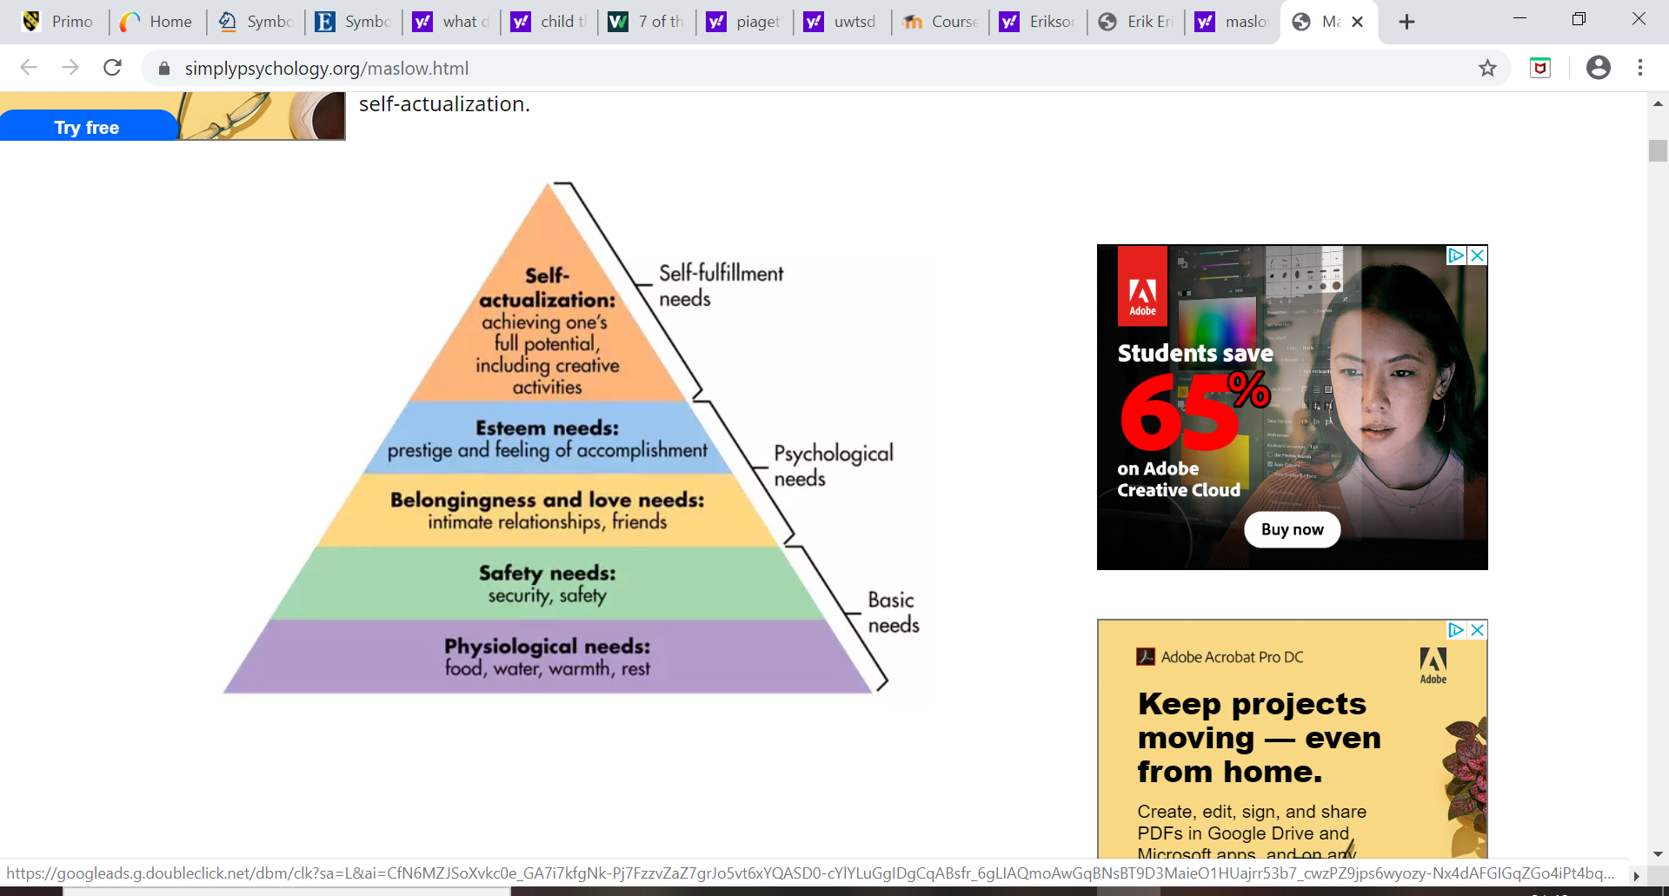
Maslow’s five stage model can be placed into deficiency demands and development needs. The first four levels are described as deficiency needs and the top tier self – actualization is known as growth or being needs. When a deficit need has mostly been met then it’s relevance will decrease as an individual sets their mind on achieving the next task. However, although an individual is working towards meeting the next need the previous needs are still valued, as without the needs lower in the hierarchy it is difficult to successfully progress.
Without Maslow’s hierarchy of needs a child may suffer with development delays as they are not in a situation where they can prosper. Although autism and developmental delays are in no way caused by a lack of basic, psychological or self – fulfilment needs, by lacking in any of these it will only perpetuate the situation (McLeod, 2020).
In conclusion, development delays can cause barriers to a child succeeding academically and personally. A way to identify development delays is through play, language and cognitive assessments. These are useful in establishing if a child is suffering with development delays and when possible counteracting them.

Reference List
- (Bourque K. Brady N. and Fleming K. (2011) Symbolic Play of Pre-schoolers with Severe Communication Impairments with Autism and Other Developmental Delays Available at: https://login.ezproxy.uwtsd.ac.uk/login?url=https://link.springer.com/article/10.1007/s10803-011-1317-7
(Accessed: 28 April 2020).
- Eisert and Lamorey (1996) The Relationship Between Play and other Development Delays. Available at: https://eric.ed.gov/?id=EJ528172 (Accessed: 27 April 2020).
- Greenway, C. (2014) Applications of Psychology in the Classroom. UWTSD: unpublished. (Accessed: 21 April 2020).
- Help Guide (2019) Secure Attachment Bond. Available at: https://www.helpguide.org/articles/parenting-family/building-a-secure-attachment-bond-with-your-baby.htm (Accessed: 22 April 2020).
- Kate Cairns Associates (2014) Five to Thrive: The things you can do every day that help your child’s growing brain. Children in Wales; Cardiff. (Accessed: 26 April 2020).
- Mandela (1995) Education in Rural South Africa, in Brown. M & White, J. (eds) (2014) Exploring Childhood in a Comparative Context. Oxon: Routledge, p.165. (Accessed: 25 April 2020).
- McLeod S. (2019) The Zone of Proximal Development and Scaffolding. Available at:https://www.simplypsychology.org/Zone-of-Proximal-Development.html (Accessed: 25 April 2020).
- McLeod S. (2020) Maslow’s Hierarchy of Needs. Available at: https://www.simplypsychology.org/maslow.html (Accessed: 28 April 2020).
- Neihart et al. (2018) Socio – Emotional Development. Available at: http://static.dergipark.org.tr:8080/article-download/ddff/2874/4c97/5e498bd38898f.pdf (Accessed: 23 April 2020).
- NSPCC (2017) How a child’s brain develops through early experiences [video]. Available at: https://www.youtube.com/watch?v=hMyDFYSkZSU (Accessed: 21 April 2020).
11.NSPCC (2019) Emotional Abuse. Available at: https://www.nspcc.org.uk/what-is-child-abuse/types-of-abuse/emotional-abuse/ (Accessed: 22: April 2020).
12. Physical Development Image. Available at: https://www.muhealth.org/our-stories/helmet-safety-tips (Accessed: 28 April 2020).
13.Public Health Wales (2019) Adverse Childhood Experiences. Available at: http://www.wales.nhs.uk/sitesplus/documents/888/RespondingToACEs_PHW2019_english%20%28002%29.pdf (Accessed: 21 April 2020).
14.Sigman, M. and Rusking, E. (1999) Continuity and change in the social competence of children with autism, down syndrome and developmental delays. Available at: https://psycnet.apa.org/record/1999-13607-001 (Accessed: 27 April 2020).
15.Understood (2017) Gross Motor Skills vs Fine Motor Skills: What’s the Difference? [video] Available at: https://www.youtube.com/watch?time_continue=11&v=l93BTYyHG0c&feature=emb_logo (Accessed: 23 April 2020).
16. Woodfield L. (2004) Physical Development Available at: https://www-dawsonera-com.ezproxy.uwtsd.ac.uk/readonline/9781441114631 (Accessed: 23 April 2020).
17. Zone of Proximal Development Image. Available at: http://www.kids-harbor.com/zone-of-proximal-development/ (Accessed: 28 April 2020)

