

MODULE NAME: EMPLOYABILITY AND CAREER DEVELOPMENT
MODULE CODE: LCLM4005_LON
LECTURER: SUKHPREET GREWAL
STUDENT NAME: JOSEPHINE C. CAITOM
STUDENT ID: 2509335

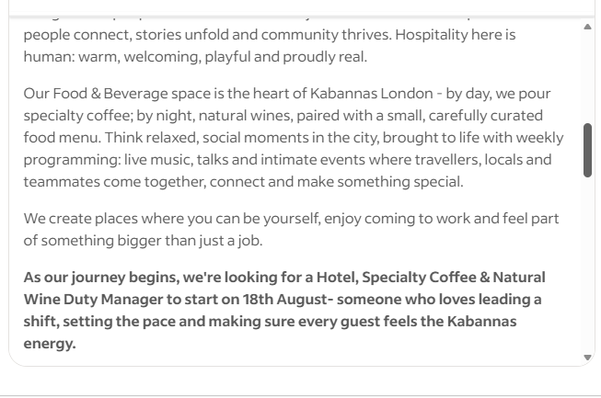
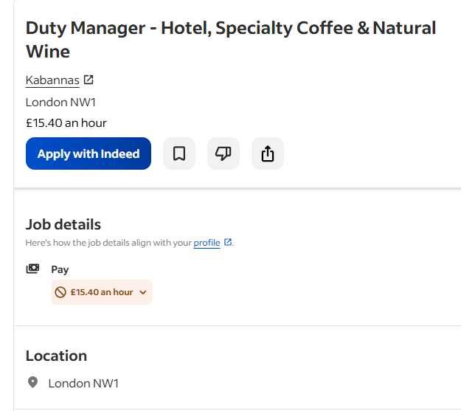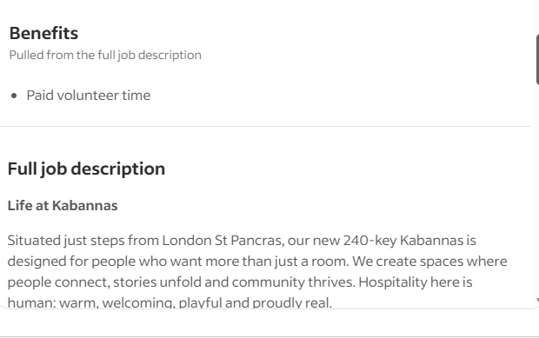
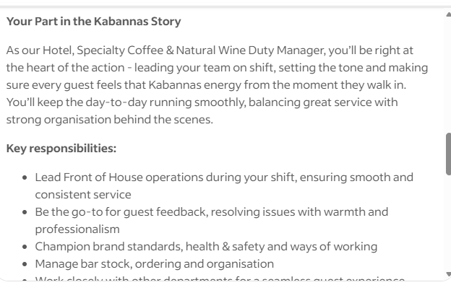
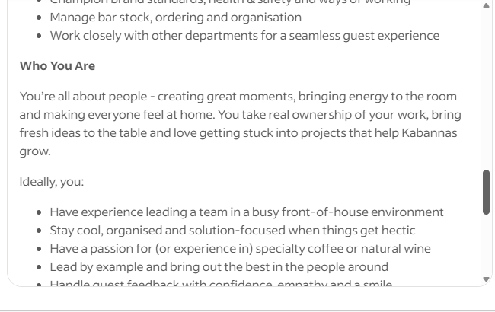
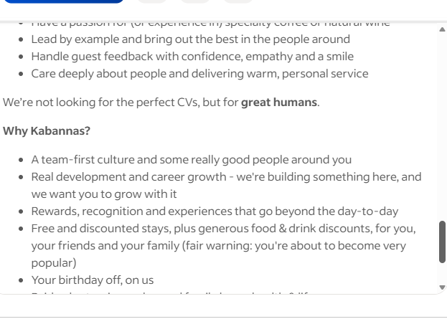

Josephine C. Caitom
2509335@student.uwtsd.ac.
Kabannas Hotel Specialty Coffee & Natural Wine
St. Pancreas London NW1
20th, July 2026
Dear Hiring manager,

I wish to apply for the role of Duty Manager at Kabannas Hotel that currently being advertised on Indeed UK. Please find my enclosed CV for your consideration.
As you can see from my attached CV, I have over 12+ years experienced in Hospitality and a private service in Hotel and Food Industry.
I believe I have built a strong Foundation in both operational Leadership and guest focused service- and I am excited to bring that combination in your company; Applying these skills and knowledge make me the right/perfect candidate for the role.
In my current role as a Private chef at Mountport Ltd. I am responsible to manage all aspect from menu planning that meet their dietary specific requirements, and directly resolving concerns, and adapting service to individual needs. This role requires strong organization skills to meet the deadline and stay effective. Scheduling independently and demonstrating strong organization and Leadership.
In my earlier role as a brand ambassador engaging customers and driving sales. I delivered consistently my positivity and make sound judgment in terms of resolving customer inquiry.
All of this, coupled with my enthusiasm and dedication, my strong Leadership, customer service, and stock management skills have helped consistently deliver high standard of service, build loyal client relationship, and manage teams effectively under pressure.
I am confident that I can bring this level of success with me to your organisation and help build upon their reputation as Micro-Accommodation Focus and capture more attention both tourist and group/ additional booking. With my previous experienced and expertise, I believe my contribution will have deliver a positive value to the company.

Thank you for taking the time to consider my application. I look forward to the opportunity to discuss my application further and how I can contribute my valuable experiences to Kabannas team.

Yours faithfully,
Josephine C. Caitom
Josephine Catalan Caitom
University of Wales Trinity St. David- London Campus
2509335@student.uwtsd.ac.uk | www.linkedin.com/in/josephine-c-caitom-866010408
PROFILE
Driven and ambitious professional with over 12+ years of experienced in hospitality, private chef services, personal assistant and in retail industry as brand ambassador, Confident leading teams, managing stock and operations, and creating warm, memorable moments for guest - well suited to a Duty Manager role in Kabannas spanning hotel, specialty coffee and natural wine service.
EDUCATION & QUALIFICATIONS
University Wales of Trinity St. David BA in Leadership and Management (First year) Aug.2026
- Academic, Digital Research, Teamworking &Effective communication, Problem Solving & Decision Making.
British Academy of Culinary Nutrition (in progress). Sept.2024
- Knowledge of fundamental science in Nutrition.
University of Kent (Online) Apr.2022
- Communicating effectively with Vulnerable young people Explored communication with vulnerable children
University Mindanao (Philippines) - Associate of Hotel & Restaurant Management Oct.2002/2004
- Obtaining this qualification strengthens my career by giving me structured operational knowledge.
- Introduction of Accounting, Balance sheet
Maragusan National High School 1995-96
- Secondary Education
WORK EXPERIENCE
Volunteer/Customer Relation officer / Cancer Research UK May 2026 to Present
Non- profit organization or business.
- Supported Cancer Research UK by promoting event tickets and encouraging public donations to fund patient care and research and working in the Till.
- Demonstrated a full understanding of the Donor Sign-up procedures for Cancer Research UK.
Private Chef/ Catering In-charge/ Mountport Ltd. Jan 2023 to Present
A Private family company that caters client weekly meeting.
- Responsible from menu planning and food ordering to service and client relations.
- Collaborated with the team to define plan and met operational targets, and the dietary requirements
- Coordinated catering logistic for the team across meeting and shoot days and hosting dinner event.
PA/ Cook | Amimed Direct Ltd. Jan 2018 to Dec 2023
Pharmaceutical/ Supplier
- Acted as firsts point of contact for client request, resolving issues promptly and professionally.
- Worked closely with front-of- house and management to ensure a seamless guest experience.
Cook/ Housekeeping / DANNY UNGAR May 2009-2017
- Baking and general household operation.
Brand ambassador/ PUMA SHOES Jan 2006 to Jan 2008
- Represent Puma brand at events and retail activations by engaging customers to meet monthly sales target.
- Delivered consistently energetic, on brand guest interaction in fast paced environment
- Strengthened my social and commercial awareness and become the competent brand ambassador
Ground handling leader for catering/Maria Clara Restaurant Nov.2004-2005
- Manages the ground operation, ensuring the client vision were meet.
- Menu designing to final input for the event program.
KEY SKILLS AND TRAINING
Training – AI Certificate (COURSIV)
- Build a solid knowledge of AI concepts, tools, and responsible use standards. I also develop practical skills like using AI system, analysing results, and applying them to solve real problems. Additionally, I gain the ability to evaluate AI outputs, adapt to new technologies, and make ethical decisions. [2026],
De-Escalating Conversations for Customer Services
- Learn these skills from LinkedIn Learning has a positive impact for personal and social skills. Having ability to manage customers emotion and able to acknowledge quickly and can set a realistic expectation- keep frustration low. [2026],
Looking into-Mirror: Using Self- Awareness to Excel at Work.
- Learned these top skills like Self- awareness and Emotional intelligence help me to be aware my own energy and strength. I consistently deliver the friendly and professional image. (2026)
Certificate a completion of Training for Sign-up Donors for Cancer Research
- Commercial awareness is the top skills I learned this training. (2026)
Technical skills
- Digital & AI Literacy & Office 365

INTEREST
- Learning, and personal development
LANGUAGES
- English and Tagalog

REFERRENCES
Available upon request

