

BA (Hons) Leadership and Management Skills for the Workplace
Module: Developing Innovation and Creativity for Business Advantage
Module Code: BMSW6102
Assignment Title: Development of innovative product or
unique service proposition (Report)
Student Name: Ionut Razvan Gradinaru
Student ID:1906093
Year: 2022-2023
Executive Summary
The report has reflected the development of a new innovative product range of Robot Vacuum along with the proposal of a new online retail business. A detailed description of the innovative product of RoVac Jam has been covered in this paper. This chapter also has highlighted the sustainable intention of the innovative business proposition along with the new innovative product. The competition between RoVac Jam along with its competitors based on differentiated product range has been evaluated in this chapter. The next chapter has also considered the proposal of building an eCommerce website for RoVac Jam by using SaaS, content development, the Amazon marketplace, and payment services like PayPal. The overall marketing procedures of RoVac Jam along with target customers and the role of customer journeys have been elaborated on in this paper. The awareness consent of the UK GDPR and PECR for the company has been illustrated in the next chapter. The importance of data protection and privacy along with cloud security for RoVac Jam has been evaluated in this paper. The conclusion has summarised all essential findings and analyses of the report.

Table of Contents
1. Introduction 4
2. Identification of the new venture 4
2.1 Background of the innovative product and its USP 4
2.2 Customer segmentation 6
2.3 Product selling strategy 7
2.4 Strategies to sustain the innovative business proportion 8
2.5 Competitor analysis 9
3. Setting up an eCommerce website 10
3.1 Utilising SaaS 10
Benefits of implementing SaaS for RoVac Jam 11
3.2 Utilising a marketplace 12
Benefits of adopting a marketplace 12
3.3 Developing content 13
Benefits of developing content for RoVac Jam 13
3.4 Utilising payment services 13
Benefits of using payment services for RoVac Jam 14
4. Marketing activities 15
4.1 Promoting Robot Vacuum by RoVac Jam 15
5. Privacy and data protection considerations of the business 19
5.1 Awareness of GDPR/Data Protection Act 2018 19
5.2 Privacy and Electronic Communication Regulations (PECR) 20
5.3 Security and its importance 21
6. Conclusion 22
References 23

1. Introduction
Innovation refers to a process by which the idea of new products or services is brought up based on current trends by a business company. In other words, innovation means introducing and developing new technology as well as establishing new ideas in the market to produce new value. The aim of the report is to understand the development of an innovative product idea by a proposed online retail business. The report will describe a brief overview of the proposed innovative product Robot Vacuum along with its target customers. The paper will also cover the method of selling the innovative product by the new venture along with its target market. The sustainability of the innovative product proposition will be illustrated in this paper. The competitive market of the innovative product will be discovered in this report. Furthermore, the proposal of setting up an online website for the new venture by using a marketplace, SaaS, content and payment services will be described. The market procedure for promoting the new product along with identifying the target customers of the new venture will be explained. Additionally, understanding the value of customer journeys along with paid search engines, email marketing and social media marketing of the new venture will be highlighted. Besides this, the data protection and privacy of the new online business will be evaluated in this report. Furthermore, encrypted traffic, default access sensitivity, and secure access of the cloud provider of the new business will be explored in this paper in an appropriate manner.

2. Identification of the new venture

2.1 Background of the innovative product and its USP
Technical advancement in the UK is very high s it is creating new advanced business ideas. According to Yapici et al., (2022), due to high inflation, the overall cost of a business is increased. Electricity and gas supply cost has also increased for the companies. Currently, entrepreneurs and new business owners are trying to set up eCommerce businesses to reduce extra operational costs. RoVac Jam is a new online tech retailer which will sell Robot Vacuums through its website. The automatic vacuum cleaner market is increasing in the UK and EU regions. There are different robotic vacuum cleaners in the market such as floor vacuum cleaners, pool vacuum cleaners, window vacuum cleaners and others. Some of them are self-driven and others are remote-controlled (Eureka Forbes, 2022). The market size of robot vacuums was £1265.7 million in 2021 which is expected to increase to £2597.13 million by 2029 (PRNewswire, 2021). According to reports, it will become one of the most demanded home gadgets in the near future.
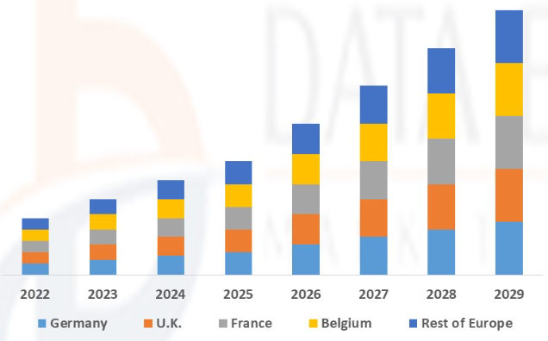
Figure 1: Robotic vacuum cleaner market in the UK and other countries
(Source: PRNewswire, 2021)
RoVac Jam will enter the market with floor-cleaning and window-cleaning vacuums and in the near future it will increase its product line. This company will use automated technology in vacuum cleaners. The USPs of this robot vacuum are the smart sensors and compact design (Eureka Forbes, 2022). There will be automated sensors in vacuum robots which will help to recognise the cleaning parts and avoid collision against any obstacles. Similarly, the overall design of the robotic vacuum will be very compact as it can easily reach any corner of the room. RoVac Jam will add different features to its vacuum cleaners such as spot cleaning mode, wet and dry-cleaning function, long battery life and remote-control sensors. The products will be available in different battery capacities as large floors require more battery capacity than mid-sized households. Robotic vacuums with 2600 mAh batteries can run up to 90 minutes constant which is efficient for cleaning a medium-sized house (Eureka Forbes, 2022). On the other hand, vacuums with 3200 mAh batteries can run up to 180 minutes which is appropriate for large households and corporate floors (Eureka Forbes, 2022). There will be also an auto battery-charging feature in every robot vacuum. The overall price range for floor vacuum cleaners will be £400- £690. Similarly, window vacuum cleaners will start from £250 onwards.

2.2 Customer segmentation
RoVac Jam will make marketing activities in UK households and small corporate businesses as its target customer. Currently, this company will only sell its products inside the UK region but based on its sales growth it will increase its market in the EU and USA countries. The robot vacuums of RoVac Jam are pet-friendly and child safe. Parents, pet owners and working professionals are the target customers of this company. As per the view of Nicholls et al., (2019), elderly people with various physical divisibility also can use robotic vacuums easily. This company will also target middle to high-income households as robotic vacuums are more affordable enough than its competitors. The living standard in the UK is rapidly increasing and people are preferring to use smart home appliances. According to reports, the demand for automated home gadgets increased by 56% in the last five years only in the UK (Blusynergy, 2023). The trend followers and tech-savvy population of the UK prefer to use robotic vacuums. Working professionals and parents prefer to use this product instead of traditional vacuums as these are a time saver for their busy lifestyle. A brief customer segmentation table for RoVac Jam is provided below.
Geographical | Demographical | Physiographic
- Country: UK  - Region: Urban and semi-urban areas  - Households and commercial places. | - Age: 25-65 years old  - Gender: Men and women.  - Income: Medium to high-income households. | - Social class: Middle to high-standard people.  - Social status: Parents, corporate professionals, young adults, elderly people with disabilities and company owners.  - Lifestyle: Trend followers, minimalist and tech-savvy.  - Personality: Busy homeowners, career-driven youngsters.  - Preferences: User-friendly, pet-friendly, safe for children and easy to carry.  - Usage rate: Daily usage.
Table 1: customer segmentation for RoVac Jam
(Source: Author)

2.3 Product selling strategy
RoVac Jam will establish itself as an eCommerce business in the UK which will sell its products through its website. Apart from that, the robotic vacuums of this company will be also available in global online marketplaces such as Amazon. Using the Amazon marketplace will increase the brand awareness of this company and also reach the UK consumer base easily (PRNewswire, 2021). The company can create a listing of its product based on pricing and usage. Apparently, RoVac Jam also can track its sales and inventory through this. Creating a seller account and identifying items as well as weird pricing is important in the Amazon marketplace. The company will use SaaS to monitor eCommerce activities in business platforms such as Shopify. RoVac Jam will create its online store on this platform as a small business because Shopify is a very user-friendly option for new businesses. Customers can reach this company through the online platform, marketplace and its own company website to place an order. The company will deliver the products to customers' locations without any extra charges. Currently, RoVac Jam will provide this service in the overall UK.

2.4 Strategies to sustain the innovative business proportion
Marketing activities: Marketing activities for robot vacuums need to be creative enough to sustain the business venture. RoVac Jam will use online marketing and promotional activities instead of traditional marketing. The company will focus on digital marketing channels such as social media marketing, email marketing and paid search engine marketing. Using Facebook and Instagram for developing content can easily reach the target customer. Accordingly, promoting through Instagram influencers will be also effective enough for this company. Apart from that, sending customised emails to specific customers and providing high-quality content will also influence the purchase decisions of customers (PRNewswire, 2021). Innovative marketing strategies will help this company to sustain itself in the UK market.
Best features with advanced technology: RoVac Jam will include advanced technology and the best features in its robot vacuum which will distinguish it from its competitors. There will be sensors in the vacuum cleaner which will identify the obstacles and avoid them during floor mapping. Similarly, the window and floor vacuum cleaners will be in a very sleek design which will be easily portable. According to Yapici et al., (2022), there will be some other advanced features such as a remote-control facility, a self-driven option and auto changeable mode. These features will increase its market demand as well. Users can control the vacuum or it will clear the floor in self-driven mode.
Affordable pricing: RoVac Jam will use a competitive pricing strategy for the robot vacuums. This pricing strategy is best to get a competitive advantage in the market. The price range will be affordable enough to its competitors which will lead to sales growth (Blusynergy, 2023). Apart from that, various features under an affordable price will also increase its demand in median UK households. According to Yapici et al., (2022), due to Brexit, buying products from EU regions becomes very costly hence, customers will prefer to try this company as well. On the other hand, after creating a sufficient customer base RoVac Jam can change its pricing strategy to value-based pricing. Improving product quality will create a more genuine and premium customer base for RoVac Jam which will also improve its brand awareness.

2.5 Competitor analysis
Vacuum Cleaner is one of the essential home gadgets in the UK household and this market will grow by 3% in 2023 (Blusynergy, 2023). Automated or robot vacuums are the current entries in this industry. As per the view of Hendriks et al., (2018), China, the USA and Japan are the key competitors of the UK vacuum cleaner industry. iRobott, Proscenic, Samsung and LG Electronics are the leading global robot vacuum brands in the UK. On the other hand, Dyson is another leading UK brand which provides the best-automated vacuum cleaners. Dyson is popular for its high-range vacuum cleaners and effective brand promotion activities (Blusynergy, 2023). Accordingly, it also provides global services which is a key advantage of this company. Market competition will be moderate for RoVac Jam in the UK segment but with efficient marketing strategies and high product quality the company will get the advantage as well.

Components | RoVac Jam | Dyson | Hoover
Products and services | - Floor and window robotic vacuum cleaners with various battery capacities.  - Suitable for household and commercial places. | - Floor robot vacuum cleaners such as Dyson 360 and 360 Heuristic (Dyson, 2023).  - Suitable for household usage. | - Floor robot vacuum cleaners such as Rogue 970 and Quest 1000 (Hoover, 2023).  - Commercial business and household use.
Product features | Spot cleaning mode, wet and dry-cleaning function, long battery life, self-driven technology and remote-control sensors. | Superior suction power, HEPA filters and Ball Technology (Dyson, 2023). | Advanced Gyroscopic Navigation Technology (Hoover, 2023).
Selling platforms | Online platforms such as Amazon and Shopify. | Online and offline platforms. | Online and offline platforms.
Table 2: Competitor analysis
(Source: Author)

3. Setting up an eCommerce website
This chapter is going to discuss the proposal of setting up a new online website for RoVac Jam as follows;

3.1 Utilising SaaS
According to Hall (2023), in the recent period, new businesses are looking to install new software to meet their business demands for customers. In the modern world, most of the technology is focusing on Software as a Service (SaaS) products through digital integration.

Benefits of implementing SaaS for RoVac Jam
Cost benefits: According to Hall (2023), SaaS provides an extremely competitive space and cost advantage for SMEs rather than traditional software. Therefore, implementing SaaS will be a lower-cost option for RoVac Jam to set up its eCommerce website.
Easy to use: Utilising SaaS will be a user-friendly option for RoVac Jam due to its flexible interface and design. According to STL (2022), convenient and inbuilt best practices of SaaS will be helpful for business users. Therefore, RoVac Jam could easily channelise their eCommerce activities by using SaaS.
Integrate and scale with the business: Adapting SaaS will be integration for new businesses and scalable due to its flexibility (Goodrich, 2023). As shown in Figure 2, around 73% of businesses have committed to installing SaaS as their prime application software (STL, 2022). As an example, Adopting Shopify will be helpful for RoVac Jam due to its Application Programming Interface (API) integration.
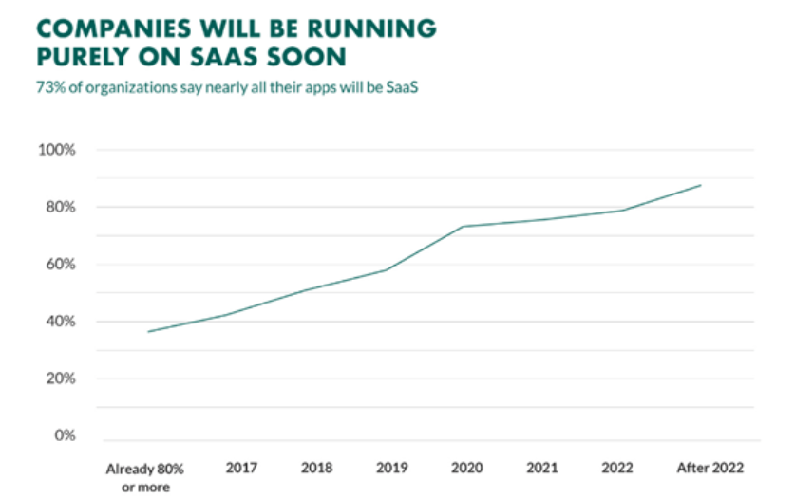
Figure 2: Integration of SaaS by businesses
(Source: STL, 2022)
Accessibility: According to STL (2022), customers can easily access information from anywhere anytime as SaaS stores data in the cloud storage. Therefore, potential customers of RoVac Jam can easily access SaaS applications like Shopify to get better information about Robot Vacuum (STL, 2022).

3.2 Utilising a marketplace
According to Wieczorek (2023), using a marketplace will be helpful for RoVac Jam to accelerate its eCommerce business. Around 89% of sellers have demanded that using a marketplace like Amazon is more profitable than a traditional market (Wieczorek, 2023). Around 37% of businesses reported gaining increased profits through a marketplace despite rising inflation and economic uncertainty in 2022.

Benefits of adopting a marketplace
Planning for additional inventory: Adapting the online marketplace of Amazon will be more beneficial for RoVac Jam. According to Wieczorek (2023), the online marketplace provides RoVac Jam with good management of its inventory for its innovative product line Robot Vacuum. Additionally, it will be also helpful to maintain the supply chain through the Amazon marketplace.
Better shopping experience: Using an online marketplace will also be beneficial for RoVac Jam to provide better shopping to its potential customers. In this case, customers would verify and compare prices of the innovative product range of RoVac Jam. Additionally, customers could also share their experience of using the new innovative product of RoVac Jam.
Greater transparency: According to NiBusinessInfo (2023), an online marketplace will provide potential customers with the price, availability and stock levels of the new product line in a transparent way. Therefore, RoVac Jam would be able to provide its potential customers with an accessible open environment during purchasing Robot Vacuum through a marketplace.
Become a whole funnel: According to the report of Jungle Scout (2022), around 63% of consumers directly search for their product on Amazon during purchasing it. Therefore, adopting a marketplace will help RoVac Jam become a full-funnel for its advertising purpose through its online website. This would help the company to understand every vital touchpoint of its website throughout the customer journey.

3.3 Developing content
According to Perricone (2023), developing content on the innovative product will be an innovative way for RoVac Jam to set up its eCommerce business to reach potential customers. Around 40% of businesses consider content marketing as an important part of their online marketing strategy.

Benefits of developing content for RoVac Jam
Benefits of photograph content: According to Perricone (2023), most businesses in modern use image and photograph-based content to increase the engagement of the audience. Photograph content will be helpful for RoVac Jam due to its simple way of visual storytelling. Colourful and attractive images along with the proper tagline of the innovative product will help RoVac Jam reach more potential customers.
Advantages of copy content: According to Cody (2023), copy content will be an effective way for RoVac Jam to save more time during developing its online website. Copywriting content will be more beneficial to present quality content regarding Robot Vacuum to potential customers of the company. Another advantage of copywriting content is to produce a more convincing, measurable and persuasive value of the innovative product line for potential customers. As a result, the company could get the benefit of stress-free web optimisation during developing its website (Cody, 2023).

3.4 Utilising payment services
Adapting effective payment services to the online website of RoVac Jam will provide a better advantage to fostering its business. According to Up Tech (2023), around 47% of business users already use digital payment methods like PayPal for a better customer experience.

Benefits of using payment services for RoVac Jam
Advantage of the digital payment system: Accepting online payment by using the digital application will be beneficial and convenient for businesses to accelerate their payment system. Therefore, customers can easily, quickly and securely transfer money for online payment during purchasing new innovative products from the eCommerce website (Morand, 2023). According to Morand (2023), PayPal is a popular payment provider for customers worldwide due to its convenient services and effective security. According to Statista (2023), global PayPal users reached 430 million in 2022 as shown in Figure 3. Therefore, RoVac Jam can easily adopt PayPal as their secure online payment service provider.
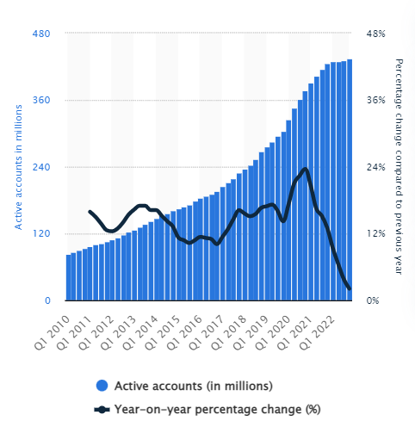
Figure 3: PayPal users in the world
(Source: Statista, 2023)
Advantages of PCI DSS for RoVac Jam: According to Groot (2023), PCI DSS compliance assists those customers who do not follow the procedure of online payments. PCI DSS compliance maintains the firewall and password protection of cardholders of a business. Therefore, individual customers can make their payments by using their credit or debit cards (Groot, 2023). However, RoVac Jam must be aware of the issues of PCI-DSS compliance during accepting payments from customers through cards.

4. Marketing activities

4.1 Promoting Robot Vacuum by RoVac Jam
The promotional activities of RoVac Jam to promote its innovative product range of Robot Vacuum are going to be covered as follows;
Advertising with online marketing strategy: According to McCormick (2023), digital marketing will be a better option for RoVac Jam to advertise and promote its Robot Vacuum than traditional marketing. Additionally, around 70% of customers go through content mediums to learn more about a new product. Therefore, RoVac Jam can use content marketing on its eCommerce website by developing attractive content to promote its Robot Vacuum. As per the report of Sean (2022), almost 74% of customers prefer SEO to find out their choice of product. Therefore, SEO could also be an option for a new venture like RoVac Jam to reach potential customers by integrating its new product Robot Vacuum. Furthermore, the main benefit of digital marketing over traditional marketing is its cost advantage and immense scope for innovative products. Therefore, advertising and promoting the product through online markets will help RoVac Jam build brand awareness, generate customer leads, and increase sales.
Target Customers: The target customers of RoVac Jam will be based on small businesses, bloggers, entrepreneurs, and social media users. According to Statista (2023), there are around 5.16 billion internet users and 4.76 billion social media users in the world as shown in Figure 4. Around 92% of the population with high income from various countries reported using the internet on a daily basis (Statista, 2023). Therefore, RoVac Jam will target this huge number of digital users as its potential customers for promoting its new innovative product via social media as well as the online market. The company will develop its eCommerce website and SEO tool to generate more traffic. Besides this, RoVac Jam will advertise its product line on social media platforms like Facebook, Instagram and YouTube to reach more potential customers.
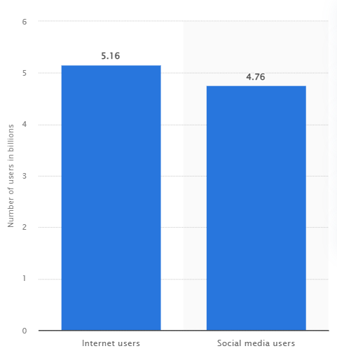
Figure 4: Number of social media and internet users worldwide
(Source: Statista, 2023)
Social media marketing: According to Sean (2022), social media is a better option for promotional activities of a new innovative product of a company. Social media allows a business to elaborate on the characteristic features of its new product. This could help people gather knowledge about the benefits of the innovative product and make them excited to purchase it. According to Statista (2023), the number of social media users is rapidly growing and reached 4.76 billion in 2023. Therefore, the huge number of potential customers for RoVac Jam is available on Facebook as well as on Instagram. According to a survey, a simple advertisement contest on Facebook can reach 34% of new followers for a new venture like RoVac Jam. Instagram also will allow the company to promote Robot Vacuum with the help of Instagram influencers. This will be an innovative method of promoting the new product, increasing brand value and reaching more potential customers from the follower base of influencers. Furthermore, Instagram also will allow RoVac Jam to create promotional content on Robot Vacuum in video formats to attract more potential customers.
Paid search engines: According to Sean (2022), a great example of paid search engine for worldwide business is Google Ads. This is a category of Pay-Per-Click (PPC) ads in which business companies used to pay for new lead clicks for an advertisement to the ad publisher. According to a survey, around 66% of customers used to click on Google Ads during purchasing something from the online market. Therefore, it will be beneficial for RoVac Jam to promote its Robot Vacuum by advertising on Google Ads to generate new traffic leads. These leads will help the company reach more potential clients and effectively promote its product. There are so many benefits of using Google Ads for a company to promote its marketing activities. According to a survey report, Google Ads could help RoVac Jam boost its brand awareness by 40% (Sean, 2022). Google Ads is relatively faster and easier than SEO which will be beneficial for RoVac Jam to effectively promote its Robot Vacuum.
Role of customer journeys: According to Decision Link (2022), the role of the customer journey is very essential for a business to understand the advantages and solutions of the new innovative product. As shown in Figure 5, the customer journey is a strategic way to describe the interconnection and interrelationship of customers with a brand. The role of the customer journey will be very vital for RoVac Jam from considering all the way to becoming a promoter of the company. Mapping the customer journey will also be beneficial for the company to increase brand awareness, engagement of customers, and retention of the product line. Therefore, the customer journey will be helpful for RoVac Jam to promote its product and reach more potential customers. The customer journey is also essential for a company to develop a solution for the product about what customers used to look for. Additionally, RoVac Jam will be able to figure out the needs of customers by calculating their goals. This will help the company to modify its product as per customer needs before promoting it in the market.
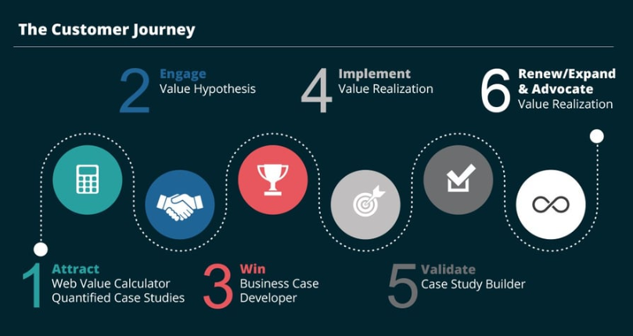
Figure 5: Customer Journey
(Source: Decision Link, 2022)
Email marketing: According to Sean (2022), email marketing is the most efficient digital marketing method for a business to reach potential customers. According to a study by Alice (2023), it was found that around 66% of customers have made purchases of a new product as they received an email through the digital marketing of the company. Therefore, RoVac Jam could promote its product by sending emails regarding the details of the new product. In this case, RoVac Jam will need to consider the pre-launch promotion of the product to acquire the email addresses of potential customers. The purpose of the pre-launch promotional campaign will help RoVac Jam to convert the audience from email leads by launching an offer on Robot Vacuum. Therefore, it will help the company to gain more subscribers with the pre-launch offer.

5. Privacy and data protection considerations of the business
This chapter is going to highlight the data protection, privacy and security of RoVac Jam based on the awareness of regulations in the UK. The considerations of privacy and security concerns of RoVac Jam during the launching of its product are going to be covered as follows;

5.1 Awareness of GDPR/Data Protection Act 2018
The UK government regulated the Data Protection Act in 2018 to protect all kinds of information across the country (Spencer and Patel, 2019). As per this law, RoVac Jam must be aware of the protection of customer information in the following manner;
Need for consent: According to ICO (2023), the consent of the Data Protect Act of 2018 is essential for legitimising the use of the special category of information. Explicit consent could legitimise the overseas transfer of information and automated decision-making. The need for consent of RoVac Jam must be given freely so that customers can have access to and control over their information. According to GDPR (2023), RoVac Jam must identify the legal basis of its data process regarding developing its product. In this case, consent will allow the company to gain overall control of customer information. On the other hand, explicit consent by RoVac Jam without the permission of the data subject could cause a huge amount of fine.
The provisional facility of opting out of marketing communications: According to Zuko (2023), RoVac Jam must provide a provisional facility to its potential customers to opt out of their marketing communication. This means potential customers must be provided with the power of withdrawing their consent from marketing communication as per their willingness. As an example, customers can opt out if they do not want to hear from the company by email relevant to marketing. In this case, if customers do not want to receive further emails, they have to actively choose the option of opting out of marketing communication.
Requirement of support rights like "the right to erasure": According to ICO (2023), the UK GDPR introduced a support right for individual people in the UK to erase their personal data. According to ICO (2023), the right to erasure by individual people is also referred to as the right to be forgotten. RoVac Jam must allow the need for support rights for its customers after their request for erasure in writing or verbally. In this case, RoVac Jam will be required to provide data subjects or customers with the possibility of deleting their personal information. In this case, there is no legitimate rationale for RoVac Jam to keep the information of customers if they do not want to proceed anymore (ICO, 2023).

5.2 Privacy and Electronic Communication Regulations (PECR)
According to ICO (2023), the UK government passed the PECR Act in 2003 to protect the privacy rights of people on electronic communication. RoVac Jam must be aware of the consent of PECR to securely regulate its electronic marketing of Robot Vacuum.
Requirement for consent: The consent of the PECR Act 2003 will help RoVac Jam to have full control over electronic marketing information during developing its Robot Vacuum. Alike the UK GDPR consent standard, PECR consent is also applicable to businesses. Therefore, if RoVac Jam sends information on electronic marketing by using similar technologies or cookies it must comply with PECR consent (ICO, 2023).
Provisional benefits of opting out of marketing communication: According to ICO (2023), the PECR Act will also be helpful for RoVac Jam to provide its customers with the withdrawal benefit of electronic marketing communication. Therefore, potential customers of RoVac Jam will have the right to withdraw their consent from electronic marketing communication.
Requirement of the right to erasure: According to ICO (2023), similar to the UK GDPR, the PECR Act also will provide the right to erasure for customers of RoVac Jam. Therefore, the potential customers of RoVac Jam will be benefited from the right of removing their information if they do not need it anymore.

5.3 Security and its importance
The development of security for RoVac Jam is very essential to effectively operate its online business. The essential components of security services are going to be illustrated as follows;
Secure access to cloud providers: According to Box (2022), in recent days cloud security has become very essential for business organisations to provide secure access to clients. According to a survey, the adoption of public cloud service was estimated to grow by 23.1% in 2021 (Box, 2022). Therefore, RoVac must adopt a secure cloud provider like Google Cloud to secure its potential customer information on cloud storage. This will be beneficial for the company to develop its innovative product Robot Vacuum by analysing highly sensitive information from cloud storage. According to Box (2022), the centralised security of cloud storage will allow RoVac Jam to easily perform online operations under a secure network.
Sensitivity to frequent changes and default access: According to IBM (2021), sensitivity security can be applied by RoVac Jam to secure its sensitive customer information. The sensitivity level of information can be assigned to individual customers for restricting default access or frequent changes to their information. According to IBM (2021), potential customers of RoVac Jam only can have default access and modification capability to their information due to security purposes.
Encrypting traffic at rest and in transit: According to Google Cloud (2023), encryption in transit will be very vital for RoVac Jam to defend its customer information against potential cyber-attackers by establishing an authenticated connection. In this case, RoVac Jam will need to remove the lower layers of the encrypted network provided by third-party providers. Encrypted traffic at rest will help RoVac Jam prevent cyber-attackers from accessing customer information if internal communication will be intercepted by attackers (Google Cloud, 2023). Additionally, the removal of potential attack surfaces by encrypted traffic in transit will also effectively secure business information for RoVac Jam. As an example, Google Cloud Service securely protects customers' insights into its cloud storage with its encrypted network.

6. Conclusion
Henceforth, Robot Vacuum as an innovative product has been identified successfully in this paper. The overview of the Robot Vacuum of RoVac Jam has been briefly described in this paper. The customer segmentation market of the RoVac Jam company has been devised in this report. The viability of the innovative product and business proposition has been analysed in this paper. The paper also has identified the competitive market of Robot Vacuum selling companies in the UK. Additionally, the proposal of developing a new online website for RoVac Jam has been devised by considering the Amazon marketplace, SaaS, content development, and suitable payment services. The possible marketing methods of RoVac Jam to promote Robot Vacuum have been covered in this paper. In this context, target customers are identified as well along with considering social media marketing and paid search engines of Google Ads. Additionally, the role of the customer journey and utilisation of email marketing in promoting the innovative product of RoVac Jam has been illustrated in this report. The report has also analysed the Data Protection Act of 2018 and the PECR Act of 2003 to evaluate the awareness of privacy as well as data protection for RoVac Jam. Furthermore, the importance of cloud security and encrypted traffic for RoVac Jam has been explained in the paper very well.

References
Blusynergy, (2023). How to Use Pricing and Value to Sustain Business. Available at: https://blusynergy.com/blog/subscription-business-strategy/use-pricing-value-sustain-business/ [Accessed 21 April 2023]
Box, (2022). What is cloud security? Available at: https://www.box.com/en-in/resources/what-is-cloud-security [Accessed 21 April 2023]
Cody, (2023). 7 Benefits of Using a Copywriter. Available at: https://www.textbroker.com/7-copywriter-benefits [Accessed 21 April 2023]
Decision Link, (2022). The Importance of Customer Journey Mapping. Available at: https://www.decisionlink.com/blog/the-importance-of-customer-journey-mapping#:~:text=Customer%20journey%20maps%20are%20a,customers%20to%20retain%20their%20business. [Accessed 21 April 2023]
Dyson, (2023). Homepage. Available at: https://www.dyson.co.uk/vacuum-cleaners/robot/360-heurist/nickel-blue [Accessed 21 April 2023]
Eureka Forbes, (2022). Robotic vacuum cleaners and their technologies explained. Available at: https://www.eurekaforbes.com/blog/robotic-vacuum-cleaner-advance-technology.html [Accessed 21 April 2023]
GDPR, (2023). What are the GDPR consent requirements? Available at: https://gdpr.eu/gdpr-consent-requirements/#:~:text=Businesses%20must%20identify%20the%20legal,permission%20from%20the%20data%20subject. [Accessed 21 April 2023]
Goodrich, R., (2023). What Is SaaS (Software as a Service)? Available at: https://www.businessnewsdaily.com/4793-what-is-saas-software-as-a-service.html [Accessed 21 April 2023]
Google Cloud, (2023). Encryption in transit. Available at: https://cloud.google.com/docs/security/encryption-in-transit#:~:text=Encryption%20in%20transit%20defends%20your,Reducing%20the%20potential%20attack%20surface [Accessed 21 April 2023]
Groot, J.D., (2023). What is PCI Compliance? 12 Requirements & Common Concerns. Available at: https://www.digitalguardian.com/blog/what-pci-compliance [Accessed 21 April 2023]
Hall, D., (2023). What is SaaS and how can it help your business? Available at: https://hellotracks.com/en/blog/What-is-SaaS-and-how-can-it-help-your-business/#:~:text=SaaS%20vendors%20can%20invest%20in,than%20an%20on%2Dpremise%20system. [Accessed 21 April 2023]
Hendriks, B., Meerbeek, B., Boess, S., Pauws, S. and Sonneveld, M., (2018). Robot vacuum cleaner personality and behavior. International Journal of Social Robotics, 3, pp.187-195.
Hoover, (2023). Homepage. Available at: https://www.hoover.dk/en_GB/robot-vacuum-cleaners/-/catalog/38383000/hgo320h-011 [Accessed 21 April 2023]
IBM, (2021). Sensitivity Security. Available at: https://www.ibm.com/docs/en/spm/7.0.9?topic=security-sensitivity [Accessed 21 April 2023]
ICO, (2023). Consent. Available at: https://ico.org.uk/for-organisations/guide-to-data-protection/guide-to-the-general-data-protection-regulation-gdpr/lawful-basis-for-processing/consent/#:~:text=Consent%20is%20one%20lawful%20basis,and%20overseas%20transfers%20of%20data. [Accessed 21 April 2023]
ICO, (2023). What are PECR? Available at: https://ico.org.uk/for-organisations/guide-to-pecr/what-are-pecr/ [Accessed 21 April 2023]
Jungle Scout, (2022). Amazon Advertising Report | 2022. Available at: https://www.junglescout.com/amazon-advertising-report/ [Accessed 21 April 2023]
McCormick, K., (2023). 12 Ways to Effectively Promote a New Product or Service. Available at: https://www.wordstream.com/blog/ws/2020/07/29/how-to-promote-a-product [Accessed 21 April 2023]
Morand, T., (2023). The Best Online Payment Service Providers in 2023. Available at: https://www.wildapricot.com/blog/online-payment-services [Accessed 21 April 2023]
NiBusinessInfo, (2023). Selling through online marketplaces. Available at: https://www.nibusinessinfo.co.uk/content/advantages-and-disadvantages-using-online-marketplaces [Accessed 21 April 2023]
Nicholls, L. and Strengers, Y., (2019). Robotic vacuum cleaners save energy? Raising cleanliness conventions and energy demand in Australian households with smart home technologies. Energy Research & social science, 50, pp.73-81.
Perricone, C., (2023). The Ultimate Guide to Content Creation. Available at: https://blog.hubspot.com/marketing/content-creation [Accessed 21 April 2023]
PRNewswire, (2021). Robotic Vacuum Cleaners Market to Gain Over 75% of Revenue from In-house Robots Sales: FMI. Available at: https://www.prnewswire.co.uk/news-releases/robotic-vacuum-cleaners-market-to-gain-over-75-of-revenue-from-in-house-robots-sales-fmi-821881655.html [Accessed 21 April 2023]
Sean, (2022). Sell It! How to Promote a Product Using Digital Marketing Methods. Available at: https://www.lyfemarketing.com/blog/how-to-promote-a-product/ [Accessed 21 April 2023]
Spencer, A. and Patel, S., (2019). Applying the data protection act 2018 and general data protection regulation principles in healthcare settings. Nursing Management, 26(1).
Statista, (2023). Global user number of PayPal from 1st quarter 2010 to 4th quarter 2022. Available at: https://www.statista.com/statistics/218493/paypals-total-active-registered-accounts-from-2010/ [Accessed 21 April 2023]
Statista, (2023). Number of internet and social media users worldwide as of January 2023. Available at: https://www.statista.com/statistics/617136/digital-population-worldwide/ [Accessed 21 April 2023]
STL, (2022). What is SaaS (Software as a Service)? Available at: https://www.stl.tech/blog/saas-helping-businesses-scale-their-way-to-success/ [Accessed 21 April 2023]
Up Tech, (2023). How To Create A Website With An Online Payment System? Available at: https://www.uptech.team/blog/how-to-create-online-payment-website [Accessed 21 April 2023]
Wieczorek M., (2023). 4 Ways to Use Amazon Marketplace to Fuel Business Growth. Available at: https://www.entrepreneur.com/growing-a-business/4-ways-to-use-amazon-marketplace-to-fuel-business-growth/448924 [Accessed 21 April 2023]
Yapici, N.B., Tuglulular, T. and Basoglu, N., (2022), April. Assessment of Human-Robot Interaction between Householders and Robotic Vacuum Cleaners. In 2022 IEEE Technology and Engineering Management Conference (TEMSCON EUROPE) (pp. 204-209). IEEE.
Zuko, (2023). Opt in, opt out and marketing preferences - Getting Customers' Permission. Available at: https://www.zuko.io/blog/opt-in-opt-out-and-marketing-preferences-getting-permission-from-customers#:~:text=Opting%20out%20means%20that%20someone,they%20will%20be%20opted%20in. [Accessed 21 April 2023]

