EVALUATING THE IMPACT OF ADOPTING FOURTH INDUSTRIAL REVOLUTION TECHNOLOGIES ON OPERATIONAL EFFICIENCY IN THE AUTOMOTIVE INDUSTRY

Student’s Full Name: Aleksandar Zdravkov
Student Number: 2242990

Supervisor Name: Dr Eric Osei

Dissertation submitted as part of the requirements for the award of BA Leadership and Management

03/2026

Declaration

I, Aleksandar Zdravkov, declare that this dissertation has been composed by myself, that the work contained herein is entirely my own except where explicitly stated otherwise in the text, and that this work has not been submitted for any other degree or qualification, in whole or in part, except as specified.

Signature: Aleksandar Zdravkov
Date: 14/03/2026

Acknowledgements
I want to express my heartfelt thanks to my educational staff and supervisor for their unconditional guidance and ongoing assistance throughout the overall research journey. I also want to showcase my gratitude to the university members and librarians for offering important resources. Lastly, I am thankful to my colleagues and classmates for their guidance and encouragement throughout this research process.

Abstract
Chapter 1 reflects the background, research aim, question, and objectives for doing the study. The topic illustrates the significance of using Ford IR technologies in increasing the operational efficiency of the automobile sector by improving productivity, reducing waste and errors efficiently.
Chapter 2 illustrates the concept of 4IR technologies, along with discussing the role of additive manufacturing, artificial intelligence, autonomous robots, and the Internet of Things in increasing the operational efficiency of the chosen sector. According to the literature, 4IR technologies can significantly increase the efficiency of the operations within the automotive industry. High cost of investment, lack of skills, and security threats are, however, barriers to a high level of adoption. The strong leadership, facilitative policies, and functional integration strategies facilitate sustainable and competitive digital transformation.
Chapter 3 described the methodology used to examine the effects of 4IR technologies on operational efficiency in the automotive business. The study was enabled by Saunders’ Research Onion to execute interpretivism philosophy, the inductive approach, exploratory design, case study strategy, secondary qualitative data collection method, and thematic analysis.
In Chapter 4, the findings and discussion of the 4IR technology uptake in the car industry are presented. The supply chains are more efficient, cost-effective, and optimally productive with the help of AI, IoT, robotics, additive manufacturing, and digital twins. The threats are linked to the high cost of implementation, cybersecurity, and skills gap. Strategic planning, leadership, and employee training are key factors that facilitate the success of its adoption.
Chapter 5 examines further the 4IR adoption, its suggestions, conclusion, efficiency enhancement, and human-technology integration. Nevertheless, it does not ignore the restrictions and further study of SMEs, sustainability, and 4IR automation to develop operations.

Table of Contents
Declaration 1
Acknowledgements 2
Abstract 3
Table of Contents 4
List of Figures 6
List of Tables 7
ABBREVIATIONS 8
Chapter 1: Introduction 9
1.1 Introduction 9
1.2 Background of the Research 9
1.3 Research Aim 11
1.4 Research Objectives 11
1.5 Research Questions 12
1.6 Organisation of Research 12
1.7 Chapter Summary 12
Chapter 2: Literature Review 13
2.1 Introduction 13
2.2 Concept of 4IR Technologies 13
2.3 Types of 4IR Technologies Used by the Automakers 13
2.4 Role of these Technologies in Different Operational Domains 14
2.5 Effects of the Use of 4IR Technologies on Operational Effectiveness 15
2.6 Challenges and Success Factors Influencing the Uptake of 4IR Technologies 15
2.7 Tactics Used by the Automakers for Using 4IR Technology to Optimise Operating Efficiency 16
2.8 Theoretical Framework 18
2.9 Conceptual Framework 19
2.10 Literature Gap 19
2.11 Summary 20
Chapter 3: Methodology 21
3.1 Introduction 21
3.2 Research Philosophy 21
3.3 Research Approach 22
3.4 Research Strategy 22
3.5 Research Design 23
3.6 Methodological Choice 23
3.7 Time Horizon 23
3.8 Data Collection 24
3.9 Data Analysis 24
3.10 Ethical Considerations and Selection Criteria 24
3.11 Summary 25
CHAPTER 4: Results and Discussion 26
4.1 Introduction 26
4.2 Findings 26
4.2.1 Adoption of Fourth Industrial Revolution (4IR) Technologies in the Automotive Industry 27
4.2.2 Impact of 4IR Technologies on Operational Efficiency 30
4.2.3 Challenges and Barriers to 4IR Adoption in the Automotive Industry 33
4.2.4 Key Success Factors for Effective Implementation of 4IR Technologies 35
4.2.5 Strategies Used by Automakers to Improve Operational Efficiency through 4IR 37
4.3 Analysis (Thematic) 38
4.4 Discussion 40
4.5 Summary 41
CHAPTER 5: Recommendations, Conclusion, and limitations of the research 42
5.1 Recommendations 42
5.2 Conclusion 42
5.3 Research Limitations 42
5.4 Future Implications 43
References 44

List of Figures
Figure 1.1: Different 4IR Technologies in the Automobile Sector 10
Figure 2.1: “Characteristics and Components of 4IR technology” 17
Figure 2.2: “TOE (Technology-Organisation-Environment)-Based Innovation Model” 18
Figure 2.3: “Conceptual Framework” 19
Figure 3.1: “Application of Saunders’ Research Onion” 21
Figure 4.1: “Global Smart Factory Market Size” 28
Figure 4.2: “Current Applications of AM in the Automobile Industry and Future Prospects” 29
Figure 4.3: “Application of Digital Twin in the Automotive Industry” 30
Figure 4.4: “Downtime Reduction Via Predictive Maintenance” 31
Figure 4.5: “Automotive Manufacturing Metrics Comparison” 32
Figure 4.6: “Smart Factory Implementation Challenges” 34
Figure 4.7: “Key Success Drivers of Digitally Mature Firms” 35
Figure 4.8: “Industry 4.0 Market Outlook” 37

List of Tables
Table 4.1: “Table of result” 26
Table 4.2: “Manufacturing Performance Metrics and Smart Factory Implementation Results” 32

ABBREVIATIONS
• 4IR- Fourth Industrial Revolution
• AGVs- Automated Guided Vehicles
• AI Artificial Intelligence
• AM- Additive Manufacturing
• CAGR- Compound Annual Growth Rate
• CNC- Computer Numerical Control
• DCT- Dynamic Capacity Theory
• DOI- Diffusion of Innovations
• EV- Electric Vehicle
• IoT- Internet of Things
• MES- Manufacturing Execution Systems
• ML- Machine Learning
• OEMs- Original Equipment Manufacturers
• R&D- Research and Development
• RBV- Resource-Based View
• SMEs- Small and Medium-sized Enterprises
• TAM- Technology Acceptance Model
• TOE- Technology–Organisation–Environment
• USD- United States Dollar

Chapter 1: Introduction

1.1 Introduction
In today’s business environment, the introduction of Fourth Industrial Revolution (4IR) technologies is reshaping global production and manufacturing systems by enabling greater degrees of connectivity, a data-driven approach, and automation. The paper will discuss the role of these technologies in the automobile sector to boost productivity, improve product quality, and optimise the supply chain. Hence, the primary purpose of this research is to investigate the role of 4IR technologies in affecting the operational efficiency of the automobile industry effectively.

1.2 Background of the Research
In the current trend, the “Fourth Industrial Revolution (4IR)” integrates different digital technologies, like the “Internet of Things (IoT)”, “artificial intelligence (AI)”, “Big Data analytics”, additive manufacturing, and advanced robotics into the production systems of the automobile sector. By integrating such technologies (as provided in Figure 1.1), automobile manufacturers are able to make operational flexibility, product quality, and production reliability more efficient and reduce downtimes and material waste, thereby augmenting the overall operational efficiency (Shimkus, 2025). Empirically, it is noted that over 85% of auto stakeholder companies globally are engaging in digital transformation initiatives to raise production performance and competitiveness . In addition, nearly 70% of automotive OEMs now target AI, IoT, and autonomous technologies to control predictive maintenance and smart manufacturing capabilities with substantial proportions of their R&D outlays (Tran, 2026). The example of major automakers, e.g., BMW, Tesla and Toyota, shows that it is possible to change automation and interconnection of activities of manufacturing networks by using 4IR.


Figure 1.1: Different 4IR Technologies in the Automobile Sector
(Source: Shimkus, 2025)
However, small automobile firms, particularly small- to medium-sized suppliers, continue to experience considerable challenges to 4IR adoption. The main issues are high prices of digital infrastructure, cybersecurity issues, resistance of organisations to changes, and a lack of skilled labour. It is important to note that Zhong and Moon (2023) consider that operational efficiency gains vary radically by organisational size and market circumstance. Despite this adoption by many firms, it has challenges in the aspect of technology adoption because many cannot guarantee returns or justify investments. This means that digital projects are not necessarily followed by the desired efficiency benefit.
Nonetheless, it has been identified that proper plans can reduce the interference and maximise the output of the 4IR implementation. Other organisations state that older legacy “Manufacturing Execution Systems (MES)” are inadequate to address the new digital requirements, which limits the ability to gain insights. On the other hand, firms that are engaged in targeted upgrades achieve measurable efficiency benefits. The case in point is that in 2030, Volkswagen will spend over €1 billion on AI development, and by 2035, the company will reach the maximum efficiency gains of up to €4 billion (Chopping, 2025). This leads to the reality gap that has always been present between the degree of adoption and the increase in measurable operational performance.
Currently, the automotive industry is highly investing in 4IR to not only increase operational efficiency, but also to sustain its competitive advantage and fulfil the needs of the shifting market trends. The statistical data illustrate that 85% of the automobile manufacturers in the nation are investing in various digital technologies to increase production efficiency in businesses (Zipdo.co, 2025). Due to such investment, the global automotive industry is projected to reach $77 billion at the end of 2027. The above information shows the urgency and need for introducing 4IR technologies by the automobile industry across the nation. The primary rationale for doing the study is to analyse the brought advantages of using 4IR technologies to improve operational efficiency across the automotive context by productivity improvement, reducing downtime and saving costs immensely.
The research will shed light on which 4IR technologies are currently integrated by the automakers and how they are used in different operational domains. Besides, the findings of this paper can also assist the automobile organisation to successfully create digital transformation plans that improve the skill level of workers for using this new technology efficiently. Moreover, the future outcomes of this paper are to provide evidence-based information regarding the use of these technologies, including their success, factors and obstacles that can help automakers to use these technologies efficiently for optimising operations in businesses (Ghadge et al., 2022).

1.3 Research Aim
“This study aims to investigate how the automotive industry’s adoption of Fourth Industrial Revolution (Industry 4.0) technologies affects operational efficiency, as measured by productivity, cost reduction, quality improvement, and flexibility, and to pinpoint the main facilitators and impediments to this adoption.”

1.4 Research Objectives
Based on the above research aim, the primary objective of the study is discussed below:
- To discuss current 4IR technologies used by car manufacturers and how they work in key areas of operations
- To examine the effects of the use of 4IR technologies on the operational effectiveness of the automobile sector
- To discuss the main issues and success factors in the introduction of these technologies in the chosen industry
- To investigate the tactics used by auto makers to use 4IR technology to optimise operational efficiency

1.5 Research Questions
The research questions are provided below:
- “Which 4IR technologies do automakers implement in several areas of operation?”
- “What effects does the use of 4IR technologies have on operational effectiveness?”
- “What are the main obstacles and success factors influencing their uptake?”
- “What tactics may automakers use using 4IR technology to optimise operating efficiency?”

1.6 Organisation of Research
This research is categorised into five chapters. Chapter One is the introduction of the research. Chapter Two offers a literature review. Chapter Three is devoted to the methodology. The fourth chapter analyses results and discusses findings. Chapter Five presents the conclusion of the study by offering recommendations and future direction of research.

1.7 Chapter Summary
The paper illustrates that 4IR technologies help the automobile sector to lower operating costs and maximise production efficiency through predictive maintenance and real-time monitoring processes. Besides, the paper also discussed the role of these technologies in improving flexibility, product quality, and reducing downtime and waste, which overall enhances the operational efficiency of the automobile industry. Moreover, the paper also discussed that some SME faces issues in integrating these technologies due to their high cost and maintenance, but still, the implementation of these technologies is increasing rapidly across the chosen sector.

Chapter 2: Literature Review

2.1 Introduction
The chapter provides a brief overview of the concept of 4IR technologies, the types and roles in enhancing operational efficiency across the automobile sector. In addition, the paper will also discuss the effect of using these technologies and the tactics used by the auto makers to optimise operational efficiency by using these technologies. Moreover, the paper illustrates the success factors and the various challenges faced by automakers while implementing these technologies across business operations.

2.2 Concept of 4IR Technologies
The 4IR technologies demonstrate the advanced digital technologies that merge the biological, physical and digital world to connect with objects by finding new ways to interact with various machines and increase human abilities. According to Noor et al., (2024), 4IR technology is demonstrated as a fusion of different technologies that provide advanced analytics, real-time data and also help in making smart decisions across sectors. The automobile sector extensively uses this technology in its manufacturing system to improve the supply chain, along with managing competitive advantage through maintaining quality, cost and delivery time. By introducing this technology, the automobile sector maintains a quantifiable increase in its productivity, reduces downtime through real-time and predictive maintenance and maintains more flexibility in fulfilling consumer demand.

2.3 Types of 4IR Technologies Used by the Automakers
The various technologies that drive the revolution across the automobile sector are additive manufacturing, artificial intelligence, autonomous robots, and Internet of Things (IoT). According to Parupelli (2019), additive manufacturing (AM) technology, or 3-D printing, helps the automobile companies to produce a prototype of the vehicle, much quicker and at a cheaper amount as compared to the traditional manufacturing. It helped the automakers to create lightweight versions of tiny vehicle structures that reduced cost and made it within a shorter timeframe, as studied by Vasco (2021). In contrast, the AI technologies are used for production optimisation, quality control analytics, and predictive maintenance of vehicle data (Finn and Downie, 2025). It helps automakers to respond and predict defects of a vehicle in real-time to avoid potential failure on the production line.
According to Sherwani et al., (2020), autonomous robot technology enables robots to perform complicated and dangerous tasks related to the automobile sector that are too unsafe and difficult for humans. Besides, these robots help the organisation to increase its production speed, reduce workplace injuries, and maintain consistency in product lines across manufacturing units (Drystek, 2025). In other words, IoT technology helps to optimise the development of vehicles and delivery times in different areas within the plants (Muthiya et al., 2023). Besides, this technology helps the automakers maintain connectivity between sensors, systems and machines across the manufacturing environment as studied by Katlinsky (2023). It provides real-time data to maintain safety on the roads with vehicles by identifying poor driving skills and accidents in real time.

2.4 Role of these Technologies in Different Operational Domains
The above-discussed technologies play a significant role in different operational domains in the automobile industry. As per Drystek (2025), 3-D printing or additive manufacturing helps automakers to create various prototypes of different vehicles in a short span of time. The ability to provide accurate and quick results by customising automotive components and parts is the major role of this technology. For example, the Ford Company makes a prototype of each vehicle through AI so that the inspection time can be reduced and any defects can be noticed at an early stage (Makarevich, 2021). AI is adopted by the chosen sector to maintain a secure journey and safe ride for humans across the nation. In the opinion of Finn and Downie (2025), by using this technology, the automakers create alerts regarding potential failure or defective parts in the vehicle and analyse information from machines in real-time to enhance the efficiency levels. For example, BMW uses AI technology to drive efficiency levels and optimise production procedures effectively by collaborating and communicating with humans, systems and machines in real time (Law, 2024).
In other words, the automobile sector is currently adopting autonomous robot technology to handle repetitive tasks and heavy loads, which can help to reduce the rate of accidents and enhance efficiency. According to Huang et al., (2025), by using this technology, the automotive sector coordinates workflows, easily transports material, and reduces workflow errors in larger automobile plants. For example, Porsche has implemented a flexible line considering the automated robotic option where driverless transportation systems are used to transport and pick up the vehicles for quality control (Makarevich, 2021). In this situation, the robots reduce the risk of damage to the vehicle and allow workers to focus on serious work. In contrast, the IoT technologies are significantly used by the automobile sector to create a network of scale, gauges and sensors, where collected data provides actionable and valuable insights regarding safety and productivity. This technology helps to reduce reworking and scrapping of parts by using quality control data to identify the issue that leads to the creation of faulty parts, as mentioned by Rosca et al., (2025). For example, BMW use these technologies in the manufacturing prostitutes to create more efficient, responsive and smarter production systems (Law, 2024).

2.5 Effects of the Use of 4IR Technologies on Operational Effectiveness
In the opinion of Elkateb et al., (2024), 4IR technologies create a significant impact on automobile business operations by increasing productivity and efficiency of the business. The introduction of AI and autonomous robots manages complex labour-intensive tasks and reduces the risk of the vehicles. Automated lines of production across the automobile sector reduce errors by workers and maintain consistent output, along with better usage of the production. Besides, the use of IoT helps in reducing downtime and increasing the reliability of the asset. By using this technology, the automobile organisations monitor the performance of each machine in real time and introduce predictive strategies.
It helps the organisations to easily and quickly manage breakdowns of machines and reduce maintenance costs by ensuring reliable and smoother operations. According to Alshahrani (2023), the introduction of 3-D printing helps the automobile organisation to maintain continuous inspection of the production procedure so that any kind of defect can be identified at an early stage and avoid any further production of faulty products. Hence, it is evaluated that the impact of 4IR technologies on operational efficiency is increasingly positive, but the high cost of implementation, shortages of skilled workers and cybersecurity problems limit the benefits of these technologies across the organisations. However, Parupelli (2019) suggested that the role of increasing reliability, productivity and performance is the key factors that influence automakers to implement 4IR technologies in their business operations.

2.6 Challenges and Success Factors Influencing the Uptake of 4IR Technologies
The adoption of “Fourth Industrial Revolution (4IR)” technologies within the automotive industry seems to be an opportunity for revolution in terms of operational efficiency. However, there are several technological, organisational, and financial issues that hinder the adoption process. Among the main concerns of the literature is the high initial investment in high-tech digital infrastructure. Such costs include robotics, AI, IoT and big data analytics required in the Industry 4.0 implementation. The effect of such capital intensity is an inhibitory resource among small and medium-sized firms but not resource-endowed automakers (Mittal et al., 2019). The outdated production systems and old legacy systems also complicate the integration of cyber-physical production environments (Noor et al., 2024).
Such structural limitations undermine real-time data flows and disrupt evidence-based operation decision-making competencies. The next significant challenge is that there is still a shortage of skilled workers capable of operating advanced IT tools. Alshahrani (2023) further notes that even with a good leadership commitment, organisations are frequently unable to enjoy the full advantages of technologies like AI and big data analytics, which demand adequate digital skills and continuous workforce training. Interconnected system risks, as well as the possible operational and data risks, also impede adoption since it is prone to being attacked by cybersecurity threats. Ethnic concerns regarding data breaches and system outages augment organisational anxieties involving colossal digital integration (Perody and Sudhakara, 2024).
In contrast, the literature introduces organisational and strategic success factors that significantly ease the adoption of 4IR technology. The endorsement of the top management and the coherence of strategy provoke a pledge and fund digital resources in the long run (Alshahrani, 2023). The successful and scalable results in the implementation achieved are based on strong digital infrastructure, including connection platforms and integration structures. The policies and funding mechanisms of government incentives reduce the entry barrier factors, particularly in the emerging markets. Collaboration with other academic and research centres also contributes to the innovative potential and addresses the gap in skills among employees. Overall, to implement sustainable 4IR, leadership ecosystems and particular capacity-building of transforming constraints into competitive facilitators are essential.

2.7 Tactics Used by the Automakers for Using 4IR Technology to Optimise Operating Efficiency
The implementation of the “Fourth Industrial Revolution (4IR)” technologies (see figure 2.1) to optimise operating efficiency diffuses via a multiplicity of mechanisms implemented by automakers, including unfamiliar applications and impracticality (McKinsey, 2022). One of the primary tactics is predictive maintenance, which is highly supported by the IoT and AI systems. These technologies give a chance to control the condition of machines in real time and avoid failure on time. Consequently, manufacturers can reduce unexpected downtime and attain a high degree of asset reliability, according to Elkateb et al., (2024). Still, the effectiveness of predictive maintenance is not even at all firms. Success mostly relies on sensor precision, platform cross-compatibility, and data quality. Yusuf et al., (2020) argue that poor integration could limit information and productivity gains through foresight. Therefore, the benefits of data-driven maintenance are efficiency gains, and the potential of this kind of maintenance is curtailed by the implementation problems.
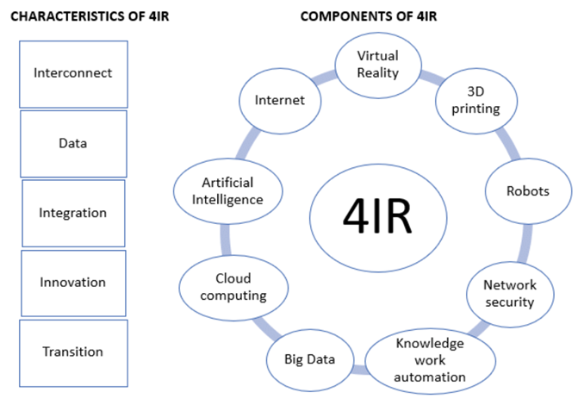

Figure 2.1: “Characteristics and Components of 4IR technology”
(Source: Yusuf et al., 2020)
Another strategy was the adoption of digital twin technology in automotive activities. Digital twins are imitations of assets, production lines, or entire factories. Such simulations help in changing processes and simulating operations in real time. Therefore, car manufacturers could map the bottlenecks and optimise the processes without disrupting the running production, as investigated by Liu et al., (2025). For example, Toyota used digital twins, increased speed in its production and reduced delays in the supply chain (Toyota, 2023). Even though they are strengths, digital twins need to incorporate systems. Interdepartmental coordination requirements may be so high as to hinder deployment and limit scalability. Thus, only technologically developed firms can attain the benefits.
Modern automotive plants also comprise established advanced robotics and collaborative automation. AGVs, robotic arms, and cobots (Collaborative Robots) are such technologies that guarantee the accuracy and consistency of operations (Shimkus, 2025). Such systems generate reduced cycle times and quality gains for the products. Nonetheless, automation must be correlated with skilled labour and smartly organised. Poor training may lead to non-utilisation and working breakdowns. Finally, AI-based analytics and machine learning simplify logistics, inventory and schedule choices (Haman et al., 2025). However, poor data governance and organisational preparedness still limit efficient changes.

2.8 Theoretical Framework
To understand the implementation and impact of the use of “Fourth Industrial Revolution (4IR)” technologies in the automotive sector, concrete theoretical constructs describing performance and adoption outcomes are required. One of the theoretical frameworks of Industry 4.0 studies is the “Technology-Organisation-Environment (TOE) framework”, which focuses on the technological, organisational, and environmental factors that influence adoption (see figure 2.2) (Haman et al., 2025). Notably, TOE aids in evaluating internal capabilities and external conditions that shape the adoption of the IoT, AI, robotics, and analytics for automotive transformation (Zhong and Moon, 2023).
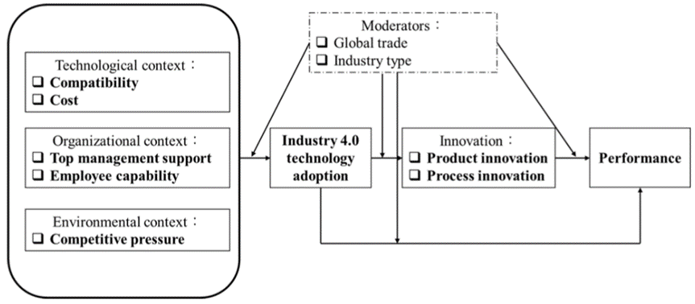

Figure 2.2: “TOE (Technology-Organisation-Environment)-Based Innovation Model”
(Source: Zhong and Moon, 2023)
Besides TOE, the “Diffusion of Innovations (DOI) theory” examines the elements of technology to determine its impact on adoption decision-making within organisations. It explains the diffusion of 4IR technologies, where the benefits accelerate the diffusion process, and complexity and uncertainty constrain upstreaming (Le et al., 2023). Similarly, the “Technology Acceptance Model (TAM)” with its extensions pays attention to the usefulness and ease of use of intentions (Zou et al., 2025). Besides the adoption theory, there are the “Resource-Based View (RBV)” and “Dynamic Capacity Theory (DCT)”, which assume how to transform 4IR investments into benefits (Osei et al., 2025). RBV prioritises the unique resources, and DCT centres on reconfiguring capabilities to manage the change in the environment (Haman et al., 2025).

2.9 Conceptual Framework
The conceptual framework, as shown in Figure 2.3, relates the implementation of the 4IR technology to the outcome of operational efficiency in the automotive industry. It is a vital mix of antecedents, mediators, and outcomes, which explains how readiness, leadership, skills, and analytics transform it. External policy support and competitive pressure mediate these relationships by improving or restricting productivity, quality, cost reduction, and flexible operations.
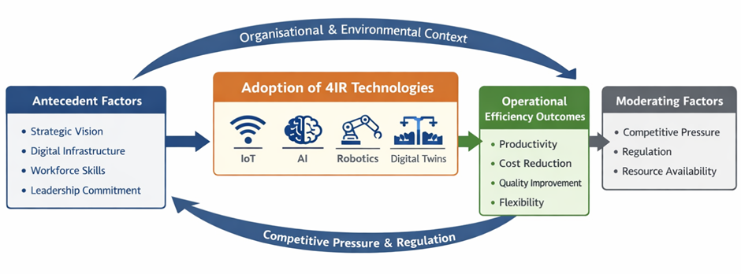

Figure 2.3: “Conceptual Framework”
(Source Self-constructed)

2.10 Literature Gap
Despite the extensive discussion of the use of 4IR in the automotive industry, the identified gaps can be created based on the research objectives. Firstly, the available literature introduces 4IR technologies in general but lacks a current, comparative example of how auto manufacturers are utilising numerous technologies simultaneously. Second, it lacks empirical data that link specific 4IR technologies with specific operational domains such as production, logistics, and maintenance. Third, direct and measurable 4IR impacts on the overall performance are not well-studied, even though productivity has been enhanced. Fourth, the previous literature has considered challenges and success factors independently without a sufficient level of cross-organisational analysis. Finally, it does not feature a tactical vision of how exactly the automakers benefit from the performance through 4IR technologies.

2.11 Summary
Literature reveals that the implementation of 4IR depends on the alignment of strategy, technological readiness, and the capabilities of its employees. Investment costs are high, and skills are short, hampering adoption, but the efficacy of adoption is evident. Adoption procedures and success attainment are framed by models such as TAM, TOE, DOI, and RBV.

Chapter 3: Methodology

3.1 Introduction
This chapter has determined the methodological framework for exploring the role of the Fourth Industrial Revolution (4IR) in the functioning of automotive industries by examining their effectiveness. To perform systematic collection, analysis, and interpretation, qualitative secondary design followed the guidelines relevant to organising and selecting the methods used, the Research Onion developed by Saunders (see Figure 3.1) (Saunders et al., 2023). Each level of methodology was critically justified to demonstrate why this was the most appropriate in this present study compared to the rest.
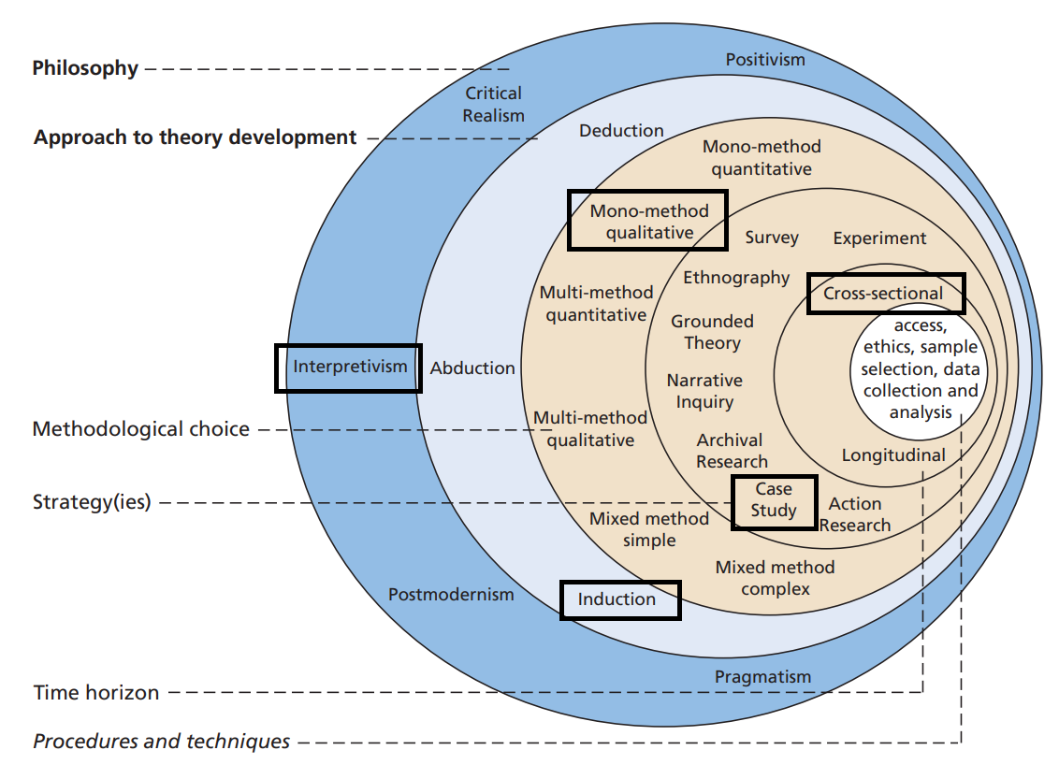

Figure 3.1: “Application of Saunders’ Research Onion”
(Source: Saunders et al., 2023)

3.2 Research Philosophy
“Research philosophy” refers to assumptions and beliefs about how knowledge is formed and perceived in a study (Gamage, 2025). Philosophy is the outer layer of “Saunders’ research onion” that influences the subsequent methodological decisions (see Figure 3.1). The “research philosophy” adopted in this research was interpretivism, which involves the interpretation of complex social and organisational phenomena and does not in any way rely on objective measurement. Adopting this philosophy allowed for exploring subjective insights and individual experiences of both managers and the workforce regarding embracing 4IR technologies and their perceived influence on operational effectiveness in the automobile sector (Acharya, 2025).
The adoption of interpretivism was appropriate because the research was aimed at knowing how the 4IR technologies are perceived and used in automotive organisations to enhance efficiencies in their operations. Unlike the positivist research philosophy that deals with large numbers and hypothesis testing, in interpretivism, the insight can be unlocked in the reports, case studies and publications (Ikram and Kenayathulla, 2022). Interpretivism has contextual insight into the digital transformation, and the outcomes can be biased by the researcher, which limits the generalisation of his/her in comparison with other forms of positivist approaches (Acharya, 2025).

3.3 Research Approach
This research employed an “inductive approach” where observations and data analysis are employed to initially generate generalisations or theoretical implications. Qualitative research is suited to inductive reasoning because patterns and relationships are created with data, but not hypotheses (Yuwono and Rachmawati, 2023). Similarly, Lim (2025) is adamant that inductive methodological approaches create theoretical knowledge by observing and determining patterns of information collected in each form. The approach was appropriate to the study because it explored operational impacts of 4IR technologies without predetermined assumptions (Kumar and Ujire, 2024). Inductive research may limit generalisation when compared to “deductive research” that focuses on verifying known theories by using systematic hypotheses and data (Saunders et al., 2023).

3.4 Research Strategy
A research strategy is a plan for how the research question will be answered. This research has employed a “case study research strategy” to examine the automotive companies that have implemented 4IR technologies in their work systems. Case studies help to deepen the analysis of current phenomena in complex organisational contexts (Annamalah et al., 2025). The method here reviewed published cases like digital manufacturing systems, predictive maintenance, and smart supply chains that are induced by AI. The case studies also gave a deeper understanding of the organisational process and managerial decision-making compared with large sample surveys. However, the fewer cases complicate the generalisation, and surveys may provide evidence on firms (Abbasi and Bahrami Dehdar, 2025).

3.5 Research Design
The study has been conducted under an “exploratory research design”. In an “exploratory research design”, the phenomena under study are dynamic, and the aim of the research is to explain phenomena rather than theorise about potential theoretical connecting factors (Makri and Neely, 2021). As the application of 4IR technologies in the automotive manufacturing sector is a relatively new phenomenon, “exploratory design” helped pin down the trends of operation in addition to organisational responses. However, integration, efficiency, and problems can be analysed, and these studies may lack systematic measurement systems (Abbasi and Bahrami Dehdar, 2025).

3.6 Methodological Choice
The study employed a mono-method qualitative choice in accordance with the research onion (see Figure 3.1). A qualitative method is also suitable for researching complex organisational phenomena and constituting meanings within the industrial settings. The mono-method relies on the qualitative data alone and fails to include the qualitative and quantitative methods (Saunders et al., 2023). The choice was valid, as the study was aimed at the interpretation of industry insights and organisational practices regarding 4IR technologies. Qualitative analysis enabled the criticism of narratives, industry reports, and scholarly arguments on the digital revolution in the motor industry. However, it is not statistically valid compared to mixed-method approaches, which enhance reliability (Vivek and Nanthagopan, 2021). In any case, it remained proper when explaining industrial knowledge compared to numerical relationship quantification.

3.7 Time Horizon
The research time horizon was cross-sectional; it collected information at a specific point based on the existing resources (Abbasi and Bahrami Dehdar, 2025). This time horizon was chosen to reflect on modern trends in adopting 4IR technologies in the automotive sector and rely upon the current reports. But it restricts knowledge on how things change with time. On the one hand, longitudinal studies offer richer details concerning trends and causal influence but require additional resources and time (Neale, 2020). In this way, the “cross-sectional time horizon” was realistic and constrained.

3.8 Data Collection
The “secondary data collection” method was used in the research. Secondary data involves data published or recorded by other organisations and researchers. These were academic journal articles (accessed on academic databases like Google Scholar, ResearchGate, ScienceDirect, MDPI, etc.), automotive industry reports, industry publications, market research reports, and reliable news, which were used for collecting reliable data. The primary benefit lies in the possibility to receive a large amount of information without “primary data collection”, which is time- and money-consuming (Taherdoost, 2021). Yet, secondary data may also be authentic, biased, or irrelevant. As such, sources were chosen and cross-checked to be credible.

3.9 Data Analysis
Thematic analysis was used to analyse the collected secondary qualitative data, according to the six-phase method proposed by Braun and Clarke (2021). Thematic analysis means identifying patterns, themes, and helpful observations in a text (Byrne, 2022). These 6 steps include familiarisation, coding, theme development, theme reviewing, defining, and reporting (Ahmed et al., 2025). This also searched the literature and industry reports of 4IR technologies and operational efficiency qualitatively, allowing for the recognition of repeated patterns, main insights and basic themes regarding the adoption of technologies and their influence on operational efficiency. Also, unlike “primary research”, it is prone to researcher bias, though it applies to large quantities of data. However, it fitted the close reading of written evidence of secondary materials well.

3.10 Ethical Considerations and Selection Criteria
Ethics were considered in the research to ensure that no use of information was irresponsible. This analysis relied on secondary data, and no personal or confidential data was used. References were also placed well to prevent plagiarism and promote academic integrity (Palikhe and Phuyal, 2025). The inclusion criteria were the peer-reviewed journals published between 2016 and 2026 to maintain credibility, industry reports in the automotive industry, and valid market studies in 4IR technologies and operational efficiency. The exclusion criteria were used to filter false blogs and outdated or non-academic sources to ensure that the study was conducted on the specific subject matter of interest and credibility.

3.11 Summary
The chapter covers the methodological elements utilised for examining the influence of 4IR technologies on the operations of the automobile industry. The research adopted an “interpretivism research philosophy”, “inductive research approach”, “exploratory research design” and secondary qualitative data. Utilising case studies as well as thematic analysis, this study systematically evaluated industry-based literature while confirming responsible usage of authentic data sources.

CHAPTER 4: Results and Discussion

4.1 Introduction
Chapter 4 presents the research results on the impact of Fourth Industrial Revolution (4IR) technologies on operational efficiency within the automotive sector. The data has been collected from a qualitative study of secondary sources, including scholarly journals, industry reports, company reports, and reliable databases. Key themes have been identified through thematic analysis to classify the findings. This approach helped them identify trends in technology utilisation, operational efficiency growth, and the challenges faced in its application to automotive production, as well as the strategic success factors.

4.2 Findings
Sources (Journals and Websites) | Main Discussion | Themes
Richter (2026) | Predictive AI maintenance reduces downtime. | Technology Adoption
S&P Global (2025) | AI vision detects defects better. | Operational Efficiency
Yang et al., (2019) | IoT enables real-time production tracking. | Technology Adoption
Urrea and Kern (2025) | Robotics increases productivity and security. | Operational Efficiency
Piromalis and Kantaros (2022) | Digital twins overcome the simulation of production. | Technology Adoption
Kolluri (2025) | Smart factories improve productivity. | Operational Efficiency
Ozsevim (2026) | High costs limit 4IR adoption. | Challenges
Rockwell Automation (2025) | Shortage of skills affects implementation. | Challenges
Zhou et al., (2024) | Leadership promotes digital change. | Strategic Enablers

Table 4.1: “Table of Results”
(Source: Self-developed)

4.2.1 Adoption of Fourth Industrial Revolution (4IR) Technologies in the Automotive Industry
Artificial Intelligence and Machine Learning
Artificial intelligence (AI), including machine learning (ML), has become the technology that allows production in the car industry to become data driven. They are applied in predictive maintenance, production planning, and automated quality inspection. The AI programs scan sensor input of manufacturing machines to identify early indicators of mechanical failures; when this occurs, predictive maintenance is used instead of corrective maintenance. Approximately 72% of vehicle makers are claimed to utilise AI predictive upkeep that decreases the device downtimes by around 30% across the entire production plant (Richter, 2026). AI-driven computer vision systems are used to detect micro-defects in paint, a welding system or a battery component that correction workers do not usually notice (S&P Global, 2025).
The application of AI in car manufacturing, however, is not even. Only 45% of manufacturers have adopted AI in the manufacturing process, as of 2023 (Richter, 2026). The data infrastructure is expensive, and software skills in the company are low, thus leading many firms to rely on traditional analytics. AI vision devices detect flaws and can make real-time modifications to increase the speed of EV production at General Motors’ “Factory Zero” (Jena et al., 2023; Wohl and Schrag, 2023). But AI investment, operated over the long run, analysts fear, is limited by the software and organisational challenges of incumbents.
Internet of Things (IoT) and Smart Manufacturing Systems
The Internet of Things (IoT) is the heart of smart manufacturing in the automotive industry; it assumes that a network of machines, sensors, and systems is created. IoT devices capture real-time information about equipment, such as vibration, temperature, and pressure and process optimisation (Yang et al., 2019). Smart factories provide a purpose in production and supply flow that may be utilised to detect bottlenecks and lessen unavailability. The 2024 global market size of smart factories is projected to be USD 154.89 billion, and it is projected to be USD 272.64 billion in 2030 (see figure 4.1). In 2025-2030, its growth rate is also 10.0% CAGR (Grand View Research, 2025).
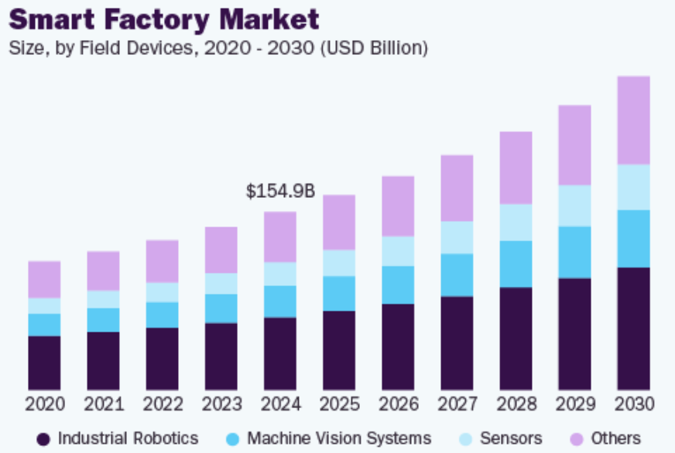

Figure 4.1: “Global Smart Factory Market Size”
(Source: Grand View Research, 2025)
Large automakers often have IoT-based manufacturing systems. As an example, BMW implemented over 3000 machines, robots and autonomous transport systems in a cloud-based IoT to organise complex production networks and assemble more than 1000 vehicles per day worldwide (BMW Group, 2019). Such connectivity enables the real-time data of production to be analysed and optimises scheduling, logistics and setting of resources. However, IoT implementation results in difficulties and obstacles when managing large amounts of industrial data and cybersecurity threats. It is also technically complex and costly on a small scale for the other automotive supply chain suppliers to integrate IoT.
Advanced Robotics and Automation
Advanced robotics is another key Industry 4.0 implementation ground in the automotive-manufacturing industry. The robots and cobots are used in repetitive and hazardous tasks, since the robots are working on welding, painting, assembling, and transporting materials (Urrea and Kern, 2025). Automation is faster, more accurate and safer and lowers exposure to work. For example, the Tesla Gigafactories are indicators of high-tier automation of manufacturing ramps, output, and consistent quality of goods (Shamsuddoha et al., 2025).
Case studies reveal that in smart factories, robotics is increasing in its role. A case in point is that BMW attempts AI-controlled humanoid robots that operate with high-voltage batteries, as well as sheet-metal parts down to the millimetre level, over 90,000 parts. If processed by U.S. pilots (Cotton, 2026). Also, at the Hyundai EV factory, cars are assembled, and inventory is checked using drones, robotic arms, and autonomous vehicles (Hyundai, 2026). Displacement of the workforce and costs are factors that impede robotics adoption, despite affecting small vendors, and require significant amounts of training (Soori et al., 2024).
Additive Manufacturing (AM) and Digital Twin Technology
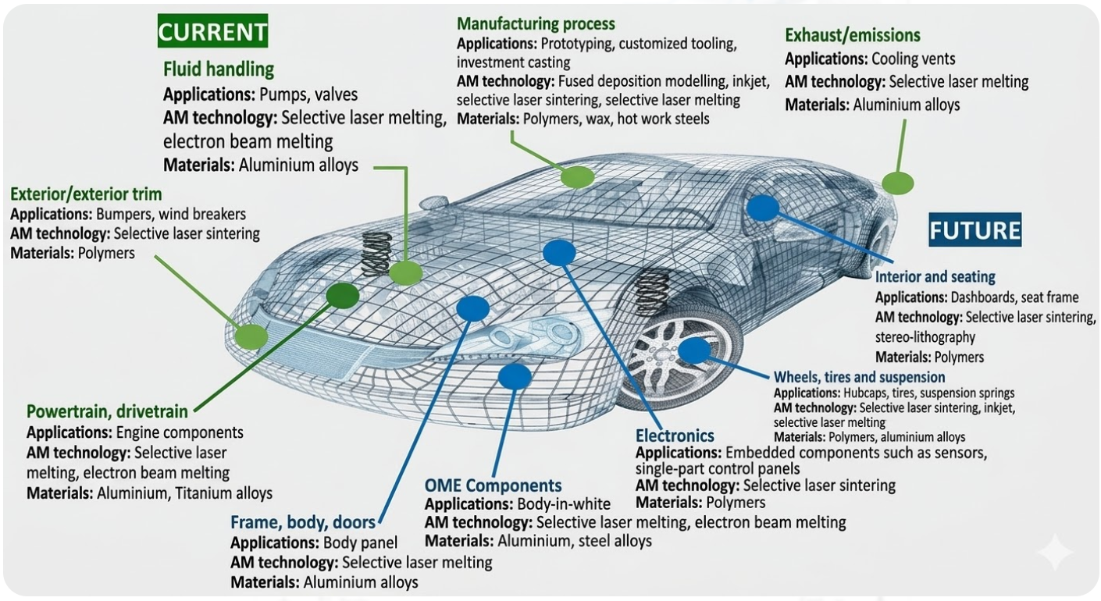

Figure 4.2: “Current Applications of AM in the Automobile Industry and Future Prospects”
(Source: Yang et al., 2024)
In the automotive manufacturing industry, “additive manufacturing (AM)” and “digital twin” technologies have become handy to make designs flexible and production plans. As Ben et al., (2025) observe, AM helps to speed up prototyping of properties, personalised parts and even lightweight structures. It further enables quickly testing numerous design iterations; it also lowers the time spent on development and, when loading with long development times, is the most effective (Yang et al., 2024).
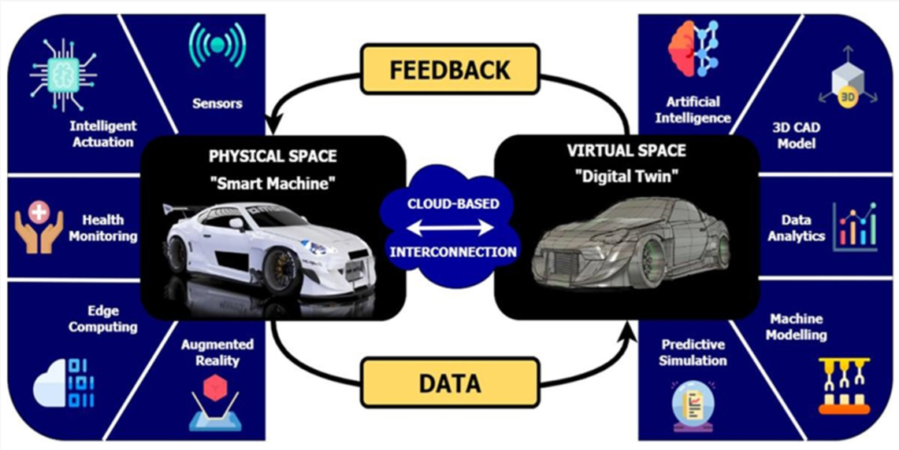

Figure 4.3: “Application of Digital Twin in the Automotive Industry”
(Source: Piromalis and Kantaros, 2022)
Meanwhile, the digital twin technology creates virtual models of the physical manufacturing systems so that engineers can simulate and optimise manufacturing even before the process takes place. Auto firms are adopting digital twins to enhance operational planning and minimise expensive factory interruption (Piromalis and Kantaros, 2022). With the “Virtual Factory” platform of BMW (with over 30 production sites globally), one can simulate the project of launching a new vehicle and its operations worldwide and implement a new procedure without actual activities (BMW Group, 2025). Hill (2025) approximates that the approach can reduce death planning expenses by up to 30%, which proves economical in large-scale manufacturing. But 3D printing is slow and costly when compared with the traditional mass production that is used in large quantities. A digital twin needs a lot of data infrastructure, the strength of simulation, and technical skills, which are available only to large and well-outfitted automotive firms (Piromalis and Kantaros, 2022).

4.2.2 Impact of 4IR Technologies on Operational Efficiency
Productivity Improvement
Implementation of the fourth industrial revolution (4IR) technologies has been vital in enhancing automotive productivity, involving speeding up production cycles and greater usage of equipment, in addition to process coordination. The so-called foresight allows the serial creators to optimise schedules and reduce downtime with the assistance of artificial intelligence, the Internet of Things, and advanced analytics.
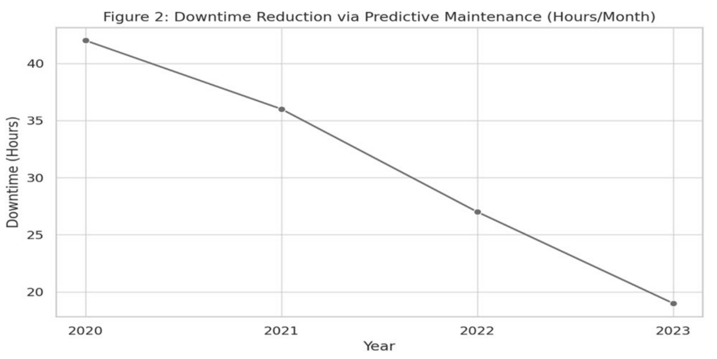

Figure 4.4: “Downtime Reduction Via Predictive Maintenance”
(Source: Barua et al., 2025)
According to it (Barua et al., 2025), 78% have implemented AI-driven predictive maintenance tools; machine downtime decreased by 42 to 19 hours per month; and reliability in operations increased (AI production management study) (Barua et al., 2025). Similarly, smart factory implementation improved labour productivity by 17.5%, and operating capacity from 72% to 98.5%, showing the undeniable efficiency of digital integration in its application form (see Table 4.2) (Kolluri, 2025).
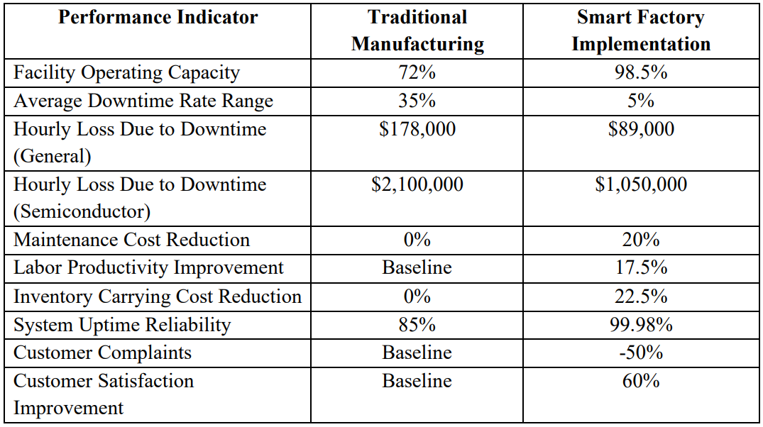

Table 4.2: “Manufacturing Performance Metrics and Smart Factory Implementation Results”
(Source: Kolluri, 2025)
There are also automobile cases which point to operational benefits of these technologies. Predictive maintenance lowered the deficits of equipment by 79% to 94.8% and the general services by 68% to 91% (Oxmaint, 2025). Nonetheless, small suppliers often lack the infrastructure and funds to expand on Industry 4.0’s boost to productivity.
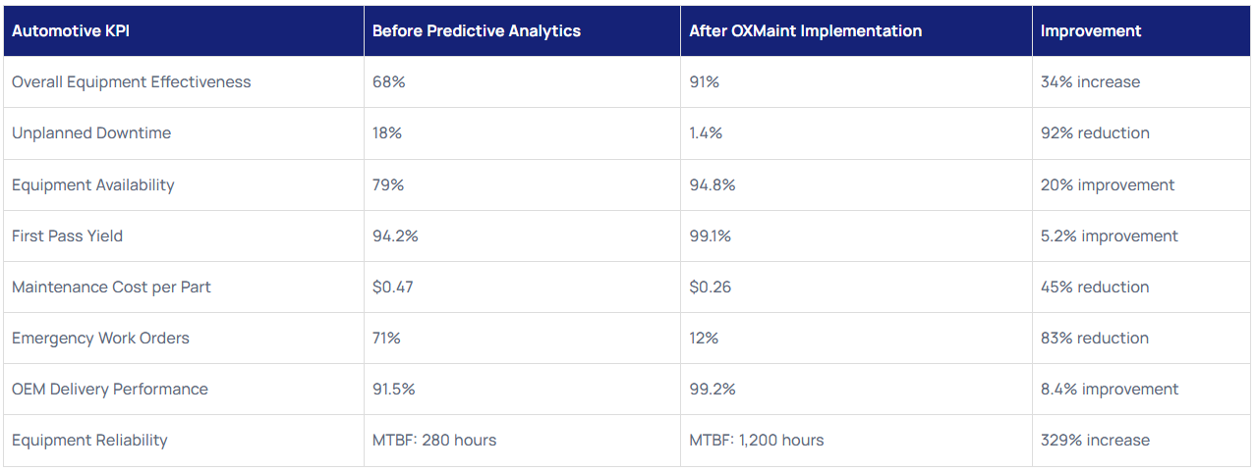

Figure 4.5: “Automotive Manufacturing Metrics Comparison”
(Source: Oxmaint, 2025)
Reduction in Operational Costs
Another major impact of 4IR technologies is predictive maintenance, automation, and better utilisation of resources, which reduces the cost of operation. Predictive maintenance systems predict potential failure in equipment early using IoT sensors and machine learning, thereby preventing emergency repair and unplanned production failures. Ruzicka (2025) has shown that predictive maintenance has the potential to save machine downtime by 30-50% and maintenance by 30-40%, and increase equipment life and operation. Smart factory adoption has financial benefits, as well, with Industry 4.0 apps resulting in a 20% decrease in maintenance and over 22% reduction in inventory-bearing costs (Kolluri, 2025). Yet the high costs of start-up of digital infrastructure and robotics are often high enough to choke small suppliers from getting their full benefits.

Quality Enhancement and Defect Reduction
Industry 4.0 technologies have seen the automotive industry improve the quality of products and reduce defects (Soori et al., 2024). In quality inspection systems, AI is utilised to identify microscopic defects along the assembly line, during welding or painting, typically at the production point, which are not easily visible to human inspections. Automated monitoring systems are used to analyse the production data to identify the deviations at the earliest stage to prevent defects. In reports by Oxmaint (2025), it is recorded that predictive monitoring and smart inspection enhance yield rates of first pass by 94.2% to 99.1%, giving a strong decrease in noise (refer to Figure 4.5). Similarly, predictive analytics in the monitored applications reduces defects by 9% to 3% (Fenton, 2025). However, advanced AI systems need tuning, technology, and human intervention to ensure erroneous assessment and overconfidence in the automation.
Supply Chain and Logistics Efficiency
The automotive industry has tremendously optimised efficiency and logistics in its supply chain thanks to IoT, big data analytics, and cloud computing. Smart supply chains enable the tracking of component and inventory flows and production, rapid response to demand changes, and supply disruptions (Alonge et al., 2023). IoT-based monitoring systems retrieve real-time information associated with the inventory and production orders and increase the synchronisation of suppliers, manufacturers, and distribution channels. These systems reduce the inventory carrying costs by over 22% and enhance delivery rates in smart factory designs (Kolluri, 2025). Predictive analytics forecast demand and handle logistics plans, yet in digital supply chains, cybersecurity threats and data complexity are problems and thus require robust governance.

4.2.3 Challenges and Barriers to 4IR Adoption in the Automotive Industry
High Implementation Costs
A huge initial cost is regarded as one of the biggest implementation barriers in the automotive industry of the Fourth Industrial Revolution (4IR). Better AI, robot-making, and the Internet of Things can result in efficiency improvements, but they are costly. Looking at the financial burden, Reeves (2026) reveals that in 2023, major manufacturers will spend $12 billion on AI predictive maintenance, $28 billion on digital supply chains and $25 billion on 5G-enabled factory infrastructure, each costly to run compared to its benefits of operation.
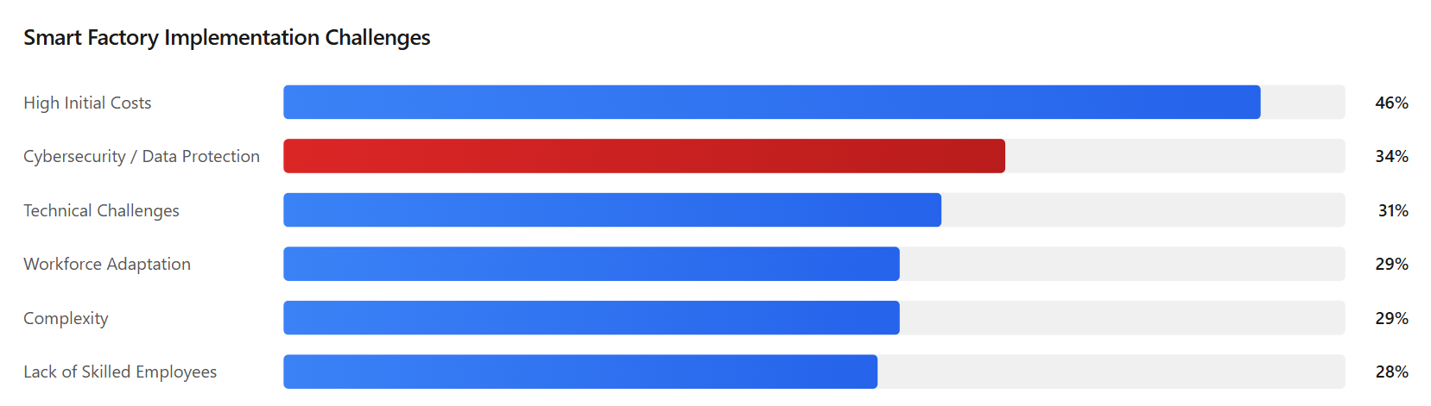

Figure 4.6: “Smart Factory Implementation Challenges”
(Source: Ozsevim, 2026)
Similarly, the average cost to implement robotic process automation in the largest automotive organisations was nearly $200 million (Reeves, 2026). Large companies like BMW Group and Toyota can access such investments, whereas small suppliers can get access to fewer funds and bigger returns. The obstacle to the implementation of smart factories is their high cost, according to 46% of manufacturers, especially SMEs (see figure 4.6) (Ozsevim, 2026). This means that 4IR use is low despite efficiency being increased.
Another important barrier to the use of Industry 4.0 technologies is the threat of security risks and data privacy regarding the interconnected systems. Smart factories are associated with sensors, robotics, cloud services, and digital twins that communicate real-time information to enhance efficiency but increase their vulnerability. A report by Ozsevim (2026) adds that 34% of car manufacturers note cybersecurity as a key detrimental issue, only after the high cost of investment. Although targeted cyberattacks have risen by 47% between 2021 and 2023, breaches have averaged $3.8 million (Nayan, 2025). A major cyberattack that Jaguar Land Rover suffered was £1.9 billion (Ozsevim, 2026) and is part of the bad omen of the need to pay attention to the operational risks and compliance with the regulations.
The transition to Industry 4.0 technologies also suggests a huge need for a skilled workforce capable of running digital manufacturing systems, and numerous automotive organisations are encountering severe skills crises. The advanced technologies like AI, robotics, and big-data analytics demand the knowledge of data science, automation, and digital system operation. According to Rockwell Automation (2025), 37% of firms cite organisational change management as a major workforce concern, 36% report the rising costs of skilled labour, and 31% are challenged to find talent. The automation process is prevented because global industries will lack 7.9 million skilled workers by 2030. Automation is productive but requires enormous reskilling to establish efficient human-computer co-existence (Rockwell Automation, 2025).
Other challenges to the automotive companies, among others, are the deficiency of Industry 4.0 technologies’ integration with the already existing infrastructure. The old MES and control systems that cannot incorporate real-time statistics are still in use by most plants. Korodi et al., (2024) assert that retrofitting or replacement of equipment is normally necessary. The digital solutions that are poorly integrated may begin to disrupt the working process and reduce the reliability, even though they could benefit the operations and flexibility in production.

4.2.4 Key Success Factors for Effective Implementation of 4IR Technologies
Strong Leadership and Strategic Vision
Effective leadership and a strategic vision are widely agreed to be key motivators for the success of automotive 4IR technology applications. Digital change involves organisations restructuring, cultural change, and strategic investments. Zhou et al., (2024) reveal top management support, technological competence, and organisational readiness as the predictors of success.
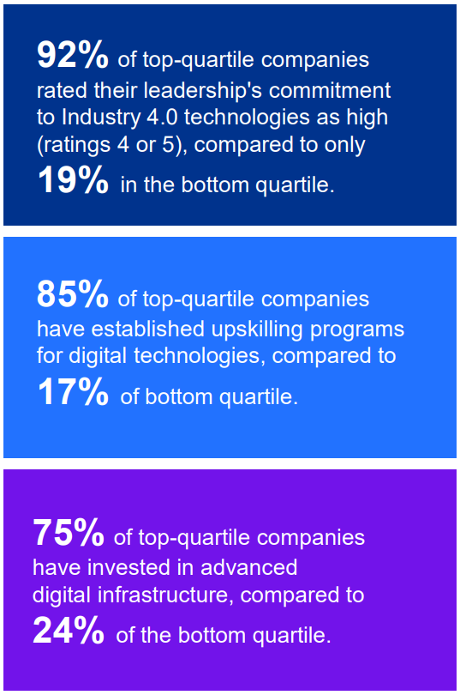

Figure 4.7: “Key Success Drivers of Digitally Mature Firms”
(Source: KPMG, 2024)
On the same note, digitally mature manufacturing organisations have also been found to portray more leadership commitment towards Industry 4.0 activities than the less advanced organisations. High leadership commitment is present in approximately 92% of the companies that do best, and 19% of the companies that do not do well (see figure 4.7) (KPMG, 2024). Nevertheless, leadership does not imply success since the development of digital work is likely to fail because of the lack of alignment and plan (Gregolinska et al., 2022). Digital transformation further requires periodic organisational alignment and operational goals.
Investment in Digital Infrastructure
Implementation of Industry 4.0 relies on more investment in digital infrastructure, such as the cloud, data platforms, smart sensors, and industrial IoT networks. With such technologies, carmakers can record and interpret real-time data on operations to assist in making decisions and predictive manufacturing. The report prepared by Reeves (2026) revealed that 68% of the OEMs further expanded the speed of digital transformation after COVID-19, and 75% will embrace the utilisation of the internet of things by 2025. The smart sensors check the temperature, vibration, and performance and minimise the downtimes (Pech et al., 2021). Nevertheless, it is a high cost, and small suppliers are unable to afford these costs, and divided systems do not allow for an important understanding.
Workforce Training and Skill Development
The advancement of the working force and the digital skills training are also crucial in applying the Industry 4.0 technologies. This necessity to introduce AI, robotics, and data analytics implies that employees will have higher-level digital skills, including data analysis, automation management skills, and system integration skills. Over 85% and 17% of digitally developed organisations and less-developed companies, respectively, run structured upskilling programmes, indicating the strategic value of workforce development. Mărcuță (2025) reports that the implementation of AI reduces the downtime by 20% since the specialised staff members are using digital tools. This lack of training can negatively affect the effectiveness of technology and result in resistance or inefficiency in the operations, and continuous reskilling is one of the keys to a successful digital transformation and long-term productivity.
Collaboration with Technology Partners
The implementation of 4IR relies heavily on partnerships with external technology providers like digital businesses, research firms, and innovation platforms. They provide AI, robotics, data analytics, and web knowledge that is not within the company. Zhou et al., (2024) note that successful Industry 4.0 relies on networks that encompass technologies and support from suppliers. These alliances are vital in ensuring the manufacturers adopt the 4IR in an efficient way that does not restrict competitiveness and innovation.
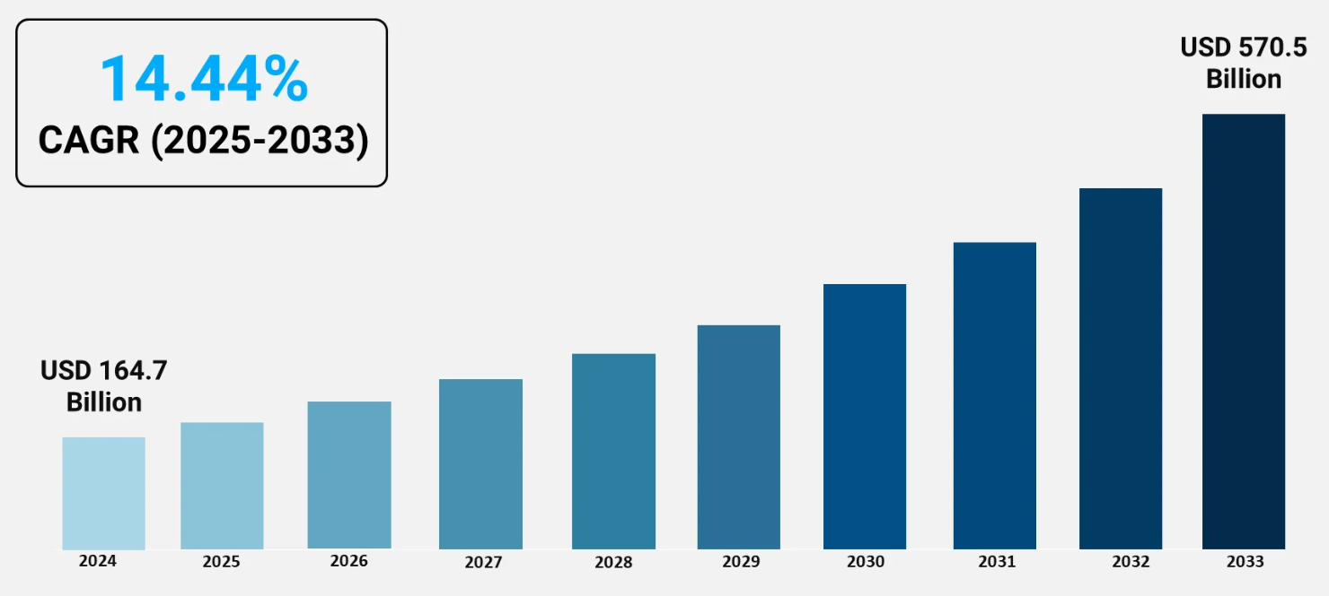

Figure 4.8: “Industry 4.0 Market Outlook”
(Source: IMARC, 2024)
In line with this, collaborative ecosystems may assist manufacturers to develop pilot projects and test digital solutions on a smaller scale before attempting large-scale. The IMARC (2024) predicts that Industry 4.0 in the world in 2024 will be USD 164.7 billion. It is projected to go further to USD 570.5 billion in 2033 with a CAGR of 14.44% in 2025-2033 (see figure 4.8). These robotics, automation and AI ecosystems increase efficiency and workflow by exchanging expertise. However, dependence on the outside world also translates to loss of intellectual property, and companies must retain the capacity to show strategic control.

4.2.5 Strategies Used by Automakers to Improve Operational Efficiency through 4IR
Smart Factory Implementation: One of the most significant steps toward improving the efficiency of operations by 4IR technologies is the arrival of smart factories. These factories utilise AI and IoT, robotics, cloud computing, and digital twins to synchronise machinery and workers digitally. In estimations, 24% of the auto factories will become smart, and 49% of the automakers will incur over $250 million (Catherine, 2022). The BMW Group Dingolfing factory utilises IoTs, AGVs, robotisation, and AI quality control to increase production efficiency (BMW Group, 2023). The quality of such systems is up to 99.998% (Anderson, 2025). The infrastructure expenses are, however, good, and this may inhibit the uptake by small suppliers.
Predictive Maintenance Systems: Predictive maintenance is another strategy that car makers can use to make operations more efficient using Industry 4.0. IoT sensors, data analytics, and AI are used to operate the systems and monitor equipment performance and predict their breakdowns. Within these systems, Tran (2026) notes that one can save up to 30% of machine downtimes, as well as 20% of equipment life. The BMW Group AI maintenance system reduced failure and repair time by 30% and 25% (Innovate, 2025). The CNC machines and the assembly lines can be monitored, and therefore, anomalies are identified early (Facttwin, 2024). The accuracy of systems, though, demands quality information and built-in sensors.
Data-Driven Decision Making: Data-driven decision-making has become a vital instrument that can enable automakers to make their operations more efficient with the help of Industry 4.0 tools. The car manufacturing generates numerous data on operations such as machines, sensors, and supply chains. Firms are applying AI and big data analytics to analyse this data to plan and use resources more effectively. Tran (2026) asserts that AI analytics will result in the effectiveness of equipment that is 10% better and a 50% decrease in the time to market. Processes are reconstructed using digital twins to determine the presence of inefficiencies prior to (Shaw, 2025). However, about 70% of the manufacturers lament the quality of data and integration problems (GreenData, 2026).
Integrated Digital Supply Chains: Another strategy that car manufacturers resort to to improve the efficiency of their operations is the development of integrated digital supply chains. Industry 4.0 technologies combine the suppliers, logistics, and production systems in a real-time data exchange. Sensors and cloud platforms are used to monitor inventory, shipments, and demand. Tran (2026) states that AI optimisation can reduce inventory by about 20% and, making storage less expensive. The visibility of the supply chain and the quickness of responses are increased through digital platforms. However, the standards of high integration and cybersecurity threats are also a matter of operation.
All in all, the strategies imply that automotive 4IR success must include the integration of digital systems, predictive maintenance, analytics, and connected supply chains to execute the best.

4.3 Analysis (Thematic)
Thematic analysis has been used to extract patterns in the six-phase approach created by Virginia Braun and Victoria Clarke. First, the process of familiarisation consisted of repeated review of Chapter Four outcomes to serve the aim of assessing the impact of 4IR technologies on the efficiency of operations. Subsequently, initial codes have been created, and these concepts were repetitive, like smart manufacturing, predictive maintenance, automation, cost reduction, and digital supply chains. The themes have been then critically clustered, revised, and typed over to further levels, giving rise to a narrative in relation to connections among digital technologies and efficiency (Braun and Clarke, 2022).
Theme 1: Adoption of Advanced Digital Manufacturing Technologies
This theme highlights the increasing adoption of the hi-tech 4IR technologies in the automobile manufacturing systems. They are artificial intelligence, Internet of Things, robotics, additive manufacturing, and digital twins, as they are deemed the central technologies to alter modern manufacturing. Findings suggest that such technologies can convert the smart factory into one in which machines, systems, and workers will communicate through a network of digital interactions. Predictive maintenance and automated quality inspection were assisted by AI-enabled systems, although they are costly and require skills. Robotics enhances the precision of production and safety of the working place, yet it is expensive and hard to combine with the existing manufacturing systems. Digital twin technology assists in the planning of production by simulating the process prior to its actual implementation to enable evaluation to be carried out, but it requires good operational data to power it.
Theme 2: Operational Efficiency Improvements through Digital Transformation
This theme revolves around the measurable impact of 4IR technologies on the performance of operations. The analysis demonstrates that digital technologies contribute to productivity and reduce operational expenses, along with the improvement of the quality of manufacturing. These benefits, however, depend on effective merging of automation, analytics and organisational readiness in the production systems. The reduction of engineering downtime and potentially the enhancement of the life of equipment are alleviated by predictive maintenance systems, though issues are the cost of system implementation and data integrity of the method. Automation also boosts the speed and precision of production, but an excess of that can also cause issues with adapting to the workforce. Meanwhile, real-time IoT information enables ongoing observation and helps to activate a more timely response to the functioning and more informed administration. Overall, the efficiency of the automotive operations can be enhanced by the digital transformation.
Theme 3: Challenges and Barriers to Industry 4.0 Adoption
The digital transformation does not have all positive sides; nevertheless, the analysis indicates that there are many impediments that stand in the way of the mass adoption of 4IR. The high cost of the digital infrastructure, robotics and data platform can remain large, particularly for the suppliers of small and medium-sized. Cybersecurity is an issue of interconnected systems that are a challenge to its operations and regulations that must be conquered by companies. In the old manufacturing systems, most organisations cannot assimilate the new technologies, hence restricting the benefits in efficiency. Other skill shortages within the workforce and more complex technologies demand specialised literature within the data analytics, automation, and control of digital systems. These barriers are all slowing down the implementation of 4IR and must be overcome with planning initiatives, strategic investment, and employee training.
Theme 4: Strategic Enablers for Successful 4IR Implementation
The final theme is focused on the organisation and strategic considerations of the achievement of the implementation of Industry 4.0 technologies. In facilitating transformation efforts and resistance, leadership commitment is highly significant. Investment in the digital infrastructure pays an easy, romantic entry of AI, IoT and data analytics systems in the business. The workforce training will result in employee preparedness and digital preparedness that will directly influence the success of the adoption. The collaboration with external technology may provide the chance to obtain specialised expertise and solutions. Those companies that are focused on systematic change strategies and continual competence improvement achieve more sustainable efficiency improvement. These findings are that, unless strategic planning and organisational preparation are in place, technology adoption is not adequate.

4.4 Discussion
Based on the findings, adoption of Fourth Industrial Revolution (4IR) technologies has been a key factor in enhancing the degree of operational efficiency in the automotive sector. The first objective aimed to comment on the current 4IR technologies deployed by a car manufacturer has been achieved in defining the main tools of AI, IoT, advanced robotics, additive manufacturing, and digital twins. It is claimed that the AI-driven predictive maintenance systems can reduce downtimes by more than 30% (Richter, 2026) and provide the IoT-driven smart factories a superior way to plan and allocate resources (BMW Group, 2019). These results confirm the concept of Noor., (2024), who believe that the 4IR technologies integrate digital, physical, and human systems, permitting them to make decisions in real-time.
The second objective, an analysis of effects on the effectiveness of operations, has been achieved by evidence revealing 4IR technology increases productivity, reduces operational costs, enhances quality, and eases supply chain performance. The predictive maintenance and smart factory applications have increased the availability of equipment (79% to 94.8%) and first-pass yield rates (94.2-99.1%) (Oxmaint, 2025; Fenton, 2025). These results agree with Elkateb et al., (2024) and permit the objective impact of digital transformation on efficiency in production.
The third objective related to barriers and success factors has been addressed in the research as well. These barriers have been enumerated to include high cost of implementation, cybersecurity concerns, lack of skilled workers and the fitment of old systems (Ozsevim, 2026; Rockwell Automation, 2025). Contrary to this, there were strong, well-coordinated sources of change, employee education, collaboration, and cooperation with tech companies that were adopted as the most significant sources of their support (Zhou et al., 2024; KPMG, 2024).
Finally, the fourth objective, exploring what needs to be done to stream operational performance, has been achieved with the forecast of maintenance, smart factories, data-driven decision-making, and integrated digital supply chains as tactical alternatives (Tran, 2026; Catherine, 2022). All these findings support the fact that organisational preparation and strategic planning are equally important to the technological adoption that widens the existing knowledge on the successful 4IR implementation in the automotive manufacturing industry.

4.5 Summary
This chapter represents the key findings and discussions regarding the adoption of 4IR technologies in the automobile sector. It indicates how IoT, AI, digital twins and robotics enhance quality, productivity and cost-effectiveness. This chapter also recognised barriers, including increased costs and inadequate skills, while focusing on training, infrastructural growth and leadership as fundamental success drivers.

CHAPTER 5: Recommendations, Conclusion, and limitations of the research

5.1 Recommendations
Based on the findings of the provided study, several recommendations will assist in enhancing the adoption and implementation of the Fourth Industrial Revolution (4IR) technologies in the automotive sphere. First of all, automotive companies must devote more attention to the digital infrastructure, including the Internet of Things networks, artificial intelligence, robotics, and digital twins, since they offer the necessary means of efficiency improvements in operations. Secondly, the organisations are encouraged to listen to the lifelong training and reskilling of the working population to be capable of working with new manufacturing systems, reducing downtime to a minimum and harnessing the advantages of predictive maintenance. Third, complex systems that require the protection of sensitive information must be protected using robust cybersecurity systems. Fourth, it fosters the pace of innovation by collaborating with technological partners and research organisations. Finally, an effective transformation plan that is led ensures organisational readiness and 4IR implementation.

5.2 Conclusion
This study has verified that the implementation of 4IR technologies has significantly contributed to the efficiency of operations in the automotive sector. AI, IoT, sophisticated robotics, additive manufacturing and digital twins are potent tools that can be used to enhance productivity, decrease the cost and streamline the supply chains. One of the effective methods of decreasing machine downtime, as well as raising the level of first-pass yield, is the implementation of predictive maintenance and intelligent factories. However, technological application is not a necessary ensemble of changes; the degree of leadership, talents of the workplace and interaction with technological allies are also significant considerations. An interplay of digital, physical, and human systems enables the production process to be data-driven, responsive, and flexible, generating a necessity to concentrate on technology and human capital to sustain the efficiency benefits.

5.3 Research Limitations
The study has been limited by citing secondary data sources, which might not fully represent the nuances of technology adoption in all automotive companies. The analysis has especially focused on manufacturers endowed with more resources, and this may not be the best representation of issues of smaller firms and those in the market in their emergent state. Additionally, 4IR technologies are dynamic, and the outcomes can be easily out-of-date due to the introduction of new tools and applications.

5.4 Future Implications
Future research should include empirical studies and case studies in different automotive environments, including SMEs and new markets, to learn more regarding the 4IR implications. The long-term organisational results, e.g., the sustainability and human-machine cooperation, must be expanded on. Studies can also measure the AI-based analytics using automated systems to automate the processes of production and supply chains. Overall, the research shows that 4IR can be a disruptive technology to guide the future of divisional strategic decisions in the automobile sector.

References

Abbasi, A. and Bahrami Dehdar, M. (2025) ‘Proposing a spider web model: an evolutionary pattern utilizing the research onion framework’, Methodology of Social Sciences and Humanities, 31(123), pp. 107–134. Available at: https://method.rihu.ac.ir/article_2371.html?lang=en (Accessed: 5 February 2026).
Acharya, R. (2025) ‘Examining interpretivism in social science research: exploring subjectivity, context, and meaning in social inquiry’, Education Science & Technology. Available at: https://journal.skultech.com/index.php/est/article/view/8/11 (Accessed: 5 February 2026).
Ahmed, S.K., Mohammed, R.A., Nashwan, A.J., Ibrahim, R.H., Abdalla, A.Q., Ameen, B.M.M. and Khdhir, R.M. (2025) ‘Using thematic analysis in qualitative research’, Journal of Medicine, Surgery, and Public Health, 6, p. 100198. Available at: https://www.sciencedirect.com/science/article/pii/S2949916X25000222 (Accessed: 5 February 2026).
Alonge, E.O., Eyo-Udo, N.L., Ubanadu, B.C., Daraojimba, A.I., Balogun, E.D. and Ogunsola, K.O. (2023) ‘Real-time data analytics for enhancing supply chain efficiency’, Journal of Supply Chain Management and Analytics, 10(1), pp. 49–60. Available at: https://www.allmultidisciplinaryjournal.com/uploads/archives/1744697208.pdf (Accessed: 11 March 2026).
Alshahrani, S.T. (2023) ‘Industry 4.0 in “major emerging markets”: a systematic literature review of benefits, use, challenges, and mitigation strategies in supply chain management’, Sustainability, 15(20), p. 14811. doi: https://doi.org/10.3390/su152014811.
Anderson, D.C. (2025) What is Industry 4.0? Available at: https://bizmasterz.com/what-is-industry-4-0/?utm_source=chatgpt.com#google_vignette (Accessed: 11 March 2026).
Annamalah, S., Aravindan, K.L., Ahmed, S. and Sentosa, I. (2025) ‘Exploring the relevance and rigour of case study research in business: a contemporary perspective’, Journal of Sustainability Research, 7(2). Available at: https://sustainability.hapres.com/UpLoad/PdfFile/JSR_1730.pdf (Accessed: 5 February 2026).
Barua, D.A., Sami, S.A. and Barua, L. (2025) ‘Leveraging artificial intelligence for smart production management in Industry 4.0’, Scientific Reports, 15(1), p. 41559. Available at: https://www.nature.com/articles/s41598-025-25413-6.pdf (Accessed: 11 March 2026).
Ben Said, L., Ayadi, B., Alharbi, S. and Dammak, F. (2025) ‘Recent advances in additive manufacturing: a review of current developments and future directions’, Machines, 13(9), p. 813. Available at: https://www.mdpi.com/2075-1702/13/9/813 (Accessed: 11 March 2026).
BMW Group (2019) Open, connected, collaborative: building the smart factory together. Available at: https://www.bmwgroup.com/en/news/general/2019/open-manufacturing-platform.html (Accessed: 11 March 2026).
BMW Group (2023) Automated driving at the BMW Group plant in Dingolfing. Available at: https://www.visit-bmwgroup.com/en/automated-driving-at-the-bmw-group-plant-in-dingolfing/ (Accessed: 11 March 2026).
BMW Group (2025) BMW Group scales Virtual Factory. Available at: https://www.press.bmwgroup.com/global/article/detail/T0450699EN/bmw-group-scales-virtual-factory?language=en (Accessed: 11 March 2026).
Braun, V. and Clarke, V. (2021) Thematic analysis: a practical guide. Available at: https://www.researchgate.net/profile/David-Morgan-43/post/How_to_teach_and_or_supervise_qualitatve_data_analysis/attachment/5d448bd33843b0b9825d91e4/AS%3A787530584698880%401564773331825/download/Braun+12+APA+Handbook.pdf (Accessed: 5 February 2026).
Byrne, D. (2022) ‘A worked example of Braun and Clarke’s approach to reflexive thematic analysis’, Quality & Quantity, 56(3), pp. 1391–1412. Available at: https://link.springer.com/content/pdf/10.1007/s11135-021-01182-y.pdf (Accessed: 5 February 2026).
Catherine, S. (2022) Impact of Industry 4.0 in automotive industry. Available at: https://www.fogwing.io/blog/industrial/industry-40-in-automotive-industry/ (Accessed: 11 March 2026).
Chopping, D. (2025) ‘Volkswagen to invest $1.2 billion in artificial intelligence by 2030’, The Wall Street Journal, 9 September. Available at: https://www.wsj.com/tech/ai/volkswagen-to-invest-1-2-billion-in-artificial-intelligence-by-2030-e41b2021 (Accessed: 17 February 2026)
Cotton, B. (2026) BMW puts AI humanoid robots on its European production line. Available at: https://www.rac.co.uk/drive/news/motoring-news/bmw-puts-ai-humanoid-robots-on-european-production-line/ (Accessed: 11 March 2026).
Drystek, A. (2025) Seven vital Industry 4.0 automotive technologies. Available at: https://acerta.ai/articles/key-technologies-for-automotive-industry-4-0/ (Accessed: 5 February 2026).
Elkateb, S., Métwalli, A., Shendy, A. and Abu-Elanien, A.E. (2024) ‘Machine learning and IoT–based predictive maintenance approach for industrial applications’, Alexandria Engineering Journal, 88, pp. 298–309. doi: https://doi.org/10.1016/j.aej.2023.12.065.
Facttwin (2024) Promoting peak performance in automotive manufacturing. Available at: https://facttwin.com/industries/automotive (Accessed: 11 March 2026).
Fenton, T. (2025) What is trimming output monitoring technology and why it’s revolutionizing industrial automation monitoring systems? Available at: https://pulsefactshub.com/futuretrendsintrimmingoutputmonitoringtechnology/ (Accessed: 11 March 2026).
Finn, T. and Downie, A. (2025) AI in automotive industry. Available at: https://www.ibm.com/think/topics/ai-in-automotive-industry (Accessed: 7 March 2026).
Gamage, A.N.K.K. (2025) ‘Research design, philosophy, and quantitative approaches in scientific research methodology’, Sch J Eng Tech, 2(1), pp. 91–103. Available at: https://www.academia.edu/download/122341245/SJET_132_91_103c_published_paper.pdf (Accessed: 5 February 2026).
Ghadge, A., Mogale, D.G., Bourlakis, M., Maiyar, L.M. and Moradlou, H. (2022) ‘Link between Industry 4.0 and green supply chain management: evidence from the automotive industry’, Computers & Industrial Engineering, 169, 108303. Available at: https://wrap.warwick.ac.uk/id/eprint/168996/1/WRAP-link-between-Industry-4.0-green-supply-chain-management-evidence-automotive-industry-Moradlou-2022.pdf (Accessed: 5 February 2026).
Grand View Research (2025) GVR report cover smart factory market (2025–2030). Available at: https://www.grandviewresearch.com/industry-analysis/smart-factory-market (Accessed: 11 March 2026).
GreenData (2026) Industry 4.0 in 2025: AI-powered smart factories come of age. Available at: https://greendata.io/insights/industry-4-0-smart-factories-2025 (Accessed: 11 March 2026).
Gregolinska, E., Khanam, R., Lefort, F. and Parthasarathy, P. (2022) Industry 4.0: digital transformation in manufacturing. Available at: https://www.mckinsey.com/capabilities/operations/our-insights/capturing-the-true-value-of-industry-four-point-zero (Accessed: 11 March 2026).
Haman, S., Ben Abdelouahab, A., El Bouzekri El Idrissi, Y., Merzouk, S. and Moumen, A. (2025) ‘Supply chain in the age of Industry 4.0: a literature review’, Logistics, 9(4), p. 173. doi: https://doi.org/10.3390/logistics9040173.
Hill, M. (2025) BMW Group transforms global manufacturing operations with advanced digital twin technology. Available at: https://www.processexcellencenetwork.com/digital-transformation/news/bmw-group-transforms-global-manufacturing-operations-with-advanced-digital-twin-technology/amp (Accessed: 11 March 2026).
Huang, J., Liu, H., Junginger, S. and Thurow, K. (2025) ‘Mobile robots in automated laboratory workflows’, SLAS Technology, 30, p. 100240. doi: https://doi.org/10.1016/j.slast.2024.100240.
Hyundai (2026) Hyundai Motor Group announces AI robotics strategy to lead human-centered robotics era at CES 2026. Available at: https://www.hyundai.com/worldwide/en/newsroom/detail/hyundai-motor-group-announces-ai-robotics-strategy-to-lead-human-centered-robotics-era-at-ces-2026-0000001100 (Accessed: 11 March 2026).
Ikram, M. and Kenayathulla, H.B. (2022) ‘Out of touch: comparing and contrasting positivism and interpretivism in social science’, Asian Journal of Research in Education and Social Sciences, 4(2), pp. 39–49. doi: https://doi.org/10.55057/ajress.2022.4.2.4.
IMARC (2024) Top factors driving growth in the Industry 4.0 market. Available at: https://www.imarcgroup.com/insight/top-factors-driving-growth-in-industry-4-0-market (Accessed: 11 March 2026).
Innovate (2025) Smart factories of the future: powered by AI, AR & spatial computing. Available at: https://www.innovate-labs.com/wp-content/uploads/2025/07/smart-factories-of-the-future.pdf (Accessed: 11 March 2026).
Jena, M.C., Sahoo, J.M., Iqbal, S. Katlinsky, I. (2023) Automotive IoT: applications, real-life examples & technologies. Available at: https://www.itransition.com/iot/automotive (Accessed: 7 March 2026).
Katlinsky, I. (2023) Automotive IoT: applications, real-life examples & technologies. Available at: https://www.itransition.com/iot/automotive (Accessed: 7 March 2026).
Kolluri, S. (2025) ‘Advancing process optimization through AI-enhanced cloud computing for real-time data insights’, International Journal for Multidisciplinary Research, 7(3). doi: https://doi.org/10.36948/ijfmr.2025.v07i03.44019.
Korodi, A., Nițulescu, I.V., Fülöp, A.A., Vesa, V.C., Demian, P., Braneci, R.A. and Popescu, D. (2024) ‘Integration of legacy industrial equipment in a building-management system Industry 5.0 scenario’, Electronics, 13(16), p. 3229. Available at: https://www.mdpi.com/2079-9292/13/16/3229 (Accessed: 11 March 2026).
KPMG (2024) Industry 4.0 adoption and strategic roadmap for Indian manufacturing. Available at: https://smartmfgindia.com/Document/KnowledgeRepository/Industry%204.0%20Adoption%20and%20Strategic%20Roadmap%20for%20Indian%20Manufacturing-1-36.pdf (Accessed: 11 March 2026).
Kumar, S. and Ujire, D.K. (2024) ‘Inductive and deductive approaches to qualitative research’, International Journal of Multidisciplinary Educational Research, 13(1), pp. 58–63. Available at: http://ijmer.s3.amazonaws.com/pdf/volume13/volume13-issue1(4)/9.pdf (Accessed: 5 February 2026).
Law, M. (2024) BMW & Industry 4.0 revolutionising automotive manufacturing. Available at: https://technologymagazine.com/articles/bmw-industry-4-0-revolutionising-automotive-manufacturing (Accessed: 5 February 2026).
Le, V.L.T., Nguyen, T.H. and Pham, K.D. (2023) ‘What drives Industry 4.0 technologies adoption? Evidence from a SEM-neural network approach in the context of Vietnamese firms’, Sustainability, 15(7), p. 5969. doi: https://doi.org/10.3390/su15075969.
Lim, W.M. (2025) ‘What is qualitative research? An overview and guidelines’, Australasian Marketing Journal, 33(2), pp. 199–229. Available at: https://journals.sagepub.com/doi/pdf/10.1177/14413582241264619.
Liu, H., Zhang, B., Wu, V., Yang, X. and Wang, L. (2025) ‘Review of digital twin in the automotive industry on products, processes and systems’, International Journal of Automotive Manufacturing and Materials, pp. 6–6. Available at: https://www.sciltp.com/journals/ijamm/article/view/971 (Accessed: 5 February 2026).
Makarevich, A. (2021) Top 5 Industry 4.0 technologies for the automotive sector. Available at: https://www.softeq.com/blog/top-5-industry-4-technologies-for-the-automotive-sector (Accessed: 5 February 2026).
Makri, C. and Neely, A. (2021) ‘Grounded theory: a guide for exploratory studies in management research’, International Journal of Qualitative Methods, 20, p. 16094069211013654. Available at: https://journals.sagepub.com/doi/pdf/10.1177/16094069211013654 (Accessed: 5 February 2026).
Mărcuță, C. (2025) Impact of Industry 4.0 on manufacturing – expert insights from digital transformation leaders. Available at: https://moldstud.com/articles/p-impact-of-industry-40-on-manufacturing-expert-insights-from-digital-transformation-leaders (Accessed: 11 March 2026).
McKinsey (2022) What are Industry 4.0, the Fourth Industrial Revolution, and 4IR? Available at: https://www.mckinsey.com/featured-insights/mckinsey-explainers/what-are-industry-4-0-the-fourth-industrial-revolution-and-4ir (Accessed: 5 February 2026).
Mittal, S., Khan, M.A., Romero, D. and Wuest, T. (2019) ‘A critical review of smart manufacturing & Industry 4.0 maturity models: implications for small and medium-sized enterprises (SMEs)’, Journal of Manufacturing Systems, 49, pp. 194–214. Available at: https://www.researchgate.net/profile/David-Romero-32/publication/328726147_A_Critical_Review_of_Smart_Manufacturing_Industry_40_Maturity_Models_Implications_for_Small_and_Medium-sized_Enterprises_SMEs/links/5be0577a4585150b2ba092ef/A-Critical-Review-of-Smart-Manufacturing-Industry-40-Maturity-Models-Implications-for-Small-and-Medium-sized-Enterprises-SMEs.pdf (Accessed: 5 February 2026).
Muthiya, S.J., Anaimuthu, S., Dhanraj, J.A., Selvaraju, N., Manikanta, G. and Dineshkumar, C. (2023) ‘Application of internet of things (IoT) in the automotive industry’, in Integration of mechanical and manufacturing engineering with IoT: a digital transformation, pp. 115–139. doi: https://doi.org/10.1002/9781119865391.ch4.
Nayan, K.R. (2025) Digital manufacturing transformation in the automotive industry: a technical analysis. Available at: https://www.academia.edu/download/121876936/Digital_Manufacturing_Transformation_in_the_Automotive_Industry_A_Technical_Analysis.pdf (Accessed: 5 February 2026).
Neale, B. (2020) Qualitative longitudinal research: research methods. London: Bloomsbury Publishing. Available at: https://www.bloomsbury.com/uk/qualitative-longitudinal-research-9781350188945/ (Accessed: 5 February 2026).
Noor, M.F., Kumar, A., Tripathi, S. and Gupta, V. (2024) ‘Challenges in adopting Industry 4.0 for Indian automobile industries: a key experts’ perspective’, Journal Européen des Systèmes Automatisés, 57(1). doi: https://doi.org/10.18280/jesa.570123.
Osei, S., Ahmed, A., Ayentimi, D.T. and Cobbinah, B. (2025) ‘Examining the effects of technological capabilities on value creation: mediated moderation role of disruptive business model and market turbulence’, Journal of Open Innovation: Technology, Market, and Complexity, p. 100658. doi: https://doi.org/10.1016/j.joitmc.2025.100658.
Oxmaint (2025) Boosting uptime in automotive manufacturing with predictive maintenance analytics. Available at: https://oxmaint.com/case-study/post/automotive-manufacturing-predictive-maintenance (Accessed: 11 March 2026).
Ozsevim, I. (2026) Automotive cybersecurity. Available at: https://www.automotivemanufacturingsolutions.com/smart-factory/cybersecurity-now-tops-production-concerns-as-smart-factories-expand-vulnerabilities/2607302 (Accessed: 11 March 2026).
Palikhe, A. and Phuyal, S. (2025) ‘Ethical consideration on editing of data in research’, PAAN Journal, 31, pp. 1854–1872. Available at: https://nepjol.info/index.php/paanj/article/download/73613/56371 (Accessed: 5 February 2026).
Parupelli, S.K. (2019) ‘A comprehensive review of additive manufacturing (3D printing): processes, applications and future potential’, American Journal of Applied Sciences. Available at: https://www.academia.edu/download/95222064/ajassp.2019.244.pdf (Accessed: 5 February 2026).
Pech, M., Vrchota, J. and Bednář, J. (2021) ‘Predictive maintenance and intelligent sensors in smart factory’, Sensors, 21(4), p. 1470. Available at: https://www.mdpi.com/1424-8220/21/4/1470 (Accessed: 5 February 2026).
Perody, S.H. and Sudhakara, A.M. (2024) ‘Adopting Industry 4.0 in India’s automotive sector: challenges, enablers, and policy implications’, Asian Review of Mechanical Engineering, 13(2), pp. 25–31. Available at: https://armejournal.org/index.php/arme/article/download/4277/7646 (Accessed: 5 February 2026).
Piromalis, D. and Kantaros, A. (2022) ‘Digital twins in the automotive industry: the road toward physical-digital convergence’, Applied System Innovation, 5(4), p. 65. Available at: https://www.mdpi.com/2571-5577/5/4/65/pdf (Accessed: 5 February 2026).
Reeves, D. (2026) Digital transformation in the car industry statistics. Available at: https://gitnux.org/digital-transformation-in-the-car-industry-statistics/ (Accessed: 11 March 2026).
Richter, J. (2026) AI in the automotive industry statistics. Available at: https://gitnux.org/ai-in-the-automotive-industry-statistics/ (Accessed: 11 March 2026).
Rockwell Automation (2025) Automotive industry shifts gears as talent and technology take center stage. Available at: https://www.rockwellautomation.com/en-in/company/news/press-releases/Automotive-Industry-Shifts-Gears-As-Talent-and-Technology-Take-Center-Stage.html (Accessed: 11 March 2026).
Rosca, C.M., Rădulescu, G. and Stancu, A. (2025) ‘Artificial intelligence of things infrastructure for quality control in cast manufacturing environments shedding light on industry changes’, Applied Sciences, 15(4), p. 2068. doi: https://doi.org/10.3390/app15042068.
Ruzicka, A. (2025) How predictive tech cuts downtime and boosts bottom line. Available at: https://insights.samsung.com/2025/10/08/how-predictive-tech-cuts-downtime-and-boosts-bottom-line/ (Accessed: 11 March 2026).
S&P Global (2025) AI in the automotive industry: trends, benefits & use cases (2025). Available at: https://www.spglobal.com/automotive-insights/en/blogs/2025/07/ai-in-automotive-industry (Accessed: 11 March 2026).
Saunders, M.N., Lewis, P. and Thornhill, A. (2023) Research methods for business students. Available at: https://www.researchgate.net/publication/240218229_Research_Methods_for_Business_Students (Accessed: 8 March 2026).
Shamsuddoha, M., Nasir, T. and Fawaaz, M.S. (2025) ‘Humanoid robots like Tesla Optimus and the future of supply chains: enhancing efficiency, sustainability, and workforce dynamics’, Automation, 6(1), p. 9. Available at: https://www.mdpi.com/2673-4052/6/1/9 (Accessed: 8 March 2026).
Shaw, J. (2025) The evolution of Industry 4.0 in automotive manufacturing. Available at: https://www.motor.com/2025/03/the-evolution-of-industry-4-0-in-automotive-manufacturing/ (Accessed: 11 March 2026).
Sherwani, F., Asad, M.M. and Ibrahim, B.S.K.K. (2020) ‘Collaborative robots and industrial revolution 4.0 (IR 4.0)’, in 2020 International Conference on Emerging Trends in Smart Technologies (ICETST), pp. 1–5. doi: https://doi.org/10.1109/ICETST49965.2020.9080724.
Shimkus, B. (2025) Hyundai built its newest factory around AI-powered technology like robotics and digital twins. Available at: https://www.businessinsider.com/hyundai-ai-powered-factory-smart-metaplant-america-2025-8 (Accessed: 5 February 2026).
Soori, M., Dastres, R., Arezoo, B. and Jough, F.K.G. (2024) ‘Intelligent robotic systems in Industry 4.0: a review’, Journal of Advanced Manufacturing Science and Technology, 4(3), p. 2024007. Available at: https://www.sciopen.com/local/article_pdf/10.51393/j.jamst.2024007.pdf (Accessed: 5 February 2026).
Taherdoost, H. (2021) ‘Data collection methods and tools for research: a step-by-step guide to choose data collection technique for academic and business research projects’, International Journal of Academic Research in Management (IJARM), 10(1), pp. 10–38. Available at: https://hal.science/hal-03741847v1/file/Data%20Collection%20Methods%20and%20Tools%20for%20Research%20.pdf (Accessed: 5 February 2026).
Toyota (2023) Our manufacturing companies have digital twins. Available at: https://www.toyota-europe.com/news/2023/our-manufacturing-companies-have-digital-twins (Accessed: 5 February 2026).
Tran, O. (2026) Industry 4.0 statistics. Available at: https://wifitalents.com/industry-4-0-statistics/ (Accessed: 11 March 2026).
Urrea, C. and Kern, J. (2025) ‘Recent advances and challenges in industrial robotics: a systematic review of technological trends and emerging applications’, Processes, 13(3), p. 832. Available at: https://www.mdpi.com/2227-9717/13/3/832 (Accessed: 11 March 2026).
Vasco, J.C. (2021) ‘Additive manufacturing for the automotive industry’, in Additive manufacturing, pp. 505–530. Elsevier. doi: https://doi.org/10.1016/B978-0-12-818411-0.00010-0.
Vivek, R. and Nanthagopan, Y. (2021) ‘Multi method qualitative research study in management’, Available at: http://digitalrepository.cipmlk.org/bitstream/handle/1/208/JHRMP%2006(2)%20-%20Final%20Book-31-49.pdf?sequence=1 (Accessed: 5 February 2026).
Wohl, D. and Schrag, D. (2023) Increasing manufacturing capacity to electrify passenger vehicles. Available at: https://www.belfercenter.org/sites/default/files/pantheon_files/files/publication/Wohl%20Schrag_EV%20Manufacturing%20Capacity_FINAL.pdf (Accessed: 11 March 2026).
Yang, H., Kumara, S., Bukkapatnam, S.T. and Tsung, F. (2019) ‘The internet of things for smart manufacturing: a review’, IISE Transactions, 51(11), pp. 1190–1216. Available at: https://par.nsf.gov/servlets/purl/10109126 (Accessed: 11 March 2026).
Yang, J., Li, B., Liu, J., Tu, Z. and Wu, X. (2024) ‘Application of additive manufacturing in the automobile industry: a mini review’, Processes, 12(6), p. 1101. Available at: https://www.mdpi.com/2227-9717/12/6/1101 (Accessed: 11 March 2026).
Yusuf, B., Walters, L.M. and Sailin, S.N. (2020) ‘Restructuring educational institutions for growth in the Fourth Industrial Revolution (4IR): a systematic review’, International Journal of Emerging Technologies in Learning, 15(3), pp. 93–109. Available at: https://www.academia.edu/download/69546958/6507.pdf (Accessed: 5 February 2026).
Yuwono, M.A. and Rachmawati, D. (2023) ‘Combined methods: can this solve the differences between deductive and inductive methods in qualitative research?’, Moroccan Journal of Quantitative and Qualitative Research, 5(3). Available at: https://revues.imist.ma/index.php/MJQR/article/download/45541/25214 (Accessed: 5 February 2026).
Zhong, Y. and Moon, H.C. (2023) ‘Investigating the impact of Industry 4.0 technology through a TOE-based innovation model’, Systems, 11(6), p. 277. doi: https://doi.org/10.3390/systems11060277.
Zhou, H., Zhou, B., Nie, Z. and Zheng, L. (2024) ‘Identifying key success factors for Industry 4.0 implementation: an empirical analysis using SEM and fsQCA’, Applied Sciences, 14(12), p. 5244. Available at: https://www.mdpi.com/2076-3417/14/12/5244 (Accessed: 5 February 2026).
Zipdo.co (2025) Digital transformation in the automobile industry statistics: ZipDo education reports 2025. Available at: https://zipdo.co/digital-transformation-in-the-automobile-industry-statistics/ (Accessed: 5 February 2026).
Zou, W., Man, S.S., Hu, W., Zhou, S. and Chan, H.S. (2025) ‘Factors influencing the acceptance of Industry 4.0 technologies in various sectors: a systematic review and meta-analysis’, Applied Sciences, 15(9), p. 4866. doi: https://doi.org/10.3390/app15094866.

