FCCU
Catalytic Circuit
&
Recovery
Unit

Contents

Page 3
Introduction

Page 4-5
PRT

Page 6-7
Riser, Reactor & Regenerator

Page 8
Fractionator

Page 9-10
Wet Gas Compressor

Introduction

The FCCU or Fluid Catalytic Cracking Unit is built of two parts. The catalytic circuit and the recovery unit. These two parts both work together and is built in one big circuit using each other to keep the unit running and keep it efficient.

This report will investigate the catalytic circuit and the recovery circuit. Made up of the PRT, riser, reactor, regen, fractionator column and the wet gas compressor. Along with the instruments, other vessels and critical equipment that are used to measure and control the unit. It will follow the process of the product coming into the unit and where it is sent.

PRT

The PRT (Power Recovery Train) consists of an expander linked by shafts in series to an air blower, steam turbine, reduction gearbox and motor generator. Energy is recovered from the flue gas stream at 695°C when it expands to a lower pressure/temperature condition across the single stage expander. The recovered energy is used to drive the multistage axial compressor which provides combustion air to the regenerator.
- Motor Generator 02-MG-101, makes use of the hot gases to generate electricity which can be used across site and is used as back-up power in the situation of a power cut. The motor generator (Mogen) on the PRT can operate as a motor driver to supplement the expander prior to using the steam turbine, or as an electric generator. The motor generator a 11MW maximum load and has a continuous load of 7MW at 1500 rpm.

- Air Blower uses the hot gases from the regen to turn the rotor which draws in air. As the air is drawn through the fans it heats up to 300º. The fans can be turned to compress the air more which will heat up quicker and draw more air in. This is used mainly in start-up as it will allow the heat to build up slowly and can allow the Catalytic Circuit to heat up thoroughly.

- Steam Turbine 02-CT-101B, is only used at start-up. It is designed to bring the train up to speed until sufficient power can be provided by the expander. The Steam turbine is also used to control the power train speed when there is insufficient energy available from the expander and the motor generator is fully loaded in the drive mode. The steam turbine uses 32 Kg/cm² HP steam at a temperature around 325°C. The steam rate is 69,100 Kg/hr and the BHP is 11,000 HP.

- The Expander is used to decrease the pressure of the flue gases from the regenerator. Doing this helps to make use of the hot gases to produce more energy. The expander is designed to operate at a maximum BHP of 18,460BHP and a flow capacity of 287.970 Kg/hr. The 60" flue gas outlet of the 3rd stage separator 02-D-107 flows through the expansion joint 02-EJ-102D to the suction of the expander 02-CT-101A, which is under the control of 02-PV-218B. There is also a 38" flue gas bypass around the expander under the control of 02-PV-218A. If the expander train shutdown circuit is activated, 02-PV-218A will fully open and 02-PV-218B (expander suction) will fully close.
At the expander suction point 02-AE-338 analyses and monitors the flue gas for:
  - Carbon Monoxide
  - Carbon Dioxide
  - Nitrogen
  - Oxygen Sulphur Dioxide
  - Water
Other Instruments such as, 02-AE-339, 02-AE-2451, 02-AE-338C, 02-TI-1080, 02-TQI-1587 are used to measure separate contents with alarms configured with them.

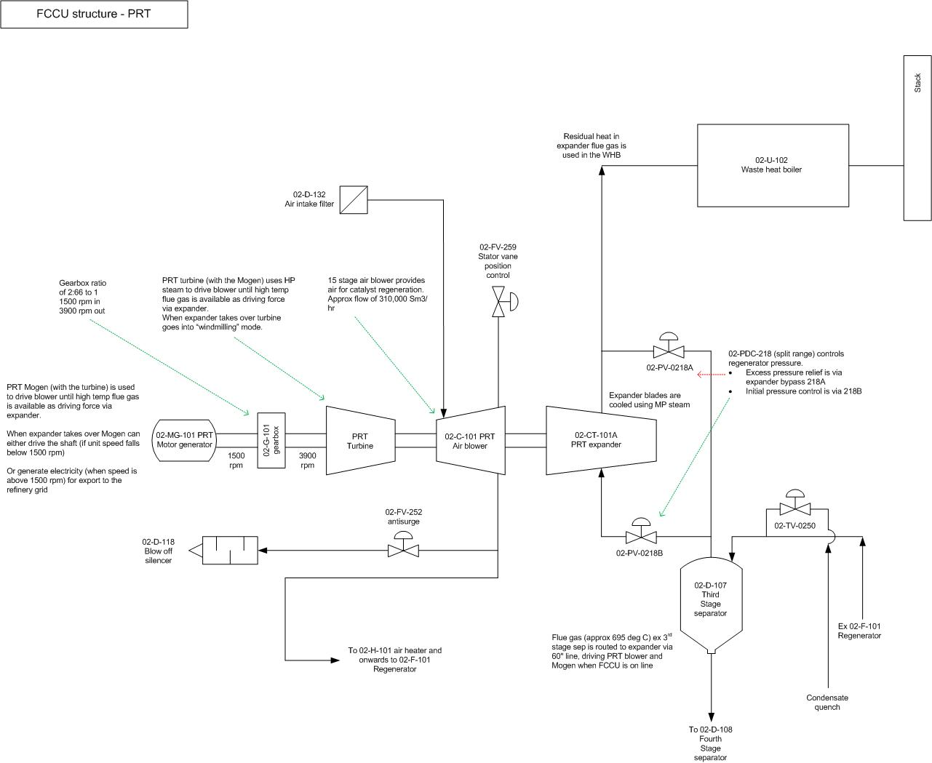

Riser, Reactor & Regenerator (regen)

In the riser, hydrocarbons are combined with atomizing steam and catalyst. Atomizing steam helps breaks up the hydrocarbons into smaller particles making the process more efficient. Due to the high pressure of atomizing steam being introduced into the riser with the hydro-carbons, it creates a low-pressure side drawing in catalyst from the new catalyst tank and from the bottom of the re-gen when the slide valve opens. 02-TT-215 measures the feed temperature to the riser. Catalyst is used as carbon sticks to it, which then removes the carbon from the product. The reaction takes place in the first 20-30% of the riser. Due to the reactions taking place it creates heat around 600º. Due to the hot temperature the product is boiled into a gas. The gas and spent catalyst then rise to the top of the riser into the reactor. The light gases then come off the top into the main fraction column. The spent catalyst falls to the bottom of the reactor where it sits on SCSV 02-D-105. Using 02-PDT-202, the pressure on each side of SCSV is measured to give a flow rate of spent catalyst when SCSV opens. Separate pressure recorders upstream and downstream of the SCSV 02-PR-231 and 02-PR-232 record the respective pressures. This again is used as a seal to stop heat from the regen from getting into the reactor where it could ignite the gases going into the main frac column. Cyclones are used in both the reactor and the regen to circulate air to help separate the catalyst from the gases. The cyclones also help to stop the catalyst from settling.
Measured amounts of carbonised catalyst is then released into the regen where heaters burn off the carbon from the catalyst. The heat generated from burning off the carbon is enough to keep the heat inside the regen hot enough that new carbonised catalyst instantly burns off the carbon. The clean catalyst then falls to the bottom of the regen where it then sits on RCSV 02-D-104. The position of 02-D-104 is set by 02-TIC-215. Differential pressure across 02-D-104, is obtained from 02-PDT-201. Air blowers from the PRT supply air into the bottom of the regen to create a fluidised bed. The regenerated catalyst is then added back into the riser with the feed. Over a 24-hour period around 3 tonnes of catalyst is lost. Hoppers are used to add in new catalyst along with additives which help with emissions.
The hot gases are then taken off the top of the regen, through another slide valve and into the expander. From here the hot gases then go into the waste heat boiler for steam production and then up off the top of the column.

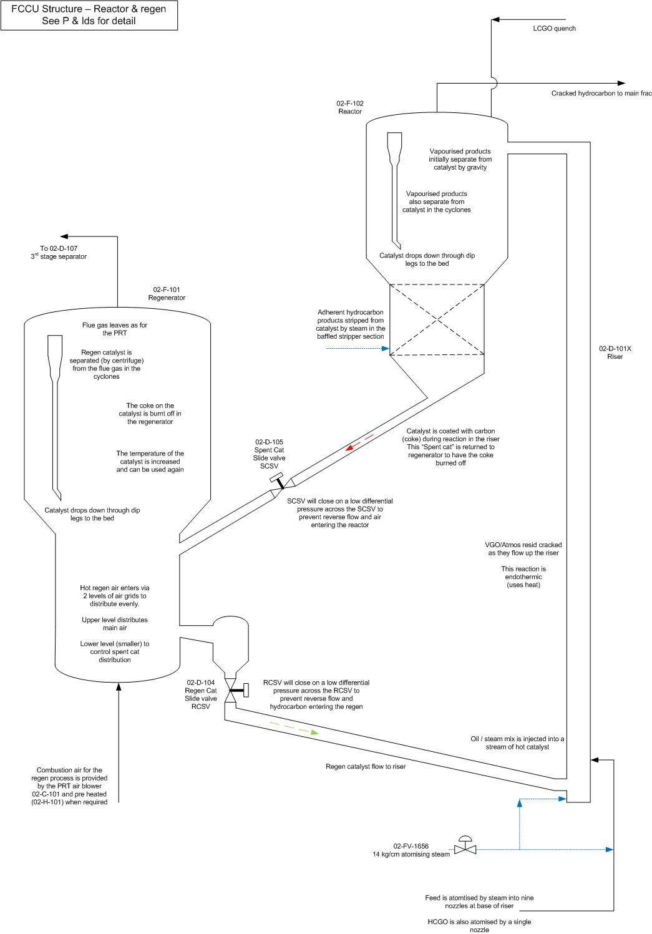
Fractionator Column
The main fractionator 02-F-201 separates the liquids such as LPG and Naphtha from the gases from the overheads from the reactor. The superheated vapours from the reactor are routed to the bottom section of the fractionator and fractional distillation separates the various streams.
The main fractionator unit consists of five main separate sections, which are:
- Heavy Cycle Gas Oil
- Intermediate Cycle Gas Oil
- Light Cycle Gas Oil
- Top Pump Around
- Overheads and Top Pump Back

The feed into the 02-F-201 is quenched to bring the temperature down to around ± 350°C. 02-F-201 bottoms pumps 02-P-202 A, B, C achieve quenching by pumping the hot liquid through a series of heat exchangers, where it is cooled against other process streams, then returning it to the Fractionator as reflux.
The overheads are used as feed for the recovery section the heavier products are sent to storage or used for blending. The gases are then sent to the main overhead accumulator 02-F-211 where any remaining liquids are dropped out of the product. From there they then go into the wet gas compressor to increase the pressure of product as in the 02-F-201 the head pressure is around 2Kg. The pressure of the heads in 02-F-201 is monitored by 02-PT-0077 which controls 02-XV-0077, which will send the gases off to flare in the case of a trip at 3.2Kg.
Heavy cycle gas oil (HCGO) is used to give heat input to the reboilers of the LCGO and naphtha product streams and to produce MP steam in the Fractionator Bottoms Steam Generators. HCGO between 270°C and 280°C is refluxed to the column through a distributor located above the Glitsch grids to quench the superheated feed entering the Main Fractionator.
In 02-F-201 there are 5 main DP transmitters which monitor the pressure across the trays:
- 02-PDI-4050 across trays 31 and 32
- 02-PDI-4049 across trays 19 to 30
- 02-PDI-4048 across trays 11 to 18
- 02-PDI-4047 between top of Glitsch grid and tray 10
- 02-PDI-4046 across the Glitsch grid

Wet Gas Compressor
The Wet Gas Compressor, 02-C-301 A & B is a two-stage centrifugal compressor driven by HP steam. The main purpose of the wet gas compressor is to increase the pressure of the Main Fractionator overhead vapour stream which then promotes more liquid recovery and provides the important function of maintaining pressure control on the Main Fractionator and Reactor systems.
The wet gas compressor is only designed for gases, however the gases that flow through are sticky as they are at the point of condensing.
Wet Gas Compressor 02-C-301 A and B
Suction Pressure | 1.8 Kgs
1st Stage Discharge | 6.8 Kgs
2nd Stage Suction | 6.5. Kgs
2nd Stage Discharge | 13.0 Kgs

02-LT-352 is connected to 02-LSXH-352 which will activate a local and control room alarm 02-LAXH-352. This will shut down the compressor and sound the control room shut down alarm 02-SDA-352. Most of the equipment on the wet gas compressor uses a 2/3 voting system. However, a shut-down will be initiated from the vibration monitoring only when 2 out of 2 have alarmed.



