LISA ROY
1804811
Learning Log
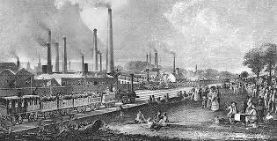

Distinctiveness and
Regeneration
BMSP4005
Tutor: Anthony Burns
Introduction
For this assignment I will write a Log based on three different lots of information. The first was a talk from Guest speaker Julie Hannam on the roots of Modern Llanelli, the second was a trip to The Wetlands Centre in Llanelli including a talk from Sarah Rees and the third was a talk from Nicola Jones from Tata Steel in Trostre. I will be explaining my findings on what is distinctive in the Llanelli area.

Guest speaker Julie Hannam – The roots of modern Llanelli
The Industrial Revolution began in the early 18th Century. This brought a huge change in the way people lived and worked. They left the farms in search of work in newly built factories. When the land was Farms it was controlled by large Estates which are still named after the owners today. Between 1700-1750 Coal seams from large estates were rented out. There was high quality coal in the Llanelli area and was used in steam engines. Between 1750-1796 Industrialisation came to Llanelli and the first tramroads and steam engines were constructed. The Rees family mine was the first to have a steam engine installed to allow them to dig deeper. The tramroads enabled efficient transport of the coal. In Llanelli there were 3 things needed to set up industry
- Land
- Money
- Workers
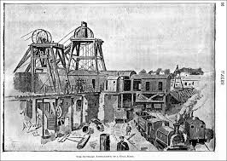Coal Mine in Llanelli
(Llanelli community heritage, 2019)

Key people involved in developing the Llanelli area:
- Chauncey Townsend -
- Alexander Raby (a main investor, credited as being the first of Llanelli’s great Industrialists)
- Squire, Evans and Beynon
- Robert Morgan (Industrialist interested in Iron furnaces and forges)
- Sir Thomas Stepney
- Rees family (Installed a steam engine)
There was a huge competition for control of the coal fields, but Llanelli failed to do well during this time. Alexander Raby arrived in 1797 and had Iron, copper and coal interests. He constructed 3 mines, workers cottages and residencies for himself and his agent. He attracted many entrepreneurs to the area. Alexander Raby had a 91-year lease of Busy Vein Coal under the Stradley estate. This enabled him to gain a lot of good quality coal. He also upgraded existing mines in the area.
After almost 100 years Llanelli was on the map for Coal and was part of the Industrial Revolution.
The Pemberton Family: Arrived in 1804 and invested lots of money and installed a steam pump engine. They brought 1300 acres of land and Pemberton House in the town centre. Parc Pemberton is a reminder of their presence in the area.
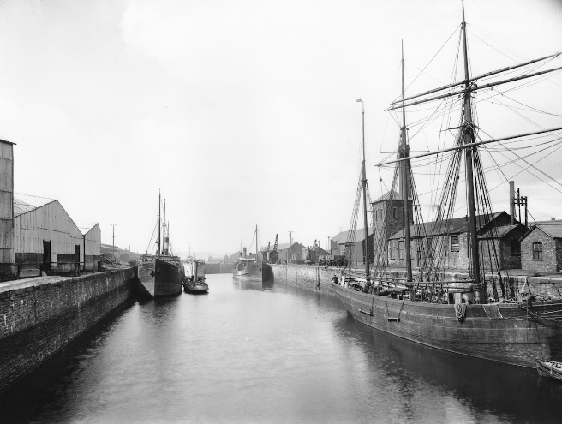Llanelli Copperworks docks 1805-1951
(www.llanellich.org.uk, 2019)
Between the 1830’s and 1870’s local people began to open their own enterprises. Land was owned by more people and tramways and railways expanded connecting the mines and quays. LLanelly Copperworks – founded by Charles Neville - donminated the industry in the Llanelli area with 60% of the output from them. In the second half of the nineteenth century Iron works took off and so did Tin plating. The Industrial revolution in Llanelli grew gradually and of sturdy foundation. It changed Society, land ownership and industry. (Hannam, 2019)

Trip to the Wetlands Centre Llanelli – 19th February 2019

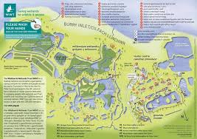 Map of the wetlands centre
(www.tripadvisor.co.uk, 2019)
The wetlands centre is situated on the outskirts of Llanelli and has been regenerated into a tourist attraction. It was first opened in 1991 and its aim is to protect wildlife in the area.
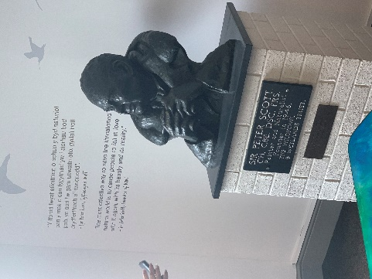Bust of Sir Peter Rees, Founder. My photo
Sarah Rees the tour guide at the wetlands centre gave us a talk on the history of the centre. It was set up by Sir Peter Scott. His vision was to get people closer to nature through bird interaction. They chose the site at Trostre as it as less likely to suffer from pollution. Its site on unused farmland. It is a salt marsh developed for different habitats for different species of birds. The centre had 70,000 visitors in 2018 compared to 24,000 in 2014. These visitors comprise of families, bird watchers and educational groups. (https://www.wwt.org.uk/who-we-are/, 2019)
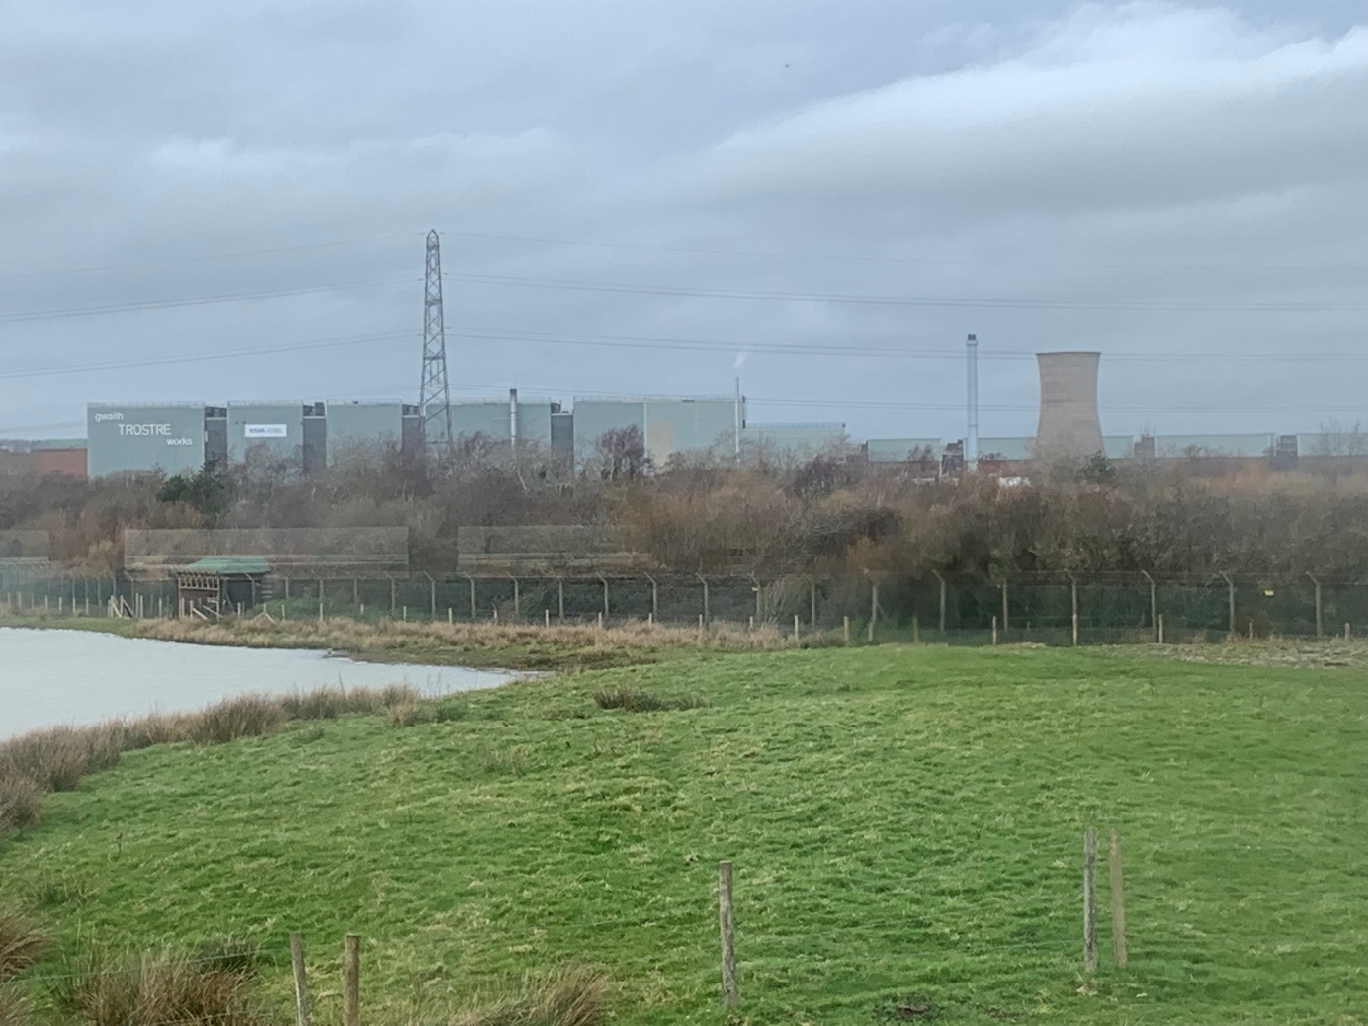
This is a picture of Tata steel I took at the Wetlands centre. It is the view from the Steel Hide, and it dominates the landscape.

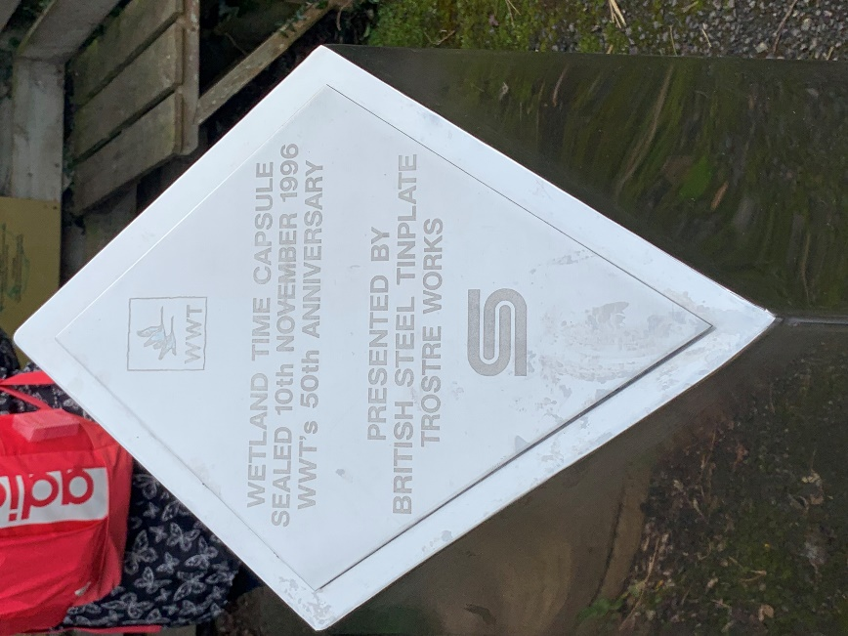
restore and create wetlands, save wetland wildlife, and inspire everyone to value the amazing things healthy wetlands achieve for peop

This is a time capsule placed at the wetlands centre in 1996 by the British steel tin plate Trostre works. Picture taken by me.

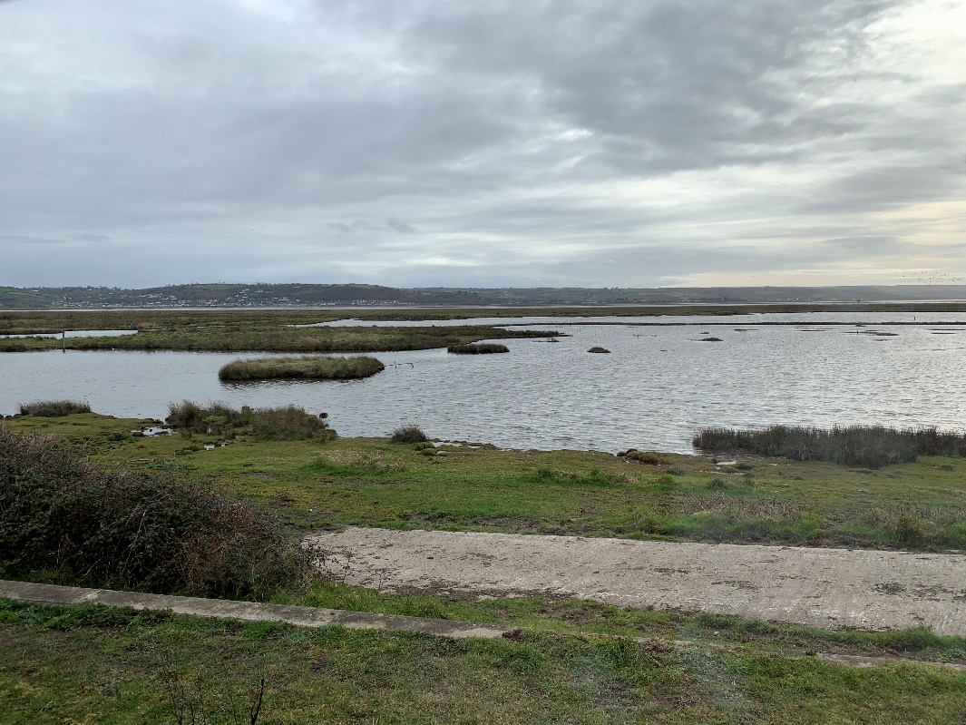
My photo of the salt marshes at Trostre which conserve the wildlife.

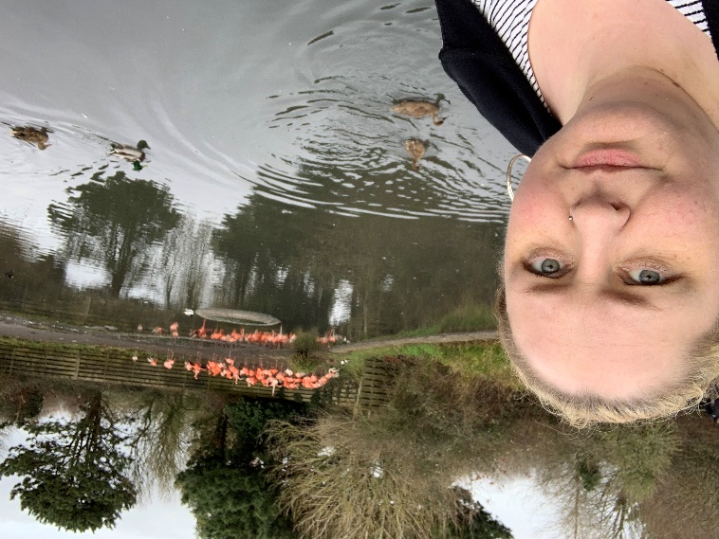
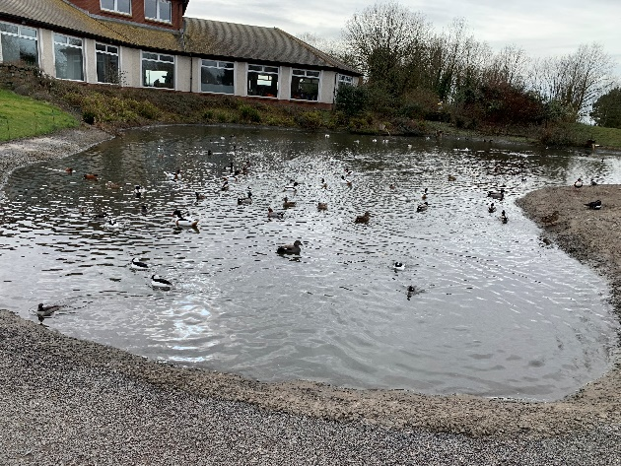
My photos of just some of the
Wildlife at the wetlands centre.
I would say that the wetlands centre has successfully regenerated this area of Llanelli and at the same time keeping wildlife safe. This land was previously unused farm land and would have sat empty. The visitor count gets higher each year and it appears to be bringing new people into the local area. The entrance fee helps to pay for the upkeep of the land, feeding of the birds and the staffs wages so it pays for itself. I am unsure if these same visitors venture into Llanelli town itself so has it done a lot for the town’s economy? Maybe not but it has put Llanelli on the map for conservation.

Guest Speaker Nicola Jones from Tata Steel – 19th February 2019
Job Title: Packaging and recycling manager (Tata group), she has worked for Tata steel for 20 years.
Tata at Trostre
Tata at Trostre employs 600 people it was called Corus before Tata and is an Indian company which own 20 other companies including Jaguar/Landrover. They both make and recycle steel. They produce tin cans, jam jar lids and biscuit tins as a couple of examples. In Trostre the steel is brought from Port Talbot by train and is thinned out to make the tin cans there. Heinz are one of their biggest customers.
Tata at Port Talbot
Steel is moved by Trostre by train for tin plating. The plot it sits on is 5 miles long and 3 miles wide and the train line is a private network for them. They have 2 lagoons for cooling needs on site. There are around 3500 employees on the site and a further 3500 contractors. The river severn has the largest tide and rise in the world ideal for docking ships which bring in raw materials to make the steel such as Iron Ore, coal and Limestone. There is a large deep-water harbour there in Port Talbot to accommodate these huge ships.
Iron combined with scrap steel (recycling) is blasted with oxygen at twice the speed of sound. This turns it into liquid steel, and it is then transported via Torpedos on train lines within the steel works. The blast furnaces on the site are heated to 1200 degrees and turn raw materials into steel.
(Jones, 2019)
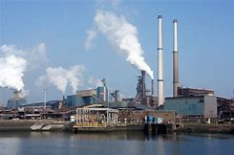Tata Steel, Port Talbot
(www.financeminutes.com, 2019)

Conclusion
Llanelli has undergone many regeneration projects. The wetlands being just one of them. This has brought tourism and conservation to the area and brought in new faces. I am unsure if these same visitors venture into Llanelli town itself so has it done a lot for the town’s economy? Maybe not but it has put Llanelli on the map for conservation. There are many places still to be regenerated and the area could definitely use this. The Industrial revolution was good for Llanelli as it put the town on the map and brought it up to the times. The area now has a lot of various industries including steel and continues to thrive Industrially. The manufacture of steel in Port Talbot and Trostre has undoubtably brought industry and jobs to the area. The steel works appears to be a sustainable industry that is thriving as it is one of a kind in this area and has the good transport links. Llanelli in my opinion has come a long way and is upcoming and just requires more input from the local authorities.

Works Cited
(2019). Retrieved from www.financeminutes.com.
Hannam, J. (2019, 29th January). The Roots of modern Llanelli.
https://www.wwt.org.uk/who-we-are/. (2019). Retrieved from www.wwt.org.co.uk.
Jones, N. (2019, feb 19). Tata Steel.
Llanelli community heritage. (2019). Retrieved from llanellich.org.uk.
Rees, S. (2019, February 19th). Llanelli, Wales.
www.llanellich.org.uk. (2019). Retrieved from www.llanellich.org.uk.
www.tripadvisor.co.uk. (2019).

