The Villa Savoye and The Schroder House will be analysed and used to explore the early phase of the modern movement in Europe. This will be done through four subheadings including: Historical Background; Plans and Sections; Materials and Light; Ideas and Theories.
Historical Background
Firstly, the Villa Savoye is located in Poissy, France and was designed in 1929 (Jencks, 2000) by Swiss born architect Le Corbusier who moved to France in the 1920s (Padovan, 2002). The purpose of the building was to be used as a luxury holiday home for the clients (Jencks, 2000). Padovan (2002) suggests that the style of the Villa Savoye is modernist and is viewed by some as significantly influential to the modern movement.
Secondly, the Schroder House was designed by Gerrit Rietveld in 1924 (Zijl, 2010), it is situated at the end of a row of terraced houses in Utrecht, The Netherlands (Frampton, 2016). The house was designed for the artist Truus Schroder and her family as their permanent home (Frampton, 2016). The Schroder house is a good example of the De Stijl movement and its ideas (Frampton, 2016).

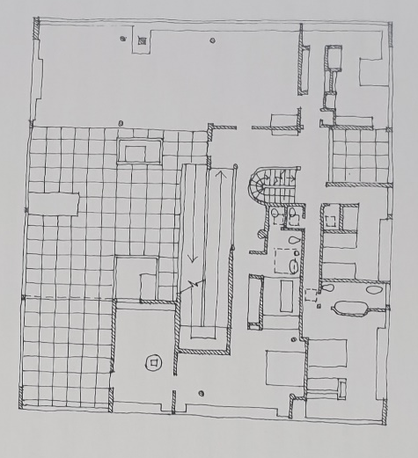
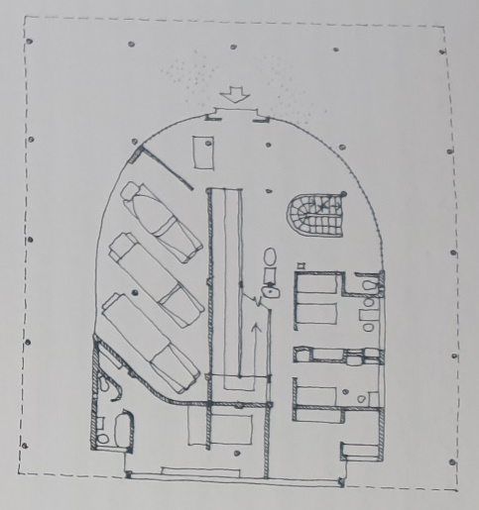
Plan and Section

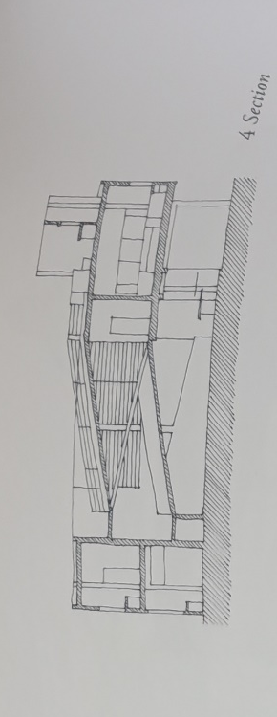
Figure 1: Villa Savoye ground-floor plan (Unwin, 2009)
Figure 2: Villa Savoye first-floor plan (Unwin, 2009)
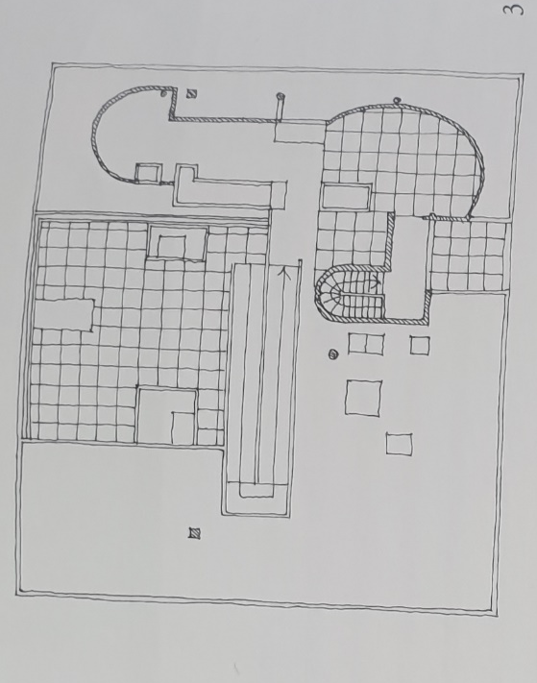

Figure 4: Villa Savoye section (Unwin, 2009)
Figure 3: Villa Savoye second-floor plan (Unwin, 2009)

The Villa Savoye incorporates ‘five points of new architecture’ in its design, which is Le Corbusier’s architectural manifesto, and includes: building elevated by pilotis; free plan; free façade; garden roof; and horizontal windows (Pawley, 1970; Jencks, 2000). The house is also designed on a square grid plan of columns which creates a free plan by reducing the number of walls inside the building (Murray and Osley, 2009). However, Le Corbusier has deviated from the grid to incorporate the central ramp which leads from the ground floor to the first floor (Unwin, 2010). The Villa Savoye has a reduced ground floor plan (figure 1) which is around one third of the area of the house, this is done using pilotis to lift the house from the ground, which gives the impression that the house is floating (figure 5) (Jencks, 2000).
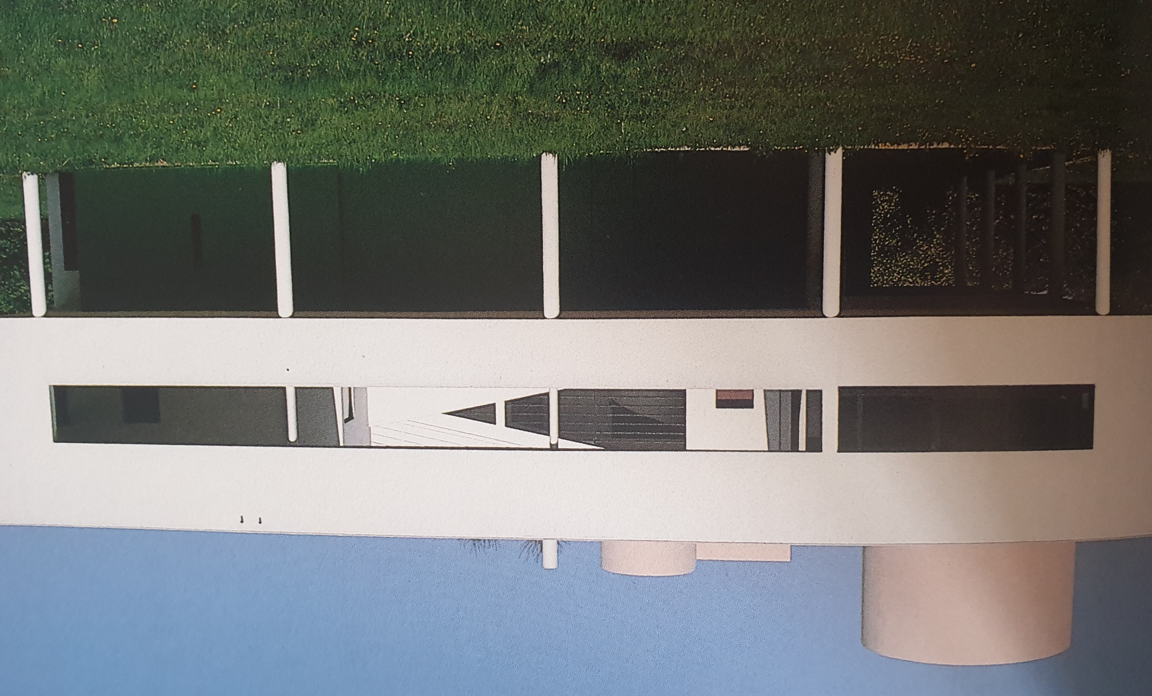

Figure 5: Villa Savoye elevation (Curtis, 1986)

Unwin (2009) suggests that a section through the Villa Savoye (figure 4) shows that the layering of the floors resembles the journey from darkness to lightness. For example, the ground floor is used as an access point for cars which receives least amount of light. Leading on to the main living area on the first floor (figure 2) whereby the space receives more light. Finally, leading to the garden roof (figure 3), which receives most light (Unwin, 2009). Furthermore, Curtis (1986) suggests that Le Corbusier creates a route through the Villa Savoye, e.g. entering the main hall at ground floor, the ramp then leads to the first floor which has bedrooms and living spaces and then the spiral staircase leads to the garden roof. This defining route through the house can be known as an ‘architectural promenade’ (Unwin, 2009).

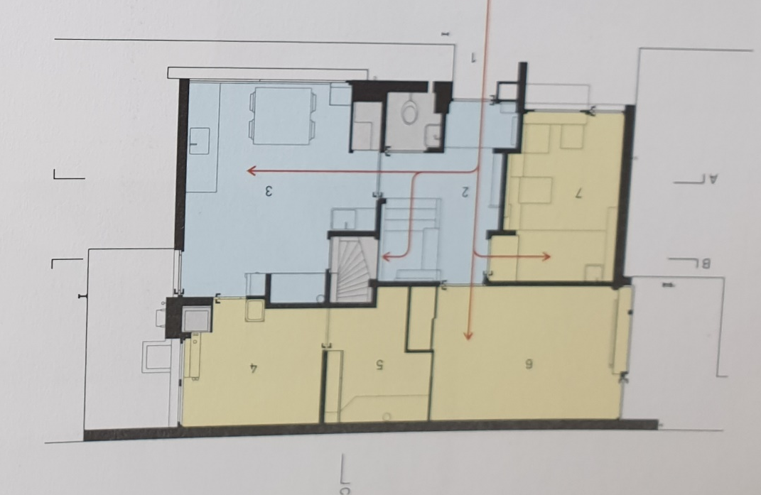
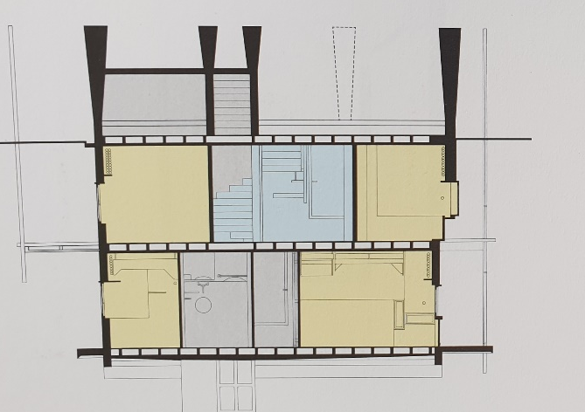
Figure 7: Schroder House ground-floor plan (Frampton, 2016)
Figure 6: Schroder House section (Frampton, 2016)

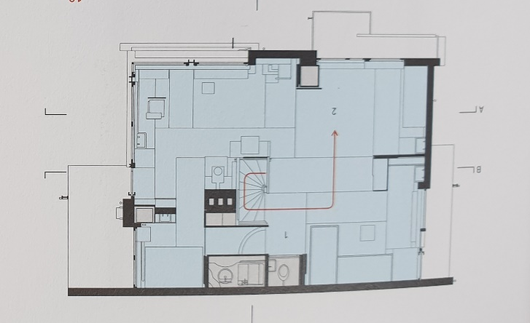

Figure 8: Schroder House first-floor plan (Frampton, 2016)

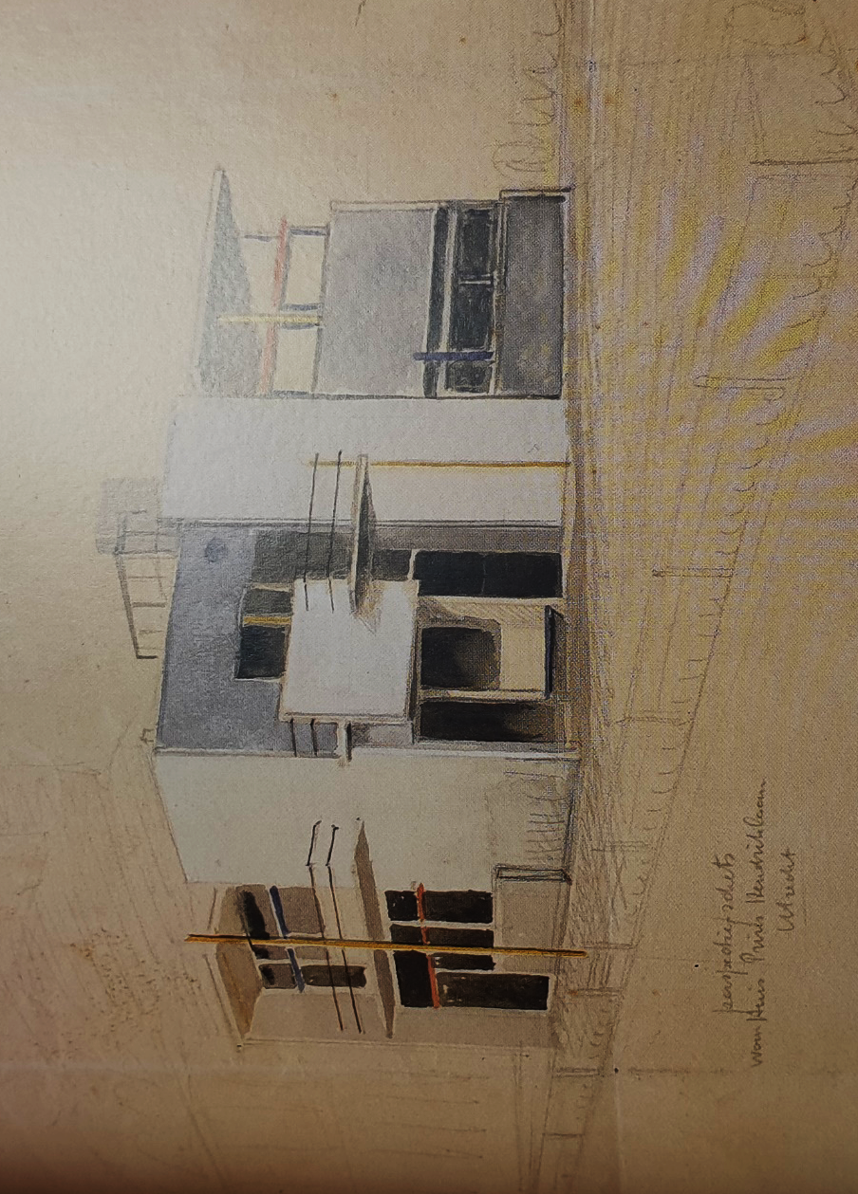
The Schroder house has three levels (figure 6), the cellar, ground floor and first floor (Zijl,2010), but there is a contrast between the first and ground floor. For example, the kitchen, studio and office on the ground floor are centred around a small hallway (figure 7), whereas the first floor (figure 8) is open plan with bedrooms and living spaces (Padovan, 2002). The open plan first floor is not typical of houses at the time and was seen as a new idea (White, 2003). However, open plan living allowed for both private and shared social spaces for the family to use, the rooms were separated by furniture and could be changed by sliding screens (Padovan, 2002; White, 2003).
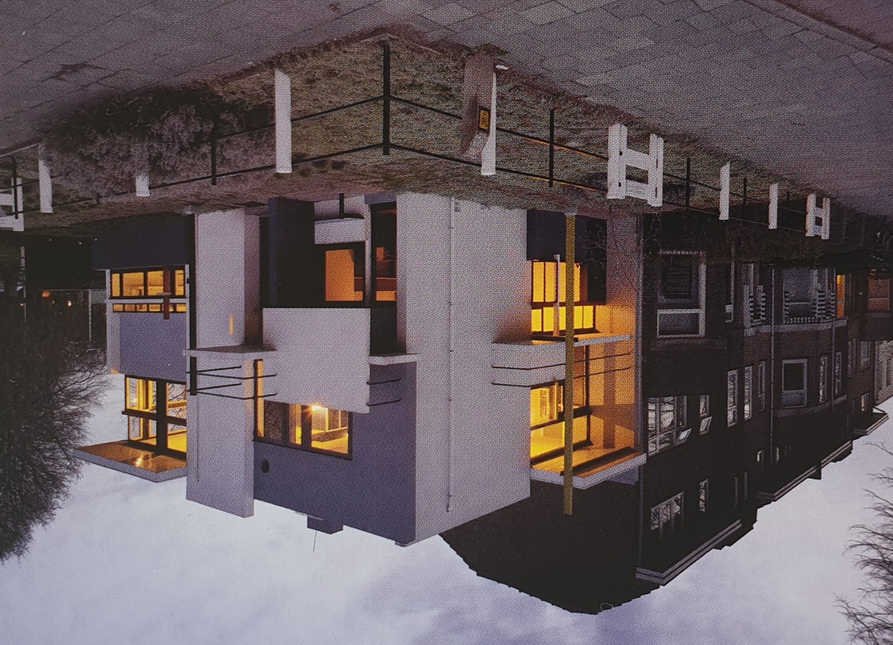

Figure 9: Schroder House drawing (Zijl, 2010)
Figure 10: Schroder House elevation (Zijl, 2010)

The open plan living spaces in the Schroder House are similar to the theories of Le Corbusier’s ‘free plan’ where rooms are separated by columns and walls are removed. Other similarities to the Villa Savoye are that the Schroder House has a simple rectangular plan, with the rooms centred around a small hallway and winding staircase (White, 2003). The three façades of the Schroder House have a ‘pin-wheel’ effect (figures 9 and 10) as they pass one another and cross which gives the impression of continual movement (Frampton, 2016). Additionally, the introduction of primary colours to the Schroder House help distinguishes each element and resemble a Mondrian painting (Zijl, 2010).

Materials and Light
The Villa Savoye is constructed of reinforced concrete and is described by Curtis (1986) as sharp planes floating above the ground. The use of pilotis and the ground floor painted green gave the illusion of the property floating (Murray and Osley, 2009). There is a contrast between the green base and the bright white façades, furthermore, the curves on the second floor were originally painted pink and blue to enhance this contrast and appear as if the building was an elevated single storey (Curtis, 1986).
The Villa Savoye has horizontal ribbon windows as specified in the ‘five points of new architecture’ which allows for more light into the building (Jencks, 2000). In addition, sunlight enters through the garden roof and into the first floor to light the living spaces (Unwin, 2010). Furthermore, the horizontal windows also allow for views of the surrounding area (Curtis, 1986).
The Schroder House has a timber frame with cement and brick cladding, this can sometimes be mistaken for a concrete structure due to the use of coloured planes to hide the materials used (Frampton, 2016). The use of primary colours outside the building continues into the interior floors and ceilings, which are used to emphasise the material aspects of the design and create an illusion that the rooms are larger (Zijl, 2010).
Unlike the Villa Savoye which floats above the ground, the Schroder house integrates into the area e.g. the mixing of interior and exterior spaces whereby the window wraps around the corner and opens to different views around the house (Frampton, 2016). This corner window design also allows for more natural light into the room which makes the small room seem larger and enhances the ‘pin-wheel’ effect (Frampton, 2016). Additionally, the upper floor is lit from a roof light above the central staircase, similar to the Villa Savoye which receives light from the roof garden (Zijl, 2010).

Ideas and theories
One of the main ideas of the design of the Villa Savoye is the demonstration of the ‘five points of new architecture’ (Jencks, 2000). Furthermore, Jencks (2000) compares many features of the design to a Purist painting, e.g. the ramp, double height spaces, spiral staircase and the curved solarium. The Villa Savoye demonstrates a contrast between the irregular surroundings and the geometric cube building (Unwin, 2009; Unwin, 2010). The Villa Savoye is elevated from the natural ground by pilotis which has been likened to a Greek temple which similarly is elevated by a platform (Unwin, 2009). This is in contrast to other buildings such as Fallingwater by Frank Lloyd Wright, which has a much stronger connection with its surroundings.
The Schroder House is said to be one of the only true works of the De Stijl movement (Padovan, 2002; Zijl, 2010). Similarly, to the Villa Savoye, the Schroder House can be compared to an artistic style, e.g. has many characteristics of a Mondrian painting (Unwin, 2010). The house can be seen as a sculpture of these paintings due to its irregular composition and geometric lines (Padovan, 2002). In comparison with the Villa Savoye, the Schroder House is detached from its dull surroundings (Unwin, 2010) and the one main idea of the Schroder House was to oppose the formality of typical houses of the time e.g. the introduction of open plan living and the use of more vibrant colours (Padovan, 2002). Another idea from the De Stijl movement that is demonstrated in the Schroder House is the use of planes floating or gliding past each other, this ensures that space is not enclosed (Padovan, 2002). By extending elements such as balconies and columns it gives the impression of movement (Zijl, 2010). This can be compared with the Villa Savoye which can be seen to be moving away from the ground by the use of pilotis (Unwin, 2010).

Conclusion
To conclude the Villa Savoye and Schroder House both had a significant part in shaping the ideas of the modern movement of architecture in Europe. The Villa Savoye demonstrates Le Corbusier’s ‘five points of new architecture’ and the Schroder House portrays the main characteristics of the De Stijl movement. Similarly, both buildings utilised the individual levels e.g. the Villa Savoye is layered in order of each floor receiving most light, whereas, the Schroder House is layered with the closed ground floor and open plan first floor. Originally both buildings used colour e.g. the Villa Savoye uses colours to give the illusion that the building is floating. However, the Schroder House uses colour to emphasise the extending planes.
The Villa Savoye posed many problems which later resulted in the neglect of the house e.g. the flat roof leaked, and the horizontal windows allowed too much heat loss (Pawley, 1970). The Villa Savoye has been seen as a failure as a house by many but found a new purpose of a ‘museum’ house (Unwin, 2010). However, the Villa Savoye was a turning point and landmark of modern architecture which demonstrated all ‘five points of new architecture’ (Jencks, 2000). Furthermore, Le Corbusier pioneered the use of reinforced concrete, glass and steel which has influenced many architects and buildings thereafter (Murray and Osley, 2009).
Similarly, to the Villa Savoye, the Schroder House is now used as a museum, however, can be seen to have been more successful (Padovan, 2002). The Schroder House was successful as a house and also demonstrates the De Stijl movement very well (Zijl, 2010). However, the design of the Schroder House was unpopular, and many people disliked the open plan living areas. This was due to the contrasting formality of buildings at the time (Padovan, 2000).

Word count: 1628

References
Curtis, W. (1986) Le Corbusier ideas and forms. London: Phaidon Press Limited.
Frampton, K. (2016) A Genealogy of Modern Architecture. Switzerland: Lars Muller Publishers.
Jencks, C. (2000) Le Corbusier and the Continual Revolution in Architecture. New York: The Monacelli Press.
Murray, I. and Osley, J. (2009) Le Corbusier and Britain. Oxon: Routledge.
Padovan, R. (2002) Towards universality Le Corbusier, Mies and De Stijl. Oxon: Routledge.
Pawley, M. (1970) Le Corbusier. London: Thames and Hudson.
Unwin, S. (2009) Analysing Architecture. 3rd Ed. Oxon: Routledge.
Unwin, S. (2010) Twenty Buildings Every Architect Should Understand. Oxon: Routledge.
White, M. (2003) De Stijl and Dutch Modernism. Manchester: Manchester University Press.
Zijl, I. V. (2010) Gerrit Rietveld. London: Phaidon Press Limited.

