

Applied Leadership and Management in the Workplace
Module Assignment Submission
Student Name: | Natalie O’Sullivan
Student Number: | 2328789@student.uwtsd.ac.uk
Module No: | BMSK5011
Module Title: | Developing Workplace Critical Thinking

Statement of Confirmation of Authenticity

By making this submission, the student declares that this is the work of the student named above. The work has not, in whole or in part, been knowingly presented elsewhere for assessment, or where assessment has been built on a previous assessment, this has been identified. Where materials have been used from other sources it has been properly acknowledged. If this statement is untrue, the student acknowledges that an assessment offence has been committed.

Attention is drawn to the plagiarism and unfair practice policies of both the University and of ILM.

Contents
Contents 2
Critical Thinking in the Workplace: The use of Critical Thinking for Workplace Decision Making 4
Summary 4
Introduction 4
Overview of Critical Thinking Theories and Frameworks 6
Bloom's Taxonomy: 6
Krathwohl's Taxonomy: 6
RED Model: 7
Paul-Elder Framework: 8
Critical Thinking aids in decision-making and problem-solving. 9
Bloom's Taxonomy: 9
Krathwohl's Taxonomy: 9
RED Model: 9
Paul-Elder Framework: 9
Critically evaluate the role of Critical Thinking in decision-making and problem-solving in the workplace 11
Examples of Decision-Making Scenarios Where Critical Thinking is applied 11
Analysis of the Effectiveness of Critical Thinking in These Scenarios 12
Demonstrate how biases and assumptions can impact or influence processes 14
Explanation of Biases and Assumptions 14
Types of Biases 14
How Biases and Assumptions Influence Decision-Making and Problem-Solving 15
Case Studies Illustrating the Impact of Biases and Assumptions 15
In Summary 16
Application of Critical Thinking Frameworks to the Workplace 18
Scenario 18
Chosen Frameworks: 18
Step-by-Step Analysis Using the Paul-Elder Critical Thinking Framework 18
Step-by-Step Analysis Using Six Thinking Hats Framework 20
Evaluation of the Outcomes and Effectiveness of the Applied Frameworks 21
Outcomes: 21
Effectiveness: 22
In Summary: 22
Conclusion 23
Summary of Key Findings 23
Implications for workplace decision-making. 24
Recommendations for Improving Critical Thinking in the Workplace 25
References 27

Critical Thinking in the Workplace: The use of Critical Thinking for Workplace Decision Making

Summary

This report investigates the significance of critical thinking in workplace decision-making and problem-solving. It seeks to assess how critical thinking frameworks, such as Bloom's Taxonomy, Krathwohl's Taxonomy, the RED model, and the Paul-Elder framework can help to improve decision-making processes. The research also examines the impact of biases and assumptions on decision-making, using case studies and examples to demonstrate their significance. The research demonstrates the effectiveness of critical thinking frameworks in resolving complicated situations by applying them in depth to real working contexts. Key findings emphasise the necessity of developing critical thinking abilities in the workplace to improve decision-making outcomes, and they offer techniques for improving these skills through training and development programs.

Introduction

Critical thinking is the ability to analyse information objectively and make sound decisions. It entails examining data, facts, observable occurrences, and research findings. Critical thinking has long been a cornerstone of education and intellectual conversation, with origins dating back to Socratic inquiry and the scientific method. In today's world, it is recognised as an essential ability in a variety of professions, including business, healthcare, and education.
In the workplace, critical thinking is required for effective decision-making and problem-solving. It allows employees to navigate difficult situations, recognise possible problems, and devise new solutions. Critical thinking promotes a culture of continual improvement and flexibility, which is essential in today's fast-paced, ever-changing work environment. Critical thinking can help organisations improve their strategic planning, risk management, and overall performance.
This report aims to:
- Assess the importance of critical thinking in workplace decision-making.

- Examine the effects of biases and assumptions on the decision-making process.

- Apply critical thinking frameworks to real-world working circumstances to demonstrate their efficacy.

Overview of Critical Thinking Theories and Frameworks

Critical thinking requires analysing, evaluating, and synthesising data to make sound decisions. Several theories and frameworks have been established to improve critical thinking, each providing unique views and tools.

Bloom's Taxonomy:

Created by Benjamin Bloom in 1956, Bloom's Taxonomy is a hierarchical model that divides cognitive skills into six levels: knowledge, comprehension, application, analysis, synthesis, and evaluation (Bloom, 1956). This concept helps people graduate from basic data recall to higher-order thinking skills like analysing and evaluating information. Bloom's Taxonomy can be used to build training programs, devise problem-solving tactics, and evaluate employee performance.
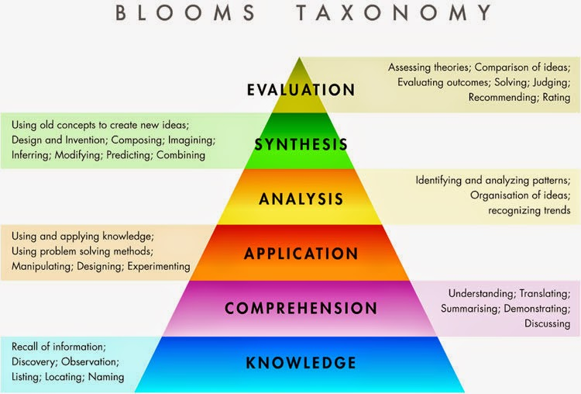
Bloom, B. S. (1956)

Krathwohl's Taxonomy:

Krathwohl's Taxonomy is an extension of Bloom's Taxonomy that focuses on the affective domain of attitudes, values, and emotions. It divides affective skills into five categories: receiving, responding, valuing, organising, and characterising (Krathwohl, 1964). This approach emphasises the value of emotional intelligence and ethical decision-making. In the workplace, Krathwohl's Taxonomy can be used to improve team relations and communication to build a healthy organisational culture.
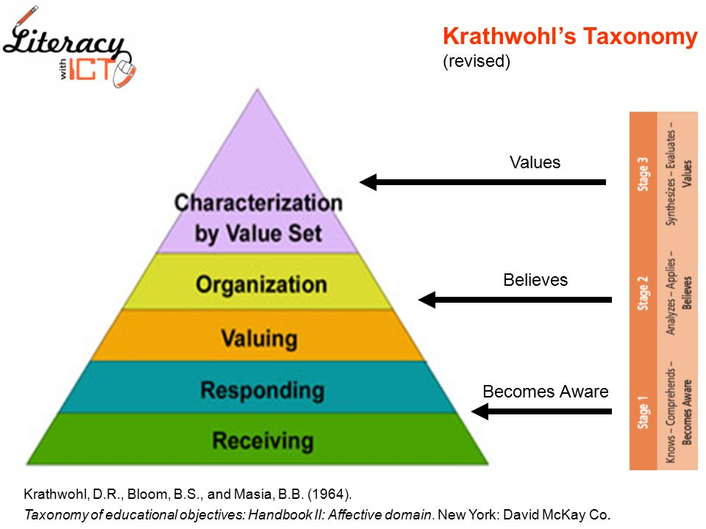
Krathwohl, D. R., Bloom, B. S., & Masia, B. B. (1964)

RED Model:

Pearson devised the RED Model, which stands for Recognise Assumptions, Evaluate Arguments, and Draw Conclusions. This framework promotes an organised approach to critical thinking by encouraging people to discover underlying assumptions, evaluate the validity of arguments, and make sound conclusions (Pearson, 2021). The RED model is particularly beneficial in the workplace for risk assessments, strategic planning, and dispute resolution.
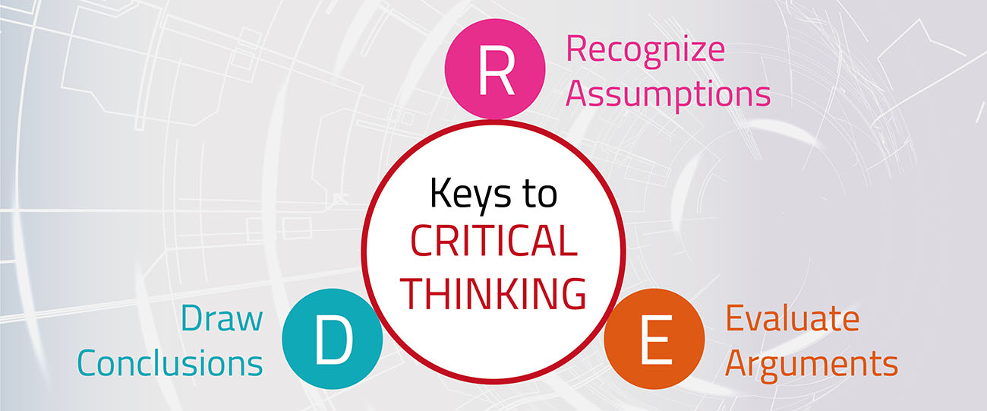
Pearson. (2021).

Paul-Elder Framework:

Richard Paul and Linda Elder developed this framework, which has three components: Elements of Thought, Intellectual Standards, and Intellectual Traits. The Elements of Thought are purpose, inquiry, information, interpretation, concepts, assumptions, implications, and point of view. Intellectual standards such as clarity, accuracy, precision, relevance, depth, breadth, and logic are employed to assess the quality of thought (Paul & Elder, 2001). To improve critical thinking, intellectual traits such as humility, courage, empathy, honesty, perseverance, belief in reason, and fair-mindedness are nurtured. The Paul-Elder model is broad and applicable to a variety of workplace contexts, including decision-making, problem-solving, and leadership development.
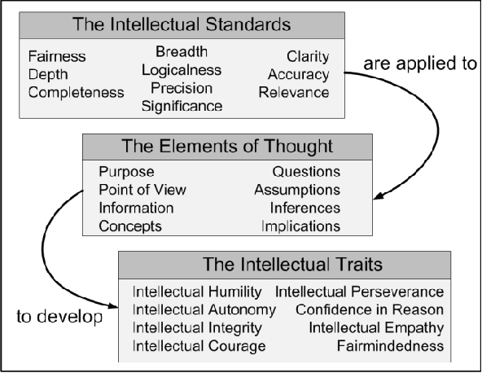
(Paul & Elder, 2001).

Critical Thinking aids in decision-making and problem-solving.

Critical thinking frameworks offer systematic ways to decision-making and issue resolution, allowing people to navigate difficult situations more effectively. In the workplace, these frameworks can be used to improve many elements of organisational performance.

Bloom's Taxonomy:

It is useful in establishing training programs that gradually improve employees' cognitive skills, allowing them to tackle increasingly difficult situations. By encouraging higher-order thinking, employees can produce more innovative ideas.

Krathwohl's Taxonomy:

This highlights the importance of emotional intelligence and ethical considerations in decision-making. Employees who value and organise their emotions and attitudes can improve their interpersonal abilities, resulting in improved team collaboration and dispute resolution.

RED Model:

Establishes a clear framework for analysing assumptions and arguments, which is critical for making sound judgments. Employees can eliminate bias and make more objective decisions by carefully identifying assumptions, assessing arguments, and reaching conclusions.

Paul-Elder Framework:

Provides a complete approach to critical thinking by combining thought elements, intellectual standards, and intellectual characteristics. This framework assists employees in developing a comprehensive awareness of situations, thoroughly evaluating information, and cultivating qualities that improve their decision-making abilities.

These frameworks enable people to think critically, make informed decisions, and solve problems efficiently, improving organisational performance and fostering a culture of continuous development.

Critically evaluate the role of Critical Thinking in decision-making and problem-solving in the workplace

Critical thinking improves workplace decision-making by requiring a thorough comprehension of the issues at hand. It requires employees to question their assumptions, detect prejudices, and consider alternate perspectives (Skrzek-Lubasińska & Malik, 2023). This approach reduces the possibility of errors while promoting reasonable, evidence-based decisions.
Additionally, critical thinking promotes a culture of constant progress. Organisations can improve performance by encouraging people to critically evaluate current methods and outcomes. This proactive attitude is critical in today's fast-changing corporate climate, where adaptation and innovation are essential for success.
Furthermore, critical thinking promotes ethical decision-making. It enables employees to recognise the potential repercussions of their activities and examine the broader influence on stakeholders. Organisations that prioritise ethical issues can develop confidence with customers, staff, and the larger community, improving their reputation and long-term viability.

Examples of Decision-Making Scenarios Where Critical Thinking is applied

Strategic Planning:
When creating a long-term business strategy, critical thinking is essential for analysing market trends, evaluating competitive advantages, and recognising potential hazards (Hoffman, 2023). For example, a company's leadership team may utilise critical thinking to assess various market entry plans, market size, competition, and the regulatory environment. By systematically analysing the benefits and drawbacks of each alternative, they can make an informed decision that corresponds with company objectives.

Crisis Management:
In times of crisis, critical thinking allows organisations to respond more effectively. It entails immediately acquiring pertinent information, assessing the situation from several perspectives, and devising a strategic reaction plan. For example, following a data breach, a company's IT team may utilise critical thinking to determine the source of the leak, assess the degree of the damage, and adopt preventative measures. By making data-driven decisions, they can reduce the effect of the crisis and restore stakeholder trust.

Resource Allocation:
When allocating resources, critical thinking ensures that decisions are made after conducting a thorough study of priorities and prospective results. For example, a project manager may use critical thinking to assess the possible return on investment for various projects, considering cost, time, and strategy alignment. They can maximise the value of the organisation's resources by critically evaluating the available possibilities.

Analysis of the Effectiveness of Critical Thinking in These Scenarios

The efficiency of critical thinking in these settings can be assessed based on the outcomes and techniques used.
Strategic Planning:
In the strategic planning example, critical thinking allowed the leadership team to make an informed conclusion that was in line with company objectives. By thoroughly examining market entry tactics, they lowered the possibility of costly mistakes and positioned the company for long-term success. This highlights how critical thinking can help ensure that strategic decisions are sensible, and evidence based.

Crisis Management:
In the crisis management example, critical thinking enabled IT staff to respond effectively to a data breach. By promptly assessing the problem and adopting data-driven remedies, they reduced the crisis's impact and restored stakeholder trust. This emphasises the need for critical thinking in helping organisations navigate complicated, high-pressure situations with agility and resilience.

Resource Allocation:
In the resource allocation example, critical thinking ensured that resources were allocated in a way that maximised value for the organisation. By rigorously evaluating possible initiatives, the project manager made informed judgements that were consistent with strategic aims and made the best use of available resources. This emphasises the importance of critical thinking in ensuring efficient and effective resource management.

Ultimately, critical thinking is essential for making decisions and solving problems in the workplace. It guarantees that decisions are based on a thorough study of facts, encourages continual improvement, supports ethical considerations, and allows for effective answers to difficult issues. Organisations that develop a culture of critical thinking can improve their decision-making processes, drive innovation, and achieve long-term success.

Demonstrate how biases and assumptions can impact or influence processes

Biases and assumptions can have a substantial impact on workplace decision-making and problem-solving, often resulting in inferior outcomes. This report investigates how biases and assumptions affect processes, describes the nature of biases and assumptions, and presents case studies to demonstrate their impact.

Explanation of Biases and Assumptions

Biases are preconceived assumptions or prejudices that influence our judgements and decisions, often unconsciously. They can result from a variety of circumstances, including personal experiences, cultural background, and social pressures (Smith & Noble, 2024). In contrast, assumptions are beliefs or concepts that we accept without examination. These assumptions are frequently founded on our values, attitudes, and beliefs, which influence our perspective of reality.

Types of Biases

Confirmation Bias: People frequently seek out and assign more weight to information that supports their pre-existing ideas while ignoring or undervaluing contradictory evidence (Nickerson, 1998). This can create misleading views and promote wrong preconceptions.
Anchoring Bias: This occurs when people place too much importance on the first piece of information they come across, which disproportionately influences their subsequent judgements and decisions, even if the initial information is irrelevant or misleading.
Availability Bias: People tend to overestimate the value of information that is easily accessible or recent. This can distort decision-making and lead to mistakes in judgement.
Stereotyping: The process of making generalised assumptions about individuals or groups based on attributes such as ethnicity, gender, or age (Dovidio et al., 2010). Stereotypes can lead to incorrect judgements and discriminatory behaviour, ignoring individual differences and contributions.

How Biases and Assumptions Influence Decision-Making and Problem-Solving

Biases and preconceptions can have a substantial impact on decision-making and problem-solving because they shape how information is viewed, understood, and assessed. They might lead to:
Narrowed Perspectives: Biases can narrow possibilities, resulting in limited or distorted decisions. For example, confirmation bias may drive a manager to disregard new ideas that contradict their current approach, resulting in missed chances and inferior solutions.
Inequitable Outcomes: Stereotyping can lead to biased hiring practices and unequal opportunities for advancement, perpetuating prejudice and limiting workplace diversity (Calluso & Devetag, 2024). This can create a hostile climate and impede the organization's ability to flourish.
Assumptions: Biases can impede creativity by encouraging established thought patterns while ignoring other alternatives. This rigidity can stifle the exploration of new ideas and limit an organization's ability to adapt and innovate in response to changing conditions.

Case Studies Illustrating the Impact of Biases and Assumptions

- Case Study: Hiring Process
In a Tech company, hiring leads constantly prefer candidates from famous institutions, presuming they are more qualified. This notion, impacted by the halo effect (where one favourable attribute overshadows other factors), leads to a lack of diversity in the workforce.

Over time, this stifles innovation since the team lacks diverse perspectives.
To address this bias, the organisation uses blind recruitment processes, in which candidates' educational histories are kept anonymous during the initial screening phase. This transformation creates a more varied and inclusive team, which generates new ideas and improves problem-solving abilities.

- Case Study: Product Development
A consumer product company's marketing team is working on a new millennial-targeted product. The team members, largely from Generation X, base their conclusions about millennial preferences on stereotypes. They presume that millennials prioritise cost above quality and build low-priced products.
However, further market research has revealed that millennials respect sustainability and are prepared to pay a premium for environmentally friendly products. The team's early assumptions resulted in a product that did not correspond with the tastes of the target market, resulting in low sales. By challenging their assumptions and undertaking extensive market research from the start, the team may have created a product that better met the demands of customers.

- Case Study: Crisis Response
During a public relations crisis, a company's leadership team experiences confirmation bias. They rely on internal reports that downplay the gravity of the situation while rejecting external criticism that underlines the potential harm to the company's image. This prejudice leads to a delayed and ineffective reaction, aggravating the issue.
By seeking multiple perspectives and thoroughly reviewing all available information, the leadership team could have taken more informed decisions and reduced the effect of the crisis.

In Summary
Biases and preconceptions can have a substantial impact on workplace processes, including decision-making and issue resolution. They can lead to limited perspectives, unequal consequences, and less creativity. Organisations may develop a culture of critical thinking and evidence-based decision-making by identifying and confronting these biases and preconceptions. Implementing techniques like blind recruiting, extensive market research, and seeking varied opinions can help offset the negative consequences of biases and preconceptions, resulting in more successful and inclusive outcomes.
Employees can make better-informed and sensible decisions if they are aware of their biases and preconceptions. This, in turn, improves the organisation's overall efficacy.

Application of Critical Thinking Frameworks to the Workplace

Using critical thinking frameworks in business scenarios can significantly improve decision-making and problem-solving processes. Below is a detailed application of critical thinking frameworks to a specific workplace scenario, including a step-by-step study of the chosen frameworks and an assessment of the outcomes and effectiveness of the applied frameworks.

Scenario
A technology company is experiencing diminishing sales of its flagship product. The leadership team must make a strategic decision about whether to invest in improving the existing product, developing a new product, or entering a new market.

Chosen Frameworks:
1. The Paul-Elder Critical Thinking Framework
2. The Six Thinking Hats Framework by Edward de Bono

Step-by-Step Analysis Using the Paul-Elder Critical Thinking Framework

- Purpose:
Identify the objective: Make a strategic decision that will increase sales while ensuring the company's long-term viability. This includes establishing clear goals and integrating decision-making with the company's vision and mission.
2. Question at Issue:
Clarify the fundamental question: Should the company invest in refining its current product, creating a new product, or entering new markets? Clarifying this subject is critical for guiding future investigation and ensuring that all relevant options are considered.
3. Information:
Collect relevant data: Collecting appropriate data is critical for making educated decisions. This covers market trends, sales data, consumer feedback, and competitor information. Comprehensive data collecting aids in comprehending existing market dynamics and spotting prospective opportunities and risks.
4. Interpretation & Inference:
Analyse data: Examine sales decreases, solicit consumer feedback, and evaluate market patterns to uncover potential causes and solutions. This stage is crucial for reaching accurate conclusions and making sound decisions regarding the best course of action.

5. Concepts:
Apply appropriate theories: Use marketing theories, product development principles, and market entry tactics, to create an organised decision-making process. These principles assist in determining the feasibility and potential impact of each option.
6. Assumption:
Identifying the underlying assumptions: This is critical for conducting a thorough investigation. This comprises estimates of the product's market potential, client preferences, and competition landscape. Challenging these preconceptions leads to a more objective and unbiased appraisal.
7. Implications and consequences:
Evaluate possible outcomes: Consider the impact of each alternative on sales, market share, and brand reputation. This stage entails considering both the short-term and long-term effects of each choice to maintain sustainable growth.

8. Points of view:
Consider perspectives: Considering the perspectives of various stakeholders, including consumers, employees, and investors, provides a comprehensive picture of the decision's impact. This stage guarantees that the decision is consistent with the interests of all parties involved and promotes a collaborative and inclusive approach.

Following the above steps allows organisations to use the Paul-Elder Critical Thinking Framework to create well-reasoned and strategic decisions that boost sales and ensure long-term success.

Step-by-Step Analysis Using Six Thinking Hats Framework

- White Hat (Information):
Concentrate on collecting and analysing objective facts and data. This comprises sales figures, market trends, consumer feedback, and competitive analysis. Examining this information objectively acquires a clear view of the existing situation and discovers gaps or opportunities.
2. Red Hat (Feelings):
Consider team members' emotions and intuitions regarding present products, new product ideas, and possible market growth (de Bono, 1985). Understanding key stakeholders' emotional responses, such as those of employees, customers, and investors, can reveal important information about their fears, hopes, and reservations.
3. Black Hat (caution):
Identify risks and potential issues: Examine the potential drawbacks of each alternative, including financial risks, resource allocation, and market obstacles. By carefully considering these disadvantages, you can anticipate possible issues and devise mitigation solutions.

- Yellow Hat (Benefits):
Highlight the positive features: This includes identifying the benefits, such as greater sales, market distinctiveness, and improved customer satisfaction. Focussing on the potential upside helps to create a convincing case for each alternative and motivates people to pursue specific methods.
5. Green Hat (Creative):
Develop innovative ideas for product features, marketing strategies, and partnering opportunities. This step entails thinking creatively and investigating novel ways that may lead to breakthroughs. Encourage brainstorming and creative thinking to identify new answers and tactics.
6. Blue Hat (Process):
Manage the decision-making process. Lead the team through the organised thought process, ensuring that all viewpoints are considered, and the conclusion is well-reasoned. This includes creating an agenda, moderating debates, and ensuring that each hat receives appropriate attention.

Applying the Six Thinking Hats framework ensures a full and balanced analysis, resulting in well-considered and strategic decisions that address both the organization's potential and difficulties.

Evaluation of the Outcomes and Effectiveness of the Applied Frameworks

Outcomes:

The Paul-Elder Critical Thinking Framework facilitated a methodical analysis of the problem, considering all important elements. By breaking down the decision into manageable components, the team was able to assess the possible impact of each option.
The Six Thinking Hats Framework allowed for a thorough analysis of the subject from several angles. It promoted innovation while also addressing potential risks and advantages, resulting in a balanced and educated conclusion.

Effectiveness:

Enhanced Decision-Making:
The organised approach of both frameworks improved decision-making, resulting in more considered and evidence-based choices.
Team Collaboration:
The frameworks encouraged team collaboration and open communication, considering varied perspectives.
Informed Choices:
Analysing data and considering views helped the team make educated decisions aligned with the company's strategic goals.

In Summary:

Using critical thinking frameworks in workplace contexts can greatly improve decision-making and problem-solving processes. In this example, the Paul-Elder Critical Thinking Framework and the Six Thinking Hats Framework provide a disciplined strategy to analysing the situation, ensuring that all important elements were considered.
The frameworks' efficacy was evidenced by improved decision-making quality, increased team collaboration, and informed decisions. Organisations that cultivate a culture of critical thinking can handle complicated challenges and achieve long-term success.

Conclusion

Developing critical thinking skills within the workplace is essential for fostering a culture of innovation, improving decision-making processes, and enhancing overall organizational performance. The findings of this report underscore the importance of critical thinking as a fundamental competency that can be cultivated through targeted training programs, a supportive work environment, and ongoing practice. As businesses navigate an increasingly complex and dynamic landscape, the ability to think critically and make informed decisions will be a decisive factor in achieving sustainable success.

Summary of Key Findings
Definition and Importance:
Critical thinking is the ability to analyse information, evaluate evidence, and generate well-reasoned arguments. It is essential for problem solving, creativity, and strategic planning, allowing people to traverse ambiguity and make informed judgements.
Current state:
Many organisations understand the need of critical thinking but struggle to integrate it into their culture. Common challenges include a lack of training, insufficient leadership support, and a preference for short-term results over long-term thinking.
Effective Training Programs:
Focussing on practical application, real-world settings, and collaborative learning has been shown to improve critical thinking skills. The most effective programs include reflective behaviours, feedback, and chances for continuing development (Rajaram, 2021).

Leadership:
Fostering a critical thinking culture requires leaders to model desired behaviours, encourage open conversation, and provide resources for skill development. Leadership commitment is vital for fostering an environment conducive to critical thinking.
Organisational culture
Plays a crucial role in critical thinking development and implementation. Cultures that value inquiry, open-mindedness, and the courage to question assumptions promote critical thinking.
Measuring Impact:
Evaluating the effectiveness of critical thinking efforts involves both qualitative and quantitative measurements. Surveys, performance evaluations, and assessments can assist monitor critical thinking skill development and its impact on organisational results.

Implications for workplace decision-making.
Improved Problem Solving:
Better critical thinking abilities help employees uncover root issues, produce inventive solutions, and predict prospective challenges.
Informed Decision-Making:
Critical thinkers may analyse sources, assess risks, and base judgements on evidence and reasoning. This leads to better-informed and strategic decision-making processes.
Improved Collaboration:
Critical thinking skills lead to more constructive debates, consideration of varied perspectives, and consensus-building. This promotes a collaborative environment in which ideas are freely shared and assessed.
Adaptability and Resilience:
Critical thinkers exhibit greater adaptability and resilience to change. Their capacity to analyse circumstances, learn from experiences, and make sound judgements enables organisations to better navigate uncertainties and disruptions (Folke et al., 2010).

Recommendations for Improving Critical Thinking in the Workplace

Implement comprehensive training programs
Emphasise practical applications of critical thinking. Use real-world scenarios, case studies, and simulations to provide students with hands-on experience. Use reflective activities and
feedback mechanisms to reinforce learning.
Create a supportive organisational culture
Encourage inquiry, open-mindedness, and constant learning. Encourage employees to ask questions, challenge assumptions, and consider alternate perspectives. Recognise and reward behaviours that show critical thinking.
Boost Leadership Commitment
Ensure that leaders at all levels prioritise critical thinking. Provide leadership development programs that emphasise the value of modelling critical thinking behaviours, encouraging open debate, and assisting with skill development projects.

Encourage Collaborative Learning
Provide opportunities for employees to communicate, share ideas, and learn from each other (Nokes-Malach et al., 2019). Create cross-functional teams to address complicated issues and promote varied perspectives.

Provide resources and tools
Help employees improve critical thinking abilities. This could include access to online classes, workshops, reading materials, and mentoring programs.
Measure & Evaluate
Implement metrics to evaluate the performance of critical thinking efforts. Use surveys, performance evaluations, and assessments to collect information about skill development and its impact on organisational results. Continuously adjust and improve training programs in response to feedback and results.

Promote Reflection
Encourage employees to reflect on their experiences, identify lessons learnt, and apply critical thinking to future circumstances. Create chances for regular reflection, such as journaling, debriefing sessions, and peer review (Helyer, 2015).
Encourage risk-taking and innovation
Create a safe environment for employees to try out new ideas. Encourage innovative thinking by giving people time and tools to experiment with new ideas and learn from their mistakes.

Implementing these principles can help organisations build a workplace atmosphere that fosters critical thinking abilities, resulting in better decision-making, increased collaboration, and greater adaptability in the face of change.
Finally, developing critical thinking skills can help organisations achieve long-term success and resilience in an ever-changing business world.

References

Bloom, B. S. (1956). Bloom's Taxonomy of educational objectives: Cognitive domain. Journal of Educational Psychology, 51(1), 25-36.
Calluso, C., & Devetag, M. G. (2024). Discrimination in the hiring process – state of the art and implications for policymakers. Equality, Diversity and Inclusion, 43(9), 103–121. https://doi.org/10.1108/EDI-10-2023-0340
de Bono, E. (1985). Six thinking hats: An essential approach to business management. Little, Brown and Company.
Dovidio, J. F., Hewstone, M., Glick, P., & Esses, V. M. (2010). The SAGE handbook of prejudice, stereotyping, and discrimination. SAGE Publications. https://doi.org/10.4135/9781446200919
Folke, C., Carpenter, S. R., Walker, B., Scheffer, M., Chapin, T., & Rockström, J. (2010). Resilience thinking: Integrating resilience, adaptability, and transformability. Ecology and Society, 15(4), Article 20. https://doi.org/10.5751/ES-03610-150420
Helyer, R. (2015). Learning through reflection: The critical role of reflection in work-based learning (WBL). Journal of Work-Applied Management, 7(1), 15–27. https://doi.org/10.1108/jwam-10-2015-003
Hoffman, B. (2023). Why your business needs critical thinking. Forbes. Retrieved from Forbes.
Krathwohl, D. R., Bloom, B. S., & Masia, B. B. (1964). Taxonomy of educational objectives: The classification of educational goals. Handbook II: Affective domain. Longman.
Nickerson, R. S. (1998). Confirmation bias: A ubiquitous phenomenon in many guises. Review of General Psychology, 2(2), 175–220. https://doi.org/10.1037/1089-2680.2.2.175
Nokes-Malach, T. J., Zepeda, C. D., Richey, J. E., & Gadgil, S. (2019). Collaborative learning: The benefits and costs. In J. Dunlosky & K. A. Rawson (Eds.), The Cambridge handbook of cognition and education (pp. 500–527). Cambridge University Press. https://doi.org/10.1017/9781108235631.021
Paul, R., & Elder, L. (2001). Critical thinking: Tools for taking charge of your learning and your life. Prentice Hall.
Pearson. (2021). The RED Model for developing critical thinking. TalentLens. Retrieved from TalentLens.
Rajaram, K. (2021). Learning interventions: Collaborative learning, critical thinking, and assessing participation real-time. In Evidence-Based Teaching for the 21st Century Classroom and Beyond (pp. 77–120). Springer. https://doi.org/10.1007/978-981-33-6804-0_3
Skrzek-Lubasińska, M., & Malik, R. (2023). Is critical thinking a future skill for business success: science mapping and literature review. Central European Management Journal, 31(1), 48-63. https://doi.org/10.1108/CEMJ-09-2021-0110
Smith, J., & Noble, H. (2024). Understanding sources of bias in research. Evidence-Based Nursing. https://doi.org/10.1136/ebnurs-2024-104231

