DS 1 Template

My Screenshots/Photos
- Please add 4–6 screenshots or photos of your digital life.
- You can use your phone or laptop.
- For each screenshot, write one or two sentences explaining what it shows.

Screenshot/Photo 1
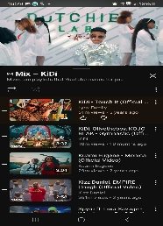
YouTube allows me to stay updated with current music

Screenshot/Photo 2
[Insert Photo/Screenshot below]
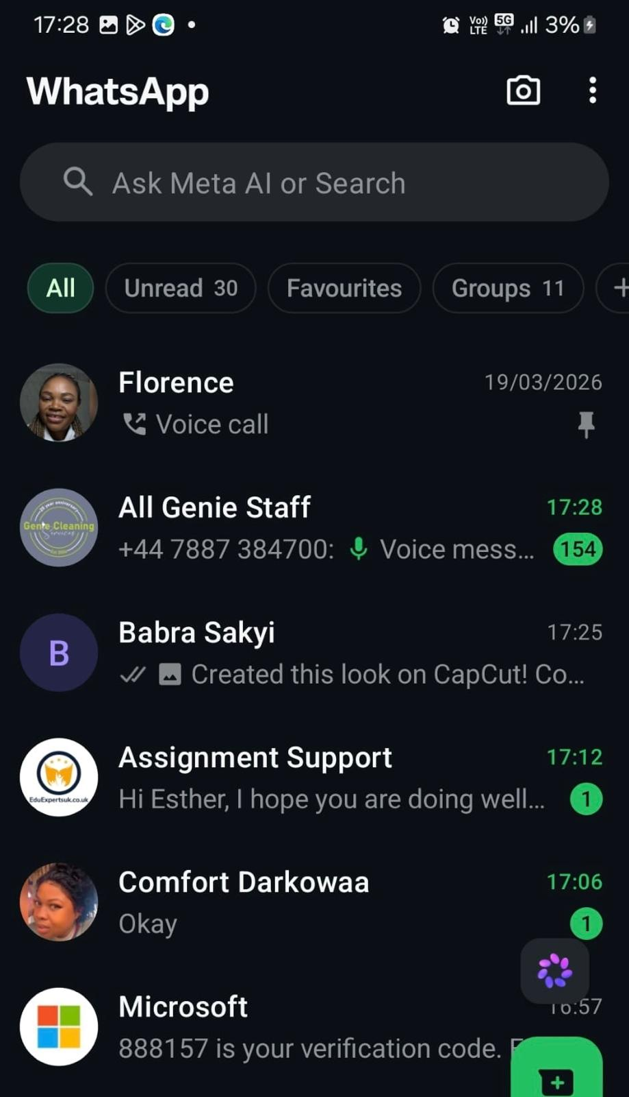
Using WhatsApp to be collected to my relatives

Screenshot/Photo 3
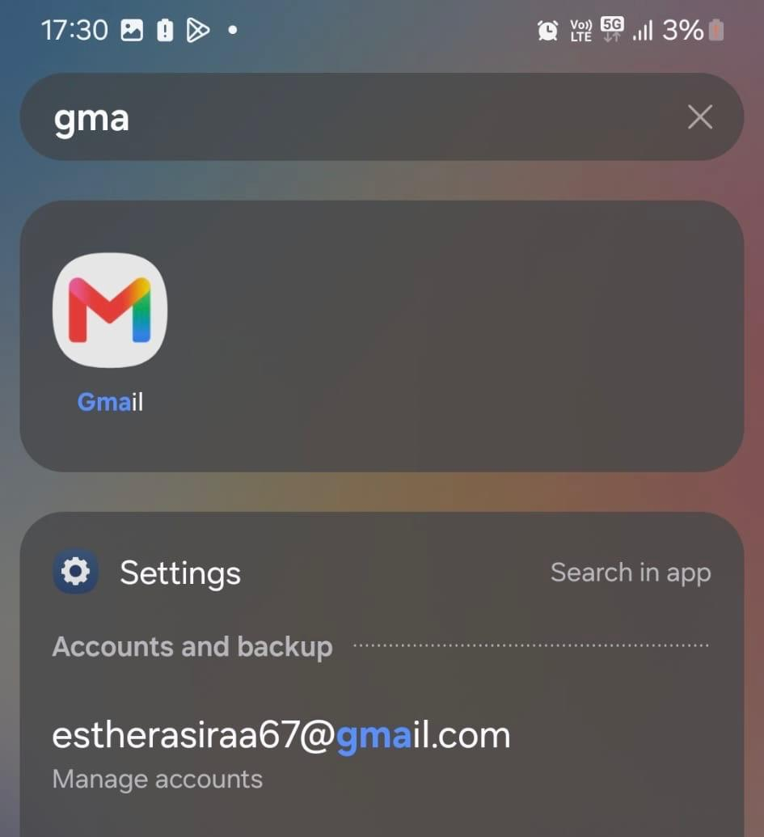
Having an email is very important in today’s world for everyone to have

Screenshot/Photo 4
[Insert Photo/Screenshot below]
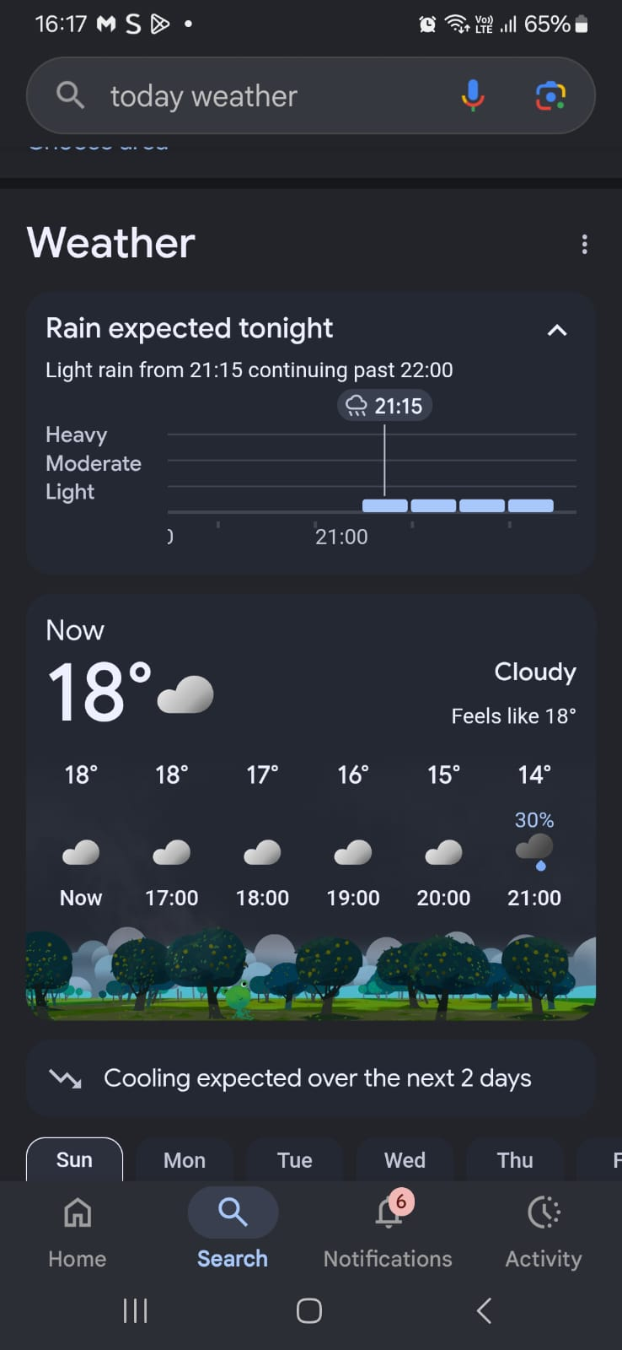
I use Google search to check the Weather before leaving the house

Screenshot/Photo 5
[Insert Photo/Screenshot below]
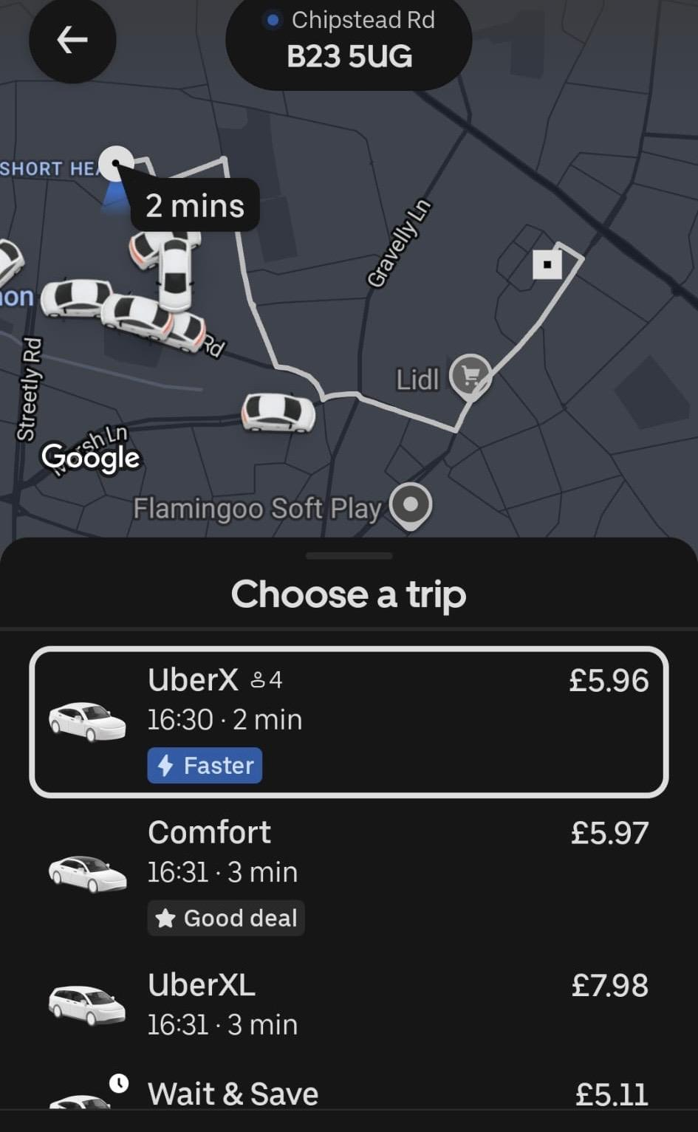
I use Uber to get to my destination more quickly

Screenshot/Photo 6
[Insert Photo/Screenshot below]

[Write what this shows of your digital life]

My Short Reflection
- Write 5–8 simple sentences about your digital life.
- You can use the sentence starters below if helpful.
I use digital tools to find information to help me with my assignment.
I feel confident when I use Google Search, Gmail, and galleries on my phone
I want to improve how to use Facebook market
I often use these tools: WhatsApp to be collected to my family and friends
I sometimes feel nervous about Microsoft Office 365
I hope this module will help me to build my confidence using technology

Sentence starters
- I use digital tools to …
- I feel confident when I …
- I want to improve …
- I often use these tools: …
- I sometimes feel nervous about …
- I hope this module will help me …
- Digital skills are important for me because …
You can write more if you want.

Submission Checklist
Before you submit, please check:
​​​ ☐ I added 4–6 screenshots
☐ I wrote short sentences for each screenshot
☐ I wrote my short reflection
☐ My work is my own
☐ My file opens correctly
​​☐ My file opens correctly

