
Student Name: Rinkeshkumar Ahir
Student ID Number: 2431174
Programme: MSc In Data and AI
Module: L7 – Research Method and Professional Development
Module Code: ACFA7004

AI-Powered Web Scraping: Verifying Product Image Data Against Descriptions Using User Comments

Abstract
The use of AI based web scraping allows checking the presence of images of the products based on the text reviews left by users. As e-commerce has expanded at a very fast rate, discrepancies between text descriptions and the photographs of the product have become more frequent, causing dissatisfaction among the customers and returning rates of the products. The paper suggests a multimodal verification framework that will require wrapping Python web scraping with Natural Language Processing models like BERT and Convolutional Neural Networks on visual features. The system will identify intermodal inconsistencies by comparing image embeddings, product descriptions, and insight generated by sentiment based on user comments. The anticipated results are the improved accuracy of the detection, increase consumer trust, and valuable contributions to the field of multimodal AI. The results have great implications to online retailers since it enhances authenticity verification of products and minimizes the risk of fraud.
Keywords: Artificial intelligence based Web scraping, e-commerce, BERT, CNN, Image-Text Alignment, Discrepancy Detection, Product Authenticity, Fraud Detection, Multimodal Learning, Product Verification, RoBERTa, Natural language processing, User comments, Python, Customer trust.

1. INTRODUCTION

1.1 Context and Background

1.1.1 Detailed Overview
Artificial intelligence has become one of the most revolutionary technologies of the contemporary world that has transformed e-commerce and improved customer experiences with smart data analysis. Product misrepresentation is one of the most long-standing problems of online shopping when customers are offered goods that are not similar to the pictures and descriptions presented in advertisements. This problem has largely led to decline in consumer trust, high rates of returns and dissatisfaction rates [1]. The latest research states that over a quarter of e-commerce returns can be explained by the discrepancies between product data and the expectations of the customers, and efficient product authenticity checking systems can safeguard the consumers and enhance the credibility of the platform.

1.1.2 Current Developments
Web scraping with AI, together with the development of Natural Language Processing and Computer Vision, has become an efficient solution to the problem of product misrepresentation in the e-commerce industry. With the help of modern scraping pipelines, it is possible to automatically extract the images of the products, their descriptions and user reviews on the online basis. Although the previous scraping approaches were primarily based on structured metadata, in more recent times, deep learning models that can verify the relationship between product images and their textual descriptions are being integrated [2]. Convolutional Neural Networks (CNNs) are still popular in visual feature extraction and shape, colour and texture, whereas transformer-based networks like BERT and CLIP (Contrastive Language-Image Pre-training) show very good performance in the vision-language gap. Collectively, these multimodal approaches allow an image and text to be cross-validated and the analysis of user reviews to determine possible patterns of product misrepresentation.

1.1.3 Associated Challenges
According to recent studies, there are a number of new trends and current issues regarding the application of AI to e-commerce. Multimodal learning: Multimodal learning involves a combination of text and visual information and has been found to be very promising when it comes to enhancing product verification systems. Simultaneously, user-created content has been gaining more and more value, as customer reviews are a direct evidence of deviations between the expectations of the products and their delivered specifics [3]. With recent developments in scalable big-data systems like PySpark and TensorFlow, researchers can now scale through product listing Millions of product listings can now be processed in near real time. Nevertheless, there are still major issues, such as high noise or incompleteness of the data, biases in user reviews, and inability to provide adequate generalization across diverse product groups with the support of verification models.

1.1.4 Dataset Relevance
Fashion Product Images Dataset, which has over 44,000 records of products with characteristics including gender, category, colour, usage, and display name, offers a very appropriate basis of this study [4]. The combination of visual and textual features it contains allows making systematic analyses of the discrepancies between product images and descriptions. Together with the user remarks gathered by AI-based web scraping, the set enables the offered model to identify the anomalies in several modalities. Since product authenticity and the correct representation is a crucial factor in the development of trust in consumers in e-commerce, this dataset provides a suitable real-world environment to create and test an AI-based verification framework.

1.2 Research Problem

1.2.1 Problem Statement
With the ever growing pace of the e-commerce, the consumers are becoming more and more reliant on the digital representation of the products, where the pictures, descriptions, and reviews of the products are less debatable in their influence over the buying choices. The major issue that has remained constant is the discrepancy between the product images and their textual descriptions which has resulted in customer dissatisfaction, increased rates of returns and a decrease in their trust in the online sites [5]. Even with the new AI and machine learning methods, the existing verification systems are not very developed. Most of them only use textual metadata or keyword analysis and do not use the multimodality of product information [6]. Although computer vision systems like CNNs are useful in extracting visual features, and natural language systems like BERT are highly accurate in interpreting textual descriptions, there are only few applications with built-in systems capable of jointly analyzing the two modalities. Also, the solutions that are in place tend to ignore useful user-created comments, which can be considered as invaluable signals about a misrepresentation of products. This gap demonstrates the necessity to introduce a scalable, multimodal system of verification that includes images, text, and remarks of customers to improve the process of authenticity evaluation of the product in online shopping.

1.2.2 Current Challenges
The other important challenge is associated with scalability and generalizability of the existing verification systems. Most recent methods are domain or computationally precise or tested on small and highly aggregated retail data. Other problems that negatively affect verification accuracy include noisy or incomplete product metadata, inconsistent image quality, and bias in user-generated reviews [7]. These shortcomings point to a lack of strong, scalable AI systems that would help automatically detect the differences between product pictures, descriptions, and customer reviews. The current literature thus suggests the need to develop a multimodal system, which combines web scraping, computer vision, and Natural language processing and can be deployed across scale to increase the authenticity checks of the products and consumer trust in an e-commerce platform.

1.3 Research Aim and Objectives

1.3.1 Aim
This research will attempt to develop and test a multimodal verification system based on AI, which will verify the consistency of product pictures and textual product information in e-commerce websites and is expected to increase consumer trust, for decreasing product returns.

1.3.2 Objectives
No. | Objective | Measurable Output
1. | To review the current literature on AI-based product verification, multimodal learning, and e-commerce fraud detection critically and identify the gaps in the literature used to address the image-text-comment validation gap. | An extensive literature review that points to some weaknesses in scalability, accuracy, and multimodal integration.
2. | In developing the multimodal model, in order to preprocess and analyse the Fashion Product Images Dataset, attributes like gender, category, colour and display name must be extracted. | A completely cleanE and tabulated data that can be integrated with scraped user comments and further analyzed.
3. | To create and execute Python-based web scraping pipeline to gather product description, images, and comments made by users of the e-commerce sites. | An efficient scraping tool that can be used to retrieve multimodal data in real time to verify such data.
4. | To develop AI models that combine computer vision and NLP to evaluate the similarity between product images and text messages. | A multimodal AI model that was developed and optimized based on criteria like accuracy, precision and recall, and F1-score.
5. | To add sentiment analysis of user comments as another validation step of recognizing product mismatches and misrepresentation. | Sentiment analysis module that classifies the user comments and adds to multimodal verification.
6. | To compare the suggested AI model with the baseline techniques based on text or image analysis only. | Comparison evaluation outcomes showing enhancements on mismatch identification and effectiveness, as well as strength.
7. | To determine the implications of the research on practical implications on the e-commerce platform, it is necessary to concentrate on minimizing the rates of returns and maximizing consumer trust. | One of the evidence-based recommendations based on experimental evidence.
Table 1: Objectives and measurable output

1.3.3 Rationale for the Aim and Objectives
The purpose and objectives of this study are well grounded, as it provides a well-ordered and quantifiable structure of the study, which imparts systematic advancement between the data preparation phase and model formulation, testing, and application. All the objectives directly reflect on a particular part of the research problem, so the approach to the investigation of inconsistencies between the product images and descriptions, as well as user comments, is structured. The choice of the Fashion Product Images Data set makes sure that the study is based on the real world product data and therefore multimodal analysis can be done meaningfully. The application of Python-based AI procedures, such as web scraping, computer vision, and transformer-based NLP models, is indicative of the existing developments in e-commerce analytics and data science. Combining all these aspects, the study fills an important gap in the existing literature and provides applicable knowledge on e-commerce retailers who want to minimize the misrepresentation of products, increase consumer trust, and elevate customer satisfaction in general.

1.4 Significance of the Research

1.4.1 Importance of the Research
Misrepresentation of products in e-commerce has been an issue that has led to lack of consumer confidence, high product returns, and deterioration of online retailing activities. This paper attempts to solve this problem by developing a comprehensive multimodal system of verification that has the ability of analysing product images, text descriptions, and comments posted by users. The study advances multimodal learning methodology and enhances the precision of product authenticity verification with the help of the implementation of AI-based web scraping, computer vision, and natural language processing [8]. Such work is not limited by its academic merits because it would help protect consumers better, improve transparency on the platform, and foster more trustworthy online shopping experiences in the entire e-commerce industry.

1.4.2 Potential Applications
The suggested system will have a great practical importance to online retailers as it will allow verifying product authenticity automatically, lower costs of operations related to returns, and enhance overall customer satisfaction [9]. In addition to direct retail advantages, the framework also offers a platform on which the new generation of AI-based quality assurance systems can be implemented in an online marketplace, fashion retail, and fraud detection. Its multimodal capabilities enable it to be flexible in a wide range of e-commerce contexts and facilitate more open and trustworthy digital shopping experiences.

2. LITERATURE REVIEW

2.1 Introduction to the Literature Review
In this literature review, the researcher focuses on existing studies on AI-based web scraping, multimodal validation, and product authenticity detection in the context of e-commerce initiatives. It examines the major advances in computer vision, natural language processing, and user-generated content analysis and its use on the detection of product misrepresentation. Special consideration is paid to AI applications in online shopping, more sophisticated web scraping methods, and multimodal learning algorithms, including CNNs, BERT, and CLIP, and the importance of consumer feedback in the validation systems. The review states that existing research has several significant themes, discussions, and constraints, including the problem of scalability, the integration of multimodal information and the application of big real-world datasets like the Fashion Product Images Dataset. Mapping these gaps, such a section places the current research work into the context of the larger scientific system and alters the necessity of the use of a comprehensive AI-based verification system.

2.2 Thematic Organization of Literature

2.2.1 AI in E-commerce Data Verification
The field of e-commerce has made notable changes to the use of artificial intelligence, which has enabled the applications of recommendation engines, personalised search, and fraud detection. Nevertheless, the implementation of AI to check the authenticity of products, i.e. product picture, text description and customer feedbacks have received relatively little scholarly attention [10]. The classical methods of verification put much emphasis on the structured metadata, or matching based on keywords and thus are susceptible to sloppy, incomplete, or conflicting data. Consequently, there is a high probability of inconsistencies between the multimodal product information, which is hard to reliably detected by current systems, which underscores the importance of more advanced AI systems that can incorporate visual, textual, and user-generated information.

2.2.2 Web Scraping and Data Mining in Online Retail
One of the major techniques of retrieving product information on e-commerce sites, be it structured or unstructured, is web scraping. The previous scraping was based on the rule-based approaches, whereas the recent studies report AI-based scrapers that have the ability to gather multimodal data, which includes images, descriptions, and user reviews, in real-time [11]. These systems are capable of fostering scalability and automated authenticity of products when combined with NLP and Computer Vision.
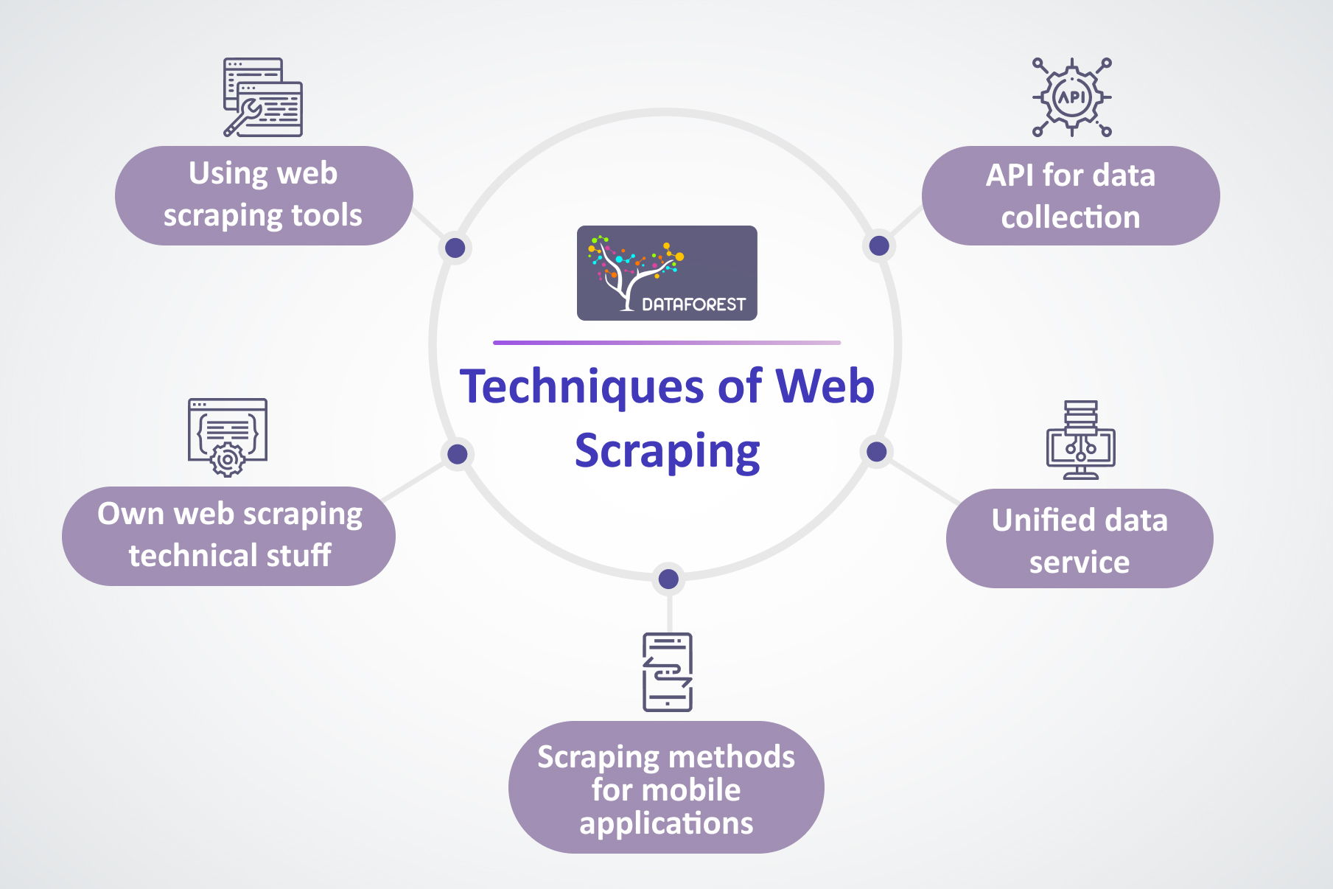
Fig 1: Techniques of Web Scraping
The figure shows some types of web scraping, such as using special tools to scrape, data collection via API, unified data services, handwritten scraper, and mobile-specific scraping methods.

2.2.3 Multimodal Learning for Image-Text Verification
Multimodal learning is concerned with integration of visual and textual information, which allows AI systems to match the product images with their description. Conventional Neural Networks (CNNs) like VGG16 and ResNet are extensively utilized in image recognition tasks because they are capable of finding visual features, colour, texture and shape. Simultaneously, transformer-based models such as BERT offer a contextual interpretation of product descriptions, allowing a better comprehension of textual attributes [12].
New trends are directed at filling in the gap between these two modalities. Delegating the learning of joint image-text representations in common space Contrastive Language-Image Pre-Training (CLIP), e.g. learns joint representations of images and text in a shared embedding space, which is then used to quantify their semantic congruence. With this ability, it is possible to do real cross-modal verification, which is more effective than image-only or text-only classifiers. The present study aims to enhance the precision of product authenticity checks by taking advantage of such multimodal architectures by increasing the consistency between the visual contents, textual descriptions, and user generated feedback.

2.2.4 Use of User Comments and Sentiment Analysis
The importance of user-generated reviews as an underexplored resource in terms of identifying the product misrepresentation in e-commerce is significant. The existing literature reveals that sentiment analysis can assist in uncovering the tendencies of customer dissatisfaction and indicate the differences between the marketed and the provided products [13]. Nevertheless, sentiment classification can be easily degraded by the fact that noisy, biased or sarcastic comments are present, and this can limit the effectiveness of these techniques. Nevertheless, the difficulties notwithstanding, the inclusion of user reviews in multimodal verification systems can provide an extra piece of evidence, which can reinforce the process of detecting anomalies with the products.

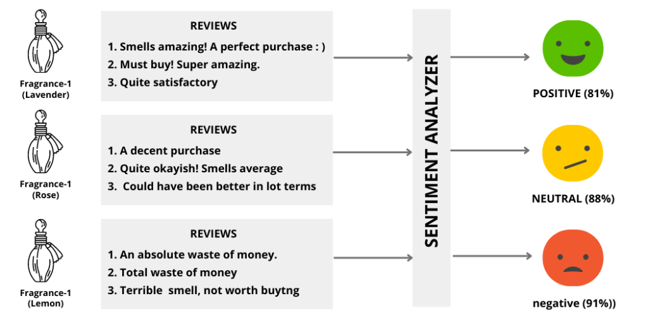
Fig 2: Sentiment Analysis of Product
The figure illustrates the sentiment analysis workflow, where customer review texts are processed by a sentiment analysis model that classifies them into positive, neutral, or negative categories based on linguistic cues and semantic content.

2.3 Key Contributions and Gaps
CNNs and transformer-based architectures are deep learning models that have enhanced product image classification and text interpretation, whereas multimodal networks such as CLIP facilitate a more effective correspondence between visual and textual data [14]. Additional developments on automated web scraping and sentiment analysis can be used to collect data on e-commerce on large scale and verification using customer reviews.
Nevertheless, current research usually deals with image, text, and user reviews in isolation without a fully developed multimodal approach. Most of the models also do not scale to large size data sets and cannot work on real-life e-commerce data [15]. There is little work that uses AI-based scraping and multimodal validation on big data such as the Fashion Product Images Dataset that there would be a significant gap in this study.

2.4 Theoretical and Technical Frameworks

2.4.1 Theoretical Frameworks
The theoretical basis of the study is the theory of multimodal learning that focuses on the combination of various data modalities, including images, text, and user-created content, to gain a more comprehensive and more precise contextual understanding. The application of multimodal frameworks in the context of e-commerce is where the verification of product authenticity is especially appropriate, as they allow checking the visual features, texts, and reviews of the buyers at the same time [16]. Also, consumer trust theories in online platforms emphasize the significance of effective product display, which contributes to the societal and business applicability of the creation of effective AI-driven verification tools.

2.4.2 Technical Frameworks
Computer Vision:
Convolutional Neural Networks and its versions, including ResNet and VGG, are popular in image features extraction and classification. When applied to e-commerce, these models can discern such visual properties as colour, texture, and product category.
Natural Language Processing:
BERT and RoBERTa are transformer-based models that are used to process product descriptions and retrieve semantic meaning [17]. The sentiment analysis tools also categorize user-created reviews based on whether they are positive, negative, or neutral, and they give indicators of possible product misrepresentation.
Multimodal Models:
CLIP allows simultaneous embedding of text and images in a common set of vectors to facilitate cross-modal alignment as well as improving to verify image-description consistency.
Tools of Web Scraping and Data Processing:
Product data is collected using Python packages like BeautifulSoup, Scrapy and Selenium packages to extract product information through e-commerce web pages and Pandas and PySpark package to process the data, clean and analyse the data on a large scale [18].
Evaluation Metrics:
The effectiveness of the verification system is measured using standard AI measures, such as accuracy, precision, recall, and F1-score, as well as domain-specific measures, such as the rate of misrepresentation detection.
These technical principles make it possible to be able to verify products in a multimodal way, but also expose drawbacks, such as model bias, computational complexity, and the difficulty of processing noisy or unstructured review information.

2.5 Relation to Current Study
The current study also builds on the previous works as it introduces a complete multimodal verification system, which integrates product images, textual descriptions, and user remarks, in contrast to the previous studies, which considered all these modalities independently [19]. The large-scale Fashion Product Images Dataset will be utilized, which means that the system will be trained on a realistic and varied data in e-commerce and become more scalable and applicable in practice. One such contribution is the user reviews as a validation layer which has been hardly examined in the literature [20]. The proposed framework is more robust in terms of determining the authenticity of the products and by adopting sentiment analysis and mismatch detection of reviews, the solution can easily be scaled and applied in the real-world context of online retailing.

2.6 Literature Summary
Recent studies prove that image verification with CNNs, text processing with transformer models, and user review sentiments analysis make great strides. Nevertheless, there are still gaps to completely incorporate these modalities, scaling of systems to large real-world data, and multimodal verification frameworks to use in e-commerce. Although there are some theoretical and technical underpinnings of multimodal learning, the given study is a unique contribution as it creates AI-based web-scraping to cross-validate product images, descriptions, and user comments. It fulfills the gap on integration and scalability by serving as a step forward in academic research and the practical means to enhance the authenticity of the product in online retail.

3. RESEARCH DESIGN AND METHODOLOGY

3.1 Research Design
In this work, the Design Science Research (DSR) methodology will be employed relying on simulation and experimental analysis to create and test an AI-based web scraping system that will check the correspondence between product images and textual descriptions and user comments. The type of research that is best aligned with DSR is the one that involves the creation and testing of technological artefacts, which is why it is fitting to develop a Python-based multimodal verification framework based on computer vision, natural language processing, and sentiment analysis [21]. In contrast to many of the purely theoretical or observational methods of design, DSR places value on iterative design and prototyping, and testing performance against quantifiable standards. This is in tandem with the applied and technical goals of the current study.

3.1.1 The Three Phases of DSR Cycle
The three stages of the Design Science Research (DSR) cycle are used in this study. First, Problem Identification and Motivation brings in the problem of product misrepresentation in e-commerce as one of the major problems. Second, Design and Development entails the development of a multimodal AI system to coordinate image features, textual descriptions, and user comments to confirm them. Third, Evaluation checks the system with the help of Fashion Product Images Dataset and scraped reviews and employs the metrics including accuracy, precision, recall, and the misrepresentation detection rate [22].

3.2 Research Methods and Materials

3.2.1 Research Methods

3.2.1.1 Methodological Approach
This paper is mixed-methods because it combines both quantitative model analysis and qualitative data analysis through user-generated comments. The quantitative part offers scientific rigor in terms of performances like accuracy, precision, recall and misrepresentation detection rate. The qualitative aspect provides an interpretive layer through reviewing the reviews of the customers to recognise recurring patterns and indicators of inconsistencies [23]. These approaches combined help to have a holistic perspective of product misrepresentation in e-commerce.

3.2.1.2 Research Strategy
The research method in this project is a software development approach and experimental analysis. Python prototype of the multimodal verification scheme is created and evaluated on the Fashion Product Images Dataset, which is provided with user comments scraped [24]. This is a correct approach as it does not focus on theoretical analysis but it provides functional solution to a verification problem in the real world. Replicability, validity and reliability of the system performance is guaranteed through experimental evaluation through standardised test metric.

3.2.1.3 System Architecture & Framework Design
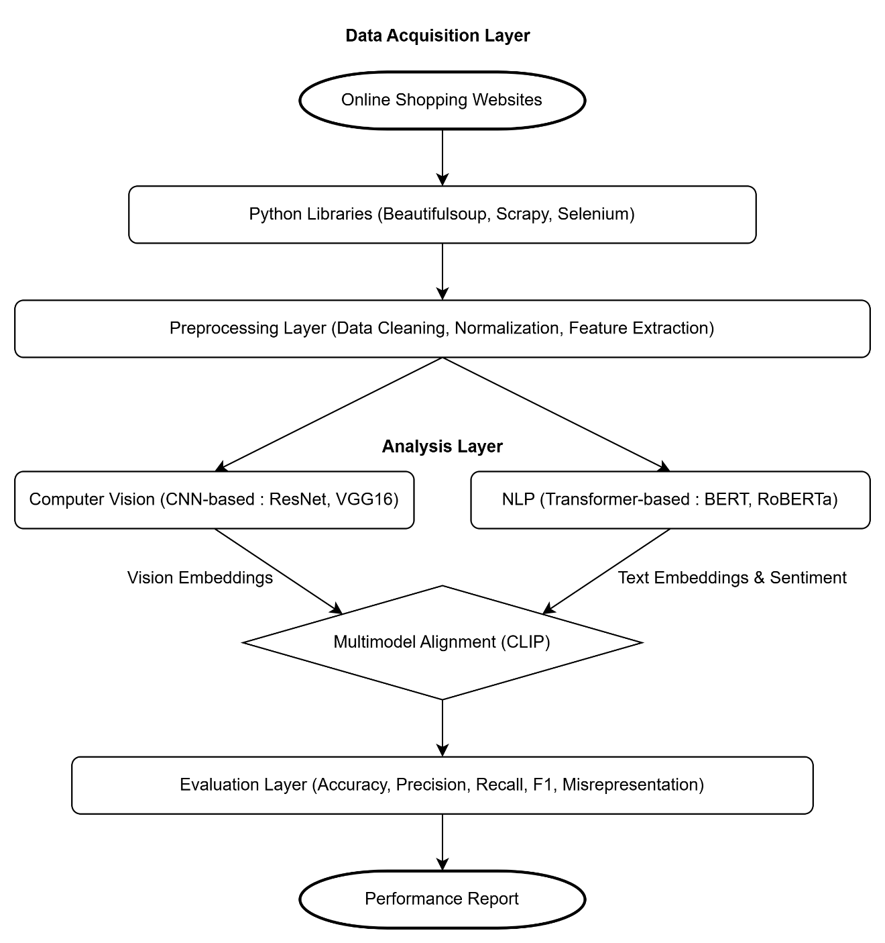
Fig 3: Proposed modular architecture for multimodal product analysis
Data Acquisition Layer: Python libraries like BeautifulSoup, Scrapy, Selenium is used to gather product descriptions and product comments from the websites of online shopping business owners.
Preprocessing Layer: Data cleaning and data preparation - there are missing values in Fashion Dataset, text normalization, and image feature extraction [25].
Analysis Layer:
Computer Vision Module: CNN-based models to extract the features and classify images of the product CNN Block: CNN-based models like ResNet, VGG16 models will be used to extract features from the images and based on these features the identity will be selected.
NLP Module: Transformer-based Model BERT, RoBERTa for the semantic understanding of product descriptions and sentiment recognition of comments [26].
Multimodal Alignment Module: Multimodal alignment between embedding of vision and text and use models such as CLIP to perform cross verification.
Evaluation Layer: Evaluation of performance in form of accuracy evaluations, which involves precision, recall, F1, and detecting the misrepresentation accuracy

3.1.2.4 Data Analysis and Evaluation Techniques
Image characteristics are detected with the help of pre-trained CNNs, and BERT generates text embeddings. Sentiment analysis identifies user comments as positive, neutral and negative. Accuracy, precision, recall, and F1-score are used to determine the performance of the system and ROC-AUC and confusion matrices are used to determine the robustness and misclassification behavior.

3.2.2 Materials

3.2.2.1 Research Data
Dataset Source: The Fashion Product Image Dataset, which consists of more than 44,000 records of fashion product with the following attributes, product id, gender, product category, product colour and display name, is used in the study.
Data Collection Method: Data Collection Method: Supported study through user reviews and product descriptions through online marketplace scraping.
Tools: Python is utilized in the data scraping of Python libraries like BeautifulSoup, Scrapy, and Selenium and Pandas is utilized in preprocessing.
Rationale: The data set is based on the actual fashion retail data and is favorable to the objectives of this research as it incorporates images of products, written descriptions, and comments left by users [27].

3.2.2.2 Ethical Concerns
Ethical Web Scraping:
Any scraping will be within the services of the target websites. No high-quality or exclusive data will be accessed and the only information that will be gathered is the publically available information.
Privacy and Anonymisation:
No personal identifiable information will be collected. The scraped user comments in online marketplaces will be anonymised and kept in a secure location. All the data will be accessed only to conduct the research, and no individual users will be identified.
Data Protection Compliance:
GDPR and Data privacy:
The research is based on GDPR and institutional data protection requirements. The sources of data are publicly available, and all information gathered will be used responsibly to prevent the unauthorised use and access.
Mitigation of Fairness and Bias:
There can be cultural, linguistic or gender-related biases in user reviews and this can affect sentiment analysis. To mitigate this, the study uses balanced sampling in carrying out the study and the results are interpreted carefully to minimize unfairness in model predictions.
Responsible AI Practices:
The system will be created in accordance with the principles of transparency, explainability, and accountability. The model assumptions, limitations, and training datasets will be well documented in order to make AI decisions readable and repeatable.

3.2.2.3 Software
Category | Tools Or Libraries | Description 0r Purpose
Programming Language | Python | General-purpose language is widely used for AI, ML, data science, and web development.
Computer Vision Libraries | TensorFlow, Keras, PyTorch, OpenCV | Frameworks and tools for building and training deep learning models for image and video processing.
Natural Language Processing (NLP) Libraries | Hugging Face Transformers (BERT, RoBERTa), NLTK, SpaCy | Libraries for text processing, tokenization, and implementing advanced transformer-based NLP models.
Web Scraping Tools | BeautifulSoup, Scrapy, Selenium | Tools for extracting data from websites, automating browsing, and parsing HTML/XML content.
Data Analysis Tools | Pandas,NumPy, PySpark, Matplotlib, Seaborn | Libraries for data manipulation, numerical computation, scalable processing, and visualization.
Version Control | GitHub | Platform for source code management, collaboration, and version control.
Table 2: Programming Tools and Libraries Overview

3.2.2.4 Hardware Requirements
Category | Tools Or Hardware | Description Or Purpose
GPU | NVIDIA GPU | Provides high-speed computation for deep learning model training and inference.
Server Or Cloud | Google Colab, AWS, Azure | Cloud environments that enable scalable training for large machine learning and AI models.
Local System | 16GB RAM, Intel i7 processor, SSD storage | Recommended system configuration for preprocessing, experimentation, and smaller-scale model development.
Table 3: Hardware and System Requirements

3.2.2.5 Rationale of Materials
The selected data, software, and computing resources are associated with the state of the art practice in multimodal AI studies. The customizable, scalable Python is the programming language that gives the flexibility and scalability needed to develop models of computer vision, NLP, and multimodal alignments, and the computing hardware, be it a GPU or a cloud, makes the training of architecturally expensive models possible. Anonymity of the user data and adherence to the responsible web-scraping and data protection scope ethics questions.

3.2.3 Research Design and Methodology Overview
In this work, the Design Science Research is combined with the experimental analysis to develop and test the AI-based verification system in a systematic way. It is a mixed-methods study that will utilize not only quantitative measures of performance but also incorporate the qualitative input of user comments. The system architecture is the modular system that includes computer vision, natural language processing, and sentiment analysis implemented to the Fashion Product Images Dataset and reviews that have been web-scraped [28]. It is technically implemented with Python, TensorFlow, Hugging Face Transformers and web-scraping libraries with either a GPU or cloud computing environment. Any data collection and processing procedures are conducted in terms of the existing ethical standards so as to use information in a responsible manner.

4. EXPECTED OUTCOME

4.1 Anticipated Results
It is believed that the research will generate a Python-based multimodal AI model that can be used to determine the similarity between the images of products, textual descriptions, and comments left by users. It is expected that with the combination of computer vision models with transformer-based NLP and CLIP to align cross-modal, the system will be able to outperform traditional single-modality methods in accuracy, precision, and recall [29]. In particular, the framework will be used to attain a misrepresentation detection rate over 85% and higher F1-scores in sentiment-aware classification.

4.2 Implications
It is expected that the expected results will yield both theoretical and practical contributions. Theoretically, the research will build on the previous literature of multimodal learning by showing how image, text, and user-generated information can be analysed together to verify a product in e-commerce. In practice, the suggested framework is a demonstration of how AI-based verification systems can minimize product misrepresentation, decrease the number of returns, and enhance consumer confidence in the online marketplaces. The modular and scalability architecture of the system also presents opportunities of application in other fields of retail other than the fashion datasets.

4.3 Limitations
The study may be limited in a number of ways. To begin with, user generated comments may be noisy, biased or ambiguous and this may affect the precision of sentiment analysis. Second, multimodal AI models are computationally expensive to train, and need high-performance GPU or cloud computing, where scaling can be constrained by limited resource availability [30]. Lastly, web scraping can be limited by ethical considerations (i.e. compliance with platform terms of service and protection of user information) that might limit the amount and nature of data that can be scraped.

5. TIMELINE
The proposed research will take place with a 4-month schedule from January to April 2026, and distinct milestones that identify important work and outcomes. The timeline for project plan is show in Table 4 and visualised in a Gantt chart in Fig 4.
Month | Dates | Milestone
January 2026 | 1–5 Jan | Project Planning & Tool Setup – Defining objectives, tools, and resource allocation.
January 2026 | 6–9 Jan | Target Website Selection & Access Configuration – identify e-commerce sources.
January 2026 | 12–21 Jan | Web Scraping Script Development – Python scripts for images, descriptions, and reviews.
February 2026 | 22 Jan–11 Feb | Data Cleaning & Preprocessing – handling missing values, duplicates, and formatting.
February 2026 | 12–20 Feb | NLP Model Setup (BERT/RoBERTa) – configuring for textual analysis of user comments.
February 2026 | 23 Feb–5 Mar | Sentiment Analysis & Keyword Extraction – deriving structured insights.
March 2026 | 6–19 Mar | Image Feature Extraction & Encoding – extracting embeddings using CNN-based models.
March 2026 | 20–27 Mar | Multimodal Feature Comparison – integrating NLP and vision features for validation.
April 2026 | 30 Mar–9 Apr | Discrepancy Detection Model Implementation – training detection pipeline.
April 2026 | 10–16 Apr | Real-World Testing & Validation – evaluating accuracy, precision, recall, and F1.
April 2026 | 17–23 Apr | System Refinement & Debugging – improvements based on test results.
April 2026 | 24–30 Apr | Final Review & Report Preparation – documentation and submission.

Table 4: Timeline

Gantt chart:
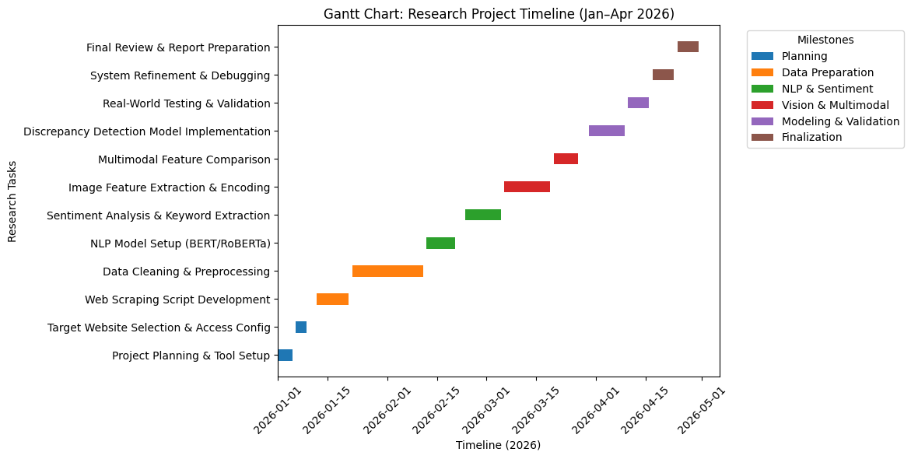
Fig 4: Gantt chart for Project Planning

6. REFERENCES
[1] A. Radford et al., “Learning Transferable Visual Models From Natural Language Supervision,” Proc. ICML, pp. 8748–8763, 2021.
[2] J. Li, R. Selvaraju, A. Gotmare, S. Joty, and C. Xiong, “Align Before Fuse: Vision and Language Representation Learning With Momentum Distillation,” NeurIPS, pp. 9694–9705, 2021.
[3] W. Kim et al., “ViLT: Vision-and-Language Transformer Without Convolution,” Proc. ICML, pp. 5583–5594, 2021.
[4] L. Zhou, S. Chen, Y. Yu, and A. Jain, “Unified Vision-Language Pre-Training for Image Captioning and VQA,” AAAI, vol. 34, no. 7, pp. 13041–13049, 2020.
[5] X. Li et al., “OSCAR: Object-Semantics Aligned Pretraining for Vision-and-Language Tasks,” ECCV, pp. 121–137, 2020.
[6] Z. Chen, Y. Jiang, and Y. Yu, “Image–Text Matching for E-Commerce Product Verification Using Multimodal Deep Learning,” IEEE Trans. Multimedia, vol. 24, pp. 1235–1248, 2022.
[7] H. Singh and A. K. Jain, “AI-Based Detection of Misleading Product Images in Online Marketplaces,” IEEE Access, vol. 9, pp. 119233–119245, 2021.
[8] C. Zhao et al., “Detecting Misleading Product Listings Using Multimodal Fusion,” ACM Trans. Inf. Syst., vol. 41, no. 4, pp. 1–26, 2023.
[9] J. Chen et al., “Multimodal Deep Networks for Product Matching in E-Retail,” Pattern Recognition, vol. 132, p. 108992, 2022.
[10] E. H. Hossain and S. Roy, “Fake and Fraudulent Product Detection Using CNN–BERT Multimodal Classification,” IEEE Access, vol. 10, pp. 23112–23125, 2022.
[11] A. A. Ilyas and D. Scarpazza, “A Survey on Web Scraping Techniques for Big Data Mining,” IEEE Access, vol. 9, pp. 113–134, 2021.
[12] M. Ferrara, “Web Data Extraction, Web Harvesting and Web Scraping: A Survey,” IEEE Trans. Knowl. Data Eng., vol. 35, no. 2, pp. 857–870, 2023.
[13] S. Zhang, T. Liu, and P. Ren, “AI-Enhanced Web Scraping for Large-Scale E-Commerce Analytics,” IEEE Access, vol. 8, pp. 22456–22469, 2020.
[14] P. Jain and A. K. Sharma, “Deep Learning-Driven Web Scraping for Market Intelligence,” IEEE Access, vol. 10, pp. 20114–20127, 2022.
[15] J. Devlin, M. Chang, K. Lee, and K. Toutanova, “BERT: Pre-Training of Deep Bidirectional Transformers for Language Understanding,” NAACL, 2019.
[16] Y. Liu et al., “RoBERTa: A Robustly Optimized BERT Pretraining Approach,” arXiv:1907.11692, 2019.
[17] Y. Wu et al., “Sentiment Analysis of User Reviews Using Transformer Models,” IEEE Trans. Comput. Social Syst., vol. 10, no. 3, pp. 688–702, 2023.
[18] A. Kumar and R. Singh, “Detecting Fraudulent Reviews Using BERT-Based Classification,” IEEE Access, vol. 9, pp. 142890–142904, 2021.
[19] S. Majumder, A. Sharma, and S. Ghosh, “Multimodal User Review Analysis for Detecting Inconsistent Product Listings,” Expert Syst. Appl., vol. 231, p. 120681, 2023.
[20] K. He, X. Zhang, S. Ren, and J. Sun, “Deep Residual Learning for Image Recognition,” CVPR, pp. 770–778, 2016.
[21] K. Simonyan and A. Zisserman, “Very Deep Convolutional Networks for Large-Scale Image Recognition,” ICLR, 2015
[22] A. Dosovitskiy et al., “An Image is Worth 16×16 Words: Transformers for Image Recognition at Scale,” ICLR, 2021
[23] G. Huang et al., “Densely Connected Convolutional Networks,” CVPR, pp. 4700–4708, 2017.
[24] N. K. R. Maddikunta et al., “AI in E-Commerce: A Comprehensive Review,” IEEE Access, vol. 8, pp. 179807–179833, 2020.
[25] S. M. Al-Bourini and K. Al-Kofi, “AI-Driven E-Commerce Fraud Detection Systems,” IEEE Trans. Ind. Inform., vol. 18, no. 5, pp. 925–935, 2022.
[26] Y. Wang and Z. Chen, “Deep Learning for Product Review Analysis and Consumer Trust Modeling,” IEEE Trans. Comput. Social Syst., vol. 9, no. 2, pp. 401–415, 2022.
[27] J. Baltrušaitis, C. Ahuja, and L. Morency, “Multimodal Machine Learning: A Survey and Taxonomy,” IEEE Trans. Pattern Anal. Mach. Intell., vol. 41, no. 2, pp. 423–443, 2019.
[28] M. Xu et al., “Multimodal Fusion Techniques for Image–Text Tasks: A Comprehensive Review,” IEEE Trans. Neural Netw. Learn. Syst., vol. 34, no. 10, pp. 6789–6805, 2023.
[29] S. Yang et al., “Cross-Modal Retrieval Using Deep Metric Learning,” IEEE Trans. Multimedia, vol. 24, pp. 319–333, 2022.
[30] H. Zhang et al., “Deep Multimodal Embedding for Product Matching in E-Commerce,” IEEE Access, vol. 11, pp. 4551–4562, 2023.

7. APPENDIX
Dataset link: -https://www.kaggle.com/datasets/paramaggarwal/fashion-product-images-small

