Asics makes step-change to CRM for ‘truly personalised shopping’
Asics is developing a unified CRM strategy across all its virtual and physical touchpoints to fuel its multichannel plans.
By Seb Joseph 4 Nov 2014 3:20 pm
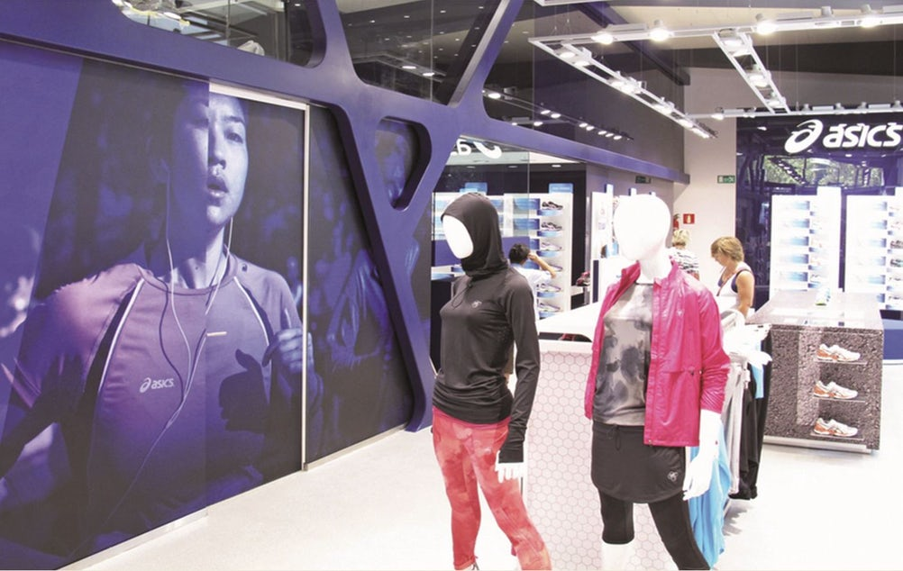Asics will capture CRM data in stores to fuel its personalisation plans.
The sportswear maker is ramping up CRM across all branded channels including its MYASICS running app and ecommerce portal to better understand how loyal its customers are. New interaction points will also be created both in-store and online to boost the number of data points it can extract insights from.
Asics will use the data to underpin the customer insight, contact strategy and tactical campaigns that will work in closer tandem with its bigger advertising efforts across Europe.
ADVERTISING
The company has been bolstering its marketing with customer data, media consumption behaviour and attitudinal data for the past two years but does not yet have a clear sight of the customer’s journey. By making the most of its CRM, Asics hopes to move toward an integrated customer journey capable of supporting personalised messages.
The framework is being mapped out now with Asics hiring Draw Group to get it up and running.
It is likely the CRM play will eventually widen to the company’s in-store Product Advisor. Using a connected large wall mounted screen and iPad, customers answer a series of questions before being matched to their recommended shoe based on their personal preferences and current running habits. The tool was unveiled in Germany last month and will be rolled out to selected markets.
The Amaze-developed in-store service is just one of several Asics is launching to try and strengthen brand affinity with runners. Others include Foot ID, which uses a biomechanical analysis video to determine a person’s running style and a 3D Foot Mapping System that helps find the right shoe for a person’s optimum running technique.
Martin Block, education and training manager at ASICS, says: “Incorporating more digital touch points within our retail stores is a key part of our strategy to create a better customer experience for all – whether they are in-store to browse or to buy. Retail technologies, which make bespoke selections about products, have become of increasing importance to the sports industry in recent years and the new Product Advisor now takes this personalisation to a wider community.”
Asics’ omnichannel bid comes as Nike and Adidas ramp up efforts to win over runners, a category they both believe has the potential to be more lucrative with women, and boost their standing in the eyes of female customers. Asics is trying to counter their advances by stretching its positioning to tennis and rugby in order to show the brand is not just for runners.
Separately, Asics is looking to build its presence in the branded content arena. This weekend (8 November) will see the broadcast of the company’s “Outrun the Sun” documentary on Channel 4. The film, shot by production com pay Sunset+Vine, follows the two relay teams of trail runners as they prepare to race up Mont Blanc – Western Europe’s highest peak. The added challenge is they must finish the race between sunrise and sunset.
Asics products are show helping each endurance athletes overcome the trials and tribulations on the race.

