

Evaluating the Effectiveness of Scaffolding Problem Based Learning to Teach Software Design Patterns
by
XXXXXXXXX
Supervisor: XXXXXXXXX
Second Marker: XXXXXXXXXXX

Project submitted as part of the requirements for the award of BSc (Hons) Web Development

April 2017

Declaration FORM AND FORM OF CONSENT
DECLARATION

I, ……………………………………….. declare that I am the sole author of this Project; that all references cited have been consulted; that I have conducted all work of which this is a record, and that the finished work lies within the prescribed word limits.

This work has not previously been accepted as part of any other degree submission.

Signed: .............................................

Date: ...............................................

FORM OF CONSENT

I ……………………………………………..hereby consent that my Project, submitted in candidature for the B.Sc. Web Development degree, if successful, may be made available for inter-library loan or photocopying (subject to the law of copyright), and that the title and abstract may be made available to outside organisations.

Signed: .............................................

Date: ...............................................

Abstract
This project is based on evaluating using a PHP framework as a scaffold to teach third year Degree Web Development students software design patterns.
The objectives of this project were to analyse the most common PHP frameworks to identify common features between them, evaluate an approach to teaching, using a PHP framework and design patterns by creating a PHP learning environment. To obtain results, a study was conducted using a focus group and questionnaire to determine the effectiveness of the teaching approach. This project extends the work of Mike Dacey.
Despite the decrease in popularity, the Waterfall Development Life Cycle was adopted alongside Object Oriented methods involving Object Oriented Analysis (OOA) and Object Oriented Design (OOD).
A PHP framework was supplied by Mike Dacey and was extended by the author of this project. Alongside this framework, HTML exercises which included scaffolds (in the form of hints) were presented to students to complete an uncompleted version of the framework.
The findings suggest that scaffolding in Problem Based Learning (PBL) is an effective teaching approach. However, it was found that extra background information should have been provided to aid the students.
It is recommended that further research into structuring the content to encourage the student to explore the problem and provide better scaffolding.

Table of Contents
Table of Figures vi
Table of Tables viii
1 Chapter 1 - Introduction 1
1.1 Background 1
1.2 Aim 2
1.3 Objectives 2
1.4 Report Structure 3
2 Chapter 2 – Review of Literature 4
2.1 Introduction 4
2.2 Object Oriented Programming 4
2.2.1 PHP 5
2.3 Frameworks 6
2.3.1 Symfony 7
2.3.2 Laravel 8
2.3.3 Zend Framework 8
2.3.4 Yii Framework 9
2.3.5 PHP Extension and Application Repository (PEAR) 10
2.3.6 Summary 11
2.4 Software Design Patterns 13
2.4.1 Structure of Design Patterns 15
2.4.2 Organisation of Design Patterns 16
2.5 Design Patterns in the Learning Environment 17
2.5.1 Pedagogy and Pedagogical Approaches 19
2.6 Conclusion 21
3 Chapter 3 – Research and Development Methodology 23
3.1 Research Methodology 23
3.1.1 Research Philosophy 23
3.1.2 Research Strategy 24
3.2 Development Methodology 25
3.2.1 Object Oriented Analysis (OOA) 27
3.2.2 Object Oriented Design (OOD) 27
3.2.3 Object Oriented Construction (Implementation) 28
3.3 Conclusion 28
4 Chapter 4 – Design and Implementation 30
4.1 Design 30
4.1.1 Overall Framework Design 31
4.2 Implementation 32
4.2.1 Registry and Singleton Design Pattern 32
4.2.2 Command Design Pattern 34
4.2.3 Front Controller Design Pattern 36
4.2.4 Application Controller 38
4.2.5 Domain Model Pattern 40
4.2.6 Data Mapper Pattern 42
4.2.7 Iterator Design Pattern 46
4.2.8 Identity Object Pattern 48
4.2.9 Template View Pattern 56
4.2.10 Testing 58
4.2.11 Teaching Approach and Plan 61
4.2.12 Teaching Materials 62
4.2.13 Hosting 63
5 Chapter 5 –Analysis 64
5.1 Quantitative Data 64
5.1.1 Hint System 64
5.1.2 Questionnaire 68
5.2 Qualitative Data 75
5.2.1 Focus Group 75
5.3 Summary 77
6 Chapter 6 – Evaluation 78
7 Chapter 7 – Conclusions and Recommendations 80
8 Chapter 8 – Reflections 82
8.1 Literature 82
8.2 Design and Implementation 82
8.3 Writing the Report 83
9 References 84
10 Appendices 92
10.1 Appendix 1 – deliverables 92
10.2 Appendix 2 – exercise Examples 92
10.2.1 Registry Design Pattern 92
10.2.2 Hint System 92
10.2.3 Code Examples 93
10.2.4 Overall Structure 93

Table of Figures
Figure 2-1 : Zhag and Budgen’s results based on a survey they created, answered by experienced developers [48] 15
Figure 2-2 [16] : The GoF’s organisation technique 16
Figure 3-1 – The Research Onion 23
Figure 3-2 : Waterfall Model (Royce, 1970), Taken from [81] 26
Figure 3-3 28
Figure 4-1 : Folder Structure 31
Figure 4-2 : Overall Framework Design Class Diagram 31
Figure 4-3 : Registry Design Pattern UML Class Diagram 33
Figure 4-4: Private Constructor 33
Figure 4-5: GetInstance() Method 34
Figure 4-6: Command Design pattern UML Class Diagram 35
Figure 4-7: File path enforcing a convention 36
Figure 4-8: Subclass check 36
Figure 4-9 : Front Controller UML class Diagram 37
Figure 4-10 : Front Controller UML Sequence Diagram 37
Figure 4-11: Handle Request Method 38
Figure 4-12 : Application Controller Class UML Diagram 39
Figure 4-13 : Application Controller Mapping Views 39
Figure 4-14: Associative Array containing view objects 40
Figure 4-15: Domain Model UML Class Diagram 41
Figure 4-16: Get Collection method in Domain Model 42
Figure 4-17 42
Figure 4-18 : Data Mapper Pattern UML diagram 43
Figure 4-19: Data Mapper FindById UML sequence diagram 44
Figure 4-20: Abstract Mapper Constructor 45
Figure 4-21 45
Figure 4-22: Do Create Object Method 46
Figure 4-23 : Collection Working with the Data Mapper Pattern 47
Figure 4-24: Get Current Method in Abstract Collection Class 48
Figure 4-25: Add Method 48
Figure 4-26: Concrete Collection Target Class method 48
Figure 4-27 : Identity Object working with other classes to form an ORM 50
Figure 4-28 : Sequence Diagram using the Identity Object Pattern with Mapper Find method 51
Figure 4-29 52
Figure 4-30: Field Method 53
Figure 4-31: Operator Method 53
Figure 4-32: Method to Add a Group by Clause 54
Figure 4-33: Add Field Constraint Method 54
Figure 4-34: New Select Statement Method 55
Figure 4-35: Preparing and Executing the generated statement 55
Figure 4-36 : View Class 56
Figure 4-37: Instantiating Twig 57
Figure 4-38: Acquiring the data using the response object 57
Figure 4-39 58
Figure 4-40: Simple PHPUnit Test 58
Figure 4-41: Unit Test Passing 58
Figure 4-42: Observer Pattern used for testing 59
Figure 4-43: Twig Template 60
Figure 4-44: Test Results 61
Figure 4-45 : Teaching plan 62
Figure 4-46 63
Figure 4-47: Ajax Code 63
Figure 5-1 66
Figure 5-2: Percentage of Hints Clicked Per Exercise 67
Figure 5-3 68
Figure 5-4: Questions by Rating 71
Figure 5-5: Problem Based Learning Questions by Rating 72
Figure 5-6: Questions by Median 73

Table of Tables
Table 1 65
Table 2 : Likert Rating System 70
Table 3: Questionnaire Statements 70
Table 4: Raw Questionnaire results 71

Chapter 1 - Introduction

Background
“Time is money” [1] is a common phrase that everyone hears in everyday life. The meaning of this phrase implies that time is a valuable resource as the amount of time we have is limited [2]. Today, this has no exception to productivity within an organisation as productivity has a huge impact of that organisation’s success. This also concerns any organisation within the software engineering industry.
Although Hernandez-Lopez [3] states that it is difficult to gain full understanding of productivity, Jones identified that productivity is measured by the ratio between the product or service that is produced and the expenses of labour used to produce or provide that product or service, cited in Sidler [4].
An earlier measurement of productivity in the software development sector involved measuring line of code per man hours worked. Following Jone’s [5] theory, Sidler [4] has concluded that software productivity is measured by the ratio between the functionality of the software produced to the labour and expenses to produce it.
Although there are many definitions that surrounds the measurement of productivity, within the software engineering industry, all software development companies have a common interest. This interest involves exploring new ways to improve developer productivity and improve the quality of code produced. To help achieve this goal, it is thought by Rodriguez et al [6] that team size of a project is considered a large factor. Not all organisations may have large teams, this means that other considerations need to be taken regarding smaller, local companies, Sidler states [4]:
“Software productivity can be enhanced by reusing code”.
The introduction of Object Oriented Programming in the late 1960’s [7] has made code re-use less challenging, allowing the introduction of software frameworks that are built on common design patterns that assist on building applications more rapidly.
With the increase of popularity of software design patterns, particularly in 1995 after the release of the book “Design Patterns: Elements of Reusable Object-Oriented Software” by Gamma et al [8], software design patterns have become a crucial subject in the computer science education curriculum.
This project extends the research of Mike Dacey based upon the teaching approaches used to teach university students.

Aim
The aim of this project is to evaluate the effectiveness of teaching software design patterns by developing a PHP framework as a learning environment.

Objectives
To achieve the aim of this project, a few objectives will be undertaken. The objectives are:
- Analyse the most common and popular PHP frameworks and software design patterns used today and researching frameworks and their common features.
- Evaluate an approach to teaching, using a PHP framework and design patterns by designing and building a PHP learning environment.
- Conduct a study using a focus group, and analyse the results to determine the effectiveness of the framework and the teaching approach.

Report Structure
This report is divided into another 9 chapters in total, of which includes this chapter – the introduction. The following chapters are:
- Chapter 2 – The Literature Review: The literature review discusses the object-oriented paradigm in a deeper depth, evaluates current PHP frameworks and design patterns, finishing with a conclusion with the findings.
- Chapter 3 – Research & Development Methodology: This chapter will discuss the research methodology chosen to gather information as well as the development methodology.
- Chapter 4 – Design and Implementation: This chapter will involve the design of the framework using Unified Modelling Language (UML) class and sequence diagrams explaining why certain patterns were used over others, along with code snippets illustrating how the framework was produced.
- Chapter 5 – Analysis: This chapter analysis the data to retrieve results allowing a conclusion to be met.
- Chapter 6 – Evaluation: This chapter evaluates the project and provides a conclusion from the data collected.
- Chapter 7– Conclusions and Recommendations: This chapter summarises what was achieved in the project and if any further research is required.
- Chapter 8 – Reflections: This chapter includes a personal reflection of the author based on the experience of this project and what has been learnt.
- Chapter 9 – References: Documents all references used.

In the next chapter of the review of the literature, object-oriented programming will be discussed in a deeper depth including how it can be used to create frameworks using design patterns.

Chapter 2 – Review of Literature

Introduction
This literature review evaluates 5 common PHP frameworks, identifying common features between them that will be incorporated into a custom-built framework, which will be used as a scaffold to teach 3rd year students software design patterns. Literature based upon teaching design patterns is also evaluated to gain an understanding what teaching approaches will be most effective.

Object Oriented Programming
Object Oriented Programming is a programming language based on the objected-oriented paradigm and design philosophy [9] which was first introduced in 1961 by Ole-Johan Dahl and Kristen Nygaard when designing the SIMULA language [7]. Although the objected-oriented paradigm and design was first introduced in the 1960s, it did not gain popularity until the late 1990s [10] with the introduction of the object-oriented programming language Java. Despite the slow advance in popularity, object-oriented concepts managed to evolve in the 1970s with the introduction of the programming language Smalltalk. A revival of interest also emerged in the 1980s of object-oriented methodologies amongst programmer due to object-oriented languages such as C++ catching their interest [10].
Today, the object-oriented paradigm is widely used across the world and is the mainstream concept in the software development industry and is taught in many universities at an undergraduate level [11].
The object-oriented paradigm is used to analyse, design and implement software and web applications. In Object Oriented programming, one of the central concepts is based upon objects [10], [12] that can interact with one another [13].
The use of object-oriented programming allows a programmer to solve problems by breaking them up into smaller problems through the use of classes. This promotes code re-use [13] and offers better maintainability, flexibility and extensibility through using the concepts of inheritance, polymorphism and encapsulation.
A class is a ‘blueprint’ that is used to instantiate objects. A class contains properties and methods that describe what an object will look like. An object is an instance of a class which contains the values for the properties and performs the methods it holds.
Inheritance involves a class (also known as a child or subclass) inheriting and extending the functionality of the base class (also known as the parent or superclass). The term polymorphism means “many forms”. Polymorphism is implemented through different objects, all sharing a common interface through inheritance but containing different implementations of the same method.

PHP
PHP was not formally known as an object-oriented language when it was first released. PHP first started off as a set of 2 tools known as PHP/FI tools developed by Rasmus Lerdof as a set of macros for sending SQL statements to databases, process forms and managing personal pages[14] , PHP meaning Personal Home Pages and FI standing for Form Interpreter.
Later, PHP was extended by Lerdof, Suraski and Gutmans who decided to build a new independent language, renamed PHP, the acronym for PHP: Hypertext Pre-processor. This version of PHP was PHP 3 and offered extensibility support and was the first version to offer object-oriented concepts, offering a more consistent syntax [15].
Briefly after the release of PHP 3.0, the developers started working on the core of PHP, to improve the performance of complex applications and improve the modularity of PHP’s code base [15]. PHP 4.0 then was released with the Zend Engine being the main driver, this introduced support for web servers and HTTP sessions.
Before the release of PHP 7 recently, the latest version of PHP was PHP 5.6. The introduction of PHP 5 allowed the clear support for objects and object-oriented programming. This approach has become the most popular paradigm for PHP developers and implemented in many PHP applications. PHP has become increasingly popular with large internet companies such as Yahoo and Facebook. Now with complete support for objects, this is a recommend approach in developing enterprise applications in PHP.
Today PHP is one of the most popular server-side scripting languages to build web applications using object oriented methods that can be embedded into Hyper Text Mark-up Language (HTML), allowing dynamic content to be displayed.

Frameworks
The “skeletal structure” of an application, is the description given by Wirfs-Brock, Wilkerson and Wiener [16] of a framework. There are a number of definitions and descriptions given to frameworks in the literature, but it is thought that a software framework is a software architecture or platform, that consists of a collection of classes (also known as libraries). Frameworks incorporate common design patterns containing abstract and concrete classes that solve common design problems. This allows developers to emphasise more on the business logic [17] of an application.
Designing a framework can be a problem itself as the architecture is crucial. The architecture of a framework needs to be considered if it would allow the framework to work with many applications, also allowing the framework to be flexible and extensible. Saray [18] suggests that the most successful common frameworks are so successful because of their careful architecture. To achieve this, frameworks incorporate design patterns. However, choosing the appropriate ones to use is crucial. Gamma et al state [8, p. 27]:
“A framework that addresses design patterns is far more likely to achieve high levels of design and code reuse than one that doesn’t”.
Frameworks allow applications to be built faster, increasing the productivity of software engineers. Another advantage is the application built is more consistent and easier to maintain compared to applications that are not built using frameworks[19].
As this project is based upon the scripting language PHP, this literature review will evaluate the following five common PHP frameworks:
- Symfony
- Laravel
- Zend Framework
- CakePHP
- Pear

Symfony
On the Symfony website [20] it states that the Symfony Framework is:
“The leading PHP framework to create websites and web applications. Built on top of the Symfony Components”.
Symfony was created by Fabien Potencier [21] and was released as an open source project in 2005 entirely written in PHP 5 and has been used in real-world projects such as Drupal. Symfony has been known to be installed and configured easily and was designed to increase optimisation of the development of web applications [22]. With such advances which continue to increase in the information technology (IT) industry, Symfony has been designed to be enterprise ready and able to comply with existing information technology polices [22], most web practises and design patterns.
Symfony adopts the Model – View – Controller (MVC) architectural design pattern, resulting in the isolation of each layer. The model layer within the Symfony framework is divided into 2 sub-layers. An Object Relational Mapping (ORM) layer, incorporating the Doctrine ORM (an interface that translates object to logic to relational logic) and a data abstraction layer handled by PHP Data Objects (PDO)[23], to avoid the use of specific Structured Query Language (SQL) syntax, resulting in easier database portability [22]. The view layer involves presentation, based upon the Twig template engine [24] that uses placed tags in the Hypertext Markup Language (HTML) which are generated into values, commonly using a helper object [14], [25].
Symfony supports common tasks such as form validation to be automated, also integrating with PHPUnit (a programmer testing framework for PHP [26]) to support automated unit tests. For its configuration files, Symfony uses YAML (a data serialisation standard), a simple syntax which is converted to PHP arrays [27]. This allows the configuration files and syntax to be more readable and easier to write for developers.

Laravel
Laravel is known to be the framework for ‘web artisans’ [28] that provides elegant syntax and was produced by Taylor Otwell in 2011. Otwell wanted to provide an improved framework, in an alternative to the CodeIgniter Framework due to it lacking functionality [29]. Laravel, like Symfony is an open-sourced framework. Within Laravel, already existing components are reused offering a cohesive layer, of which web applications can be built upon in a more structured way [30].
Similarly, to Symfony, Laravel adopts the Model-View-Controller architectural pattern and within the model layer, uses a ORM named Eloquent that implements the Active Record design pattern to access the database. Another class used to access the database in the model layer, is the Fluent query builder class. This class allows database queries to be build using PHP syntax by chaining methods and uses PHP Data Objects (PDO) to action database queries in the backend [31]. Like Symfony, Laravel uses a template system within its view/presentation layer. Alternatively, to Symfony, Laravel uses Razor for its template engine.
Laravel offers a database schema allowing to be structured using PHP and uses database migrations to track changes to the database, pairing with database seeding allowing test data to be populated to the database.
In web applications, common tasks involve emailing and user authentication. Laravel wraps the Swift Mailer library (a library, that is component based to send emails [32]) in its own mailer class making it easier to send emails. For authentication, Laravel uses a default implementation for the registration of users as well as authentication and supports password reminders to be sent.

Zend Framework
The Zend Framework was created by Zend Technologies and is an open source framework (licensed under the BSD license) containing a collection of PHP packages (individual components) providing a loose coupled architecture being 100% fully object oriented. Zend utilises most new features in PHP 5.3 such as namespaces allowing reusability of code, decreasing code duplication. According to the Zend website [33], Zend has over 68 million installations.
Following the same architecture as Symfony and Laravel, the Zend Framework follows standard compliant and best practises providing a filesystem layout incorporating the Model-View-Controller (MVC) architectural pattern. This pattern contains a data abstraction layer and incorporates the front controller design pattern to route and manage web requests [34]. Although the MVC pattern is implemented, the Zend Framework does not force the developer to use the full structure but allows the developer to use certain components when needed [34][35] due to its loose coupling architecture and each component being independent. This also allows integration with other libraries, although when used together, the components can form a very powerful web application framework.
Vaswani [35] suggests that Zend has a very strict unit testing policy and performs its unit tests using PHPUnit.
Using a command line script, the Zend Framework automatically generates a filesystem layout (as discussed, implemented in MVC) and populates it with controllers and views ready for developers to use [35] to perform common tasks within web applications, including form rendering, validation and filtering.
Unlike Laravel, Zend does not use the Active Record pattern, due to the pattern’s weakness in performance and flexibility [34]. Due to Object Relational Mappers being known as complex and being implemented by other projects (Doctrine), Zend decided not to implement one in their framework.

Yii Framework
Yii is a performance optimised open-source PHP framework. This framework typically tends to be in the top percentile in speed tests, specifically in Germany where the framework is very popular [24]. Yii was founded by Qiang Xue, of whom started the project in January 2008 but Yii was not released until the following December [36]. Yii encourages rapid software development and is designed using enterprise design patterns to easily allow integration with other third party libraries, allowing Yii’s functionality to be extended.
Likewise, to other frameworks, Yii adopts the MVC architectural pattern, also supporting common tasks such as input and output validation and authentication and authorisation. A query builder is used to build Structured Query Language (SQL) queries, reducing the risks of SQL injection attacks.
The Yii Framework also implements the Active Record design pattern as an Object Relational Mapper (ORM), allowing developers to model database data as objects. Data Access Objects (DAO) are built on top of the PHP Data Object (PDO) extension, allowing access to different database management systems (DBMS).
Another similar feature to the other 3 frameworks evaluated is Yii’s support for unit testing through PHPUnit. Unique features include skinning and theming to allow customisation on the outlook of web pages, security support, reducing the risk of cross-site scripting as well as SQL injection and finally, auto code generation provided by Gii [37].

PHP Extension and Application Repository (PEAR)

About
The PEAR website describes it as [38]:
“PEAR is a framework and distribution system for reusable PHP components”
Although, PEAR is not a PHP framework but a library of PHP packages, it is worth evaluating the PEAR package briefly as it is one of the oldest library for PHP extensions [18]. The PEAR library is divided into packages that are all depended in one another having their own development team and version[39].

Features
PEAR includes the following packages:
- PEAR Mail: is an interface that uses various backend systems such as the mail function for PHP and SMTP to send mail.
- PEAR MDB2: Database abstraction layer.
- PEAR DB Data Object: Acts as a data store for a table row and builds SQL statements.
Many more packages are contained within the PEAR library all totalling up to 602 packages.

Summary
As a result of evaluating 5 of the most common PHP frameworks, it is clear they all adopt the Model View Controller architectural design pattern. Paikens and Arnicans [40, p. 64] study of “design patterns in PHP based web application frameworks”, also concluded 9 / 10 frameworks they evaluated, also adopted the Model-View Controller pattern, which included Zend and Symfony. Within their conclusion [40], the MVC pattern also won the leading design pattern used in the 10 PHP frameworks discussed, alongside the Singleton Design pattern (a design pattern, only allowing a class to be instantiated once, having one instance providing the same access to an object throughout the application).

Model View Controller Pattern
From reviewing the literature, many authors call the MVC pattern a design pattern, but what differentiates the MVC paradigm from a design pattern is it does not directly map to a class structure [41].
The Model-View-Controller paradigm is an architectural pattern which was developed by Trygve Reenskaug in 1979 [41] [42] to separate user interaction to the processing of data. The MVC paradigm uses three vital components, the Model, the View and the Controller. The MVC paradigm has been known to reduce coupling [14], [42] allowing new interfaces to be added with no or very little writing [14]. It has also been described by Curry and Grace [42, p. 88] as a “powerful mechanism” for data to be altered and viewed.
- The Model: Contains application logic and data. The model can have many views or controllers and commonly incorporate an ORM (Symfony, Laravel and Yii) using Data Access objects (DAO), either in the form of the Active Record Pattern or the Data Mapper Pattern.
- The View: The view represents the graphical interface that can contain multiple views of the same data. Aihara [43] , Krasner and Pope [44] all identify that views can also be divided into sub-views. Template engines such as Twig and Razor adopt the Template View Pattern.
- The Controller: In Web applications, the controller handles HTTP requests from user interaction and interacts with both the model and views. This is commonly implemented using the Front Controller Pattern (a pattern offering a central access point for requests). The controller updates the model [45] and alternatively chooses the correct view to display the response or results to the user commonly using the Application Controller Pattern (a class commonly used by the front controller to centralise the flow of an application).

Object Relational Mapping
Most applications are built using the object orientation paradigm but databases are commonly relational. Unfortunately, objects are not structured or behave the same way as tables within a database causing an object-relational impedance mismatch between the two. As discovered 3 out of 5 frameworks evaluated, use an Object Relational Mapper (ORM), although according to Paikens and Arnicans study [40] with only half of frameworks evaluated use an ORM. In this study, Symfony, Laravel and Yii all use an ORM, with Symfony using Doctrine and Laravel and Yii both implementing the Active Record design pattern (an object that commonly uses a domain model object and encapsulates database access and interaction directly in the class [25][41]). Most of the frameworks build upon the PHP Data Object (PDO) extension, a data access abstraction layer interface for the access of databases allowing the same methods to be used to issue queries and retrieve data irrespective to what database is being used. Although PDO should not be confused with a database abstraction layer[46].

Unit Testing
Symfony, Zend and Yii all adopt unit testing provided by PHPUnit. Unit tests are concerned with individual components (commonly classes) within a system on how they work and interact with one another. A unit test, tests each class in isolation and tests methods within the class, to see if it performs as it should [14]. With testing being such a fundamental part of software and web development, unit tests are a great tool, that certifies the quality of the system design [14].

Software Design Patterns
The concept of software design patterns was influenced from the work of an architect named Christopher Alexander et al [47], an architect who developed the pattern language [8]. Alexander et al [47] uses the following description to define a pattern:
“Each pattern describes a problem which occurs over and over again…and then describes the core of the solution to that problem, in such a way that you can apply this solution million times over.”
Although Alexander et al [47] pattern language basis itself on towns and buildings [8], this helped the GoF [8] develop the concept of the design pattern. After a significant amount of experience in their field, the GoF started to notice certain patterns of designs from many development projects, resulting the publishing of their design pattern catalogue “Design Patterns: Elements of Reusable Object Oriented Software”[8], [18], [48].
With several definitions surrounding the concept of a design pattern and Fowler [25] developing the claim there is no accepted definition of a design pattern [48] , it is thought that a design pattern is a bottom up approach to solutions that can be re-used and applied to problems which re-occur in object orientation design and development.
Each design pattern is independent, offering a different level of abstraction although, some patterns are similar in context and can relate to other patterns. Some patterns are also not used unless another pattern is present.
With applications becoming more complex and with increase pressure on developer productivity and product quality, many professionals acknowledge design patterns making them and essential skill within software and web development [49].
Design patterns makes it less complicated to re-use successful designs and architectures, allowing designers to use the ‘correct’ pattern in a quicker time [8]. The GoF [8] propounds the view that when using design patterns, object-oriented designs become more flexible, elegant and reusable promoting greater code maintainability and understanding. Saray [18, p. 8] lends support to this claim and argues:
“This means the Pattern may not be specifically tailored to your situation but will have greater code maintainability and understandability.”
This has allowed better understanding of the relationships between classes and objects [50].
Along similar lines Alghamdi and Qureshi [51] argue that many experiments that replicate the study conducted by Prechelt et al [52] to evaluate the impact of design patterns on software maintainability concluded that software design patterns did not improve maintainability. In the study, the non-pattern version of the applications was easier to maintain [51]. Even though Prechelt et al [52] original study concluded it is useful to use design patterns, on smaller projects or solutions it is better based on the common sense of the engineer [51]. Hegedus et al [53] considered the replicated experiments wrong by conducting a different approach to maintainability by conducting an empirical analysis. This study concluded using design patterns, do improve and have a positive impact on maintainability, although the authors state that their results should be handled with caution.
Although there are a variety of conclusions surrounding software design patterns and their effectiveness within software development, software design patterns are tried and tested [14] techniques that follow a set of design principles and are used by the most popular frameworks. Design patterns has been regarded to represent some of the best practises within the object-oriented paradigm by many professionals. All design patterns by the GoF [8], are patterns that has been used by many experienced designers and developers, Gamma et al states [8, p. 2]:
“None of the design patterns in this book describes new or unproven designs.”
Other criticism involving design patterns recently implies that inexperienced designers and developers are known to over use them and they sometimes do not offer the greatest efficiency within an application, which can be a problem in large enterprise applications.
After gathering results from their recent study, Zhag and Budgen [54] concluded that only three software design patterns (Observer, Composite and Abstract Factory patterns) (Figure 2-1) are highly recommended by respondents of their survey, with having ten years or more experience in object-oriented development.
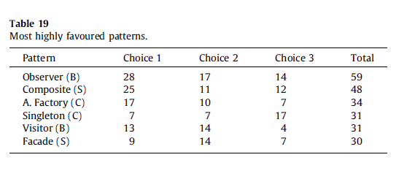
Figure 2-1 : Zhag and Budgen’s results based on a survey they created, answered by experienced developers [48]
Design patterns are language independent allowing them to be applied in any object-oriented programming language. This means that design patterns are not the full implementation but in each pattern, an approach to solving a problem is described, allowing many ways for the solution to be implemented and personalised to each problem. “Half baked” is the term used to describe a design pattern by Fowler, cited in Zandstra [14].

Structure of Design Patterns
In the literature, there are several examples how to describe a software design pattern including Unified Modelling Language (UML) Diagrams, implementation examples and code examples. In this project, the four essential elements of design pattern will be discussed. The four essential elements include:
- Pattern Name:
By naming a design pattern, the design problem is described [8] including the behaviour and relationship of the pattern [18]. Naming and choosing the correct name for the pattern is very important as a common vocabulary is provided for designers, improving the language of programmers[14]. Martin Fowler [25] describes the pattern name as “crucial”.

- The Problem:
This part of the structure of a design pattern, the problem is explained and when the pattern should be applied and implemented.
- The Solution:
The solution explains an approach to solving the problem by describing the design elements using a UML diagram and basic code examples.
- The Consequences:
The consequence of a design pattern is the result and impact of applying that design pattern.

Organisation of Design Patterns
Each design pattern varies in level of abstraction and level of detail. Considering there are so many design patterns, the GoF [8] has categorised each pattern to organise them. The GoF [8] state that using the categorisation helps object-oriented designers refer to families of related patterns and helps to learn patterns within their catalogue faster.
The technique and criteria the GoF used, divides the criteria into a purpose and a scope. The purpose defines what a pattern does, the scope identifies whether the pattern should be applied to the class or object (Figure 2-2).
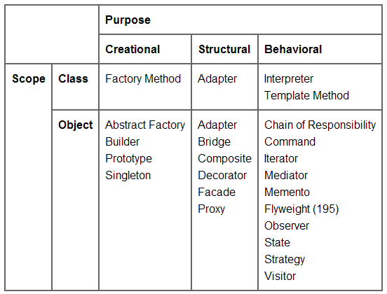
Figure 2-2 [16] : The GoF’s organisation technique
This organisation has been extended by both Zandstra [14] and Fowler [25] emphasising more on enterprise patterns.

Design Patterns in the Learning Environment
With the popularity of design patterns increasing and becoming an essential skill, design patterns have recently become an essential component within the learning environment, commonly at universities at an undergraduate level [55].
In their study “Cognitive Learning efficiency through the use of design patterns in teaching”, Kolfschoten et al [56] explain it is key that students learn in a way that students can recognise problems and apply a solution to that problem. To achieve this, Kolfschoten et al [56] suggest design patterns can be used, allowing best practises and expertise to be learned.
Johnson, Brugali, Menga and Aarsten all state that the pattern language has a major educational purpose, although Kolfschoten et al [56] suggest that teaching the pattern language, does not limit teaching a student or novice “new tricks” but offers them a toolbox to recognise problems. Within their study, Kolfschoten et al [56] conducted 3 case studies and came up with the conclusion that design patterns help novices gain a greater understanding in design and problem solving skills and improve their learning efficiency.
To support Kolfschoten et al [56] suggestions, other authors also state they can see design patterns have a greater educational purpose. Sterkin documents [57]:
“I sense a deeper connection between design patterns and the education process”.
Within his study “Teaching Design Patterns”, Sterkin [57] also suggests design patterns should also be taught because they allow the introduction of abstractions within software development.
Despite design patterns being introduced in the education curriculum, students are unable to apply the skills taught at university in industry. This could link to the teaching approach, teaching materials and the limited amount of teaching hours available to teach design patterns [55]. It seems the traditional approach of lecture-based teaching offers the students an insufficient ‘real-feel’ for design patterns [58], only enabling to provide them surface knowledge. Teaching materials available such as text books and online resources also have lack of quality of examples used, commonly being too simple to use in a real-world problem or application. In “Explaining design patterns through one application”, Ouyang [49, p. S1G–7] states:
“After searching through various books and websites in design patterns, I have found that many examples given in these books and web sites are too simple to have real application”.
One book recommended for the study of design patterns, is the GoF “Design Patterns: Elements of Reusable Object-Oriented Software” [8]. This book is a catalogue of design patterns and has become very popular by object-oriented designers, but examples within this book can be inadequate for students because they are too abstract.
Another problem with the teaching approach of design patterns within education is design patterns are one of the last topics to be taught and studied. Design patterns are commonly taught in the third year of computer science degrees, this is reflected in the author’s current university of study where design patterns are marginally introduced in earlier years but are investigated more in the third. Despite this , Fojtik [59] came to the conclusion, design patterns can also be successfully taught at lower schools or education institutions as well as universities. Although design patterns cannot be taught before the student has a basic grasp of object-oriented programming.
Recently, coding has had full attention in education in the United Kingdom as a result of major technology companies such as Google and Microsoft complaining that the United Kingdom does not produce enough quality graduates to fill job vacancies. Since 2013, the educational curriculum has been altered to introduce coding to children as young as 5 years of age. At this stage children are introduced to algorithm [60] and by the time of finishing secondary school, the student will know at least 2 programming languages.
Many researchers have tried to investigate different pedagogical approaches on teaching design patterns. This project will evaluate approaches already taken to determine an approach to apply to this project.

Pedagogy and Pedagogical Approaches
There is a broad definition regarding the term pedagogy, with so many definitions available, it is thought that pedagogy is a method or strategy that is a structural and subject – oriented process allowing teachers to be influential on the learning of others [61] (also known as “the art and science of teaching, particularly within an academic subject”)[62].
The pedagogical approach is crucial to improve the effect of the teaching, resulting in how effective students learn.
To use a framework in the learning environment to teach software design patterns, a few pedagogical approaches will be evaluated.

Problem Based Learning
Problem based learning (PBL) was first applied in the 1950’s by Case Western Reserve University [55], followed in the 1960’s by Howard Barrows at the McMaster University [63]. This resulted in PBL being commonly used as an effective pedagogical approach in medical education.
PBL is a student centred pedagogical approach, that enables students to become self-directed and independent learners [64], enhancing their lifelong learning. PBL assumes that learning is an active process which starts with encountering the problem first and most commonly based on real world problems.
PBL commonly encourages group work, allowing students to work alongside their classmates to solve a complex problem [55]. However, a drawback of working in groups is the tendency for there to be a student who will play the dominant role within the group, resulting in students learning not to be developed equally[55].
Within PBL, students are required to apply their current knowledge regarding the problem to help them identify what information is needed to solve the problem and then strategies to find a solution. Unfortunately, students commonly find this difficult. To guide students, a lecturer becomes a facilitator who plays a vital role in guiding students by monitoring their discussion amongst the group [64], [65].
For PBL to be successful, as a consequence of the problem being the main driving force, it is crucial to have a useful set of problems [66]. Within the computer science discipline, particularly with design patterns this can be very difficult, which is reflected in limited examples found in textbooks and online resources.
It is difficult to conclude how effective the PBL teaching approach is within teaching design patterns as most studies cover students in all disciplines. There were limited studies that have covered using a PBL approach to design patterns [55], [58], although both authors slightly modified the approach, to achieve a better outcome. Other studies [64]–[66] have concluded that PBL is an effective approach that student performance is improved [64] and PBL improves student’s problem solving skills [65]. However, not all conclusions are as positive. In their study “A Tiny Adventure: the introduction of problem based learning in an undergraduate chemistry course”, Williams et al [67] concluded that PBL had no effect on the performance of students. Albanese [68] suggests that PBL should be used with caution and students who have been taught using a PBL approach also have gaps within their knowledge.

Scaffolding-Based Learning
Scaffolding was created by a psychologist named Jerome Bruner [69] and is based on Vygotsky’s concept of “Zone of proximal development (ZPD)”[70], which is the difference between a child or learner can do with support compared to what they could not do independently [71]. Likewise, to PBL, scaffolding is also a student centred approach, that encourages students to take more of an active approach into their own learning [72] and the lecturer becomes more of a facilitator. In scaffolding, temporary support structures or teaching materials are used to help a student complete a task they could not complete independently, these are called scaffolds. When the student can complete that task, the scaffolds are taken away, known as “fading”.
Commonly in scaffolding based learning, the framework outlined by Ellis and Larken [69], [73] is used. Within this framework, the teacher demonstrates to the class how to complete the task (within this case, solve the problem), the class then all complete the task together, then ending with groups and individuals completing the task individually [69].
When using scaffolding, a supportive learning environment is provided where students can provide feedback, ask questions and participate within group discussions, allowing the opportunity for peer to peer teaching and learning. Using scaffolding has known to increase the possibility of students completing objectives. Within their study “An Instructional Scaffolding Approach to Teaching Software Design”, Linder et al. [70], short assignments based on design and an architectural pattern are given to students each week, helping them to develop tools for their final projects. Feedback received from students were all positive, although Linder et al. [70] did not state how effective their approach was.
Ginat [74] conducted a study of “Interleaved Pattern Composition and Scaffolding Learning” and tested high school novices and seniors. The tasks given to the participants were three simple programming tasks. Before scaffolding, Ginat [74] identified that not all students complete some of the simplest tasks, Ginat [74] then applied a scaffolding to each task. Once the students were given an additional task, it was seen that the students managed to apply design patterns to their solution that were missed in the previous tasks before scaffolding.

Scaffolding Problem Based Learning
Scaffolding in PBL involves the use of scaffolds and instructions within a PBL environment. In his study “Scaffolding for Success in Problem Based Learning”, Greening [75] implies that there is a need for scaffolding within the PBL discipline, alternatively Choo et al. [76] concluded within their study, using scaffolds did not enhance the learning of students within their PBL framework. There are very few quality sources regarding integrating the scaffolding and PBL approach and its effectiveness in student learning.

Conclusion
By reviewing the literature, it has been identified that object oriented programming has allowed the introduction of software frameworks increasing productivity in the software engineering industry. These frameworks all have features in common and are built on software and architectural design patterns. With the increase of popularity of design patterns, design patterns have become a fundamental requirement within the software development industry and has resulted them being taught in education across the world. Despite these findings, design patterns are not taught until the later stages of higher education. Students are unable to apply the skills taught at university due to design patterns stored as surface knowledge.
After evaluating teaching approaches, both PBL and scaffolding based learning have a divided reputation within the literature, both being concluded as and effective pedagogy. However, in other studies, these approaches have not been as successful. It is thought using both pedagogical approaches can be a very effective approach to teaching software design patterns to year 3 Advanced Web Development students. Alternatively, it was identified there is a gap of research with little quality of sources regarding the effectiveness of using the both approaches together.

Chapter 3 – Research and Development Methodology
This chapter discusses the processes taken to decide upon an appropriate research strategy to gather results. The development methodology is also discussed giving details what development methods will be used to develop the MVC framework.

Research Methodology
In order to develop an appropriate research approach for this project, the research ‘onion’, developed by Saunders et al. [77] (Figure 3-1) has been used. To develop a research strategy, each layer within the onion has been covered.
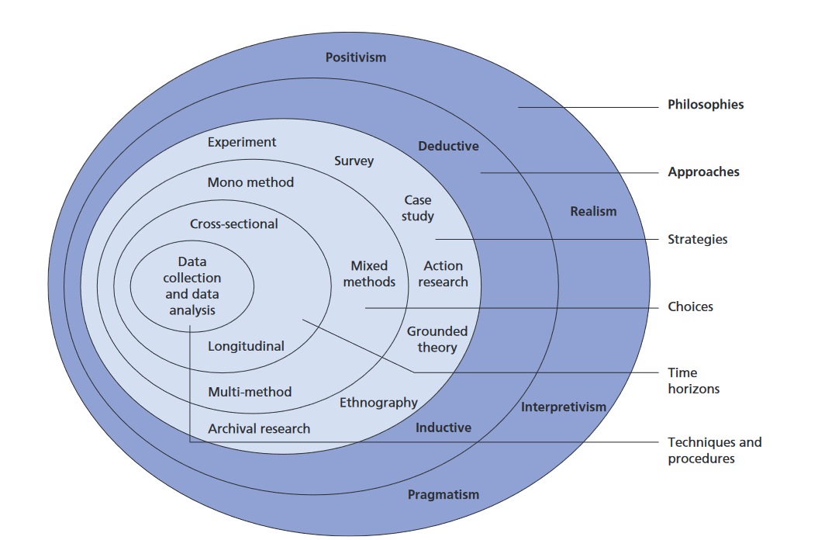
Figure 3-1 – The Research Onion

Research Philosophy
Within this project, the phenomenology philosophy is the main philosophy adopted. The phenomenology philosophy emphasises qualitative data and is based upon understanding participant’s perceptions and human behaviour. This philosophy commonly uses small samples and uses the inductive research approach that will allow a theory to be developed based upon the analysis and evaluation of results.

Research Strategy
After being taught selected design patterns, participating students will be handed numerous exercises to test if they can apply what has been learnt. Once completed a focus group will be conducted to gather qualitative feedback from students on the teaching approach.
A focus group is a data collection method that helps the researcher gain qualitative data through the participant’s attitudes, feelings and experiences within a certain subject of interest.
Focus groups offer a flexible and natural setting where participants are asked to engage in a group discussion (commonly between 5-11 people) that is guided by the researcher, who acts more as a facilitator asking a series of questions, ensuring participants do not go off topic [78].
When using focus groups, many responses can be explored during that one meeting and all participants can ask questions amongst one another. Focus groups also help participants to recall issues they might have forgotten.
When using focus groups, it also needs to be considered that not everyone in the group may contribute. This could be a result of some participants may feel too nervous or anxious to speak in front of other participants within the group. Therefore, it is also important for the facilitator of the group to create a welcoming setting and relaxing the participants with a few ice breaker questions. Another reason for no contribution from all members could be one person overpowering everyone else’s views and experiences not giving anyone else a chance to speak. This can also be overcome by the facilitator actively involving other members by asking them questions related to the previous comment.
To overcome the risk of not all participants participating within the focus group, a secondary data collection method will be used in the form of a questionnaire. Questionnaires are an effective research tool and has become one of the most popular techniques to be used[79], [80]. Questionnaires can contain open ended questions, closed ended questions or a mixture of both. In this project, the questionnaire will use a combination of both open and closed questions. The closed questions will be used to gather quantitate data and the open questions will allow the respondents to explain their experience and feelings of the teaching approach. For questionnaires to be successful, questionnaires rely on a significant number of respondents, which is a risk in this project, although with a smaller respondent set, this makes the analysis of the quantitative data simpler.
Questionnaires can be distributed in a variety of ways, for example email, post, face to face and over the telephone. In this project, the questionnaire will be handed to the participants after they have completed the exercises provided and just before the focus group. This ensures a higher response rate.

Development Methodology
Within this project, the system development life cycle (SDLC) that will be used is the Waterfall Model. The Waterfall Model was the first SDLC and was introduced in the 1970’s by Royce. Royce developed this model to impose control over prior development approaches, for example the build and fix it approach and the stage wise approach [81].
The Waterfall Model is divided into sequential steps (Figure 3-2) that must be completed in succession. The next stage should not be started unless the previous step has been fully completed and signed off, although Weaver [80] suggests in reality, stages can overlap. Within this project, the building and testing stage will overlap, allowing each class to be tested through unit testing using PHPUnit.
As requirements forever change and increase, recently the Waterfall Method has become less popular in industry especially with the introduction of more iterative approaches like Agile. Regardless of this, the Waterfall Model will still be used in this project as requirements will be clearly understood and will not need to change and the Waterfall has been known to be very useful for unexperienced practitioners, offering a great starting point for students [80].
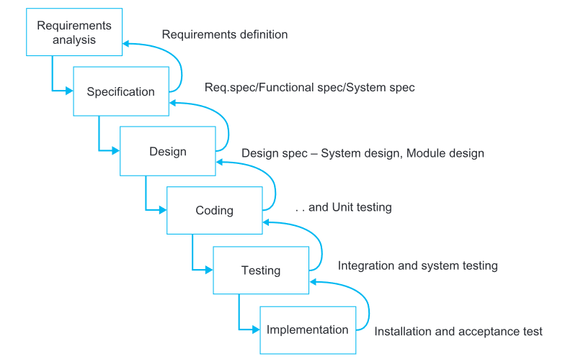
Figure 3-2 : Waterfall Model (Royce, 1970), Taken from [81]
To accompany the Waterfall Model, the development methodology used for this project will be Object Oriented Methods (OOM). These methods include Object Oriented Analysis (OOA), Object Oriented Design (OOD), Object Oriented Construction (implementation) and testing.
Following the work of Coad and Yourdon [82], Booch and Jacobson, Object Oriented methods became most influential in the early 1990’s incorporating the same underlying concepts as object oriented programming languages [80]. These concepts are based upon objects that are self-contained packages that encapsulate data and behaviour which are based upon real-life objects, providing a more natural way of world representation within software.
Object Oriented Methods assume the system being built will be implemented using an Object-Oriented programming (OOP) language. During the early stages of the life cycle, the system is implemented at a high level abstraction and as the project progresses, the system is added to gradually [80].This applies to this project as the framework will be built on mostly abstractions with few concrete classes and then will be extended by third year students to help them gain understanding of design patterns.
Object Oriented methods is now gaining popularity in more student projects due to code re-use and application becoming more extensible and maintainable [11].

Object Oriented Analysis (OOA)
The purpose of the analysis stage is to gain an understanding of the application to be built and describe what it will do (the requirements of the application)[13]. Although Coad and Yourdon’s [82] original methodology of OOA has been extended, Avison and Fitzgerald [83] uses the this original description of OOA. When performing OOA, Coad and Yourdon [82] highlight that OOA consists of 5 sequential steps. These are:
- Identifying classes and objects: Finding relative classes and objects that build the core of an application, known as “system Responsibilities”.
- Identifying structures: Organising classes into hierarchies into base and derived classes.
- Identification of subjects: Grouping similar classes together and the application structure into more understandable subject structures.
- Defining attributes: Attributes of classes are defined.
- Defining services: Methods and behaviour are defined.

Object Oriented Design (OOD)
To design the framework, Unified Modelling Language (UML) will be used. UML is a notation language that was developed by Booch, Rumbaugh and Jacobson (The three Amigos[11], [80]) in 1997 and has become the established industry standard for object oriented notation. UML consists of 9 types of diagrams. Within this project, only 2 out of the 9 diagrams will be used, these are the class diagram and the sequence diagram.

Class Diagram
Class diagrams are the most widely used diagram within UML [14] and are used for modelling the static structure of an application. Class diagrams are very effective approach to illustrate object-orientation relationships. In a class diagram, a class is represented as a square / rectangle box which is divided into 3 components (Figure 3-3). The top component is the class name, commonly in centre aligned and bold weight, with italics also being used for abstract classes. The second component includes any attributes that the class holds, finishing of the third component illustrating behaviour and methods.
Figure 3-3

Sequence Diagram
A sequence diagram is an interaction diagram that portrays the interaction between objects in sequential order from left to right. Objects are represented as a rectangle at the top of the diagram and its existence, known as its lifeline being portrayed as a dotted line running from the object down the page [83].

Object Oriented Construction (Implementation)

PHP
From the literature review, it has been identified that PHP has increased popularity in web development. With the increase of popularity, PHP is the chosen language to use within this project to build the simple framework to teach design patterns to students.
As PHP 7.0 is still relatively new, PHP 5.6 will be used for this project as some servers may not support 7.0 and on the website PHP.net, it states PHP 7.0 should be tested carefully and should not be used in production [84].

Software
The software that will be used to implement the framework will be Phpstorm by JetBrains. Phpstorm is an integrated development environment (IDE) that offers smart code completion, syntax highlighting and code verification. Phpstorm also includes support for front end technologies such as HTML, CSS and JavaScript, also providing in-built tools for testing using PHPUnit. Although Phpstorm is a licensed product, with a student email address, it is possible to gain a free licence for a year.

Conclusion
This chapter has discussed the research approach and development methodology that is used in this project. The research approach chosen is the phenomenology research philosophy that will involve the use of a focus group and questionnaire to gather qualitative results on the student’s perception of the teaching approach adopted.
It has also been discussed that the Waterfall System Development Life Cycle will be used accompanied by Object Oriented methods to develop the framework. With growing popularity PHP is the chosen technology to teach design patterns and build the framework.

Chapter 4 – Design and Implementation
This chapter outlines the design decisions and implementation on the PHP framework built and the teaching approach that has been adopted. The design discusses the requirements for the framework and justification for teaching and using certain design patterns. The implementation section within this chapter discusses and describes how the framework was built and what teaching material was used.

Design
From evaluating common PHP frameworks in the literature review, it was summarised that majority of these frameworks follow the Model View Controller architectural pattern, as well as other frameworks that was evaluated in Paikens and Arnicans study [40]. This architecture pattern however incorporates other design patterns within its structure.
With MVC popularity increasing, the MVC pattern has been chosen as the main architecture of the custom framework. This will also help the students to learn how a system can be divided into layers and how each layer works together.
As the MVC pattern has been adopted for this design and implementation, the framework was divided by various folders. As identified in the literature review, 3 of these files included models, views and controllers (Figure 4-1).
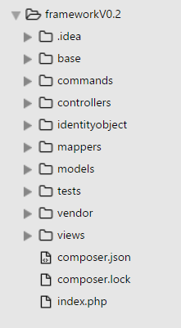
Figure 4-1 : Folder Structure

Overall Framework Design
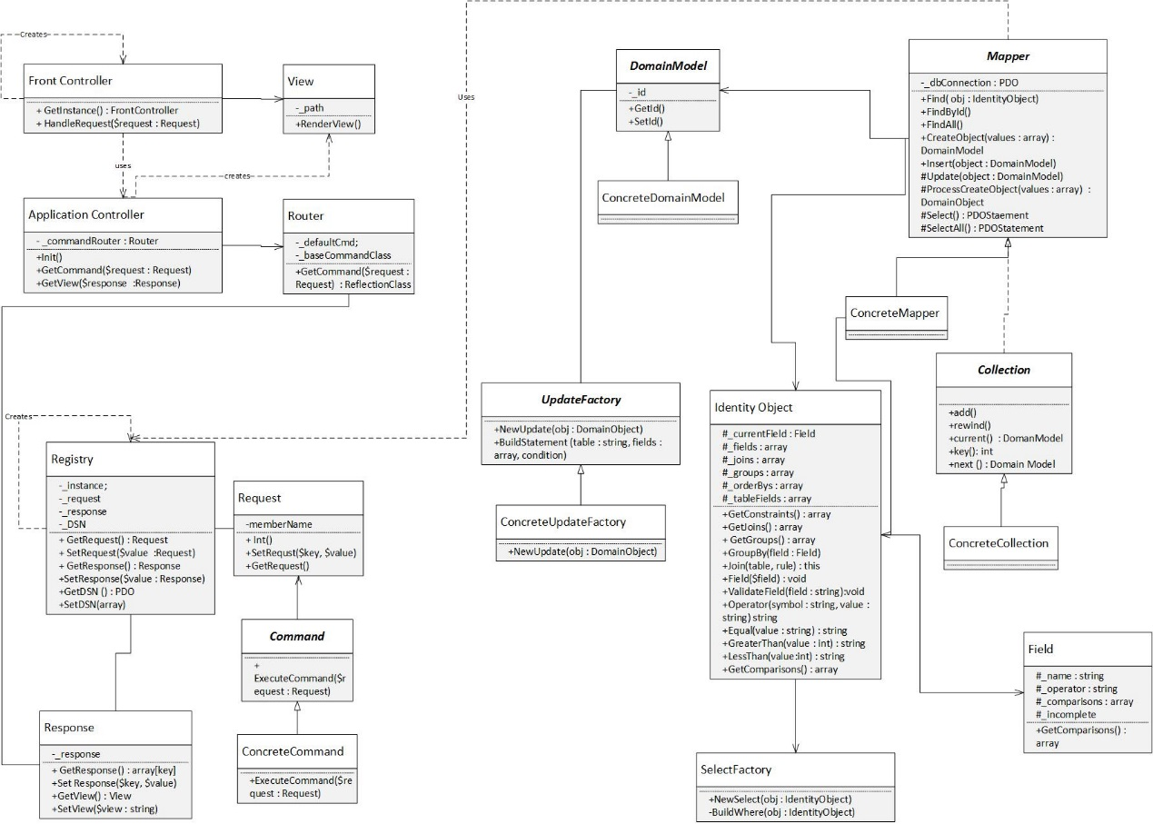
Figure 4-2 : Overall Framework Design Class Diagram
The class diagram depicted in Figure 4-2 illustrates the overall design of the custom framework. The left-hand side of the diagram, describes how the classes work together to process a request. The following patterns used for request handling involve the Front Controller, Application Controller, Registry Design Pattern and Command Design pattern. Alternatively, the right-hand side illustrates the database handling side of the framework which has been built as an Object Relational Mapper (ORM) incorporating various design patterns including the Domain Model, Data Mapper and Identity Object pattern.
Due the nature of this project the design and implementation section of this project has been combined together.

Implementation
The original framework was supplied by Mike Dacey, consisting of 9 classes that have been modified. These classes are Front Controller, Application Controller, Abstract Command, Response, Request, Registry, Router and View classes. However, the view class was heavily modified to accommodate the template engine Twig. The author then extended the framework to accommodate and Object Relational Mapper (ORM). The classes designed and implemented by the author are: Domain Model, concrete Models, Abstract Mapper, concrete Mapper classes, Collection Class, Collection Factory, Identity Object, concrete Identity Object, Field, Select and Update Factories.

Registry and Singleton Design Pattern
Resulting in applications and frameworks adopting the MVC pattern, it can be difficult for a layer to access data that is contained within a different layer of the application or framework [14]. The required data could be passed along as objects within the different layers, but this increases coupling within the system forcing each object to be altered. These objects become tramp data [14], [41].
The Registry design pattern is a class that provides system wide access to objects and is commonly implemented using the Singleton design pattern. However, like the majority of design patterns, the Registry design pattern can be implemented in various ways.
Although there are divided opinions surrounding the Singleton design pattern with many professionals calling it poor practise, Saray [18] claims the Singleton is the design pattern is commonly used. Along similar lines, Zandtsra [14] propounds the view that the singleton can be useful and a number of professionals, including himself still use this pattern. As there is only one registry that is required in this project, the Singleton Pattern will be used allowing only one instance to be instantiated of the registry class and allowing global access to it within the framework.
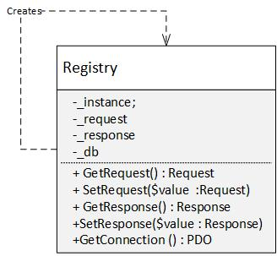
Figure 4-3 : Registry Design Pattern UML Class Diagram
To stop client coders from instantiating multiple registry objects, the constructor of the application was set to private (Figure 4-4).
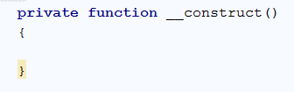
Figure 4-4: Private Constructor
As client coders will be unable to instantiate a new Registry object, the class to contains a method called GetInstance(). This method checks if an instance has already been instantiated using an instance attribute and the PHP in-built isset() function (Figure 4-5). If the instance attributed is not set, the class instantiates a new instance of itself and instantiates new instances of the request and response class. As the Registry class provides system wide access, the request and response objects are also instantiated in this class as these objects will be needed in most layers of the framework.
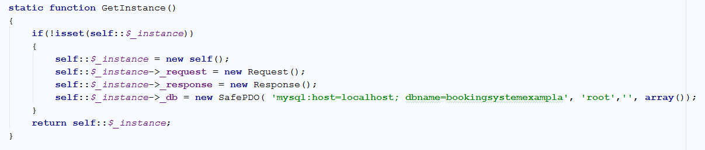
Figure 4-5: GetInstance() Method
The database connection is also instantiated using the SafePDO class [85]. This class extends PDO and catches any exceptions in alternative to displaying the SQL and exception on screen. This SafePDO class also contains getter and setter methods, allowing the client to acquire any data or objects that might be needed.

Command Design Pattern
When interacting with an application, a request is sent to the application from the user. The application needs to decide what to do with this request without knowing the operation that has been requested. The Command design pattern encapsulates a request as an object that is used to perform a command. Zandstra [14] suggests that this pattern promotes prime enterprise design and incorporates this pattern into his projects. There are 4 participants within the Command design pattern, these are:
- Command Interface / Abstract class: Has an execute method to perform the command.
- Concrete Command: Extends or implements the Command interface and provides an implementation of the execute method.
- Receiver: Command operates on this.
- Invoker: executes the command.
- Client: Instantiates the concrete command.
In this project, the Router class acts as the client and returns a concrete command to the Application Controller which then passes the command to the Front Controller (invoker) to execute the command (Figure 4-6).

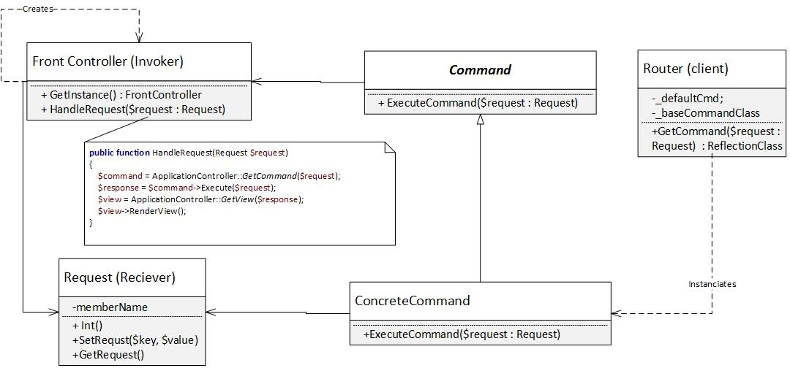
Figure 4-6: Command Design pattern UML Class Diagram
To implement the Command Design pattern, it was decided to implement an abstract command class and multiple concrete command classes that extend the abstract class. When handling a request, the Front Controller is unaware of what command it will execute in run time. The abstract class contains an abstract method named ‘Execute’ which all concrete commands are forced to implement. The Execute() method has been implemented to accept a request as a parameter and to return a response object. When the command has been executed, returning the response object allows the Front Controller to pass in the response object to the Application Controller which uses the response to return the appropriate view.
A Router class has been implemented to return the concrete command to the application controller. To do this, the class uses the GetCommand() method. In this method, a request object is passed in as a parameter and is used to obtain the request. If the request has not been set, a default command is returned. The default command is instantiated in the Router’s constructor and has been set to the home command to redirect users to the homepage. Secondly by using the request, a file path is constructed (Figure 4-7). When constructing the file path, the word ‘Command’ is appended at the end of the request. This sets up a convention for the students to use. For the framework to run correctly, the students are forced to create their command classes ending with “command”.
Figure 4-7: File path enforcing a convention
After checking if the file path and class exists, the Router class uses Reflection to gain information about the concrete command class. The router uses this information to check if this command is a subclass of the abstract command class (Figure 4-8), if not, the class throws an error. This also sets a convention, enforcing the students to extend the abstract command class when creating concrete command classes.
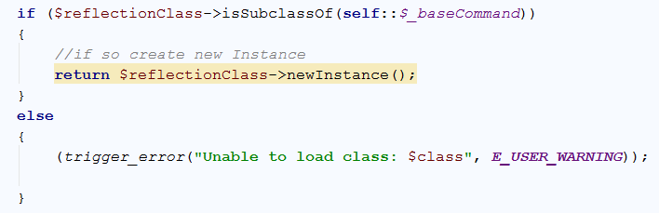
Figure 4-8: Subclass check

Front Controller Design Pattern
When summarising the MVC pattern in the literature review, it was discovered this architectural pattern commonly uses the Front Controller design pattern. This pattern offers a central access point for all requests. The request is channelled through a handler that dispatches the request to the appropriate or required command in a command hierarchy [14][86]. There should only be one Front Controller in the framework, therefore it will implement the Singleton design pattern.
In this project, the Front Controller will use another type of controller called the Application Controller to retrieve the appropriate command to execute.
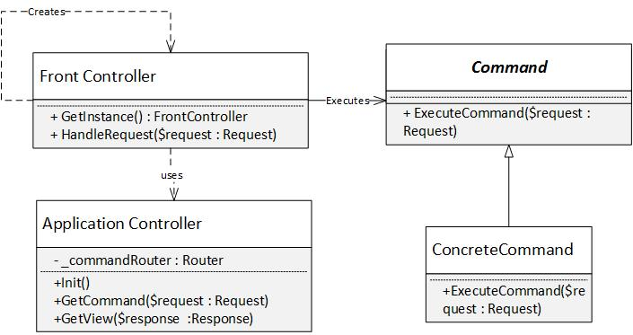
Figure 4-9 : Front Controller UML class Diagram
The UML class diagram (Figure 4-9) for the Front controller illustrates the front controller’s structure and how it relates and uses other classes. Being a singleton, the Front Controller instantiates itself, if an instance does not already exist.
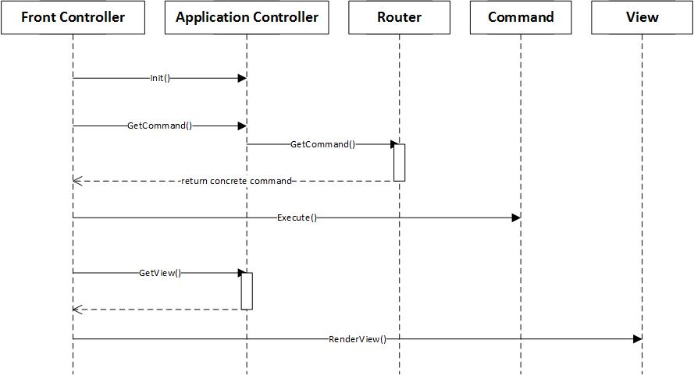
Figure 4-10 : Front Controller UML Sequence Diagram
The UML sequence diagram, represented in (Figure 4-10) describes how the Front Controller will use and interact with other objects in the framework. Upon instantiation, the Front Controller will run the Application Controller’s Init() method. The Front Controller will then use the Application Controller (which uses the router object) to retrieve the appropriate concrete command. Once the command is acquired, the Front Controller will execute the command. Upon receiving a response, the Front Controller again will use the Application Controller to retrieve the view to display.
By providing a central access point, the Front Controller reduces code duplication and increases security, but by providing a single entry point, it can become congested (choke point) making it more difficult for forbidden attempts to access the web application [87].
When implementing the HandleRequest() method in the Front Controller, the controller uses the Application Controller to acquire the concrete command and view using its GetCommand and GetView methods, respectively (Figure 4-11). This allows the Front Controller to follow the Single Responsibility Design Principle, making it solely responsible for handling the request and displaying the required view. This allows the Application Controller to control the flow of the application.
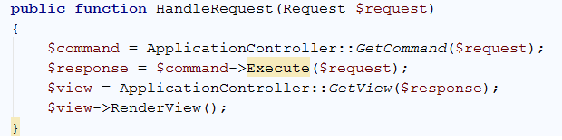
Figure 4-11: Handle Request Method

Application Controller
The Application Controller is a class that is commonly used by the Front Controller that centralises the control of the application. This pattern is responsible for controlling navigation, page flow and associating requests to commands and commands to views [14].
In this framework, the Application Controller delegates the responsibility of acquiring a command to the Router class (Figure 4-12). This class, will acquire the required command from the uniform resource locator (URL) and will return a concrete command.
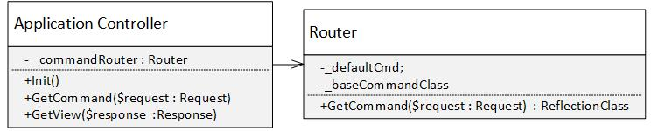
Figure 4-12 : Application Controller Class UML Diagram
The Front Controller sequence diagram (Figure 4-10) already outlines the process of the Application Controller and how it uses the Router class and returns the view to the Front Controller. To return the correct view to the Front Controller, the Application Controller uses the response object to acquire the view name and then maps the name to a file path that will be stored in an array (Figure 4-13). The benefit of using this approach is that the developer does not need to know the exact file path of the view. Another benefit of this approach allows the view name to be changed and the new view name will still route to the correct view file.
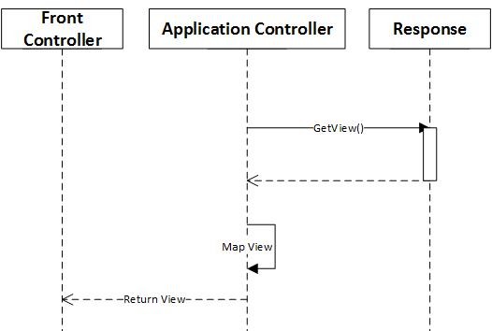
Figure 4-13 : Application Controller Mapping Views
The Application Controller reduces code duplication and makes it easier to alter the flow of an application by only requiring changes to made in one place. Another benefit of using the Application Controller is this class encapsulates the association between commands and views which offers increased flexibility when refactoring is needed [14].
In the implementation, the Application Controller uses an Init() method to instantiate a new Router object. The Application uses this Router object to fetch the required concrete command using the Router object’s GetCommand() method. This helps both the Application Controller and the Router class to adopt the Single Responsibility Design principle.
The Application Controller stores the views within the system in an associative array. This array has been implemented to contain name and value pairs to map the views passed into the Response object to the required View Object (Figure 4-14).
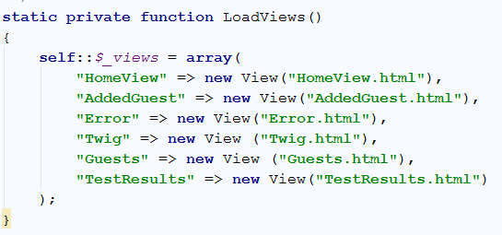
Figure 4-14: Associative Array containing view objects

Domain Model Pattern
Although Fowler [25] propounds the view that the Transaction Script pattern is the simplest and in majority of cases, the ideal business logic pattern to use, Zandstra [14] identifies that this pattern is a typical quick fix because the Transaction Script is only suitable for smaller projects and applications. As a system extends and becomes larger, the Transaction Script pattern becomes less effective and can result in the same tasks being completed by different scripts causing code duplication [14].
The Domain Model Pattern however, allows various ways to structure code, increase readability, allow extensibility and decrease code duplication [25]. The Domain Model represents the real-world participants within a system [14] that abstract the real world problem, logic and data [41].
There are 2 types of Domain Model, a Simple Domain Model and a Rich Domain Model. Within a Simple Domain Model, each model reflects to a database table within the database structure while alternatively, a Rich Domain Model is different from the database and includes inheritance, strategies and other design patterns.
In this project the Simple Domain Model will be used as it is easier to manage and a Rich Domain model is ideally suited for more complex logic, Sweat states [41, p. 286]:
“Which style of Domain Model you adopt depends on the context of your application…if you’re writing a library that’s to be the core of a multi-million-dollar enterprise’s intranet infrastructure, then the effort you put into developing a Rich Domain Model is likely to pay off…”.
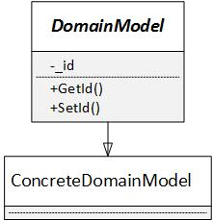
In this project, the framework will have an abstract Domain Model class that all models must extend. This abstract class will store the model’s ID and having getter and setter methods to allow access to this data (Figure 4-15).

Figure 4-15: Domain Model UML Class Diagram
To implement the Domain Model, an abstract class was chosen in alternative to an interface because it was wanted the abstract domain model to provide default functionality and data in the concrete model classes.
The abstract Domain Model class stores the model ID and provides methods to acquire and set that ID. A Collection class will implement the Iterator pattern to store these objects. When a client requests a collection from the concrete class, the class returns the collection. Alternatively, if no collection exists, it will return an empty or null value. To overcome this issue, a method was implemented to return an empty collection object.
To return an empty object, the GetCollection() method uses another class that adopts the Factory Method Design pattern to generate an empty collection. The decision of what concrete collection will be returned is based on the type that is passed in as a parameter. If no type is specified, the abstract domain model uses the get_called_class() function to return the name of the concrete model class that calls the GetCollection() static method (Figure 4-16).
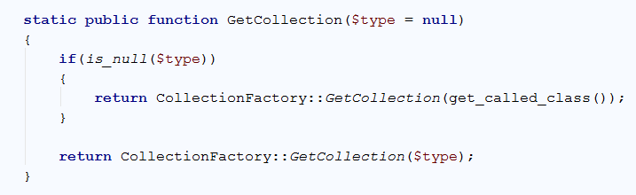
Figure 4-16: Get Collection method in Domain Model
The GetCollection() method within the CollectionFactory class, first replaces any unwanted characters from the type and attaches the word ‘collection’. The factory then checks if the collection exists. If the collection exists, the factory returns a new instance. Alternatively, the factory throws an exception (Figure 4-17);
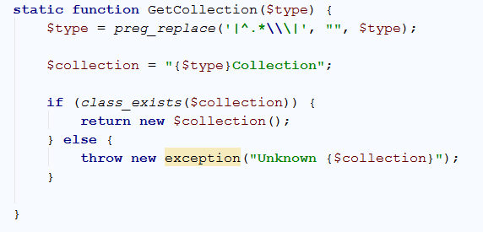
Figure 4-17

Data Mapper Pattern
From reviewing the literature, it is evident that majority of the PHP frameworks use and Object Relational Mapper (ORM). It was summarised that Symfony used a third party ORM called Doctrine, alternatively Laravel and the Yii Framework both use the Active Record design pattern.
The Active Record Pattern is a simplistic and easy to learn pattern that majority of the population could read and write to a database. The problem with the Active Record pattern is that it maps directly to the database schema, wrapping a database row in an object. Each Active Record class also contains methods that can interact directly with the database allowing them to perform create, read, update and delete (CRUD) operations. This leads to increased coupling between application code and database structure [25], [41] making the application harder to test and refactor [25].
In comparison to the Active Record pattern, the Data Mapper pattern is a layer between the business logic and database that understands both type of representations of the information to able to transfer data between the two. This allows the databases to be hidden from the Domain Model and business logic keeping the in-memory objects and database independent of one another. This increases flexibility between the domain and database.
The Data Mapper patterns consists of an abstract Mapper class and concrete Mapper classes (Figure 4-18). From the UML diagram, it is seen that the Data Mapper pattern will work with the Domain Model and will use methods to process CRUD operations, keeping the Domain Model and Database Independent of one another.
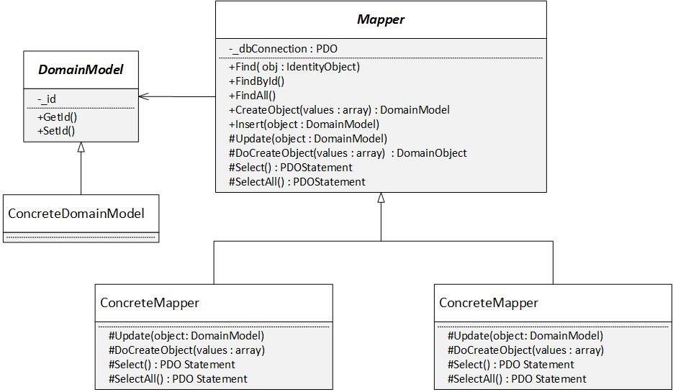
Figure 4-18 : Data Mapper Pattern UML diagram
The sequence diagram describes how the Data Mapper interacts with other objects when searching for a record based on its Id. The Mapper will request the connection using a method in the Registry class and will then perform a select statement on the database to acquire the desired record. Once the record has been acquired by the Mapper, the Mapper will pass in the array returned by the database into its CreateObject() method to instantiate a new object which is then returned to the client.
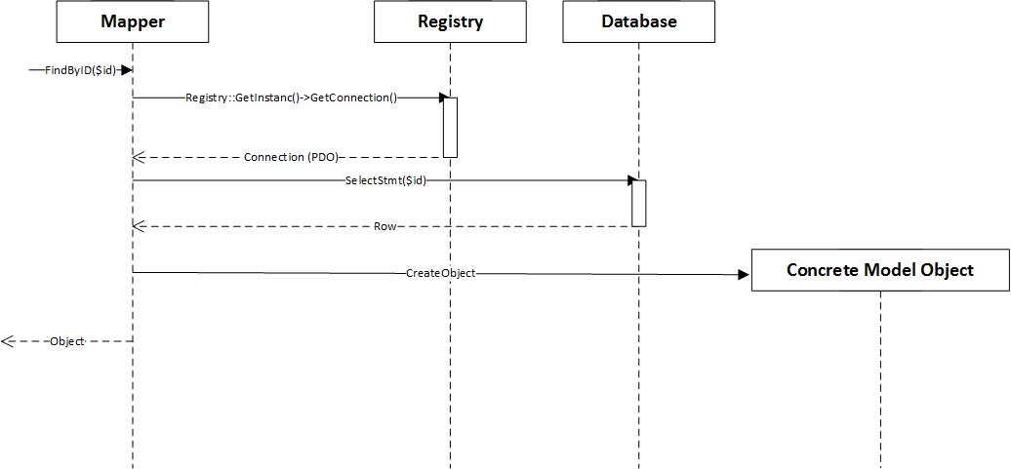
Figure 4-19: Data Mapper FindById UML sequence diagram

Within the abstract Mapper class of the framework, the class uses the Registry object to obtain the database connection (Figure 4-20). All database transactions are processed through this abstract Mapper class. Including the database connection in the abstract mapper helps with database abstraction, making the framework to be more flexible. If it we need to change the database driver, the connection would only need to be changed in the abstract mapper rather than in every concrete Mapper class. This allows extra concrete mapper classes to be added for different database drivers.
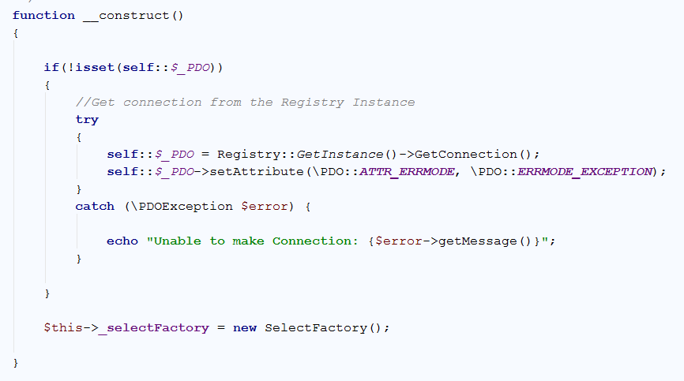
Figure 4-20: Abstract Mapper Constructor
To help further with database abstraction, the Data Mapper pattern also works alongside the Identity Object pattern (Figure 4-21). The Data Mapper uses this pattern to construct SQL statements within its concrete mapper classes. If the database driver is ever changed, this allows the SQL syntax to be changed in one place.
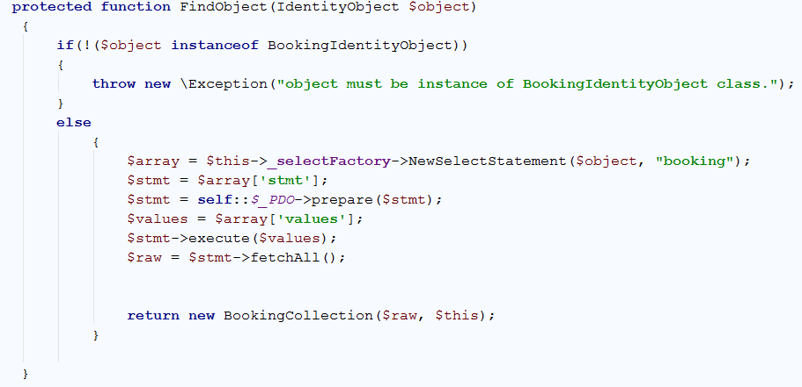
Figure 4-21
In this implementation, the abstract Mapper class uses methods to perform create, read, update and delete (CRUD) operations but delegates this process to the concrete Mapper class because it is the concrete Mapper classes that provide the details of the implementation based on the database table. An example of this implementation is the CreateObject() method in the abstract class that delegates the process to the DoCreateObject() method in the concrete Mapper. When the abstract class fetches a record from the database, it instantiates a new object based on the concrete Mapper that is used (Figure 4-22). This encapsulates the details, making it easier for the client to fetch, delete, update and insert new objects and data to the database.
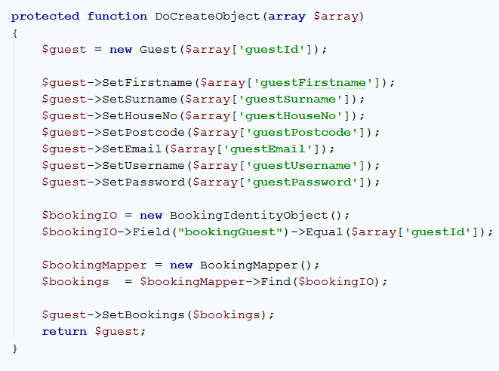
Figure 4-22: Do Create Object Method

Iterator Design Pattern
It is simple using the Data Mapper pattern on its own to add, update, delete or read single records from the database but it becomes somewhat difficult when retrieving a significant amount of data from the database. Objects can be returned in an array, although this requires each object to be instantiated first [14] and can cause slight overhead if thousands of objects are returned
To solve this problem, the framework will contain a collection class that implements the Iterator interface. This interface requires the Collection class to implement methods that allow one to query a list [48].
This pattern will work alongside the Data Mapper pattern (Figure 4-23) and will store the retrieved result set in an array in the Collection class. When a certain data set element is requested, the class will use a method to check if an object already exists in an objects array. If false, the collection will instantiate a new object and return it to the client.
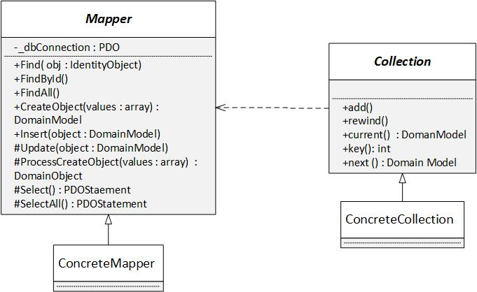
Figure 4-23 : Collection Working with the Data Mapper Pattern
When implementing collections in the framework, an abstract Collection class and concrete Collection classes have been used. The abstract class contains functionality that all concrete classes must implement, on the other hand, the concrete collection class represents and returns the type of collection, for example a booking collection.
The abstract Collection class was implemented using the PHP in-built \Iterator interface because the pre-defined methods used in this interface allow the class to be used in a foreach loop just like an array.
The abstract collection class stores the raw data of the collection within an array and when requested by a client, the GetCurrent() method (Figure 4-24) is used to instantiate the current array item to an object. To do this, the mapper is passed into the collection constructor and the GetCurrent() invokes its CreateObject() method, passing in the current array item. This only requires the current element to be instantiated as an object reducing overhead. Once instantiated, the new object is added to an objects array.
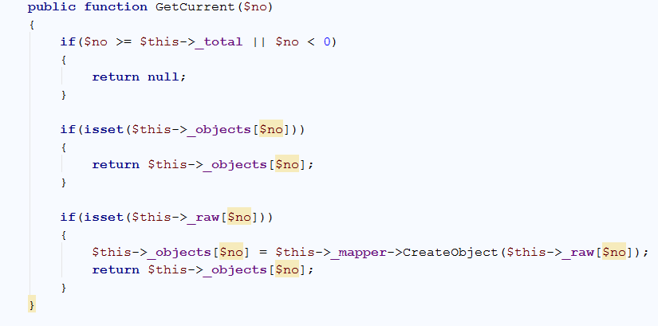
Figure 4-24: Get Current Method in Abstract Collection Class
The abstract Collection class also allows new objects to be added to existing collections. An Add() method has been implemented and uses the TargetClass() method (Figure 4-26), implemented by the concrete Collection which returns the collection type to check if the object passed in to the Add() method is an object of the class returned. This stops other object instances from other classes being added to that collection.
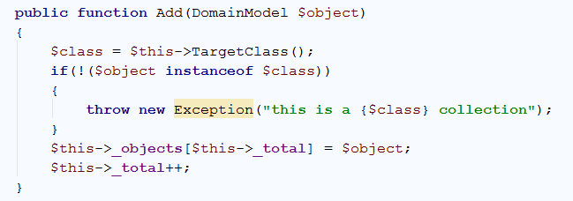
Figure 4-25: Add Method
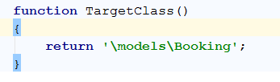
Figure 4-26: Concrete Collection Target Class method

Identity Object Pattern
Although the Data Mapper pattern is deemed an appropriate pattern for Object Relational Mapping (ORM), it does have its flaws. It is difficult to predict what client coders will query in the future. The larger the size of the domain model in a system, the more filters a client coder will need to use to get the results they require. One solution to this problem could be adding extra methods to each mapper class to accommodate these filters, although this causes inflexibility and code duplication as similar SQL statements will be generated across multiple mapper classes also causing coupling.
However, another solution is the Identity Object Pattern (named by Zandstra [14]). This pattern encapsulates the conditional element of the query criteria and allows multiple query criteria combinations to be combined at runtime, in alternative to writing an extra SQL query in a concrete mapper class. Using the Identity Object pattern decouples the system from the database syntax, changing the database syntax just requires either a new class can be added or changes to the syntax will only need to be edited in one place.
In this implementation, the Identity Object pattern will include an Identity Object class, a Field class and a Select Factory class. The field class will store and encapsulate the data to be compared. The Identity Object class will work alongside the Field class to store and set the query criteria. The Identity Object class will also store an array of the required fields that represent the fields in the database table. To build the SQL query, the Identity Object will use a Select Factory class. This class will accept the Identity Object and based on the fields, query criteria and any other data, the factory will build and return the SQL statement.
To execute the returned statements, the Identity Object pattern will work alongside the Data Mapper pattern. The Data Mapper pattern will use a method to accept an Identity Object to search for records based on the query criteria held in the Identity Object. Although it does not work with the Identity Object directly, an Update Factory will be used and implemented in the Data Mapper class to reduce code duplication. This Update factory will accept a Domain Model object as a parameter and based on the ID being set, it will generate either an Insert or Update SQL statement, therefore reducing code duplication by eliminating the need for similar update and insert statements across concrete mapper classes. This design completes the Object Relational mapping for the framework (Figure 4-27).
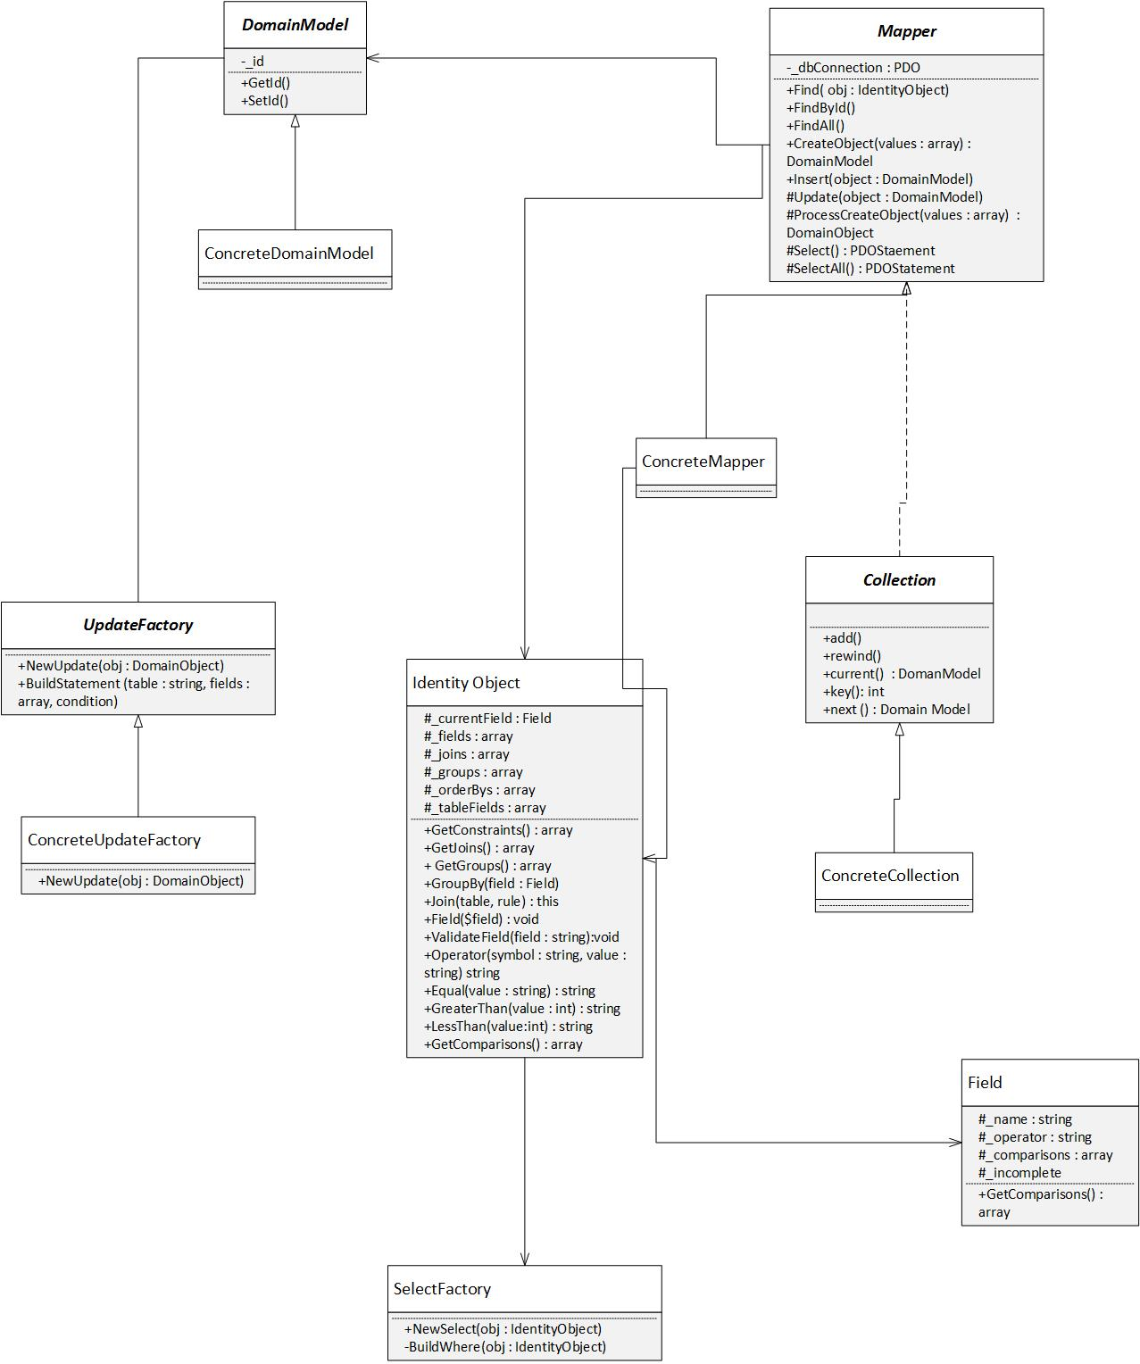
Figure 4-27 : Identity Object working with other classes to form an ORM
The sequence diagram in (Figure 4-28) depicts how the framework will use the Identity Object to acquire results through the concrete mapper object’s Find method.
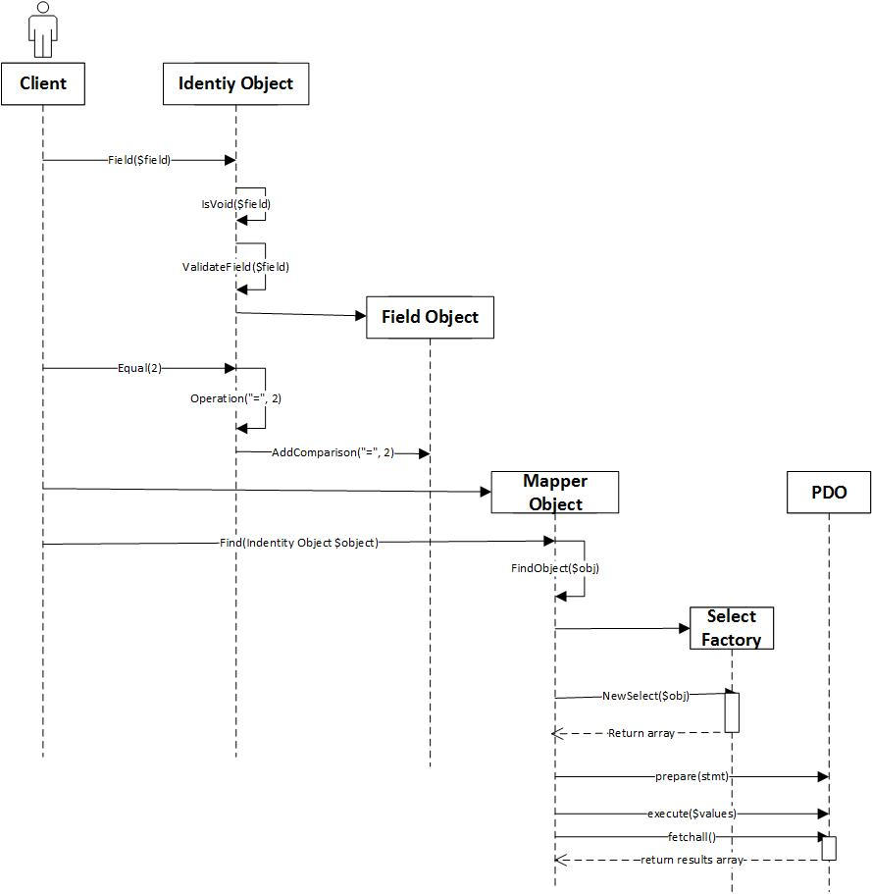
Figure 4-28 : Sequence Diagram using the Identity Object Pattern with Mapper Find method
The Identity Object will also be used in the concrete mapper objects to acquire a record with a specific id. When the FindById() method in the abstract Mapper class is invoked, it will delegate the process to the SelectStatement() method in the concrete Mapper. In this method, an Identity Object will be instantiated and used to acquire the correct record. The sequence diagram in (Figure 4-29) illustrates the interaction between the classes.
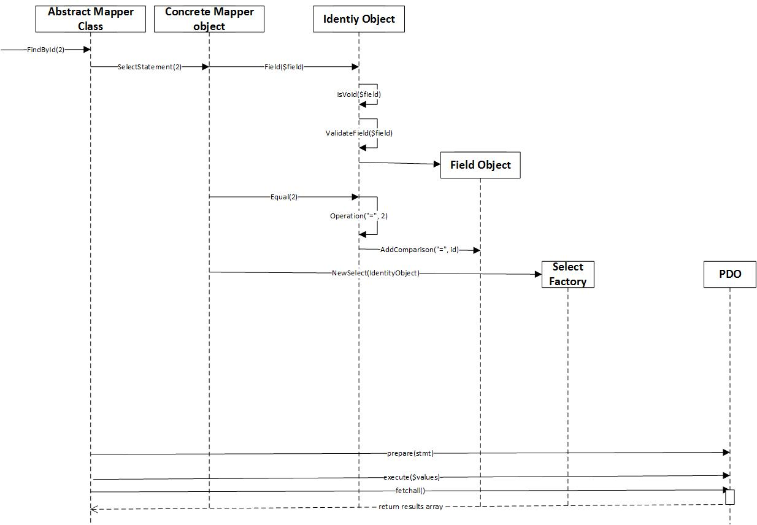
Figure 4-29
The Identity Object class has been implemented as an abstract class because it is this class that manages the common operations that are required by the Identity Object subclasses. This also allows the concrete Identity Objects to share a type, allowing an Identity Object to be passed into the Find() method in the abstract Mapper class in the Data Mapper pattern without knowing the concrete Identity Object will be used.
In its constructor, the Identity Object abstract class accepts two parameters, a field and an array of required fields, although both have the default value of null. This allows the client coder to either specify a field when instantiating an Identity Object or to use the Field() method. The required fields however, is passed in by the concrete Identity Object, as they contain the field names that are associated with the database table.
To store the comparison data of an SQL query, various arrays and methods are used. The Field() method (Figure 4-30) has been implemented to accept a field name. This method first checks to see if the current field has been completed using the IsVoid() method and the IsInComplete() method. Both methods return an empty array. After that check, the method identifies if the field passed in is currently set in the fields array. If the field is already contained in the fields array, the method does an additional check and validates if this is in the required fields array using the ValidateField() method. This check is done because it stops the client coder from adding fields that are not used in the database table. Alternatively, if the field name is not in the fields array, the method instantiates a new Field object passing in the field name, sets it to the current field and then adds it to the fields array.
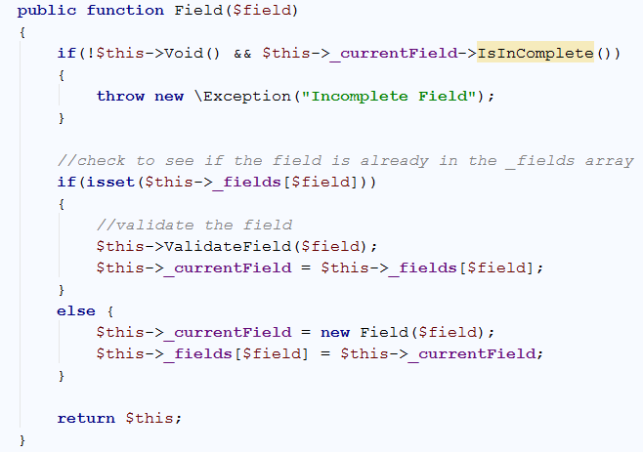
Figure 4-30: Field Method
To add comparisons to the field, Add(), Equal(), GreaterThan() and LessThan() methods were added to the Identity Object class. These methods are associated with the comparison operator. Each of these methods invoke the Operator() method (Figure 4-31), passing in the appropriate operator and a value. The Operator() method then calls the AddComparison() method on the current field, adding the comparison to the field.
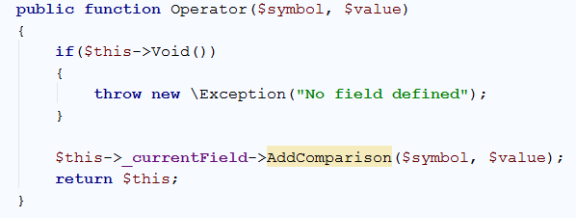
Figure 4-31: Operator Method
Other arrays and methods was added to the Identity Object class to support other SQL query criteria such as Joins, Group by and Order by clauses.
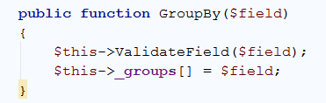
Figure 4-32: Method to Add a Group by Clause
Implementing this class, by passing in the required fields, this can limit the type of queries, client coders can build, for example the use of aggregate functions. To address this problem, a method was added to the identity object to allow the client to add a field constraint.
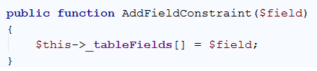
Figure 4-33: Add Field Constraint Method
Most of the methods in the Identity Object class, return an object instance using the ‘$this’ keyword. This allows client coders to chain the methods together, resulting in the client code representing the criteria almost like a sentence making it easier for client coders to read and understand. Particularly if they do not understand SQL syntax.
To build the query, this pattern uses a SelectFactory class which contains two methods. The method used by the client coder is the NewSelectStatment() method. This method accepts an Identity Object and the table name, allowing only one class to be used rather than multiple concrete classes. This method uses the Identity Object to get the fields of the table to build the core of the SQL statement (Figure 4-34).
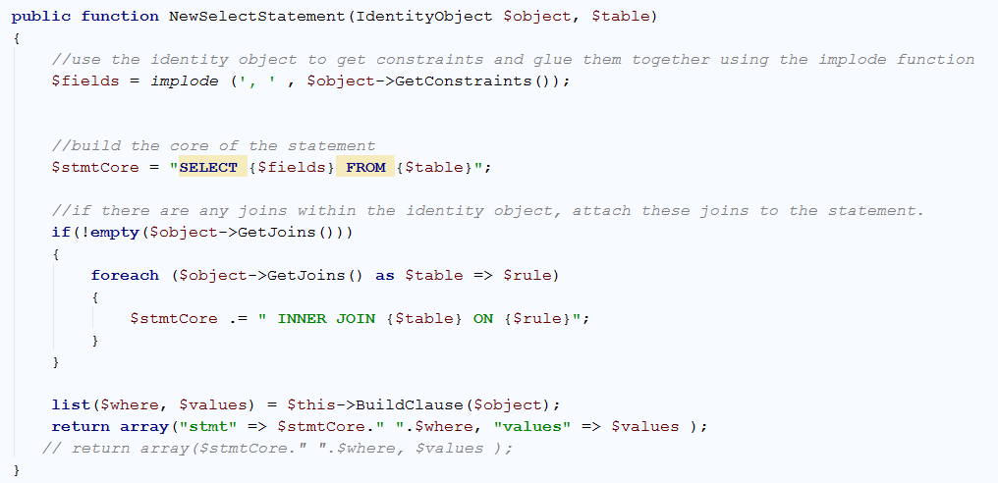
Figure 4-34: New Select Statement Method
The NewSelectStatement() method then invokes the BuildClause() method to build the remaining section of the SQL statement. This method is a private method and encapsulates its process from the client coder. The method loops through the comparison data within the Identity Object adding the name and operator of the comparison along with a parameter place holder to an array. The value of the comparison is added to a separate array. The method then builds the WHERE clause section of the SQL statement before returning both the remaining statement and value back to the NewSelectStament() method.
To return the statement and values back to the client coder, the List function was originally used. This function assigns variables as if they were an array [88], however, this caused an offset error. To overcome this issue, the return array() method was used assigning both the statement and value to array key elements. This allows the client coder to retrieve the statement and value using the array keys and allows the statement to be prepared and executed normally (Figure 4-35).
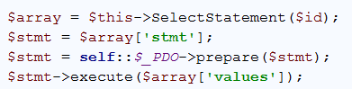
Figure 4-35: Preparing and Executing the generated statement
As stated in the design, the Identity Object works alongside the Data Mapper pattern so after implementing the Identity Object pattern, the Data Mapper pattern was refactored to accommodate the Identity Object. This meant that not so many methods were needed to perform the common CRUD operations. Originally, a Select Factory class was instantiated in each of the concrete Mapper classes causing more objects to be instantiated than needed. To resolve this, the SelectFactory class is instantiated in the abstract Mapper class.

Template View Pattern
Commonly when building applications that use server pages, it is very tempting to use conditional logic within the Hypertext Mark-up Language (HTML), especially in PHP. The problem with this approach is it makes it difficult for the front-end web developer / designer to amend the presentation of the application. Other drawbacks that surrounds this approach involves testing and code duplication. With testing made more difficult, applications become more prone to errors and with code duplication, the application can become tedious to debug.
As identified in the literature, the MVC pattern already addresses this problem by separating the level of concerns by applying layers to the system architecture and keeps the views and presentation independent from any logic code. When evaluating PHP frameworks, it was discovered that some frameworks use a PHP templating system to display dynamic data. To do this, templating systems use placed tags in the HTML mark-up which are generated into values using a helper object [14], [25].
In this framework, the view will be represented as a single class. This class will store the path of the HTML file and will use the Twig template engine (by Symfony) to display the dynamic content.
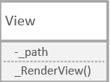
Figure 4-36 : View Class
To implement the Template View pattern, a template engine named Twig was chosen. Twig was developed by Fabien Potencier (the creator of Symfony) and was chosen because it is an easy template engine to learn. To use Twig, Twig was installed using PHPStorm adding a dependency to Composer. The version was selected and installed.
A new Twig Loader must be instantiated along with a Twig environment (Figure 4-37). The Twig filesystem loader instructs Twig where to find the views and the Twig environment creates a new Twig instance.
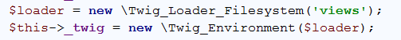
Figure 4-37: Instantiating Twig
As collection objects store multiple records, to display these records using Twig, the collection object was passed in the Twig render() function. This function passes the data into the template and displays the resulting HTML page. However, displaying results this way, causes an error as the render() function can only accepts the path of the view and can only accept data in arrays.
The first approach to solve this problem involved retrieving the raw data in the Collection object using the GetRaw() method to save the associate array to a variable. This allowed the data to be passed into the response object. The view then uses the response object to retrieve the data and passes it into the Twig render() function. When assigning the data to the response object, the data is assigned to a name, value pair. As the View class uses the name to retrieve the data, this forces client coders to follow a convention naming their responses “data”.
Figure 4-38: Acquiring the data using the response object
It was thought this would work, but again the same error occurred. To the solve the problem, the raw data array was stored into another associative array assigning it to an array key allowing it to be accessed by the template.
Figure 4-39
Assigning the array to a named key, forces coders to follow the convention to use the word “data”.

Testing
To test the framework, PHPUnit was chosen to build and run unit test. To install PHPUnit, a dependency was added to Composer in PHPStorm. To confirm PHPUnit was installed correctly, a simple test was implemented (Figure 4-40). In this test, a value got assigned to a variable and the PHPunit’s assertEquals() method was used to compare the expected value to the actual value. The test run and passed (Figure 4-41).
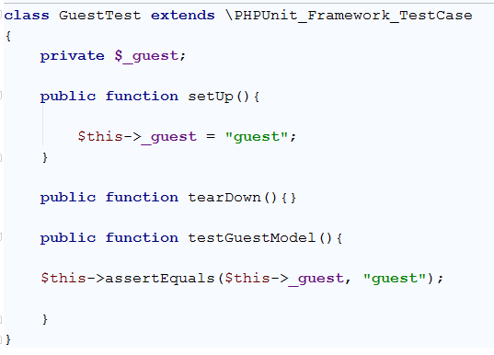
Figure 4-40: Simple PHPUnit Test
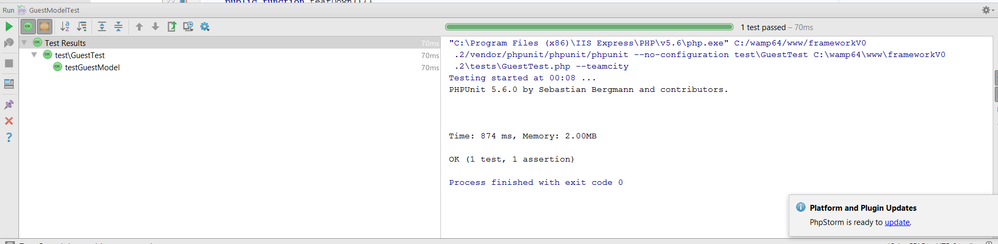
Figure 4-41: Unit Test Passing
However, when creating other tests for classes, an unexpected error code with an error message stating “Framework quit unexpectedly with exit code 255”, meaning the test did not run. After much research and trying various solutions including changing configuration files, a solution could not be found to the problem. It is thought the require_once() statements were causing the issue, because when the require_once() statements were not used, the test would run and fail but when included in the tests, the test would not run. Even after emailing the developer of PHPunit Sebastian Bergmann, Sebastian replied with no suggestions what could be causing the error or how to fix it.
To solve this issue, a custom test system was implemented. The Observer design pattern was used (Figure 4-42) to allow multiple tests to be added to a ClassTester class that implements an ITester (IObservable) interface. This enforces the ClassTester class to implement methods to attach, detach and notify Test classes. Once multiple tests have been added, the notify() method in the ClassTester class can be used to loop through each test, causing them to run altogether helping to save time rather than running each test individually.
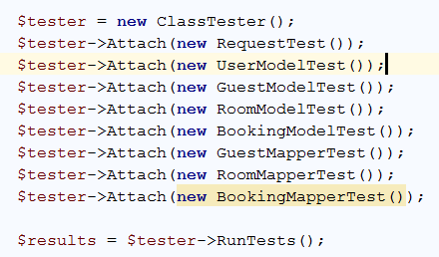
Figure 4-42: Observer Pattern used for testing
The abstract Test class stores an array of messages, allowing messages to be added if a test fails or passes. The Test class also uses the get_class() method to return the current calling class. To perform a test on the concrete test classes, the abstract class contains methods which follow the same concept of PHPUnit’s testing strategy. These methods can be used to compare a set of values, test if a method returns true or false and to check if a value is an array.
To run the tests, the command “RunTests” needs to be added as a parameter to the URL which is illustrated below:
“url/?cmd=RunTests”.
To display the results, a HTML Twig template (Figure 4-43) which loops through the array of messages and displays them on screen (Figure 4-44).
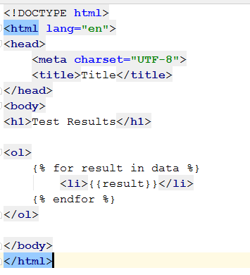
Figure 4-43: Twig Template
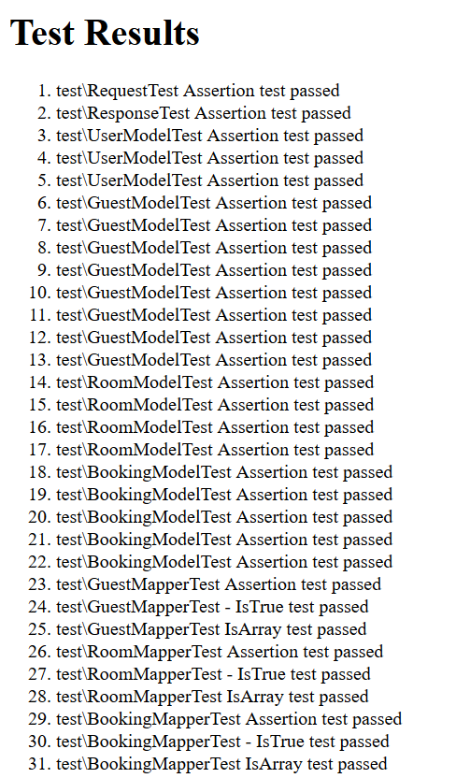
Figure 4-44: Test Results

Teaching Approach and Plan
To teach students design patterns, a teaching plan has been designe. This plan has been designed in such a way that students first start off with smaller problems and in each lecture a new and more difficult pattern and problem is introduced. The last task of this approach involves the students using what they have learnt throughout every lecture and putting it all together to solve a larger problem.
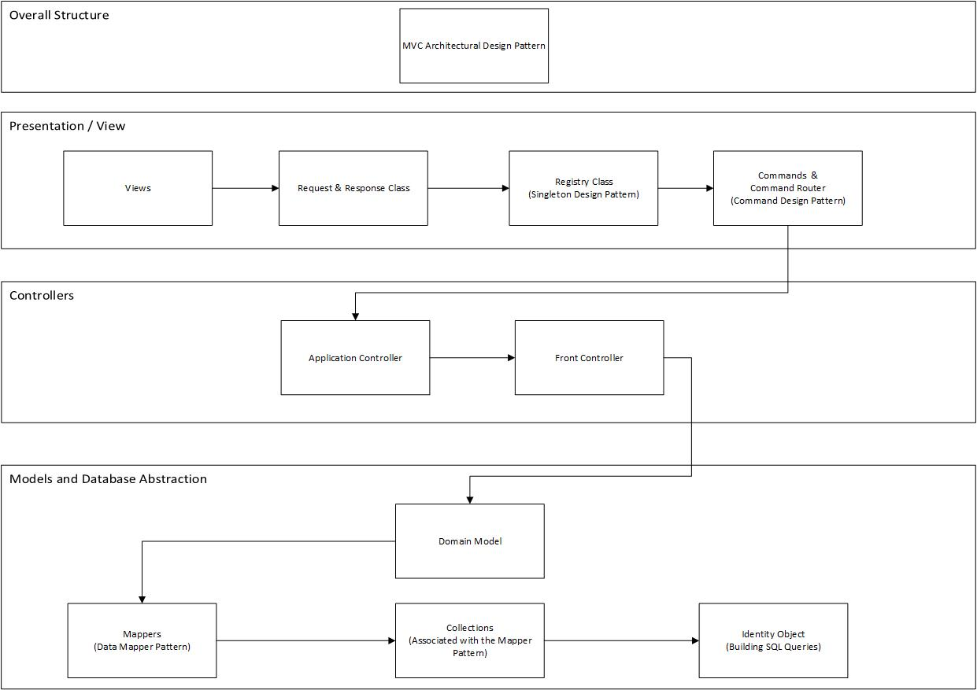
Figure 4-45 : Teaching plan
As represented in Figure 4-45, likewise to MVC, the teaching plan has also been divided into layers. The overall structure of MVC will first be explained to help students understand why they will be learning the design patterns and how they all relate to one another. The teaching approach starts off with the smaller and simple design patterns first in the view/presentation layer and then moves on to controllers, finishing with a more complicated ORM and model layer.

Teaching Materials
Teaching materials was implemented as HTML pages following Mike Dacey’s structure convention. These pages detailed the name of the design pattern for that task, the motivation of the pattern, the UML diagram, its usage and the details. This allowed to explain to students why they were implementing the pattern, giving them an understanding how it would be used and how it works with other patterns to solve a bigger problem.
The HTML pages includes a Prism Cascading Style Sheet (CSS) and a Prism JavaScript file. This is syntax highlighter was used to highlight code examples on the HTML page. This allows the code to become easier to follow when a student is reading it. For example, explanations on the HTML pages refer to methods in the code, the JavaScript file allows students to click on the method name and then reverts the student to the method in the code example. This works using the data-lines stated in the <pre> HTML tag.
Figure 4-46
At the end of each exercise in the HTML page, a set of hints are hidden using jQuery. This hides the hints from the students and if a student needs help completing a task, they can click on each hint allowing jQuery to reveal the hint using its slideToggle() function. The number of hints clicked by each student has also been chosen to be recorded to evaluate how much scaffolding each student needed. To do this, Ajax (Figure 4-47) was used to post the data to a PHP page to add the data to a database. The code was added to separate file to reduce code duplication across the HTML pages.
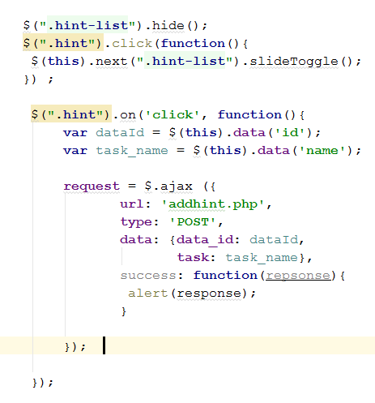
Figure 4-47: Ajax Code

Hosting
To enable the students to complete the tasks, the framework exercises were hosted in a virtual server at the university. WAMP server was installed on the virtual server which was used to host the HTML framework exercises and a database.

Chapter 5 –Analysis
To evaluate the effectiveness of the teaching approach and materials used to teach software design patterns, a hint system was used to gather quantitative data and a focus group was used to collect qualitative data. A questionnaire was also distributed to collect both quantitative and qualitative data.

Quantitative Data

Hint System
Using the hint system to collect data allowed the author to identify how many hints the students clicked on each task and to determine how much scaffolding was needed per exercise.
Table 1
Exercise No | Exercise Name | Number of Hints | Student 1 | Student 2 | Student 3 | Student 4 | Student 5 | Student 6 | Percentage of hints Clicked
1 | Registry Pattern | 3 | 3 | Abs | 3 | 3 | 3 | 3 | 100%
2 | Application Controller | 3 | 0 | 0 | 0 | 0 | 0 | 0 | 0%
3 | Front Controller | 3 | 0 | 3 | 0 | 0 | 0 | 0 | 16.6%
4 | Command Pattern | 3 | 0 | 0 | 0 | 3 | 0 | 0 | 16.6%
5 | Domain Model | 2 | 0 | 2 | 0 | 2 | 0 | 0 | 33.33%
6 | Data Mapper Pattern | 3 | 0 | 2 | 1 | 3 | 1 | 0 | 38.6%
7 | Collections | 4 | 2 | Abs | 4 | 1 | 0 | 0 | 35%
8 | Acquiring Collections | 4 | 4 | Abs | 4 | 4 | 4 | 4 | 100%
9 | Identity Object Pattern | 2 | 2 | Abs | Abs | Abs | 2 | 2 | 100%
10 | Update and Select factory | 3 | 3 | Abs | Abs | Abs | 3 | 3 | 100%
11 | Template View Pattern | 3 | 3 | Abs | Abs | Abs | 3 | 3 | 100%

Table 1 display the raw results collected from the hint system. Within this table, “Abs” stands for absent. This shows that there were inconsistent attendances each week in the teaching process. Resulting in some exercises having different amount of hints than others, a percentage has been calculated to display the percentage of hints that was used on each exercise by the students. This percentage was calculated by adding all the amount of hints clicked by all participating students of the exercise.
In the first exercise (the Registry pattern), all students who attended this lecture clicked on every hint that was available. This was expected as it was the first exercise to be given to the students starting a new topic. However, the patterns and exercises that followed the Registry pattern exercise, did not have so many hint clicks. From the table, it is seen that the Application Controller exercise received no hint clicks. This result may have been biased by students being aware about the amount of hints they were clicking was being collected.
As difficulty increases, the number of hints clicked also increases. This was expected because as identified in the Literature Review, scaffolds can help students complete a task that they not might complete independently.
The Acquiring Collections, Identity Object and the Select and Update Factory exercises were the most difficult out of the 11 exercises that were distributed which is reflected in these results. It is also noticed, in the lectures that these exercises were distributed, there was very poor attendance (Figure 5-1 shows the relationship of the percentage of hints clicked compared to the student attendance in each exercise). Given the difficulty, as expected, all the students who attended these classes used every hint that was available.
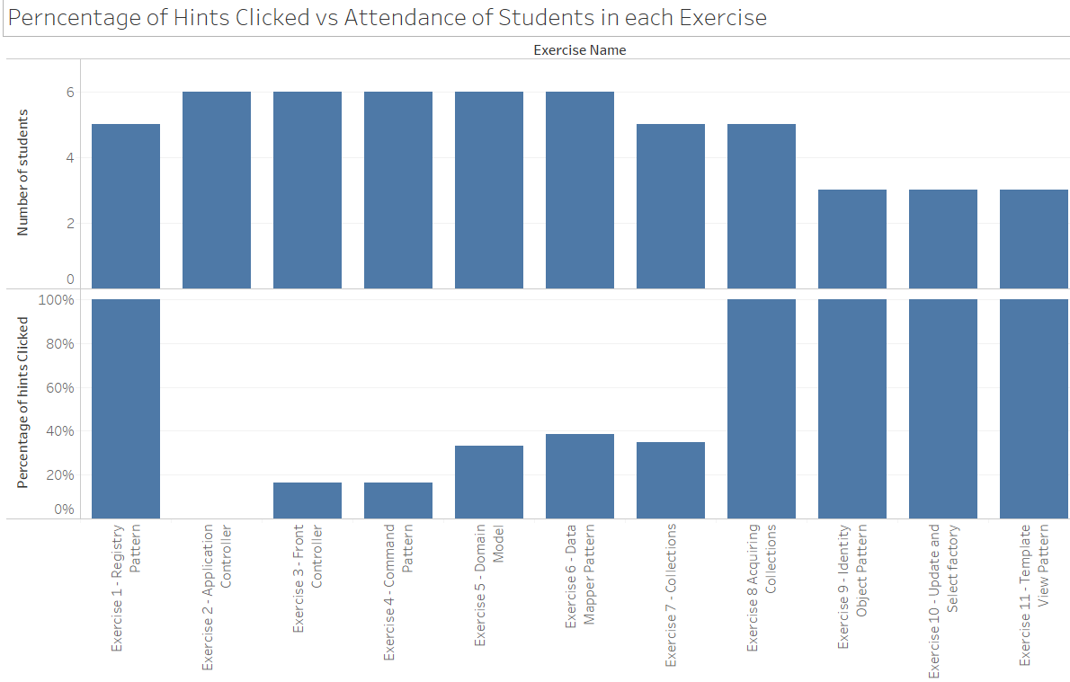
Figure 5-1
An unexpected result was the amount of hints that were clicked for the last exercise, the Template View pattern. It was expected that the students would find this exercise simpler compared to the previous exercises before it, however, all students clicked on every hint available. The last exercise was too difficult because too much was asked. This could have been because the exercise was more complex than what it really needed to be.
From looking at Figure 5-1 and Figure 5-2 it is clearly seen that the trend was more hints were used as the exercises became more difficult.
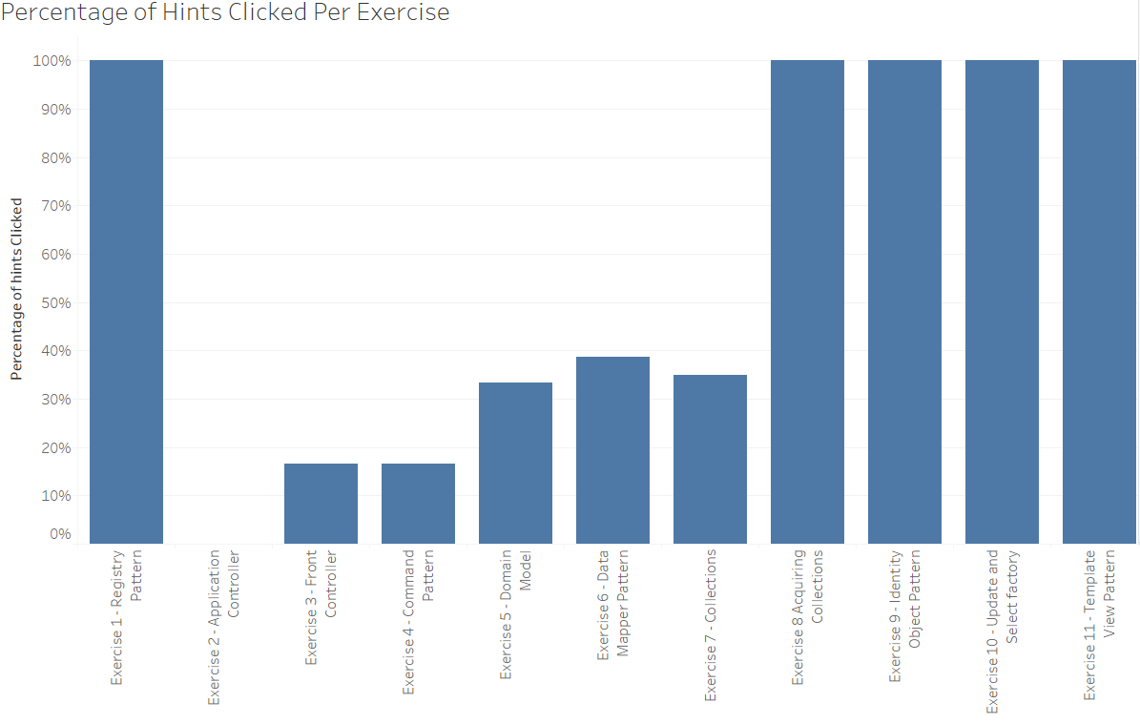
Figure 5-2: Percentage of Hints Clicked Per Exercise
One issue of this data collection method involved inconsistent attendances each week and students not catching up (as already seen in the raw results). This has resulting in a slight imbalance of the results, especially in the later exercises where there were only 3 students who participated. For example, if all 6 students attended and attempted the exercises, the results could have been different as the remaining 3 students may have not needed all hints to complete them. However, based on the 3 students that attended every lecture, the relationship of scaffolding in each exercise is not that much different (Figure 5-3).
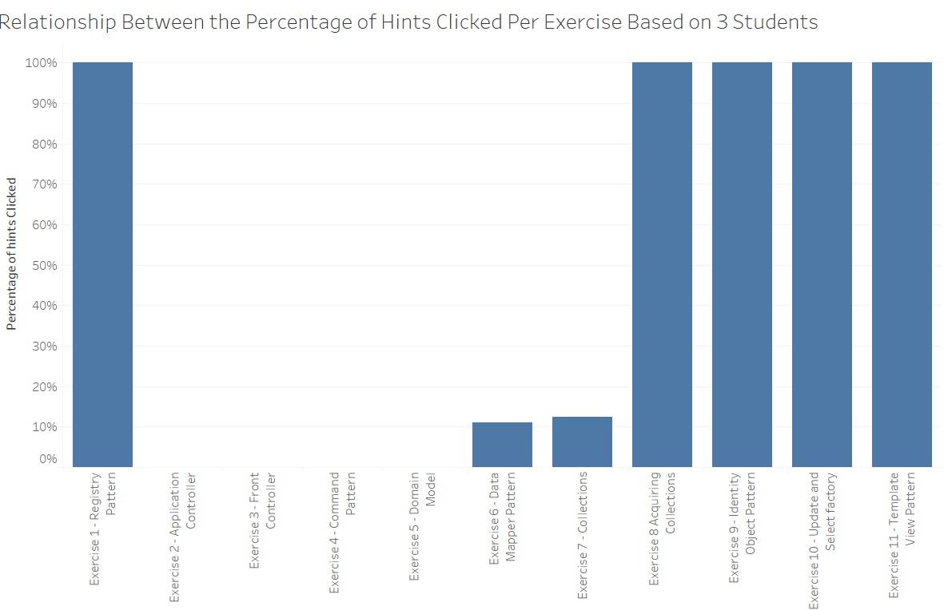
Figure 5-3
As seen in Figure 5-3, the trend of hint clicks is very similar to the results including all 6 students in Figure 5-2.

Questionnaire
Although the main data collection method for this project was a focus group, a questionnaire was also constructed to collect both quantitative and qualitative data. The questionnaire is an electronic copy that was posted on esurv.org and can be found at https://eSurv.org?u=spteaching. This allowed students to complete the questionnaire quickly and posting it online lowered the risk of any data loss.
The questionnaire used the Likert scale to allow the students to rate the questionnaire statements. The rating system involved responses from Strongly Disagree to Strongly Agree with each response given a value (Table 2).

Table 2 : Likert Rating System
Response | Rating Value
Strongly Agree | 5
Agree | 4
Neither | 3
Disagree | 2
Strongly Disagree | 1

The statements used in this questionnaire are displayed in Table 3.
Table 3: Questionnaire Statements
Question Number | Statement
Q1 | The teaching approach helped me recognise the importance of solving problems in programming
Q2 | I have learnt more by attempting to solve problems myself
Q3 | The teaching approach leads to more class interaction between students and the facilitator
Q4 | I found the class more interesting when trying to solve the challenges presented by the facilitator
Q5 | I prefer to follow code or solutions, step-by-step with the lecturer
Q6 | The teaching approach helped me gain a better understanding of the technologies or principles being taught
Q7 | It is more interesting to discover problems myself, as a consequence of completing the previous task
Q8 | I prefer to learn new technologies or concepts by building my own solutions
Q9 | Sufficient amount of documentation and instruction was provided to attempt the exercises
Q10 | Providing hyperlinks between the code in the documentation enabled me to follow the code
Q11 | The exercises provided a gradual increase of difficulty
Q12 | Hints provided helped me complete a task that I would have not been able to complete independently
Q13 | Hints provided were of good quality and helped me think about the solution differently
Q14 | I will be more confident in studying new technologies in the future

While analysing the results from the questionnaire, each statement was given an overall rating based on the student’s responses. Within these results, a median response was also calculated for each statement. The median was calculated by ordering each rating from lowest to highest and the median is the value at the halfway point. The median was chosen over the mean because the median is less likely to be affected by any extreme results [80]. The raw results produced in the questionnaire are listed in Table 4.
Table 4: Raw Questionnaire results

It can see from just looking at this table that majority of the questions have a rating of 60% and above. It is also noticeable that majority of the questions having a median of 4 indicating majority of the students agreed with these statements.

Problem Based Learning Questions

Figure 5-4: Questions by Rating
It is evident from the ‘questions by rating’ bar chart in Figure 5-4 that question 1 has the highest rating (rating at 86.67%) out of all the 14 questions. Question 1 asked “The teaching approach helped me recognise the importance of solving problems in programming”. 4 of the 6 respondents agreed with this statement while the remaining 2 respondents strongly agreed. This is essential for Problem Based Learning (PBL) to be successful.
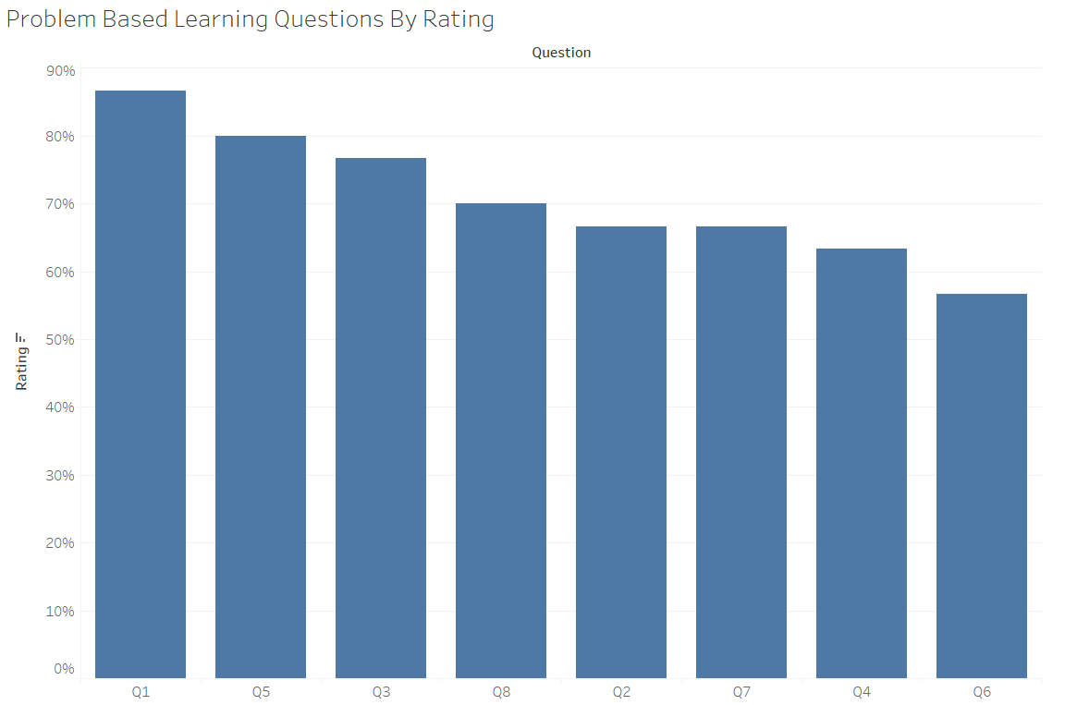
Figure 5-5: Problem Based Learning Questions by Rating
Other questions relating to PBL does not score has high. However, majority of the PBL questions scored a rating of above 60% (Figure 5-5). Within these questions, majority of students stated that this teaching approach increased interaction between the students and facilitator (Q3) with a rating of 76.67% rating. When asked “I prefer to learn new technologies or concepts by building my own solutions”, students also suggested that they prefer to build their own solutions to help them learn new technologies giving the question an overall rating of 70%. In these questions, students also suggested in question 2 and question 7 that they find it more interesting and they learn more by identifying and solving problems themselves. Despite the low percentage rating of 66.67%, relating to students identifying and solving problems themselves, questions 2 and 7 both scored a high median of 3.5 and 4 (Figure 5-6) with most students agreeing and strongly agreeing to these questions. It was identified that other studies [55], [58] that used a modified PBL teaching approach could be successful and that PBL can increase the student’s problem solving skills.

Figure 5-6: Questions by Median
Overall, the PBL section of this teaching approach scored an average of 69.53% which suggests that the students liked having the problem as the main driving force, however there is one question that catches the eye with a low percentage rating. Question 6 which asked, “the teaching approach helped me gain a better understanding of the technologies or principles being taught”, has the lowest rating out of the PBL questions (Figure 5-5) of 56.67%. Despite students suggesting they learnt more by identifying and solving problems themselves, majority of the students neither agreed or disagreed that the teaching approach helped them gain understanding of the technologies or principles being taught. however, 1 student did agree. This lends support for both Williams el at [67] and Albanese [68] claims that they feel that PBL does not increase student performance.

Scaffolding Questions
Looking back at Figure 5-4, question 10, question 12 and 13 have scored high ratings of 80%, 80% and 73%. These questions surround the Scaffolding section of the teaching relating to the scaffolds supplied and the teaching materials used. Respondents have suggested that using Prism for hyperlinks in the documentation allowed them to follow the code more easily. In question 10 students were asked “providing hyperlinks between the code and documentation enabled me to follow the code”. Nearly all respondents either agreed or strongly agreed with only 1 student neither agreeing or disagreeing. From the focus group, it was identified that 1 student did not use this facility which is mostly the reason they could not agree or disagree. Likewise, to question 10, question 12 that asked students “hints helped me complete a task that I would have not been able to complete independently” also was given a very high rating of 80% with 2 students strongly agreeing, 2 students agreeing and 2 students neither agreeing or disagreeing. Students feel that hints provided were of good quality, helped them think about solution differently and helped them complete a task that they might have not completed independently. It was identified in a study [74] that scaffolds helped their students apply software design patterns to their solutions.
With and average rating of 71.27% (questions 9 - 13), this argues Greening’s [75] claim that there is a need for scaffolding in a problem based learning environment.
However, what decrease the average of the scaffolding based learning questions, is the poor rating given to question 9. This statement asked if there was enough sufficient documentation and instruction to attempt the exercises. Although 2 students agreed with this question, 3 students disagreed causing such a low median. The lack of quality of teaching materials was identified by Ouyang [49] suggesting examples were too simple, In this approach examples could have been too complicated requiring students to need more information.

Qualitative Data

Focus Group
After the last lecture, a 10-minute focus group was used to understand how the students felt towards the teaching approach. The focus group consisted of 6 students. The focus group started with the facilitator thanking everyone for participating and the students were given an explanation what the research involved. The facilitator then started the focus group by specifying some discussion points.

Importance of Solving Problems in Programming
The students were first asked “did this teaching approach help you identify the importance of solving problems in programming?”.
One student stated:
“It presents you with a lot more problems as you are building something from scratch, however I worked through each one by one to get the solution and it made me feel good that I was solving them myself.”
Along similar lines, another student quoted:
“Trying to solve the errors helped you learn”.
This feedback indicates that students enjoy solving problems and although they may not find the solution first time. They learn how each pattern relates to one another by solving additional errors which can help when in industry.

Teaching Materials
When asked about teaching materials, students suggested that more background information was needed. One student suggested:
“More background information is needed because in a lot of the exercises, I was unsure what to do, especially the first as I was unsure how MVC worked.”
This could explain the reason why so many hints were clicked in the first task. Other students quoted:
“extra examples would have been nice”.
“More information could have been provided to help complete the exercises, especially as I felt that I was asking you for too much help.”
These results were unexpected because when developing the teaching materials, as much information on how the patterns worked was included, trying to make it as simple as possible without giving away the solution.
Along similar lines, another student quoted that they would have liked the lecturer to of spent more time explaining the pattern.
Another student suggested that more information could have been provided, but as an option.
Despite these findings, one student also suggested that the teaching approach that had been adopted is more pro-active than the traditional lecture based method, he stated:
“Although, it is better this way than just copying the lecturer, I do not remember much when I just copy off the board.”
This was expected as it was identified by Cinnéide and Tynan [58] that traditional lecture-based teaching gives students an insufficient feel for design patterns.

Scaffolds and Prism
When asked about the scaffolds, feedback was very positive. One student stated:
“I found myself opening them, more or less, every time”.
Despite this feedback, this is not reflected in the questionnaire results, however the most recent exercises could have been on the student’s mind.
When discussing Prism, the students came across very enthusiastic. One student replied with:
“it makes it 100% easier!”
Other students suggested:
“it saves you time from looking through all the code. The colour also helps as it is like a normal text editor.”

Overall Experience
When closing the focus group, the students were asked about their overall feelings towards the teaching approach. One student quoted:
“Needs more explanation at the beginning”
Other students stated:
“It’s a good way and it could really work with some adjustments”.
Another student suggested:
“I would suggest having a smaller end product, but apart from that, it works fine.”
This particular statement was unexpected as one issue identified surrounding design patterns in the education environment is that examples used in textbooks are too simple to use in real-world problems and applications.

Summary
In the results, it was identified that students more likely needed scaffolding in the later exercises in comparison to the earlier exercises. It is suggested that this learning approach really helps students to identify the importance of solving problems in programming. Students find it interesting to identify and solve problems themselves which helps them more likely to learn, especially when encountered with errors. Students really liked the use of Prism, stating that the hyperlinks in the text really helped them to search through the code examples quickly and effectively, making it easier to understand. The students suggested that the hints provided were of good quality and really helped them complete exercises that they would have not been able to complete independently.

Chapter 6 – Evaluation
Based on the findings in the analysis, the data presented that Problem Based Learning is not entirely an effective teaching approach that other studies concluded, identified in the Literature Review. It was also evident from the main findings that Scaffolding Based Learning is an effective approach.
Although the findings suggest that extra background information is needed, looking at the overall results, it can be concluded that the overall teaching approach, Scaffolding Problem Based Learning adopted in this project has been effective. With small adjustments to provide extra background information, the teaching approach and use of a framework can be very effective to teach students software design patterns. Using scaffolds in this teaching approach as also helped the students to identify and to solve problems themselves.
Within this project, all objectives, including the main aim were met. To achieve the first objective, the most common PHP frameworks were investigated identifying all their features and the common features between them. Design patterns were also evaluated for their effectiveness within software development and as an essential component within computer science education curriculum. After identifying common features between frameworks and the investigation of teaching approaches, a framework and a teaching approach developed by Mike Dacey were applied and implemented. The teaching approach required students to finish building the framework using the teaching materials developed using HTML 5, JavaScript, jQuery, Ajax and PHP by the author.
If this research was to be performed again, more instructions in the documentation would be provided. The design patterns chosen for this project would also be used again as these offer best practises to separate the levels of concerns, dividing applications into layers. However, other smaller design patterns that are illustrated and implemented in the GoF [8] book “Design Patterns: Elements of Reusable Object-Oriented Software” would be taught to students. Identified in the Literature Review, this book includes examples that are too abstract for students to follow, therefore it would have been ideal for some of these examples to be implemented into the framework to help students understand how they can be incorporated into larger scale enterprise applications.

Chapter 7 – Conclusions and Recommendations
Within this project, productivity within the software development industry was evaluated as well as how productivity is measured within software development. In the late 1970’s, the introduction of object-oriented programming improved the quality of code produced and productivity of software developers.
The increase popularity of object-oriented programming resulted in the introduction of software frameworks which are built on common design patterns, allowing developers to build applications more rapidly. Five of the most common PHP frameworks that are used today were evaluated which identified features that all five share in common.
It was evaluated that software design patterns offer best practise in software development with many professionals now adopting this approach. This has resulted in software design patterns becoming an essential component within the computer science education curriculum. However, design patterns are one of the last topics to be taught at university. Teaching materials and examples in textbooks are known to be too abstract, simple and lacking in quality, making them difficult to use in real-world problems and applications. This has resulted in students gaining an insufficient feel for design patterns, resulting in students not being able to apply them in industry due to design patterns becoming surface knowledge.
As a result of this, pedagogical approaches were investigated which identified that Problem Based Learning has been used as an effective approach within the medical industry. Although there was not much research surrounding Problem Based Learning for teaching design patterns, studies that used a modified approach were successful. Scaffolding Based Learning was also investigated. This is an approach that use temporary support structures known as scaffolds to help students complete a task that they could not complete independently. Combining the two approaches was also investigated, following the approach specified by Mike Dacey.
A MVC PHP framework was extended to incorporate the design patterns and features that all the most popular frameworks had in common. A teaching approach and materials was also designed and developed, beginning with smaller problems to help students learn to solve bigger problems by incorporating the previous knowledge they had learnt. These teaching materials included HTML pages that included scaffolds in the form of hints that were hidden by jQuery. If the student needed assistance in completing the exercise, they could click on the hint to reveal its contents.
The key findings from the analysis and evaluation was that scaffolding in a Problem Based Learning environment is an effective teaching approach. However, in this study extra instruction and documentation is needed.
One limitation of this study was the size of the student body, which consisted of just 6 students, however, this allowed more personal interaction between the facilitator and each student within the group. It is suggested that further research would need to include more documentation and instruction with the pattern being explained more before implementation. It is also suggested that further research should be performed on larger groups of students and in earlier years within the undergraduate degree discipline.

Chapter 8 – Reflections

Literature
When researching PHP frameworks, although some academic journals were available, they did not identify any of the features of each framework. This caused me to search and read through online documentation. With the internet being really accessible, the internet can contain many unreliable resources. Because of this, I learnt how to identify the more reliable information compared to information that was unreliable.
Along similar lines, when researching other areas, many academic journals were available from various years, including both old and more recent. In the beginning of the research, I would read the whole journal, however would miss important information causing me to re-read it. Later, I would plan what I would write in my literature, but I would forget what journal I read the information. This would take up extra time that was unnecessary. As a result, I learnt how to read journals more efficiently and effectively. I then started to use posted notes on each journal or book so when it came to referencing, All I had to do was to check the posted notes to identify the sources where I had read the literature. When reading academic journals and other sources, it made me realise how much better quality of information is available in comparison to books and websites. This has also helped be in other assignments throughout the academic year.

Design and Implementation
When developing the framework, 2 versions were developed and maintained. When making amendments to the completed version, sometimes I would forget to make the same amendments to the uncompleted version. When it came to the students extending the uncompleted version, on occasions the students would be presented with errors because of this mistake. This taught me that I need to be careful when amending code and if the code is in 2 places, care needs to be taken to ensure that both areas are changed. Within industry, if this mistake happened it could cause a devastating effect (depending on the context). However, from this experience I also learnt the importance of reducing code duplication when coding. This is an advantage for using design patterns, including the Model-View-Controller architectural pattern. This helped to put the literature into context and proved how important and effective design patterns can be in the software development industry.
When designing the framework, teaching materials and facilitating the lectures, I learnt that because I find a subject or topic easy to understand, it does not mean that others would find it as easy to understand. This was one of the main learning curve for myself during the project. When designing and structuring the exercises, I had to be mindful of this, ensuring that I was not asking too much of the students. This meant that the exercises could not be too difficult, however, they also needed to be challenging so the students would learn.
Extending the original framework helped me to understand how design patterns are used within a larger scale and within enterprise applications. This involves how each design pattern works together to handle user requests to then send back a response to the user. When extending the framework, I also learnt how the design patterns used help improve maintainability, help to reduce code duplication and increase flexibility of an application. Examples include the Command and Data Mapper patterns in particular.

Writing the Report
In the beginning of the report, after proof-reading, I found that I was writing my report around the phrase “of which”. Altogether, halfway through the report, 72 occurrences of “of which” was found. However, this was not the only errors in my writing. I also found I was stretching my sentences and missing punctuation. To solve these issues, I read my current progress aloud to myself and had others to proof-read my work. From this experience, I learnt how to write to a higher standard towards more of an academic style. This also taught me that it is very hard to proof read your own work, therefore always get another person to read my writing, whether it is and email, report or documentation.

References
[1] A. P. Boulter, Richard West, Gilbert Burnet, Henry Stephens, “The Free Thinker,” Free Think., vol. 3, p. 395, 1719.
[2] R. C. Lee, “What is the idea behind the quote ‘time is money’?,” 2014. [Online]. Available: https://www.quora.com/What-is-the-idea-behind-the-quote-time-is-money. [Accessed: 01-Jul-2016].
[3] A. Hernández-López, “Productivity in software engineering: A study of its meanings for practitioners: Understanding the concept under their standpoint,” 2012.
[4] Robert Sidler, “Software Productivity,” 2002. [Online]. Available: http://www.umsl.edu/~sauterv/analysis/488_f02_papers/SoftwareProductivity.html. [Accessed: 03-May-2016].
[5] C. Jones, Applied software measurement : assuring productivity and quality. McGraw-Hill, 1997.
[6] D. Rodríguez, M. A. Sicilia, E. García, and R. Harrison, “Empirical findings on team size and productivity in software development,” J. Syst. Softw., vol. 85, no. 3, pp. 562–570, 2012.
[7] A. P. Black, “Object-oriented programming: Some history, and challenges for the next fifty years,” Inf. Comput., vol. 231, pp. 3–20, 2013.
[8] J. V. Erich Gamma, Richard Helm, Ralph Johnson, Design Patterns : Elements of Reusable Object-Oriented Software. Reading: Addison-Wesley, 1995.
[9] “Introduction to Object Oriented Programming Concepts (OOP) and More - CodeProject,” 2015. [Online]. Available: http://www.codeproject.com/Articles/22769/Introduction-to-Object-Oriented-Programming-Concep#OOP. [Accessed: 04-Jul-2016].
[10] D. Clark, Beginning C♯ object-oriented programming, Second Edi. Apress, 2013.
[11] D. Brown, An introduction to object-oriented analysis : objects and UML in plain English, Second. New York: Wiley, 2002.
[12] A. Shalloway and J. Trott, Design patterns explained : a new perspective on object-oriented design, Second. Addison-Wesley, 2005.
[13] I. Jacobson, Object-oriented software engineering : a use case driven approach. Wokingham: ACM Press, 1992.
[14] M. Zandstra, PHP Objects, Patterns, and Practice: Fourth Edition, Fourth Edi. Berkeley: APress, 2013.
[15] “PHP: History of PHP - Manual.” [Online]. Available: http://php.net/manual/en/history.php.php. [Accessed: 04-Nov-2016].
[16] L. W. Rebecca Wirfs-Brock, Brian Wiklerson, Designing Object-Oriented Software. Prentice Hall, 1990.
[17] M. H. Rahman, “Designing framework for web development,” p. 36, 2011.
[18] A. Saray, Professional PHP design patterns. Indianapolis: Wiley, 2009.
[19] M. Mattsson, “Object-Oriented Frameworks A survey of methodological issues,” p. 128, 1996.
[20] Symfony, “Chapter 1 - Introducing Symfony.” [Online]. Available: http://symfony.com/legacy/doc/book/1_0/en/01-Introducing-Symfony. [Accessed: 16-Aug-2016].
[21] B. Porebski, L. Nowak, and K. Przystalski, Building applications with Symfony, CakePHP, and Zend Frameworks. Idianapolis: Wiley, 2011.
[22] F. Zaninotto and F. Potencier, The definitive guide to symfony. Apress, 2007.
[23] T. Bowler and W. Bancer, Symfony 1.3 web application development : design, develop, and deploy feature-rich, high-performance PHP web applications using the Symfony framework. Birmingham: Packt Publishing, 2009.
[24] T. Hanna, “10 of the Best PHP Frameworks,” Web Des., no. 248, pp. 72–77, 2016.
[25] M. Fowler, Patterns of Enterprise Application Architecture. Addison-Wesley, 2002.
[26] “PHPUnit – The PHP Testing Framework.” [Online]. Available: https://phpunit.de/. [Accessed: 23-Sep-2016].
[27] “The Yaml Component (The Symfony Components).” [Online]. Available: http://symfony.com/doc/master/components/yaml.html. [Accessed: 16-Aug-2016].
[28] Laravel, “Laravel - The PHP Framework For Web Artisans.” [Online]. Available: https://laravel.com/. [Accessed: 23-Sep-2016].
[29] J. Samra, “Comparing Performance of Plain PHP and Four of Its Popular Frameworks,” Thesis Proj., 2015.
[30] M. Bean, Laravel 5 Essentials : Explore the fundamentals of Laravel, one of the most expressive and robust PHP frameworks available. Birmingham: Packt Publishing, Ltd, 2015.
[31] A. Kılıçdağı and H. I. Yilmaz, Laravel Design Patterns and Best Practices : enhance the quality of your web applications by efficiently implementing design patterns in Laravel. Packt Publishing, Ltd, 2014.
[32] SwiftMailer, “Introduction – Documentation – Swift Mailer.” [Online]. Available: http://swiftmailer.org/docs/introduction.html. [Accessed: 21-Aug-2016].
[33] Zend Framework, “Zend Framework - About.” [Online]. Available: https://framework.zend.com/about. [Accessed: 17-Aug-2016].
[34] R. Grehan, “Fabulous PHP frameworks: Zend Framework | InfoWorld,” 2011. [Online]. Available: http://www.infoworld.com/article/2625211/fabulous-php-frameworks--zend-framework.html. [Accessed: 24-Sep-2016].
[35] V. Vaswani and Zend Technologies., Zend framework : A Beginner’s Guide. McGraw-Hill, 2010.
[36] “About Yii | Yii PHP Framework.” [Online]. Available: http://www.yiiframework.com/about/. [Accessed: 21-Aug-2016].
[37] “Features | Yii PHP Framework.” [Online]. Available: http://www.yiiframework.com/features/. [Accessed: 21-Aug-2016].
[38] “PEAR - PHP Extension and Application Repository.” [Online]. Available: https://pear.php.net/index.php. [Accessed: 21-Aug-2016].
[39] “Manual :: What is PEAR?” [Online]. Available: https://pear.php.net/manual/en/about.pear.php. [Accessed: 21-Aug-2016].
[40] A. Paikens and G. Arnicans, “Use of Design Patterns in PHP-Based Web Application Frameworks,” Latv. Univ. Artic., vol. 733, pp. 53–71, 2008.
[41] J. E. Sweat, PHP/architect’s guide to PHP design patterns. Toronto: Marco Tabini & Associates, 2005.
[42] E. Curry, “Flexible Self-Management using the Model-View-Controller Pattern,” IEEE Softw., no. May / June, pp. 84–91, 2008.
[43] D. S. Aihara and R. Torkar, “Study About the Relationship Between the Model-View-Controller Pattern and Usability,” p. 139, 2009.
[44] G. E. Krasner and S. T. Pope, “A Description of the Model-View-Controller User Interface Paradigm in the Smalltalk-80 System,” J. object oriented Program., vol. 1, no. 3, pp. 26–49, 1988.
[45] C. Hopkins, “PHP Master | The MVC Pattern and PHP, Part 1,” 2013. [Online]. Available: https://www.sitepoint.com/the-mvc-pattern-and-php-1/. [Accessed: 09-Aug-2016].
[46] “PHP: Introduction - Manual.” [Online]. Available: http://php.net/manual/en/intro.pdo.php. [Accessed: 25-Sep-2016].
[47] C. Alexander, S. Ishikawa, and M. Silverstein, A Pattern language : Towns, Buildings, Construction. Oxford University Press, 1977.
[48] D. Tucker, “Advanced Web Development Part 1,” 2017.
[49] Y. Ouyang, “Explaining design patterns through one application,” 32nd Annu. Front. Educ., vol. 3, p. S1G–6–S1G–11, 2002.
[50] N. M. Edwin, “Software Frameworks , Architectural and Design Patterns,” J. Softw. Eng. Appl., no. July, pp. 670–678, 2014.
[51] F. M. Alghamdi and M. R. J. Qureshi, “Impact of Design Patterns on Software Maintainability,” no. September, pp. 41–46, 2014.
[52] L. Prechelt, B. Unger, W. F. Tichy, P. Brossler, and L. G. Votta, “A controlled experiment in maintenance: comparing design patterns to simpler solutions,” IEEE Trans. Softw. Eng., vol. 27, no. 12, pp. 1134–1144, 2001.
[53] and T. G. Péter Hegedüs, Dénes Bán, Rudolf Ferenc, “Myth or Reality ? Analyzing the Effect of Design,” Asea/Drbc 2012, Ccis 340, pp. 138–145, 2012.
[54] C. Zhang and D. Budgen, “A survey of experienced user perceptions about software design patterns,” Inf. Softw. Technol., vol. 55, no. 5, pp. 822–835, 2013.
[55] H. Huang and D. Yang, “Teaching design patterns: A modified PBL approach,” Proc. 9th Int. Conf. Young Comput. Sci. ICYCS 2008, pp. 2422–2426, 2008.
[56] G. Kolfschoten, S. Lukosch, A. Verbraeck, E. Valentin, and G. De Vreede, “Computers & Education Cognitive learning efficiency through the use of design patterns in teaching,” Comput. Educ., vol. 54, no. 3, pp. 652–660, 2010.
[57] A. Sterkin, “Teaching Design Patterns,” South. African Comput. Lect. Assoc., 2011.
[58] M. Ó. Cinnéide and R. Tynan, “A problem-based approach to teaching design patterns,” ACM SIGCSE Bull., vol. 36, no. 4, p. 80, 2004.
[59] R. Fojtik, “Design Patterns in the Teaching of Programming,” Procedia - Soc. Behav. Sci., vol. 143, pp. 352–357, 2014.
[60] S. Dredge, “Coding at school: a parent’s guide to England’s new computing curriculum | Technology | The Guardian,” 2014. [Online]. Available: https://www.theguardian.com/technology/2014/sep/04/coding-school-computing-children-programming. [Accessed: 10-Oct-2016].
[61] Child Australia, “WHAT IS PEDAGOGY ? How does it influence our practice ?”
[62] A. Tan, “Session 3: Pedagogical Approaches,” 2009. [Online]. Available: http://www.slideshare.net/ashleytan/ict-for-meaningful-learning-session-3. [Accessed: 30-Sep-2016].
[63] M. Albanese, “Problem-based learning: Why curricula are likely to show little effect on knowledge and clinical skills,” Med. Educ., vol. 34, no. 9, pp. 729–738, 2000.
[64] D. Allen, R. Donham, and S. Bernhardt, “Problem-Based Learning,” New Dir. Teach. Learn., no. 119, pp. 35–41, 2009.
[65] R. Gabb and C. Vale, “Speaking of Teaching,” Stanford Univ. Newsl. Teach., vol. 11, no. 1, pp. 1–8, 2001.
[66] J. O. Kelly, N. U. I. Maynooth, J. P. Gibson, K. Computer, and I. S. Education, “RoboCode & Problem-Based Learning: A non-prescriptive approach to teaching programming,” no. June, pp. 217–221, 2006.
[67] D. P. Williams, J. R. Woodward, S. L. Symons, and D. L. Davies, “A Tiny Adventure: The Introduction of Problem Based Learning in an Undergraduate Chemistry Course,” Chem. Educ. Res. Pract., vol. 11, no. 1, pp. 33–42, 2010.
[68] M. Albanese and S. Mitchell, “Problem-based Learning: A Review of Literature on its outcomes and implementation issues,” Acad. Med., vol. 68, no. 1, pp. 52–81, 1993.
[69] M. Larkin, “Using Scaffolded Instruction To Optimize Learning,” 2002. [Online]. Available: http://www.vtaide.com/png/ERIC/Scaffolding.htm. [Accessed: 14-Oct-2016].
[70] S. Linder, D. Abbott, and M. Fromberger, “An instructional scaffolding approach to teaching software design,” J. Comput. Sci. …, pp. 238–250, 2006.
[71] M. Hurst, “Zone of Proximal Development and Scaffolding in the Classroom - Video &amp; Lesson Transcript | Study.com.” [Online]. Available: http://study.com/academy/lesson/zone-of-proximal-development-and-scaffolding-in-the-classroom.html. [Accessed: 14-Oct-2016].
[72] Norhtern Illinois University, “Instructional scaffolding to improve learning - instructional_scaffolding_to_improve_learning.pdf.”
[73] M. Larkin and Ellis, “Strategic instruction for adolescents with learning disabilitie,” Learn. about Learn. Disabil., pp. 585–656, 1998.
[74] D. Ginat, “Interleaved pattern composition and scaffolded learning,” ACM SIGCSE Bull., vol. 41, no. 3, p. 109, 2009.
[75] T. Greening, “Scaffolding for Success in Problem-Based Learning,” Sch. Inf. Technol. Math. Sci., pp. 1–15, 1998.
[76] S. S. Y. Choo, J. I. Rotgans, E. H. J. Yew, and H. G. Schmidt, “Effect of worksheet scaffolds on student learning in problem-based learning,” Adv. Heal. Sci. Educ., vol. 16, no. 4, pp. 517–528, 2011.
[77] M. Saunders, P. Lewis, and A. Thornhill, Research Methods for Business Students, Fifth. Harlow: Pearson Education Limited, 2008.
[78] C. Dawson, Introduction to Research Methods : A Practical Guide for Anyone Undertaking a Research Project, Fourth Edi. Oxford: How To Books Ltd, 2009.
[79] L. Blaxter, C. Hughes, and M. Tight, How To Research, Second Edi. Bukingham: Open University Press, 2001.
[80] P. Weaver, Success in Your Project: A Guide to Student System Development Projects. Harlow: Prentice Hall, 2004.
[81] C. W. Dawson, Projects in computing and information systems : a student’s guide. Addison-Wesley, 2009.
[82] P. Coad and E. Yourdon, Object-oriented design. Yourdon Press, 1991.
[83] D. Avison and G. Fitzgerald, Information Systems Development methodologies, techniques & tools, 4th ed. London: McGraw-Hill, 2006.
[84] “PHP: Hypertext Preprocessor,” 2016. [Online]. Available: http://php.net/. [Accessed: 04-Nov-2016].
[85] M. Dacey, “Course: L6 - Advanced Web Development (M6X01086).” [Online]. Available: http://moodle.swanseamet.uwtsd.ac.uk/course/view.php?id=714. [Accessed: 21-Apr-2017].
[86] A. Barczynski, “Accessing the Impact of Using Design Patterns of Enterprise Application Architecture,” 2014.
[87] “Core J2EE Patterns - Front Controller.” [Online]. Available: http://www.oracle.com/technetwork/java/frontcontroller-135648.html. [Accessed: 05-Jan-2017].
[88] “PHP: list - Manual.” [Online]. Available: http://php.net/manual/en/function.list.php. [Accessed: 12-Feb-2017].

Appendices

Appendix 1 – deliverables
The CD attached to this project consists of 2 frameworks, an un-completed and completed version, along with the HTML exercises with that were distributed to the students. A copy of the SQL database is also supplied.

Appendix 2 – exercise Examples

Registry Design Pattern
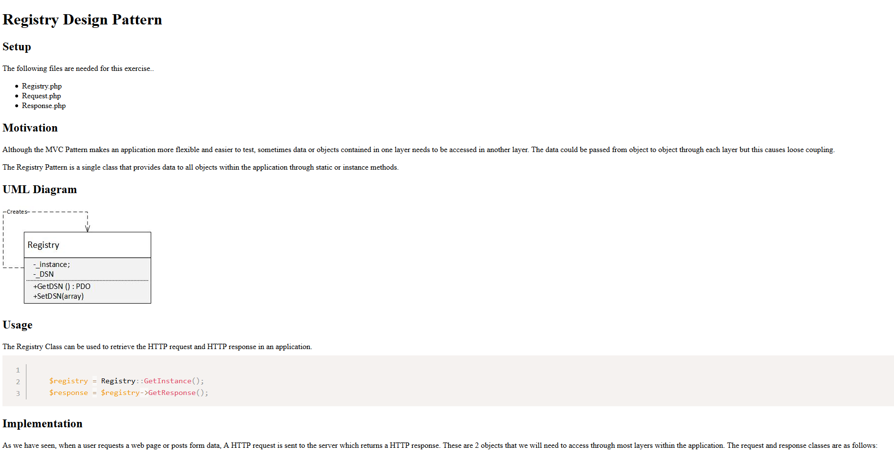

Hint System
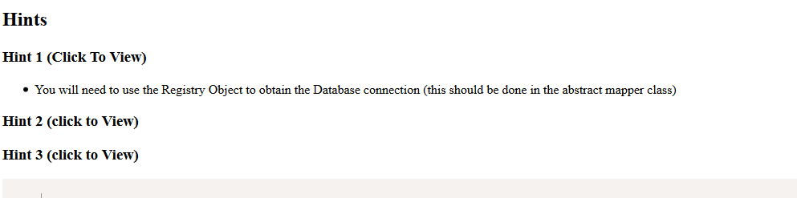

Code Examples
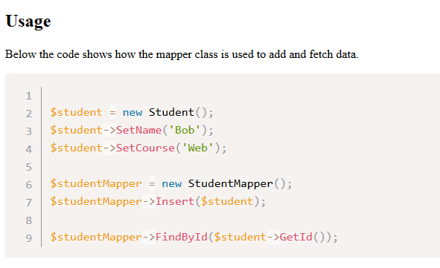

Overall Structure


