University of Wales Trinity Saint David

School of Engineering

‘An Investigation into driver performance improvement using data acquisition & setup optimization using design of experiments’

Samuel Jones

P146165

BSC Motorsport Engineering

23/04/18

Research Methods & Project M3X9486


Declaration of Authenticity
This thesis is the result of the author’s original research. It has been composed by the author and has not been previously submitted for examination which has led to the award of a degree.

Signed: Date:

Abstract
This paper looks at the research behind and analysis data collected from these two experiments: using data acquisition to improve driver performance, and using design of experiment to optimize vehicle setup.
The research is broken down into the following sections: Design of experiments, data types, types of experiments, driver advice & performance measures, and finally driver in the loop simulators. These sections look at theory behind the experiments, how they are used in industry, and the validity of the experiments.
The methodology for the driver improvement experiment is explained. A general overview of each driver is given as well as the reasons behind the choice of circuit and vehicle. The parameters for the sessions are explained to avoid factors such as driver fatigue and how the drivers could affect each other’s performance. Lastly, it’s explained how using values such as distance and time adds detail to the data when presented to the drivers.
The methodology for the setup optimization experiment is then detailed. There is an overview given of the driver used in the experiment, how the results were gathered for the multi-level categorical and Box Behnken experiment designs, and the straight line test procedure.
Both experiments are then analysed, driver improvement is analysed using Motec data traces and excel graphs to showcase the driver’s performance before and after instructions, and comparing the drivers against a benchmark set of data. Whilst setup optimization is analysed using Motec data traces and graphs to show how the chosen factors varying in performance benefits, from camber having the greatest effect on performance to roll stiffness distribution having the smallest effect.
Lastly the conclusion states how both experiments fulfilled the project aims. The overall statements from the driver performance experiment and how certain factors may have contributed to predictions of the results weren’t met. How the results from the setup optimization experiment characterise vehicle performance for the Silverstone GP track.

Acknowledgments
I would like to thanks Richard Sutton, Paul Davies, Andrew Noble, for volunteering to be test drivers for these experiments, Tim Tudor for be a test driver, an incredibly helpful and supportive supervisor and for teaching me Motec and the working of the simulator, and finally my friends and family for supporting me over the last three years.

Contents Page

Declaration of Authenticity 2
Abstract 3
Acknowledgments 4
Contents Page 5
List of Figures: 8
1.0 Introduction 10
2.0 Research 12
2.1 Design of Experiments: 12
2.2 Data Types 13
2.21 Nominal/ Categorical: 13
2.22 Ordinal Data: 13
2.23 Ratio: 13
2.3 Types of Experiment 13
2.31 Multi-Level Factorial: 13
2.32 Box Behnken: 13
2.4 Driver advice & Driver Performance Measures: 14
2.5 Driver in the loop simulators: 14
3.0 Methodology 16
3.1 Driver analysis and improvement experiment: 16
3.2 Setup Optimization: 17
4.0 Analysis 19
4.1 Fastest Lap Progression 19
4.2 Drivers A&B Session 1: 21
4.3 Driver A Session 2: 22
4.31 Driver A Session 2 Instruction 1: 22
4.32 Driver A Session 2 Instruction 1 Results 23
4.33 Driver A Session 2 Instruction 2 25
4.34 Driver A Session 2 Instruction 2 Results 26
4.41 Driver A Session 3 Instruction 1 27
4.42 Driver A Session 3 Instruction 1 Results: 28
4.43 Driver A Session 3 Instruction 2: 29
4.44 Driver A Session 3 Instruction 2 Results 30
4.45 Driver A Session 3 Instruction 3 31
4.46 Driver A Session 3 Instruction 3 Results 32
4.5 Driver A Session 4: 33
4.51 Driver A Session 4 Instruction 1 33
4.52 Driver A Session 4 Instruction 1 Results 34
4.53 Driver A Session 4 Instruction 2: 36
4.54 Driver A Session 4 Instruction 2 Results 37
4.6 Driver A Session 5: 38
4.61 Driver A Session 5 Instruction 1 38
4.62 Driver A Session 5 Instruction 1 Part 1&2 Results 39
4.63 Driver A Session 5 Instruction 2: 40
4.64 Driver A Session 5 Instruction 2 Results 41
4.7 Driver B Session 2: 42
4.71 Driver B Session 2 Instruction 1 42
4.72 Driver B Session 2 Instruction 1 Result 43
4.73 Driver B Session 2 Instruction 2 44
4.74 Driver B Session 2 Instruction 2 Results: 45
4.75 Driver B Session 2 Instruction 3: 46
4.76 Driver B Session 2 Instruction 3 Results: 47
4.8 Driver B Session 3: 48
4.81 Driver B Session 3 Instruction 1: 48
4.82 Driver B Session 3 Instruction 1 Results: 49
4.83 Driver B Session 3 Instruction 2: 50
4.84 Driver B Session 3 Instruction 2 Results: 51
4.85 Driver B Session 3 Instruction 3: 52
4.86 Driver B Session 3 Instruction 3 Results: 53
4.9 Driver B Session 4: 54
4.91 Driver B Session 4 Instruction 1: 54
4.92 Driver B Session 4 Instruction 1 Results: 55
4.93 Driver B Session 4 Instruction 2: 56
4.94 Driver B Session 4 Instruction 2 Results: 57
4.10 Driver B Session 5: 58
Driver B Session 5 Instruction 1: 58
4.101 Driver B Session 5 Instruction 1 Results: 59
4.102 Driver B Session 5 Instruction 2: 60
4.103 Driver B Session 5 Instruction 2 Results: 61
4.11 Driver A Overall: 62
4.12 Driver B Overall: 64
5.0 Setup Optimization: 66
5.1 Camber: 66
5.2 Toe Angle: 70
5.3 Roll Stiffness Distribution: 73
5.4 Optimization: 75
6.0 Conclusions 77
6.1 Driver Improvement Investigation: 77
6.2 Setup Optimization: 78
7.0 Evaluation 79
8.0 References 80
9.0 Appendices 83

List of Figures:
Figure 1:Process input/output with variable categories (Shewchuk, 2017). 12
Figure 2: Driver A Fastest Lap Time Progression Graph 19
Figure 3: Driver B Fastest Lap Time Progression Graph 19
Figure 4: Driver A Session 1 Lap Times 21
Figure 5: Driver B Session 1 Lap Times 21
Figure 6 Driver A 1st Instruction Part 2 22
Figure 7 Driver A 1st Instruction Part 1 22
Figure 8 Driver A 1st Instruction Part 1 Result 23
Figure 9 Driver A Session 2 Instruction 1 Part 2 Result 24
Figure 10 Driver A Session 2 Instruction 1 Part 2 Attempts 24
Figure 11 Driver A Session 2 Instruction 2 25
Figure 12 Driver A Chapel Corner Entry Steering Wheel Percentage 25
Figure 13 Driver A Session 2 Instruction 2 Results 26
Figure 14 Driver A Session 2 Instruction 1 vs Instruction 2 26
Figure 15 Driver A Session 3 Instruction 1 27
Figure 16 Driver A Session 3 Instruction 1 Results 28
Figure 17 Driver A Session 3 the Loop exit Throttle & Steering Data Traces 28
Figure 18 Driver A Session 3 Instruction 2 29
Figure 19 Driver A Session 3 Luffield Steering Trace 29
Figure 20 Driver A Session 3 Instruction 2 Results 30
Figure 21 Driver A Session 3 Instruction 2 30
Figure 22 Driver A Session 3 Instruction 3 31
Figure 23 Driver A Session 3 Instruction 3 Results 32
Figure 24 Driver A Session 4 Instruction 1 33
Figure 25 Driver A Session 4 Instruction 1 Village & the loop Result 34
Figure 26 Driver A Session 4 Instruction 1 Village & the loop 34
Figure 27 Driver A Session 4 Instruction 1 Results 35
Figure 28 Driver A Session 4 Instruction 1 Results 35
Figure 29 Driver A Session 4 Instruction 2 36
Figure 30 Driver A Session 4 Instruction 2 Result 37
Figure 31 Driver A Session 5 Instruction 1 Part 2 38
Figure 32 Driver A Session 5 Instruction 1 Part 1 38
Figure 33 Driver A Session 5 Instruction 1 Part 1 Results 39
Figure 34 Driver A Session 5 Instruction 1 Part 2 Results 39
Figure 35 Driver A Session 2 Instruction 2 40
Figure 36 Driver A Session 5 Instruction 2 Results 41
Figure 37 Driver B Session 2 Instruction 1 42
Figure 38 Driver B Session 2 Instruction 1 Results 43
Figure 39 Driver B Session 2 Instruction 2 44
Figure 40 Driver B Session 2 Instruction 2 Results 45
Figure 41 Driver B Session 2 Instruction 3 46
Figure 42 Driver B Session 2 Instruction 3 Results 47
Figure 43 Driver B Session 3 Instruction 1 48
Figure 44 Driver B Village & the Loop Steering trace 48
Figure 45 Driver B Session 3 Instruction 1 Results 49
Figure 46 Driver B Village & the Loop Improvement from Session 3 49
Figure 47 Driver B Session 3 Instruction 2 50
Figure 48 Driver B Session 3 Instruction 2 Results 51
Figure 49 Driver B Session 3 Instruction 3 52
Figure 50 Driver B Session 3 Club Corner Exit 52
Figure 51 Driver B Session 3 Instruction 3 Result 53
Figure 52 Driver B Session 4 Instruction 1 54
Figure 53 Driver B vs Richard Long G 54
Figure 54 Driver B Session 4 Instruction 1 Results 55
Figure 55 Driver B Fastest Lap vs Session 4 Quickest Lap 55
Figure 56 Driver B Session 4 Instruction 2 56
Figure 57 Driver B Session 4 Instruction 2 Results 57
Figure 58 Driver B fastest last sector 57
Figure 59 Driver B Session 5 Instruction 1 58
Figure 60 Driver B Session 5 Instruction 1 59
Figure 61 Driver B Session 5 Instruction 1 60
Figure 62 Driver B Session 5 Instruction 1 Results 60
Figure 63 Driver B Session 5 Instruction 2 61
Figure 64 Driver B Session 5 Instruction 2 Results 62
Figure 65 Driver A Session 2 Lap Times 63
Figure 66 Driver A Session 3 Lap Times 63
Figure 67 Driver A Session 4 Lap Times 64
Figure 68 Driver A Session 5 Lap Times 64
Figure 69 Driver B Session 2 Lap Times 65
Figure 70 Driver B Session 3 Lap Times 65
Figure 71 Driver B Session 5 Lap Times 66
Figure 72 Driver B Session 4 Lap Times 66
Figure 73 Camber Results Graph 67
Figure 74 Lat G vs Long G Scatter Graph 68
Figure 75 Copse Corner Understeer Channel 68
Figure 76 Maggotts, Becketts, Chapel Complex 69
Figure 77 Throttle Histogram 69
Figure 78 Run 5 vs Run 26 Straight Line Test 70
Figure 79 Run 16 vs Run 26 Straight Line Test 70
Figure 80 Toe Results Graph 71
Figure 81 Abbey Corner G Force Graph 71
Figure 82 Runs 1, 13, 16 Abbey Corner Steering Trace 72
Figure 83 Run 1 vs 26 Straight Line Test 72
Figure 84 Run 13 vs 26 Straight Line Test 73
Figure 85 Roll Stiffness Distribution Results Graph 74
Figure 86 Chapel Corner Steering Trace 74
Figure 87 Abbey Corner Steering Trace 74
Figure 88 Copse Corner Steering Trace 74
Figure 89 Run 19, 22, 26 Straight line Test 75
Figure 90 Run 26 vs Optimization Run 3 G Force Graph 76
Figure 91 Run 26 vs Optimization Run 3 G Force Graph Copse Corner 77
Figure 92 Session 1 Test Plan 84
Figure 93 Session report from scrapped driver A session 1 84
Figure 94 Example of a variance channel 85
Figure 95 Run List 85

1.0 Introduction
Since 2009, when the FIA banned in-season track testing, formula 1 teams have placed a greater reliance on the use simulators. In an interview with SAFEisFAST.com Felipe Massa states that “it’s important for setup changes and for developing the car with new parts, that we are going to use in the next race” (How F1 Teams Test Today with Felipe Massa, 2015). New part tests, possible setup changes and learning the next track are now done through a simulator, this brings up the questions: how can the data collected from the sim to be used to its full potential and how close to reality are the simulators.
The driver improvement investigation will look into how KPI’s, key performance indicators, can be used to improve a driver’s performance. This will be investigated by using an Rfactor simulator to gain data from two different drivers, then by comparing KPI’s against a fully improved driver’s data (Richard Sutton), advice is then given to the drivers to help improve their lap times.
The driver improvement investigation has three aims:
- Collect and collate date using driver in the loop simulator,
- Try to improve driver lap times through the use of key performance indicators
- Identify which performance indicator has the greatest effect on driver performance increase.
The setups optimization investigation will look into how design of experiment software can be used to design suitable experiments for testing different factors that affect a car’s handling characteristics, and using these factors to create optimal setups. This will be investigated using an Rfactor simulator to gain data from a single driver.
The setup optimization investigation has three aims:
- Collect and collate data using driver in the loop simulator
- Investigate how each factor affects lap times and which has the greatest effect
- Using design experiment software to optimize the setup factors
The deliverables for the entire project are:
- Data showcasing driver lap time improvements
- How data is best presented to a driver for development, (Verbal, printed, fully explained)
- Data showcasing the effect of camber, toe and roll stiffness distribution on lap times
- Optimization of the three setup factors
This paper will look at the research for these investigations, this research will include: driver performance measures and driver advice, the usefulness of driver in the loop simulators and how close to reality they are, design of experiments, and finally the factors for the setup optimization experiment.
This will then lead on to the methodology for the two different experiments, first:
How the data is collected using the Rfactor simulator from the two drivers, how the test sessions are designed to get the maximum amount of useful data whilst avoiding unnecessary problems such as driver fatigue, the control parameters for the simulator sessions and how the data is analysed using Motec software. Finally, how the data is presented to the driver to maximise its usefulness without overloading the driver with irrelevant information and how the instructions given to the drivers for each session need to be clear and accurate to avoid incorrect data collection.
Secondly: how design experiment software is used to design a multi-level categorical and Box Behnken experiment, how the simulator is used to adjust the GP2’s setup, why driver feedback is recorded for each setup change, and how this data is then input back into the design experiment software.
The driver improvement data is then analysed using Motec to show data traces comparing drivers A & B against Richard Sutton before and after instructions and Excel graphs to show fastest lap progression and individual session progression, a short statement about overall performance is then made.
The setups data is then analysed using graph from design experiment to show individual factor effects, and Motec data traces and graphs to show how changing a factor changed the vehicles behaviour on track.
Lastly conclusions are drawn from both experiments about the results and whether they satisfied the aims of their respective investigations. The testing procedures are then analysed and any comments on how they could have been improved are made, the report as a whole is then summarised.

2.0 Research

2.1 Design of Experiments:
Design of experiments is a statistical analysis method used to determine and analyse relationships between factors and the effect the factors have on outputs, (Sundararajan, 2011). When planning an experiment, a question must first be set to plan the experiment around. Setting a question allows for inputs and outputs to be selected and the process to start. Inputs are process variables, and output are performance variables, (Antony, 2014), in the case of the experiment in this paper the different setup changes that are made to the vehicle are the inputs and lap time and driver feedback are the outputs.
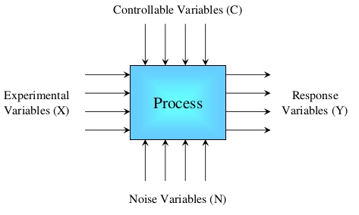
Figure 1: Process input/output with variable categories (Shewchuk, 2017).
Input variables are split into three different categories: experimental, controllable and noise/uncontrollable. Experimental variables are the chosen variables to be tested to see how they affect the output, which has the most affect and whether there is any relationship between them. Controllable variables must be kept constant to ensure consistency of the experiment so they have no effect on the result. Noise variables are uncontrollable factors that will influence the outcome of the experiment but cannot be planned for, (Shewchuk, 2017), it’s important to identify these variables and design the experiment in such a way so it’s insensitive to them, (Weibull.com, 2008).
The experimental factor(s) are broken down into levels, an example of this could be min, mid and max, the number of factors and levels used in the experiment dictate how many runs are required, (Weibull.com, 2008), the greater number of factors or levels the greater amount of runs required.
The type of experiment used for the driver improvement experiment in this paper is called benchmarking. This is a method of improving performance by making comparisons against others, and then using those comparisons to make improvements to yourself (Anon., n.d.). This is a technique commonly used in business to analyse competitors and make changes to your own company to close the gap in business (Lock, 2001). The principle though can be used for driver comparison as its analysing data, then using the data to establish improvement techniques.

Each level fits into one of four possible categories (Andy Field, 2003).

2.2 Data Types

2.21 Nominal/ Categorical:
This is data that fits into set categories, for example does a setup produce a faster lap time than the standard setup either yes or no. This type of data can be used to shorten the list of useful data, referring back to the example an engineer would only look at setups that can produce faster laps so would disregard any data in the no category, (w, 2017).

2.22 Ordinal Data:
This puts the data is a ranking order, usually something like 1-10, this can be used to show that firstly certain results have occurred and secondly the order in which they occurred in, (Andy Field, 2003). However there is no way of telling the differences between the intervals so cannot be used as judgement on performance, (Sauro, 2010). If the differences are known and are constant throughout this is then known as interval data, (Trochim, 2006).

2.23 Ratio:
For data to be categorised at ratio it must have all the aspects of interval data, but also the ratios of values along the interval scale have to be meaningful (Andy Field, 2003). For this data to be meaningful it has to be set against an absolute zero value, examples of this are age or weight, (Motulsky, 2009).
These different types of data are used in a variety of different experiment types, this part of the research will focus on the two different types used for this paper: Multi level Factorial (General factorial) and Box Behnken.

2.3 Types of Experiment

2.31 Multi-Level Factorial:
This is a combination of two different types of design, multi-level and Factorial.
Factorial designs are common type of design with all input factors set at two levels, high and low, (NIST/SEMATECH, 2012) and performs at least one trial run for every possible combination of factors and levels. This type of design gives the ability to examine the interaction between variables as well as requiring fewer runs, when compared with other design, to achieve the same level of statistical power, (Linda M. Collins, 2009), statistical power is the likelihood that the design will show an effect by one of the factors, if there is a high statistical power then it’s more likely an effect will show (Magnusson, 2015).
Multi-level designs simply add extra levels to the variables to model possible curvature in the response variable (NIST/SEMATECH, 2012), this defines whether a variable as a linear response or not and is usually done by adding a mid-level (Anon., 2018), however by adding more levels, the cost of the experiment increases.

2.32 Box Behnken:
Box Behnken is a response surface methodology (RSM) style experiment, using multiple input factor with multiple levels, then from analysing the results obtained in the experiment the design is able to optimize the input factors and suggest optimal settings for the input factors to achieve the greatest results (Kathleen M. Carley, 2004). The design limit the sample size as the number of parameters grow, either factors or levels, to the smallest amount of runs needed to still achieve the same statistical power as a factorial design (Emerson, 2013).
When designing an experiment using a human element it’s important to remember that a human is an uncontrollable factor and that they will not be the same in every session as there are external factors placed on the drivers, whether this from social or workplace environment these factors could influence a driver’s ability on a given day, (Valkenburgh, 2000).

2.4 Driver advice & Driver Performance Measures:
Carroll Smith writes in his book ‘Drive to Win: The Essential Guide to Race Driving’ that “Achieving excellence as a racing driver is about 98 percent cerebral and two percent physical” (Smith, 1996), the ability to be confident in your own driving ability can have a massive effect on your driving performance. This is where the use of data acquisition can help, if the driver is given an instruction to make a change to the way they are driving and this instruction is backed up with the use of relevant data which the driver can interpret and use to their advantage then this can lead to improvements in performance. (Bentley, 2011).
Using data is an important part of increasing driver performance (Mayer, 2002), but it must be done in a way that is made easy for the driver to interpret. An easy and effective way of doing this is using overlays, (Smith, 1996). By simply comparing at least two driver’s data against each, then differences in how they drive become apparent and points can be marked as to where time is being either gained or lost.
When the driver is sat in the cockpit of their vehicle they only have five direct controls over the vehicle to drive it as fast as possible: Throttle pedal, Brake pedal, Clutch pedal, Steering wheel and gears, (Segers, 2008), however for the purposes of this investigation the clutch pedal is not in use.
The data engineer can then use the data collected to help a driver achieve their fastest lap, or setup race simulations where tyre or fuel saving or different weather conditions, (Sakamoto, 2014). These controls are the influence for the KPI’s selected for this investigation, because this is only a simulation there are no real-world implications in terms of needing to change any factors on the car such as setup, tyres or fuel, so the main source of lap time improvement will be how fast the driver can go.

2.5 Driver in the loop simulators:
Simulators are used in motorsport to test new parts and setups and for drivers to learn new tracks amongst other reasons (Martin, 2011). Since major championships such as formula 1 and NASCAR banned in season testing, (Anon., n.d.) (Anon., 2014), simulators have been used more to collect valuable data that teams need for race weekends.
With the increase in simulator use, Red Bull f1 say there both of their drivers and both Toro Rosso drivers used their simulator facilities to race every grand prix on the calendar in 2011, (Fagnan, 2015), how valid is the data that comes from the simulator sessions and can the simulator be used as a learning tool for experienced and inexperienced drivers.
Most big teams in motorsport use simulators across all areas such as f1, NASCAR, V8 supercars, and with positive reviews from a lot of drivers. iRacing is an online racing simulator that is available to the public but it’s used by a host of professional racing drivers for learning new vehicles or track as their testimonial page shows, (iRacing, n.d.), however not all drivers agree. In an interview with Autosport, Lewis Hamilton states that “there’s a difference between driving the simulator and the real thing” and in terms of using it for learning new tracks on the calendar he said, “I can learn as much from simulators as I can from video games”. (Anderson, 2016)
In terms of data validity it’s often hard to test the premise due to issues such as vehicle setup, track layout and track conditions. In an article written by DrRacing, an experiment is setup to see how close the data is from a simulated session when compared to data taken from the real world. The data is taken from a formula 3 practise session at Monza in 2008, the simulated car is setup as closely as possible to the real car, however it’s noted that two aspects of the setup are not the same and these are downforce and drag, this is because of a lack of reliable data about these setup point so they set to manufacturers specifications. It’s also worth noting that the same driver is not used for both sessions, although the simulator driver is a professional driver who has experience with both simulator and formula 3 driving.
The article compares: speed, G force and suspension behaviour. When these three variables were compared overall the data was found to have a “very good correlation”. The small differences that did occur were put down to mostly down to the track or the driver, with the article stating that the track modelling accuracy couldn’t be verified and the author believed that some of the “virtual zones” were slightly different to the real thing. A conclusion drawn from the article is that when accurate data is used it pushed the driver to drive the car as he would if he was driving on the real track, which helps to enforce the reliability of the results. (DrRacing, 2014)

3.0 Methodology

3.1 Driver analysis and improvement experiment:
This investigation will use two drivers to collect data and improve. The two drivers are:
Driver A- Andrew Noble. Andrew has a moderate amount of experience using the simulator, he has spent this year as the simulator driver for his group project, and this means he has experience with both the simulator and using Motec to analysis data and make improvements.
Driver B- Samuel Jones (Myself). Samuel is a novice in the simulator with no prior experience, has experience with data analysis having previously used Pi analysis software and this year using Motec extensively.
Richard Sutton – Richard is the comparison driver, having already completed the four improvement sessions, Richards driving has been fully improved to the best of the engineers ability. His fastest lap is used as the benchmark that driver A & B are compared against. Richard has a number of years’ experience in the simulator and is the fastest simulator driver at the university.
The drivers will use the Rfactor simulator to perform laps around Silverstone GP track in a GP2 car. Silverstone GP was chosen for two reasons, the first is because of a mixture of low and high-speed corners, such as the loop and copse, (F1, 2017) which provide a good mixture of data. The second reason was that driver A had experience with both the GP2 car and Silverstone GP track, because driver B had no experience with simulator at all, it was decided to use a vehicle and track at least one driver had experience with.
The testing sessions were planned as five sessions, starting with a base data session and then continuing with four sessions afterwards. The sessions would each focus on improving a specific KPI in this order: throttle position, brake pedal position, steering angle, and finally gears.
The KPI’s were selected in this order for a few reasons: throttle and brake position were chosen as the first two KPI’s as they needed to be coached before the steering angle session could be conducted. This is because the drivers would need to sort out where and how hard they were braking and accelerating and perfect their corner entry, mid and exit speeds before adjusting steering angle. It wouldn’t matter if the drivers were putting the perfect amount of steering angle on if they were braking too late and locking the wheel or accelerating far too early and understeering through the corner. This left gears session for last.
All the sessions must adhere to the control parameters, these are: the same vehicle (GP2) and track (Silverstone GP), the vehicle setup must remain as standard, this is the default setup that the simulation provides, all driver aids must be switched off and the force feedback set at 75%.
The sessions start with the session plan being given to the driver, Figure 92 see appendices, and an explanation of the instructions for the session. For the base data session, the driver gets an outlap and two full ‘sighting laps’, the driver is instructed on these laps to not push the car and to use them to judge entry and exit points of corners, gauge how tight corners are and grasp a general feel of the circuit.
From this point the driver gets 15 clean laps, the driver is instructed to concentrate on staying on track and not pushing so hard that constant mistakes are made. This decision was made after the first session with driver A was conducted, where the instruction was to drive until stagnation, this was defined as three consecutive laps of non-improvement, however driver A was constantly making mistakes and around lap 20 started to suffer fatigue, figure 93 shows a record of mistakes made by driver A during the first session, so the decision was made to shorten the session to avoid fatigue, add the sighting laps and give the instruction of clean laps, driver A’s first session was repeated with the new test plan.
For sessions 2-5 the plan changes to accommodate for driver coaching. The drivers are given 5 laps, before driver coaching has been given, to become comfortable with the track and vehicle, whilst also trying to set some fast laps so they are closer to their fastest lap. This is done so that after the engineer has given some driver coaching the driver is not having to become comfortable again whilst also trying to implement new driving techniques. Once these laps have been completed the driver is stopped and the coaching can begin.
Before the session two or three main sections of data will have been identified as areas where the most improvement can be made. This is done using the variance channel on Motec, this channel compares the selected laps times of the drivers, as shown in figure 94 see appendices, the laps selected will be the individual driver’s fastest lap. The fastest lap is compared against Richard Sutton’s fastest lap, once the two or three sections have been selected and the driver has completed their 5 laps the first of three sections is explained to the driver.
The driver is shown just the small section of data it may the braking before a corner, the distance between themselves and Richards data is shown at this point and its explained how moving his braking point forwards or backwards can be beneficial to his performance, or how quickly they get back on the throttle pedal when exiting a corner, this can be shown against time when compared to a Richard if they are getting back on the accelerator too quickly or slowly. With this data explained, the driver is told how they can improve by implementing the Richards technique.
The driver is then placed back in the simulator and instructed to focus on the section of improvement, they are given another 5 laps to make this improvement before the driver is stopped again. This process is then repeated for each section until all instructions have been completed.
The driver is then shown their data from the session compared against their base data, this is to see if the driver has successfully completed each instruction. Each section is examined to show how much of a difference, if any, the instruction made to just that section of the lap.

3.2 Setup Optimization:
This investigation used one driver to collect the data, this driver is:
Paul Davies. Paul has a moderate amount of experience using the simulator, he was part of a project both last and this year to improve his lap times on the simulator, so he’s not a novice and understands how the data works, and he also understands the technical aspect as he is the universities technician.
First the standard setup was recorded and then the maximum, middle and minimum of the three factors, the maximum and minimum figures were then input into the Multi-level categorical and Box Behnken experiment designs.
Paul was instructed to drive an outlap and three flying laps around the Silverstone GP track in the GP2 car. This vehicle and track were chosen due to the driver’s knowledge and experience with both. This was done so when driver feedback was recorded Paul was asked to refer his answer against the standard setup.

Using the run list generated by design expert, see figure 95 in appendices, Paul is instructed to perform an outlap and three flying laps for every setup change. After each setup paul is asked for feedback on the setups regarding its handling characteristics such as whether it over or undertseering and how it felt in a straight line whether its good or bad good or bad. He also not allowed to see the setup changes being made so there is no expectation of how the vehicle will handle that Paul can driver differently to avoid.
These results are then input into the multi-level categorical design where they are analysed and the fastest setting for each factor is identified. The results are also transferred across to the Box Behnken where they are analysed and used to suggest optimal setups.
Paul also performed straight line tests for Roll stiffness distribution, camber and toe. Using the results from the design expert to identify the fastest setting for each factor. Each factor is then changed between maximum, mid and minimum while the other two factors are kept at their fastest setting to identify how each factor affects straight line speed.

4.0 Analysis

4.1 Fastest Lap Progression
This first section will look at satisfying the aims of the investigation, namely improving driver performance through the use of KPI’s and identify which KPI has the greatest effect on driver performance increase.
Figure 2: Driver A Fastest Lap Time Progression Graph

Figure 3: Driver B Fastest Lap Time Progression Graph

Figures 2 and 3 satisfy both aims by showing the progression of the both drivers over the 5 sessions and their performance improvements through their lap times. The graphs show the fastest lap times from each session, this shows how each session helped to improve lap time performance. Both graphs show that drivers A & B improved most in session, this is the throttle pedal KPI. This doesn’t however show the improvement of sector times or consistency.

A previous prediction made for this experiment was that all sessions would produce an improvement in lap time for all drivers. This prediction is true for driver A however, driver B makes no improvement in session 3 (brake pedal KPI) and in session 5 (gear KPI) is only faster by 0.022 seconds which is such a slight improvement that it’s unlikely that the instructions from the session caused this improvement.
It was previously stated that possible factors for this could have been due to: bad data presentation, driver not being 100% or simulator glitches. These factors can however be ruled out as, firstly driver B had confirmed that they were of good health for that particular section, the way in which the data was presented didn’t change between drivers, and driver A made an improvement of 0.389 seconds in their brake KPI session, finally there was no recorded simulator glitch during the session. One of the most plausible reasons for the lack of improvement is the inexperience of the driver, with no prior simulator experience before the experiment the driver could not have been fully confident in the car and found the correct braking/accelerating points or the best lines for the corners.

4.2 Drivers A&B Session 1:

Figure 4: Driver A Session 1 Lap Times
Driver A’s session 1 lap times show how the experience the driver has with the simulator helps with the consistency over a number of laps and the gradual improvement of lap time over the course of the session. The laps marked in orange are where the driver made a mistake such as spinning out or running very wide and caused a slow lap time, these are anomalies are marked to look at the consistency of the driver as the more marked points the more mistakes are being made and therefore this shows an inconsistent driver. An Anomaly is categorised as a lap time above 1:43.00.

Figure 5: Driver B Session 1 Lap Times
Comparing driver B’s graph with driver A’s shows the inexperience of the driver and this affects not only the lap time but also the consistency of the lap times. Driver B is the slower of the two drivers setting a slower fastest lap time of 1:40.645, which is 1.17 seconds slower than driver A. The gradients of the trendlines show the differences in consistency of the drivers, with driver A have a smaller gradient indicating lap times that are much closer together when compared with driver B and therefore more consistent, 14 of the 17 lap’s driver A performs are all within 2.945 seconds of each other, driver B has a much bigger range of 3.649 seconds, but no recorded mistakes.

4.3 Driver A Session 2:

4.31 Driver A Session 2 Instruction 1:
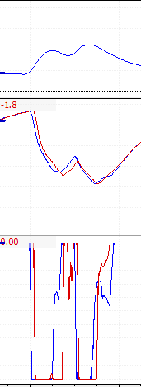
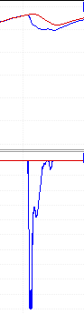
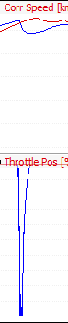
Figure 6 Driver A 1st Instruction Part 2
Figure 7 Driver A 1st Instruction Part 1

Key:
Red line – Richard
Blue Line – Driver A session 1 data trace
Driver A’s first instruction, part 1, in session 2 was to not lift of the throttle around abbey and copse corner, as shown in figure 7. Although this wasn’t causing the greatest loss of lap time when compared to Richard it was an easy fix that would help with the loss of speed as shown in the figure 7 , losing 30.9 km/h at abbey (left image) and 27.9 km/h at copse (right image), and entry speeds to the subsequent corners, (village & maggots respectively).
Because of how simple this instruction was it was given along with a secondary instruction. Part two was the about the application of the throttle pedal around luffield corner. At the corner entry driver A was instructed to release the throttle later and stay off the throttle until the start of the right hand turn of luffield, this was done to bring the drivers corner entry speed down to help avoid any under/oversteer that could develop. Secondly to apply the throttle later at the corner exit so the driver could reach 100% sooner and improve corner exit speed, as driver A is losing 7.2 km/h on the exit, as shown in figure 6. Although the driver gains back most of the time lost over the corner the overall aims of this instruction is to minimize the amount of time lost during the corner which at its peak is 2.226 seconds, if this can be minimized then there’s potential for driver A to gain time on Richard through the exit of luffield.

4.32 Driver A Session 2 Instruction 1 Results:
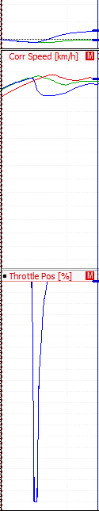
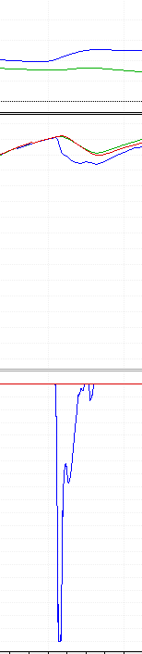
Key;
Red line – Richard
Blue line – Driver A Session 1 data trace
Green Line – Driver A Session 2 data trace
The results from part 1 of the first instruction, shown in figure 8, show having driver A keeping the throttle at 100% throttle around abbey and copse and producing a significant increase in speed. Around abbey driver A is now traveling 25.2 km/h faster and is 0.087 seconds faster, whilst at copse driver A is travelling 24.8 km/h quicker and is 0.373 seconds quicker at the corner exit and because of the additional speed this gap extends to 0.548 seconds by the entry of maggotts.

Figure 8 Driver A 1st Instruction Part 1 Result

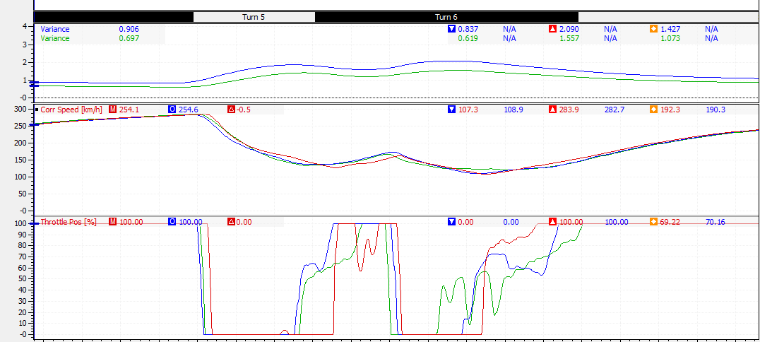
Figure 9 shows the data trace from the fastest lap performed in this session by driver A, this was also the fastest lap overall up to that point, compared against Richards data and the data from session 1 as a comparison to show the improvement made. The green data trace, which is driver A’s new fastest lap of 1:38.074, shows how the driver did make the adjustments according to the instructions given although didn’t manage to match Richards data trace.
Figure 9 Driver A Session 2 Instruction 1 Part 2 Result
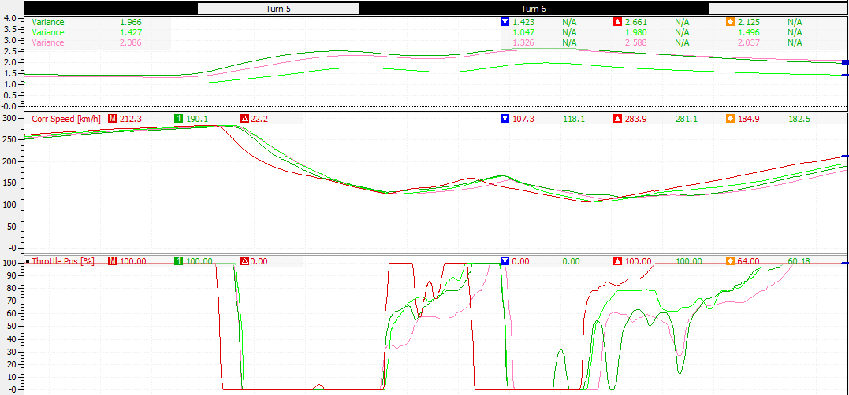
Through the corner driver A is now 0.5 seconds faster than before, this is due to being slightly later off the throttle, around 0.04 hundredths of a second, and the slightly longer period which driver isn’t applying the throttle pedal, this cuts his corner entry speed to the right hand turn section of luffield down by 15 km/h. This achieves the first aim of this instruction, however driver A then applies the throttle 0.6 of a second earlier at the corner apex. Because of this driver A is having to feather the throttle through the exit of the corner and reaches 100% 0.6 of a second later, this negatively impact his lap time and by the next corner the gap has reduced down to only 0.2 seconds quicker than his previous lap.
3 of driver A’s previous attempts in the session achieved later braking than Richards, shown in figure 10. These however negatively impacted the entire corner as he was unable to accelerate into the left hand section early enough, this caused the driver to have to wait longer on the corner exit before applying the throttle and ultimately cost him between 20 and 30 km/h of speed down the national pits straight, depending on the lap.
Figure 10 Driver A Session 2 Instruction 1 Part 2 Attempts
Overall this instruction produced a new fastest lap of 1:38.074, this is an improvement of 1.401 seconds.
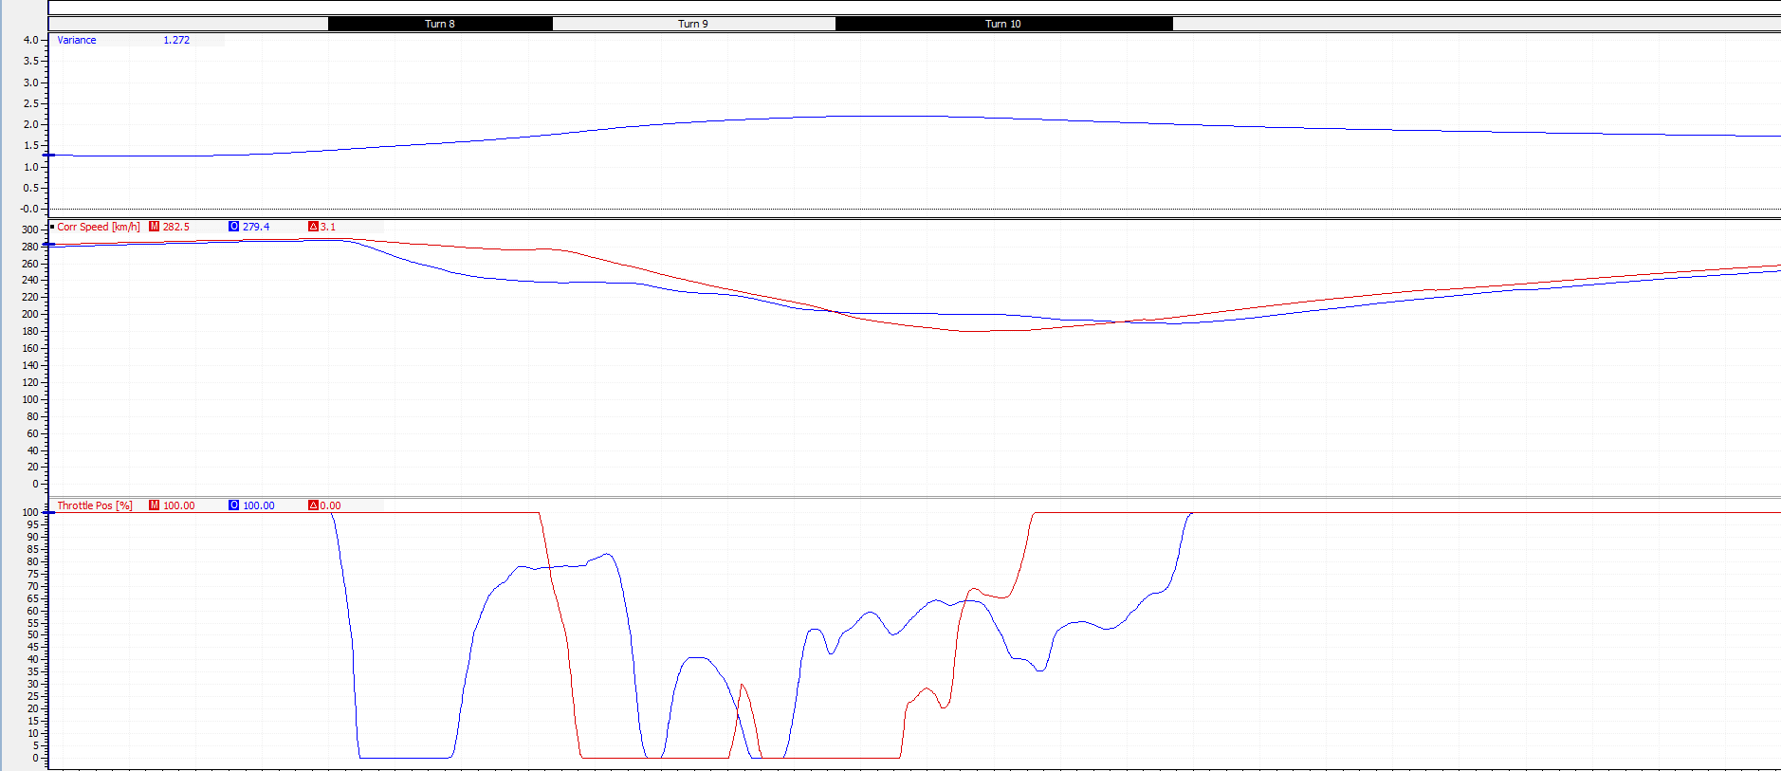
4.33 Driver A Session 2 Instruction 2:
Figure 11 Driver A Session 2 Instruction 2
Key:
Red line – Richard data trace
Blue Line – Driver A session 1 data trace
The second section an instruction was given for was the Maggotts, Becketts, Chapel complex. Through this complex driver A was instructed to not come off the throttle until the entry of Becketts, stay off the throttle around Becketts corner and only apply a small amount at the exit, lastly start to apply throttle gradually around chapel corner and be at 100% by the start of the corner exit.
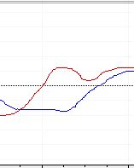
These instruction were created to solve several issues: firstly the lack of speed the driver had around maggotts corner, due to the early throttle lift driver A had significantly less speed around maggotts which at its peak he was driving 39 km/h slower and he lost 0.5 seconds of time to richard. Secondly due to the on/off accleration through becketts driver A was carrying too much speed through the exit of becketts into chapel, this shown in figure 12 where the steering wheel percentage, which the driver was not shown, shows how driver A was running much wide on the track at the exit of becketts and was still steering left when at the entry of chapel whereas richard had a much better track position and was turning into chapel. Lastly as a result of the previous two two points mentioned driver A was 1.193 seconds slower upto 100% throttle this meant at the exit of chapel he was travelling 11.7 km/h slower.
Figure 12 Driver A Chapel Corner Entry Steering Wheel Percentage

4.34 Driver A Session 2 Instruction 2 Results:

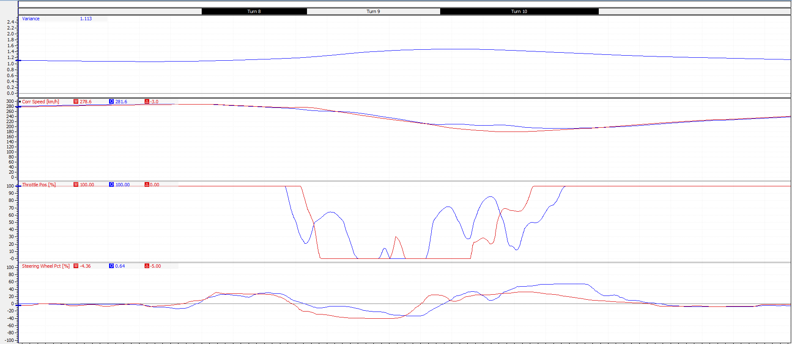
Figure 13 is the data trace of the fastest lap driver A produced after the instruction was implemented, shown in blue, plotted against Richards’s data, shown in red. Driver A has followed the instruction to stay at 100% through maggotts this has stopped him losing speed through the corner and into the entry of Becketts. He is still however applying the throttle at the entry and the exit of Becketts, this is still causing the driver to have to apply more steering at the exit of Becketts to correct his track position which is costing him time, see circled area on figure 13. Lastly he is reaching 100% throttle out of chapel corner 0.675 seconds quicker than before, the earlier throttle application closes the corner exit speed gap down from nearly 12 km/h to 4.2 km/h.
Figure 13 Driver A Session 2 Instruction 2 Results
However this instruction didn’t produce a new fastest lap time or fastest sector, this is partly down to Driver A losing time through luffield on every lap.
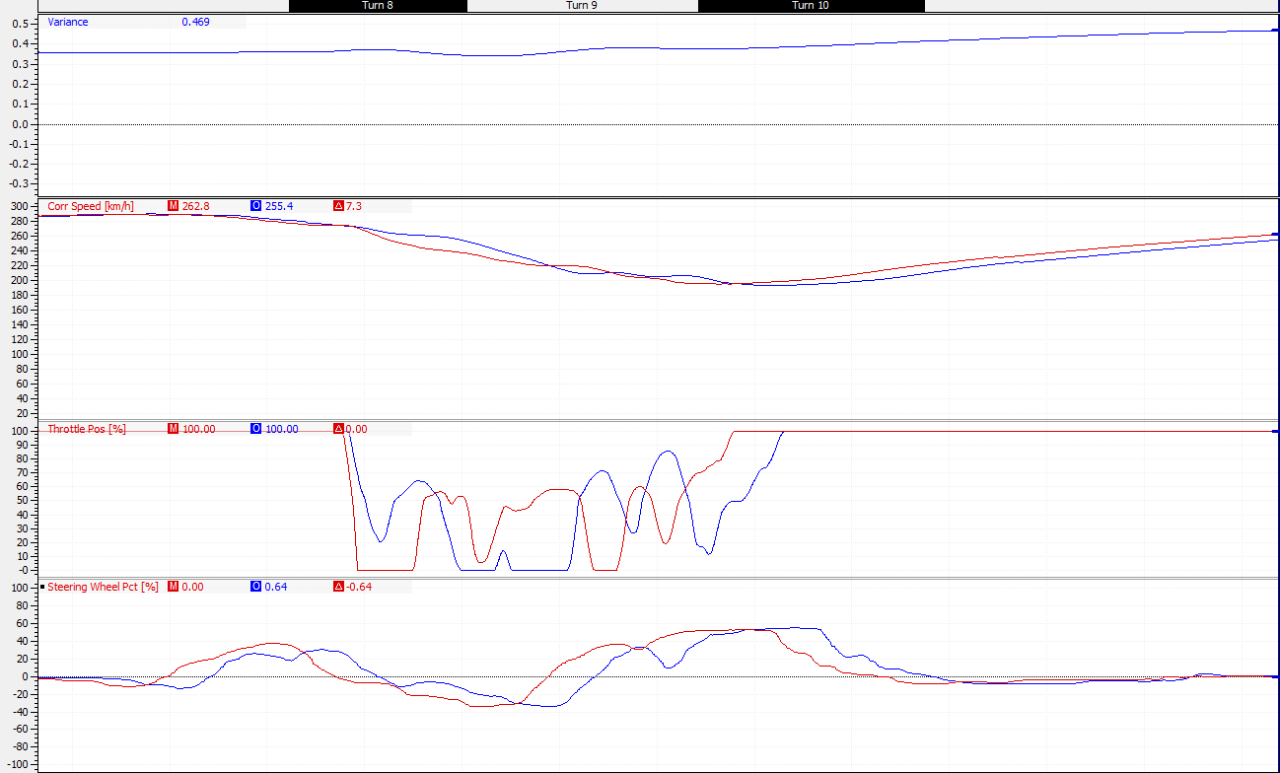
It’s also partly due to the engineer using old data to create the second instruction. Because the second instruction was created using driver A’s session 1 data, during the first section of session 2, driver A changed how he drove the complex when setting his new fastest lap, and because the second instruction was created from session 1 data the instruction given made him slower through the complex resulting in a slower sector and lap time. This is shown in figure 14.
Figure 14 Driver A Session 2 Instruction 1 vs Instruction 2
4.4 Driver A Session 3:
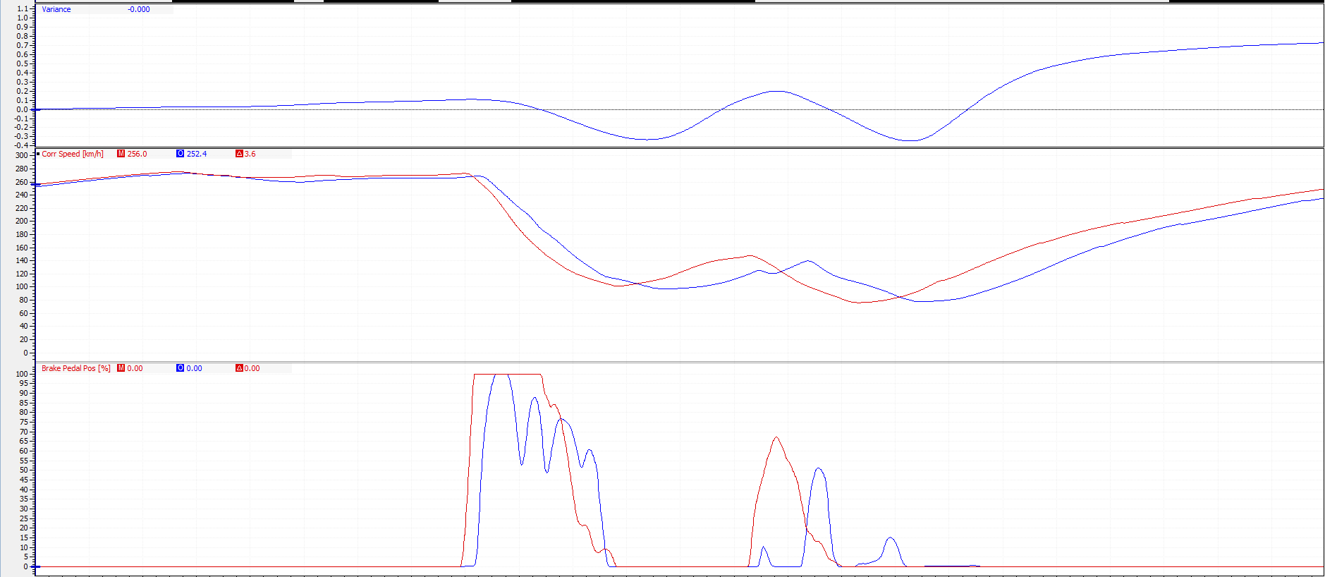
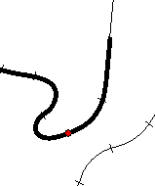
4.41 Driver A Session 3 Instruction 1:
Figure 15 Driver A Session 3 Instruction 1
Key:
Red Line – Richards Data trace
Blue line – Driver A Session 2 Data trace
Village and the loop corners were the first areas of improvement identified for session 3. For village corner driver A was instructed to brake 20 meters and to hold the pedal at 100% for around 70 meters rather than feathering the pedal. This would bring down his corner entry speed and aid with cornering as village is a very tight corner. Secondly he was instructed to brake 20 meters earlier for the loop and be harder on the brakes by 15%, this is also a very tight corner and an with a slower speed a tighter turn in can be achieved this would aid with the earlier application of the throttle and therefore exit speed as driver A is travelling 44 km/h slower at the mark indicated on figure 15. Overall Driver A losses over 0.5 seconds over the two corners.

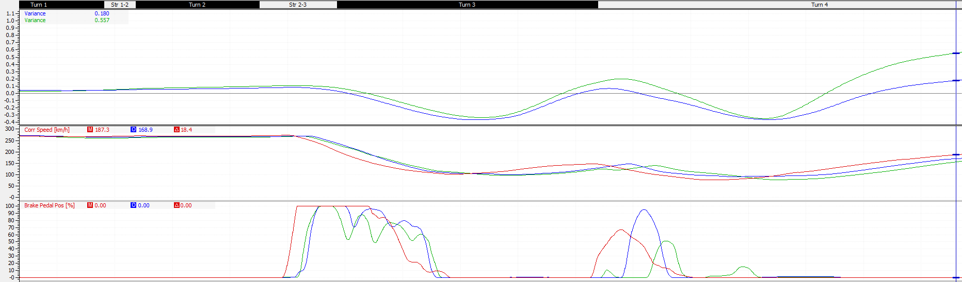
4.42 Driver A Session 3 Instruction 1 Results:
Figure 16 Driver A Session 3 Instruction 1 Results
As the results show, during driver A’s fastest lap of the session, shown in blue, he failed to bring his initial braking point, however he did hold the brakes at 100% for a longer a period of time than the previous fastest lap, shown in green. This increase of braking drops his corner entry speed by 6 km/h this allows for smoother cornering and is therefore faster.
For the loop driver A does bring his braking point back by around 10 meters, although this is not as far back instructed it still has a positive effect. Driver A also increases his brake pedal percentage by 50%, this is much higher than Richards pedal usage but because of the later braking it has the same desired effect. Driver A’s entry speed for the loop is now 23.6 km/h slower, this means he achieve a better track positon and corner smoother and can apply the throttle earlier, as shown in figure 17. This increases his corner exit speed by 20 km/h and by the exit of the corner was 0.361 seconds quicker than his previous fastest lap.
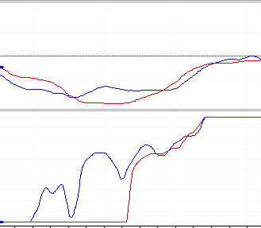
This instruction produced both new fastest first sector of 27.403, this was faster by 0.153 seconds, and new fastest lap of 1:37.685 an improvement of 0.389 seconds.
Figure 17 Driver A Session 3 the Loop exit Throttle & Steering Data Traces
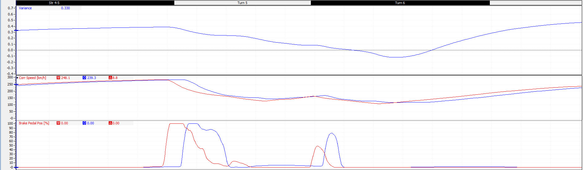
Figure 18 Driver A Session 3 Instruction 2

4.43 Driver A Session 3 Instruction 2:
Driver A’s second instruction was to change his breaking points for luffield corner. Using the data trace from driver A’s new fastest lap set earlier in the session the instruction was given to brake earlier, both before the left and right hand sections of luffield, this late breaking approach was costing driver A 25 km/h of exit speed and he was losing 0.2 seconds through the corner. This was done to avoid the much wider line that driver A was forcing himself to take with the late braking as shown in figure 19.

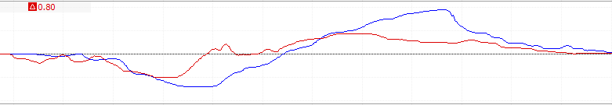
Figure 19 Driver A Session 3 Luffield Steering Trace

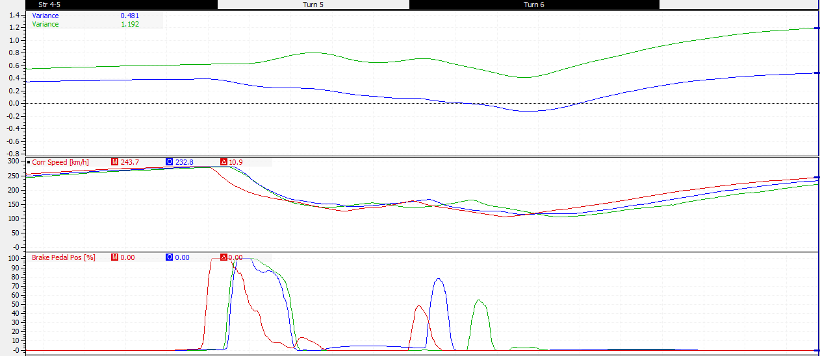
4.44 Driver A Session 3 Instruction 2 Results:
Figure 20 Driver A Session 3 Instruction 2 Results
Driver A struggled to achieve the earlier braking as he found he was locking the wheel when braking for the corner entry , this also meant he was accelerating later round the corner and therefore braking later in the second braking phase as shown by the green trace in figure 20.
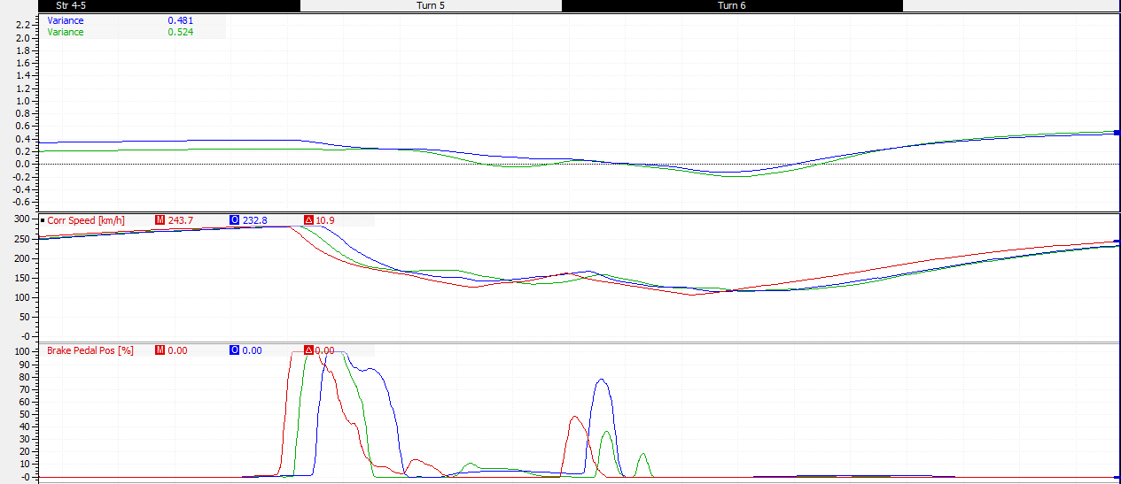
This resulted in driver A losing just over 0.7 seconds by the start of the national pits straight.
Figure 21 Driver A Session 3 Instruction 2
The closest driver A came to matching Richards trace is the data shown in figure 21, this lap Driver A broke earlier than before and shortened the time he applied the brake pedal, this stopped the brakes locking, however during the second braking phase not enough brakes were applied and this meant he had to apply a touch of secondary braking ultimately costing him time and speed.
By the start of the national pits straight this lap was 0.044 seconds slower than drivers A’s current fastest lap. Meaning overall this instruction gave no advantage to the driver and therefore driver A was instructed to disregard this instruction and return to driving luffield corner how he previously drove it.
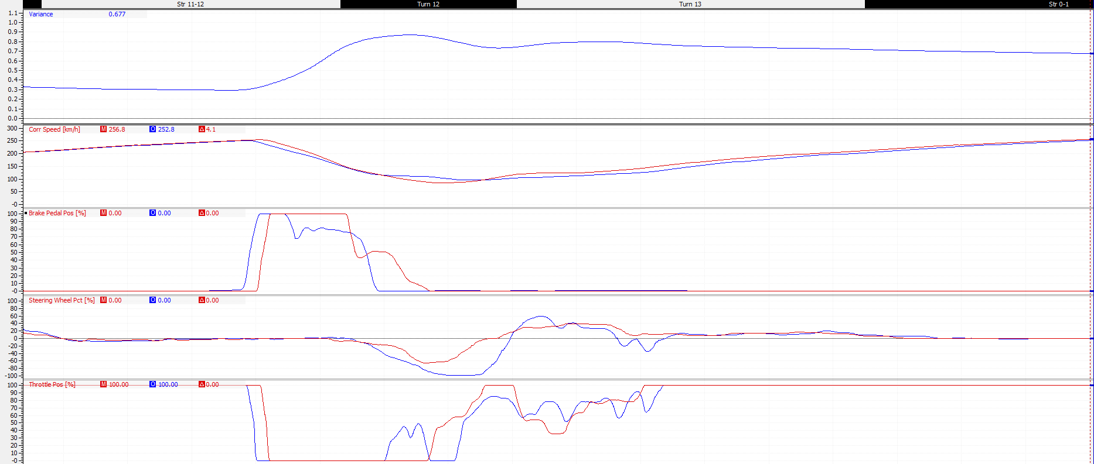
4.45 Driver A Session 3 Instruction 3:
Figure 22 Driver A Session 3 Instruction 3
The last instruction for session 3 was for club corner. Firstly, driver A was instructed to brake 16 meters later, this was done to increase entry speed into club and not fall 0.853 seconds behind Richard, this area is circled on figure 22. The second part of the instruction was to apply 100% brakes for 60 meters and travel 120 meters from first application of the brakes to completely off the brake pedal. This is so driver A doesn’t carry too much speed into the corner and risk understeering, by the point Richard starts turning into club he is travelling 22.1 km/h slower, this allows for smoother and more controlled cornering and enables Richard to get back on the throttle earlier.

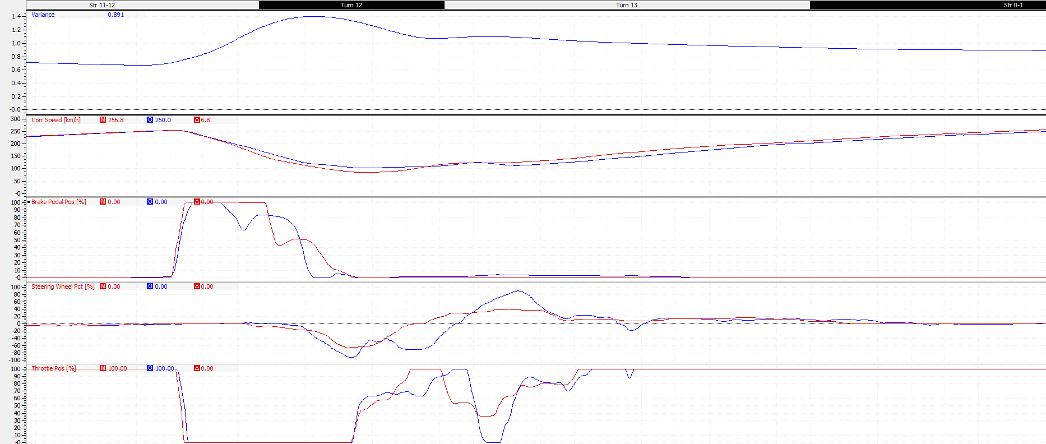
4.46 Driver A Session 3 Instruction 3 Results:
Figure 23 Driver A Session 3 Instruction 3 Results
The results in figure 23 show that driver A successfully moved the breaking point to match Richards, however continued to feather the brake throughout the braking zone, this meant that the corner entry speed, whilst it has lowered by 5km/h, is still 17 km/h quicker than Richards. This continued to have a negative impact on the rest of the corner and specifically on this lap, which was the fastest set in the third part of session 3, the higher entry speed meant driver A had to lift completely off the throttle, shown in the circled section on figure 23. This lost the corner exit speed which driver A had gained.

4.5 Driver A Session 4:
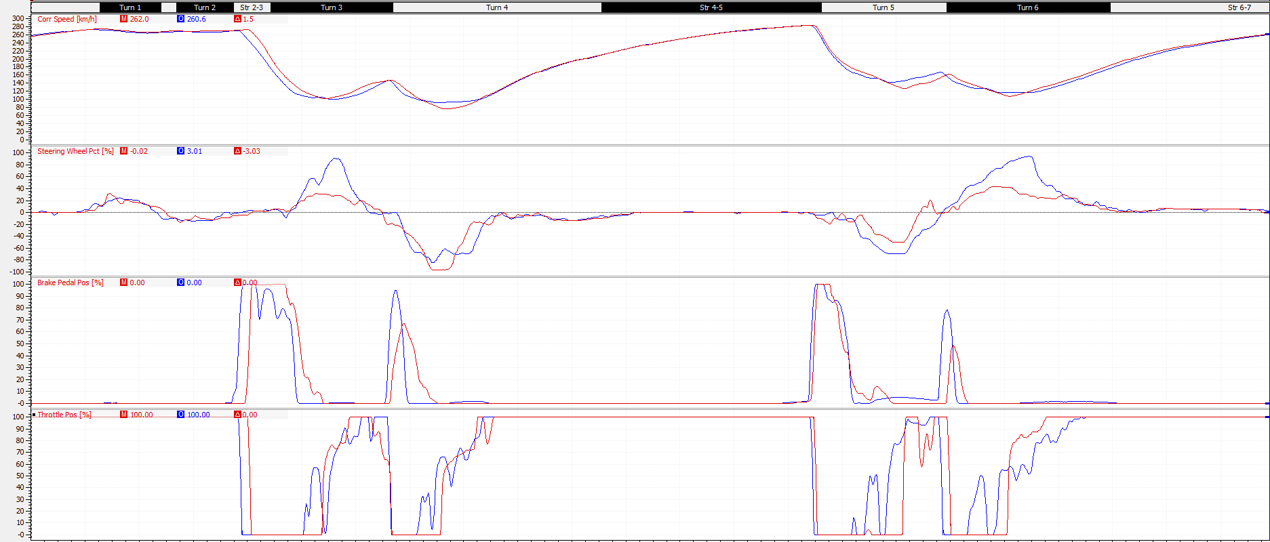
4.51 Driver A Session 4 Instruction 1:
Figure 24 Driver A Session 4 Instruction 1
Driver A’s first instruction for session 4 was for both the village and the loop corners and luffield.
For village driver A was instructed to use less steering angle, this was so that more speed could be carried through the corner, following this use a much wider line out of the corner towards the loop, this would require driver A to use more steering lock and turn sharper into the loop. This was done so driver A wouldn’t have to feather the throttle as much through the exit of the loop and gain exit speed.
Secondly for luffield driver A was instructed to use less steering lock through all of luffield, this was too avoid the need to feather the throttle throughout the corner and gain in entry, mid and exit corner speed.

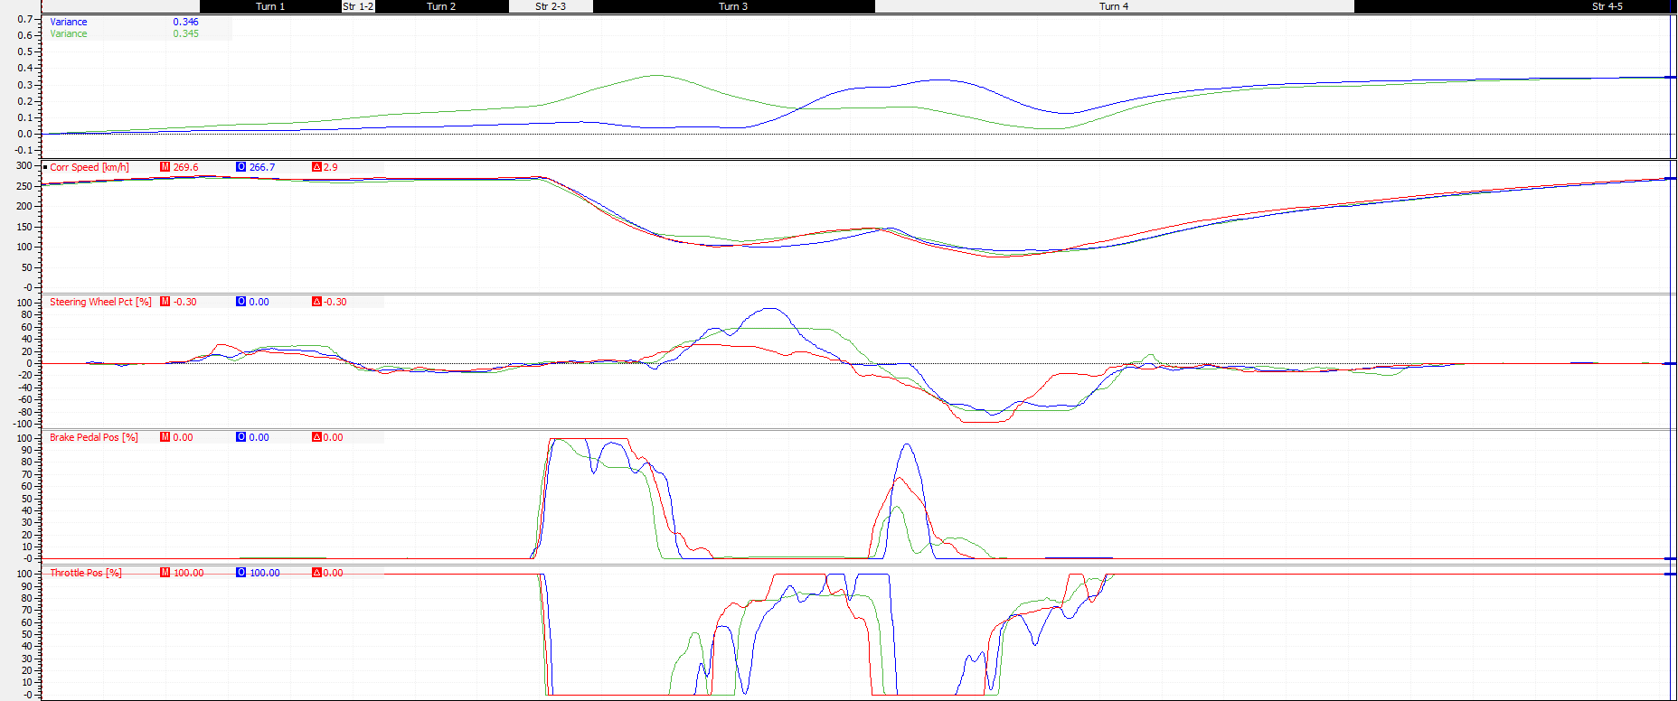
4.52 Driver A Session 4 Instruction 1 Results:
Figure 25 Driver A Session 4 Instruction 1 Village & the loop Result
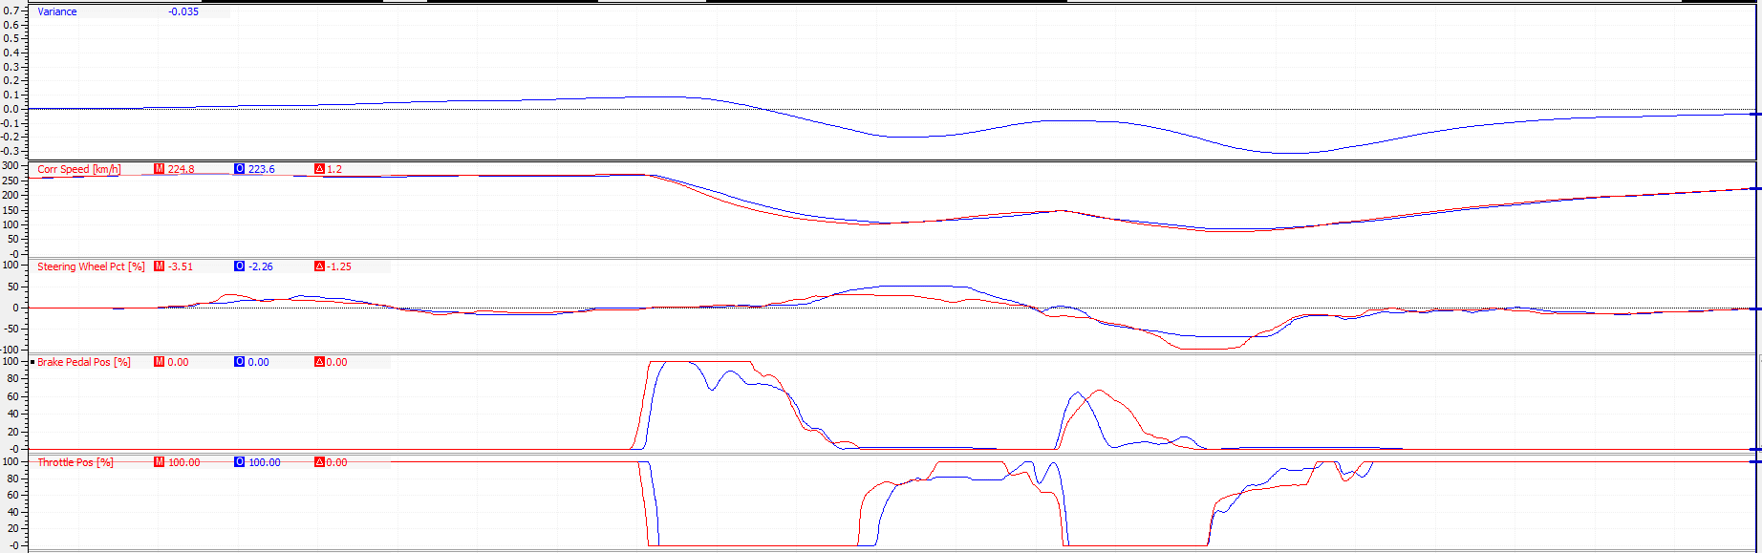
Driver A uses less steering angle around village corner than he was previously, this increases corner speed by 23 km/h and he gains 0.2 seconds on his previous fastest lap, as shown by the green trace circled in black. However, driver A doesn’t apply enough brakes during the second braking phase for the loop, this causes him to carry too much speed into the corner and the data indicates that he understeers through the exit of the loop, losing exit speed and time, this is shown in the yellow circle on figure 25.
Figure 26 Driver A Session 4 Instruction 1 Village & the loop
Driver A did produce a faster time through the corners in a previous lap, shown in figure 26. Driver A used the same steering angle through village but applied more brakes in the second braking phase, he didn’t use such a wide line and therefore applied less steering angle through the loop than Richard. This however resulted in a faster time through the corners than Richard and a new fastest first sector for driver A of 27.080, this was quicker than his previous by 0.219 seconds and quicker than Richards first sector by 0.068 seconds.

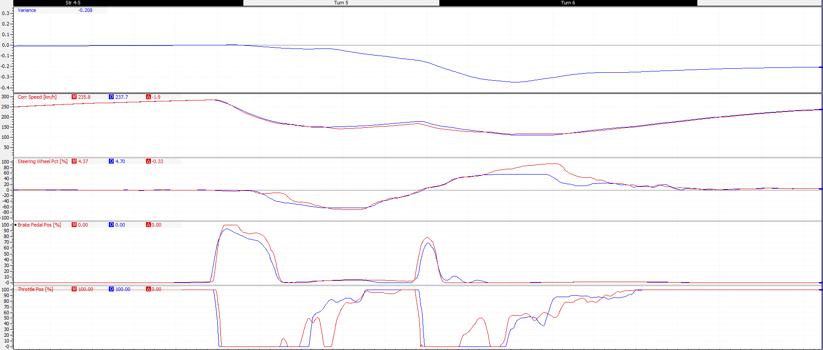
Figure 27 shows driver A’s session 3 fastest lap, red trace, against his current fastest lap, blue trace.
Figure 27 Driver A Session 4 Instruction 1 Results
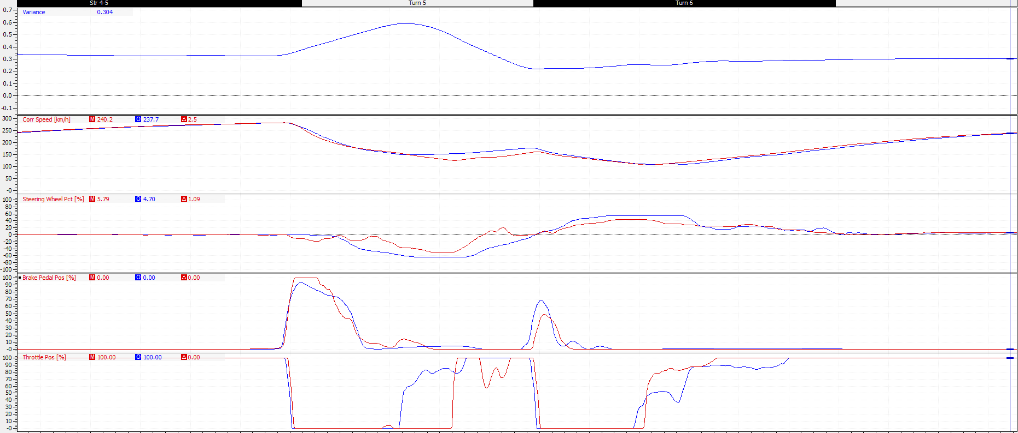
Driver A uses 30% more steering lock on the entry to luffield, this was the opposite of the instruction given however he is able to carry more speed through the left hand turn of luffield, this makes driver A 0.340 seconds faster. The instruction to use less steering lock is followed for the right hand turn of luffield, subsequently driver A is 5km/h faster on the exit of luffield. This speed advantage does become smaller as the vehicle accelerate away from the corner, by the start of the national pits straight the gap has shrunk to only 1 km/h. This is most likely because in session 3 driver A was able to get on the throttle earlier at the exit of luffield this cut speed advantage later down the straight.
Figure 28 Driver A Session 4 Instruction 1 Results
Figure 28 compares Driver A’s data against Richards, although an improvement was made Driver A is still slower. Because of the wider line driver A takes around the left hand corner of luffield he loses 0.26 tenths of a seconds to Richard, he is however able to get on the throttle earlier and gains 0.3 tenths of a second by the start of the second braking phase. Driver A then again takes a wider line and has to feather the throttle through the exit of luffield, this leads to him being 10km/h slower.
Overall this instruction was an improvement, Driver A set a new fastest middle sector of 40.192, this was 0.235 seconds quicker than his previous, and set a new fastest lap of 1:37.333 an improvement of 0.352 seconds.

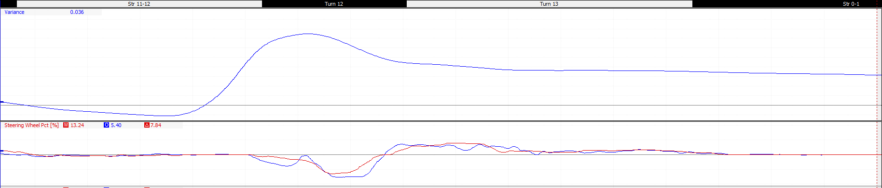
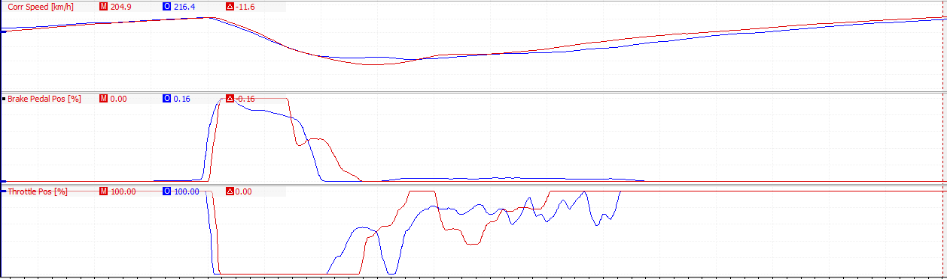
4.53 Driver A Session 4 Instruction 2:
Figure 29 Driver A Session 4 Instruction 2
The second instruction for session 4 was for club corner. Driver A was instructed to use less steering lock and take a shallower line through club, this could stop driver A having to lift completely off the throttle after the left hand turn of club as this was costing driver A speed on the exit where he was 15 km/h slower.
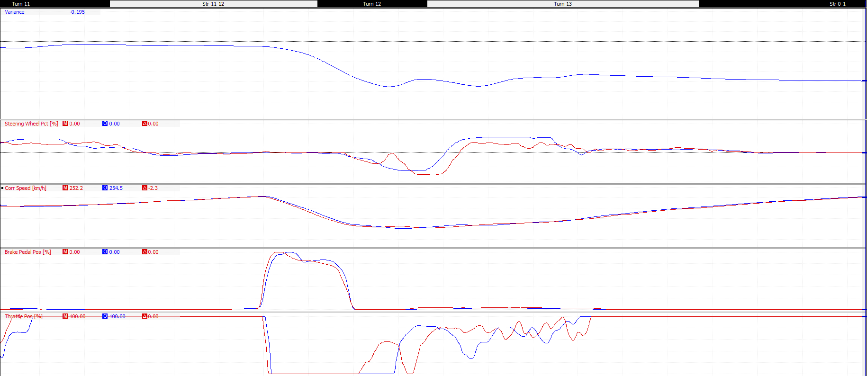
4.54 Driver A Session 4 Instruction 2 Results:
Figure 30 Driver A Session 4 Instruction 2 Result
The results shows that use of less steering lock for entrance of club corner resulted in 10 km/h more entry speed and driver A didn’t have to lift after the corner apex. Because of the tighter line driver A was also able to achieve 100% throttle much earlier and gain 8km/h in mid corner speed. However through the right hand corner of club a wider line was taken, this lost Driver A 5km/h of exit speed.
Overall this instructions set both a new fastest sector time of 29.352, this is an improvement of 0.124 seconds, and a new fastest lap of 1:37.135 an improvement of 0.198 seconds. With one session left driver was now only 0.13 seconds slower than Richards’s fastest lap.

4.6 Driver A Session 5:
4.61 Driver A Session 5 Instruction 1:
The first instruction in session 5 was when to change up to 6th gear at abbey corner. Driver A was changing up before turning for abbey, this meant whilst cornering that his speed dropped by 10 km/h and the engine RPM dropped by 1200. Whereas Richard was changing up just after abbey and was therefore able to keep his acceleration and top speed up whilst cornering. Overall this was losing Driver A 0.2 seconds by the braking phase for village corner, as shown in figure 32.
Much like session 2 Driver A was given a second instruction because the first is simple to apply. The second part of the instruction was for luffield corner. Driver A was still struggling to achieve 100% throttle early enough and as a result was 10 km/h slower through the exit of luffield, as shown in figure 31. To try and increase Driver A’s acceleration he was instructed to use second gear from the first braking phase right through to the corner apex.

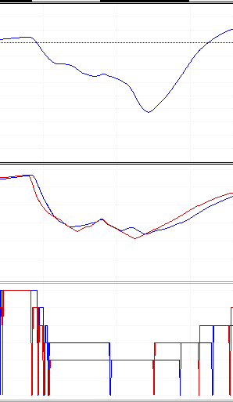
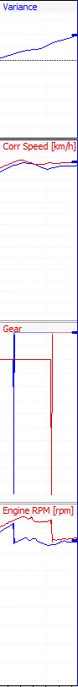
Figure 31 Driver A Session 5 Instruction 1 Part 2

Figure 32 Driver A Session 5 Instruction 1 Part 1
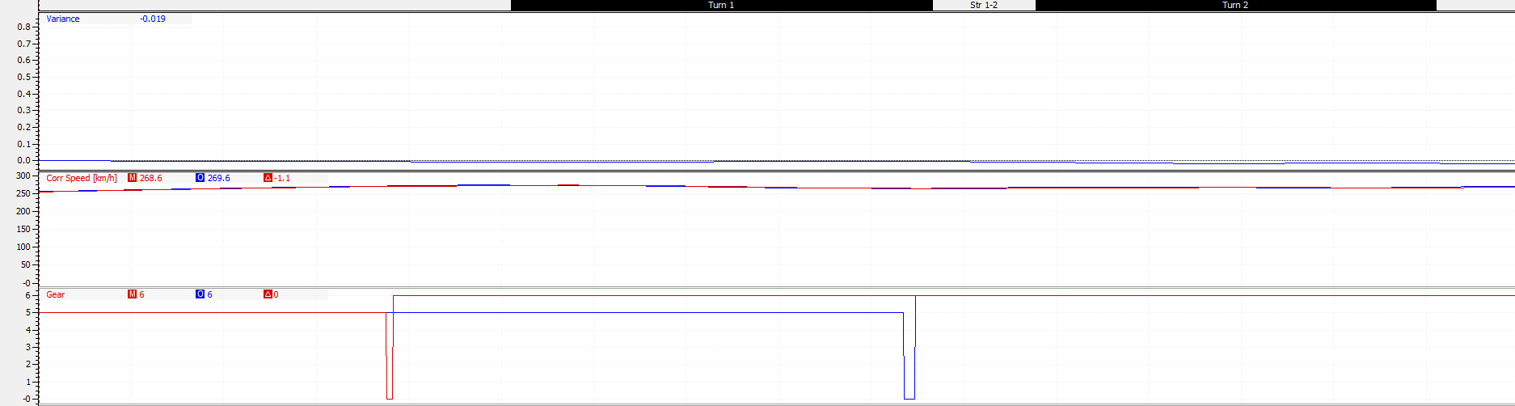
4.62 Driver A Session 5 Instruction 1 Part 1&2 Results:
Figure 33 Driver A Session 5 Instruction 1 Part 1 Results
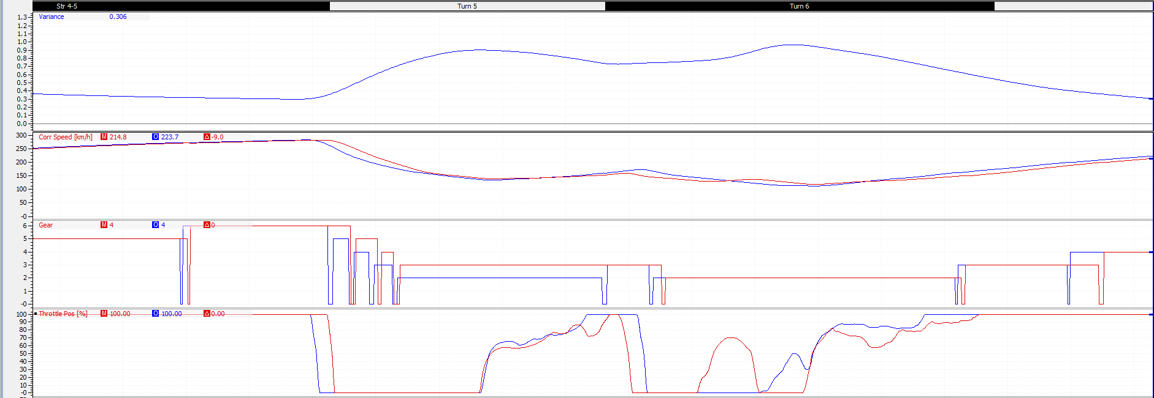
Driver A’s later change up to 6th gear increased his speed by 4 km/h around abbey at he gained 0.02 seconds of time on his fastest lap. This helped Driver A to achieve a new fastest first sector of 27.395 an improvement of 0.161 seconds.
Figure 34 Driver A Session 5 Instruction 1 Part 2 Results
Using 2nd gear through luffield enabled driver A to accelerate earlier both mid corner and on the exit, this gave him 30km/h extra mid corner speed at an extra 10km/h on the exit. Going into luffield driver A was already 0.35 seconds down on his fastest lap, but the extra speed gained through the corner closed this gap down to 0.166 seconds by the start of national pits straight.
Both of these instructions were faster than Driver A’s fastest lap but he was unable to string together a completely clean lap. Therefore Driver A was instructed to keep using these changes throughout the session.

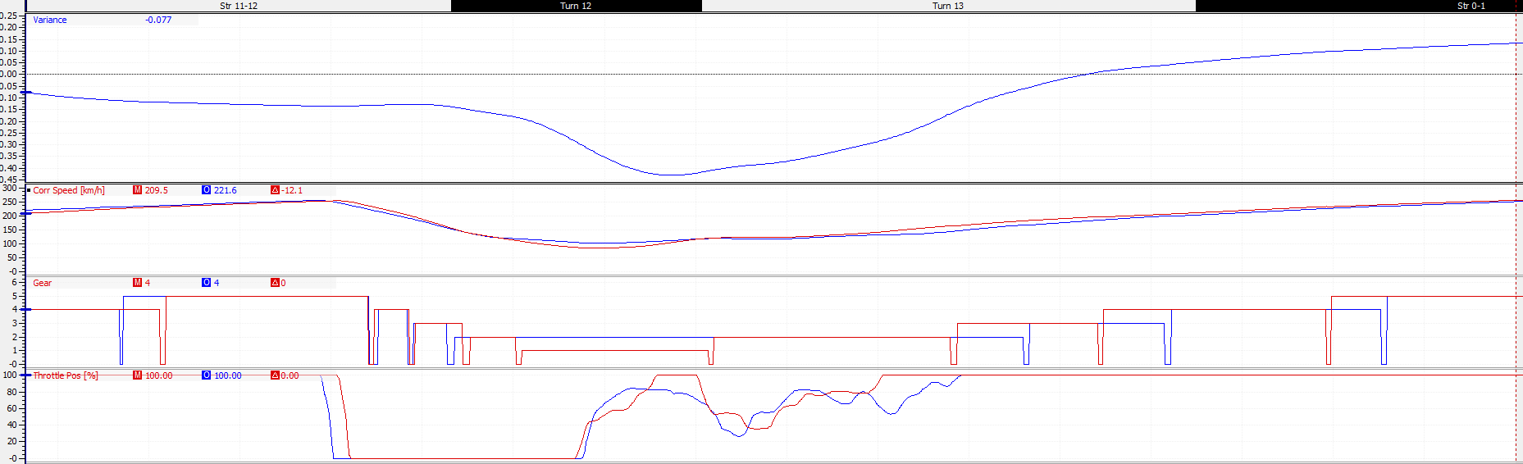
4.63 Driver A Session 5 Instruction 2:
Figure 35 Driver A Session 2 Instruction 2
Driver A’s second instruction was for club corner. He was instructed to use 1st gear to increase initial acceleration out of the corner and gain exit speed. Driver A was instructed to use 1st gear for the left hand turn and to accelerate as he was level with the curb, the aim was to increase mid corner speed, where he was 5km/h slower and exit speed where he was 20km/h slower.

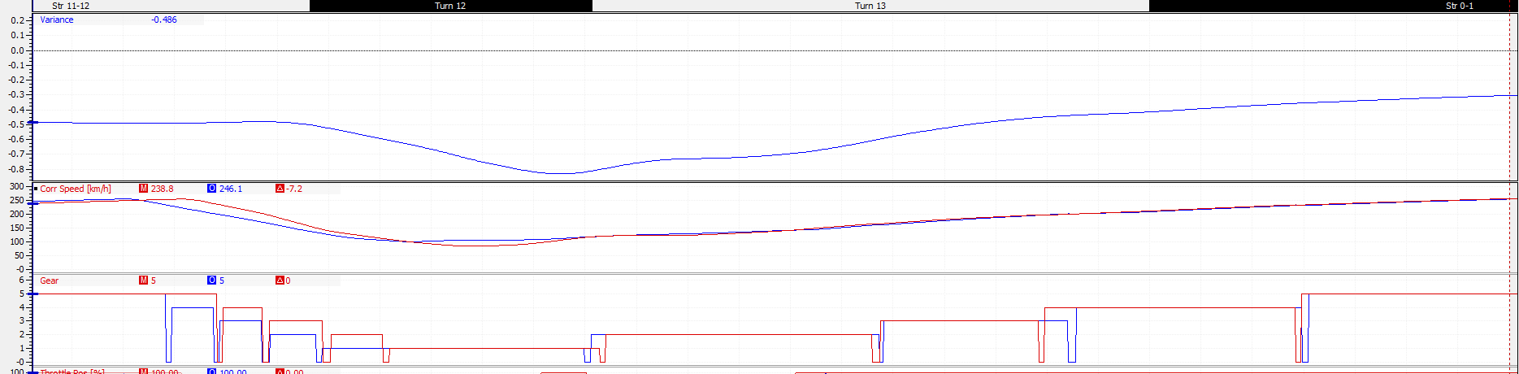
4.64 Driver A Session 5 Instruction 2 Results:
Figure 36 Driver A Session 5 Instruction 2 Results
Using 1st gear for club corner gave the desired effect as driver A increased his mid corner speed and is now 20km/h quicker than Richard through the left hander. It’s also increases his exit speed where driver A is now 5 km/h quicker than Richard leading onto the pit straight.
This increase of corner speed and a quicker exit out of Stowe helped driver A set a new fastest last sector of 29.259 this is 0.116 seconds quicker than Richards’s fastest last sector.
Using the first instructions driver A also set a new fastest middle sector of 40.185, this combined with the fastest last sector meant that driver A set a new fastest lap of 1:36.702. This an improvement of 0.433 seconds on his own fastest lap and quicker than Richards fastest lap by 0.303 seconds.

4.7 Driver B Session 2:
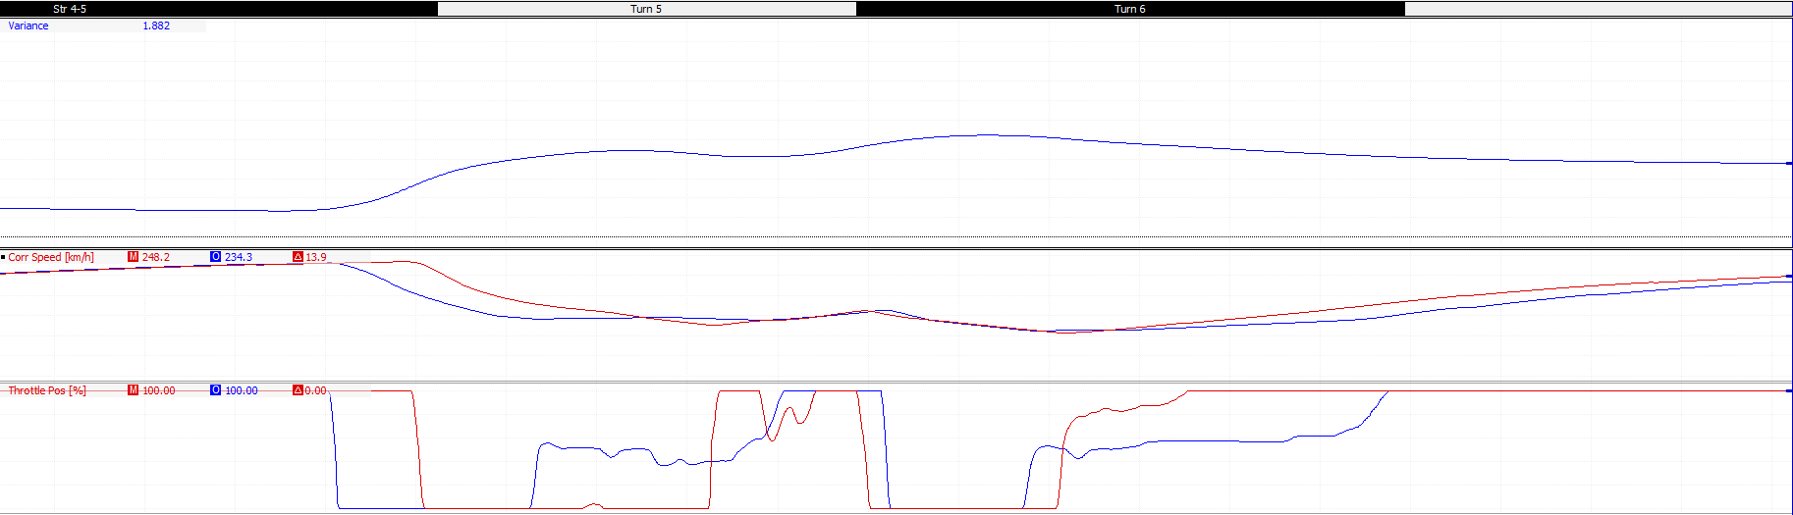
4.71 Driver B Session 2 Instruction 1:
Figure 37 Driver B Session 2 Instruction 1
Over the course of luffield driver A loses 1.2 seconds to Richard the aim of this instruction is to reduce this.
For the corner entry Driver A was instructed to stay on the throttle for another 60 meters, this is to increase corner entry speed which was 60 km/h slower than Richards and losing driver B 2 seconds by the first apex.
The second part was stay off the throttle after braking until the left hand corner apex, then use 100% throttle rather than feather the throttle through the corner, this will increase mid corner speed.
Lastly be earlier to 100% on the corner exit, currently driver A was 30 km/h slower by the start of the national pits straight by achieving maximum throttle earlier driver b will increase his corner exit speed and therefore his speed down the straight.

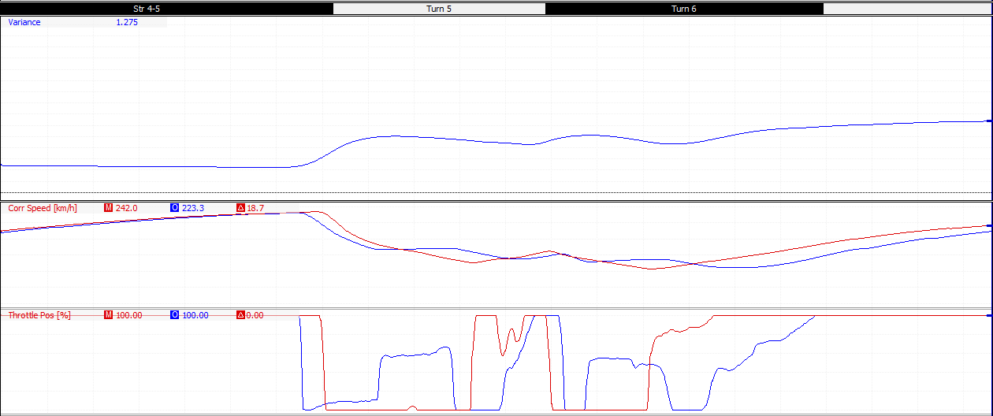
4.72 Driver B Session 2 Instruction 1 Result:
Figure 38 Driver B Session 2 Instruction 1 Results
Driver B moved his braking point forward 40 meters increasing corner entry speed by 30km/h, although this is still significantly slower than Richard it’s a marked improvement and gained driver B 1.2 seconds by the first corner apex.
However, driver B was unable to follow the 2nd and 3rd parts of the instruction, the use of on/off throttle through the entry and mid corner meant driver B lost 0.5 seconds by the right corner apex. It also meant he had to feather the throttle through the exit but was able to get up to 100% earlier than before, which meant by the start of the national pit straight driver B was now 20km/h slower than Richard.
Overall driver B improved by 0.3 seconds through luffield, but was still 1.3 seconds slower than Richard. This instruction helped produce a new fastest middle sector of 41.668 this is 0.2 seconds quicker than previous, this new fastest sector helped to contribute to a new fastest lap of 1:39.615, this was a massive improvement of 1.017 seconds.

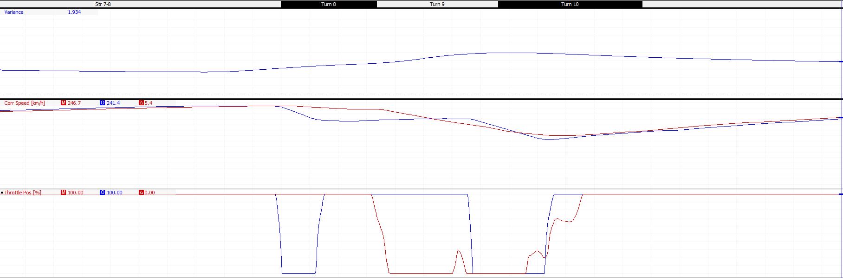
4.73 Driver B Session 2 Instruction 2:
Figure 39 Driver B Session 2 Instruction 2
Driver B’s second instruction was for maggotts and Becketts.
Firstly for maggotts, driver B was instructed to stay at 100% through the entire, the corner can be taken at full throttle and lifting for the corner was losing driver B 45km/h through maggotts corner and 0.4 seconds to time by the start of Becketts.
Secondly driver B was instructed to stay off the throttle through Beckett’s corner, with a short burst of throttle at the exit of the corner. Where previously driver B was at 100% throttle around the entirety of Becketts this was losing him more time, by the start of chapel corner driver B had lost a further 0.7 seconds and was now 2.4 seconds behind Richard. Although driver B gained some of this time back because he was able to accelerate harder out of chapel corner he was still 1.9 seconds down by the start of the hanger straight and travelling 10 km/h slower.

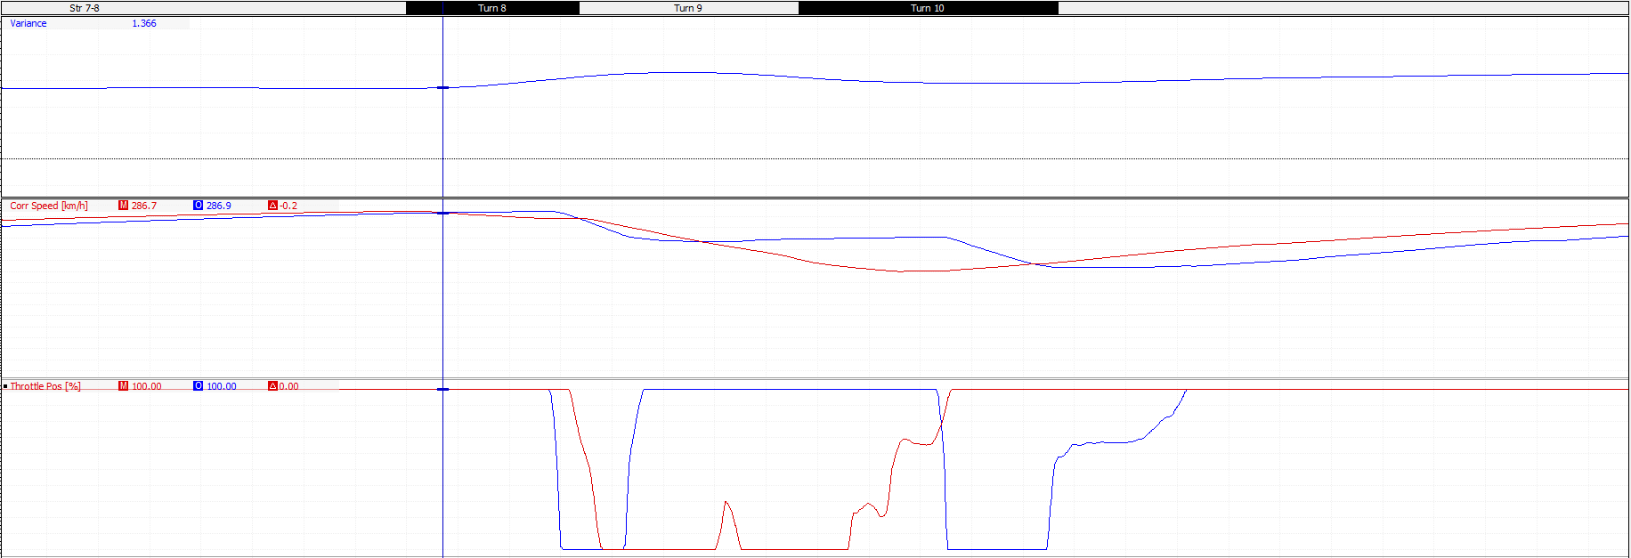
4.74 Driver B Session 2 Instruction 2 Results:
Figure 40 Driver B Session 2 Instruction 2 Results
Driver B successfully moved his braking forward so now he was staying on the throttle throughout maggotts corner, this closed the speed gap around maggotts from 45km/h down 9km/h just before initial braking and had lost only 0.2 seconds to Richard compared with 0.4 seconds before hand.
However driver B then only lifted off the throttle through the entry off Becketts before applying it again through Becketts and up to the apex of chapel, whilst this did gain driver B time through this section it meant he had to lift through the exit of chapel which lost him, time and speed leading on the national pits straight. By the start of the straight driver B was travelling 25 km/h slower than Richard and was 1.5 seconds slower this would extend to 1.7 seconds by the end of the straight.
Overall this instruction didn’t produce a new fastest sector and because the driver didn’t correct his throttle usage through Becketts and chapel he consistently lost time through the complex. However, driver B did set a new fastest time of 1:39.539, quicker by 0.08 seconds, this was not because of this instruction and because of a quicker first sector.

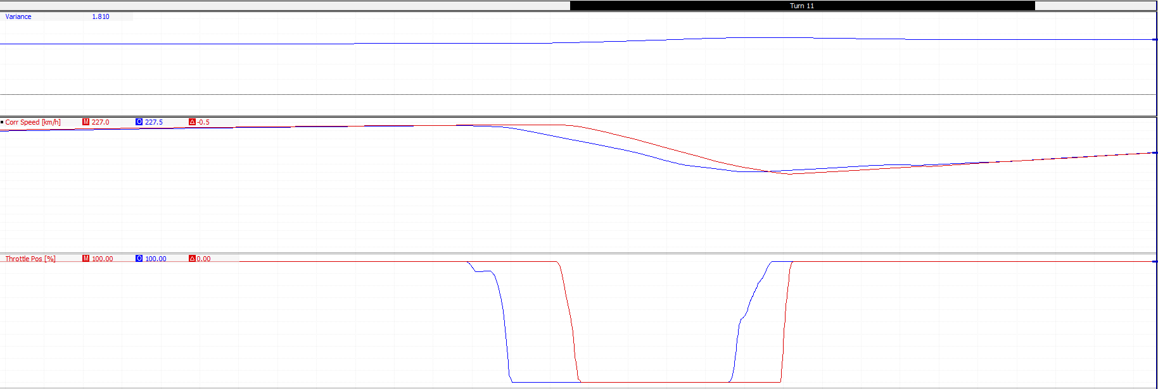
4.75 Driver B Session 2 Instruction 3:
Figure 41 Driver B Session 2 Instruction 3
The last instruction for session 2 was at Stowe corner. Driver B was lifting 30 meters earlier than Richard causing him to be 30km/h slower around Stowe and losing 0.4 seconds. This was also causing driver b to take less entry speed into club corner which was losing further time.

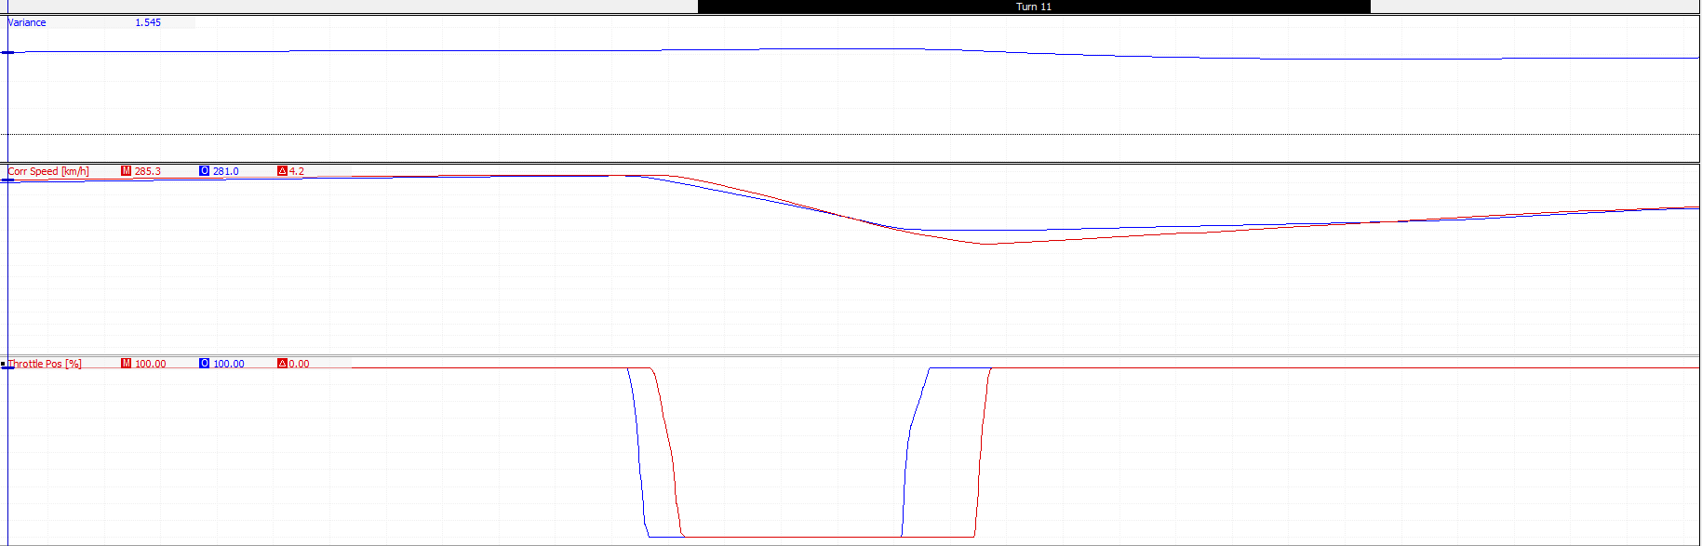
4.76 Driver B Session 2 Instruction 3 Results:
Figure 42 Driver B Session 2 Instruction 3 Results
Driver B moved his braking point forward 25 meters, this cut any speed deficit he had from Richard whilst cornering Stowe and because of his earlier accelerating point on the exit driver B was 15 km/h quicker than Richard and was gaining time on him. Driver B was now gaining 0.1 seconds on Richard through Stowe and increasing his entry speed into club corner by 5km/h.
This extra speed helped driver B to set a new fastest last sector of 29.873 seconds this was an improvement of 0.6 seconds on his previous best and was a part of a new fastest lap of 1:39.090, this is quicker by 0.449 seconds.

4.8 Driver B Session 3:

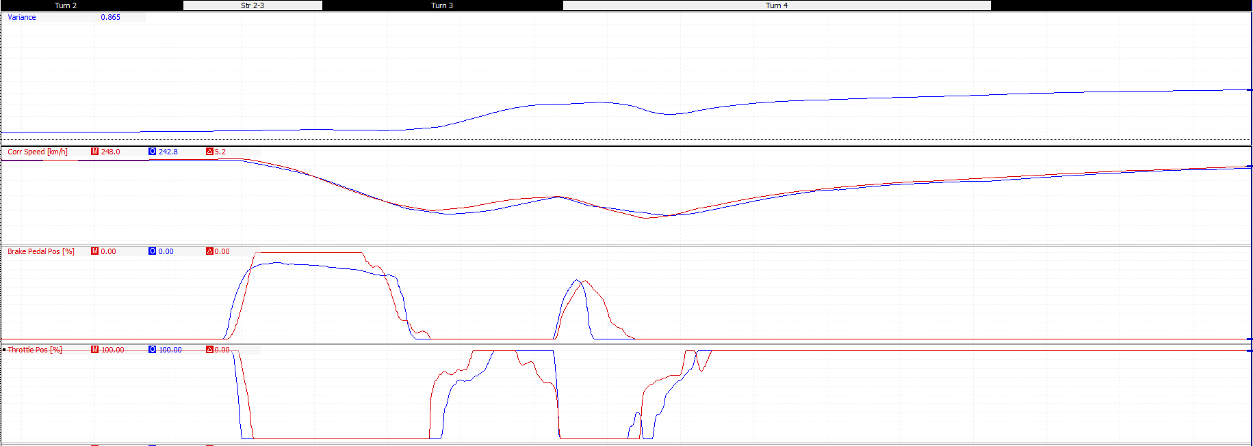
4.81 Driver B Session 3 Instruction 1:
Figure 43 Driver B Session 3 Instruction 1
Driver B’s first instruction for session 3 was how hard the brakes were applied at the village and the loop corners.
For the village corner whilst the braking point and the amount of time the brakes are applied is almost identical to Richard with 5 meters, driver B never uses more than 85% of the brakes in the first braking phase, this meant he carried 5km/h more speed through the entry of village corner.
As a result of this he was forced to take a wider line through village corner, shown in figure 44, and was 10 meters later on the throttle, this caused driver B to be 20 km/h slower in between village and the loop.
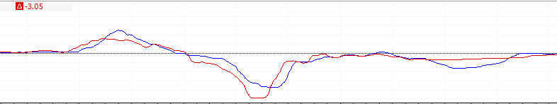
For the loop driver B was instructed to increase the duration he applied to brakes by an extra 15 meters. This is to reduce the speed driver B has around the loop, which is 18 km/h higher than Richards, and not have to lift off the throttle at the corner exit. Due to the lift driver B applied the throttle 10 meters later than Richard and was 10 km/h slower down the wellington straight.
Figure 44 Driver B Village & the Loop Steering trace

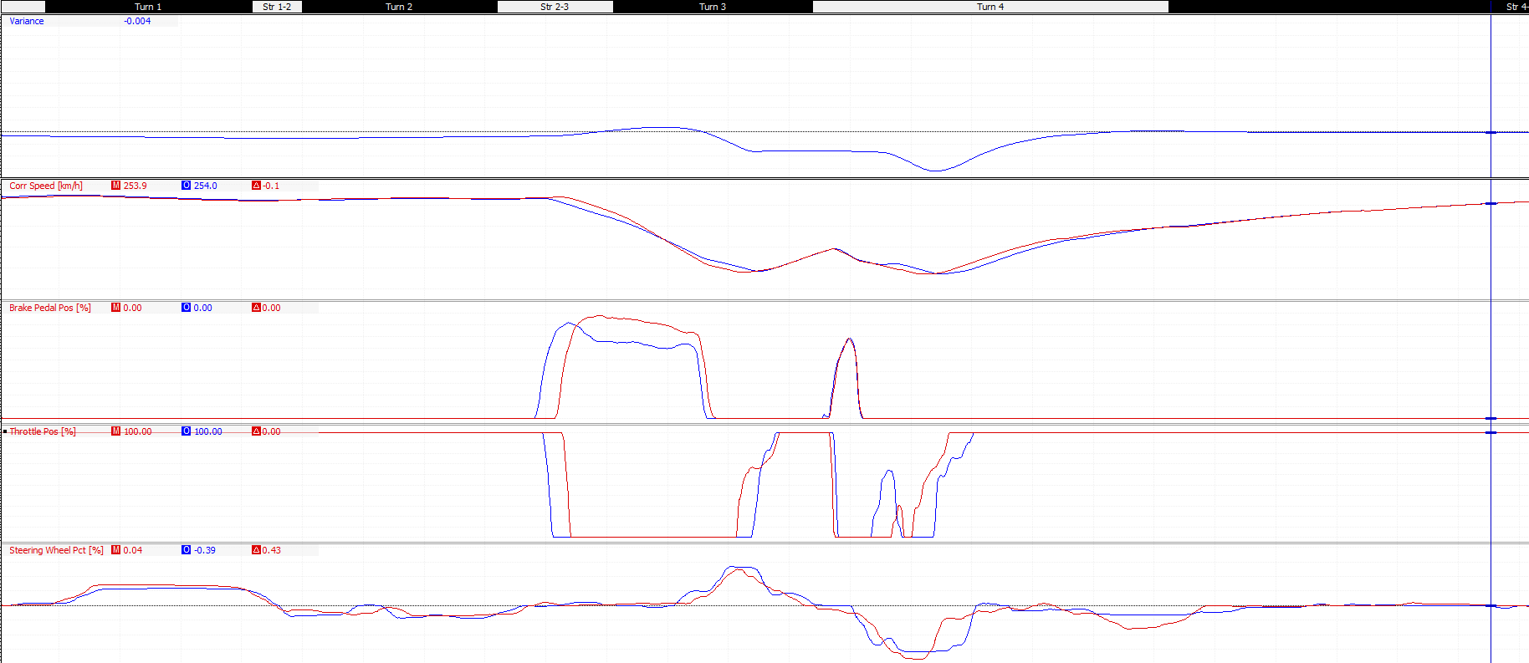
4.82 Driver B Session 3 Instruction 1 Results:
Figure 45 Driver B Session 3 Instruction 1 Results
The blue data trace shows how driver B session 2 fastest lap, red data trace, against the fastest lap from session 3, blue data trace.
Driver B didn’t increase brake usage, and actually used less for the first brake phase into the village. This had the same effect as before as driver B carried even more speed into and through village corner. Whilst this does gain the driver 0.2 seconds this time is lost through the exit driver B has to lift again around the loop for a longer period this lap because of the extra speed. This loses driver B a further 12 km/h of exit speed and the 0.2 seconds gained through village corner.
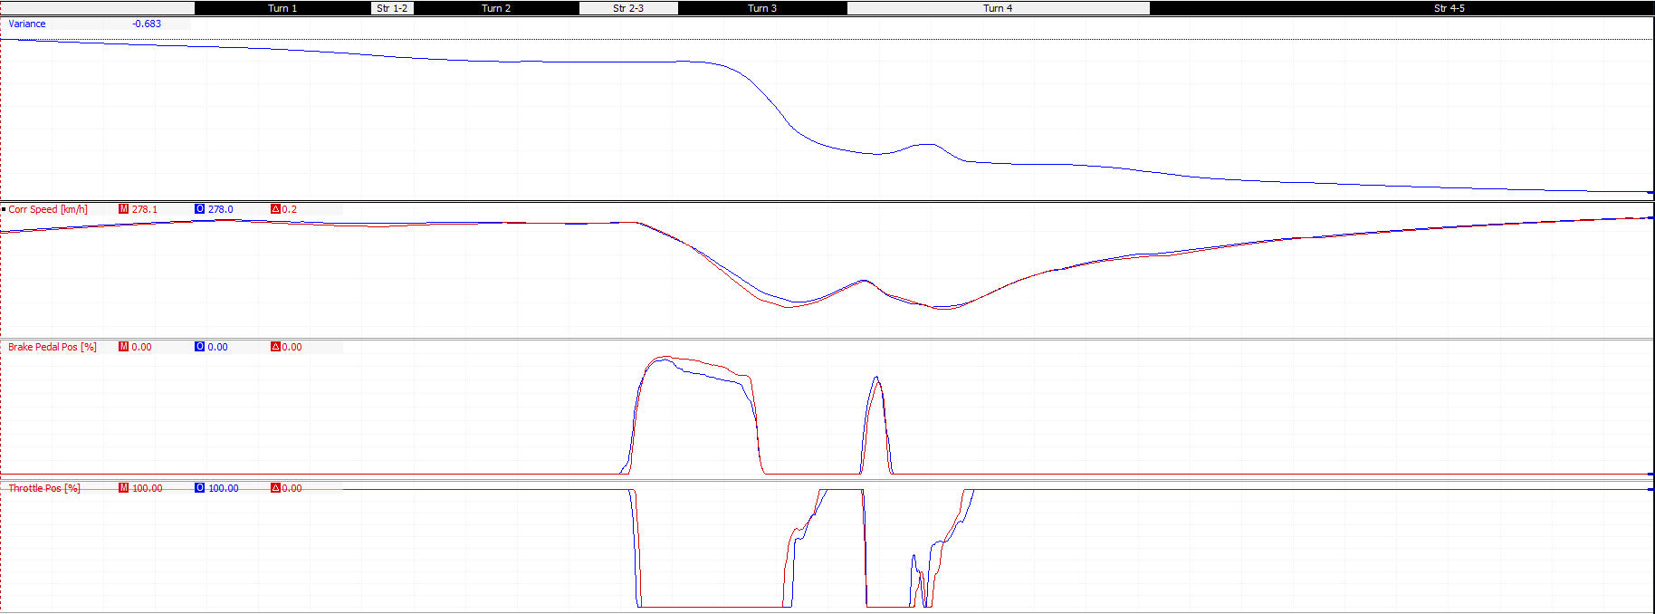
Driver B did manage to set a new fastest 1st sector after the second instruction of session 3. Whilst the brake usage didn’t reach 100% in the first braking phase for village corner, driver b increased brake usage by 10% in the second braking phase for the loop. This enabled driver B to apply the throttle 5 meters earlier and harder through the exit of the loop, this gained driver b an extra 5km/h of exit speed onto the wellington straight, this combined with the being 15km/h quicker through the village corner put driver B 0.6 ahead of his fastest lap by the start of the wellington straight, as shown in figure 45. This set a sector time of 27.282 an improvement of 0.309 seconds.
Figure 46 Driver B Village & the Loop Improvement from Session 3

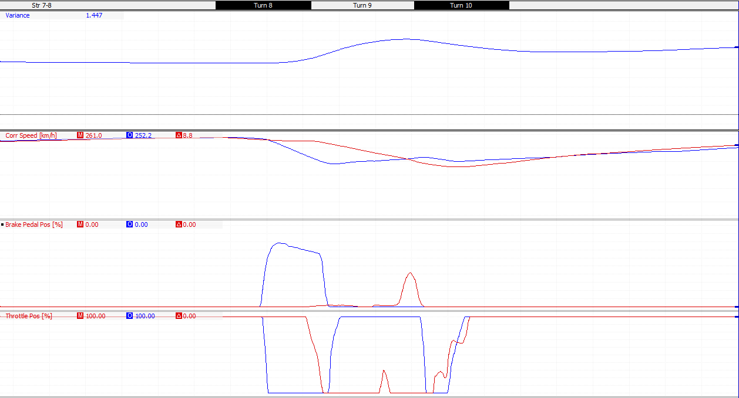
4.83 Driver B Session 3 Instruction 2:
Figure 47 Driver B Session 3 Instruction 2
Driver B’s second instruction was the moving the braking point and the amount of brakes used around the maggotts, Becketts, chapel complex.
Driver B was braking through the entry of maggotts right through to the corner apex, by the exit of maggotts driver B was 75km/h slower than Richard and by the entry of chapel was a further 0.5 seconds behind Richard.
Whilst driver B did gain time back through Becketts because he was able to accelerate through the corner whereas Richard lifted off the throttle, this only gained driver B 0.25 second back. This time was then lost again as driver B had to lift around chapel whereas Richard could accelerate through, this meant driver B was 10km/h slower down the hangar straight and lost 0.15 seconds.
Driver B was instructed to not apply the brakes through both maggotts and Becketts corners and only apply 40% brakes at the entry to chapel corner to aid with cornering and so the throttle can be applied earlier out of the corner.

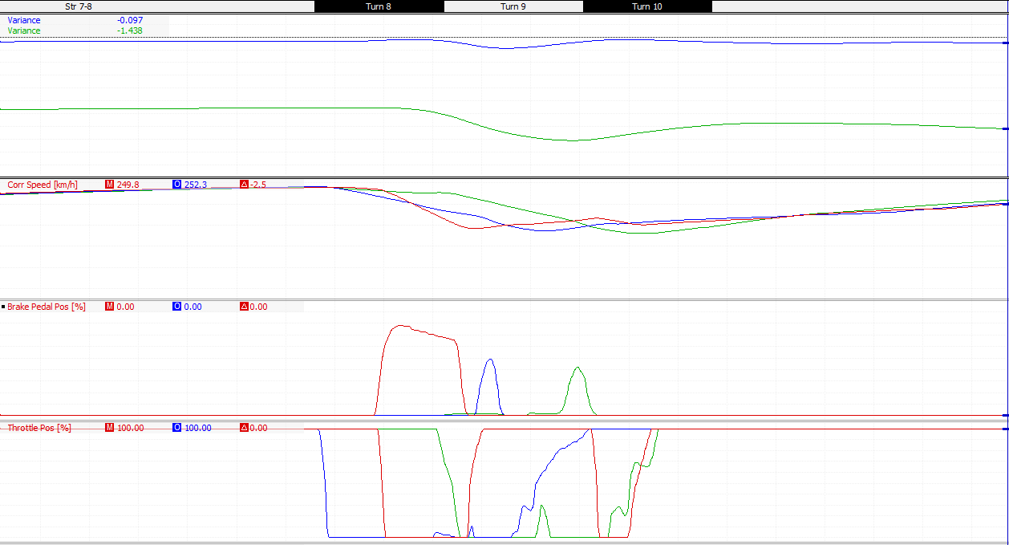
4.84 Driver B Session 3 Instruction 2 Results:
Figure 48 Driver B Session 3 Instruction 2 Results
Driver B followed the instruction applying no brakes through both maggotts and Becketts, whilst the braking for chapel was earlier than Richards, shown as the green trace, driver B was able to apply the throttle at the apex of Becketts and reach 100% throttle by entry to chapel.
Driver B was 31km/h faster through Maggotts than previously by not braking through the corner, and gained 0.175 seconds by the apex of Becketts. Whilst the later braking lost almost all this advantage, because before driver b was flat on the throttle through all of Becketts, where driver b had to previously lift around chapel, now driver B is flat out. This means he is 5km/h faster by the start of the hangar straight and 0.1 seconds ahead of his fastest lap.
This instruction only gained driver B 0.025 seconds over the complex, this may be less because of the braking and more because of driver B’s throttle application through maggotts and Becketts.

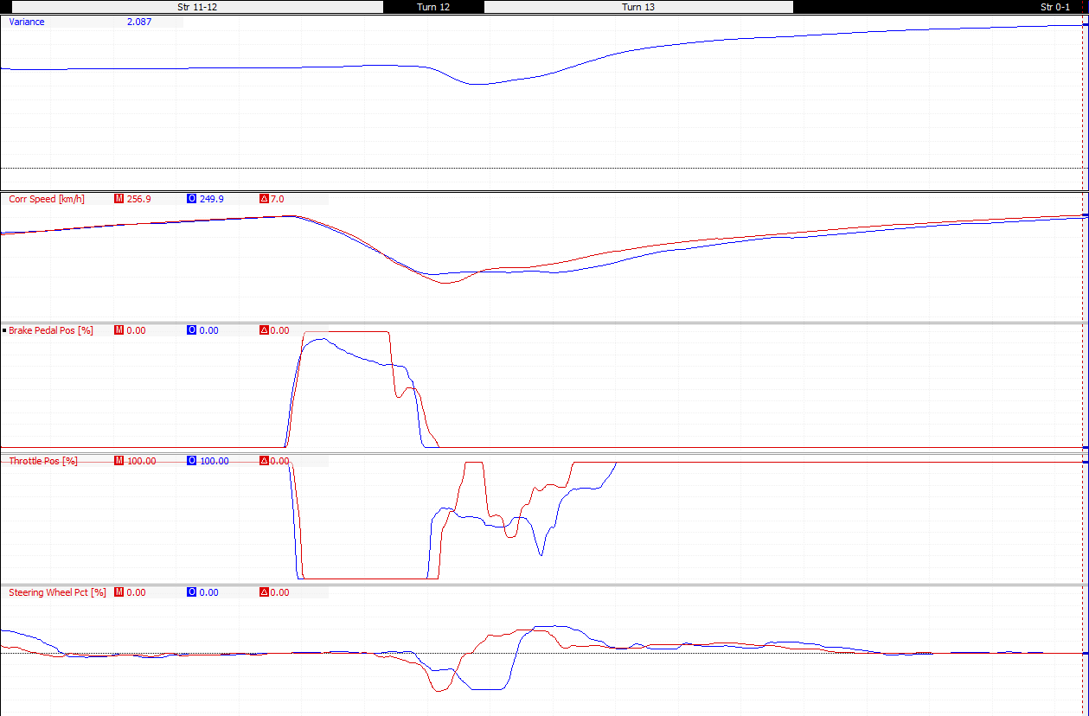
4.85 Driver B Session 3 Instruction 3:
Figure 49 Driver B Session 3 Instruction 3
Driver B’s last instruction for session 3 was to increase brake usage at club corner.
In the braking phase for club corner driver B is using 10% less of the brakes under initial braking, Richard also uses 100% brakes for 65 meters before lifting off whereas driver B stats to lift off after only 30 meters. This causes driver B to be 24km/h quicker into the left hand corner of club, this effects both throttle application and steering.
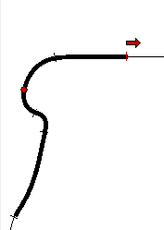
As the steering wheel channel shows driver B has to take a wider line and apply more steering lock into club corner. Driver B is also unable to apply the throttle as early or has hard as Richard as he having to take a wider line through the corner. By the point shown in figure 50 driver B is 30km/h slower than Richard and by the end of the lap is 2.087 seconds behind Richard.
Overall driver B loses 0.6 seconds through club corner and because of the slower speed down the pit straight is already at a disadvantage to Richard at the start of the next lap.
Figure 50 Driver B Session 3 Club Corner Exit

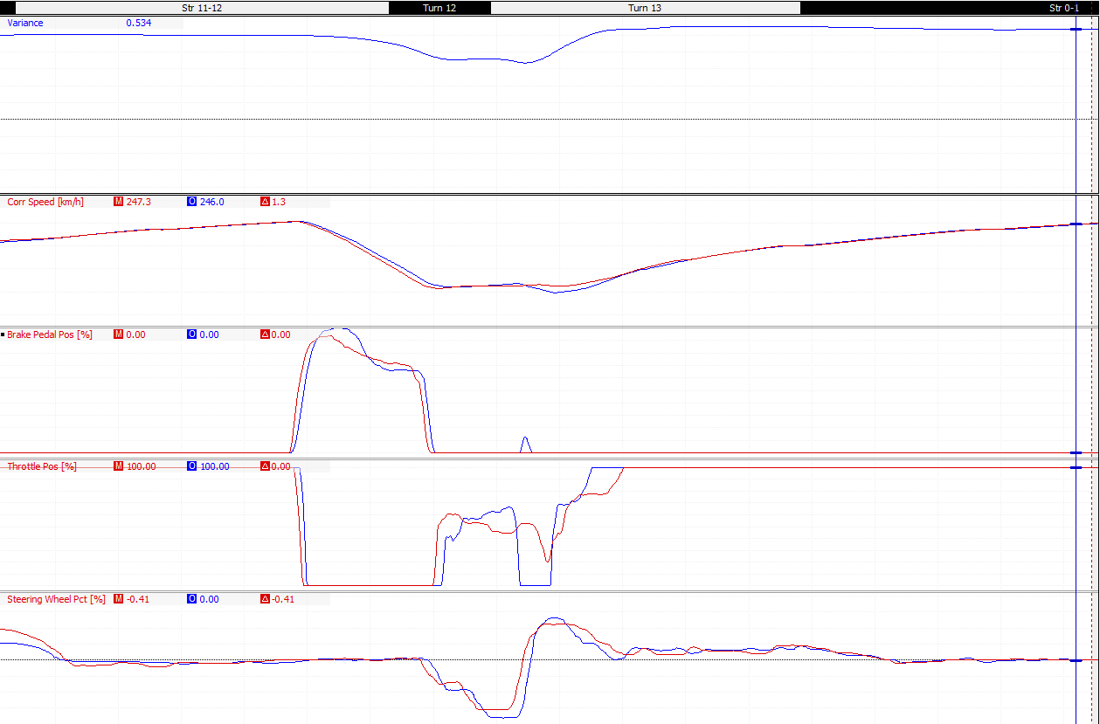
4.86 Driver B Session 3 Instruction 3 Results:

Figure 51 Driver B Session 3 Instruction 3 Result
Figure 51 shows driver B’s fastest lap time against his quickest lap from session 3 instruction 3.
Whilst driver B did use 100% of the brakes in the initial braking phase, the later braking point by 5 meters and the sharper drop off on the brakes, circled on figure 51, meant that driver b was 12km/h faster into club corner than previously. This caused driver B to take an even wider line through both sections of club corner. He also had to lift completely off the throttle so as not to run wide through the right hand corner of club. Driver B lost another 0.1 of a second through club corner.

4.9 Driver B Session 4:

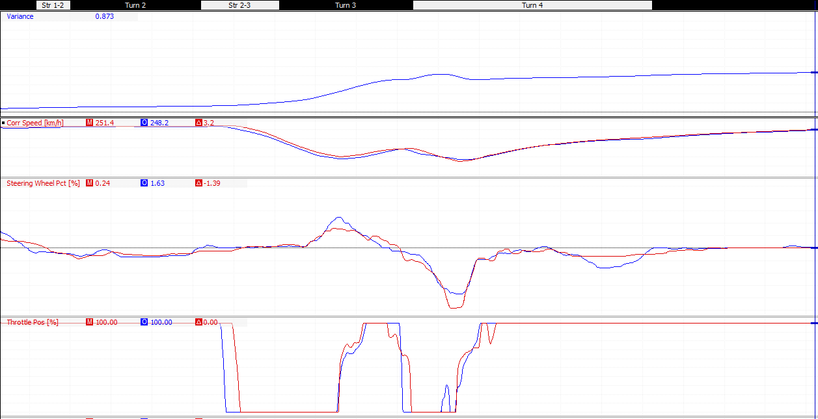
4.91 Driver B Session 4 Instruction 1:
Figure 52 Driver B Session 4 Instruction 1
Driver B’s first instruction for session 4 was looking at the amount of steering lock applied around village and the loop corners.
Driver B was taking a wider line through village, this combined with the earlier braking for the village means driver B is 15km/h slower out of village corner. Driver B then uses 25% less steering lock than Richard for the loop, the wider line of Richard allows him to accelerate quicker, shown in the Long G data trace in figure 53, and gain a speed advantage of 8km/h over driver B by the start of the wellington straight.
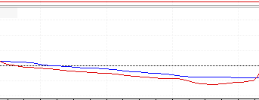
Driver B was instructed to use less steering lock through village to able to carry more speed through the corner, and use a wider line through the loop to aid with acceleration out of the corner onto the wellington straight.
Figure 53 Driver B vs Richard Long G

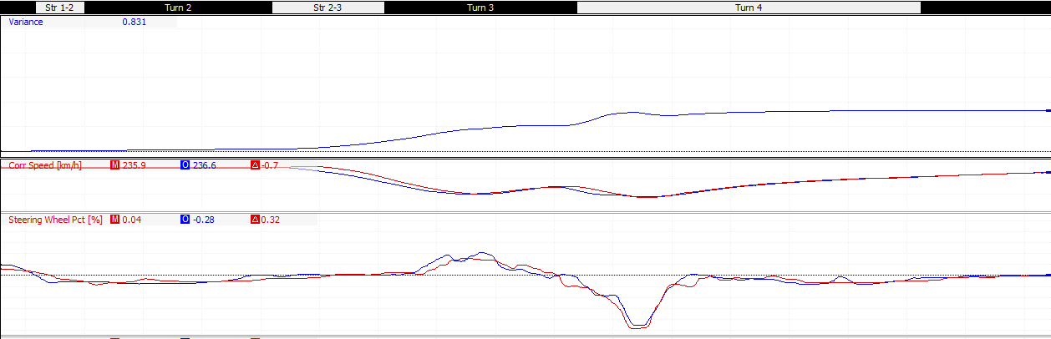
4.92 Driver B Session 4 Instruction 1 Results:
Figure 54 Driver B Session 4 Instruction 1 Results
Driver B matched Richards steering data through both village and the loop corners.
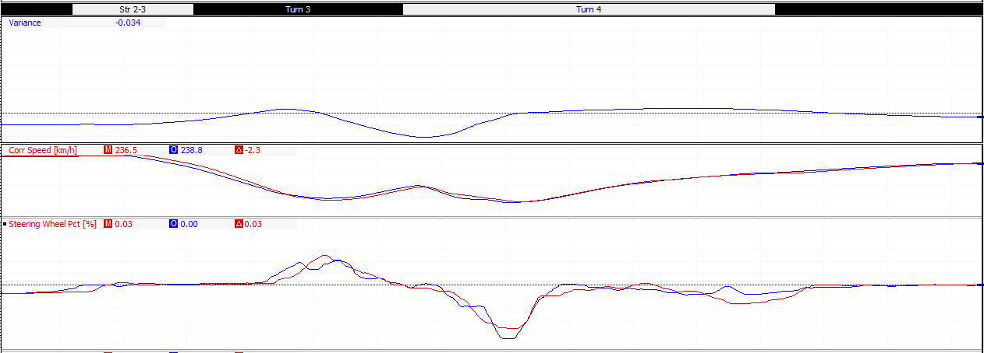
The tighter line taken through village corner increases driver B’s corner speed by 10 km/h this is shown in figure 55 when driver B’s fastest lap is compared against the quickest lap from the session. This puts driver B 0.35 seconds ahead of his fastest lap at the entry of the loop. Driver B uses a wider line through the loop, however this doesn’t have the desired effect and driver B is slower by 3km/h out the loop and loses time, by the start of the wellington straight driver B is now 0.04 seconds behind his fastest lap time.
Figure 55 Driver B Fastest Lap vs Session 4 Quickest Lap

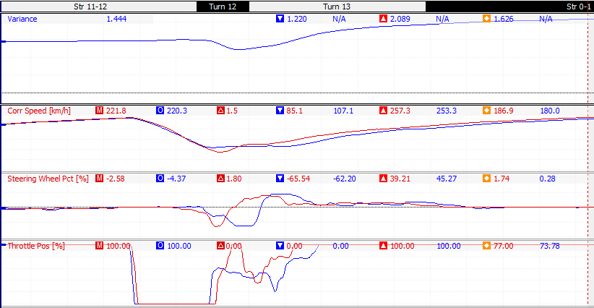
4.93 Driver B Session 4 Instruction 2:
Figure 56 Driver B Session 4 Instruction 2
Driver B’s last instruction for session was the turning point for club corner.
Richard is applying 65% steering lock at the apex of the left-hand corner of club, then applying 37% lock around the right-hand corner of club. This allows him to apply more throttle through both corners and be 20km/h quicker through club and 15km/h quicker down the pit straight.
Driver B’s wider line means no more than 45% throttle is applied until the exit of club, this slower angle through club loses driver B 0.589 seconds by the end of the lap. Driver B was instructed to use a more direct line through club, this should allow him to apply more throttle and increase mid corner and exit speeds.

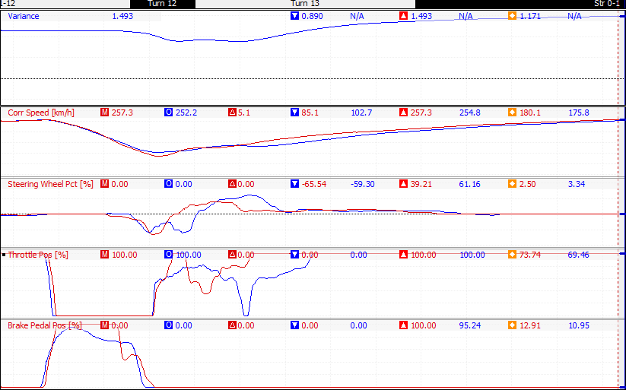
4.94 Driver B Session 4 Instruction 2 Results:
Figure 57 Driver B Session 4 Instruction 2 Results
Driver B started applying steering lock 10 meters earlier than previously, this allowed driver B to start to match Richards data trace, however because driver B didn’t brake as hard as Richard he is travelling 18km/h faster into club. This extra speed causes driver B to understeer, as shown in the circled area, and applies more steering lock later in the corner.
Driver B continues to apply the throttle whilst cornering, this causes more understeer on the exit, this time driver applies more steering lock and lift of the throttle, because of this driver B is 25km/h slower out of club corner.
Driver B still loses less time than before, only losing 0.3 seconds over club, and sets a new fastest lap of 1:38.496. This is quicker by 0.594 seconds.
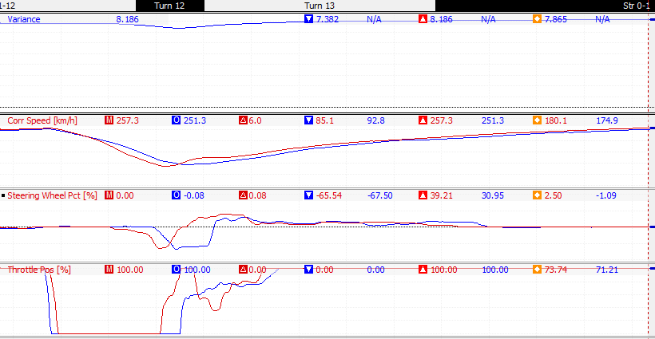
On a different lap driver B also sets a new fastest last sector, the data trace is shown in figure 58. This is achieved by using less steering lock for the right-hand corner and out of club, this means driver B doesn’t have to lift and is therefore only 10km/h slower than Richard out of club. This lap sets a new fastest last sector of 29.662 this is quicker by 0.211 seconds.
Figure 58 Driver B fastest last sector

4.10 Driver B Session 5:

Driver B Session 5 Instruction 1:
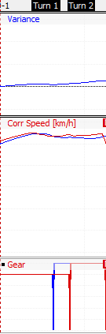
Driver B had the same instruction for abbey as driver A, changing into 6th gear after abbey corner to maintain speed around the corner. Driver B was 0.135 seconds behind and 9km/h slower by the braking phase for village.
As with driver A this instruction was combined with another because of the simplicity of it.

Figure 59 Driver B Session 5 Instruction 1

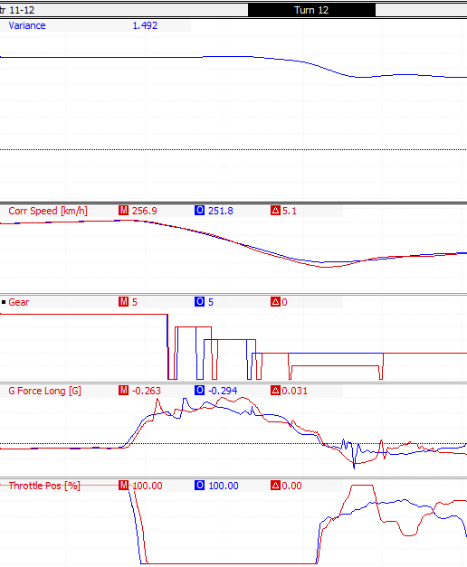
Driver B’s next instruction was changing down to first gear for the left hand corner of club. This lower gear allows Richard to accelerate harder out of the corner through club and have 7km/h higher exit speed when compared to driver B.
Figure 60 Driver B Session 5 Instruction 1

4.101 Driver B Session 5 Instruction 1 Results:

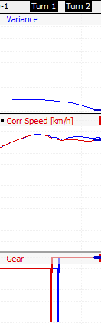
Changing to 6th gear later increased driver B’s speed through abbey from 262km/h up to 269km/h, this 7km/h increase in speed put driver B 0.085 seconds ahead of his fastest lap by the braking phase for village corner.

Figure 61 Driver B Session 5 Instruction 1

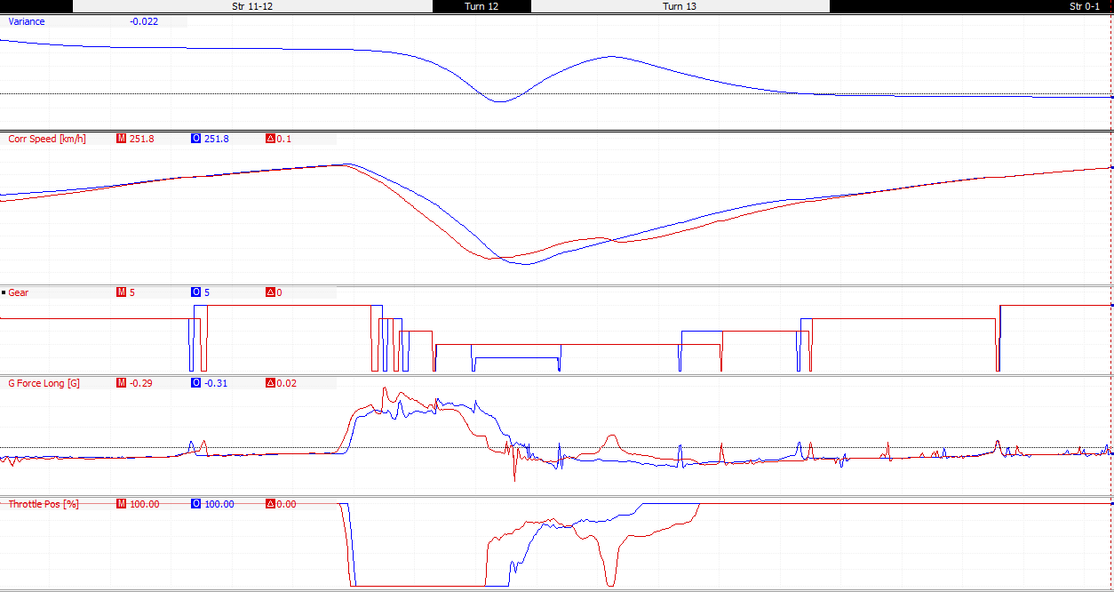
Driver B’s shift down to first gear for club didn’t have the desired effect, unlike Richard who was able to use 100% throttle whilst in first gear, driver B feathered the throttle through club. When asked driver B’s feedback was that he believed if anymore throttle was applied the vehicle would have spun out.
Figure 62 Driver B Session 5 Instruction 1 Results

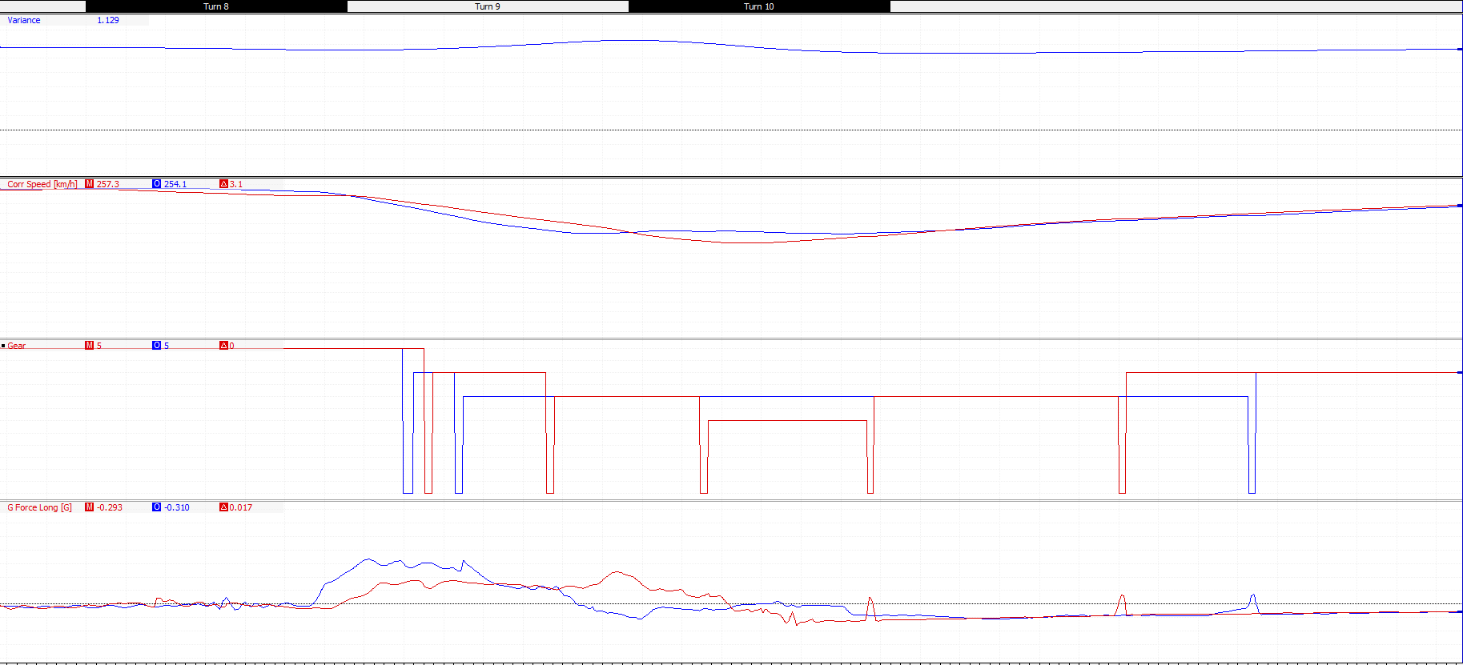
4.102 Driver B Session 5 Instruction 2:
Figure 63 Driver B Session 5 Instruction 2
Driver B’s second instruction was for chapel corner.
Richard changes down to third gear for the exit of chapel, this means he can accelerate harder out of the corner, this is shown by his long G data trace. Whilst Richard is in third gear he is producing 0.5 more G than driver B, this extra acceleration helps Richard regain the speed lost through the exit of Becketts.

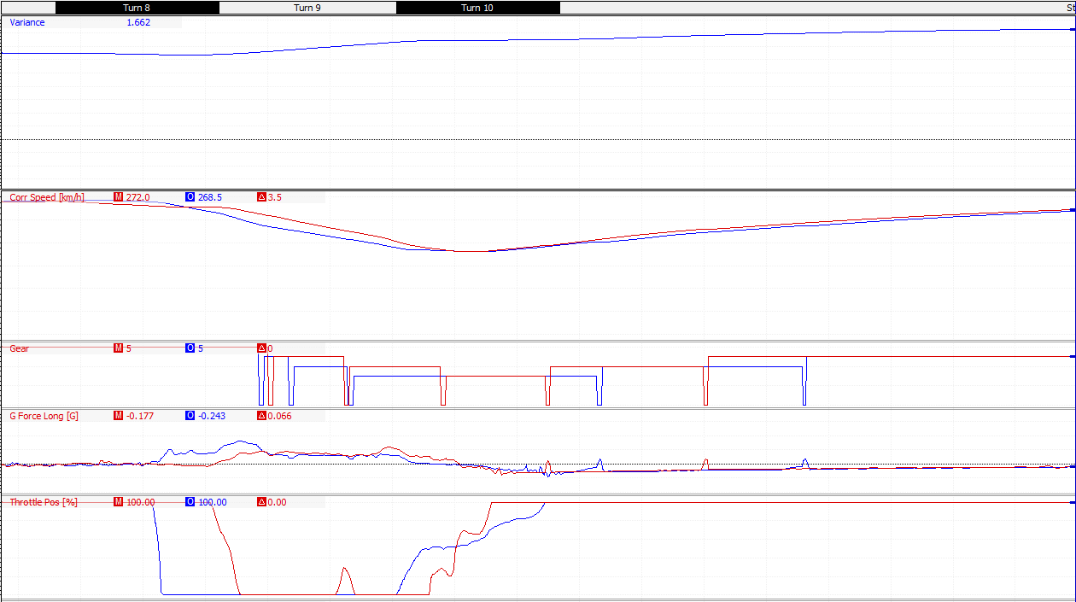
4.103 Driver B Session 5 Instruction 2 Results:
Figure 64 Driver B Session 5 Instruction 2 Results
Driver B changes down to 3rd gear at the entry of Becketts rather than the apex as instructed, this earlier change down increases engine braking because of the lower gear. The increased engine braking causes driver B to be 15km/h slower before the apex of Becketts and has to apply the throttle. Now instead of applying the throttle at the apex of the corner and being able to accelerate harder, driver B now has to feather the throttle through the corner and can’t increase throttle use until the exit of Becketts.
Driver B reaches 100% throttle 40 meters after Richard, this slower acceleration means driver B is 8km/h slower down the hangar straight. In total driver B loses 0.4 seconds through Becketts and chapel.

4.11 Driver A Overall:
The following figures show how drivers A & B improved over each session with trendlines to show both driver consistency for the session and whether any improvements in lap times were gradual or one quick lap, finally the orange data point to mark slow lap times due to a mistake on track.

Figure 65 Driver A Session 2 Lap Times

Figure 66 Driver A Session 3 Lap Times

Figure 67 Driver A Session 4 Lap Times

Figure 68 Driver A Session 5 Lap Times

4.12 Driver B Overall:

Figure 69 Driver B Session 2 Lap Times
Figure 70 Driver B Session 3 Lap Times

Figure 71 Driver B Session 5 Lap Times
Figure 72 Driver B Session 4 Lap Times

5.0 Setup Optimization:
Using the lap times gathered from the multi-categorical test, the different setups are sorted into two categories, setups that produce faster lap times than the standard setup and setups that produce slower lap times. From this filter five setups remain, runs; 13,14,19,22 and 26, these setups are then compared looking for correlations.
Run Number | Roll Stiffness Distribution (%) | Camber (°) | Toe Angle (°) | Fastest Lap Time
13 | 66 | -4.5 | 2 | 1:40.98
14 | 44 | -4.5 | 0 | 1:40.381
19 | 81 | -4.5 | -2 | 1:39.734
22 | 44 | -4.5 | -2 | 1:39.443
26 | 66 | -4.5 | -2 | 1:39.206
Table 1 Setup Sheet

5.1 Camber:
The clear correlation between all the laps is the camber angle with all the fastest setups running with maximum negative camber, this was expected as the standard setups runs with -2.7° camber.
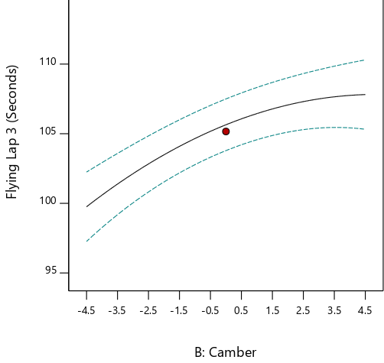
Figure 73 shows how altering the camber from maximum to minimum alters the predicted lap time. With the toe set at -2° and the roll stiffness distribution at 66% the graph suggests the more negative camber applied the faster the vehicle will be over the course of a lap.
As documented earlier in the research section, negative increases performance by using the lateral forces applied when cornering to create the biggest contact patch and therefore the most grip and speed.
Figure 73 Camber Results Graph
This performance benefit is demonstrated in figure 74, showing how the G forces both laterally and longitudinally for runs: 5, 16 and 26. These runs were selected as all three had roll stiffness distribution set at 66% and toe angle at -2°, run 5 had 0° camber, shown as the green trace, run 16 had +4.5° camber, shown as the blue data trace, and run 26 had -4.5°, shown as the red trace.
The graph shows cornering power of both setups, this is known as the traction circle, (Segers, 2014), by plotting the Lat G vs Long G the differences of total grip created by both setups can be compared. The wider the traction circle created the more of the available grip the driver is using (vrperfdev, 2016), the change in camber changes the amount of available grip and therefore the amount of lateral G’s created when cornering.
The blue and red cursors on figure 74 shown the lateral G being created at the apex of copse corner by both setups. This corner was chosen as it’s a fast, flat out corner that generates a lot of lateral G. The cursors show that run 26 is producing -4G, Run 5 is producing -3.27G and run 16 is producing -3.15G.

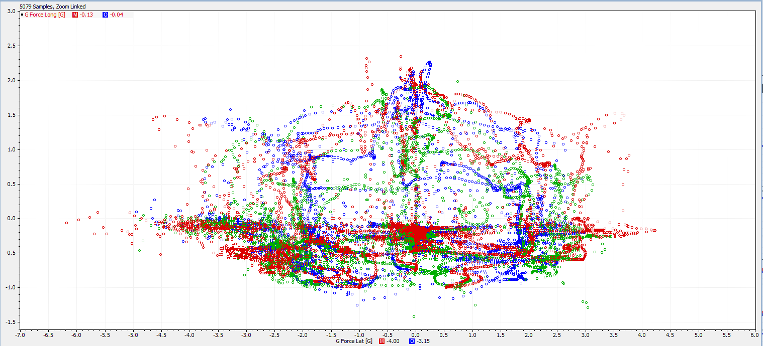
Figure 74 Lat G vs Long G Scatter Graph
The driver commented that the lack of cornering grip leads to increased amount of understeer when cornering in runs 5 and 16, this is backed up by the understeer channel shown in figure 75. All three setups understeer naturally because of the setup of the roll stiffness distribution, but as figure 74 shows the increase in camber creates more understeer which leads to lack of Lat G force shown in figure 74. Around copse corner run 26, red trace, is creating 25% less understeer, because of this the driver is able to carry more speed through the corner and on the exit of copse is 8 km/h faster than the other setups.
The lower increased understeer and lower Lat G force levels also affect the throttle application of the driver, this is shown in figure 75 where run 26 is shown to use 100% throttle application over the course of a lap more than runs 5&16. The highest Lat G created and lower amounts of understeer also mean run 26 spends the least amount of time completely off the throttle.
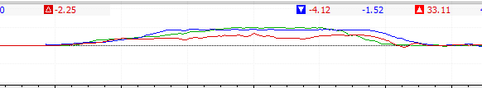
Figure 76 shows the driver through the Maggotts, Becketts, chapel complex. The throttle trace shows how that because of the run 26’s negative camber setup, the driver is able to apply the throttle earlier out of all three corners and has significantly more speed through the complex. This is most apparent at chapel corner where the driver is able to apply the throttle 20 meters earlier than the green trace, 0° camber, and 55 meters earlier than the blue trace, +4.5° camber. This meant by the apex of the corner run 26 was 19km/h faster than run 5 and 55km/h faster than run 16.
Figure 75 Copse Corner Understeer Channel
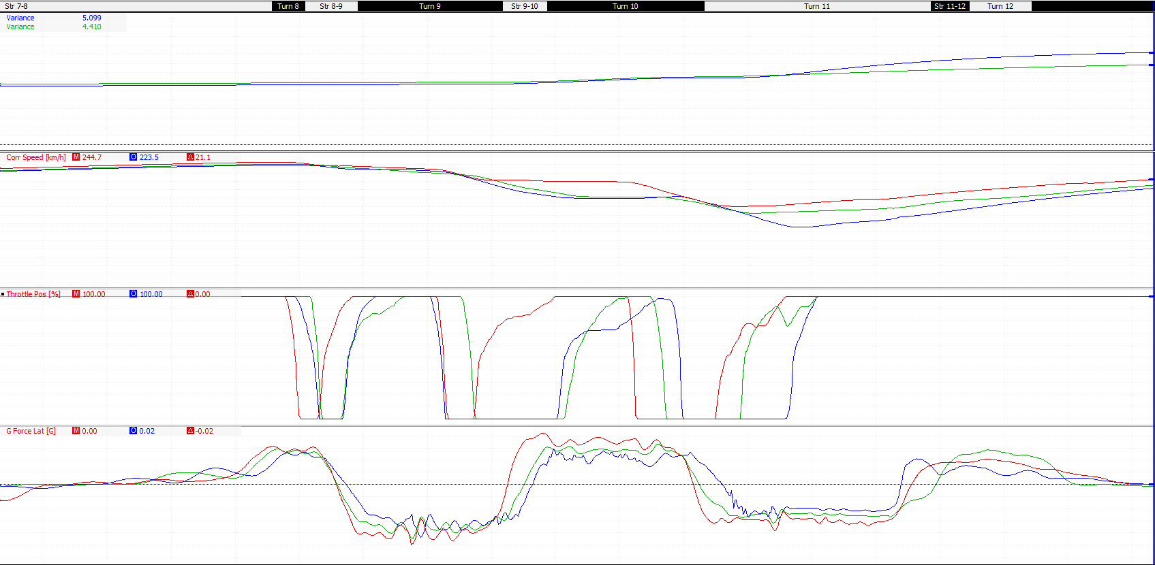
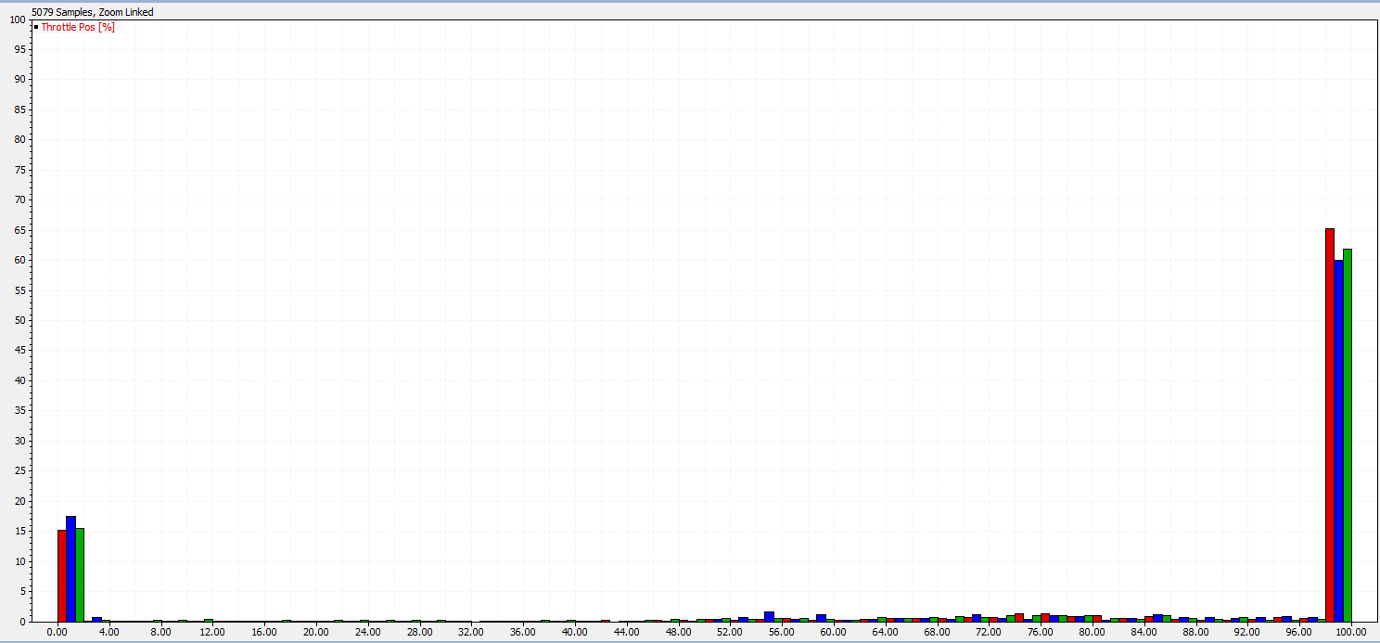
The negative camber also has slight straight line speed benefits. When -4.5° camber, run 26, is compared against 0° camber, run 16, the negative camber setup accelerates between 0.1 and 0.2 ${m/s}^{2}$ faster through the gears, however when run 26 is in 6th gear and travelling above 290km/h the speed difference between the two setups, which is 4.1km/h when run 26 is at 290km/h, starts to close, by the end of the straight both setups are travelling the same speed. As shown in figure 79.
Figure 76 Maggotts, Becketts, Chapel Complex
Figure 77 Throttle Histogram
As previously mentioned in the research section large amounts of camber negatively affect straight line speed due to lack of grip and increased drag, because the speed difference becomes smaller at higher speeds this would suggest drag as the reason rather than lack of grip as that would more likely present under initial acceleration.
When -4.5° camber, run 26, is compared against +4.5° camber, run 5, the lack of grip the positive camber has is more apparent. There are two main differences in the data between the two runs, firstly through the gears run 5 accelerates between 0.2 and 0.25${m/s}^{2}$quicker, secondly run 16 never reaches the maximum top speed of the Gp2 car of 307km/h, by the end of the straight run 16 is at a speed of 303.2km/h whereas run 26 achieved top speed 1190 meters earlier. As shown in figure 78.

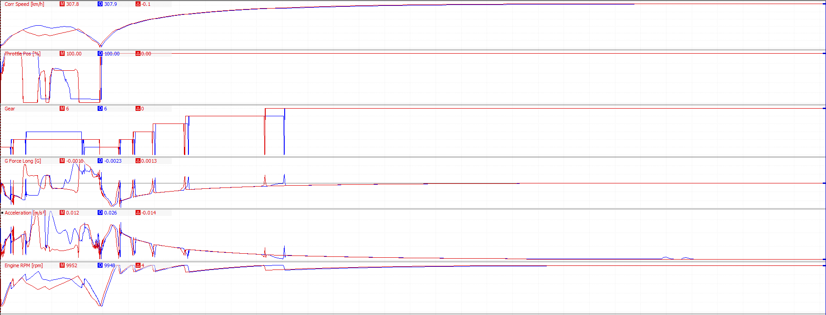
Figure 78 Run 5 vs Run 26 Straight Line Test

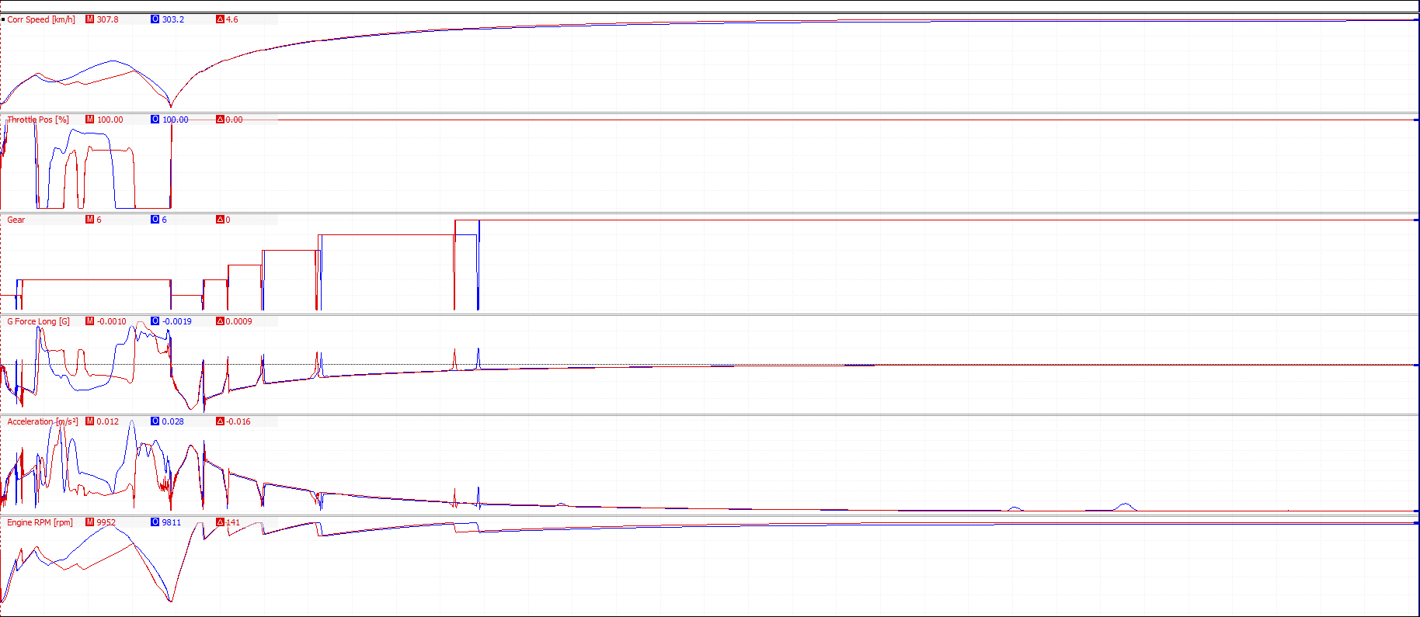
Figure 79 Run 16 vs Run 26 Straight Line Test

5.2 Toe Angle:
The second biggest factor is toe angle, with the three fastest setups all using -2° toe.
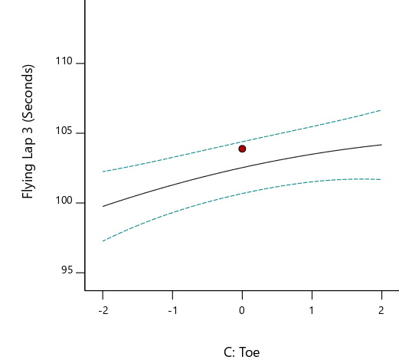
As shown by the graph in figure 80 the GP2 cars performance is enhanced when toeing out. As with camber, toeing out provided the vehicle with greater performance when cornering.
Figure 80 Toe Results Graph
The performance benefit that toe angle provides is smaller when compared camber, the range between faster and slowest lap when comparing toe angles is only 2.2 seconds, compared with camber which had a range of 6.8 seconds.

The following three setups compared all have roll stiffness distribution set at 66% and camber at -4.5°, the red trace, run 1, has a toe angle of 0°, the blue trace, run 13, has a toe angle of +2°, and the green trace, run 26, has a toe angle of -2°.
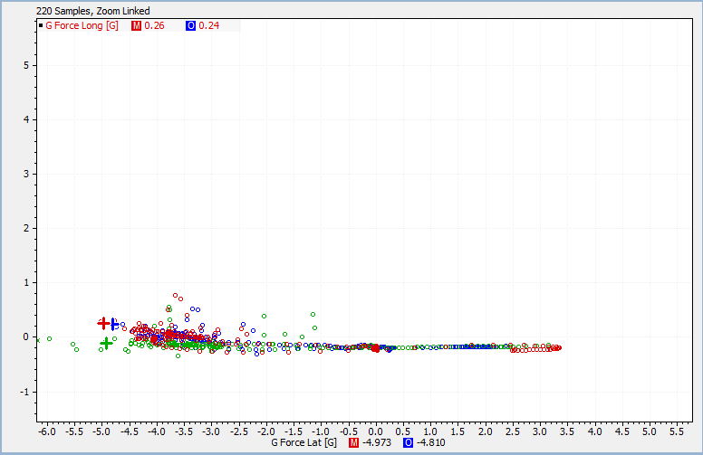
Figure 81 is the G force graph for the three setups around abbey corner. Whilst all three setups produce nearly same amount of lateral G, all within 0.2 of each other, runs 1&13 produce more positive longitudinal G. This means these setups are slowing further down than run 26.
Figure 81 Abbey Corner G Force Graph

This drop in speed around abbey is due to the understeer being created, this shown in figures 82 as the steering trace for the different setups around copse corner. The setup with -2° toe angle is able to corner with much less steering angle, this was expected, however the setup with +2° toe angle is able to corner using less angle than the setup with 0° toe angle. This is unexpected at the research suggests that the more the vehicle is toeing in the worse it should be at cornering.
Figure 82 Runs 1, 13, 16 Abbey Corner Steering Trace
Run 1, red trace, also produced slower lap times than both run 13&26, this was also unexpected as the standard setup for the GP2 car is -0.05° toe out, so a setup with 0° camber is the closest to this standard setup and was expected to produce faster times than the +2° toe in setup.

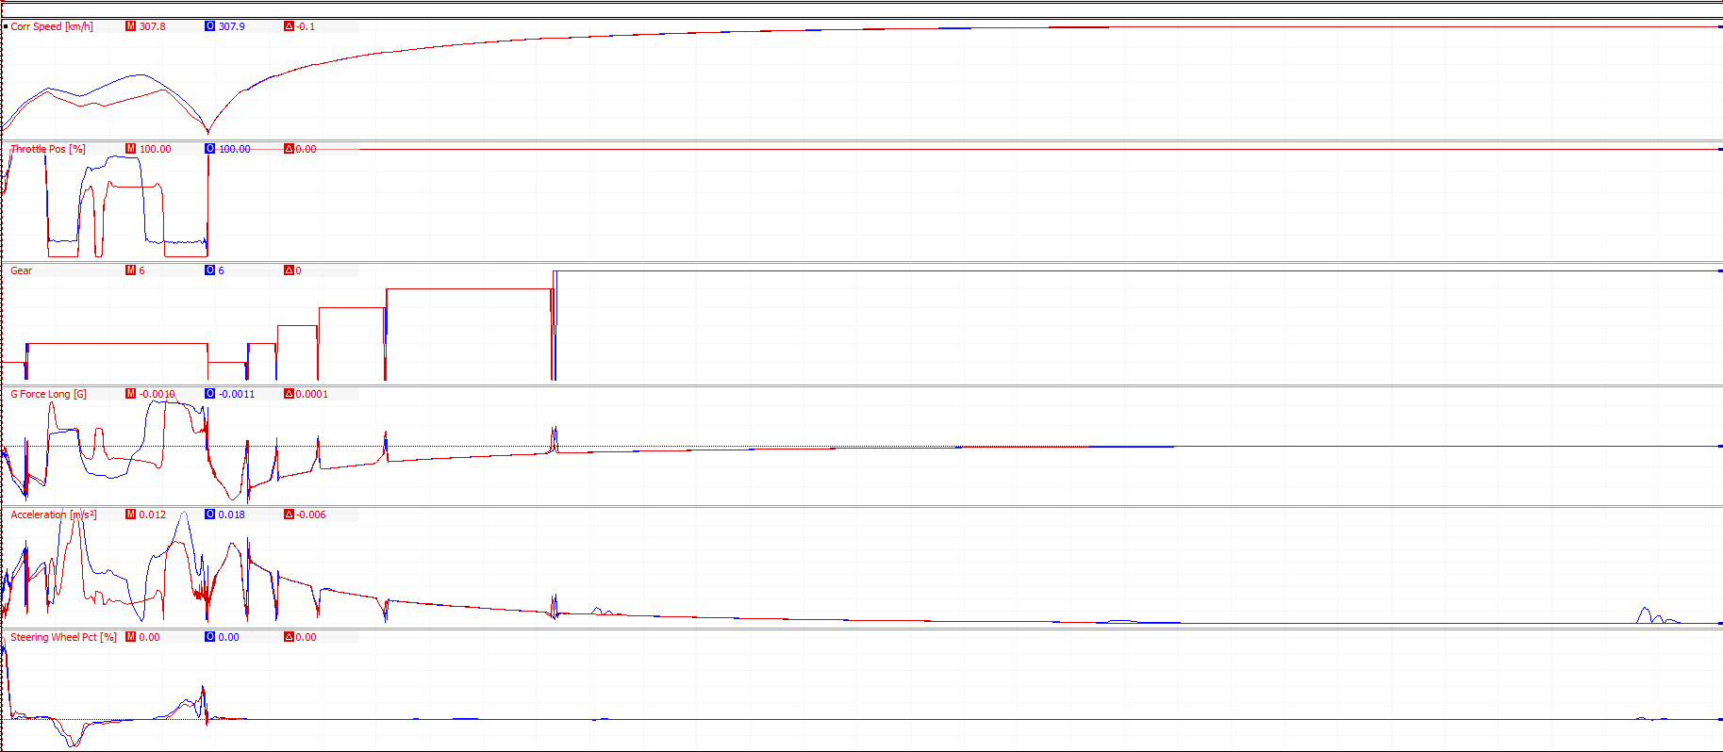
The straight line speed test shows no difference between 0° and -2° toe angle, figure 83, both setups accelerate at the same rate and both reach the GP2 car’s top speed at the same point. This was also an unexpected results as the research suggests a vehicle toeing out should be slower in a straight line test.
Figure 83 Run 1 vs 26 Straight Line Test

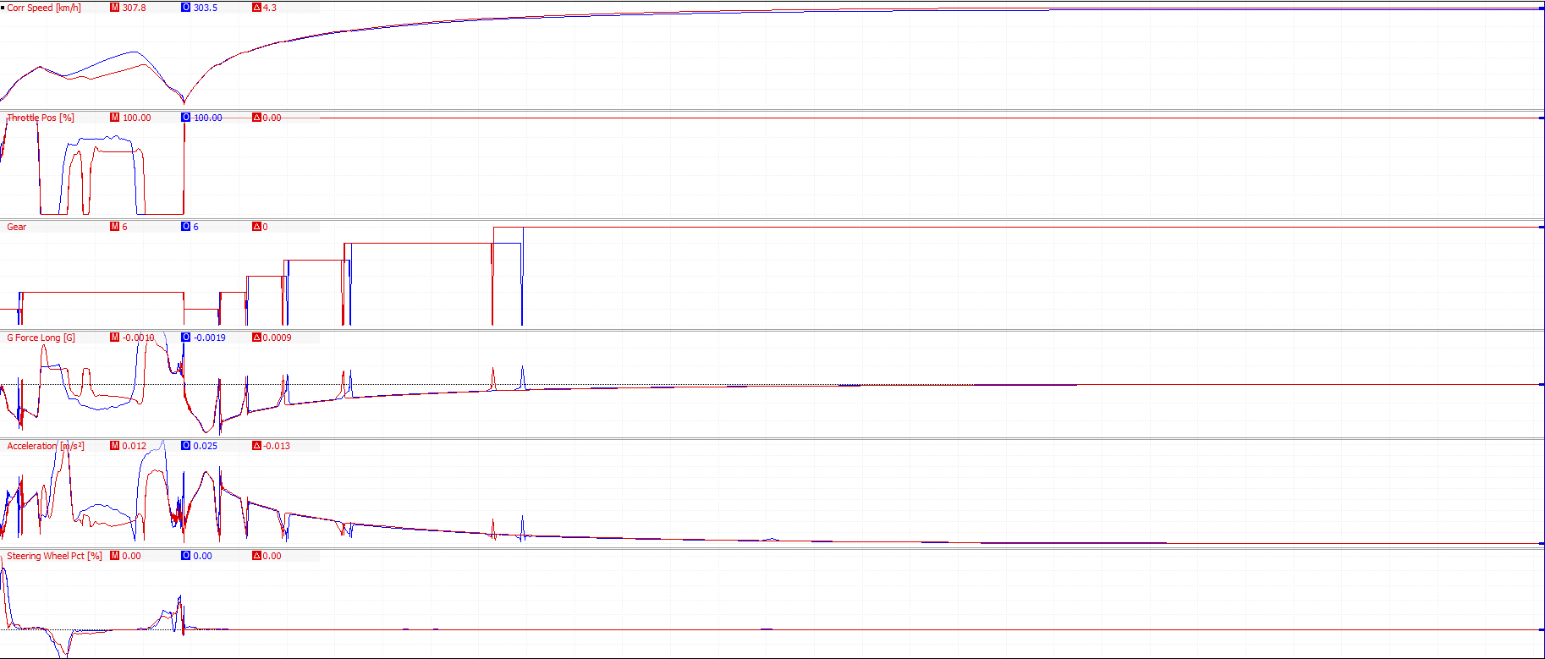
The research suggests that toeing in should be faster in straight line than toeing out, this however is not what the results show. Through the gears run 26 accelerates between 0.2-03${m/s}^{2}$faster, and achieves the GP2 car’s top speed. Run 13 should be faster, but fails to even reach the GP2 car’s top speed and by the end of the run is 4.3km/h slower than run 26.
Figure 84 Run 13 vs 26 Straight Line Test

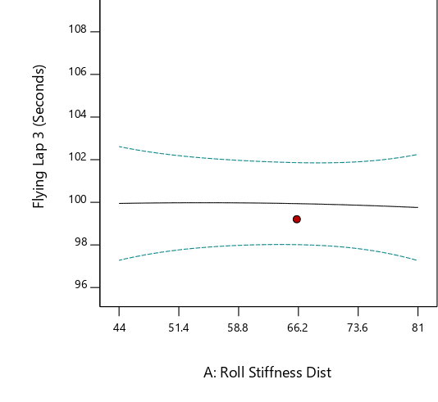
5.3 Roll Stiffness Distribution:
Figure 85 Roll Stiffness Distribution Results Graph
The graph shown in figure 85 indicates that the GP2 car performs marginally better with a roll stiffness distributed towards the front of the vehicle, with camber set at -4.5° and toe set at -2°,.
The performance benefit that a change in roll stiffness distribution provides is the smallest when compared against camber and toe angle. The range between faster and slowest lap when comparing roll stiffness distributions is only 0.5 seconds, compared with camber which had a range of 6.8 seconds and toe which had a range of 2.2 seconds.

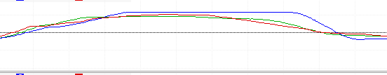
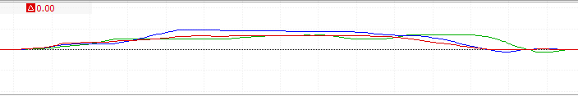
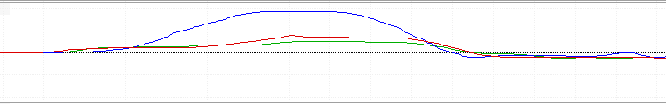
Changing the roll stiffness distribution mainly effects the levels of under/oversteer the driver will experience, the further forward the distribution is the less the vehicle should oversteer but will increase understeer and vice versa. However the results show that moving the roll stiffness towards the rear made the vehicle understeer in fast corners such as abbey, copse and chapel, as shown in figures 87, 88 & 89 respectively. The blue trace has the roll stiffness distribution set at 44%, this should have caused oversteer due to a softer front end, however in the fast corners the driver is having to apply more steering lock suggesting understeer.
Figure 86 Chapel Corner Steering Trace
Figure 87 Abbey Corner Steering Trace
Figure 88 Copse Corner Steering Trace
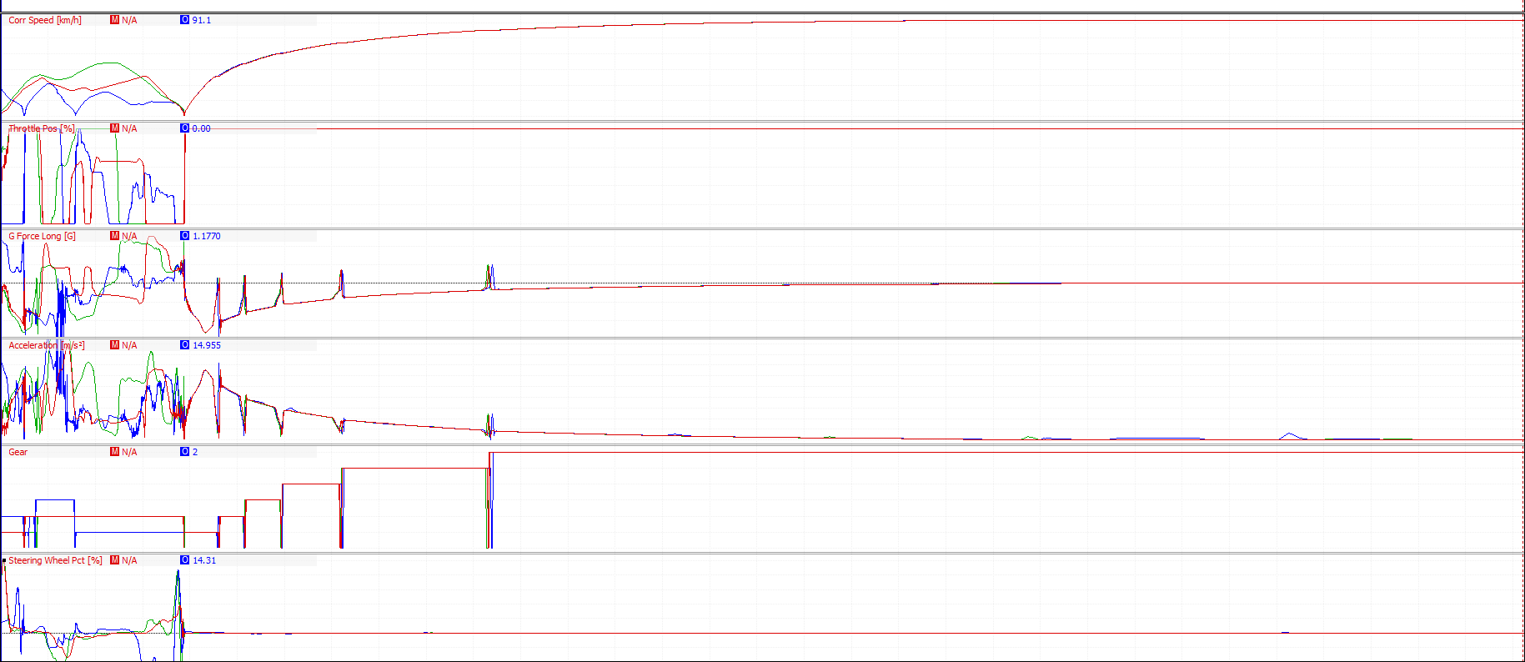
As expected the change in roll stiffness distribution has no effect on the straight line performance of the vehicle, all three setups accelerate within 0.1${m/s}^{2}$ of each other and all reach the Gp2 cars top speed.
Figure 89 Run 19, 22, 26 Straight line Test

5.4 Optimization:
The Box Behnken design uses the data provided to suggest optimal setups and predict lap times for these setups, from these suggestions the fastest three were implemented to test the accuracy of the suggestions and to start to fine tune the setup.

Run | Roll Stiffness Distribution (%) | Camber (°) | Toe (°) | Predicted Fastest Lap | Actual Fastest Lap
1 | 73 | -4.5 | -2 | 1:39.701 | 1:39.420
2 | 72 | -4.5 | -2 | 1:39.709 | 1:40.812
3 | 75 | -4.5 | -2 | 1:39.710 | 1:38.851
Table 2 Optimization Runs Setup Sheet
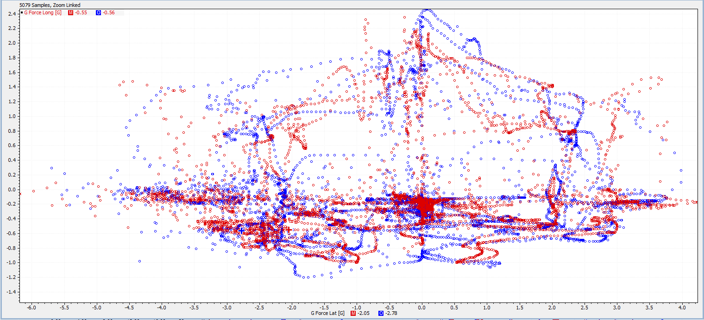
Whilst run 1&3 performed better than their predicted lap times, only run 3 produced a faster lap time than the fastest from the original setups.
Figure 90 Run 26 vs Optimization Run 3 G Force Graph
This improved performance is, in part, due to the setups ability to produce higher amounts G force both lateral and longitudinal, shown as the blue trace in figure 90. This increased amount of G force created means that the setup is braking & accelerating harder, and the wider general trend of the traction circle means that the setups is using more of the available grip.
An example of this is figure 91, this shows both setups G force around copse corner. The optimized setup is producing 1.64 more G at the apex of the corner and is traveling, because of this extra grip the driver is able to corner 12km/h faster. This extra speed gained through copse gains the driver a 0.3 seconds advantage by the entry of Maggotts.

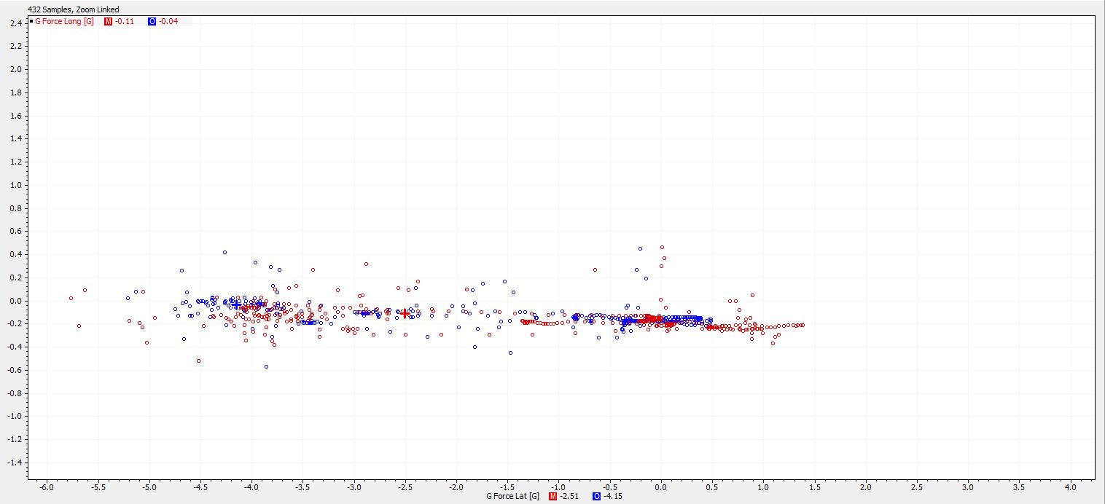
Figure 91 Run 26 vs Optimization Run 3 G Force Graph Copse Corner
Overall the optimization confirms the earlier statements made, that the GP2 car performs better when the roll stiffness is distributed further forward on the vehicle and is faster with the camber set at -4.5° camber and -2° toe angle. The increased G force able to be produced, in place of straight line speed confirms that for the Silverstone GP track cornering speed is a bigger factor for quick lap time than straight line speed.

6.0 Conclusions

6.1 Driver Improvement Investigation:
Overall driver A improved his fastest lap by 2.773 seconds over the 4 sessions, and improved in all three sectors. Driver A improved his first sector by 0.726 seconds, second sector by 0.144 seconds and third sector by 0.382. With these three fastest sectors driver A fastest theoretical fastest lap is 1:36.387, this is only 0.315 seconds quicker than driver A’s actual fastest lap.
Overall driver B improved by 2.171 seconds over the 4 sessions, improving in all three sectors. Driver B improved by 0.568 seconds in the first sector, 0.789 seconds in the second sector and finally 0.764 seconds in the final sector. Using driver B’s fastest sectors a theoretical fastest lap of 1:38.394 seconds is possible, this is only 0.08 seconds quicker than driver B’s actual fastest lap.
For both drivers session the throttle pedal KPI session created the biggest lap time improvement with driver A improving their fastest lap by 1.401 seconds and driver B improving by 1.555 seconds.
This is a finding also observed in other driver improvement experiments, such ‘Training Test Drivers with Data Acquisition’ by Wm. C .Mitchell et al and ‘Focused Novice Driver Program – Assessment Results and Discussion’ by John Wagner et al, who both observed that drivers almost always improve significantly in their second session as they have become familiar with both the car and the track and now feel comfortable enough to push the vehicle closer to its and the tracks limits and improve their performance. (Wm. C. Mitchell, 2000), (John Wagner, 2013).
The way in which the drivers had their data presented was different and this could have been a factor in their difference in performance over the 4 KPI sessions.
Driver A was presented the data using Motec data traces, as seen earlier in the analysis section, and a discussion was held with the driver about how to implement these instructions and whether they needed to be changed at all based off feedback from the driver.
Whereas because driver B is myself, there is no discussion about the instructions and how or if they should be changed slightly, because I was both engineer and driver it also meant that the entirety of the data was analysed to create the instructions whereas driver A was only shown the small sections of data that related to his instructions and therefore had no other knowledge about the rest of his lap.
This lack of second party input could be a contributing factor as to why driver B only have significant improvements in two of the four KPI session as there was no other person double checking and having an input on the effectiveness of the instructions.

6.2 Setup Optimization:
From the results from both toe and camber angle the results indicate that around Silverstone the GP2 car can sacrifice straight line for improved cornering performance. This backed up by the lap times collected where the top 9 fastest laps recorded had the camber set at -4.5° and the top two fastest laps used -2° toe out, these were also the only two setups to post a time below 1:40.
The lap times suggest that the GP2 car performs best when setup with a slightly further forward roll stiffness distribution, this, in theory, leads to vehicle that tends to understeer more through the corners. However this could have just been driver preference, ideally this experiment would have been repeated with multiple times with multiple drivers of varying skill level and preferences. Because this is not the case, the conclusion is made that the GP2 car performs better when setup to understeer but more data is needed to validate this statement.
However, it’s important to consider that the results shown are simulated data that doesn’t include factors such as, tyre temperature and tyre wear that can be caused by excess camber, toe or roll stiffness distribution. Because the simulation doesn’t account for these factors over the course of several laps it doesn’t simulate problems that could arise such as temperature related issue like punctures or reduced levels of grip. This means it’s difficult to state whether using the extremes of any of the three factors would be beneficial over the course of a full distance race.

7.0 Evaluation
The driver improvement investigation was originally completed using three drivers with different levels of experience and skill levels who were compared against each other rather than one baseline set of data. This would have provided the experiment with a greater range of results and other factors to compare such as drivers with a racing licence against drivers without, fast simulator drivers against fast real world drivers, and which driver’s data is best to improve a slower driver; a fast real world racing driver or a fast simulator driver.
However the data collected for these three drivers became corrupted and unrecoverable, this resulted in the experiment being repeated at the last minute using two drivers instead of three and myself as one of the drivers. This presented problems as mentioned in the conclusion about unable to check instructions and having to analyse all the data rather than just viewing the sections of data used for instructions.
The use of different drivers means that the experiment was completed in 4 days rather than 6 weeks, this was done by having both drivers completer sessions on the same day and having drivers perform multiple sessions on each day. This could have increased levels of driver fatigue which would be major factor in performance, this was avoided as best as possible by spacing the session out between the morning and the afternoon, but it was still asking the drivers to perform up to 80 laps in one day.
Time is also the factor behind why the setup optimization test were only repeated once, ideally they would have been repeated at least three times to gain an average and with multiple drivers so account for different driver styles.

8.0 References
Anderson, B., 2016. Lewis Hamilton: Formula 1 simulators no better than computer games. [Online]
Available at: https://www.autosport.com/f1/news/124814/hamilton-simulators-no-better-than-games
[Accessed 16 Novemeber 2017].
Andy Field, G. H., 2003. How to Design and Report Experiments. London: SAGE Publications.
Anon., 2014. Testing ban carries stiff penalty. [Online]
[Accessed 16 November 2017].
Anon., 2018. Design of Experiments: Science, Industrial DOE. [Online]
Available at: http://www.statsoft.com/Textbook/Experimental-Design#index
Anon., n.d. Formula 1, Testing. [Online]
[Accessed 16 November 2017].
Anon., n.d. http://constructingexcellence.org.uk/kpis-and-benchmarking/. [Online].
Antony, J., 2014. Design of Experiments for Engineers and Scientists. London: Elsevier Ltd.
Bentley, R., 2011. Ultimate Speed Secrets: The Complete Guide to High-Performance and Race Driving. s.l.:s.n.
DrRacing, 2014. How close is close enough?. [Online]
Available at: https://drracing.wordpress.com/2014/01/03/how-close-is-close-enough/
[Accessed 16 November 2017].
Emerson, R. W., 2013. Optimization Methods: From Theory to Design. Berlin: Springer-Verlag Berlin Heidelberg.
F1, 2017. 2017 British Grand Prix | Virtual Circuit Guide. [Online]
[Accessed 15 novemeber 2017].
Fagnan, R., 2015. Inside story: How Red Bull's F1 simulator really works. [Online]
Available at: https://www.motorsport.com/f1/news/inside-story-how-red-bull-s-f1-simulator-really-works/
[Accessed 16 November 2017].
How F1 Teams Test Today with Felipe Massa. 2015. [Film] Directed by SAFEisFAST.com. s.l.: s.n.
iRacing, n.d. Testimonials. [Online]
Available at: http://www.iracing.com/testimonials/
[Accessed 16 November 2017].
John Wagner, L. C. K. A. P. P. K. R., 2013. Focused Novice Driver Program - Assessment Results and Discussion, Clemson : Clemson University .
Kathleen M. Carley, N. Y. K. J. R., 2004. Response Surface Methodology, Pittsburgh: Carnegie Mellon University.
Linda M. Collins, J. J. D. R. L., 2009. Design of Experiments with Multiple Independent Variables: A Resource Management Perspective on Complete and Reduced Factorial Designs. [Online]
Available at: https://www.ncbi.nlm.nih.gov/pmc/articles/PMC2796056/
Lock, D., 2001. Benchmarking. International Journal of Project Management , pp. 253-254.
Magnusson, K., 2015. Understanding Statistical Power and Significance Testing. [Online]
Available at: http://rpsychologist.com/d3/NHST/
Martin, 2011. Digital reality: F1 simulators revealed. [Online]
Available at: http://www.racecar-engineering.com/articles/f1/digital-reality-f1-simulators-revealed/
Mayer, J. I., 2002. Coaching Tools for High Performance Driving , s.l.: MIT.
Motulsky, H., 2009. What is the difference between ordinal, interval and ratio variables? Why should I care?. [Online]
Available at: https://www.graphpad.com/support/faq/what-is-the-difference-between-ordinal-interval-and-ratio-variables-why-should-i-care/
NIST/SEMATECH, 2012. Full factorial designs. [Online]
Available at: https://www.itl.nist.gov/div898/handbook/index.htm
Sakamoto, K., 2014. How Top-Tier Racing Teams Use Simulators To Ensure Success. [Online]
Available at: https://www.carthrottle.com/post/how-toptier-racing-teams-use-simulators-to-ensure-success/
[Accessed 16 November 2017].
Sauro, J., 2010. Fundamentals of Statistics 1: Basic Concepts :: Nominal, Ordinal, Interval and Ratio. [Online]
Available at: http://www.usablestats.com/lessons/noir
Segers, J., 2008. Analysis Techniques for Racecar Data Acquisition. s.l.:SAE International .
Segers, J., 2014. Analysis Techniques for Racecar Data Acquisition. 2nd ed. Warrendale : SAE International.
Shewchuk, R., 2017. Design of Experiments. [Online]
Available at: https://www.slideshare.net/RonaldShewchuk/design-of-experiments-72572089
Smith, C., 1996. Drive to Win: The Essential Guide to Racecar Driving. s.l.:Carroll Smith Consulting, Inc.
Sundararajan, K., 2011. Design of Experiments – A Primer. [Online]
Available at: https://www.isixsigma.com/tools-templates/design-of-experiments-doe/design-experiments-%E2%90%93-primer/
Trochim, W. M., 2006. Levels of Measurement. [Online]
Available at: https://socialresearchmethods.net/kb/measlevl.php
Valkenburgh, P. V., 2000. Race car engineering and mechanics. s.l.:Seal Beach, Calif. : Paul Van Valkenburgh.
vrperfdev, 2016. Traction Circle “G-G” Diagram, Explained. [Online]
Available at: https://vrperfdev.wordpress.com/2016/01/01/traction-circle-g-g-diagram-explained/
[Accessed 11 April 2018].
w, E., 2017. What is meant by the terms nominal, ordinal, interval and ratio data and why is it important to know the difference between the four terms?. [Online]
Available at: https://www.mytutor.co.uk/answers/4496/A-Level/Psychology/What-is-meant-by-the-terms-nominal-ordinal-interval-and-ratio-data-and-why-is-it-important-to-know-the-difference-between-the-four-terms
Weibull.com, 2008. Introduction to Design of Experiments (DOE). [Online]
Available at: http://www.weibull.com/hotwire/issue84/hottopics84.htm
Weibull.com, 2008. Introduction to Design of Experiments (DOE) - DOE Types. [Online]
Available at: http://www.weibull.com/hotwire/issue85/relbasics85.htm
Wm. C. Mitchell, M. U. R. S. D. B. G., 2000. Training Test Drivers with Data Acquisition, Pennsylvania: SAE International .

9.0 Appendices

Figure 92 Session 1 Test Plan


Figure 93 Session report from scrapped driver A session 1

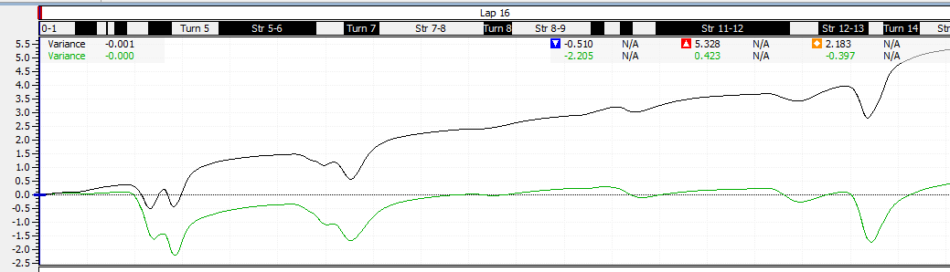
Figure 94 Example of a variance channel

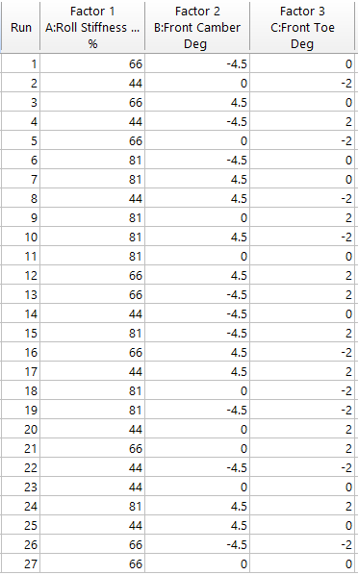
Figure 95 Run List

